**NASA DEVELOP National Program**



NASA Langley Research Center

*Summer 2016*

Southwest US Ecological Forecasting

Mapping Invasive Species to Efficiently Monitor Southwestern National Park Areas

**Technical Report** 

August 11, 2016

Ryan Avery (Project Lead)

Katherine Landesman

Timmera Whaley

Jordan Vaa

Dakoyta Greenman

Dr. Kenton Ross, NASA DEVELOP National Program (Science Advisor)

# 1. Abstract

The southwestern United States spans six states, over 55 national parks, and a wide range of ecosystems, historical landmarks, and culturally significant landscapes. Of these parks, Bandelier National Monument (NM), Big Bend National Park (TX), Glen Canyon National Recreation Area (AZ, UT), and Valles Caldera National Preserve (NM) are threatened by three particularly problematic invasive plant species: cheatgrass (*Bromus tectorum*), ravenna grass (*Saccharum ravennae*), and giant reed (*Arundo donax*). Currently, park management uses field observations to monitor these species, which requires a significant investment in time, effort, and money by the National Park Service (NPS). The NPS is interested in mapping and predicting the presence of these invasive species using NASA’s Earth observations. To this end, the Southwest U.S. Ecological Forecasting team created classified species distribution maps using Moderate Resolution Imaging Spectroradiometer (MODIS) data and Landsat 5 and 8, Operational Land Imager (OLI) data for the years 2002 and 2016. This project also used vegetation and topographic indices as well as field data to predict invasive species presence using a Species Distribution Model (SDM) for each national park area and generated likelihood maps of species presence/absence.

**Keywords**

Remote Sensing, Terra MODIS, Landsat OLI/TIRS, Land Cover classification, NDVI, Cheatgrass

# 2. Introduction

Whether purposefully introduced or unintentionally transported, non-native plant species have become a major problem in the United States. The excessive competition that pre-adapted invasive species bring to native landscapes has been categorized as the second largest catalyst of extinction and habitat destruction behind human development (Wilcove et al, 1998). This threat poses a serious challenge for the National Park Service. In the southwest, the accumulated impact of the reduction of native herbaceous vegetation and an influx of non-native seeds has made the area particularly susceptible to invasive species (Pellant, 1996). To this end, NASA DEVELOP’s Southwest U.S. Ecological Forecasting team is utilizing Earth observation systems to create invasive species distribution maps and forecast models. These products will help the National Park Service (NPS) locate invasive species in order to effectively allocate resources and management efforts.

***2.1 Background Information***

One of the most widespread and problematic invasive weeds that land managers must contend with in the region is cheatgrass(*Bromus tectorum*). Cheatgrass has the ability to germinate in the fall or the spring and is usually dry by mid-July (Pellant, 1996; Peterson, 2005). Because of this comparatively early phenology, cheatgrass is able to plant its seeds earlier in the year than other perennial species. This allows it to quickly establish itself after wildfires, easily take over the land, and crowd out native species. Additionally, cheatgrass can establish quickly after wildfires, and due to its early dry season, it is also a fire hazard (Menakis, 2002). The numerous advantages that give cheatgrass the ability to outcompete native vegetation allow it to permanently alter entire ecosystems, posing threats to the preservation of the native and natural character of the lands.

Another major non-native weed in the southwest region that thrives on fire is giant reed (*Arundo donax*). It was originally introduced to California as an erosion-control agent in the 1820’s and has since colonized stream banks along the Rio Grande. This perennial grass can grow up to 10 meters in height and establishes itself in riparian areas in clonal colonies by taking advantage of native vegetation’s susceptibility to fire in the dry season (Bell, 1997; Yang, 2009). Like cheatgrass, giant reedis highly flammable and can propagate quickly after fire by being the first to grow after recent burns (Bell, 1997; DiPietro, 2002). In the southwest, giant reed can asexually reproduce and grow their colonies downstream in a widespread fashion, thus taking over soil space, sunlight, and other resources that native plants would normally utilize (Bell, 1997; Yang, 2009). Aside from crowding out native species, giant reed does little to provide food or habitat for wildlife and consumes exceptional amounts of water (DiPietro, 2002; Yang, 2009). These characteristics make giant reeda threat to both the hydrology and ecosystem health of southwestern Texas.

Lastly, ravenna grass (*Saccharum ravennae*) was originally imported as an ornamental grass but is now considered a noxious weed in the Southwest. It is a perennial that can grow 2 to 4 meters with leaf blade bases that are densely covered with fuzzy hairs (Feulner, 2009; Winston, 2014). Their seeds are held in fluffy plumes and dispersed by wind or water (DiTomaso et al, 2013). They propagate in early summer then germinate in late July until the first winter frost (Hayward, 1993; Winston, 2014). Like giant reed*,* ravenna grassgrows in riparian areas and poses a major threat to the local vegetation (DiTomaso et al, 2013), therefore making this a danger to the natural ecosystems managed by the NPS.

**Study Area/Period**

The study area included four national parks in the southwestern United States and the land surrounding them. The parks are Glen Canyon National Recreation Area (UT), Big Bend National Park (TX), Valles Caldera National Preserve (NM) and Bandelier National Monument (NM). The elevation of the Utah and New Mexico region ranges from about 1,000 meters to 3,400 meters, whereas Big Bend’s elevation ranges from about 500 meters to 2,300 meters. The average annual precipitation in the Southwest ranges from 127 mm to 500 mm (Sheppard, 2002). Data were acquired within the ranges of early March to mid-April and early June to mid-July for the years 2000 to 2016, based on the phenology of the invasive plants being studied as these correspond to the green-up and brown-down times of cheatgrass during the season.

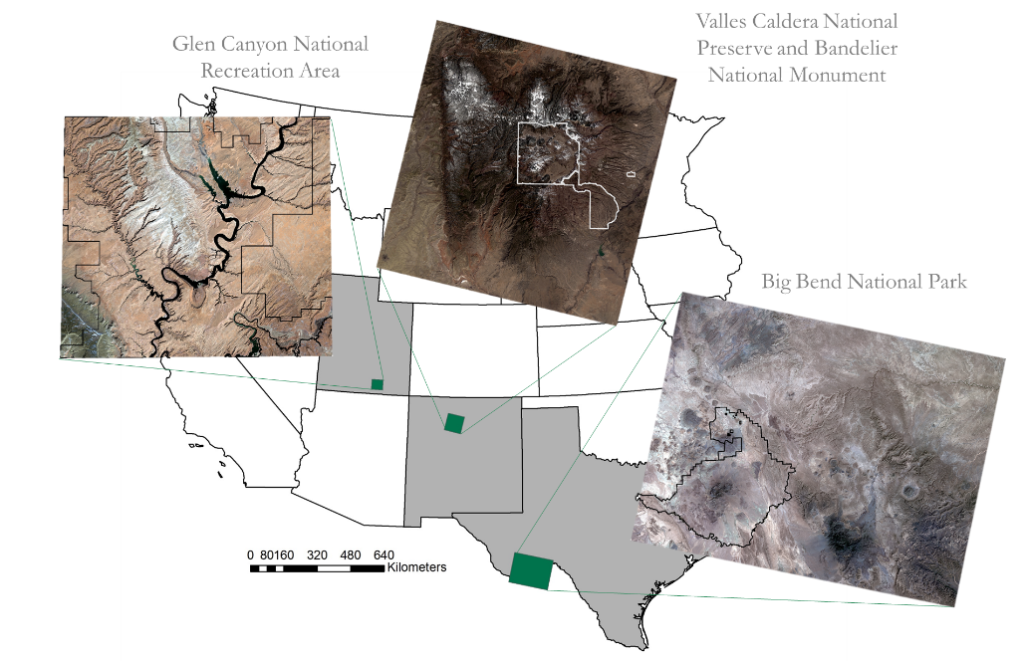

Figure 1: Study area map of four different national parks

***2.2 Project Partners & Objectives***

**National Application Addressed**

This project addresses the NASA Applied Sciences Program application area of Ecological Forecasting for the Southwest U.S. by mapping the distribution and predicting future spread of cheatgrass, giant reed, and ravenna grass. The results of this research will contribute to the inventory, monitoring, and treatment practices of these three species within national parks in the southwest United States.

**Project partners/Objectives**

The NPS’ priority is to preserve and protect America’s natural resources. These responsibilities require the NPS to seek out the most cost-effective option for maintaining the cultural, environmental, and recreational value of the lands it oversees. To this end, our project partners at the Southwest Exotic Plant Management Team (EPMT) and the Colorado Plateau Cooperative Ecosystem Studies Unit (CPCESU) proposed this project to apply NASA Earth observations in identifying and forecasting invasive species presence in their management regions. These Earth observations have the potential to complement and even reduce the need for on-the-ground surveys, making management efforts more practical. NASA Earth observations have the potential to map invasive species over large spatial scales as well as model and forecast where they may spread to in the future.

# 3. Methodology *3.1 Data Acquisition* Landsat

The team obtained Landsat 5 Thematic Mapper (TM), Landsat 7 ETM+, and Landsat 8 Operational Land Imager (OLI) Surface Reflectance Level 1 imagery for the years 2000 - 2016 from the United States Geological Survey (USGS) Earth Explorer download client. Two images with the least amount of cloudiness were downloaded for each year, one in late April/early May and one in late June/early July, for the study region of each National Park area. Images were selected in late April and in late June because of cheatgrass’ unique phenology; it greens up before the surrounding vegetation in late April/early May and browns down before other vegetation in late June/early July. However, spatial variance also plays a factor into its phenology. According to our project partners, cheatgrass observations have also shown to green up in May within higher elevations in Valles Caldera National Preserve; therefore, we acquired Landsat scenes for May and July to effectively classify scenes that represent the correct phenological profile.

***ForWarn***

The team also used *ForWarn* data from the USDA to examine phenology patterns of land cover in our study areas. *ForWarn’s* phenological parameter data measures seasonal changes in Normalized Difference Vegetation Index (NDVI), by representing different percentages of the year’s maximum NDVI. These metrics can indicate the time of green-up, senescence, or maximum NDVI in each 250 meter pixel area (Hargrove et al, 2009).

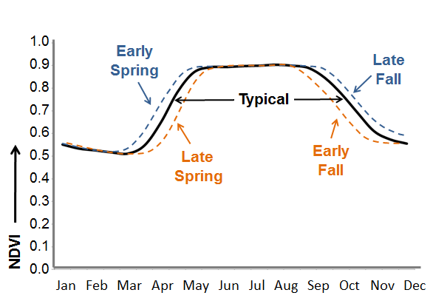

Figure 2: An overview of seasonal NDVI change. Species like cheatgrass have an earlier phenological cycle, greening up in early spring and browning down in summer/early fall depending on the region (Source: ForWarn).

Theoretically, the start of the spring green-up season for native vegetation in the Southwest region is represented by the left 20% while images that show the end of a season are represented by the right 20%. Additionally, the left 80% represents the beginning of the peak green-up and the right 80% represents the beginning of the brown down (Figure 2).

**Sentinel-2a**

The team downloaded 10-meter Sentinel-2a, Level 3 images for the months of January through June for 2016 from the Copernicus download hub. Sentinel-2a is operated by the European Space Agency (ESA) and due to the constrained window of access that is placed on Sentinel-2a data within the U.S., only data from within a 6 month time period could be procured. Scenes were downloaded for the area surrounding Big Bend National Park and the Rio Grande River, and scenes with minimal cloud cover were selected for processing.

**National Elevation Dataset**

The team acquired ⅓ arc-second void-filled digital elevation models (DEM) for each study area from the USGS’s TNM Download Client. With this, a slope image and an aspect image were derived with ArcMap tools.

***In situ* data**

The NPS provided the team with ESRI shapefiles of wildfire extent within the Valles Caldera and Bandelier park areas as well as with presence/absence data for cheatgrass, ravenna grass, and coverage data of giant reed. *In situ* data was collected by the NPS from the year 2000 to 2016. Additionally, *in situ* data for cheatgrass was downloaded from SciNET (Table 1).

Table 1: Description of in situ data downloaded

|  |  |  |  |  |  |
| --- | --- | --- | --- | --- | --- |
| Park | Source | Number of records | Feature Type | Has Percent Cover | Years |
| Big Bend | NPS | 17 | Polygon | Yes | 2016 |
| Valles Caldera | SEINet | 12 | Point | No | 2001-2009 |
| Valles Caldera and Bandelier | NPS | 577 | Point | Some | 2002-2016 |
| Bandelier | SEINet | 6 | Point | No | 1948-2003 |
| Glen Canyon (Ravenna) | NPS | 14 | Point | Yes | 2014-2015 |
| Glen Canyon (Cheatgrass) | NPS | 19 | Point | No | 2008-2014 |

**GAP studies**

The team also utilized version 2 of the land cover data from the National Gap Analysis Program (GAP) supported by the USGS. GAP is a meso-scale land cover map, and the land cover data is based on spectro-physiographic zoning and uses 1999-2001 Landsat Enhanced Thematic Mapper Plus (ETM+) products as base maps, along with ecological categories through the NatureServe’s Ecological System and other similar modeling techniques (Lowry et al, 2005).

***3.2 Data Processing***

**GAP studies**

From the GAP dataset, the team extracted the introduced and semi-natural vegetationclass, which is categorized by vegetation dominance, from the ecological systems layers in each NPS boundary (Lowry et al, 2005). The ecological systems layer contains plants with similar ecological behaviors that grow within particular landscapes based on their phenological properties (Lowry et al, 2005).

**Landsat**

Each Landsat scene’s respective study area was first clipped to a smaller study area surrounding each national park and then clipped using the Gap Analysis Land Cover dataset in order to reduce edge artifacts of Landsat scenes and to remove land cover types that cannot serve as invasive species habitat (such as urban cover). Additionally, the study area was also clipped to exclude areas above 3,000 meters since cheatgrass typically does not grow in this elevation. For Big Bend National Park, two Landsat scenes taken in the same orbital path were mosaicked in order to capture a larger extent of the Rio Grande River.  Additionally, NDVI images were made using the red and near infrared bands for every Landsat image and then the June NDVI image was subtracted from the April NDVI image for each year.

***ForWarn***

A composited image was made with the *ForWarn* data using the NDVI max image, the left 20% image, and the right 20% image for each year as RGB bands.  These images show vegetation with earlier seasons in darker values and vegetation with later seasons in brighter values, while vegetation with a more vigorous NDVI overall is also brighter.  Next, histograms of the left 20% and the right 20% were inspected to show when plants in the area started to green-up and when they were almost completely at senescence.  These two images were then added together for each year to emphasize the differences in the phenology of vegetation in our study area. Individual *ForWarn* bands were also re-projected so that they could be used as variables in our unsupervised classification. We used the Re-Project tool in ERDAS for this and re-projected *ForWarn* data into WGS84 UTM 13N, as this was the projection of our Landsat bands.

***3.3 Data Analysis***

**Unsupervised Classification**

Our team made two classification maps for the years 2002 and 2016 in the area surrounding Bandelier and Valles Caldera. K-means clustering, an unsupervised classification method, was chosen since this method does not require labeled training data. K-means was run several times with different combinations of variables used. Table 2 lists the different variable combinations we tested for the 2002 classification, whether the variables were clipped to a specific extent using the GAP land cover dataset, and the relative performance of each map output. In the end, using Landsat 7 bands 1-7 from the early greenup date, aspect, and an NDVI difference image between the early and late dates as variables produced the best results for the year 2002. For 2016, Landsat 8 bands 2-7from the early greenup date, aspect, and an NDVI difference image between the early and late start dates was computed. Once the classification maps were produced, the *in situ* points for each respective years were overlaid and the classes with the most *in situ* points within them were calculated. Because of the inconsistency of amount of *in situ* points for each year, *in situ* points for 2002 and 2003 were analyzed with the 2002 image and *in situ* points from 2013-2016 were analyzed with the 2016 image. Graphs were made showing how many *in situ* points fell in which classes, and then the classification maps were displayed and analyzed based on this information (Figure 2). Classes with a significant amount of *in situ* points were analyzed to determine if these areas were indeed those suspected of likelihood for cheatgrass invasion.

Figure 3: Graph showing how many in situ points fell within a single class for the 2002 classification image.

**Supervised Classification**

Having more coverage information with the *in situ* polygons of giant reed around the Rio Grande, the team was able to perform supervised classifications in the area surrounding Big Bend. Two methods of supervised classifications were run and compared. First, both Landsat bands and Sentinel-2a bands were classified using the Classification Tree Analysis (CTA) method in TerrSet. Additionally, we used Random Forest, where the classification tree process is iterated hundreds of times, using a different random set of training data each run and for the final classification image, appointed the class that got chosen the most. The team ran Random Forest several times with different spectral band combinations. Random Forest was run with Landsat 8 bands as input variables and then run again with Sentinel-2a bands as input variables. The training data that was used included the *in situ* data for giant reed and shapefiles of other classes (water, bare soil, shrubland, and other vegetation) that were made by the team looking at a false color composite of Sentinel-2a and high resolution National Agriculture Imagery Program (NAIP) imagery. Random Forest was run several times, using different band combinations and number of training pixels sampled. Table 3 shows some of the different band combinations we used and outputs we received for the Sentinel-2a classification. Our best classification result with Landsat 8 used bands 2-7 and sampled 200 training pixels. Our best classification result with Sentinel-2a used bands 2, 4, 8, 11, and 12 and sampled 500 pixels. Because the shortwave infrared bands in Sentinel-2a (bands 11 and 12) are at 20 meters, all the other bands were resampled up to 20 meters as well.

# 4. Results & Discussion

***4.1 Analysis of Results***

**Valles Caldera and Bandelier**

Our classification maps of Valles Caldera and Bandelier performed best when using bands 2-7 from either Landsat 7 or Landsat 8, an NDVI difference image computed using a March and June date, and aspect. Classification performance was qualitatively assessed by determining which classification captured the most *in situ* data points within the smallest number of classes. Classifications in 2016 were more thorough than 2002 in mapping grassland susceptible to cheatgrass as evidenced by the difference in coverage of grasslands within Valles Caldera (Figure 3).

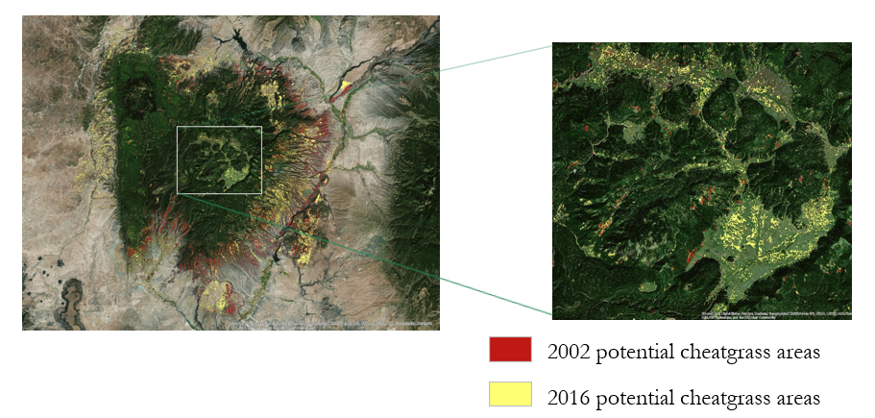

Figure 4: 2002 and 2016 unsupervised classifications of Bandelier and Valles Caldera

The 2002 classification was also compared to GAP land cover classes to check if the validated classes matched up with larger class groups. Figure 4 shows our 2002 classifications on top of the 2002 GAP studies land covers. Our classifications are mainly on the East side of the study area and fall mostly on the Forest and Woodland class, most of that being within Pinyon-Juniper. A lot of our classifications also fall within the recently burned areas. This is most likely due to cheatgrass’ ability to regrow quickly after a fire. The 2002 classification does not, however, map potential invasion areas in the grassland classes; our 2016 classification explains this grassland invasion much better, as seen in figure 1. We believe that this is due to the large increase in *in situ* data points within the period of 2013-2016 compared with 2002-2003. Figure 5 shows a comparison of the distribution of *in situ* data across both temporal ranges, with the 2013-2016 time range having both a wider coverage and more *in situ* data points than 2002-2003.

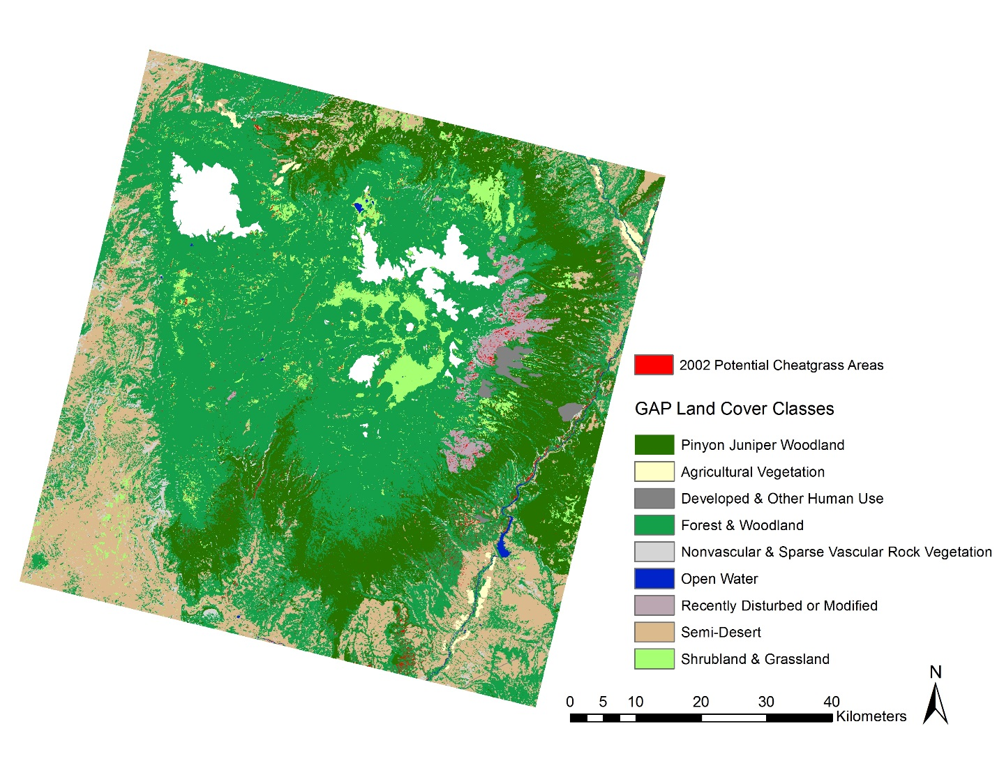

Figure 5: 2002 Classification image on top of the GAP studies land covers

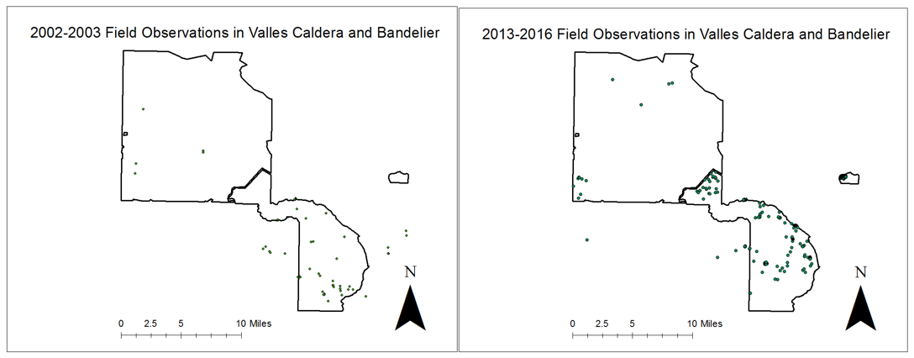

Figure 6: Distribution of in situ data for 2002-2003 compared to 2013-2016

We were not able to discern meaningful differences in the reflectance values of Landsat pixels where cheatgrass coverage was deemed present by field observations. This could be because Landsat’s resolution is too coarse, the polygons did not represent 100% coverage of cheatgrass at high density, or that the cheatgrass had not experienced significant greenup or brown down relative to the surrounding vegetation at the time that the Landsat scenes were taken. We believe that the cause is a combination of the three. It was difficult to obtain a cloud free Landsat image that fell within our time range and it was required for us to use *in situ* data outside the year the Landsat image was remotely sensed to validate the classification. The Valles Caldera National Preserve park staff acknowledge that cheatgrass experiences variability in phenology events from year to year and because of an elevation difference, the preserve’s patches of cheatgrass experience these events later relative to Bandelier’s patches. However, it was necessary to classify cheatgrass using Landsat imagery which covered Bandelier in order to have enough in situ points to validate a classification.

**Big Bend and the Rio Grande**

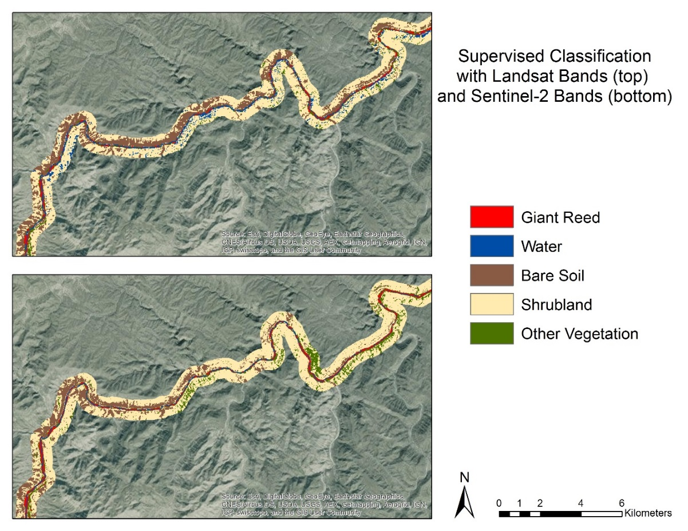As can be seen from the comparison in Figure 6, Sentinel-2a performs much better than Landsat 8 in correctly classifying most classes, especially the open water of the Rio Grande. Our error matrix for Sentinel-2a shows that giant reed was classified correctly about 90% of the time; however we believe that this is because both results over classify areas along the river as giant reed when in reality those areas could be other types of riverside vegetation. This hypothesis is supported by the fact that our error matrix for our Random Forest Sentinel-2a classification shows that the other vegetation class was classified as giant reed about 5% of the time (Table 4). Furthermore, from a visual inspection of our classified map overlaid with high resolution

Figure 7: Random Forest classification of Landsat (top) and Sentinel-2a (bottom) around the Rio Grande

imagery from Google Earth, it is clear that the classifier labels multiple vegetation types as giant reed or other vegetation.

It could be that the labeled class “other vegetation” is too broad, and includes riparian cover with similar spectral signatures to giant reed. This misclassification could also be a result of how the boundaries of our giant reed *in situ* polygons were delineated. Figure 7 shows that the polygons representing 100% giant reed cover sometimes overlap with Sentinel-2a pixels that represent open water areas. We believe that this is because the polygons were digitized using arial orthoimagery, which makes areas where giant reed hangs over the river edge appear to be areas with 100% giant reed cover. In fact, the spectral signature at these areas near the river edge represent open water but are classified as giant reed. This error in the training data could have caused the Random Forest Classifier to over fit a wide ranging spectral distribution informed by this faulty training data, thus capturing many non-labeled pixels in the giant reed class than if the training data had been delineated solely over vegetated giant reed patches. However, the classifier does appear to succeed in delineating shrubland, bare soil, and open water quite well, based on visual inspection and the error matrix. Furthermore, from a visual inspection it appears that while the giant reed class does capture many types of vegetation that are not giant reed, the class does not often misclassify tree canopy as giant reed. The specificity of this classification given the training data used shows that there is still potential for much improvement.

Additionally, we've found that our best Random Forest classified image classified a little over half the pixels that make up the entire class of giant reed with at least 75% certainty (Table 5). The measure of certainty indicates, for a given pixel, that out of all classification trees generated by the Random forest algorithm, 75% or more agree that a given pixel is classified as giant reed. This is not a measure of accuracy and we still believe that the classifier over classifies riparian vegetation as giant reed. However, we are excited that the Sentinel-2a data is able to so finely separate these classes as it is and we expect that more training data and training shapefiles of vegetation classes other than giant reed could greatly increase the performance of future classifications.

***4.2 Future Work***

Next steps in this project would fall into three different categories, utilizing new in situ data, new classification methods, and new classification variables.

**New Data**

Having more cheatgrass patches with at least over 40% cover would be helpful in developing a classified map that represents the direct spectral signature of cheatgrass rather than the more general case of grasslands that are potentially susceptible to cheatgrass. More field observations and a larger spread of field observations over a greater area will allow for a more fine-tuned ability to pick out cheatgrass patches from surrounding vegetation. Also having *in situ* data and information on the different types of native species in the area could help us pick out areas that are not cheatgrass in order to focus more on where cheatgrass might be.

Similarly, in Big Bend, *in situ* measurements of common riparian vegetation that is not giant reed would greatly improve classifications. With knowledge of the other types of riparian vegetation that grows next to and surrounds giant reed, Random Forest, or any other classification algorithm, could more clearly distinguish vegetation growing along the Rio Grande. Because of the high performance of Sentinel-2, it would benefit having this imagery for later dates in order to classify images in the past and potentially forecast into the future. The ESA and USGS are developing an agreement for hosting Sentinel-2a data through an open data plan, allowing full access to the Sentinel-2a data library. This, along with additional data generated over the course of the satellite’s mission, will allow for further refinement of the classification maps.

**New Methods**

SAHM, or the Software for Assisted Habitat Modeling could be used to test how other classifiers perform relative to one another. While the Wyoming Fall 2015 DEVELOP project found that Random Forest performed best relative to other classifiers, it did not perform statistically significantly better and other methods should be tested. Additionally, although we were not able to map the distribution of ravenna grass due to it growing in small patches and not having enough *in situ* points, there is a huge potential for its habitat to be modeled. With more field observations of ravenna grass and a greater knowledge of the conditions it grows in, we would be able to predict areas that are at risk to its invasion. This can be done with the Habitat and Biodiversity Modeler in TerrSet, which can model species distribution by using environmental variables to predict areas that a species could inhabit.

**New Classification Variables**

Future classification variables could examine Normalized Difference Water Index (NDWI), Modified Normalized Difference Water Index (MNDWI), EVI, Soil Adjusted Vegetation Index (SAVI), and indices from a tasseled cap (TCAP) transformation: TCAP soil brightness, TCAP vegetation greenness, TCAP soil/vegetation wetness as applied in the Wyoming Ecological Forecasting project. However, it should be noted that the Wyoming Ecological Forecasting project had access to percent cover cheatgrass field data for 166 points within the study area for their supervised classifications. An increase in *in situ* data and attributes for in situ data representing cheatgrass coverage relative to native vegetation coverage would improve supervised classification results and improve the ability to cross-validate these results.

# 5. Conclusions

NASA Earth observations have the potential to be an essential tool in mapping distributions of invasive species and forecasting their future spread. However, in order to get solid validation of results, quality *in situ* data is necessary. As seen with our comparisons of the 2002 classification map and the 2016 classification map in Bandelier and Valles Caldera, an increase in field observations and a wider spatial spread of the data improved the classification of potentially invaded grasslands. Furthermore, with an increased amount of field observations of both cheatgrass and other native vegetation that this invasive species outcompetes, a supervised classification could be possible to delineating where cheatgrass actually is. With more accurate classification maps like these, forecasting the future distribution of invasive species would become more plausible.

We also found that Landsat’s 30m pixels are not small enough to classify riparian vegetation and land cover in and around the Rio Grande. However, just a 20m difference in pixel size, with Sentinel-2a data, greatly improved our classifications. Further improvements could be made with more detailed and accurate training data. Sentinel-2a bands may also be a good candidate as variables to map the habitat of ravenna grass, since this invasive species also grows in thin patches along rivers and lakes. As Sentinel-2a becomes more available it will be an excellent aid in further studies focusing on these species.

# 6. Acknowledgments

* Charles Schelz (Southwest Exotic Plant Management Team, Program Manager)
* Steven Buckley (Southwest Exotic Plant Management Team, Ecologist)
* Todd Chaudhry (Colorado Plateau Cooperative Ecosystem Studies Unit, Research Coordinator)
* Dr. Kenton Ross (NASA DEVELOP National Program Science Advisor)
* Emily Gotschalk (LaRC Center Lead)
* Tyler Rhodes (LaRC Center Lead)
* Kathleen Moore (LaRC Assistant Center Lead)
* Carrie Kelley (LaRC Assistant Center Lead)

Any opinions, findings, and conclusions or recommendations expressed in this material are those of the author(s) and do not necessarily reflect the views of the National Aeronautics and Space Administration. This material is based upon work supported by NASA through contract NNL11AA00B and cooperative agreement NNX14AB60A.

# 7. References

Bell, G. P. (1997). Ecology and management of *Arundo donax* and approaches to riparian habitat restoration in southern California.

Breiman, L. (2001). Random forests. *Machine learning*, *45*(1), 5-32.

Buchanan‐Wollaston, Vicky (2007). *Senescence in Plants.* John Wiley & Sons Ltd, Chichester. http://www.els.net

DiPietro, D. Y. (2002). *Mapping the invasive plant Arundo donax and associated riparian vegetation using hyperspectral remote sensing* (Doctoral dissertation, UNIVERSITY OF CALIFORNIA, DAVIS).

DiTomaso, J. M., Kyser, G. B., Oneto, S. R., Wilson, R. G., Orloff, S. B., Anderson, L. W., ... & Ransom, C. (2013). Weed control in natural areas in the western United States.

USDA Forest Service (2016). Land Surface Phenology. <http://forwarn.forestthreats.org/overview/detecting-change>.

Feulner, G. R., & Karki, N. (2009). Hidden in plain view: first UAE record of the wadi grass Saccharum kajkaiense and notes on its distribution in the UAE and neighbouring Oman. *Tribulus*, *18*, 50.

Hargrove, W. W., Spruce, J. P., Gasser, G. E., & Hoffman, F. M. (2009). Toward a national early warning system for forest disturbances using remotely sensed canopy phenology.

Hayward, P. (1993). Erianthus ravennae. *American Nurseryman* *Vol. 6. 138*.

Lowry Jr, J. H., Ramsey, R. D., Boykin, K., Bradford, D., Comer, P., Falzarano, S., ... & Manis, G. (2005). Southwest regional gap analysis project: final report on land cover mapping methods. *RS/GIS Laboratory, Utah State University, Logan, Utah*, *50*.

Menakis, J. P., Osborne, D., & Miller, M. (2002). Mapping the cheatgrass-caused departure from historical natural fire regimes in the Great Basin, USA. *FIRE, FUEL TREATMENTS, AND ECOLOGICAL RESTORATION.[vp]. 16-18 Apr*.

Pellant, M. (1996). Cheatgrass: the invader that won the west (p. 22). *US Department of the Interior, Bureau of Land Management.*

Peterson, E. B. (2005). Estimating cover of an invasive grass (Bromus tectorum) using tobit regression and phenology derived from two dates of Landsat ETM+ data. *International Journal of Remote Sensing*, *26*(12), 2491-2507.

Schulte, D, Fowler, C, Krail, S, Miltenberger, O (2015). Mapping Cheatgrass Distribution and Phenology in a Post-Wildfire landscape in Wyoming’s Medicince Bow National Forest. *NASA DEVELOP National Program, USGS at CO State University.*

Sheppard, P. R., Comrie, A. C., Packin, G. D., Angersbach, K., & Hughes, M. K. (2002). The climate of the US Southwest. *Climate Research*, *21*(3), 219-238.

Software for Assisted Habitat Modeling (SAHM). (n.d.). Retrieved June 28, 2016, from https://www.fort.usgs.gov/sites/default/files/RAM/SAHM.html

Wilcove, D. S., Rothstein, D., Dubow, J., Phillips, A., & Losos, E. (1998). Quantifying threats to imperiled species in the United States. *BioScience*, *48*(8), 607-615.

Winston, R., DesCamp, W., Andreas, J., Randall, C. B., Milan, J., & Schwarzländer, M. (2014). *New Invaders of the Southwest*, *18-19.*

Yang, C., Goolsby, J. A., & Everitt, J. H. (2009). Mapping giant reed with QuickBird imagery in the Mexican portion of the Rio Grande Basin. *Journal of Applied Remote Sensing*, *3*(1), 033530-033530.

# 8. Content Innovation

Glossary Viewer (see separate document)

Inline Supplementary Material (see above)

Interactive Map Viewer: https://drive.google.com/open?id=0B6--Mo210fZ4NTVPZFppQl9pdkk

# 9. Appendices

Table 2: Variables used and results of unsupervised classifications in Bandelier and Valles Caldera

|  |  |  |  |
| --- | --- | --- | --- |
| Variables Used | Clipped Out | Highest *in situ* in one output class | Average *in situ* in one output class |
| April Landsat Bands 1-7; slope; aspect | Above 3000m | 11 | 3.76 |
| April Landsat Bands 1-7; aspect; slope | Above 3000m, GAP classes that don’t have *in situ* points in them | 10 | 3.08 |
| April Landsat Bands 1-7; aspect | Above 3000m, GAP classes that don’t have *in situ* points in them | 10 | 3.74 |
| April Landsat Bands 1-7; aspect; slope | Above 3000m, GAP classes that don’t have *in situ* points in them plus Pine | 10 | 2.75 |
| April Landsat Bands 1-7; June Landsat Bands 1-7; aspect; NDVI difference | Above 3000m, GAP class woodland except where there was a lot of *in situ* | 8 | 2.94 |
| April Landsat Bands 1-7; June Landsat Bands 1-7; aspect; NDVI difference | Above 3000m, every GAP class except grassland, semi-desert, and recently burned | 3 | 1.22 |
| April Landsat Bands 1-7; aspect; NDVI difference | Above 3000m, GAP class woodland except where there was a lot of *in situ* | 14 | 2.65 |
| Landsat Bands1-7 (not6); aspect; NDVI difference; ForWarn left 20 | Above 3000m, clipped to a smaller ForWarn extent | 7 | 2.57 |

Table 3: Variables used and results from the Random Forest supervised classifications around the Rio Grande

|  |  |  |  |
| --- | --- | --- | --- |
| Variables Used | Training Pixels Used | Error Output | Giant Reed Error |
| SENTINEL: 2-4, 8, 11-12 | 100 | 0.106 | 0.17 |
| SENTINEL: 2, 8, 11-12 | 100 | 0.126 | 0.15 |
| SENTINEL: 2-4, 8, 11 | 100 | 0.142 | 0.23 |
| SENTINEL: 2-4, 8, 12 | 100 | 0.11 | 0.14 |
| SENTINEL: 2-4, 8, 11-12 | 500 | 0.081 | 0.11 |
| SENTINEL: 2, 4, 8, 11-12 | 500 | 0.0796 | 0.09 |
| SENTINEL: 2, 4, 8, 11 | 500 | 0.083 | 0.088 |
| SENTINEL: 2, 4, 8, 12 | 500 | 0.084 | 0.092 |

Table 4: Error matrices of the best Random Forest classifications and the Sentinel-2a CTA

|  |  |  |  |  |  |  |
| --- | --- | --- | --- | --- | --- | --- |
| **Landsat 8** | Giant Reed | Water | Bare Soil | Shrubland | Other Vegetation | Class Error |
| Giant Reed | 168 | 15 | 1 | 0 | 16 | 0.160 |
| Water | 8 | 190 | 1 | 0 | 1 | 0.050 |
| Bare Soil | 0 | 0 | 191 | 8 | 1 | 0.045 |
| Shrubland | 0 | 0 | 2 | 187 | 11 | 0.065 |
| Other Vegetation | 18 | 1 | 1 | 25 | 155 | 0.225 |
| **Sentinel-2a** |  |  |  |  |  |  |
| Giant Reed | 455 | 19 | 1 | 0 | 25 | 0.090 |
| Water | 14 | 481 | 0 | 2 | 3 | 0.038 |
| Bare Soil | 0 | 1 | 492 | 5 | 2 | 0.016 |
| Shrubland | 0 | 0 | 8 | 462 | 30 | 0.076 |
| Other Vegetation | 25 | 3 | 5 | 56 | 410 | 0.178 |
| **Sentinel-2a CTA** |  |  |  |  |  |  |
| Giant Reed | 337 | 157 | 0 | 0 | 93 | 0.426 |
| Water | 6 | 718 | 0 | 0 | 1 | 0.010 |
| Bare Soil | 1 | 0 | 394 | 1 | 48 | 0.113 |
| Shrubland | 1 | 4 | 1 | 1645 | 1112 | 0.405 |
| Other Vegetation | 69 | 18 | 0 | 361 | 3275 | 0.120 |

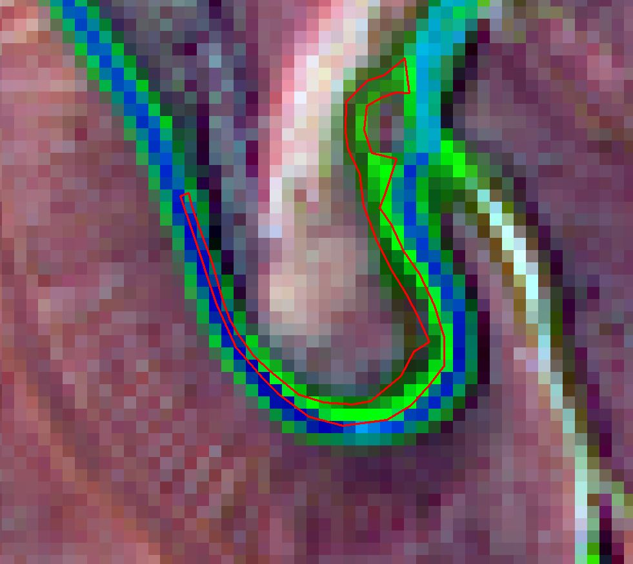

Figure 8: An in situ giant reed polygon on top of a false color composite of Sentinel-2a bands. The polygon is clearly overlapping with some open water.

Table 5: Pixel count for the supervised classified images around the Rio Grande

|  |  |  |  |
| --- | --- | --- | --- |
| **Sentinel Classification** | *Total Pixels Classified* | *Total Pixels Above 75% Probability of Correct Classification* | *Percentage of Total Above 75% Threshold* |
| Giant Reed | 18158 | 11167 | 0.614990638 |
| Water | 14939 | 10138 | 0.678626414 |
| Bare Soil | 83119 | 49338 | 0.593582695 |
| Shrubland | 228151 | 151404 | 0.663613133 |
| Other Vegetation | 57094 | 23621 | 0.413721232 |
| **Landsat Classification** |  |  |  |
| Giant Reed | 7005 | 2534 | 0.361741613 |
| Water | 11777 | 5793 | 0.491890974 |
| Bare Soil | 35534 | 21372 | 0.60145213 |
| Shrubland | 106378 | 52811 | 0.496446634 |
| Other Vegetation | 17256 | 5032 | 0.291608716 |