**NASA DEVELOP National Program**

 NASA Langley Research Center

**Summer 2015**

**Short Title: Colorado Water Resources II**

**Subtitle:** Utilizing NASA Earth Observations to Identify Locations for Sedimentation Mitigation in the Ralston Creek Watershed Following the September 2013 Colorado Floods

**VPS Title:** Water We Drinking? Mapping Mitigation Sites in Ralston Reservoir, CO

**Project Team & Partners**

**Project Team:**

Tyler M. Rhodes (Team Lead), [Tyler.M.Rhodes@nasa.gov](mailto:Tyler.M.Rhodes@nasa.gov)

Amy Phillips

Romina Gotzmann

Rebekke Muench

Jared Ryks

**Advisors & Mentors:**

Dr. Kenton Ross (NASA DEVELOP National Program)

**Past or Other Contributors:**

Geordi Alm

Janice Maldonado Jaime

Rachel Wolf

Amanda Collins

**Partner Organizations**

Denver Water, End-User, POC: Linda Rosales, Diego Portillo, Sheila Pelczarksi

**Project Details**

**Applied Sciences National Applications Addressed:** Water Resources

**Study Area:** Ralston Creek Watershed (Near Denver, CO)

**Study Period:** 2001, 2006, 2011, June 2014

**Earth Observations & Parameters**

Landsat-8, OLI/TIRS – Land classification

**Ancillary Datasets Utilized**

* FEMA LiDAR – Digital Elevation Model
* USGS National Land Cover Dataset – Land cover
* PRISM precipitation point data – Precipitation data
* CO Department of Transportation  – Roads
* USDA Web Soil Survey – Soil classification data

**Models Utilized**

* USDA Revised Universal Soil Loss Equation (RUSLE) Model

**Software Utilized**

TerrSet - land classification of Landsat imagery, change analysis, forecasting maps

ArcGIS - raster manipulation/analysis, map creation, extensions (ArcHydro)

ENVI - LiDAR manipulation

**Project Overview**

**80-100 Word Objectives Overview**

Denver Water supplies 1.3 million people with potable resources every year. The landscape surrounding the Ralston Reservoir, a major supply source for Denver Water, was altered during a severe flooding event in September 2013.  In mountainous regions, like Ralston, sedimentation poses a threat to potable water. Sedimentation typically contains organic materials, chemicals, and additional contaminants, which negatively affects waterways. This project utilized NASA’s Landsat 8 to geospatially locate optimal areas within the Ralston Creek Watershed for mitigation efforts to reduce sedimentation.

**Abstract**

The September 2013 flooding in Denver, CO, characterized as a “one in 1,000” rainfall event, resulted in excessive runoff and sedimentation, which altered surrounding watershed structure and hydrology. This flooding event and the uncharacteristic weather in spring 2015 prompted a study by the NASA DEVELOP team to address community concerns regarding water quality. DEVELOP worked with Denver Water, the city’s primary water supplier, to determine erosion mitigation sites in the Ralston Creek Watershed using the Revised Universal Soil Loss Equation (RUSLE). This model combines rainfall, slope, land cover, and conservation practices to predict soil loss. This research integrated land cover maps derived from NASA’s Landsat 8 with a high resolution airborne LiDAR digital elevation model, which provided Denver Water with a fine scale map detailing potential mitigation sites. Mitigation sites were determined based on RUSLE outputs and accessibility.

**Community Concerns**

* Sedimentation can increase the amount of nutrients and heavy metals in water. If the sedimentation continues then it could cause eutrophication in the ecosystem as well as compromise general water quality in the future.
* The Ralston Reservoir provides water resources to Denver Water. As the end-user, Denver Water would like to identify potential sites of high erosivity risk in order to perform watershed mitigation.

**Current Management Practices & Policies**

Denver Water currently samples water quality in several areas around the Ralston Creek Watershed twelve to sixteen times a year. In these tests, they measure nutrients, heavy metals with an emphasis on uranium, and turbidity. These tests have revealed increased sedimentation in the waterways, which would negatively impact water quality and compromise environmental health. Denver Water wants to identify areas at risk for above-average sedimentation in order to implement mitigation practices in these areas. Denver Water is not currently studying the Ralston Creek Watershed to locate and mitigate high risk erosion sites.

**Decision Support Tools & Benefits**

|  |  |  |
| --- | --- | --- |
| **End-Product** | **Earth Observations Used** | **Benefit & Impact** |
| Map extent of Ralston Creek Watershed | LiDAR | Better understanding of areas of concern |
| Up-to-date land cover classification map | Landsat-8 OLI/TIRS  LiDAR | Produce the C factor for the RULSE model |
| Risk map based on RUSLE model | Landsat-8 OLI/TIRS  LiDAR | Map to identify prime locations for sedimentation mitigation and inform policymakers where to begin waterway mitigation |

**Project Imagery**

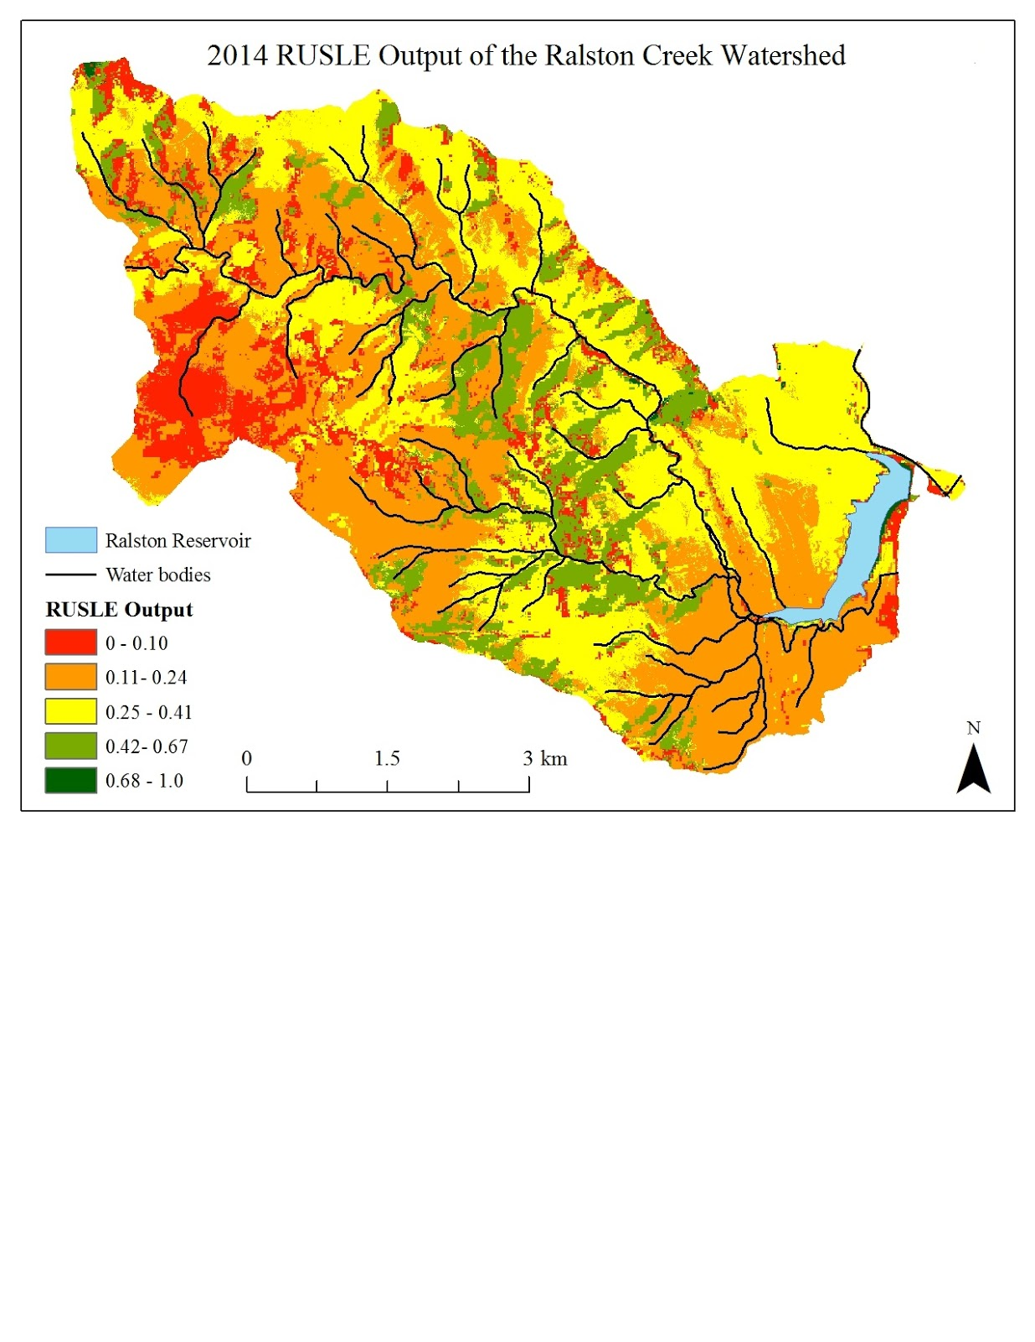

**Caption:** 2014 RUSLE risk assessment map. High risk is indicated in red. Image Credit: Colorado Water Resources II Team.

**Image:** RUSLE_2014.jpg (Please submit your image as a separate .jpeg as well as inserting it in this document)