**NASA DEVELOP National Program**



Team Location (University of Georgia)

*Spring 2014*

South Africa Ecological Forecasting

Understanding Landscape Changes in Elephant Habitat within the Kruger National Park through NASA Earth Observing Systems)

**Final Report**

April 4, 2014

Andrea Presotto, University of Georgia (Project Lead)

Christine Brady, University of Georgia

Ashley Dupont, University of Georgia

Kirstin Valdes, University of Georgia

Dr. Richard Fayrer-Hosken (San Diego Zoo)

Dr. Marguerite Madden (University of Georgia)

Steve Padgett-Vasquez (University of Georgia)

# I. Abstract

South Africa’s Kruger National Park (KNP) is experiencing a landscape transformation from woodland to grassland habitat. Park management and researchers have been reporting that the African Elephant (*Loxodonta africana*) population could be contributing to the landscape change; however, the relationship between elephant behavior and loss of woodland habitat is poorly understood. This study used NASA Earth observations to quantify land cover change and investigate other possible contributing factors within an area inhabited by African elephants in KNP from 1998 to 2013. The study area was defined by geographic coordinates collected from GPS-enabled collars attached to four female elephants over the span of six months. After plotting these locations, the minimum convex polygon (MCP) method was used to extrapolate the elephants’ habitat and define the study area. Individual land cover maps were produced from a time series of Landsat images using both pixel-based and object-based classification methods in order to compare the effectiveness of both methods and their results. In addition to land cover changes, nitrogen, biomass, and vegetation structure aspects were analyzed to create a habitat suitability model.

**Keywords**

Land cover classification, object-based classification, African elephants, Kruger National Park

# 

# II. Introduction

Kruger National Park (KNP) is located in the provinces of Limpopo and Mpumalanga, South Africa, and covers approximately 20,720 km2 (Dennis, 2000). It is one of the world’s largest wildlife sanctuaries and is home to a diversity of species. The altitude of the park ranges from 200 m to 840 m, featuring a wide diversity of ecological habitats. The average precipitation in the park is between 450 and 500 mm, which supports its 13 major vegetation types (Dennis, 2000). The park is largely maintained by tourist activities which are popular due to the excellent viewing experiences that the park offers (Dennis, 2000).

Previous studies on vegetation structure, species, and succession from woodland to grassland habitat have been conducted in Kruger since the 1970s (Laws, 1970; Vanak, 2012). These studies suggest that African elephants are part of the cause of habitat transformation, and in some cases may be as destructive as wildfire (Buss, 1961; Owen-Smith et al., 2006; Ludwig et al., 2008; Young et al., 2009; Boundja and Midgley, 2009; Vanak, 2012). With the widespread opinion that elephants are the problem, they become labeled as a landscape species, or a species that causes impact on its environment due to its compression into protected areas (Sukumar, 2003; Ludwig et al., 2008; Vanak et al., 2012). However, a number of publications and reported actions of elephants stripping bark and branches off trees does not match species-specific behavior (Sukumar, 2003). Male elephants, also known as bulls, have been observed pushing over trees with no intention of using them for feeding. This has been described as an aggressive behavior from which most trees are unable to recover. Although not performed by all bulls (Fayrer-Hosken, personal communication), this male specific behavior is thought to be a contributing factor to the temporal decline in tree density within the park. Further research is required to determine if elephants are largely responsible for KNP woodland conversion to grassland.

**About the African Elephant**

The Elephantidae family originated in the Miocene epoch (23-5 million years ago) and includes Asian Elephants (*genus Elephas*), African elephants (genus *Loxondonta*), and the extinct mammoths (Rohland et al., 2010). In addition to being the largest of land mammals, the Elephantidae family is distinguished by having an advanced social organization. The African elephant society is matriarchal, consisting of strong bonds formed among females, and long term associations among individuals (Wilson, 2000). Each elephant population is organized into a two or three-tiered hierarchy of social groupings. Directly above the individual is the family unit, a tightly knit herd of 10-20 females and their offspring that is led by a powerful matriarch. The second level in social organization is the kinship group, an ensemble of family units that remain near one another and show some degree of familiarity. It is likely that such groups originate when family units divide by a process known as fission (Wilson, 2000). Adult males live alone or in bands and disperse across wider areas than females (Lindsay and Croze, 2011). When in groups, males compete for position within a dominance hierarchy (Wilson, 2000).

The African elephants eat a variety of plants within their habitat. In a four-and-a-half yearlong study at Lake Manyara National Park, elephants were seen to sample 64 species of plants belonging to 28 families in a 12-hour period. Within natural environments, elephants are good food dispersers, especially for fruit trees species, improving the chances of germination by softening or scarification of the seed coat (Sukumar, 2003). This is important for the regeneration of vegetation after elephants occupy an area.

**Current Management Plan**

In an effort to control the elephant population, KNP management has attempted to use different methods such as contraceptives, translocation, and culling, with no apparent success (KNP Plan, 2013). Elephants demand more effective conservation plans including reduced conflicts with humans, and a better understanding of their role in ecosystems (Kuiper and Parker, 2014.) Human populations living in close proximity to the park rely on fences to protect them from Kruger wildlife. Elephants in particular, have been known to habitually break them and enter the surrounding areas. The environment at KNP requires equilibrium between elephant population, human interaction, and vegetation density (Douglas-Hamilton, 1973, 1998, Blake et al., 2001, Kuiper and Parker, 2011) but such parameters have not yet been established.

This study quantified land cover changes from 1998 to 2013, with a prediction that African elephants alone, are not capable of producing the extensive changes in vegetation physiognomies (i.e., structural types of trees, shrubs and grasses) that would convert woodland to grassland. We suspect other contributing influences such as fire and climate change factors are responsible for landscape change through the suppression of growth of new trees necessary to regenerate the landscape. In order to perform our analysis we used several different data sets including Landsat imagery, GPS data points, and nitrogen and biomass maps (extracted from Rapideye, 2010 by our South African Contributors). Our study area, within 260 hectares, is located within Kruger National Park (KNP), South Africa (Figure 1) and was defined by the spatial extent of GPS data points collected from four collared females that were extrapolated using a minimum convex polygon method.

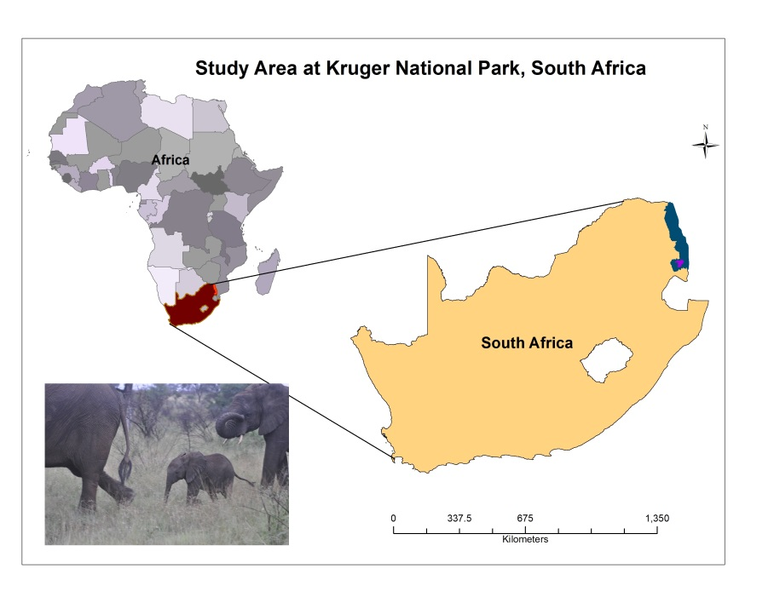

Figure 1. Location of South Africa, Kruger National Park, and the studied elephants’ area

The types of vegetation in the study area include open savanna grassland on basalt, wooded savanna on shale, mixed woodland and thorn thickets, and mixed thorn and marula (Table 1). The time series analysis of land cover aimed to show changes over the past 16 years within the following classes: woodland, grassland, mixed vegetation, bare soil, and water. In conjunction with the time series analysis, nitrogen and biomass levels were analyzed in order to determine locations of suitable vegetation and optimal elephant habitat.

Table 1. Types of vegetation, and associated description, present in Kruger National Park (Provided by KNP)

|  |  |
| --- | --- |
| **Vegetation Type** | **Description** |
| Open savanna grassland on basalt | nutritious grazing on open plains; lots of large grazing herds & predators |
| Wooded savanna on shale | mixed knob thorn, marula, & bush willow woodlands & thorn thickets; good grazing; lead woods along the drainage lines |
| Mixed woodland and thorn thickets | mostly in the lower contours of the catchment areas along the Crocodile & Sabie Rivers; good game viewing because of close proximity to water |
| Mixed thorn and marula | woodlands on granite; low, rolling hills with bush willows & acacias; sweeter grazing along the drainage lines with marula trees |

The purpose of this study was to contribute evidence towards an investigation of the impact of the elephant population in KNP on vegetation changes in the study area over the last 16 years, affecting the successional landscape change. Pixel-based and object-based classification methods were used in order to compare the effectiveness of both methods in producing a time series of land cover from Landsat images. KNP would benefit from a broad-scale quantification of vegetation type changes over time that can inform a decision making process regarding the prevention of the degradation of woodland habitat.

# III. Methodology

**Data Sets**

Imagery was acquired from Landsat 5, 7, and 8 for the years 1998, 2006, and 2013, respectively, (path 168, row 77) from the United States Geological Survey (USGS), Earth Explorer, and GLOVIS database. The images were captured during the transition between the dry and wet season (August-November) to avoid cloud cover. The images required radiometric correction, which was performed using ENVI FLAASH (MODTRAN). Vegetation physiognomies were classified using indices that would enhance the differences between vegetation types: (i) normalized vegetation and (ii) moisture: Normalized Difference Vegetation Index (NDVI) and Normalized Difference Water Index (NDWI). The NDVI was used to enhance the variation in vegetation using bands 3 and 4 in Landsat 5 and Landsat 7 images and bands 4 and 5 in Landsat 8 images. Contributors from South Africa provided RapidEye imagery from 2010, which they used to create the biomass and nitrogen data layers. Additionally, a set of geographic points acquired from GPS collars attached to four female elephants from a herd within Kruger National Park were obtained from the project partner, Dr. Richard Fayrer-Hosken. These data were gathered in the wet season from 1998-1999 (September-February with a collection interval of once every hour). Once plotted, the area inhabited by the elephant group was extrapolated as the extent of our study area using the minimum convex polygon method.

**Classification Methods**

All Landsat images underwent pixel based classification and object-based classification in order to identify five categories of land cover: grassland, mixed vegetation, woodland, bare soil, and water (Table 2). Both classifications were performed in order explore the advantages, disadvantages, and differences between the methods and their results.

Table 2. Land cover classes and associated definitions

|  |  |
| --- | --- |
| **Land Cover Class** | **Definition** |
| Grassland | Identified by lower & taller grass |
| Mixed Vegetation | Identified shrubs & sparse trees smaller than 10 m |
| Woodland | Identified by tree density & with trees taller or equal to 10 m |
| Bare Soil | Identified by absence of foliage |
| Water | Consists of perennial rivers, streams, and lakes |

The pixel-based classification was performed using ArcGIS software and employed a standard supervised classification using the maximum likelihood algorithm. This method required the selection of training areas representative of each land cover class and selected from multiple areas of each image. The signature (or spectral mean of reflectance values) of the training areas were then used to assign pixel classes to the entire image scene.

The segmentation and object-based classification was first performed using IDRISI Selva based on maximum likelihood algorithm. Additionally, object-based classification was performed using eCognition software and as in IDRISI, was split into two steps, segmentation and classification.

The process of IDRISI segmentation and eCognition was similar, including the setting of thresholds for scale and heterogeneity of the defined objects. The process of segmenting the images into objects considered four parameters: scale, color, texture and form. The scale parameter is influenced by the heterogeneity of the pixels within objects, while the color and texture parameters balance the homogeneity of a segment’s color with the homogeneity of its texture. The form parameter is a balance between the smoothness of a segment’s border and its compactness.

Different scale parameters were used for each data set due to differences in image quality. For Landsat 5 and 7 images, the default parameters did not yield desirable segmentations, so the scale parameter was decreased to 15, and the color parameter increased to 0.5, for both object-based software packages. However, Landsat 8 images segmented very well using a scale parameter of 25 and color parameter of 0.35.

In order to classify images with an object-based approach, training areas were created using segmented image objects to represent the five land cover classes. Class rules were then developed using spectral signatures, color, and texture and nearest neighborhood classifier was used to categorize query points based on their distance to points in a training area. In eCognition, the nearest neighbor classifier was automatically generated based on sample objects and resulted in a supervised classification using fuzzy classifier rules that return probabilities of class membership.

After classification, the image and classified data sets were exported as GeoTiff files and input to ArcGIS. Each image and land cover map was cropped to the study area using the Spatial Analyst, Extract by Mask tool (ArcMap 10.1). The proportion of land cover per class was calculated using the pixel count and size of the study area. In addition to providing changes in land cover maps, statistical analyses were performed in order to determine statistical significance between years and across both classification methods. A common area of (262.1 hectares) was used in order to maintain consistency across images. The land cover changes across each data set were analyzed using Analysis of Variance (ANOVA), Mann-Whitney, and Student’s t-test. The latter two were used to compare 1998 and 2013 class results from pixel and object based results. The raw numbers of land cover categories were tested using SigmaPlot at 95% confidence interval.

A habitat suitability model was generated in ArcGIS using nitrogen, biomass, and object based classification maps. Nitrogen and biomass values were extracted from 2010 RapidEye imagery, and combined in a GIS model to represent the highest, medium, and least suitable locations for animals in the study area. The nitrogen in the study area ranged from 0 to 1.8, (the raw numbers are the mean of N concentration, and the CV = coefficient of variation), or CV=67% and the biomass ranged from 0 to 380 (380 correspond to CV=40%, (Ramoelo et al. 2012). The woodland classification was overlaid with the GIS model to extract the woodland locations spatially coincident with the highest values of nitrogen and biomass. The original nitrogen and biomass data sets were reclassified in ArcGIS 10.1 as areas of low, medium and higher levels of elephant habitat suitability.

# IV. Results & Discussion

Time series results show that there is not a significant statistical difference between vegetation changes in the last sixteen years within the area occupied by elephants.

The results and discussion are organized into three areas: (i) a comparison of pixel based and object based methods; (ii) the actual characteristic of the vegetation structure within the study area; and (iii) the nutritional suitability of the study area for ungulates, including elephants, based on nitrogen and biomass.

**Comparison of Pixel and Object Based Methods**

Final classification maps (Figures 2 and 3) show that both pixel and object based methods present similar results for land cover classes. However, the pixel-based analysis did not classify grassland accurately, and depicted higher variance in land cover percentages over the study period (Figure 3).

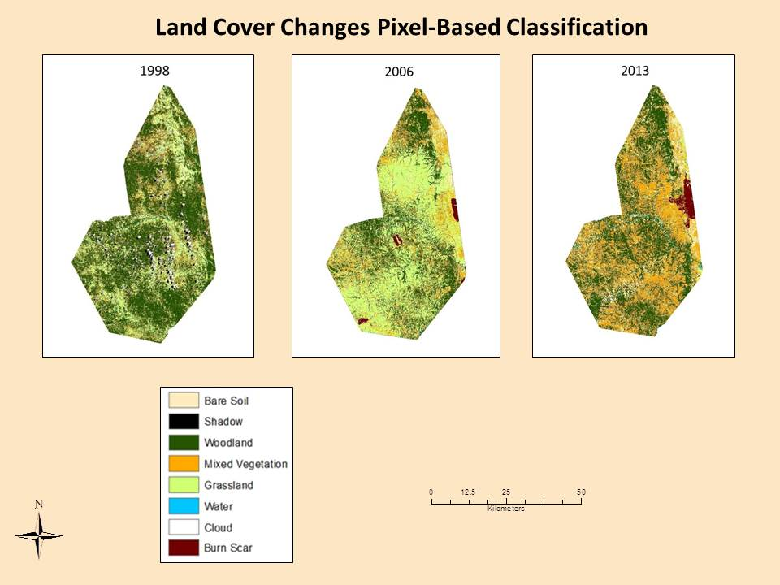

Figure 2. Pixel based classification depicting changes from 1998 to 2013 within study area

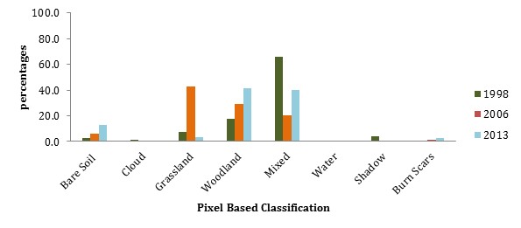

Figure 3. Pixel based classification results showing steady increase in percentage of woodland habitat and wide variation in percent cover of grassland habitat

The object-based classification revealed less variation between the data sets and depicted an overall increase in grassland habitat (Figure 4). Experimentation revealed that when using object based classification for Landsat imagery in specific areas like that of savanna, it is necessary to test band combination, NDVI, and scale parameters to find the desirable results. Resolution quality and object type (e.g., type of features being classified) are also important factors. For instance, in urban environments segmentations of well-defined objects such as highways and large buildings using Landsat can be effective using a scale parameter of 25. Vegetation boundaries with transition zones may require smaller scale parameters.

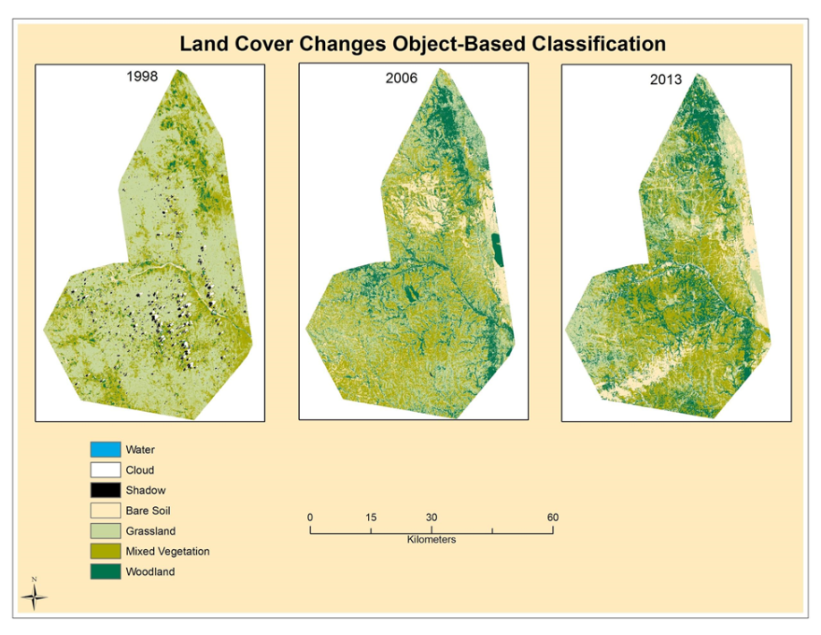

Figure 4. Object based classification maps depicting changes from 1998, 2006 and 2013 within study area. Analysis performed in IDRISI.

# Despite the percentage differences in both pixel and object based classification (Figure 5, results from eCognition, and IDRISI), there was no statistical significance between classes of both methods (pixel based 1998, 2006, 2013, Kruskal-Wallis One Way Analysis of Variance P=0.970; object-based IDRISI, 1998, 2006, 2013, Kruskal-Wallis One Way Analysis of Variance P=0.874; object-based eCognition, 1998, 2006, 2013, Kruskal-Wallis One Way Analysis of Variance P=0.427).

# Although differences can be observed on land cover maps, statistical analysis revealed they are not significant. Mann-Whitney statistic test was conduct to compare the difference between pixel and object-based for each pair of years. The comparative results for 1998 pixel and object based were not significant P = 0.328; for 2006, P=0.515, and 2013 P=0.310, were also not significant. Tests results are included on the appendices.

Figure 5a and b. Object-based classification results showing a slight increase in grassland habitat with woodland habitat and wide variation in percent cover of grassland habitat. a) Analysis performed in eCognition, b) Analysis performed in IDRISI

**Actual characteristics of the vegetation structure in our study area**

Pixel-based classification results were varied for the three image dates. Trends in bare soil and mixed vegetation showed steady increases over the course of the study period (Figure 2). Woodland habitats are likely over classified in 1998 due to poor image quality, which may misrepresent the lack of change from 1998 to 2013. Based on a visual assessment, grassland is likely underestimated in 2013 which may also misrepresent changes over the 16-year study period. It is more likely that grassland has a higher percent cover for 2013.

IDRISI object-based classification results also showed varied results over the three images. Trends in grassland habitat showed a steady increase, with a likely over-classification in 2006. Other land cover classifications tended to be erratic and showed no trend over the 16 year study period.

Although calculated over a smaller subset of the study area, eCognition object-based classification results displayed a consistent response in land cover classification from 1998 to 2013. eCognition showed a small decline in the percent of woodland habitat followed by increases in both grassland and mixed vegetation habitats (Figure 6). This may result from woodland degradation followed by successional recovery in the study area.

# 

Figure 6. eCognition object-based classification results illustrating a decrease in woodland habitat and an increase in grassland and mixed vegetation.

# An independent Student’s t-test was conducted for the three classes of vegetation in 1998 and 2013: woodland, mixed vegetation, and grassland. Given that p=0.235, it was concluded that each of the levels of the independent variable are normally distributed. Assuming the normal distribution for this sample, a t-test was conducted, resulting in no statistic significant difference (t(4) -1.213, p=0.292).

**Suitable location for ungulate animals in our study area**

A GIS model was created using spatial overlay functions combining data layers of vegetation classes, nitrogen and biomass of the study area. Areas of spatially coincident high levels of nitrogen and biomass in open woodlands were deemed the most suitable habitat for ungulate animals. The highest levels of nitrogen and biomass occur on Riparian areas, and combined with the GIS model, the woodland class (results from the object-based classification) had the highest presence of biomass (Figure 7). These results may be useful to KNP managers who need to target management practices to areas of most valuable wildlife habitat.

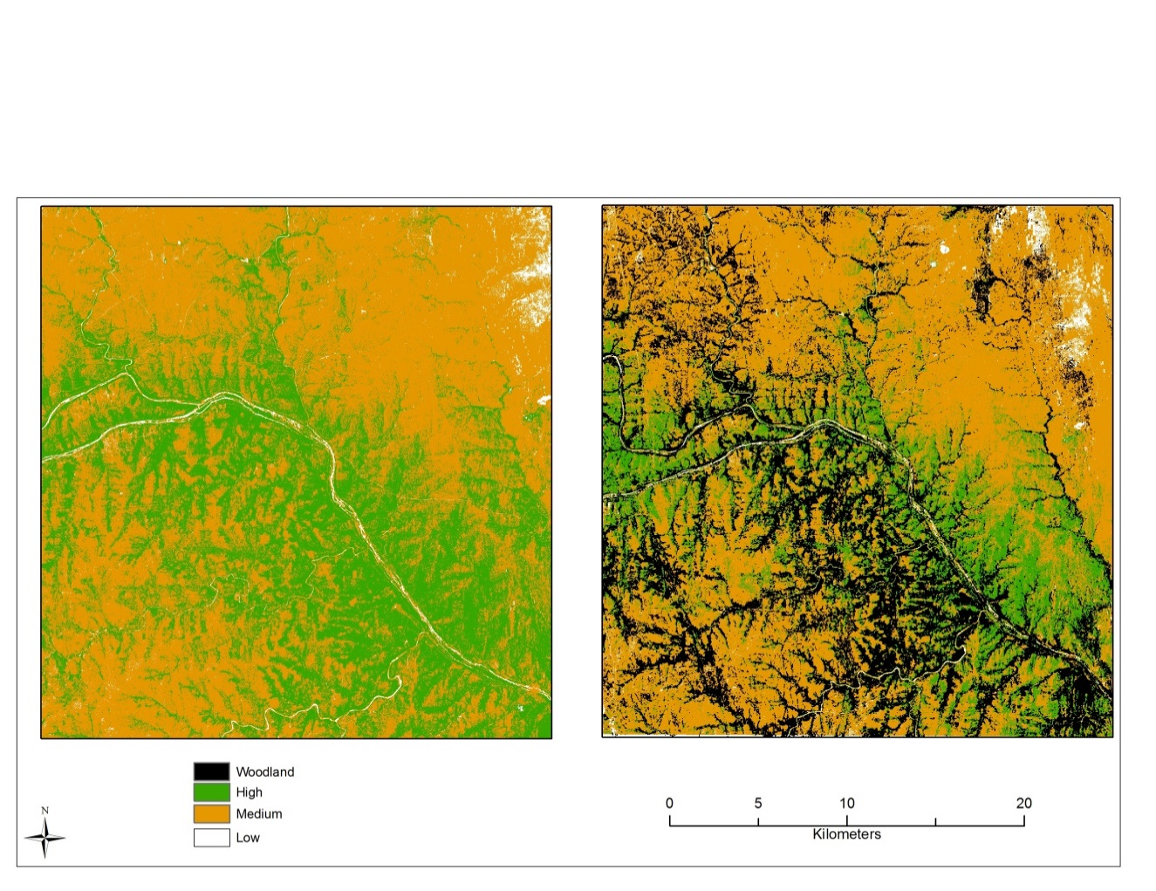

Figure 7. GIS model showing the levels of nitrogen and biomass in the study area, woodland class (Landsat 8, 2013). Analysis performed with ArcGIS 10.1.

# Future quantitative analyses will be performed in order to investigate the correlation between the object-based classification and results of the GIS habitat suitability model.

# V. Conclusions

Results of this study can be used to investigate the potential impacts of the elephants in KNP on vegetation in the study area over the last 16 years. Pixel-based and object-based classification methods were used to produce a time series of land cover from Landsat images. Object-based results demonstrated improved delineation of linear features such as woodlands along rivers.

The classification results showed land cover changes within the study area between 1998 and 2013 were not significantly different, particularly with regard to the changes in vegetation structure. The hypothesis that elephants inhabiting an area of KNP for 16 years would cause significant loss of woodland to grassland was not confirmed. However, while not statistically significant, eCognition results indicated an increase in mixed vegetation and grassland, and a decrease in woodland. An increase in mixed vegetation in 2013 could have been a result of the transitional process of vegetation succession. The woodland class from the Landsat 8 image spatially correlated with the highest levels of nitrogen and biomass, which indicated a suitable habitat for elephants in the area, as well as other animals.

Changes in vegetation structure are occurring in KNP. Yet, whether the elephant population is responsible for the change remains unclear. Ecosystems change naturally over time. However, the fact that KNP administers controlled, intentional fires year around, in addition to being a fenced park, can accelerate the natural process of landscape change. Further analyses considering climate change and models to test the impact of fire and human activities in the area should be conducted to investigate other factors. Without further conclusive studies, it cannot be assumed that African elephants are the main cause of woodland degradation within KNP. Finally, KNP may benefit from a broad-scale quantification of vegetation type changes over time that can inform the decision making processes regarding degradation of woodland habitat.

# VI. Acknowledgments

We would like to thank Abel Ramoelo and Moses Cho from the Council of Scientific and Industrial Research for their collaboration and access to the RapidEye products. Additionally, we thank Kruger National Park for inviting Andrea Presotto for a field visit. We thank Zaneta Kaszta for sharing her knowledge of the study area and organizing the Kruger National Park field work. Finally, we thank the University of Georgia’s Center for Geospatial Research staff including Dr. Thomas Jordan, Dr. Marguerite Madden, Nancy O’Hare, and Caren Remillard.

# VII. References

Blake, S., Douglas-Hamilton, I., Karesh, W.B. 2001. GPS telemetry of forest elephants in Central Africa: results of a preliminary study. *African Journal of Ecology*, 39, 178-186.

Boundja, R.P. and Midgley, J.J. 2009. Patterns of elephant impact on woody plants in the Hluhluwe-Imfolozi Park, Kwazulu-Natal. *African Journal of Ecology*, 48, 206-214.

Buss, I.O. 1961. Some observations on food habitats and behavior of the African elephant. *The Journal of Wildlife Management*, 25, 131-148.

Dennis, N. 2000. Kruger. Cape Town: Struik Publishers.

Douglas-Hamilton, I. 1973. On the ecology and behavior of the Lake Manyara elephants. *African Journal of Ecology*, 11, 401-403.

Douglas-Hamilton, I. 1998. Tracking African elephants with a global positioning system (GPS) radio collar. *Pachyderm*, 25, 81‐92.

Knegt, H.J., van Langevelde, F., Skidmore, A.K., Delsink, A., Slotow, R., Henley, S., Bucini, G., Boer, W.F., Coughenour, M.B., Grant, C.C., Heitkonig, I.M.A., Henley, M., Knox, N.M., Kohi, E.M., Mwakina, E., Page, B.R., Peel, M., Pretorius, Y., van Wieren, S.E., Prins, H.H.T. 2011. The spatial scaling of habitat selection by African elephants. *Journal of Animal Ecology*, 80, 27-281.

Kruger National Park Management Plan. 2008. Available:

http://www.sanparks.org.

Laws, R.M. 1970. Elephants as agents of habitat and landscape change in East Africa. *Oikos*, 21, 1-15.

Linsday, W. F., Croze, H. 2011. The Amboseli Context: Ecology, People, and Genetics. In: Moss, C. J., Lee, P.C. (eds) *The Amboseli Elephants: A Long-Term Perspective on a Long-Lived Mammal.* The University of Chicago Press, Chicago.

Ludwig, F., De Kroon, H., Prins, H.H.T. 2008. Impacts of savanna tree on forage quality for a large African herbivore. *Oecologia*, 155, 487-496.

Owen-Smith, N., Kerley, G.I.H., Page, B., Slotow, R., and van Aarde, R.J. 2006. A scientific perspective on the management of elephants in the Kruger National Park and elsewhere. *South African Journal of Science*, 102, 389-394.

Ramoelo, A., 2012. Savanna Grass *Quality: Remote Sensing Estimation from Local to Regional Scale*, Ph.D. Dissertation, University of Twente ITC.

Rohland, N., Reich, D., Mallick, S., Meyer, M., Green, R.E., Georgiadis, Roca, A.L., and Hofreiter, M. 2010. Genomic DNA sequences from Mastodon and Woolly Mammoth reveal deep speciation of forest and savanna elephants. *PLoS: Biology*, 8, 1-10. doi:10.1371/journal.pbio.1000564

Sukumar, R. 2003. *The Living Elephants: Evolutionary Ecology, Behavior, and Conservation.* New York: Oxford University Press.

Vanak, A.T., Shannon, G., Thaker, M., Page, B., Grant, R., and Slotow, R. 2011. Biocomplexity in large tree mortality: interactions between elephant, fire and landscape in an African savanna. *Ecography*, 35, 315-321.

Wilson, E.O. 2000. *Sociobiology: The New Synthesis*. Cambridge, MA: Belknap Press of Harvard University Press.

Young, K.D., Ferreira, S.M., van Aarde, R.J. 2009. The influence of increasing population size and vegetation productivity on elephant distribution in the Kruger National Park. *Austral Ecology*, 34, 329-342.

# VIII. Appendices

Test results for pixel and object-based of 1998

**Object and pixel based 1998**

t-test Wednesday, April 02, 2014, 4:27:21 PM

Data source: Data 1 in Notebook4

Normality Test (Shapiro-Wilk) Failed (P < 0.050)

Test execution ended by user request, Rank Sum Test begun

Mann-Whitney Rank Sum Test Wednesday, April 02, 2014, 4:27:21 PM

Data source: Data 1 in Notebook4

Group N Missing Median 25% 75%

1998Pixel 8 0 107033.500 20381.250 459036.750

1998Object 8 0 427976.500 67937.000

Mann-Whitney U Statistic= 22.000

T = 58.000 n(small)= 8 n(big)= 8 P(est.)= 0.318 P(exact)= 0.328

The difference in the median values between the two groups is not great enough to exclude the possibility that the difference is due to random sampling variability; there is not a statistically significant difference (P = 0.328)

**Object and pixel based 2006**

t-test Monday, April 07, 2014, 2:28:38 PM

Data source: Data 1 in Notebook6

Normality Test (Shapiro-Wilk) Passed (P = 0.243)

Equal Variance Test: Passed (P = 0.244)

Group Name N Missing Mean Std Dev

2006Pix 6 0 480870.500 493710.906 201556.633

2006Obj 6 0 316244.500 336674.210 137446.671

Difference 164626.000

t = 0.675 with 10 degrees of freedom. (P = 0.515)

95 percent confidence interval for difference of means: -378951.589 to 708203.589

The difference in the mean values of the two groups is not great enough to reject the possibility that the difference is due to random sampling variability. There is not a statistically significant difference between the input groups (P = 0.515).

Power of performed test with alpha = 0.050: 0.050

The power of the performed test (0.050) is below the desired power of 0.800.

Less than desired power indicates you are less likely to detect a difference when one actually exists. Negative results should be interpreted cautiously.

**Object and pixel based 2013**

t-test Monday, April 07, 2014, 2:31:32 PM

Data source: Data 1 in Notebook7

Normality Test (Shapiro-Wilk) Failed (P < 0.050)

Test execution ended by user request, Rank Sum Test begun

Mann-Whitney Rank Sum Test Monday, April 07, 2014, 2:31:32 PM

Data source: Data 1 in Notebook7

Group N Missing Median 25% 75%

2013Px 6 0 228433.000 57855.000 1155686.750

2013Ob 6 0 373891.500 153481.000

Mann-Whitney U Statistic= 11.000

T = 32.000 n(small)= 6 n(big)= 6 P(est.)= 0.298 P(exact)= 0.310

The difference in the median values between the two groups is not great enough to exclude the possibility that the difference is due to random sampling variability; there is not a statistically significant difference (P = 0.310)

**Object based variance IDRISI – comparing classes’ results of 1998, 2006, and 2013**

One Way Analysis of Variance Monday, April 07, 2014, 1:54:43 PM

Data source: Data 1 in Notebook4

Normality Test (Shapiro-Wilk) Failed (P < 0.050)

Test execution ended by user request, ANOVA on Ranks begun

Kruskal-Wallis One Way Analysis of Variance on Ranks Monday, April 07, 2014, 1:54:43 PM

Data source: Data 1 in Notebook4

Group N Missing Median 25% 75%

1998 7 0 77879.000 45970.000 173094.000

2006 7 0 102407.000 0.000 605266.000

2013 7 0 480902.000 0.000 727132.000

H = 0.269 with 2 degrees of freedom. (P = 0.874)

The differences in the median values among the treatment groups are not great enough to exclude the possibility that the difference is due to random sampling variability; there is not a statistically significant difference (P = 0.874)

**Object based variance eCognition – comparing classes’ results of 1998, 2006, and 2013**

One Way Analysis of Variance Monday, April 07, 2014, 2:04:18 PM

Data source: Data 1 in Notebook5

Normality Test (Shapiro-Wilk) Failed (P < 0.050)

Test execution ended by user request, ANOVA on Ranks begun

Kruskal-Wallis One Way Analysis of Variance on Ranks Monday, April 07, 2014, 2:04:18 PM

Data source: Data 1 in Notebook5

Group N Missing Median 25% 75%

1998 7 0 687424.000 45704.000 1825444.000

2006 7 0 83375.000 0.000 439036.000

2013 7 0 240537.000 0.000 2223191.000

H = 1.703 with 2 degrees of freedom. (P = 0.427)

The differences in the median values among the treatment groups are not great enough to exclude the possibility that the difference is due to random sampling variability; there is not a statistically significant difference (P = 0.427)