**NASA DEVELOP National Program**



NASA Goddard Space Flight Center/NASA Marshall Space Flight Center/Wise County

*Summer 2015*

Alto Orinoco Health and Air Quality

Utilizing NASA Earth Observations to Locate Remote Yanomami Villages in the Alto Orinoco Municipality for Targeted Eradication of River Blindness Disease

**Technical Report** 

Final Draft – August 6, 2015

Goddard Space Flight Center

Amanda Rumsey (Project Lead)

Timothy Larson

Kyle Sowder

Marshall Space Flight Center

Sara Amirazodi (Project Lead)

Wise County and City of Norton Clerk of Court's Office

Rajkishan Rajappan (Project Lead)

Annabel White

Zachary Tate

Dr. Kenton Ross, NASA DEVELOP (Science Advisor)

Dr. John D. Bolten, NASA Goddard Space Flight Center (Science Advisor)

Dr. Jeff Luvall, NASA at National Space Science and Technology Center (Science Advisor)

Dr. Robert Griffin, University of Alabama in Huntsville (Science Advisor)

Dr. Jim Tucker, NASA Goddard Space Flight Center (Science Advisor)

Dr. Tom Sever, University of Alabama in Huntsville (Science Advisor)

Dan Irwin, SERVIR (Science Advisor)

# I. Abstract

Onchocerciasis, or River Blindness, is a treatable disease caused by the vector-borne parasite, *Onchocerca volvulus.* The parasite is transmitted through bites of infected black flies from the genus *Simulium*. Once inside the human host, *O. volvulus* migrates to the skin, various organs, and eyes, causing debilitating itching and rashes, disfigurement, visual impairment, and complete blindness. The Alto Orinoco Municipality of Venezuela is the last remaining area for active transmission of onchocerciasis in the Americas. Yanomami tribes occupy the Alto Orinoco Municipality in secluded rainforest villages and migrate frequently due to shifting cultivation, flooding, and food shortages. The remote locations of the Yanomami villages present a unique set of challenges to health workers when distributing regular treatments, collecting data, and locating groups of nomadic people whose survival depends on relocating regularly and living in isolation. The NASA DEVELOP team analyzed data from NASA’s Landsat 8 Operational Land Imager (OLI) and Thermal Infrared Sensor (TIRS) and Terra Advanced Spaceborne Thermal Emission and Reflection Radiometer (ASTER) to map suspected locations of the Yanomami villages from 2005 to 2015. Spectral analysis, cloud masking, and classification techniques along with DigitalGlobe high-resolution data were utilized to locate villages. A suitability model was also created using Landsat 8 OLI/TIRS and Shuttle Radar Topography Mission (SRTM) data. Ultimately, this project assisted The Carter Center River Blindness Elimination Program in targeting its efforts to eliminate onchocerciasis in the Americas by the end of 2015.

**Keywords**

# Disease Eradication, The Carter Center, Onchocerciasis, River Blindness Disease, Brazil, Venezuela, Yanomami, Alto Orinoco

# II. Introduction

The Carter Center is a world leader in charitable organizations that strives to combat and eliminate the world’s preventable diseases by providing health education and low cost methods of treatment. The work performed by The Carter Center emphasizes “building partnerships for change among international agencies, governments, nongovernmental organizations, corporations, national ministries of health, and most of all, with people at the grassroots” (The Carter Center, 2015). Currently, the focus is battling six main preventable diseases: guinea worm, onchocerciasis, trachoma, schistosomiasis, lymphatic filariasis, and malaria. The Carter Center is working with the Ministries of Health in Latin America and Africa to eliminate one of the leading causes of blindness due to the infection, onchocerciasis (The Carter Center, 2015).

Onchocerciasis, commonly known as river blindness, is a treatable disease caused by the vector-borne parasite *Onchocerca volvulus.* The parasite is transmitted through bites of infected blackflies from the genus *Simulium* (Pan American Health Organization, 2014). Once inside the human host, *O. volvulus* migrates to the skin, various organs, and eyes. As the larvae migrate to the skin and die, they cause debilitating itching, rashes, and skin discoloration (World Health Organization [WHO], 2015). This intense itching has been known to drive people to injure themselves to obtain relief and in some cases even commit suicide (Landau, 2013). Onchocerciasis also has other ill effects, such as elephantiasis-type disfigurement, glandular inflammation, “hanging groin”, visual impairment, and eventually leads to complete blindness (Centers for Disease Control and Prevention, 2013). The majority of these symptoms diminishes a person’s quality of life and reinforces the cycle of poverty in already poverty stricken communities.

Today, The Carter Center identifies 36 countries in Africa and Latin America where onchocerciasis is endemic (The Carter Center, 2015). Worldwide, there are an estimated 17.7 million people infected with onchocerciasis (WHO, 2015) and 120 million people “at risk” of infection (WHO, 2013). Of those populations affected by onchocerciasis, only 1% occurs in the Americas. This has ignited a great effort by The Carter Center’s Onchocerciasis Elimination Program for the Americas (OEPA), in coordination with the Ministries of Health in Latin America and the 2013 WHO mandate ‘CD52/INF4 Towards the Elimination of Onchocerciasis (River Blindness) in the Americas’, to eliminate the disease by the end of 2015. Previous efforts in Colombia, Ecuador, Mexico and Guatemala have achieved complete elimination of the disease or have halted transmission rates while evaluation of complete eradication is pending.

The border along Brazil and Venezuela, recognized by both Brazilian and Venezuelan Governments as the Yanomami Territory (Figure 1), is the last remaining area for active transmission of onchocerciasis in the Americas and is inhabited by the indigenous Yanomami Indian tribe.

In this territory, there is active transmission of the disease with an approximated 20,500 people currently in need of treatment for onchocerciasis (Pan American Health Organization, 2014). The Carter Center has been working diligently to reach the Yanomami people, but the area is situated in the dense jungle of the Amazon. This location presents several obstacles in accessing the area for the effective distribution of treatment: remote physical locations of Yanomami villages, entry into the Amazon hindered by political boundaries and policies, and limited research data available on Yanomami migration patterns. The Yanomami are a nomadic tribe and migrate frequently. They create a new housing structure, called a “*yano*” or “*shabono*”, every two to three years due to shifting cultivation, flooding, intertribal warfare (2015 Encyclopedia Britannica, Inc.), modern operations encroachment, and food shortages (Salgado, 2014). These hindrances make it difficult for The Carter Center to appropriately identify active villages and predict migrations using their current methods of helicopter field surveys.

*Figure 1: The study area was the Alto Orinoco region in the Venezuela side of the Brazil-Venezuela border*

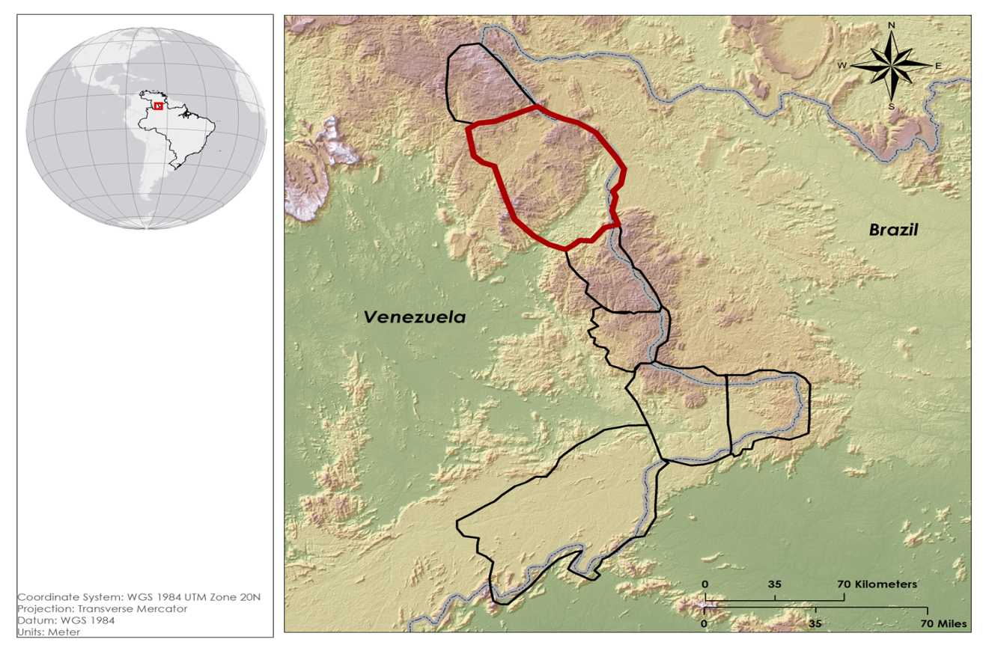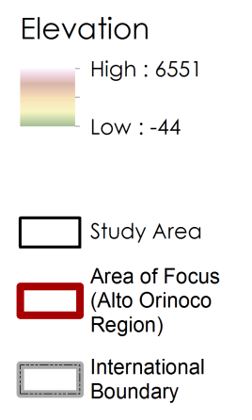

Previously, The Carter Center partnered with the University of South Florida (USF) in an attempt to use remote sensing methods for village identification. While successful in identifying villages, methods developed by USF created an opportunity to further develop a methodology that could help The Carter Center predict village relocation patterns and adapt treatment distribution as necessary.

The multi-node NASA DEVELOP Alto Orinoco Health and Air Quality Team partnered with The Carter Center in its mission to eliminate onchocerciasis from the Americas by utilizing NASA’s Earth observations’ remote sensing data. This project was concentrated in the NASA national application areas of Health and Air Quality and Ecological Forecasting. It helped address those issues by providing assistance in identifying remote, nomadic villages to expand treatment disbursement and creating a suitability model to aid in future migratory predictions. The study period spanned the months of November to February from 2011 to 2014 and the months May to August for the years 2012 to 2015. These study periods were chosen for their distinct weather patterns. November to February, the rainy season, showed a more intense visual distinction in greenness of the Amazon canopy. May to August, the dry season, typically had less cloud cover (New World Encyclopedia, 2013). The remote sensing data gathered and use of image processing tools assisted The Carter Center identifying villages in remote locations in the Yanomami territory.

# III. Methodology

**Data Acquisition:**

In order to create a cloud-free composite image of the Alto Orinoco region, Landsat 8 OLI and TIRS imagery covering Paths 1 and 2 and Rows 57 and 58 were downloaded from USGS EarthExplorer. Landsat 8 surface reflectance products that had acquisition dates ranging from late 2013 to early 2015, and had less than 50% cloud cover were selected for processing. 15 to 20 surface reflectance scenes were acquired for each path row combination. Each Landsat surface reflectance scene included bands 1 to 7, a cloud mask, a cloud confidence mask, and a quality assessment band.

**Data Processing:**

The 15 to 20 Landsat images that were downloaded for each path row combination were then sorted in order from the lowest amount of cloud cover to the highest amount of cloud cover. A five step classification process used the cloud mask, the confidence mask, the quality assessment band, and various band 1, band 2, and band 7 thresholds to create a cloud-free Landsat composite for each path row combination. The five step classification system shown in Table 1 consists of five classification categories including “Highly Conservative Band 1”, “Highly Conservative Band 2”, “Moderately Conservative Band 1”, “Moderately Conservative Band 2”, and “Final Mask”.

|  |  |
| --- | --- |
| Classification Categories | Pixel Classified as Cloud if Following Conditions are True |
| Highly Conservative Band 1 | * Cmask = 2|3|4 * Cmask Confidence = 2|3 * QA Band Confidence = Medium | High * Band 1 < -30 | Band 1 > 60 * Band 7 < 300 |
| Highly Conservative Band 2 | * Cmask = 2|3|4 * Cmask confidence = 2|3 * QA Band Confidence = Medium | High * Band 2 < -30 | Band 2 > 100 * Band 7 < 300 |
| Moderately Conservative Band 1 | * Cmask = 2|3|4 * Cmask confidence = 2|3 * QA Band Confidence = Medium | High * Band 1 < -30 | Band 1 > 120 * Band 7 < 300 |
| Moderately Conservative Band 2 | * Cmask = 2|3|4 * Cmask confidence = 2|3 * QA Band Confidence = Medium | High * Band 2 < -30 | Band 2 > 150 * Band 7 < 300 |
| Final Mask | * Cmask = 2|3|4 * Cmask confidence = 2|3 * QA Band Confidence = Medium | High * Band 7 < 300 |

*Table 1: Classification Categories and Threshold Values*

The classification process began by assessing the image with the lowest amount of cloud cover on a pixel-by-pixel basis. Pixels that were classified as clear according to the “Highly Conservative Band 1” classification became part of the final “Highly Conservative Band 1” composite image. Pixels that were classified as cloud according to the “Highly Conservative Band 1” classification were assigned NoData values. Once all of the pixels were analyzed in the first image, the pixels in the second clearest image that correspond with NoData pixels in the first image were assessed on a pixel-by-pixel basis. Pixels in the second image that were classified as clear in the “Highly Conservative Band 1” classification became part of the final “Highly Conservative Band 1” composite image. Pixels in the second image that were categorized as cloud in the “High Conservative Band 1” classification were assigned NoData values. Once all pixels were analyzed in the second clearest image, the pixels in the third clearest image that corresponded with no data pixels in the first and second images were examined (Figure 3).The consecutive image compositing technique continued until the 15-20 images were evaluated and categorized. The resultant “Highly Conservative Band 1” composite image included a combination of clear pixel values derived from the 15-20 images, and contained pixels with NoData values that represent permanent cloud cover. This compositing technique was applied four more times to create the “Highly Conservative Band 2”, “Moderately Conservative Band 1”, “Moderately Conservative Band 2”, and “Final Mask” composite images.

The five composited images were then combined using pixel-by-pixel analysis technique. Pixels in the “Highly Conservative Band 1” composite image that were classified as permanent cloud and represented by NoData values were replaced with clear pixel values from the “Highly Conservative Band 2” composite image. This technique continued in replacing permanent cloud areas with pixels from the “Moderately Conservative Band 1”, “Moderately Conservative Band 2”, and “Final Mask” composite image. This compositing technique resulted in a final cloud-free composite. The same process was carried out for each of the path row combinations that make up the study area, and the resultant images were mosaicked to a single image (Figure 4).

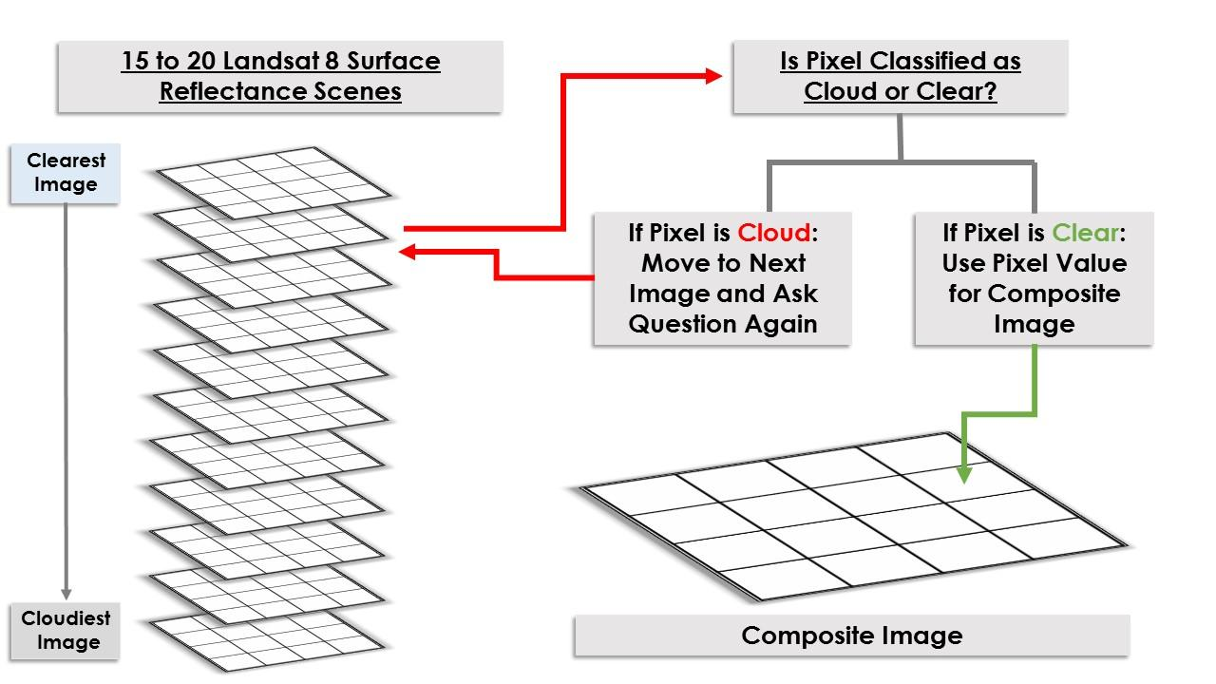

*Figure 3: Pixel-by-Pixel Compositing Technique Flow Chart*

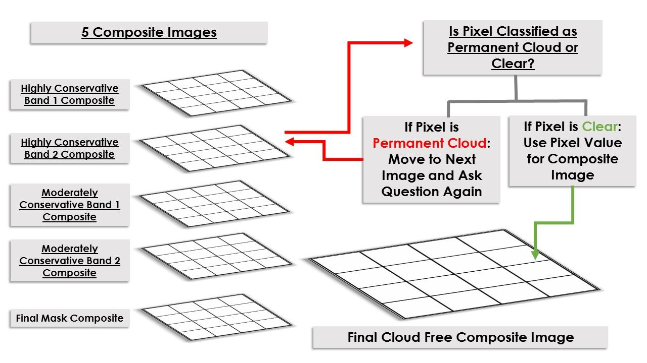

*Figure 4: Pixel-by-Pixel Compositing Technique for Final Cloud Free Composite Image*

**Data Analysis:**

To identify the Yanomami villages, the study area was dissected into 46 sub regions and each team member was assigned 7 to 8 sub regions to visually inspect. Each person visually inspected their assigned sub-regions on a pixel-by-pixel basis using high-resolution Digital Globe cloud-free mosaics. The Fishnet tool in ArcMap was used to make sure that none of the areas were left uninspected. Because the Alto Orinoco region is an extremely cloudy subtropical region, not all clouds were eliminated during the mosaicking process. If a cloud was present in the mosaic, raw DigitalGlobe data from another sensor was substituted in its place.

The cloud-free Landsat 8 surface reflectance products, obtained as a result of the process at Figure 4, were then used as a cross-checking tool. An unsupervised k-means classification was then performed on the cloud-free composite to produce a binary “Forest/Non-forest” layer. The “Forest/Non-forest” layer was overlaid onto the high resolution imagery, and areas that were classified as “Non-forest” were manually double checked for villages.

After completing the initial inspections for our assigned grids, the raw high-resolution panchromatic and RGB DigitalGlobe imagery were used to cross-check each other’s work. Everyone was assigned a new set of sub grids and then used a panchromatic and RGB yearly mosaics to search for villages. When a village was identified, the village was marked with a point vector. Village ID, village diameter, number of huts, temporal history, sensor history, and current population estimates were then recorded in the attribute table. The estimates of population size were computed as a function of their dwelling size (Walker, 2014).

Once villages had been located, suitable habitat variables were created using SRTM data from 2012 to present in ArcMap to develop the suitability model. Variables included elevation, slope, distance to stream, height above nearest drainage, normalized difference vegetation index (NDVI), temperature, and precipitation. Village location coordinates were used as presence samples to create variables for presence vs. absence. Then a logistic regression technique was performed with Python using the variables to predict presence and absence. This output the probability of a village occurring at a particular location, and results were scaled to values of zero to one as a relative probability. Then a threshold was identified to create a binary presence or absence. Predictions were extracted and compared to absence and presence. Statistics were also run on samples to check for accuracy.



# IV. Results & Discussion

The compositing technique from Figure 4 was really helpful in removing clouds in the study area, since that would have been a hindrance to the project (Figure 5).

*Figure 5: The pixel-by-pixel composting technique resulted in cloud-free Landsat images*

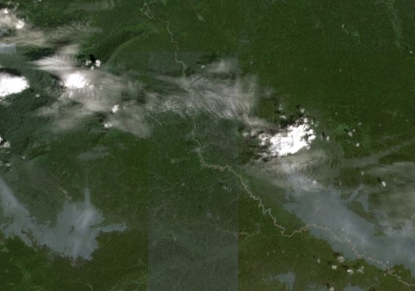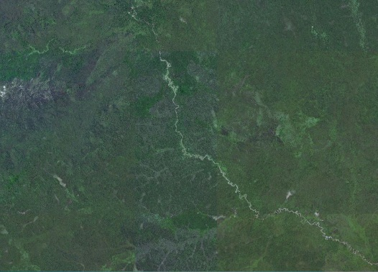

# In many locations, more than one high-resolution dataset was available (Figure 6), spanning a time range as far back as 2007. This helped in building temporal attributes for villages going as far back as could be confirmed with the available data. The data was not uniform in its spatial extent or temporal extent, so in some cases the most recent imagery available was from 2008, while in others, up to 2015. In a few cases, villages were found that appeared in prior imagery but were abandoned in the most recent data; so that information was added to the database to provide to the end user. Other attributes were measured, such as the roof area, which allowed implementing a crude population estimation method that assigns an average amount of living space per person at 17.4 m2, based on another study conducted in another region of the Amazon (Walker, 2014).

*Figure 6: Villages were cross-checked using high-resolution imagery from different years*

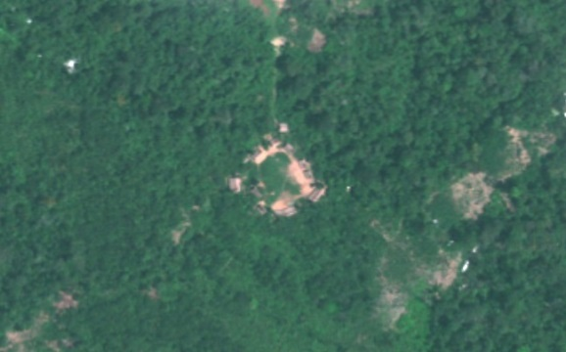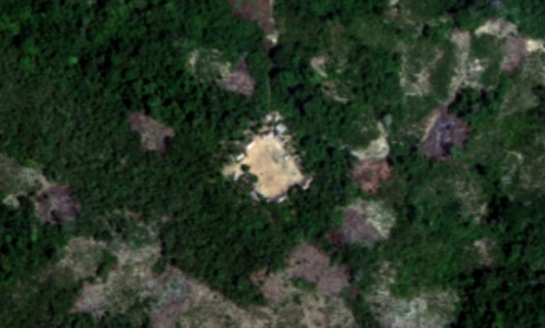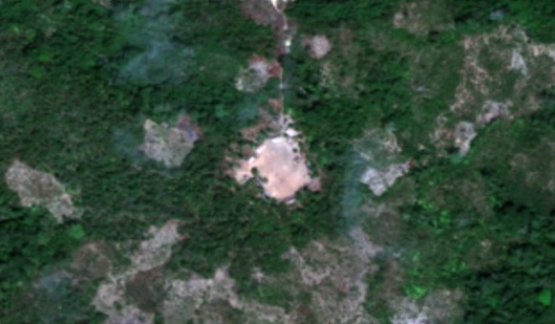

2010

2015

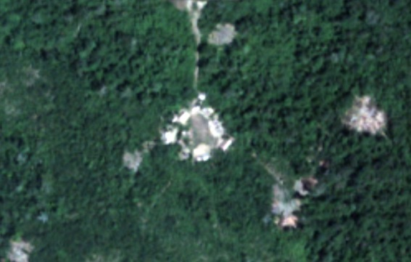

2009

2014

Data will be provided to the end user in shapefile, KML, and spreadsheet formats; the KML was chosen in order to provide a useful format that can be utilized by less-experienced GIS users through Google Earth. This way the end user can easily access the information for each of the villages without needing complicated spatial analysis software such as ArcGIS. Each village placemark contains a thumbnail image, dates and sensor where the village was visible, the date when the village appeared abandoned (if applicable), roof area, population estimate, and coordinates.

A total of 137 active villages and 26 abandoned villages were found as a result of this project. There are an estimated 3125 people living in those active villages.

These coordinates of village locations, as well as other environmental parameters, were used in a Suitability Model to estimate the probability of a village being located there (Figure 7). This process yielded results with a cross-validation accuracy of 76%, a cross-validation correlation of 0.6, and a significance of less than 0.01.

**

*Figure 7: Probable village locations estimated based on the environmental factors corresponding to the villages*

# V. Conclusions

Currently, the main hindrance to Carter Center’s mission of eradicating onchocerciasis from the Americas by the end of 2015 is locating remote Yanomami villages. The results from this project will help them find those locations. In the next 2-4 months, the Carter Center will work with the Venezuelan government and send public health workers to the region to deliver medicines. The suitability model will help them in identifying not only villages for initial treatment, but also to find the villages for follow-up treatment once they’ve migrated to new locations.

# VI. Acknowledgments

* Dr. Jim Tucker (NASA Goddard Space Flight Center)
* Kel Markert (Mentor & Science Advisor)
* Dan Irwin (SERVIR Collaborator)
* Leigh Sinclair (Center Lead, Marshall Space Flight Center)
* Amberle Keith (Assistant Center Lead, Marshall Space Flight Center)
* Dr. Kenton Ross (NASA DEVELOP)
* Dr. John D. Bolten (NASA Goddard Space Flight Center)
* Dr. Jeff Luvall (NASA at National Space Science and Technology Center)
* Dr. Robert Griffin (University of Alabama in Huntsville)
* Katie Melocik (NASA Goddard Space Flight Center)
* Dr. Thomas Unnasch (University of South Florida)
* Melanie Salyer (Mentor, Wise County)
* Jordan Bates (Center Lead, Wise County)
* Kiersten Newtoff (Center Lead, NASA Goddard Space Flight Center)

This material is based upon work supported by NASA through contract NNL11AA00B and cooperative agreement NNX14AB60A.

# VII. References

Callahan, M. (2014, May 24). *US man finds lost mother in Amazon tribe*. Retrieved June 22, 2015, from <http://nypost.com/2014/05/24/son-finds-his-lost-mother-in-a-stone-age-tribe/>

Centers for Disease Control and Prevention. (2013, May). *Parasites - Onchocerciasis (also known as River Blindness).* Retrieved June 22, 2015, from <http://www.cdc.gov/parasites/onchocerciasis/disease.html>

Encyclopædia Britannica, Inc. (2015). Yanomami. Retrieved June 22, 2015, from <http://www.britannica.com/topic/Yanomami>

Landau, E. (2013, February 2). With river blindness, 'you never sleep' - CNN.com. Retrieved June 22, 2015, from <http://www.cnn.com/2013/02/02/health/river-blindness/index.html>

New World Encyclopedia. (2013). *Amazon River*. Retrieved 22 June 2015.

<http://www.newworldencyclopedia.org/entry/Amazon_River>

Pan American Health Organization. (2014). *Onchocerciasis - River Blindness*. Retrieved June 22, 2015, from <http://www.paho.org/hq/index.php?option=com_topics&view=article&id=39&Itemid=40762>

Salgado, S. (2014, July 25). *Life among the Yanomami: An isolated yet imperiled Amazon tribe*. (B. Gross & S. Tan, Eds.). Retrieved June 22, 2015, from <http://www.washingtonpost.com/wp-srv/special/world/yanomami/>

The Carter Center. (2015). Onchocerciasis Transmission in the Americas 2014. Retrieved June 22, 2015 from <http://www.cartercenter.org/resources/pdfs/health/river_blindness/OEPA-foci.pdf>

The Carter Center. (2015). *River Blindness Elimination Program*. Retrieved June 22, 2015, from <http://www.cartercenter.org/health/river_blindness/index.html>

Walker, R., Hamilton, M. (2014) Amazon Societies on the Brink of Extinction. American Journal of Human Biology 26:570-572.

World Health Organization. (2013). *Onchocerciasis – or 'river blindness' – is a parasitic disease*. Retrieved June 22, 2015, from <http://www.who.int/onchocerciasis/en/>

World Health Organization. (2015). *Onchocerciasis - river blindness.* Retrieved June 22, 2015, from<http://www.who.int/mediacentre/factsheets/fs095/en/>