Keweenaw Bay Water Resources
Turbidity Data Decision Support for Shoreline Assessment and Management in Lake Superior’s Keweenaw Bay


Technical Report
Final – November 18th, 2022

Khaim Syed-Raza (Project Lead)
Lisa Siewert
Nora Whitelaw-McDonald
Sofia Vakhutinsky

Advisors:
Dr. Kenton Ross, NASA Langley Research Center (Science Advisor)
Lauren Childs-Gleason, NASA Langley Research Center (Science Advisor)

Fellow:
Olivia Landry (Virginia – Langley)

1. Abstract
The Keweenaw Bay Indian Community (KBIC) has shoreline along the south of Lake Superior that is contaminated with copper stamp sands from legacy mining. The stamp sands have been capped with sandy-loam soils and restored native species, but erosion and flooding threaten to re-deposit these stamp sands onto wetlands and into the bay. Erosion and flooding also threaten loss of beaches and shoreline, infrastructure, wetland restoration projects, and coastal highways, which has driven shoreline armoring. However, while shoreline armoring can be effective in protecting the intended areas, it can also exacerbate erosion in nearby unarmored areas, so its net impact on the shoreline is yet to be quantified. The DEVELOP team partnered with KBIC and the Environmental Protection Agency (EPA) to utilize imagery from Landsat 8 Operational Land Imager (OLI) and Sentinel-2 Multispectral Instrument (MSI) in order to analyze turbidity proxies. The results from these analyses showed that seasonal variation in study area was greatest during the season dominated by rain, but spatial variability across our study period did not show a clear trend. These results will be used to better inform future shoreline management efforts and support resilience in the face of more coastal erosion.

Key Terms
remote sensing, Landsat 8-OLI, Sentinel-2, coastal erosion, turbidity, stamp sands, GEE, NDTI

2. Introduction
2.1 Background Information
Keweenaw Bay is situated in the western Upper Peninsula of Michigan, on Lake Superior (Figure 1). Between 1850 and 1929, the Keweenaw Peninsula was the second largest producer of copper in the world (Kerfoot, 2012). Copper-rich rocks extracted from the mines were transported to stamp mills located near large water bodies, where the ore was crushed and sifted to extract metallic copper (Figure 2). The tailings from the stamp mills, fine gravels laden with lead and residual copper called “stamp sands,” (Figure 3) now occur in shifting shoreline deposits that leach heavy metals into the bay.
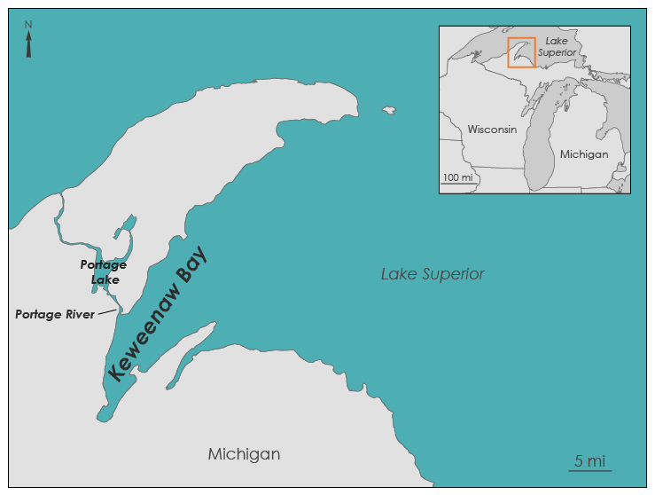
Figure 1: Study area map of Keweenaw Bay, Michigan.

The Michigan and Mass Mills were located in and north of the L’Anse Reservation, home of the Keweenaw Bay band of Chippewa (Figure 2). The two mills discarded a combined six billion pounds of stamp sands, which continue to be transported south by the Keweenaw Current (Nankervis, 2013). The shoreline is especially vulnerable to flooding and erosion, and these stamp sands are among the sediments and soil washed into the bay and lofted in the water column, creating turbid water (Kerfoot, 2020). Such sediments threaten wetland restoration projects and critical habitats for the fish and flora that serve as traditional food sources for the community.

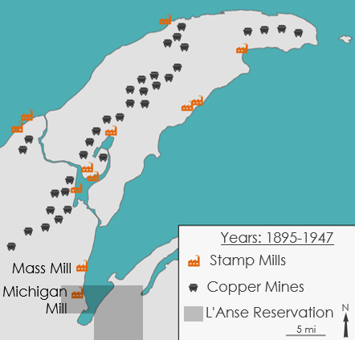 | 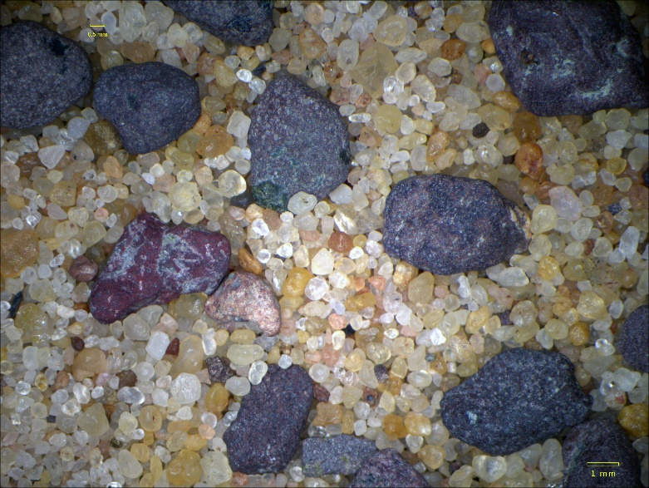
Figure 2: Map showing the location of copper mines and stamp mills in operation between 1895 and 1947, with the Mass and Michigan Mills highlighted near the L’Anse Reservation. | Figure 3: Sample of mixed sediment shown under a microscope at 7.5x magnification. Dark-colored, coarse-grained stamp sands are readily distinguishable from light-colored, finer-grained native sand. Scale bar at bottom right for reference. Image credit: Jason Chaytor, USGS
Studying the turbidity of Keweenaw Bay over time is one way to observe how and when nearshore and coastal sediments, including the stamp sands, are redistributed (Mi, 2020; Mentaschi, 2018). Prior to this project, the turbidity trends of Keweenaw Bay were largely unknown as a result of limited in situ turbidity data collection. In situ measurements are a common methodology in understanding sediment dynamics, but remote sensing estimations have also proven useful in situations where obtaining timely samples is not possible due to geographic or economic constraints (Bid, 2019). To address this data gap within Keweenaw Bay, the NASA DEVELOP Langley team studied sediment patterns using NASA satellite data and a remote sensing algorithm designed to measure turbidity and sediment suspension (Dogliotti, 2015). Previous research indicated that lakewater turbidity varies seasonally (Bid, 2019). So, the team analyzed changes in turbidity in Keweenaw Bay from 2013–2022 during three distinct periods of time (Tables 1 and 2), the snowmelt season, the season marked by intermittent high precipitation events, and a ‘drier’ period with less precipitation to determine if snowmelt, high-precipitation events, and drier conditions had a greater influence on coastal turbidity and thus the redistribution of stamp sands.

The shoreline of Lake Superior is a dynamic and quickly changing environment. Turbidity mapping along the bay provides visual record of coastal erosion and sediment redistribution patterns during the study period. The team used advanced remote sensing techniques to detect sediment distribution and spatial patterns (Ghorai, 2020). Understanding the dynamics of stamp sand redistribution and coastal changes with turbidity mapping adds to an ongoing analysis of coastal dynamics within Keweenaw Bay.

2.2 Project Partners & Objectives
The Keweenaw Bay Indian Community (KBIC) is the governing body of the combined Chippewa Indian bands living within the L’Anse Reservation. The Lake Superior region, in which KBIC resides, is home to an interconnected network of rivers, streams, lakes, and wetlands, most of which eventually flow into the Great Lake. Water plays an integral role in the lives of the community. The people of KBIC have a long and deep place-based cultural connection with the water and wetlands as they own and maintain 19 miles of Lake Superior shoreline and 3,000 acres of wetlands. KBIC’s Natural Resources Department partnered with the NASA DEVELOP Langley team to gain insight into the mobilization of coastal sediments as they transition between phases I and II of their Environmental Protection Agency (EPA)-funded Long-Term Coastal Dynamics Collaborative for Tribal Resiliency. The EPA Office of Community Revitalization served as a collaborator on this project and partnered with KBIC to measure the western Keweenaw Bay coastal erosion and sediment dynamics (phase 1) and plan to continue the Coastal Dynamics Collaborative project after additional funding is secured to map the southern and eastern shoreline (phase 2). The team created a seasonal turbidity analysis to understand the sediment redistribution patterns and provided insight to KBIC and the EPA on coastal sediment dynamics. The team provided their partners with images of median and maximum seasonal turbidity, which will be used in applications for phase 2 funding, aid in informed decision-making of shoreline management, and also support insights into the most effective erosion mitigation methods.

3. Methodology
3.1 Data Acquisition
The team determined beginning and end dates for the snowmelt season using three methods. First, they visually examined NASA Aqua and Terra Moderate Resolution Imaging Spectroradiometer (MODIS) scenes from 2013–2022 in NASA Worldview. The team recorded when discrete snow-free areas became visible and ice began breaking in the bay (indicating the beginning of snowmelt) and when the land was completely snow-free (indicating the end of snowmelt). Second, they used snowmelt window dates provided by KBIC (Table 1). Third, they analyzed snow depth data derived from the National Weather Service (NWS) weather station in Baraga, a community in the southwest corner of Keweenaw Bay (Figure 4). The team then used the NWS Baraga station data exclusively to constrain the rain dominated and drier seasons (Table 2), defining the rainy season by a period in which no more than three days passed without precipitation, and the drier season by a period in which no rain event greater than 0.1 inch/day occurred. Using the derived 2013–2022 date ranges for each of the seasons, the team acquired Landsat 8-OLI and Sentinel-2 MSI for analysis in Google Earth Engine (GEE). Landsat 8-OLI images spanned from January 2013 to October 2022 at a 30m spatial resolution, while Sentinel-2 images spanned from July 2015 to October 2022 at a 10m spatial resolution.

Table 1. KBIC-provided Spring snowmelt window dates |  |  |  | Table 2. NWS Baraga-7 station derived rain-dominated and drier season window dates
 |  |  |  |  | Rain-Dominated |  | Drier
Year | Start | End |  | Year | Start | End | Start | End
2013 | Apr 28 | May 7 |  | 2013 | July 7 | Aug 13 | Sept 5 | Oct 3
2014 | Apr 21 | May 10 |  | 2014 | July 7 | Aug 3 | Sept 19 | Oct 13
2015 | Mar 31 | Apr 18 |  | 2015 | June 7 | July 20 | Sept 21 | Oct 7
2016 | Mar 28 | Apr 20 |  | 2016 | June 4 | July 28 | Oct 27 | Nov 20
2017 | Mar 21 | Apr 14 |  | 2017 | June 11 | Aug 17 | Sept 11 | Oct 16
2018 | Apr 24 | May 3 |  | 2018 | June 13 | July 17 | Sept 9 | Nov 5
2019 | Apr 15 | Apr 28 |  | 2019 | July 8 | Sept 5 | Oct 3 | Nov 3
2020 | Mar 31 | May 2 |  | 2020 | July 2 | Sept 10 | Oct 25 | Nov 15
2021 | Mar 18 | Apr 3 |  | 2021 | June 11 | July 11 | Sept 29 | Oct 21
2022 | Apr 18 | May 4 |  | 2022 | June 12 | July 16 | N/A | N/A

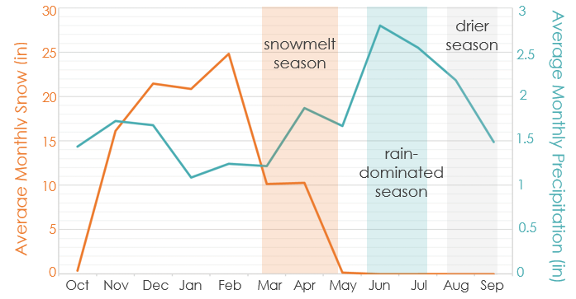
Figure 4: Average monthly snow and non-snow precipitation from the NWS Baraga-7 station. Data collected daily from January 2013 – October 2022.

3.2 Data Processing
After acquiring the raw data, the team selected the least cloudy images available for the given dates, ranging from 5% to 30% cloud cover (Table 3). A higher cloud cover was used if the majority of the clouds were over land rather than over water. The Normalized Difference Water Index, or NDWI, was then used to mask out the land, so that turbidity could be calculated using the water pixel values. NDWI takes the normalized difference of the green and the near-infrared (NIR) bands to identify water (Equation 1).

$NDWI = \frac{\left(GREEN - NIR\right)}{\left(GREEN + NIR\right)}$ (1)

Table 3: Number of images collected for each season
Landsat 8-OLI Tier 1 Collection | Snowmelt Season | 2 Images
 | Rain-dominated Season | 8 Images
 | Drier Season | 3 Images
Sentinel-2 MSI Collection | Snowmelt Season | 10 Images
 | Rain-Dominated Season | 193 Images
 | Drier Season | 14 Images

3.3 Data Analysis
The team mapped turbidity using the Normalized Difference Turbidity Index (NDTI). NDTI is calculated by comparing the values of the red and green wavelength bands for each pixel. In clear water, the low reflectance in the green band exceeds the far lower reflectance in the red and near-infrared bands, yielding a negative NDTI. As the concentration of suspended sediment, organic matter, and other solids increases, the red reflectance rises faster than the green reflectance and the sign of the NDTI flips (Bid, 2019). To ensure consistency of the metric across different light conditions, the turbidity index takes the normalized difference of the red and green band reflectance (Equation 2).

$NDTI = \frac{\left(RED-GREEN\right)}{\left(RED+GREEN\right)}$ (2)

The team analyzed the NDTI changes using GEE, then compared the snowmelt season to the rain-dominated season, as well as the drier season, to determine which season had a greater impact on NDTI, a proxy for turbidity, in the bay. Due to limited data availability, the team did not perform a time series analysis as originally planned. Instead, after the NDTI layer was calculated for every image in a season, the images were reduced to one composite image by calculating the median pixel values. This process was also repeated by reducing the images by the maximum pixel value to get maximum turbidity for the snowmelt and dry seasons. The team reduced the composites of the rain-dominated season by calculating 10th percentile and 90th percentile pixel values because there were more usable images during the rain-dominated season. This process was conducted on Landsat 8 OLI and Sentinel-2 MSI data, resulting in fourteen composite images total that could be used for analysis.

4. Results & Discussion
4.1 Results
The median NDTI from the Landsat 8 OLI imagery shows that the rain-dominated season had the greatest turbidity proxy signature (Figure 5b). The snowmelt season had the lowest turbidity proxy signature but had some high NDTI values in the upper left corner of Keweenaw Bay. This is where the Portage River empties into the bay, with the input of suspended sediment from the river clearly depicted in Figure 5a. The drier season had a moderate NDTI signature (Figure 5c).

a) 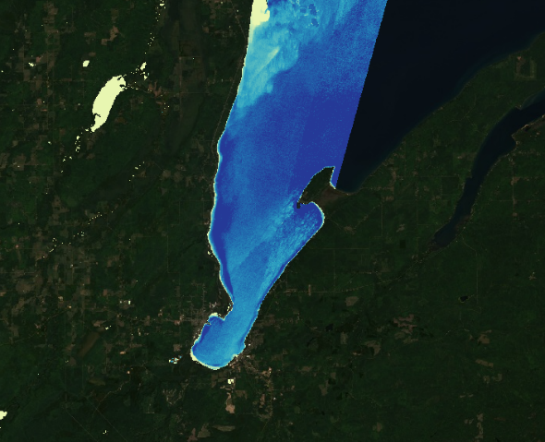 b) 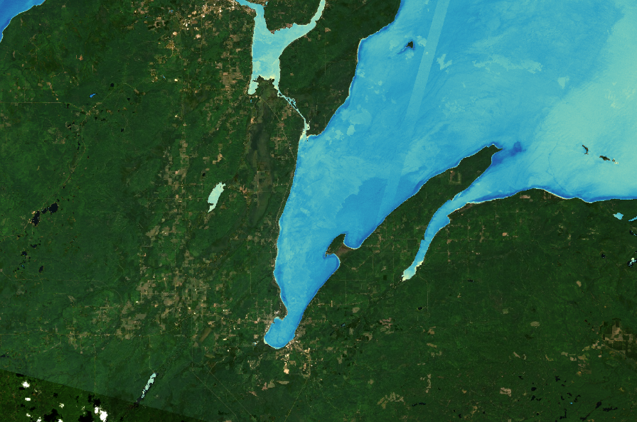 c) 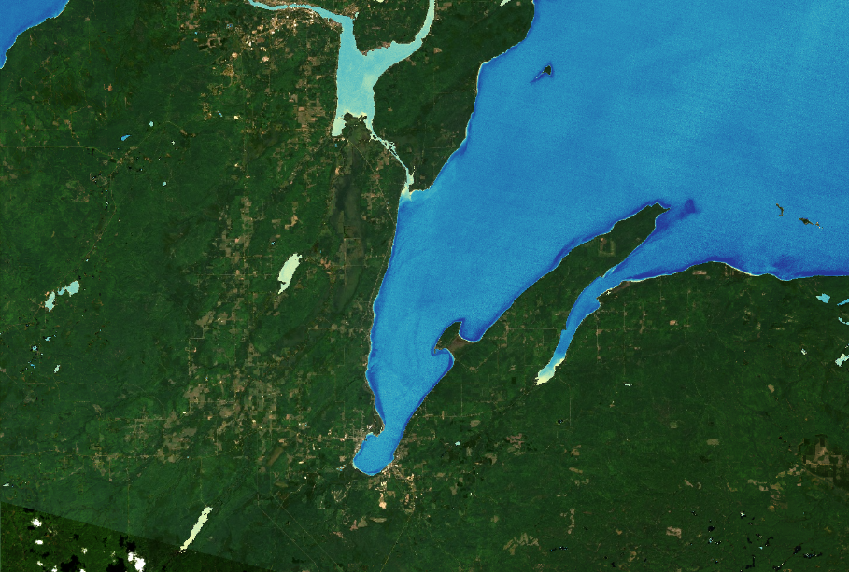
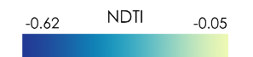
Figure 5: Median NDTI calculated from Landsat 8 OLI imagery: a) snowmelt season; b) rain-dominated season; c) drier season.

The maximum NDTI calculated from Landsat 8 OLI imagery depicts a similar signature as that observed in the median composite images above. The rain-dominated season (Figure 6b) has the greatest NDTI values whereas the snowmelt season has the lowest (Figure 6a). Again, there is a high NDTI signature at the Portage River mouth. The drier season has a moderate NDTI signature (Figure 6c).
a) 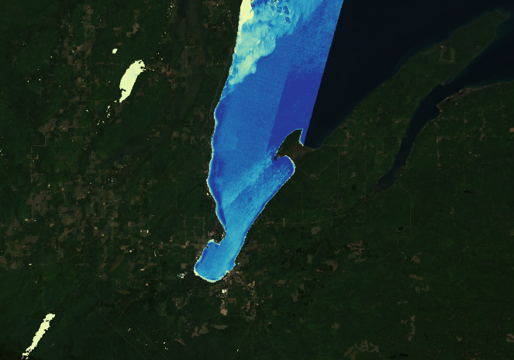 b) 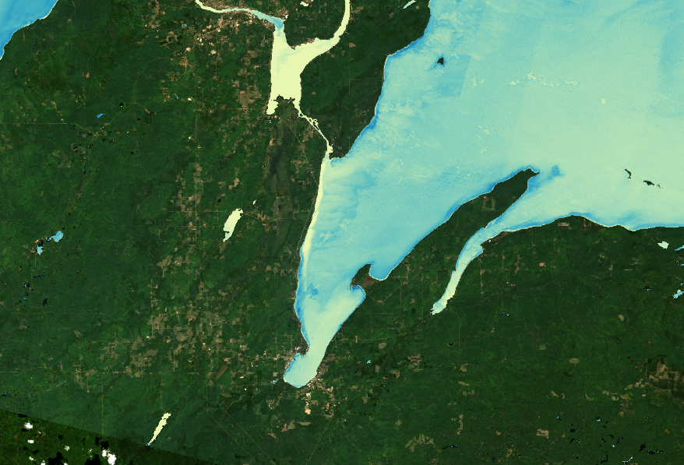 c) 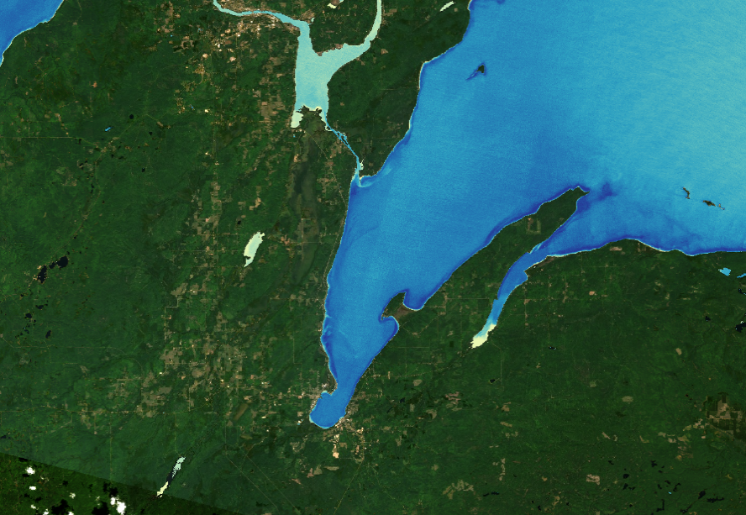
Figure 6: Maximum NDTI calculated from Landsat 8 OLI imagery: a) snowmelt season and c) drier season use maximum pixel values. b) Rain-dominated season depicts 90th percentile pixel values.

The median NDTI calculated from the Sentinel-2 MSI imagery (Figure 7) shows less variation in NDTI among the three seasons as compared to the median NDTI calculated from Landsat 8-OLI imagery (Figure 5). The snowmelt season had the greatest turbidity proxy signature (Figure 7a). The input of sediment from the Portage River is more clearly depicted in the rain-dominated season image (Figure 7b), but it is also visible, to a lesser extent in the snowmelt (Figure 7a) and drier seasons (Figure 7c).

a) 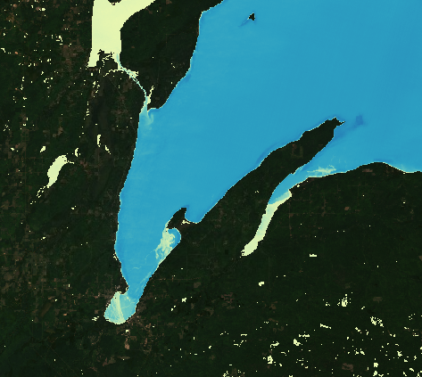 b) 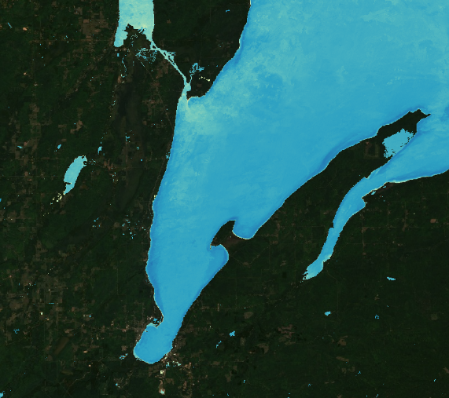 c) 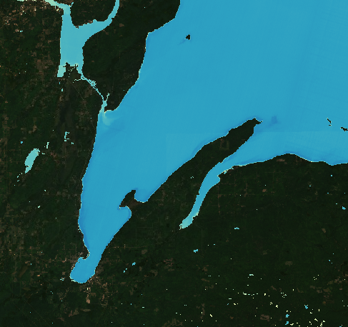
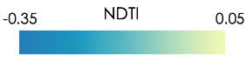
Figure 7: Median NDTI calculated from Sentinel-2 MSI imagery: a) snowmelt season; b) rain-dominated season; c) drier season.

The maximum NDTI calculated from the Sentinel-2 MSI imagery (Figure 8) depicts that the snowmelt season had the greatest turbidity proxy signature (Figure 8a). Turbidity caused by the Portage River is evident in the rain-dominated season composite image (Figure 8b) and to a lesser extent in the drier season (Figure 8c).

a) 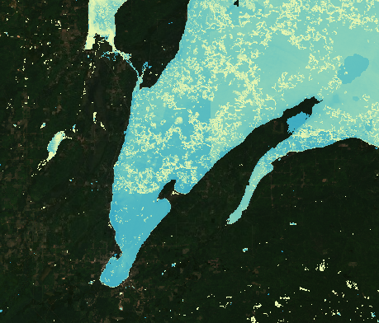 b) 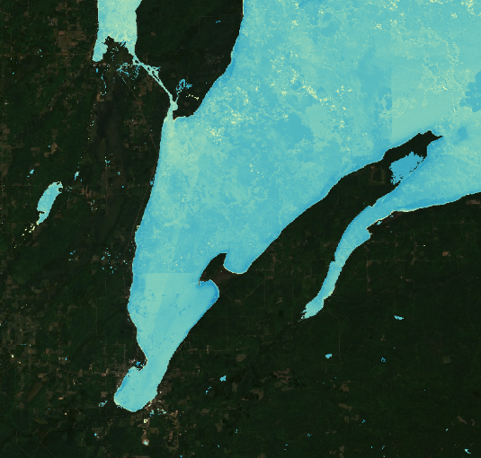 c) 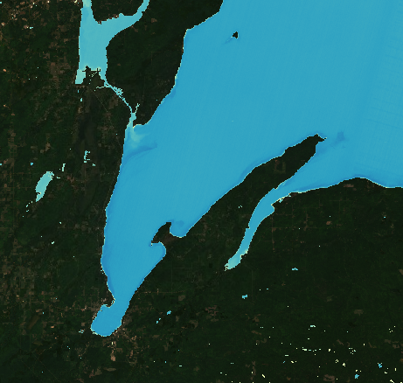
Figure 8: Maximum NDTI calculated from Sentinel-2 MSI imagery: snowmelt season (a) and drier season (c) use maximum pixel values. Rain-dominated season depicts 90th percentile pixel values (b).

4.2 Analysis of Results
For both sets of satellite data, the rain-dominated season contributed the most to turbidity in the southern part of Keweenaw Bay. One of the most notable observations was that the NDTI values for the dry season were often larger than the NDTI values during the snowmelt season and were most clearly seen in the Landsat 8 OLI data (Figures 5 and 6). These higher turbidity values indicated that there were likely factors other than rain and snowmelt that contributed to the sediment flows in the bay, such as water circulation in Lake Superior, as well as surface mixing from wind and wave action.

Furthermore, although the same indices were used to mask out water and calculate NDTI for both satellites, almost all of the Sentinel-2 MSI images showed higher turbidity values than their Landsat 8 OLI counterparts. This was most prevalent when comparing the median turbidity snowmelt seasons (Figure 5a vs. Figure 7a); as well as the dry season median turbidity (Figure 5c vs. Figure 7c). However, there is one exception; the 90th percentile rainy season values for Landsat 8 OLI were higher than those for Sentinel-2 MSI (Figure 6b vs. Figure 8b). One explanation for this was that due to the more frequent revisitation period of Sentinel-2 MSI, there were more images during the same date ranges that contributed toward the composite, thereby balancing out possible outliers from the Landsat 8 OLI composite image. Another explanation could be the differences in the bandwidths of the satellites, which would change the scale of the turbidity index, even though the same functions were used to calculate turbidity in both instances.

4.3 Errors and Uncertainties
The analysis was limited by the limited number of images available due to Landsat 8 OLI and Sentinel-2 MSI only flying over the study area about two times per month per satellite. The number of usable images was further reduced due to obstructions from cloud and ice cover. For example, Figure 8a shows high NDTI values, but the turbidity pattern appears disrupted — likely either by scattered clouds or lake ice.

The brevity of the snowmelt season (Table 1), given the relatively long revisitation periods of 16 days for Landsat 8-OLI and 10 days for Sentinel-2 MSI, made it difficult to single out days when there were no clouds, but also no lake ice obscuring the water. This made conducting a time series analysis nearly impossible. Further, NDWI only looks at the spectral band values of the pixels; therefore, it is not always possible to differentiate between ice along the perimeter of the bay and the liquid water in the bay. Many images also had to be omitted from the composites for this reason, as the overall median or maximum values of the composites would have been skewed toward the higher turbidity values.

Another issue the team wrestled with was masking out clouds. The cloud masking functions effectively masked cumulus, low-lying, and highly reflective clouds. However, they would often times miss the hazy and wispy cirrus clouds, that would then show up as high turbidity values over the water. This made interpreting the results more difficult, as these clouds were barely visibly in the raw images, and therefore made differentiating between actual sediment flows and unmasked clouds difficult. For example, the higher turbidity values that were apparent in the southern portion of the bay in Figures 5a and 6a — were likely influenced by ice or clouds.

4.4 Future Work
Due to the project shift away from time series analysis and towards seasonal analysis, the team could not analyze specific turbidity flows and patterns, which greatly reduced the application of our products for informing shore armoring efforts of the Keweenaw Bay Indian Community. With more time, it would be useful to acquire elevation and in-situ data to contextualize the results of this study. Elevation data would allow a future team to locate watersheds and identify sources of sedimentary runoff. More importantly, the use of in-situ data, such as actual turbidity measurements, or magnitude and direction of currents, could have provided a scale against which to compare and find the spatial patterns and relative NDTI values. Lastly, employing future third-party high-resolution satellite imagery following major storm-driven erosion events may provide crucial insight into where sediment plumes from coastal erosion are likely to travel, and thus where to focus remediation efforts.

5. Conclusions
Through the seasonal analysis of Landsat 8 OLI and Sentinel-2 MSI images using the NDTI index, the team was able to identify seasonal trends in turbidity in Keweenaw Bay. The snowmelt season showed very low turbidity in the bay contrasted by high turbidity plumes from Portage River, suggesting low coastal erosion during this season. The drier season showed moderate turbidity across the bay, providing evidence that turbidity resulting from coastal erosion was occurring independent of precipitation and runoff, but the results again, did not show the desired spatial patterns of erosion.

The rain-dominated season yielded the most turbid images, showing a major contribution of sediment from the Portage River to the north but otherwise an unclear spatial pattern of erosion. The Portage River sediment contribution to Keweenaw Bay was clearly transported south into KBIC property by shoreline currents and wave action. Thus, more stamp sands disposed by stamp mills along Portage Lake, located on the interior of the Keweenaw Peninsula (Figure 2), would eventually be redeposited in Keweenaw Bay —adding to the stamp sands discarded by the Mass and Michigan Mills. This would further exacerbate the ongoing concern held by KBIC regarding stamp sands leaching heavy metals into traditional freshwater sources and contaminating wetlands.

6. Acknowledgments
The team would like to acknowledge those who supported and provided guidance for the Keweenaw Bay Water Resources project. We thank Dr. Kenton Ross, our science advisor at the Langley Research Center, NASA DEVELOP Fellow Olivia Landry, and NASA DEVELOP Science Manager Lauren Childs-Gleason. A special thanks to our project partners who provided us with resources throughout the project. The team would also like to thank Dione Price, Evelyn Ravindran, and Erin Johnston from the Keweenaw Bay Indian Community Natural Resources Department. Additionally, the team thanks the entirety of the NASA DEVELOP network for its support and its provided access to resources from previous teams that have helped guide this project.

This material contains modified Copernicus Sentinel data (2015-2022), processed by ESA.
Any opinions, findings, and conclusions or recommendations expressed in this material are those of the author(s) and do not necessarily reflect the views of the National Aeronautics and Space Administration.

This material is based upon work supported by NASA through contract NNL16AA05C.

7. Glossary
ArcGIS Pro – Geographic Information System (GIS) software.
Earth observations – Satellites and sensors that collect information about the Earth’s physical, chemical, and biological systems over space and time.
GEE – Google Earth Engine.
Landsat 8 Operational Land Imager (OLI) – A satellite operated by NASA and the USGS which hosts the sensor Operational Land Imager, used for measuring Earth’s reflected radiance.
MODIS – Moderate Resolution Imaging Spectroradiometer.
NDTI – Normalized Difference Turbidity Index.
NDWI – Normalized Difference Water Index.
Sentinel-2 MultiSpectral Instrument (MSI) – Satellite, operated by the European Space Agency, the sensor is the Multi-Spectral Instrument for measuring Earth’s radiance.
Turbidity – A measurement of water clarity based on suspended sediments within the water column.

8. References
Bid, S., & Siddique, G. (2019). Identification of seasonal variation of water turbidity using NDTI method in Panchet Hill Dam, India. Modeling Earth Systems and Environment, 5(4), 1179–1200. https://doi.org/10.1007/s40808-019-00609-8

Dogliotti, A. I., Ruddick, K. G., Nechad, B., Doxaran, D., & Knaeps, E. (2015). A single algorithm to retrieve turbidity from remotely-sensed data in all coastal and estuarine waters. Remote Sensing of Environment, 156, 157–168. https://doi.org/10.1016/j.rse.2014.09.020

European Space Agency. Copernicus Sentinel data (2015-2021). Accessed from https://earth.esa.int/web/sentinel/user-guides/sentinel-2-msi/product-types
Ghorai, D., & Mahapatra, M. (2020). Extracting Shoreline from Satellite Imagery for GIS Analysis. Remote Sensing in Earth Systems Sciences, 3(1–2), 13–22. https://doi.org/10.1007/s41976-019-00030-w
Kerfoot, W. C., Urban, N., Jeong, J., MacLennan, C., & Ford, S. (2020). Copper-rich “halo” off Lake Superior’s Keweenaw Peninsula and how mass mill tailings dispersed onto tribal lands. Journal of Great Lakes Research, 46(5), 1423–1443. https://doi.org/10.1016/j.jglr.2020.07.004
Kerfoot, W. C., Yousef, F., Green, S. A., Regis, R., Shuchman, R., Brooks, C. N., Sayers, M., Sabol, B., & Graves, M. (2012). Light detection and ranging (LIDAR) and multispectral studies of Disturbed Lake Superior Coastal Environments. Limnology and Oceanography, 57(3), 749–771. https://doi.org/10.4319/lo.2012.57.3.0749
Mentaschi, L., Vousdoukas, M.I., Pekel, J.F. (2018). Global long-term observations of coastal erosion and accretion. Scientific Reports, 8(12876). https://doi.org/10.1038/s41598-018-30904-w
Mi, H., Fichot, C.G., Bryan, K.R., Qiao, G. (2020). Rapid shoreline flooding enhances water turbidity by sediment resuspension: An example in a large Tibetan lake. Earth Surface Processes and Landforms, 45(15), 3780-3790. https://doi.org/10.1002/esp.5000
Nankervis, P. (2013) Sand Point Wildlife Habitat Restoration Project. United States Environmental Protection Agency-Great Lakes Restoration Initiative.
U.S. Geological Survey Earth Resources Observations and Science Center. (2021). Landsat 8OLI/TIRS Level-1 Surface Reflectance (SR) [Data set]. U.S. Geological Survey. https://doi.org/10.5066/F71835S6

