Powder River Basin Transportation & Infrastructure

Monitoring Land Disturbances Caused by Coal Mining in the Powder River Basin  
Using Remote Sensing

**Technical Report**

August 8th, 2019

Gina Cova (Project Lead)

Andrew Bake

Claudia Herbert

Hayley Pippin

Dr. Juan Torres-Pérez, Bay Area Environmental Research Institute, NASA Ames Research Center (Science Advisor)

Dr. Kenton Ross, NASA Langley Research Center (Science Advisor)  
John Dilger, Spatial Informatics Group, LLC (Science Advisor)

# 1. Abstract

Coal mines in the Powder River Basin of Wyoming account for approximately 41 percent of coal production in the United States, causing significant land disturbances. Without proper reclamation practices, orphan mines create barren, unstable lands unlikely to recover. Where mines have been successfully reclaimed, human and natural communities have benefited from reconnected hydrology, functioning ecosystems, and economic opportunities, but the financial decline of the coal industry has raised concerns about the stability of long-term reclamation efforts. The Powder River Basin Transportation & Infrastructure Team partnered with the Powder River Basin Resource Council and the Western Organization of Resource Councils to create a Coal Mining Assessment Tool (CMAT) in Google Earth Engine to monitor the impacts and reclamation efforts of coal mines in the basin. The tool incorporates Earth observations from Landsat 5 Thematic Mapper (TM), Landsat 7 Enhanced Thematic Mapper Plus (ETM+), and Landsat 8 Operational Land Imager (OLI), and utilizes the LandTrendr change detection algorithm to assess land disturbance. CMAT outputs include land disturbance maps and charts showing how land cover, Normalized Difference Vegetation Index (NDVI), Normalized Difference Water Index (NDWI), and tasseled cap transformations have changed from 1985 to 2018. In a case study of three neighboring mines, results showed that the mine nationally recognized for its reclamation practices recovered land up to 78 percent faster than its neighbors. The ability to visualize and assess how coal mining and reclamation has progressed over the study period will allow partners to better understand and advocate for regional reclamation practices.

**Keywords**

Google Earth Engine, Landsat, reclamation, Coal Mining Assessment Tool, Wyoming, change detection,

tasseled cap, LandTrendr

# 2. Introduction

***2.1 Background Information***

The Powder River Basin in northeastern Wyoming is a predominantly herbaceous grassland on the Fort Union Formation, a geologic unit home to roughly 40 percent of the coal production in the United States and approximately one-third of the nation’s coal reserves (Luppens, Scott, Osmonson, Haacke, & Pierce, 2013). Thirteen percent of the United States’ energy-related greenhouse gas emissions come from coal burned from the Powder River Basin, and approximately 11.3 billion tons of coal have been mined in Wyoming since 1865. Most coal production in the basin began in the 1990s when an amendment to the Clean Air Act limited sulfur dioxide emissions and created an opportunity for Wyoming’s low-sulfur coal to lead industry production (Gillingham et al., 2016; Kehoe, 2019). The local impacts from mining are ecologically devastating; surface mining requires removing large amounts of topsoil to reach coal seams below (Bian, Inyang, Daniels, Otto, & Struthers, 2010). In the short-term, such land conversion reduces habitat. The sage-grouse (*Centrocercus urophasianus*), a key indicator species, has lost half of its habitat over the last century, causing population declines of over 90 percent (Rait, 2018). In the long-term, land can become too arid for revegetation due to water extraction, mineral leaching can produce acid mine drainage, and land disturbance can facilitate invasive species establishment (Stearns, Tindall, Cronin, Friedel, & Bergquist, 2005).

Federal and state regulations on coal mining emerged in the late 1960s and 1970s to protect environmental and public health (Alden, 2009). Without reclamation management by mining companies of lands disturbed by extraction, ecosystems are unlikely to recover on timescales suitable to the communities that rely on them (Ogle & Redente, 1988). Reclamation occurs over a minimum of ten years in three phases — to ensure reclamation occurs, coal companies are legally required to post bonds that provide a budget to complete reclamation when mining of an area begins (Alden, 2009). Bonds are held by the state or a third-party agency and released in conjunction with reclamation phase completion. However, as of July 2018, only 2.4 percent of all mined land had been fully reclaimed (Powder River Basin Resource Council, 2018).

Effective reclamation of mining sites is critical for human livelihood and ecological stability, but recent downturns in coal profitability raise questions about the long-term financial viability of reclamation. The number of coal plants in the Powder River Basin has decreased 35 percent since 2008, as cheaper natural gas displaces coal demand (Feaster & Cates, 2019). Though reclamation is required to occur contemporaneously with active mining to avoid orphan mines, financial hardships of coal companies can hinder compliance with mandated environmental standards. Additionally, reclamation assessments are time and labor intensive. Individual facilities must undergo hundreds of hours of in-person inspections to ensure completion of the reclamation process (Powder River Basin Resource Council, 2018). Effective reclamation over the next decade is unlikely to occur without pressure by stakeholders and vigilant monitoring that remote sensing could support.

***2.2 Project Partners***

The Powder River Basin Transportation & Infrastructure Team, in collaboration with the Clemson Energy-Economy-Environment (E3) Systems Analysis Group and SkyTruth, partnered with the Powder River Basin Resource Council (PRBRC) and the Western Organization of Resource Councils (WORC), regional resource councils that wage campaigns to protect the area’s natural resources from coal mining, oil and gas drilling, uranium mining, and other forms of environmental degradation. The Powder River Basin extends north of Wyoming under the Crow and Northern Cheyenne Indian Reservations. For this reason, the team also contacted the Department of Natural Resources for both tribes and partnered with the Northern Cheyenne Tribe. The team was able to provide data on how a surface mine on the Northern Cheyenne reservation, closed before the start of the study period, changed with reclamation in the 1990s. Both the PRBRC and WORC officials are interested in the responsible development of resources while protecting surrounding communities and ensuring the preservation of agricultural operations for ranchers and farmers of the Powder River Basin. Using the Powder River Basin Transportation & Infrastructure Team’s Coal Mining Assessment Tool (CMAT), hosted in Google Earth Engine (GEE), all partners will be able to use Earth observations to access and analyze data on land disturbances and reclamation efforts by mining companies.

***2.3 Scientific Basis & Objectives***

This study addressed the feasibility of using Earth observations at the individual mining level in the Powder River Basin (*Figure 1*) to monitor reclamation and long-term effects of mining on land cover. Previous studies on strip mining leverage the difference between vegetation cover in surrounding land and land barren from mining. (Prakash & Gupta, 1998). Applying vegetation indices such as the Normalized Difference Vegetation Index (NDVI), Normalized Difference Water Index (NDWI), and tasseled cap transformation (TCT) to Landsat and Sentinel imagery can effectively detect the fluctuations in green reflectance in these areas (Alden, 2009; Karan, Samadder, & Maiti, 2016; Kauth & Thomas, 1976; Latifovic, Fytays, Chen, & Paraszak, 2005). Furthermore, the spatial and temporal resolution of Landsat allows for an accurate, broad-scale survey of reclamation activity (Townsend et al., 2009). This project analyzed the effectiveness of indices like NDVI, NDWI and mathematical transformations like TCT greenness and TCT angle to evaluate the extent and timing of land disturbance and reclamation as a result of surface mining in the Powder River Basin. Using satellite imagery between June and August from 1985 through 2018, this project provided the PRBRC and the WORC with a better understanding of the scale of landscape changes associated with mining and the effectiveness of land reclamation activities.

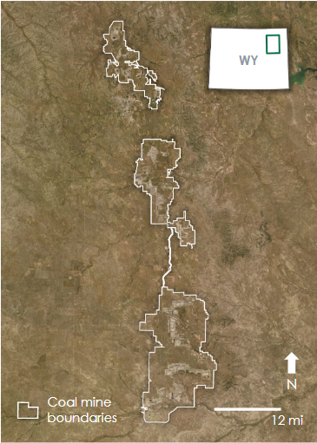

*Figure 1.* The study area focused on twelve active coal mines in the   
Powder River Basin of northeastern Wyoming.

# 3. Methodology

**3.1 Data Acquisition**

*3.1.1 Earth Observation Data*

The team used GEE to access and analyze Landsat 5 Thematic Mapper (TM), Landsat 7 Enhanced Thematic Mapper Plus (ETM+), and Landsat 8 Operational Land Imager (OLI) data (Table 1). Landsat sensors were chosen for their high spatial and temporal resolution, capturing images at a 30 m resolution every 16 days throughout the study period duration. Imagery for the period June 1st to August 31st was analyzed annually from 1985 to 2018. This three-month period is the most snow-free, productive growing period for the study region, which allowed for more distinct NDVI, NDWI, and TCT values. The evaluation used data from Landsat 7 for 2012, as the data availability of Landsat 5 extended only to May 5, 2012, and Landsat 8 data availability began on April 11, 2013.

Table 1 *Earth observations used in the land disturbance analysis for Wyoming’s Powder River Basin*

|  |  |  |
| --- | --- | --- |
| **Platform and Sensor** | **GEE ImageCollection ID** | **Image Collection Dates** |
| Landsat 5 TM Tier 1 Surface Reflectance | LANDSAT/LT05/C01/T1_SR | 1985 to 2011 |
| Landsat 7 ETM+ Tier 1 Surface Reflectance | LANDSAT/LE07/C01/T1_SR | 2012 |
| Landsat 8 OLI Tier 1 Surface Reflectance | LANDSAT/LC08/C01/T1_SR | 2013 to 2018 |

*3.1.2 Ancillary Data*

The team used a downloadable GIS coal dataset of coal maps from the Wyoming State Geological Survey (WSGS) to establish the boundaries of active coal mining facilities in the study region. These maps were uploaded as assets in GEE. The PRBRC confirmed the names and boundaries of the mining facilities in a publication examining the state of mining and reclamation in the Wyoming region of the Powder River Basin. The United States Geological Survey (USGS) National Land Cover Database (NLCD) Gap Analysis dataset was used to determine the vegetation types and land cover of the study area. Sage-grouse core area and habitat maps were downloaded from the Wyoming Game and Fish Department (WGFD) and uploaded as ancillary data in CMAT. The sage-grouse acts as an indicator species for the overall health of the sagebrush landscape of the Powder River Basin. Precipitation data were used from the Climate Hazards Group Infrared Precipitation with Station Data (CHIRPS) dataset and were used to contextualize fluctuations in NDVI, NDWI, and TCT within the study area. CHIRPS data is captured at the pentad scale and can be accessed through GEE. The Protected Areas Database of the United States (PADUS) was added to determine where and to what extent mined land overlapped with public lands. Coal production data from 1985 through 2018 in the Powder River Basin was also gathered from the Energy Information Administration and used to contextualize fluctuations in land disturbance associated with mining. Table A1 outlines the ancillary data used for the project.

***3.2 Data Processing***

*3.2.1 Cloud Masking*

Cloud-free composite images were created from data for the summer season of each year using the GEE cloud score algorithm to filter cloudy pixels from images. The algorithm identifies two key cloud properties in the imagery: relative brightness in the blue, visible, and infrared bands, and relative coolness in temperature. It then applies a “score” to each pixel to rank its cloudiness. This method anticipates potential confusion of clouds with snow and uses the Normalized Difference Snow Index (NDSI, Equation 1) to differentiate between the two (Hall, Riggs, & Salomonson, 1995). The least cloudy pixels were then selected from each image and composited into a single scene. All analyses relied on this set of composited images. We then clipped the composite images around the mine sites shapefile created by the University of Wyoming geospatial GeoHub to limit the analysis to areas where surface mining drove the disturbance. Lastly, we applied a mask to these temporally filtered images to exclude urban areas from our analysis.

$\text{NDSI} = \frac{\text{Green - Short Wave Infrared}}{\text{Green + Short Wave Infrared}}$ (1)

*3.2.2 Water and Vegetation Detection*

The composite Landsat images were used to develop maps of NDVI using Equation 2 and NDWI using Equation 3 (Gao, 1996; Rouse Jr., Haas, Schell, & Derring, 1973).  Additionally, we applied TCT to the composite imagery to determine the tasseled cap greenness (TCG), brightness (TCB), and wetness (TCW) values for the study area by multiplying a matrix of coefficients with the composite image bands (Crist & Cicone, 1984; DeVries, Pratihast, Verbesselt, Kooistra, & Herold, 2016). Table A2 in the Appendix outlines the coefficients used for the transformation. We also calculated the tasseled cap angle (TCA; Equation 4) values for the study area using the TCG and TCB index values (Powell et al., 2010). TCA examines the denseness of the vegetation in a certain area. Because this calculation takes in two bands, TCA provides more detail about the area’s vegetation levels than either the greenness or brightness bands alone. NDVI, NDWI, TCG, and TCA were added to the CMAT tool for users to track changes over time.

$\text{NDVI }= \frac{\text{Near Infrared - Red}}{\text{Near Infrared + Red}}$ (2)

$\text{NDWI = }\frac{\text{Near Infrared - Shortwave Infrared}}{\text{Near Infrared + Shortwave Infrared}}$ (3)

$\text{TCA = ta}{\text{n}}^{\text{-1}}\text{(}\frac{\text{TCG}}{\text{TCB}}\text{)}$ (4)

*3.2.4 Elevation*

Three digital elevation models are available for Wyoming: the USGS National Elevation Dataset (NED) 1/3 arc-second, Shuttle Radar Topography Mission (SRTM) Digital Elevation Data 30 m, and the AG100: Advanced Spaceborne Thermal Emission and Reflection Radiometer (ASTER) Global Emissivity Dataset 100-meter V003. Utilizing these Digital Elevation Models (DEMs) would have been beneficial to verify our results from other indices. We visually inspected and graphed the elevation data for each of the mine sites looking for elevation change, but given the different sensor spatial resolutions and lack of two-date sensor returns in the composite elevation imagery, we were unable to identify changes in elevation related to surface mining disturbance.

*3.2.5 Precipitation*

Precipitation data were incorporated into the analysis to contextualize fluctuations in vegetation and water indices. We accessed data via GEE from the CHIRPS (version 2.0 final) dataset at the pentad scale. We extracted precipitation annual averages for the study area using a mean reducer across all pixels in an image to plot against water and vegetation indices. Values were then put in spreadsheet format and normalized on a scale from 0 to 1 using Equation 5 to plot easily against NDVI and NDWI values.

${\text{P}}_{\text{normalized}} =\frac{\text{P - }{\text{P}}_{\text{min}}}{{\text{P}}_{\text{max}}\text{ - P}}$ (5)

***3.3 Data Analysis***

*3.3.1 Identifying Land Disturbance and Reclamation*

Land change identification was carried out in GEE using the LandTrendr Greatest Disturbance Mapping for surface mining detection and Fastest Growth Mapping for mine reclamation detection using a time series pixel-difference change analysis (Townsend et al., 2009; Yang, Erskine, et al., 2018). Our project initially proposed using land classification change over time as a measure for land disturbance or reclamation. The herbaceous vegetation cover of our study area posed challenges to developing land classifications because it was difficult to discern the difference between barren land that was from surface mining disturbance versus land without vegetation due to low precipitation. Similarly, identifying a vegetation class of irrigated grass from reclamation versus agriculture would run into high commission errors. These examples highlighted the need for a land change detection method that performs well in arid ecosystems. Additionally, in order to study surface mining, the change detection analysis needed a measure of durability of disturbance, or for how long land was disturbed before it was revegetated. Disturbance duration would allow us to characterize the differences between short-term land disturbance resulting from non-mining processes and long-term mining-related disturbance. To determine this measure, the research required a time series analysis of pixel change over time, not just two-date comparisons.

The LandTrendr Algorithm was developed for monitoring forest disturbance and regeneration. It is a pixel-change, time-series analysis that plots pixel change over time and fits a model to the pixel values, reducing noise related to interannual variation and can identify significant pixel changes. If the pixel exceeds the parameters that constitute ‘change,’ the algorithm outputs the year of change, magnitude of change, pre-change pixel value, root square mean error and fit-to-vertex image data. We investigated LandTrendr outputs for our study area on pixel values for NDVI, NDWI, TCG, and TCA. The team built an image collection for the area of interest by reducing the imagery from June 1st to August 31st into one composited annual image for each year. The collection was masked for clouds, snow, and shadows in LandTrendr. We found that TCA was the best input for tracking surface mining and re-vegetation from reclamation. Table A3 describes the parameters we used to run the LandTrendr algorithm, which we based on the parameters outlined in Kennedy, Yang, & Cohen (2010). Future researchers should adjust these parameters if a different study area is selected. Finally, we clipped the LandTrendr outputs to our study area geometry, rather than allowing the algorithm to chart every pixel change in a scene. We wanted to monitor changes associated with mining, so we aimed to limit the inclusion of land cover changes from non-mining processes.

*3.3.2 Land Disturbance and Reclamation Visualization*

To visualize these outputs, we created an artificial three-band composite image that included the magnitude and duration of change observed, as well as the pre-change spectral value for each pixel. Magnitude and duration of change were useful for identifying areas of mining and reclamation because mining-related surface area disturbance persisted for multiple years and reclamation is legally supposed to be demonstrated for ten years before considered complete in Wyoming. For land disturbance, the magnitude of change is shown with the red band and duration with the green. For land reclamation, duration of change is shown with the red band and magnitude with the green. This artistic choice led disturbance to appear overwhelmingly red and reclamation to appear overwhelmingly green because magnitude had the brightest readings. We used the blue band for the pre-change value because we found when comparing it to true color images that it was effective at identifying areas with land cover changes likely related to non-mining activities. Under this visualization scheme, pixels that appear more purple or blue were disturbances unrelated to mining or re-vegetation from reclamation. This design allows the user to easily identify the interannual vegetation change driven by riparian zones as opposed to mining activities. Finally, the legends for the two maps are the likelihood that the observed pixel change resulted from mining activities. Outside of visual inspection with true-color images, we did not conduct any robust accuracy assessment for the LandTrendr outputs. Research or policy work using these outputs as anything more than a visual representation of change should establish accuracy.

*3.3.3 Zonal Analysis*

Accounting for precipitation was critical in our contextual analysis of the mining area due to the low rainfall in the study area. Depending on the amount of rainfall in a given year, it can dramatically skew the amount of vegetation seen from one year to another. Halounová (2008) writes that without climatic and precipitation controls, the NDVI index displays values almost 0.2 points lower than actual. To control for this variation in rainfall we created reference sites that were located at the same latitude as the mine sites.

For each mine in our study area, three reference sites were selected, totaling or exceeding the mined area in size. Reference sites were selected using the USGS NLCD to identify vegetation areas that were similar in composition to mined areas. These references sites allowed us to create ratios of the different zonal indices between mine sites and their corresponding reference sites. Equation 6 illustrates the equation used to conduct a ratio analysis for TCG, TCA, and land disturbance and revegetation magnitude. This method allowed us to quantify land disturbance and reclamation practices as change beyond standard interannual vegetation variation.

$\text{Index ratio}\text{ = }\frac{\text{Mining site zonal index mean}}{\text{Reference site zonal index mean}}$ (6)

*3.3.4 Statistical Analysis*

All statistical analyses and evaluation for this project were computed using R, a software environment for statistical computing and graphics (R Project for Statistical Computing, n.d.). The team explored the relationship between precipitation and land disturbance levels to determine to what degree surface mining had an effect on land disturbance. This relationship was determined using Pearson’s Correlation Coefficient with a standard p-value of 0.05. Linear regression was used to analyze the trends in NDVI and TCT brightness, greenness, wetness, and angle index change for the mining regions. The team also calculated the persistence of each area’s land classification to gauge the significance of the classification and better understand how much mining contributed to the disturbance.

# 4. Results & Discussion

***4.1 Analysis of Results***

*4.1.1 LandTrendr Evaluation*

The LandTrendr algorithm was effective in illustrating land disturbance and reclamation related to mining activities across the study period. *Figures 2 and 3* illustrate the land change for the North Antelope-Rochelle and Antelope mines, respectively. The brighter pink coloring indicates a greater probability of mining-related disturbance, while the brighter green signals a higher probability of mining-related reclamation. The areas in purple and blue suggest that the detected land disturbance or revegetation results from interannual vegetation changes rather than mining. Both of the mines display far greater levels of pink between the years 1996 and 2007 than the southern reference site (*Figure 4*), allowing us to see the extent of the impact of increased mining levels. Furthermore, the mines also exhibit more green coloring than the reference site, demonstrating how using a time series analysis can make reclamation processes visually distinct from non-reclamation vegetation.

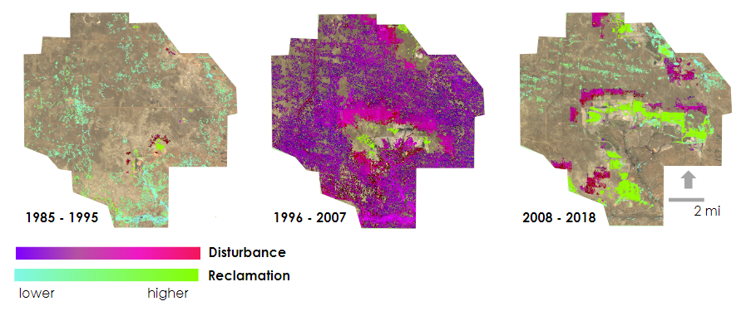

*Figure 2.* LandTrendr pixel time series analysis imagery indicating the extent of land disturbance and land revegetation (reclamation) over three ten-year periods for the North Antelope-Rochelle mine.

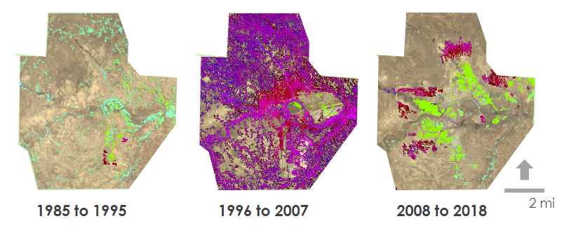



*Figure 3.* LandTrendr pixel time series analysis imagery indicating the extent of land disturbance and land revegetation (reclamation) over three ten-year periods for the Antelope mine.

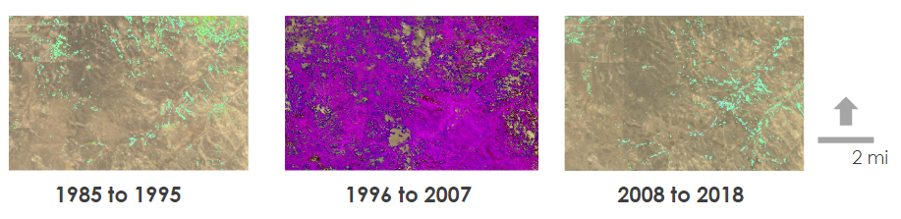



*Figure 4.* LandTrendr pixel time series analysis imagery indicating the extent of land disturbance and land revegetation (reclamation) over three ten-year periods for the Southern reference site.

*4.1.2 Zonal Ratio Analysis*

We conducted a ratio analysis of TCG and TCA for three case study mines: the North Antelope-Rochelle mine, the Black Thunder mine, and the Antelope mine. The North Antelope-Rochelle mine is the largest coal mine in the world and does not have any land that has achieved Phase III bond release (Peabody Energy Inc., 2019; Powder River Basin Resource Council, 2018). Black Thunder mine is also among the largest coal mines in the world and currently does not engage in active contemporaneous reclamation. Antelope mine, on the other hand, has won national recognition and awards for its land reclamation efforts. We ran the analysis for all three mines from 1985 through 2018.

*Figure A1* shows how the TCG ratios for the three mines change over the study period. All three mines have similar TCG ratio values until 2005, where Antelope mine maintains a ratio around 1.00 for the rest of the study period, indicating that the mining site vegetation levels are keeping up with the surrounding undisturbed land. Antelope mine also demonstrates large spikes in its TCG ratio. These spikes likely arise from the reseeding and vegetation succession that occurs during Phases II and III of reclamation, so the mining site would have higher levels of vegetation than the reference site.

The TCA ratio analysis shows greater distinction between the three mines’ land change than the TCG analysis (*Figure A2*). The Antelope mine tends to keep its TCA ratio around 1.00 for the full duration of the study period, while the North Antelope-Rochelle and Black Thunder mines sustain a ratio below 1.00, highlighting the negative impact of the mines on the land’s vegetation. In 2005, Antelope sustains a ratio of 1.00 for about 10 years, the length of time required for Phase III bond release. Additionally, Antelope’s TCA ratio increases 78 percent faster than North Antelope-Rochelle’s TCA ratio, demonstrating that mines with contemporaneous reclamation can re-establish vegetation levels much faster than mines without. This difference demonstrates the impact of Antelope’s contemporaneous reclamation and TCA’s effectiveness in monitoring mining-related land disturbance and reclamation.

*4.1.3 Correlations*

The tasseled cap correlations were tested against precipitation data to identify mines that were potentially failing to properly reclaim their land. The chart in *Figure A4* shows that TCG and TCA are both well correlated with precipitation with an r-value averaging around 0.75, whereas TCW has an almost consistently lower r-value. This trend likely emerges because the soil in undisturbed areas can retain water to a higher degree than the semi-impervious soil in active mining zones, which could lead to a lower correlation between wetness and precipitation in mined areas (Simmons et al., 2008).

We used the TCA index to analyze the reclamation levels for specific mines. Correlating the mining site TCA value with its reference site TCA values allows us to determine the effectiveness of reclamation. We find that only Antelope, Buckskin and Dry Fork mines, all notable for their reclamation efforts, have a high r-value of 0.90 or greater (*Figure A5*). Other mines, such as North Antelope Rochelle and Coal Creek, have r-values around 0.70. These low values correspond with limited reclamation occurring at the mine sites.

LandTrendr magnitude and disturbance values correlated with coal production are a good indicator of reclamation occurrence in the overall basin. Table A4 shows that coal production and the magnitude of disturbance are negatively correlated with an r-value of -0.108. As the amount of land disturbed increased over the years, the quantity of coal mined decreased. Coal production and the magnitude of reclamation are also negatively correlated with an r-value of -0.559. As land is being reclaimed, the quantity of coal is decreasing. Taken together, these trends show that contemporaneous reclamation occurred over the study area since the quantity of coal mined decreased as the land was being reclaimed.

***4.2 Coal Mining Assessment Tool***

*4.2.1 Tool Development*

CMAT was developed in JavaScript to run in GEE. Using a Graphical User Interface (GUI), CMAT facilitates analysis of Landsat 5, 7, and 8 imagery to monitor land disturbance associated with surface mining and revegetation associated with mine reclamation. The CMAT GUI allows users to set start and end years between 1985 and 2019. The 2019 imagery will become available once it is added to GEE. The user may set the study area for analysis by selecting any of the twelve individual mines in Campbell County, WY, the entire region of interest (called General Study Area), uploading an asset to GEE, or by drawing a geometry on the map. The tool then creates a collection of annual composite images based on the user’s spatial and temporal inputs from available imagery collected between June and August, masking cloud, snow, and shadows to get the clearest image available. This collection can then be visualized on the map window in GEE, used to generate charts of pixel value changes in the tool, or exported as individual annual images or videos. To properly visualize these exported images in a spatial software it is recommended that the end user stretches the images to the specifications laid out in Table A5. Users can also add ancillary datasets to the map to facilitate the imagery’s use for management or policy decisions. Some datasets have already been added, which help the user understand what type of land cover is being disturbed, where public lands management areas exist, which agencies may be involved or impacted by surface mining, and the location of the sage-grouse core management area, a local bird that has been driven to endangerment from habitat loss from mining. Additionally, a northern, central, or southern reference site can be selected for running analyses that help gauge the interannual changes on the surrounding landscape resulting from non-mining processes. Users may find this data helpful to compare against LandTrendr or zonal index analysis for mining sites over the same study period.

*4.2.2 Tool Applications*

CMAT is available for use after completion of the NASA software release process. CMAT code should be used in GEE. A video tutorial of how to input the code into GEE and how to use the tool itself is available in the project handoff folder. CMAT is sensitive to user inputs; it generates image collections based on user-determined spatial and temporal inputs so that the tool may be used to track mining and reclamation in the Powder River Basin. The ability to run analysis on drawn geometries and uploaded assets means that the tool could be applied to regions outside of the Powder River Basin. If users are applying CMAT to other regions, the LandTrendr disturbance and reclamation parameters may need to be modified to accurately track disturbance and reclamation outside of the study area.

CMAT leverages the difference in spectral properties between barren and vegetated landscapes and timing of changes to visualize disturbance associated with coal mining and vegetation re-planting associated with reclamation. This means that reclamation on this tool is not observed until the land has been revegetated; thus, the ‘Year of Detection’ in the LandTrendr Revegetation output represents the start of Phase II rather than Phase I reclamation. We found vegetation indices and mathematical transformations were effective at identifying stark landscape changes associated with mining. However, these same methods may identify vegetation change from non-surface mining processes. We clipped the output of our tool to be the preset mine boundaries or user-supplied asset to limit the number of land disturbances picked up from other processes. CMAT outputs rely on users’ expert knowledge in identifying areas that have experienced surface mining for accurate interpretations.

***4.3 Sources of Error***

NDVI and NDWI did not prove to be very effective in distinguishing the mines in the Powder River Basin. There is very little variation between the average NDVI or the average NDWI values for the North Antelope-Rochelle, Black Thunder, and Antelope mines (*Figure A3*). Furthermore, we observe that NDVI and NDWI fluctuate seasonally due to their sensitivity to precipitation levels far more than TCG or TCA. The team recommends using other indexing methods like TCT, despite the prevalence of NDVI and NDWI, for similar arid landscapes.

While LandTrendr was able to detect land change most likely related to mining activities, we did not carry out an accuracy assessment for the algorithm, so we cannot gauge the validity of our results. The LandTrendr outputs can therefore only be used as a visual representation of mining-related land change; an accuracy assessment must be carried out before a quantitative analysis can be run on the algorithm’s outputs. Furthermore, Landsat imagery has a moderate spatial resolution of 30 m, which makes it difficult to conduct analysis at the individual mining level. Thus, LandTrendr could not provide as much detail as the team desired with regard to each mine’s impact on the surrounding vegetation.

Finally, errors may have arisen in the ratio analysis due to our reference site selection. Each mine had three reference sites that were selected based on the similarity of the vegetation to the mining site. These reference sites were selected by visual inspection, however, so the undisturbed land may not have as much similarity to the mining site as the team anticipated. The ratio values for TCG and TCA may then not reflect the amount of land disturbance or reclamation that the mine carried out.

***4.4 Future Work***

Future work is necessary due to the limitations of remote sensing in evaluating mining reclamation in Wyoming due to the aridity of the ecosystem. A supervised land classification system specifically to differentiate between barren disturbed and barren undisturbed land could be done by utilizing either higher spatial or spectral resolution imagery. While the land may look reclaimed, the hydrologic properties of that land still operate very similarly to semi-impervious mined land and can take centuries to return to its natural state; Townsend et al. (2009) used a combination of NDVI, Tasseled Cap Brightness, Greenness and Wetness to better identify reclaimed land. This method, however, was deployed in Appalachia, which has a significantly higher level of precipitation and any future work would likely need to be adjusted for the unique parameters of Wyoming as a study site due to the aridity of the climate.

Furthermore, the team identified three DEM’s for analysis but found that there was not enough spatial or temporal scope to identify the mines rendering any verification of mine growth impossible. Pending funding for a LiDAR aerial campaign of Wyoming, future work could incorporate elevation analyses when this data becomes available. Examining the impact that mines have on the topography of the landscape could provide further insight as to how mining affects the study area.

Lastly, the team tried to verify its data by exporting the results from the CMAT tool in a GeoTIFF format and visualizing the images in ArcGIS. Future projects could work with these outputs in developing and applying an accuracy assessment to the outputs. Using this accuracy assessment in conjunction with the tool could help ensure that the partners are given a verified repository of data to inform their decisions.

# 5. Conclusions

Working with the PRBRC, WORC, and the Northern Cheyenne Tribes in the Powder River Basin, the team identified a pressing community need to monitor land disturbance and reclamation from surface mining as mining companies declare bankruptcy and are at risk of leaving mines abandoned. Because the local herbaceous vegetation experiences high interannual variability due to changes in precipitation, the team identified remote sensing methods that could remove the noise from interannual variability and detect durable land cover changes from mining and mine reclamation. This approach relied on pixel-change time series analyses using the LandTrendr algorithm and using reference sites to understand non-mining vegetation changes. CMAT combines the remote sensing methods we found effective for monitoring mining disturbance and reclamation into an easy-to-use graphical user interface where our end-users and collaborators can replicate our methodology to monitor mines in the future. Outputs from this tool include time-series pixel change maps and charts and annual composite imagery of vegetation and water indices, exported as individual images or videos.

Along with the use of spatially-explicit outputs, like the LandTrendr Disturbance and Reclamation maps, we found zonal statistics can be effective at quantitatively describing the amount of vegetation disturbance and re-establishment associated with surface mining. Using reference site ratio comparisons and correlative tests, we identified mines, such as Antelope, Buckskin and Dry Fork, with effective reclamation practices that maintain vegetation levels close to those of non-mined reference sites. Mines with less reclamation in this region have lower ratios and correlation r-values, indicating the lack of vegetation in those mined areas compared to the non-mined reference sites. Our partners at the PRBRC and WORC will be able to use CMAT and our research findings to increase pressure on state environmental regulators to enforce surface mining reclamation standards on mines that have lower reclamation to reference site vegetation correlations. While the Northern Cheyenne Tribe does not have current surface mining disturbances on their land, we produced imagery of a mine on their reservation that was reclaimed during the 1990’s to help demonstrate how remote sensing can be used to monitor mine reclamation and land management practices on their reservation. All project partners will be able to use CMAT to understand how surface mining disturbances and reclamation practices impact regional ecology currently and in the future.

# 6. Acknowledgments

The Powder River Basin Transportation & Infrastructure Team would like to thank the following people:

* Shannon Anderson, Powder River Basin Resource Council, Staff Attorney
* Dan Cohn, Western Organization of Resource Councils, Regional Organizer
* Jason Whiteman, Northern Cheyenne Tribe, Water and Natural Resources Administrator
* Dr. Mik Carbajales-Dale, Clemson Energy-Economy-Environment (E3) Systems Analysis Group, Director
* Christian Thomas, SkyTruth, Geospatial Engineer
* Dr. Juan Torres-Pérez, Bay Area Environmental Research Institute, NASA Ames Research Center, Science Advisor
* Dr. Kenton Ross, NASA Langley Research Center, Science Advisor
* John Dilger, Spatial Informatics Group, LLC, Science Advisor
* Farnaz Bayat, DEVELOP National Program, California – Ames Node Center Lead
* Jerrold Acdan, DEVELOP National Program, California – Ames Node Project Coordination Fellow

Any opinions, findings, and conclusions or recommendations expressed in this material are those of the author(s) and do not necessarily reflect the views of the National Aeronautics and Space Administration.

This material is based upon work supported by NASA through contract NNL16AA05C.

# 7. Glossary

**CMAT** – Coal Mining Assesment Tool

**Earth observations** – Satellites and sensors that collect information about the Earth’s physical, chemical, and biological systems over space and time  
**MSI** – Multispectral Instrument

**OLI** – Operational Land Imager

**PRBRC** – Powder River Basin Resource Council

**Reclamation Phases** –Phase I involves backfilling and replacing topsoil and contouring the land to resemble pre-mining topography. Reseeding native vegetation occurs in phase II, and phase III requires proof of revegetation succession after a minimum of 10 years

**TM** – Thematic Mapper

**WORC** – Western Organization of Resource Councils

**NDVI** – Normalized Difference Vegetation Index

**NDWI** – Normalized Difference Water Index

**TCB** – Tasseled Cap Brightness

**TCG** – Tasseled Cap Greenness

**TCW** – Tasseled Cap Wetness

**TCA** – Tasseled Cap Angle

**WORC** – Western Organization of Resource Councils

# 8. References

Alden, M. G. (2009). *Remote sensing techniques for monitoring coal surface mining and reclamation in the Powder River Basin.* (Unpublished master's thesis). University of Ohio, Athens, OH. http://rave.ohiolink.edu/etdc/view?acc_num=ohiou1257279388

Bian, Z., Inyang, H. I., Daniels, J. L., Otto F., & Struthers, S. (2010). Environmental issues from coal mining and their solutions. *Mining Science and Technology (China), 20*(2),215-223. <https://doi.org/10.1016/S1674-5264(09)60187-3>

Crist, E. P, & Cicone, R. C. (1984). A physically-based transformation of thematic mapper data — the TM tasseled cap. *IEEE Transactions on Geoscience and Remote Sensing, GE-22*(3)*,* 256-263. https://doi.org/10.1109/TGRS.1984.350619

DeVries, B., Pratihast, A. K., Verbesselt, J., Kooistra, L., & Herold, M. (2016). Characterizing forest change using community-based monitoring data and Landsat time series. *PLoS ONE, 11*(3),e0147121. https://doi.org/10.1371/journal.pone.0147121

Energy Information Administration. (2018). [Interactive mapper of Energy Souces]. *Wyoming State Profile and Energy Estimates.* Retrieved from <https://www.eia.gov/state/?sid=WY>

Feaster, S., & Cates, K. (2019). *Powder River Basin coal industry is in long-term decline: Fast-changing markets indicate deeper downturns to come in Montana and Wyoming*. IEEFA Report*.* Retrieved from <http://ieefa.org/wp-content/uploads/2019/03/Powder-River-Basin-Coal-Industry-Is-in-Long-Term-Decline_March-2019.pdf>

Gao, B. (1996). NDWI – A normalized difference water index for remote sensing of vegetation liquid water from space. *Remote Sensing Environment, 58*(3),257-266. <https://doi.org/10.1016/S0034-4257(96)00067-3>

Gillingham, K., Bushnell, J., Fowlie, M., Greenstone, M., Kolstad, C., Krupnick, A., … Stock, J. (2016). Reforming the U.S. coal leasing program. *Science, 354*(6316),1096-1098. https://doi.org/10.1126/science.aak9851

Halounová, L. (2008). Reclamation areas and their development studied by vegetation indices. *International Journal of Digital Earth, 1*(1), 155-164. https://doi.org/10.1080/17538940701782627

Hall, D. K., Riggs, G. A., & Salomonson, V. V. (1995). Development of methods for mapping global snow cover using Moderate Resolution Imaging Spectroradiometer data. *Remote Sensing of Environment*, *54*(2), 127-140. <https://doi.org/10.1016/0034-4257(95)00137-P>

Karan, S. K., Samadder S. R., & Maiti, S. K. (2016). Assessment of the capability of remote sensing and GIS techniques for monitoring reclamation success in coal mine degraded lands. *Journal of Environmental Management, 182*, 272-283. <https://doi.org/10.1016/j.jenvman.2016.07.070>

Kauth, R. J., & Thomas, G. S. (1976). The tasselled cap – A graphic description of the spectral-temporal development of agricultural crops as seen by LANDSAT. In *Laboratory for Applications of Remote Sensing Symposia* (Paper 159). West Lafayette, IN: The Institute of Electrical and Electronics Engineers, Inc. Retrieved from <http://citeseerx.ist.psu.edu/viewdoc/download?doi=10.1.1.461.6381&rep=rep1&type=pdf>

Kehoe, K. (2019). Coal production & mining. Retrieved June 25, 2019, from <https://www.wsgs.wyo.gov/energy/coal-production-mining>

Kennedy, R. E., Yang, Z., & Cohen, W. B. (2010). Detecting trends in forest disturbance and recovery using yearly Landsat time series: 1. LandTrendr – temporal segmentation algorithms. *Remote Sensing of Environment*, *114*(12)*,* 2897-2910. <https://doi.org/10.1016/j.rse.2010.07.008>

Latifovic, R., Fytays, K., Chen, J., & Paraszak, J. (2005). Assessing land cover change resulting from large surface mining development. *International Journal of Applied Earth Observation and Geoinformation, 7*(1),29-48. <https://doi.org/10.1016/j.jag.2004.11.003>

Luppens, J. A., Scott, D. C., Osmonson, L. M., Haacke, J. E., & Pierce, P. E. (2013). *Assessment of coal geology, resources, and reserve base in the Powder River Basin, Wyoming and Montana* (Fact Sheet 2012–3143). Reston, VA: United States Geological Survey. Retrieved from <https://pubs.usgs.gov/fs/2012/3143/fs-2012-3143.pdf>

NASA JPL. (2014). *ASTER Global Emissivity Dataset, 100-meter, HDF5*. NASA EOSDIS Land Processes DAAC. Accessed 08 August 2019 from https://doi.org/10.5067/Community/ASTER_GED/AG100.003

Ogle, P. R. & Redente, E. F. (1988). Plant succession on surface mined lands in the West. *Rangelands, 10*(1), 37-42. Retrieved from <https://journals.uair.arizona.edu/index.php/rangelands/article/download/10369/9640>

Peabody Energy, Inc. (2019). North Antelope-Rochelle Mine. Retrieved from https://www.peabodyenergy.com/Operations/U-S-Mining/Powder-River-Basin-Mining/North-Antelope-Rochelle-Mine

Powder River Basin Resource Council. (2018). *Reclaim Wyoming: Prioritize coal mine reclamation.* Sheridan, WY: Hesid Brandow. https://www.powderriverbasin.org/wp-content/uploads/2018/07/Coal-Mine-Reclamation-Web-Final.pdf

Powell, S. L., Cohen, W. B., Healey, S. P., Kennedy. R. E., Moisen, G. G., Pierce, K. B., & Ohmann, J. L. (2010). Quantification of live aboveground forest biomass dynamics with Landsat time-series and field inventory data: A comparison of empirical modeling approaches. *Remote Sensing of Environment, 114*(5)*,* 1053-1068. https://doi.org/10.1016/J.RSE.2009.12.018

Prakash, A. & Gupta, R. P. (1998). Land-use mapping and change detection in a coal mining area - a case study in Jharia coalfield, India. *International Journal of Remote Sensing, 19*(3),391-410. <https://doi.org/10.1080/014311698216053>

R Project for Statistical Computing. (n.d.). What is R?*.* Retrieved August 1, 2019 from <https://www.r-project.org/about.html>

Rait, K. (5 June 2018). Sage-grouse habitat, vital for many species, faces new threat. *Pew*.Retrieved from <https://www.pewtrusts.org/en/research-and-analysis/articles/2018/06/05/sagegrouse-habitat-vital-for-many-species-faces-new-threat>

Rouse Jr, J. W., Haas, J. A., Schell, D. W., & Derring, H. A. (1973). *Monitoring the vernal advancement and retrogradation (Green Wave Effect) of natural vegetation* (Type III Final Report).Greenbelt, MD: NASA Goddard Space Flight Center. Retrieved from: https://ntrs.nasa.gov/archive/nasa/casi.ntrs.nasa.gov/19730017588.pdf

Simmons, J. A., Currie, W. S., Eshleman, K. N., Kuers, K., Monteleone, S., Negley, T. L., … Thomas, C. L. (2008). Forest to reclaimed mine land use change leads to altered ecosystem structure and function. *Ecological Applications*, *18*(1), 104-118. doi: 10.1890/07-1117.1

Stearns, M., Tindall, J. A., Cronin, G. Friedel, M. J., & Bergquist, E. (2005). Effects of coal-bed methane discharge waters on the vegetation and soil ecosystems in the Powder River Basin, Wyoming. *Water, Air, & Soil Pollution, 168*(1-4)*,* 33-57. https://doi.org/10.1007/s11270-005-0588-z

Townsend, P. A., Helmers, D. P., Kingdom, C. C., McNeil, B. E., de Beurs, K. M., & Eshleman, K. N. (2009). Changes in the extent of surface mining and reclamation in the Central Appalachians detected using 1976-2006 Landsat time series. *Remote Sensing of Environment, 113*(1),62-72. <https://doi.org/10.1016/j.rse.2008.08.012>

U.S. Geological Survey, 2017, 1/3rd arc-second Digital Elevation Models (DEMs) - USGS National Map 3DEP Downloadable Data Collection: U.S. Geological Survey.

U.S. Geological Survey (USGS) Gap Analysis Project (GAP). (2018). Protected Areas Database of the United States (PAD-US): U.S. Geological Survey data release. https://doi.org/10.5066/P955KPLE.

US Geological Survey Earth Resources Observation and Science Center. (2017). Landsat 8 OLI/TIRS

Level-2 Data Products – Surface Reflectance. US Geological Survey, accessed

5 Aug, 2019. https://doi.org/10.5066/F78S4MZJ

US Geological Survey Earth Resources Observation and Science Center. (2017). Landsat 7 ETM+ Level-2 Data Products – Surface Reflectance. US Geological Survey, accessed

5 Aug, 2019. https://doi.org/10.5066/F7Q52MNK

US Geological Survey Earth Resources Observation and Science Center. (2017). Landsat 4-5 TM

Level-2 Data Products – Surface Reflectance. US Geological Survey, accessed

5 Aug, 2019. https://doi.org/10.5066/F7KD1VZ9

Wyoming Game and Fish Department. (2015). *Sage-Grouse Data* [Data file]. Retrieved from https://wgfd.wyo.gov/Habitat/Sage-Grouse-Management/Sage-Grouse-Data

Wyoming State Geological Survey. (2019). *Coal Maps & Data* [Data file]. Retrieved from https://www.wsgs.wyo.gov/energy/coal-maps-projects

Yang, Y., Erskine, P. D., Lechner, A. M., Mulligan, D., Zhang, S., & Wang, Z. (2018). Detecting the dynamics of vegetation disturbance and recovery in surface mining area via Landsat imagery and LandTrendr algorithm. *Journal of Cleaner Production*, *178,* 353-362. https://doi.org/10.1016/j.jclepro.2018.01.050

# 9. Appendix A

Table A1

*Ancillary datasets used in the land disturbance analysis for Wyoming’s Powder River Basin*

|  |  |  |
| --- | --- | --- |
| **Data Type** | **Specifications** | **Source** |
| Coal mining facility maps | Shapefile | [Wyoming State Geological Survey GIS Coal dataset](https://www.wsgs.wyo.gov/energy/coal-maps-projects) |
| Active mining areas of interest | Written report | [Powder River Basin Resource Council](https://www.powderriverbasin.org/) |
| Vegetation and land cover types | National Land Cover Database Gap Analysis | [United States Geological Survey](https://developers.google.com/earth-engine/datasets/catalog/USGS_NLCD) |
| Sage-grouse core area and habitat maps | Shapefile | [Wyoming Game and Fish Department](https://wgfd.wyo.gov/Habitat/Sage-Grouse-Management/Sage-Grouse-Data) |
| Precipitation (1984 to 2018) | CHIRPS Pentad: Climate Hazards Group Infrared Precipitation with Station Date | [Google Earth Engine](https://developers.google.com/earth-engine/datasets/catalog/UCSB-CHG_CHIRPS_PENTAD) |
| Protected US Areas | USGS Gap Analysis Project | [Gap Analysis Project](https://www.usgs.gov/core-science-systems/science-analytics-and-synthesis/gap/science/protected-areas) |
| Coal Production (1984-2017) | Excel Files | [Energy Information Administration Production Data](https://www.eia.gov/coal/data.php#prices) |

Table A2

*Coefficients used to transform the composite surface reflectance image bands into tasseled cap indices.*

|  |  |  |  |  |  |  |
| --- | --- | --- | --- | --- | --- | --- |
|  | **Blue** | **Green** | **Red** | **NIR** | **SWIR1** | **SWIR2** |
| **TCB** | 0.2043 | 0.4158 | 0.5524 | 0.5741 | 0.3124 | 0.2303 |
| **TCG** | -0.1603 | 0.2819 | -0.4934 | 0.7940 | -0.0002 | -0.1446 |
| **TCW** | 0.0315 | 0.2021 | 0.3102 | 0.1594 | -0.6806 | -0.6109 |
| **fourth** | -0.8242 | 0.0849 | 0.4392 | -0.0580 | 0.2012 | -0.2768 |
| **fifth** | -0.3280 | 0.0549 | 0.1075 | 0.1855 | -0.4357 | 0.8085 |
| **sixth** | 0.1084 | -0.9022 | 0.4120 | 0.0573 | -0.0251 | 0.0238 |

Note: Rows ‘“fourth,” “fifth,” and “sixth” are noisy bands not used in analysis.

Table A3

*Model parameters for the LandTrendr Algorithm.*

|  |  |  |
| --- | --- | --- |
| **LandTrendr** | **Run Parameters** | **Change Parameters** |
| Disturbance | Greatest Loss  1985-2018  Magnitude greater than 200  Duration greater than 5 years  Prevalue not used | maxSegments: 6,  spikeThreshold: 0.9,  vertexCountOvershoot: 3, preventOneYearRecovery: true, recoveryThreshold: 0.25,  pvalThreshold: 0.05, bestModelProportion: 0.75, minObservationsNeeded: 6 |
| Reclamation | Fastest Gain  1985-2018  Magnitude greater than 600  Duration greater than 5 years  Prevalue not used | maxSegments: 6,  spikeThreshold: 0.9,  vertexCountOvershoot: 3, preventOneYearRecovery: true, recoveryThreshold: 0.25,  pvalThreshold: 0.05, bestModelProportion: 0.75, minObservationsNeeded: 6 |

Table A4

*Correlation Tests for Land Disturbance and Coal Production in the Powder River Basin*

|  |  |  |  |
| --- | --- | --- | --- |
| **Variable 1** | **Variable 2** | **Time Period** | **Significance** |
| Magnitude Reclamation (LandTrendr) | Quantity of Coal Mined (Short Tons) | 1985 to 2018 | r = -0.559 |
| Magnitude Disturbance (LandTrendr) | Quantity of Coal Mined (Short Tons) | 1985 to 2018 | r = - 0.108 |
| Quantity of Coal Mined (Short Tons) | Price of Coal | 2001 to 2017 | r = -0.022 |

Table A5

*The visualization recommended for exported images from CMAT*

|  |  |  |
| --- | --- | --- |
| **Layer** | **Bands, Min & Max** | **Hex Colors**  **(low to high values, left to right)** |
| True Color | Full image has 7 bands:   1. blue, 2. green, 3. red, 4. nir, 5. swir1 6. swir2 7. temp | Null, for a True Color Visualization,  red: band_3, green: band_2, blue: band_1.  Gamma Stretch: 1.4 (if on ArcMap, try 2.4 stretch) |
| NDVI | bands: "NDVI"; min: 0, max: 1 | #FFE333, #3368FF |
| NDWI | bands: "NDWI"; min: -1, max: 0.5 | #FFE333, #'3368FF |
| TCG | bands: 'greenness'; min: -75, max: 805 | #FD0000, #FF5605, #F3E584, #D4E960, #77B402, #4A7000' |
| TCA | bands: 'TCA', min: -0.05; max: 0.2 | #FFFFFF, #00FFFF, #1593FF, #3200FF |

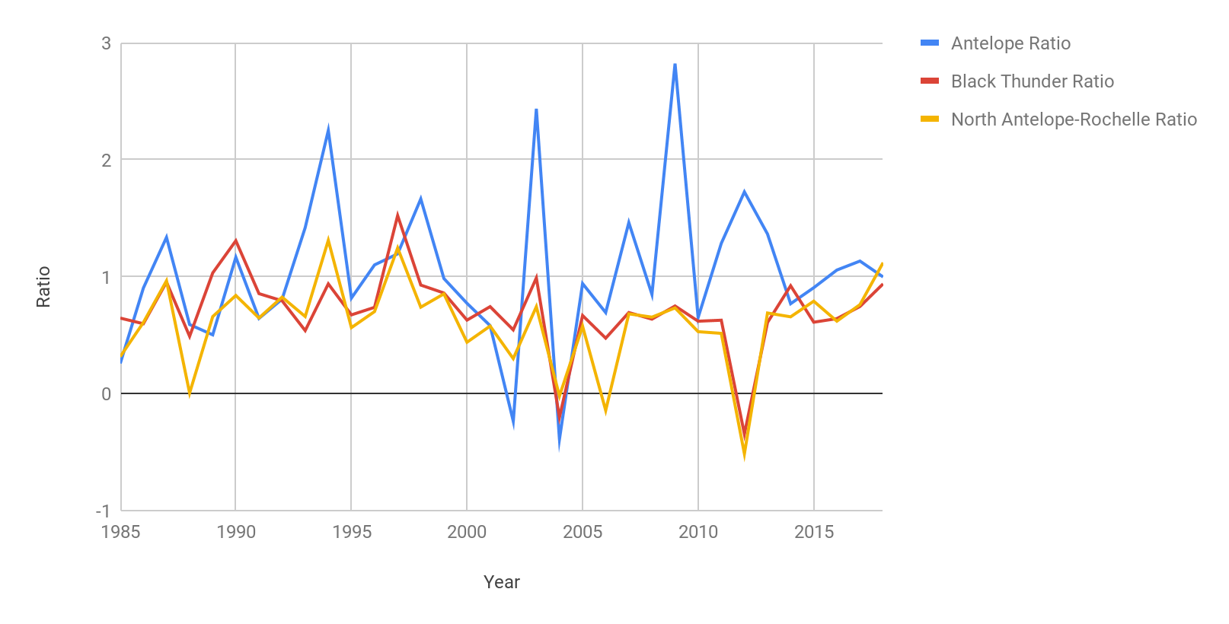

*Figure A1.*Chart of TCG ratio values between the North Antelope-Rochelle, Black Thunder, and Antelope mines from 1985 through 2018.



*Figure A2.*Chart of TCA ratio values between the North Antelope-Rochelle, Black Thunder, and Antelope mines from 1985 through 2018.

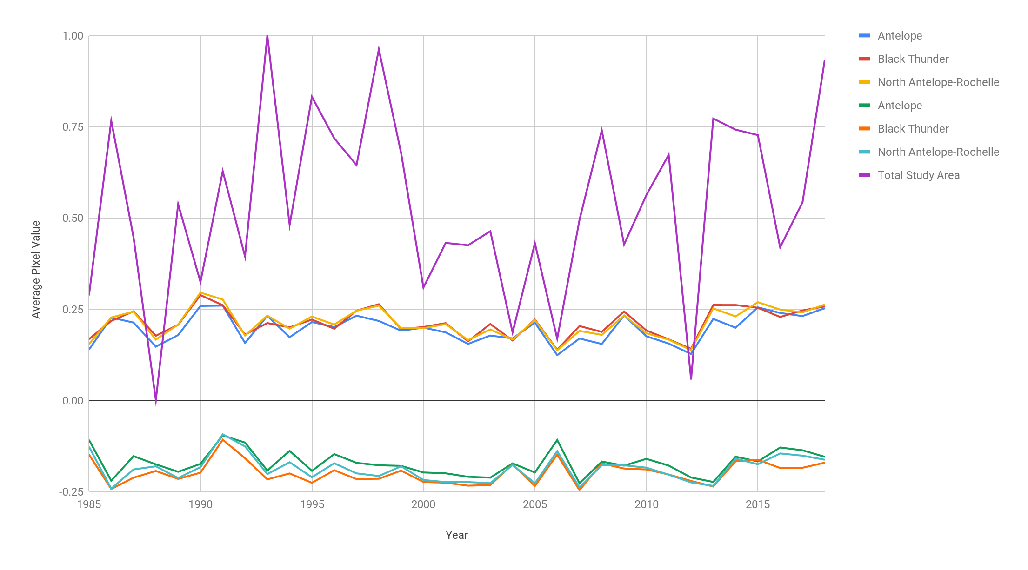

*Figure A3.*Chart of annual precipitation, NDVI, and NDWI for North Antelope-Rochelle, Black Thunder, and Antelope mines from 1985 through 2018.

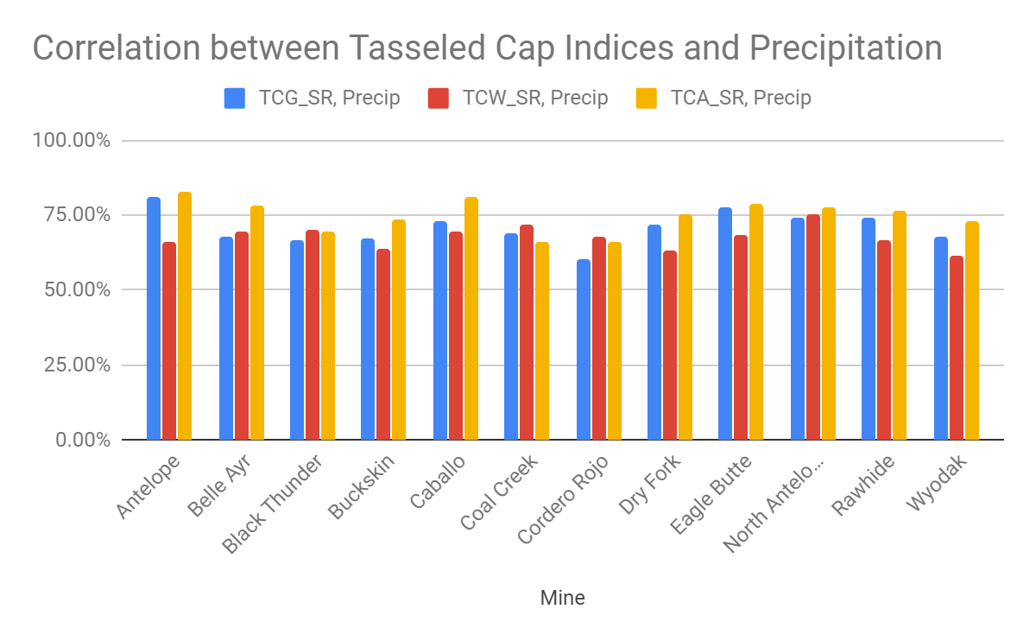

*Figure A4.* Chart of tasseled cap values for mines in the Powder River Basin correlated with precipitation.

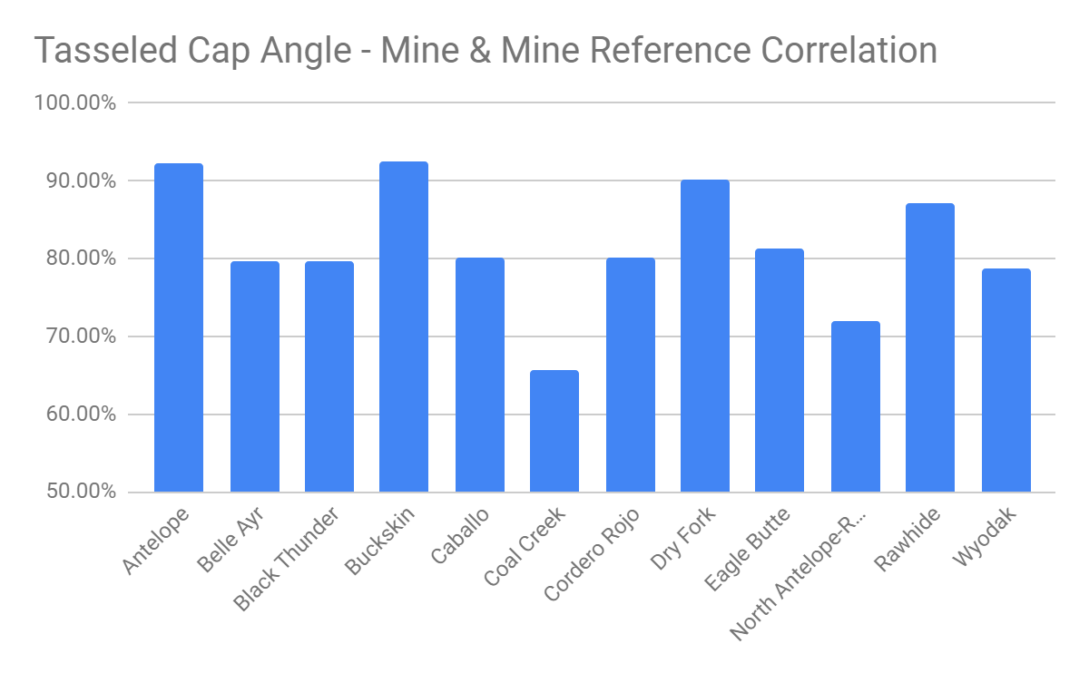

*Figure A5.* Chart of TCA values for mines and mine reference sites correlated to determine reclamation success in the Powder River Basin.