Alaska Ecological Forecasting II

Semi-Automated Mapping of Alaskan Wetland Inundation by Integrating Synthetic Aperture Radar and Optical Satellite Imagery

 **Technical Report**

Final Draft – April 4th, 2019

Alana Higgins (Project Lead)

Roger Ly

Annemarie Peacock

Adam Vaccaro

Bruce Chapman, NASA Jet Propulsion Laboratory, California Institute of Technology (Science Advisor)

Previous Contributors:

Briant Fabela

Alice Lin

# 1. Abstract

Alaska’s wetlands make up over a third of the state’s land cover and provide numerous ecosystem services, such as water filtration and storage, nutrient retention, and habitat to a diverse range of plant and animal species. Temporal variations in wetland inundation impact these ecosystem services, thus monitoring patterns and change is crucial for proper wetland management and future sustainability. The spring 2019 NASA DEVELOP Alaska Ecological Forecasting II team, in partnership with the Alaska Satellite Facility (ASF) and US Fish and Wildlife National Wetlands Inventory (USFWS NWI), built on the existing SAR Wetland Extent Exploration Tool (SWEET) created by the previous Alaska Ecological Forecasting team. The original features of SWEET included the creation of a land cover classification map showing wetland inundation using C-Band Synthetic Aperture Radar (C-SAR). This term, the tool additionally classified water regime based on inundation detected from a collection of multi-temporal C-SAR data. This new feature allowed for the analysis of inundation frequency, an attribute that gave important information on the behavior of wetlands throughout the year. The inundation tool was edited in a Jupyter Notebook and used radar data from Sentinel-1 C-SAR to create its inundation extent products. A new validation method that incorporated polygon data from the NWI was used to assess the accuracy of the inundation products created by the tool, in addition to validation using Landsat 8 Operational Land Imager imagery. With the addition of wetland frequency used in the assessment of SWEET products, end users were better equipped to analyze wetland extent by incorporating Alaska’s highly seasonal climate.

**Keywords**

remote sensing, wetlands, Alaska, inundation, land cover classification, synthetic aperture radar

# 2. Introduction

* 1. ***Background Information***

Wetlands in Alaska cover over 40 percent of the state, making this unique environment highly influential in ecological processes and resource management. Vital functions of this type of landscape include habitats for plants and animals, protection from erosion, sediment control, storage of flood waters, and numerous recreational and aesthetic uses (Hall, Frayer, & Wilen, 1994). These benefits are at risk for loss as climatic changes can alter wetland landscapes. To combat the issues of wetland vulnerability and adjusting to environmental impacts, scientists and policymakers seek to improve the efficiency of wetland extent mapping and analysis (Erwin, 2008).

Currently, the National Wetlands Inventory (NWI), managed by the US Fish and Wildlife Service (USFWS), is responsible for the classification of wetland types, which is provided for only 24 percent of Alaska. Mapping is carried out by image analysts who digitally delineate wetlands from high-resolution optical imagery and enter corresponding attributes. Unfortunately, this tedious process of manual mapping and lack of data due to cloud and canopy cover has proven inadequate and unreliable (Wilen & Bates, 1995).

Previous studies have explored the use of raster datasets created with C-band synthetic aperture radar (C-SAR) instruments to accurately classify land cover type. The Sentinel-1 C-SAR instrument implements a method of active remote sensing where sensors emit radiation toward the desired study area and the radiation interacts with the terrain. Receivers on the sensor record the portion of the radiation that reflects back toward the sensor. Since the return energy is dependent on surface roughness, backscatter values can be used to accurately interpret land cover (ESA, 2019). Sentinel-1 C-SAR instruments emit radiation in the C-band wavelength range (3.9 to 7.5 cm); at this range, the radiation is able to penetrate cloud cover and some vegetation (Kasischke & Bourgeau-Chavez, 1997). One advantage of using C-SAR data is that unlike passive remote sensors, the data will ideally be unaffected by the atmosphere, meaning clouds and atmospheric gases will not distort the images collected (Jensen, 2014). Since C-SAR sensors create illumination through the emission of microwaves, data collection is not dependent on the illumination of the sun on Earth’s surface, allowing data collection to occur at any time of day. Because of these advantages, C-SAR data were preferred over optical data to create land cover classifications to assist with the development of wetland maps in Alaska (Psomiadis, Soulis, Zoka, & Dercas, 2019).

This study focused on three sites in Alaska deemed important by partners at the NWI. Selawik and Area 1002 were NWI active mapping sites and Bear Lake was the algorithm testing site (*Figure 1*). The time period this analysis covered was the summer of 2017 (May to September), with a model forecasting until January 2020. This was the second term of the project, which was initially started by the fall 2018 DEVELOP Alaska Ecological Forecasting team. In the previous term, the team built a wetland inundation tool that used C-SAR imagery to create land cover classifications of wetland extent and used Landsat 8 Operational Land Imager (OLI), RapidEye, and PlanetScope imagery to quantitatively and qualitatively validate the classifications (Peacock, Fabela, Lin & Vaccaro, 2018). This term, changes were made to the tool to improve wetland land cover classification capabilities and data from the NWI and Landsat 8 were used for quantitative validation assessments of the tool’s output.

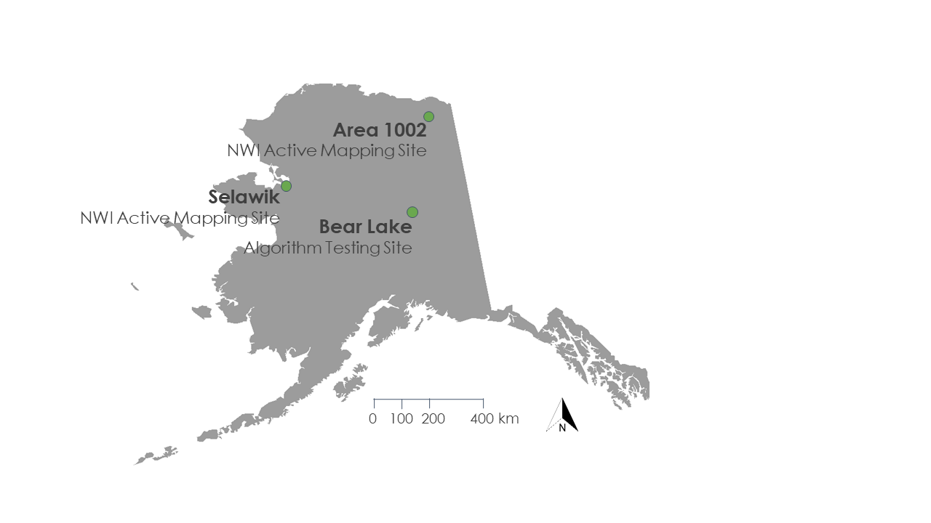

*Figure 1.* NWI active mapping and algorithm testing sites in Alaska, USA.

* 1. ***Project Partners & Objectives***

We collaborated with the USFWS NWI and the Alaska Satellite Facility (ASF). The NWI creates and manages the Wetlands Mapper, a web-based platform that provides detailed digital maps of wetlands in the United States. However, only around one-third of Alaska’s wetlands are currently included in the Wetlands Mapper. The NWI creates their maps through optical imagery interpretation and *in situ* validation, a process that can be resource intensive, particularly in Alaska’s remote areas. The addition of an algorithm to classify C-SAR data could provide ancillary data to enhance the NWI’s map production, and the NWI can use the inundation maps generated by the C-SAR algorithm to produce and refine their wetland maps.

The ASF provides on-demand, processed C-SAR imagery through their Hybrid Pluggable Processing Pipeline (HyP3), a cloud-based C-SAR data archive and processing platform. We collaborated with the ASF to obtain C-SAR imagery and to build an interactive tool in Jupyter Notebook to process C-SAR imagery and generate wetland inundation maps. The ASF can integrate the tool’s algorithm into their HyP3 platform and use the Jupyter Notebook as both a tutorial and a platform for users to interact with the processing and classification parameters.

The first term of this project created the SAR Wetland Extent Exploration Tool (SWEET). SWEET was built in Jupyter Notebook and its algorithm processes C-SAR data and outputs maps of wetland inundation extent. For the project’s second term, the project objectives were to build on SWEET by incorporating NWI water regime classifications and refining the algorithm to capture seasonal changes of inundation. For successful implementation of the tool, this project aimed to validate SWEET inundation maps with available NWI maps and Landsat 8 products and provide the NWI with final wetland inundation maps of specific study sites to enhance their current mapping efforts.

# 3. Methodology

***3.1 Data Acquisition***

We acquired 2017 C-SAR data in both vertically transmitted vertically received (VV) and vertically transmitted horizontally received (VH) polarizations from the ASF’s HyP3 tool data download portal, which provided co-registered and radiometrically corrected imagery (Hogenson et al., 2016) (Table 1). Sentinel-1 scenes were first visually inspected in the ASF’s Vertex interface to identify the Sentinel-1 paths and frames capturing our study areas in the ‘near range’ of the sensor as smaller incidence angles allow for stronger backscatter returns in the imagery. Sentinel-1 C-Band SAR imagery was used for its ability to penetrate cloud cover and record surface roughness in any weather, and the 10-meter resolution sufficiently captured study area surface features.

Multi-spectral optical Landsat 8 OLI Tier 1 Surface Reflectance images were accessed through Google Earth Engine and filtered to the corresponding C-SAR study period. Landsat 8 OLI products were acquired at 30 x 30 m resolution in 11 bands covering the ultra-blue to the thermal infrared spectrum. Tier 1 products were received already calibrated and radiometrically corrected (Table 1). The NWI shapefiles for the Bear Lake and Area 1002 study sites were downloaded from the NWI Wetlands Mapper. Our project partners at the NWI provided a recent draft version for the study site Selawik, Alaska.

Table 1

*Compilation of dataset information and acquisition*

|  |  |  |  |
| --- | --- | --- | --- |
| **Dataset** | **Parameters** | **Metadata** | **Data Acquisition** |
| Sentinel-1 C-SAR | Backscatter values, surface roughness | Level 1 IW, VV + VH,  30 m, 12-day return, May 2017 to September 2017 | ASF Vertex/HyP3 |
| Landsat 8 OLI | Surface reflectance | Tier 1, 30 m, 8-day return, May 2017 to September 2017 | Google Earth Engine |
| Wetlands Mapper | Wetland system, vegetation class, and subclass, water regime | Optical and field data indicating wetland extent and type, collected from a multitude of dates | US Fish and Wildlife Service, National Wetlands Inventory |

***3.2 Data Processing***

*3.2.1 C-SAR Processing*

A number of steps were required to prepare the C-SAR imagery for analysis (Appendix B). We first verified that the spatial coordinates of the C-SAR images were encoded in the Universal Transverse Mercator (UTM) projected coordinate system, and if not, we projected them using a shell script from the Geospatial Data Abstraction Library (GDAL). We also checked the co-registration of the images and omitted ones that were not registered correctly. We then took subsets of the images resulting in rectangular images free of missing values.

Having verified and subset the C-SAR data, we employed two subsequent methods to check for calibration errors. First, we calculated and mapped VV/ VH polarization ratios for each scene and visually inspected brightness anomalies. Second, we calculated the average brightness value for a given scene and plotted it over time. Based on these visual checks, we were able to identify and omit improperly calibrated C-SAR images as well as select date ranges that corresponded to the beginning and end of summer as reflected in the changes in brightness (Chapman et al., 2015). Calibrated C-SAR images that fell within summer months were used for analysis.

*3.2.2 National Wetlands Inventory Reclassification*

Acquired NWI wetland maps contained over 100 distinct wetland types based on various environmental factors. The wetland type of each defined polygon in our study sites was depicted in the form of a 4- to 8-character attribute code in which the different characters described the polygon’s wetland system, vegetation class, vegetation type, and frequency of inundation. From the unique attribute codes, we first reclassified NWI data into 13 broader classes based on the frequency, type of inundation, and the type and presence of vegetation. In order to directly compare NWI maps and the C-SAR classifications, we further aggregated the 13 classes into the 4 classes of permanent open water, permanent inundated vegetation, permanent not inundated, and seasonal inundation (Appendix C).

*3.2.3 Landsat 8 DSWE Algorithm*

Landsat 8 imagery was classified in Google Earth Engine (GEE) using a workflow based on the Dynamic Surface Water Extent (DSWE) algorithm developed by John W. Jones and Michael J. Starbuck of the US Geological Survey (USGS). The DSWE algorithm extracts five land cover classes from Landsat surface reflectance products by calculating and thresholding different bands and indices to determine surface water extent for each Landsat pixel (Jones, 2015) (Appendix A). Our script in GEE obtained Landsat 8 OLI scenes and output initial DSWE classifications. The script then masked out areas with snow, cloud shadows, clouds, and steep regions that are unlikely to retain surface water in order to output the filtered DSWE classification. To obtain permanent and seasonal inundation classes, we applied the DSWE algorithm to all available Landsat 8 OLI acquisitions from May to September 2017 in each study area. From this image collection of DSWE classifications, we calculated the minimum and maximum inundation composites. The difference in the minimum and maximum extent was used to determine each pixel’s permanence or seasonal change. The output classes of permanent open water, permanent not inundated, permanent inundated vegetation, and seasonal inundation were reclassified to match C-SAR.

***3.3 Data Analysis***

*3.3.1 C-SAR Classification*

The classification of C-SAR imagery was built off of the previous term’s SWEET product created in a Jupyter notebook for Python, which incorporated both automated algorithms and manual visual image interpretation (Appendix B). Multi-temporal averages were calculated for VV, VH, and VV/VH ratio intensity images tosmooth out the noise in the raw C-SAR images and estimate a site’s typical state. A rules-based thresholding classification was applied to the multi-temporal averages. Classes for open water and inundated vegetation were represented by ranges of VV, VH, and VV/VH values defined by upper and lower thresholds (Table 2). Each pixel was individually inspected to see if its three indices were contained in the specified ranges for each class. If the pixel values fell within the range of the open water class, the pixel was assigned to that class. If not, the process was repeated for the inundated vegetation class. If a pixel could not be classified as either open water or inundated vegetation, it implied that no surface water could be detected in the C-SAR imagery, and as such, these pixels defaulted to the not inundated class.

Classifications made using the multi-temporal averages were considered the typical inundation states during the study period. However, class thresholds were site-specific as soil and vegetation type differed across the state, resulting in the need to determine thresholds on a site-by-site basis. Thresholds were determined by visual inspection, along with trial and error by plotting the average VV, VH, and VV/VH ratios, visually interpreting different categories of inundation, and comparing pixel values for each. Multiple thresholds were tested until a range could be adequately selected for a site.

Multi-looked averages were determined by applying a 3- x 3-pixel moving window to VV, VH, and VV/VH images from individual dates. Similar to taking a multi-temporal average, multi-looking smooths the noise from raw C-SAR imagery, but it is only applied to a single date during each iteration, resulting in a set of classified products representing the inundation state on specific dates. These single date multi-looked images were used to produce classifications that showed the minimum, maximum, and seasonal inundation states.

A spatiotemporal stack of the multi-looked averages for each site was assembled to derive the minimum, maximum, and seasonal inundation states. The multi-looked images within a site had identical spatial coverage and spatial grids, but each one represented a different time stamp. For the minimum inundation state, the algorithm first checked if a pixel was classified as not inundated at any time and assigned the pixel as so. If the pixel was never classified as not inundated, the process was repeated for the open water class. If a pixel was never either not inundated or open water at any time, the pixel was assigned as inundated vegetation. The maximum inundation classification followed a similar process. If a pixel was ever classified as inundated vegetation, it was assigned as such in the maximum inundation product. Otherwise, the pixel values defaulted to the classes assigned in the typical inundation state.

To create a refined classification that output permanent as well as seasonal inundation classes, class occurrence counts were generated from the spatiotemporal stack for each class across all time stamps. A third and final thresholding-based classification was performed using the class occurrence counts. A minimum count threshold was input for each class in order to define the cut-off between permanent and seasonal variations of the classes. If a pixel’s occurrence count for a certain class was above the minimum threshold, it was determined to have persisted in that inundation class for a sufficient amount of time to be considered permanent. For each pixel, the algorithm first checked if the pixel could be classified as permanent water. If a classification of permanent open water could not be made, the algorithm moved on to check the permanent status of the next class in the sequence of open water > not inundated > inundated vegetation. If a pixel could not be determined to be a member of any of the permanent classes, it was assigned as seasonal inundation because not meeting the criteria for any of the permanent classes implied that it had changed inundation states throughout the time period. The output classes of this process were permanent open water, permanent not inundated, permanent inundated vegetation, and seasonal inundation.

Table 2

*C-SAR brightness thresholds for the Bear Lake site (units in digital number)*

|  |  |  |
| --- | --- | --- |
|  | **Open Water** | **Inundated** |
| **VV Low** | 0 | 0.1 |
| **VV High** | 0.2 | 0.63 |
|  |  |  |
| **VH Low** | 0 | 0 |
| **VH High** | 0.063 | 0.33 |
|  |  |  |
| **VV/VH Low** | 0 | 3 |
| **VV/VH High** | 10 | 50 |

*3.3.2 Accuracy Assessments*

We compared our tool’s C-SAR seasonal inundation classifications to reclassified NWI maps and Landsat 8 DSWE classifications. To assess accuracy, confusion matrices were generated and analyzed in the Harris Corporation ENVI software where NWI and DSWE were set as the “ground truth” images and overlaid with the C-SAR classification. To accurately compare classifications, NWI maps were converted to 10-meter resolution rasters and C-SAR data were resampled to 30 meters for comparison with Landsat DSWE. Additionally, NWI maps only include areas classified into a wetland or inundated class and lack data in areas without inundation. To only compare C-SAR in areas with available NWI, the C-SAR classification was extracted to available NWI extent.

***3.4 Wetland Modeling to 2020***

A wetland model was created using the Sea Level Affecting Marshes Model (SLAMM) that simulates wetland change due to sea level rise. The mathematical model accepts raster data in ESRI ASCII Raster format and requires the minimum inputs of a digital elevation model (DEM), slope, and SLAMM NWI rasters to run. Additional data that the model can take into consideration include accretion rates, erosion rates, precipitation rates, and more. An IfSAR 5-meter Digital Terrain Model (DTM) was downloaded from USGS Earth Explorer and transformed into an ESRI ASCII format in ArcMap to be used as the DEM data in our model. A slope raster was created using the IfSAR DTM and the Slope tool in ArcMap. NWI data were acquired as a shapefile from the National Wetlands Mapper and clipped to our study area. In order for SLAMM to be able to read the NWI data, attribute codes were transformed into SLAMM codes as specified by the NWI to SLAMM Category Conversion table in the SLAMM 6.7 Technical Documentation (Appendix D). A new raster was created using the SLAMM Code values in ESRI ASCII format. Global sea level rise rate was adjusted to match current values in 2019 (3.2 mm/yr) in the model. The model was started in 2010 which was chosen based on the NWI data received, and the study area was modeled to 2020.

# 4. Results & Discussion

***4.1 Analysis of Results***

The series of C-SAR images in *Figure 2* demonstrate seasonal variation in inundation extent. Only three out of the ten C-SAR images used are shown in *Figure 2*. In this area of Selawik, the imagery signatures suggest a drying trend occurring throughout the summer. In the May acquisition, darker areas of lower backscatter return indicate the presence of surface water surrounding the central lake, flooding onto land. In these same areas, the transition to bright, higher backscatter returns in July suggests the growth of vegetation as the double bounce effect occurs in areas of emergent inundated vegetation. The final image in September occurs at the end of the growing season, a time of less inundation and dieback of vegetation.

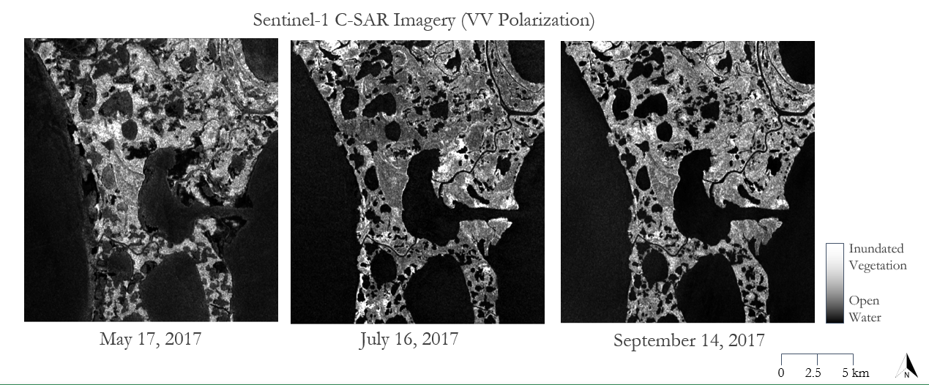

*Figure 2.* C-SAR imagery of the same extent as the classification in Selawik, Alaska, over single dates spaced two months apart. Darker tones of lower backscatter return indicate areas with surface water and lighter tones indicate the presence of vegetation. The top right portion of the central lake experiences changes in backscatter values.

***4.2 National Wetlands Inventory Comparison***

The C-SAR classification was compared to the NWI Reclassification to check for validity (*Figure 3*). Bodies of open water are similarly classified between the two. The reclassified NWI image on the left has more areas classified as permanent inundated vegetation (indicated with yellow) than the SAR classification which has classified the majority of this area as seasonally inundated vegetation (indicated by green). This is especially visible in the area surrounding the largest lake in the center of the image. To further check the validity of the C-SAR classification, each image used in the classification were manually analyzed through visual interpretation. For Selawik, this visual interpretation agreed with the C-SAR classification created by our tool – large areas around the central lake are seasonally inundated.

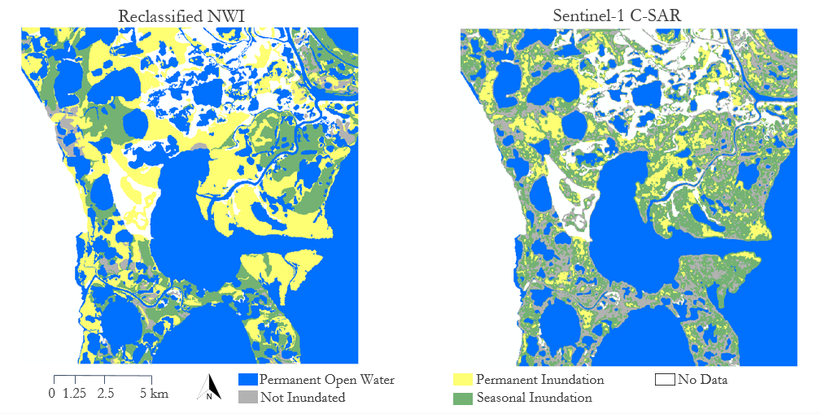

*Figure 3.*Comparison of water regime classifications of an area of interest in Selawik, Alaska. The NWI classification was derived from NWI draft data from March 2019. The C-SAR classification was created with the SWEET algorithm using Sentinel-1 C-SAR data from May 2017 through September 2017.

The disagreement between NWI and C-SAR for areas of permanently inundated vegetation and seasonally inundated vegetation is seen in the lowered percentages in the confusion matrix (Table 3). It is important to note that although the confusion matrix shows the “Not Inundated” as only agreeing with NWI data 46.98 percent of the time, this class had significantly less land cover in this area in the NWI data, causing small mismatches to be inflated into a large percent of disagreement. In this specific extent, areas classified as permanently inundated in the NWI data had the water regime modifier F – semi-permanently inundated. The definition for semi-permanently inundated areas according to the wetland classification documentation used by the National Wetland Inventory says it includes “Surface water [that] persists throughout the growing season in most years. When surface water is absent, the water table is usually at or very near the land surface.” (Federal Geographic Data Committee, 2013). There is the possibility that this area is actually permanently inundated, but the year observed with C-SAR data was drier causing areas to dry up and become classified as seasonally inundated. However, it is more likely that the C-SAR classification is better able to identify seasonal inundation due to the tool’s ability to pick up on changes in inundation through multiple dates of imagery as shown in the case with Selawik.

Table 3

*Confusion matrix comparison NWI Reclassification and Sentinel-1 C-SAR Classification*

|  |  |  |  |  |  |
| --- | --- | --- | --- | --- | --- |
| **Overall agreement: 59.10%** | | **NWI Classification** | | | |
| **Permanent Open Water** | **Not Inundated** | **Permanent Inundated Vegetation** | **Seasonal Inundated Vegetation** |
| **C-SAR**  **Classification** | **Permanent Open Water** | 80.01% | 0.03 | 0.13 | 0.07 |
| **Not Inundated** | 9.24 | 46.98% | 17.55 | 36.83 |
| **Permanent Inundated Vegetation** | 0.64 | 8.24 | 24.19% | 17.17 |
| **Seasonal Inundated Vegetation** | 10.11 | 44.75 | 58.13 | 45.93% |

***4.3 Landsat DSWE Comparison***

The C-SAR classifications were also compared against Landsat DSWE images to validate with another multi-temporal dataset (Table 4). C-SAR classified more areas as inundated, possibly due to a bias in the DSWE dataset (*Figure 4*). Multispectral imagery is unable to penetrate cloud cover and DSWE masks portions of imagery covered by clouds. Although all available dates were included in the DSWE algorithm, areas are more likely unmasked and cloudless during warmer and drier periods, possibly resulting in an underestimation of inundated area in DSWE. Also, compared to C-SAR, DSWE classified significantly fewer inundated areas as permanently inundated vegetation. Vegetation growth throughout the summer may have impacted DSWE’s underestimation of inundation permanence (*Figure 4*). As Selawik is primarily composed of emergent vegetation, lower biomass earlier in the growing season results in more detectable inundation in the multispectral optical imagery. Increasingly dense vegetation later in the summer may have limited DSWE’s ability to penetrate the canopy and capture a water signal. Another factor that impacted differences in classification was that DSWE considers vegetation as a determinant for wetland identification while C-SAR directly focuses on the presence of water.

Table 4

*Confusion matrix comparison between Landsat 8 DSWE classification and Sentinel-1 C-SAR classification*

|  |  |  |  |  |  |
| --- | --- | --- | --- | --- | --- |
| **Overall agreement: 65.5%** | | **DSWE Classification** | | | |
| **Permanent Open Water** | **Not Inundated** | **Permanent Inundated Vegetation** | **Seasonal Inundated Vegetation** |
| **C-SAR**  **Classification** | **Permanent Open Water** | 87.79% | 0.02 | 5.51 | 1.30 |
| **Not Inundated** | 4.64 | 33.49% | 43.83 | 28.89 |
| **Permanent Inundated Vegetation** | 1.08 | 8.24 | 10.92% | 18.96 |
| **Seasonal Inundated Vegetation** | 6.49 | 51.70 | 39.74 | 50.85% |

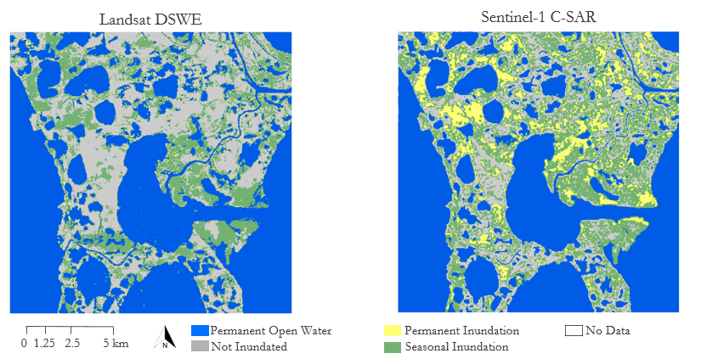

*Figure 4*. Comparison between Landsat 8 DSWE Multi-Temporal Classification and C-SAR Multi-Temporal Classification at Selawik. Both used available data from May 2017 to September 2017.

***4.4 Wetland Modeling Results***

We ran the SLAMM model on Selawik and created a wetland classification map and a 3-dimensional visualization of the area (*Figure 5*). Selawik’s close proximity to the ocean makes it a primary location that would be affected by sea level rise and storm surges. Its remote location has made it an ideal area to observe the natural cycles of change in wetlands and their response to climate variations. The raster produced was visually similar to the reclassified NWI map that we produced, which is to be expected due to the short forecasting range (2010 to 2020). Higher elevations corresponded to not inundated upland indicated in red, and lower elevations were lake or wetland areas indicated by blue or green. The key difference that the model produced was the introduction of the estuarine open water class. This indicates that this area could see the introduction of more saltwater from the Pacific Ocean as a result of sea-level rise, creating a brackish wetland environment in the near future. Many ecosystem services will be altered with the transition to a brackish environment, and plants and animal species might not be able to adapt. With this information, scientists can locate wetlands with impact potential and observe the change in those areas of interest. This model can be applied to any other site covered by a DEM and NWI data, making it a powerful tool for identifying wetlands at risk of change. With SWEET, NWI data can be updated more often at a higher spatial resolution, allowing for models with higher spatial resolution and validity.

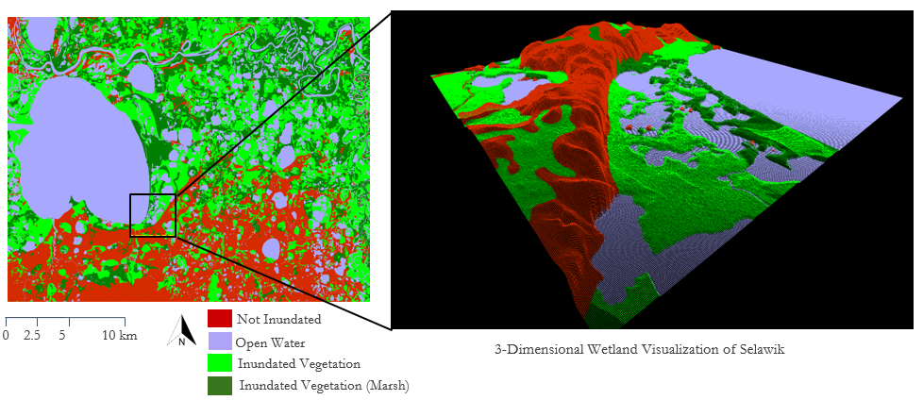

*Figure 5.* Sea Level Affecting Marshes Model (SLAMM) output of Selawik, Alaska, using NWI Draft Data and IfSAR Alaska 5 m DTM.

***4.5 Future Work***

The primary focus of future work on this project would be to automate the class threshold selection process. Proposed solutions include machine learning approaches that incorporate an unsupervised learning method, such as clustering, that is augmented by a rules-based ranking system in order to make the workflow fully automated. Alternatively, a supervised learning classification method such as random forest or neural networks could be employed to automate the threshold selection. Aside from machine learning solutions, the thresholding automation could be accomplished through a grid search of parameter values embedded in a full classification-validation workflow that would return the optimal threshold values according to validation scores.

Other future work includes preparing SWEET for either deployment onto ASF’s Open SAR Lab Jupyter notebook environment by polishing the interactive user experience of the SWEET Jupyter Notebook or integration into ASF’s HyP3 by importing the notebook code into a standalone Python module. A possible extension of the project’s work would be to explore the capabilities of different SAR bands from other Earth observation (EO) satellites. The intention would be to determine the potential for future NASA EO data, such as L-Band SAR data from the upcoming NASA-ISRO SAR Mission (NISAR), to be used to delineate wetland areas using SWEET or similar algorithms.

# 5. Conclusions

By comparing the C-SAR classifications to multiple datasets, we increased validation methods and were able to assess accuracy with more confidence. Both automated and visual inspections increased our understanding of wetland extent with regards to seasonal change. Additionally, by incorporating our partner’s database into the validation process, this project increased its relevance and applicability to involved organizations and individuals. Although the NWI is not involved in policy making for the study sites, they serve as a foundation for authority figures to reference in order to make informed decisions. Our findings can benefit wetland management and further enhance wetland repositories for the state of Alaska. As our partners begin mapping efforts in Area 1002, they can use our preliminary SAR output maps to instantaneously validate any field data collected and to cross-check qualitative observations.

The C-SAR thresholding process effectively detected inundation, and although VV, VH, and VV/VH thresholds varied between sites, threshold selections showed potential for automation. When examining C-SAR data for the summer season of 2017, the maximum inundation extent was found to be less than that of NWI estimates. This difference could be accredited to vast changes in water systems and climatic influences, as NWI data date back to the 1970s and 1980s. Finally, Sentinel-1 C-band SAR is most accurate in delineating inundation in open water and herbaceous and shrub-filled wetlands. Understanding the sensor’s strengths and limitations can aid in the future remote sensing of wetland environments.

# 6. Acknowledgments

The Alaska Ecological Forecasting II team would like to thank the mentors and partners who provided their support and time to make this project possible. Specifically, thank you to our Science Advisor Bruce Chapman at JPL, project partners Dr. Megan Lang at the NWI, Jeremy Nicoll and Franz Meyer at the ASF, and Term I DEVELOP team members, Alice Lin, and Briant Fabela.

This material contains modified Copernicus Sentinel data (2017), processed by ESA.

Any opinions, findings, and conclusions or recommendations expressed in this material are those of the author(s) and do not necessarily reflect the views of the National Aeronautics and Space Administration.

This material is based upon work supported by NASA through contract NNL16AA05C.

# 

# 7. Glossary

**ASF** – Alaska Satellite Facility

**ASF Vertex** – Data acquisition portal of the Alaska Satellite Facility for remotely sensed data of the Earth

**ASCII** – American Standard Code for Information Interchange

**Co-registration** – The process of accurately aligning the same geographical locations on different data sets; essential when performing analysis or change detection processes

**DEM** – Digital Elevation Model

**Digital Number** – The intensity value of a pixel

**DTM** – Digital Terrain Model

**Earth Explorer** – USGS satellite, aerial imagery, and remote sensing data catalog

**Earth observations** – Satellites and sensors that collect information about the Earth’s physical, chemical, and biological systems over space and time

**ENVI** – Harris Corporation image analysis software and file format that incorporates an image file and a header ASCII file containing the image’s metadata and other metrics

**GEE** – Google Earth Engine

**GDAL** –Geospatial Data Abstraction Library; Shell and Python script library for processing vector and raster geospatial data

**GeoTIFF** – File format that integrates georeferenced geographical data with TIFF imagery

**HyP3** – Hybrid Pluggable Processing Pipeline; ASF tool for providing on-demand processed SAR data

**NISAR** – NASA-ISRO SAR Mission; an upcoming SAR mission jointly planned by NASA and the Indian Space Research Organization (ISRO) that will provide L-Band and S-Band SAR measurements

**NWI** – National Wetlands Inventory; established by the US Fish and Wildlife Service

**SAR** – Synthetic Aperture Radar

**SWEET** – SAR Wetland Extent Exploration Tool; Python Jupyter Notebook tool developed during the first term of this project to create wetland extent maps from C-SAR imagery

**USFWS** – United States Fish and Wildlife Service

**VV** – Vertical transmit, vertical receive; radar system wave polarization consisting of vertical linear transmission and vertical linear reception

**VH** – Vertical transmit, horizontal receive; radar system wave polarization consisting of vertical linear transmission and horizontal linear reception

# 8. References

Chapman, B., McDonald, K., Shimada, M., Rosenqvist, A., Schroeder, R., & Hess, L. (2015). Mapping regional inundation with spaceborne L-band SAR. *Remote Sensing*, *7*(5), 5440–5470. <https://doi.org/10.3390/rs70505440>

Erwin, K. L. (2008). Wetlands and global climate change: the role of wetland restoration in a changing world. *Wetlands Ecology and Management*, *17*(71). https://doi.org/10.1007/s11273-008-9119-1

ESA. (2019). *User Guides - Sentinel-1 SAR - Geophysical Measurement - Sentinel Online.* Retrieved from https://sentinel.esa.int/web/sentinel/user-guides/sentinel-1-sar/product-overview/geophysical-measurements

Federal Geographic Data Committee (2013). *Classification of wetlands and deepwater habitats of the United States*. Retrieved from https://www.fws.gov/wetlands/documents/Classification-of-Wetlands-and-Deepwater-Habitats-of-the-United-States-2013.pdf

Hall, J. V., Frayer, W. E., & Wilen, B. O. (1994). *Status of Alaska wetlands* (Report for the US Fish and Wildlife Service). Retrieved from <https://www.fws.gov/wetlands/documents/status-of-alaska-wetlands.pdf>

Hogenson, K.., Arko, S. A., Buechler, B., Hogenson, R., Herrmann, J., & Geiger, A. (2016). Hybrid Pluggable Processing Pipeline (HyP3): A cloud-based infrastructure for generic processing of SAR data [Abstract]. Poster presented at the AGU Fall Meeting, San Francisco, CA, 13 December 2016. Retrieved from <https://agu.confex.com/agu/fm16/meetingapp.cgi/Paper/190997>

Jensen, J. R. (2014). *Remote sensing of the environment: An Earth resource perspective* (2nd ed.). Essex: Pearson Education Limited.

Jones, J. W. (2015). Efficient wetland surface water detection and monitoring via Landsat: Comparison with in situ data from the Everglades Depth Estimation Network. *Remote Sensing*, *7*(9), 12503-12538. <http://dx.doi.org/10.3390/rs70912503>

Kasischke, E. S., & Bourgeau-Chavez, L. (1997). Monitoring South Florida Wetlands Using ESR-1 SAR Imagery. *Photogrammetric Engineering and Remote Sensing*, *63*(3), 281-291. Retrieved from https://www.academia.edu/20773363/Monitoring_South_Florida_wetlands_using_ERS-1_SAR_imagery

Kautz, S. (2018). Landsat 8 OLI (Operational Land Imager) and TIRS (Thermal Infrared Sensor) [Dataset]. US Geological Survey. https://doi.org/10.5066/f71835s6

National Wetlands Inventory. Wetlands Mapper [Dataset]. Accessed February 1, 2019. Retrieved from https://www.fws.gov/wetlands/data/mapper.html

Peacock, A., Fabela, B., Lin, A., & Vaccaro, A. (2018). *Automated wetland hydroperiod mapping by integrating optical satellite imagery and synthetic aperture radar.* Technical report for the NASA DEVELOP National Program.

Psomiadis, E., Soulis, K. X., Zoka, M., Dercas, N. (2019). Synergistic approach of remote sensing and GIS techniques for flash-flood monitoring and damage assessment in Thessaly Plain area, Greece. *Water*, *11*(3). https://doi.org/10.3390/w11030448

Wilen, B. O., & Bates, M. K. (1995). The US Fish and Wildlife Service's National Wetlands Inventory Project. *Vegatatio, 118*(1-2), 153-169. <https://doi.org/10.1007/BF00045197>

**9. Appendices**

**Appendix A.** DSWE classes and corresponding reclassified categories

|  |  |
| --- | --- |
| **DSWE Category** | **Reclassified Category (Binary)** |
| Not water | Not inundated |
| High confidence water | Inundated |
| Moderate confidence water | Inundated |
| Potential wetland | Inundated |
| Low confidence water or wetland | Not inundated |

**Appendix B.** SWEET workflow schematic

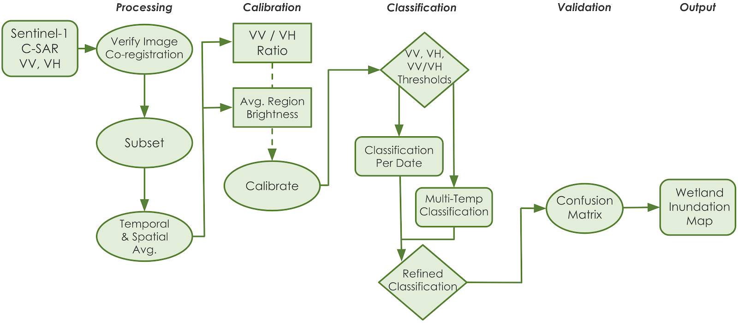

**Appendix C.** Reclassified NWI water regime codes

|  |  |  |  |  |
| --- | --- | --- | --- | --- |
| **Permanent Inundation** | **Permanent Open Water** | **Seasonal Inundation** | **Seasonal Open Water** | **Not Inundated** |
| L2EM2F | E1ABL | E2EM1P | L2USA | PSS1/FO1D |
| L2EM2H | E1UBL | E2SS1P | L2USC | PEM1/SS1B |
| PEM1/2F | L1ABH | PEM1/SS1A | PEM1/USC | PEM1/SS1D |
| PEM1/SS1F | L1ABV | PEM1/SS1C | PUSA | PEM1B |
| PEM1/SS1T | L1UBH | PEM1/SS1Cx | PUSC | PEM1D |
| PEM1/SSF | L1UBHh | PEM1/SS1E | PUSCx | PSS/EM1B |
| PEM1F | L1UBV | PEM1/SS1EE | R2USA | PSS1/EM1B |
| PEM1T | L2AB2H | PEM1/SS1R | R2USC | PSS1/EM1D |
| PEM2/1F | L2AB3H | PEM1A | R3USA | PSS1B |
| PEM2/SS1F | L2ABH | PEM1C | R3USC | PSS1D |
| PEM2F | L2EM2/UBH | PEM1E | R4SBC | PSSA/EM1D |
| PEM2H | L2UBF | PEM1R | R5USC | PEM1/SSB |
| PSS/EM1F | M1UBL | PFO/SS1A | R4SBA | PUS/EM1E |
| PSS1/EM1F | PAB3F | PFO/SS4B | E2USN | PEM1/SS1Ad |
| PSS1/EM1T | PAB3H | PFO1/SS1A | E2USP |  |
| PSS1/EM2F | PEM1/UBF | PFO1/SS1E | M2USP |  |
| PSS1F | PUBF | PFO4/SS1B |  |  |
| PSS1T | PUBH | PFO4/SS1E |  |  |
| R2EM2F | PUBV | PFO4/SS4B |  |  |
| R2EM2H | R1UBT | PSS/EM1A |  |  |
| PUBHx | R1UBV | PSS/EM1C |  |  |
| L2AB3/EM2H | R1USQ | PSS/EM1E |  |  |
| L2EM2/AB3H | R2UBF | PSS1/4A |  |  |
| L2UB/EM2F | R2UBH | PSS1/4B |  |  |
| L2UB/EM2H | R3UBH | PSS1/EM1A |  |  |
| PAB3/EM1F | R5UBH | PSS1/EM1C |  |  |
| PAB3/EM2H | L2UBH | PSS1/EM1E |  |  |
| PAB3/SS1F | R2UB/EM2H | PSS1/EM1EE |  |  |
| PEM1/AB3F |  | PSS1/EM1R |  |  |
| PEM1/UBT |  | PSS1/FO1E |  |  |
| PEM2/AB3H |  | PSS1/FO4B |  |  |
| PEM2/UBF |  | PSS1/FO4E |  |  |
| PEM2/UBH |  | PSS1A |  |  |
| PUB/EM2F |  | PSS1C |  |  |
| PUB/EM2H |  | PSS1E |  |  |

|  |  |  |  |  |
| --- | --- | --- | --- | --- |
| **Permanent Inundation** | **Permanent Open Water** | **Seasonal Inundation** | **Seasonal Open Water** | **Not Inundated** |
| R2EM2/UBH |  | PSS1R |  |  |
| PFO1F |  | PSS2B |  |  |
|  |  | PSS4/1B |  |  |
|  |  | PSS4/2B |  |  |
|  |  | PSS4/EM1B |  |  |
|  |  | PSS4/FO4B |  |  |
|  |  | PSS4B |  |  |
|  |  | PEM1/SS1Ad |  |  |
|  |  | R3UBF |  |  |
|  |  | PUS/SS1A |  |  |
|  |  | PEM1/FOCh |  |  |
|  |  | R2UBG |  |  |
|  |  | PFO1/2B |  |  |
|  |  | PFO1/4B |  |  |
|  |  | PFO1A |  |  |
|  |  | PFO1B |  |  |
|  |  | PFO1E |  |  |
|  |  | PFO4/1A |  |  |
|  |  | PFO4/1B |  |  |
|  |  | PFO4/2B |  |  |
|  |  | PFO4B |  |  |
|  |  | PFO4E |  |  |
|  |  | PEM1/USA |  |  |
|  |  | PEM1/USE |  |  |
|  |  | PSS1/UBF |  |  |
|  |  | PSS1/USA |  |  |
|  |  | PSS1/USC |  |  |
|  |  | PUB/EM1F |  |  |
|  |  | PUS/EM1A |  |  |
|  |  | PEM1/FO1E |  |  |
|  |  | PEM1/FO4E |  |  |

**Appendix D.** NWI Attribute Codes to SLAMM Codes

|  |  |  |
| --- | --- | --- |
| **ATTRIBUTE** | **SLAMM Code** | **SLAMM Class** |
| PSS1E | 3 | Nontidal Swamp |
| PSS1F | 3 | Nontidal Swamp |
| PSS1/EM1E | 3 | Nontidal Swamp |
| PSS1/EM1F | 3 | Nontidal Swamp |
| PSS1/EM1D | 3 | Nontidal Swamp |
| PSS1D | 3 | Nontidal Swamp |
| PSS1/UBF | 3 | Nontidal Swamp |
| PSS1/FO4E | 3 | Nontidal Swamp |
| PSSA/EM1D | 3 | Nontidal Swamp |
| PEM1F | 5 | Inland Fresh Marsh |
| PEM1/SS1F | 5 | Inland Fresh Marsh |
| PEM1/SS1E | 5 | Inland Fresh Marsh |
| PEM1E | 5 | Inland Fresh Marsh |
| PEM1/SS1D | 5 | Inland Fresh Marsh |
| PEM1D | 5 | Inland Fresh Marsh |
| L2EM2F | 5 | Inland Fresh Marsh |
| PEM1/UBF | 5 | Inland Fresh Marsh |
| L2EM2H | 5 | Inland Fresh Marsh |
| PEM1/SSF | 5 | Inland Fresh Marsh |
| L2EM2/UBH | 5 | Inland Fresh Marsh |
| R2UBH | 15 | Inland Open Water |
| L1UBH | 15 | Inland Open Water |
| L1ABH | 15 | Inland Open Water |
| PUBH | 15 | Inland Open Water |
| R2UBF | 15 | Inland Open Water |
| R3UBH | 15 | Inland Open Water |
| L2ABH | 15 | Inland Open Water |
| PUB/EM1F | 15 | Inland Open Water |
| PUBF | 15 | Inland Open Water |
| R4SBC | 22 | Inland Shore |
| R2USC | 22 | Inland Shore |