**NASA DEVELOP National Program**



NASA Jet Propulsion Laboratory

*Fall 2016*

Southern Arizona Ecological Forecasting

Detecting and Monitoring Invasive Buffelgrass in the National Parks of Southwestern Arizona

** Technical Report**

Final Draft – November 17, 2016

Molly Spater (Project Lead)

Natalie Queally

Nick Rousseau

Erika Higa

Natasha Stavros, NASA Jet Propulsion Laboratory (Science Advisor)

# 1. Abstract

Organ Pipe Cactus National Monument, located in southern Arizona, is home to both diverse native species and a rich cultural history. It is the only place in the United States where large stands of organ pipe cactus (*Stenocereus thurberi*) can be found. Unfortunately, the Park’s landscape is under threat from invasive buffelgrass (*Pennisetum ciliare*), a non-native species originally brought to the United States from Eurasia and Africa to stabilize soils and improve the productivity of rangelands. Buffelgrass forms dense mats in vacant gaps between native plants that normally serve as fire breaks. Consequentially, these mats become vast fuel loads with high peak fire temperatures that drastically increase the chance of devastating wildfires. The plant also threatens the transformation of native desertscapes to grasslands through an expansive root system that allows the species to outcompete native flora. Currently, park managers rely on costly aerial and ground surveys to monitor this species. To improve the capability of the National Park Service (NPS) to combat the spread of buffelgrass, this project investigated and furthered two methodologies for buffelgrass detection, and mapped predicted locations of buffelgrass presence. Because buffelgrass has a quick phenological response to precipitation events, the Climate-Landscape Response (CLaRe) model was used to study the relationship between remotely sensed Normalized Difference Vegetation Index (NDVI) data derived from the Moderate Resolution Imaging Spectroradiometer (MODIS) and rainfall data from the Parameter-elevation Relationships of Independent Slopes Model (PRISM). We also tested a spectral-based approach, using the Mixture Tuned Matched Filtering (MTMF) technique on high-spatial-resolution WorldView-2 data.

**Keywords**

Remote Sensing, Buffelgrass, Invasive Species, MODIS, Landsat, WorldView-2, CLaRe Metrics, MTMF

# 2. Introduction

* 1. ***Background Information***

Buffelgrass (*Pennisetum ciliare*), a perennial bunchgrass native to Africa, the Middle East, Asia and Europe, was brought to the United States as early as 1889 to stabilize soils and improve the productivity of rangelands affected by drought and overgrazing (Van Devender et al., 2009). As an aggressive invasive species, buffelgrass has since expanded across the southwestern United States threatening to turn native diverse ecosystems into grasslands (Figure 1). Buffelgrass’s ability to establish itself stems from an expansive root system. The plant, with this system, is able to outcompete local flora for essential soil nutrients, and respond to precipitation events faster, furthering advancing its ability to dominate landscapes (Lyons et al., 2013). As buffelgrass spreads, it populates otherwise barren vegetation gaps in the desert landscape forming vast fuel loads with high peak temperatures (Wallace et al., 2016). The presence of buffelgrass in the landscape therefore magnifies risk of wildfire and alters local fire regimes. While native vegetation is not adapt to frequent wildfires, buffelgrass flourishes as it is able to propagate more rapidly (Lyons et al., 2013). Dramatic wildfire events put public safety in the region at risk as well. Containing the spread of buffelgrass infestations is of high priority to land managers in the southwest.

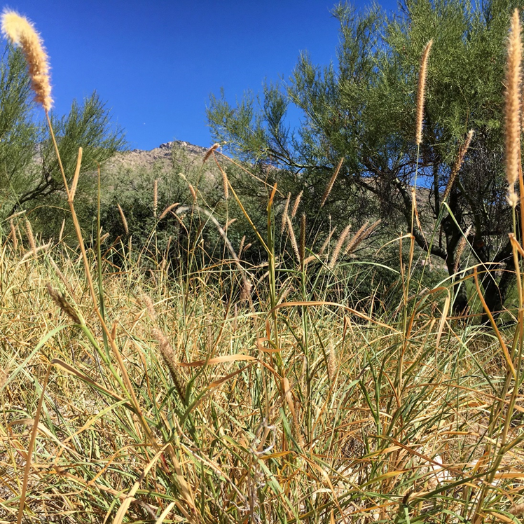

**Figure 1.** Buffelgrass can grow in large patches which makes the landscape more susceptible to wildfires.

Remote sensing methods for targeted invasive species detection have been the subject of many past studies. Our project investigated two of these proposed methods to improve monitoring of buffelgrass in the southwestern United States. The first method, the Climate Landscape Response (CLaRe) metric model developed by Wallace et al (2016), harnesses phenological characteristics of buffelgrass as a means of detection. The second, Mixture-Tuned Matched Filtering (MTMF), analyzes spectral information within pixels to determine the plant’s presence within a landscape.

Buffelgrass, as an opportunistic invader, “greens up” much quicker in response to precipitation than native flora. This dynamic is the basis of the CLaRe metric model. Wallace et al (2016) demonstrated that the rapid response behavior of buffelgrass could be identified through correlation values between measures of greenness and precipitation in Saguaro National Park.

Mixture-Tuned Matched Filtering (MTMF) is a subpixel, spectral-based approach for detecting a target species. The method operates by estimating the percentage of land coverage of a target species per pixel based upon reflectance values observed. Land cover types can be differentiated by their unique reflectance values across the electromagnetic spectrum, known as a spectral signature (Figure 2). Sankey et al. (2014) was able to successfully utilize MTMF to map the presence of Sahara mustard (*Brassica tournefortii*) in Saguaro National Park based on its spectral signature.

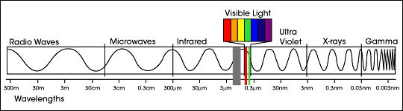

**Figure 2:** Electromagnetic Spectrum. Image credit: NASA

* 1. ***Study Area and Study Period***

Organ Pipe Cactus National Monument (OPCNM) covers 516 square miles of the Sonoran Desert in southwestern Arizona, spanning wide alluvial basins, steep mountain ranges, and rare desert springs (Figure 3). The Park with its diverse Sonoran flora and fauna is a designated United Nations Educational, Scientific And Cultural Organization (UNESCO) International Biosphere Reserve (National Park Service, n.d.). Organ pipe cactus (*Stenocereus thurberi*) and saguaro cactus (*Carnegiea gigantean*) are the most renowned species of cacti in the Monument. Common native shrub species in the park include brittle bush (*Encelia farinosa*), jojoba bush (*simmondsia chinensis*), ocotillo (*Fouquieria splendens*), and creosote (*Larrea tridentata*) (National Park Service, n.d.). This distinct landscape was the chosen study area for this project. The study period was 2009-2012, coinciding with the time period of available field data.

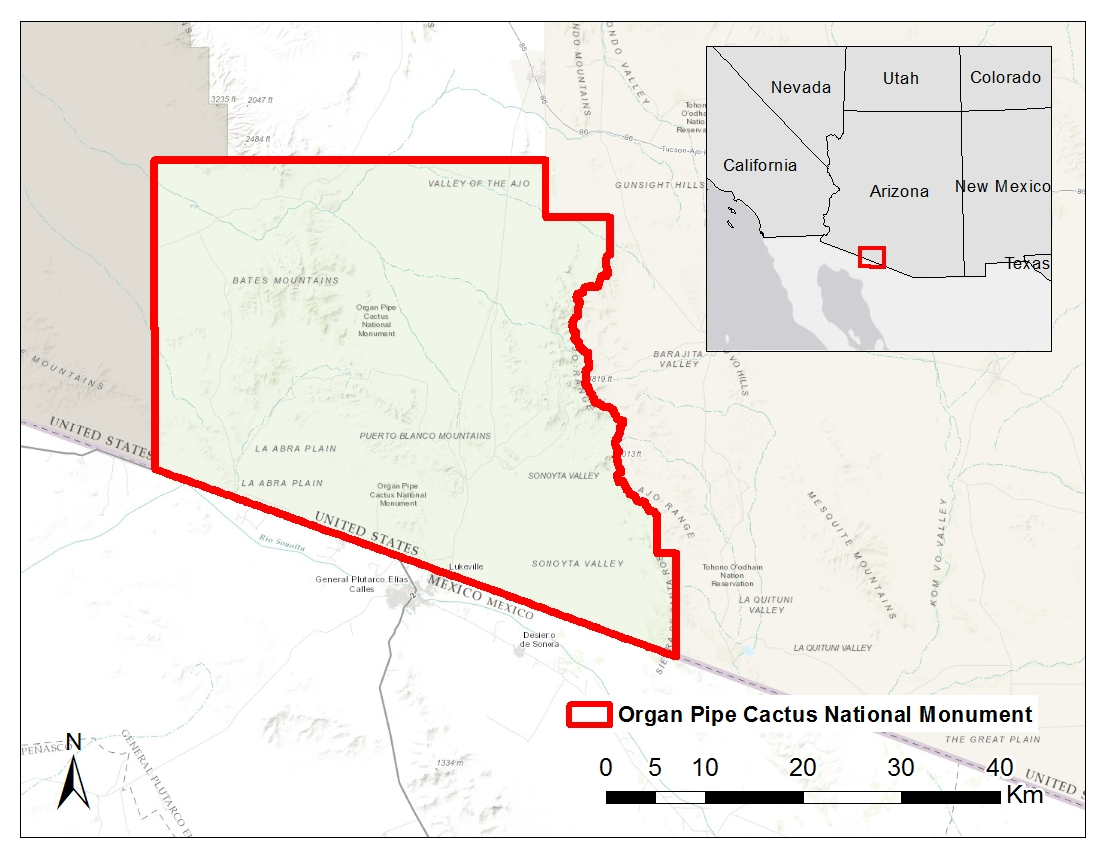

**Figure 3.** Study area map of Organ Pipe Cactus National Monument in Southwestern Arizona.

* 1. ***Project Partners & Objectives***

Ecosystem science stakeholders throughout Southwestern Arizona are interested in increasingly accurate and time-sensitive methods of buffelgrass detection as it spreads across the landscape. Two of the partners on this project were research scientist Dr. Cynthia Wallace and research ecologist Dr. Seth Munson from the United States Geological Survey (USGS) Southwest Biological Science Center (SBSC). The other two partners included Dr. Temuulen Sankey, a remote sensing scientist from Northern Arizona University (NAU), and Dana Backer, a National Park Service (NPS) park ecologist from Saguaro National Park.

Current efforts to detect and monitor buffelgrass rely on expensive and time-consumptive ground and aerial surveys. Remote sensing provides the opportunity to drastically reduce both of these costs. The primary objective of this project was to expand the capabilities of the NPS to detect, track, and map non-native buffelgrass via remote sensing in order to preserve the park’s natural resources. The second objective was to investigate the effectiveness of the CLaRe and MTMF metrics for buffelgrass detection. Understanding the environmental conditions that buffelgrass prospers will aid managers in developing a management strategy and better identify areas that require buffelgrass removal. This project addresses the NASA Applied Science Application Area of Ecological Forecasting.

# 3. Methodology

***3.1 Data Acquisition***

3.1.1 CLaRe

We began data acquisition by downloading Moderate Resolution Imaging Spectroradiometer (MODIS) products for the study period 2009 - 2012. We first downloaded MODIS Level 3 Surface Reflectance 8-Day Composite (MOD09Q1) data from the USGS EarthExplorer website for tile H8 V5 at 250 meter (m) spatial resolution. Additionally, we downloaded 8-day integrated Global Evapotranspiration (ET) Project (MOD16A2) data from the University of Montana Numerical Terradynamic Simulation Group (NTSG) website for the same tile at 1 kilometer (km) resolution.

We then obtained Parameter-elevation Relationships of Independent Slopes Model (PRISM) daily precipitation (mm) and monthly temperature (°C) data from 2008 - 2011 at 4 km spatial resolution from the PRISM Group at Oregon State University.

Lastly, we acquired and mosaicked four National Elevation Dataset (NED) Digital Elevation Model (DEM) rasters at 1/3 arc-second resolution (approximately 10 m) from the USGS Global Visualization viewer.

3.1.2 MTMF

WorldView-2 images were acquired from within WRS-2 path 37, row 38 at 2.2 m resolution via USGS EarthExplorer. Unfortunately, only a handful of images from 2012 were available to download. We prioritized images that were taken between January - March or August - October, corresponding to the bimodal precipitation pattern experienced in OPCNM. A National Agriculture Imagery Program (NAIP) 1 meter resolution image from 2010 was accessed via the United States Department of Agriculture (USDA) Natural Resources Conservation Services.

Buffelgrass spectral information was collected in the field by project partner Dr. Sankey. Jeanne Taylor, botanist at OPCNM, provided us with two field data shapefiles. One contained information on buffelgrass presence and absence in OPCNM, and the other contained detailed land cover polygons. Field presence and absence data consisted of 1,288 points and two polygons, reflecting field surveys of buffelgrass from 2009 - 2012. The attribute table, though inconsistent, included information on plot size, visit date, and whether or not the buffelgrass was removed in 2012 through the use or herbicides or by manual removal. The vegetation polygon map stratified OPCNM into 39 land cover types.

***3.2 Data Processing***

3.2.1 Field Data

The field data was processed independently for CLaRe and MTMF due to the difference in spatial resolution between MODIS and WorldView-2. For use with CLaRe metrics, field presence points with at least 10 plants were converted to raster using the “most frequent” method in the Point to Raster Tool within ArcMap. Generated field data rasters had 250 m resolution and were snapped to match the extent of the MODIS rasters. Absence data was only available for 2012, and was created in the same fashion as presence points (Table 1).

|  |  |  |  |  |  |  |  |  |
| --- | --- | --- | --- | --- | --- | --- | --- | --- |
|  | **Presence** | **C1\*** | **C2\*** | **C3\*** | **Absence** | **C1\*** | **C2\*** | **C3** |
| **2009** | 129 | 25 | 56 |  |  |  |  |  |
| **2010** | 83 |  | 29 |  |  |  |  |  |
| **2011** | 251 | 63 | 130 | 35 |  |  |  |  |
| **2012** | 53 | 28 | 50 |  | 143 | 18 | 55 |  |

**Table 1:** Number pixels at the Monument-wide and vegetation type scale with field confirmed presence and absence of buffelgrass by year. *Pixel counts differed when threshold values were applied see section 3.3.1.

For use in MTMF, utilizing the field data was much more complicated. The presence and absence point data of 2012 was full of uncertainties stemming from each point representing a larger patch. Where in CLaRe this was sufficient, as MODIS 250 m pixels encompassed even the largest patch sizes, the 2.2 m resolution of WorldView-2 mandated much more detailed information about location and orientation of patches. As a method of solving this issue, the points were converted to circles which preserved the area of the plot size. For example, a plot size of 10 x 15 m, would be converted to a circle with a radius of approximately 6.91 m (Figure 4). Points without patch sizes and presence and absence circles that intersected were eliminated from analysis. The total number of presence and absence points varied by each WorldView-2 image.

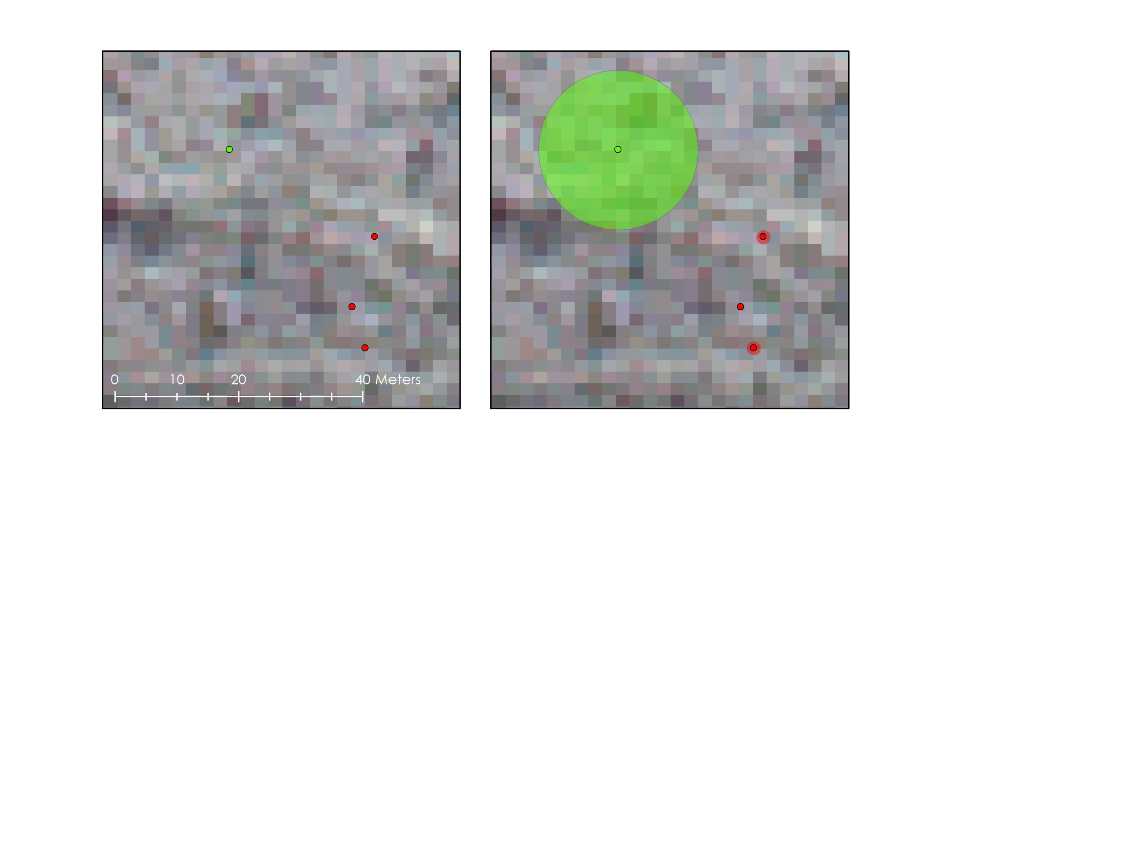

Field presence buffer

Field absence buffer

Field absence

Field presence

**Figure 4:** Presence and Absence points from 2012 were converted into larger circles based on the area of the original plot size.

The vegetation polygon map was used to stratify the landscape for use with CLaRe metrics. The polygon map was first converted to raster using the “maximum area” method of the Polygon to Raster Tool in ArcMap. Due to such small field data counts, the vegetation raster was reclassified to a coarser scale, from 39 classes to 9, to ensure enough points fell into each land cover type. Reclassification took into account both dominant species and elevation. The three classes of vegetation with sufficient field data were name Class 1, Class 2, and Class 3 (Table 2, Map 1 Appendix B).

|  |  |
| --- | --- |
|  | **Vegetation** |
| **Class 1** | *Parkinsonia microphylla*, *Ambrosia deltoidea*, *Stenocereus* sp., *Jatropha* sp. |
| **Class 2** | *Acacia* sp. *, Ambrosia ambrosioides, Ambrosia deltoidea, Parkinsonia microphylla* |
| **Class 3** | *Larrea divaricate, Larrea tridentata,* *Ambrosia deltoidea*, *Fouquieria splendens* |

**Table 2:** Vegetation in each of the three Classes.

3.2.2 CLaRe

All MODIS data was first preprocessed with the MODIS Reprojection Tool (MRT), downloaded from the Land Processes Distributed Active Archive Center (LP DAAC). We conducted an MRTBatch to first convert all MODIS HDF files to GeoTiffs, and then reproject them into NAD83 UTM 12N. Both the composite data and ET data were next subset to the study area using an OPCNM boundary shapefile which we derived from a shapefile containing all National Park boundaries provided by the NPS Integrated Resource Management Applications (IRMA) site. The ET data was further processed by resampling pixels to 250 m spatial resolution and eliminating pixels with elevation over 900 m. Buffelgrass does not prefer conditions over 900 m and evapotranspiration behavior changes as elevation increases (Marshall 2013, M.L. Goulden et al, 2012).

PRISM data was first reprojected into NAD83 UTM Zone 12N and resample from 4 km to 250 m using nearest neighbor techniques. It was then clipped to the study area. Daily precipitation rasters were then aggregated to create 8-day accumulation rasters corresponding to the same 8-day periods of the MODIS composite images. Lag time rasters were then produced through Python to create accumulation rasters 8 to 64 days prior to the start of every MODIS composite image (Figure 5).

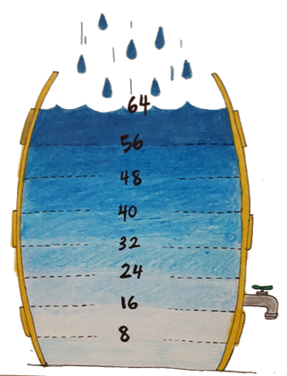

**Figure 5:** To test correlations between NDVI and different spans of input precipitation PRISM rasters were integrated so that each 8-day MODIS composite image had nine corresponding precipitation rasters. The first being the precipitation that happened over the same 8 days, and the last being the accumulation of 64 days prior.

We next calculated Normalized Difference Vegetation Values (NDVI) from the 8-day MODIS composite images by first extracting band 1 (red) and band 2 (near-infrared or NIR) from each image. NDVI measures the greenness of plants and is the most widely used vegetation index. An ArcMap script tool was produced to expedite calculations of NDVI using Equation 1.

$NDVI = \frac{NIR - Red}{NIR + Red}$ (1)

We also calculated change in NDVI rasters by subtracting the composite NDVI values that occurred directly before a precipitation interval from a composite NDVI that occurred directly after the precipitation value (Figure 6).

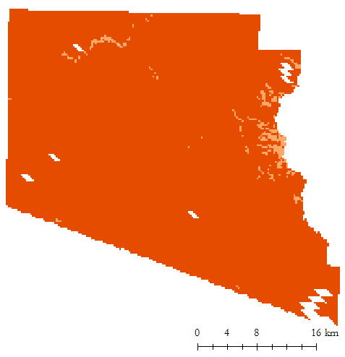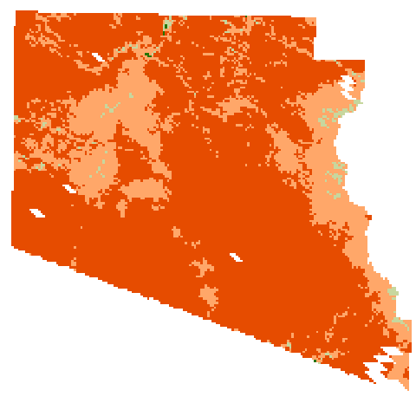

NDVI Jun 25 – Jul 2nd , 2012

NDVI Jul 27th – Aug 3rd, 2012

24 Days of Rain: July 3rd – July 26th, 2012

0.2

0.5

**Figure 6:** Change in NDVI Rasters were created by subtracting the NDVI composite image following a precipitation interval (*far left*) from the NDVI composite image directly prior to the precipitation interval (*far right*).

Since CLaRe is based in the phenology of buffelgrass to rapidly respond to precipitation events, we investigated whether this behavior could be further capitalized on by focusing on the cool season from October to March when native flora adapted to summer monsoonal rains are less productive. PRISM and NDVI rasters were truncated to include October – March for this portion of the analysis on years 2010 - 2012. The cool season of 2010, for example, ranged from October 2009 to March 2010. We did not include 2009, as we did not acquire MODIS images for 2008.

For later use in t-test analyses exclusively at the Monument-wide scale, we created pseudo absence rasters for the years 2009 – 2012. A raster was first produced with 500 m buffers around pixels with field confirmed buffelgrass presence for each year. This raster was then utilized as a mask to exclude pixels within 500 m of presence from being randomly selected for t-tests.

3.2.3 MTMF

MTMF requires input of spectral information about the target species. Our partner Dr. Sankey provided 39 spectral reflectance measurements from the fall season and 45 spectral reflectance measurements from the summer, which she collected in the field with the use of a spectrometer. In order to have usable spectral files for MTMF, the mean spectra of each season was calculated in ViewSpec Pro, a program provided by Analytical Spectral Devices (ASD), Inc. The mean values were exported as ASCII text files.

The level-one WorldView-2 data products were radiometrically calibrated and atmospherically corrected using the Fast Line-of-sight Atmospheric Analysis of Hypercubes (FLAASH) module in ENVI 5.3 to correct for cloud coverage and aerosols. The images were then orthorectified to the 1/3-arc-second NED DEM and registered to NAIP 2010 orthoimagery to correct for possible errors in orientation.

***3.3 Data Analysis***

3.3.1 CLaRe

We developed a code in R, entitled PiCo (Pixel-wise Correlation-Based Landscape Classifcation), to perform CLaRe metrics. We ran six different pixel-wise regressions between (1) NDVI and precipitation at the Monument-wide scale, (2) Change in NDVI ~ precipitation at the Monument-wide scale, (3) NDVI ~ precipitation at the vegetation class scale, (4) change in NDVI ~ precipitation at the vegetation class scale, (5) NDVI ~ precipitation and evapotranspiration at the vegetation class scale, and (6) cool season NDVI ~ cool season precipitation at the vegetation class scale (Table 3). Another R code was developed to run t-tests between the correlation values at pixels with known buffelgrass and pixels with unknown presence to investigate whether the difference in these values were statistically significant - the null hypothesis being that there is no difference between r2 values of pixels invaded with buffelgrass and those pixels belonging to the pseudo absence rasters. Pixels with unknown presence were randomly sampled 100 times from pseudo absence rasters at the Monument-scale. The amount of randomly sampled pixels was determined by the number of presence pixels. At the vegetation class scale, due to reduced pixel counts, all pixels excluding presence points were eligible for random selection. We used the means from the 100 random samples as the input for the unknown presence portion of t-test analyses.

|  |  |  |  |
| --- | --- | --- | --- |
|  | **CLaRe Metric Iterations** | **Precipitation Intervals** | **Scale** |
| **1** | NDVI ~ Precipitation | No Lag – 64 Days | Whole Monument |
| **2** | Change in NDVI ~ Precipitation | 24 – 64 Days | Whole Monument |
| **3** | NDVI ~ Precipitation | 24 – 64 Days | Vegetation Type |
| **4** | Change in NDVI ~ Precipitation | 24 – 64 Days | Vegetation Type |
| **5** | NDVI ~ Precipitation + Evapotranspiration | 24 – 64 Days | Vegetation Type |
| **6** | Cool Season NDVI~ Cool Season Precipitation | 16 – 32 Days | Vegetation Type |

**Table 3:** Iterations of CLaRe metrics.

Following work in R, we investigated whether a model informed by results from both CLaRe and MTMF could be produced to predict possible buffelgrass locations by evaluating environmental conditions of modeled presence results. We identified which year and method correlation values at 24 day precipitation intervals were strongest. This value was derived from 2012, Change in NDVI ~ Precipitation for Class 1. We then isolated the top 5% of correlation values for all 2012 Class 1 vegetation from iterations 3, 4, and 5. The pixel with the highest 5% were analyzed to extract average elevation, slope, most frequent aspect, annual precipitation in 2012, summer precipitation in 2012, and annual evapotranspiration in 2012. The values at pixels within the lower 95% were also extracted and recorded. The same terrain analysis was performed on modeled MTMF buffelgrass presence results. An experimental model was produced by stratifying the top 5% of correlation values for Class 5 from iteration by environmental constraints informed by the CLaRe and MTMF terrain analysis into three groups: least likely, likely, and more likely (Table 4). Pixels classified “least likely” had attributes of one of the three constraints, while “likely” pixels had attributes of two, and “more likely” pixels had attributes of all three. The range for aspect included the most frequent aspect of modeled presence results. The ranges for elevation and slope were determined by averaging the values one standard deviation above and below the mean values of the February MTMF presence, the October MTMF presence, and the top 5% of CLaRe iteration 4 (Table 4).

|  |  |
| --- | --- |
|  | Environmental Parameter Constraints |
| Aspect | West, South, Southwest |
| Elevation | 658 – 821 m |
| Slope | 6 - 30° |

**Table 4:** Environmental constraints for use in experimental composite model.

We also attempted to formulate a generalized linear model (GLM) in R to uncover a probability threshold that could inform land managers on the meaning of correlation values mean in terms of buffelgrass presence and absence. The code divided 2012 field presence and absence data in half for separate use in model calibration and validation. The GLM was run on a matrix with correlation values and their associated presence (1) or absence (0) binary value from the calibration dataset (Equation 2). The equation derived from the GLM was then run with the validation correlation values and transformed with Equation 3 into probability values ranging from 0 to 1 (Stavros, 2014).

glm(formula = PA ~ precipitation interval, family = “binomial”, data= Calibration Dataset), where PA = the binary presence (1) and absence (0) (2)

P(Buffelgrass) = 1/(1+eb), where b =

GLM derived Intercept + [GLM derived coefficient * (r2 of validation data)] (3)

A Cohen’s Kappa Coefficient Analysis, which will be discussed in the next section, is then run to determine a probability threshold. All probability values above this value would be classified as presence, and all below as absence.

3.3.2 Spectral-Based Classification

The MTMF target detection method was performed on WorldView-2 images that contained at least 30 field presence patches and 30 field absence patches using the target spectra provided by project partner Dr. Sankey. This narrowed down the image selection to three: one from 1/16/12, one from 2/10/12, and one from 10/14/12 (Figure 7). MTMF is performed with the Target Detection Wizard tool in ENVI.

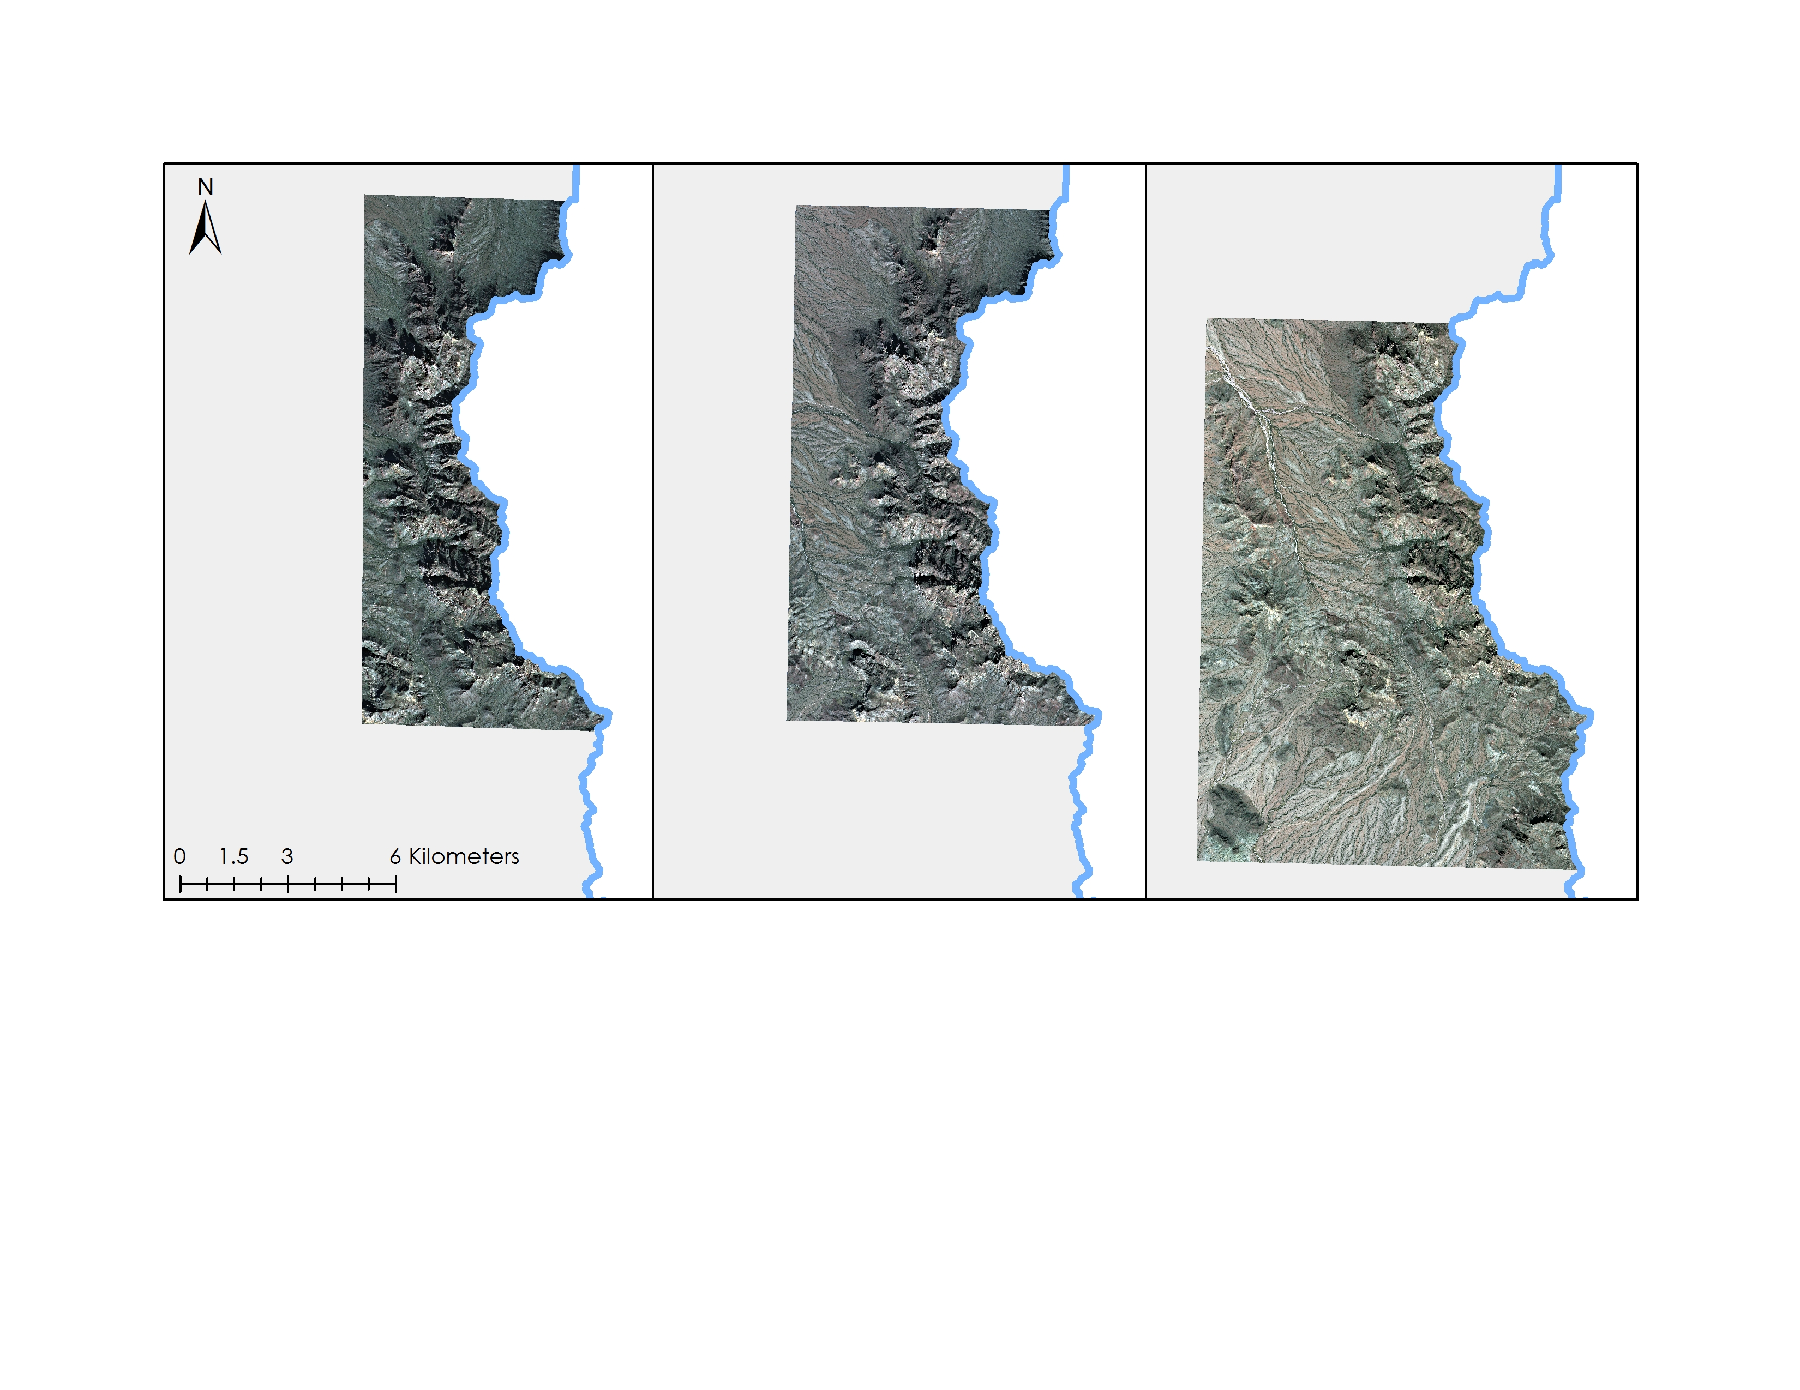

1/16/12

2/10/12

10/14/12

**Figure 7:** WorldView-2 images utilized in MTMF analysis.

MTMF has two pixel-wise outputs: a Matched Filter (MF) Score and an Infeasibility Value. The MF Score gives the estimated percentage of coverage within a pixel of the target spectra. The Infeasibility Value indicates where false positives may have occurred. The higher the Infeasibility Value, the less likely the target spectra is actually within a pixel. To yield a result of target or non-target, in the case of this project, presence or absence of buffelgrass, the MF Score and Infeasibility Values must be combined. Currently, there is no automated way for this to be done. We chose to set an Infeasibility Value maximum at 10, more conservative than the default setting of 18, and experiment with different MF thresholds to investigate how they affected the accuracy of buffelgrass target detection result. For each set of WV-2 MTMF images (consisting of the MF and Infeasibility bands), a conditional statement in ArcMap’s raster calculator was utilized to set Infeasibility < 10 and n < MF < 1, where n represents the minimum MF value. The output raster was used to classify the presence and absence patches into four groups: presence patches that intersected MTMF modeled presence (yes yes – YY), presence patches that did not intersect MTMF modeled presence ( yes no – YN), absence patches that intersected MTMF modeled presence (NY), and absence patches that did not intersect MTMF modeled presence (NN) (Figure 8). A model was developed in ArcMap’s ModelBuilder to identify the four patch categories at each trial MF threshold and create output raster datasets. The resulting pixel count for each category was recorded. The pixel counts were used in a Cohen’s Kappa Coefficient analysis.

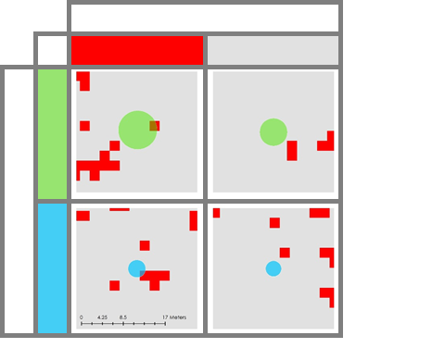

**MTMF Modeled Data**

Yes

No

**Field data**

Yes

No

+

+

+

+

YY

YN

NY

NN

**Key**

**Figure 8:** Method for analyzing accuracy of MTMF modeled results. Results were classified by agreement between field data and MTMF modeled presence and absence.

Cohen’s Kappa Coefficient describes the agreement between two judges of categorical items. In this project, the judges included field data classification of presence and absence, and the MTMF modeled classification of presence and absence. Cohen’s Kappa assesses the level of agreement between the two judges, while taking into account the level of agreement that would occur by chance. The higher the output Kappa value, the greater agreement between the two judges. For each of the three WV-2 images, MF thresholds were tested starting at 0.1 and ending after the peak Kappa value was recorded (Table 5). The MF threshold that yielded the highest Kappa value was used to create the final MTMF classification map of buffelgrass predicted presence. Average elevation, slope, most frequent aspect, were extracted from modeled presence pixels for comparison with CLaRe predicted presence pixels.

**4. Results & Discussion**

***4.1 Analysis of Results***

4.1.1 CLaRe

Inconsistencies in reporting and lack of density measures in field data complicated interpretation and validation efforts of CLaRe metric results (Appendix A). No lag to 16-day accumulation periods will not be further analyzed in this section as correlations were very weak suggesting at least 24 days of precipitation are needed for plant response, similar to results in Wallace et al (2016). Focus is placed upon the 24-day lag interval, as CLaRe is focused upon isolation of buffelgrass based on its rapid response to precipitation events.

Focusing first at the Monument-wide scale, a similar pattern exists between NDVI ~ Precipitation and Change in NDVI ~ Precipitation in terms of what accumulation periods pixels with known and unknown buffelgrass presence were statistically different (Table 1C and 2C). Specific accumulation periods that were statistically different varied primarily at shorter accumulation periods (24-40 days), while all were significant at 48 to 64 days. Wallace et al (2016) found that native vegetation starts to experience stronger correlations after 40 days of accumulated rain. Heightened NDVI values due to the response of native flora may be why mean correlation values are stronger at these longer lag times and why pixels with confirmed presence are still statistically different from those with unknown presence. Variation at shorter intervals for years 2009 and 2010 might be explained by precipitation trends impacting NDVI values. Year 2009 had below average rainfall, where 2010 experience most precipitation within January.

Mean correlation values for both iteration 1 and iteration 2 were almost exclusively higher in confirmed buffelgrass presence pixels than those of unknown presence suggesting that CLaRe is detecting a difference between the two pixel types. However, it must be noted that correlation values were not always particularly strong (ie. < 0.4), and uncertainties exist in whether the pseudo absence pixels are in fact completely absent of buffelgrass. Change in NDVI correlations were stronger in years 2010 and 2012, and weaker in 2009 and 2011. This may be attributed to the pattern of rainfall, especially summer rainfall (Figure 9). Both 2010 and 2012 experience more dramatic fluctuations across the year, while 2009 and 2011 were generally more consistent. Focusing on the summer, 2010 and 2012 experienced peaks followed by a month of no precipitation, while 2009 and 2011 follow historical normal with sustained precipitation throughout the summer. Water is extremely limited in semi-arid regions, and even small changes can have dramatic impacts. Changes in actual NDVI values might have been greater in 2010 and 2012 as drops in precipitation might have decreased plant productivity at certain points throughout the year. This would help explain why mapped images of correlation values at shorter time intervals appear more noisy in Change in NDVI~ Precipitation rasters and more clustered in NDVI ~ Precipitation in 2010 and 2012, and the exact opposite in 2009 and 2011 (Maps 1-4, Appendix B). It is interesting to note that in comparing correlation value behavior in 2009 and 2011 to 2010 and 2012, year 2011, which experienced near normal annual precipitation, is more similar to that of 2010 and 2012, than 2009 which experienced below average precipitation. The same pattern between 2009 and 2011, and 2010 and 2012 exists when stratifying the landscape.

**Figure 9:** Monthly rainfall in OPCNM from years 2009 -2012 plotted against historical normals.

Though Class 1 and Class 2 have similar species, t-tests between correlation results were statistically different at every time interval for every year. Correlation values for each iteration, with the exception of number 6, were higher at shorter accumulation periods at the vegetation type scale than when CLaRe metrics were run at the Monument scale. Plant communities have favored environmental conditions. Categorizing pixels by vegetation type removes environmental variables that have the potential to impact correlation results at the Monument scale. One example of such a variable is elevation. Higher correlation values across the Monument appear at pixels in and adjacent to areas of higher elevation. These areas experience more rainfall throughout year and higher evapotranspiration rates (Figure 10). Together these parameters suggest greater plant productivity at higher elevations. Vegetation Class 3, with pixels on average at lower elevations than Class 1 and Class 2, had no precipitation intervals in which pixels of known and unknown buffelgrass presence were statistically different. Lower evapotranspiration rates could indicate less photosynthetic activity. White bursage and chaparral, two of the dominant shrub species types comprising Class 3, also experience periods of dormancy in the summer and periods of limited rain which could lower composite NDVI values. Class 1 and Class 2 also contain some species of bursage, which may be more productive throughout the year due to higher precipitation rates in comparison to Class 3. Both Class 1 and Class 2 also contain trees, such as yellow palo verde and velvet mesquite, whose foliage might be better picked up by MODIS, allowing for a better performance of CLaRe metrics. We also considered temperature as an explanation for the difference in Class 3 behavior. However, in isolating temperature by vegetation type annually and by summer values, all were within 1°C of the other.

2012

2011

2009

2010

1

2

3

Vegetation Classes

**Figure 10:** Annual Evapotranspiration Values by Vegetation Class for years 2009 - 2012. *Values are scaled by 10

Continuing to focus on evapotranspiration, correlation values for all vegetation types at all intervals and years, except for 2012, strengthened when evapotranspiration was added as an explanatory variable in iteration 5. The fragile nature of water balance in the Sonoran Desert and its importance to health of vegetation might explain why correlations were strengthened with the input of evapotranspiration. The impact of inconsistent monthly patterns of rain and strong summer monsoons on actual changes in NDVI values, as discussed previously, are most likely the cause of correlation values not being strengthened in iteration 5 for year 2012. Higher annual evapotranspiration rates as seen in Figure 10 seem to support the idea that plants in general were more photosynthetically active. Additionally, temperature is one of the main drivers of evapotranspiration. The fact that annual and summer temperature values were so close across the vegetation types in 2012 contributes to the argument for 2012 being a higher productive year for plants based off examining evapotranspiration rates.

Correlation values derived from cool season NDVI ~ cool season precipitation were extremely weak, with all but one r2 value below 0.01. Buffelgrass, as mentioned previously, is opportunistic and responds to precipitation whenever it falls. The weak correlation values indicate that the response, by possibly smaller plants due to less productivity, might be too small for MODIS to read.

The GLM was not successful, but could possibly be with more informed field data. Correlation values at absence pixels were often higher or the same as presence pixels which prohibited the development of a probability threshold. Rather than an indication that CLaRe correlations were not functioning properly, the issue could stem from the absence data itself. The majority of absence data for 2012 was determined based upon whether plots were treated, either by manual removal of plants or application of herbicide. Treatments took place at different points throughout the year and whether these treatments were completely successful is unknown. What is known is that the locations of absence pixels are in geographic areas buffelgrass populations could successfully establish. Therefore, there is the possibility of buffelgrass impacting values at what this study considered to be absence pixels. Plot sizes were also smaller than MODIS pixels leading to the possibility of buffelgrass presence elsewhere in the 250 m pixels.

4.1.2 MTMF

We used the guidelines of Fleiss (1981) to rate kappa coefficient scores of < 0.40 as poor, 0.40 - 0.75 as fair to good, and > 0.75 as excellent. Cohen’s kappa was calculated at different MF thresholds for each image until a peak value was observed. These peaks denoted which MF score yielded a binary classification map with the highest agreement with field data. For the January image, this peak occurred at MF > 0.2 (Table 5). The kappa value was 0.487 and was rated fair to good. Similar to January, the peak kappa value for February appeared at MF > 0.2, though was much stronger at 0.841. We rated this agreement as excellent. The October image peaked at MF > 0.5 with a kappa value of 0.709, which was rated as fair to good.

Differences in MF thresholds could be attributed to a combination of plant productivity in response to precipitation occurring before WorldView-2 images were taken and to variation in the number of field data buffers in each image. Approximately 38.62 mm of rain fell in the month prior to the January image, approximately 1.77 mm before the February image, and 64.42 mm before the October image. The growing season for most Sonoran Desert plants and C4 grasses, which includes buffelgrass, is in the summer. (Dimmet, 2016). Therefore, this might indicate that plant abundance and size in general is smaller in the cool season, allowing MTMF to distinguish smaller patches of buffelgrass from surrounding flora (causing a lower MF threshold). Because both native vegetation and buffelgrass are responding to summer monsoonal rain and favorable growing conditions, a larger threshold might be necessary for MTMF to be able to identify buffelgrass in a more crowded landscape. It must also be noted that the October image did contain more field patches, which lowered the agreement between modeled and field data at lower MF thresholds due to field absence intersecting more of the MTMF presence.

|  |  |  |  |  |  |
| --- | --- | --- | --- | --- | --- |
|  |  |  |  | **.95 Confidence Interval** | |
| **Date** | **MF Threshold** | **Kappa** | **Standard Error** | **Lower Limit** | **Upper Limit** |
| **16-Jan-12** | 0.1 | 0.34 | 0.049 | 0.245 | 0.435 |
| 0.15 | 0.428 | 0.047 | 0.335 | 0.520 |
| 0.2 | 0.487 | 0.046 | 0.397 | 0.576 |
| 0.25 | 0.487 | 0.046 | 0.397 | 0.576 |
| 0.3 | 0.407 | 0.039 | 0.331 | 0.483 |
| **10-Feb-12** | 0.1 | 0.577 | 0.036 | 0.507 | 0.648 |
| 0.15 | 0.675 | 0.032 | 0.613 | 0.737 |
| 0.2 | 0.841 | 0.022 | 0.798 | 0.885 |
| 0.25 | 0.793 | 0.024 | 0.746 | 0.840 |
| **14-Oct-12** | 0.1 | 0.058 | 0.015 | 0.029 | 0.088 |
| 0.2 | 0.164 | 0.023 | 0.12 | 0.208 |
| 0.3 | 0.185 | 0.025 | 0.137 | 0.234 |
| 0.4 | 0.45 | 0.025 | 0.402 | 0.498 |
| 0.5 | 0.709 | 0.019 | 0.673 | 0.746 |
| 0.55 | 0.097 | 0.010 | 0.077 | 0.117 |

**Table 5:** Cohen’s Kappa Coefficient results for varying MF threshold values.

We used the MF thresholds with the highest kappa coefficient values for each image to create final maps of the MTMF modeled presence and absence (Figure11).

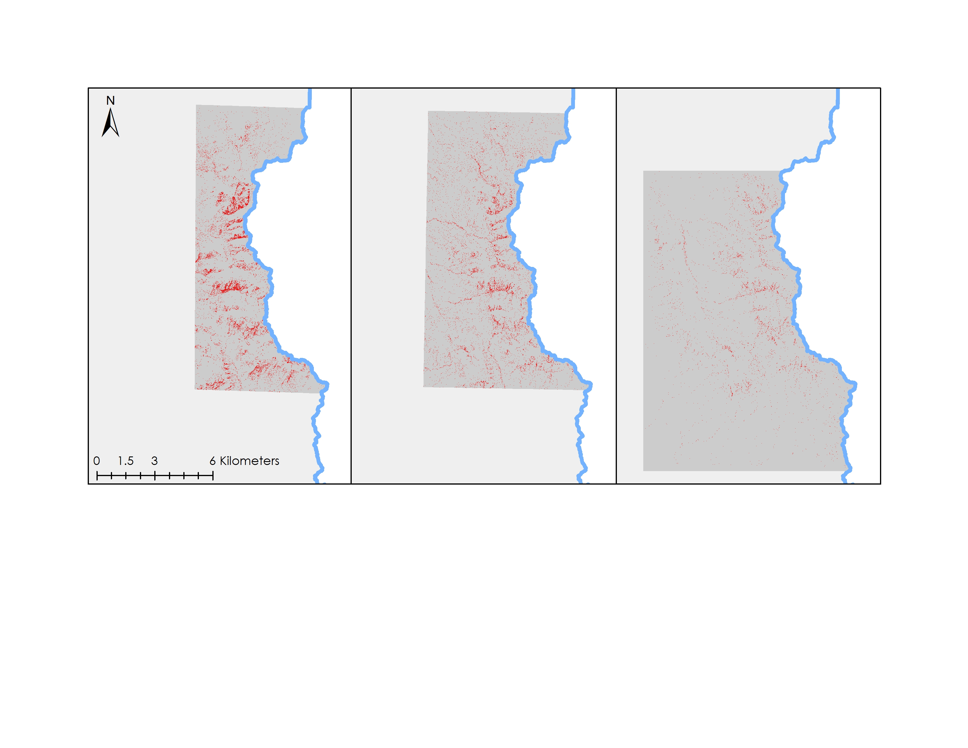

1/16/12

2/10/12

10/14/12

Predicted Buffelgrass Presence

**Figure 11:** Predicted buffelgrass locations based upon highest Kappa coefficient scores. The January and February image map all percent coverage greater than 20%. The October image maps all patches above 50% coverage.

4.1.3 Intersection of CLaRe and MTMF

Many similarities in regards to terrain exist in pixels modeled as presence by CLaRe and MTMF (Table 1-3, Appendix C). Mean elevation between pixels modeled as presence by the two methods fell within 30 m, though standard deviations averaged around 80 m. Mean elevation values were higher in presence than in absence pixels in both models, though the difference was greater in CLaRe due possibly to the larger geographic area extent encompassed by the pixels included in the model and that the elevation values were resampled from the 10 m DEM to 250 m. Mean slope values between the models fell within approximately 9° of each other, with steeper slopes experienced in presence pixels. Most frequent aspect followed the same pattern as modeled presence pixels from both models were west, southwest, and south. Aspect deviated from the pattern in terms of CLaRe as the most frequent aspect were the same between modeled presence and absence points. The terrain of modeled presence aligned with expectations of suitable habitat for buffelgrass as the species has an upper range of 900 m and prefers steeper south and southwestern facing slopes (Marshall, 2013). Annual precipitation and summer precipitation values were also extracted from CLaRe presence and absence pixels. Standard deviations were higher in presence pixels than absence pixels, unlike those of elevation, slope, and aspect where standard deviations were higher in absence pixels. The ability of buffelgrass to respond to a wider range of precipitation inputs, while still being limited by terrain parameters, might explain this variation.

The experimental model produced from CLaRe and MTMF inputs is promising (Figure 12). Results indicate that there is a spatial coincidence between field points and predictive categories. Presence and absence points from 2012 were combined due to the uncertainties in the absence data, as discussed previously, and as both are indications of where buffelgrass populations have flourished. The results suggest that incorporating site specific terrain analysis could be one of necessary elements in efforts to regionalize the use of the CLaRe model in the southwest.

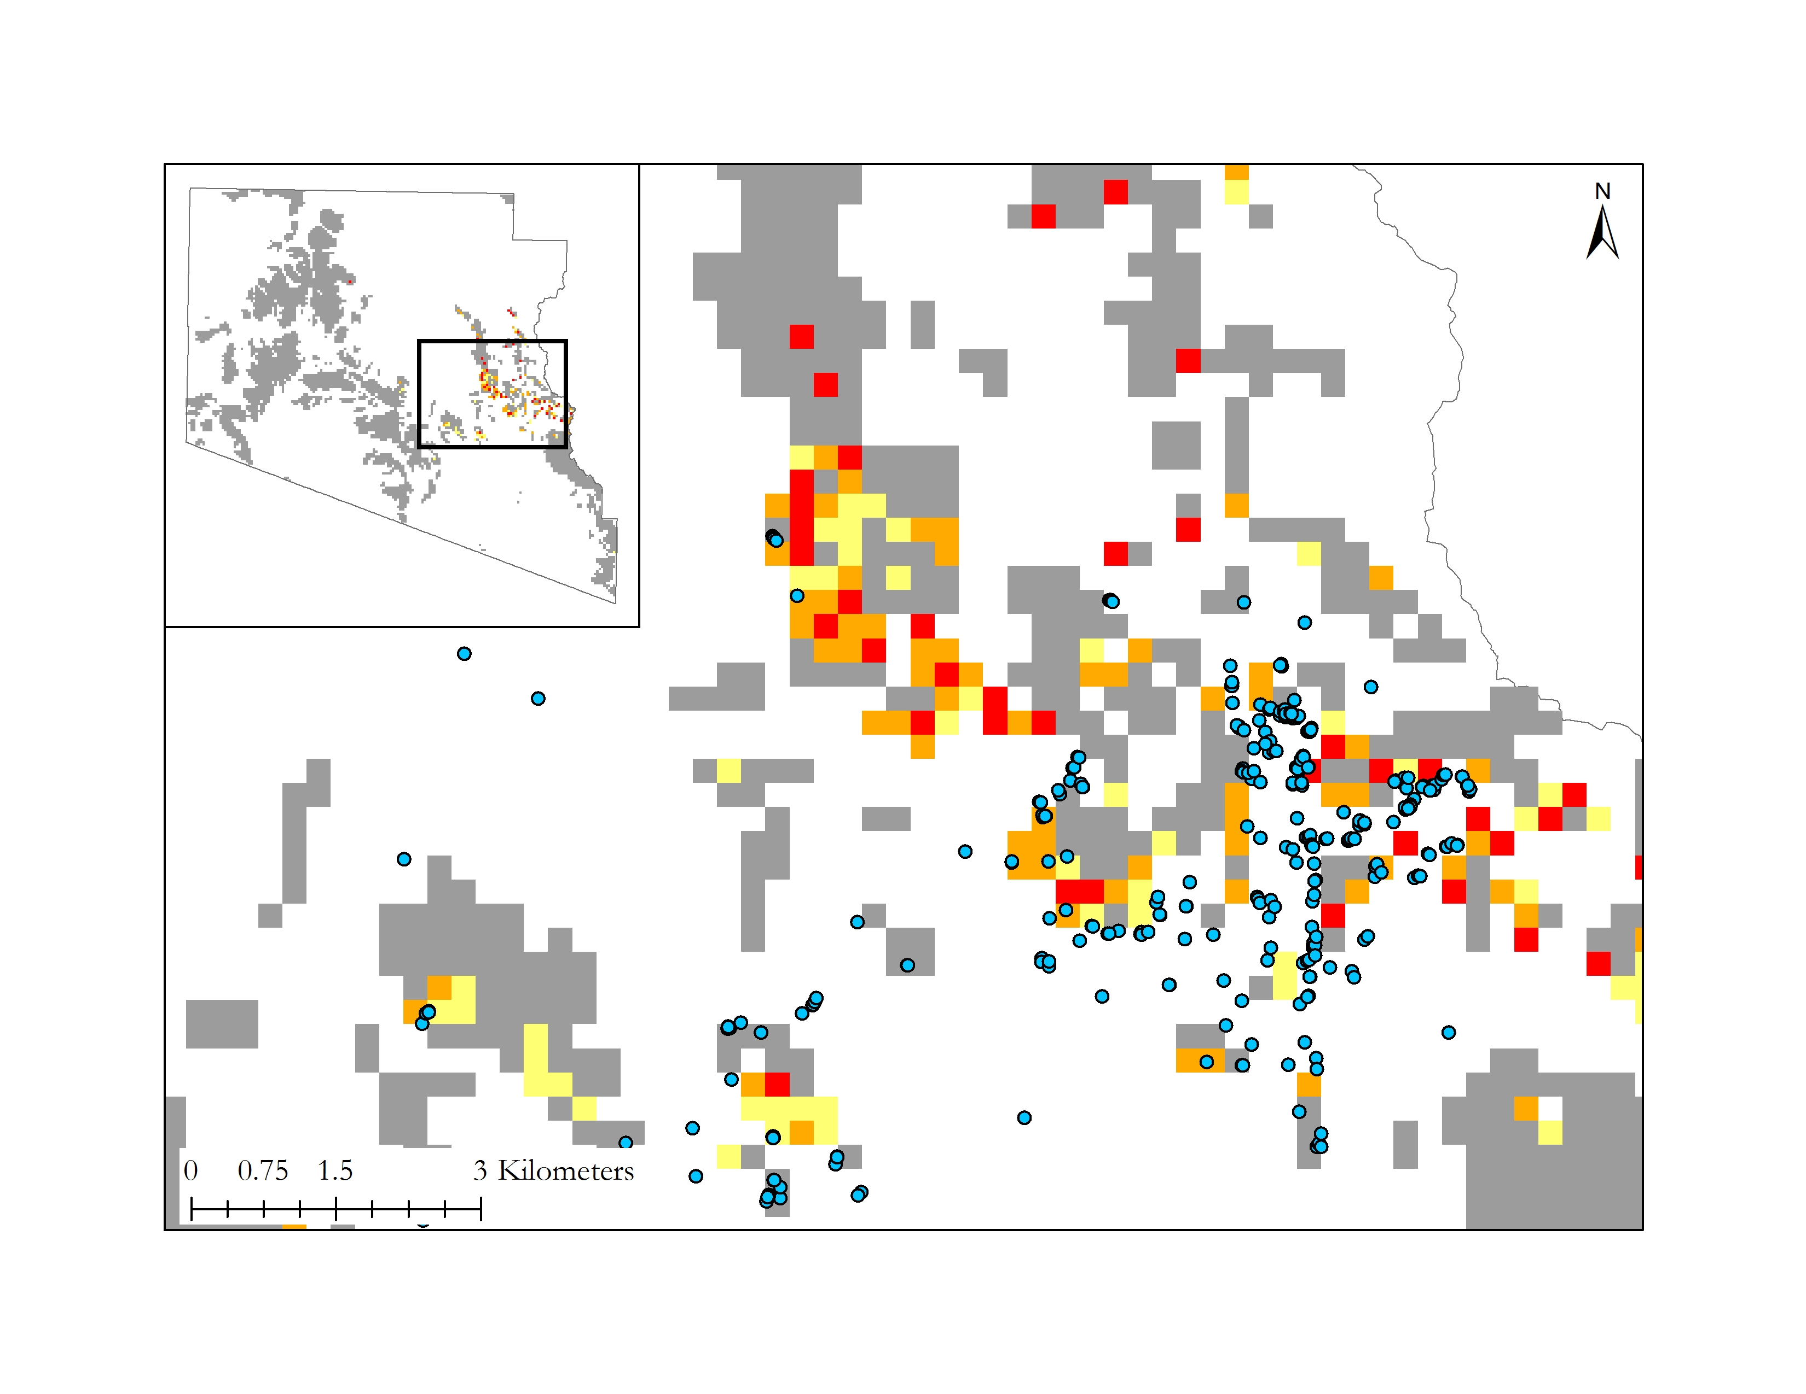

Least Likely

Likely

More Likely

Field Data

**Figure 12:** Experimental model results from stratifying the top 5% of correlation values from the Class 5, 2012 Change in NDVI ~ 24 Day Precipitation, by environmental parameters. Areas in yellow are the least likely to contain buffelgrass, areas in orange are more likely than yellow to contain buffelgrass, and areas in red are the most likely of the three to contain buffelgrass.

***4.2 Future Work***

Future work to evaluate CLaRe and MTMF methodologies should focus on areas with similar environmental conditions and, ideally, much more detailed field data. With such field data, many of the uncertainties arising in this study could be eliminated and results could be more clearly interpreted and validated.

In terms of CLaRe, future studies could investigate the impact of other variables such as water use efficiency (WUE) and growing degree days (GDD) on correlation values with NDVI. This analysis could be easily run with PiCo. The GLM could also be revisited with better field data to uncover a probability threshold that could be used by land managers in the future.

Future work with MTMF could utilize sensors with higher spectral resolution than WorldView-2 (8 bands, roughly 400-900 nm). Some studies suggest that the spectral signature of buffelgrass might not be distinct enough to separate it from similar vegetation (Marshall, 2013). Having high spectral resolution is therefore as important as having high spatial resolution for this type of analysis. Furthermore, investigations into whether seasonal or monthly MF threshold exists could prove very useful for land managers producing MTMF classifications.

Finally, both methods could be better informed with the incorporation of some factors that we did not investigate in this paper. These factors may include certain soil properties, including soil type and soil texture. Using the knowledge that buffelgrass tends to occur in volcanic-derived soil types or clay loam soil textures could be used to mask out pixels with unfavorable conditions and prevent over-classification of buffelgrass in the models. Furthermore, since buffelgrass tends to extend along disturbed roadways, a road proximity analysis may provide some classification insight (Marshall 2013).

# 5. Conclusions

Our analysis demonstrates that the Climate Landscape Response (CLaRe) metric and Mixture-Tuned Matched Filtering (MTMF) models have the potential to be powerful tools for land managers dealing with infestations of buffelgrass. Results of the CLaRe model indicate that including additional environmental variables, such as evapotranspiration, have the potential to strengthen CLaRe correlations with shorter accumulation periods of precipitation. Results also suggest that variables to include in correlation analysis could be determined by examining precipitation patterns that have occurred during the study period of interest. MF threshold results produced presence maps with fair to excellent accuracy, bearing in mind uncertainties introduced by field data. To prevent over-classification by MTMF in future analysis, environmental variables should be taken in to account to eliminate habitat unsuitable for buffelgrass before running target detection. With further development, our project partners can incorporate both methods in tracking the expanse of buffelgrass in desertscapes. While more field data was necessary to fully analyze and test the accuracy of the results from CLaRe and MTMF, this project furthered research into how remote sensing techniques can pinpoint potential buffelgrass locations and how they can be utilized in the future as a means for land managers to plan for buffelgrass eradication efforts and protect the natural ecosystems of the southwestern United States.

# 6. Acknowledgments

* Dr. Natasha Stavros, NASA Jet Propulsion Laboratory
* Dr. Cynthia Wallace, USGS Southwest Biological Science Center
* Dr. Temuulen Sankey, Northern Arizona University
* Dr. Seth Munson, USGS Southwest Biological Science Center
* Dana Backer, NPS - Saguaro National Park Rincon Mountain District
* Jeanne Taylor, Botanist, Organ Pipe Cactus National Monument

Any opinions, findings, and conclusions or recommendations expressed in this material are those of the author(s) and do not necessarily reflect the views of the National Aeronautics and Space Administration.

This material is based upon work supported by NASA through contract NNL11AA00B and cooperative agreement NNX14AB60A.

# 7. References

Dimmitt, M.A. (2016). *Plant ecology of the Sonoran Desert region*. Retrieved from <https://www.desertmuseum.org/books/nhsd_plant_ecology.php>

Fleiss, J. L. (1981). *Statistical methods for rates and proportions*. 2nd ed. New York: John Wiley & Sons Ltd.

Goulden, M. L., Anderson, R.G., Bales, R. C, Kelly, A. E., Meadows, M., & and Winston, G.C. (2012). Evapotranspiration along an elevation gradient in California's Sierra Nevada. *Journal of Geophysical Research*, *117*(G3). doi:[10.1029/2012JG002027](http://dx.doi.org/10.1029/2012JG002027).

Lyons, K. G., Maldonado-Leal, B. G., & Owen, G. (2013). Community and ecosystem effects of buffelgrass (Pennisetum ciliare) and nitrogen deposition in the Sonoran Desert. *Invasive Plant Science and Management*, *6*(1), 65-78. <http://dx.doi.org/10.1614/IPSM-D-11-00071.1>

Marshall, V. (2013). *Mapping, Modelling, and Remote Sensing Buffel grass (Cenchrus ciliaris) Infestations in Arid Australia* (Doctoral dissertation).  University of Adelaide School of Earth and Environmental Sciences (Accessed September 26, 2016).

National Park Service (n.d.). Organ Pipe Cactus International Biosphere Reserve. Retrieved from <https://www.nps.gov/orpi/learn/nature/biosphere.htm>

National Park Service (n.d.). Trees and Shrubs. Retrieved from [https://www.nps.gov/orpi/learn/nature/treesandshrubs.htm](https://www.nps.gov/orpi/learn/nature/biosphere.htm)

Sankey, T., Dickson, B., Sesnie, S., Wang, O., Olsson, A., & Zachmann, L. (2014). WorldView-2 high spatial resolution improves desert invasive plant detection. *Photogrammetric Engineering & Remote Sensing*, *80*(9), 885-893. <http://dx.doi.org/10.14358/PERS.80.9.885>

Stavros, N., Abatzoglou, J.T., McKenzie, D., Larkin, N. (2014). Regional projections of the likelihood of very large wildland fires under a changing climate in the contiguous Western United States. *Climatic Change, 126*(3), 445-468. http://dx.doi.org/10.1007/s10584-014-1229-6

Van Devender, T. R., Felger, R.S., Reina-Guerrero, A. L., & Sanchez-Escalante, J. J. (2006). Sonora: Non-native and invasive plants. *Invasive plants on the move: Controlling them in North America*, 85.

Wallace, C. S., Walker, J. J., Skirvin, S. M., Patrick-Birdwell, C., Weltzin, J. F., & Raichle, H. (2016). Mapping Presence and Predicting Phenological Status of Invasive Buffelgrass in Southern Arizona Using MODIS, Climate and Citizen Science Observation Data. *Remote Sensing*, *8*(7), 524. [http://dx.doi.org/](http://dx.doi.org/10.1614/IPSM-D-11-00071.1)[10.3390/rs8070524](http://dx.doi.org/10.3390/rs8070524)

# 8. Content Innovation

**Content Innovation #1**

VPS Video – Buffelgrass the Grass that Won’t Quit!

Link: https://www.youtube.com/watch?v=ugo53KBXZ4Y

**Content Innovation #2**

Glossary Viewer (Should be alphabetical)

* Composite Raster - in terms of the MODIS composite rasters day composite represents the best value of each pixel in the image for those 8 days of data. The best values will be different for each adjacent pixel since it will have values from different dates.
* Cohen’s Kappa Coefficient **-**  a type of analysis that describes the agreement between two judges of categorical items
* Cumulative Raster **-** A raster that is the sum of all the individual rasters.
* Evapotranspiration **-** The water loss that occurs in plants through the process of transpiration and evaporation.
* Gross Primary Productivity **-** The total amount of energy that the plants produce.
* Invasive species **-** A species that is alien to the ecosystem and its introduction to the new environment causes environmental harm to other native species.
* Mixture Tuned Matched Filtering **-** A spectral based tool that is part of the Exelis ENVI software that targets a desired spectral signature across a satellite raster image and produces an infeasibility image of the likelihood of false positives in the Matched Filtering image.
* NDVI **-** A Normalized Difference Vegetation Index that measures and determines where there is live green vegetation.
* Net Primary Productivity **-** The total rate at which plants store and capture energy.
* Orthoimagery: a uniform-scale image that has been corrected for tilt, terrain relief, and sensor geometry
* Phenological **-** Observation of seasonal natural phenomena that relates to plant/animal life with the environmental factors, such as climate.
* Raster **-** A matrix of equally sized pixels organized into a grid in which each pixel has a single numerical value.
* Remote Sensing **-** The art and science of obtaining measurements and information of the Earth using airborne sensors and satellites.
* Spectral Signature **-** A measure of reflectivity and absorption of an observed object which varies by wavelength and is thus used to identify objects in satellite imagery.
* Water Use Efficiency **-** Is a ratio of the plant’s production of energy and use of water with the amount of water lost through transpiration and evaporation. WUE is calculated from GPP/ET.

**Content Innovation #3**

Interactive Map Viewer

2016Fall_JPL_SouthernArizonaEco_CHNDVI_P_2012_24day.kmz

2016Fall_JPL_SouthernArizonaEco_CHNDVI_P_2012_24day_C6.kmz

2016Fall_JPL_SouthernArizonaEco_NP_2012_24day_C5.kmz

2016Fall_JPL_SouthernArizonaEco_MTMF_Feb.kmz

2016Fall_JPL_SouthernArizonaEco_MTMF_Jan.kmz

2016Fall_JPL_SouthernArizonaEco_MTMF_Oct.kmz

2016Fall_JPL_SouthernArizonaEco_StudyArea.kmz

2016Fall_JPL_SouthernArizonaEco_VegClass1.kmz

2016Fall_JPL_SouthernArizonaEco_VegClass2.kmz

2016Fall_JPL_SouthernArizonaEco_VegClass3.kmz

# 9. Appendices

**Appendix A:** **Mean Correlation Values and p-Values for all CLaRe Iterations**

Iteration 1: NDVI ~ Precipitation at the Monument-wide Scale

|  |  |  |  |  |  |  |  |  |  |
| --- | --- | --- | --- | --- | --- | --- | --- | --- | --- |
| **Mean Correlation Values at Presence Pixels: NDVI ~ Precipitation** | | | | | | | | | |
|  | **No Lag** | **8 Day** | **16 Day** | **24 Day** | **32 Day** | **40 Day** | **48 Day** | **56 Day** | **64 Day** |
| **2009** | 0.00879 | 0.01054 | 0.07794 | 0.13143 | 0.25187 | 0.34732 | 0.45114 | 0.50883 | 0.54739 |
| **2010** | 0.00743 | 0.00315 | 0.01097 | 0.02742 | 0.06319 | 0.12569 | 0.25963 | 0.3454 | 0.44905 |
| **2011** | 0.06971 | 0.11107 | 0.02721 | 0.27309 | 0.35508 | 0.39318 | 0.42852 | 0.42446 | 0.40034 |
| **2012** | 0.01146 | 0.02126 | 0.03985 | 0.07878 | 0.12398 | 0.16271 | 0.20335 | 0.25257 | 0.30889 |

|  |  |  |  |  |  |  |  |  |  |
| --- | --- | --- | --- | --- | --- | --- | --- | --- | --- |
| **Mean Correlation Values at Absence Pixels: NDVI ~ Precipitation** | | | | | | | | | |
|  | **No Lag** | **8 Day** | **16 Day** | **24 Day** | **32 Day** | **40 Day** | **48 Day** | **56 Day** | **64 Day** |
| **2009** | 0.01035 | 0.02147 | 0.10674 | 0.16989 | 0.27296 | 0.34684 | 0.42061 | 0.46109 | 0.48855 |
| **2010** | 0.00631 | 0.00454 | 0.01034 | 0.02495 | 0.05774 | 0.1125 | 0.22489 | 0.30299 | 0.41693 |
| **2011** | 0.07122 | 0.0814 | 0.19128 | 0.19467 | 0.27857 | 0.33479 | 0.37341 | 0.36761 | 0.34568 |
| **2012** | 0.01343 | 0.01051 | 0.03685 | 0.06082 | 0.08731 | 0.10998 | 0.13528 | 0.16734 | 0.2088 |

Table 1A. and 1B. Mean presence (top) and absence (bottom) correlation values of NDVI ~ Precipitation.

|  |  |  |  |  |  |  |  |  |  |
| --- | --- | --- | --- | --- | --- | --- | --- | --- | --- |
| **p -Values : NDVI~Precipitation** | | | | | | | | | |
|  | **No Lag** | **8 Day** | **16 Day** | **24 Day** | **32 Day** | **40 Day** | **48 Day** | **56 Day** | **64 Day** |
| **2009** | 0.104262 | 5.61E-17 | 3.47E-13 | 3.84E-13 | 0.000794 | 0.945233 | 0.000196 | 2.17E-07 | 8.61E-09 |
| **2010** | 0.405604 | 0.017885 | 0.660966 | 0.435926 | 0.393846 | 0.175093 | 0.003411 | 0.00248 | 0.031975 |
| **2011** | 0.425609 | 9.44E-29 | 6.66E-41 | 1.69E-35 | 1.69E-29 | 2.11E-23 | 5.59E-21 | 1.51E-21 | 4.80E-18 |
| **2012** | 0.207415 | 0.833807 | 0.593341 | 0.077018 | 0.009645 | 0.002279 | 0.000656 | 0.000145 | 4.08E-05 |

Table 1C. NDVI ~ Precipitation t-test results. p- values below 0.05 are highlighted in orange.

Iteration 2: Change in NDVI ~ Precipitation at the Monument-wide Scale

|  |  |  |  |  |  |  |
| --- | --- | --- | --- | --- | --- | --- |
| **Mean Correlation Values at Presence Pixels: Change in NDVI ~ Precipitation** | | | | | | |
|  | **24 Day** | **32 Day** | **40 Day** | **48 Day** | **56 Day** | **64 Day** |
| **2009** | 0.060926 | 0.091102 | 0.12127 | 0.136426 | 0.137126 | 0.141837 |
| **2010** | 0.115993 | 0.142531 | 0.238711 | 0.256809 | 0.25419 | 0.218986 |
| **2011** | 0.204234 | 0.249398 | 0.333843 | 0.26218 | 0.190145 | 0.145771 |
| **2012** | 0.51168 | 0.501551 | 0.51334 | 0.561956 | 0.590386 | 0.591564 |

|  |  |  |  |  |  |  |
| --- | --- | --- | --- | --- | --- | --- |
| **Mean Correlation Values at Absence Pixels: Change in NDVI ~ Precipitation** | | | | | | |
|  | **24 Day** | **32 Day** | **40 Day** | **48 Day** | **56 Day** | **64 Day** |
| **2009** | 0.066595 | 0.083122 | 0.099178 | 0.108526 | 0.102588 | 0.104137 |
| **2010** | 0.105271 | 0.143873 | 0.243091 | 0.275159 | 0.303777 | 0.2903 |
| **2011** | 0.189106 | 0.239912 | 0.274836 | 0.23329 | 0.15923 | 0.124187 |
| **2012** | 0.264838 | 0.27854 | 0.29719 | 0.353035 | 0.385473 | 0.402039 |

Table 2A and 2B: Mean presence (top) and absence (bottom) correlation values of Change in NDVI ~ Precipitation.

|  |  |  |  |  |  |  |
| --- | --- | --- | --- | --- | --- | --- |
| **p -Values: Change in NDVI ~ Precipitation** | | | | | | |
|  | **24 Day** | **32 Day** | **40 Day** | **48 Day** | **56 Day** | **64 Day** |
| **2009** | 0.332305 | 0.29255 | 0.020631 | 0.005974 | 0.00078 | 0.000257 |
| **2010** | 0.29617 | 0.878056 | 0.545562 | 0.024782 | 2.67E-06 | 2.45E-08 |
| **2011** | 0.001258 | 0.039995 | 3.63E-19 | 5.56E-09 | 1.50E-08 | 1.36E-06 |
| **2012** | 2.56E-24 | 1.00E-22 | 1.09E-21 | 2.02E-22 | 3.44E-22 | 4.55E-22 |

Table 2C. Change in NDVI ~ Precipitation t-test results. p- values below 0.05 are highlighted in orange.

Iteration 3: NDVI ~ Precipitation at the Vegetation Class Scale

|  |  |  |  |  |  |  |  |  |  |  |  |  |
| --- | --- | --- | --- | --- | --- | --- | --- | --- | --- | --- | --- | --- |
| **NDVI ~ Precipitation Mean Correlation Values: Vegetation Class 1** | | | | | | | | | | | | |
|  | **24 Day** | | **32 Day** | | **40 Day** | | **48 Day** | | **56 Day** | | **64 Day** | |
|  | P | A | P | A | P | A | P | A | P | A | P | A |
| **2009** | 0.1535 | 0.1589 | 0.2872 | 0.2724 | 0.388 | 0.355 | 0.502 | 0.4463 | 0.5682 | 0.4958 | 0.6235 | 0.5316 |
| **2011** | 0.2996 | 0.2386 | 0.387 | 0.3373 | 0.4181 | 0.3882 | 0.4546 | 0.4131 | 0.4489 | 0.392 | 0.4219 | 0.36 |
| **2012** | 0.0887 | 0.1207 | 0.1486 | 0.1643 | 0.1988 | 0.1925 | 0.2504 | 0.2193 | 0.3112 | 0.2555 | 0.376 | 0.2908 |

|  |  |  |  |  |  |  |  |  |  |  |  |  |
| --- | --- | --- | --- | --- | --- | --- | --- | --- | --- | --- | --- | --- |
| **NDVI ~ Precipitation Mean Correlation Values: Vegetation Class 2** | | | | | | | | | | | | |
|  | **24 Day** | | **32 Day** | | **40 Day** | | **48 Day** | | **56 Day** | | **64 Day** | |
|  | P | A | P | A | P | A | P | A | P | A | P | A |
| **2009** | 0.1271 | 0.2121 | 0.2432 | 0.3428 | 0.336 | 0.4178 | 0.442 | 0.4955 | 0.5043 | 0.5348 | 0.5417 | 0.553 |
| **2010** | 0.0334 | 0.0217 | 0.0785 | 0.0626 | 0.1472 | 0.1201 | 0.2732 | 0.2354 | 0.3657 | 0.3191 | 0.4841 | 0.4401 |
| **2011** | 0.3058 | 0.2258 | 0.3901 | 0.3109 | 0.4218 | 0.357 | 0.4532 | 0.3898 | 0.4505 | 0.3885 | 0.4279 | 0.3651 |
| **2012** | 0.1103 | 0.0462 | 0.1723 | 0.07228 | 0.2252 | 0.1016 | 0.2759 | 0.1287 | 0.3329 | 0.1688 | 0.3977 | 0.2164 |

|  |  |  |  |  |  |  |  |  |  |  |  |  |  |
| --- | --- | --- | --- | --- | --- | --- | --- | --- | --- | --- | --- | --- | --- |
| **NDVI ~ Precipitation Mean Correlation Values: Vegetation Class 3** | | | | | | | | | | | | | |
|  | **24 Day** | | **32 Day** | | **40 Day** | | **48 Day** | | **56 Day** | | **64 Day** | | |
|  | P | A | P | A | P | A | P | A | P | A | P | A |
| 2011 | 0.1646 | 0.1474 | 0.2386 | 0.2213 | 0.3034 | 0.2897 | 0.3449 | 0.349 | 0.3445 | 0.3448 | 0.3279 | 0.3256 |

Table 3A., 3B., 3C: Mean correlation values of NDVI ~ Precipitation at presence (P) and absence (A) pixels stratified by vegetation class type.

|  |  |  |  |  |  |  |
| --- | --- | --- | --- | --- | --- | --- |
| **p -Values: NDVI ~ Precipitation - Vegetation Class 1** | | | | | | |
|  | **24 Days** | **32 Days** | **40 Days** | **48 Days** | **56 Days** | **64 Days** |
| **2009** | 4.76E-06 | 0.000963 | 0.097431 | 0.722181 | 0.084702 | 0.000949 |
| **2011** | 4.57E-14 | 1.64E-08 | 0.000237 | 5.55E-07 | 5.06E-10 | 7.71E-10 |
| **2012** | 0.012739 | 0.357036 | 0.748091 | 0.15051 | 0.020225 | 0.001442 |

|  |  |  |  |  |  |  |
| --- | --- | --- | --- | --- | --- | --- |
| **p -Values: NDVI ~ Precipitation - Vegetation Class 2** | | | | | | |
|  | **24 Days** | **32 Days** | **40 Days** | **48 Days** | **56 Days** | **64 Days** |
| **2009** | 1.39E-07 | 3.83E-05 | 0.011181 | 0.589788 | 0.353932 | 0.30917 |
| **2010** | 0.02775 | 0.123083 | 0.066477 | 0.026033 | 0.014063 | 0.027828 |
| **2011** | 7.00E-33 | 1.93E-29 | 1.32E-23 | 1.88E-20 | 2.51E-19 | 2.47E-16 |
| **2012** | 5.82E-08 | 3.53E-09 | 2.27E-09 | 5.65E-10 | 3.48E-10 | 1.42E-10 |

|  |  |  |  |  |  |  |
| --- | --- | --- | --- | --- | --- | --- |
| **p -Values: NDVI ~ Precipitation - Vegetation Class 3** | | | | | | |
|  | **24 Days** | **32 Days** | **40 Days** | **48 Days** | **56 Days** | **64 Days** |
| **2011** | 0.219831 | 0.232819 | 0.323777 | 0.793169 | 0.985776 | 0.884932 |

Table 3D., 3E, 3F. NDVI ~ Precipitation t-test results for the stratified vegetation types. p- values below 0.05 are highlighted in orange.

Iteration 4: Change in NDVI ~ Precipitation at the Vegetation Class Scale

|  |  |  |  |  |  |  |  |  |  |  |  |  |
| --- | --- | --- | --- | --- | --- | --- | --- | --- | --- | --- | --- | --- |
| **Change in NDVI ~ Precipitation Mean Correlation Values: Vegetation Class 1** | | | | | | | | | | | | |
|  | **24 Day** | | **32 Day** | | **40 Day** | | **48 Day** | | **56 Day** | | **64 Day** | |
|  | P | A | P | A | P | A | P | A | P | A | P | A |
| **2009** | 0.1184 | 0.1334 | 0.1565 | 0.1624 | 0.1967 | 0.1799 | 0.2188 | 0.1916 | 0.2074 | 0.1732 | 0.2018 | 0.1747 |
| **2011** | 0.2107 | 0.2045 | 0.2557 | 0.2546 | 0.3566 | 0.3024 | 0.2566 | 0.2053 | 0.18 | 0.1175 | 0.1425 | 0.0973 |
| **2012** | 0.5765 | 0.3483 | 0.5669 | 0.3426 | 0.5744 | 0.3517 | 0.6119 | 0.3765 | 0.6347 | 0.4013 | 0.6335 | 0.4111 |

|  |  |  |  |  |  |  |  |  |  |  |  |  |
| --- | --- | --- | --- | --- | --- | --- | --- | --- | --- | --- | --- | --- |
| **Change in NDVI ~ Precipitation Mean Correlation Values: Vegetation Class 2** | | | | | | | | | | | | |
|  | **24 Day** | | **32 Day** | | **40 Day** | | **48 Day** | | **56 Day** | | **64 Day** | |
|  | P | A | P | A | P | A | P | A | P | A | P | A |
| **2009** | 0.0568 | 0.0536 | 0.0898 | 0.0743 | 0.1196 | 0.0925 | 0.133 | 0.1039 | 0.1398 | 0.0968 | 0.1477 | 0.1009 |
| **2010** | 0.1504 | 0.13 | 0.1704 | 0.158 | 0.2507 | 0.2444 | 0.2699 | 0.2616 | 0.2787 | 0.289 | 0.2494 | 0.2721 |
| **2011** | 0.2181 | 0.2195 | 0.2616 | 0.2706 | 0.3603 | 0.3121 | 0.2803 | 0.2596 | 0.2119 | 0.1847 | 0.163 | 0.1413 |
| **2012** | 0.537 | 0.291 | 0.5232 | 0.2987 | 0.5384 | 0.3197 | 0.5871 | 0.3738 | 0.6173 | 0.4124 | 0.615 | 0.4277 |

|  |  |  |  |  |  |  |  |  |  |  |  |  |
| --- | --- | --- | --- | --- | --- | --- | --- | --- | --- | --- | --- | --- |
| **Change in NDVI ~ Precipitation Mean Correlation Values: Vegetation Class 3** | | | | | | | | | | | | |
|  | **24 Day** | | **32 Day** | | **40 Day** | | **48 Day** | | **56 Day** | | **64 Day** | |
|  | P | A | P | A | P | A | P | A | P | A | P | A |
| **2011** | 0.169 | 0.1629 | 0.2281 | 0.2196 | 0.2473 | 0.2383 | 0.2427 | 0.2364 | 0.1675 | 0.167 | 0.1202 | 0.1207 |

Table 4A., 4B., 4C. Mean correlation values of Change in NDVI ~ Precipitation at presence (P) and absence (A) pixels stratified by vegetation class type.

|  |  |  |  |  |  |  |
| --- | --- | --- | --- | --- | --- | --- |
| **p -Values: Change in NDVI ~ Precipitation - Vegetation Class 1** | | | | | | |
|  | **24 Days** | **32 Days** | **40 Days** | **48 Days** | **56 Days** | **64 Days** |
| **2009** | 0.272247 | 0.692999 | 0.358014 | 0.125646 | 0.066874 | 0.143245 |
| **2011** | 0.423467 | 0.892942 | 6.76E-07 | 2.95E-07 | 8.66E-08 | 8.07E-06 |
| **2012** | 1.91E-12 | 1.39E-11 | 2.29E-11 | 1.51E-12 | 6.34E-12 | 6.15E-12 |

|  |  |  |  |  |  |  |
| --- | --- | --- | --- | --- | --- | --- |
| **p -Values: Change in NDVI ~ Precipitation - Vegetation Class 2** | | | | | | |
|  | **24 Days** | **32 Days** | **40 Days** | **48 Days** | **56 Days** | **64 Days** |
| **2009** | 0.663397 | 0.149748 | 0.051436 | 0.049836 | 0.005338 | 0.002885 |
| **2010** | 0.195849 | 0.328095 | 0.511403 | 0.336311 | 0.380054 | 0.139655 |
| **2011** | 0.802603 | 0.12567 | 9.40E-11 | 0.000535 | 4.60E-05 | 0.000118 |
| **2012** | 1.70E-16 | 9.15E-16 | 4.49E-15 | 1.79E-15 | 3.67E-15 | 9.23E-15 |

|  |  |  |  |  |  |  |
| --- | --- | --- | --- | --- | --- | --- |
| **p -Values: Change in NDVI ~ Precipitation - Vegetation Class 3** | | | | | | |
|  | **24 Days** | **32 Days** | **40 Days** | **48 Days** | **56 Days** | **64 Days** |
| **2011** | 0.685345 | 0.564855 | 0.606157 | 0.667685 | 0.97121 | 0.961215 |

Table 4D., 4E., 4F. NDVI ~ Precipitation t-test results. p- values below 0.05 are highlighted in orange.

Iteration 5: NDVI ~ Precipitation + Evapotranspiration at the Vegetation Class Scale

|  |  |  |  |  |  |  |  |  |  |  |  |  |
| --- | --- | --- | --- | --- | --- | --- | --- | --- | --- | --- | --- | --- |
| **NDVI ~ Precipitation + Evapotranspiration Mean Correlation Values: Vegetation Class 1** | | | | | | | | | | | | |
|  | **24 Day** | | **32 Day** | | **40 Day** | | **48 Day** | | **56 Day** | | **64 Day** | |
|  | P | A | P | A | P | A | P | A | P | A | P | A |
| **2009** | 0.4276 | 0.3671 | 0.5204 | 0.4721 | 0.5743 | 0.5277 | 0.6225 | 0.5625 | 0.6671 | 0.5945 | 0.7132 | 0.6253 |
| **2011** | 0.5851 | 0.5655 | 0.6229 | 0.6034 | 0.6266 | 0.6138 | 0.6902 | 0.6649 | 0.7153 | 0.6783 | 0.6846 | 0.6475 |
| **2012** | 0.2729 | 0.2433 | 0.2957 | 0.2687 | 0.3217 | 0.285 | 0.3595 | 0.3068 | 0.4034 | 0.3329 | 0.4538 | 0.3707 |

|  |  |  |  |  |  |  |  |  |  |  |  |  |
| --- | --- | --- | --- | --- | --- | --- | --- | --- | --- | --- | --- | --- |
| **NDVI ~ Precipitation + Evapotranspiration Mean Correlation Values: Vegetation Class 2** | | | | | | | | | | | | |
|  | **24 Day** | | **32 Day** | | **40 Day** | | **48 Day** | | **56 Day** | | **64 Day** | |
|  | P | A | P | A | P | A | P | A | P | A | P | A |
| **2009** | 0.4044 | 0.306 | 0.4788 | 0.3992 | 0.5259 | 0.4567 | 0.565 | 0.5084 | 0.6035 | 0.5486 | 0.6361 | 0.5898 |
| **2010** | 0.3687 | 0.2967 | 0.3749 | 0.2917 | 0.3846 | 0.3034 | 0.4221 | 0.3367 | 0.473 | 0.3944 | 0.5559 | 0.4893 |
| **2011** | 0.605 | 0.5462 | 0.6398 | 0.5754 | 0.6446 | 0.5833 | 0.7052 | 0.6402 | 0.7324 | 0.6661 | 0.7048 | 0.6407 |
| **2012** | 0.345 | 0.1893 | 0.3568 | 0.201 | 0.3744 | 0.2112 | 0.4017 | 0.2333 | 0.4337 | 0.2604 | 0.4785 | 0.2959 |

|  |  |  |  |  |  |  |  |  |  |  |  |  |
| --- | --- | --- | --- | --- | --- | --- | --- | --- | --- | --- | --- | --- |
| **NDVI ~ Precipitation + Evapotranspiration Mean Correlation Values: Vegetation Class 3** | | | | | | | | | | | | |
|  | **24 Day** | | **32 Day** | | **40 Day** | | **48 Day** | | **56 Day** | | **64 Day** | |
|  | P | A | P | A | P | A | P | A | P | A | P | A |
| **2011** | 0.504 | 0.4693 | 0.5248 | 0.4909 | 0.5399 | 0.5144 | 0.5975 | 0.5762 | 0.6231 | 0.6002 | 0.6029 | 0.5866 |

Table 5A., 5B., 5C. Mean correlation values of NDVI ~ Precipitation + Evapotranspiration at presence (P) and absence (A) pixels stratified by vegetation class type.

|  |  |  |  |  |  |  |
| --- | --- | --- | --- | --- | --- | --- |
| **p - Values: NDVI ~ Precipitation + Evapotranspiration - Vegetation Class 1** | | | | | | |
|  | **24 Days** | **32 Days** | **40 Days** | **48 Days** | **56 Days** | **64 Days** |
| **2009** | 0.017962 | 0.019466 | 0.011954 | 0.000216 | 1.26E-05 | 4.15E-08 |
| **2011** | 0.015475 | 0.033185 | 0.150137 | 0.003997 | 5.08E-05 | 0.000103 |
| **2012** | 0.23227 | 0.286427 | 0.155614 | 0.047057 | 0.00912 | 0.002953 |

|  |  |  |  |  |  |  |
| --- | --- | --- | --- | --- | --- | --- |
| **p - Values: NDVI ~ Precipitation + Evapotranspiration - Vegetation Class 2** | | | | | | |
|  | **24 Days** | **32 Days** | **40 Days** | **48 Days** | **56 Days** | **64 Days** |
| **2009** | 3.88E-05 | 0.00016 | 0.000198 | 0.000296 | 0.000322 | 0.001859 |
| **2010** | 0.033017 | 0.014219 | 0.01397 | 0.00655 | 0.008639 | 0.012182 |
| **2011** | 4.43E-26 | 3.86E-27 | 1.87E-26 | 7.93E-29 | 1.87E-32 | 6.40E-28 |
| **2012** | 1.18E-08 | 2.50E-08 | 1.55E-08 | 1.39E-08 | 8.63E-09 | 3.38E-09 |

|  |  |  |  |  |  |  |
| --- | --- | --- | --- | --- | --- | --- |
| **p - Values: NDVI ~ Precipitation + Evapotranspiration - Vegetation Class 3** | | | | | | |
|  | **24 Days** | **32 Days** | **40 Days** | **48 Days** | **56 Days** | **64 Days** |
| **2011** | 0.072649 | 0.068608 | 0.180469 | 0.274281 | 0.265556 | 0.396681 |

Table 5D., 5E., 5F. NDVI ~ Precipitation t-test results. p- values below 0.05 are highlighted in orange.

Iteration 6: Cool Season NDVI ~ Cool Season Precipitation

|  |  |  |  |  |  |  |
| --- | --- | --- | --- | --- | --- | --- |
| **Mean Correlation Values at Presence Pixels: NDVI ~ Precipitation** | | | | | | |
|  | **16 Day** | | **24 Day** | | **32 Day** | |
|  | **C1** | **C2** | **C1** | **C2** | **C1** | **C2** |
| **2010** | 0.0182 | 0.0225 | 0.0245 | 0.0183 | 0.0096 | 0.009 |
| **2011** | 0.0587 | 0.0519 | 0.0292 | 0.0232 | 0.0243 | 0.0181 |
| **2012** | 0.1163 | 0.1156 | 0.0408 | 0.0398 | 0.0902 | 0.0740 |

Table 6A: Mean correlation values of Cool Season NDVI ~ Cool Season Precipitation at presence pixels in vegetation class 1 (C1) and vegetation class 2 (C2)

**Appendix B: Maps**

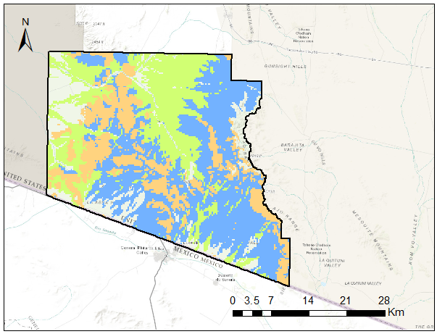

Class 1

Class 2

Class 3

Map 1: Spatial extent of the three vegetation classes throughout OPCNM

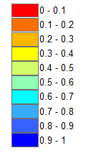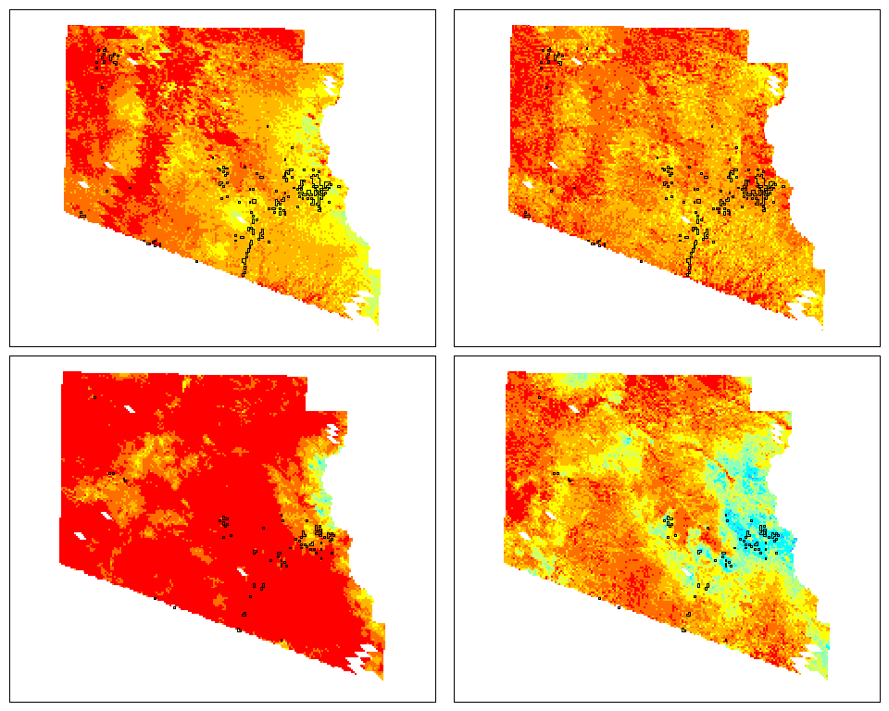

2011 NDVI ~ Precipitation

2011 Change in NDVI ~ Precipitation

2012 NDVI ~ Precipitation

2012 Change in NDVI ~ Precipitation

**Map 2:** Comparison of spatial distribution of correlation values resulting from NDVI ~ 24 Day Precipitation and Change in NDVI ~ 24 Day Precipitation in 2011 (top) and 2012 (bottom)

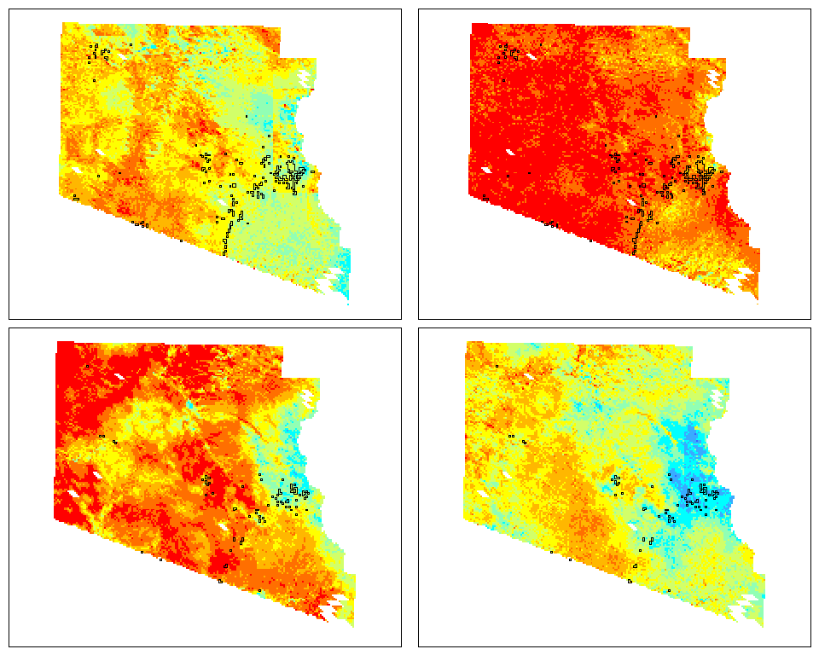

2011 NDVI ~ Precipitation

2011 Change in NDVI ~ Precipitation

2012 NDVI ~ Precipitation

2012 Change in NDVI ~ Precipitation

**Map 3:** Comparison of spatial distribution of correlation values resulting from NDVI ~ 64 Day Precipitation and Change in NDVI ~ 64 Day Precipitation in 2011 (top) and 2012 (bottom)

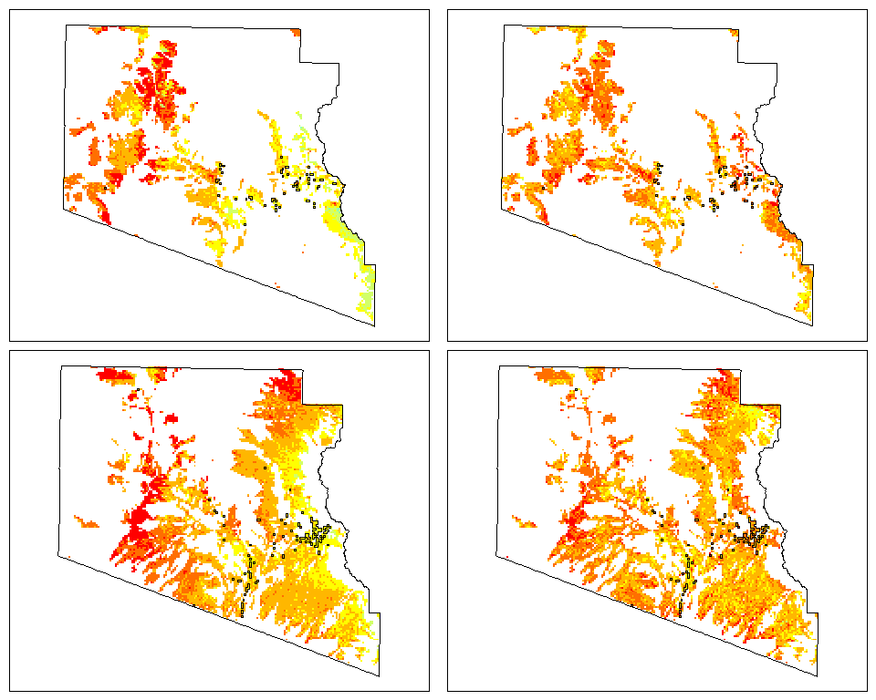

Class 1

2011 NDVI ~ Precipitation

Class 1

2011 Change in NDVI ~ Precipitation

Class 2

2011 NDVI ~ Precipitation

Class 2

2011 Change in NDVI ~ Precipitation

**Map 4:** Comparison of spatial distribution of correlation values resulting from NDVI ~ 24 Day Precipitation and Change in NDVI ~ 24 Day Precipitation in 2011 Class 1 (top) and 2011 Class 2 (bottom)

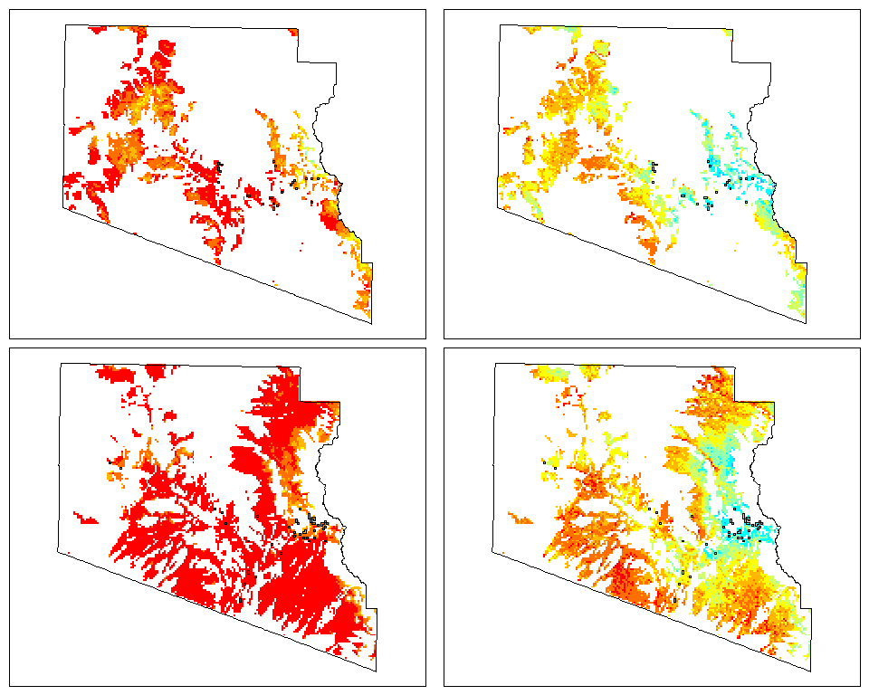

Class 1

2012 NDVI ~ Precipitation

Class 1

2012 Change in NDVI ~ Precipitation

Class 2

2012 NDVI ~ Precipitation

Class 2

2012 Change in NDVI ~ Precipitation

**Map 5:** Comparison of spatial distribution of correlation values resulting from NDVI ~ 24 Day Precipitation and Change in NDVI ~ 24 Day Precipitation in 2012 Class 1 (top) and 2012 Class 2 (bottom)

**Appendix C: Terrain Analysis Results from CLaRe and MTMF Modeled Presence**

|  |  |  |  |  |  |  |
| --- | --- | --- | --- | --- | --- | --- |
|  | **Date** | **Processing Extent** | **Mean** | **Min** | **Max** | **SD** |
| **Elevation** | 10-Feb | MTMF pixels, 20% MF threshold | 755.12 | 583 | 900 | 74.97 |
| MTMF Absence | 723.95 | 582 | 900 | 72.67 |
| 14-Oct | MTMF pixels, 50% MF threshold | 744.06 | 535 | 900 | 83.57 |
| MTMF Absence | 676 | 518 | 898.5 | 86.38 |
| 2012 | CLaRe Top 5% correlation values: ΔNDVI ~ precipitation / 24-Day | 720.01 | 544 | 898 | 88.63 |
| CLaRe Bottom 95% correlation values: ΔNDVI ~ Precipitation / 24 Day | 558.42 | 300 | 899 | 116.51 |
| CLaRe Top 5% correlation values: NDVI ~ Precipitation, ET / 24 Day | 754.5 | 481 | 899 | 84.95 |
| CLaRe Bottom 95% correlation values: NDVI ~ Precipitation, ET / 24 Day | 555.9 | 300 | 899 | 113.24 |
| CLaRe Top 5% correlation values: NDVI ~ Precipitation / 24 Day | 735 | 370 | 898 | 105.73 |
| CLaRe Bottom 95% correlation values: NDVI ~ Precipitation / 24 Day | 559.23 | 300 | 899 | 115.86 |

**Table 1:** Elevationdata extracted from CLaRe and MTMF modeled presence and absence pixels

|  |  |  |  |  |  |  |
| --- | --- | --- | --- | --- | --- | --- |
|  | **Date** | **Processing Extent** | **Mean** | **Min** | **Max** | **SD** |
| **Slope** | 10-Feb | MTMF pixels, 20% MF threshold | 15.75 | 0 | 76.22 | 13.34 |
| MTMF Absence | 11.45 | 0 | 78.30 | 11.96 |
| 14-Oct | MTMF pixels, 50% MF threshold | 16.47 | 0 | 65.24 | 12.91 |
| MTMF Absence | 11.45 | 0 | 78.29 | 11.96 |
| 2012 | CLaRe Top 5% correlation values: ΔNDVI ~ precipitation / 24-Day | 23.13 | 1 | 58.4 | 10.30 |
| CLaRe Bottom 95% correlation values: ΔNDVI ~ Precipitation / 24 Day | 17.88 | 0 | 64.6 | 10.95 |
| CLaRe Top 5% correlation values: NDVI ~ Precipitation, ET / 24 Day | 24.01 | 1.02 | 64.68 | 11.28 |
| CLaRe Bottom 95% correlation values: NDVI ~ Precipitation, ET / 24 Day | 17.81 | 0 | 64.07 | 10.88 |
| CLaRe Top 5% correlation values: NDVI ~ Precipitation / 24 Day | 26.94 | 1.05 | 58.42 | 12.49 |
| CLaRe Bottom 95% correlation values: NDVI ~ Precipitation / 24 Day | 17.78 | 0 | 64.68 | 10.77 |

**Table 2:** Slopedata extracted from CLaRe and MTMF modeled presence and absence pixels

|  |  |  |  |  |  |
| --- | --- | --- | --- | --- | --- |
|  | **Date** | **Processing Extent** | **Orientation** | **Pixel Count** | **Percentage** |
| **Aspect** | 10-Feb | MTMF pixels, 20% MF threshold | Flat | 1048 | 0.052 |
| North | 1315 | 0.066 |
| Northeast | 1343 | 0.067 |
| East | 1386 | 0.069 |
| Southeast | 1465 | 0.073 |
| South | 2830 | 0.141 |
| Southwest | 4100 | 0.205 |
| West | 3707 | 0.185 |
| Northwest | 2807 | 0.14 |
| Total | 20001 | 1 |
| 14-Oct | MTMF pixels, 50% MF threshold | Flat | 500 | 0.054 |
| North | 445 | 0.048 |
| Northeast | 403 | 0.043 |
| East | 512 | 0.055 |
| Southeast | 743 | 0.08 |
| South | 1666 | 0.179 |
| Southwest | 2222 | 0.239 |
| West | 1862 | 0.2 |
| Northwest | 954 | 0.103 |
| Total | 9307 | 1 |
| 2012 | CLaRe Top 5% correlation values: ΔNDVI ~ precipitation / 24-Day | West |  |  |
| South |  |  |
| CLaRe Bottom 95% correlation values: ΔNDVI ~ Precipitation / 24 Day | West |  |  |
| Southwest |  |  |
| CLaRe Top 5% correlation values: NDVI ~ Precipitation, ET / 24 Day | West |  |  |
| Southwest |  |  |
| CLaRe Bottom 95% correlation values: NDVI ~ Precipitation, ET / 24 Day | West |  |  |
| Southwest |  |  |
| CLaRe Top 5% correlation values: NDVI ~ Precipitation / 24 Day | Southwest |  |  |
| South |  |  |
| CLaRe Bottom 95% correlation values: NDVI ~ Precipitation / 24 Day | West |  |  |
| Southwest |  |  |

**Table 3:** Aspect data derived from CLaRe and MTMF modeled presence and absence pixels