**NASA DEVELOP National Program**



NASA Langley Research Center

*Summer 2015*

Alaska Disasters

Utilizing NASA Earth Observations to Identify Oil Spills and Natural Oil Seeps off the Coast of Northern Alaska

**Technical Report** 

Rough Draft – June 25, 2015

Will Manion (Project Lead)

Amy Ferguson

Jordan Vaa

Kristen Noviello

Nicole MacDonald

Katelynn Quinn

Dr. Kenton Ross, DEVELOP National Program (Science Advisor)

Emily Adams, NASA Langley DEVELOP (Center Lead)

Daniel Wozniak, NASA Langley DEVELOP (Assistant Center Lead)

# I. Abstract

[Placeholder - do not put anything here until the final draft submission. The abstract in the project summary is where the working draft of the abstract should “live”]

**Keywords**

Remote Sensing, Alaska, Oil Spills, Natural Seeps, Sea Ice, Sentinel-1, MODIS, Landsat

# II. Introduction

Satellite data show a dramatic decrease in Arctic sea ice over the last thirty years (Zigmuntowska et al., 2014; Laxon et al., 2013). As a result, maritime transportation and energy exploration is expected to increase in the region (National Oceanic and Atmospheric Administration [NOAA], 2015). A recent development in May 2015 saw the United States Bureau of Ocean Energy Management (BOEM) conditionally approve offshore oil exploration north of Alaska. This overall increase in traffic, combined with challenges unique to an Arctic environment, escalates the risk of oil spills. Perils significant to operations in the Arctic include extended periods of darkness, lack of support infrastructure, and severe environmental conditions (e.g., low temperatures, sea ice, poor visibility, strong wind and sea currents) (Tunaley, 2010). These hazardous conditions make oil spill discovery difficult and recovery efforts dangerous (Bureau of Safety and Environmental Enforcement [BSEE], Arctic Oil Spill Response Research [OSRR], 2015).

An oil spill in the Arctic represents both an ecologic and economic disaster. Oil behavior in freezing environments is complex due to its spreading on and under ice, absorption in snow, containment on and in ice, and spreading over ice-infested water (Fingas and Hollebone, 2003). In addition, lower temperatures slow the rate of dissipation, dispersion, and degradation of hydrocarbons, so oil persists longer and has a higher potential for greater impact to the environment (Tunaley, 2010; Atlas, 1972). The Arctic marine ecosystem is a region of high biological productivity, supporting a wealth of life from the water column to the coastal plain and even above, below and within sea ice (National Snow and Ice Data Center [NSIDC], 2015; Geiselman et al., 2012). Biological and environmental damage due to an oil spill can create critical challenges to human health, food security, and the survival of indigenous cultures who depend on Arctic species availability for their livelihood (NSIDC, 2015). As the Arctic nations - Canada, Denmark, Finland, Iceland, Norway, Russia, Sweden, and the United States - continue to grow in commercial shipping, fisheries, tourism, and energy exploration, an oil spill heralds a serious economic disturbance (United States Coast Guard [USCG], 2015; Clark et al., 2010).

In addition to human activities, oil enters the marine environment through natural seepage, a geographically common, natural phenomena active throughout geologic time (Kvenvolden and Cooper, 2003). A natural seep is defined as visible evidence of past or present oil, gas or bitumen leakage on the surface of the Earth (Hunt, 1979). NOAA’s Alaska Office Assessments Division identified 29 seepage areas that occur within the coastal areas of Alaska, seven of which are located along its northern shore (Becker and Manen, 1988). 47% of crude oil entering the marine environment is from natural seeps; therefore, given the deleterious impact oil has on the environment, detecting and monitoring these coastline and oceanic seeps is appropriate (Kvenvolden and Cooper, 2003).

The project partner for this study, the US Coast Guard (USCG), faithfully executes its mission in the Arctic to serve and safeguard the public, protect the environment and its resources, and defend the Nation’s interests in the maritime region. US Federal Law requires all citizens to report an oil spill to the National Response Center immediately upon discovery. Once a spill is reported, the USCG will investigate the location and formulate a clean-up or dispersal plan. The USCG currently conducts fly over assessments in an effort to locate any unreported oil spills. Modern remote sensing techniques can assist USCG response personnel in detecting, mapping and monitoring oil spills and natural oil seeps.

Due to the complexity of the study area – the northern shore of Alaska – remotely sensing the presence of oil in an ice-infested region requires a mix of sensors, both passive and active, operating across the electromagnetic spectrum (Fingas and Brown, 2014). Moderate Resolution Imaging Spectroradiometer (MODIS), Landsat 4-5 Thematic Mapper (TM) and Landsat 7 Enhanced Thematic Mapper Plus (ETM+), and Synthetic Aperture Radar (SAR) are reported as suitable space-borne sensors for oil detection (Hu et al., 2009; Polychronis and Vassilia, 2013; Brekke and Solberg, 2004). Due to individual sensor limitations (e.g., all-weather, revisit frequency, coverage) and the unique Arctic environmental challenges, a mixture of sensors is desirable (Tunaley, 2010). Thus, access to spectral imagery from NASA’s Earth Observing System (EOS) – specifically from Aqua and Terra MODIS and Landsat – combined with radar imagery from European Space Agency (ESA) Earth observations (EO) - Sentinel-1 - could support effective strategic response planning for the USCG in the event of an Arctic spill.

The Alaska Disasters project addressed the NASA Applied Sciences Program application area of Disasters. By familiarizing the USCG with the use of NASA and ESA EO, the organization is able to improve coastal management practices and emergency preparedness and response. Of note, although the SAR data used in this study were provided by the ESA, its effectiveness as an oil detection remote sensing technique showcases a future NASA sensor, NASA Indian Space Research Organization SAR (NISAR), expected to launch in 2020 as the first dual frequency radar imaging satellite.

The objective of this study was to provide the USCG with a Python-based, graphical user interface (GUI) to retrieve imagery data in order to quickly visualize spectral and radar information to detect, map, and monitor oil spills and natural oil seeps within the coastal area of Alaska. In addition, a static map displaying known natural oil seeps will give the USCG the ability to monitor and account for background pollution in the study area. Ultimately, the project aimed to inject all final deliverables into the Arctic Emergency Response Management Application (ERMA), a NOAA sponsored web-based Geographic Information System (GIS) tool, in order to improve USCG communication and coordination efforts.

# III. Methodology

**Historic Natural Oil Seeps Map**

The project team used the Landsat Shaded Basemap Image Service in the creation of the historic natural oil seeps map product. The Landsat Shaded Basemap is natural color, 15-meter resolution, pansharpened Landsat imagery that is enhanced with topographic hillshading and color balancing (Esri, 2014). The dataset is created by the United States Geologic Survey (USGS) and NASA using Global Land Survey (GLS) 2000 and 2005. GLS2000 uses Landsat 7 Enhanced Thematic Mapper Plus (ETM+) data while GLS2005 uses a combination of Landsat Thematic Mapper (TM) and ETM+ data.

Spatial data for Outer Continental Shelf (OCS) oil and gas wells and the Trans Alaskan Pipeline were downloaded from the Arctic ERMA and projected in the North American Datum (NAD) 1927 Alaska Albers Meters coordinate system in ArcMap 10.3.1. Spatial information for natural oil seeps were derived by comparing drawings in a report published by NOAA’s Alaska Office Assessments Division to Google Maps, and Google Earth (Figure 1)(Becker and Manen, 1988). This data was compiled as XY data in an Excel spreadsheet and converted into a shapefile using ArcCatalog 10.3.1. The data were then projected in the NAD 1927 Alaska Albers Meters coordinate system in ArcMap.

Finally, the natural oil seep spatial data were incorporated into the Arctic ERMA as a static update to its baseline data used as a planning tool for emergency responders.

**Imagery Retrieval Tool**

*Data Acquisition*

See Table 1 for a summary of NASA and ESA EO data acquisition. Aqua MODIS, Terra MODIS, and Landsat 8 Operational Land Imager (OLI) and Thermal Infrared Sensor (TIRS) data were retrieved from EarthExplorer operated by the USGS (<http://earthexplorer.usgs.gov>). MOD09GA and MYD09GA are MODIS Land Surface Reflectance Daily 1km and 500m data products that provide Bands 1-7 in a gridded level-2 (L2G) product (Land Processes Distributed Active Archive Center [LPDAAC], 2014). Of note, these two products are composed of bands defined for land surface reflectance and, as such, are developed using land-based algorithms. The project team decided to use them despite this fact because they offer high spatial resolution that is necessary for oil detection. MODIS data were projected in true color using bands 1, 4, 3 (Red, Green, Blue). Landsat 8 OLI and TIRS data were projected in true color using bands 4, 3, 2 (Red, Green, Blue).

Synthetic Aperture Radar (SAR) data were retrieved from the Sentinel-1 Scientific Data Hub operated by the ESA (<https://scihub.esa.int/dhus/>). Sentinel-1 carries a C-band SAR instrument and is an ideal platform for this study due to its all-weather capability; ability to distinguish open ocean, ice, wind, and waves; and expedient production of 10m resolution images within hours to support emergency response operations (ESA, 2015).

**Table 1. Satellite Remote Sensing Data Acquisition**

|  |  |  |  |  |  |
| --- | --- | --- | --- | --- | --- |
| **Platform** | **Sensor** | **Product** | **Level** | **Bands** | **Source** |
| **Aqua** | MODIS | MYD09GA  Surface Reflectance Daily: Global 1km and 500m | L2G | 1,4,3 | [earthexplorer.usgs.gov](http://earthexplorer.usgs.gov) |
| **Terra** | MODIS | MOD09GA  Surface Reflectance Daily: Global 1km and 500m | L2G | 1,4,3 | [earthexplorer.usgs.go](http://earthexplorer.usgs.gov)v |
| **Landsat 8** | OLI/TIRS | LC, LO, LT | L1T | 4,3,2 | [earthexplorer.usgs.go](http://earthexplorer.usgs.gov)v |
| **Sentinel-1** | SAR |  | S1SLC |  | [scihub.esa.int/dhus](https://scihub.esa.int/dhus/) |
| L2G = Gridded Level-2; L1T = Level 1T - Terrain Corrected; LC = Combined (OLI/TIRS);  LO = OLI only; LT = TIRS only; S1SLC = SAR Level 1 Single Look Complex | | | | | |

*Graphical User Interface*

The project team utilized Python 2.7 to create a GUI that facilitates on-demand visualization of Aqua and Terra MODIS, Landsat 8 OLI and TIRS, and Sentinel-1 data. Python was used because of its open-source nature; its ability to use several packages within a single, interpreted environment; and its interconnected ability to apply innovative packages from the science community (Lin, 2012). The imagery retrieval tool was written in Python 2.7, using the modules Shapely, pycURL, elementTree, gdal, and urllib. Shapely is used for manipulation and analysis of planar geometric objects and, while not concerned with data formats or coordinate systems, it can be integrated with packages that are (Python Software Foundation [PSF], 2015). The pycURL module provides bindings for the cURL library (PSF, 2015). ElementTree stores hierarchical data structures in memory that can be converted to and from XML (PSF, 2015). The gdal module is used to manipulate geospatial raster data (PSF, 2015). Last, the urllib module is an HTTP library with thread-safe connection pooling and file post support (PSF, 2015).

*WE ARE STILL WORKING ON THE GUI METHODOLOGY.

# IV. Results & Discussion

**Analysis of Results**

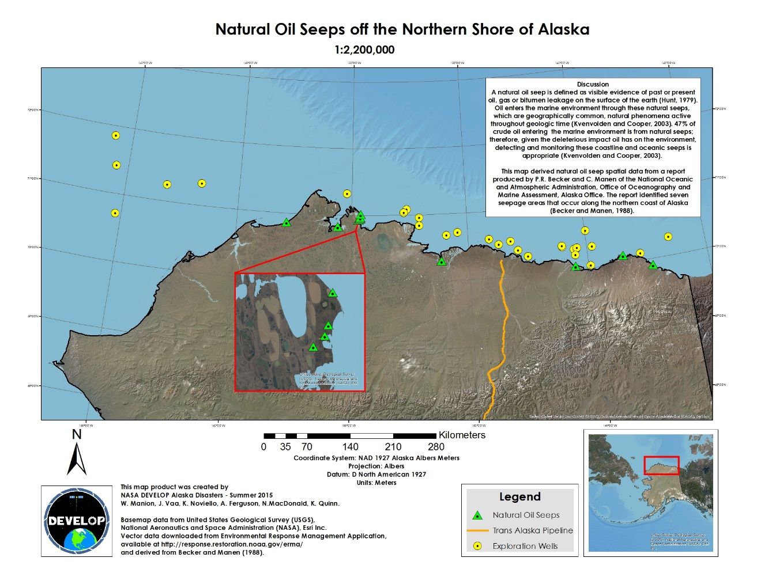

**Errors and Uncertainty**

**Future Work**

Insert images, graphs, maps, charts, etc. here. Choose the most important results to highlight here. No word cap, but two to six pages is a good range.

Things to discuss:

* Analysis of Results: What can you tell from your graphs, images, etc.? What does this mean for your project?
* Errors & Uncertainty: What factors could you not account for, what things didn’t work out like you expected they would, etc.
* Future Work: If this project was to be selected for another term, what would be the focus? What other areas would be of interest?

# V. Conclusions

Final conclusions. Word count: 200-600 (~a page).

# VI. Acknowledgments

* MST1 Justin Hoffer (USCG): Partner POC
* Dr. Amy Merten (NOAA): Partner POC
* Dr. Kenton Ross (NASA DEVELOP National Program): Science Advisor
* Emily Adams (Langley DEVELOP Center Lead)
* Daniel Wozniak (Langley DEVELOP Assistant Center Lead)

This material is based upon work supported by NASA through contract NNL11AA00B and cooperative agreement NNX14AB60A.

# VII. References

Atlas, R., and Bartha, R., 1972, Biodegradation of petroleum in seawater at low temperatures: Canadian Journal of Microbiology, v. 18(12), p. 1851-1855, doi: 10.1139/m72-289.

Becker, P.R., and Manen, C.A., 1988, Natural oil seeps in the Alaskan marine environment: Outer Continental Shelf Environmental Assessment Program, Research Unit 703.

Brekke, C., Holt, B., Jones, C., and Skrunes, S., 2014, Discrimination of oil spills from newly formed sea ice by synthetic aperture radar: Remote Sensing of Environment, v. 145, p. 1-14.

Bureau of Safety and Environmental Enforcement, 2015, Arctic Oil Spill Response Research (OSRR): [http://www.bsee.gov/Technology-and-Research/Oil-Spill-Response-Research/Categories/Arctic-Oil-Spill-Response-Research](http://www.bsee.gov/Technology-and-Research/Oil-Spill-Response-Research/Categories/Arctic-Oil-Spill-Response-Research/) (accessed June 2015).

Clark, R., Ott, A., Rabe, M., Vincent-Lang, D., and Woodby, D., 2010, The effects of changing climate on key habitats in Alaska: Alaska Department of Fish and Game Special Publication No. 10-14.

Esri, 2014, Landsat Shaded Basemap: <http://doc.arcgis.com/en/living-atlas/item/?itemId=e41378aa89fa46e3a58708ea4115468f> (accessed June 2015).

European Space Agency, 2015, Sentinel-1 Emergency Response: <http://www.esa.int/Our_Activities/Observing_the_Earth/Copernicus/Sentinel-1/Emergency_response> (accessed June 2015).

Fingas, M.F., and Brown, C., 2014, Review of oil spill remote sensing: Marine Pollution Bulletin, v. 83, p. 9-23.

Fingas, M.F. and Hollebone, B.P., 2003, Review of behaviour of oil in freezing environments: Marine Pollution Bulletin, v. 47, p. 333-340.

Geiselman, J, DeGange, T., Oakley, K., Derksen, D., and Whalen, M., 2012, Changing Arctic ecosystems: Research to understand and project changes in marine and terrestrial ecosystems of the Arctic: United States Geological Survey Fact Sheet 2011-3136, 4 p.

Hu, C., Li, X., Pichel, W.G., and Muller-Karger, F.E., 2009, Detection of natural oil slicks in the NW Gulf of Mexico using MODIS imagery: Geophysical Research Letters, v. 36, L01604, doi: 10.1029/2008GL036119.

Hunt, J.M., 1979, Petroleum Geochemistry and Geology: Freeman, San Francisco, CA.

Kvenvolden, K.A. and Cooper, C.K, 2003, Natural seepage of crude oil into marine environment: Geo-Marine Letters, v. 23, p. 140-146, doi: 10.1007/s00367-003-0135-0.

Laxon, S.W., Giles, K.A., Ridout, A.L., Wingham, D.J., Willatt, R., Cullen, R., Kwok, R., Schweiger, A., Zhang, J., Haas, C., Hendricks, S., Krishfield, R., Kurtz, N., Farrell, S., and Davidson, M., 2013, CryoSat-2 estimates of Arctic sea ice thickness and volume: Geophysical Research Letters, v. 40, p. 732-737, doi: 10.1002/grl.50193.

Land Processes Distributed Active Archive Center, 2014, Surface Reflectance Daily L2G Global 1km and 500m: <https://lpdaac.usgs.gov/dataset_discovery/modis/modis_products_table/mod09ga> (accessed June 2015).

Lin, J.W., 2012, Why Python is the next wave in earth science computing: American

Meteorological Society, v. 93, p. 1823-1824, doi: 10.1175/BAMS-D-12-00148.1.

National Oceanic and Atmospheric Administration, 2015, Arctic Emergency Response

Management Application: [http://response.restoration.noaa.gov/maps-and-spatial-data/environmental-response-management-application-erma/arctic-erma.htm](http://response.restoration.noaa.gov/maps-and-spatial-data/environmental-response-management-application-erma/arctic-erma.html)l (accessed June 2015).

National Snow and Ice Data Center, 2015, All about sea ice:

<http://nsidc.org/cryosphere/seaice/index.html> (accessed June 2015).

Norwegian Clean Seas Association for Operating Companies, 2015, OPV 2015:

<http://translate.google.com/translate?hl=en&sl=no&u=http://www.nofo.no/&prev=search> (accessed June 2015).

Polychronis, K., and Vassilia, K., 2013, Detection of oil spills and underwater natural oil outflow using multispectral satellite imagery: International Journal of Remote Sensing Applications, v. 3, p. 145-154.

Python Software Foundation, 2015, Python Package Index: <https://pypi.python.org/pypi> (accessed June 2015).

Suresh, G., Heygster, G., Bohrmann, G., Melsheimer, C., and Korber, J., 2013, An automatic detection system for natural oil seep origin estimation in SAR images: Geoscience and Remote Sensing, p. 3566-3569.

Tunaley, J.K.E., 2010, Detection of oil spills in or with ice using SAR: London Research and Development Corporation.

United States Coast Guard, 2015, U.S. Coast Guard Arctic training activities 2015: <http://www.uscg.mil/d17/docs/Draft_2015_USCG%20Arctic%20EA_public.pdf> (accessed June 2015).

United States Geologic Survey, 2012, A global land-imaging mission: USGS Survey Fact Sheet 2012-3072, 4 p., revised July 19, 2012.

Zygmuntowska, M., Rampal, P., Ivanova, N., & Smedsrud, L.H., 2014, Uncertainties in Arctic sea ice thickness and volume: new estimates and implications for trends: The Cryosphere, v. 8, p. 705-720. doi: 10.5194/tc-8-705-2014.

# VIII. Content Innovation

In preparation for DEVELOP’s coming microjournal, please select two content innovation features to support your paper. For each item, please list the name of the feature, and include the tool itself if possible (e.g. glossary terms and definitions). If the tool does not work in Microsoft Word (e.g. Interactive MATLAB Figure Viewer), please list the file name and upload the related file to the microjournal folder on the DEVELOP Exchange. If you choose to use Inline Supplementary Material, please also include where the material should appear in the text.

**Some options include:**

AudioSlides

Database Linking Tool

Data Profile

Executable Papers

Featured Author Videos

Featured Multimedia for this Article (video and podcast options)

Glossary Viewer

Inline Supplementary Material (figures, tables, computer code)

Interactive Map Viewer

Interactive MATLAB Figure Viewer

Interactive Plot Viewer

Nomenclature Viewer

# IV. Appendices

Insert here