**NASA DEVELOP National Program**



NASA Marshall Space Flight Center

*Summer 2015*

East Africa Disasters

Assessing Landslide Characteristics and Developing a Landslide Hazard Map and a Landslide Susceptibility Map in Rwanda and Uganda Using NASA Earth Observations

 **Technical Report**

Final Draft – August 6, 2015

Leigh Sinclair (Project Lead)

Padraic Conner (Co-Project Lead)

Tyler Finley

Jeanné le Roux

Dr. Jeffrey Luvall, NASA at NSSTC (Science Advisor)

Dr. Robert Griffin, University of Alabama in Huntsville (Science Mentor)

# I. Abstract

The International Emergency Disasters Database indicates that a total of 482 people have been killed and another 27,530 have been affected by landslides in Rwanda and Uganda, although the actual numbers are thought to be much higher. Data for individual countries are poorly tracked, but hotspots for devastating landslides occur throughout Rwanda and Uganda due to the local topography and soil type, intense rainfall events, and deforestation. In spite of this, there has been little research in this region that utilizes satellite imagery to estimate areas susceptible to landslides. This project utilized Landsat 8 Operational Land Imager (OLI) data and Google Earth to identify landslides that occurred within the study area. These landslides were then added to SERVIR’s Global Landslide Catalog (GLC). Next, Landsat 8 OLI, the Tropical Rainfall Measuring Mission (TRMM), the Global Precipitation Measurement (GPM), and Shuttle Radar Topography Mission Version 2 (SRTM-v2) data were used to create a Landslide Susceptibility Map. This was combined with population data from the Socioeconomic Data and Applications Center (SEDAC) to create a Landslide Hazard map. A preliminary assessment of the relative performance of GPM and TRMM in identifying landslide conditions was also performed. The additions to the GLC, the Landslide Susceptibility Map, the Landslide Hazard Map, and the preliminary assessment of satellite rainfall performance will be used by SERVIR and the Regional Centre for Mapping of Resources for Development (RCMRD) for disaster risk management, land use planning, and determining landslide conditions and moisture thresholds.

**Keywords**

Landslide, Rwanda, Uganda, Remote Sensing, Disasters, Global Landslide Catalog

# II. Introduction

The East African countries of Rwanda and Uganda have an unfortunate history of disastrous landslides due to a combination of intense rainfall events, topography, and populations living on or near steep slopes. For example, on March 1, 2010, a landslide struck the Bududa region of Eastern Uganda, killing over 350 people and leaving more than 5,000 others homeless (Zawedde 2010). Currently, both national governments have disaster preparedness policies and programs in place for such events, but these efforts are limited in scope and are more focused on disaster response than prevention or early warning. These countries lack the spatial and temporal information required to accurately and effectively identify hazardous areas and properly warn at-risk populations. Instead, mitigation efforts have focused largely on moving populations away from areas known to have had landslides occur in the past (Nsengiyumva 2012).

The objective of this project was to supply the national governments and related organizations of Rwanda and Uganda with decision support information that will enable them to more effectively identify hazardous locations and warn at-risk populations. This objective was split into three sub-goals, which included updating the Global Landslide Catalog (described below), creating a Landslide Susceptibility Map and a Landslide Hazard Map, and performing a preliminary assessment on the ability of three different satellite derived rainfall datasets to predict landslides. These project objectives address the Disasters section of NASA’s Applied Science application areas.

The first goal was to update the Global Landslide Catalog (GLC), an online database created in 2007 at NASA Goddard Space Flight Center (GSFC) to document global rainfall-triggered landslide events. The GLC compiles information through a combination of newspaper reports, published articles, disaster databases, Google alerts, blog entries, and personal witness accounts. Each entry can be identified as a point on a map with specific information including date, time, location accuracy, landslide size, landslide type, and fatalities (Kirschbaum et al. 2015). Updates to this catalog will allow SERVIR to more effectively support landslide monitoring efforts.

The second goal focused on creating a Landslide Susceptibility Map and a Landslide Hazard Map that incorporated a number of known landslide risk variables to visually display areas where landslides are most likely to occur. This was accomplished through a review of the literature to determine which risk variables to consider, and which thresholds of each variable were likely to cause a landslide. The resulting map gave end-users concrete locations to apply appropriate policies and mitigation efforts rather than reliance on anecdotal evidence or field studies. An additional Landslide Susceptibility Map was created using lower resolution data to examine whether higher resolution data was better for predicting landslides.

The final goal was a preliminary assessment of satellite rainfall performance in identifying landslide conditions. Measurements from both the Tropical Rainfall Measuring Mission (TRMM) and the Global Precipitation Mission (GPM) were compared with ground-based measurements from the Climate Hazards Group InfraRed Precipitation and with Station Data (CHIRPS) to assess their relative capability to monitor rainfall events that can trigger landslides.

The study area for this project encompassed the countries of Rwanda and Uganda, found in East Africa. Due to their topography, landslides can occur almost anywhere within their borders, although some sites see a much higher incidence. The Mt. Elgon region of Eastern Uganda is one such example. This study used historical landslide records and precipitation data spanning from 2010 until present day.

Project partners for this project included the Regional Visualization and Monitoring System (SERVIR) and the Regional Centre for Mapping of Resources for Development (RCMRD). SERVIR is a joint effort between NASA and the United States Agency for International Development (USAID) utilizing Earth observations and predictive models derived thereof to aid decision makers. SERVIR has partnered with RCMRD in Nairobi, Kenya to create a SERVIR hub in Africa. RCMRD services 18 member countries, including Rwanda and Uganda, and oversees a variety of projects that improve environmental management and resilience to climate change. Currently, information on landslides from remotely-sensing platforms is limited in Rwanda and Uganda. While there is a general knowledge of where landslide prone areas are located in both countries, more precise mapping and a more thorough investigation of landslide characteristics in the region will help disaster management officials with preventative practices regarding rainfall-triggered landslides.

# III. Methodology

***Landslide Event Data Identification***

The first objective of this study was to update the GLC. This served a dual purpose, as it helped improve the catalog, as well as helped determine where landslides are historically common in both Rwanda and Uganda. The GLC entries in Rwanda and Uganda were examined individually to check for location accuracy. Google Earth’s historical time slide viewer was used to visually identify additional landslide points in these countries. Landslide coordinate points were collected and recorded as KML files. The date before and after each landslide became visible in Google Earth was recorded. Due to inconsistencies in available imagery over Rwanda and Uganda, the time interval between before and after imagery of landslide occurrence ranged from 2 days to nearly 12 years in duration. A subset of landslide occurrences with a date range of 5 months or less were chosen to be added to the GLC, since the GLC entries require a certain degree of temporal accuracy.

***Landslide Susceptibility and Landslide Hazard Map Creation***

Once additional landslide points were identified, the focus of the study shifted to the Landslide Susceptibility Map and the Landslide Hazard Map. Variables considered for the Landslide Susceptibility Map were: elevation, slope, plan curvature, profile curvature, distance from roads, distance from streams, distance from ridges, Topographic Wetness Index (TWI), terrain roughness, and depth to bedrock. Each of these factors is described below.

The 30m resolution elevation data for Rwanda and Uganda were retrieved from Shuttle Radar Topography Mission Version 2 (SRTM-v2). Individual tiles spanning the study area were downloaded, reprojected from GCS WGS 1984 coordinate system to WGS 1984 Web Mercator Auxiliary Sphere, and then mosaicked together. The mosaicked layer was clipped to the combined country boundary of Rwanda and Uganda using the “Clip” tool in ArcMap. The elevation data had a spatial resolution of 30m and values that ranged from 440m to 4,501m.

A slope profile for Rwanda and Uganda was derived from the SRTM-v2 elevation data and processed using the ArcMap spatial analyst tool “Slope.” Resulting pixels had a 30m resolution with pixel values that ranged from 0° to 81.5° slope.

Curvature topography for Rwanda and Uganda was created using the SRTM-v2 DEMs and the ArcMap “Curvature” tool. Both plan and profile curvatures were generated and clipped to the study area. Positive plan curvature values indicated divergence of flow, while negative values indicated convergence. Positive profile curvature values indicated convex profiles, while negative values indicated concave profiles.

A raster image depicting distance from roads was created using a roads shapefile obtained from NASA SEDAC’s Global Roads Open Access Dataset and the “Euclidean Distance” tool. The raster was then clipped to the study area.

The hydrography of the study area was also derived using the SRTM-v2 elevation data. ArcMap “Fill” tool was used to fill all sinks in the DEM and then “Flow Direction” and “Flow Accumulation” tools were used to derive the flow direction and the flow accumulation. Next, ArcMap was used to delineate streams. Distance from stream was calculated using the “Euclidian Distance” tool in ArcMap.

Distance from ridge was derived from flow accumulation. Water cannot accumulate at ridges, so the “Reclassify” tool was used to only show areas where flow accumulation is 0. The “Euclidean Distance” tool was then used to determine the distance from ridge.

The Topographic Wetness Index (TWI) is a steady-state wetness index showing how wet an area may be based on the topography. This was calculated by extrapolating previously derived data from the DEMs. The flow accumulation and slope rasters were used as inputs, and TWI was calculated from the following equation in raster calculator:

$$Ln(\frac{\text{FlowAcc}*900}{Tan\left(\text{Slope}\right)})$$

Where,   
*“FlowAcc”* is the flow accumulation  
*“Slope”* is the slope of the DEM

Terrain roughness is a calculation which shows the variable ruggedness of an area’s terrain based on its DEM. This calculation identified landscape patterns that corresponded with certain soil characteristics, vegetation, or rock types. First, a minimum elevation raster, a maximum elevation raster, and a smoothed DEM were calculated by using the “Focal Statistics” tool in ArcMap. Then, the terrain roughness was calculated within the following equation in raster calculator:

$$\frac{\text{10x10}-\text{minDEM}}{\text{maxDEM}-minDEM}$$

Where,

*10x10* is the smoothed elevation raster

*minDEM* is the minimum elevation raster

*maxDEM* is the maximum elevation raster

A raster layer covering the study area representing depth to bedrock was downloaded from the International Soil Reference and Information Center. The raster layer was clipped to the study area, and the resulting raster had a spatial resolution of 250m with values that ranged from 41cm to 175cm. The depth to bedrock layer was then resampled to 30m to be consistent with other variable layers.

Once all raster layers for susceptibility variables were prepared, each variable was assigned a fuzzy membership using the “Fuzzy Membership” tool in ArcMap. The fuzzy membership tool reclassified each variable to a scale from 0 to 1, with values closer to 0 indicated lower landslide susceptibility and values closer to 1 indicated higher landslide susceptibility. Variables were individually rescaled using an algorithm with unique parameters in the fuzzy membership tool (Table 1). Knowledge from the literature review in combination with the values corresponding to known landslide locations were considered to determine the unique parameters for each fuzzy membership. The result was 10 raster layers that corresponded to the 10 susceptibility variables with values ranging from 0 to 1 and had a spatial resolution of 30m.

Table 1: Variable Parameters for Fuzzy Membership 30m DEM

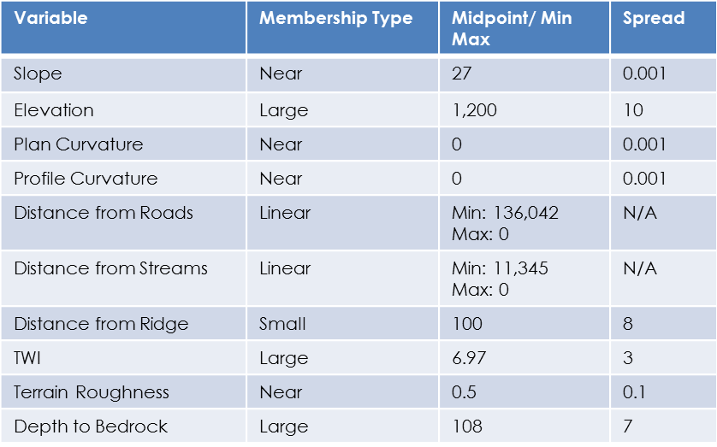The final step in producing the Landslide Susceptibility Map involved combining all of the fuzzy membership layers. This was achieved with the “Fuzzy Overlay” tool in ArcMap. The “AND” operator was chosen to combine the layers since this operator considered the combined input of all variables when assigning pixel values. Pixels were assigned the lowest value from the corresponding pixels of the input layers. This resulted in a raster layer with values ranging from 0 to 1, where pixels closer to zero represented low susceptibility to landslides and pixels closer to 1 represented high susceptibility to landslides.

Population data was combined with the Landslide Susceptibility Map to show landslide hazard. Once the Landslide Susceptibility Map was completed, areas with values of 0.5 or greater were selected to represent “highly susceptible areas.” A 1km buffer was generated around the highly susceptible areas to include places that could be affected by the outflow of a worst-case-scenario landslide event. SEDAC’s population data was then clipped to the buffered area to show the distribution of population density in highly susceptible areas. People living in these areas are considered to be at risk, and this was reflected spatially in the Landslide Hazard Map.

An additional susceptibility map was created from the methods outlined above, only using lower resolution SRTM-v2 90m data.

An Error Matrix was constructed to cross validate the susceptibility map by taking 56 identified landslide points and recording the values for each point from the susceptibility map using the “Extract Values to Points” tool in ArcMap. This was used as the presence data. An additional 56 points were randomly generated using the “Random Points” tool in ArcMap to serve as the absence data. Absence points were converted to KML files and examined in Google Earth to determine if any landslides had actually occurred within 100 meters. One point was discovered to be near a landslide and was thrown out and replaced. The susceptibility value for each absence point was recorded and entered in Excel along with the values of the presence data. Using this data, a matrix of true positives, false positives, true negatives, and false negatives was constructed and analyzed. This was repeated for the same points using the 90m resolution susceptibility map.

***Preliminary Assessment of Satellite Rainfall Performance***

Data products from both TRMM and GPM rainfall detecting satellite missions were downloaded and compared with the ground based CHIRPS data product for a baseline assessment of landslide predicting capability. The TMPA 3B42 product was used for TRMM, and the IMERG version 3 data product was used for GPM. Both products were downloaded from the NASA GIOVANNI site. The study period for this assessment was dependent on when the GPM and TRMM satellite missions overlapped in data recording and whether such data were available. This period was from April 2014 to February 2015, an 11 month study period. For the assessment, both daily totals and monthly averages were used for comparison.

The “Create Random Points” tool in ArcMap was used to generate 100 random points within the study area. Each point was given a data value that corresponded to the pixel in which it fell using the “Extract Values to Points” tool.  This was performed for each data product, giving three sets of identical points with different values. The values were then exported to a spreadsheet. A set of 100 random points were created and the process repeated for each month in the study period to give a full set of data values for each data product. This process was repeated for the daily assessment using data from the 30 days of September 2014, which was the rainiest month of the study period.

Once all values were entered into the spreadsheet, a Pearson’s r correlation was performed to determine whether the satellite measurements were similar to the ground-based measurements.

The upper quartile of the highest rainfall totals for each data product was selected and a second correlation was performed. This was to test how the data products correlated during extreme rainfall events.

This preliminary assessment was conducted on data that were at different spatial resolutions. To determine if this would affect the results, TRMM and CHIRPS data were interpolated using the “Resample” tool in ArcMap to match the coarser resolution of the TRMM data. The daily and monthly precipitation assessments were repeated on this data set.

# IV. Results & Discussion

***Global Landslide Catalog***Through the use of Landsat 8 OLI, Google Earth, and news articles, 13 new landslides (Figure 1) were found and added to the GLC. Each entry featured an exact geographic location, but did not have an exact date. Approximations for landslide occurrence were made using the Historical Imagery Slider in Google Earth.

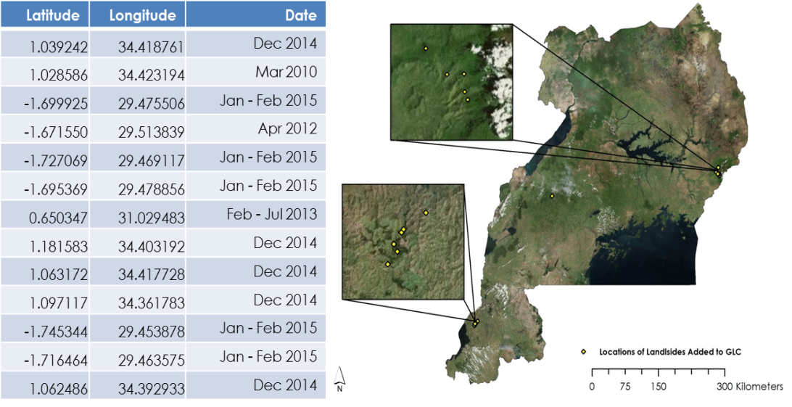

Figure 1: Location and Date Range for Landslide Entered in Global Landslide Catalog

***Landslide Susceptibility Map***

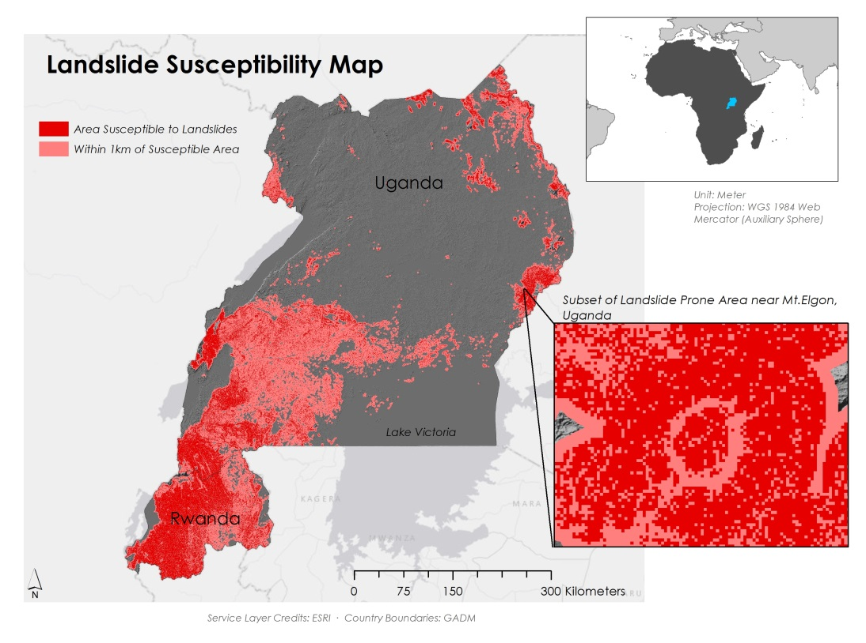

Figure 2: Landslide Susceptibility Map from 30m DEM

The Landslide Susceptibility Map revealed that several locations within the study area were highly susceptible to landslides. Eastern Uganda around Mt. Elgon, southwestern Uganda, and western Rwanda all displayed values of 0.5 or greater, meaning a landslide was 50% more likely in these areas than in the study area as a whole. The map also revealed areas with very low landslide susceptibility, lower than 0.2. These areas were located mostly in northern and central Uganda. Rwanda had very sparse low susceptibility areas, most likely due to the country’s high average elevation.

The susceptibility map was cross-validated using an error matrix. Results show that the model performed well with a true positive rate of approximately 84%. The overall accuracy of the model was approximately 88%. The misclassification rate was approximately 12% (Figure 3).

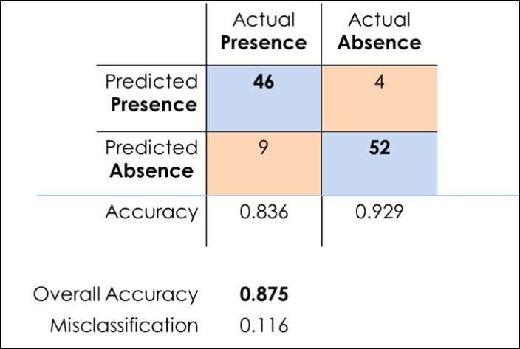

Figure 3: Error Matrix for 30m Resolution Landslide Susceptibility Map

Cross validation of the 90m resolution Landslide Susceptibility Map (Figure 4) revealed that it performed poorly compared to the 30m resolution Landslide Susceptibility Map. The number of false positives was very high and the overall accuracy of the model was just over 50%. The misclassification rate was over 48% (Figure 5).

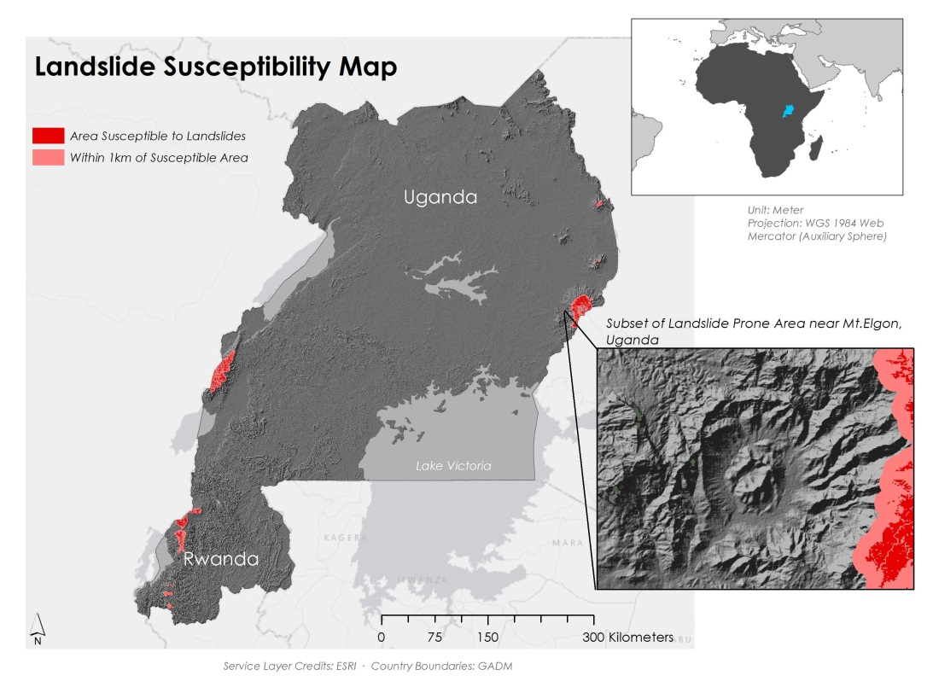

Figure 4: Landslide Susceptibility Map using 90m DEM

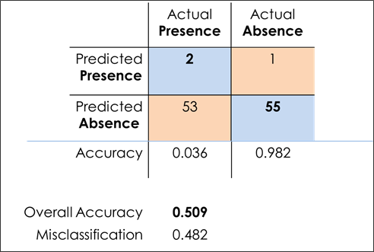

Figure 5: Error Matrix for 90m Resolution Landslide Susceptibility Map

***Landslide Hazard Map***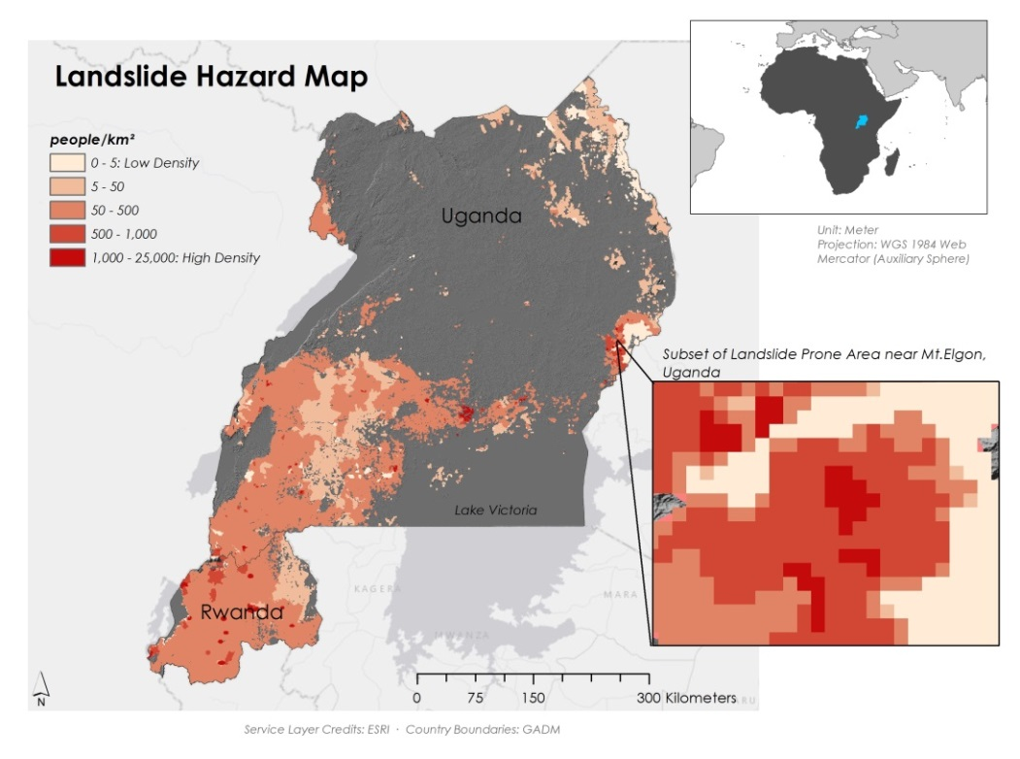

Figure 6: Landslide Hazard Map from 30m DEM

The addition of SEDAC population data to the 30m Landslide Susceptibility Map resulted in the creation of the Landslide Hazard Map (Figure 6). This map revealed that over 16 million people lived in susceptible areas or within 1km of susceptible areas, meaning that they were at risk of being affected by a landslide. A large portion of this at-risk population came from the heavily populated slopes of Mt. Elgon. Other densely populated areas at high risk included Uganda’s capital city, Kampala, located on the northern shores of Lake Victoria, Rwanda’s capital city, Kigali, located in central Rwanda, and the city of Gisenyi, located on the Rwandan border with the Democratic Republic of the Congo.

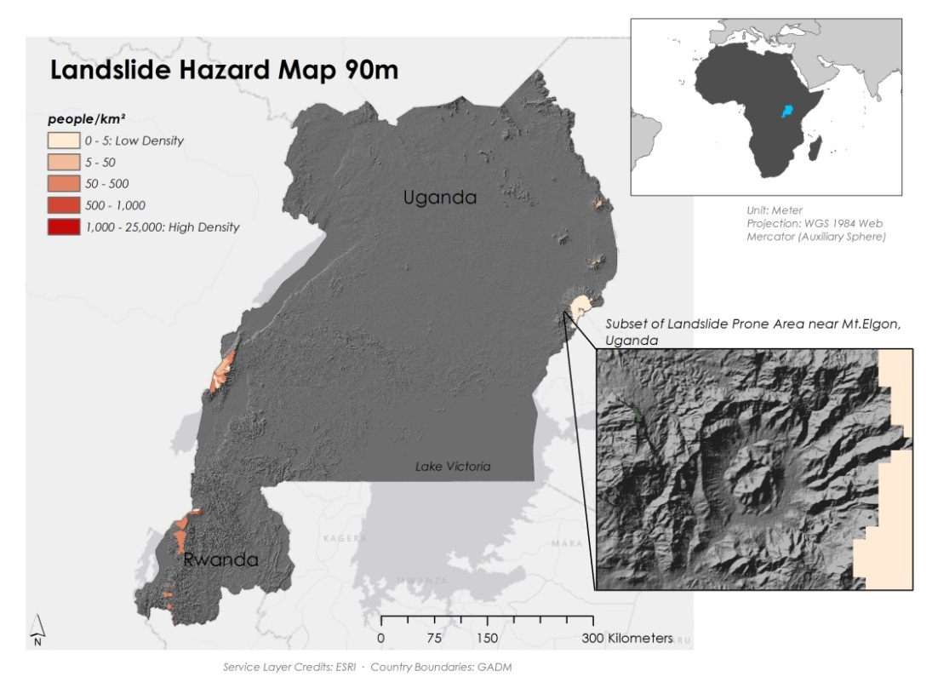

Figure 7: Landslide Hazard Map from 90m DEM

The addition of SEDAC data to the 90m Landslide Susceptibility Map resulted in a similar Landslide Hazard Map (Figure 7), but with fewer people affected. The 90m Hazard map indicated that only about 560,000 people were at-risk of a landslide. The 90m map does not include Kampala, Kigali, Goma, or most of the Mt. Elgon region, resulting in the stark difference in projected at-risk populations between the two maps.

***Preliminary Assessment of Satellite Rainfall Performance***The preliminary assessment of satellite rainfall performance revealed that TRMM, GPM, and CHIRPS positively correlated to one other quite strongly at the monthly scale. A strong positive correlation was also present at the daily scale. For both monthly and daily scales, TRMM and GPM were more strongly correlated to one other than with CHIRPS. When extreme rainfall events were examined, there was a strong positive correlation between TRMM and GPM at the monthly scale. CHIRPS however, showed a weak positive correlation to TRMM and GPM at the monthly scale. Extreme rainfall events at the daily time scale showed a strong positive correlation between TRMM and GPM; however, CHIRPS showed a weak positive correlation to both TRMM and GPM (Table 2). See Appendix B for interpretation of correlation values relationship.

The daily and monthly assessment performed on interpolated data that were at the same spatial resolution had very similar correlation values as the non-interpolated data with all correlations differing by less than 2%. Daily correlations were slightly higher for the interpolated data while monthly correlations were slightly lower.

Table 2: Pearson's r Correlation Values for Preliminary Assessment of Satellite Rainfall Perfomance

 

 

***Errors and Uncertainties***Due to volcanic activity and recurrent brush fires in the East African rift, there was a considerable amount of smoke in the Landsat data. There was also difficulty with cloud cover. In addition, small villages named in news articles were frequently not documented on any accessible maps. The Historical Imagery Slider in Google Earth did not give uniform coverage of the study area, resulting in uncertainties as to when a landslide may have actually occurred. In some cases, a range of several months was the most accurate estimate available.

The methodology used to make the Susceptibility and Hazard Maps also had its limitations, most notable of which was the fuzzy membership assuming all incorporated variables had an equal effect on landslide occurrence. While all factors included in this study are known to have some effect on landslide occurrence, many previous works, notably Knapen et al. (2006), suggest that factors such as slope and rainfall amount are much more significant.

It should be noted that even though the CHIRPS dataset was chosen for the rainfall assessment due to its incorporation of ground measurements, there were actually very few, if any, reliable ground measurements incorporated into the dataset. This highlights the unavailability of any consistent, standardized, or reliable ground-based precipitation measurements for the study area. As a result, the assessment was limited by the number of ground validation points available.

***Future Work***This project used a heuristic method to examine the factors associated with landslides in Uganda and Rwanda. This problem could also be approached from other directions. Project partner Eric Anderson is currently working on using a statistical method utilizing logistic regression. This study could also be approached with a logical method using Multiple Factor Method (MuF). MuF is based on logical operation that incorporates the additive influence of the higher susceptibility level of the instability factors (Bathrellos et al. 2009). Another term might also address the rainfall intensity-duration threshold for East Africa. Establishing a regional threshold could greatly increase landslide prediction accuracy. Also, no variables were included in the maps that were subject to seasonal or yearly variation, resulting in a static map. This included land use data, precipitation data and soil moisture data. Inclusion of such datasets in the future, if done correctly, could result in the creation of a near real-time susceptibility map.

The threat of dangerous landslides in East Africa is not restricted to Uganda and Rwanda. Other countries, including Tanzania, Kenya, and Ethiopia also experience such events and future studies should be expanded to include these countries. Project partner Dennis Macharia also expressed a need for the inclusion of Malawi in future studies, as it is an emerging landslide hotspot.

# V. Conclusions

This project provided a landslide susceptibility map, a landslide hazard map, and a preliminary assessment of GPM and TRMM to help understand which areas are prone to landslides, the number of people that could potentially be affected, and how well GPM and TRMM correlate, respectively. This project also added 13 new landslide points to the GLC. These end-products were used by SERVIR and RCMRD to aid disaster risk management efforts and land use planning in the region, as well as to increase understanding of the conditions required to trigger a landslide. Although it is not yet possible to predict a landslide with any substantial accuracy, effective preparation and planning can limit negative impacts and promote a sense of well-being within landslide prone areas.

# VI. Acknowledgments The East Africa Disasters team would like to acknowledge Dr. Jeffrey Luvall and Dr. Robert Griffin for providing guidance and support throughout this project. We would also like to thank our project partners Eric Anderson, Dr. Dalia Kirschbaum, and Denis Macharia for guidance and for providing data for this project.

# This material is based upon work supported by NASA through contract NNL11AA00B and cooperative agreement NNX14AB60A.

# VII. References

Kirschbaum, Dalia, Thomas Stanley, and Yaping Zhou. “Spatial and Temporal Analysis of  
 a Global Landslide Catalog.” *Geomorphology* (2015): n. pag. Web.

Knapen, A., M.g. Kitutu, J. Poesen, W. Breugelmans, J. Deckers, and A. Muwanga.

“Landslides in a Densely Populated County at the Footslopes of Mount Elgon

(Uganda): Characteristics and Causal Factors.” Geomorphology 73.1-2 (2006):

149-65. Web.

Nsengiyumva, Jean Baptiste. *Disaster High Risk Zones on Floods and Landslides.* Rep.  
 Kigali: Ministry of Disaster Management and Refugee Affairs, 2012. Web.

Socioeconomic Data and Applications Center (SEDAC). <http://dx.doi.org/10.7927/H4R20Z93>. Accessed 29 July 2015

Zawedde, J. “Uganda: Companies aid landslide victims.” *Reliefweb.* From Uganda Red  
 Cross, 16 March 2010. Web. 18 June 2015.  
 <http://reliefweb.int/rport/uganda/uganda-companies-aid-landslide-victims-0>

# VIII. Content Innovation

VPS

File Name: 2015Sum_MSFC_EastAfricaDisasters_TechPaper_FeaturedMultimediaForThisArticle

Interactive Map

File Name:

2015Sum_MSFC_EastAfricaDisasters_TechPaper_InteractiveMapViewer

Data Profile

File Name:

2015Sum_MSFC_EastAfricaDisasters_TechPaper_DataProfile.xml

# IV. Appendices

***Appendix A: Maps of Individual Landslide Variables***

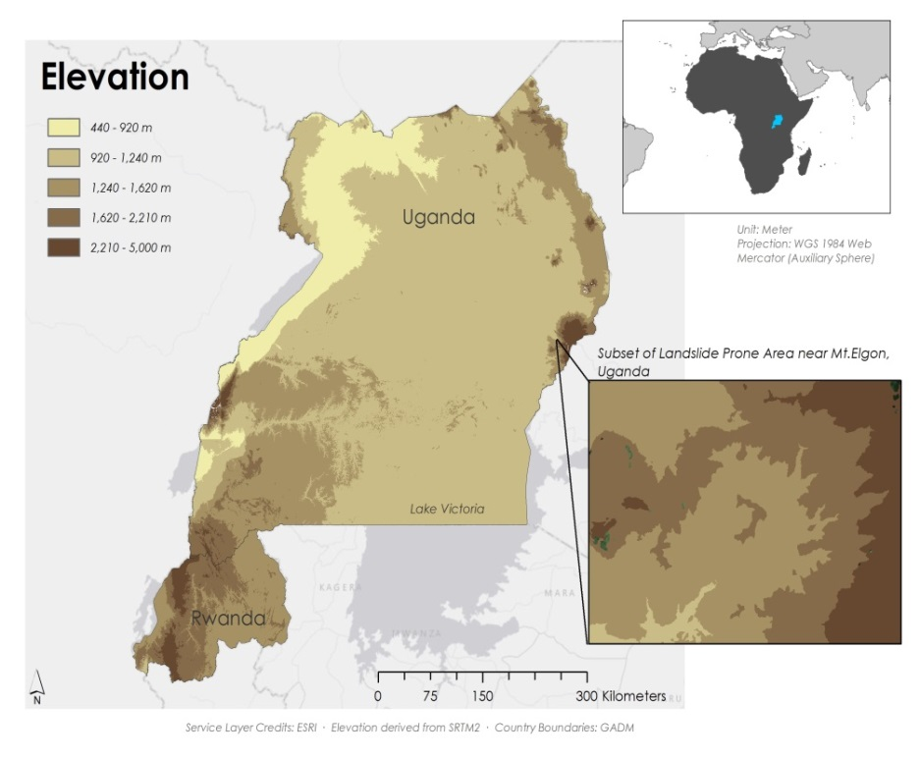

Figure 8: Elevation from 30m DEM

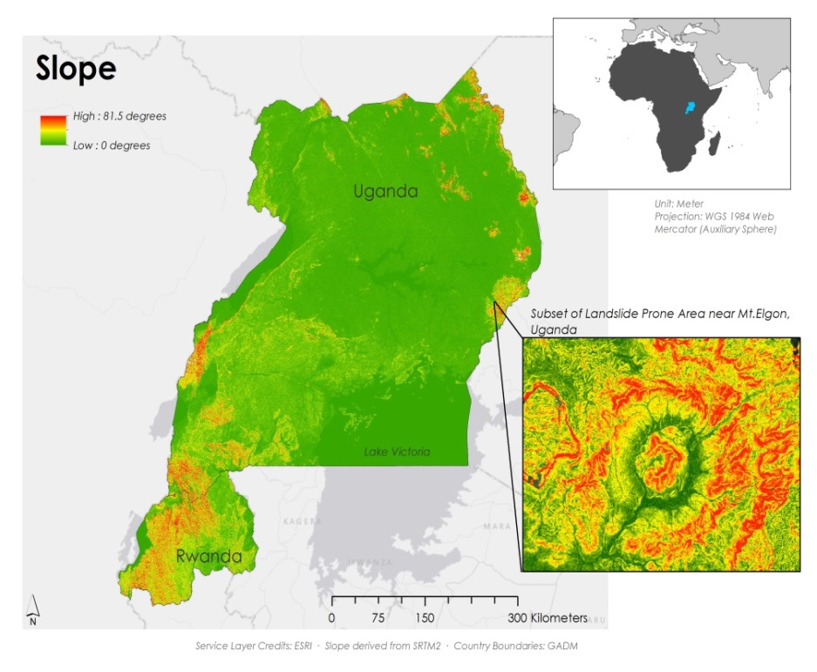

**Figure 9: Slope from 30m DEM**

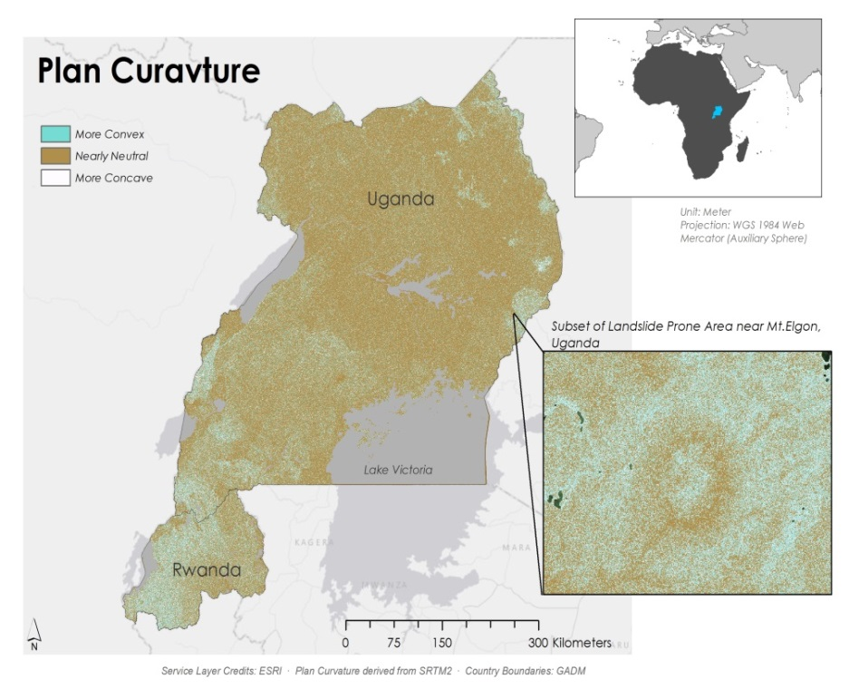

Figure 10: Plan Curvature from 30m DEM

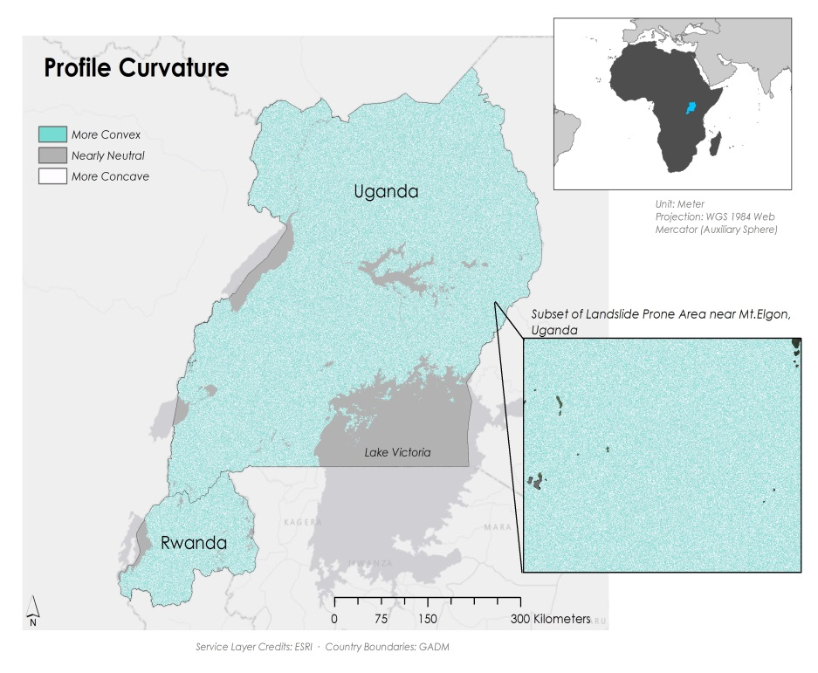

Figure 11: Profile Curvature from 30m DEM

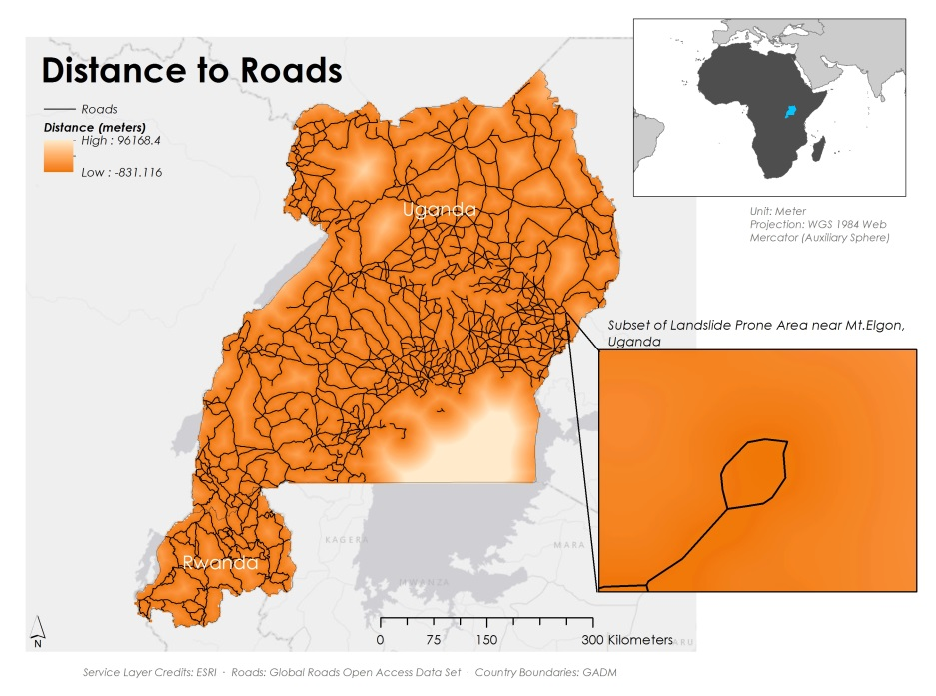

Figure 12: Distance to Road throughout Rwanda and Uganda

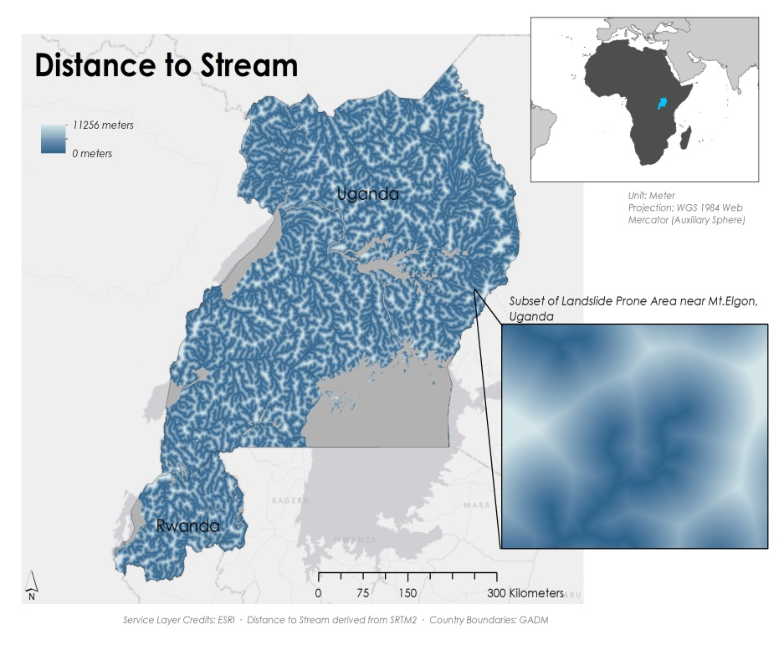

Figure 13: Distance to Stream from 30m DEM

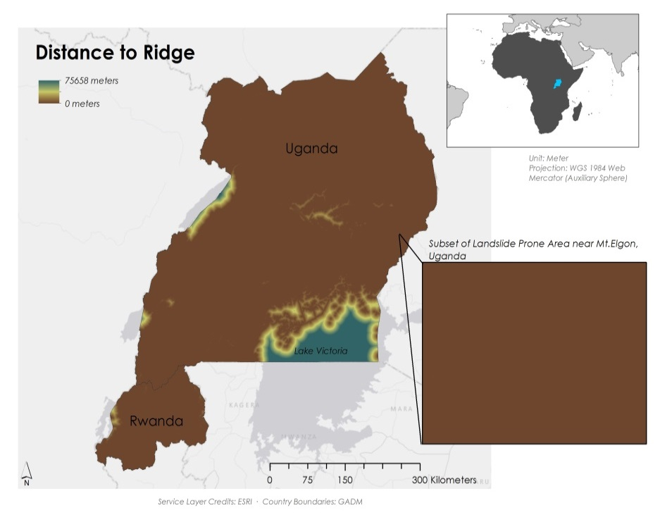

Figure 14: Distance to Ridge from 30m DEM

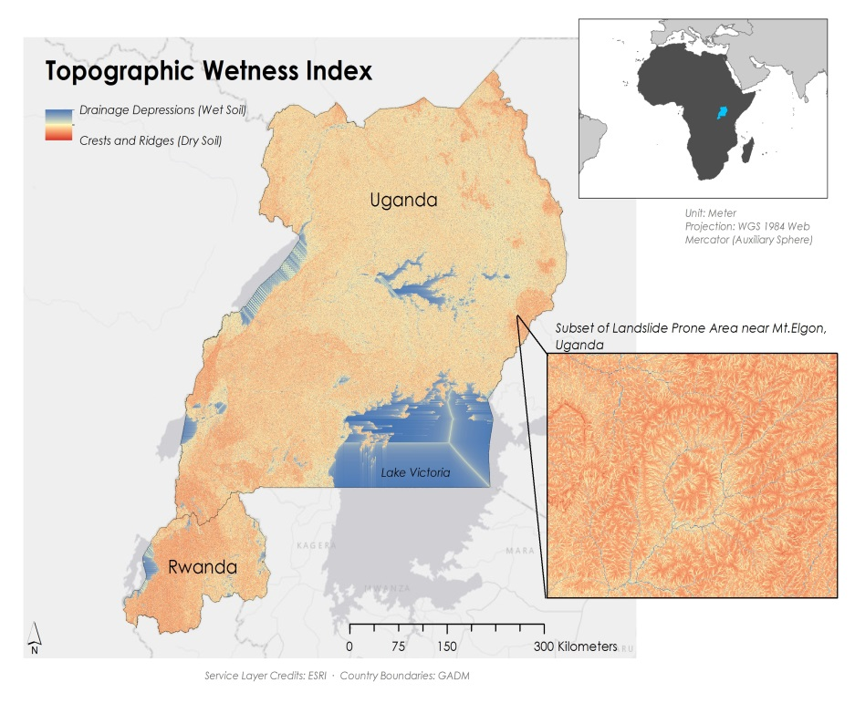

Figure 15: Topographic Wetness Index from 30m DEM

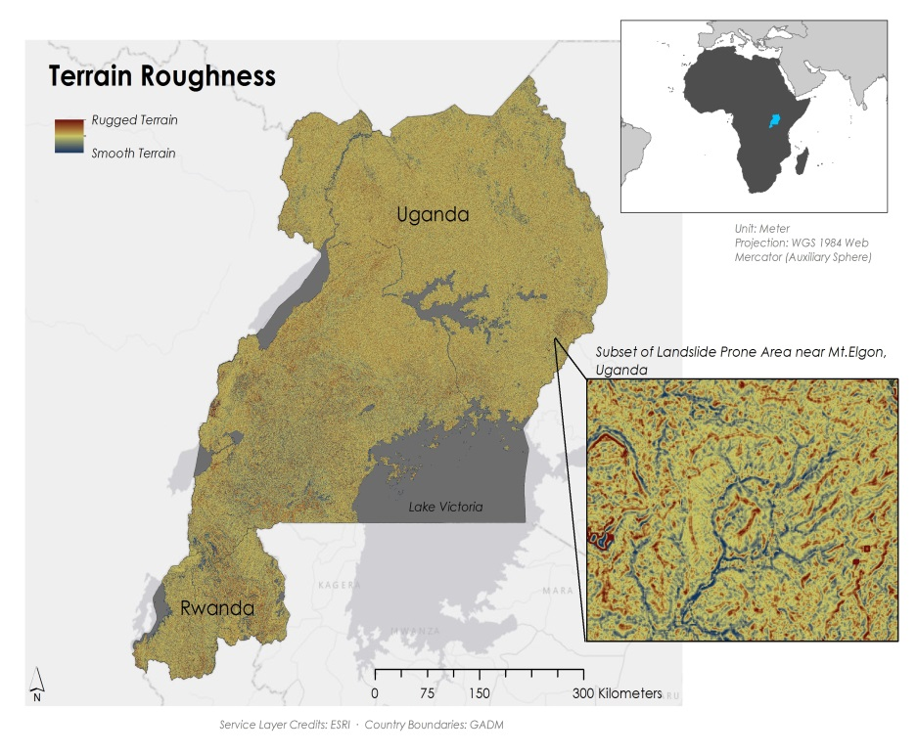

Figure 16: Terrain Roughness from 30m DEM

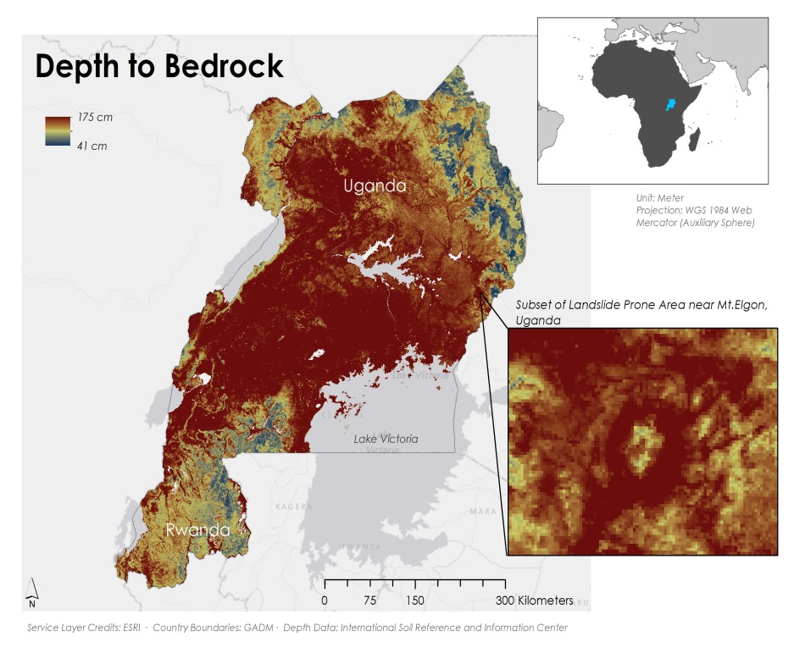

Figure 17: Depth to Bedrock throughout Rwanda and Uganda

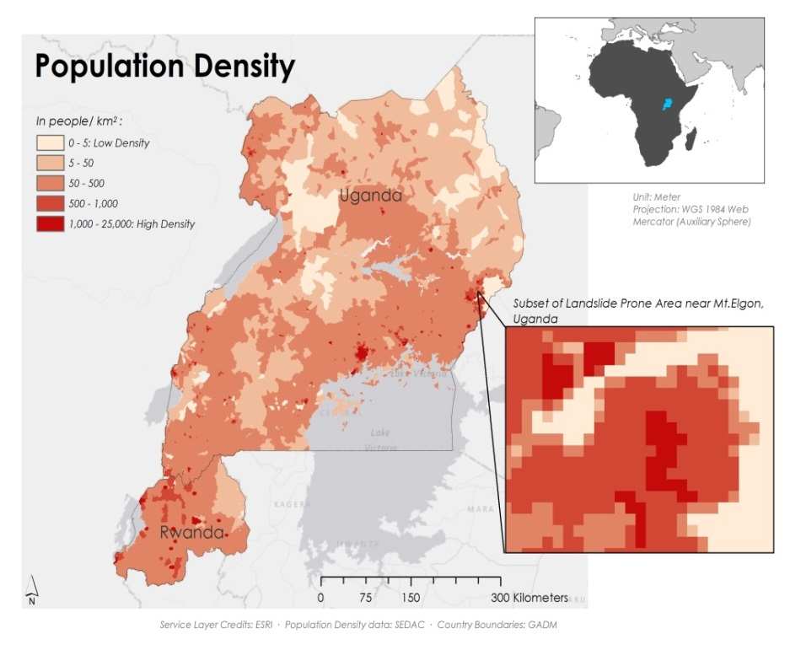

Figure 18: SEDAC’s Population Density Data throughout Rwanda and Uganda

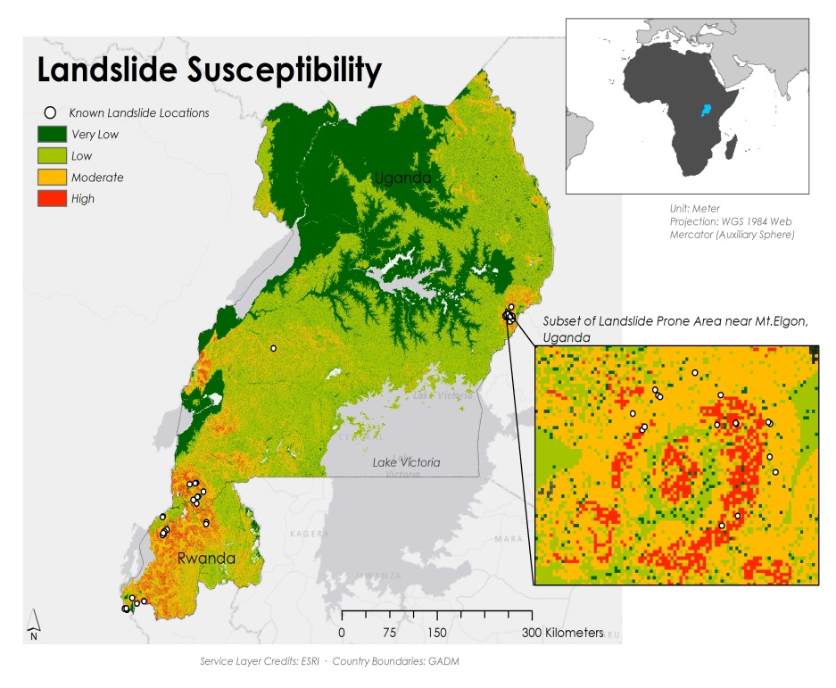

Figure 19: Landslide Susceptibility Map from 30m DEM broken down in very low, low, moderate, and high susceptibility of a landslide along with known landslide points

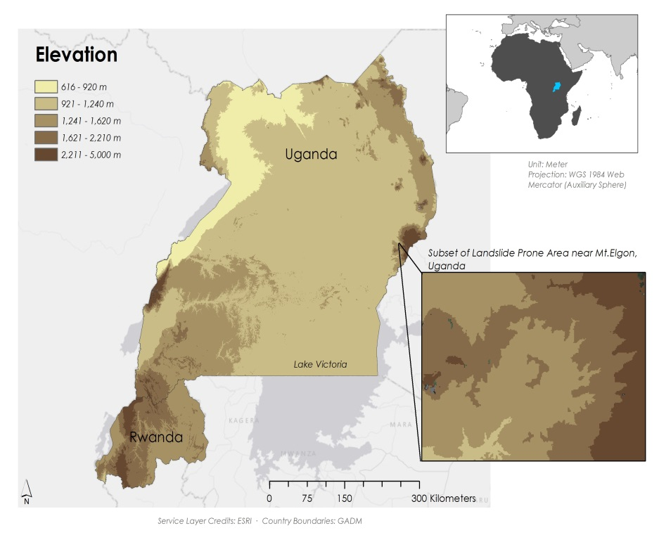

Figure 20: Elevation from 90m DEM

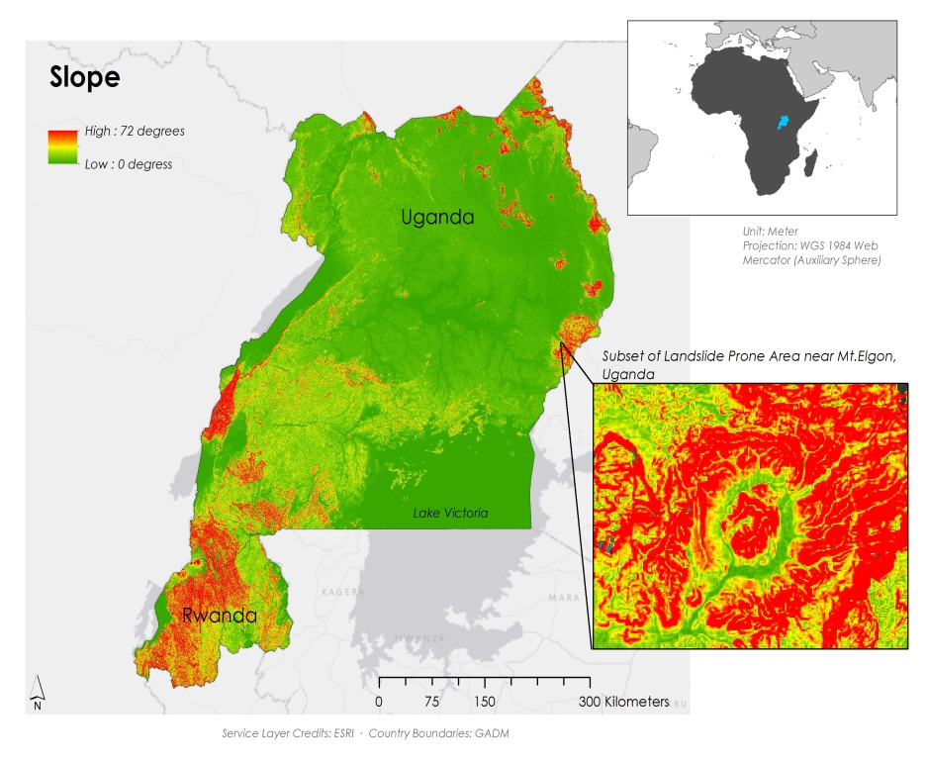

Figure 21: Slope from 90m DEM

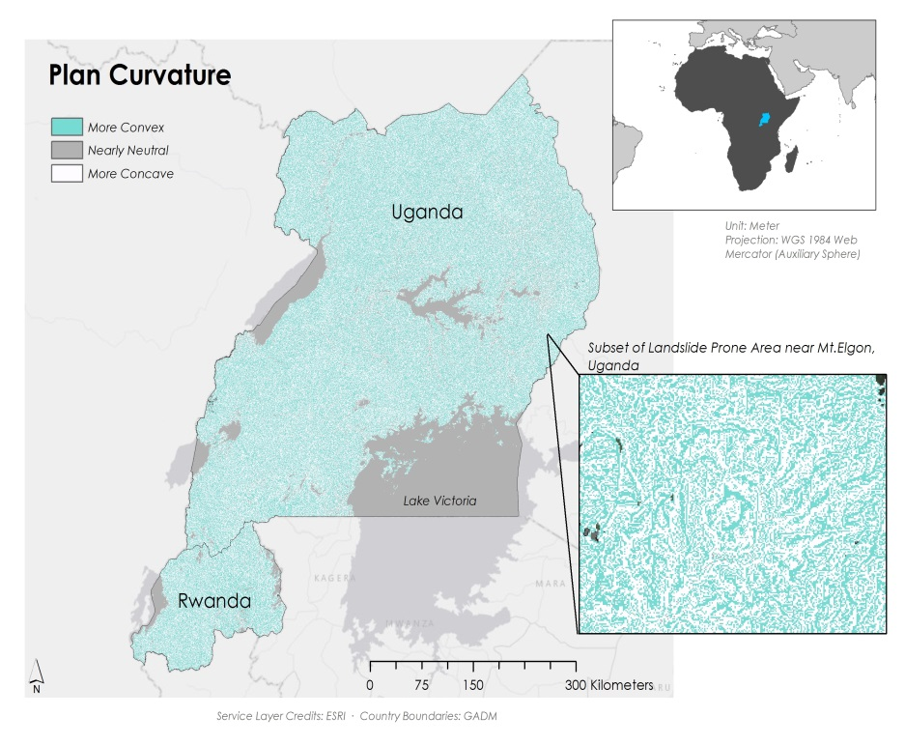

Figure 22: Plan Curvature from 90m DEM

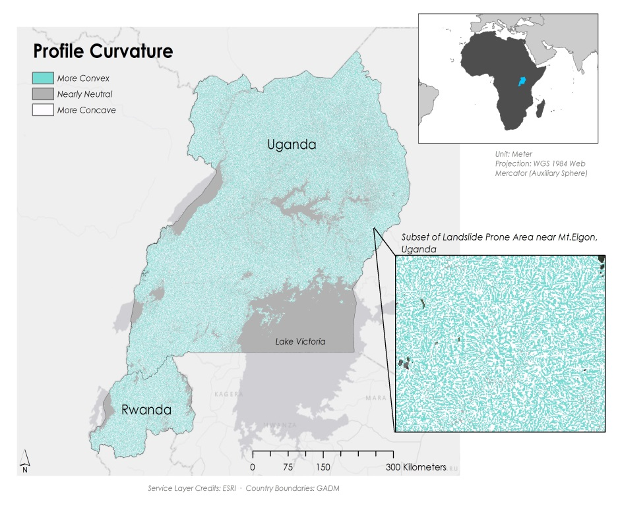

Figure 23: Profile Curvature from 90m DEM

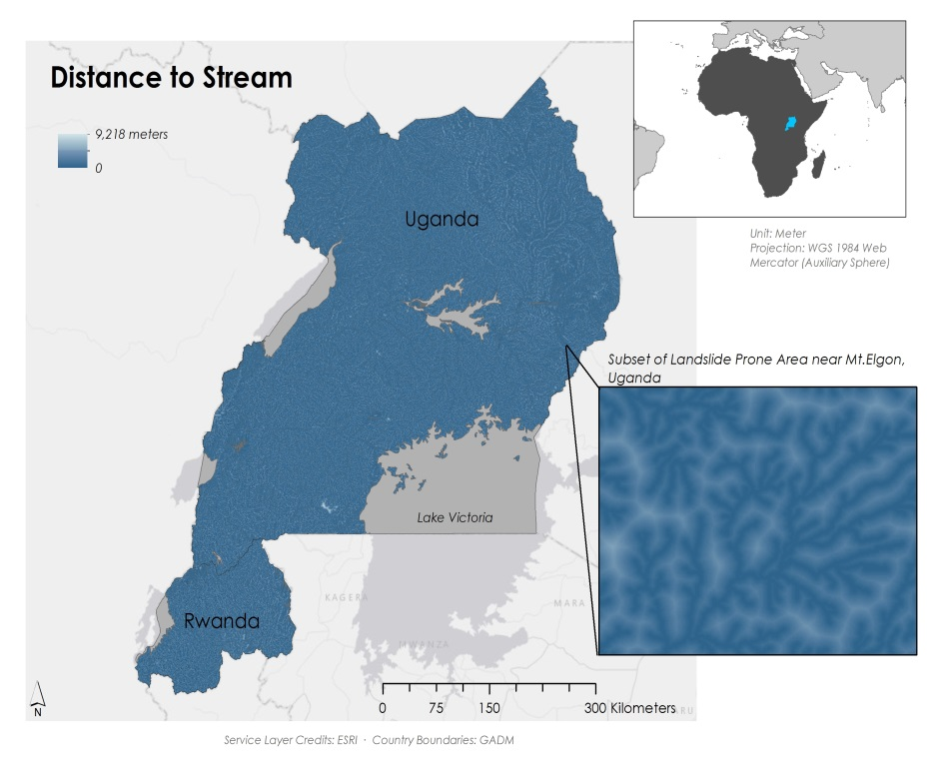

Figure 24: Distance to Stream from 90m DEM

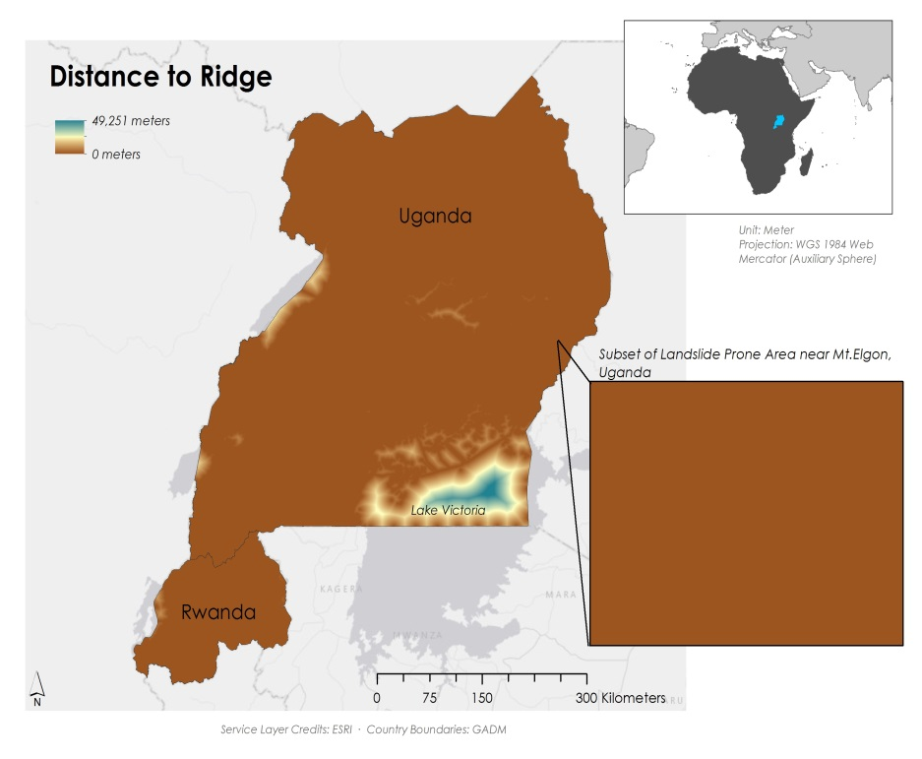

Figure 25: Distance to Ridge from 90m DEM

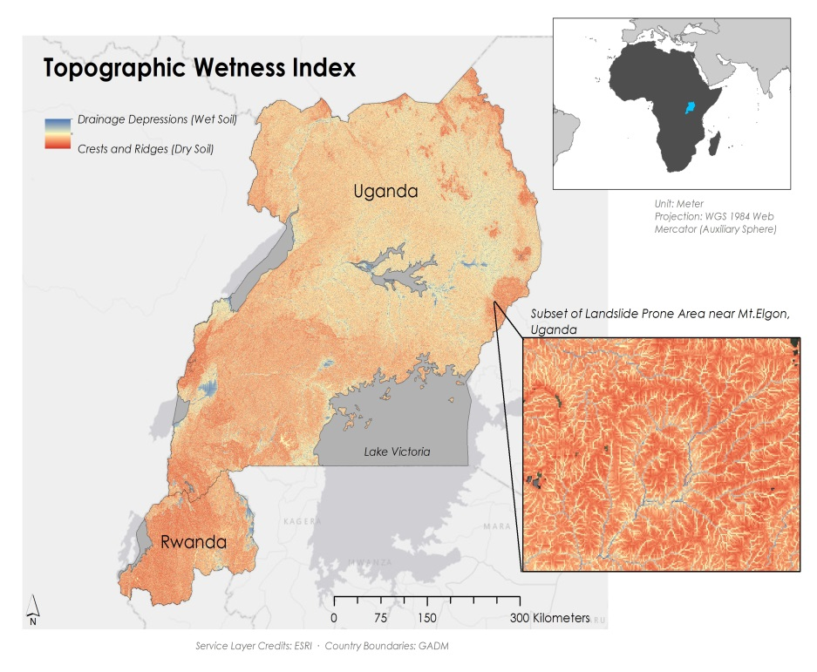

Figure 26: Topographic Wetness Index from 90m DEM

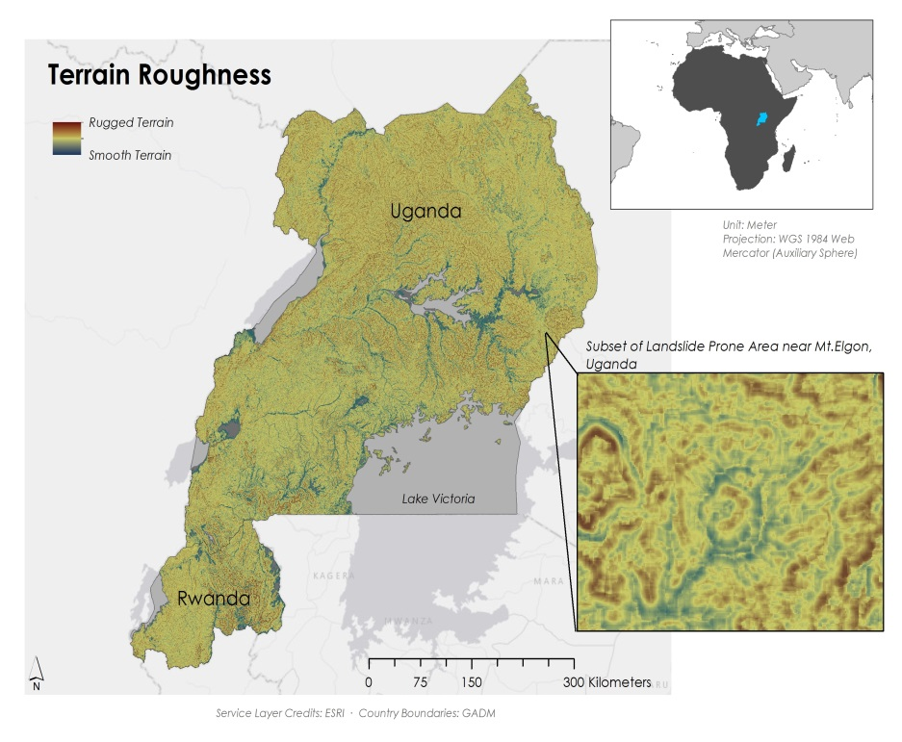

Figure 27: Terrain Roughness from 90m DEM

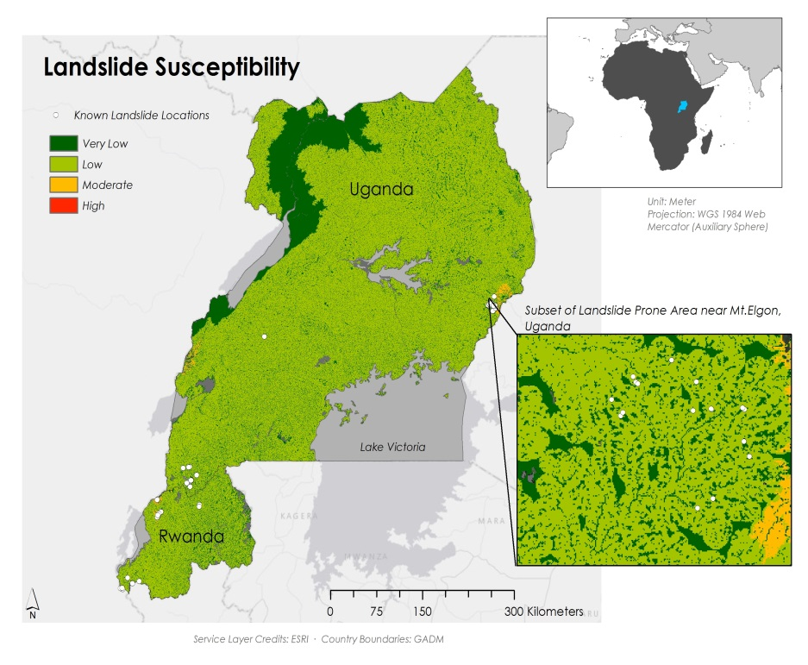

Figure 28: Landslide Susceptibility Map from 90m DEM

***Appendix B: Strength of Correlation*  
Table 3: Interpretation of Pearson’s r Values Strength of Correlation for Preliminary Precipitation Assessment**

|  |  |
| --- | --- |
| ***Interpretation of Strength of Correlation*** | |
| If r = +.70 or higher | Very strong positive relationship |
| +.40 to +.69 | Strong positive relationship |
| +.30 to +.39 | Moderate positive relationship |
| +.20 to +.29 | Weak positive relationship |
| +.01 to +.19 | No or negligible relationship |
| -.01 to -.19 | No or negligible relationship |
| -.20 to -.29 | Weak negative relationship |
| -.30 to -.39 | Moderate negative relationship |
| -.40 to -.69 | Strong negative relationship |
| -.70 or lower | Very strong negative relationship |

***Appendix C: Strength of Correlation*  
Table 4: Variable Parameters for Fuzzy Membership 90m DEM**

|  |  |  |  |
| --- | --- | --- | --- |
| **Variable** | **Membership Type** | **Midpoint/ Min Max** | **Spread** |
| Slope | Near | 24.23 | 0.001 |
| Elevation | Large | 2,641.5 | 1 |
| Plan Curvature | Near | 0 | 0.1 |
| Profile Curvature | Near | 0 | 0.1 |
| Distance from Roads | Linear | Min: 10,774  Max: 0 | N/A |
| Distance from Streams | Linear | Min: 92  Max: 1037 | N/A |
| Distance from Ridge | Small | 92.67 | 10 |
| TWI | Near | 6.95 | 0.1 |
| Terrain Roughness | Near | 0.38 | 10 |
| Depth to Bedrock | Large | 108 | 7 |