**NASA DEVELOP National Program**

****USGS at Colorado State University - Fort Collins, CO

**Spring 2016**

**Short Title: Laramie Mountains Ecological Forecasting**

**Subtitle:** Mapping Fire History in the Laramie Mountain Range, Wyoming with a 31-year Landsat Time Series

**VPS Title:** Playing with Fire: Delineating Fire History with Earth Observations

**Project Team & Partners**

**Project Team:**

Stephanie Krail (Project Lead), StephanieAKrail@gmail.com

Alexa Grafton

Aubrey Hilte

Darin Schulte

Brian Woodward

**Advisors & Mentors:**

Dr. Paul Evangelista (Colorado State University, Natural Resource Ecology Laboratory)

Dr. Amanda West (Colorado State University, Natural Resource Ecology Laboratory)

**Partner Organizations:**

Wyoming Game and Fish Department (End-User), POC: Ryan Amundson

USDA Forest Service, Laramie Ranger District (End-User), POC: Daron Reynolds

Colorado State University, Natural Resource Ecology Laboratory (NREL) (Collaborator), POC: Dr. Amanda West; Boundary Organization

**Project Details**

**Applied Sciences National Applications Addressed:** Ecological Forecasting

**Study Area:** Laramie Range, WY

**Study Period:** June 1984 – August 2015

**Earth Observations & Parameters:**

Space Shuttle, SRTM V2 – Digital Elevation Model

Landsat 5, TM – Land cover

Landsat 7, ETM+ – Land cover

Landsat 8, OLI & TIRS – Land cover

**Ancillary Datasets Utilized:**

* Natural Resource Ecology Laboratory Records – Aspen field data
* USDA Forest Service Administrative Boundaries – Forest management boundaries
* USDA Forest Service Vegetation Records – Historical vegetation records for Wyoming
* USDA Forest Service Fire History Records – Records of previous fires in Wyoming
* LANDFIRE Reference Database (LFRDM) – Vegetation and fuel data
* Monitoring Trends in Burn Severity (MTBS) Project – Records of previous fires and current vegetation type

**Models Utilized:**

* Laboratory for Applications of Remote Sensing in Ecology, Oregon State University, LandsatLinkr package
* Random Forest classification
* Maximum Likelihood classification

**Software Utilized:**

ArcGIS – Landsat imagery processing, derivation of indices, map creation

IDL and ENVI – Landsat imagery processing and analyzing

R – Statistical modeling and graphing

**Project Overview**

**80-100 Word Objectives Overview:**

Aspen trees (*Populus tremuloides*) play a crucial role in ungulate species health by supporting diverse forage, ensuring adequate fawn rearing, and providing cover from predators. This project is the first of two terms that will correlate fire history and aspen species distribution in the southeastern Wyoming focusing on the Laramie Mountain Range. We used multi-temporal and multi-spectral indices to create a time series of the regional fire history and severity, identify fire return intervals, and analyze susceptibility to future fires within the study area. Our findings supplement the data on aspen stand locations and ungulate species distribution to be modeled during the following term.

**Abstract:**

The Laramie Mountain Range, located in southeastern Wyoming, supports a multitude of plant and animal communities as well as human activities. Recreational opportunities, ample views, and critical mule deer (*Odocoileus hemionus*) and elk (*Cervus canadensis*) habitat are facets that depend heavily upon the presence of aspen (*Populous tremuloides*) communities. However, the success of these relationships is inhibited by the limited distribution of aspen in the Laramie Mountain Range. The ultimate objective of this two term project is to evaluate the carrying capacities of mule deer and elk in the Laramie Mountain Range by identifying current aspen distribution. Due to the scattered distribution of aspen trees in southeastern Wyoming, understanding historic fire patterns and future fire susceptibility in areas of close proximity to aspen stands can inform management practices. Thirty-one years of remotely sensed data were processed to create a spectrally and spatially consistent tasseled-cap time series. Tasseled-cap indices were utilized to estimate fire severity and perform a supervised classification to detect burned areas. Results from both processes were compared with the Monitoring Trends in Burn Severity product (which employs the Normalized Burn Ratio) to evaluate the use of tasseled-cap indices for fire monitoring. A fire hazard analysis was conducted to quantify fire susceptibility throughout the study area. Multi-temporal pixel values were extracted from spectral, topographic, and climatic indices and compared to pre-fire pixel values at historic fire locations. The similarity of a given pixel to previously burned pixels was estimated with a series of distance metrics.

**Community Concerns:**

* By supplying critical forage, habitat, and cover, aspen stands are crucial to the survival and overall health of mule deer and elk.
* The burgeoning of Sudden Aspen Decline (SAD) in the west is a growing concern for the fitness of the mule deer and elk populations.
* Extensive research exists on techniques to increase aspen growth throughout the Western United States. At the forefront of these techniques, prescribed burning allows land managers to directly assist in the regeneration of aspen stands across the landscape. Further monitoring of the success of prescribed burning as a means to facilitate aspen regeneration is critical to the health of mule deer and elk populations nationwide.

**Current Management Practices & Policies**:

Currently, field surveys are the only tool utilized to track aspen growth and monitor ungulate habitat. However, given limited access to the study area and financial constraints of the project partners, this method delivers fragmented conclusions about aspen regeneration on the landscape. While land managers would like to employ prescribed burning as a means to increase aspen growth and preserve critical habitat, no research examining the relationship among fire, aspen, and ungulate populations is readily available.

**Decision Support Tools & Benefits:**

|  |  |  |
| --- | --- | --- |
| **End-Product** | **Earth Observations Used** | **Benefit & Impact** |
| Study Area Map | SRTM | Create a map of the study area that the second term will utilize |
| Fire History Map | Landsat 5 TM, Landsat 7 ETM+, Landsat 8 OLI & TIRS | Identify previous fires to better understand aspen growth and aid in the management of the study area |
| Fire Severity Map | Landsat 5 TM, Landsat 7 ETM+, Landsat 8 OLI & TIRS | Classify previous fire strengths to discern the relationship between aspen regeneration and fire severity |
| Fire Return Intervals | Landsat 5 TM, Landsat 7 ETM+, Landsat 8 OLI & TIRS | Calculate fire return intervals to learn about fire frequency in relation to aspen regeneration and assist in the timing of prescribed fires |
| Fire Hazard Analysis | Landsat 5 TM, Landsat 7 ETM+, Landsat 8 OLI & TIRS | Analyze locations that are most susceptible to future fires |

**Project Imagery**

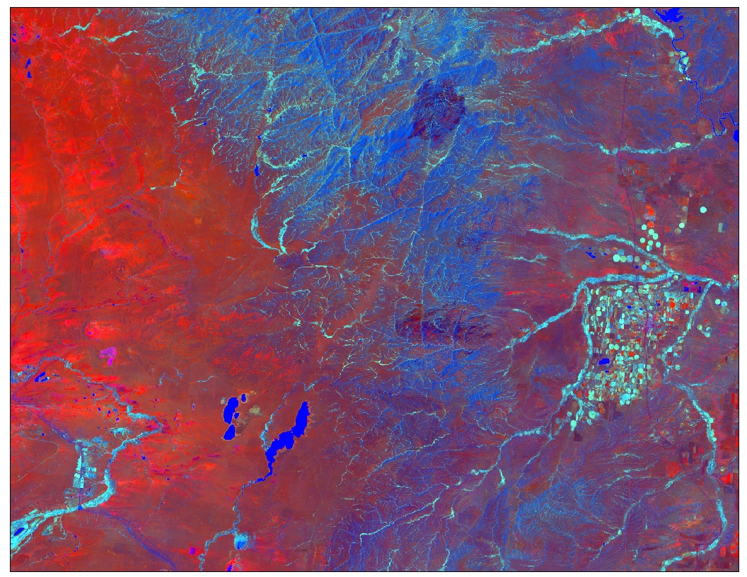

**Legend**

Tasseled-Cap Brightness

Tasseled-Cap Greenness

Tasseled-Cap Wetness

**Caption:** A tasseled-cap composite of our study area depicting the Laramie Mountain Range, burn scars, agricultural landscapes, and rivers. Image Credit: Laramie Mountains Ecological Forecasting Team.

**Image:** 2016Spring_FC_LaramieMountainsEco_VPSimage.jpg

**Software Release Requirements**

Category I