**NASA DEVELOP National Program**



University of Georgia

*Spring 2014*

Miami-Dade Ecological Forecasting

Utilizing NASA Earth Observations to Enhance Corridor Prioritization and Design Plans for the Western Greenway Corridor in

Miami-Dade County, South Florida

**Technical Report Final Draft**

April 3, 2014

Ning Chen, University of Georgia (Project Lead)

Caren Remillard, University of Georgia

Becky Lynn, University of Georgia

Ike Astuti, University of Georgia

Dr. Rosanna G. Rivero, College of Environment and Design, University of Georgia

(Science Advisor)

Dr. Francisco J. Escobedo, School of Forest Resources and Conservation, University of Florida (Science Advisor)

Steve Padgett-Vasquez, Department of Geography, University of Georgia (Mentor)

**I. Abstract**

Miami is a city of rapid and constant change, some of which is at the expense of its neighboring wetland area, the Everglades. As the largest subtropical ecosystem in the United States, the Everglades is located along avian migratory routes and is home to many endemic plant and animal species. The protection and restoration of this region is critical not only for ecological reasons, but also for the protection of water recharge resources for future urban water consumption by the 2.5 million residents of Miami-Dade County. The Miami-Dade County Parks, Recreation and Open Spaces Department (MDC-PROS) has embarked on an ambitious planning effort in partnership with The Trust for Public Land to develop a Western Greenway system of trails and recreational destinations along the County’s western edge. To assist Greenway planning efforts, this project used NASA satellite imagery to derive a vegetation index which served as an input of land cover for the Land-Use Conflict Identification Strategy (LUCIS) model. Additional land use information from a Miami-Dade County 2013 Land Use Management Application (LUMA) data set provided details on current urban development. Conclusions drawn from the LUCIS model identified the most suitable land for recreation, conservation, and production. This project contributes to decision support tools of MDC-PROS and The Trust for Public Land for planning green infrastructure corridors preserving the Everglades.

**Keywords**

Landsat, Miami-Dade County, Everglades, Remote Sensing, LUCIS model, Environmental Planning and Design, Green Infrastructure, urban-wetland fringe

# II. Introduction

Miami-Dade County is uniquely situated between natural boundaries. With the Everglades to the west and the Atlantic Ocean to the east, this County has little room to grow without disrupting biological diversity and natural resources. To cope with this reality, the Parks, Recreation and Open Spaces Department (MDC-PROS) and Trust for Public Land are embarking on an ambitious project to develop the Western Greenway. The greenway will provide a transition between developed areas and the Everglades to conserve ecosystem functions and provide associated ecosystem services.

Miami-Dade County is located between two national parks: the Everglades National Park and Biscayne National Park. It covers a total area of 4,916 km2 and has an average elevation of 3.66 meter above sea level (Miami for Visitors). In 2012, the United States Census Bureau reported Miami-Dade County’s population at just over 2.5 million residents (Miami for Visitors). The restoration and protection of the Everglades is critical not only for ecological reasons, but also for the protection of water recharge services that could become vital for future urban water consumption (Pittman 2006). Unfortunately, urban development is threatening the attempts to maintain and restore this system. Urban sprawl has historically played a central role in altering the environment by contributing to habitat fragmentation, the introduction of exotic species, and changes in land use and cover (Bryant 2006).

The Everglades was once a 15,000km2 wetland located in central and south Florida (Graf 2013). Preceding urban development within the area, rainfall within Central Florida would flow from Kissimmee River to Lake Okeechobee. When the lake reached its capacity, the excess water spilled over and moved south through fifty-mile wide and two-inch deep sawgrass, which served as a water filtration system. However, in 1947, this natural flow was altered by a flood control project enacted by Congress after the city of Fort Lauderdale was flooded from two hurricanes. This project consisted of more than 1,600 kilometers of canals, 150 water control structures, and 16 major pumping stations, all completed by 1968. This cleared the way for human settlement, but unfortunately resulted in a 90% loss of the wading bird population (Pittman 2006). In a short period of time, this system over-compensated by draining more than one billion gallons of water a day on average back to the sea.

In the 1990s, it became clear that a large scale restoration plan would be needed to reverse the declining ecosystem within the Everglades (Graf 2013). In 2000, the Comprehensive Everglades Restoration Plan (CERP) began an initiative to reverse the negative impacts caused by this complex system of levees and canals built to drain South Florida for settlement. CERP’s main objective was to hold water in reservoirs, release it at a more gradual pace, and redirect it towards the Everglades, consistent with its natural flow. The complex system developed by CERP is a critical system because it provides the drinking water for Florida’s growing population. The Clinton administration, the Department of Interior, and the public soon became increasingly concerned about this issue and provided significant support to the protection of this natural system. However, once these leaders left office, the push for restoration ceased (Graf 2013). The state and the Corps of Engineers’ restoration efforts continued, but often contradicted their work by approving additional development in the region (Pittman 2006).

More than half of the original Everglades have already been lost to human land use in the form of residences, farms, mines, and commercial development (Pittman 2006). As suburbs are developed around a city, natural habitats are fragmented and biodiversity is lost. Urban development in particular compromises this through land disturbance, surface conversion, and removal of native vegetation, introduction of exotics, and isolation and fragmentation of the remaining natural areas. (Bryant 2006).

The Western Greenway project is part of a long-term, complex solution to protect this delicate system. The project has been heard before numerous bodies of elected officials and was approved by the Board of County Commissioners at a public hearing on February 19, 2008. It is described as a green infrastructure that will help protect the Everglades from the invasion of fast sprawling urban areas. Benedict and McMahon (2006) define green infrastructure as strategically planned and managed networks of natural lands, working landscapes, and other open spaces that conserve ecosystem functions and provide associated benefits to human populations. Green infrastructures provide a systematic and strategic approach to land conservation, encouraging land use planning and practices that are beneficial to nature and people (McMahon and Benedict 2006). The planning and management of a green infrastructure network can guide the creation of an open space system that supports multiple objectives and can be applied to situations where infrastructure, such as roads and utility lines in development (Amundsen 2009). The planning effort is critical to the development of the project and must be completed before any action can be taken.

**Current Practices**

Miami-Dade County is currently using aerial photography for their Environmentally Endangered Lands (EEL) program to prioritize and monitor land acquisition.

**Study Area**

This project’s study area encompasses the southern tip of Florida for the entirety of the Western Greenway. The site spans from the urban-wetland fringe of Miami-Dade County’s western edge, which borders Everglades National Park, to the Northern lake belt area. The continuously growing population of Miami induces constant urban sprawl and development. The Everglades is unique because it contains expansive freshwater wetlands that gradually integrate with saline marshes and mangrove forests at the southern tip of Florida. As an ecosystem, it is the only subtropical preserve in North America—hosting the largest sawgrass prairie in the world and the largest mangrove complex in the Western Hemisphere (Brown et al. 2006).

**Study Period**

The project will use a Landsat image acquired November 10, 2011. The GIS ancillary data were obtained from Miami-Dade County GIS Portal: 2013 Land Use Management Application (LUMA) data set, DERM Environmentally Endangered Land Sites (EEL), Florida Natural Areas Inventory: Comprehensive Everglades Restoration Plan (CERP), functional wetlands, strategic habitat conservation areas, Rare Species Habitat Conservation Priorities, and Florida Geographic Data Library datasets: roads, FEMA flood zone, and soil drainage.

**National Application(s) Addressed**

Ecological forecasting applies knowledge of physics, ecology and physiology as well as socio-economic consideration to better understand the complexity of ecosystems related to their affecting factors and to predict howecosystems may change in the future in response to environmental factors or stressors such as climate change and rapid population. It is a way to project changes in living ecosystems by including possible uncertainties and errors to allow for alternative decisions to be made. In this study, ecological forecasting was used to plan and design the Western Greenway in a rapidly changing environment of Miami-Dade County.

**Project Partners**

The integration of programs, tools, and resources is necessary to restore biodiversity within developed communities (Bryant 2006). It is essential to have stakeholder participation in the planning process. In collaboration with Miami-Dade County, Environmentally Endangered Lands Program and the Trust for Public Land this project is focused on the design and planning of the Western Greenway. The Western Greenway will establish a system of connected greenway trails and recreational areas along Miami-Dade County’s western edge. Its benefits include scenic corridors, and freshwater lakes and beaches for recreational activities such as kayaking.

**Project Objectives**

The main purpose of this project is to design and illustrate the most effective areas to implement a greenway with a focus on biodiversity conservation within Miami. Successfully initiating a greenway requires the parties involved to have an understanding of both the natural ecology and the social obstacles presented by the city. The team constructed a recent NDVI map as a proxy for vegetation condition and utilized the information from LUMA land use map in order to apply the LUCIS model. This model is a land use-conflict identification strategy which will be used to predict future development and assess conflicts of use based upon weighted factors involved in agriculture, natural, and urban land models. Ultimately, recommendations will be developed to enhance the decision making process by providing suitable areas for development and identifying potential conflict areas for the Western Greenway.

# III. Methodology

This study utilized NASA Earth Observations to produce a current land cover map of the Western Greenway study area. The imagery selection was based on quality and date of acquisition. This project utilized an image with 0% cloud cover, allowing for the most accurate land cover results. The image was captured by Landsat 5 path 15 and row 42 on November 10, 2011.

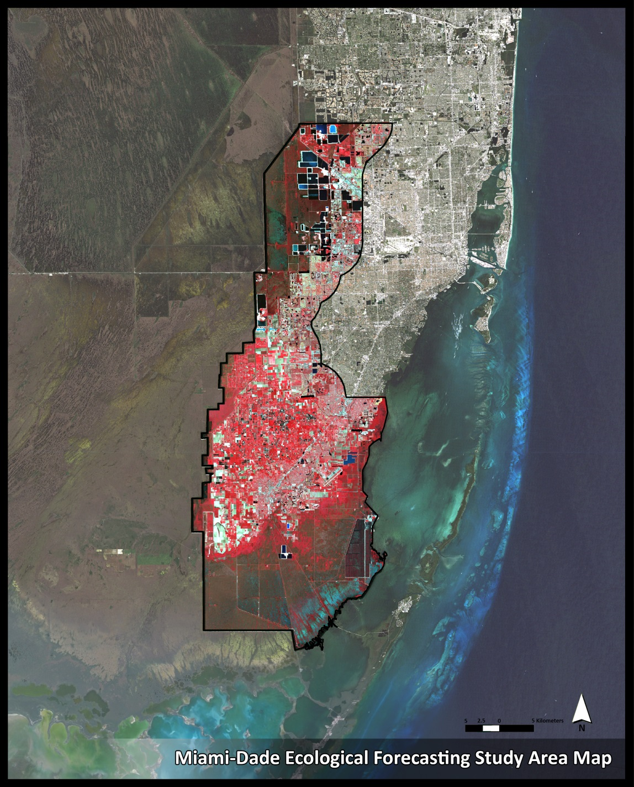

**Figure1.** Study area in false color image

**Data Processing**

The Landsat image was downloaded from the United States Geological Survey Global Visualization Viewer (GLOVIS). Processing included calibration and radiometrically correcting the image. Calibration is the process that converts the raw digital numbers of the image to reflectance and radiance units in order to be used in ESRI ArcGIS 10.1. Atmospheric correction is a process that radiometrically corrects the reflectance and radiance input by taking into account the influence of atmospheric effects such as Rayleigh scattering and non-selective scattering. Both processes were performed using the Environment for Visualizing Images (ENVI; ITT Visual Solutions, Boulder, CO, USA) 5.0. Quick Atmospheric Correction (QUAC) corrected wavelengths in the visible through near-infrared and shortwave infrared regions using radiative transfer approach. Lastly, the image was cropped to the boundaries of the study area.

**Data Analysis**

In this study, three major land cover types greatly influenced the formation of scenarios which included agricultural land, urban development land, and conservation land. We performed a suitability analysis specifically to each land cover type. The project goals shaped the suitability analysis criteria and determined the weights/types of shapefile inputs. Three suitability maps were as follows: Conservation Goals Suitability map, Production Goals suitability map, and Recreation Goals suitability map. The Conservation Goals map was the weighted overlay results of certain shapefiles containing strategic conservation lands, vegetation habitats, natural hydrology, and artificial hydrology (channels). The Production Goals map was the weighted overlay results of certain shapefiles containing soil, parcels, unprotected conservation lands, and farm lands. The Recreation Goals map was the weighted overlay results of certain shapefiles containing city boundaries, roads, impervious pavement, parks/open spaces, soil, recreational trails, schools, DRI (development regional impact), and water treatment. Most of these inputs were derived from the land use classification map. Equal weighting factors were assigned for all the inputs in the suitability analysis. The weighting factors will be adjusted according to stakeholders preferences in the public input meeting, which is scheduled to be held later in July. The results of the suitability maps had pixel values ranging from 1-9. The values were reclassified into the range of 1-3. [1=1-3, 2=4-6, 3=7-9].

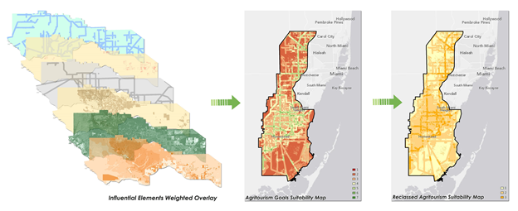

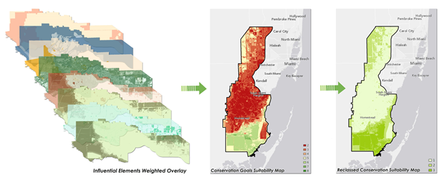

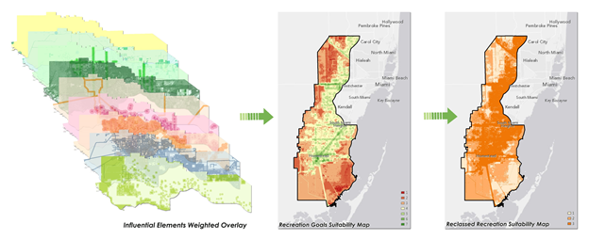

**Figure2.** Conservation Goals Suitability Map, Production Goals Suitability Map and Recreation Goals Suitability Map

The value of each pixel in the recreation map was then multiplied by 10, the value of each pixel in the conservation map was multiplied by 100, and the value of each pixel in the production map was multiplied by 1. After adding all the values together, the preferential degrees of different land cover types could be compared together. Based on this, areas of potential opportunity were determined. When the same preferential degrees occur in one pixel, a decision on which one was most preferred was made based on the project objectives.

Within this study, the 27 pixel values were categorized into three groups: Strict Conservation Areas, Moderate Conservation Areas, and Least Conservation Areas.

**Group 1:** Strict Conservation Areas. This group contained all the numbers with conservation goals value 3, which indicates that these areas need strict conservation regardless of how suitable they are for recreation and production use. The pixel values were: 311, 312, 313, 321, 322, 323, 331, 332, 333.

**Group 2:** Moderate Conservation Areas combined with recreation and production uses. This group contained all the numbers with conservation goals value 2, which indicates that these areas require moderate conservation, and could be considered for passive recreation / conservation agriculture/ production uses at the same time. These areas were defined as the potential locations for the green corridor development. The pixel values were: 211, 212, 213, 221, 222, 223, 231, 232, 233. In addition to these, pixel values 111, 112 and 121 were also included in this group, because these pixels did not represent strong bias to any of the three categories. They could be designated as part of group 2. Furthermore, the inclusion of these pixel values could improve the connectivity of the corridor.

**Group 3:** Least Conservation Areas with recreation / production uses. This group contained all the numbers with conservation pixel value 1 (omitting the three previously categorized pixel values), the rest of the two digit numbers showed relatively strong bias to certain land uses, which indicates that these areas require the least amount of conservation action, and could be considered for recreation / production uses. The pixel values were: 113, 122, 123, 131, 132, 133.

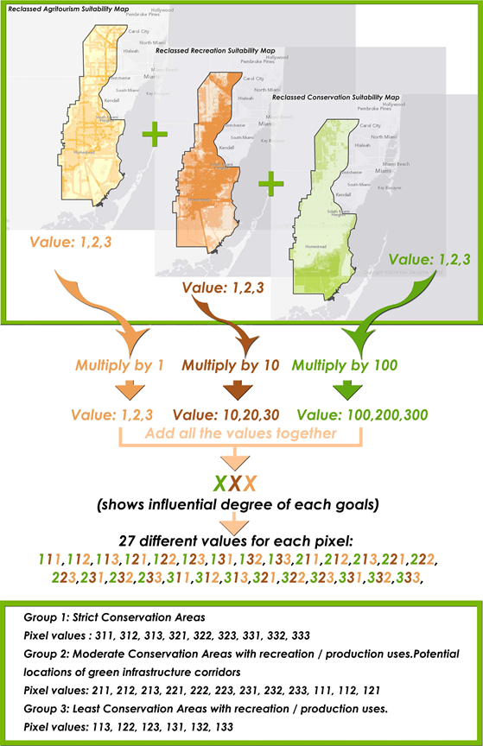

**Figure 3.** LUCIS model work flow chart

# IV. Results & Discussion

**Product 1: NDVI Map**

The NDVI map derived from the 2011 NASA Landsat image showed differing degrees of vegetative cover in the study area (Figure 4). Pixels with NDVI values above 150 were classified as dense vegetation, pixels with NDVI values between 120 and 150 were classified as high urban forest cover, pixels with NDVI values between 100 and 120 were classified as low urban forest cover, and pixels with NDVI values between 0 and 100 were classified as non-vegetation areas. Using the defined NDVI thresholds it was determined that high urban forest cover and dense vegetation classes dominated the area (92.98%). High urban forest cover was also relatively concentrated in the northern and southern parts of the study area. Low vegetation areas such as low urban forest cover and non-vegetative cover was found in a limited extent (7.02%).

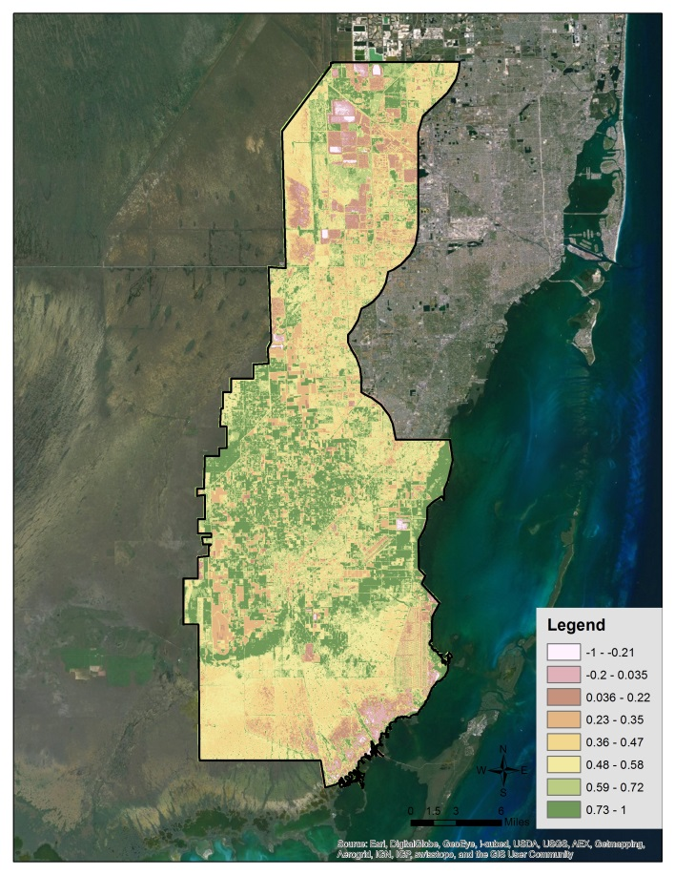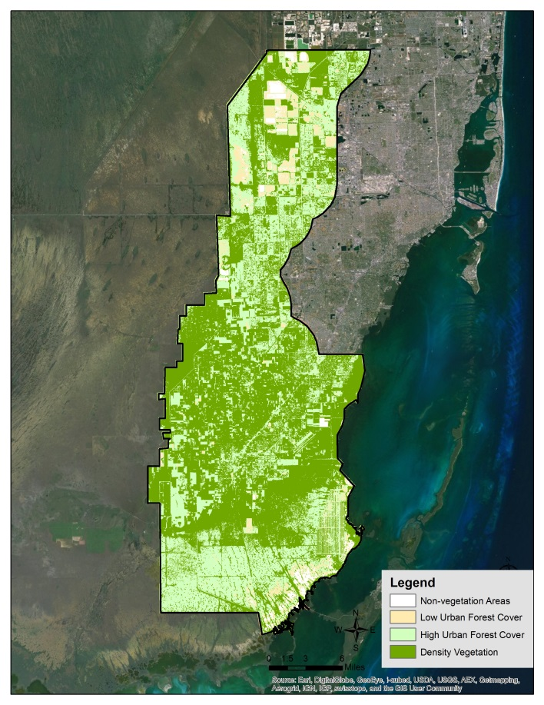

**Figure 4.** Natural breaks NDVI map and defined class NDVI map

**Product 2: LUCIS Model**

The three groups of pixel values were used to visualize an opportunity map (Figure5) for greenway development, based on the dominant values from the three categories: recreation, conservation, and production goals. The goals for each of the three categories were defined by stakeholders needs (see suitability analysis criteria matrix in the appendices).

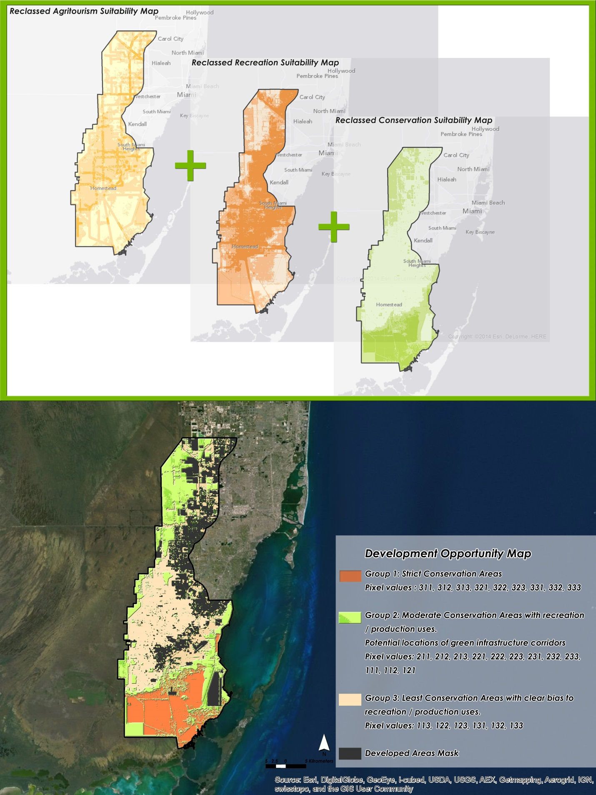

**Figure 5.** LUCIS Model analysis results: Development Opportunity Map

**Product 3: Green Infrastructure Corridor Map**

The corridor map, derived from products 1 and 2, displayed future protection in areas of potential rapid change and identified the most suitable lands for greenway development. The potential green corridor locations accounted for 37.56% of the total study area. Overlaying the corridor boundary with the NDVI map enabled us to identify the variability of its vegetation condition. Among the proposed corridor area, 86.98% was identified as high density vegetation cover and 13.02% was identified as low density vegetation cover. The high proportion of dense vegetative cover suggests that the corridor is highly important as an instrument to foster vegetation conservation.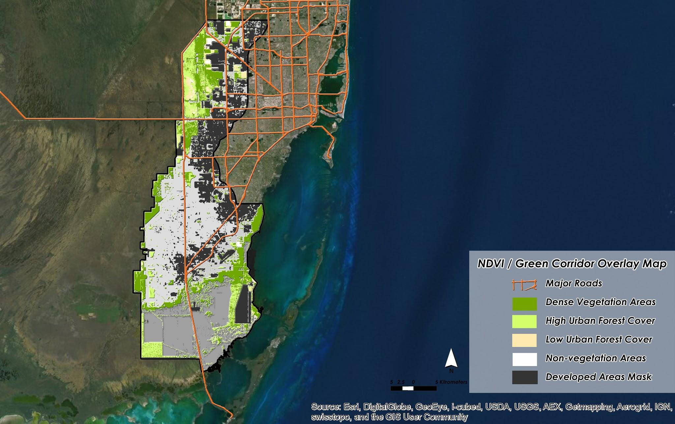

**Figure 6.** Green Infrastructure Corridor Map

# V. Conclusions

LUCIS model had effectively helped identify the development opportunity areas in this study. From the model, 28.04% of the area was identified for strict conservation purposes that do not allow future land cover modification. These areas were concentrated in the southern part and represented the importance of biological diversity. About 37.56% or approximately 93,169 km2 of the area was identified as the potentially suitable lands for the greenway development, which allowed limited recreation and production activities without disturbing the environment. The rest or about 34.40% was identified as more relevant to production and recreation development.

**Table 1.** The percentage of corridor size/ conservation / recreation by pixel numbers

|  |  |  |  |  |
| --- | --- | --- | --- | --- |
|  | **Pixel Values** | **Count** | **Area size (km)2\*** | **Percentage (%)** |
| **Strict Conservation Areas** | 311 | 24,270 | 6,793 |  |
|  | 312 | 27,166 | 7,628 |  |
|  | 313 | 1,771 | 499 |  |
|  | 321 | 116,931 | 33,781 |  |
|  | 322 | 59,155 | 17,143 |  |
|  | 323 | 4,504 | 1,309 |  |
|  | 331 | 656 | 195 |  |
|  | 332 | 5,694 | 1,701 |  |
|  | 333 | 1,662 | 498 |  |
|  | **Sub total** |  | **69,549** | **28.04** |
| **Moderate Conservation Areas with Recreation/Production Uses** | 211 | 64,423 | 12,234 |  |
|  | 212 | 68,367 | 13,044 |  |
|  | 213 | 2,899 | 556 |  |
|  | 221 | 117,836 | 23,438 |  |
|  | 222 | 67,258 | 13,438 |  |
|  | 223 | 6,836 | 1,372 |  |
|  | 231 | 18,372 | 3,820 |  |
|  | 232 | 37,651 | 7,862 |  |
|  | 233 | 6,690 | 1,403 |  |
|  | 111 | 33,694 | 3,366 |  |
|  | 112 | 74,186 | 7,478 |  |
|  | 121 | 47,378 | 5,159 |  |
|  | **Sub total** |  | **93,169** | **37.56** |
| **Least Conservation Areas with Recreation / Production Uses** | 113 | 9,605 | 977 |  |
|  | 122 | 145,174 | 15,940 |  |
|  | 123 | 31,743 | 3,514 |  |
|  | 131 | 87,678 | 10,337 |  |
|  | 132 | 345,323 | 41,024 |  |
|  | 133 | 113,224 | 13,553 |  |
|  | **Sub total** |  | **85,345** | **34.40** |
|  | **TOTAL** |  | **248,064** | **100.00** |

*\*Area size = number of pixels multiplied by 0.03 X 0.03 km2*

**Reflections and Future Work**

The NDVI map derived from NASA satellite imagery played a vital role in assisting the designation of Western Greenway planning. However, some improvements are worth noting. First, the NDVI image was the only dataset that resulted from remote sensing analysis. Other datasets such as land use, soil, and road maps were derived from other finalized GIS products. The threshold used for relating NDVI values to vegetation density and urban forest were adopted from a published paper (Szantoi et al., 2012). Since NDVI threshold is species-specific, error and uncertainty concerning the use of NDVI- based classification was present within the image atmospheric correction and the methods employed for classifying the NDVI values. Second, the use of NDVI from a single time point may not be adequate to capture temporal variation of vegetative cover. Improvements can be made by including temporal NDVI features on a seasonal basis. Third, 30-m satellite data was used as an input for deriving a vegetative index. It should be noted that at this level of resolution, objects in the field may be moderately variable, thus the occurrence of mixed pixels is inevitable. Finer resolution imagery more accurately discriminates vegetation pixels from non-vegetation pixels, which results in a more accurate NDVI classification. Finally, in the suitability analysis process, equal weight was applied for all input variables. However, this a straightforward approach may not represent the relative importance of certain variables. Additional studies may be incorporated for future refinement of the criteria. Discussion with relevant stakeholders could help to identify the relative importance of certain variables. It is necessary to keep this in mind and adapt to the ever-changing needs of the stakeholders as well as the ecosystem.

# VI. Acknowledgments

We would like to thank Dr. Rosanna G. Rivero from the College of Environment and Design, University of Georgia, for being our director and advisor for this project. We appreciate Dr. Francisco J. Escobedo, School of Forest Resources and Conservation, University of Florida as a helping hand while we worked through the LUCIS model. Also, we appreciate Dr. Marguerite Madden, Director of the Center for Geospatial Research, University of Georgia, for developmental assistance of this project. We want to give thanks to Steve Padgett-Vasquez for his mentoring assistance in regards to the NASA DEVELOP program. We are very grateful for our project partners, Trust for Public Land, and the Miami-Dade County’s Environmentally Endangered Lands program for having interest and concern of the ecological well-being of the Everglades. Without this initiative, none of this would have been possible. We would also like to thank Dylan Tracy for providing technical support throughout the year.

# 

# VII. References

Amundsen, O. A. 2009. Green infrastructure planning: recent advances and applications. Chicago: Planners Advisory Service Memo. American Planning Association.

Brown, M. T., M. J. Cohen., E. E. Bardi, and W. W. Ingwersen. 2006. Species diversity in the Florida Everglades, USA: a systems approach to calculating biodiversity. *Aquatic Sciences*, 68, 254-277.

Bryant, M.M., 2004. Urban landscape conservation and the role of ecological greenways at local and metropolitan scales. *Landscape and Urban Planning*, 76, 23-44.

Classifying Landsat Data for the National Landcover Dataset. <https://www.e-education.psu.edu/natureofgeoinfo/c8_p19.html>

Everglades National Park . National Park Service. Accessed: February 2,2014.

<http://www.nps.gov/ever/index.htm>

EXELIS, ITT. 2012. *Quick Atmospheric Correction (QUAC)* [Online]. Accessed February 20, 2014. <http://www.exelisvis.com/docs/QUAC.html>

Fry, K. Facts about Miami. Miami and South Florida for Visitors. Accessed: February 19, 2014.

<http://www.miamiforvisitors.com/local/facts.htm>

Graf, W. 2013. Water Resources Science, Policy, and Politics for the Florida Everglades. *Annuals of The Association Of American Geographers*, 103, 353-362.

Maryland Department of Natural Resources. 2003. Greenways: Making Natural Connections. Accessed: February 13, 2014. http:/dnr.state.md.us/greenways/

Mcmahon, E. T., and M. A. Benedict. 2006. Green Infrastructure: Linking Landscapes and Communities. Island Press, Washington, DC.

Pittman C. 2006. Bogged down in the Everglades: politics ensnares Florida's big restoration project. *Planning*, 72, 12-17.

Szantoi, Z., Escobedo, F., Wagner, J., Rodriguez, J.M., and Smith, S. 2012. Socioeconomic Factors and Urban Tree Cover Policies in a Subtropical Urban Forest. *GISScience and Remote Sensing,* 49, 428-449.

United States Census Bureau. Accessed: February 19, 2014.

<http://quickfacts.census.gov/qfd/states/12/12086.html>

**VIII. Appendices**

**For recreation goals: Providing new opportunities for recreation access**

|  |  |  |  |  |  |  |  |  |
| --- | --- | --- | --- | --- | --- | --- | --- | --- |
| **Objective** | **Criteria/ Type of analysis** | **Influencing factors** | **High Priority** | **Medium Priority** | **Low Priority** | | **References** | **Data Sources** |
| Maximize use of water bodies for recreational fishing |  | fishing | Water body | 50 ft buffer | All the other areas | | Western Greenway Technical Advisory, Team LEED site selection credit 1 |  |
| Identify denser vegetated (or areas with diverse vegetation?) | NDVI – denser areas can be more attractive, give more shade | vegetation density/health | High density area(150-200) | medium density area (120-150) | Low density area  (100-120) | Non-vegetation  (0-100) | http://earthobservatory.nasa.gov/Features/MeasuringVegetation/ | Land sat 5 NASA satellite imagery |
| Identify areas in proximity to project gateways and destination | Distance/proximity | Proposed gateways | 1. Broward – Dade County Line  2. US Highway 27, 3. NW 25th Street, 4. 8th Street, 5. 88th Street  6. 184th Street  7. 248th Street or Silver Palm  8. Biscayne – Everglades Greenway  9. Black Point Park & Marina  10. River of Grass Greenway  (5 min walking distance) | 10 min walking distance | All the other areas | | Western Greenway Technical Advisory  Team | 2014 Proposed Gateways to Western  Greenway  Miami-Dade GIS Portal |
| Maximize connectivity to existing parks and other recreational sites | Buffer or proximity to existing parks, for connectivity of expansion  Absence/ presence of marks (higher priority where there is already a park or rec area) | Existing parks | The existing parks | 5 min walking distance | All the other areas | | <http://islamorada.fl.us/comprehensive_plan/vp/Chapter%207%20DIA%20.htm>  5 min walking distance 400 meters | LUMA map  Miami-Dade GIS Portal |
| Maximize connectivity to existing trails. | Buffer to existing trails | Existing Trails | 5 min walking distance |  | All the other areas | | LEED site selection credit 5.1 | Miami-Dade GIS Portal |
| Maximize accessibility to certain services but at the same time keep noise and less quiet | Extract Recreation/ cultural related features | Proximity to Schools,  Libraries, supermarkets, theaters, community centers, restaurants, museums, place of worship, hospitals, etc | Within 0.5 mile of at least 10 basic services  Buffer 0-0.25 mile | 0.25-0.75 mile | All the other areas | | LEED site selection credit 2 | 2013 Public Schools  2013 Private Schools  2012 Colleges and Universities  2013 Adult Living Facilities  2013 County Public Libraries  2012 Municipal Public Libraries  Libraries,, Miami-Dade GIS Portal |
| Maximize accessibility but at the same time keep noise and less quiet | Define a min and max from road and public transit stations | Public Transit, Major roads, Railroads, Airports | Railroad stations, metro rail stations: 0.5 mile radius  Bus stops: 0.25 mile radius | Highway/ Major roads: buffer 0.5 mile | Local roads0.1 mile | | LEED site selection credit 4.1  LEED site selection credit 5.1 | 2006 Major Streets, Highways, railroads  2013 Bus Stops  2013 MetroRail Stations  2013 MetroMover Stations  Miami-Dade GIS Portal |
|  |  | Marina (waterfront/ coastal line recreation) | 5 min walking distance | 10 min walking distance | All the other areas | |  | Miami-Dade GIS Portal |
| Maximize accessibility but at the same time keep noise and less qui |  | Proximity to residential areas | Existing Residential zone(high/medium density) | 0.5 mile buffer | All the other areas | | LEED site selection credit 2 | Residential areas extracted from 2013  Existing Landuse (LUMA)  Miami-Dade GIS Portal |

**For conservation goals: Identifying opportunities for conservation of lands important to water quality protection and habitat/climate resilience**

|  |  |  |  |  |  |  |  |  |
| --- | --- | --- | --- | --- | --- | --- | --- | --- |
| **Objective** | **Criteria/ Type of analysis** | **Influencing factors** | **High Priority** | **Medium Priority** | **Low Priority** | | **References** | **Data Sources** |
|  |  | water features | Water body | 50 ft buffer | All the other areas | | LEED site selection credit 1 | Water manegement  Project: 2012  CERP Boundaries,  Miami-Dade GIS portal: 2010 Waterbodies  2010 Streams  2012 Canals  2009 Lakes |
| Maximize protection of higher density areas |  | vegetation density/ health | High density area(150-200) | High density area(120-150) | Low density area(100-120) | Non-vegetation | http://earthobservatory.nasa.gov/Features/MeasuringVegetation/ | Landsat 5 NASA satellite imagery |
|  |  | Native Biodiversity | Strategic Habitat  Conservation Areas criteria | Strategic Habitat  Conservation Areas criteria | Strategic Habitat  Conservation Areas criteria | | Pine Rockland, Rockland Hammock, Scrubby Flatwoods,  Coastal Uplands,  Wetlands  , Historic Transverse Glades, Ecotones. | Cooperative Land Cover (2012)  2013 Strategic Habitat Conservation  Areas (ver 4)  Florida Natural Areas Inventory (FNAI) |
|  |  | Natural Floodplains | A, AE, AH, AO,AR, A99, V, VE | B, X (shaded) C, X (unshaded) | D | | FEMA requirements: https://msc.fema.gov/webapp/wcs/stores/servlet/info?storeId=10001&catalogId=10001&langId=-1&content=floodZones&title=FEMA%2520Flood%2520Zone%2520Designations | 2013 Natural Floodplains (ver 4)  FNAI GIS Portal |
| Maximize protection of existing wetland areas | Buffer | Functional Wetlands | Functional wetlands criteria | Functional wetlands criteria | Functional wetlands criteria | | Wetlands and Upland Buffer Requirements - 4.01.06  <http://www.sjcfl.us/Environmental/Wetlands.aspx>  LEED site selection credit 1 | 2013 Functional Wetlands (ver 4)  FNAI GIS Portal |
| Maximize connectivity to EEL lands | Buffer or distance function to these lands | Environmentally  Endangered Lands (EEL) | EEL Lands |  | All the other areas | | Western Greenway Technical Advisory  Team | 2013 Miami-Dade EEL Lands  Miami-Dade Regulatory and Economic  Resources (RER) Department |
|  |  | Rare Species Habitat | Rare Species Habitat Conservation lands criteria | Rare Species Habitat Conservation lands criteria | Rare Species Habitat Conservation lands criteria | | Western Greenway Technical Advisory  Team | 2013 Rare Species Habitat Conservation  Priorities (ver 4)  FNAI GIS Portal |
|  |  | Critical  Restoration Projects | Critical Restoration Projects properties |  | All the other areas | | Western Greenway Technical Advisory  Team | 2011 Critical Restoration Projects  SFWMD GIS Portal |

**For production goals: Promoting agri-tourism in the region**

|  |  |  |  |  |  |  |  |  |
| --- | --- | --- | --- | --- | --- | --- | --- | --- |
| **Objective** | **Criteria/ Type of analysis** | **Influencing factors** | **High Priority** | **Medium Priority** | **Low Priority** | | **References** | **Data Sources** |
|  |  | **vegetation density/health** | Non-vegetation areas (0-100) | low density area (100-120) | Medium density area (120-150) | High density areas (150-200) | http://earthobservatory.nasa.gov/Features/MeasuringVegetation/ | Land sat 5 NASA satellite imagery |
|  |  | **Soils floodplain** | Suitable soils for drainage | Medium drainage degree | Low drainage degree | |  |  |
| **Avoid mining** |  | **Mining** | Existing Mining sites |  | All the other areas | |  | 2013 Rock Mining Sites: LUMA Landuse  Miami-Dade GIS Portal |
|  |  | **Canal** | Existing canals + 5 min walking distance |  | All the other areas | | LEED site selection credit 1 | Miami-Dade GIS Portal |
|  |  | **Agriculture** | Existing agriculture areas |  | All the other areas | |  |  |
|  |  | **Major roads** | 5 min walking distance |  | All the other areas | |  |  |