**NASA DEVELOP National Program**

****University of Georgia

**Spring 2016**

**Short Title: Perú Climate II**

**Subtitle:** Monitoring and Forecasting Shifting Climate and Land Change Impacts in Perú’s Parque de la Papa for Enhanced Agricultural Management

**VPS Title:** Hot Potato, Hot Potato: The Effects of Climate Change on Traditional Andean Farming in Perú

**Project Team & Partners**

**Project Team:**

Caren Remillard (Project Lead), carenremillard@gmail.com

Brandon Hays

Benjamin Page

Adam Salway

Sam Weber

Xuan Zhang

**Advisors & Mentors:**

Dr. Kenton Ross (NASA DEVELOP National Program Science Advisor)

Dr. Marguerite Madden (University of Georgia, Center for Geospatial Research, UGA DEVELOP Lead Science Advisor)

**Past or Other Contributors:**

Rebekke Muench

Kayla McDonald

Ryan Murphy

Michael Sclater

Richard Rose

Dajon Begin

Noel Baker

Genesis Abreu

**Partner Organizations:**

International Potato Center (CIP) (End-User), POCs: Dr. Noelle Barker, Dr. David Ellis, and Rene Gomez; Boundary Organization

Asociación para la Naturaleza y el Desarrollo Sostenible (ANDES) (End-User), POC: Alejandro Argumedo

**Project Details**

**Applied Sciences National Applications Addressed:** Climate, Agriculture, Ecological Forecasting

**Study Area:** Parque de la Papa, Perú

**Study Period:** January 1985 - December 2015

**Earth Observations & Parameters:**

Landsat 4, TM - Land cover/planting patterns

Landsat 5, TM - Land cover/planting patterns

Landsat 8, OLI/TIRS - Land cover/planting patterns, land surface temperature

Terra, ASTER- Elevation

**Ancillary Datasets Utilized:**

* NOAA NCDC Climate Data - temperature and precipitation
* CIP HOBO Transportable Weather Stations - temperature, relative humidity, dew point
* CIP GPS coordinates - locations of potato plots

**Software Utilized:**

ArcGIS - Raster manipulation/analysis, image enhancement & map creation

ENVI - Raster manipulation/analysis, image enhancement & map creation, Atmospheric correction

MATLAB - Raster manipulation/analysis, image enhancement & map creation

**Project Overview**

**80-100 Word Objectives Overview:**

In recent years, changing climatic conditions have forced traditional farmers in the Perúvian Andes to plant potatoes at increasingly higher elevations. The goal of this project is to document recent changes in cropland distribution and elevation, temperature, and precipitation within the Parque de la Papa, Perú. These results will inform a crop suitability model designed to identify areas with the most potential for future agricultural use.

**Abstract:**

In the face of global climate change, agricultural systems in tropical montane regions are particularly vulnerable. Anecdotal evidence within Parque de la Papa, Perú indicate farmers following traditional practices have moved potato crops to higher elevations seeking suitable growing conditions for the potato varieties they have cultivated for centuries. The primary threat to native potatoes is increased mortality rates from pests and diseases. In particular, rising temperatures have led to increases in the population and habitat range of the Andean potato weevil, *Premnotrypes spp.* We quantified changes in potato field elevation over the past three decades using Landsat imagery to confirm these trends. The cultivation time-series analysis, slope and elevation data from ASTER, and historical changes in precipitation and temperature will be incorporated into a crop suitability model used to predict areas for potato cultivation. This model will be given to the International Center for Potatoes (CIP) for use in a management plan to inform the farming efforts of the indigenous communities within Parque de la Papa.

**Community Concerns:**

* Local farmers have (been forced to move) moved their potato crops to higher elevations in response to changing growing seasons, varied precipitation patterns, and increased pest survival
* Less land is available for harvesting and higher elevations bring topographic challenges
* Indigenous farmers work to maintain traditional farming practices and conserve multiple native potato varieties, making genetic preservation a challenge

**Current Management Practices & Policies**:

CIP is working with local communities within Parque de la Papa to ensure farmers are able to maintain potato biodiversity and continue to use traditional practices. CIP currently maintains and evaluates multiple research plots at different elevations in the park. These plots provide locations for specific potato varieties and contain equipment to monitor meteorological conditions. CIP purchased satellite images in 2007 to map locations of potatoes and other crops but have not yet integrated climatic data to assess potato suitability.

**Decision Support Tools & Benefits:**

|  |  |  |
| --- | --- | --- |
| **End-Product** | **Earth Observations Used** | **Benefit & Impact** |
| Cultivation Time-series Analysis | Landsat 4 TM, 5 TM, and 8 OLI/TIRS | Quantify changes in spatial distribution and abundance of land under cultivation |
| Climate Variability Visualizations | None | Model and assess temperature and precipitation regimes affecting the park |
| Crop Suitability Map | Landsat 4 TM, 5 TM, and 8 OLI/TIRS, Terra ASTER | Identify areas with the most potential for future agricultural use under changing climate conditions |

**Project Imagery**

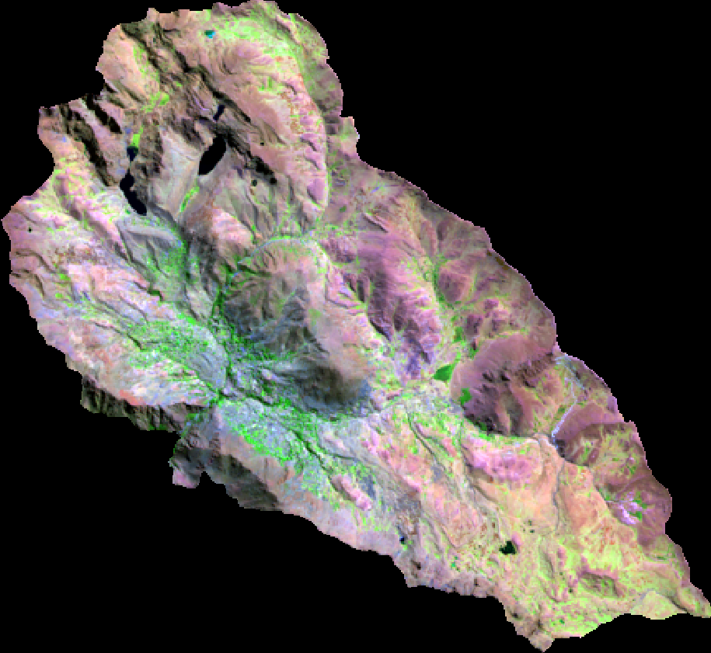

**Caption:** Landsat 8 OLI 6-5-2 band composite image (July 29, 2013). Agricultural crops appear bright green. Image Credit: Perú Climate II Team.

**Image:** 2016Spring_UGA_PeruClimateII_ProjectSummary_Image_RD

**Software Release Requirements**

What category do the tools your project is creating fall within? [Options: No software development involved, or if there is scripting/coding involved the category I to V]