**NASA DEVELOP National Program**



BLM at Idaho State University GIS TReC

*Fall 2015*

Southeast Idaho Disasters

Juniper Encroachment and Management in the Western U.S. Relative to Catastrophic Wildfires

 **Technical Report**

Rough Draft – October 8, 2015

Zachary Simpson (Project Lead)

Jenna Williams (Center Lead)

Sara Ramos

Keith Weber, Idaho State University, GIS Training and Research Center (Science Advisor)

John Schnase, NASA Goddard Space Flight Center (GSFC) (Science Advisor)

Mark Carroll, GSFC (Science Advisor)

# I. Abstract

The expansion of juniper species from their original habitats has altered fire regimes and increased fire intensity, not only in Idaho, but throughout the Great Basin and Intermountain West. As junipers expand their range, they begin to dominate plant communities resulting in the recession of shrubs, grasses, and forbs. This expansion alters many habitat structures, endangers human life and property, and threatens sagebrush-obligate species such as the greater sage-grouse (*Centrocercus urophasianus*). Land management agencies have a strong commitment to find areas that are vulnerable to juniper encroachment, so that these areas can be studied and more effectively managed. Juniper classification maps and models created through this project will assist these agencies in future management practices. These results incorporate Landsat and orthophotgraphy with varying resolutions which can be used in juniper encroachment and density models.

**Keywords**

Juniper (*Juniperus* spp.), Remote Sensing, wildfire, juniper encroachment, wildland urban interface, WUI

# II. Introduction

## Overview

One of the most pronounced vegetation changes in recent history is the expansion of junipers throughout the intermountain west. Many different types of juniper exist within this region such as western juniper (*Juniperus occidentalis*), utah juniper (*Juniperus osteosperma*), rocky mountain juniper (*Juniperus scopulorum*), and pinyon (*Pinus spp.*) (Miller & Tausch 2001; Miller & Wigand 1994). These native shrub species have expanded from their traditional fire-safe habitats into fire-dependent communities as a result of climatic fluctuations, grazing patterns, and wildfire suppression efforts (Ansley & Wiedemann 2008; Barney & Frischknecht 1974; Dennison et al. 2014; Miller & Tausch 2001; Noson et al. 2006). Climate fluctuations have caused expansion and recession of these species throughout the Holocene (Miller 2005; Miller & Wigand 1994). Prior to European settlement (>140 years ago) of much of the ecosystem of the Intermountain West was sagebrush steppe (Williams et al. 2014). Recent estimates have placed contemporary juniper stands at 18 million hectares (Williams et al. 2014). This increase in fuel loads has changed fire regimes and intensified the severity of wildfires throughout this region (Miller 2005; Miller & Wigand 1994).

Increasing juniper dominance has resulted in the recession of shrubs, grasses, and forbs thus reducing species richness and diversity. The loss of species diversity decreases habitat values such as cover and forage for the many birds, mammals, and plants that rely upon sagebrush communities for survival. These sagebrush-obligate species include the greater sage-grouse (*Centrocercus urophasianus*), pygmy rabbit (*Brachylagus idahoensis*), and pronghorn antelope (*Antilocapra americana*) (Barrett & Board 2007).

Researchers have discovered that juniper encroachment phases are directly linked to juniper dominance over other ecological processes (Davis et al. 2010).

We used the same classification for juniper phases that is used by the sage steppe program.

In the first phase of juniper encroachment, shrubs and herbaceous plants are dominant and tree cover is less than 15%. By phase two junipers are actively expanding and becoming co-dominate with shrubs, grasses, and forbs with tree cover between 15 and 45%. In phase three tree cover is greater than 45% with >75% shrub die-off and severe limitation on grass and forb species (Barrett & Board 2007; Davis et al. 2010; Williams et al. 2014).

When woody vegetation overtakes a habitat and becomes the dominate species this is referred to as a “woodland steady state”. During this stage it is unlikely that these areas will return to sagebrush/herbaceous habitats without anthropological influence (Ansley & Wiedemann 2008).

Identifying phase extent is important to determine which restoration method is best suited for an area. Identification methods have included using various remote sensing data in correlation to ground truthing. Most ground truthing is conducted by using the line-intercept method which measures the amount and type of vegetation that crosses a study line (Caratti 2006). Remote sensing studies use a variety of data including Landsat and LIDAR (Campell et al. 2012; Chen et al. 2011; Noone et al. 2013; Sankey et al. 2010). Studies have focused on spectral reflectance (Bradley & Fleishman 2008; Campbell et al. 2012; Lupton 2008), near-infrared (NIR) (Everitt et al. 2001) and object-based image analysis (OBIA) (Davies et al. 2010; Roundy et al. 2015) to identify juniper encroachment.

In addition to ecological degradation, humans are directly affected by juniper encroachment due to the increased potential for devastating wildfires. As more humans inhabit and develop in the wildland urban interface (WUI) they come into contact with the increasing fuel loads and are therefore exposed to a higher chance of a catastrophic wildfire. The WUI is defined by the Federal Register as an area with at least 6.17 housing units/km² (Randloff et al. 2005). The increasing cost of fire suppression is thought to be related to the expansion of people moving into the wildlands. It is estimated that the US Forest Service and the Department of the Interior spent $1.8 billion in 2014, $470 million more than was budgeted to combat wildfire (Gorte 2013). These estimates were direct suppression costs which did not include damage to property and land rehabilitation.

## Objectives

The objective of this study was to create a juniper distribution map, identifying areas with high concentrations of juniper species. Using a multi-scaled approach, the Southeast Idaho Disasters project mapped out *Juniperus spp*. to determine overall land cover, as well as tree density and frequency. Identifying juniper dense areas will help end-users manage risk in areas with large fuel loads and allocate pre- and post-fire resources efficiently.

## Study Area

The study area includes the semi-arid savanna rangelands and mountainous forest regions of Southeast Idaho. The ecology of this region encompasses the Snake River Plain, an area classified as a ‘cold desert’ that sustains much of the plant and animal life unique to this area. A focused study area was provided the BLM due to their interest in future management of areas effected by juniper encroachment.

## Project partners

This project falls under the Disaster Application Area working with the Bureau of Land Management (BLM), Idaho Department of Lands (IDL), and the broader fire community to improve access to information regarding juniper land cover as well as tree density and frequency. The BLM and IDL are the primary end-users for this project. Recent efforts to manage juniper expansion has included mechanical treatments such as thinning (removing a proportion of trees within a dense stand), limbing (removing the lower limbs on all trees within a stand to reduce the potential for a fire to enter the crown), and shredding juniper stands (C. Burger, personal communication, October 27th 2015). These efforts are meet with limited success in part because pre- and post-treatment of juniper density is unknown. The ideal management process requires action when juniper plants are first entering an area. The results of this study will provide these organizations information, which will be used in resource allocation pre- and post-fire and land restoration planning.

# III. Methodology

## Data Acquisition

### Satellite Imagery

Landsat 8 Operational Land Imager (OLI) imagery was acquired from the United States Geological Survey’s (USGS) Earth Explorer for WRS-2 Path 39 Row 30 and WRS-2 Path 38 Row 30. Images from September 2015 were chosen because evergreens are easily distinguishable compared to the less photosynthetically active vegetation.

### NAIP Imagery

National Agriculture Imagery Program (NAIP) imagery taken in 2011 was acquired through Inside Idaho in quarter quadrangle areas. The spatial resolution is one meter creating large files, therefore only the southern half was attained.

### Supplemental Imagery

Surface Management Agency (SMA) data, created in 2014, was acquired through the NASA RECOVER program. This data was chosen for the ability to distinguish between privately and publically owned lands.

Idaho cropland data, created in 2014, was acquired through Inside Idaho. This data was chosen for the ability to distinguish agriculture land.

US Forest Service Remote Sensing Application Center (RSAC) mid-level vegetation data, created in 2014, was acquired through the United States Forest Service. This data was chosen to help identify and verify vegetation type.

### **Data Processing**

### Fuel Classification Model

The two Landsat 8 images that defined the study area had less than 1% cloud cover and were mosaicked together using IDRISI TerraSet. Corrections for atmospheric effects were applied using the *Cos*(t) model; while calculations to derive surface reflectance from multispectral bands were computed using the IDRISI TerrSet Landsat archive import module. Thirty-meter slope and aspect were derived from the National Elevation Dataset. Modified Soil-adjusted Vegetation Index (mSAVI2), Tassel Cap Transformation (TCT) brightness, wetness, and greenness (Huang et al. 2002), near difference bare soil (NDBSI) indices, and topographic variables were standardized by ensuring all data was projected to WGS 84 UTM zone 12N. Standardization of rows and columns was accomplished by applying a window of 11,721 km² (4,525 mi²) that did not extend past the boundary of any image used in the classification.

### Object-based Classification

Quarter quadrangle data, from 2011 NAIP imagery, were rectified to eight bit unsigned datum; histograms and statistics were also calculated for each datum. The dataset was then mosaicked together. These data were color balanced to homogenize tones, saturation, and brightness. A mask was applied to exclude privately owned lands. These areas were mostly agricultural which would have introduced classification error and increased processing time.

### **Data Analysis**

### Fuel Model Classification Sites

Four classes of land cover were analyzed: juniper mix, bare ground, mixed forest and sagebrush/herbaceous. The Juniper mix classification included: Western Juniper, Utah Juniper, Pinyon-Juniper, and Rockey Mountain juniper. The mixed forest classification included: conifer, douglas-fir, pine, spruce, aspen, maple and mahogany. These points were digitized using 2013 NAIP imagery and correlated with 2014 Caribou-Targhee National Forest mid-level vegetation data from RSAC to correctly identify species type. The data consisted of 935 classification sites in total: 214 juniper mix, 211 bare ground, 276 mixed forest, and 234 sagebrush/ herbaceous. These classification sites were randomly divided using the Hawth’s tool in ArcGIS into a 60% training sites that were used to build the model and 40% test sites that were used to assess the accuracy of the model.

### Object-based Model Classification Sites

Object-based classification sites were created using 2014 Caribou-Targhee National Forest mid-level vegetation data and 2011 NAIP imagery. These sites consisted of circular polygons 7m2 – 50m2 in area. Five classes were created consisting of bare ground, juniper mix, mixed forest, sagebrush/herbaceous and shadows. The additional class of shadows was used to better differentiate between juniper and mixed forest. To create a statistically accurate model 180 training sites and 120 validation sites were created for each class. This created a 60/40 split used to test classification accuracy.

### Fuel Classification Model

A classification tree analysis (CTA) of the classification sites was used because it is a non- parametric data driven analysis allowing for the development of a decision tree training and model validation of this data set (Miller & Franklin 2002). Gini split method and a 5% auto- pruning were specified in the classification. A mask was then applied to remove cultivated fields, water, and basalt outcrops.

### Fuel Severity Model

The fuel severity model combined slope and aspect in a linear regression and quantified the fire severity on a per pixel basis identifying areas that would burn hotter and longer due to fuel type. Variables were reclassified according to the intensity and severity of a wildfire occurrence. Steep slopes and south facing aspects were given the highest values. A land cover data layer was produced that assigned high values to juniper dominated areas followed by mixed forest, sagebrush/herbaceous, and bare soil (Mattsson & Thoren 2004).

### Object-based Model

The object-based model segmented 2011 NAIP imagery according to the spectral and spatial detail of the objects. Like areas were grouped together (e.g. grasses) creating an object-based image discrimination raster.

Covariance matrices and other statistics were created through a signature analysis. Within this analysis, separate bands were used to more fully utilize the spectral variability of band 4 (NIR) when comparing the other bands and segmented raster.

The multivariate analysis tool of Maximum Likelihood Classification was used because it uses the assumption of normal distribution and Bayes’ theorem to weigh each pixel. The classes were then determined according to equal weight probability. The resulting classification was created by using the signature file to compare the segmented raster to other individual bands.

Using the classification results juniper density was determined by calculating the sum of juniper cover within 1² acre divided by the total area. The resulting density map was classified into Phase I, Phase II and Phase III with 0.1% to15%, 15% to 45% and >45% juniper cover respectively.

# IV. Results & Discussion

**Results**

Accuracy assessment of the fuel model produced an overall accuracy of 86% with a kappa coefficient of 0.81 (Table A). Visual validation using the 2013 NAIP imagery in

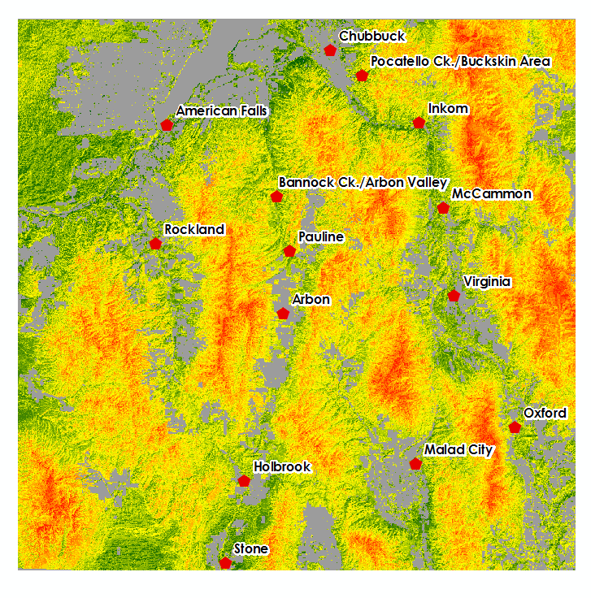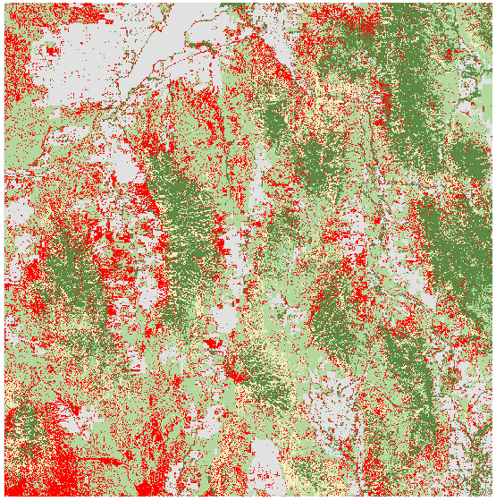comparison with the fuel classification result show dense juniper stands can be identified using 30 meter Landsat 8 imagery (Figure 1).



Sagebrush/Herbaceous

Bare ground

Juniper Mix

Mixed Forest

Mask

**Classification Sites**

*Figure 1: Image displays the results of the CTA highlighting dense juniper stand*

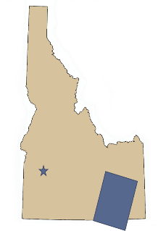

Interpretation of the fire severity results show areas that have large amounts of heavy fuels. These fuels will burn more severely and with greater intensity then areas with finer fuels. The pixel-based fire severity model was overlaid with community concern data provided by the BLM (Figure 2). These data highlighted areas that are at greatest risk for catastrophic wildfire event, especially communities that are building in the WUI.

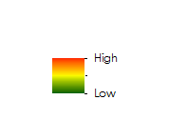The object based model resulted in an overall accuracy of 91% with a kappa coefficient of 0.89 calculated from an error matrix (Table B). This model clearly classifies individual junipers as well as large groups accurately (Figure 3). This precision allows for detailed calculations of juniper density and phase.

*Figure 2: Fuel severity model overlaid with communities at risk due to long burning heavy fuels*

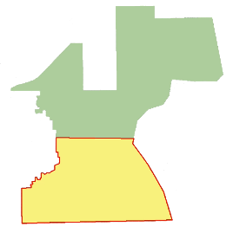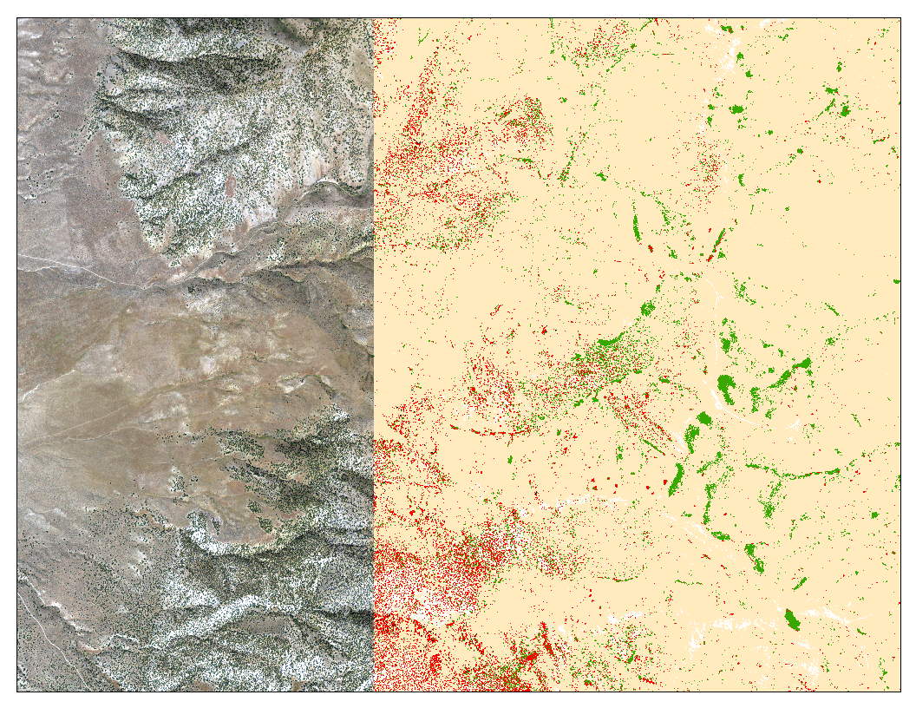

**Classification Sites**



Bare Ground

Juniper Mix

Mixed Forest

Sagebrush/ Herbaceous

Shadows

*Figure 3: Zoomed in object-based results overlaid upon 2011 NAIP imagery.*

**Discussion**

Fuel Classification and Fire Severity Models

Due to the large amount of bare ground in this area spectral mixing introduced error due between vegetation classes. Denoting spectral signatures of junipers were also difficult due to the similarities between juniper and agricultural reflectance. Thirty meter Landsat 8 data does not allow for the delineation between phase one and two because of the pixel size and spectral noise between other classifications. Adding in-situ data for training and validation site could result in greater accuracy of the model.

Advantage of a fire severity map include being able to visually identify areas that are prone to large intense wildfire events. However, limitations to this severity map is that it do not take into account weather patterns or soil moisture. Addition of this type of data would improve the model.

Object-based Classification

Previous studies on object based image analysis suggest that Trimble eCongition Developer produces the best classification results (Weisberg et al. 2007). This program is expensive and was inaccessible for this project. Roundy (2015) compared eCongition, ArcMap Feature Analyst, and ENVI Feature Extraction in a juniper cover calculation study. ENVI Feature Extraction contained an overall accuracy of 94%, ESRI Feature Analyst contained an overall accuracy of 92%, eCognition contained an overall accuracy of 91%. This study suggested that the overall accuracy of ESRI would be sufficient for this project. Due to this ArcGIS was used to preform object-based image analysis to produce results easily reproduce-able by the end-users.

Data management becomes more difficult when working with large datasets. NAIP imagery has small spatial resolution and therefore produces a much larger dataset for the same area as was processed by the CTA. Much of the masking was done prior to classification in order to reduce dataset size and improve processing time. Even with this adjustment, some of the layers produced took several hours to process. Due to processing times, this method is not suggested for large areas of research.

The Image classification tool bar was used to create training points. This toolbar was newly released with ArcGIS 10, and therefore contains some programming errors. Points created through this bar are not as manipulate-able as point feature classes. Once created the file cannot be edited including clipping, adding points or deleting points. Attempts were made to bypass this tool, but no solution was found. The tool Create Signatures only accepted an input file of specific specifications; the image classification toolbar was used because it output the correct file parameters.

Object-based classification was attempted on 1990 Orthophotgraphy as well as 2011 NAIP imagery. Classification of the 1990 data was poor due to the lack of recorded data. Technology used to record this data was black and white photography which recorded only values on a grey scale. Orthophotgraphy taken in 1990 comprises 1 band while 2011 imagery contained 4 bands. The additional bands within the NAIP gave a larger variance between training points. This was further enhanced by comparing each band to the near-infrared (band 4).

The largest error in object-based classification was in the miss-classification of mixed forest as juniper (Table B). An attempt was made to mask the mixed forest areas, although no viable process for this was determined. The other major error came from dark sagebrush areas classified as juniper. This error is not represented in the error matrix but in the density map. The map classifies large areas as phase I (classified by 0.1% to

15%) because a single sagebrush is misclassified.

**Future Work**

In the second term of this study historic juniper encroachment will be analyzed to determine if there is a specific trajectory that this species takes. As juniper encroaches into areas with greater soil moister like the sage steppe system it uses more moisture at a faster rate than the native species. This reduces the amount of moisture replenished the following growing season, making it harder for native species to survive. Principal component analysis will be used to reduce noise and compress data when analyzing time series data. As our end-users plan their field management in-situ data will be provided that will help improve juniper identification. The introduction of Soil Moisture Active Passive (SMAP) satellite data will be used to assess temporal changes. It will also be used to analyze cheatgrass dominated sites and compare these changes in soil moisture to sagebrush dominated sites. The addition of cheatgrass and soil moisture will aid in further understanding the changing fire regimes.

# V. Conclusions

Land managers are interested in phase identification for both pre-fire and post-fire planning as well as juniper encroachment management. Allocation of resources are better spent in areas that are more likely to recover or revert back to its natural ecologic status. This study identifies the usefulness of a multi-scaled approach.

The 30 meter Landsat 8 OLI decision tree approach produced both a fuel classification map and a fire severity map. This process can be replicated by land managers when they are trying to identify heavy fuel load areas or need to quickly assess an area for dense juniper stands. This model will also assist in forecasting areas prone to juniper invasion.

The 1 meter 2011 NAIP imagery, object-based analysis produced a classified map (Figure 5) and a juniper density map (Figure 4). The high spatial resolution allows for a more detailed assessment of juniper location and density. These can be used on areas of interest to assist managers in project planning.

# VI. Acknowledgments

We would like to thank our science advisors, Keith Weber, Dr. Mark Carroll, and Dr. John Schnase as well as Margaret Wooten for their guidance and feedback throughout the life of this project.

Any opinions, findings, and conclusions or recommendations expressed in this material are those of the author(s) and do not necessarily reflect the views of the National Aeronautics and Space Administration.

This material is based upon work supported by NASA through contract NNL11AA00B and cooperative agreement NNX14AB60A.

# VII. References

Ansley, R. J., & Wiedemann, H. T. (2008). Reversing the woodland steady state: vegetation responses during restoration of Juniperus-dominated grasslands with chaining and fire. In *Western North American Juniperus Communities* (pp. 272-290). Springer New York.

Barney, M. A., & Frischknecht, N. C. (1974). Vegetation changes following fire in the pinyon-juniper type of west-central Utah. *Journal of Range Management*, 91-96.

Barrett, H., & Board, O. W. E. (2007). *Western juniper management: a field guide*. Oregon Watershed Enhancement Board.

Bradley, B. A., & Fleishman, E. (2008). Relationships between expanding pinyon–juniper cover and topography in the central Great Basin, Nevada. *Journal of Biogeography*, *35*(5), 951-964.

Campbell, J. L., Kennedy, R. E., Cohen, W. B., & Miller, R. F. (2012). Assessing the carbon consequences of western juniper (Juniperus occidentalis) encroachment across Oregon, USA. *Rangeland Ecology & Management*, *65*(3), 223-231.

Caratti, J. F., & others. (2006). Line Intercept (LI). *FIREMON: Fire Effects Monitoring and Inventory System. Rocky Mountain Research Station, Natural Resources Research Center, Fort.*

Chen, F., Weber, K. T., Anderson, J., & Gokhal, B. (2011). Assessing the susceptibility of semiarid rangelands to wildfires using Terra MODIS and Landsat Thematic Mapper data. International Journal of Wildland Fire, 20(5), 690-701.

Davies, K., Petersen, S., Johnson, D., Davis, D., Madsen, M., Zuirzdin, D., & Bates, J. (2010). Estimating Juniper Cover From national Agriculture Imagery program (NAIP) Imagery and Evaluating Relationships Between Potential Cover and Environmental Variables. *Rangeland Ecology & Management,* 63(6), 630-637.

Dennison, P. E., Brewer, S. C., Arnold, J. D., & Moritz, M. A. (2014). Large wildfire trends in the western United States, 1984–2011. *Geophysical Research Letters*, *41*(8), 2928-2933.

Everitt, J. H., Yang, C., Racher, B. J., Britton, C. M., & Davis, M. R. (2001). Remote sensing of redberry juniper in the Texas rolling plains. *Journal of Range Management*, 254-259.

Huang, C., Wylie, B., Yang, L., Homer, C., & Zylstra, G. (2002). Derivation of a tasselled cap transformation based on Landsat 7 at-satellite reflectance.*International Journal of Remote Sensing*, *23*(8), 1741-1748.

Gorte, R. (2013). The rising cost of wildfire protection. Headwaters Economics.

Hardy, C. (2005). Wildland fire hazardand risk: Problems, definitions, and context. Forest Ecology and Management, 73-82. Retrieved June 3, 2015, from www.sciencedirect.com

Lupton, D. M. (2008). Remote Sensing of Wooded Species Remediation, 1–17.

Mattsson, D., & Thorén, F. (2004). Wildland/urban interface fire risk model (Doctoral dissertation, Tesis B. Sc Programme for GIS Engineering. Lulea University of Technology, Sweden).

Miller, R. F. (2005). *Biology, ecology, and management of western juniper (Juniperus occidentalis)*. Corvallis, Or.: Agricultural Experiment Station, Oregon State University.

Miller, J., & Franklin, J. (2002). Modeling the distribution of four vegetation alliances using generalized linear models and classification trees with spatial dependence. *Ecological Modelling*, *157*(2), 227-247.

Miller, R. F., & Tausch, R. J. (2001). The role of fire in juniper and pinyon woodlands: a

descriptive analysis. *Fire Conference 2000: The First National Congress on Fire Ecology,*

*Prevention and Management.*

Miller, R., & Wigand, P. (1994). Holocene Changes in Semiarid Pinyon-Juniper Woodlands. Bioscience, 44(7), 465-474.

Noone, M., Kagan, J. S., & Nielsen, E. (2013). *Western Juniper (Juniperus occidentalis) and invasive annual grass mapping in Eastern Oregon*. Institute for Natural Resources.

Noson, A. C., Schmitz, R. A., & Miller, R. F. (2006). Influence of fire and juniper encroachment on birds in high-elevation sagebrush steppe. *Western North American Naturalist*, *66*(3), 343-353.

Radeloff, V. C., Hammer, R. B., Stewart, S. I., Fried, J. S., Holcomb, S. S., & Mckeefry, J. F. (2005). the Wildland – Urban Interface in the United States. *Ecological Applications*, *15*(3), 799–805. <http://doi.org/10.1890/04-1413>.

Roundy, D. B. (2015). Estimating Pinyon and Juniper Cover Across Utah Using NAIP Imagery. Retrieved from <http://scholarsarchive.byu.edu/etd/5575/>.

Sankey, T. T., Glenn, N., Ehinger, S., Boehm, A., & Hardegree, S. (2010). Characterizing western juniper expansion via a fusion of Landsat 5 Thematic Mapper and LIDAR data. *Rangeland ecology & management*, *63*(5), 514-523.

Weisberg, P. J., Lingua, E., & Pillai, R. B. (2007). Spatial patterns of pinyon-juniper woodland expansion in central Nevada. *Rangeland Ecology & Management*, *60*(2), 115-124.

Williams, C. J., Pierson, F. B., Al‐Hamdan, O. Z., Kormos, P. R., Hardegree, S. P., & Clark, P. E.   (2014).  Can wildfire serve as an ecohydrologic threshold‐reversal mechanism on

juniper‐encroached shrublands. *Ecohydrology*, *7*(2), 453-477.

# IV. Appendices

Table A: Confusion matrix for the 30 meter Landsat 8 fuel classification approach

|  |  |  |  |  |  |  |
| --- | --- | --- | --- | --- | --- | --- |
| **Error Matrix Analysis – Fuel Classification Model** | | | | | | |
|  | Sagebrush/  Herbaceous | Bare Ground | Junier Mix | Mixed Forest | Total | ErrorC |
| Sagebrush/  Herbaceous | 60 | 2 | 1 | 0 | 63 | 0.04 |
| Bare Ground | 1 | 53 | 7 | 6 | 67 | 0.21 |
| Juniper Mix | 7 | 4 | 60 | 1 | 72 | 0.16 |
| Mixed Forest | 0 | 10 | 6 | 108 | 124 | 0.13 |
| Total | 68 | 69 | 74 | 115 | 326 |  |
| ErrorO | 0.12 | 0.23 | 0.19 | 0.06 |  | 0.14 |

Kappa Coefficient: 0.81

Table B: Confusion matrix for 1 meter object based classification approach

|  |  |  |  |  |  |  |  |
| --- | --- | --- | --- | --- | --- | --- | --- |
| **Error Matrix Analysis – Object-based Results** | | | | | | | |
|  | Juniper | Mixed Forest | Sagebrush | Bare ground | Shadows | Total | ErrorC |
| Juniper | 106 | 28 | 0 | 0 | 3 | 137 | 0.20 |
| Mixed Forest | 11 | 92 | 0 | 0 | 5 | 108 | 0.10 |
| Sagebrush | 3 | 0 | 120 | 0 | 2 | 125 | 0.02 |
| Bare ground | 0 | 0 | 0 | 120 | 0 | 120 | 0 |
| Shadows | 0 | 0 | 0 | 0 | 110 | 110 | 0 |
| Total | 120 | 120 | 120 | 120 | 120 | 600 |  |
| ErrorO | 0.11 | 0.23 | 0 | 0 | 0.08 |  |  |

Kappa Coefficient: 0.89

Figure 4: Raster-like layer of juniper phase calculations. Juniper density was calculated in 12 acre areas using object-based classified raster for values.



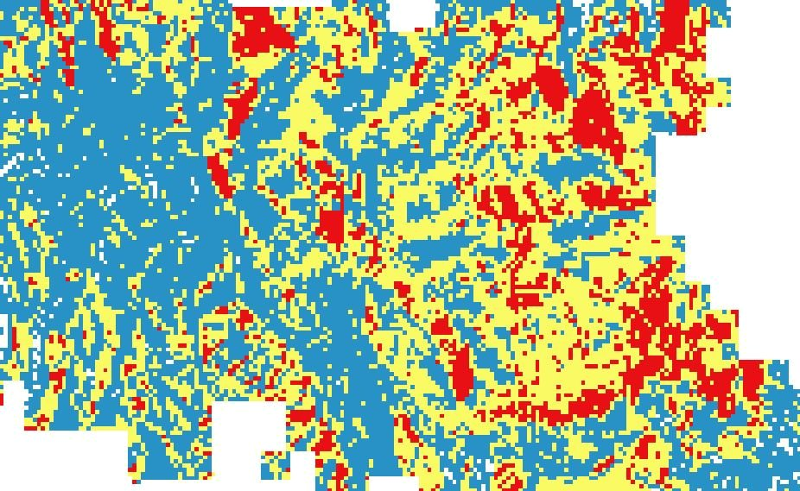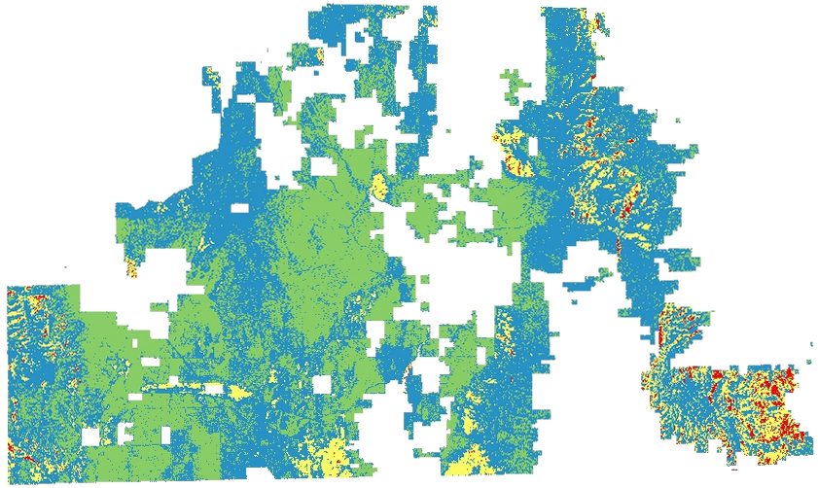

Phase III

Phase II

Phase I



Figure 5: Classified raster of southern portion of study area.

