Southern Wyoming Ecological Forecasting

Monitoring Cheatgrass in Southern Wyoming and Northern Colorado to Inform Management Efforts Post-Mullen Fire

 **Technical Report**

Final – November 18th, 2021

Dahlia Shahin

Emily Snyder

Sanju Khatri

Kyle Paulekas

Michael Segala

***Advisors:***

Dr. Paul Evangelista, Colorado State University, Natural Resource Ecology Lab

Dr. Catherine Jarnevich, United States Geological Survey

Dr. Anthony Vorster, Colorado State University, Natural Resource Ecology Lab (Primary Science Advisor)

Dr. Brian Woodward, Colorado State University, Natural Resource Ecology Lab (Primary Science Advisor)

Peder Engelstad, Colorado State University, Natural Resource Ecology Lab

Nicholas Young, Colorado State University, Natural Resource Ecology Lab

# 1. Abstract

Cheatgrass (*Bromus tectorum*) is a prominent invasive species in the Intermountain West that has the potential to out-compete native plant species, reduce biodiversity, and reduce quality of habitat for ungulates. Furthermore, because cheatgrass readily establishes in disturbed landscapes, it can potentially increase fuel loads and exacerbate wildfire risk. In 2020, the Mullen Fire burned 176,878 acres in Carbon and Albany Counties, Wyoming and Jackson County, Colorado. Large fires such as this one raise concern for our partners, the United States Forest Service and the United States Geological Survey Fort Collins Science Center who are tasked with rapidly detecting and controlling invasive species in the post-fire environment. We developed a random forest model trained by in-situ field data and spectral indices such as Normalized Difference Vegetation Index, Soil Adjusted Vegetation Index, and Enhanced Vegetation Index derived from Landsat 8 Operational Land Imager, Sentinel-2 MultiSpectral Instrument, and Shuttle Radar Topography Mission to detect and map cheatgrass presence during the 2021 growing season. Our team was able to successfully create a spectral cheatgrass detection map in the study area (RMSE = 13.71, R2 = 0.34). We also produced a NDVI time-series derived from Sentinel-2 MSI to analyze vegetation recovery pattens.

**Key Terms**

remote sensing, post-fire, invasive species, cheatgrass presence, Landsat 8 OLI, Sentinel-2 MSI, random

forest

# 2. Introduction

***2.1 Background Information***

Invasive species *Bromus tectorum*, or cheatgrass, was introduced to the US in the 1800s through grain seed and packing material imports (Novak & Mack, 2001). Cheatgrass has since become a prominent invasive species in the Intermountain West from the Rockies to the Cascadian range. Cheatgrass germinates in the fall, spreading an extensive seed bank before winter, growing to maturity in spring, and dying off by early summer. Traits such as prioritizing seed production over root development, establishing quickly in disturbed areas, and favoring elevated nitrogen levels have allowed cheatgrass to out-compete native vegetation and readily establish in post-wildfire landscapes. Cheatgrass can potentially alter ecosystem fire regimes post-invasion, increasing fire frequency and intensity, which further exacerbates the invasion (Peters & Bunting, 1994; Bradley et al., 2018).

Physical, cultural, biological, and chemical methods can be used to control the spread of cheatgrass depending on the management goals and objectives. To determine an appropriate method, land managers need to assess the degree and density of infestation, current land use, and site conditions (USDA 2014). Due to the difficulties associated with field-based data collection, the use of remote sensing is promising since it provides a landscape-level view of an area with a high temporal resolution (Rocchini, 2010).

Remote sensing can provide a unique approach for the detection of invasive plants and freely available imagery can be used to evaluate its distribution. Vegetation indices derived from different spectral bands have been recognized as useful transformations to distinguish vegetation on the landscape (West et al., 2017). The Landsat 8 Operational Land Imager (Landsat 8 OLI) and Sentinel-2 MultiSpectral Instrument (Sentinel-2 MSI) provide multispectral and moderate spatial resolution imagery of the earth’s surface making both ideal instruments for deriving vegetation indices and monitoring vegetation.

For example, Bradley et al. (2018) used satellite phenology predictors and field surveys of cheatgrass abundance to create regional models of cheatgrass distribution and percent cover. This study found that 1) cheatgrass is more spatially exclusive and abundant than previously documented and 2) cheatgrass has the potential to double fire frequency. West et al. (2017) successfully mapped cheatgrass cover with high accuracy in aerial herbicide sprayed areas after the Squirrel Creek fire in Medicine Bow National Forest using tasseled cap indices, a Modified Normalized Difference Water Index (MNDWI), and a Normalized Difference Water Index (NDWI) derived from summer months.

***2.2 Project Partners & Objectives***

The Mullen Fire ignited in September 2020 and burned 176,878 acres across Wyoming and northern Colorado. Land managers have become concerned about the potential spread of the invasive species Bromus tectorum, cheatgrass, into large post-fire regions. The U.S. Forest Service and Wyoming Game & Fish Department are both concerned with managing recovery after the Mullen Fire. They have identified the control of invasive species as a common goal to provide quality habitat and encourage the recovery of native vegetation. They sprayed cheatgrass with herbicide during the summer of 2021, with planned efforts to continue over the next few years. They are deciding which areas to prioritize for treatment in the future and are interested in evaluating the effectiveness of spraying in post-fire environments.

The team investigated the use of remote sensing data to detect and map cheatgrass in this post-fire environment to inform the US Forest Service and Wyoming Game & Fish Department management efforts. Additionally, we utilized pre- and post-fire imagery to generate a burn severity and vegetation recovery analysis and explored patterns in cheatgrass cover. These data may provide our partners with critical information to assess the current extent of cheatgrass and plan for appropriate mitigation strategies.

***2.3 Study Area***

The study area encompasses the Savage Run and Platte River Wilderness and the Medicine Bow National Forest, with an elevation range between 1,500m to 4,000m, with a broad range of habitat types (Figure 1). The upper elevations are primarily dominated by Engelmann spruce, ponderosa pine, and Douglas fir. At lower elevations the landscape is dominated by annual grasses and the sagebrush steppe and includes riparian habitats. For upland vegetation in the Medicine Bow National Forest, mean fire return intervals have become longer at low elevations on drier sites, but fire intensity is higher due to the amount and continuity of fuels that have developed in some areas, which could lead to more stand-replacing fires in the future (Dillon, Knight, & Meyer, 2005). In recent years, pre-emergent herbicide treatments used near our study area have shown promising long-term reductions in cheatgrass (Courkamp & Meiman, 2020).

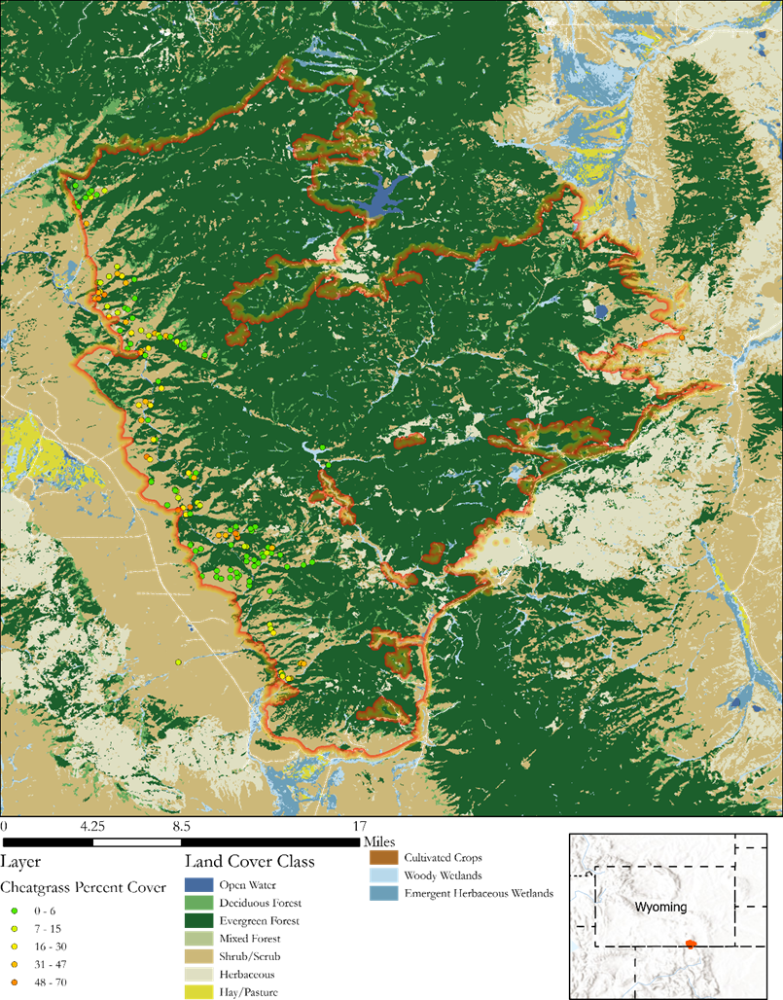

Figure 1. A study area map of the Mullen Fire in southern Wyoming and northern Colorado. Percent cover of cheatgrass points are derived from field sampling measurements collected by US Forest Service and Wyoming Department of Fish and Game.

# 3. Methodology

***3.1 Data Acquisition***

Remote sensing data from Landsat 8 OLI, Sentinel-2 MSI, and Shuttle Radar Topography Mission Data Version 3 (SRTM) were obtained from Google Earth Engine (GEE) (Table 1). In our predictor selection process, we took into consideration that cheatgrass has a unique life cycle compared to surrounding vegetation. The cheatgrass life cycle has an early green up in the spring and senescence occurs in July. In order to capture its phenological stages, we acquired post-fire images from summer months in 2021 (Table 1).

Table 1.

*Remote sensing data sources. Source: which satellite data imagery was derived from, Resolution: the original resolution of the images captured, Acquisition date: which dates the images derive from and whether they were pre- or post-Mullen Fire*

|  |  |  |  |  |
| --- | --- | --- | --- | --- |
| **Satellite Data** | | | | |
| **Data** | **Data Source** | **Spatial Resolution** | **Acquisition Date** | |
| **Pre-fire** | **Post-fire** |
| Sentinel-2 MSI | European Space Agency | 20 m | 7/10/2020 | 6/10/2021, 7/10/2021, 8/29/2021, 10/3/2021 |
| Landsat 8 OLI | NASA Earth Observing Systems | 30 m | 8/10/2020 | 6/10/2021, 8/29/2021, 9/7/2021 |
| Shuttle Radar and Topography Mission (SRTM) | NASA Earth Observing Systems | 30 m | February 2000 | |

A total of 150 vegetation field samples were collected by the United States Forest Service (USFS) between May 24th and August 18th, 2021, across the study area (Figure 1). Field plots contained a mixture of planned percent cover sampling (83 points), opportunistic percent cover sampling (23 points), and floristic sampling plots (44 points) at a minimum distance of 100 meters apart. Out of the 150 field-collected cheatgrass cover points, 46 had no cheatgrass present (31%). Each sampling site had 20-meter radial vegetation plots to assess for percent coverage of cheatgrass, perennial forbs/grasses, shrub/woody species, bare ground, and rock. Only percent cover for cheatgrass and plot location were considered for this project.

***3.2 Data Processing***

To meet our project objectives, the team plotted NDVI in a time-series to analyze vegetation recovery patterns, created a cheatgrass detection map using a random forest (RF) model, and produced a burn severity map showing differenced Normalized Burn Ration (dNBR) on a continuous scale. Image pre-processing and deriving model inputs was performed in GEE. We used RStudio for developing and performing statistical analysis on the model. We ran the final model in GEE for a preliminary visualization, and used ArcGIS Pro to create our final maps and products (Section 3.2.2)

*3.2.1 NDVI Time Series*

Image processing of Sentinel-2 data included a cloud mask to remove any poor data influenced by clouds before NDVI calculations were applied to the time series. NDVI was derived from images before (July 2020) and after (June 2021 - October 2021) the Mullen fire used Sentinel-2 data to gain insight in cheatgrass green up and senesces phases. Time series plots of NDVI at cheatgrass presence points provided guidance on which dates throughout the year we selected to conduct further analysis based on life stage identification of cheatgrass.

*3.2.2 Cheatgrass Cover Using Random Forest*

We used a RF machine learning algorithm to perform both a classification for discrete categorical data and a regression for continuous numerical data. RF combines numerous decision trees to reduce overfitting and bias-related inaccuracy (Breiman, 2001). We used NDVI, Enhanced Vegetation Index (EVI), and Soil Adjusted Vegetation Index (SAVI) in our analysis (Table A in appendix). To identify photosynthetically active vegetation and monitor vegetation health, NDVI is frequently used in landscape ecology (Huete et al., 2002). We used EVI due to its sensitivity to high density vegetation and corrects for some distortions in the reflected light caused by particles in the air as well as the ground cover below the vegetation (Gao et al., 2000). Areas where vegetative cover is low (i.e., < 40%) and the soil surface is exposed, the reflectance of light in the red and near-infrared spectra can influence vegetation index values making SAVI a useful index (Singh & Rai, 2018).We also performed differencing of NDVI to see if phenological changes between summer months would influence model performance (Table 2).

Table 2.

*Predictor variables and the associated dates with the corresponding satellite used to calculate the difference between the dates in order to highlight changes in cheatgrass phenology.*

|  |  |
| --- | --- |
| **Predictor Variables** | **Differencing Dates** |
| NDVI, NDMI, Tasseled cap brightness, Tasseled cap greenness, Tasseled cap wetness | July 10th - June 10th (Sentinel-2 MSI) |
| August 29th – July 10th (Sentinel-2 MSI) |
| October 3rd - August 29th (Sentinel-2 MSI) |
| August 29th – June 10th (Landsat 8 OLI) |
| September 7th - August 29th (Landsat 8 OLI) |

*3.2.3 Burn Severity*

We calculated Normalized Burn Ratio (NBR) and the dNBR using Sentinel-2 MSI imagery before and after the fire to measure disturbance related to the Mullen Fire. The NBR identified burned areas and provided a measure of burn severity. The dNBR calculation indicated areas with vegetation regrowth and highlighted areas more affected by the Mullen fire.

***3.3 Data Analysis***

We produced a 1-step regression model to predict cheatgrass percent cover over the study area. This allowed us to investigate which predictors were driving the model and best recognized cheatgrass. To identify the top performing predictors, the variables were imported from GEE to RStudio to perform statistical analysis using the ‘randomForest’ package (Liaw and Wiener, 2002). When building the 1-step model, our independent variable was cheatgrass percent cover and our dependent variable were the predictors. First, we removed highly correlated variables that had correlation values greater than 0.7 (Dormann et al., 2013). We tested different subsets of variables with the goal of creating a parsimonious model that used the top predictors and reduced model over-fitting. The root mean squared error (RMSE) is a standard measure of model error predicting quantitative data and was used as an indicator of model performance. Furthermore, partial dependency plots and variable importance comparisons provided further analysis of variable influence on model results (Friedman, 2001). We ran the final model in R to create visualization of the cheatgrass detection raster and edited products and maps for our partners in ArcGIS Pro.

The zero-rich nature of the field data used as training data in our model encouraged us to explore a zero-inflated model. Following Savage et al., 2017, our team took a more conservative approach and created a 2-step random forest model. This model used a ‘kitchen sink’ method, in which all predictor variables were included in the model. First, we performed a binary classification to map only cheatgrass presence and absence. Then, a continuous regression was run over the binary cheatgrass presence. For both models, we used spectral indices difference between two dates to highlight the phenological change between the boot and senescing stages (Table 2).

**4. Results & Discussion**

***4.1 Analysis of Results***

The 1-step cheatgrass detection model predicted a range from 0 to 47 percent cheatgrass cover while the 2-step model predicted a range from 0 to 51 percent cheatgrass cover (Figure 2). In order to increase the accuracy of the model, we masked out landcover types we knew cheatgrass didn't typically establish in. Using the LandFire ‘Existing Vegetation Type’ data set, the team created a mask based on an inverse selection of vegetation types that contained field collected data points (LANDFIRE). Then, we determined all landcover types except Sagebrush Steppe, Ponderosa Pine Woodland, Foothill Shrubland, and Subalpine Grassland to be included in the mask. This resulted in the mask covering 85 percent of the study area.

B

A

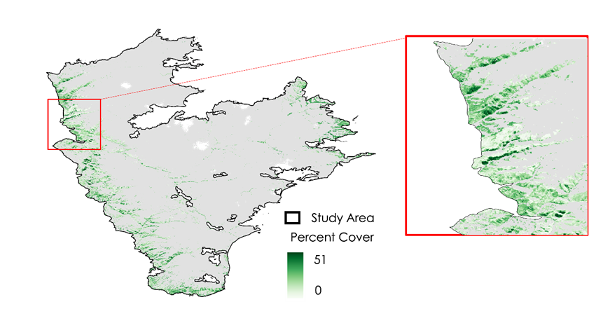

*Figure 2*. A 1-step RF model depicting cheatgrass percent cover within the study area (A) and 2-step model (B). Light to dark green depicts less to more cheatgrass percent cover.

*4.1.1 Models*

Our 1-step model had parameters ‘mtry’ and ‘ntree’ set to 3 and 1000, respectively, and included seven predictor variables (Table 3). This produced an R2 of 0.34 and a RMSE of 13.71. The top performing variables were NDVI difference between June and July (Sentinel-2), simple ratio June (Sentinel-2), and SAVI June (Sentinel-2) (Figure 3A). The top predictor being NDVI differencing corresponds with what we know about unique cheatgrass phenology. Its green-up was early in the summer (June) and began senescence near the end of June to the beginning of July. This predictor targeted important stages in the cheatgrass life cycle and distinguished cheatgrass from surrounding vegetation efficiently. The ability of SAVI using a soil-brightness correction made it efficient at distinguishing vegetation from soil. With the high percentage of bare ground cover our study area had, it makes sense that SAVI June (Sentinel-2) was an important predictor. The partial dependence plots show NDVI difference between June and July (Sentinel-2) with an increase in regression from about 0 to 0.05, June simple ratio (Sentinel-2) with an increase in regression from 0.75 to 0.8, and SAVI June (Sentinel-2) with an increase in regression from 0.1 to 0.2 (Figure 3B).

Table 3.

*Model performance for different random forest parameters and sets of predictor variables.*

|  |  |  |  |  |  |
| --- | --- | --- | --- | --- | --- |
| **Description** | **mtry** | **ntree** | **Predictor Variables** | **R-squared** | **RMSE (%)** |
| All 168 variables | 5 | 1000 | All | 0.26 | 14.54 |
| 7 variables | 3 | 1000 | ' NDVI difference between June and July (Sentinel-2) ', ' Simple ratio June (Sentinel-2) ', ' SAVI June (Sentinel-2) ', 'NDVI September (Landsat 8), ' EVI September (Landsat 8) ', ' Green difference between July and August (Sentinel-2) ',' NDVI difference between July and August (Sentinel-2) ' | 0.34 | 13.71 |
| 2-step model | 13 | 1000 | All | 0.7 | 13.86 |

Our 2-step model had the parameters ‘mtry’ and ‘ntree’ set to 13 and 1000 respectively and included all 163 predictor variables. We tested a ‘kitchen sink’ method for the 1-step model, which only had an RMSE greater by 1 percent (Table 3). Because of this small difference, we moved forward with this method for the 2-step model. This model produced an R2 of 0.70 and an RMSE of 13.86. We did not do further analysis on top performing predictors for the 2-step model because it contained highly correlated variables. This made it difficult to distinguish which variables were contributing more to the model. However, the 2-step model predicted cheatgrass cover with greater accuracy compared to the 1-step model.

B

*Figure 3.* Top predictors in our 1-step cheatgrass detection model (A) as described on the y-axis, with the increase of the mean squared error (or how much our model accuracy decreases if we leave out that variable) on the x-axis. Partial dependence plots (B) showing predicted cheatgrass cover on the y-axis and the value of the predictor on the x-axis.

*4.1.2 Time Series*

The time series plot which shows the NDVI values across the summer and fall months of 2021 at the 10 different camera locations and have been divided into cheatgrass present and absent in the view of each camera (Figure 4).The mean and a confidence interval were plotted for both the cheatgrass present cameras and the cheatgrass absent ones. The cheatgrass absent cameras show dramatic changes in the mean NDVI values over the course of the summer and fall while the cheatgrass present cameras show little change in vegetation growth over the course of the summer and fall. Growth was not as prevalent due to the fire occurring less than a year previously.

*Figure 4.* This plot shows NDVI values at the locations of 10 time-lapse cameras in our field site divided into two categories (absent and present) from June 2021 to October 2021. The colored lines represent the mean for each category and each category has a 95% confidence interval associated with it shown. Time-lapse cameras with cheatgrass absent from view are shown in red and the cameras with cheatgrass present in view are in blue.

*4.1.3 Limitations*

The study period of June-September 2021 had significant cloud cover in satellite imagery, which reduced image quality. There was also little vegetation growth post-fire as this was only the first growing season after a burn. Field observations stated that bare ground dominated much of the post-fire environment (89 of 150 field data points had ≤ 10% cheatgrass cover). This reduced accuracy when detecting cheatgrass below 40% cover. Lastly, a combination of the above factors resulted in model difficulties of spectrally distinguishing cheatgrass from surrounding vegetation. This potentially impacted lower cheatgrass cover being undetected by our model.

***4.2 Future Work***

We recommend comparing sites treated with and without herbicide would increase the understanding of the importance of using herbicide to prevent cheatgrass growth. The Natural Resource Ecology Lab at Colorado State University will continue to refine the cheatgrass map for years to come with the assistance of our partners in the US Forest Service and the USGS. We also hope to present our work either at a conference or via a publication.

# 5. Conclusions

The analysis of this study highlights the importance of implementing Earth observations to detect cheatgrass. Post wildfire disturbance in the Intermountain West is of grave concern as cheatgrass spreads across large landscapes, out-competing native plant species, reducing biodiversity, and reducing quality of habitat for ungulates. By applying a random forest model, our team detected cheatgrass through Landsat 8 OLI and Sentinel-2 MSI within the study area. Our findings have demonstrated that in burned areas of the Mullen Fire, NDVI from the end and middle of the growing season (July) differenced from the start of the growing season (June) were top predictors for inputs in the random forest model to detect the different phenological trends of cheatgrass. The predictor variables employed in the random forest model have been selected based upon their ability to accurately and efficiently identify cheatgrass percent cover post-disturbance. However, the random forest model used to detect cheatgrass has a weak relationship between the predicted and actual observations. In addition, the team found a weak relationship between cheatgrass percent cover and fire burn severity. Thus, the study provides a valuable framework for land managers who may need similar products and data to manage invasive species post-disturbance.

# 

# 6. Acknowledgments

Thank you to our collaborator Dr. Janet Prevey with the USGS and end user Dr. Katie Hanes with the USFS for providing us with expertise about cheatgrass occurrence and cheatgrass phenology in the study area. Also, thank you to Scott Cunningham, our Fellow with DEVELOP, and our primary science advisors, Dr. Paul Evangelista, Dr. Anthony Vorster, Dr. Brian Woodward, and Peder Engelstad with Colorado State University's Natural Resource Ecology Lab and Dr. Catherine Jarnevich with the USGS.

This material contains modified Copernicus Sentinel data (2020), processed by ESA. Any opinions, findings, and conclusions or recommendations expressed in this material are those of the author(s) and do not necessarily reflect the views of the National Aeronautics and Space Administration. This material is based upon work supported by NASA through contract NNL16AA05C.

# 7. Glossary

**Difference Normalized Burn Ratio (dNBR):** The difference between pre and post fire normalized burn ratio.

**Earth Observations (EO):** The collection of data about the physical, chemical, and biological systems of planet Earth.

**Earth Observing Systems (EOS):** NASA funded satellite missions that provide long-term global observations of land surfaces, biosphere, solid Earth, atmosphere and oceans for research.

**Enhanced Vegetation Index (EVI):** A vegetation index to quantify greenness that corrects for atmospheric conditions.

**Fire Regimes:** The patters, frequency, and intensity that fire occurs in a given ecosystem.

**Google Earth Engine (GEE):** A geospatial processing service provided by Google powered by a cloud platform to perform analysis at scale.

**Moderate Resolution Imaging Spectroradiometer (MODIS):** An imaging sensor onboard the Terra and Aqua satellite missions funded by NASA

**Normalized Burn Ratio (NBR):** A burn index used to identify burned areas and assess severity

**Normalized Difference Vegetation Index (NDVI):** A vegetation index using the difference between visible and near-inferred reflectance as an indicator of vegetation health.

**Remote Sensing (RS):** The recording and collection of information the ultraviolet, visible, near infrared, infrared and microwave regions of the electromagnetic spectrum through cameras, scanners, lasers, and/or sensors located on platforms such as aircraft or spacecraft.

**Relative Burn Ratio (RBR):** A burn ratio index which performs best a determining high severity burns in low vegetation cover areas.

**Relative Differenced Normalized Burn Ratio (RdNBR):** An adjusted dNBR, which accounts for the different chlorophyl content values of the vegetation pre-fire.

**Shuttle Radar Topography Mission (SRTM):** An international research mission to establish a near-global digital elevation model of the Earth.

**Software for Assisted Habitat Modeling (SAHM):** An opensource software package designed to construct habitat suitability models by combining environmental predictor layers of an area of interest with field samples to predict potential species distribution.

**Soil Adjusted Vegetation Index (SAVI):** An index for correcting the Normalized Difference Vegetation Index for the influence of soil brightness in locations of low vegetation cover.

**Tasseled Cap Brightness (TCB):** A linear equation transformation that is specific to a sensor producing a brightness value for the ground.

**Tasseled Cap Greenness (TCG):** A linear equation transformation that is specific to a sensor producing a brightness value for the ground.

**Tasseled Cap Wetness (TCW):** A linear equation transformation that is specific to a sensor producing a brightness value for the ground.

# 8. References

Breiman, L. (2001). Random forests. *Machine Learning*, *45*(1), 5–32. <https://doi.org/10.1023/A:1010933404324>

Bradley, B. A., Curtis, C. A., Fusco, E. J., Abatzoglou, J. T., Balch, J. K., Dadashi, S., & Tuanmu, M. N. (2018). Cheatgrass (Bromus tectorum) distribution in the intermountain Western United States and its relationship to fire frequency, seasonality, and ignitions. *Biological Invasions*, *20*(6), 1493-1506.

Courkamp, J. & Meiman, P. 2020. Long-term Cheatgrass Reduction with Indaziflam in Sagebrush-Grassland Plant Communities in Sublette County, Wyoming. (*In prep*)

Crist, E.P., and Cicone, R.C. (1984). A physically-based transformation of Thematic Mapper data---the TM

Tasseled Cap. *IEEE Transactions on Geoscience and Remote Sensing,* *22*(3), 256-352.

<https://doi.org/10.1109/tgrs.1984.350619>

Dillon, G. K., Knight, D. H., & Meyer, C. B. (2005). Historic range of variability for upland vegetation in the Medicine Bow National Forest, Wyoming (RMRS-GTR-139; p. RMRS-GTR-139). U.S. Department of Agriculture, Forest Service, Rocky Mountain Research Station. <https://doi.org/10.2737/RMRS-GTR-139>

Dormann, C.F., Elith, J., Bacher, S., Buchmann, C., Carl, G., Carré, G., Marquéz, J.R.G., Gruber, B., Lafourcade, B., Leitão, P.J., Münkemüller, T., McClean, C., Osborne, P.E., Reineking, B., Schröder, B., Skidmore, A.K., Zurell, D. and Lautenbach, S. (2013), Collinearity: a review of methods to deal with it and a simulation study evaluating their performance. Ecography, 36: 27-46.

<https://doi.org/10.1111/j.1600-0587.2012.07348.x>

Friedman, Jerome H. (2001). Greedy function approximation: A gradient boosting machine. *Annals of*

*Statistics*, *29*(5), 1189-1232. <http://www.jstor.org/stable/2699986>

Huete, A. R. (1988). A soil-adjusted vegetation index (SAVI). *Remote Sensing of Environment*, *25*(3), 295–309. <https://doi.org/10.1016/0034-4257(88)90106-X>

Huete, A., Didan, K., Miura, T., Rodriguez, E. P., Gao, X., & Ferreira, L. G. (2002). Overview of the radiometric and biophysical performance of the MODIS vegetation indices. *Remote Sensing of Environment*, 83(1-2), 195-213. <https://doi.org/10.1016/S0034-4257(02)00096-2>

Key, C., & Benson, N. (2006). Landscape assessment: Ground measure of severity, the Composite Burn Index; and remote sensing of severity, the Normalized Burn Ratio. In FIREMON: Fire Effects Monitoring and Inventory System (p. LA 1-51).

LANDFIRE. (2016). Existing Vegetation Type Layer. LANDFIRE 2.0.0, U.S. Department of the Interior, Geological Survey, and U.S. Department of Agriculture. Accessed 9 November 2021 at <http://landfire.cr.usgs.gov/viewer/>.

Liaw, A., & Wiener, M. (2002). Classiﬁcation and Regression by randomForest. 2, 5.

Liu, H. Q., & Huete, A. (1995). A feedback-based modification of the NDVI to minimize canopy background and atmospheric noise. *IEEE Transactions on Geoscience and Remote Sensing*, *33*(2), 457–465. <https://doi.org/10.1109/TGRS.1995.8746027>

McFeeters, S. K. (1996). The use of the Normalized Difference Water Index (NDWI) in the delineation of open water features. *International Journal of Remote Sensing*, *17*(7), 1425–1432. <https://doi.org/10.1080/01431169608948714>

Miller, J. D., & Thode, A. E. (2007). Quantifying burn severity in a heterogeneous landscape with a relative version of the delta Normalized Burn Ratio (dNBR). *Remote Sensing of Environment*, *109*(1), 66–80. <https://doi.org/10.1016/j.rse.2006.12.006>

Novak, S. J., & Mack, R. N. (2001). Tracing plant introduction and spread: Genetic evidence from Bromus tectorum (Cheatgrass): Introductions of the invasive grass Bromus tectorum worldwide were broadly similar and closely tied to patterns of European human immigration. *BioScience*, *51*(2), 114-122.

Parks, S. A., Dillon, G. K., & Miller, C. (2014). A new metric for quantifying burn severity: The relativized burn ratio. *Remote Sensing*, *6*(3), 1827–1844. <https://doi.org/10.3390/rs6031827>

Peters, E. F. & Bunting, S. C. (1994). FIRE CONDITIONS PRE-AND POSTOCCURRENCE OF ANNUAL GRASSES ON THE SNAKE RIVER. In *Proceedings--Ecology and Management of Annual Rangelands* (Vol. 313, p. 31). United States Department of Agriculture, Forest Service, Intermountain Research Station.

Rocchini, D. (2010). Ecological status and change by remote sensing. *Remote Sensing*, *2*(10), 2424-2425.

<https://doi.org/10.3390/rs2102424>

West, A. M., Evangelista, P. H., Jarnevich, C. S., Kumar, S., Swallow, A., Luizza, M. W., & Chignell, S. M. (2017). Using multi-date satellite imagery to monitor invasive grass species distribution in post-wildfire landscapes: An iterative, adaptable approach that employs open-source data and software. *International Journal of Applied Earth Observation and Geoinformation*, *59*, 135-146. <https://doi.org/10.1016/j.jag.2017.03.009>

Xu, H. (2006). Modification of normalised difference water index (NDWI) to enhance open water features in remotely sensed imagery. *International Journal of Remote Sensing*, *27*(14), 3025–3033. <https://doi.org/10.1080/01431160600589179>

# 9. Appendices

*Table A*

*Predictor variables for detection modeling. All indices were derived from both Landsat 8 and Sentinel-2 imagery and were processed in GEE. Equations: raster math of bands to derive the predictor variables*

|  |  |  |
| --- | --- | --- |
| **Predictor Variable** | **Equation** | **Reference** |
| NDVI  Normalized Difference Vegetation Index | $$\frac{NIR-RED}{NIR+RED}$$ | Huete et al., 2002 |
| SAVI​  Soil Adjusted Vegetation Index | $$1.5*\frac{(NIR-Red) }{(NIR + Green + 0.5)}$$ | Huete, 1988 |
| EVI​  Enhanced Vegetation Index | $$2.5*\frac{NIR-RED}{\left(NIR+6*RED-7.5*BLUE\right)+1}$$ | Liu & Huete, 1995 |
| NDMI​  Normalized Differenced Moisture Index | $$\frac{(SWIR1- NIR)}{(SWIR1 + NIR)}$$ | McFeeters, 1996 |
| MNDWI​  Modified Normalizd Difference Water Index | $$\frac{(Green - SWIR1)}{(Green + SWIR1)}$$ | Xu, 2006 |
| NBR  Normalized Burn ration | $$\frac{(NIR- SWIR1)}{(NIR + SWIR1)}$$ | Key & Benson 2006 |
| dNBR  delta NBR | $${NBR}_{Prefire}-{NBR}_{Postfire}$$ | Key & Benson 2006 |
| RBR  Relative Burn Ratio | $$\frac{dNBR}{{NBR}_{Prefire}+1.001}$$ | Parks et al., 2014 |
| RdNBR  Relative Delta NBR |  | Miller & Thode, 2007 |
| TCB  Tasseled Cap Brightness | $$0.3037(BLUE)+0.2793(GREEN)+0.4743(RED)+0.5585(NIR)+0.5082(SWIR1)+0.183(SWIR2)$$ | Crist et al., 1986 |
| TCG  Tasseled Cap Greenness | $$-0.2848(BLUE)- 0.2435(GREEN)-0.5436(RED)+0.7243(NIR)+0.0840(SWIR1)-0.1800(SWIR2)$$ | Crist et al., 1986 |
| TSW  Tasseled Cap Wetness | $$0.1509(BLUE)+0.1973(GREEN)+0.3279(RED)+0.3406(NIR)-0.7112(SWIR1)-0.4572(SWIR2)$$ | Crist et al., 1986 |