**NASA DEVELOP National Program**

****NASA Goddard Space Flight Center

**Summer 2016**

**Short Title: Northern Great Plains Ecological Forecasting**

**Subtitle:** Utilizing NASA Earth Observations to Map Temporal and Spatial Patterns of Annual Bromes in the Northern Great Plains to Develop a Management Plan for Invasive Species Control

**VPS Title:** Bad Bromes in the Badlands: Monitoring Invasives in the Great Plains

**Project Team & Partners**

**Project Team:**

Amanda Clayton (Project Lead), Amanda.l.clayton@nasa.gov

Jessica Fayne

Carl Green

Jared Tomlin

**Advisors & Mentors:**

Dr. Kenton Ross (NASA Langley Research Center)

**Partner Organizations:**

|  |  |  |  |
| --- | --- | --- | --- |
| **Organization** | **POC (Name, Position/Title)** | **Partner Type** | **Boundary Org?** |
| National Park Service, Northern Great Plains Network Inventory & Monitoring Program | Dr. Isabel Ashton, Plant Ecologist | End-User | No |
| USGS Northern Prairie Wildlife Research Center | Dr. Amy Symstad, Research Ecologist | Collaborator | No |

**Project Details**

**Applied Sciences National Application Addressed:** Ecological Forecasting

**Study Area:** SD, Northern Great Plains (NGP) including Badlands National Park, Wind Cave National Park, and Jewel Cave National Park

**Study Period:** Mar 2000 - Jun 2016; forecasting to 2017

**Earth Observations & Parameters:**

Landsat 8, Operational Land Imager (OLI) – land cover classification

Landsat 5, Thematic Mapper (TM) – land cover classification

Sentinel-2, Multispectral Instrument (MSI) – land cover classification

Terra/Aqua, Moderate Resolution Imaging Spectroradiometer (MODIS) – vegetation, NDVI

**Ancillary Datasets Utilized:**

* ForWarn phenology dataset – MODIS derived phenology parameters
* NPS *in situ* data – ground truth vegetation
* USGS-NPS vegetation mapping project – vegetation classification

**Models Utilized:**

* TerrSet Land Change Modeler

**Software Utilized:**

* TerrSet – raster manipulation/analysis, modeling, forecasting
* ArcGIS – vector shapefile manipulation, raster manipulation/analysis, image enhancement & map creation
* ENVI – raster manipulation/analysis, forecasting
* Sentinel Application Platform (SNAP) – Sentinel-2 toolbox for raster manipulation/analysis

**Project Overview**

**80-100 Word Objectives Overview:**

The project objective was to utilize NASA Earth observations to remotely sense spatial and temporal trends in annual brome grass abundance in the Northern Great Plains national park units and surrounding areas. The unique timing of brome green up and senescence allowed for phenology-based classification of invasive bromes within the native prairie ecosystem. Maps depicting areas of historic, current, and future brome invasion will aid the National Park Service (NPS) in the development of a comprehensive management plan for the control of these invasive grasses.

**Abstract:**

Cheatgrass (*Bromus tectorum*) and Japanese brome (*Bromus japonicus*) are widespread invasive annual brome grasses that are distributed throughout the western United States. In the Northern Great Plains (NGP), the presence of these invasive brome species has led to a decrease in native plant diversity, reduced soil water content, and altered fire regimes—leading to more frequent fires of higher intensity. The National Park Service Northern Great Plains Network (NGPN) Inventory & Monitoring Program conducts vegetation monitoring throughout national park units to develop management practices for habitat restoration and invasive species control. Incorporating remotely sensed NASA Earth observations data enables the NGPN to efficiently monitor the regional extent of brome abundance over time. The spatial and temporal resolution of Aqua/Terra Moderate Resolution Imaging Spectroradiometer (MODIS), Landsat 8 Operational Land Imager (OLI), Landsat 5 Thematic Mapper (TM), and Sentinel-2 Multispectral Instrument (MSI) were leveraged to capture the vegetation phenology of these invasive brome species across the NGP. The satellite-derived Normalized Difference Vegetation Index (NDVI) was used to determine the distinct and early green up and senescence patterns of brome. Using unsupervised classification methods, the invasive bromes were identified from the surrounding native grassland species and associations were made between brome abundance and NDVI phenology metrics. Understanding the behavior of these invasive species through space and time will aid managers in developing a successful annual brome management strategy for NGP park units and identify areas for targeted management efforts.

**Keywords:**

Cheatgrass, Japanese Brome, Phenology, NDVI, MODIS, ForWarn, National Park Service

**Community Concerns:**

* The Northern Great Plains is one of the most threatened ecosystems in the United States, impacted by the invasion of annual brome grasses, cheatgrass (*Bromus tectorum*) and Japanese brome (*Bromus japonicas*), throughout NPS units and the surrounding area
* Brome invasion in the NGP has accelerated since 1950 and the NGPN identified a relative 10% of invasive brome grass in sample sites since beginning monitoring in 1998
* Invasive annual bromes are abundant and widespread, impairing native grasslands and decreasing native species diversity
* It is unknown if remote sensing methods used to detect and measure invasive bromes in the western United States can be applied to the mixed-grass prairie habitats of the NGP

**Current Management Practices & Policies**:

Successful management of prairie habitat within the Northern Great Plains NPS park units relies upon translating results from small-scale studies to the landscape level. Beginning in 1998, the NPS has been monitoring invasive brome presence and abundance at long-term monitoring plots across seven national park units in South Dakota, Nebraska, and Wyoming. While the field plots are uniform in size and follow an established monitoring protocol, the distribution of plots, revisit schedules, and monitoring frequencies vary among parks. Predictive distribution models of brome species are required by the NPS in order to develop a comprehensive invasive species management plan.

**Decision Support Tools & Benefits:**

|  |  |  |  |
| --- | --- | --- | --- |
| **End-Product** | **Earth Observations Used** | **Benefit & Impact** | **Software**  **Release** |
| Distribution maps of invasive bromes | Landsat 8 OLI, Landsat 5 TM, Aqua/Terra MODIS, Sentinel-2 MSI | Identify areas of brome abundance and provide insight on temporal and spatial patterns | 1 |
| Predictive map off future brome invasion | Landsat 8 OLI, Landsat 5 TM, Aqua/Terra MODIS, Sentinel-2 MSI | Use information from distribution maps to predict future locations for management decisions | N/A |

**Project VPS/Booklet Imagery**

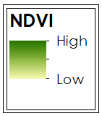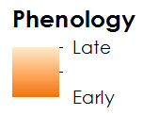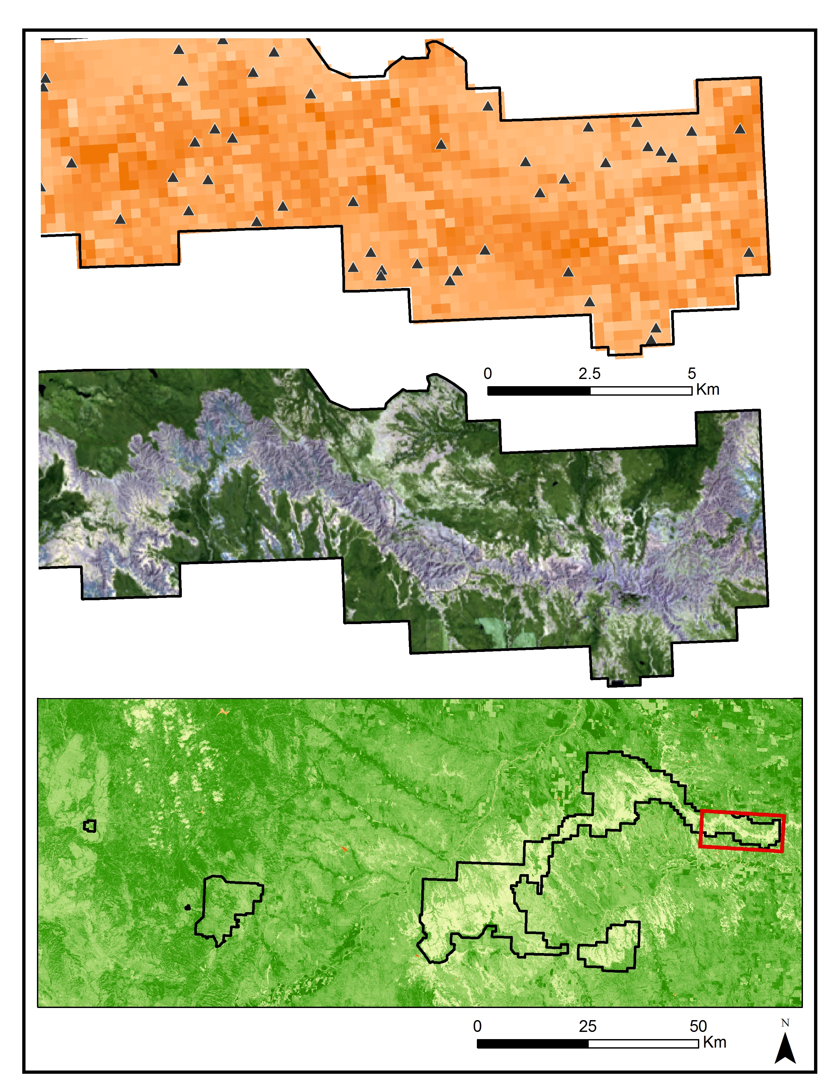

**Caption:** MODIS ForWarn (top), Landsat 8 (middle), and Sentinel-2 (bottom) data were used together with *in situ* data to identify invasive annual brome. Image Credit: Northern Great Plains Ecological Forecasting Team.

**Image:** 2016Sum_GSFC_NorthernGreatPlainsEco_VPSImage.jpeg