**NASA DEVELOP National Program**

****NASA Marshall Space Flight Center

**Spring 2016**

**Short Title: Lake Victoria Water Resources II**

**Subtitle:** Developing an Automated, Near Real-Time System to Monitor *Eichhornia Crassipes* over the Winam Gulf in Lake Victoria

**VPS Title:** Catch Me If You Can: Near Real Time Monitoring of Water Hyacinth

**Project Team & Partners**

**Project Team:**

Jeanné le Roux (Project Lead), leRoux1419@gmail.com

Daryl Ann Winstead

Christina Fischer

Sara Amirazodi

Dwight Tigner

**Advisors & Mentors:**

Dr. Jeffrey Luvall (NASA at the National Space Science and Technology Center)

Dr. Robert Griffin (The University of Alabama in Huntsville)

Africa Flores (NASA SERVIR Coordination Office at MSFC)

Dr. Joe Ortiz (Kent State University)

Dulci Avouris (Kent State University)

**Past or Other Contributors:**

Austin Vacek

**Partner Organizations:**

NASA SERVIR Coordination Office at MSFC (End-user), POC: Africa Flores; Boundary Organization

SERVIR-Eastern and Southern Africa Hub (End-user), POC: Dr. Robinson Mugo; Boundary Organization

Regional Centre for Mapping of Resources for Development (RCMRD) (End-user), POC: James Nyaga; Boundary Organization

Makerere University Department of Geomatics and Land Management (End-user), POC: Dr. Anthony Gidudu

**Project Details**

**Applied Sciences National Application Addressed:** Water Resources

**Study Area:** Lake Victoria in Kenya

**Study Period:** Jan 2013 to Feb 2016

**Earth Observations & Parameters:**

Landsat 8, OLI/TIRS - surface reflectance, vegetation detection

**Ancillary Datasets Utilized:**

* Regional Centre for Mapping of Resources for Development (RCMRD) - *in situ* measurements and observations of the presence of water hyacinth
* Sentinel-2, MSI - surface reflectance, vegetation detection
* WorldView-1, Panchromatic Sensor - location of water hyacinth

**Models Utilized:**

* NASA DEVELOP Program Hyacinth-Vegetation Detection Algorithm

**Software Utilized:**

Dnppy Model – Landsat 8 download and pre-processing to TOA reflectance

ArcMap 10.3 - raster manipulation/analysis, image enhancement & map creation of Landsat 8 and Sentinel-2

Python 2.7.8 - automation of Hyacinth-Vegetation detection algorithm and download of Landsat 8

**Project Overview**

**80-100 Word Objectives Overview:**

The degradation of water quality in Africa’s Lake Victoria is in part due to proliferation of the invasive plant species *Eichhornia crassipes*, commonly known as water hyacinth. This project applied NASA Earth observations and Python to create an automated process for detection of water hyacinth. These tools will help end-users determine the accuracy of results and automatically download new data for future monitoring. By providing efficient methods for managing water resources, this project illustrates the benefits of using remote sensing to improve the quality of life for communities and businesses dependent on Lake Victoria.

**Abstract:**

Lake Victoria has a surface area of 68,800 square km, making it the largest lake in Africa. The lake is surrounded by Kenya, Tanzania, and Uganda and is home to more than 30 million people. These people rely on the lake for all aspects of their lives including fishing, agriculture, and industrial applications. However, the increasing population has negatively impacted water quality due to sewage, as well as agricultural and industrial run off. Furthermore, the introduction of *Eichhornia crassipes*, or water hyacinth, has been detrimental to local communities by blocking fishing access and providing breeding grounds for diseases carried by mosquitoes and snails. Ongoing efforts between the NASA SERVIR Coordination Office at Marshall Space Flight Center, the SERVIR-Eastern and Southern Africa Hub, the Regional Centre for Mapping of Resources for Development (RCMRD), and the Makerere University Department of Geomatics and Land Management have been assessing and monitoring water quality parameters, such as chlorophyll concentration, temperature, and turbidity, for Lake Victoria using the Moderate Resolution Imaging Spectrometer (MODIS) sensor on the Aqua satellite. This project sought to include the use of Sentinel-2 Multispectral Imager (MSI), as well as the Operational Land Imager (OLI) sensor on Landsat 8, to assess water hyacinth presence in addition to current monitoring activities. This study focused on the Winam Gulf region of Lake Victoria in Kenya since this area experiences abundant water hyacinth activity and has been identified by RCMRD as an area of focus. As a continuation of the Lake Victoria Water Resources project from Fall 2015, this project used data previously collected to create an automated model to detect water hyacinth. This model employed Python scripting to continuously download and process new Landsat 8 images and automate the methodology for Sentinel-2 images. These end products will be utilized by partner organizations in their water hyacinth monitoring efforts.

**Community Concerns:**

* Eutrophication due to runoff causes water hyacinth to spread rapidly and results in the degradation of water quality in Lake Victoria, subsequently affecting everyday water usage.
* Water hyacinth growth restricts access to boating docks used for transportation, water extractors for clean drinking water and irrigation use, and fishing, which the locals depend on daily.
* Due to its nature of growth, water hyacinth blocks sunlight from the water column resulting in decreased oxygen and nutrient levels, negatively affecting biodiversity throughout the lake.
* *Schistosomiasis* is a devastating tropical parasitic disease. The infectious form of the parasite is secreted by snails living in fresh water, resulting in contamination. Water hyacinth serves as a breeding ground for snails carrying the parasite by providing physical attachment surfaces, shade, reduced temperature fluctuations, and food. Water hyacinth has a tendency to flourish in shallow waters near the lake shore, significantly increasing the human population exposure and infection risk of *schistosomiasis* due to activities such as boat launching and fishing.

**Current Management Practices & Policies**:

RCMRD is an intergovernmental organization that provides services on a demand driven basis in collaboration with other assisting institutes. Currently, RCMRD is measuring the water quality of Lake Victoria using standard methods (i.e. *in situ* measurements and observations, etc.). Current methods are considered to be expensive, time consuming, and spatially selective of one area across Lake Victoria. Improvements in remote sensing techniques are ongoing at RCMRD in collaboration with SERVIR to monitor water quality in Lake Victoria.

**Decision Support Tools & Benefits:**

|  |  |  |
| --- | --- | --- |
| **End-Product** | **Earth Observations Used** | **Benefit & Impact** |
| Surface Aquatic Vegetation Detection Tool (SADVT) | Landsat 8 OLI | Employs Python scripting to automatically download data for replication of water hyacinth detection process |
| SAVDT Accuracy Assessment | Landsat 8 OLI | Presents to end users the accuracy of the outputs produced by SAVDT |
|  | | |

**Project Imagery**

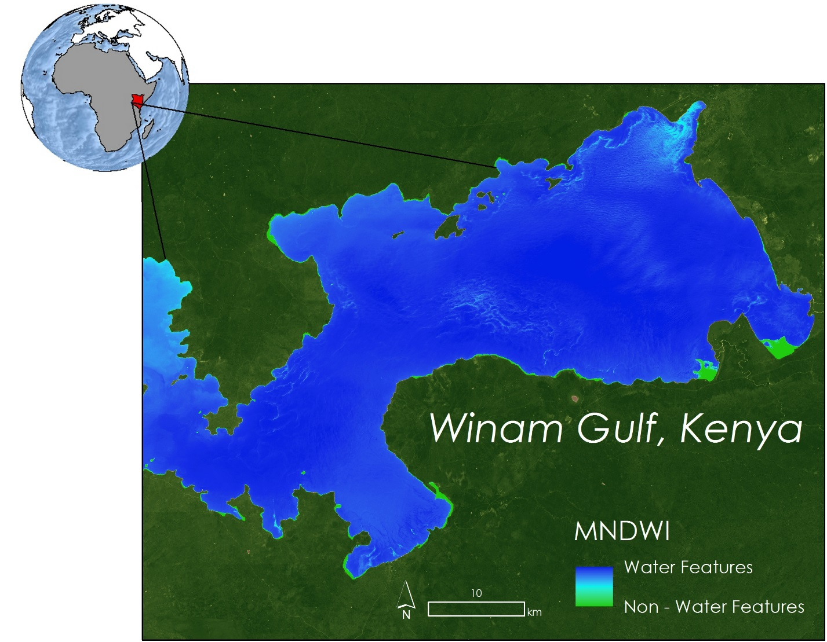

**Caption:** A wetness index highlighting areas with high chlorophyll activity in the focus study area. Image Credit: Lake Victoria Water Resources II Team.

**Image:** Spring2016_MSFC_LakeVictoriaWaterResourcesII_HighlightImage.jpg

**Software Release Requirements**

What category do the tools your project is creating fall within? Category III