**NASA DEVELOP National Program**

****University of Georgia

**Fall 2015**

**Short Title: Southeast Ecological Forecasting II**

**Subtitle:** Quantification and Phenology of *Hydrilla verticillata* Biomass using Landsat 8

**VPS Title:** It Came from the Lake: Hydrilla Mapping in Southeastern US Reservoirs

**Project Team & Partners**

**Project Team:**

Benjamin Page (Project Lead), benjaminpage8@gmail.com

Brandon Hays

Pradeep Kumar Ragu Chanthar

Linli Zhu

**Advisors & Mentors:**

Dr. Deepak Mishra (Department of Geography, University of Georgia)

Dr. Susan Wilde (Warnell School of Forestry and Natural Resources, University of Georgia)

**Past or Other Contributors:**

Wuyang Cai

Elizabeth Dyer

Shuvankar Ghosh

Peter Hawman

**Partner Organizations:**

J.W. Jones Ecological Research Center (End-User), POC: Dr. Stephen W. Golladay

Henry County Water Authority (End-User), POC: Ken Presley

Georgia Power (End-User), POC: Anthony Dodd

United States Army Corps of Engineers (End-User), POC: Allen Dean

**Project Details**

**Applied Sciences National Applications Addressed:** Ecological Forecasting, Water Resources

**Study Area:** Lakes Thurmond, Seminole, Goat Rock, Oliver, and Harding; AL, FL, GA

**Study Period:** January 2014 through November 2015

**Earth Observations & Parameters:**

Landsat 8, OLI - Hydrilla distribution and vegetation indices

**Ancillary Datasets Utilized:**

* ciBioBase sonar mapping - Bathymetry and model validation
* Unmanned aerial system, DJI Phantom 2 Vision +, Center for Geospatial Research, UGA - Aerial imagery for model validation
* Ocean optics non-imaging hyperspectral radiometer, UGA - Above water remote sensing reflectance (Rrs) measurements

**Models Utilized:**

* Deepak Mishra, UGA, Radiative Transfer Models (Benthic Mapping)
* Deepak Mishra, UGA, Green Normalized Difference Vegetation Index (NDVI)
* Deepak Mishra, UGA, Visibly Atmospheric Resistant Index (VARI)

**Software Utilized:**

ACOLITE and MatLab – Atmospheric Correction of Landsat 8 Imagery

ArcGIS - raster manipulation, creation of VARI maps and NDVI maps

**Project Overview**

**80-100 Word Objectives Overview:**

*Hydrilla verticillata* is an invasive aquatic plant which has contaminated numerous freshwater lakes and rivers throughout the Southeastern US, displacing native fauna and flora and costing millions of dollars in damages and removal efforts. This NASA DEVELOP project uses Landsat 8 OLI data to create a model mapping the current distribution of *Hydrilla* as well as predicting future growth. The goal of this work is to generate a useful rapid assessment tool that will aid control efforts targeting *Hydrilla* in local reservoirs.

**Abstract:**

*Hydrilla verticillata* is an invasive aquatic plant which has rapidly spread through many inland water-bodies across the Southeastern United States (SEUS) by outcompeting native aquatic plants and displacing fish populations. Consumption of water for drinking and power generation as well as recreational use of lakes has been threatened by the spread of *Hydrilla.* In recent years, *Hydrilla* has served as a vehicle for the spread of a toxic cyanobacteria (*Aetokthonos hydrillicola*) responsible for the neurodegenerative disease Avian Vacuolar Myelinopathy, which causes massive fish kills and bald eagle deaths throughout Georgia. Using Landsat 8 Operational Land Imager (OLI) data, a rapid assessment tool was developed to map the extent of *Hydrilla* and predict future spread throughout the SEUS by quantifying seasonal biomass through time-series analysis. A normalized difference vegetation index (NDVI) was performed and overlaid on the green band to differentiate between floating and submerged vegetation. Depth measurements were taken at Lake Herrick using Secchi disks to calculate light attenuation and identify the lower boundary of photosynthetically active regions (PAR). These data informed an unsupervised classification model, which was further trained using aerial imagery acquired by an unmanned aerial system. This model was validated with in-situ biomass measurements and local knowledge. Next, data collected from 2013-2015 were used to create a time series of true color composite images, which were analyzed to map regions of expanding *Hydrilla* presence. The time series, in conjunction with a quantitative model of *Hydrilla* growth, were used to predict future *Hydrilla* hot spots.

**Community Concerns:**

* *Hydrilla verticillata* outcompetes native plants and forms surface canopies that block sunlight, intensifying lake stratification and causing anoxic conditions.
* *Hydrilla* harbors toxic epiphytic cyanobacteria that disrupt the food chain causing wildlife fatalities.
* *Hydrilla* mats clog boat motors disrupting transportation and recreation as well as causing hazardous swimming conditions.
* *Hydrilla* obstructs water withdrawal for drinking water, irrigation, and power generation.

**Current Management Practices & Policies**:

Local management agencies use visual analysis, rake collection, and sonar analysis to monitor the spread of *Hydrilla*. Chemicals are used to manage *Hydrilla verticillata*, including copper, diguat, endothall, and fluridone. Applying these chemicals can have adverse effects on the lake ecosystem. As a lower-impact strategy, managers have introduced triploid grass carp (Ctenopharyngodon idella), a species of fish which consumes aquatic plant material including *Hydrilla*. Because triploid grass carp are sterile their populations can be controlled after introduction to the ecosystem.

**Decision Support Tools & Benefits:**

|  |  |  |
| --- | --- | --- |
| **End-Product** | **Earth Observations Used** | **Benefit & Impact** |
| *Hydrilla* distribution maps | Landsat 8, OLI | End-users will be able to continually track topped-out and submerged *Hydrilla* distribution for mitigation efforts |
| *Hydrilla* forecasting model | Landsat 8, OLI | Identification of areas where lake managers can target future mitigation efforts |

**Project Imagery**

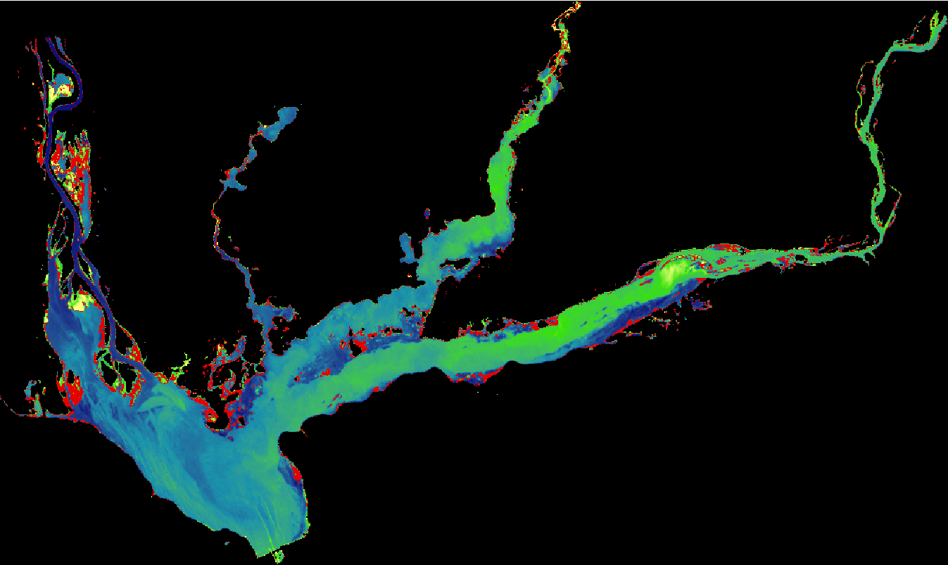

**Caption:** [Floating (red) and submerged (green) *Hydrilla* distribution in Lake Seminole, September 2014.]

Image Credit: Southeast Ecological Forecasting II Team.

**Image:** 2015Fall_UGA_SoutheastEcoForecastingII_VPS_Image.jpeg

**Software Release Requirements**

What category do the tools your project is creating fall within? Category II