Hawaiʻi Water Resources

Utilizing NASA Earth Observations to Assess Ocean Conditions Leading to the Spread of the Nuisance Red Algae (*Chondria tumulosa*) in Papahānaumokuākea Marine National Monument, Hawaiʻi

 **Technical Report**

Final Draft – November 19th, 2020

Keolohilani H. Lopes Jr. (Project Lead)

Taylor Orcutt

Ginah Tran

Anna Ballasiotes

***Advisors:***

Dr. Juan Torres-Pérez, Bay Area Environmental Research Institute, NASA Ames Research Center (Science Advisor)

Dr. Liane Guild, NASA Ames Research Center (Science Advisor)

# 1. Abstract

*Chondria tumulosa*, a newly discovered red alga, was observed in low abundance in 2016 but has since proliferated and is now smothering and decimating vast expanse of coral reefs in Manawai, located in Papahānaumokuākea Marine National Monument (PMNM). If the spread persists, the outbreak of this cryptogenic species could potentially cause region-wide ecosystem degradation. In coordination with the U.S. Fish and Wildlife Service, Marine National Monuments of the Pacific and the National Oceanographic and Atmospheric Administration (NOAA) Office of National Marine Sanctuaries, Hawai’i Regional Office, Papahānaumokuākea Marine National Monument, this project created a tool to analyze oceanographic conditions (sea surface temperature (SST), chlorophyll-a, water velocity, salinity, turbidity) across the Monument that could potentially be driving the algal spread. The Google Earth Engine (GEE) tool enabled the partners to visualize oceanographic conditions and gather time-series graphs utilizing Aqua and Terra Moderate Resolution Imaging Spectroradiometer (MODIS), Suomi National Polar-orbiting Partnership Visible Infrared Imaging Radiometer Suite (NPP VIIRS), Sentinel-3 Ocean and Land Colour Instrument (OLCI), Hybrid Coordinate Ocean Model (HYCOM) and NOAA's Climate Data Record (CDR) in a user-friendly interface. The team used in situ SST data from subsurface temperature recorders provided by the partners to validate the tool's accuracy. Preliminary statistical analysis of MODIS data found warming trends in SST in Manawai as well as increased chlorophyll-a levels during the summer months at Manawai in contrast to the control (non-infected) Lalo atoll. The tool did not aim to classify algal presence due to limited availability of higher resolution satellite imagery but instead enabled PMNM managers to monitor conditions that may be conducive to algal growth around the monument to make informed decisions and mitigation practices.

**Key Terms**

*Chondria tumulosa,* Papahānaumokuākea Marine National Monument, Google Earth Engine, remote sensing, coral reefs, MODIS, VIIRS

# 2. Introduction

***2.1 Background Information***

The rapidly changing climate is predicted to cause regime changes across coral reef ecosystems, from coral dominated systems to algal dominated systems (Hughes et al., 2007). Corals are threatened by acidification, rising ocean temperatures, and physical stressors like marine debris and other human impacts which could favor algal growth (Chollett, Mumby, & Cortés, 2010). A 2019 National Oceanic and Atmospheric Administration (NOAA) expedition into Papahānaumokuākea Marine National Monument (PMNM), a United Nations Educational, Scientific, and Cultural Organization (UNESCO) site encompassing ~1.5 million square kilometers in the Northwestern Hawaiian Islands, observed a widespread algal outbreak of the newly identified *Chondria tumulosa* (Sherwood et al., 2020). The origin of this algae is unknown and could have been introduced to the region via marine debris or could ultimately be a cryptic native species that has recently thrived due to the favorable changing ocean conditions. This outbreak is currently isolated to Manawai, also known as Pearl and Hermes Atoll, located in the Northwestern portion of PMNM (Figure 1). This reef-smothering alga has the identifiable morphology of a thick mat which has been observed covering hundreds of square meters of the coral reef ecosystems, effectively smothering all life beneath it, including all the coral colonies. The potential damage to this pristine ecosystem ranges from a limited outbreak to a complete collapse of this once pristine coral reef environments.

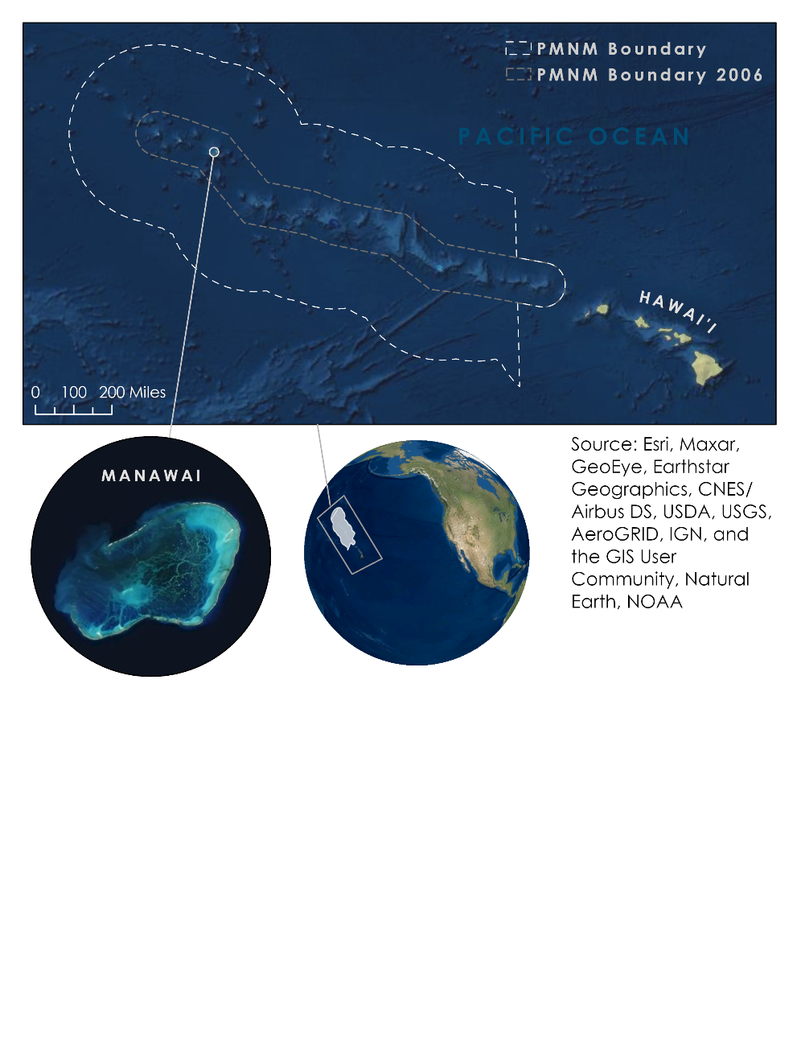

Figure 1. Map of the entirety of the Papahānaumokuākea Marine National Monument with an inset of Manawai as well as an overview locator globe.

This study focused on utilizing NASA Earth observations (EO) to analyze the oceanographic conditions surrounding Manawai. With Moderate Resolution Imaging Spectroradiometer (MODIS) and Visible Infrared Imaging Radiometer Suite (VIIRS), as well as Ocean and Land Cover Instrument (OCLI) data from the European Space Agency’s Sentinel -3 satellite, this study worked to determine what drivers are contributing to the population explosion of *C. tumulosa.* MODIS sensors have been used in multiple studies to examine ocean conditions, particularly as they relate to algal blooms (Mishra, Narumalani, Rundquist, & Lawson, 2005; Sathyendranath, 2014). This specific alga poses a unique challenge as it is not found on the surface but instead blanketing or attached to coral reefs in shallow depths (1 – 19 m) (Sherwood et al., 2020). This makes detection by satellite imagery exceptionally difficult, and as such, this project did not aim to detect the algae but to examine the ocean conditions that may have contributed to the growth and spread of the algae.

The study period was determined by the dates of algae observations from past NOAA field expeditions. The newly discovered alga wasfirst observed in 2016 and then again, encompassing a larger area, in the summer of 2019. The oceanographic observations will focus on the years between 2013 and 2020. The authors of this paper hypothesized that there are differences in oceanographic conditions such as water temperature, chlorophyll-a, salinity, and potential upwelling during the months leading up to 2016 and 2020. The team used statistical approaches to determine these drivers alongside *in situ* data for ground truthing and assessed whether there were significant differences in these parameters during this time span.

***2.2 Project Partners & Objectives***

The United States Fish and Wildlife Service (FWS) and NOAA are two of the four co-trustees in charge of managing the marine refuge, PMNM. The other two co-trustee are the Office of Hawaiian Affairs and the State of Hawai’i. These four agencies are mandated under federal law to protect the natural and cultural resources of the 10 major atolls and shoals within PMNM. These agencies have dedicated programs to support marine and terrestrial biological monitoring. They conduct field camps to monitor populations of migratory and resident sea birds, as well as monitor endangered species. They also develop policies, review permit applications, and implement strategies concerning a wide variety of issues, including invasive species control. Currently, costly and infrequent *in situ* observations from summer field camps, self-contained underwater breathing apparatus (SCUBA) expeditions, and oceanographic and terrestrial projects are the primary means of acquiring data from this remote region. Rapid changes in climate have made it a necessity to develop remote sensing tools that can maintain a vigil eye year-round over this vast archipelago. Recent events including northerly tracking hurricanes, mass coral bleaching, and the outbreak of nuisance red algae have made it apparent that year-round observation of PMNM is necessary for effective management and policymaking. This project quantified variations in oceanographic conditions around PMNM focusing on the waters surrounding Manawai and other nearby atolls. The team created a web-based tool in Google Earth Engine (GEE), Conditions Observed in Red ALgae Spread (CORALS) to visualize the ocean conditions that may have contributed to the outbreak of *C. tumulosa* and determine what other regions of the monument have experienced similar conditions to assess potentially suitable habitats for further algal spread. Lastly, the team developed a lesson plan that will be delivered by Keolohilani Lopes Jr. after the term to allow the partners to begin working with the Google Earth Engine JavaScript API.

# 3. Methodology

***3.1 Data Acquisition***

*Conditions Observed in Red ALgae Spread (CORALS) Application:*

For the application built in GEE, the team uploaded the PMNM shapefile into GEE as an asset. The application incorporated imagery from MODIS, VIIRS, and OLCI as well as climate model data from HYbrid Coordination Ocean Model (HYCOM) and NOAA’s Climate Data Record (CDR) Optimum Interpolation Sea Surface Temperature v02. MODIS Level 3 products (Ocean Color SMI: Standard Mapped Image MODIS Aqua and Terra Data) were used and contained parameters already calculated for chlorophyll-a, remote sensing reflectance, sea surface temperature, normalized fluorescence line height, and particulate organic carbon. VNP09GA: VIIRS Daily Surface Reflectance is a Level 2 product and thus had to be converted to chlorophyll-a during data processing. Sentinel-3 OLCI EFR: Ocean and Land Color Instrument Earth Observation Full Resolution was unable to be converted to a usable parameter and served as a visual representation of chlorophyll-a via the Oa04 high chlorophyll band (490 nm). The application offers access to these data and associated time series for users who are not experts in remote sensing imagery acquisition.

*Additional Data for Statistical Analysis:*

Additional data was provided by the partners including transects of surveys from field expeditions with spatial locations of areas with high concentration of *C. tumulosa* and areas without algal presence. Furthermore, temperature data from subsurface temperature recorders located on site in Manawai from the National Coral Reef Monitoring Program was provided by the partners. These two data sets will be used in conjunction with the tool’s output data for external statistical analysis and described in deeper detail in section *3.3 Data Validation* and *3.4 Data Analysis*.

*Table 1.* Comprehensive table of remote sensing, gridded, and auxiliary data acquired for study.

|  |  |  |
| --- | --- | --- |
| **Platform and Sensor or Model Organization** | **Data Product** | **Acquisition Method** |
| Aqua MODIS | Ocean Color SMI: Standard Mapped Image MODIS Aqua Data | Google Earth Engine |
| Terra MODIS | Ocean Color SMI: Standard Mapped Image MODIS Terra Data | Google Earth Engine |
| Suomi-NPP VIIRS | VNP09GA: VIIRS Daily Surface Reflectance | Google Earth Engine |
| Sentinel-3 OLCI | Earth Observation Full Resolution (EFR) Dataset: Top of Atmosphere Radiance | Google Earth Engine |
| HYCOM: Hybrid Coordinate Ocean Model | Water Temperature, Salinity, Velocity, Sea Surface Height | Google Earth Engine |
| NOAA Climate Data Record | 1/4 degree daily Optimum Interpolation Sea Surface Temperature (OISST) | Google Earth Engine |

***3.2 Data Processing***

*CORALS Application*

The GEE application was created to visualize various oceanographic parameters that might have contributed to the spread and proliferation of the red algae. We corrected several of the satellite datasets and applied common color palettes to the visualizations. To correct the VIIRS data from surface reflectance to a chlorophyll-a value, we adjusted the data using the OC3V algorithm (O’Reilly et al., 1998). For diffuse attenuation, or Kd490, we adjusted the MODIS Level 3 product using the MODIS Diffuse Attenuation at 490nm algorithm. This Kd490 metric returns the diffuse attenuation coefficient for downwelling radiance and is typically used to evaluate turbidity. HYCOM required scaling adjustments with sea surface height, water temperature, water velocity, and salinity values all multiplied by 0.001. The MODIS Level-3 data did not require any adjustments. It is these corrected data that are visualized and extractable in the application.

The application allows for a composite of increments of 5, 7, 15, and 30 days. This composite is created through a mean composite with data that has already been processed with cloud masking and/or land masking as well as the processing described above. The images are filtered to include only the user-selected date and composite length and then the mean of each available overlapping pixel is calculated to build a single image composite. This is the image that is displayed within the CORALS application.

***3.3 Data Validation***

Sea surface temperature data extracted from MODIS Aqua/Terra from the CORALS tool was validated by comparing it to data collected from *in situ* subsurface temperature recorders at three meters depth or less, located in Manawai as provided by the National Coral Reef Monitoring Program. The team compiled the SST data as a csv file from the tool by selecting Manawai as the region of interest and SST as the parameter. The temperature data was then extracted as yearly summaries from 2013-2020. The temperature data can be incomplete due to reasons like cloudy imagery as well as data not yet being available for the rest of the year 2020. At the time of this study, temperature data is only available up until July of 2020. The team considered SST the proxy for the accuracy of the satellite data for two reasons: First, SST has been reported to be accurate in many peer reviewed journal articles and second, field collected SST were available and provided by the partners. This allowed for a direct comparison between the remote sensed data against the *in situ* data. A linear regression model was done with both datasets using coding in Python to assess its correlation with one another. Proven efficacy of this tool especially with regards to sea surface temperature will enable the partners to have accurate SST data throughout the monument where there are no subsurface temperature loggers installed.

***3.4 Data Analysis***

In order to determine possible drivers of algal growth, the team performed preliminary statistical analysis using data outputs from the CORALS tool, *in situ* data of transects with algal presence from surveys done in the field provided by the partners, and *in situ* sea surface temperature data collected by subsurface temperature recorders from the National Coral Reef Monitoring Program. For the scope of the project, the team focused on sea surface temperature and chlorophyll-a as the parameters of interest that could potentially be driving the spread of *C. tumulosa* in Manawai. Experts on the algae such as Dr. Heather Spalding, hypothesized that upwelling in this region could be driving its success in proliferating around the atoll, leading to the team’s motivation to explore chlorophyll-a. Furthermore, increasingly frequent coral bleaching events due to warming temperatures around the monument prompted the team to explore ocean temperature trends around the atoll in the years 2013-2020.

The first statistical analysis was done to compare sea surface temperature around areas with known algal presence and areas with no alga discovered during the expeditions. Fortunately, there are subsurface temperature recorders located near sites where the alga was found around the atoll, as well as areas without the alga present. In order to accomplish this, the team used ArcMap to overlay temperature loggers containing their GPS coordinates over a transect map of the algal survey done in 2019. The temperature loggers nearest to the areas with high concentration and coverage of the algae was then extracted along with their temperature data. The temperature data was then separated into two subsets: “Near” and “Other”, with Other being the rest of the temperature data in areas with little to no algal presence. A boxplot value summary was done with code written in Python to compare the minimum, maximum, quartiles, and median values of the temperature data to see if they are any different and if there are any correlation to algal presence and temperature. If the boxplot summary differs for each subset, it would mean that there might also be other factors occurring at the sites leading to a difference in temperature.

The next statistical analysis was done to observe chlorophyll-a values around Manawai. In addition, a control atoll, Lalo, was set to have a point of comparison for the data. Lalo was chosen because no algal presence has been detected in this atoll on expeditions. In order to more definitely conclude that chlorophyll-a has an effect on algal growth in Manawai, chlorophyll-a levels will have to be higher in Manawai compared to Lalo. For this analysis, the team used chlorophyll-a time series data output from 2013 - 2020 from the CORALS tool using MODIS satellite imagery. The team used MODIS as opposed to VIIRS since MODIS already contains a band that measures chlorophyll-a, although the VIIRS data is provided in the CORALS application. VIIRS does have higher resolution data compared to MODIS and the tool uses the OC3V algorithm to calculate chlorophyll-a with VIIRS’ bands. This dataset can be utilized by the partners to analyze chlorophyll-a values on a finer scale in the future but for the scope of this project, MODIS was utilized.

The data was compiled in R Studio to create two boxplots summarizing the values of chlorophyll-a with a 20-kilometer buffer around Manawai and Lalo. This will show the complete range of values for every year from 2013 - 2020 including minimum, maximum, quartiles, and median. Furthermore, though boxplots are useful for summarizing the annual range of values, it does not capture the seasonality trends of chlorophyll-a. We calculated median chlorophyll-a values for every month per each year from 2013-2020. The median values were then plotted in a line plot for both atolls for side-by-side comparison. Afterwards, for closer inspection, the study years were split into 2013 - 2016 and 2017 - 2020 to assess any changes in chlorophyll-a pattern occurred in the latter years since algal presence was only minimally observed around the atoll in 2016. This is the extent of the statistical analysis that the team was able to accomplish with the hopes that the experts at FWS and NOAA will have a better understanding of the salinity, water velocity, kd490, and sea surface height data that the CORALS tool outputs.

# 4. Results & Discussion

***4.1 CORALS Google Earth Engine Tool***

The CORALS tool successfully allows users to generate charts and graphs displaying different oceanographic parameters over time that may influence the nuisance algae. There are two levels of access for the CORALS tool. Most users will access the tool via the provided app only link (Level 2). This app link will open a new browser window and start the web-based application that will have full functionality, but these users will not be able to access, view, or edit the code. This app only link will be given to Level 2 users. Level 1 users will be given access to the source code through GEE. The Level 1 user will have full access privileges including copying, editing, and deleting the code in addition to viewing, running, and extracting data from the application. The team is assuming that all users with Level 1 access will have some familiarity with GEE and will be able to run, follow the onscreen instructions, and generate output after a brief overview of the GUI. For the Level 2 user, detailed descriptions within the application have been added to allow the user to understand the functionality and outputs for the options provided.

The GEE application includes two primary panels: 1) the map panel and 2) the information panel. Within the map panel there is a drop-down menu in which you can select any one of six atolls of PMNM to zoom into as well as the entire Monument. Just below this menu is a button that will allow the users to generate a link to extract a georeferenced .tif file of the most recently generated composite that can be directly loaded into GIS software for analysis outside of GEE. Within the information panel there are composite options and time series options.

The information panel within CORAL app contains background information on the nuisance algae and why this tool is needed. The section below that is the Composite where users can select the parameter to investigate (Chlorophyll-a, Sea Surface Temperature, Salinity, Velocity (Ocean), Kd490 (turbidity), Sea Surface Height) with the available sensors as well as the period of interest. Users can select a composite date and can choose from a 5-, 7-, 15-, and 30-day composite. After selecting these parameters, the user can select the Display Composite button and a map will be generated. On the map, a label displays the sensor used as well as the dates of the composite generated. This label is replaced each time a new composite is generated whether or not the map has been cleared. The next section of the app contains the Time Series Graph area where the user will select from the same parameters as the Composite but with an option for a 1-, 3-, 6-, and 12-month time series graph. This data is also extractable via an expand icon in the upper right-hand corner of the generated timeseries graph. This icon will bring up a subsequent screen to show three options for downloading a CSV, SVG, or PNG. This data can be used for further analysis using other software analysis tools.

These time-series charts were compared to the expansion of known *C. tumulosa* throughout PMNM, and further analysis was conducted on the satellite to test it against the *in situ* data gathered by the project partners. The point inspector built into GEE allows the user to gain values for the multiple data layers within the tool. An image of the CORALS tool user interface is shown below (Figure 2).

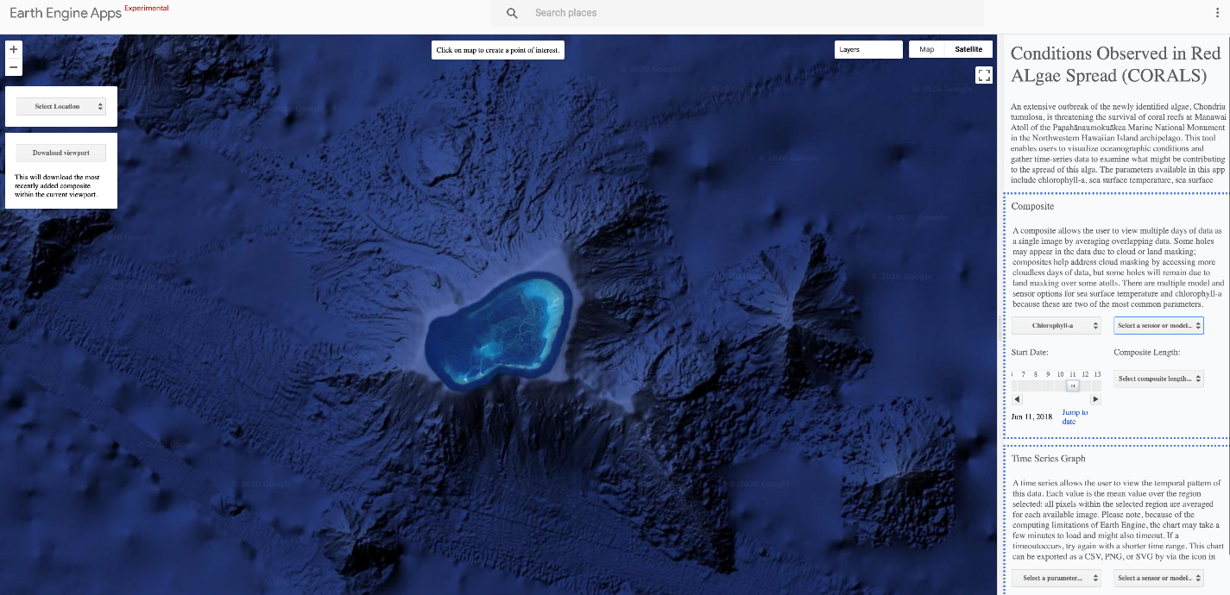

Figure 2. Example of the interface for the CORALS application created for the project partners.

***4.2 Statistical Analysis***

As previously mentioned,the team validated part of the tool’s accuracy in terms of sea surface temperature by comparing it against *in situ* temperature data collected from subsurface temperature recorders located on site. This will provide the partners with confidence when utilizing the tool to visualize temperature variations within the monument or different atolls that currently do not have subsurface temperature recorders. We performed a linear regression model with both datasets using Python (*Figure A.1*), which yielded a strong correlation or r² = 0.95. This indicated that there is no significant statistical difference with both sea surface temperature data from MODIS data in the tool and *in situ* recordings. The team also created a scatterplot showing daily average SST data in Manawai from the years 2013 to the summer of 2019 (*Figure A.2*). The time frame of this analysis was determined by the temporal extent of the *in situ* data (2013 – mid 2019). Black data indicate values from *in situ* subsurface temperature recorders with MODIS SST data overlaid in red. MODIS data, though not as complete due to factors like cloudy satellite imagery, still corresponds well with the ground truth data.

Figure A.4 is a side by side boxplot summary of yearly sea surface temperature output values from the CORALS tool for Manawai. There is not a discernible pattern of warming temperatures from this visualization although it does seem that minimum values are not as low in recent years as they are in 2014 and 2016. In this graph, 2020 data has only been extracted through July and is not a complete year of data. While the median values are similar from year to year, the values indicate that 2019 is one of the warmer years. 2020 may continue this warming trend but more complete data will need to conclude this.

As for SST comparison between areas with algal presence and areas without alga, we created a box plot summary of values for areas near the sites with alga and sites without. Figure A.3 shows a side-by-side comparison of these values as “Near” (sites near algal presence) and “Other” (sites without algal presence). We acquired *in situ* temperature data from loggers placed by project partners and used these data for analysis as multiple loggers were located in areas both with and without *C. tumulosa.* The boxplot graph in Figure A.3 shows no significant difference in temperature between the sites. This may indicate that the sea surface temperature is quite uniform throughout the atoll.

For the chlorophyll-a values, the team hypothesized that higher concentrations of chlorophyll-a(mg/m³) might occur in Manawai compared to another atoll in the Monument such as Lalo. We created boxplot summaries of chlorophyll-a ranges for the years 2013-2020 for both atolls (*Figure B.1*, *Figure B.2*). We do not see higher levels of chlorophyll-a in Manawai but instead higher median values in Lalo. Manawai has more outliers observed but chlorophyll-a ranges have stayed rather uniform from 2013-2020 and therefore, nothing conclusive can be determined about the effects of chlorophyll-a levels on algal growth.

In order to capture the seasonality trends of chlorophyll-a data, we calculated the median values for every month for each year for both atolls. Line graphs were made to visualize the median values for each month for the years 2013-2020 (*Figure B.3*, *Figure B.4*). In general, chlorophyll-a values tend to be higher in January-February and November-December, which corresponds with lower temperature and higher levels of nutrients in the winter. However, upon closer inspection of chlorophyll-a levels in more recent years 2017-2020 there is a distinct difference between the two atolls (*Figure B.5*, *Figure B.6*). In the summer months in Manawai where the temperature levels are warmest, chlorophyll-a levels spike up while Lalo levels decrease as expected. In *Figure B.6*, chlorophyll-a levels visibly reduce in the month of July for Lalo while in *Figure B.5* chlorophyll-a levels show an increase in May through August in Manawai. This might be an interesting phenomenon to expand upon in future studies, but we cannot make significant statistical conclusions about the effects of chlorophyll-a in algal growth in this region.

***4.3 Sources of Error***

While creating the tool and collecting EO data, we encountered several challenges. The location of the study area meant that the team faced significant issues with the availability and viability of satellite data. Many datasets that were initially considered for the project had to be removed from the code and tool due to lack of either spatial, temporal, or spectral resolution, as well as, in the case of Landsat 8 Operational Land Imager (OLI), the degree to which the data was pre-corrected before it was imported into GEE’s repository of datasets. Sentinel-3 data also had to be reduced in its usage based on the inability to reasonably process the data within the tool to display chlorophyll-a levels.

Other sources of error for the statistical analysis portion, particularly with chlorophyll-a data, may be due to missing data from cloudy satellite imagery, which can ultimately skew the data. Furthermore, optically shallow waters can lead to chlorophyll-a values being depicted as orders of magnitude higher than surrounding waters. In reference to the lagoon in Manawai, the satellite may assume that the brighter colors of the lagoon are higher levels of chlorophyll-a rather than reflectance from optically shallow waters. We used an algorithm for calculating chlorophyll-a that is tailored to open ocean conditions as opposed to coastal or shallow waters like those in atolls. However, a mask can be applied in the future to account for this error and give more accurate chlorophyll-a values.

***4.2 Future Work***

This project was faced with several limitations in terms of spatial resolution as well as availability of satellite data for the remote location of PMNM. Ideally our GEE application would allow project partners to classify scenes and detect the presence of algae in the monument in order to track the spread through a time series. Currently, there are no publicly accessible sensors or imagery with spatial resolution high enough to detect underwater features. Furthermore, we were not able to process some data for the specific use desired with this project. Landsat 8 was only categorized as Tier 2 for this region, which means it does not have the inherent image quality that allows for conversion to Surface Reflectance as a Tier 1 image would. Until efforts are made to improve coverage, processing, and sensor data correction for this region and other water ecosystems, detecting small underwater features at localized oceanic regions will prove challenging for any satellite imagery. Currently, the partners have access to WorldView data, which they have previously used to extract spectral features at study sites using ArcGIS Pro. The partners hypothesized that the algae showed low spectral reflectance in the WorldView-2 images and have identified additional dark spots to examine in the field to confirm whether algae are present. This method is time consuming in that users must manually classify each scene that is downloaded. It is also possible for users to misclassify topographic shading from underwater features as algal presence. Future improvements on satellite spatial resolution available on GEE would streamline this process and allow the partners to track the spread through time series.

Another avenue to explore for future studies would be the impact of marine debris as an agent for algae migration into the monument. Manawai is prone to catching marine debris like open ocean fishing nets or wrecked fishing boats from tsunamis. There is still much to be learned about the alga itself, particularly how it was introduced into this region.

# 5. Conclusions

This project successfully created an oceanographic data extraction tool that will give PMNM managers a means to monitor, analyze, and extract ocean conditions using NASA EO derived data as well as the HYCOM model and other remote sensing platforms like Sentinel-3. An advantage of GEE is the continual update of the latest data sets available for all the sensors currently listed. Additionally, with modifications to the code, this tool could incorporate newer systems and data as they become publicly available on the GEE platform. The flexibility incorporated will also allow for simple band calculations if specific frequencies are identified with this nuisance algae. The team believed the GEE platform would allow the best adaptability for any added information discovered about *C. tumulosa*. Furthermore, the tool is user-friendly and accessible to those who are new to remote sensing without the need of proprietary software like ArcGIS suite or ENVI. The link for the application can be easily shared between the monument co-managers.

Since *C. tumulosa* has only recently been discovered and identified, much is still to be learned about it including the basic information like lifecycle patterns, nutrient uptake, origin and other characteristics. One of the most pressing questions that needs to be answered by the phycologists studying this species is whether this alga isa native species previously held in check by natural processes of predation and competition for space until environmental changes altered this natural balance in favor or the *C. tumulosa*. An example can be loss of natural competitors due to a slowed coral growth rate or loss of algal grazing species in the region. It is also possible this species was introduced into the region or perhaps drifted in on marine debris or vessel traffic. With the preliminary statistical analyses completed during this study, the team cannot determine which, if any, oceanographic conditions allowed for the expansive spread of this algae throughout Manawai. The primary focus of this project was to create a functioning tool to deliver to partners, which they can then utilize to inform future expeditions into the monument as well as monitor changing trends in oceanographic conditions incorporated into the tool, which includes sea surface temperature, chlorophyll-a, salinity, sea surface height, water velocity and kd490. The team hopes that the experts at NOAA and FWS can find patterns utilizing the data outputs from the tool. The team hopes that availability of higher resolution satellite imagery or even drone imagery will allow for identification and classification of this alga and tracking its spatial extent.

# 6. Acknowledgements

The Hawaii Water Resources team at NASA Ames Research Center would like to thank our partners from the US Fish and Wildlife Service and National Oceanic and Atmospheric Administration for their feedback and involvement in the development of the CORALS tool. Thank you to our Science Advisors who provided the team with guidance and support: Dr. Juan Torres-Perez of Bay Area Environmental Institute and NASA Ames Research Center, and Dr. Liane Guild, NASA Ames Research Center. Thank you also to our NASA DEVELOP Fellow Britnay Beaudry and Senior Fellow Hayley Pippin for their project coordination and general assistance throughout the term.

This material contains modified Copernicus Sentinel data (2016-2020), processed by ESA and EUMETSAT.

Funding for the development of HYCOM has been provided by the National Ocean Partnership Program and the Office of Naval Research. Data assimilative products using HYCOM are funded by the U.S. Navy. Computer time was made available by the DoD High Performance Computing Modernization Program. The output is publicly available at https://hycom.org.

Any opinions, findings, and conclusions or recommendations expressed in this material are those of the author(s) and do not necessarily reflect the views of the National Aeronautics and Space Administration.

This material is based upon work supported by NASA through contract NNL16AA05C.

# 

# 7. Glossary

**CORALS –** Conditions Observed in Red ALgal Spread

**Earth observations** – Satellites and sensors that collect information about the Earth’s physical, chemical, and biological systems over space and time

**GEE** – Google Earth Engine

**EO –** Earth observations

**MODIS** – MODerate resolution Imaging Spectroradiometer

**VIIRS** – Visible Infrared Imaging Radiometer Suite

**Chlorophyll-a** – photosynthetic pigment found in green plants and algae

**HYCOM** – HYbrid Coordination Ocean Model

**FWS** – Fish and Wildlife Service

**NOAA** – National Oceanic and Atmospheric Administration

**Rrs** – Remote sensing reflectance

**PMNM** – Papahānaumokuākea Marine National Monument

**OLCI** – Ocean and Land Cover Instrument

# 8. References

Chollett, I., Mumby, P. J., & Cortés, J. (2010). Upwelling areas do not guarantee refuge for coral reefs in a warming Ocean. *Marine Ecology Progress Series*, *416*, 47–56. doi:10.3354/meps08775

Clayson, Carol Anne; Brown, Jeremiah; and NOAA CDR Program (2016). NOAA Climate Data Record Ocean Surface Bundle (OSB) Climate Data Record (CDR) of Ocean Near Surface Atmospheric Properties, Version 2. NOAA National Center for Environmental Information, accessed 08 October 2020. doi:10.7289/V55T3HH0.

Copernicus Sentinel-3 OLCI EFR Data. [2016 - 2020]. Retrieved from Google Earth Engine, processed by ESA.

Cummings, J.A. and Smedstad, O. M. (2013). Variational Data Assimilation for the Global Ocean. *Data Assimilation for Atmospheric, Oceanic and Hydrologic Applications* (2), 303-343.

Hughes, T. P., Rodrigues, M. J., Bellwood, D. R., Ceccarelli, D., Hoegh-Guldberg, O., McCook, L., Moltschaniwskyj, N., Pratchett, M. S., Steneck, R. S., & Willis, B. (2007). Phase Shifts, Herbivory, and the Resilience of Coral Reefs to Climate Change*. Current Biology, 17*(4), 360–365. doi:10.1016/j.cub.2006.12.049

Mishra, D. R., Narumalani, S., Rundquist, D., & Lawson, M. (2005). Characterizing the vertical diffuse attenuation coefficient for downwelling irradiance in coastal waters: Implications for water penetration by high resolution satellite data*. ISPRS Journal of Photogrammetry and Remote Sensing*, *60*(1), 48–64. doi:10.1016/j.isprsjprs.2005.09.003

NASA Goddard Space Flight Center, Ocean Ecology Laboratory, Ocean Biology Processing Group. Moderate-resolution Imaging Spectroradiometer (MODIS) Aqua/Terra Ocean Color Data, NASA OB.DAAC, Greenbelt, MD, USA, accessed 08 October 2020. doi:10.5067/TERRA+AQUA/MODIS/L3M.

O'Reilly, J.E., Maritorena, S.,Mitchell, B. G., Siegel, D. A., Carder, K. L., Garver, S. A., Kahru, M., & McClain, C. R. (1998). Ocean color chlorophyll algorithms for SeaWiFS. *Journal of Geophysical Research 103*, 24937-24953, [doi: 10.1029/98JC02160](http://dx.doi.org/10.1029/98JC02160).

Reynolds, R. W., Banzon, V.F., and NOAA CDR Program (2008): NOAA Optimum Interpolation 1/4 Degree Daily Sea Surface Temperature (OISST) Analysis, Version 2. NOAA National Centers for Environmental Information, accessed 08 October 2020. [doi:10.7289/V5SQ8XB5](https://doi.org/10.7289/V5SQ8XB5)

Sathyendranath, S. (2014). Phytoplankton Functional Types from Space. In *Reports of the International Ocean Colour Coordinating Group* (15).

Sherwood, A. R., Huisman, J. M., Paiano, M. O., Williams, T. M., Kosaki, R. K., Smith, C. M., Giuseffi, L., & Spalding, H. L. (2020). Taxonomic determination of the cryptogenic red alga, Chondria tumulosa sp. nov., (Rhodomelaceae, Rhodophyta) from Papahānaumokuākea Marine National Monument, Hawai’i, USA: A new species displaying invasive characteristics. *PLoS ONE*, *15*(7 July), 1–16. [doi:10.1371/journal.pone.0234358](https://doi.org/10.1371/journal.pone.0234358)

Vermote, E., Franch, B., Claverie, M. (2016). VIIRS/NPP Surface Reflectance Daily L2G Global 1km and 500m SIN Grid V001. NASA EOSDIS Land Processes DAAC, accessed 01 October 2020. doi:10.5067/VIIRS/VNP09GA.001

# 9. Appendices

**Appendix A.**

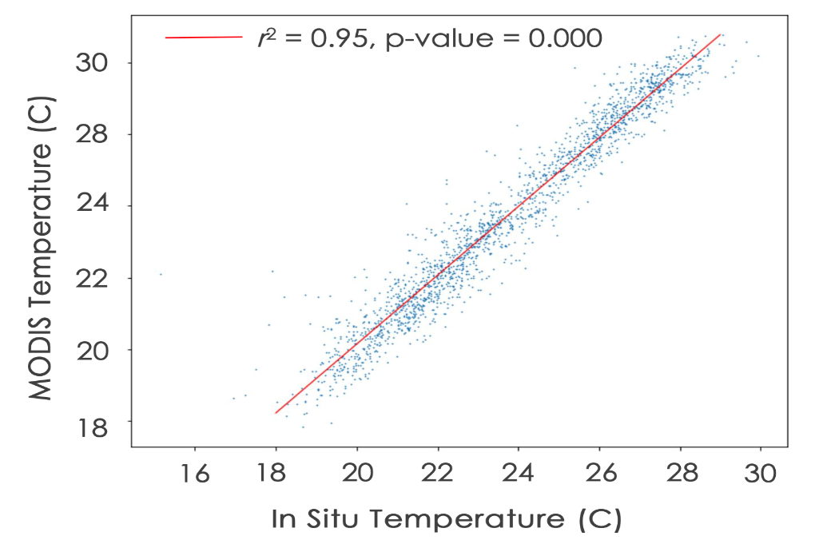

*Figure A.1* Linear regression graph comparing MODIS SST output from the CORALS tool and in situ SST data from subsurface temperature recorders located on site in Manawai.

# 

*Figure A.2* Scatterplot showing daily average SST data in Manawai from 2013-2019. In black are values from in situ subsurface temperature recorders with MODIS SST data overlayed in red.

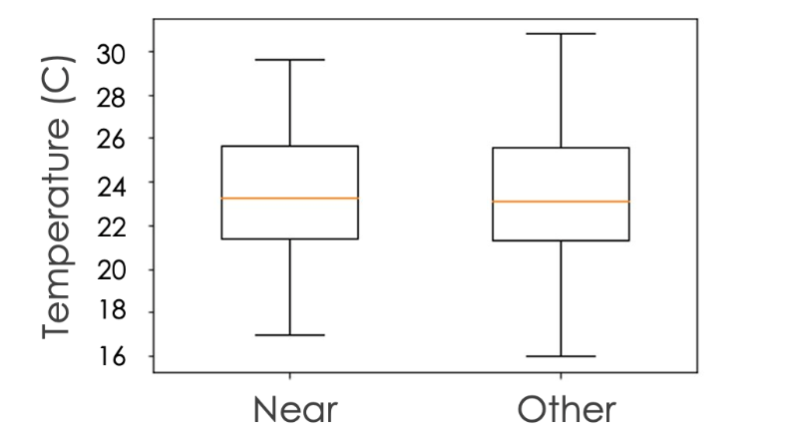

Figure A.3 Side by side boxplot summary of in situ SST values for sites near areas of known algal presence and areas without algal presence.

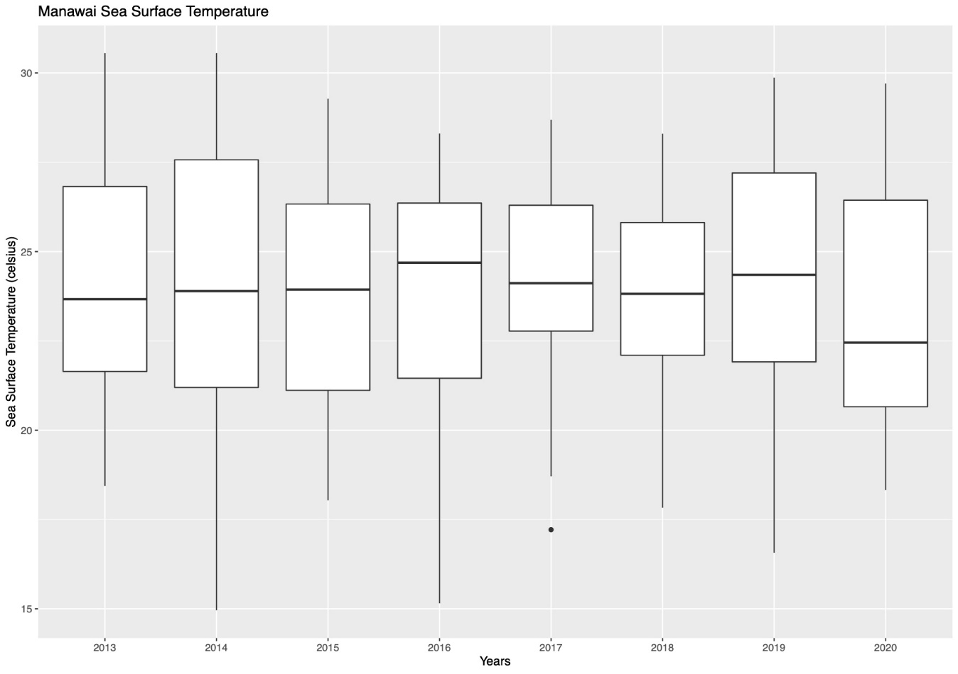

Figure A.4 Side by side boxplot summary of yearly sea surface temperature output values from the CORALS tool for Manawai

**Appendix B.**

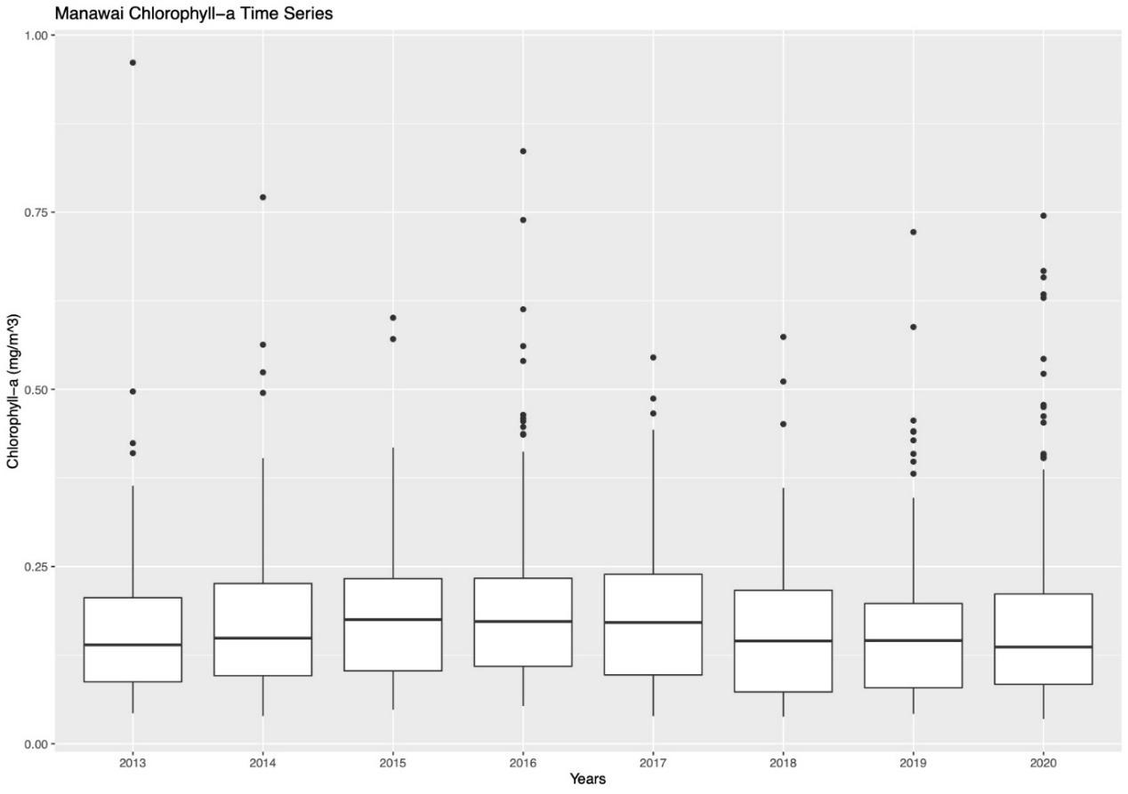

Figure B.1 Boxplot representation of Chlorophyll-a value output from CORALS tool with 20 kilometers buffer around the center of Manawai.

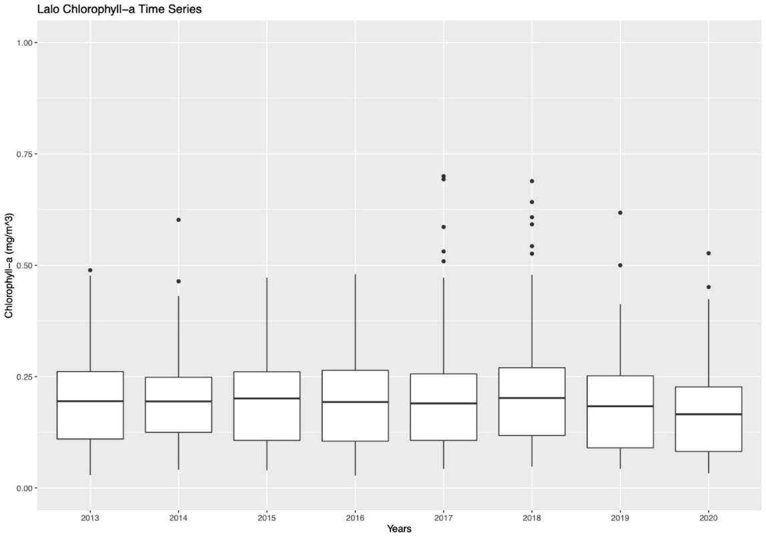

*Figure B.2* Boxplot representation of Chlorophyll-a value output from CORALS tool with 20 kilometers buffer around the center of Lalo, the control atoll with no discovery of *C. tumulosa*.

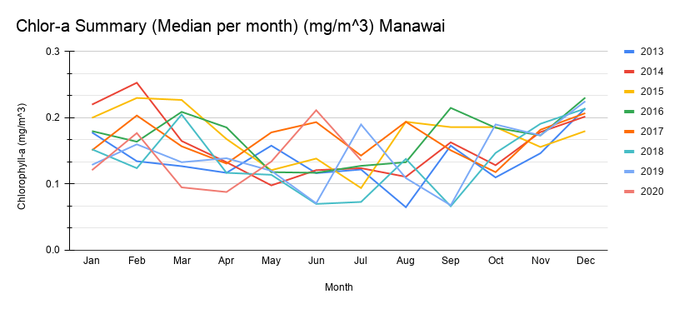

*Figure B.3* Summary of median chlorophyll-a for Manawai for every month shown in a line plot for the years 2013-2020.

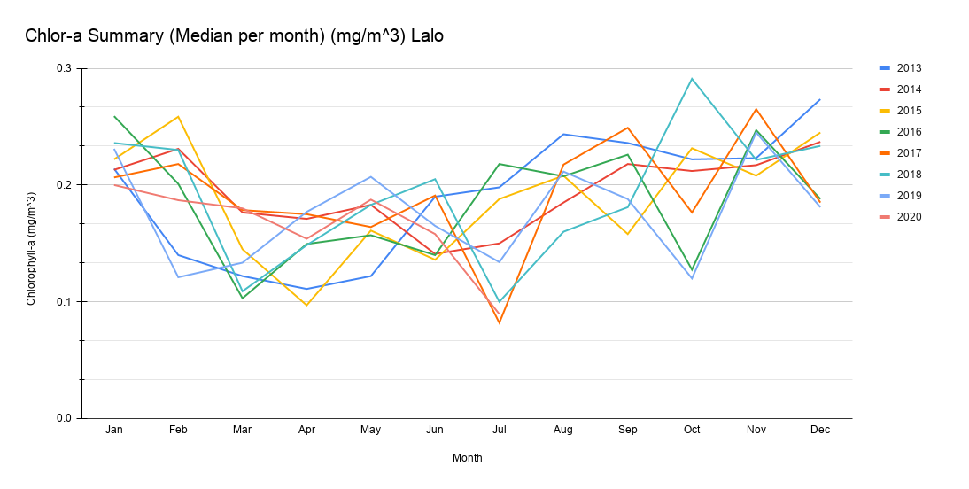

*Figure B.4* Summary of median chlorophyll-a for Lalo, the control atoll, for every month shown in a line plot for the years 2013-2020.

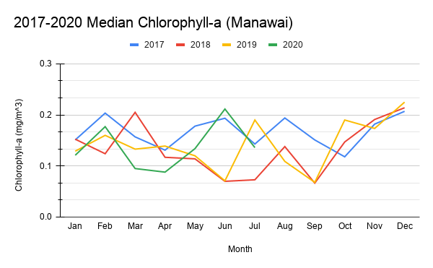

*Figure B.5* Line plot of Chlorophyll-a data from MODIS showing median values for every month for the years 2017-2020 showing seasonality patterns for Chlorophyll-a in Manawai.

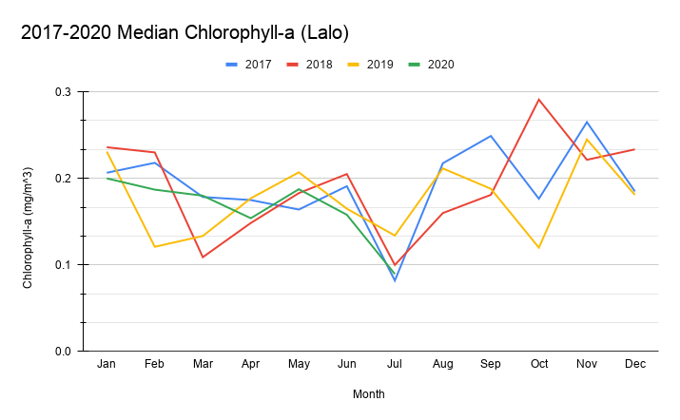

*Figure B.6* Line plot of Chlorophyll-a data from MODIS showing median values for every month for the years 2017-2020 showing seasonality patterns for Chlorophyll-a in Lalo, the control atoll.