**NASA DEVELOP National Program**

 NASA Goddard Space Flight Center

**Spring 2016**

**Short Title: Indonesia Agriculture**

**Subtitle:** Identifying Current Areas of Palm Oil Production and Modeling a Risk Map for Future Expansion in Central Kalimantan, Indonesia

**VPS Title:** Calamity in Kalimantan: Palm Oil Growth at the Expense of Diversity

**Project Team & Partners**

**Project Team:**

Kyle T. Peterson (Project Lead), kyle.t.peterson@nasa.gov

Michael Riedman

Abigail Childs

**Advisors & Mentors:**

Dr. Naikoa Aguilar - Amuchastegui (WWF)

Aakash Ahamed (USRA/GSFC)

**Partner Organizations:**

World Wildlife Fund (End-User), POC: David McLaughlin; Boundary Organization

**Project Details**

**Applied Sciences National Application Addressed:** Agriculture

**Study Area:** Central Kalimantan, Indonesia

**Study Period:** January 2000 - January 2016

**Earth Observations & Parameters:**

TRMM, TMI – precipitation measurements and totals

GPM, GMI – precipitation measurements and trends

Aqua, MODIS – land surface temperature

Terra, MODIS – land surface temperature

Landsat 8, OLI – land cover land use

SRTM, IFSAR – elevation and slope

**Ancillary Datasets Utilized:**

* DIVA GIS - administrative boundaries, rivers/streams, roads
* FAO - UNESCO — Digital Soil Maps of the World
* Global Forest Watch - forest conservation and degradation, primary forest, palm oil concessions
* RSPO & WRI - locations of sustainable palm oil mills
* Socioeconomic Data and Applications Center (SEDAC) - population
* UMD Global Forest Change - forest degradation and tree cover
* USGS National Land Cover Dataset (NLCD) - land cover
* WorldPop - spatial population distribution
* WWF - palm oil plantation locations

**Models Utilized:**

* AT&T Labs - Research, Maximum Entropy (MaxEnt)

**Software Utilized:**

ArcGIS - raster manipulation/analysis, image enhancement & map creation of Landsat 8 OLI, Aqua/Terra MODIS, & Global Forest Watch. Vector manipulation/analysis of WWF, FIRMS, DIVA GIS data

TerrSet - raster manipulation/analysis, running MaxEnt statistical model

Python - code to analyze data and automate tasks

ENVI/IDL - raster manipulation/analysis, image processing

R - statistical analysis of MaxEnt results

**Project Overview**

**80-100 Word Objectives Overview:**

Palm oil is the major economic export of Indonesia, and the government intends to substantially increase palm oil production in the coming years. Although this expansion in palm oil production stimulated the local economy, it came at an environmental cost. To protect the biological and ecological diversity of the rainforest, it is essential to map potential future palm oil plantation locations at the district level and encourage expansion in regions that will not cause rainforest degradation.

**Abstract:**

Indonesia is the world’s leading producer of palm oil. To keep pace with the continued worldwide expansion of palm oil demand, the government of Indonesia formulated an agricultural policy with the express purpose of doubling palm oil production by 2020. Unfortunately, palm oil plantation expansion came at the cost of natural rainforest and biodiversity loss in the Central Kalimantan region. Although the government imposed a moratorium on deforestation in 2011 and extended it to present, there has been insufficient enforcement and deforestation continues to be a pressing issue in the region. The purpose of this project was to work with the WWF to establish current natural forest areas and to identify current palm oil plantations, including those on protected lands. A second component of the project was to delineate future suitable locations for palm oil plantations that do not cause rainforest loss by creating a risk map of areas that are most vulnerable to deforestation. The suitability analysis of palm oil plantations relied on MaxEnt to model palm oil plantation locations. This model used known plantation locations, continuous data from remote sensing systems including Landsat and 8 OLI, TRMM, GPM, MODIS, Aqua/Terra along with ancillary data, to best predict other current and future locations of palm oil plantations. This analysis was overlaid by both a fuzzy weighted linear combination and a geographically weighted regression to compare different approaches. By mapping and predicting future locations, conservation groups can more effectively allocate their resources to prevent rainforest degradation.

**Community Concerns:**

* The production and harvesting of palm oil is widely recognized as a leading driver of deforestation in Indonesia, especially in Central Kalimantan.
* Deforestation caused by expanding palm oil plantations is encroaching on critical habitat of endangered species.
* Increased CO2 emissions from unsustainable agricultural expansion and burning of peatlands.

**Current Management Practices & Policies**:

Deforestation and conservation issues are some of the long term goals of WWF in Indonesia. WWF is currently working on projects that address palm oil plantation growth and deforestation by creating district level incentives to increase local governance and oversight of deforestation practices. Currently, WWF has been limited to country- and district-level analyses based on field work and case studies. Remote sensing and prediction modeling is not a major application behind WWF’s work on sustainable agriculture and forest conservation.

**Decision Support Tools & Benefits:**

|  |  |  |
| --- | --- | --- |
| **End-Product** | **Earth Observations Used** | **Benefit & Impact** |
| Map of current locations of palm oil plantations in Central Kalimantan, Indonesia | Landsat 8 OLI,  TRMM TMI, GPM GMI,  Terra/Aqua MODIS, SRTM IFSAR | Map confirms current locations (presently unconfirmed) and will help WWF target resources to the areas and plantations most at risk for expansion |
| Risk map of future palm oil plantation locations  in Central Kalimantan, Indonesia | Landsat 8 OLI,  TRMM TMI, GPM GMI,  Terra/Aqua MODIS, SRTM IFSAR | Model shows conserved forest areas most at risk for deforestation for palm plantations and will help WWF target areas for conservation |

**Project Imagery**

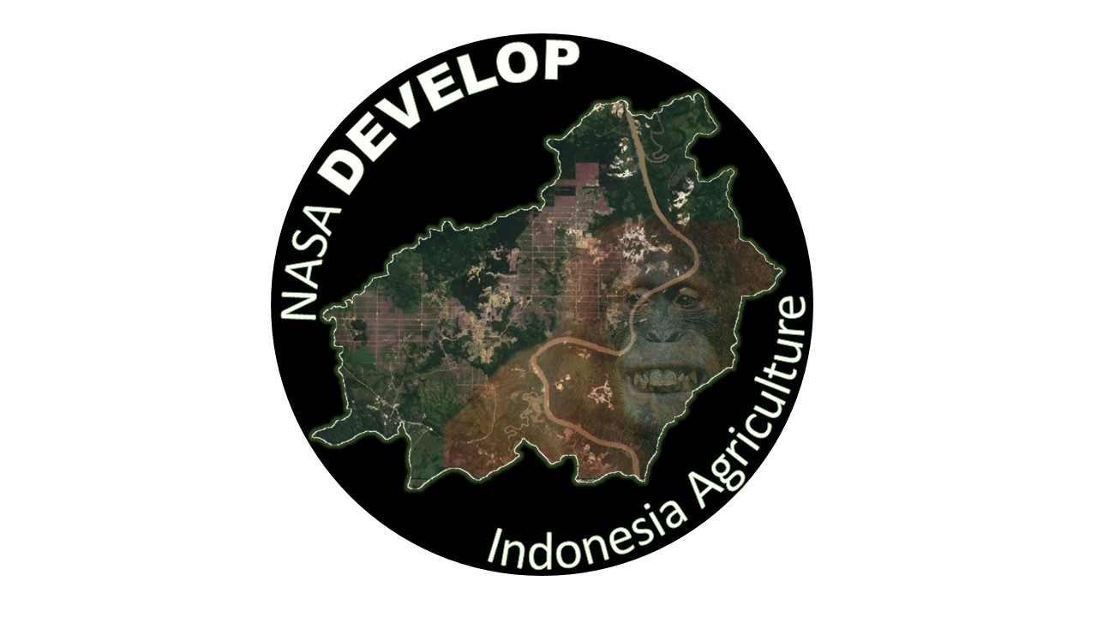

**Caption:** Study area of Central Kalimantan, Indonesia as seen from space.

Image Credit: Indonesia Agriculture Team.

**Image:** File Name: “2016Spring_GSFC_IndonesiaAg_VPS_Image.jpeg”

**Software Release Requirements**

Category III

**Software Title:** Palm Oil Plantation Modeler

**Software Abbreviation:** POPM

**Technical Point of Contact:** Kyle T. Peterson, kylepeterson777@gmail.com, SSAI, GSFC.

**Brief Description of the Software:** Utilizing the programming language, POPM software creates a simplified process of processing both raster and vector data so that it can be used within the Maxent modeling software.

**Type of Code:** Executable code

**Will the software include any embedded computer databases?** No

**Does the software use or call any open software or libraries?** Both open source and proprietary/commercial

**List the software or libraries used, under what license they were obtained, and the URL for the license in the table below:**

|  |  |  |
| --- | --- | --- |
| **Name** | **License** | **License URL** |
| ArcGIS (arcpy) | Group license through ArcGIS | <http://www.esri.com/software/arcgis> |
| Python | Open source license | <http://opensource.org/licenses/Python-2.0> |
| TerrSet | Single use license | <https://clarklabs.org/terrset/> |
| R | Open source license | <https://www.r-project.org/> |

**Full Software Description and Plan**

**Introduction/Objective:**

The process of manipulating remote sensing and vector data in order to use the Maxent modeling software has proven to be a quite complex and intensive process. By eliminating and/or automating many of these steps we can reduce the human error and streamline the process, in order to achieve more consistent, accurate input data. This tool can convert vector or raster data into the correct format and process all files in order to have identical rows, columns, resolution, and extent.

**Applications and Scope:**

This software will be utilized by the World Wildlife Fund (WWF), associated WWF projects, and partner organizations focused on sustainable palm oil plantation expansion, conservation, and reducing deforestation risk.

**Capabilities:**

This software allows non-technical users to quickly and accurately process both vector and raster data in order to use the Maxent modeling software.

**Interfaces:**

The software utilizes Python. Users will open the tool in Python (IDLE) or through the ArcGIS toolbox and execute the given script/tool.

**Assumptions, limitations, & Errors:**

The software developed was based on using Maxent through the TerrSet user interface and the raw Maxent modeling software.

**Testing:**

The software has been iteratively tested, compared, and validated to ensure accuracy when using Maxent.