**NASA DEVELOP National Program**

****NASA John C. Stennis Space Center

**Fall 2015**

**Short Title: Texas Disasters II**

**Subtitle:** Utilizing NASA Earth Observations to Assist the Texas Forest Service in Mapping and Analyzing Fuel Loads and Phenology in Texas Grasslands

**VPS Title:** Blazing Biomass: Forecasting Fires and Phenology in Texas Grasslands

**Project Team & Partners**

**Project Team:**

James Michael Brooke (Project Lead), jmichaelbrooke@gmail.com

Meredith Williams

Teresa Fenn

**Advisors & Mentors:**

Joseph Spruce (NASA John C. Stennis Space Center)

Dr. Kenton Ross (NASA Langley Research Center)

**Past or Other Contributors:**

Benjamin Beasley

Alex Holland

Kristen Kelehan

**Partner Organizations:**

Texas Forest Service (End-User), POC: Tom Spencer

Texas Forest Service (End-User), POC: Curt Stripling

USDA Forest Service ForWarn (Type), POC: William “Bill” Hargrove

**Project Details**

**Applied Sciences National Application Addressed:** Disasters

**Study Area:** TX

**Study Period:** January 2001 – November 2015

**Earth Observations & Parameters:**

Aqua and Terra, MODIS – spectral vegetation indices, phenology products

Landsat 5, TM, – spectral vegetation indices, land cover classifications

Landsat 8, OLI – spectral vegetation indices, land cover classifications

**Ancillary Datasets Utilized:**

* USGS National Land Cover Dataset (NLCD) - land cover
* US Forest Service ForWarn - phenology data, NDVI products
* PRISM - historical precipitation data

**Models Utilized:**

* TerrSet Geospatial Monitoring and Modeling Software

**Software Utilized:**

ERDAS IMAGINE - land classification of Landsat imagery and processing of MODIS data

ArcGIS - raster manipulation/analysis, image enhancement & map creation of Landsat OLI, Terra MODIS

TerrSet Geospatial Monitoring Software – modeling and map creation of vegetation type specific phenology

**Project Overview**

**80-100 Word Objectives Overview:**

Wildfire management has become more challenging due to factors such as climate change, expansion of urban areas, and the growing potential for more flammable vegetation. In response, this project focused on mapping vegetation type and specific vegetation phenology as it is related to potential wildfire fuel loads. This multi-term effort brought together the results from the Stennis Space Center (SSC) and the NASA Langley Research Center (LaRC) projects to provide products and capabilities for assessing wildfire risk in Texas.

**Abstract:**

The risk of severe wildfires in Texas has been related to weather phenomena such as climate change and recent urban expansion into wild land areas. During the MODIS era, Texas’ wild land areas are experienced sequences of wet and dry years that increased the wildfire risk and frequency. To prevent and contain wildfires, the Texas Forest Service (TFS) is tasked with evaluating and reducing potential fire risk to better manage and distribute resources. This task is made more difficult due to the vast and varied landscape of Texas. The TFS assesses fire risk by understanding vegetative fuel types and fuel loads. To better assist the TFS, NASA Earth observations, including Landsat and MODIS data, were analyzed to produce maps of vegetation type and specific vegetation phenology as it related to potential wildfire fuel loads. Fuel maps from 2010-2011 and 2014-2015 fire seasons created by Texas Disasters I project were used and provided alternating, complementary map indicators of wildfire risk in Texas. The TFS will utilize the end products and capabilities to evaluate and better understand wildfire risk across Texas.

**Community Concerns:**

* Texas’ vegetation, especially grasslands and shrub lands, are highly susceptible to seasonal wildfires during prolonged periods of severe drought.
* In recent years, the risk of severe wildfires has increased due to variable climate conditions and recent urban expansion into wilderness areas.
* Abnormally wet years can increase grassland vegetation biomass. If a dry year follows, this increased biomass will contribute to increased fuel loads leading to more frequent and intense fires.
* There is a need to develop fire risk assessment products from satellite data that can be produced and posted near real time.

**Current Management Practices & Policies**:

The Texas Forest Service currently relies on costly and time-consuming field surveys, aerial imagery, products from the LANDFIRE Program, and the National Predictive Services Unit of the National Interagency Fire Center to assess and estimate vegetation types and fuel loads in their effort to manage and allocate resources for wildfire management. LANDFIRE fuel type and fuel load data relies largely on modeling with remote sensing inputs derived from Landsat data and existing USGS datasets. Although these are useful tools, they have limitations based on the availability of recent data. Many of these products are created using the USGS National Land Cover Database which is only released every five years. Due to the fluctuations in weather and other disturbances these fuel loads can experience changes on much shorter timescales.

**Decision Support Tools & Benefits:**

|  |  |  |
| --- | --- | --- |
| **End-Product** | **Earth Observations Used** | **Benefit & Impact** |
| Fuel Type Map | Landsat 8 OLI, MODIS Landsat 5 TM | Deliver current location of potential wildfire fuel types |
| Fuel Load Map | Landsat 8 OLI, MODIS, Landsat 5 TM | Deliver current quality of wildfire fuel load |
| Seasonal Vegetation Phenology | Landsat 8 OLI, MODIS,  Landsat 5 TM | Deliver seasonal vegetation phenology to help predict potential wildfires |

**Project Imagery**

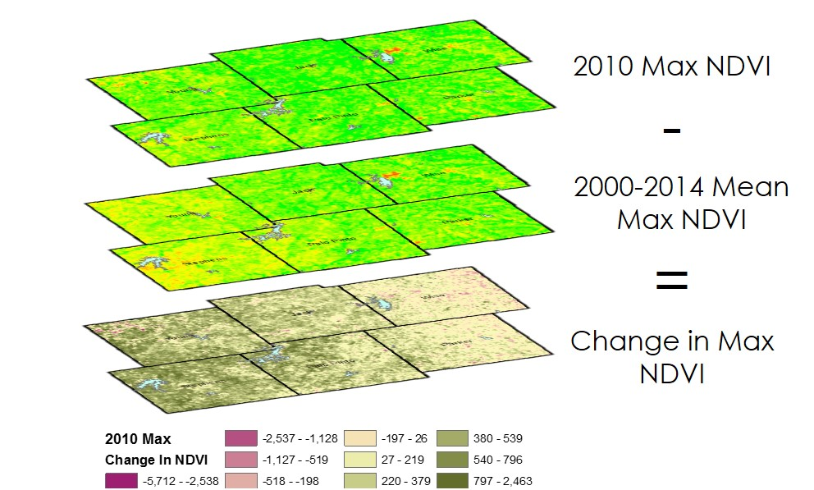

**Caption:** Yearly change from 2000-2014 mean NDVI parameters were calculated to help determine fire-sensitive phenoregions within the study area. Image Credit: Texas Disasters II Team.

**Image:** 2015Fall_SSC_TexasDisastersII_VPSImage.jpg

**Software Release Requirements**

Category I