**NASA DEVELOP National Program**



Wise County Clerk of Circuit Court’s Office

*Summer 2017*

Wyoming Cross-Cutting II

Detecting Changes in Nighttime Sky Brightness over

Grand Teton National Park with the Suomi NPP VIIRS Sensor

 **Technical Report**

Final Draft – August 10, 2017

Veronica Warda (Project Lead)

Ryan Avery

Steven Chao

Stanley Yu

Dr. L. DeWayne Cecil, NOAA National Centers for Environmental Information and Global Science & Technology, Inc. (Science Advisor)

Dr. Kenton Ross, NASA Langley Research Center (Science Advisor)

Bob VanGundy, The University of Virginia’s College at Wise (Science Advisor)

Previous Contributors:

Benjamin Marcovitz

Aubrey Hilte

Christine Stevens

Eric White

# 1. Abstract

As more outdoor lighting is installed for safety and development, light pollution has become a growing problem that threatens the quality of life for humans and wildlife. The onset of light pollution in cities and dark sky areas not only hinders humans from seeing the stars and the Milky Way but also has been linked to health disorders in humans and behavioral changes in flora and fauna. Grand Teton National Park is concerned about the scattering of light pollution and its associated impacts on visitor experience and the environment. Thus, in collaboration with the National Park Service and Wyoming Stargazing, the NASA DEVELOP Wyoming Cross-Cutting II team created the Skyglow Estimation Toolbox that utilizes data collected by the Suomi National Polar-orbiting Partnership Visible Infrared Imaging Radiometer Suite Day/Night Band. This software used images of the park and a 300 km square buffer collected by the sensor from the summer months (July, August, and September) of 2014, 2015, and 2016 to calculate the effect of light scattering. By processing the pixel values in this image through convolution, the Toolbox applies Cinzano (2001) and Garstang’s (1989) model of light propagation to create Artificial Skyglow Maps in Esri’s ArcGIS that measure skyglow at various viewing angles and lines of sight in the park, helping park officials determine current sky quality and identify sources of light pollution that are diminishing its quality. Moreover, the data produced by the Toolbox will help government officials make informed decisions regarding lighting ordinances in Teton County.

**Keywords**

Suomi NPP VIIRS Day/Night Band, light pollution, skyglow, artificial light, National Park Service, remote sensing, Grand Teton National Park

# 2. Introduction

* 1. ***Background Information***

By disrupting people’s circadian rhythms and their production of melatonin, nighttime artificial light alters human physiology and has been linked to obesity, depression, insomnia, cancer, and other health disorders (Chepesiuk, 2009, pp. A24-A27; Dominoni, 2016, pp. 1-2; Solano Lamphar & Kocifaj, 2013, p. 2). Likewise, artificial light disrupts the day/night cycles of local flora and fauna and has been shown to affect the timing of plant growth, the migratory behavior of birds, and the breeding cycles of various animals (Chepesiuk, 2009, pp. A22-A24; Gaston, Bennie, Davies, & Hopkins, 2013, p. 919; Longcore & Rich, 2004, p. 191; Solano Lamphar & Kocifaj, 2013, p. 1). A more detailed review of light pollution’s impacts on humans and wildlife can be found in Appendix A.

Officials such as Dan Greenblatt (2017) at Grand Teton National Park (GRTE) in Teton County, WY, are concerned with the negative impacts of artificial light at night on wildlife and tourism. Established in 1929, the park spans almost 310,000 acres (485 mi2) and consists of most of the Teton Range, an active fault-block mountain range, and a portion of the Jackson Hole mountain valley (National Park Service, n.d.; National Park Service [NPS], 2016b). The park’s location on this fault is responsible for its mountainous terrain and wide range in elevation, with Fish Creek being its lowest point at 6320 ft and Grand Teton Peak, its highest at 13,770 ft (National Geographic, 2015; NPS, 2016b). Over 300 species of birds, 17 species of carnivores, 6 species of amphibians, 7 species of coniferous trees, and 900 species of plants are found in the area (NPS, 2016b).

The study area (Figure 1) was expanded to include 300 km on each side of GRTE, ensuring that all relevant light sources are included when calculating raster maps of artificial light propagation (K. Ross, personal communication, March 3, 2017). This includes various urban areas, such as Idaho Falls, ID; Salt Lake City, UT; and Jackson, WY.

Previous methods of measuring sky brightness include using human visual indicators and various ground-based photometric measurements (Cinzano, Falchi, Elvidge., 2001, p. 689; Duriscoe, 2016, p. 2; National Park Service, 2016a). These *in situ* measurements are limited in timespan and coverage and are not conducive to constructing regional or global maps of skyglow (Cinzano et al., 2001, p. 689; Duriscoe, 2016, p. 2). Furthermore, acquiring these measurements can cost the park service weeks of time, and when collecting these measurements on the ground, they are often limited by weather, funding, and staff availability (S. Anderson, personal communication, June 28, 2017). Efforts to create a global quantitative measurement of the night sky began with Cinzano et al. (2000), who calculated zenith brightness at various points around the globe using the US Air Force Defense Meteorological Satellite Program Operational Linescan System (OLS). This atlas was replaced in 2016 by *The New World Atlas of Artificial Night Sky Brightness* (*NWA*) that used data from the Suomi National Polar-orbiting Partnership (NPP) Visible Infrared Imaging Radiometer Suite (VIIRS) Day/Night Band (DNB), which provides a better resolution and dynamic range compared to DMSP-OLS (Falchi et al., 2016, p. 9). This study builds upon this past research by developing an open-source model that maps skyglow at the regional scale, while allowing users to generate outputs for varying viewpoints of the night skies other than 0 degrees zenith.

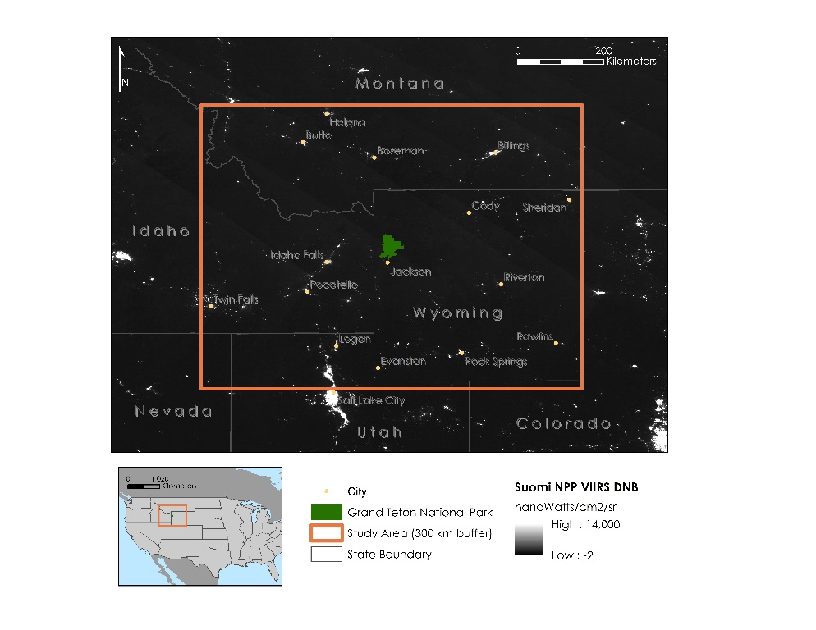

*Figure 1.* Study area encompassing the states of Colorado, Idaho, Nevada, Montana, Utah, and Wyoming.

* 1. ***Project Partners & Objectives***

Grand Teton National Park located in the National Park Service (NPS) Intermountain Region, receives around 3 million visitors each year and strives to preserve its natural and cultural qualities which include the pristine night sky (Greenblatt, 2017; National Park Service, 2017a). The Natural Sounds and Night Skies Division of the NPS is dedicated to preserving the night sky in the National Parks around the country and worked with the Wyoming Cross-Cutting II team to investigate the quality of the night sky (NPS, 2016a). Additionally, Wyoming Stargazing, a 501(c)(3) nonprofit organization based in Jackson, WY, is currently working to preserve the night sky by educating the public and petitioning for lighting ordinances to be put in place in the area (Wyoming Stargazing, 2017). To help resolve GRTE’s light pollution issue, our objectives were to expand on the work done by Falchi et al. (2016); Cinzano, Falchi, and Elvidge (2001); and Garstang (1989) by using Suomi NPP VIIRS DNB data to develop the Skyglow Estimation Toolbox, which can produce artificial skyglow maps representing different viewing angles at each DNB pixel. These goals cover several NASA National Application Areas, including Energy and Health and Air Quality. With these tools, the partner organizations will be able to precisely monitor the study area’s night sky quality, identify sources of light pollution, and make informed decisions to mitigate light pollution from its sources.

# 3. Methodology

***3.1 Data Acquisition***

Before averaging, National Oceanic and Atmospheric Administration’s (NOAA) Earth Observation Group (EOG) excludes scenes impacted by stray light, lunar illumination, and cloud cover, and the effects of ephemeral light sources like wildfires are filtered out (EOG, 2017). The images cover latitudes from 75N to 65S and are split into 6 tiles, each separated at the equator and spanning 120 degrees of longitude (EOG, 2017). Each tile contains two files, a floating point radiance value GeoTIFF with units of nWcm-2sr-1 (Figure 2) and a GeoTIFF file that contains integer counts of the number of observations that construct the average radiance image (EOG, 2017).

There are, however, two temporal restrictions on the dataset used. First, reflected light from snow cover increases sky brightness 1.3- to 2.6-fold when partially present on lit roads due to snow’s high albedo (Falchi, 2011, p. 48; Falchi et al., 2016, p. 6). Since snow cover is common for much of the year in our study area only summer months, July, August, and September, were used. These months are later in the year because the high elevation and latitude of GRTE ensures snow cover persists into the traditional North American Summer. Second, no stray light corrected data is available before 2014 (EOG, 2017). As a result, a multi-annual composite of a total nine months is utilized in the dataset: July, August, and September from 2014 through 2016.

The boundaries for GRTE were gathered from the National Park Service Data Store. This geospatial dataset (Code: 2225713) was published by the National Park Service and has been updated as of June 30, 2017 (National Park Service [NPS], 2017b). The data is intended as a tool to display NPS boundaries with each type of unit receiving a separate polygon based on Land Resources Division definitions (NPS, 2017b). The previous version used in this project was produced in October 2017 (NPS, 2017b).

***3.2 Data Processing***

The GRTE boundaries were selected from the shapefile of Administrative Boundaries of National Park System Units. After the GRTE polygon was selected the data was exported into a new shapefile. The extent of the study area for this project was determined by creating a 300 km buffer around the boundaries of GRTE using the buffer tool in ESRI’s ArcMap 10.4. The 300 km buffer around the study area was determined as a more conservative estimate of the range of relevant light sources, after the *NWA* used a 195 km buffer around each pixel to include all possible light sources (Falchi et al., 2016, p. 10). The study area was extended another 105 km to provide a region of accurate skyglow outside of the park boundaries as well as inside of them (K. Ross, personal communication, March 3, 2017). The buffer around GRTE was reshaped by the Minimum Bounding Geometry tool in ArcMap 10.4. The geometry type selected was rectangle by width. The selected Suomi NPP VIIRS DNB images were clipped using the Extract by Mask tool in ArcMap 10.4 to the minimum bounding rectangle that encompasses both GRTE and a 300 km buffer around the study area that extends from each side of the park. The median of the VIIRS multi-annual composite (detailed in section 3.1) was calculated using the Cell Statistics tool in ESRI’s ArcMap 10.4. All the clipped VIIRS tiles for the study period were input into the tool and the statistic selected was median. A mean image was also created following the same steps with the mean statistic selected.

***3.3 Skyglow Estimation Toolbox Production***

The main objective of this project was to develop a Python program called the Skyglow Estimation Toolbox (SET) that produces artificial skyglow maps from a set of inputs: a Suomi NPP VIIRS DNB image, a zenith angle, an azimuth angle, an atmospheric clarity parameter, and a central latitude of the study region. These user-defined parameters allow for a robust model since the zenith and azimuth angle enable end-users to examine sky quality in various directions and the central latitude accounts for the fact that light scatters differently depending on latitude. Although the DNB data provide precise measurements of nocturnal visible and near-infrared light emissions as viewed from nadir, the recorded measurements do not represent how an observer actually perceives the night sky on the ground. SET incorporates the geometry (seen in Figure 2) and physics of artificial light propagation that have been developed by Cinzano et al. (2000), Falchi et al. (2016), and Garstang (1989) to convert upward radiance measurements from Suomi NPP VIIRS into brightness values as observed from Earth.

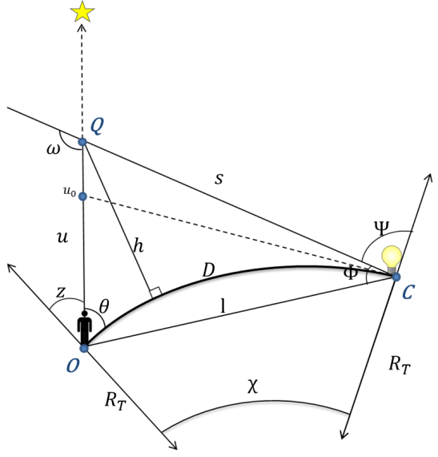

*Figure 2.* Geometric relationships; adapted from Cinzano et al. (2001) and Garstang (1989).

In the previous term, the team created an alpha version of the SET Python program. The alpha program established a target location and calculated the brightness of all light sources within approximately 300 km at set viewing angle of 0 degrees zenith (toward nadir) and 0 degrees azimuth (facing north). To accomplish this, a kernel of numerical coefficients representing weights of light propagation from source to site was created using the geometrical relations and emission functions of light scattering in the atmosphere (Cinzano et al., 2000; Cinzano et al., 2001; Falchi et al., 2016; Garstang, 1989). The alpha program then summed the total contribution of light scattering from all source pixels and calculates the total amount of light propagation at a given pixel and convolves the original VIIRS image using the kernel. Appendix B provides more information about the physics and geometry that went into the design of the code.

The current project focused on improving the light propagation model and creating a graphical user interface for SET, and georeferencing SET’s output. The beta program still uses the same procedure as the alpha program but with numerous corrections for both validation and accuracy. SET’s light propagation model begins by creating a kernel of numerical coefficients that represent the weight of light scattering on the line of sight of the observer. This requires defining three primary sets of equations: the geometrical relationships between the observer, light source, and scattering point, the effect of light propagation as it travels through the atmosphere, and the method of quantifying how light is emitted from the source. For more information on the model’s methodology, refer to Appendix B or SET’s documentation on Github.

To create the kernel, SET starts by defining relevant geometric relations given the regional latitude, zenith angle, and azimuth angle from the user. The model assumes the observer is standing at sea level and view the light on an ellipsoidal surface. Since the model is dealing with numerous light sources, each requiring a different set of geometric quantities to describe its location, the program creates several intermediate arrays, each one containing the value for a different variable. For instance, an array of β angles is created that represent the azimuth angles from the direction of each light source to the direction of the scattering point relative to the observer’s line of sight. All intermediate arrays are of the same dimension, and the elements corresponding to the same index value (i.e. row 3, column 9) describe the geometric set of variables for a potential light source.

With a quantified geometrical representation of the model, the program begins calculating the effects of light propagation in the atmosphere. For each set of corresponding elements in the arrays, atmospheric quantities such as the molecular density at sea level and inverse scale altitude of aerosols are assumed to be constant values; one exception is the atmospheric clarity parameter, which measures the ratio of aerosol scattering to gas molecule scattering and is defined by the user. The model then introduces variables relating to the scattering point between the observer and a point in the night sky, such as the distance from source to scattering point, *s*. Using these distances and the atmospheric parameters, the program computes the effect of extinction, the natural dimming of light as it travels through the atmosphere, and applies it to the total contribution of light propagation.

In the final step of creating the kernel, the model must compute how light is emitted from its source. This process is based heavily on statistical measurements conducted by Falchi et al. (2016) to normalize the calculation of light emission. By weighting light from different emission angles, a predicted total emission can be calculated and processed with scattering functions, producing the final weight of light propagation for each source. After the kernel is produced, it can be applied to any composite image of the Suomi NPP VIIRS DNB data through convolution, a method in which the kernel is applied as a filter that interprets each pixel in the Suomi NPP VIIRS image from left to right and from top to bottom. To improve the efficiency of the light propagation calculations, a Fourier transform was used instead of convolution to convert the input DNB image and the kernel into frequency space. Because the inverse Fourier transform of the product of two transformed images is equivalent to the convolution of two images, using the Fourier transform to complete this calculation expedited the calculation of the final product: the total amount of skyglow over our study region.

Lastly, to estimate the amount of skyglow that is artificial, Duriscoe’s (2013) model was used to estimate natural sky brightness in GRTE during the summer months of 2014, 2015, and 2016. This estimate was used to calculate the ratio of total skyglow to natural sky brightness, which computes a measure of artificial sky brightness similar to that in Falchi et al. (2016). When the SET is run over a VIIRS DNB composite and the user inputs the necessary parameters, the product will be an image visualizing this ratio representing artificial light pollution, dependent on the zenith, azimuth, and central latitude of the study region.

***3.3 Data Analysis***

In order to validate the math in SET, we conducted four tests of our model against the *NWA* model. First, we compared the Summer Median Artificial Skyglow Map to the *NWA* map by using the Raster Calculator Tool in ESRI’s ArcMap 10.4 to divide the Summer Median Skyglow Map by the *NWA* map. This gave us the ratio of our model to the *NWA* model in order to help us understand how closely the two models resemble each other. Second, we compared the Mean Artificial Skyglow Map, produced through SET using the same months as the *NWA*, to the *NWA* model. Similar to the first test, we used the Raster Calculator Tool to determine the ratio between the two models. Third, we tested the median months of the *NWA* against the *NWA* model to see if the way the data was compiled would affect the results. Lastly, we compared the Summer Mean Artificial Skyglow Map to the *NWA* to see if the same results would be gathered when comparing mean and median inputs for the two study time frames.

In addition, we compared our maps values to the *in situ* data collected by our partners. We extracted the SQM values, originally in min/arcsec², at each measurement location and converted them to μcd/m² values using the Unihedron Sky Quality Meter Conversion Tool (“Convert Visual,” 2015). Next, we subtracted the natural sky brightness values (174 μcd/m² as defined in *NWA*) from the converted SQM measurements. The Excel file containing the SQM values and GPS coordinates of each measurement was then added as a layer in ArcMap 10.4 and converted into a shapefile. After adding the *NWA* map and our Median Artificial Skyglow Map from summers of 2014, 2015, and 2016, we used the Extract Value to Table tool in ArcMap to derive each pixel skyglow value on the Artificial Skyglow Map corresponding with points from the SQM shapefile. The difference between the *in situ* value and the extracted skyglow value was calculated in Microsoft Excel. We added all the differences and divided the sum by the number of *in situ* locations to calculate the average discrepancy, then removed outliers and repeated the process. These steps were also repeated to calculate the average discrepancy between the *in situ* values and the *NWA*.

# 4. Results & Discussion

***4.1 Analysis of Results***

Figure 3 is a median map of the summer months in our study period. This image depicts the ratio of artificial sky brightness at zenith to natural sky brightness during the study period defined for this project, with cooler colors indicating smaller ratios and darker skies. The median of the months was taken and used as the input image for SET. The map suggests that there is significant light pollution coming from cities such as Salt Lake City, Idaho Falls, Pocatello, and Billings. Jackson and the villages in GRTE are also visible; however, they are much darker than the major cities in the study area. We used the median value rather than the mean in order to dampen the effects of outliers on the overall image. In this case, outliers can be significantly dark values due to the Suomi NPP VIIRS sensor’s inability to measure accurately very dark values, or, they can be unusually bright values from temporary light sources such as wildfires and gas flares.

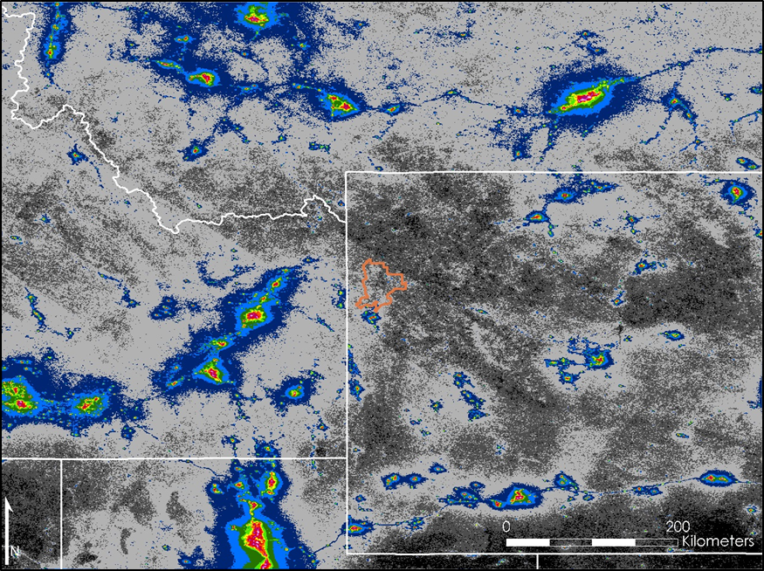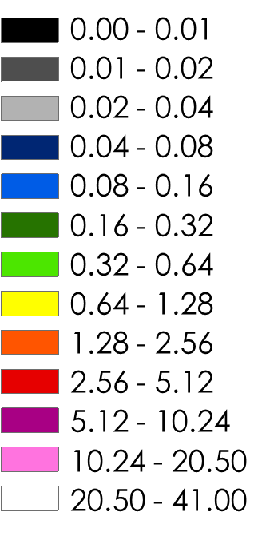

*Figure 3.* Median Artificial Skyglow Map, using study period as defined in this paper, for Grand Teton National Park.

It was important that we tested SET using the exact parameters used in the *NWA* in order to validate the math in our model. Therefore, we created a mean composite VIIRS image using data from six months in 2014, as used by Falchi et al. (2016), and inputted the image into SET (p. 10). The resulting map (Figure 4) is the ratio of artificial sky brightness produced by SET to the natural sky brightness, estimated to be about 174 μcd/m², with cooler colors indicating lower ratios.

The map in Figure 4 was then divided by the *NWA* modelto see how close our model recreates those results, shown in Figure 5. The results indicated that this recreation was not as close as the previous model and the map we produced was overall much brighter than we expect to see. Despite this, the model clearly shows the uninhabited Wind River Mountain Range (located in the center of map slightly southeast of GRTE) as having a low ratio and the densely populated Salt Lake City (southwest of GRTE) has having a high ratio.

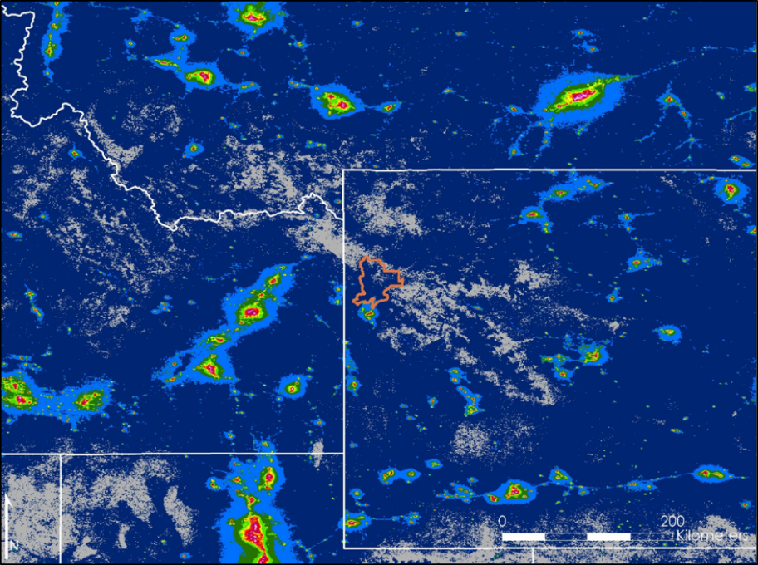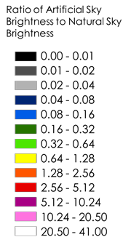

*Figure 4.* Mean Artificial Skyglow Map, using study period from the *New World Atlas*, for Grand Teton National Park.

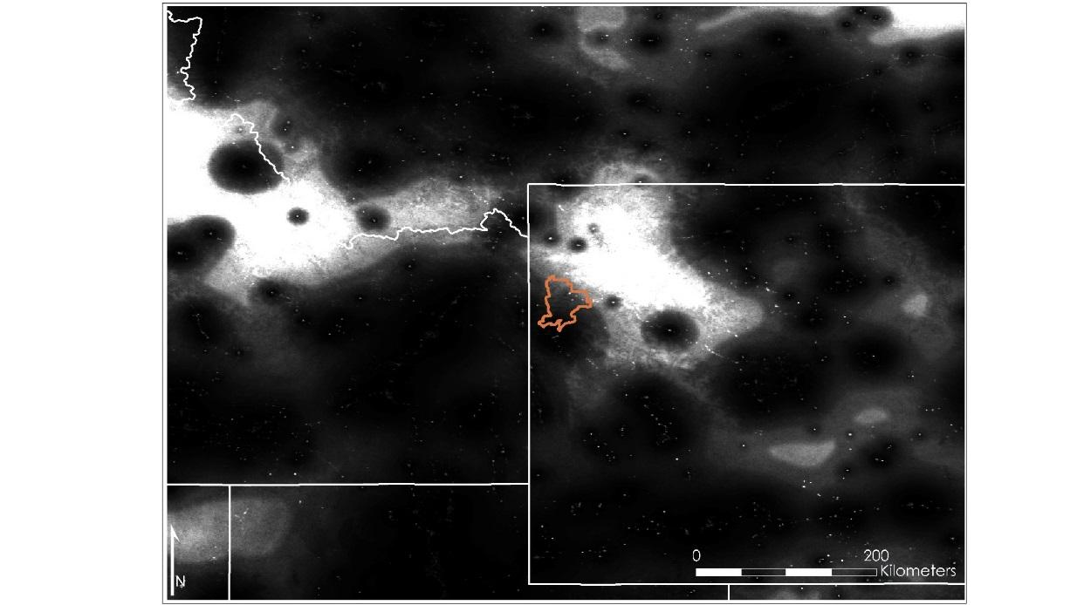

*Figure 5.* Comparison between Figure 4 and *New World Atlas* model.

Figure 6 depicts the ratio of artificial sky brightness at zenith to natural sky brightness using the mean of the summer months of 2014, 2015, and 2016. Similar to the previous maps, there are dark colors in more rural areas and bright colors in urban areas. Because we use the average values, however, the influence of outliers is greater than that on the median. Consequently, the high values are higher and the low values are lower, explaining why there is a greater color range than the median radiance map (Figure 4).

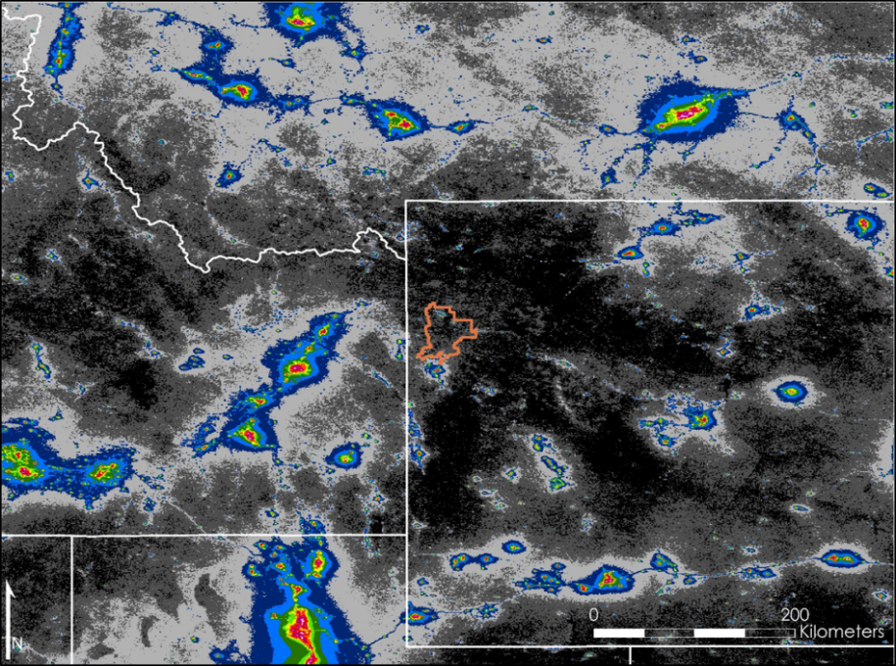

*Figure 6.* Mean Artificial Skyglow Map, using study period as defined in this study, of Grand Teton National Park.

Figure 7 suggests that this mean skyglow map (Figure 6) is quite similar to the *New World Atlas* model, which could be because the SET model is using more months than the *New World Atlas* to account for the *New World Atlas’* spatial filtering.

*Figure 7.* Comparison between Figure 5 and *New World Atlas* model.

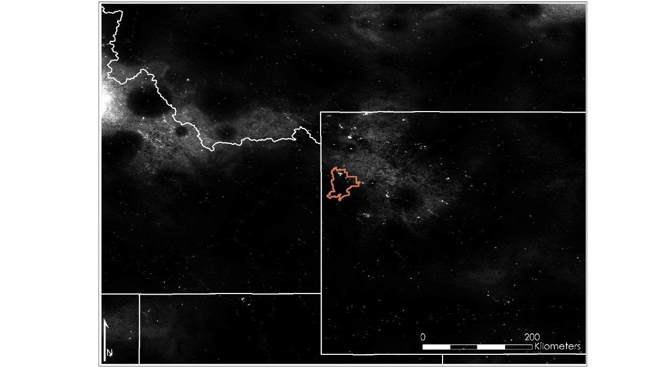

The same analysis was conducted on the median months used in the *NWA* with results indicating that the median was darker than the mean image. No pattern was discernable between the two study periods and how the data was compiled. This lead the team to test each month to see if there was a particular timeframe that was causing this discrepancy between skyglow maps. The results of this test showed that June and July 2014 were anomalously bright.

The team then looked into comparing the skyglow values predicted by the model to *in stiu* data collected by the partners. The results of this analysis can be seen in Appendix C. The Skyglow Map of the median of the summer months was on average 70 μcd/m² brighter than the *in situ* data. This means that the model our team created is predicting brighter skyglow values than seen in real life.

***4.1.5 Limitations***

There are two factors for which these produced images could not account. First, because the Suomi NPP VIIRS DNB sensor is not sensitive to wavelengths shorter than 500 nm, it under-reports the amount of light coming from blue-light emission sources, which are 2.5 times more polluting than traditional light sources (Falchi et al., 2016, pp. 7-9; Liang, Mills, Hauss, & Miller, 2014, p. 6964). Since the ratio of blue light to light from the warmer end of the spectrum varies spatially as each community makes different choices about lighting practices, *in situ* data would need to be conducted around the world, and an *in situ* measurement conducted at a certain location could only be applied for that location; there is currently no such comprehensive study. Consequently, although the sensor can detect the red and green wavelengths emitted by blue-light emission sources, the amount of blue light undetected in our study area is not known.

Second, similar to Falchi et al. (2016), the shielding impacts of topography on light pollution were not incorporated into the SET and the Artificial Sky Glow Map (p. 10). Although the math that accounts for this phenomena is available, incorporating those complex calculations into SET would require a substantial increase of computational power than currently available to our team (one Intel i5 PC, which is the current platform for SET) (K. Ross, personal communication, July 28, 2017). While Falchi et al (2016) determined that this effect on light pollution is generally minimal, GRTE’s mountainous terrain could potentially create a screening effect (p. 10). Despite these limitations, the Artificial Skyglow Map provides a robust baseline that project partners can use in the future as more data is collected from the Suomi NPP VIIRS DNB.

***4.2 Future Work***

Future work on measuring light pollution may enhance the current research in multiple ways. Since the Artificial Skyglow Map is a model of light propagation, *in situ* measurements can be used to validate the model and ensure the accuracy within the study area. In addition, should additional computation power become available, SET can be altered to incorporate the effects of topographic shielding on skyglow, which would greatly increase the accuracy of the model for mountainous regions like GRTE. The code can also be adapted to apply a correction factor for the blue light that the VIIRS sensor cannot detect. Another way to improve the current work is to format the model to automatically download composite images as they are released from the NOAA NCEI EOG and immediately update the Artificial Sky Glow Maps. Lastly, future work could focus on creating more Artificial Skyglow Maps to analyze long-term lighting trends in GRTE and in other regions.

This project will continue into the fall 2017 term. Similar to the summer 2017 project, the proposed project will detect nighttime changes in sky brightness by using SET to produce an Artificial Skyglow Map; however, the study area will be shifted to the Colorado Plateau, which incorporates various large cities and state and national parks such as Grand Canyon National Park. A comprehensive study of skyglow in this region would allow cities and parks to understand the current state of the night sky in their area. As with the data collected in the GRTE, *in situ* measurements will also be needed to verify SET’s predicted values.

# 5. Conclusions

With SET nearing the beta stage, the Wyoming Cross-Cutting II team has been able to produce a tool that will be useful for the project partners and potentially other end-users. The NPS and Wyoming Stargazing currently use ground-based light meters and cameras to study sky quality; however, they are limited by the amount of available equipment and funding, making it difficult to send researchers out periodically to track changes in the night sky. The team’s SET software is able to address this limitation by taking imagery from the Suomi NPP VIIRS DNB sensor, modeling light pollution, and producing Artificial Skyglow Maps that show the patterns of light pollution and propagation at various viewing angles. While additional work and validation is needed to make the model more robust, precise, and accurate, both the Median and Mean Artificial Skyglow Maps produced by SET closely resemble the *NWA*, although the Mean Artificial Skyglow Map is a slightly better representation than the Median. As such, SET offers broader, more dynamic capabilities and applications than handheld light meters, allowing partners to expand the geographic scope of current measurement practices, study sky quality from their office, and update their maps as more VIIRS imagery is released. In short, SET would give communities and parks the power to determine the impact of outdoor artificial lighting on their night skies and to use this data to further enhance their decision-making process in regards to lighting ordinances.

# 6. Acknowledgments

The Wyoming Cross-Cutting II team is grateful for the guidance and assistance received throughout the term from the science advisors and those at the Wise County Clerk of Circuit Court’s Office: Dr. Kenton Ross, Lead Science Advisor for NASA DEVELOP National Program; Dr. L. DeWayne Cecil, Chief Climatologist at NOAA National Centers for Environmental Information and Program Manager of Global Science & Technology, Inc.; Bob VanGundy, Geology Professor at The University of Virginia’s College at Wise; Michael Brooke, Former Center Lead at NASA DEVELOP Wise County Clerk of Circuit Court’s Office; and Christine Stevens, Acting Center Lead and Assistant Center Lead at NASA DEVELOP Wise County Clerk of Circuit Court’s Office.

Additionally, the team appreciates the cooperation, enthusiasm, and assistance of the Wyoming Cross-Cutting II partners, who made this project possible: Dan Greenblatt, Colter Bay District Interpretive Ranger at Grand Teton National Park; Randy Stanley, National Park Service Intermountain Region Natural Sounds and Night Skies Coordinator; Sharolyn Anderson, PhD, Research Scientist of the National Park Service Natural Sounds and Night Skies Division; Li-Wei Hung, PhD, Research Scientist of the National Park Service Natural Sounds and Night Skies Division; and Samuel Singer, PhD, Executive Director of Wyoming Stargazing.

*Any opinions, findings, and conclusions or recommendations expressed in this material are those of the author(s) and do not necessarily reflect the views of the National Aeronautics and Space Administration. This material is based upon work supported by NASA through contract NNL16AA05C and cooperative agreement NNX14AB60A.*

# 7. Glossary

**Albedo** – The proportion of light or radiation that reflected off a surface

**Azimuth** – The angular distance between the direction of a celestial object from the observer and the north or south point of the horizon

**Buffer** – A zone that separates the area of interest from the surroundings; in this case, it separates GRTE from the rest of the Intermountain Region

**Circadian rhythm** – A process of the physiology of living organisms that regulates sleep patterns in a 24 hour cycle

**Convolution** – A mathematical operation essential for many image processing operators that takes two functions and demonstrates how one modifies the other

**Dark sky certification** – An official designation by the International Dark-Sky Association for places with good outdoor lighting policies, practices, and education

**Day/Night Band (DNB)** – A 750-meter resolution VIIRS product that obtains total radiance with wavelengths from 500 nm to 900 nm, which includes parts of the visible and infrared spectra

**Earth Observation Group (EOG)** – A part of NCEI that specializes in nighttime observations of lights and combustion sources worldwide

**Ephemeral Light** – Light caused by temporary events such as fires, lightning, and gas flares

**Floating point** – A type of number that can represent real numbers as an approximation, refers to the number’s decimal point being able to “float” anywhere relative to the significant digits of the number

**Four Corners** – A U.S. region that where four different states meet at the southwestern corner of Colorado, southeastern corner of Utah, northeastern corner of Arizona, and northwestern corner of New Mexico

**Fourier transform** – A tool for processing images that decomposes a function into a series of sinusoidal basis functions; the output represents the image of the frequency domain while the input image is the spatial domain equivalent

**GeoTIFF** – A standard which allows georeferencing information to be implemented within a TIFF file

**Georeference** – A process that assigns the location of an object in a physical space

**GRTE** – Grand Teton National Park, a U.S. national park in northwestern Wyoming containing the Teton Range and the northern sections of Jackson Hole, also known as “GTNP” (informal name used with park visitors) and “Grand Teton”

**Graphical user interface (GUI)** – A visual program consisting of windows and icons that allows users to easily interact with the computer

***In situ*** – A Latin phrase meaning “on site” or “in position”; refers to a measurement that is taken in the same place the observation is occurring

**Kernel** – A small matrix used to generate an output array by sliding the kernel through all the positions within the boundary of the image, multiplying each kernel value and its underlying input value, and adding the results together; this process is called convolution (see *Convolution*)

**Light pollution** – Undesirable effects on natural lighting levels from artificial sources of light

**Light propagation** – The movement of light through the atmosphere

**Lunar illumination** – Light from the moon that brightens the surface of the Earth

**Melatonin** – A hormone produced by the pineal gland that regulates sleep and wakefulness

**Nadir** – The point on the celestial sphere directly below an observer’s position

**National Oceanic and Atmospheric Administration (NOAA)** – An agency under the U.S. Department of Commerce that focuses on climate monitoring, ocean research, and atmospheric science

**National Park Service (NPS)** – A U.S. federal agency established in 1916 to care for national parks among other ecological and historical properties

**New World Atlas (NWA)** – *The New World Atlas of Artificial Night Sky Brightness* by Falchi et al. (2016), a pioneering research article on artificial skyglow and light pollution

**Photometric** – Measurements of light based on the human eye’s sensitivity to brightness

**Pixel** – The smallest unit of an image that corresponds to a value and whose combination forms an image

**Productive light** – Light illuminates the intended surface to the extent needed

**Radiance** – The flux of light or heat radiation measurable by remote sensing instruments

**Sky brightness** – The light intensity of the sky seen on Earth

**Skyglow** – Brightness of the night sky built up from natural or artificial sources resulting from light pollution

**Spatial filter** – An image operation that modifies each pixel value based on the intensities of the pixels in its neighborhood

**Star ceiling** – Depictions created by the Navajo that serve as restorative cultural icons

**Steradian (sr)** – SI unit of solid angle, also known as square radian

**Stray light** – Light not belonging to the desired bandwidth

**Sun-synchronous orbit** – A Near polar orbit around Earth in which the satellite passes over any given point of the planet’s surface at the same local solar time

**Suomi National Polar-orbiting Partnership (NPP)** – A NASA joint-mission weather satellite launched in 2011 that acquires land, ocean, and atmospheric data

**Topographic shielding** – The effect of topography, such as a mountain range, blocking light from scattering from a source to a site

**Unshielded fixture** – A light fixture that does not have an opaque material blocking the transmission of light to areas outside of the intended surface

**US Air Force Defense Meteorological Satellite Program (DMSP) Operational Linescan System (OLS)** – A U.S. Department of Defense satellite program that obtains global visible and infrared data

**Visible Infrared Imaging Radiometer Suite (VIIRS)** – A scanning radiometer on the Suomi NPP satellite that collects visible and infrared imagery and measurements on the land, oceans, and atmosphere

**Wavelength** – The distance that it takes for the wave to repeat itself; the visible spectrum runs from 390 nm (violet) to 700 nm (red)

**Zenith** – The point on the celestial sphere directly above an observer’s position

# 8. References

Anderson, S. (2017, July 19). NASA DEVELOP National Program Virtual Poster Session Interview [Personal interview].

Blask, D. E., Brainard, G. C., Dauchy, R. T., Hanifin, J. P., Davidson, L. K., Krause, J. A., … Zalatan, F. (2005). Melatonin-Depleted Blood from Premenopausal Women Exposed to Light at Night Stimulates Growth of Human Breast Cancer Xenografts in Nude Rats. *Cancer Research*, 65(23), 11174-11184. doi:10.1158/0008-5472.CAN-05-1945

Brons, J., Bullough, J., & Rea, M. (2008). Outdoor site-lighting performance: A comprehensive and quantitative framework for assessing light pollution. *Lighting Research & Technology,* *40*(3), 201-224. doi:10.1177/1477153508094059

Chepesiuk, R. (2009). Missing the Dark: Health Effects of Light Pollution. *Environmental Health Perspectives,* *117*(1), A20-A27. doi:10.1289/ehp.117-a20

Cinzano, P., Falchi, F., Elvidge, C. D., & Baugh, K. E. (2000). The artificial night sky brightness mapped from DMSP satellite Operational Linescan System measurements. *Monthly Notices of the Royal Astronomical Society,318*(3), 641-657. doi:10.1046/j.1365-8711.2000.03562.x

Cinzano, P., Falchi, F., & Elvidge, C. D. (2001). The first World Atlas of the artificial night sky brightness. *Monthly Notices of the Royal Astronomical Society,* *328*(3), 689-707. doi:10.1046/j.1365-8711.2001.04882.x

Convert visual mags/arcsecond² to cd/m². (2005, July 25). Retrieved August 08, 2017, from http://unihedron.com/projects/darksky/magconv.php?ACTION=SOLVE&txtMAGSQA=21.29

Dauchy, R. T., Xiang, S., Mao, L., Brimer, S., Wren, M. A., Yuan, L., … Hill, S. M. (2014). Circadian and Melatonin Disruption by Exposure to Light at Night Drives Intrinsic Resistance to Tamoxifen Therapy in Breast Cancer. *Cancer Research*, 74(15), 4099-4110. doi:10.1158/0008-5472.can-13-3156

DIVA-GIS. Free Spatial Data. Retrieved June 21, 2017, from <http://www.diva-gis.org/Data>

Dominoni, D. M., Borniger, J. C., & Nelson, R. J. (2016). Light at night, clocks and health: from humans to wild organisms. *Biology Letters,* *12*(2), 20160015. doi:10.1098/rsbl.2016.0015

Duriscoe, D. (2001). Preserving Pristine Night Skies in National Parks and the Wilderness Ethic. *The George Wright Forum,* *18*(4), 30-36. Retrieved from <http://www.georgewright.org/184duriscoe.pdf>

Duriscoe, D. M. (2013). Measuring Anthropogenic Sky Glow Using a Natural Sky Brightness Model. *Publications of the Astronomical Society of the Pacific,* *125*(933), 1370-1382. doi:10.1086/673888

Earth Observation Group. (2017). Version 1 Nighttime VIIRS Day/Night Band Monthly Composites. NOAA National Centers for Environmental Information. Retrieved June 21, 2017, from <https://www.ngdc.noaa.gov/eog/viirs/download_dnb_composites.html>

Evans Ogden, L. J. (1996). *Collision Course: The Hazards of Lighted Structures and Windows to Migrating Birds* (pp. 1-46, Rep.). Fatal Light Awareness Program (FLAP). Retrieved August 8, 2017, from http://digitalcommons.unl.edu/cgi/viewcontent.cgi?article=1002&context=flap

Falchi, F. (2011). Campaign of sky brightness and extinction measurements using a portable CCD camera. *Monthly Notices of the Royal Astronomical Society,* *412*(1), 33-48. doi:10.1111/j.1365-2966.2010.17845.x

Falchi, F., Cinzano, P., Duriscoe, D., Kyba, C. C. M., Elvidge, C. D., Baugh, K., Furgoni, R. (2016). The new world atlas of artificial night sky brightness. *Science Advances*, *2*(6), e1600377. doi:10.1126/sciadv.1600377

Garstang, R. H. (1989). Night-sky brightness at observatories and sites. *Publications of the Astronomical Society of the Pacific,* *101*(637), 306-329. doi:10.1086/132436

Gaston, K. J., Bennie, J., Davies, T. W., & Hopkins, J. (2013). The ecological impacts of nighttime light pollution: a mechanistic appraisal: Nighttime light pollution. *Biological Reviews*, 88(4), 912-927. doi:10.1111/brv.12036

Greenblatt, D. (2017, March). NASA DEVELOP National Program Virtual Poster Session Interview [Personal interview].

Hill, D. (1992). *The Impact of Noise and Artificial Light on Waterfowl Behaviour: A Review and Synthesis of Available Literature*. Retrieved August 8, 2017, from https://www.bto.org/file/335635/download?token=7TdSzNGG

Hölker, F., Wolter, C., Perkin, E. K., & Tockner, K. (2010). Light pollution as a biodiversity threat. *Trends in Ecology & Evolution*, 25(12), 681-682. doi:10.1016/j.tree.2010.09.007

Kempenaers, B., Borgström, P., Loës, P., Schlicht, E., & Valcu, M. (2010). Artificial Night Lighting Affects Dawn Song, Extra-Pair Siring Success, and Lay Date in Songbirds. *Current Biology*, 20(19), 1735-1739. doi:10.1016/j.cub.2010.08.028

Kloog, I., Haim, A., Stevens, R. G., Barchana, M., & Portnov, B. A. (2008). Light at Night Co‐distributes with Incident Breast but not Lung Cancer in the Female Population of Israel. *Chronobiology International*, 25(1), 65-81. doi:10.1080/07420520801921572

Kloog, I., Stevens, R. G., Haim, A., & Portnov, B. A. (2010). Nighttime light level co-distributes with breast cancer incidence worldwide. *Cancer Causes & Control*, 21(12), 2059-2068. doi:10.1007/s10552-010-9624-4

Kyba, C. C., Ruhtz, T., Fischer, J., & Hölker, F. (2012). Red is the new black: how the colour of urban skyglow varies with cloud cover. Monthly Notices of the Royal Astronomical Society, 425(1), 701-708. doi:10.1111/j.1365-2966.2012.21559.x

Lacoeuilhe, A., Machon, N., Julien, J., Bocq, A. L., & Kerbiriou, C. (2014). The Influence of Low Intensities of Light Pollution on Bat Communities in a Semi-Natural Context. *PLoS ONE*, 9(10), e103042. doi:10.1371/journal.pone.0103042

Liang, C. K., Mills, S., Hauss, B. I., & Miller, S. D. (2014). Improved VIIRS Day/Night Band Imagery With Near-Constant Contrast. *IEEE Transactions on Geoscience and Remote Sensing,* *52*(11), 6964-6971. doi:10.1109/tgrs.2014.2306132

Longcore, T., & Rich, C. (2004). Ecological light pollution. *Frontiers in Ecology and the Environment,* *2*(4), 191-198. doi:10.2307/3868314

McFadden, E., Jones, M. E., Schoemaker, M. J., Ashworth, A., & Swerdlow, A. J. (2014). The Relationship Between Obesity and Exposure to Light at Night: Cross-Sectional Analyses of Over 100,000 Women in the Breakthrough Generations Study. *American Journal of Epidemiology*, 180(3), 245-250. doi:10.1093/aje/kwu117

Moran, M., & Salisbury, D. F. (2006, August 21). Constant lighting may disrupt development of preemie’s biological clocks. Retrieved August 08, 2017, from https://news.vanderbilt.edu/2006/08/21/constant-lighting-may-disrupt-development-of-preemies-biological-clocks-58939/

National Aeronautics and Space Administration (2011). NPP Press Kit: Building a Bridge to a New Era of Earth Observations. *NASA Missions* (Suomi National Polar-orbiting Partnership). Retrieved from https://www.nasa.gov/pdf/596877main_NPP_PressKit_Color.pdf

National Optical Astronomy Observatory, Office of Education and Public Outreach. (2011, March 17). *Wasted Lights and Wasted Nights: Globe at Night Tracks Light Pollution* [Press release]. Retrieved June 21, 2017, from https://www.noao.edu/news/2011/pr1101.php

National Geographic. (2015, November 13). Grand Teton National Park. Retrieved June 21, 2017, from http://www.nationalgeographic.com/travel/national-parks/grand-teton-national-park/

National Park Service. (n.d.). Geology Fieldnotes: Grand Teton National Park. Retrieved June 21, 2017, from https://www.nature.nps.gov/geology/parks/grte/index.cfm

National Park Service (2016a, September). Measuring Lightscapes. Retrieved June 23, 2017, from <https://www.nps.gov/subjects/nightskies/measuring.htm>

National Park Service. (2016b, September 16). Park Statistics. Retrieved June 21, 2017, from <https://www.nps.gov/grte/learn/management/statistics.htm>

National Park Service. (2017a). *Annual Park Recreation Visitation (1904 - Last Calendar Year)*. Retrieved June 21, 2017, from <https://irma.nps.gov/Stats/SSRSReports/Park%20Specific%20Reports/Annual%20Park%20Recreation%20Visitation%20(1904%20-%20Last%20Calendar%20Year)?Park=GRTE>

National Park Service. (2017b). Geospatial Dataset – (Code: 2225713). Retrieved July 27, 2017, from https://irma.nps.gov/DataStore/Reference/Profile/2225713

Navigant Consulting, Inc. (2012, January). *US Department of Energy* (United States, Department of Energy, Office of Energy Efficiency & Renewable Energy). Retrieved June 21, 2017, from https://www1.eere.energy.gov/buildings/publications/pdfs/ssl/2010-lmc-final-jan-2012.pdf

Ohta, H., Mitchell, A. C., & McMahon, D. G. (2006). Constant Light Disrupts the Developing Mouse Biological Clock. *Pediatric Research*, 60(3), 304-308. doi:10.1203/01.pdr.0000233114.18403.66

Pennsylvania Outdoor Lighting Council. (2015, October 21). Electricity Cost of Waste Outdoor Lighting, United States - 2014 [Chart]. In *Pennsylvania Outdoor Lighting Council*. Retrieved June 21, 2017, from http://www.polcouncil.org/polc2/US_Annual_Electricity_Cost_Waste_Outdoor_Lighting_2014.pdf

Rand, A. S., Bridarolli, M. E., Dries, L., & Ryan, M. J. (1997). Light Levels Influence Female Choice in Túngara Frogs: Predation Risk Assessment? *Copeia*, 1997(2), 447-450. doi:10.2307/1447770

Ruggles, C. L., & Cotte, M. (2010). *Heritage Sites of Astronomy and Archaeoastronomy in the context of the UNESCO World Heritage Convention: A Thematic Study*. Retrieved July 13, 2017, from <http://www.astronomicalheritage.org/index.php?option=com_content&view=article&id=28&Itemid=33>

Salmon, M., Tolbert, M. G., Painter, D. P., Goff, M., & Reiners, R. (1995). Behavior of Loggerhead Sea Turtles on an Urban Beach. II. Hatchling Orientation. *Journal of Herpetology*, 29(4), 568-576. doi:10.2307/1564740

Schernhammer, E. S., Laden, F., Speizer, F. E., Willett, W. C., Hunter, D. J., Kawachi, I., & Colditz, G. A. (2001). Rotating night shifts and risk of colorectal cancer in women participating in the nurses health study. *Journal of the National Cancer Institute*, 93(20), 1563-1568. Retrieved from https://blog.lsgc.com/wp-content/uploads/2016/04/08.-Schernhammer-2001-Nurses-Health-Study.pdf

Solano Lamphar, H. A., & Kocifaj, M. (2013). Light Pollution in Ultraviolet and Visible Spectrum: Effect on Different Visual Perceptions. *PLoS ONE,* *8*(2), e56563. doi:10.1371/journal.pone.0056563

Squires, W. A., & Hanson, H. E. (1918). The Destruction of Birds at the Lighthouses on the Coast of California. *The Condor*, 20(1), 6-10. doi:10.2307/1362354

Vinogradova, I. A., Anisimov, V. N., Bukalev, A. V., Semenchenko, A. V., & Zabezhinski, M. A. (2009). Circadian disruption induced by light-at-night accelerates aging and promotes tumorigenesis in rats. *Aging*, 1(10), 855-865. doi:10.18632/aging.100092

Wyoming Stargazing. (2017). Save Our Night Skies. Retrieved June 21, 2017, from http://www.wyomingstargazing.org/save-our-night-skies/

# 9. Appendix A - Light Pollution Impacts on Humans, Plants, and Wildlife

By disrupting people’s circadian rhythms and their production of melatonin, artificial light alters human physiology and has been linked to various health disorders (Chepesiuk, 2009, pp. A24-A27; Dominoni, 2016, pp. 1-2; Ohta, Mitchell, & McMahon, 2006, pp. 306-307). For instance, one impact of artificial light at night is sleep disorders, such as insomnia and delayed sleep-phase syndrome, a disorder where humans sleep extremely late and struggle to wake up in time in the morning for engagements (Chepesiuk, 2009, p. A24; Solano Lamphar & Kocifaj, 2013, p. 2). Researchers have also hypothesized that there is a connection between excessive exposure to artificial light and mood disorders such as depression (Chepesiuk, 2009, A25; Moran & Salisbury, 2006; Solano Lamphar & Kocifaj, 2013, p. 2). McFadden, Jones, Schoemaker, Ashworth, and Swerdlow (2014) found that women who sleep in brighter rooms have an increased risk of being obese even when other factors like diet and activity levels are accounted for. This is a result of lower melatonin levels, which influence metabolism rates.

Multiple studies have also linked artificial light to tumor growth. Based on tests exposing mice to constant artificial light, Vinogradova, Anisimov, Bukalev, Semenchenko, and Zabezhinski (2009) and Dauchy et al. (2015) concluded that the disruption of the circadian rhythm of artificial light is carcinogenic to humans (pp. 856-863; pp. 9-12). Similarly, after taking blood samples from 12 night-shift workers and observing suppressed melatonin levels, Blask et al. (2005) found a correlation between artificial light at night and breast cancer (p. 11174). Schernhammer et al. (2001) surveyed and conducted follow-up experiments with 78,586 female night shift workers and found that exposure to nighttime artificial light could increase the risk of developing colorectal cancer (pp. 1566-1567).

While these studies reveal a strong relation between artificial light and human health disorders, they focus specifically on indoor artificial light at night; the research on the connection between light pollution and human health are still in the early stages (Chepesiuk, 2009, p. A27; Kloog, Stevens, Haim, & Portnov, 2010, p. 2060). Kloog, Haim, Stevens, Barchana, and Portnov (2008) found that the risk of developing breast cancer increased by 73% for women who lived in areas bright enough to read outside at night (as cited in Chepesiuk, 2009, p. A27). In a later study, Kloog et al. (2010) used secondary data from 164 countries and imagery from the US Air Force Defense Meteorological Satellite Program and discovered that in developed countries, artificial light at night has been shown to have a positive correlation with breast cancer, increasing the risk by 30-50% than in less developed countries (p. 2059). Researchers are also concerned about the impacts of light pollution on nighttime indoor exposure to artificial light, which could in turn affect hormone production, either due to outdoor lighting directly penetrating into people’s homes or them turning on more lights indoors as a result of outdoor lighting disturbances (Chepesiuk, 2009, p. A27). In short, skyglow and light pollution could potentially increase the risk of developing health disorders (Chepesiuk, 2009, p. A27; Solano Lamphar & Kocifaj, 2013, p. 2).

Similarly, researchers have found that artificial light disrupts the day/night cycles of flora and fauna (Chepesiuk, 2009, pp. A22-A24; Gaston, Bennie, Davis, & Hopkins, 2013, p. 919). For instance, artificial light at night has been shown to alter animal behavior. This can be beneficial for some species: The onset of artificial light has created a new niche that diurnal birds and reptiles exploit, allowing them to continue foraging and scavenging at night (Hill, 1992, p. 11; Longcore & Rich, 2004, p. 193). Alternatively, light at night can be detrimental for others. The increased duration of visibility for these foragers alters predator-prey relationships and can cause increased mortality for the prey (Longcore & Rich, 2004, p. 196). Certain species of bats, who forage in the darkness, were also found to be negatively affected due to their low tolerance for light and the reduction of available prey--insects easily attracted to light--in dark areas (Lacoeuilhe, Machon, Julien, Bocq, & Kerbiriou, 2014, p. 7). Moreover, Rand, Bridarolli, Dries, and Ryan (1997) concluded that artificial light can affect breeding cycles and reproductive behavior, having found that female tungara frogs are less selective when choosing a mating partner due to higher predation risks (pp. 448-449). Likewise, Kempenaers, Borgström, Loës, Schlicht, and Valcu (2010) studied 693 songbirds and found that when exposed to artificial light, certain songbird species had less selective mating preferences and exhibited earlier-than-normal reproductive behavior (p. 1737). The ability for female fireflies to communicate and mate could also be impacted by light pollution, as they the dark sky in order to have their flashes seen by male fireflies (Longcore & Rich, 1994, p. 195).

Light pollution impacts on wildlife extend beyond breeding behavior and predator-prey relationships. Sea turtles hatchlings can become disoriented by beachfront lighting when crawling towards the sea, as they rely on the dark silhouettes of dune vegetation when moving (Anderson, 2017; Salmon, Tolbert, Painter, Goff, & Reiners, 1995, pp. 568-569). This in turn could lead to dehydration and exhaustion, making them vulnerable to predation (Chepesiuk, 2009, p. A22). The migratory patterns of birds are also impacted by constant artificial light, as birds become disoriented by artificial light sources, from smokestacks to lighthouses, and are unable to escape from these lighted areas after entering them (Chepesiuk, 2009, p. A22; Evans Ogden, 1996, p. 4; Squires & Hanson, 1918, pp. 9-10). Consequently, it is estimated that 98 million birds are killed annually in North America from colliding with lighted buildings at night (Chepesiuk, 2009, p. A24). Gaston et al. (2013) compiled several studies from other researchers in effort to document the effect of artificial light at night on organisms, such as mice and toads. Results from these studies revealed that exposure to light had numerous negative effects such as reduced nocturnal activity and feeding rate (Gaston et al., 2013, pp. 919-920).

The effect on plants is similar. Trees growing under constant artificial light have been found to be unable to adjust to seasonal variations (Chepesiuk, 2009, p. A22). Exposure to artificial light could also cause plants to produce leaves too early, lose their leaves too late, and extend their growing periods (Hölker, Wolter, Perkin, & Tockner, 2010, p. 681).

Overall, these changes caused by artificial lighting, along with other natural and human-induced disturbances, can have broad impacts on the ecosystem-level, altering the way how species interact with each other and their surroundings as they adapt (Chepesiuk, 2009, p. A22; Longcore & Rich, 2004, p. 196). Moreover, these impacts could potentially be exacerbated as society transitions towards using the cooler end of the spectrum for outdoor lighting fixtures (Gaston et al., 2013, p. 915; Kyba, Ruhtz, Fischer, & Hölker, 2012, p. 707).

# 10. Appendix B - Computer Model

**Geodesic Constants**

Radius of the Earth at the Equator, $R_{equator}$, the ellipsoid’s semi-major axis:

$R_{equator}= 6,378.1 km$

Radius of the Earth at the poles, $R_{polar}$, the ellipsoid’s semi-minor axis:

$R_{polar}= 6,356.9 km$

**Atmospheric Constants**

$N_{m,0}$, molecular density at sea level elevation. (Cinzano, Falchi, Elvidge, & Baugh., 2000, p. 645)



$N_{m, 0}=2.55×{10}^{19}\frac{molecules}{{cm}^{3}}$

$c_{isa}$, the inverse scale altitude of aerosols. For each kilometer above sea level, the molecular density of aerosols is assumed to be reduced by a factor of $0.104$. (Cinzano, et al., 2000, p. 645)



$c_{isa}=\frac{0.104}{km}$

For the general case, the ratio $K$ of aerosol scattering to gas molecule scattering is assumed to be $1:1$. A higher number indicates greater optical thickness, a lower number indicates clearer skies. (Falchi et al., 2016, p.10). For the western United States, a lower setting like 0.5 (1:2) might be more representative of typical conditions.

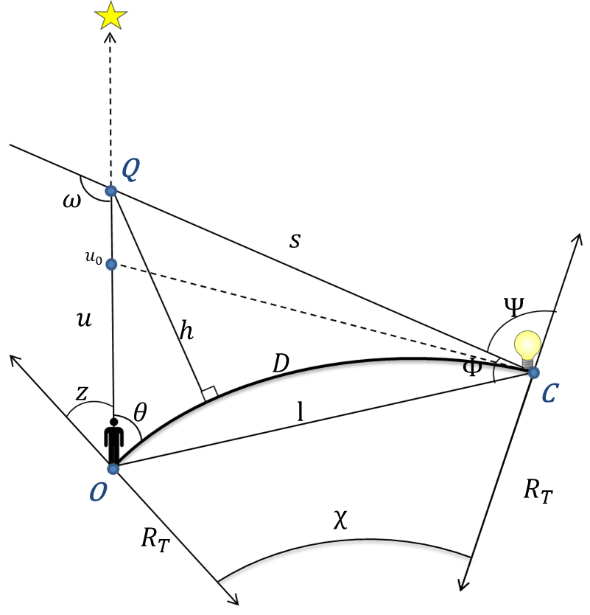

Figure 8. Geometric relationships; adapted from Garstang (1989) and Cinzano et al. (2000)

$K_{a:m}=1.0$

$a_{sha}$, the scale height of aerosols: (Cinzano, et al., 2000, p. 646)



$a_{sha}=0.657+0.059 K_{a:m}$

Coefficient $σ_{m}$ of Rayleigh scattering of visual light through a vertical cross-section of atmosphere: (Cinzano, et al., 2000, p. 646)

$σ_{m}=\frac{1.136×{10}^{-26}}{{cm}^{2} sr }$

**Geometry**

An observer at point $O$ has a direct line of sight to the star at the top of the diagram. A source of light pollution at $C$ (considered, for convenience, to be a single point-source) scatters light towards the observer’s line of sight to the star.

The model works by defining a point $Q$ between the observer and part of the night sky as the scattering-point. Light from the source at $C$ is scattered at $Q$ towards the observer, and becomes visible as sky-glow. With these points ($O$, $C$, and $Q$) fixed, many of the quantities on this diagram can be calculated by geometry.

The Earth Radius of curvature, $R_{T}$, is calculated as the Gaussian radius of curvature.

$R_{T}= \frac{R_{polar} × {R_{equator}}^{2}}{R_{equator}\cos^{2}\left(latitude\right) +{ R}_{polar} \sin^{2}(latitude)}$

The “overland” great-circle-arc distance $D$ is found from the latitude and longitude coordinates of $O$ and $C$ by the method of haversines:



$D=2R_{teton} ×\arcsin{\sqrt{\sin^{2}\left(\frac{{lat.}_{O}-{lat.}_{C}}{2}\right)+\cos\left({lat.}_{C}\right)\cos\left({lat.}_{O}\right)\sin^{2}(\frac{{long.}_{O}- {long.}_{C}}{2})}}$

$χ$, the central angle between points $O$ and $C$ on the ellipsoid: (Garstang, 1989, p. 308)



$χ= \frac{D}{R_{T}}$

$L$, the Pythagorean distance between $O$ and $C$: (Cinzano et al., 2000, p. 656, Appendix A1)



$L= \sqrt{4{R_{T}}^{2} \sin^{2}(\frac{χ}{2}) }$

Although many of the quantities on this diagram appear to follow quite simply from $L$, they are complicated by the addition of the azimuth angle, $β$.

Cinzano and Falchi’s work has so far proceeded from the adoption of the simplest geometry: an observer staring at his local zenith of the sky with $β=0°$ and $Z=0°$ (see Figure 7). In actual fact, $O$, $C$, and $Q$ need not be aligned as they are in Figure 7. This paper’s model includes the case in which they are not in the same plane: an observer may look at a star obscured by light scattered at $Q$, but from a source at a noticeable azimuth angle $β$ from the line of sight to the star (see Figure 8).

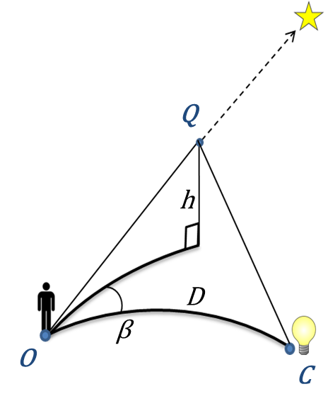

Figure 9. Three-dimensional geometric relationships.

Further calculations are simplified by the introduction of an intermediate quantity, the first of which is called $q_{1}$: (Cinzano et al., 2000, p. 656, Appendix A1; Garstang, 1989, p. 308, eq. 6)



$q_{1}= R_{T}\sin\left(χ\right)\sin\left(Z\right)\cos\left(β\right)+\cos\left(χ\right)\cos\left(Z\right)-\cos\left(Z\right)$

$θ$, the angle between the horizontal and the observer’s line of sight to $Q$, can be calculated from $q_{1}$: (Cinzano et al., 2000, p. 656)



$θ=arccos⁡(\frac{q_{1}}{L})$

**Calculation of sky-glow**

Light from the source at $C$ is limited by the curvature of the earth and first intersects the observer’s view of the star at a distance $u_{0}$ from the observer: (Cinzano et al., 2000, p. 647, eq. 21)



$u_{0}=\frac{{2 R_{T} sin}^{2}\left(\frac{χ}{2}\right)}{\sin\left(Z\right)cos\left(β\right)sin\left(χ\right) + \cos\left(χ\right)\cos\left(Z\right)}$

The model’s basic design is for each two input pixels it is given, one pixel will be considered point $O$ and the other point $C$. It uses the brightness of $C$ to calculate the amount of light scattered from $C$ to the observer at $O$. It obtains this quantity by starting its calculation at the point along the “ $u$-path” at point $u_{0}$, the shortest distance light can scatter, and extending its calculation by lengthening $u$, essentially moving the point $Q$ toward the “star” in Figures 7 and 8. As it does so, it recalculates the following quantities:

$s$, the distance between the light source at $C$ and the scattering point at $Q$: (Garstang, 1989, p. 308, eq. 7)



$s= \sqrt{{(u-L)}^{2}+4u^{2}L\sin^{2}(\frac{θ}{2})}$

$h$, the elevation of the scattering point at $Q$ above the surface of the Earth reference ellipsoid: (Cinzano et al., 2000, p. 656, Appendix A1)



$h= R_{T}\left(\sqrt{1+\frac{u^{2} + 2uR_{T} cos(Z)}{{R_{T}}^{2}}}-1\right)$

$ϕ$, the elevation angle of emission between $s$ and $L$: (Cinzano et al., 2000, p. 656, Appendix A1)

1. $ϕ=arccos(\frac{L^{2}+ s^{2}-u^{2}}{2Ls}$)

The intermediate quantities $q_{2}$ and $q_{3}$ are used to calculate the remaining angles, $ψ$ and $ω$, on the figure. Note for angles of $Z=0°$, the quantities $q_{3}$ and $q_{2}$ are the same. (Cinzano et al., 2000, p. 656, Appendix A1)



$q_{2}=u sin\left(Z\right) cos\left(β\right) sin\left(χ\right)+q_{3}$

$q_{3}=u cos\left(Z\right) cos\left(χ\right)- 2R_{T} \sin^{2}(\frac{χ}{2})$

$ψ$, the angle of emission from $C$: (Cinzano et al., 2000, p. 656, Appendix A1)



$ψ=arccos(\frac{q_{2}}{s})$

ω, the scattering angle at $Q$: (Cinzano et al., 2000, p. 656, Appendix A1)



$ω= θ+ ϕ$

**Emissions functions**

The appearance of a “dome” of sky-glow over a light source in the night sky is expressed as the physical quantity *extinction*, the natural dimming of light as it travels through the atmosphere.

$ξ_{1}$, the extinction of light along the path of $u$, is the natural dimming of light over distance in the atmosphere, and is responsible for the “glow” effect. It is calculated with several intermediate quantities: (Cinzano et al., 2000, p. 656, Appendix A2)



$p_{1}={c_{isa}}^{-1}sec\left[Z\left(1-e^{-c_{isa }× u\cos\left(Z\right)}+ \frac{16p_{3} \tan^{2}(Z)}{9π × {2c}_{isa} R_{T}}\right)\right]$

$p_{2}={a_{sha}}^{-1}sec\left[Z\left(1-e^{-a_{sha} × u\cos\left(Z\right)}+ \frac{16p_{4} \tan^{2}(Z)}{9π × 2a_{sha} R_{T}}\right)\right]$

$p_{3}=\left[{(c_{isa}}^{2} u^{2} \cos^{2}\left(Z\right)+2c_{isa}×u cos\left(Z\right)+2)e^{-c_{isa} × u cos⁡(Z)}\right]-2$

$p_{4}=\left[{(a_{sha}}^{2} u^{2} \cos^{2}\left(Z\right)+2a_{sha}×u cos\left(Z\right)+2)e^{-a_{sha} × u cos⁡(Z)}\right]-2$

$ξ_{1}= e^{-N_{m,0}σ_{m}(p_{1}+11.778K_{a:m}p_{2})}$

Likewise, $ξ_{2}$, the extinction of light along the path of $s$, is calculated with several intermediate quantities: (Cinzano et al., 2000, p. 657, Appendix A2)



$f_{1}={c_{isa}}^{-1}sec\left[ψ\left(1-e^{-c_{isa} × s\cos\left(ψ\right)}+ \frac{16f_{3} \tan^{2}(ψ)}{9π × 2c_{isa} R_{T}}\right)\right]$

$f_{2}={a_{sha}}^{-1}sec\left[ψ\left(1-e^{-a_{sha} × s\cos\left(ψ\right)}+ \frac{16f_{4} \tan^{2}(ψ)}{9π × 2a_{sha} R_{T}}\right)\right]$

$f_{3}=\left[{(c_{isa}}^{2} s^{2} \cos^{2}\left(ψ\right)+2c_{isa}×s cos\left(ψ\right)+2)e^{-c_{isa} × s cos⁡(ψ)}\right]-2$

$f_{4}=\left[{(a_{sha}}^{2} s^{2} \cos^{2}\left(Z\right)+2a_{sha}×s cos\left(ψ\right)+2)e^{-a_{sha} × s cos⁡(ψ)}\right]-2$

$ξ_{2}= e^{-N_{m,0} σ_{m} (f_{1}+11.778{ K}_{a:m}f_{2})}$

The above equations describe how light travels through the atmosphere as skyglow, but we have not yet described the emission of light at the source. Falchi, et al.’s 2016 paper proposes three models of emission named $A$, $B$, and .

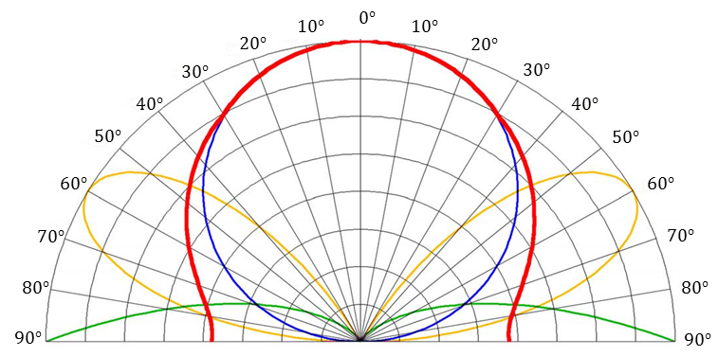

Figure 10. Three emissions functions and their normalized sum; adapted from Falchi et al., 2016.

In Figure 9 above, model A is the blue circle representing emissions due to Lambertian reflectance at the ground, directing the most energy toward the zenith above the light source. Model B, the green curves at the bottom of the figure, represent emissions due to specular reflectance at the ground. Model C, traced by the yellow curves, is a combination of models A and B. Note that with the view of the night sky angled in the above figure, the angle marked on the outside of the chart is $ψ$.

These models were tested statistically with thousands of local brightness measurements and combined into a normalized emissions function, $I\left(ψ\right)$, marked in red in Figure 9.

$I\left(ψ\right)$, total emissions:



$I\left(ψ\right)= \frac{1}{2π}\left[W_{a}A+ W_{b}B+ W_{c}C\right]$

with the formulas for the models and their weights being:

|  |  |  |
| --- | --- | --- |
| Model | Formula | Weight |
| Lambertian reflectance: | $$A= 2cos(ψ)$$ | $$W_{a}=1.9× {10}^{-3}$$ |
| Low angle emitted light: | $$B= 0.554ψ^{4}$$ | $$W_{b}=5.2× {10}^{-4}$$ |
| Intermediate angle light | $$C= sin(3ψ)$$ | $$W_{c}=7.6× {10}^{-5}$$ |

The weights are the coefficients for a least-squares regression fit to local measurements. (Falchi et al., 2016)

The total emissions from the model are then subject to the atmospheric calculations described in equations 22-31.

$i$, illuminance per unit flux: (Cinzano, et al., 2000, p. 644, eq. 6)



$i=I\left(ψ\right)×\frac{ξ_{2}}{s^{2}}$

With $h$ calculated from the above geometry, the density of gases that scatter light can be calculated more precisely along the path to the scattering point $Q$. (Cinzano, et al., 2000, p. 645, eq. 10)



$N_{m}(h)= N_{m,0}×e^{-c_{isa}×h}$

Total integrated scattering along a cross-sectional area: (Cinzano, et al., 2000, p. 645, eq. 12)



$N_{a}σ_{a}= K_{a:m}N_{m}σ_{m}×11.11$

Angular scattering function for molecular Rayleigh scattering: (Cinzano, et al., 2000, p. 646, eq. 13)



$f_{m}= \frac{3\left[1+cos⁡(ω)\right]}{16π}$

$f_{a}$, the Mie scattering by aerosols varies according to the scattering angle $ω$: (Cinzano, et al., 2000, p. 646, eq. 14)

$$f_{a}=\left\{\begin{aligned}\frac{7.5e^{-0.1249ω^{2}}}{1+0.04996ω^{2}}, &0°≥ω≥10° \\ 1.88e^{-0.07226ω + .0002406ω^{2}}, &10°>ω≥124° \\ 0.025+0.015sin(2.25ω-369°), &124°>ω≥180°\end{aligned}\right.$$

$S_{d}$, luminous flux per unit of solid angle upward from the source scattered directly toward the observer: (Cinzano, et al., 2000, p. 644, eq. 5)



$S_{d}= \left(N_{m}σ_{m}f_{m}+ N_{a}σ_{a}f_{a}\right)×i$

$D_{s}$, the double scattering correction factor: (Cinzano, et al., 2000, p. 647, eq. 20)



$D_{s}= 1+ N_{m,0}σ_{m}×\left(11.11K_{a:m}f_{2}+\frac{f_{1}}{3}\right)$

With equations 38 and 39, total scattering $S$ along the path of $u$ can be calculated as:



$S(u)= S_{d}×D_{s}$

Recall $ξ_{1}$ along the path of $u$ was calculated in equation 26. The purpose of these equations in the model so far is to simulate a beam of light that travels from a source, scatters at some point in the atmosphere, and reaches an observer. The summation of the light’s travel along the path marked as $u$ in the Figure 7 is added together to make the sum of total scattered light, $f$: (Cinzano, et al., 2000, p. 644, eq. 3)



$f= \int_{u_{0}}^{∞}{S\left(u\right)×ξ_{1}\left(u\right) du}$

Mathematically, $f$ is the sum of an infinite integral; in practice, the code calculates $f$ as a looped process of small, finite increments.

# 11. Appendix C - Skyglow Model Validation

