**NASA DEVELOP National Program**



NASA Langley Research Center

*Fall 2016*

Western U.S. Water Resources II

Assessing Landscape Vulnerability to Drought and Changing Climate in National Parks of the Western United States

https://lh6.googleusercontent.com/2AIazRYwJHtaoBllH0fb5PAiGwCl0l1yPUqkNvyx_V7XbuqiV2je7bYhGC1jcmp3nfZJPMz_dBxysMXyfKLkChDGx4X52cvnAr8dQIIAUs_kIR9UZOToYdxn07WX23zP86trZ5iG**Technical Report**

Final Draft – November 17, 2016

Andrea Martinez (Project Lead)

Amanda Clayton

Christine Sadlik

Taryn Smith

Aubry Eaton

Dr. Kenton Ross, NASA Langley Research Center (Science Advisor)

Previous Contributors:

Kelly Meehan

Teresa Fenn

Molly Spater

Thomas Smith

Kaylie Taliaferro

Grant Jaccoud

# 1. Abstract

Increased surface temperatures and a trend towards more severe drought in the western United States can impact the vulnerability of vegetation across the region. Land managers specifically seek to estimate the threshold, known as a pivot point, at which ecosystems begin to lose productivity due to increased heat or decreased water. NASA Earth observations provide the National Park Service (NPS) and United States Geological Survey (USGS) with necessary data to monitor vegetation response at a regional scale. The sagebrush shrubland ecosystem in Colorado and Utah’s Dinosaur National Monument was analyzed to determine how bioclimatic variables have impacted vegetation trends for the study area. These relationships were analyzed by the use of a stepping window written in R. The stepping window evaluated a five by five pixel matrix throughout the raster to output a correlation between annual change in vegetation and precipitation, temperature, and evapotranspiration. Based on the strength of the correlation, a multiple linear regression model was implemented. Vegetation data were acquired for a 15-year period using the Normalized Difference Vegetation Index (NDVI) from the ForWarn dataset. The model used mean temperature and precipitation from PRISM and the MODIS evapotranspiration datasets. Combining a moving window approach with remote sensing yielded a robust methodology for determining climate pivot points for western park units.

**Keywords**

Climate pivot points, NDVI, MODIS, National Park Service, ForWarn, drought, Colorado Plateau sagebrush shrubland

# 2. Introduction

***2.1 Background Information***

Changes in climate are predicted to result in increased temperatures and lower soil moisture levels across the western United States. An increase in surface temperature across the region has the potential to intensify the severity of drought conditions (Gutzler & Robbins, 2010). Over the past 30 years Colorado, in particular, has experienced an increase in annual average temperatures of 1.11°C and trended toward more severe drought conditions as measured by the Palmer Drought Severity Index (Lukas et al., 2014). The semi-arid climate that characterizes much of the western United States is uniquely prone to drought. Warmer and drier conditions are likely to cause the loss of total perennial vegetation cover while snowpack has been widely reduced across the region due to past climatic warming (Ray et al., 2008). These associated influences of changes in climate could potentially impact the natural processes and communities that make up this diverse region.

As the ecosystem destabilizes, invasive species are more likely to encroach, soil fertility diminishes, and the land loses its ability to provide for wildlife and domestic livestock (Smith et al., 2000). The ecosystem approaches a threshold where productivity begins to decline, indicated by a climate pivot point. These pivot points are a measure of a plant species’ drought resistance and represent the conditions at which a change in temperature or change in precipitation have begun to cause a loss of biomass (Munson, 2013).

The Colorado Plateau mixed low sagebrush shrubland ecotype is a rich and productive ecosystem that has been impacted drastically though fires, the encroachment of invasive species, and human disturbances. A variety of wildlife depend on the sagebrush habitat for shelter, food, and nesting grounds (Boyle & Reeder, 2005). Without a healthy sagebrush habitat, hundreds of species that depend on the habitat to survive will be directly impacted.

***2.2 Study Area and Study Period***

The study area of this project focused on Dinosaur National Monument, located on the border of northeast Utah and northwest Colorado (Figure 1). The climate of this region is semi-arid with average annual precipitation ranges from 280 mm in lower elevations to 508 mm in higher elevations (Sherrill & Romme, 2010) and average annual air temperatures of -3 to 10 °C (United State Department of Agriculture, 2007). Situated at the confluence of the Yampa River and Green River, the monument has a diverse topography as well as flora and fauna. Fossil beds preserve an abundance of plant and animal life for study and exhibition. Dominant uses of the park unit include fossil preservation, wildlife habitat, and recreational purposes such as hiking and camping (National Park Service, 2015). Data for Dinosaur National Monument were analyzed from 2000 to 2014.

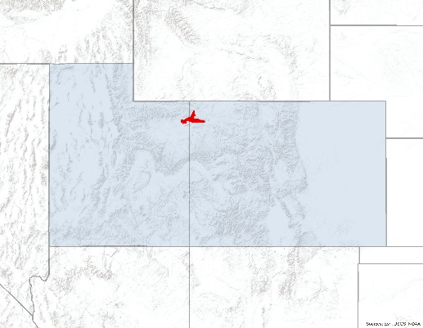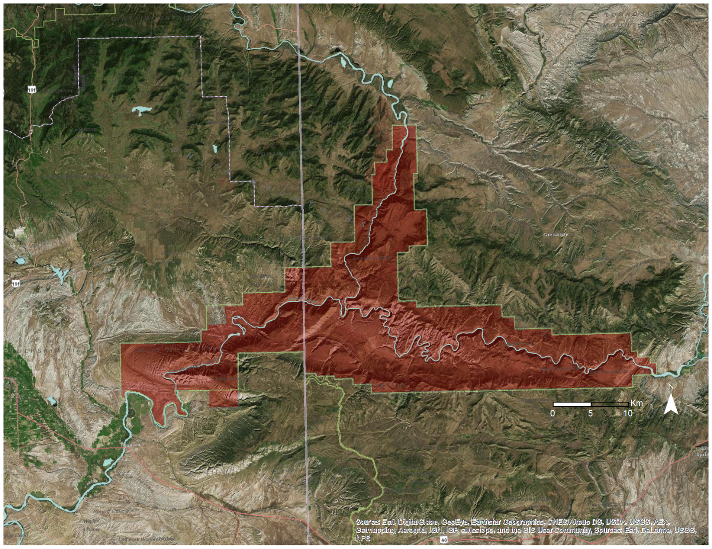

**Utah**

**Colorado**

**Figure 1**: National Park Service’s Dinosaur National Monument (UT & CO).

***2.3 Objectives & Project Partners***

This project addressed the Water Resources Application Area under NASA’s Applied Sciences Program by using NASA Earth observations to assess landscape vulnerability to drought and changing climate through the use of modeling. The main objective of this project was to determine climate pivot points for different environmental factors within the Colorado Plateau sagebrush using Moderate Resolution Imaging Spectroradiometer (MODIS) data for Dinosaur National Monument. These environmental factors included temperature, precipitation, and evapotranspiration. We further sought to validate a methodology which can be broadly applied to national parks throughout the western U.S and determine the most productive way to optimize sample sizes.

Project end-users were ecologist David Thoma of the NPS Inventory & Monitoring (I&M) Program North Colorado Plateau and Greater Yellowstone Networks, and plant ecologist Seth Munson of the United States Geological Survey (USGS) Southwest Biological Science Center. This project provided additional knowledge to partners’ current decision-making process by understanding how the sagebrush ecosystem is responding to varying climate conditions within the park and validating a methodology that may be applied to other parks and vegetation types in the region.

# 3. Methodology

***3.1 Data Acquisition***

Project data spanned 15 years from January 2000 through December 2014. Maximum annual Normalized Difference Vegetation Index (NDVI) data were retrieved from the USDA Forest Service Satellite-Based Change Recognition and Tracking System (ForWarn) to observe both annual and seasonal variability. ForWarn data was derived from the MODIS sensor onboard the Terra satellite at a 231 m spatial resolution and corrected for cloud error.

Subsurface temperature (ºC) and precipitation (mm) data were obtained from the Parameter-elevation Relationships of Independent Slopes Model (PRISM) at a 4 km resolution to observe climate patterns within the region. Evapotranspiration data were acquired from the Numerical Terradynamic Simulation Group at the University of Montana at a 1 km resolution. Global Terrestrial Evapotranspiration Data (MOD16), derived from MODIS, were utilized to account for the movement of water to the air from sources such as soil and plant canopy.

Vegetation, soil, and park boundary shapefiles were obtained from the NPS to identify major vegetation ecotypes and soil types within the national monument. Digital Elevation Model (DEM) rasters were obtained for elevation from the USGS National Map at a 10 m resolution to observe how slope and elevation relate to vegetation and soil types.

***3.2 Data Processing***

All obtained data were reprojected to NAD 1983 UTM Zone 12 and clipped to the Dinosaur National Monument boundary. Roads falling under park management, but extending beyond the boundary of the park unit, were omitted from the study area. Data provided by the NPS on vegetation type were used to create a vegetation mask. The Colorado Plateau mixed low sagebrush shrubland ecotype was selected by the project partners as the main vegetation focus for this study (Figure 2). To control for the effects of high slope on satellite retrievals, slopes greater than 30 degrees were excluded from the data set. Areas of high slope were identified by applying focal statistics to the DEM raster to determine the maximum slope within a 30 m by 30 m neighborhood. After masking areas of steep slope and masking for desired vegetation type, all data were resampled to the MODIS sensor resolution (250 m). The final step of data processing consisted of calculating the difference between yearly and average NDVI to yield ∆NDVI.

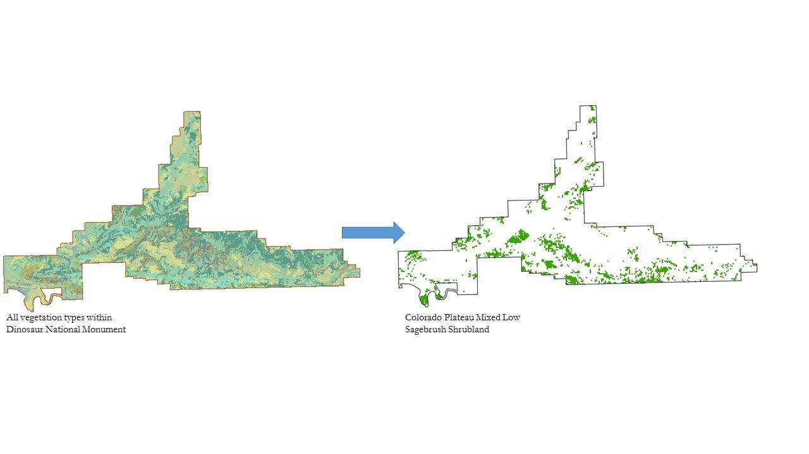  
**Figure 2**: Vegetation data from the NPS was used to create a raster vegetation layer for the Colorado Plateau mixed low sagebrush shrubland ecotype for analysis within Dinosaur National Monument.

***3.3 Data Analysis***

Data analysis began with determining the best way to partition Dinosaur National Monument to optimize sample size. At a pixel level the sample size is too small and may result in underfitting the model, while the entire study area is too general and may result in overfitting the model. Through a stepping window approach, sample size is optimized to yield a descriptive model that examines how bioclimatic variables influence vegetation productivity by proxy of NDVI. This approach uses a window that steps across 15 years (2000 – 2014) of stacked ∆NDVI data and compares it to the corresponding window of 15 years of stacked evapotranspiration, precipitation, and temperature data (Figure 3). Two window settings, pixel-by-pixel and aggregated pixels, were analyzed. In the pixel-by-pixel method, a window of 5x5 pixels moves across each stacked dataset to gather a maximum of 375 data points per window, i.e. 15 years x 25 pixels per window. Each window must have fewer than 15 null values for further consideration. The aggregated pixel analysis differs by when points are collected, they are then averaged per window before continuing the process. The pixel-by-pixel method was determined to be the best method for this project over aggregation due to a larger sample size with appropriate window yields for analysis.

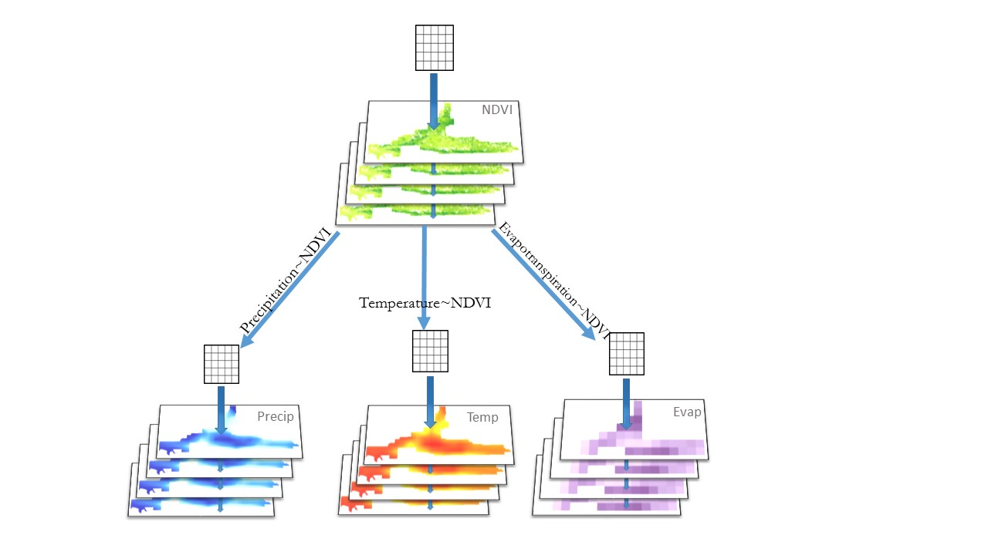

**Figure 3**: Figure depicting the stepping window approach on stacked bioclimatic variable data for regression analysis.

During the stepping window process, correlations between ∆NDVI and each climate parameter are calculated. Only those climate parameters which achieve a correlation of r ≥0.5 or r ≤ -0.5 per window are included in regression analysis (Figure 4). Regression was then carried out to model the relationship between ∆NDVI and the selected climate parameter(s). Climate pivot points were extracted by setting ∆NDVI = 0 in the regression equation (Refer to Appendix for window scatterplots and regression equations.)

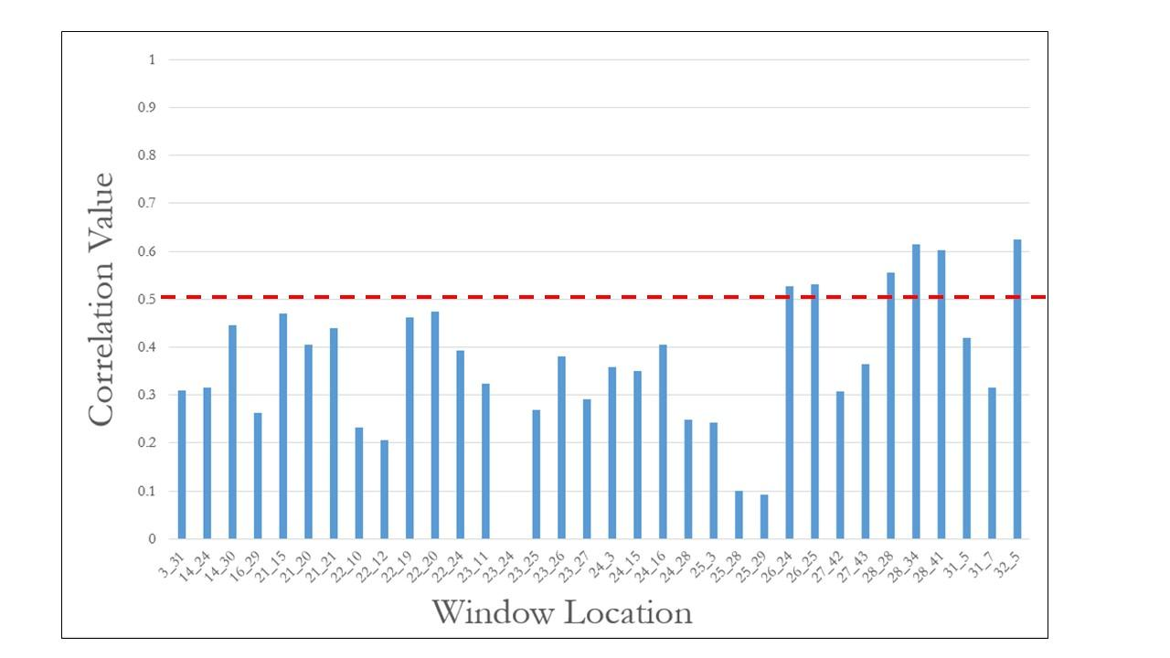

**A.**

Correlation Threshold

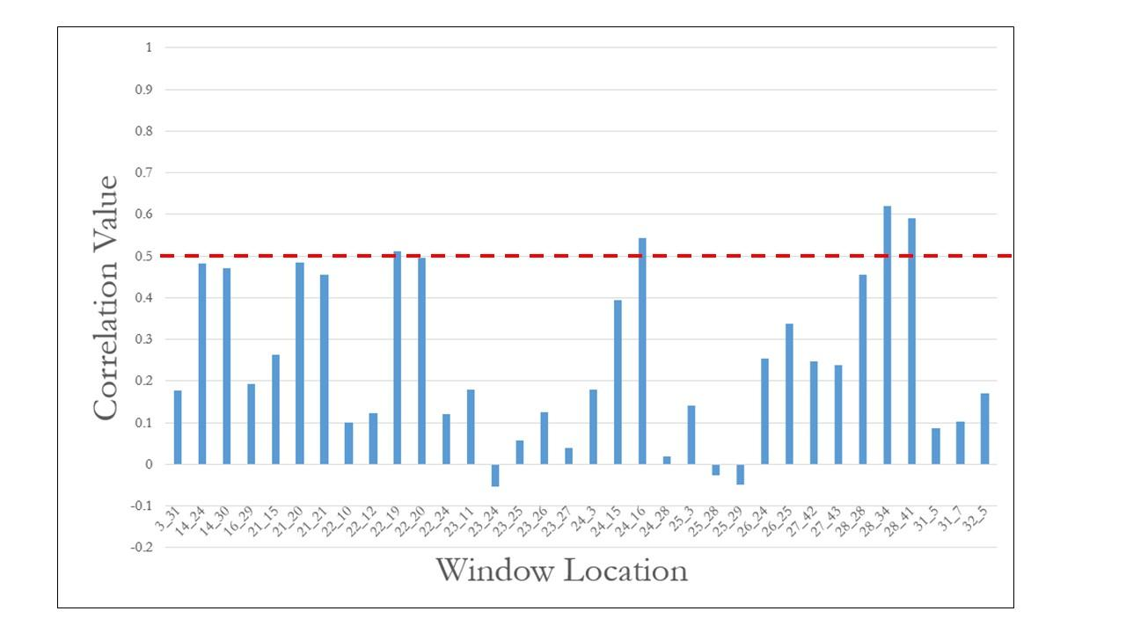

**B.**

Correlation Threshold

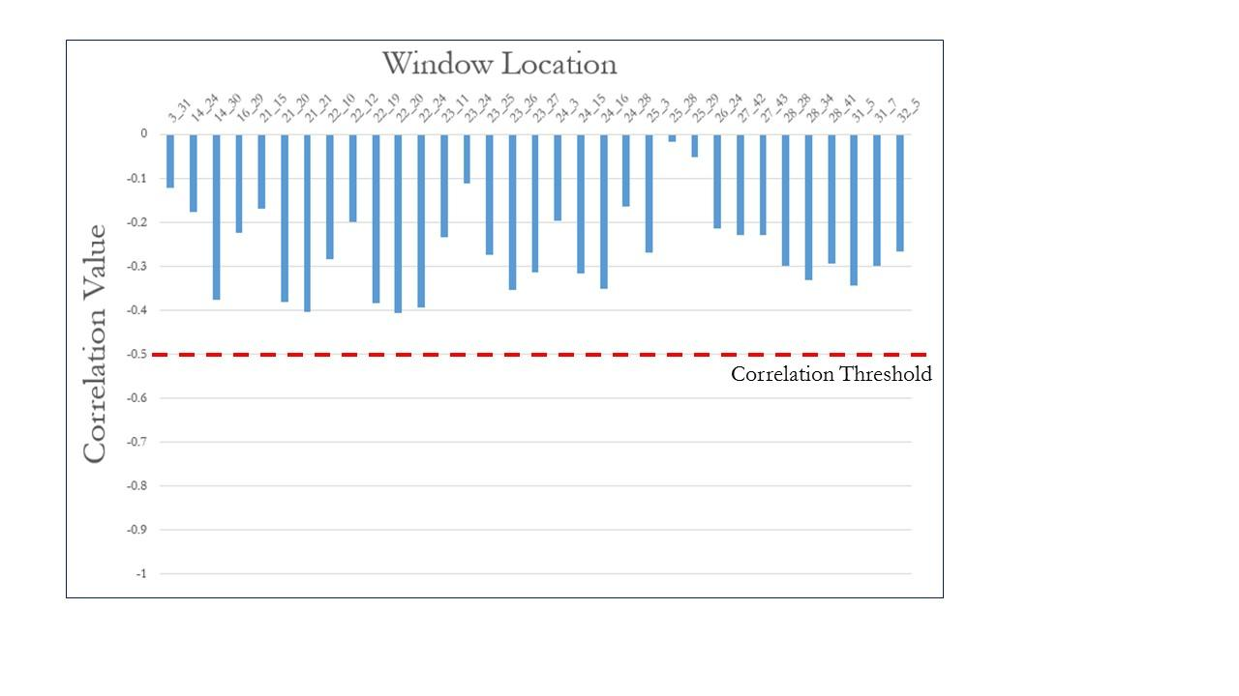

**C.**

**Figure 4**: Correlation threshold outputs from the stepping window analysis for (A) precipitation, (B) evapotranspiration, (C) temperature

# 4. Results & Discussion

***4.1 Analysis of Results***

Four windows met the correlation threshold between ∆NDVI and evapotranspiration (Figure 4b), however the aggregated method produced a negative correlation, whereas the pixel-by-pixel method yielded a positive correlation. A regression analysis was not carried out due to inconsistent results. Temperature did not pass the correlation threshold (Figure 4C) in either case, but six windows in the relationship between ∆NDVI and precipitation met the criteria (Figure 4A and Figure 5). Regression analysis resulted in pivots points for precipitation, which is depicted in Table 1.

The correlated results found that the Colorado Plateau mixed low sagebrush shrubland ecotype within Dinoaur National Monument is less vulnerable to changes in temperatures and evapotranspiration, but is more prone to experiencing damaging effects by a change in precipitation. As an adaptive and complex ecosystem, many variables factor into the productivity of Colorado Plateau sagebrush shrubland. An R-squared value of greater than 0.25 meets the threshold for significance set by the project end-users. This strength indicates that while being correlated, precipitation alone does not fully explain ∆NDVI. Additionally, while NDVI is an indicator of vegetation productivity, it is not a direct estimate. Recent data from 2014 indicate that annual precipitation is slightly above the pivot point.

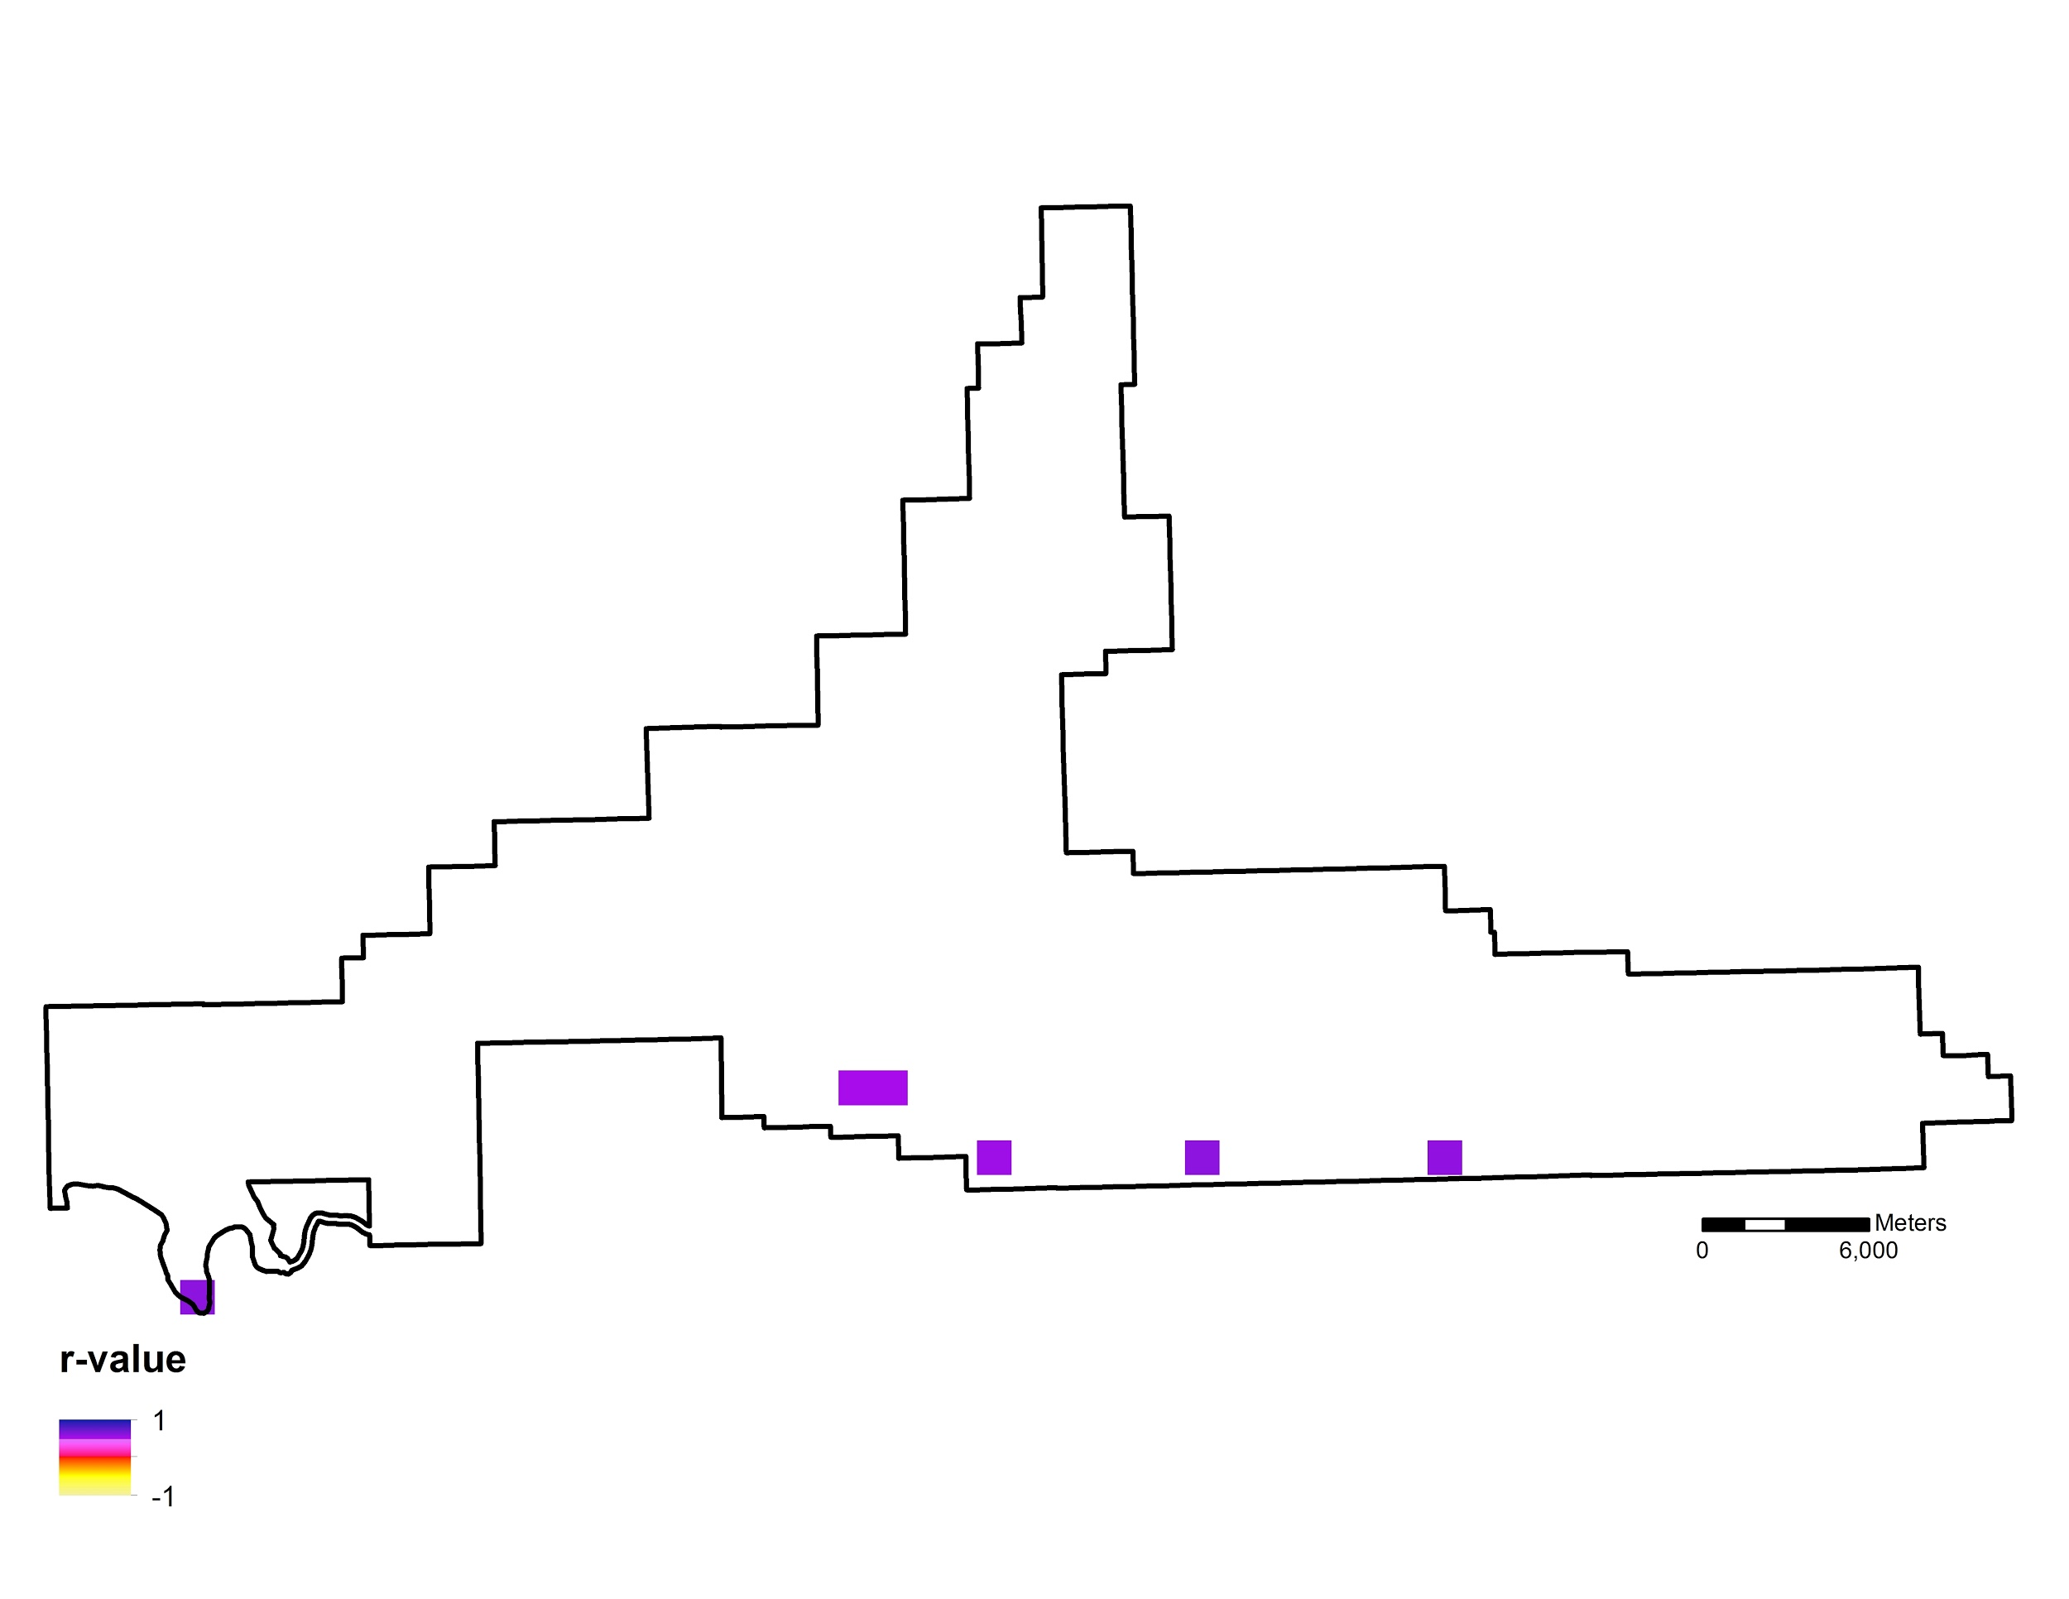

**Figure 5**: ∆NDVI and precipitation threshold windows.

**Table 1**: Calculated pivot points for Colorado Plateau mixed low sagebrush shrubland by window location.

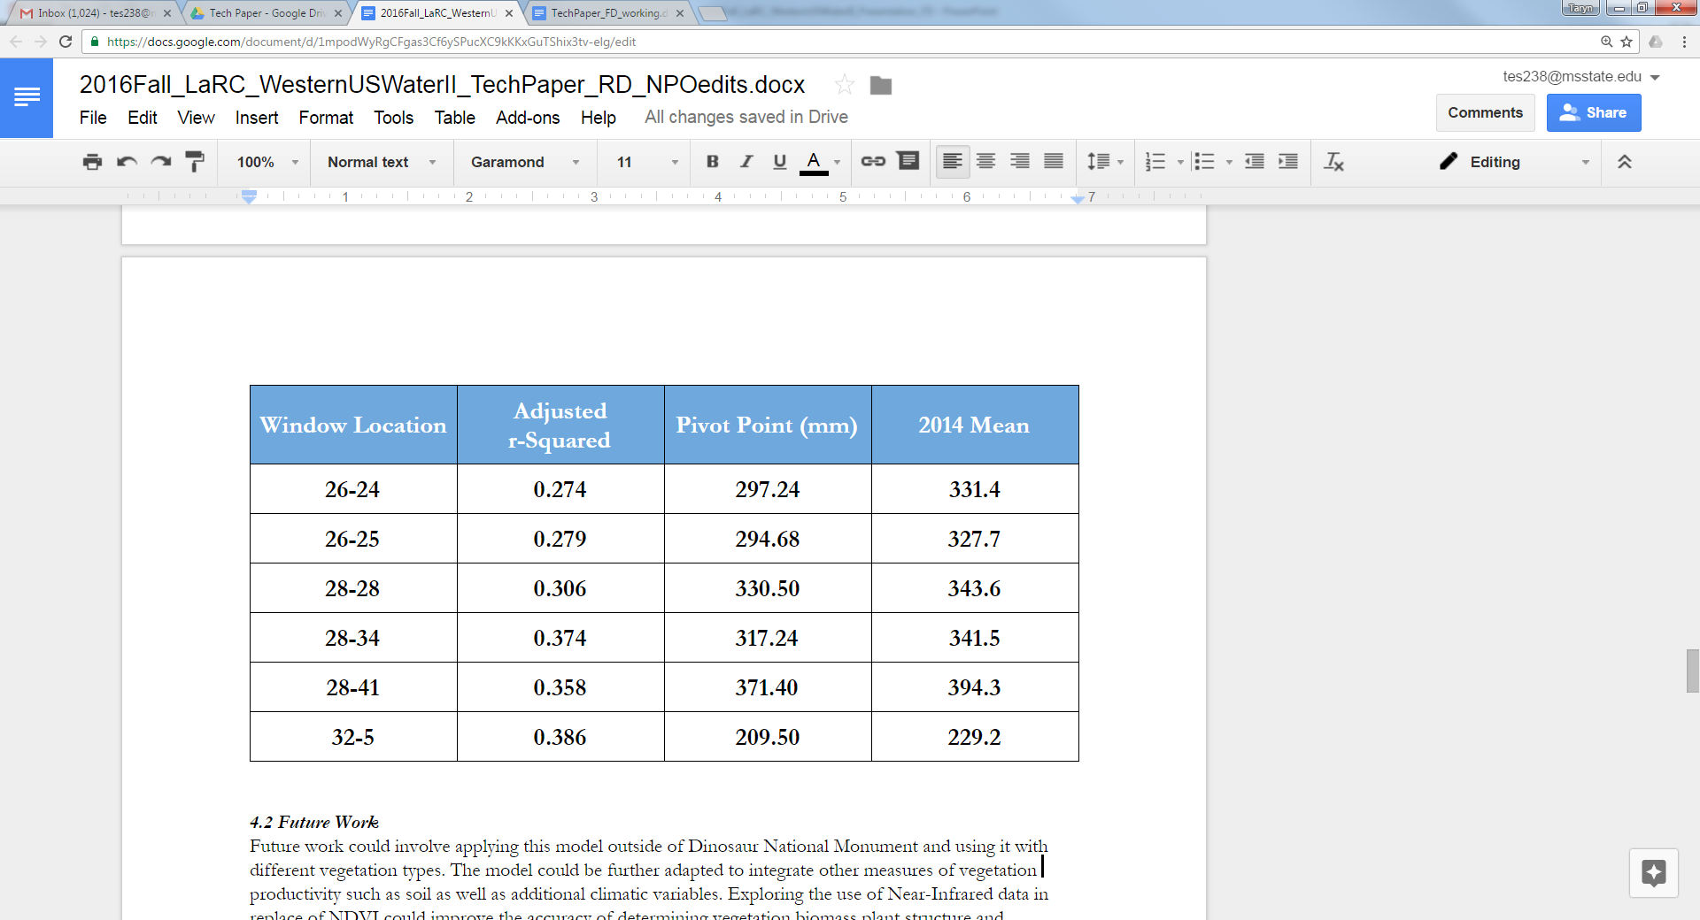

***4.2 Future Work***

Future work could involve applying this model outside of Dinosaur National Monument and using it with different vegetation ecotypes. Exploring the use of near-infrared data in instead of NDVI could improve the accuracy of determining biomass and physiological status of vegetation (Peńuelas & Filella, 2010). This could provide more insight to see if the plant is in a productive or nonproductive state. Forest fires are common throughout the west and allow a platform for invasive species, such as cheatgrass, to encroach. Incorporating forest fire data could determine areas experiencing ecological damage or areas that have been invaded by cheatgrass. The use of higher resolution data, such as Landsat, could provide more detailed information and accurate vegetation index values. The model could also be further adapted to integrate other elements of vegetation productivity such as soil and wildfires as well as additional climatic variables.

# 5. Conclusions

Integrating NASA’s Earth observations into the climate pivot point framework provides a valuable tool for understanding vegetation response to a changing climate. Historical data allows researchers to place current observations in context, while broad swath widths expand knowledge from plot to park level. The stepping window methodology effectively identified the climate parameter with a meaningful relationship to ∆NDVI.For the Colorado Plateau mixed low sagebrush shrubland ecotype within Dinosaur National Monument, results indicated that a change in precipitation has a stronger correlation with ∆NDVI than temperature or evapotranspiration. Sagebrush concentrations in Dinosaur National Monument have not currently reached their precipitation pivot point. However, if average precipitation continues to decrease, the sagebrush ecosystem may reach its pivot point and begin to lose productivity. Ecologists with the National Park Service may find this data useful when quantifying drought tolerance and sensitivity to climate. Additionally, the tools developed to implement the project methodology may be broadly applied to different vegetation ecotypes and national parks throughout the Western U.S.

# 6. Acknowledgments

* Dr. Kenton Ross, NASA Langley Research Center
* Dr. Davis Thoma, Ecologist, NPS Northern Colorado Plateau and Greater Yellowstone Networks Inventory and Monitoring Program
* Dr. Seth Munson, Plant Ecologist, USGS Southwest Biological Science Center
* Term I Members
  + Kelly Meehan
  + Teresa Fenn
  + Molly Spater
  + Thomas Smith
  + Kaylie Taliaferro
  + Grant Jaccoud

Any opinions, findings, and conclusions or recommendations expressed in this material are those of the author(s) and do not necessarily reflect the views of the National Aeronautics and Space Administration.

This material is based upon work supported by NASA through contract NNL11AA00B and cooperative agreement NNX14AB60A.

# 7. References

Boyle, A. S., and D. R. Reeder. (2005). Colorado sagebrush: a conservation assessment and strategy*. Grand Junction: Colorado Division of Wildlife*.

Gutzler, D. and Robbins, T. (2010). Climate variability and projected change in the western United States: regional downscaling and drought statistics. *Climate Dynamics*, 37(5), 835-849.

Lukas, J., Barsugli, J., Doesken, N., Rangwala, I., & Wolter, K. (2014). *Climate Change in Colorado*. Denver, Colorado: Colorado Water Conservation Board.

Munson, S. M. (2013). Plant responses, climate pivot points, and trade-offs in water-limited ecosystems. *Ecosphere*, 4(9), 1-15.

National Park Service (2015). *Foundational Document Dinosaur National Monument.* (DINO 122/127544)

Peńuelas, J. and Filella, L. (1998). Visible and near infrared reflectance techniques for diagnosing plant physiological status. *Trends in Plant Science*, vol. 3, NO. 4.

Ray, A.,Barsugli, J., Averyt, K., Wolter, K., Hoerling, M., Doesken, N., Udall, B., & Webb, R. (2008) *Climate Change in Colorado.* Denver, Colorado: Colorado Water Conservation Board.

Sherrill, K. and Romme, W. (2010). Spatial variation in postfire cheatgrass: Dinosaur National Monument, USA. *Fire Ecology*, 8(2), 38-56.

Smith, S.D., Huxman, T.E., Zitzer, S.F., Charlet, T.N., Housman, D.C., Colemanr, J.S., Fenstermaker, L.K., Seemann, J.R., & Nowak, R.S., (2000). Elevated CO2 increases productivity and invasive species success in an arid ecosystem. *Nature*, 408, 79-82.

United States Department of Agriculture (2007). *Soil Survey of Dinosaur National Monument, Colorado and Utah*

# 8. Content Innovation

Content Innovation files can be found at <https://drive.google.com/drive/folders/0BzkUJ4_aQXsUX0NWNlNHUVJEQXM>

**Content Innovation #1**

Interactive map viewer:

DNM_Outline_KML  
Precip_Window_Correlation_KML  
Sagebrush_KML

**Content Innovation #2**

Data Profile  
2016Fall_LaRC_WesternUSWaterII_dataprofile (1).xml

**Content Innovation #3**

VPS

# 9. Appendices

**Scatter Plot 1**: Colorado Plateau Mixed Low Sagebrush Shrubland Regression Plot for ∆ NDVI ~ Precipitation

**A:** **Window 26_24**

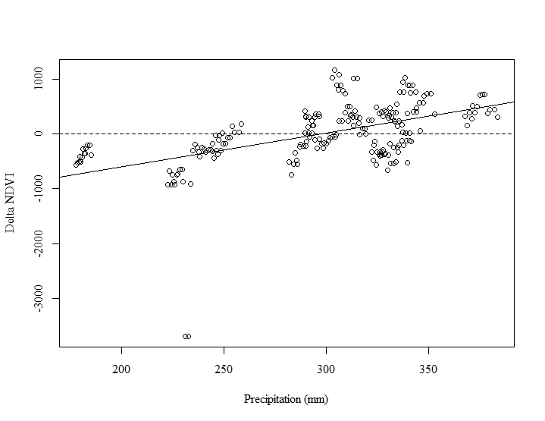

∆NDVI= -1829.79+6.16P

**B:** **Window 26_25**

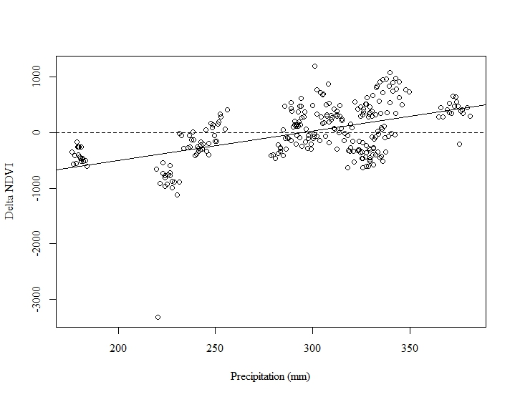

∆NDVI= -1551.58+5.27P

**C: Window 28_28**

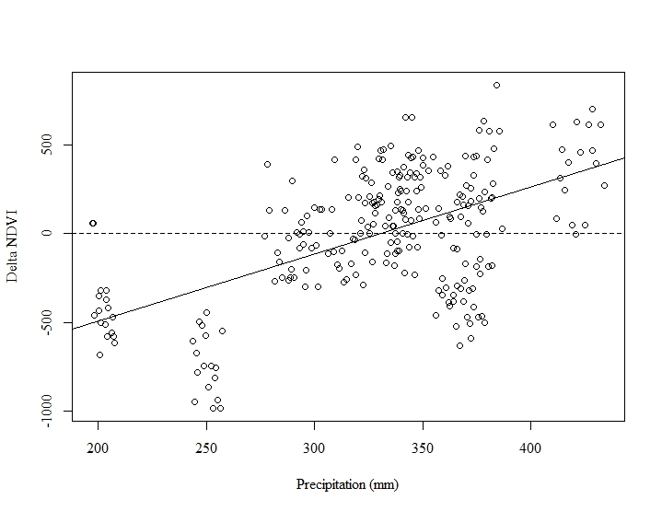

∆NDVI= -1253.29+3.79P

**D: Window 28_34**

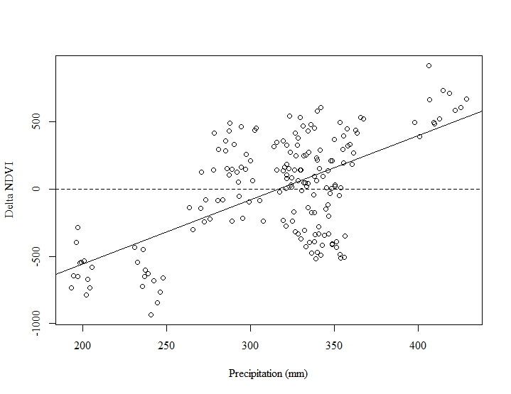

∆NDVI= -1512.76+4.77P

**E: Window 28_41**

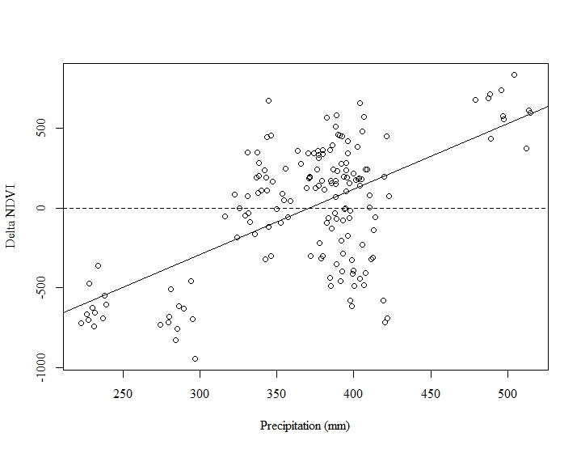

∆NDVI= -1522.69+4.1P

**F: Window 32_5**

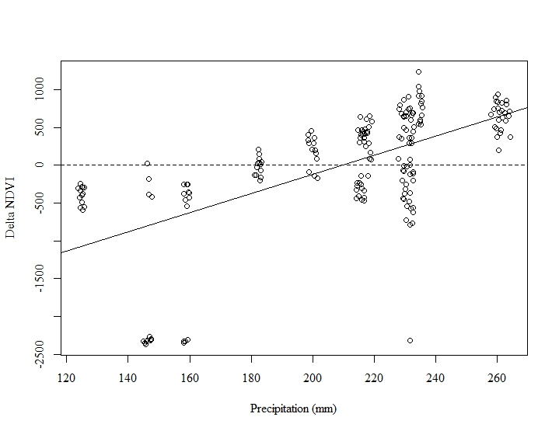

∆NDVI= -2666.87+12.73P