2016Fall
NASA DEVELOP National Program
USGS at Colorado State University
Fall 2016

Rocky Mountain National Park Climate
Monitoring Algal Productivity to Inform Spatiotemporal Alpine Lake Dynamics in Rocky Mountain National Park


Technical Report
Final Draft – November 14, 2016

Amy Stuyvesant (Project Lead)
Emily Campbell
Benjamin Ignac
Muthukumaran Sampath

Dr. Paul Evangelista, Colorado State University, Natural Resource Ecology Lab (Lead Science Advisor)
Dr. Amanda West, Colorado State University, Natural Resource Ecology Lab (Science Advisor)
Tony Vorster, Colorado State University, Natural Resource Ecology Lab (Mentor)
Brian Woodward, NASA DEVELOP, USGS at Colorado State University (Center Lead)

1. Abstract
Rocky Mountain National Park has over 140 alpine lakes that provide critical habitats for animal and plant species. Since the 1960s, these lakes have experienced an increase in nitrogen and phosphorus depositions resulting in increased algal productivity. Beginning in 2005, algal biomass has continued to increase despite relatively constant nutrient deposition. The United States Geological Survey (USGS) and National Park Service (NPS) are exploring if recent temperature changes explain this trend. Excessive algal productivity negatively affects water quality through eutrophication and the creation of anoxic events. It is important to monitor algal productivity in Rocky Mountain National Park (RMNP) lakes to prevent associated environmental degradation and socio-economic decline. The team assessed the accuracy of Landsat 8 Operational Land Imager (OLI) in estimating chlorophyll-a levels compared to in situ measurements. Earth observations provided a comprehensive analysis that has potential to supplement partner in situ data collection methods. The best performing model produced by the team was used to create algal productivity maps for RMNP lakes and has potential to inform NPS adaptation management efforts.

Keywords
chlorophyll-a, eutrophication, Landsat, water quality, Random Forests

2. Introduction
2.1 Background Information
Over the past few decades, a decline in water quality from algal growth has become a growing concern in the United States due in part to anthropogenic impacts (Mast, Drever, & Baron, 1990; O’Reilly et al., 2015; Wolfe, Van Gorp, & Baron, 2003). More specifically, influxes of nitrogen and phosphorus have entered waterways primarily through fertilizer use and the combustion of fossil fuels (Compton et al., 2011; Paerl at al., 2014; Ryther & Dunstan, 1971). An excess of nutrients amplify algal growth and in turn cause eutrophication (i.e, the depletion of oxygen in water). Increases in algal biomass can disturb the natural ecosystem and cause severe environmental degradation through means other than oxygen depletion, such as toxic blooms associated with certain species and concentrations of algae (Smith et al., 1999). Toxic algal blooms can also disrupt tourism due to foul odors, unsightly views, and fish die-off events (Howarth et al., 2000). On a national scale, detrimental economic side effects of algal blooms are also seen in expensive water treatment, habitat restoration, decreasing property values, and human health costs (U.S. Environmental Protection Agency, 2015).

Colorado’s northern Front Range alpine lakes are seeing the beginning of change in algal productivity, attracting the attention of the project partners. In Rocky Mountain National Park (RMNP) and the surrounding United States Forest Service (USFS) land, phosphorus and nitrogen are carried by wind and enter the lakes through snow and rain. Despite National Park Service (NPS) and USFS protection, alpine lakes have received higher atmospheric nutrient deposition since the 1950s (Wolfe et al., 2003). Although changes in nutrient deposition are common in many ecosystem types, alpine lakes are considered particularly fragile to these changes. High elevation lakes are naturally low in nutrients, so even slight additions can cause substantial changes in biological processes, such as algal growth (Sheibley at al., 2014). Recent increases in algal productivity despite relatively constant atmospheric inputs have led researchers to start addressing a potential link in higher air and water temperatures (Baron, 2006; O’Neil at al., 2012).

Managing alpine lakes to maintain their quality and fisheries is therefore essential and must be continuously monitored. Current research of the Loch Vale watershed relies on field data gathered by the United States Geological Survey (USGS), which quantifies the lakes’ characteristics using water column analysis. Among several parameters, researchers collect information on chlorophyll-a in these lakes. Chlorophyll-a, the green pigment that provides color in plants, is present in all species of algae that occur in the study area lakes. Additionally, chlorophyll-a has a distinct spectral signature that can be identified from Earth observations and has been extensively studied (Beck et al., 2016; Berry et al., n.d.; Dörnhöfer & Oppelt, 2016). This project aims to build the project partners’ capacity to integrate remotely sensed data into their future research efforts of evaluating algal productivity in lakes located in Colorado’s northern Front Range alpine lakes.

2.2 Study Area and Study Period
The study area encompasses lakes in RMNP as well as surrounding USFS lands. RMNP covers approximately 1,075.50 km² of land in Colorado's northern Front Range with a maximum elevation of 4,346 m (Figure 1). The USFS lands south of RMNP share similar topological and climatological features, with a slightly lower peak elevation of 4,115 m. Temperatures in the study area vary from an average low of -1.3ºC and an average high of 13.8ºF. The Rocky Mountain range hosts widely varying weather patterns throughout a single day, and the average yearly rainfall and snowfall in the study region are 14 and 33.9 inches, respectively.

Additionally, Loch Vale, Sky Pond and Long Lake were selected as case studies based on project partner interest. The study period includes summer months (June, July, and August) from 2014 to 2016.

Study-Area Alpine Lakes in Rocky Mountain National Park and
Sky Pond
Loch Vale
Surrounding United States Forest Service Land
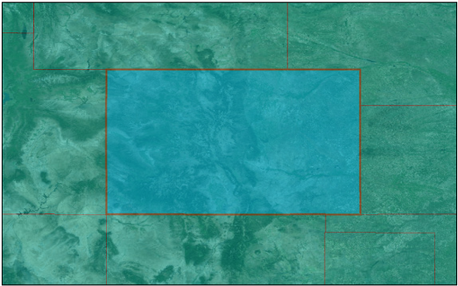
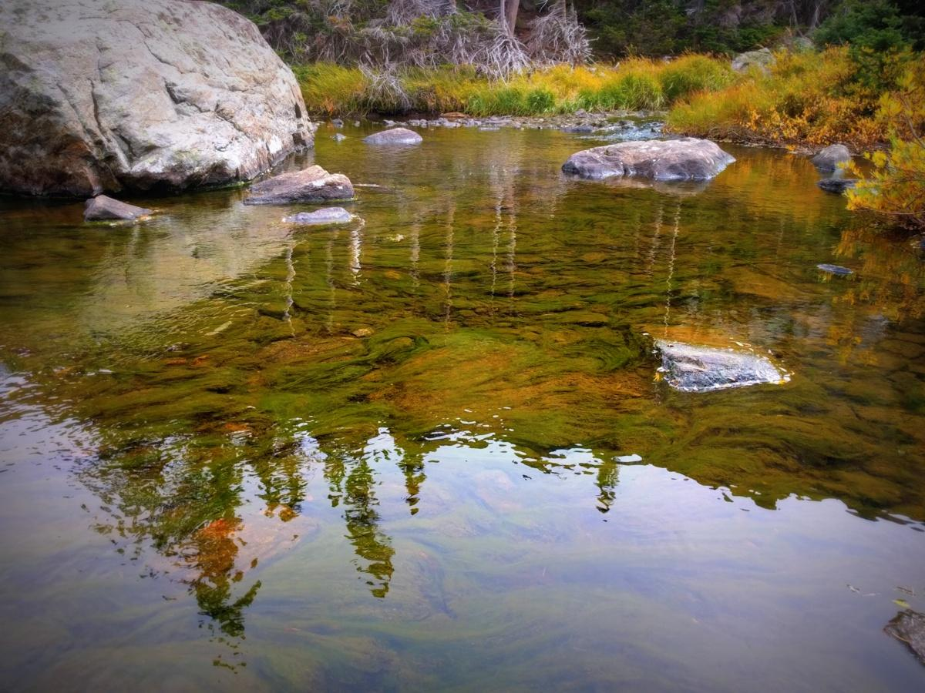
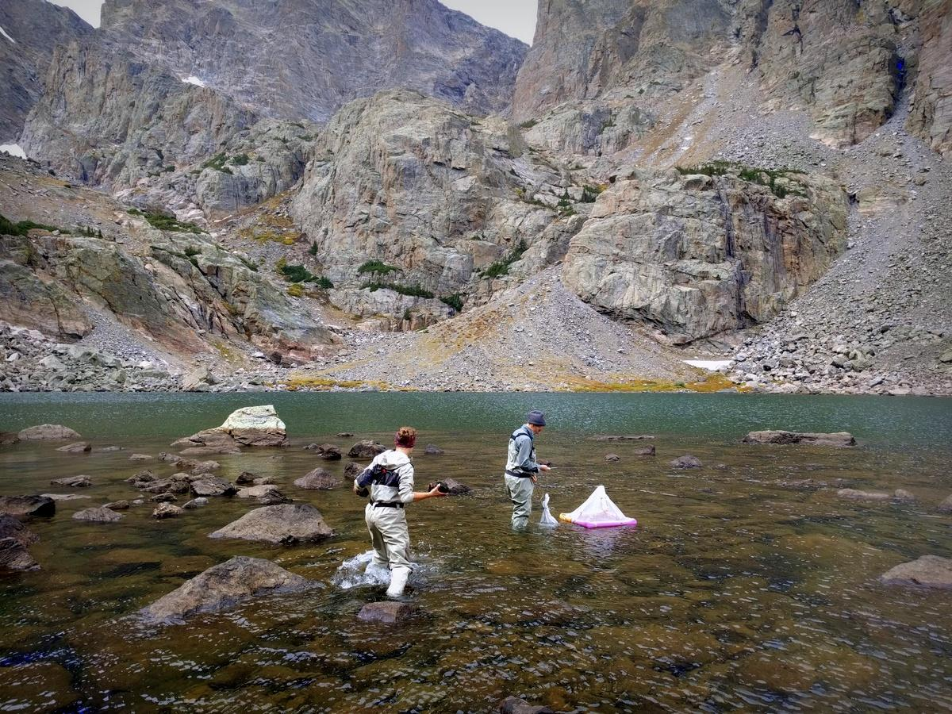
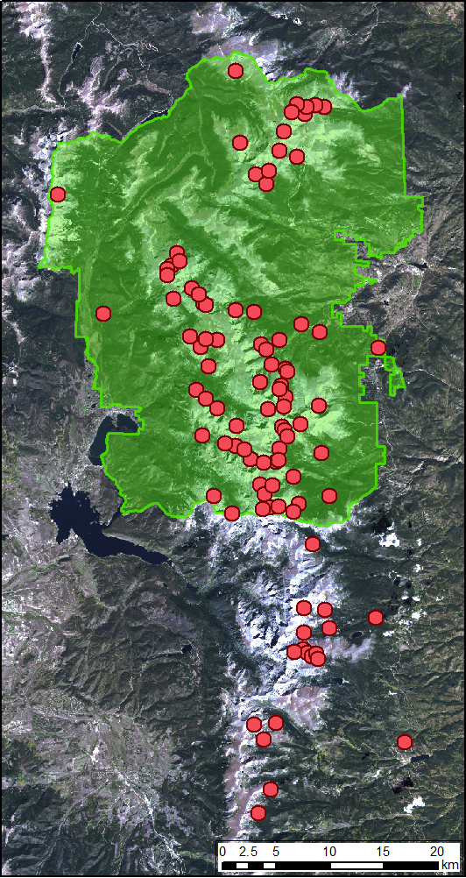
Loch Vale
Sky Pond
Colorado

Figure 1: The extent of lakes in our study area (Rocky Mountain National Park) and two of the case-study lakes (Loch Vale and Sky Pond) used for model validation. Note: Each point represents a lake in the study area. Lakes in the green shaded area fall within Rocky Mountain National Park and lakes outside this region are a part of the USFS land. Image Source: Benjamin Ignac.

2.3 Project Partners & Objectives
This project addressed both the Water Resources and Climate application areas within NASA’s Applied Sciences Program. The project partners and end users are Rocky Mountain National Park, and the USGS, Fort Collins Science Center. The USGS has been conducting a long-term watershed study at RMNP since 1981 to understand natural and anthropogenic ecosystem variability. This study has detected changes in lake conditions, particularly algal growth dynamics. Project partners are exploring potential interactions between climate and chlorophyll-a levels.

The objective of this project was to assess the feasibility of monitoring algal productivity of northern Colorado alpine lakes using Landsat 8 Operational Land Manager (OLI). We explored within- and between-lake heterogeneity of algal abundance to inform aspects of our partners’ future sampling design. Our project will aid the USGS and NPS in algal growth monitoring by expanding the spatiotemporal extent of chlorophyll-a measurements, which can improve understanding of the changes in algal productivity.

3. Methodology
3. 1 Data Acquisition
We downloaded Landsat 8 OLI Surface Reflectance High Level data products from USGS’s Earth Explorer website. Images for June - August in 2014, 2015, and 2016 were selected for the following criteria: 1) Image date fell within seven days on field measurement date (Appendix A) and 2) The lakes with field measurements did not have cloud cover or snow. It should also be noted that all lakes were not necessarily clear in every image.

We downloaded a Colorado lake delineation shapefile from the Colorado Department of Transportation’s website and the RMNP boundary shapefile was provided by the NPS. The USGS Fort Collins Science Center provided field data for Loch Vale and Sky Pond. The National Science Foundation (NSF) supported Niwot Ridge Long-Term Ecological Research project and the University of Colorado Mountain Research Station provided field data for the Green Lake chain and Dr. Pieter Johnson at the University of Colorado at Boulder provided field data for the remainder of lakes in the study area.

3.2 Data Processing
We selected lakes with a minimum distance greater than 120m using the Minimum Bounding Geometry tool in ArcGIS to ensure each lake contained enough 30m by 30m pixels for analysis. Additionally, this shapefile had a coarse delineation of shoreline and we redrew all lakes. The shapefile was then buffered inward 30m using the Buffer tool in ArcGIS to eliminate pixels containing shoreline.

3.2.1. Landsat processing
Landsat 8 OLI images were normalized band-by-band in ArcMap using the Aggregate No Change Regression method in the Rocky Mountain Research Station Raster Utility Toolbar (Hogland, 2005). Normalization was performed as an attempt to decrease spectral differences between dates. A cloud-free image from September 20, 2014 was used as the reference raster, and each of the six images for analysis were normalized to this reference raster. This tool requires the specification of a percent change between the reference raster and the raster to reference. Intervals of change (20%, 40%, 60%, and 80%) between the reference raster and raster to reference were selected, creating four new rasters for each of the seven bands (28 new rasters per date).

To determine if normalization reduced spectral variation between images, 13 spectrally-consistent objects were chosen (i.e. rooftops, intersections, rock outcrops) and the spectral value was extracted using the Extract Multi-point tool in ArcGIS for all normalized rasters. Pixel values for these points were also extracted for the pre-normalized surface reflectance data products as a point of comparison (Appendix B and Appendix C, respectively). The standard deviation was then calculated for each object over time to determine how well the normalization method performed. A larger standard deviation indicates inconsistence between images. The standard deviations for the surface reflectance product were lower than those of the normalized rasters, so the surface reflectance products were used for all analyses (Appendix D).

14 band ratios were chosen from literature on both Landsat 7 Enhanced Thematic Mapper and Landsat 8 OLI (Barrett & Frazier, n.d.; Beck et al., 2016; Theologou et al., 2016; Watanabe et al., 2015; Yang & Anderson, 2016; Appendix E). Many studies assessed multiple ratios across all Landsat bands, which is the method we chose to follow. These ratios were performed on all surface reflectance images. The average pixel value, range, and standard deviation were calculated for each resulting raster using the Zonal Statistics as Table tool in ArcGIS.

3.3. Data Analysis
The feasibility assessment breaks analysis into aggregation of data and the identification of suitable portions of the electromagnetic spectrum that delineate chlorophyll-a values in high alpine lakes. For data aggregation, field data was used both averaged by water column depth and as the surface level measurement. Raster pixel values were averaged near the point of field collection as well as averaged across the whole buffered lake. Four scenarios were created from these categories of aggregation: 1) using pixels averaged over the whole lake and field data averaged by water column depth 2) using pixels averaged over the whole lake and field data collected at the water’s surface, 3) using pixels averaged near the collection point and field data averaged by water column depth, and 4) using pixels averaged near the collection point and field data collected at the water’s surface.

Collection point GPS coordinates for each lake were provided by the respective data providers and a point shapefile was then created with an outward 30m buffer. Using the Extract by Mask tool in ArcGIS, the pixels within this 30m average were extracted and all 14 band ratios were applied separately to create 14 new rasters. We averaged the extracted and newly calculated pixels using the buffered collection point shapefile in the Zonal Statistics as Table tool in ArcGIS, which included information on the range and standard deviation of each lake. This same process was repeated for pixels over the whole lake using the redrawn and buffered shapefile.

To then determine the best sections of the electromagnetic spectrum to use, the average pixel values for each lake were used individually in a Generalized Linear Model (GLM) to test the correlation between a single band ratio with field-measured chlorophyll-a values (either averaged by water column depth or collected from the surface). Model analytics, such as p-value, R², RMSE, and an RMSE scaled to the average field measurement were examined to narrow down predictor variables for a single model. Three band ratios were selected for a multiple linear regression. Model diagnostics were then examined to assess if the assumptions of normality were met. The data used in modeling did not fit the assumptions of normality, so we proceeded with a different statistical model.

Chlorophyll-a values were then modeled using a Random Forests Model (Breiman, 2001) with the randomForest package in RStudio. Predictor variables were chosen by predictor importance and correlated predictor variables were identified. Of correlated pairs, predictor variables in agreement with the literature were chosen: Band 7 (SWIR-2) and Band 5 (NIR)/Band 4 (RED). Models were evaluated based on R², RMSE, and an RMSE scaled to the average field measurement.

Within- and around-lake heterogeneity was examined for lakes over time and location. The average of the average for each lake in each year was calculated. A One-way Analysis of Variance (ANOVA) was then computed to determine if predicted chlorophyll-a values significantly differ between years. Loch Vale, Sky Pond, and Long Lake were selected as case studies for further analysis based on the interest of the project partners. The same statistics were calculated for each lake and an ANOVA was performed to determine if predicted chlorophyll-a significantly varies between lakes. For significant ANOVA’s, a post-hoc Tukey’s Honest Significant Difference (HSD) was performed to determine where the significant differences occur.

4. Results & Discussion
4.1 Analysis of Results
As the linear model tested did not meet assumptions of normality, a Random Forests Model was used for all analyses. This model was tested for four scenarios using two variations on the number of pixels averaged (averaged for the whole lake vs. averaged near the collection point) as well as two variations on depths of field measurements (chlorophyll-a averaged for all depths vs. only surface measurements). For the first point of comparison, averaging the nearest pixels to the collection point yielded better model results using both variations of field measurement (RMSE_{Average-chl} = 3.128 and RMSE_{Surface-chl} = 4.042) than for the pixels averaged across the entire lake (RMSE_{Average-chl} = 3.381 and RMSE_{Surface-chl} = 4.510). This suggests chlorophyll-a varies throughout a single lake and a single average is not the most accurate approximation of algal biomass. Based on these same results, field chlorophyll-a averaged by depth yielded better results than field surface measurements (Table 1). Solar radiation appears to penetrate the water column enough to pick up spectral characteristics of algal biomass beyond surface concentrations.

Table 1: Results from Random Forests models using Band 7 (SWIR-2) and Band 5/Band 4 (NIR/RED) as predictor variables for four scenarios.
Sensitivity Parameters | R² | RMSE | RMSE Scaled*
1 - Collection Point - Average | 0.22 | 3.13 | 56.22%
2 - Collection Point - Surface | -0.03 | 4.05 | 82.52%
3 - Whole Lake - Average | 0.10 | 3.38 | 60.75%
4 - Whole Lake - Surface | -0.29 | 4.51 | 91.92%
*Scaled RMSE = RMSE/field measurement average

The top performing model included pixels averaged near the collection point and predicted chlorophyll-a averaged by depth (RMSE = 3.1). This model was used to predict chlorophyll-a values for every lake in the study area for the years 2014, 2015 and 2016 (n = 84, n = 85, and n = 93, respectively). The average of the average predictions for each lake was calculated. Based on a one-way ANOVA and a post-hoc Tukey’s HSD, predicted chlorophyll-a significantly varies between 2014 and 2015 as well as 2015 and 2016 (F(2, 257) = 31.29, p-value < 0.001; Figure 2). With a significant association, algal biomass to have pulsed over the entire study area in August of 2015. To refine this analysis, three lakes of interest to project partners and data providers were isolated for further testing.

Average of the Average Predicted Chlorophyll-a Values
Across All Lakes in Study Area (2014 - 2016)
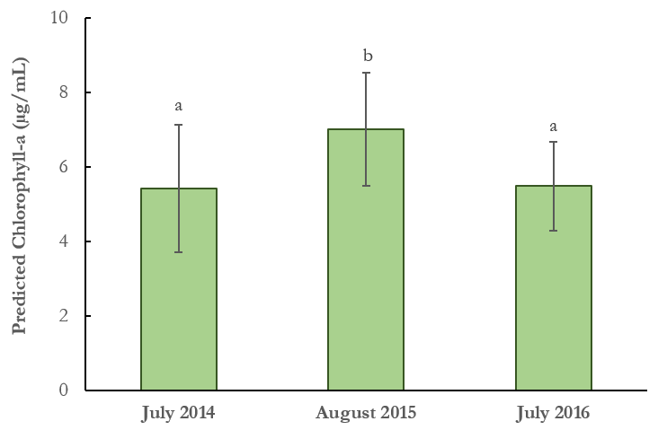
Average Predicted Chl-a (µg/mL)

Figure 2: Average values of the average predicted chlorophyll-a for all lakes in the years 2014 (n = 84), 2015 (n = 85), and 2016 (n = 93). Note: Like letters indicate years that do not significantly differ.

Looking at heterogeneity within a single lake, it is apparent that some lakes vary more than others and each lake does not vary in the same way year-to-year. With Sky Pond, 2014 predicted values were low and had little variation (2.75 ± 0.3 µg/mL). In 2015 and 2016, average predicted values increase, as does the variation between values (7.54 ± 1.5 and 6.14 ± 1.3 µg/mL). Interestingly, Long Lake had its highest level of predicted chlorophyll-a in 2014 (6.38 ± 2.0 µg/mL), while this was the lowest year for both Sky Pond and Loch Vale (Figure 3). These patterns do not match, raising questions as to why some lakes in the park may have received pulses in productivity while others did not.

Predicted Chlorophyll-a Values for
Loch Vale, Sky Pond, and Long Lake (2014 – 2016)

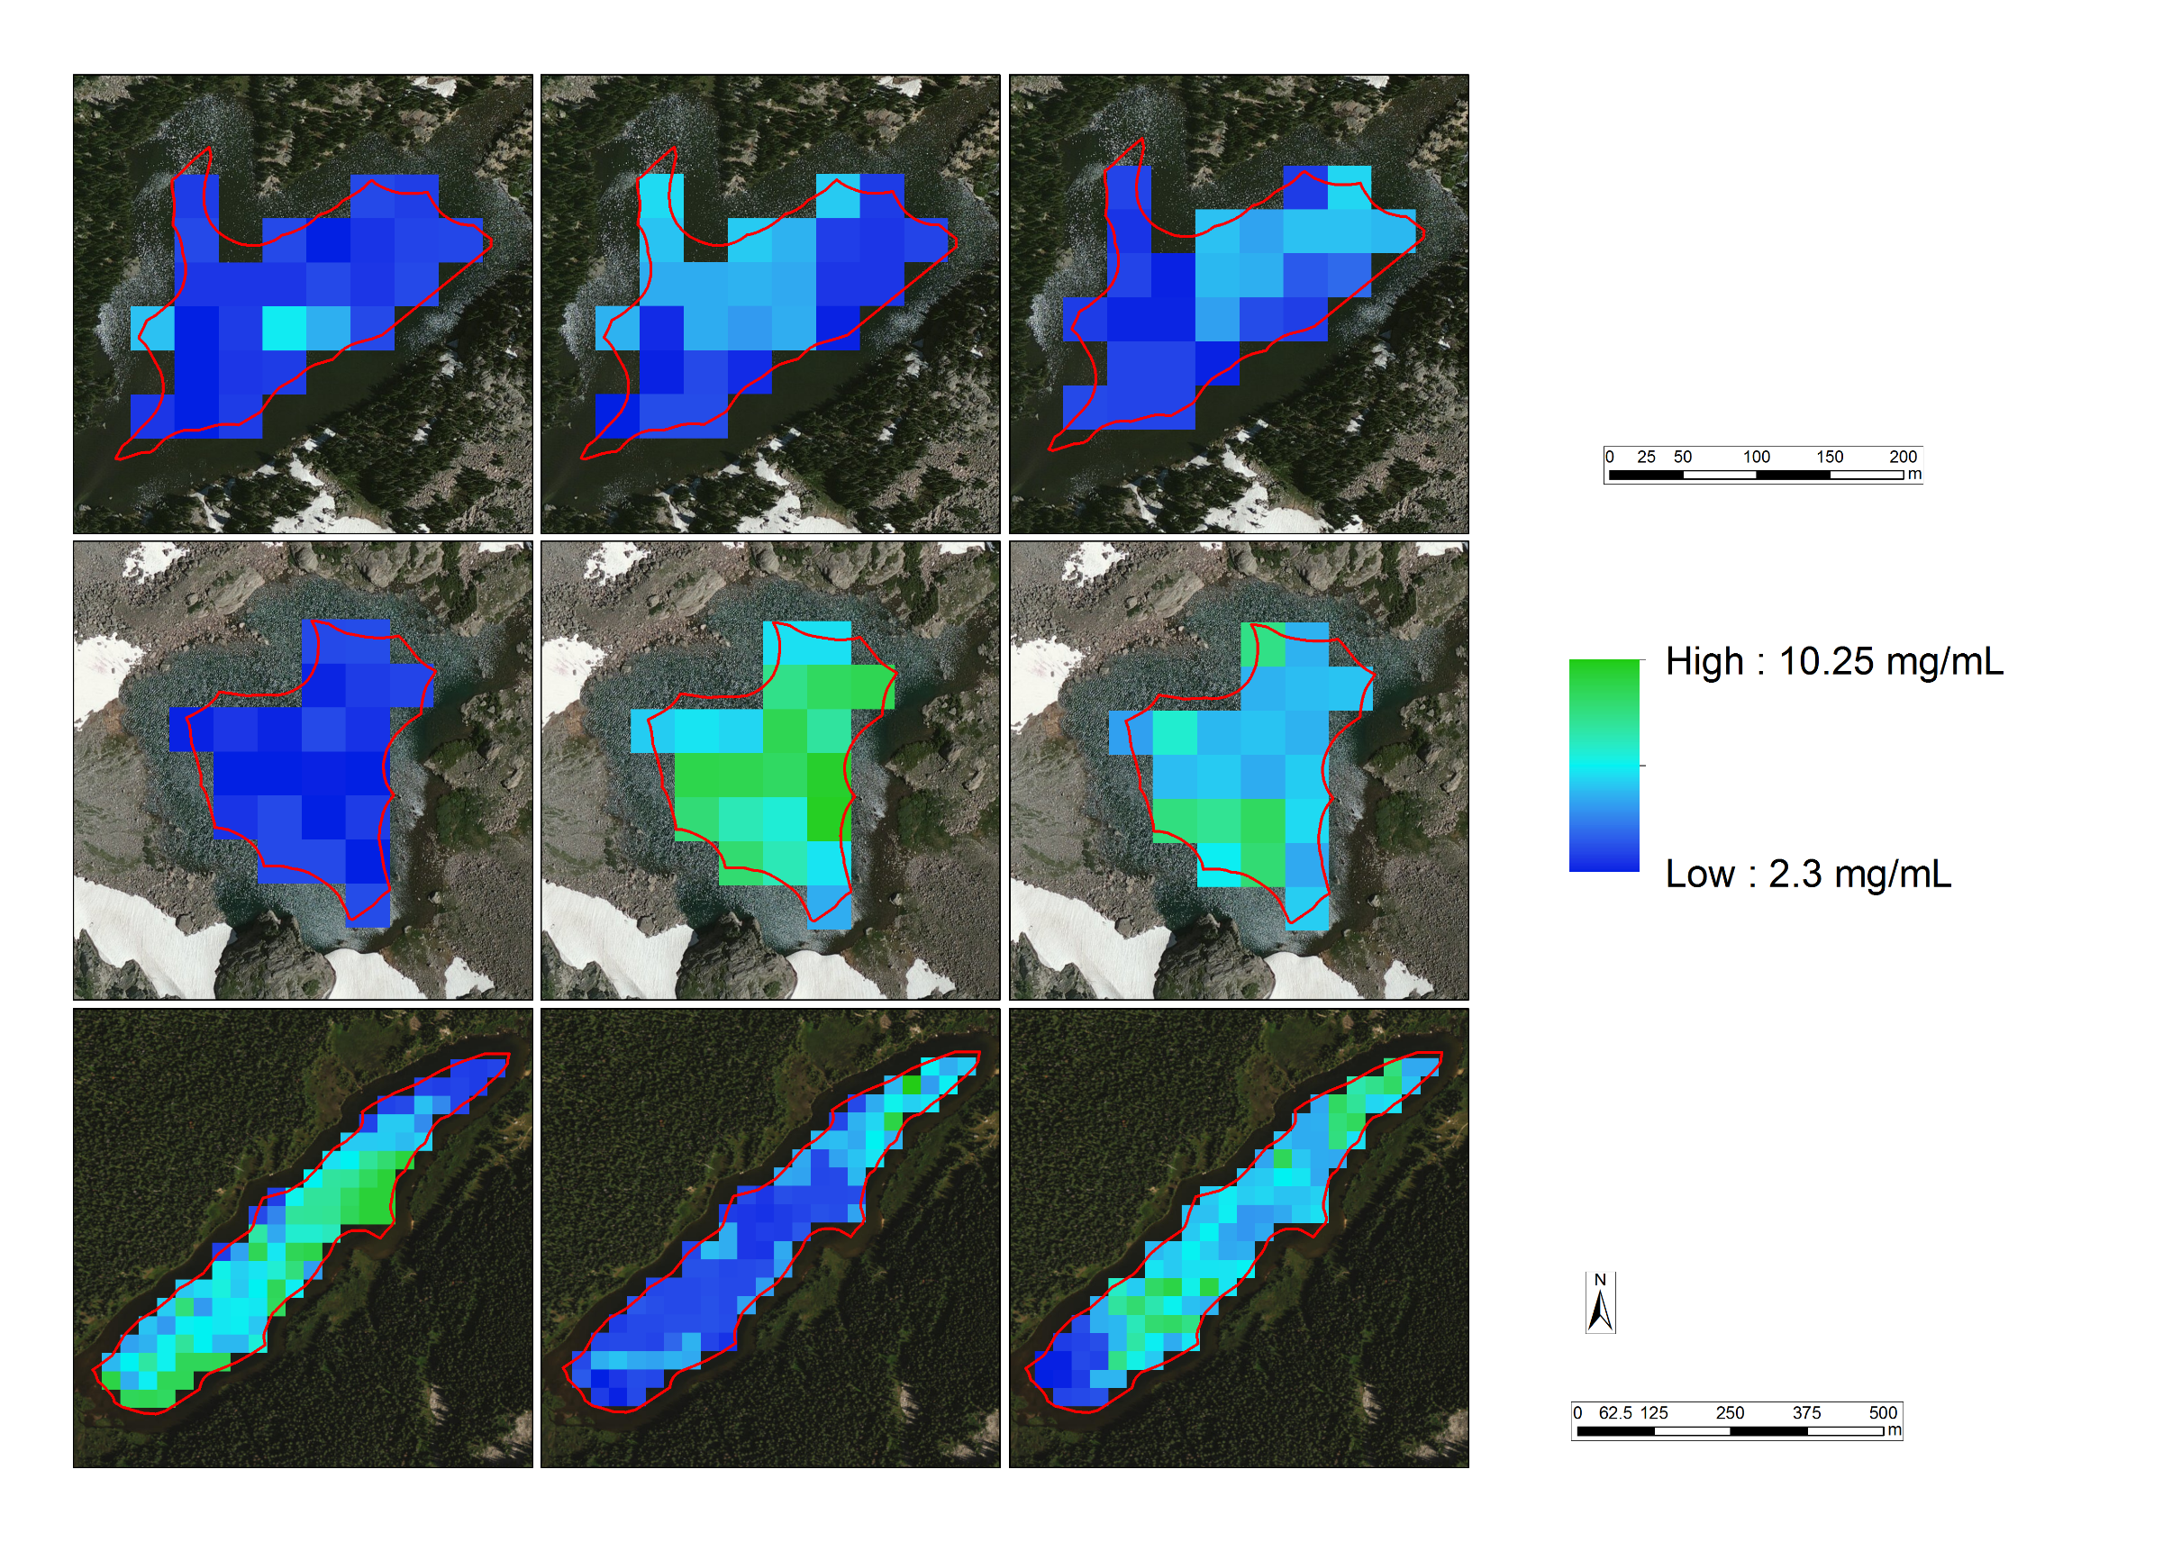
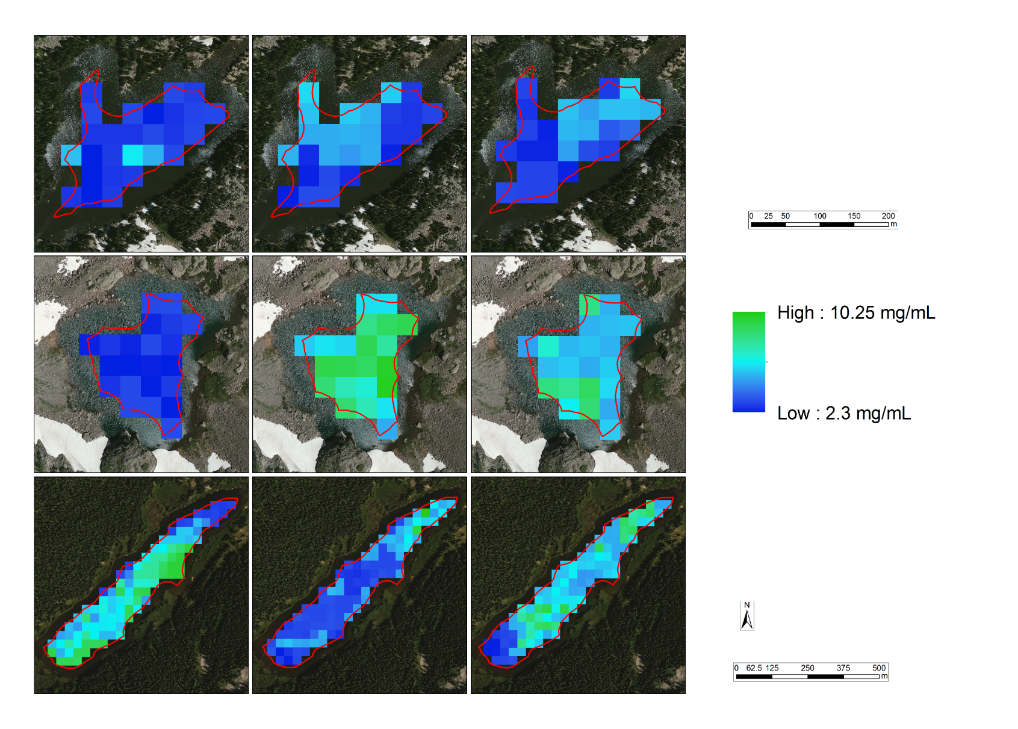
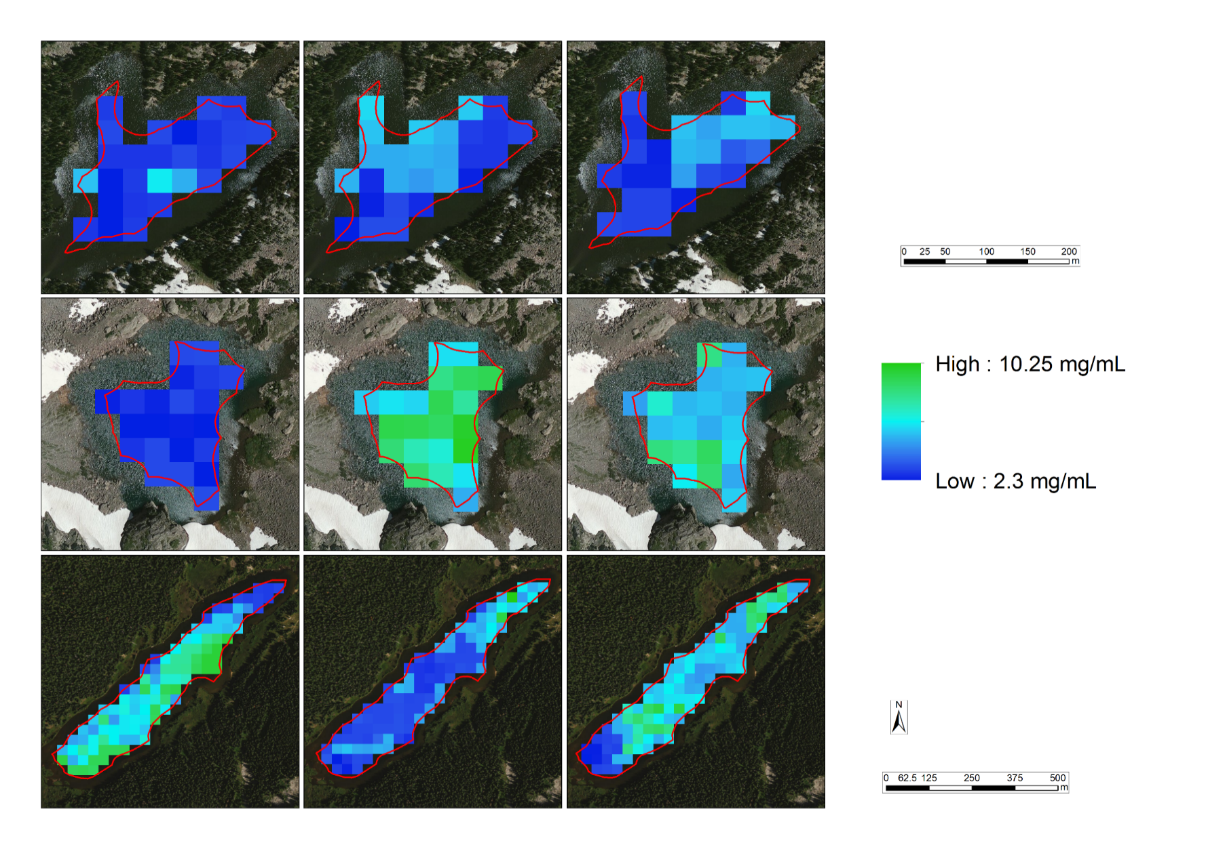
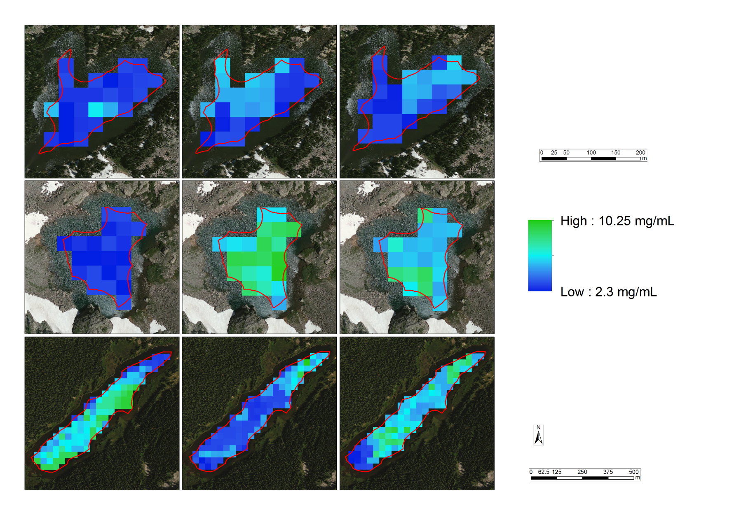
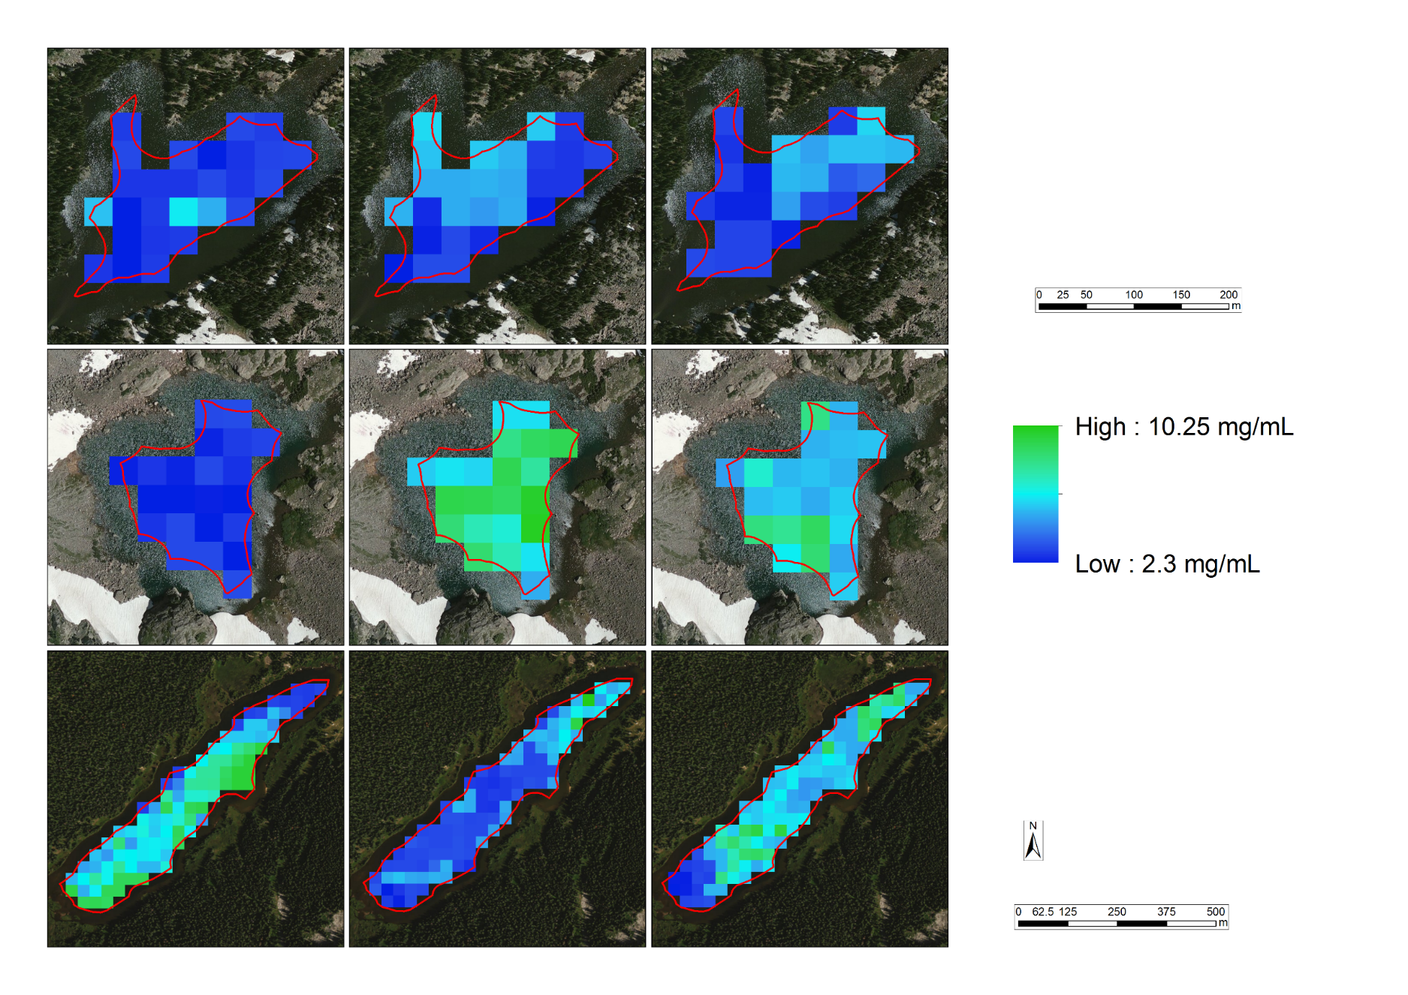
2.75 ± 0.3
2.30
10.25
Long Lake
6.38 ± 2.0
3.98 ± 1.3
5.77 ± 1.7
Sky Pond
7.54 ± 1.5
6.14 ± 1.3
Loch Vale
3.92 ± 1.2
3.71 ± 1.2
3.14 ± 0.9
July 2016
July 2014
August 2015
Chlorophyll-a (µg/mL)

Figure 3: Predicted chlorophyll-a concentrations (µg/mL) for Loch Vale, Sky Pond, and Long Lake. Each lake for each year lists the average predicted value ± standard deviation.

A one-way ANOVA determined the average of the yearly-average predicted chlorophyll-a values do not significantly differ between Loch Vale, Sky Pond, and Long Lake (F(2,6) = 1.304, p-value = 0.339; Figure 3). This analysis was supplemented by comparing field measured chlorophyll-a for Loch Vale and Sky Pond (there was not enough field data to include Long Lake). A t-test determined that these field measurement do significantly differ (p-value < 0.001). It should be noted that the model does predict values toward the mean, eliminating extreme values. The highest and lowest field values are 14.71 and 0.03 µg/mL, respectively, and the highest and lowest predicted values are 10.25 and 2.30 µg/mL, respectively. With both tails of the distribution missing in the predictions, true heterogeneity seems to have been lost in the modeling process. However, the model does still match general trends of field measurements (i.e. Sky Pond chlorophyll-a measurements are generally higher than Loch Vale).

4.2 Limitations
Observing a mountainous area proved to have many challenges. Due to the climatological features of mountain ranges, many images in the summer months included substantial cloud cover. Additionally, the high elevation of the lakes resulted in snow and ice cover in early June images, making some of these unusable. This issue is compounded by Landsat 8’s temporal resolution of 16 days. Similarly, the 30m spatial resolution of Landsat 8 also proved a challenge with such small study area lakes, especially with such optically complex lakes (i.e. shoreline and bottom-of-lake interference). This made predicting chlorophyll-a in lakes without ground-truth field measurements hard to verify.

While the Sentinel-2 MultiSpectral Imager (MSI) does have both higher spatial and temporal resolution, this satellite is new and there were only two usable images available. When cross-referenced with available field measurements, the sample size dropped to 11 from the original 38 and was deemed too small for modeling. However, Sentinel-2 MSI does show promise for future analysis once more images are made available. The inclusion of the red-edge band also shows promise in more accurately isolating chlorophyll-a’s spectral signature. This may be able to supplement prediction where Landsat 8 OLI predicted values toward the mean, excluding the lowest and highest values.

Additionally, three separate field measurement datasets were used. While all data was collected using the same methodology, human error and differences in instrument calibration could have caused error in the model.

5. Conclusions
The feasibility assessment of using Landsat 8 OLI to monitor algal productivity established four findings: 1) the normalization process increased variability between images, 2) the field measurement averaged by depth increased model performance compared to field measurements taken at the surface, 3) aggregating pixels near the collection point yielded higher model statistics compared to pixels average across the whole lake, and 4) a combination of the SWIR-2 Landsat 8 OLI band and the ratio of NIR/RED Landsat 8 OLI bands as predictor variables had the highest correlation to field measured chlorophyll-a.

Analysis of chlorophyll-a predicted by the model did show significant temporal heterogeneity. A one-way ANOVA with averages of the average predicted values of all lakes in 2014, 2015, and 2016 concluded that the year 2015 was significantly higher than the years 2014 and 2016. However, once looking at the three case-study lakes for spatial heterogeneity, no significant differences were found between Loch Vale, Sky Pond, and Long Lake. Landsat 8 OLI seems to have a saturation point where predicted chlorophyll-a values missed the high and low field measurements, which may explain the lack of spatial heterogeneity. Exploring the applicability of Sentinel-2 MSI could alleviate these shortcomings. Although the use Landsat 8 OLI data in modeling did produce coarse approximations of chlorophyll-a, it is still valuable for general spatiotemporal trends.
Overall, the model produced gives an indication of chlorophyll-a levels in all study area lakes. It is possible to examine lakes in space and time on a larger scale than has been possible with field measurements. With this, researchers may add to their body of knowledge on algal growth dynamics in the northern Front Range alpine lakes. This will aid the project partners’ capacity to discern underlying factors creating these dynamics.

6. Acknowledgments
This project was made possible through support and mentorship of select individuals and organizations:

- Dr. Paul Evangelista, Colorado State University, Natural Resource Ecology Laboratory
- Dr. Amanda West, Colorado State University, Natural Resource Ecology Laboratory
- Tony Vorster, Colorado State University, Natural Resource Ecology Laboratory
- Brian Woodward, NASA DEVELOP Fort Collins Center Lead
- Bella Oleksy, Colorado State University
- Dr. Pieter Johnson, University of Colorado at Boulder
- Dr. Hope Humphries, Niwot Ridge Long-Term Ecological Research project and the University of Colorado Mountain Research Station

Any opinions, findings, and conclusions or recommendations expressed in this material are those of the author(s) and do not necessarily reflect the views of the National Aeronautics and Space Administration.

This material is based upon work supported by NASA through contract NNL11AA00B and cooperative agreement NNX14AB60A.

7. References
Baron, J. S. (2006). Hindcasting Nitrogen Deposition To Determine An Ecological Critical Load. Ecological Applications, 16(2), 433–439. https://doi.org/10.1890/1051-0761(2006)016[0433:HNDTDA]2.0.CO;2
Barrett, D. C., & Frazier, A. E. (n.d.). Automated Method for Monitoring Water Quality Using Landsat Imagery. https://doi.org/10.3390/w8060257
Beck, R., Zhan, S., Liu, H., Tong, S., Yang, B., Xu, M., … Su, H. (2016). Comparison of satellite reflectance algorithms for estimating chlorophyll-a in a temperate reservoir using coincident hyperspectral aircraft imagery and dense coincident surface observations. Remote Sensing of Environment, 178, 15–30. https://doi.org/10.1016/j.rse.2016.03.002
Berry, J. A., Frankenberg, C., & Wennberg, P. (n.d.). New Methods for Measurements of Photosynthesis from Space.
Breiman, L. (2001). Random Forests. Machine Learning, 45(1), 5–32. https://doi.org/10.1023/A:1010933404324
Compton, J. E., Harrison, J. A., Dennis, R. L., Greaver, T. L., Hill, B. H., Jordan, S. J., … Campbell, H. V. (2011). Ecosystem services altered by human changes in the nitrogen cycle: a new perspective for US decision making. Ecology Letters, 14(8), 804–815. https://doi.org/10.1111/j.1461-0248.2011.01631.x
Dörnhöfer, K., & Oppelt, N. (2016). Remote sensing for lake research and monitoring - Recent advances. Ecological Indicators. https://doi.org/10.1016/j.ecolind.2015.12.009
Hogland, J. (2005). Creating Spatial Probability Distributions for Longleaf Pine Ecosystems Across East Mississippi, Alabama, the Panhandle of Florida, and West Georgia.
Howarth, R., Anderson, D., Cloern, J., Elfring, C., Hopkinson, C., Lapointe, B., … Walker, D. (2000). Nutrient Pollution of Coastal Rivers, Bays, and Seas. Issues in Ecology, 7.
Mast, M. A., Drever, J. I., & Baron, J. (1990). Chemical Weathering in the Loch Vale Watershed, Rocky Mountain National Park, Colorado. Water Resources Research, 26(12), 2971–2978. https://doi.org/10.1029/WR026i012p02971
O’Neil, J. M., Davis, T. W., Burford, M. A., & Gobler, C. J. (2012). The rise of harmful cyanobacteria blooms: The potential roles of eutrophication and climate change. Harmful Algae, 14, 313–334. https://doi.org/10.1016/j.hal.2011.10.027
O’Reilly, C. M., Sharma, S., Gray, D. K., Hampton, S. E., Read, J. S., Rowley, R. J., … Zhang, G. (2015). Rapid and highly variable warming of lake surface waters around the globe. Geophysical Research Letters, 42(24), 10,773-10,781. https://doi.org/10.1002/2015GL066235
Paerl, H. W., Hall, N. S., Peierls, B. L., & Rossignol, K. L. (2014). Evolving Paradigms and Challenges in Estuarine and Coastal Eutrophication Dynamics in a Culturally and Climatically Stressed World. Estuaries and Coasts, 37(2), 243–258. https://doi.org/10.1007/s12237-014-9773-x
Ryther, J. H., & Dunstan, W. M. (1971). Nitrogen, Phosphorus, and Eutrophication in the Coastal Marine Environment. Science, 171(3975).
Sheibley, R. W., Enache, M., Swarzenski, P. W., Moran, P. W., & Foreman, J. R. (2014). Nitrogen Deposition Effects on Diatom Communities in Lakes from Three National Parks in Washington State. Water, Air, and Soil Pollution, 225(2), 1857. https://doi.org/10.1007/s11270-013-1857-x
Smith, V. H., Tilman, G. D., & Nekola, J. C. (1999). Eutrophication: impacts of excess nutrient inputs on freshwater, marine, and terrestrial ecosystems. Environmental Pollution, 100(1), 179–196. https://doi.org/10.1016/S0269-7491(99)00091-3
Theologou, I., Kagalou, I., Papadopoulou, M. P., & Karantzalos, K. (2016). Multitemporal Mapping of Chlorophyll–α in Lake Karla from High Resolution Multispectral Satellite data. Environmental Processes, 3(3), 681–691. https://doi.org/10.1007/s40710-016-0163-1
U.S. Environmental Protection Agency, O. of W. (2015). A Compilation of Cost Data Associated with the Impacts and Control of Nutrient Pollution. Retrieved from https://www.epa.gov/sites/production/files/2015-04/documents/nutrient-economics-report-2015.pdf
Watanabe, F., Alcântara, E., Rodrigues, T., Imai, N., Barbosa, C., & Rotta, L. (2015). Estimation of Chlorophyll-a Concentration and the Trophic State of the Barra Bonita Hydroelectric Reservoir Using OLI/Landsat-8 Images. International Journal of Environmental Research and Public Health, 12(9), 10391–10417. https://doi.org/10.3390/ijerph120910391
Wolfe, A. P., Van Gorp, A. C., & Baron, J. S. (2003). Recent ecological and biogeochemical changes in alpine lakes of Rocky Mountain National Park (Colorado, USA): a response to anthropogenic nitrogen deposition. Geobiology, 1(2), 153–168. https://doi.org/10.1046/j.1472-4669.2003.00012.x
Yang, Z., & Anderson, Y. (2016). Estimating Chlorophyll-A Concentration in a Freshwater Lake Using Landsat 8 Imagery. Journal of Environment and Earth Science, 6(4).

8. Content Innovation
Content Innovation #1
VPS
(https://youtu.be/uKKcqIaaebo?list=PLL8pCbx5gnDaUglEO0269LJ95zp4r63V4)

Content Innovation #2
Interactive Map Viewer
ArcGIS Story Map (https://uok.maps.arcgis.com/apps/Cascade/index.html?appid=61cae58450ac4cfdb06bc5a09fe8a73b)

Content Innovation #3
Inline Supplementary Material
- Appendix A
- Appendix B
- Appendix C
- Appendix D
- Appendix E
- Appendix F

9. Appendices
Appendix A: Field Data and Satellite Imagery Pairings
Table 2: List of field measurement date, Landsat 8 OLI date, and the number of days between each date.
Field Date | Imagery Date | Difference in Dates
8/5/2014 | 8/3/2014 | 2
8/6/2015 | 8/6/2015 | 0
8/11/2015 | 8/6/2015 | 5
5/31/2016 | 6/5/2016 | 5
6/15/2016 | 6/21/2016 | 6
6/20/2016 | 6/21/2016 | 1
6/21/2016 | 6/21/2016 | 0
6/22/2016 | 6/21/2016 | 1
6/23/2016 | 6/21/2016 | 2
6/23/2016 | 6/21/2016 | 2
6/27/2016 | 6/21/2016 | 6
6/28/2016 | 6/21/2016 | 7
7/5/2016 | 7/7/2016 | 2
7/5/2016 | 7/7/2016 | 3
7/5/2016 | 7/7/2016 | 3
7/6/2016 | 7/7/2016 | 2
7/7/2016 | 7/7/2016 | 0
7/7/2016 | 7/7/2016 | 0
7/11/2016 | 7/7/2016 | 3
7/11/2016 | 7/7/2016 | 3
7/13/2016 | 7/7/2016 | 5
7/13/2016 | 7/7/2016 | 5
7/15/2016 | 7/7/2016 | 7
7/18/2016 | 7/23/2016 | 5
7/20/2016 | 7/23/2016 | 3
7/21/2016 | 7/23/2016 | 2
7/21/2016 | 7/23/2016 | 2
7/21/2016 | 7/23/2016 | 2
7/25/2016 | 7/23/2016 | 2
7/26/2016 | 7/23/2016 | 3
7/26/2016 | 7/23/2016 | 3
7/27/2016 | 7/23/2016 | 4
7/27/2016 | 7/23/2016 | 4
7/28/2016 | 7/23/2016 | 5
7/28/2016 | 7/23/2016 | 5
7/29/2016 | 7/23/2016 | 6
7/29/22016 | 7/23/2016 | 6
8/6/2015 | 8/6/2015 | 0
Appendix B: Spectrally Consistent Points of Normalized Images


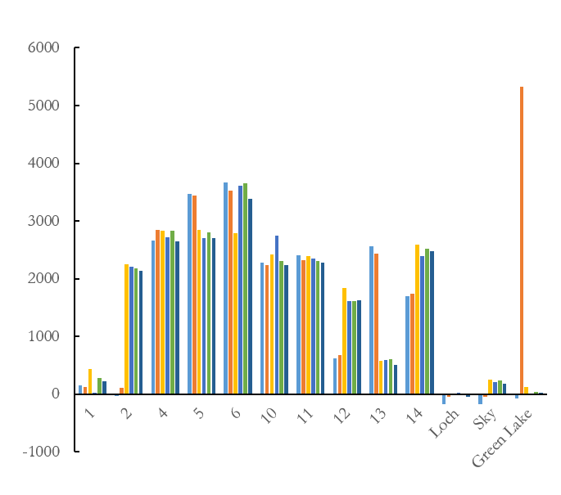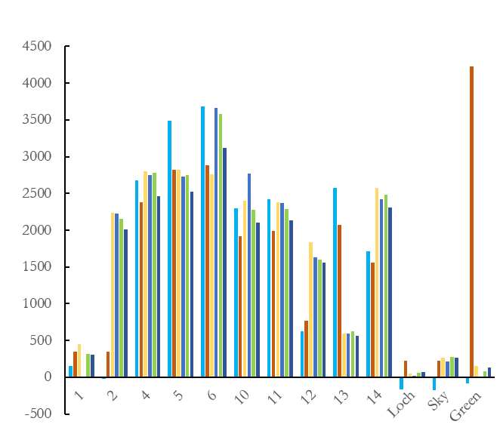
Band 1 – 40 % Change
Band 1 – 20 % Change
Flat bars = consistent over time
Pixel Value

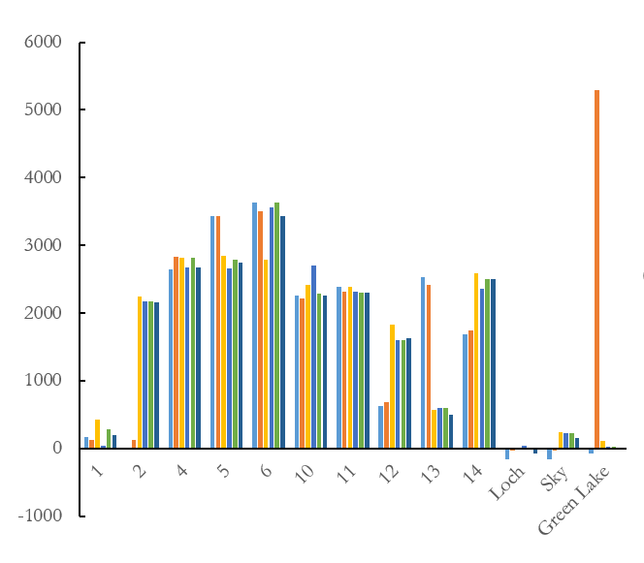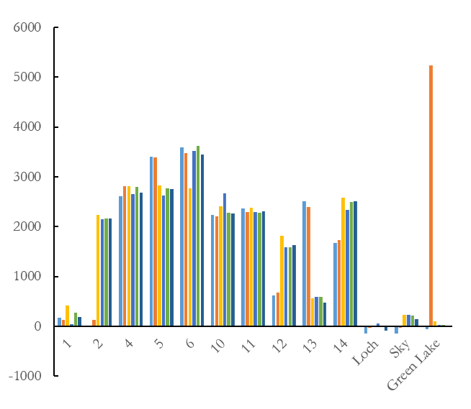
Spectrally Consistent Points and Study Lakes
Band 1 – 80 % Change
Band 1 – 60 % Change

Figure 4.1: 10 spectrally consistent points (i.e. rooftops, intersections, rock outcroppings) for each percent change between reference raster and raster to reference for Landsat 8 OLI Band 1 (Coastal/aerosol). Note: Three lakes are chosen for comparison.

Appendix B (continued): Spectrally Consistent Points of Normalized Images

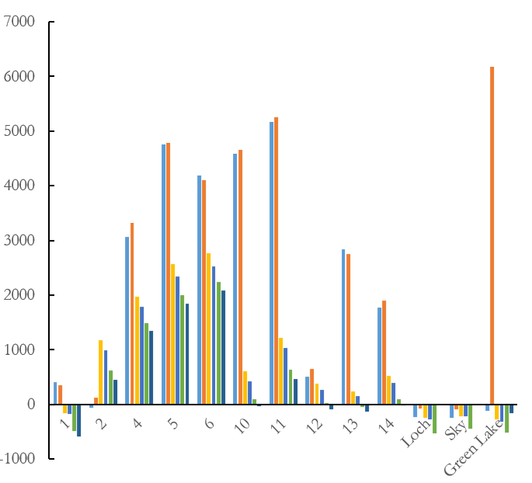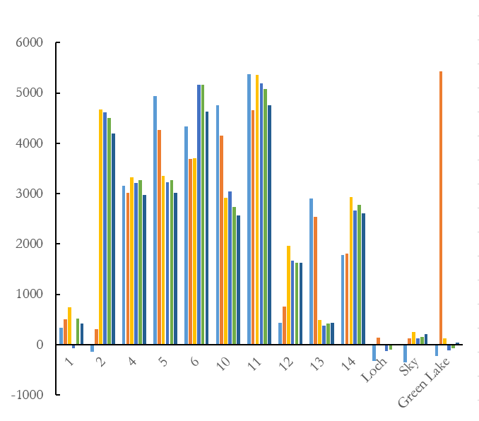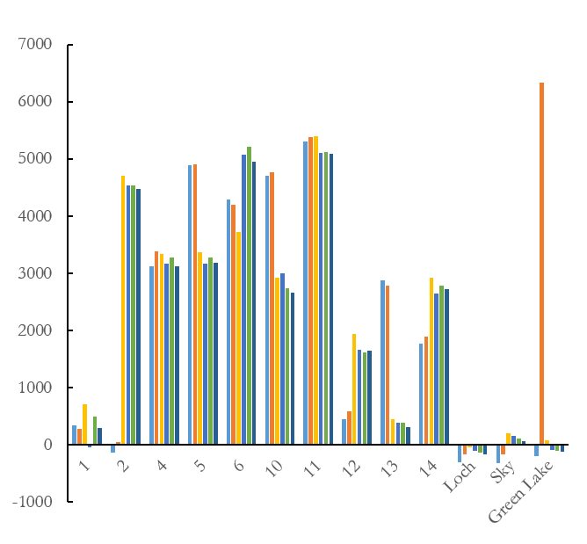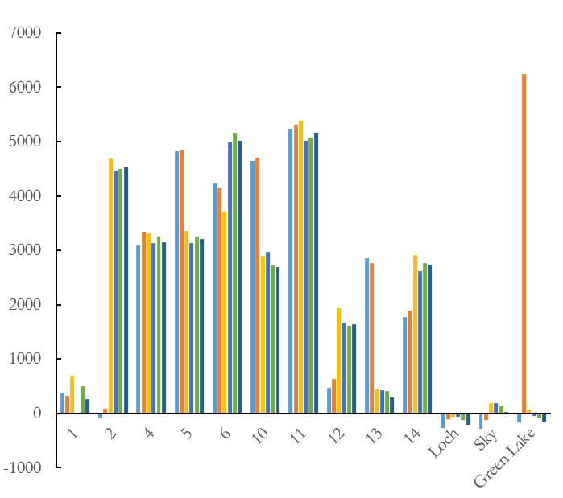
Spectrally Consistent Points and Study Lakes
Pixel Value
Band 2 – 60 % Change
Band 2 – 80 % Change
Band 2 – 40 % Change
Band 2 – 20 % Change

Figure 4.2: 10 spectrally consistent points (i.e. rooftops, intersections, rock outcroppings) for each percent change between reference raster and raster to reference for Landsat 8 OLI Band 2 (Blue). Note: Three lakes are chosen for comparison.

Appendix B (continued): Spectrally Consistent Points of Normalized Images

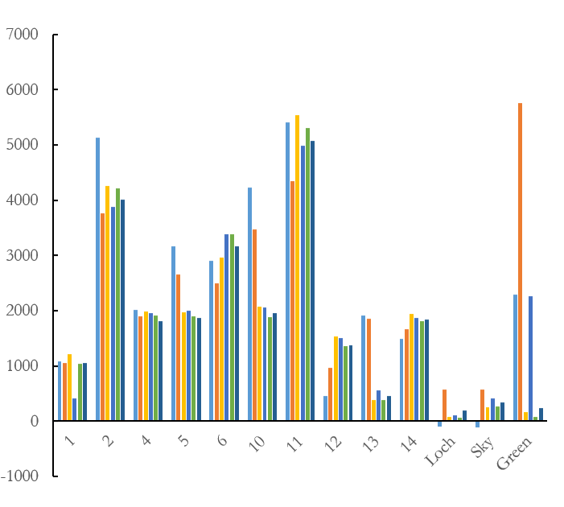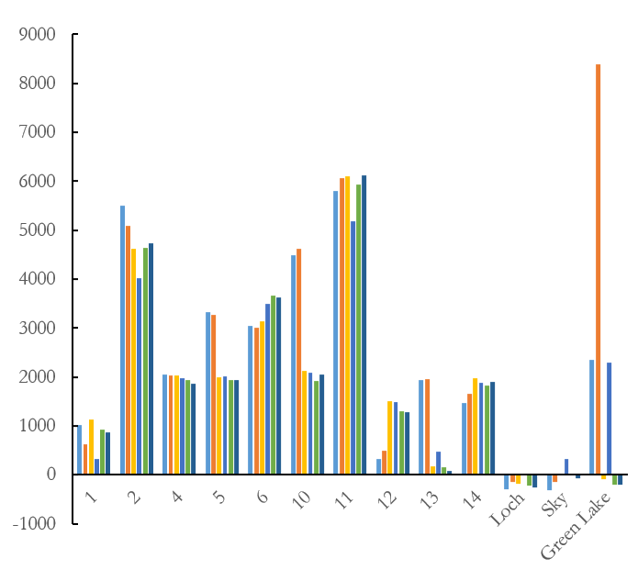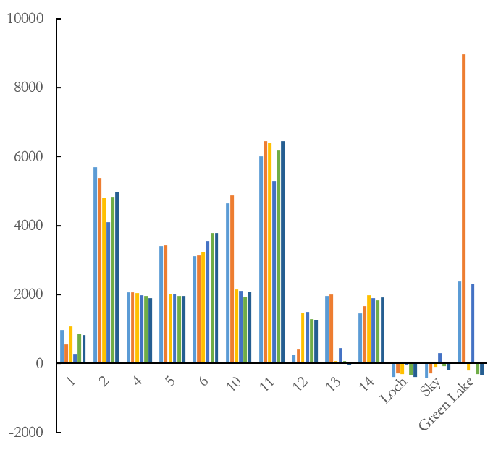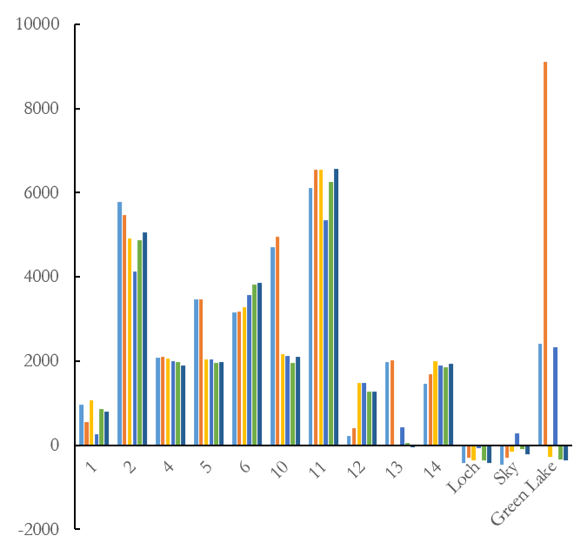
Pixel Value
Band 3 – 80 % Change
Band 3 – 60 % Change
Band 3 – 40 % Change
Band 3 – 20 % Change
Spectrally Consistent Points and Study Lakes

Figure 4.3: 10 spectrally consistent points (i.e. rooftops, intersections, rock outcroppings) for each percent change between reference raster and raster to reference for Landsat 8 OLI Band 3 (Green). Note: Three lakes are chosen for comparison.

Appendix B (continued): Spectrally Consistent Points of Normalized Images

Band 4 – 40 % Change
Band 4 – 20 % Change

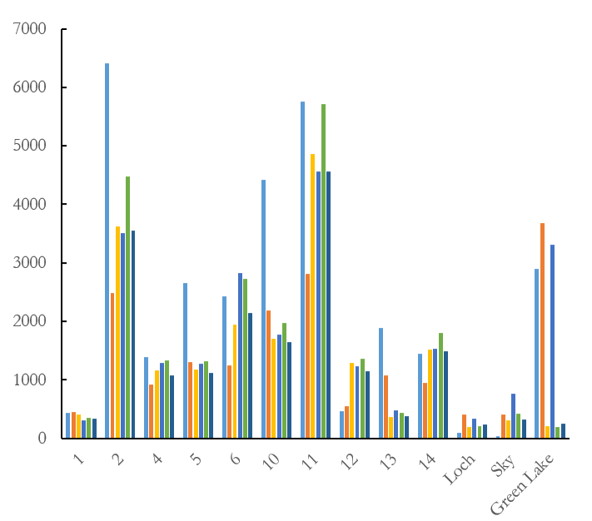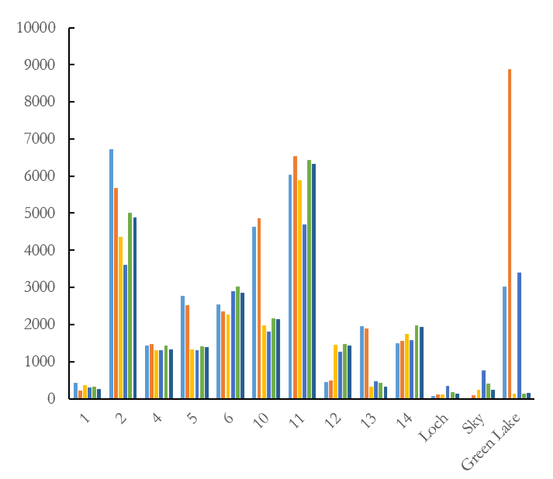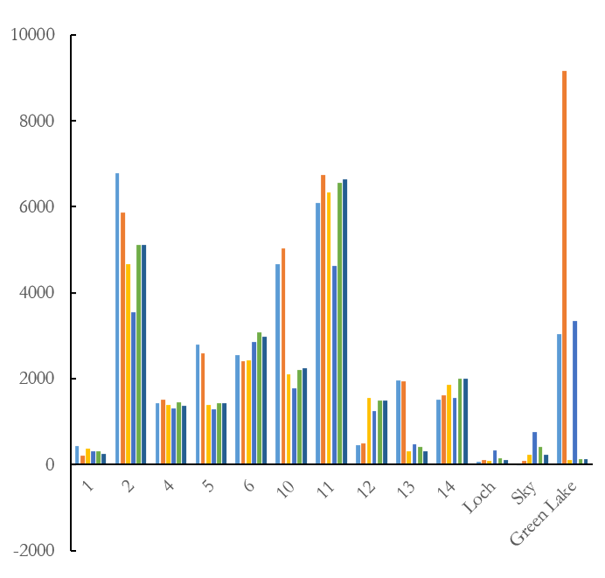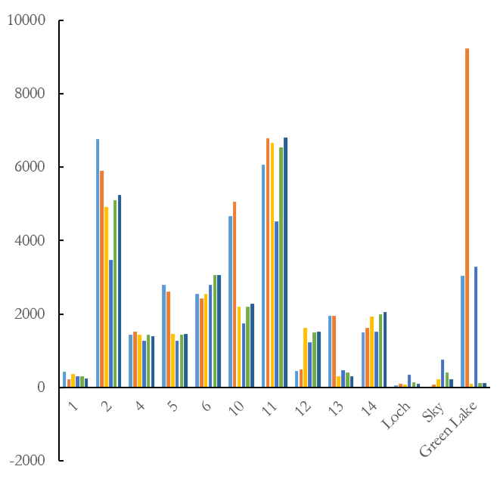
Spectrally Consistent Points and Study Lakes
Pixel Value
Band 4 – 80 % Change
Band 4 – 60 % Change

Figure 4.4: 10 spectrally consistent points (i.e. rooftops, intersections, rock outcroppings) for each percent change between reference raster and raster to reference for Landsat 8 OLI Band 4 (Red). Note: Three lakes are chosen for comparison.
Appendix B (continued): Spectrally Consistent Points of Normalized Images

Band 5 – 40 % Change
Band 5 – 20 % Change
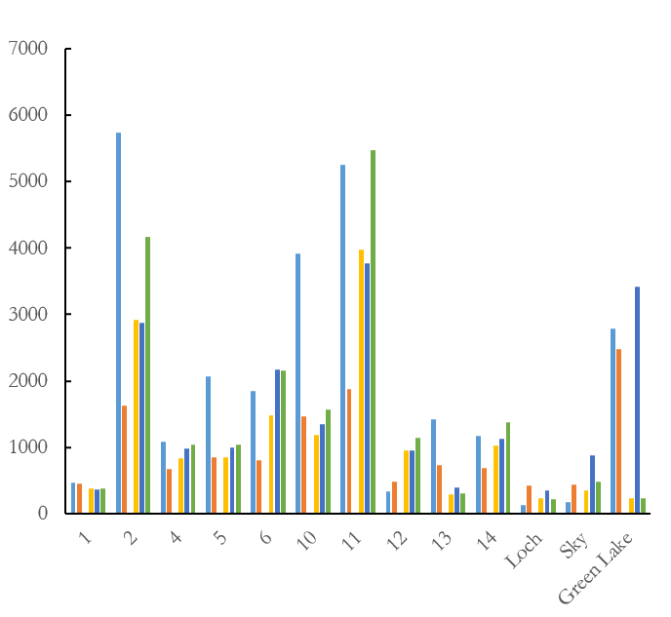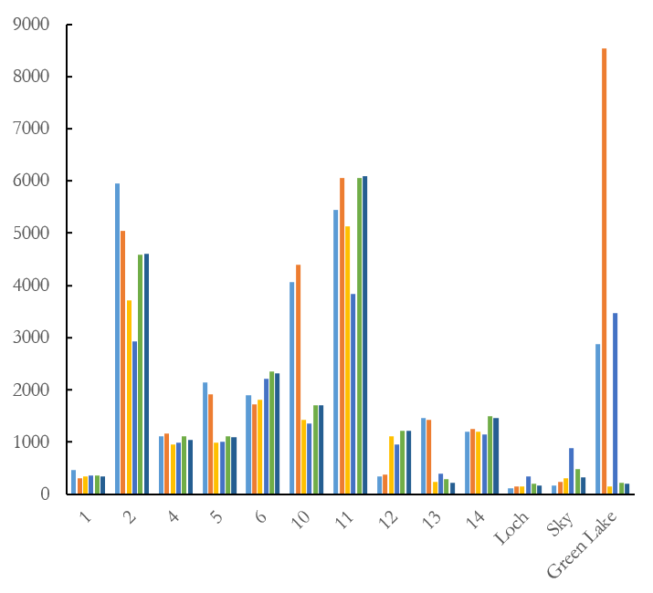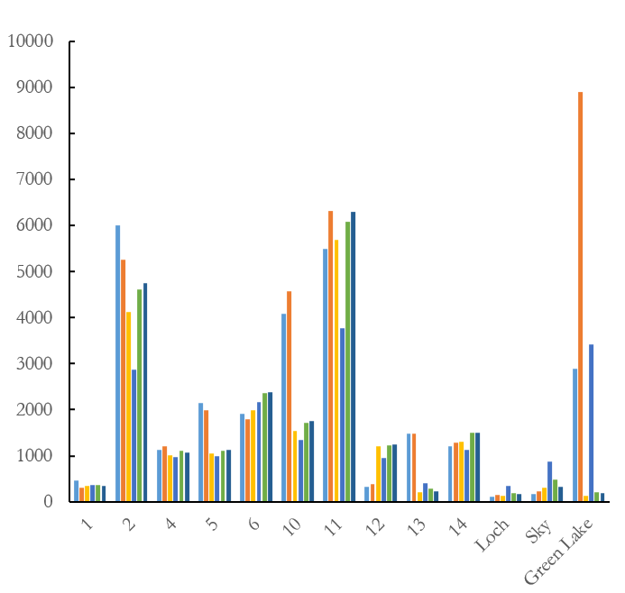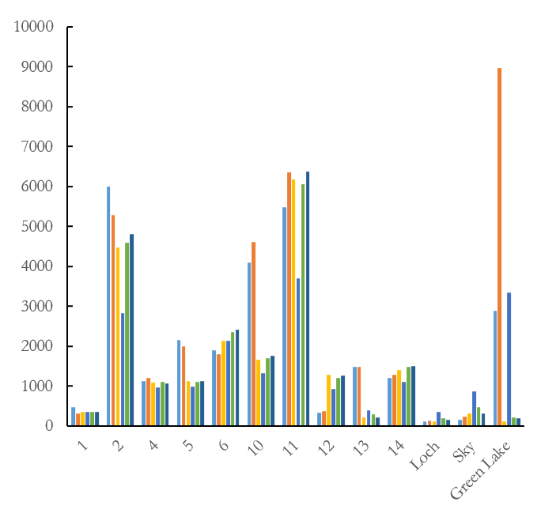
Pixel Value
Band 5 – 80 % Change
Band 5 – 60 % Change
Spectrally Consistent Points and Study Lakes

Figure 4.5: 10 spectrally consistent points (i.e. rooftops, intersections, rock outcroppings) for each percent change between reference raster and raster to reference for Landsat 8 OLI Band 5 (NIR). Note: Three lakes are chosen for comparison.

Appendix B (continued): Spectrally Consistent Points of Normalized Images
Band 6 – 40 % Change
Band 6 – 20 % Change

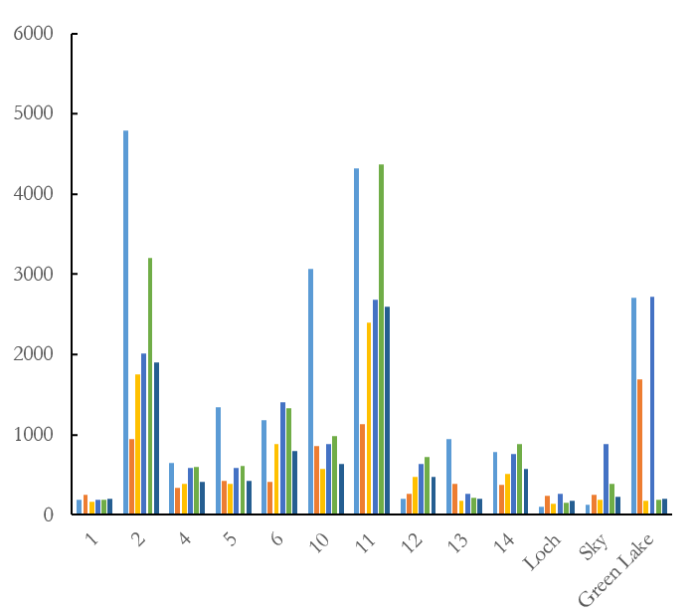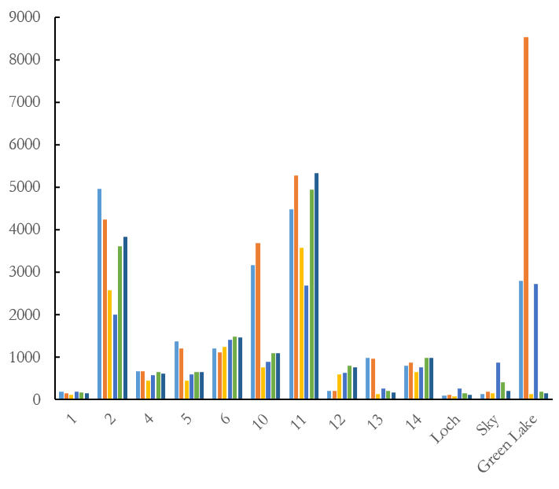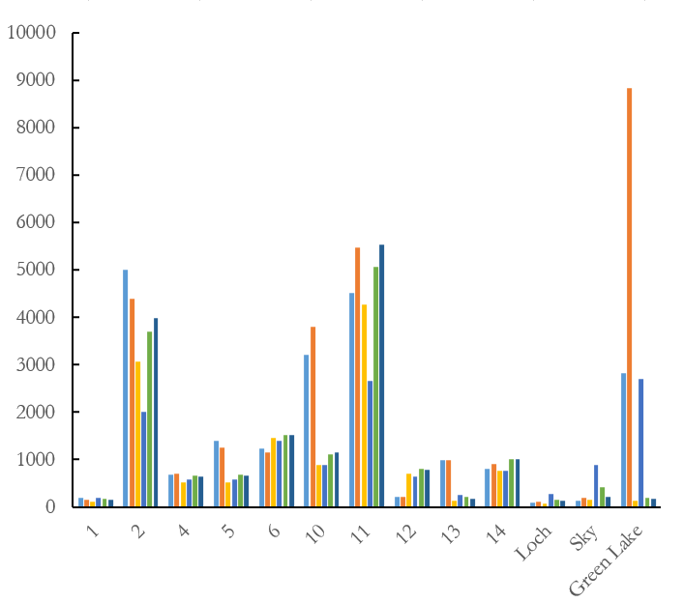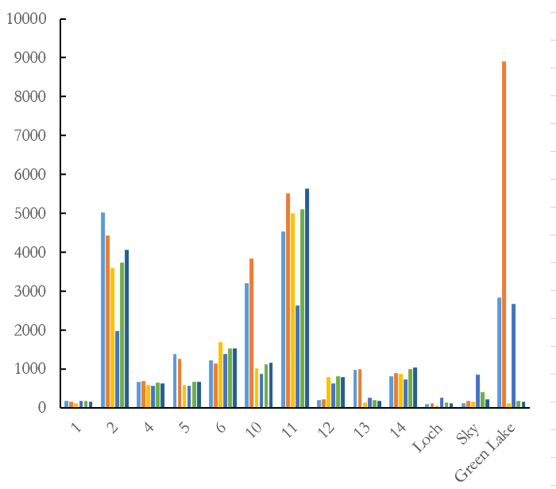
Spectrally Consistent Points and Study Lakes
Band 6 – 60 % Change
Band 6 – 80 % Change
Pixel Value

Figure 4.6: 10 spectrally consistent points (i.e. rooftops, intersections, rock outcroppings) for each percent change between reference raster and raster to reference for Landsat 8 OLI Band 6 (SWIR-1). Note: Three lakes are chosen for comparison.

Appendix B (continued): Spectrally Consistent Points of Normalized Images
Band 7 – 20 % Change

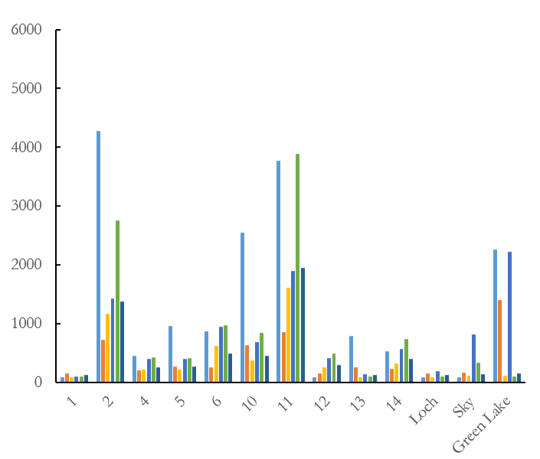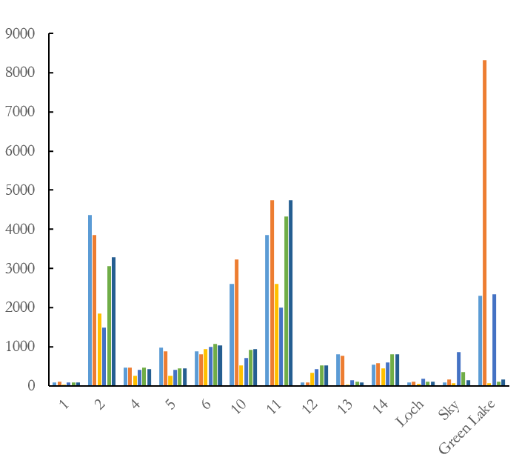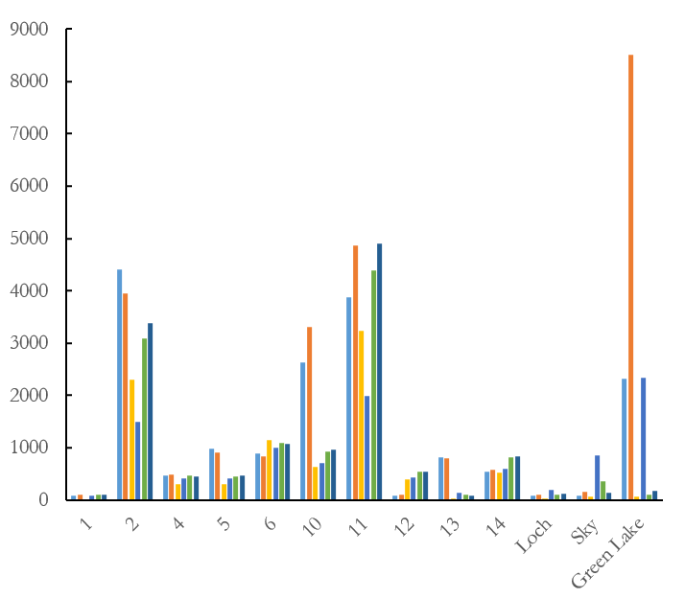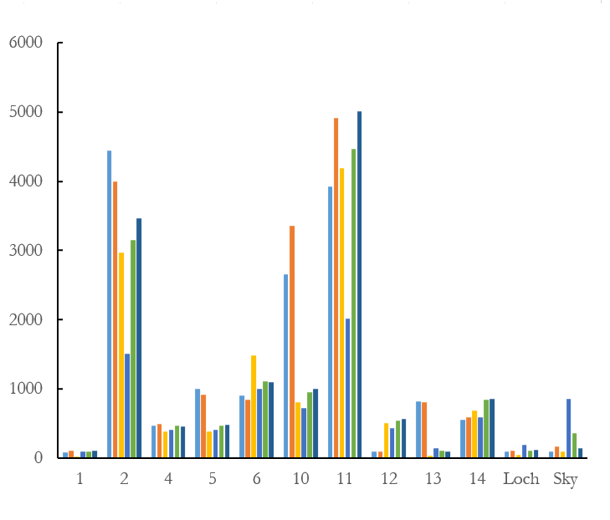
Pixel Value
Band 7 – 60 % Change
Band 7 – 80 % Change
Band 7 – 40 % Change
Spectrally Consistent Points and Study Lakes

Figure 4.7: 10 spectrally consistent points (i.e. rooftops, intersections, rock outcroppings) for each percent change between reference raster and raster to reference for Landsat 8 OLI Band 7 (SWIR-2). Note: Three lakes are chosen for comparison.

Appendix C: Spectrally Consistent Points of Surface Reflectance Images

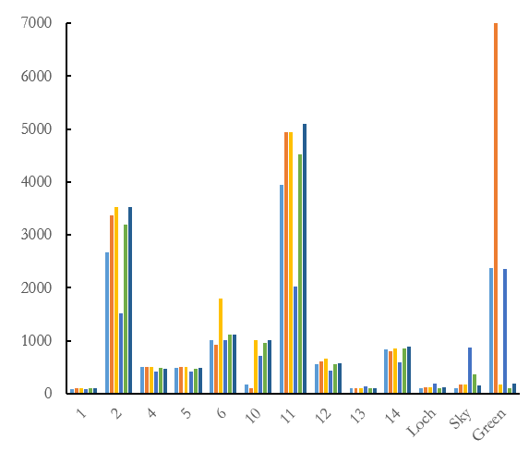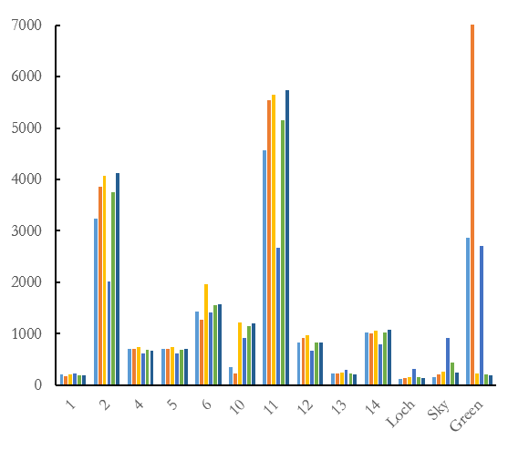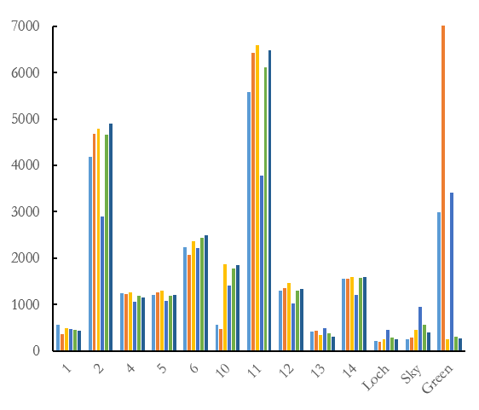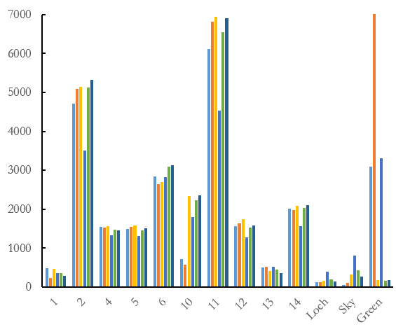
Pixel Value
Band 2
Band 1
Flat bars = consistent over time
Band 4
Band 3
Spectrally Consistent Points and Study Lakes

Figure 5.1: 10 spectrally consistent points (i.e. rooftops, intersections, rock outcroppings) for the Landsat 8 OLI Surface Reflectance images, particularly Band 1 (Coastal/aerosol), Band 2 (Blue), Band 3 (Red), and Band 4 (Red). Note: Three lakes are chosen for comparison.

Appendix C (continued): Spectrally Consistent Points of Surface Reflectance Images

Band 5
Band 6
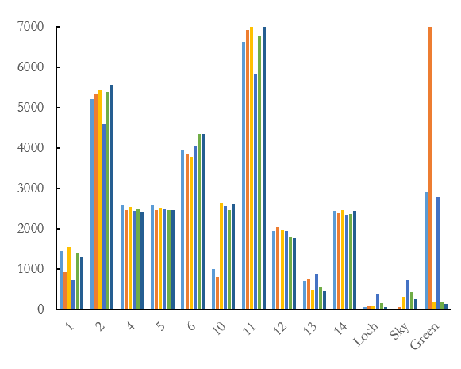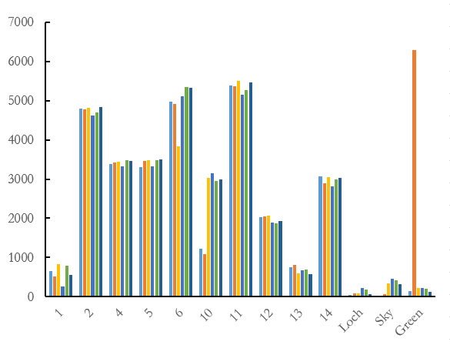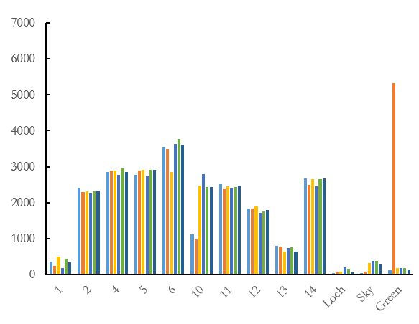
Spectrally Consistent Points and Study Lakes
Pixel Value
Band 7

Figure 5.2: 10 spectrally consistent points (i.e. rooftops, intersections, rock outcroppings) for the Landsat 8 OLI Surface Reflectance images, particularly Band 5 (NIR), Band 6 (SWIR-1), and Band 7 (SWIR-2). Note: Three lakes are chosen for comparison.

Appendix D: Difference Between the Standard Deviations of the Normalized and Surface Reflectance Images

Correlation Between Surface Reflectance
and Normalization Products' Standard Deviation
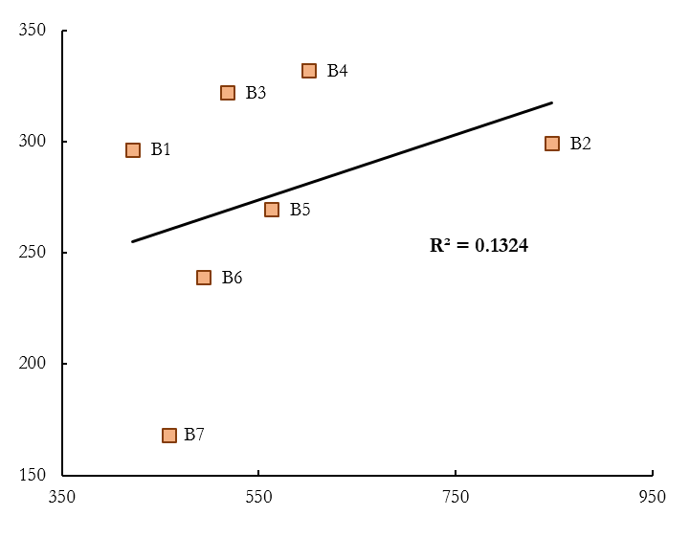
On Average, Surface Reflectance Performed 49% Better than the Normalized Product

Surface Reflectance Standard Deviation
Normalized Standard Deviation

Figure 6: Correlation between the standard deviation of the normalized images (each percent change averaged for one band average value) and the standard deviation of the surface reflectance images. Note: Each point represents where one Landsat 8 OLI Band.

Appendix E: Band Ratios

Table 3: List of band ratios used in pre-processing. Band ratios were performed on all image dates and used in analysis to narrow down top predictor variables.

Band Ratio | Band Spectrum Name
Band 2 / Band 1 | Blue / Coastal
Band 3 / Band 1 | Green / Coastal
Band 3 / Band 2 | Green / Blue
Band 4 / Band 1 | Red / Coastal
Band 4 / Band 2 | Red / Blue
Band 4 / Band 3 | Red / Green
Band 5 / Band 1 | NIR / Coastal
Band 5 / Band 2 | NIR / Blue
Band 5 / Band 3 | NIR / Green
Band 5 / Band 4* | NIR / Red*
Band 7 / Band 5 | SWIR-2/NIR
Band 5 / (Band 6 + Band 4) | NIR/(SWIR-1+Red)
Band 4 / Band 6 | Red/SWIR-1
Band 2 / Band 7 | Blue/SWIR-2
*Band ratio used in final Random Forests Model

