**NASA DEVELOP National Program**



Goddard Space Flight Center

*Summer 2015*

Thailand Disasters

Monitoring Risk and Extent of Drought for Enhanced Decision Making and Resource Allocation in the Kingdom of Thailand

 **Technical Report**

Rough Draft – June 25, 2015

Sean McCartney (Project Lead)

Nobphadon Suksangpanya

Chisaphat Supunyachotsakul

Srisunee Wuthiwongyothin

Sahakait Benyasut

Thanapat Vichienlux

Dr. John Bolten, NASA Goddard Space Flight Center (Science Advisor)

Colin Doyle, NASA Goddard Space Flight Center (Science Advisor)

# I. Abstract

**Keywords**

Thailand, Drought Indices, NASA Earth observations, Remote Sensing, NDVI, Land Surface Temperature, Precipitation, Soil Moisture Content

# II. Introduction

In recent decades, observed climate change has impacted natural and human systems across the planet, with changes in extreme weather and climatic events (IPCC, 2014). Hewitt (1997) reported that throughout the world, drought ranks first among

natural disasters in numbers of persons directly affected. Drought is a natural phenomenon resulting from deficiencies in precipitation from regional climatological norms, which are insufficient in meeting the needs of humans and the environment (Wilhite, 2005). In contrast to short-term variations in precipitation, drought is a slow-onset disaster lasting seasonally to annually. The severity of a drought depends on its duration, intensity, and spatial extent (Shaw et al., 2011). As more than half of the world’s population depends on Asian monsoon rainfall, changes in the timing, duration, and severity of precipitation can have significant effects (Buckley et al., 2006).

As one of the largest rice exporting countries in the world (USDA, 2014), Thailand farmers rely on rainfall for roughly 75% of the total 9.2 million ha of rice growing areas in the country – irrigation comprises the other 25% (Jongdee et al., 2006). Extreme climatic events like drought affect not only rain-fed crops during the monsoon season, but limit the availability of water for off-season irrigated crops. After the 2014 - 2015 drought in Thailand, rice exports were down by 4% in the first quarter of 2015 (Prasertsri, 2015), and the Thai cabinet allocated roughly 6.8 billion baht ($208.65 million) to alleviate drought through the installation of water pumps and mobile water tanks to the most drought affected regions (Kaewjinda et al., 2015).

In 2015, the Royal Thai Government established a four-part integrated plan for drought management. Currently, the drought monitoring system is provided by the Geo-Informatics and Space Technology Development Agency (GISTDA) to monitor agricultural drought, but there are no systems in place to monitor other types of drought that also impact the population. This project expanded on that role in analyzing three types of drought, as well as creating a tool to monitor agricultural drought in near-real time. The drought indices will allow Thai government agencies and NGOs the ability to identify the timing and severity of drought from 2000 - present.

The objectives of this project were to: 1) Use three different drought indices to monitor meteorological, hydrological and agricultural drought in Thailand to assist in drought management and mitigation; 2) Identify extreme drought anomalies based on a climatological baseline; 3) Create a near-real time drought monitoring tool that will aid in mitigating risk and improve resource allocation in the country. The indices we will examine to achieve our objectives are: the Standardized Precipitation Index (SPI) which incorporates precipitation data for monitoring meteorological drought; the Stream-Flow Drought Index (SDI) which incorporates in situ data from gauging stations and is used in monitoring hydrological drought; and the Drought Severity Index (DSI) which incorporates precipitation, land surface temperature (LST) and vegetation indices (VI), and is used in monitoring agricultural drought.

The study area for this project was the Kingdom of Thailand (Figure 1). Located in the tropics from 5 - 21˚ N latitude and 97 - 106˚ E longitude, Thailand has a total area of roughly 513,000 km² (CIA, 2015). From mid-May to September the monsoon rains provide precipitation for rain-fed crops, of which rice is the dominant cultivar. November through mid-March is the dry season when irrigation provides water for off-season agriculture. Most of the country has a tropical wet and dry climate, with the southern isthmus always hot and humid.

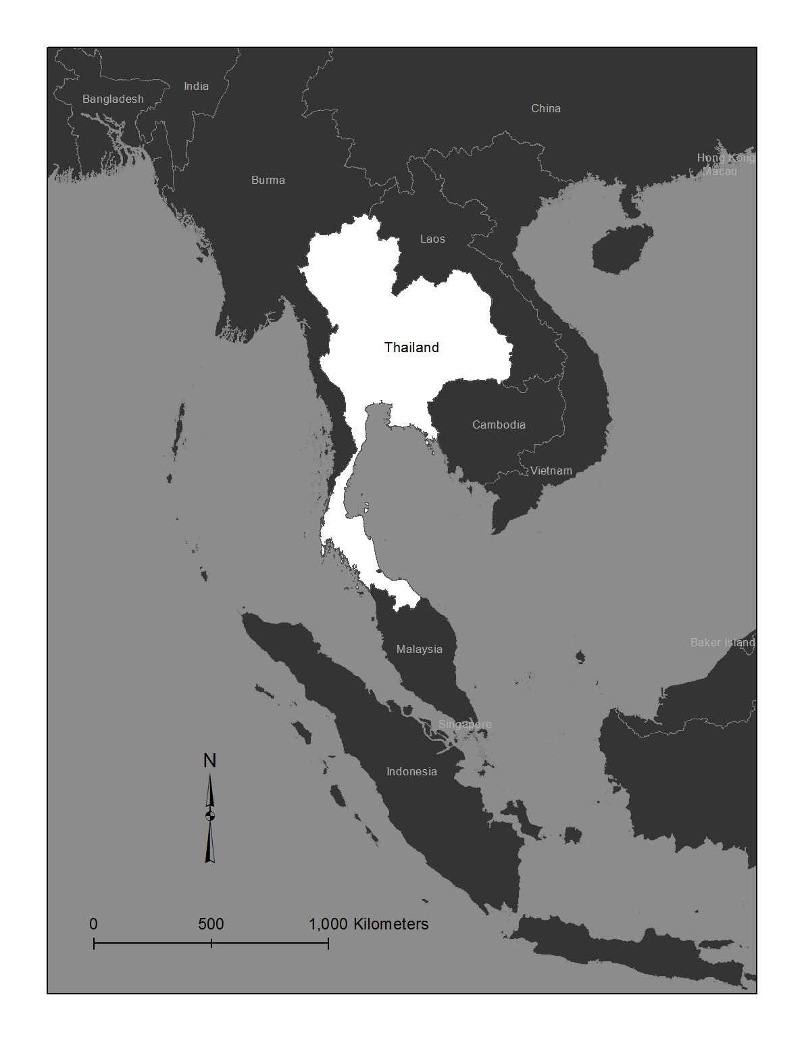

Figure 1. Study area map for the Kingdom of Thailand.

This project examined the period from 1998 - 2015 in creating indices for meteorological and hydrological drought, and the period from 2000 - 2015 in examining agricultural drought. The difference in time periods for each analysis related to data accessibility. All analyses was done on a monthly temporal resolution. The study addressed the National Aeronautics and Space Administration (NASA) Applied Science’s application area for Disasters, due to the severity of drought afflicting populations and economies in Thailand. The data analysis completed for this project contributes to improve drought monitoring, mitigation and response in Thailand. The study demonstrated how a combination of various indices can offer a better understanding of drought conditions, with data derived from Earth Observing (EO) satellites offering the ability to monitor drought across the entire country and in near-real time.

The project partners for this study were the Royal Thai Embassy and the Asian Disaster Preparedness Center (ADPC). These partners were interested in the project because they are currently only monitoring agricultural drought, and this project expanded on that role in analyzing three types of drought as well as creating a tool to monitor agricultural drought in near-real time. The drought indices allow Thai government agencies and NGOs the ability to identify the timing and severity of drought from 2000 - present. The methods employed allow for better allocation of resources to target the most affected areas of the country.

# III. Methodology

**Data Acquisition**

As insufficient rainfall is the leading cause of drought, data from NASA Earth observing satellites were used in acquiring precipitation records to create a17-year climatology for Thailand. The Tropical Rainfall Measuring Mission – Microwave Imager (TRMM-TMI) data were collected as a Level 3 product (3B42) in HDF format from the Goddard Space Flight Center downloads portal. Data were downloaded as a RT Derived Daily Product at 0.25˚ spatial resolution. Daily data were collected from January 1, 1998 – February 28, 2015. Precipitation measurements were collected as millimeters/hour (mm/hour).

After 17 years, NASA and the Japan Aerospace Exploration Agency (JAXA) stopped TRMM’s science operations and data collection on April 8, 2015, after the spacecraft depleted its fuel reserves. In order to create a continuous climatology to monitor drought in near-real time, precipitation records for TRMM’s replacement were acquired. The Global Precipitation Measurement - Microwave Imager (GPM-GMI) data were collected as a Level 3 product (Integrated Multi-satellite Retrievals for GPM [IMERG]) in HDF5 format from the Goddard Space Flight Center downloads portal. The data were downloaded at 0.1˚ spatial resolution. Thirty minute data were collected from March 6, 2015 – June 15, 2015. Precipitation measurements were collected as millimeters/hour (mm/hour).

To obtain biophysical parameters for creating drought indices, products derived from NASA EO were selected. The Terra and Aqua Moderate Resolution Imaging Spectroradiometer (MODIS) Land Surface Temperature (LST) and Normalized Difference Vegetation Index (NDVI) data were acquired using the USGS Earth Explorer tool. For LST data, MOD11C2 and MYD11C2 products were downloaded in HDF format at 0.05˚ spatial resolution at a monthly temporal resolution. For NDVI, MOD13A3 and MYD13A3 products were downloaded in HDF format at 0.01˚ spatial resolution at a monthly temporal resolution. Both datasets were collected from February 2000 – June 2015.

The stream flow data used in this study was a timeseries at monthly temporal resolution from January 1998 – June 2015. *In situ* data were acquired from gauging stations from the Thailand Royal Irrigation Department (www.rid.go.th) for each region in Thailand.

The soil moisture data were obtained from Dr. John Bolten, NASA DEVELOP Science Advisor at Goddard Space Flight Center (GSFC). His soil moisture product is derived from the Palmer Model and comes in NetCDF format at 0.25˚ spatial resolution. The dataset was provided already subset to the extent of Thailand. Temporal resolution is daily with datasets acquired from January 1, 2003 to May 9, 2015.

**Data Processing**

Precipitation was analyzed on a monthly scale since drought is a slow-onset phenomenon lasting from months to years. Since TRMM provided cumulative daily precipitation data and GPM provided rate of precipitation per hour in 30 minute increments, their data needed to be processed into cumulative monthly precipitation to correspond with the monthly LST and NDVI products. It was determined a monthly temporal resolution was appropriate in identifying historic drought anomalies and monitoring drought in near-real time. Preprocessing of both GPM and TRMM data was done using matrix laboratory software (MATLAB), summing the 30 minute and daily precipitation records to a monthly temporal resolution.

As TRMM’s spatial resolution is 0.25° and GPM’s spatial resolution is 0.1°, the latter resolution was chosen for analysis as GPM will be the main source of precipitation data until the termination of GPM’s mission. TRMM data were resampled from 0.25° to 0.1° using the methodology based on area interpolation and done using MATLAB.

SDI is the hydrological drought index based on stream flow data – which is point locations of each basin or sub-basin. The study for Thailand disasters selected records based on the completeness of readily available data and considered only the main streams and rivers throughout the country. Records were then interpolated to raster file format to create a continuous hydrological data set of stream runoff using ArcGIS software and resampled to match the 0.1˚ spatial resolution for all processed data sets.

For MODIS data, five tiles for the M*D13A3 products were downloaded for each date and the images mosaicked together using the MODIS Reprojection tool (MRT) in ArcGIS. The MRT was also used to reproject both the LST data and the vegetation data to WGS 1984. ArcGIS was used to resample the MODIS products to 0.1˚ spatial resolution to match the resolution of the precipitation data. ArcGIS was also used to subset both LST and NDVI data sets to the same spatial extent as the precipitation data.

**Data Analysis**

1) SPI (meteorological drought)

The standardized precipitation index (SPI) is an indicator of the amount of precipitation in a study area for a certain period of time (1, 3, 6, or 12 months) when compared with its historical record (McKee, 1993). Therefore, it shows the statistics of rainfall in a study area, specifically the *Z* – score of the cumulative rainfall probability. The interpretation of the SPI values is showing in Table 1.

|  |  |
| --- | --- |
| SPI | Interpretation |
| 2.0 | Extreme wet condition |
| 1.5 to 1.99 | Severe wet condition |
| 1.0 to 1.49 | Moderate wet condition |
| 0.5 to 0.99 | Mild wet condition |
| -0.49 to 0.49 | Optimum rainfall |
| -0.5 to -0.99 | Mild drought condition |
| -1.0 to -1.49 | Moderate drought condition |
| -1.5 to -1.99 | Severe drought condition |
| ≤ -2.0 | Extreme drought condition |

Table 1. Interpretation of SPI index

In this work, the period of time for drought analysis was set to be 1 month. Thus, the monthly precipitation data is analyzed by the statistical methods to determine the *Z* – score of the cumulative rainfall probability or SPI for each month and area. Firstly, the monthly precipitation data in a month in an area (*X*) from 1998 to present were gathered and were subsequently fitted into Gamma function (*g*(*X*)) in which the rainfall is statistically converted into the probability.

$$g\left(X\right)=\frac{1}{β^{α}\int_{0}^{∞}{y^{α-1}e^{-y}dy}}X^{α-1}e^{{-X}/β}$$

Where *β* and *α* are a scale parameter and a shape parameter, respectively. Nevertheless, the Gamma function is undefined for zero precipitation (*X*=0). Therefore, the probability of zero-precipitation (*g*(*0*)) is manually calculated from the ratio of the number of zero-precipitation in a time series (*m*) to the number of total precipitation observation (*n*).

$$g\left(0\right)=\frac{m}{n}$$

Then, the Accumulative Probability Function (*H*(*X*)) can be determined from:

$$H\left(X\right)=g\left(0\right)+\left(1-g\left(0\right)\right)\int_{0}^{X}{g\left(X\right)dX}$$

Finally, the inverse normal of *H*(*X*) with standardization of mean 0 and standard deviation of 1.0 would give the Z-score or, in another words, SPI.

2) SDI (hydrological drought)

The Streamflow Drought Index (SDI) is used for investigating hydrological drought occurrence. It has an advantage of simplicity and effectiveness by exclusively using streamflow as the key variable for assessing drought (Nalbantis, 2008). Due to monsoon rains dividing the country into two distinct seasons (wet and dry), the Thailand Royal Irrigation Department defines the hydrological year starting from April and ending in March.

The steps to obtain SDI value and its drought state can be defined as follows:

1. The cumulative streamflow volume (*Vi,k*) can be obtained from
$$v_{i,k}= \sum_{j=1}^{k}{Q_{i,j}} where i=1,2,… ; j=1,2,…12 ; k=3,6,9,12$$

2. The Streamflow drought index (SDI) can be calculated by

$${SDI}_{i,k}=\frac{v_{i,k}-{\overline{v}}_{k}}{S_{k}}$$

Where ${\overline{v}}_{k}$ and $S_{k}$ are respectively the mean and the standard deviation of cumulative streamflow volumes of reference period *k,* which are estimated over a long period of time.

The index *SDIi,k* requires streamflow volume values (*Qi,j*) where *i* is the year; *j* is the month according to the hydrological year (*j*=1 for April and *j*=12 for March); and *k* is the study period. The *Vi,k* is cumulative streamflow volume for the *i*-th hydrological year and *k*-th reference period.

The states of hydrological drought were classified into five states which are denoted by an integer number ranging from 0 (non-drought) to 4 (extreme drought) as shown in the following Table 2.

|  |  |  |
| --- | --- | --- |
| SDI | State | Description |
| ≥ 0.0 | 0 | Non-drought |
| -1.0 to -0.01 | 1 | Mild drought |
| -1.5 to -1.01 | 2 | Moderate drought |
| -2.0 to -1.51 | 3 | Severe drought |
| < -2.0 | 4 | Extreme drought |

Table 2. States and descriptions of SDI

3) SDCI (agricultural drought)

For agricultural drought the Scaled Drought Condition Index (SDCI) was used (Rhee et al, 2010). The SDCI combines LST, NDVI and precipitation (*X*) to monitor the extent of drought.

Each component of the index was calculated as follows:

Scaled LST = $\frac{{LST}_{max}-LST}{{LST}_{max}-{LST}_{min}}$

Scaled precipitation = $\frac{X- X_{min}}{X_{max}-X_{min}}$

Scaled NDVI = $\frac{NDVI - {NDVI}_{min}}{{NDVI}_{max}-{NDVI}_{min}}$

Finally, the components were weighted and summed together.

SDCI = 0.25(scaled LST) + 0.5(scaled precipitation) + 0.25(scaled NDVI)

The resulting index contains values ranging from 0 to 1 with 0 indicating dry conditions and 1 indicating wet conditions.

# IV. Results & Discussion

# V. Conclusions

# VI. Acknowledgments

* Dr. John Bolten (NASA DEVELOP National Science Advisor)
* Dr. Kenton Ross (NASA DEVELOP National Science Advisor)
* Dr. Dalia Kirschbaum (NASA DEVELOP National Science Advisor)
* Colin Doyle (NASA GSFC - USRA)
* Dr. Peter Cutter (ADPC)
* Lance Watkins (NASA DEVELOP Geoinformatics)
* Summer 2013 Great Plains Agriculture Team (Langley Research Center)

This material is based upon work supported by NASA through contract NNL11AA00B and cooperative agreement NNX14AB60A.

# VII. References

Buckley, B., Palakit, K., Duangsathaporn, K., Sanguantham, P., and Prasomsin, P., 2006: *Decadal scale droughts over northwestern Thailand over the past 448 years: links to the tropical Pacific and Indian Ocean sectors*, Springer.

CIA, 2015: “*The World Factbook – Thailand*.” *cia.gov* Central Intelligence Agency, 18 June, 2015.

Hewitt, K., 1997: *Regions at Risk. A Geographical Introduction to Disasters*, Addison Wesley Longman Limited. England.

IPCC, 2014: *Climate Change 2014: Synthesis Report. Contribution of Working Groups I, II and III to the Fifth Assessment Report of the Intergovernmental Panel on Climate Change* [Core Writing Team, R.K. Pachauri and L.A. Meyer (eds.)]. IPCC, Geneva, Switzerland, 151 pp.

Kaewjinda, K., Hariraksapitak, P., and Thepgumpanat, P., 2015: “Thai crops to suffer worst drought in 15 years.” *Reuters.com.* Reuters, 5 Feb. 2015.

Jongdee, B., Pantuwan, G., Fukai, S., and Fischer, K., 2006: *Improving drought tolerance in rainfed lowland rice: An example from Thailand.* Agricultural Water Management, 80:225–240

McKee, T.B., Doesken, N.J., and Kleist, J., 1993: *The relationship of drought frequency and duration to time scales*. 8th Conference on Applied Climatology.

Nalbantis,I., 2008: *Evaluation of a Hydrological Drought Index*. European Water 23/24: 67-77.

Prasertsri, P., 2015: *Thailand Grain and Feed Update – Global Agricultural Information Network.* USDA Foreign Agricultural Service, Washington, D.C.

Rhee, J., Im, J., and Carbone G., 2010: Monitoring agricultural drought for arid and humid regions using multi-sensor remote sensing data, *Remote Sensing of Environment,* 114:2875-2887

Shaw, R., Nguyen, H., Habiba, U., and Takeuchi, Y., 2011: *Droughts in Asia Monsoon Region – Overview and Characteristics of Asian Monsoon Drought*. Bingley, UK: Emerald Group Pub: 1-25.

Soleimani Sardou, F., Bahremand,F., 2013: *Hydrological Drought Analysis Using SDI Index in Halilrud Basin of Iran*, The International Journal of Environmental Resources Research, Vol.1, No. 3.

USDA, 2014: *Economic Research Service*, <http://www.ers.usda.gov/topics/crops/rice/trade.aspx#Exports> (2015)

Wilhite, D., 2005: *Drought and Water Crises – Science, Technology, and Management Issues*, Taylor and Francis Group, Boca Raton, Florida.

# VIII. Content Innovation

Inline Supplementary Material (figures, tables, computer code)

Database Linking Tool

Data Profile

Executable Papers

Interactive Map Viewer

# IV. Appendices