**NASA DEVELOP National Program**

****NASA Langley Research Center

**Spring 2016**

**Short Title: CALIPSO Cross-Cutting III**

**Subtitle:** Interacting with CALIPSO data through a graphical user interface (GUI)

**VPS Title:** “The Smoke-Screen: An Open-Source Visualizer of CALIPSO Data”

**Project Team & Partners**

**Project Team:**

Kathleen Moore (Project Lead), kathleen.d.moore@nasa.gov

Jordan Vaa

**Advisors & Mentors:**

Grant Mercer (University of Nevada, Las Vegas)

Dr. Kenton Ross (NASA DEVELOP National Program)

**Past or Other Contributors:**

Nathan Qian

Courtney Duquette

Ashna Aggarwal

**Partner Organizations:**

CALIPSO Science Team, End-User, POC: Dr. Charles Trepte and Dr. Amber Soja

**Project Details**

**Applied Sciences National Applications Addressed:** Cross-Cutting, Health and Air Quality

**Study Area:** Global

**Study Period:** May 2006 - current

**Earth Observations & Parameters:**

CALIPSO, CALIOP – Vertical Profile of Aerosols

**Software Utilized:**

Python 2.7, sqlite3, CALIPSO L1 and L2 data products

**Project Overview**

The output from one of NASA’s many “A-Train” satellites, CALIPSO, is an image depicting aerosols (sulfates, smoke, burning biomass, etc.), taken in cross-sections of the Earth’s atmosphere. *Visualization of CALIPSO* (VOCAL) is software that visualizes these images and enables easy inspection and annotation of regions-of-interest in each image by means of a user-controlled drawing toolbar. Any attributes for a region encompassed by a shape that the user draws on the image can be pushed to a backend database for the purposes of collaboration among scientists.

**Abstract:**

Atmospheric scientists analyze satellite data as part of their assessments of atmospheric health. One such satellite, the Cloud-Aerosol Lidar and Infrared Pathfinder Satellite Observation (CALIPSO), outputs images of longitudinal cross-sections of the Earth’s atmosphere. Depending on the wavelength of light used in the observation, it is possible to detect the presence of various aerosols. Some are natural sources, like dust storms, and sulfur dioxide from volcanos. Others are human-made, like sulfates from factories and smoke from burning biomass. It is important to track aerosols because an abundance of atmospheric aerosols contributes to accelerated cooling and warming of the Earth. The first instance of a visualizer for this data was written in an obscure, proprietary language, Interactive Data Language (IDL), making further modification of this tool virtually impossible. Since then, DEVELOP has produced new visualization software, *Visualization of CALIPSO* (VOCAL), written in Python.

As of the completion of the previous term, in addition to displaying CALIPSO images, the team added the ability for the user to “select” regions of interest by drawing shapes and assigning attributes to them. This information can subsequently be pushed to a backend database for the purposes of sharing and collaboration. However, the tool still needed to be enriched with other features such as better exception-handling and descriptors for annotations, and it needed to have cross-platform compatibility. Consequently, we have added these and other features to enrich the user experience, and we streamlined installation of the software on the Windows and Mac OS X operating systems. These updates have greatly improved VOCAL’s usability.

**Community Concerns:**

* Aerosols contribute to the cooling and warming of the Earth, compounding climate changes.
* Difficult-to-use visualization software has impeded scientists’ ability to track aerosols.

**Current Management Practices & Policies**:

Our end-users currently utilize a CALIPSO data visualizer that is written in an obscure, proprietary programming language, and this impedes any effort to modify or tailor the software further as the scientists have seen necessary. They manually annotate regions of interest on the image and share information in an ad-hoc, unilateral fashion. Furthermore, they have little flexibility in running the software, as the current software only runs on the Windows operating system.

**Decision Support Tools & Benefits:**

|  |  |  |
| --- | --- | --- |
| **End-Product** | **Earth Observations Used** | **Benefit & Impact** |
| Updated Visualization of CALIPSO (VOCAL) software | CALIPSO | VOCAL facilitates collaboration among Earth scientists by enabling tagging of aerosols with attributes, storing them to a database, and supporting cross-platform software installation. |

**Project Imagery**

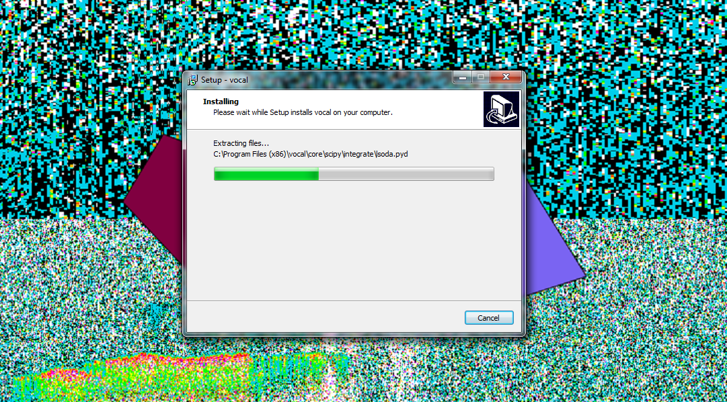

**Caption:** Screenshot of “one-click” Windows installer with example data and drawn polygons behind. Image Credit: CALIPSO Cross-Cutting III Team.

**Image:** installerVOCAL.png

**Software Release Requirements**

What category do the tools your project is creating fall within? V

**Software Title:** Visualization of CALIPSO

**Software Abbreviation:** VOCAL

**VOCAL already submitted for software release.**