**Indicator Tracking Help Guide**

Welcome to the new & exciting tracking metrics! We’ve added several new features to streamline and clarify what’s expected for each column.

Table of Contents

HELP FEATURES & GENERAL NOTES: 2

PARTICIPANTS 4

TRAINING & DEVELOPMENT 6

PROJECTS 7

PARTNERS 8

HAND-OFFS 10

PUBLICATIONS 10

PRESENTATIONS 11

RECRUITING 11

LEVERAGED RESOURCES 12

EVENT SUPPORT 12

LEADERSHIP & GENDER 12

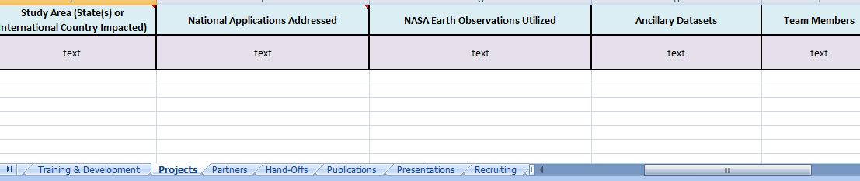This help guide first provides some general information about the tracking metrics. Each tab on the tracking metrics is then discussed (orange arrow), providing instructions, examples, and definitions relevant to each tab. Certain sections on a tab that may require further instruction are included to help clarify what should be included (green arrows).

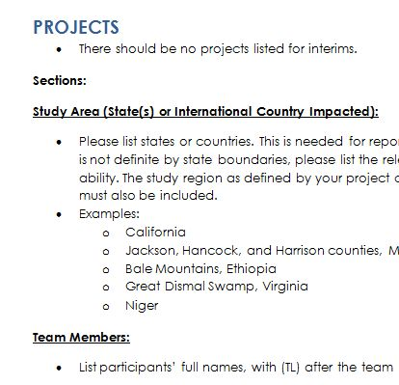

# HELP FEATURES & GENERAL NOTES:

**Help features:**

* Under each column header, you’ll find what **type of response** we’re looking for:
  + # - number (e.g. 5; 2014)
  + Text – words (e.g. Mars Water Resources)
  + Specified text – We’re asking you to choose from the options written in parentheses
    - Example: specified text (Professional, Personal)
      * Two choices: either “Professional” or “Personal”
    - specified text (Virtual, In-Person, Email)
      * Three choices: “Virtual”, “In-Person”, or “Email”
  + Date – date of event (e.g. 5/6/14)
* **Comments:**
  + Many of the column headers have a small red triangle in the upper right corner. This indicates that there is a comment associated with that column. These provide more detailed instructions and can be accessed by hovering the cursor over that cell (column header). Several also include brief examples.
* **Examples:**
  + A few of the tabs have example entries to help clarify what’s expected for each column. These are highlighted in light brown.

**General Notes:**

* **Term names**:
  + Spring
  + Spring Interim
  + Summer
  + Fall Interim
  + Fall
  + Winter Interim
* Interim activities should NOT be included for the following: Participants, Projects, Partners, Leadership & Gender
  + Note: Unless approved by NPO, there should be no projects associated with interims.
* Report through the term that just ended. As tracking metrics are due during the interim, you should be filing out the information for the previous interim and term. For example, for the winter interim, you should have Fall Interim and Fall data. This is being done so that data from all the nodes can be compared (i.e. nodes are reporting for different time periods).
  + Note: Please do not include planned events that have not happened yet (the only somewhat-exception are publications, explained below).
  + Note: If you have information for future terms (e.g. participants) at the time you’re turning in the tracking metrics, you can input them into the workbook, but they will not be included until the next interim.
* Write out full project and organization names.

**Included Sheets:**

As the tabs tend to get hidden if you don’t scroll in both directions, here is a list:

1. Intro
2. Participants
3. Training & Development
4. Projects
5. Partners
6. Hand-Offs
7. Publications
8. Presentations
9. Recruiting
10. Leveraged Resources
11. Event Support
12. Leadership & Gender

# PARTICIPANTS

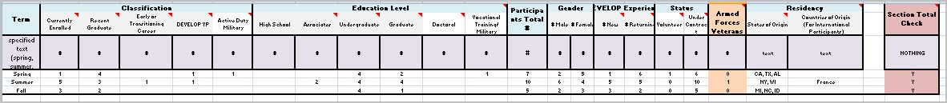

There has been a lot of confusion over this tab. We’ve changed things a bit; we’ve added a few columns, and deleted a few.

General Notes:

* YPs should be included in each section (e.g. classification, education level, participant total, etc.). DEVELOP Associates/assistants should NOT be included.
* 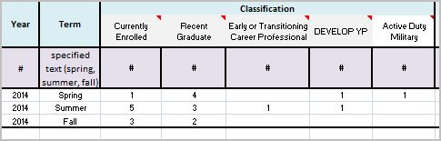Only list participants for the spring, summer, and fall terms (**no interims!**).

**Sections:**

**Classification:**

* Each participant should be sorted into the MOST appropriate category (e.g. it is possible that a participant fits into more than one category) and should be counted only ONCE.

*Classification Definitions:*

* + **Currently Enrolled Students** – Participants who are currently enrolled at a U.S. accredited community college, undergraduate or graduate college or university.
  + **Recent Graduates** – Participants who have graduated with an undergraduate or graduate degree from a U.S. accredited college or university within the past two years.
  + **Early/Transitioning Career Professionals** – Participants transitioning to a new career field, who are pursuing further experience in the Earth sciences and remote sensing (including transitioning/recently transitioned veterans from the U.S. Armed Forces).
  + **DEVELOP YP** – Participants who are currently in the Young Professional Class. A participant’s YP status “trumps” his/her other classifications (e.g. if someone is a YP and a recent graduate, list him/her as a YP and not a recent graduate).
  + **Active Duty Military –** Participants who are currently serving in the military. Note: there is a separate section to denote veteran status).

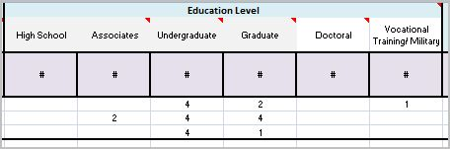**Education Level:**

* List all participants under the appropriate education column. For recent graduates, list them under the degree that they just completed. For currently enrolled participants, list them under the degree toward which they are currently working.
* Note: A currently enrolled junior working toward a B.S. would be listed under “undergraduate,” as would a recent graduate who just received his/her B.S.

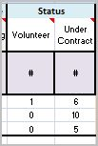

**Status**:

* This is a new section! It is to help us track how many volunteers DEVELOP has.

*Status Definitions:*

* + **Volunteer** - if a participant is a volunteer (i.e. not being paid by SSAI or Wise County)
  + **Under contract** - all participants who are being paid through SSAI or Wise County. Most participants will be in this category.

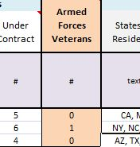

**Armed Forces Veteran:**

* List the number of participants who are veterans. DON’T INCLUDE ACTIVE MILITARY (they have their own column). This column is **ORANGE** to remind you that this is the only section that will not add up to the other sections.

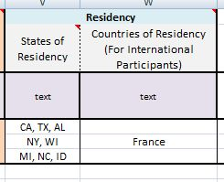**Residency:**

* List participants’ states or countries of *residency* (previously “states of origin”). List current residency, not place of birth (e.g. “What state is your license/ID from?”).
* Write the name of the state/country (state abbreviations are OK), NOT the number of participants from each (e.g. CA, NV, France).

**Section Total Check:**

* 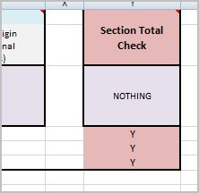Please make sure all sections (e.g. classification, education level, gender, etc.) total the same number of participants! To help you, there is a new column at the end called “Section Total Check” (highlighted in red). *YOU DO NOT HAVE TO WRITE ANYTHING IN THIS COLUMN*. It is prepopulated with a formula to let you know if your sections match. It will show “Y” for “Yes, you’re good to go!” and “N” for “No, something doesn’t add up.” This is a beta-test column. If you double-check your sections and they all match, but this column still says "N", please let me know.

**TRAINING & DEVELOPMENT**

* Training & Development: activities that help participants grow individually and professionally
* Include activities for terms and interims.
* If you’re doing inter-nodal activities, for “# Attending/Participating” list only participants from your node (and the other node will list their own participants).

**Sections:**

**Professional and Personal Development Event/Activity:**

* Write the name of each event/activity. If it is a multi-session course, please list the course once.**

**Event/ Activity Type:**

* Use **specified text** to classify each event/activity: “Personal”, “Professional”, or “Personal and Professional”

*Event/Activity Type Definitions:*

* **Personal** -educational activities that improve participants’ soft skills and/or general knowledge (i.e. not specific to the project or training)

**Activities to report:**

* Personality type workshops (e.g. 4D/MBTI)
* NASA tours
* DEVELOP leadership retreat*
* **Professional** - activities that build participants’ professional skills and knowledge

**Activities to report:**

* Guest lectures
* Trainings (e.g. ethics training, remote sensing, python)
* Workshops/ webinars (e.g. ARSET**)
* Conference attendance
* Fieldwork
* DEVELOP/ node orientation
* NPO visits & meetings
* DEVELOP leadership retreat*

*Activities such as the retreat, which fall under both types can be listed as “Personal and Professional”

**If it is a multi-session course, please list the course once. For number of participants, please list the total number of unique participants who attended the course, even if they did not all attend each session. For example, if it is a two-week ARSET course, and Bob, Sally, and Mary attended the first week, and Bob, Mary, and Joe attended the second session, you would report 5 participants.

Please feel free to use the "Additional Notes" section to list participants by name, if that helps you then count up the total number of unique participants.

# PROJECTS

* There should be no projects listed for interims.

**Sections:**

**Study Area (State(s) or International Country Impacted):**

* Please list states or countries. This is needed for reporting purposes. Even if your study area is not definite by state boundaries, please list the relevant states to the best of your ability. The study region as defined by your project can be used, but states or countries must also be included.
* Examples:
  + California
  + Jackson, Hancock, and Harrison counties, Mississippi
  + Bale Mountains, Ethiopia
  + Great Dismal Swamp, Virginia

**Team Members:**

* List participants’ full names, with (TL) after the team lead’s name.

# PARTNERS

* There should be no partners listed for interims.
* List one partner organization per row. If one project has two partners, there should be two entries listing that project (one for each partner).

**Sections:**

**Partner Organization/ Agency:**

* If your partner is part of a broad organization, please list the specific branch/office with which you were working.

Example 1:

Instead of: "NOAA"

Write: "Los Angeles/Oxnard Weather Forecast Office, NOAA"

Example 2:

Instead of: "National Audubon Society"

Write: Pascagoula River Audubon Center (National Audubon Society)

**Partner Classifications:**

* Choose the appropriate type (terms in bold) from the list below. For convenience, types have been separated by whether they refer to a governing level or not.
* **Please note** “international” can refer to both a foreign government, as well as a non-government entity (e.g. university or NGO). “International” can be used with other types (e.g. if partner is a foreign university, put "International, Academic"). International governments/agencies can simply be listed as “international” (e.g. Rwanda Ministry of Agriculture and Animal Resources).

*Partner Classifications Definitions:*

(Classifications Referring to Government)

* **Local**—refers to city to county government organizations up to anything below the state level (e.g. Miami-Dade Parks and Recreation)
* **State**—state agencies (e.g. Mississippi Department of Transportation)
* **Federal**—all agencies funded by the federal government, as well as organizations that get their funding from federal agencies (e.g some consortiums, research groups (that aren’t at a university), etc.) (e.g. USGS)
* **Regional**— organization/coalition of governing agencies that cross state borders (if something is within one state then it is local) (e.g. Great Lakes & St. Lawrence Cities Initiative)
* **Tribal**—tribal or indigenous groups (e.g. Navajo Nation)

(Classifications Referring to Non-Government)

* **Academic**—associated with an educational institution (e.g. University of Georgia)
* **NGO**—(Non-Governmental Organization) not a government (at any level) group and (usually) not for-profit organization (e.g. The Nature Conservancy)
* **Private—** organizations in the private sector such as for-profit businesses, private entities, corporations, etc. (e.g. Digital Harvest)

(Classifications Referring to Either Government or Non-Government)

* **International**—governments, organizations, etc. outside of the U.S. (e.g. Rwanda Ministry of Agriculture and Animal Resources (International) , Planet Earth Institute (International, NGO))

**Partner Types:**

*Partner Type Definitions:*

* **Partner:** the umbrella term for all types listed below.
* **Collaborator:** Organization or individual that works directly with a DEVELOP project team and provides some kind of leveraged resource (advising, data, model, software, funding, etc.), but are not actually using the project’s products or methodologies to make a decision or policy.
  + - Ex. A researcher from a university who provides a team with an ancillary dataset to validate their results.
* **End-User:** Organization or individual that receives results and methodologies from DEVELOP (either directly from a DEVELOP project team or through a partner/collaborator) and can use the project’s products or methodologies to make a decision or policy. They may also provide some kind of resources (advising, data, model, software, funding, etc.), but it is not required.
  + - Ex. The Texas Forest Service’s Predictive Services that can use the products/methodologies from the DEVELOP project in their risk mapping creation.
* **Boundary Organization:** Organization or individual that disseminates the project’s results to other end-users, decision makers, policy-makers, etc. The Applied Sciences Program defines a boundary organization as “an organization outside of your own that broadens your reach across the boundary into the operational domain (i.e. policymakers, decision makers, and other key stakeholders).”
  + - Ex. The Smithsonian Conservation Biology Institute works with local groups in Myanmar and helped DEVELOP disseminate results from the Myanmar Ecological Forecasting project to those in-country groups.

**Partnership Status:**

*Partnership Status Definitions:*

* **New** – If this is the first term working with that partner
* **Continued** – If this is not the first term working with that partner (e.g. second term of a project or if you have worked with this partner on a different project before)

# HAND-OFFS

* Write out full name of partner organization and project.
* List any further useful details regarding the type of hand-off or partner interaction in “Additional Notes” category.

**Hand-Off Type:**

*Hand-Off Type Definitions:*

* Virtual – Skype, telecon, etc.
* In-person
* 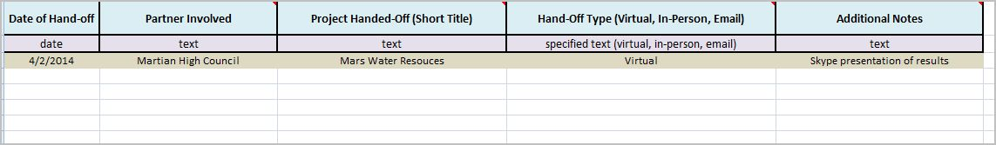Email

# PUBLICATIONS

* Please list all publications that have been completed or are in the process of being published.
* If the publication process takes longer than one term, re-list the publication with the current term and its current status (whether it is the same or different).
* Do not include posters at conferences.
* If a conference publishes a conference proceedings paper/report, then that should be included.
* Do not include VPS publications on Earthzine.

**Sections:**

**Publication Status:**

*Publication Status Definitions:*

* **Date** – Actual date of publication if published
* **Review** – If it is being reviewed by NPO/ you are in the process of completing edits for NPO
* **Submitted** – If it is submitted to a journal but not approved yet for publication
* **Pending** – If it is approved by a journal and in the journal review process (but not yet published

# PRESENTATIONS

* The main changes with presentations are that we would like you to write out each opportunity *by project* and to *include* DEVELOP presentations. For example, if your node has three projects, all of which had a poster for NASA HQ Closeout, you would write out a separate entry for each project. Also include flashtalks and highlight talks. Do the same for node closeouts and any other presentation venues. This is a bit repetitive, but it will help us better track how many projects and participants are presenting, not just the node involved.
* Types of presentations (poster or oral) to include (not an exhaustive list):
  + Conference presentations
  + NASA HQ Closeout (Annual Earth Science Applications Showcase)
  + Close-out Presentations
  + 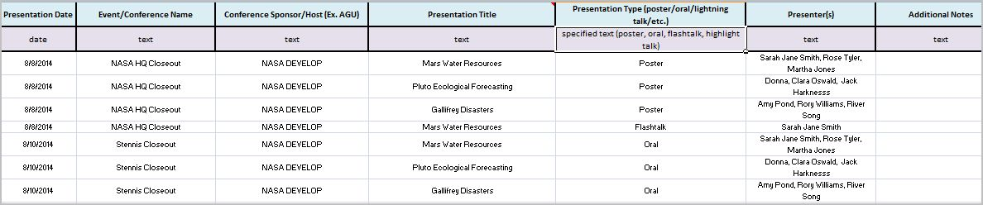DEVELOP Leadership Retreat presentations

# RECRUITING

* Types of recruiting activities to report (not an exhaustive list):
  + Email blasts
  + Classroom visits
  + Postings on university career websites
  + Flyers

# LEVERAGED RESOURCES

* We know that determining leveraged resources can be challenging. Please include whatever information you have and leave columns empty if you do not have complete information. Please contact NPO/ Impact Analysis YP if you have any questions or concerns.

# EVENT SUPPORT

* Event Support – volunteering/assisting with some sort of planned event (e.g. DEVELOP participants helping out at a NASA center’s open house)

**Sections:**

**Supporting Participant(s)**

* List the names of the participants (not the number of participants).

# LEADERSHIP & GENDER

* This is a new tab to help with gender tracking for the Equal Futures reporting. For each term, write the number of males and females in each of the following roles: young professional, center lead, assistant center lead, and team lead. If an individual has more than one role (e.g. center lead and team lead), count him/her for each position.
* 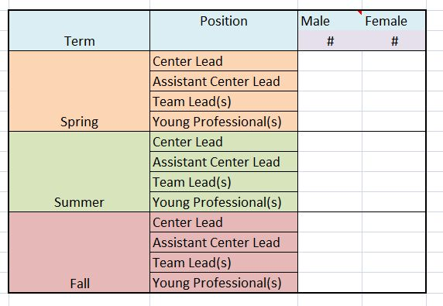Do not include interims.