Moloka’i Water Resources
Employing NASA Earth Observations to Map the Impacts of 'Ohi'a Rust on Forest Health and Coastal Turbidity on Moloka’i, Hawaii


Technical Report
Final Draft – August 9th, 2019

Nicole Pepper (Project Lead)
David Fluharty
Sophia Leiker
Caroline Odell

Dr. Paul Evangelista, Colorado State University, Natural Resource Ecology Laboratory (Science Advisor)
Dr. Catherine Jarnevich, United States Geological Survey, Fort Collins Science Center (Science Advisor)
Nicholas Young, Colorado State University, Natural Resource Ecology Laboratory (Science Advisor)
Tony Vorster, Colorado State University, Natural Resource Ecology Laboratory (Science Advisor)

1. Abstract
The threat of invasive species has impacted fragile forests across the globe; such impacts can be particularly damaging on island ecosystems resulting in a loss of native vegetation and increased runoff. A 2017 fungal outbreak of Puccinia psidii impacted 'ohi'a (Metrosideros polymorpha) on Moloka’i, Hawaii, causing widespread defoliation and tree mortality. The impacts of this disease have been intensified by invasive ungulates which increase a tree’s vulnerability to disease. We partnered with The Nature Conservancy and the United States Geological Survey to better understand the impacts of rust outbreak on 'ohi'a health and resulting changes in watershed dynamics on Moloka’i. The Nature Conservancy constructed exclosures around the island to protect vital sections of the forest from ungulates, which can overgraze forest understory and damage trees. This project assessed the feasibility of using Landsat 8 Operational Land Imager and Sentinel-2 MultiSpectral Instrument to map the impact of the rust on 'ohi'a, evaluate the effectiveness of fenced exclosures, and assess the feasibility of detecting turbid events from 2013 - 2019. Our team successfully utilized Normalized Difference Vegetation Index (NDVI) and Normalized Difference in Moisture Index (NDMI) to create 'ohi'a forest impact maps, however we were not able to detect any correlations or definitive patterns related to the rust. Further, our 'ohi'a time series analysis did not show distinct trends in regard to the 2017 rust outbreak within and outside the exclosures. We hope this feasibility assessment will help our partners make better informed management decisions to conserve the 'ohi'a and maintain its crucial ecosystem services.

Keywords
remote sensing, Landsat 8, Sentinel-2, water turbidity, forest health, invasive species, 'ohi'a, Puccinia psidii

2. Introduction
  - Background Information
A 2017 fungal pathogen outbreak of the rust disease Puccinia psidii on Moloka’i, Hawaii, has greatly impacted the island’s dominant overstory tree, the 'ohi'a (Metrosideros polymorpha). Otherwise known as 'ohi'a rust disease, this pathogen continues to cause widespread defoliation and, in some cases, tree mortality. 'Ohi'a are endemic to Hawaii and maintain components crucial to wildlife conservation, such as providing habitat and supplying nectar for native species (Anderson, 2012). Additionally, 'ohi'a play a significant role in the island’s hydrologic cycle and are of great cultural significance to the Hawaiian people (Wallace, 2016).

Invasive pathogens and ungulates have impacted fragile forests across the Hawaiian Islands. The impacts of Puccinia psidii on Moloka’i have been further compounded by ungulates, specifically invasive deer, goats, and feral pigs, which may be able to physically transfer the fungus and are also known to burrow into the root systems of the 'ohi'a. This burrowing causes stress to the trees’ immune systems and can increase the trees’ vulnerability to the rust disease (Loope, 2016). These impacts are especially damaging on islands such as Moloka’i where a loss in vegetation can result in poor infiltration, increased runoff, and increased turbidity in coastal waters. Moloka’i has one of the most extensive coral reefs of the Hawaiian Islands. Increased sedimentation in the island’s coastal waters can impact coral reefs through burial by sediment, bleaching, and increased algae growth (United States Geological Survey, n.d.). These reefs attract tourism, provide habitat for diverse species, and protect shorelines from erosion and wave damage (United States Geological Survey, n.d.).

Satellite imagery has commonly been used to assess forest health across the globe. The Normalized Difference Vegetation Index (NDVI) is the most commonly used vegetation health indicator (Pettorelli et al., 2005). Similarly, the Normalized Difference Moisture Index (NDMI) has been successfully used to indicate tree mortality and dead leaf material (Coops et al., 2010). In past research, this index has held high explanatory power when used in tree mortality models (Vorster et al., 2017). NDVI is a measurement of chlorophyll and photosynthetic productivity of a plant. It is a standardized way of indicating vegetation health. Similar to NDVI, NDMI is a measurement of a region’s vegetation water content. It is a standardized way of indicating vegetation water stress levels.

Earth observations can also be used to identify sediment plumes and help provide a better understanding of watershed dynamics (Braga et al., 2017). Previous work has demonstrated the potential for utilizing Landsat 8 Operational Land Imager (OLI) data to examine suspended sediment and turbidity levels in a variety of water body types. One method for easily detecting turbidity is the Normalized Difference Turbidity Index (NDTI), which can be employed to assess turbidity values (Lacaux et al., 2007).

  - Project Partners
We partnered with the Pu’u O Hoku Ranch, The Nature Conservancy, and the United States Geological Survey (USGS) to study the impacts of 'ohi'a rust. The Pu’u O Hoku Ranch is an organic ranch on the east end of Moloka’i, surrounded by more than 14,000 acres of protected forests. This collaborator provided first hand expertise on 'ohi'a rust-related issues and helped validate forest impact maps. The Nature Conservancy is focused on conserving the biodiversity of Moloka’i. This partner is interested in better understanding the 'ohi'a defoliation and the quantifiable effects of fenced exclosures as a mitigation technique. Our end products provided quantifiable data needed to assess the health of the 'ohi'a forests for future mitigation and conservation approaches. The USGS is interested in managing invasive species and mapping the effects of 'ohi'a rust. In addition, they provided our team with Worldview 3 high resolution data. However, our USGS partner for this project has limited use and familiarity with spectral monitoring techniques and data. This project will help build the USGS’s capability to apply NASA and ESA earth observations to management decisions.

  - Objectives
The project objectives were to (1) create an 'ohi'a impact map and analyze changes to help our partners better understand the geographic distribution and severity of the rust outbreak, (2) evaluate the impacts of The Nature Conservancy exclosures on forest health to provide numerical insights about the success of exclosures in mitigating impacts associated with the rust outbreak, and (3) assess the feasibility of detecting turbidity for big runoff events off the coast of Moloka’i.

  - Study Area
Moloka’i is the fifth largest Hawaiian island. In total, Moloka’i is 673 square kilometers, spanning 61 kilometers in length and 16 kilometers in width. Eastern Moloka’i has a wet climate and dense forests, while the west end of Moloka’i is drier with primarily low-lying vegetation. Moloka’i has a variety of ecosystem types, including lowland wet forests, shrubland, and montane wet forests. Our study area primarily focused on the east side of Moloka’i where the wet forests and high plateau reside (Figure 1). This area receives over 300 inches of rain per year and 'ohi'a is the dominant vegetation class in this region (Roessler, 2008).

Study Area

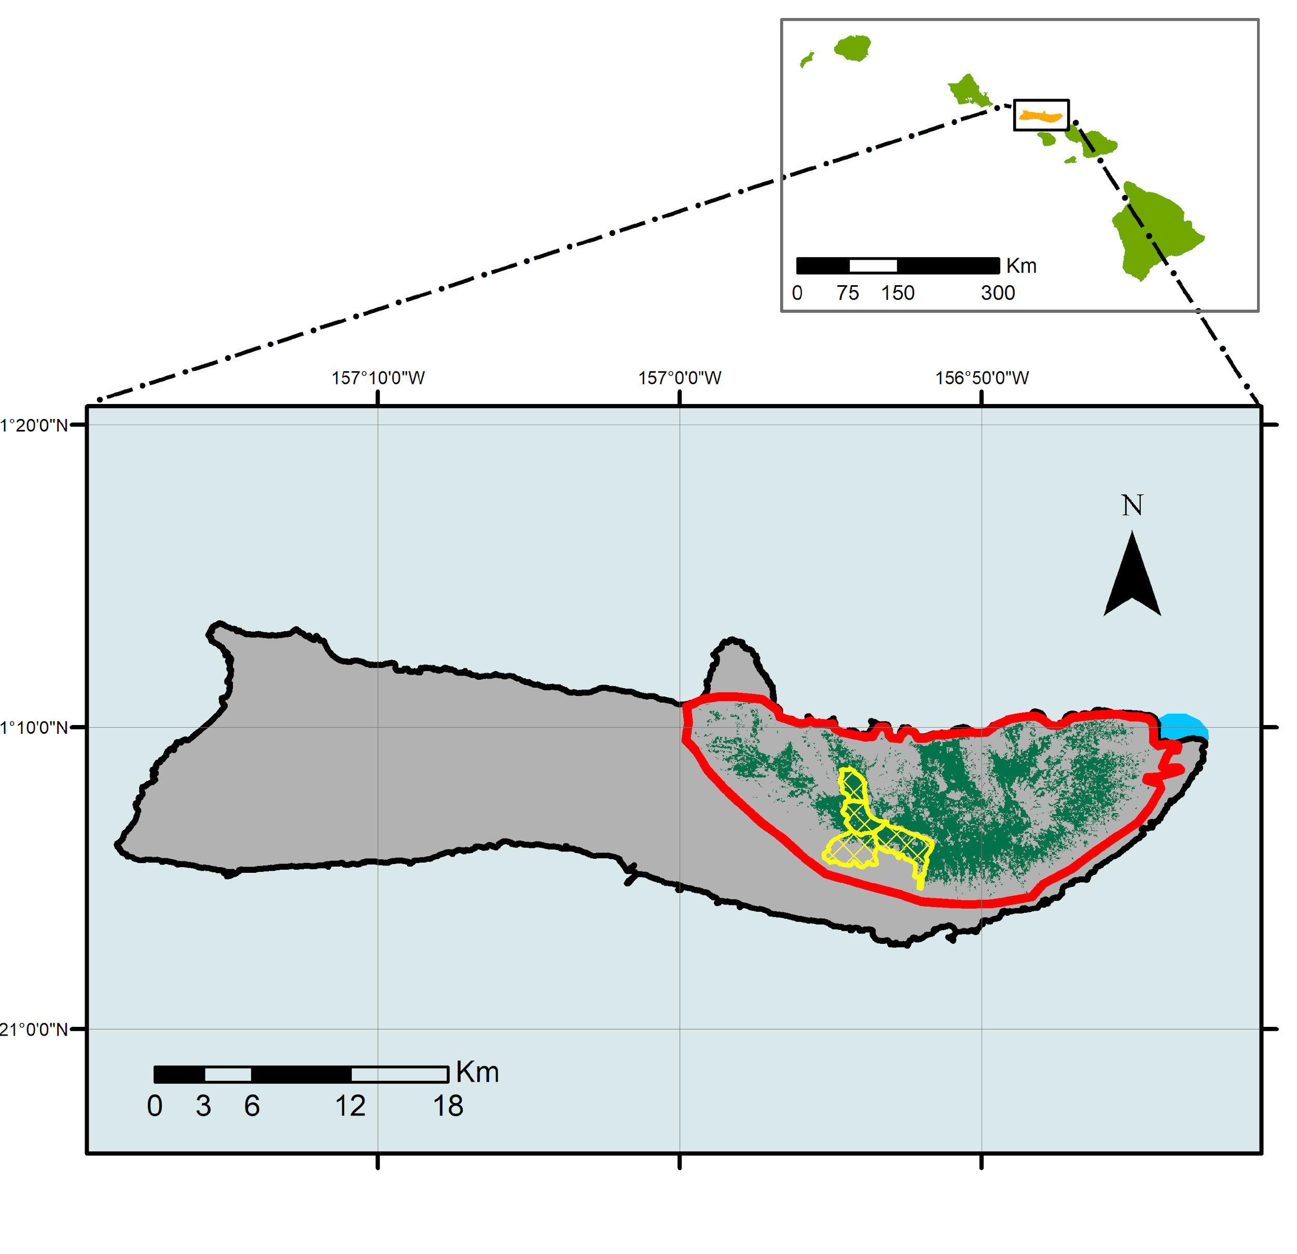

Figure 1. Study area extent on Moloka’i, Hawaii. The larger map displays the distribution of 'ohi'a vegetation across the island. The red outlines the region of our 'ohi'a impact analysis, the yellow region indicates TNC exclosures, and the blue region on the west end of the island delineates the region where the Halawa stream is located, which is the focus area of our turbidity feasibility assessment.

3. Methodology
3.1 Overview
This project employed remote sensing techniques to model the rust pathogen’s impact on forests and the resulting changes to watershed dynamics across Moloka’i. We used Landsat 8 OLI and Sentinel-2 Multispectral Instrument (MSI) spectral imagery to map the impacts on the forest by performing a time series analysis of the change of NDMI and NDVI values from 2015 to 2019. Alongside the impacted forest time series, we used the same sensors to analyze changes in coastal turbidity over time by calculating NDTI. Additionally, we looked at changes in impacted forests inside and outside exclosures to assess the effectiveness of The Nature Conservancy’s (TNC) fenced exclosures as a method for protecting the 'ohi'a from invasive pests.

3.2 Data Acquisition & Processing
Our partners at TNC provided shapefiles of 'ohi'a forest on Moloka’i. These layers were derived from LANDFIRE existing vegetation type data. These partners also provided three field validated points indicating areas with tree mortality due to the 'ohi'a rust and polygon data outlining the borders of the fenced exclosures they implemented for their conservation efforts (Figure 1). There were four exclosures included in this shapefile. The northernmost exclosure had been ungulate free for 10 years which we indicated as Exclosure 1. Below this exclosure, Exclosure 2 had been ungulate free for two years, and the two most southern exclosures (Exclosure 3 and Exclosure 4) have low ungulate levels still present. Additionally, partners provided us with polygon data indicating regions identified as impacted by the rust according to helicopter surveys. We overlaid this data over many of our visual results and we will be referring to these polygons from here on out as the rust survey polygons (Appendix F).

The USGS provided our team with high resolution Worldview 3 imagery which covered the eastern portion of our study area in Moloka’i. The imagery has a spatial resolution of 1.24 meters and was taken in February 2017. Earth observation images from Landsat 8 OLI and Sentinel-2 MSI were obtained using Google Earth Engine (GEE) for both the 'ohi'a impact analysis and the turbidity assessment. For the impact analysis, we calculated the spectral indices NDMI and NDVI (Table 1) using Landsat 8 OLI Collection-1 Tier-1 and Sentinel-2 MSI Level-1C imagery.

To test the effectiveness of the exclosures, we compared index values inside the exclosures 1, 2, 3, and 4 to an environmentally similar area outside the exclosures in eastern Moloka’i. For the comparison area, we chose a region in the eastern portion of our study area because our partners had identified it as a region that was particularly impacted by ungulates. When selecting our comparison area, we factored in our partner’s interest as well as other landscape characteristics. This included elevation, aspect, and a region’s alignment with the rust survey polygons. We also incorporated the LANDFIRE 'ohi'a shapefile, to designate a comparable area (from here on out defined as the Comparison Area). The Comparison Area had an elevation range of 168 meters to 688 meters with a majority of the values in the 400 meter range.

For turbidity analysis, a flood event image was selected using the USGS water watch flood tracker. The peak flood event that was chosen occurred on September 12, 2018 with a flood index of 9.5 feet. The closest Landsat 8 flyover date was September 17, 2018. The closest flyover date for Sentinel-2 was September 18, 2018. For the non-flood date, dates were narrowed down to less than 20% cloud cover. The Landsat 8 date chosen was from February 2, 2017. The Sentinel-2 date chosen was from February 20, 2018. Once the images were acquired, a change detection was calculated in ArcMap by differencing the turbid and non-turbid dates.

Table 1
Formulas, scales, and interpretations of the indices used in the analysis.
Name | Formula | Scale | Scale Interpretation
NDVI: Normalized Difference Vegetation Index | [NDVI = (Near-Infrared - Red) / (Near-Infrared + Red)] | -1 to 1 | High positive values near 1 indicate areas with productive and dense vegetation, low positive values near 0 indicate vegetation with low canopy cover or vegetation that is not densely productive, and negative values represent non-vegetated areas, typically water or bare soil.
NDMI: Normalized Difference Moisture Index | [NMDI = (Near-Infrared - Shortwave Infrared) / (Near Infrared + Shortwave Infrared)] | -1 to 1 | High positive values near 1 indicate areas with high levels of soil moisture and canopy cover, low positive values near 0 indicate average canopy cover with high water stress, and negative values near -1 indicate bare soil.
NDTI: Normalized Difference Turbidity Index | [NDTI = (Red - Green) / (Red + Green)] | -1 to 1 | High positive values near 1 indicate a high level of turbidity and low negative values near -1 indicate clear water (lower levels of turbidity).

3.3 Data Analysis
'Ohi'a Rust Change Detection
Change detection was calculated for NDVI and NDMI using Landsat 8 imagery between the years 2014 and 2019. These dates were chosen to capture changes related to the most severe dates of the outbreak in 2017. To perform our change detection, we first calculated NDVI and NDMI on both images in Google Earth Engine. Next, we used ArcMap’s raster calculator tool to subtract the 2014 values from the 2019 values, resulting in our change detection raster for each index.

Exclosure Analysis
To assess the effectiveness of the ungulate exclosures in relation to forest impact, we calculated the NDVI and NDMI quarterly from 2013 to 2014. The four quarters were defined as: (1) January – March, (2) April – June, (3) July – September and, (4) October – December. We faced a significant challenge when calculating these indices for multiple images because our study area regularly had significant cloud cover throughout the satellite images. We originally planned to use the quarterly median composite image for our analysis, but these images still had noise and artifacts from clouds because of the number of images containing large amounts of cloud cover in both our Landsat 8 and Sentinel-2 images. Our next approach was to look at individual images and mask out the clouds, but after doing this there were only six Landsat 8 images and eight Sentinel-2 images that had low enough cloud cover to run the analysis. We finally settled with using the quarterly greenest pixel composite images using the NDVI value as a pixel quality indicator. The function to do this is available in Google Earth Engine which mosaics an image by using the highest value for a pixel within a date range. We used the NDVI quality mosaic for all the NDVI and NDMI image calculations. For the time series analysis, we generated 500 random points within each exclosure and within the comparison area to compare the general trends in forest impacts within these separate areas over time. We then set a threshold for these points to exclude any remaining values from clouds. For NDVI we selected a threshold of greater than 0.3 and for NDMI we set a threshold for greater than 0.1, based on their scale interpretations (Table 1). For the time series analysis, we plotted mean NDVI and NDMI values over time using the random points with Landsat 8 OLI and Sentinel-2 MSI in Google Earth Engine.

‘Ohi’a Impact Classification
Using Worldview 3 imagery (1.24 meter resolution), we completed an initial supervised classification of our study area in Moloka’i. The imagery covers a portion of the larger study area used for the spectral indices. The classification included the following classes: rust infected trees, healthy vegetation, grass, bare soil, water, and shadows. Rust infected trees were considered as any large vegetation displaying typical characteristics of the rust disease, including a grey/red color and defoliated leaves. Healthy vegetation was considered larger tree species showing typical greenness and the grass/understory class was any low-lying understory vegetation. Classification was completed in Google Earth Engine where training data were collected via aerial image interpretation (digital ocular sampling) using the Worldview imagery. This sampling method included identifying 100 to 150 points and polygons of representative pixels for each class. An approximately even number of pixel samples were used as training data for each individual land cover type. Validation data were also collected using the same methodology to create a confusion matrix providing respective accuracy values for each class (Appendix D). The classification was then run using the Random Forest classification algorithm in Google Earth Engine.

Turbidity Feasibility Analysis
Using the selected dates, (Landsat 8: September 17, 2017 and February 2, 2017; Sentinel 2: September 18, 2017 and February 20, 2017) we tested the feasibility of detecting turbidity in response to flood events. To test this, we applied the NDTI to both the Landsat 8 and Sentinel-2 scenes using Google Earth Engine. Then, using ArcMap, we differenced the turbid and non-turbid images using the difference formula (Turbid - NonTurbid) via the raster calculator tool to create a change detection image. This image highlights any changes in turbidity. This change detection was used to test whether the difference between turbid versus non-turbid images was significant enough to identify.

4. Results
4.1 'Ohi'a Rust Change Detection
Below is the NDVI change detection calculated using Landsat 8 (Figure 2). A close-up of Exclosure 1 is shown in the upper left, and a close-up of the Comparison Area is shown in the upper right. Some clouds present are indicated in gray. Lower red values indicate negative NDVI changes, and higher green values indicate positive NDVI change. We also ran a change detection analysis for NDMI over the same region, which illustrated similar visual trends in Exclosure 1 and the Comparison Area (Appendix A).

NDVI Change Detection
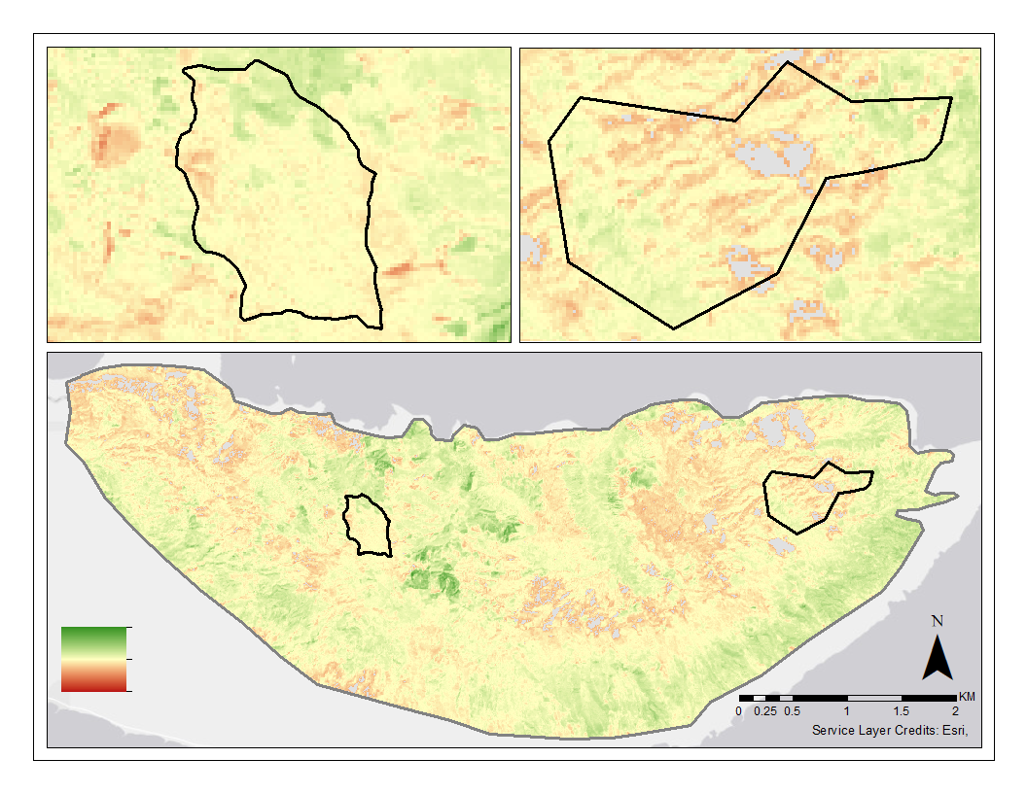
Change
0.5
-0.5
Figure 2. Landsat 8 NDVI Change Detection 2014 to 2019. Negative change in NDVI is shown in red areas and positive change in shown in green.

4.2 Exclosure Analysis
Below is the time series using the mean NDVI (green line) and NDMI (blue line) values calculated from 500 random points over the quarterly greenest pixel composite image within Exclosure 1 from 2013 - 2019 using Landsat 8 (OLI) imagery (Figure 3).

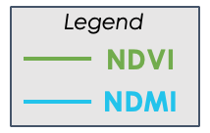
Exclosure 1
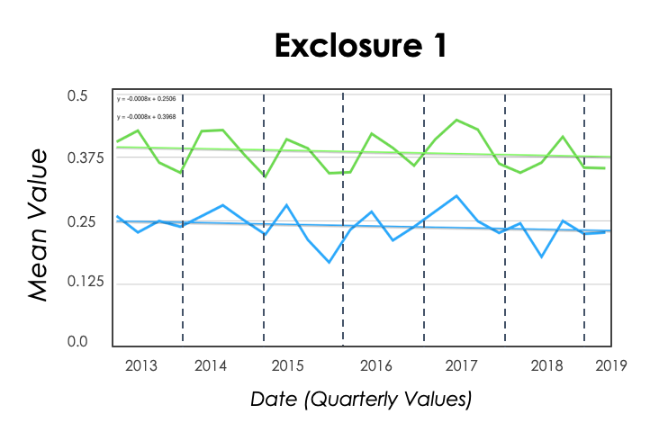

Figure 3. Time series assessment of Landsat 8 OLI values of NDVI and NDMI for Exclosure 1 from 2013 to 2019.

Below is the time series using the mean NDVI (green line) and NDMI (blue line) values calculated from 500 random points over the quarterly greenest pixel composite image within the Comparison Area from 2013 - 2019 using Landsat 8 imagery (Figure 4).

Comparison Area

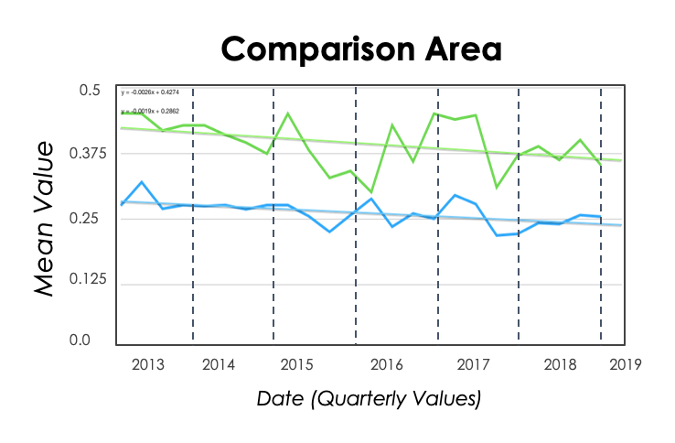

Figure 4. Time series assessment of Landsat 8 OLI values of NDVI and NDMI for Comparison Area from 2013 to 2019.
Below is the time series using the mean NDVI values calculated from the Sentinel-2 and Landsat 8 image collections. The mean values calculated from 500 random points over the quarterly greenest pixel composite image within the Comparison Area from 2016 - 2019 using Landsat 8 imagery (Figure 5).

Sentinel versus Landsat NDVI Values over Comparison Area
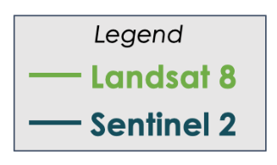
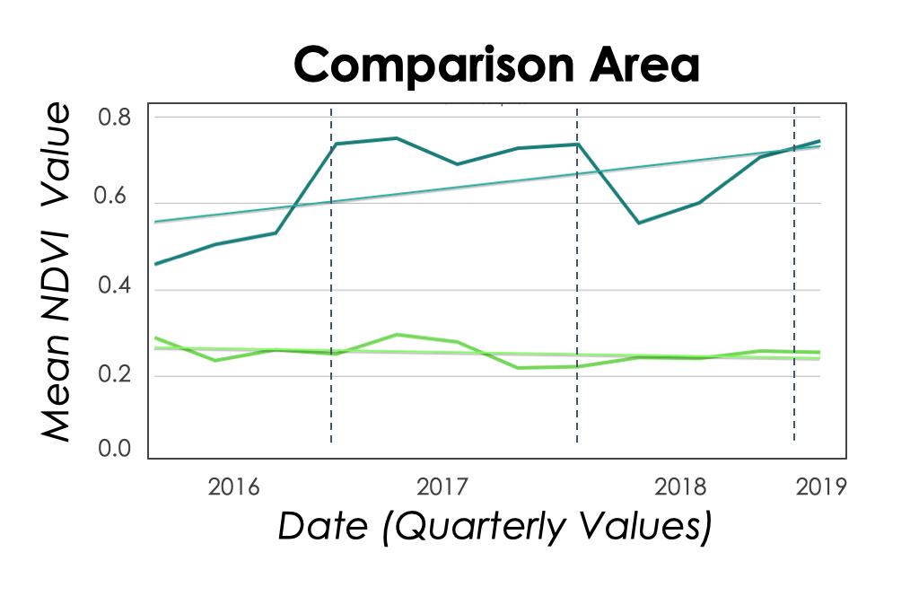
Date (Quarterly Values)
Figure 5. Time series using the mean NDVI values calculated from 500 random points over the quarterly greenest pixel composite image within the Comparison Area from 2013 - 2019 using Landsat 8 imagery (lime green line) and Sentinel-2 imagery (teal line).

4.3 'Ohi'a Impact Classification
Sentinel versus Landsat NDVI Values over Comparison Area
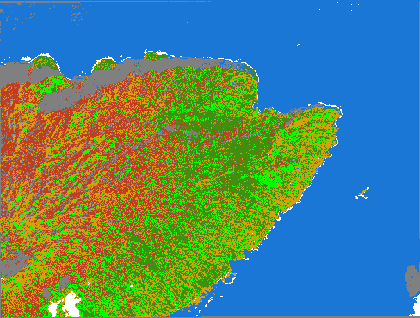
1 km

Figure 6. Supervised classification for Worldview 3 Imagery (February 2017). Affected areas shown in red and healthy vegetation shown in green.
4.4 Turbidity Feasibility Analysis
Below is the change detection output for our turbidity analysis using NDTI. Red indicates a higher change in turbidity, blue indicates a lower change in turbidity.

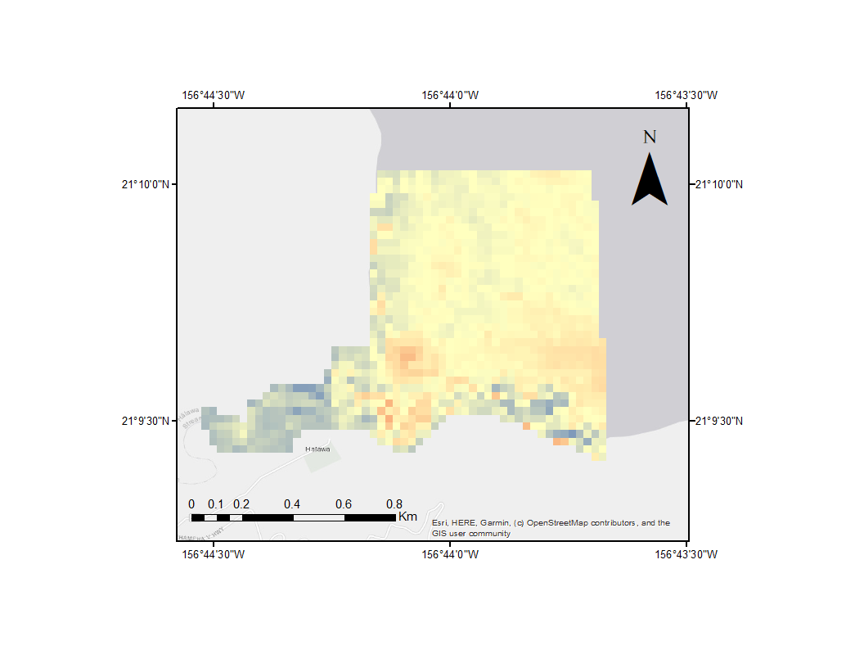
Change
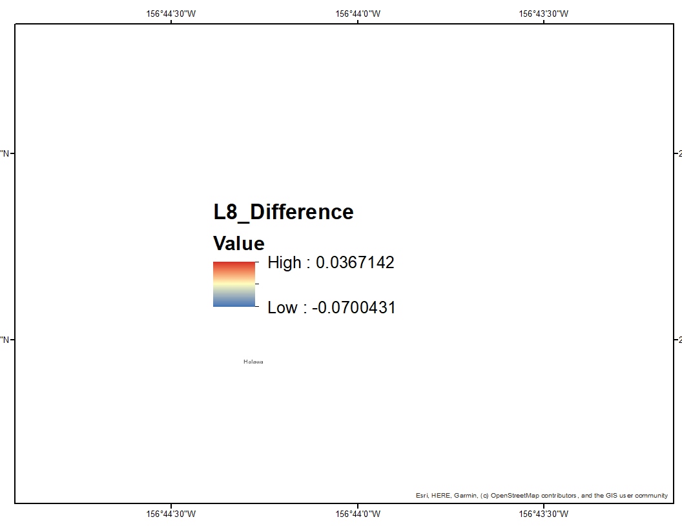
0.1

-0.1
Low: -0.1

Figure 7. Change Detection, NDTI (Landsat 8): Image of a water turbidity change detection using the NDTI for a non-turbid image Landsat 8 image from September 17, 2018 and February 2, 2017.

5. Discussion
5.1 Change Detection
Our change detection map for NDVI illustrated that areas on the eastern and northwest portions of our study area showed the greatest concentration of negative change (Figure 2). This suggested that these regions could have been particularly impacted by the rust outbreak. These low value regions visually overlapped with the rust survey polygons provided by our partners (Appendix E). This overlap suggested that NDVI may be a useful indicator for detecting impacted 'ohi'a. We also observed some positive NDVI changes along the southeastern portion of our study area. When observing the changes within Exclosure 1 in relation to the changes within our Comparison Area, we saw lower NDVI values in the Comparison Area which still have the influence of ungulates. In contrast, within Exclosure 1 the values are fairly moderate (indicating little or no change in NDVI values between the dates) with some positive values, indicating recovering vegetation. This is promising in the context of examining the influence of the exclosures on overall forest impacts, but it is not possible to validate that these changes are directly related to rust or ungulate impacts.

Our change detection map for NDMI illustrated trends similar to the NDVI change detection, where the most impacted areas where located on the eastern and northwest portion of our study area. In this case, regions with a loss of vegetation would be indicated with low values for NDMI and vice versa for areas with an increase in vegetation or vegetation health. We interpreted these areas as impacted by the tree rust because a loss in moisture often indicates increased water stress on the plant which could indicate a loss in vegetation. The lower NDMI values also overlapped with the moderate, severe, and very severely rated rust survey polygons (Appendix E). Similar to NDVI, when observing changes within Exclosure 1 in relation to our Comparison Area, our data shows more severe negative change values in the Comparison Area, which could be indicating a greater loss in moisture content. With our knowledge of the NDMI combined with the visual overlap with field data, this change detection suggests that NDMI could also be used as an indicator for impacted forests. However, once again with our data it is not possible for us to point to the rust or ungulates to explain this change because there are likely other environmental factors contributing to this change. We believe that higher resolution multi-spectral imagery and in-field validation points may be able to increase the feasibility of using these indices to indicate rust impacts.

5.2 Exclosure Analysis
With our data and results it does not appear feasible to assess temporal changes in rust impacts (Figure 3). Our time series analysis for NDVI and NDMI did not show any significant trends when comparing the four exclosures and the Comparison Area that were related to the peak rust outbreak in 2017 (Figure 3, Appendix B1, Appendix B2, Appendix B3). We were particularly interested in the trends between the Comparison Area and Exclosure 1 because Exclosure 1 is the longest standing exclosure and has been ungulate free for over 10 years. For this reason, we anticipated the comparison between these two areas would be the most telling. We saw a small decrease in NDVI and NDMI in both Exclosure 1 (Figure 3) and the Comparison Area (Figure 4). Additionally, our data did not support any trends that indicated the exclosures effectiveness or lack of effectiveness in maintaining vegetation health within its boundaries. It is important to note that when looking at NDVI in this region for a single image or trends over time, these values not only reflects the general health of 'ohi'a, but also will include other vegetation present in the ecosystem. Once a tree is impacted or killed by the rust it likely will not take long for new growth to occur in the ground layer or midstory due to decreased competition. This new growth can give off similar NDVI and NDMI values and therefore detecting significant change using NDVI in this region may be ephemeral and difficult with this approach.

We also determined that the best way to carry out calculations in these regions with high cloud cover, in the context of calculating indices for a range of time rather than for a single image, was to use the greenest pixel composite. This was the best way to look at a range of dates because using the raw images masked out large regions of the image and using the median composite image still included distortions from the clouds. Using the greenest pixel composite still contained some clouds, but there were proportionally a lot less clouds than the other two approaches. Our exclosure analysis included time series assessments of NDVI and NDMI for Landsat 8 and Sentinel-2 within each of the four exclosures as well as for each comparison area. We were unsure how NDMI would perform in such a moist environment, being that we were looking at a tropical region, but we found that NDVI and NDMI had similar trends within our study area between 2013 to 2019 when looking at both sensors. This suggests that they are both comparable and both can be used when looking at forest impact trends in our study area. One interesting result is that the values calculated using Sentinel-2 data were consistently higher than those gathered from Landsat 8 (Figure 5). We were unable to thoroughly investigate this relationship, but we believe it could be related to cloud cover or other atmospheric conditions and would be worth future investigation.

5.3 Classification
The classified Worldview image shows the distribution of rust affected and healthy vegetation throughout the eastern portion of our study area (Figure 6). The final classification resulted in a 75% accuracy for rust vegetation and 94% accuracy overall. We visually assessed the classification using the Worldview NDVI layer and the affected areas identified from rust survey polygons. It appears that the rust is being over-classified. When comparing the classification image to the impacted survey polygons (polygons that were identified as moderate, severe, and very severely impacted), there is some visual overlap with rust detected areas, but with the overclassification and generalization of the survey polygons it is not possible to say how well the rust is correctly being classified. We found it interesting that patterns of lower values from the Worldview NDVI image visually overlapped with areas identified as rust in the classification. These patterns indicate that on the western portion of the image, it is likely that there could be rust affected 'ohi'a.

There are issues with the classification that could be improved in future analysis. First, the accuracy for rust detection was 75%; this accuracy rate could be improved upon with more imagery and field validated data. The rust class was most often confused with the grass or understory class, most likely due to similar spectral characteristics that give these areas near-median NDVI values. Because of this, the classification over-estimated the extent of the rust affected vegetation. The mixing of these classifications is also likely due to the fact that some areas of the map were more difficult to classify and visually interpret due to the variety of land cover types present throughout the island.

This classification method could be improved by having more field data and high-resolution imagery. We only had access to one high resolution image (1.24 meter) for a single date for our study. By including more high-resolution imagery for additional dates it would be easier to assess the pattern of rust affected vegetation over time. Additionally, having imagery covering the entire study area could yield more informative data for the entire study area or island. Field validation data, such as plots, or single trees monitored over time, could improve the accuracy of the classification in the future. Further, collecting representative locations of a variety of land cover classes could help improve the disconnect between interpreting land cover classes from remotely sensed images and what exists on the ground.

This classification was a feasibility test. With more exploration of high resolution multi-spectral images we think it may be possible to pick up tree mortality in this area. Higher resolution calculations of vegetation health indicating variables may at least, like NDVI, help narrow down regions that may be impacted by the rust.

5.4 Turbidity Feasibility Assessment
With our data it was not possible to identify distinct differences between the two satellite images that we looked at to compare turbidity. It seemed likely to detect changes in turbidity; however, this analysis is dependent on sufficient cloudless satellite images to support a more extensive analysis. In Figure 6, the light red region by the mouth of the river indicates where there is a higher change in water turbidity. In this image, the less turbid water is indicated by lower values and the more turbid water is indicated by higher values. This change detection showed the biggest change at the mouth of the river. For both the turbid and non-turbid images, there are moderate-change pixel values surrounding the coast. When comparing the change detection to the original images, it appears likely that these pixel values are picking up wave crests rather than turbid water (Appendix C1, Appendix C2). More specifically, the light reflectance from the waves may have been misinterpreted as turbid water. An additional reason that some of the moderate-change pixel values are being misinterpreted as a higher pixel value is due to the influence of cloud cover. This misclassification is making the water appear more turbid than it actually is. These minor differences, were not enough to identify clear trends related to turbid and non-turbid events using the NDTI off of Moloka’i. However, we think it may be feasible with atmospherically corrected images closer to a flood event.

6. Challenges
Two challenges associated with the 'ohi'a impact portion of the project were cloud cover and imagery resolution. Due to Moloka’i’s location in the Pacific Ocean and the tropical climate, cloud cover was a common problem throughout the project. Clouds greatly limited the amount of available imagery to use for both Landsat 8 and Sentinel-2. To compensate for this we had to use the greenest pixel function to mosaic images over several months. This was an expected downside to using multispectral imagery and will likely remain an issue in the future for this particular location. Additionally, we were limited to Landsat 8, Sentinel-2, and a single Worldview 3 image for this project. We could have greatly benefited from access to more high-resolution imagery - although this often comes at a higher cost to acquire. Access to more high-resolution imagery, could lead to tree level precision for rust detection over time. If paired with LiDAR, photogrammetric point cloud data, or hyperspectral data, this could be a particularly powerful dataset for locating affected vegetation.

The lack of field data also posed a problem with regards to validating our classification. Although we had three presence points for affected 'ohi'a trees, we needed a more robust dataset to properly validate any classifications. If TNC is interested in performing future classifications for the island, it could be worth collecting more field data. This could involve monitoring tree stats using points or plots across different land cover types. Any additional data would be very useful for improving classification accuracy.

One of the main challenges of the turbidity analysis is that Landsat 8 and Sentinel-2 fly-over dates did not align with the turbidity events. Turbid events are often very quick and disperse rapidly. Therefore, it is critical that the flyover dates align within a few days of the event. Cloud cover is also an issue when detecting turbidity. Turbidity is of highest concern after large precipitation events, this requires having dense cloud cover. Another challenge of this assessment is that the NDTI index was picking up features that were not turbidity. These included wave crests and clouds that were not filtered out by the sentinel mask. The pixels in these areas were classified as areas with higher turbidity values.

7. Conclusions
7.1 Final Conclusions
In conclusion, our team was successful in utilizing NDVI and NDMI to create 'ohi'a forest impact maps using Landsat 8 OLI (30 meter resolution) and Sentinel-2 MSI (10 meter resolution). Our 'ohi'a time series analysis did not show distinctly promising trends in forest impact from 2013 - 2017. The 'ohi'a change detection was successful in highlighting regions of the forest that have changed the most in NDVI and NDMI. The regions with the most negative change aligned with the supporting rust outbreak polygon data that our partners supplied us with, suggesting that these changed areas may be regions impacted by the rust. However, it was not possible for us to state a definitive tie. Finally, it seems likely to detect changes in turbidity, but this analysis is dependent on sufficient cloudless satellite images to support a more extensive analysis. We believe that such a detection would be feasible with images closer to a flood event, but our data was limited by image collection dates that were either too far away from a flood event or an image where the coast was covered in clouds.

7.2 Future Work
To further expand on the rust classification, we suggest collecting more field data to strengthen the model and validate the results that we found in this study. Specifically, we suggest that field points should survey areas with 'ohi'a trees that are healthy, moderately healthy, and rust infected. We suggest additional background points be collected to identify other commonly misclassified land cover classes, such as ferns, grasses, or regions with low vegetation cover. These points could be used to verify areas of rust, non-impacted vegetation, grass, soil, and water. These points would also significantly improve the accuracy of the classification. We also suggest looking into additional resources with high resolution images because changes related to the rust happen at such a fine spatial scale. We believe that high resolution imagery across the entire island for multiple time periods would allow for a more comprehensive understanding of this complex outbreak.

To build upon the turbidity feasibility assessment, we believe that field data reporting the amount of suspended sediment in the water would be beneficial. The flood events occur very quickly and being able to compare the amount of sediment in the water before, during, and after a peak event would allow for more accurate validation. To continue to explore this topic, ACOLITE could be utilized with a more refined spatial mask. This would also allow us to assess the entire island of Moloka’i rather than having to focus on specific river outlets.

Clouds posed as a consistent issue throughout this project. In order to combat this, Sentinel-1 C Band Synthetic Aperture Radar could be utilized due to its ability to obtain imagery in all weather conditions. This makes it a great tool to monitor vegetation in dense cloudy areas.

8. Acknowledgments
The Moloka’i Water Resources Team would like to thank The Nature Conservancy and the USGS for partnering with NASA DEVELOP to make this research possible. A special thanks to Dr. Paul Evangelista, Dr. Catherine Jarnevich, Nicholas Young, Peder Engelstad, Tony Vorster, and our Center Lead Kristen Dennis for their support in the development of this research. Additionally, we would like to thank Dr. Helen Soafer, Dr. Stephanie Dunbar and Stephanie Tom from The Nature Conservancy, and Rudi Hunke from the Pu’u O Hoku Ranch for their support throughout this research project.

This material contains modified Copernicus Sentinel data (2015-2019), processed by ESA.

Any opinions, findings, and conclusions or recommendations expressed in this material are those of the author(s) and do not necessarily reflect the views of the National Aeronautics and Space Administration.

This material is based upon work supported by NASA through contract NNL16AA05C.

9. Glossary
Earth observations – Satellites and sensors that collect information about the Earth’s physical, chemical, and biological systems over space and time
ESA – European Space Agency
Exclosure – An area from which unwanted animals are excluded
NDVI – Normalized Difference Vegetation Index
NDMI – Normalized Difference Moisture Index
NIR – Near Infrared
SWIR – Shortwave infrared
Turbidity – A measure of the amount of suspended material in the water
Ungulates – A hoofed mammal
USGS – United States Geological Survey
TNC – The Nature Conservancy

10. References
Anderson, R. C. (2012). A Baseline Analysis of the Distribution, Host Range, and Severity of the Rust Puccinia psidii in the Hawaiian islands, 2005-2010 (No. 031). Honolulu, Hawaii: U.S. Geological Survey.

Braga, F., Zaggia, L., Bellafiore, D., Bresciani, M., Giardino, C., Lorenzetti, G., . . . Brando, V. E. (2017). Mapping turbidity patterns in the Po river prodelta using multi-temporal Landsat 8 imagery. Estuarine, Coastal and Shelf Science, 198, 555-567. doi:10.1016/j.ecss.2016.11.003

Copernicus Sentinel Data [2015-2019]. Retrieved from Google Earth Engine June 12, 2019, processed by
ESA, from https://developers.google.com/earth-engine/datasets/catalog/COPERNICUS_S2

Lacaux, J. P., Tourre, Y. M., Vignolles, C., Ndione, J. A., & Lafaye, M. (2007). Classification of ponds from high-spatial resolution remote sensing: Application to Rift Valley Fever epidemics in Senegal. Remote Sensing of Environment, 106(1), 66-74. https://doi.org/10.1016/j.rse.2006.07.012

Loope, L. (2016). GUIDANCE DOCUMENT FOR RAPID ‘ŌHI‘A DEATH. Background for the 2017—2019 ROD Strategic Response Plan, 1-45. Retrieved June 17, 2019, from https://www.fs.fed.us/psw/publications/hughes/psw_2016_hughes006_loope.pdf

Pettorelli, N., Vik, J. O., Mysterud, A., Gaillard, J. M., Tucker, C. J., & Stenseth, N. C. (2005). Using the satellite-derived NDVI to assess ecological responses to environmental change. Trends in Ecology & Evolution, 20(9), 503-510. doi:10.1016/j.tree.2005.05.011

Roessler, C. E. (2008, November 26). Island of Molokai, a tiny window into the Hawaii of old. The New York Times. Retrieved June 19, 2019, from https://www.nytimes.com/2008/12/30/travel/30iht-trhawaii.1.18941130.html

United States Geological Survey Pacific Coastal and Marine Science Center. (n.d.). Coral Reef Project. Retrieved June 12, 2019, from https://www.usgs.gov/centers/pcmsc/science/coral-reef-project?qt-science_center_objects=0#qt-science_center_objects

US Geological Survey Earth Resources Observation and Science Center. (2017). Landsat 8 OLI/TIRS
Level-2 Data Products – Surface Reflectance. [Image collection]. Retrieved June 10, 2019. doi.org/10.5066/F78S4MZJ

Vorster, A. G., Evangelista, P. H., Stohlgren, T. J., Kumar, S., Rhoades, C. C., Hubbard, R. M., … Elder, K. (2017). Severity of a mountain pine beetle outbreak across a range of stand conditions in Fraser Experimental Forest, Colorado, United States. Forest Ecology and Management, 389, 116-126. https://doi.org/10.1016/j.foreco.2016.12.021

Wallace, G. (2016, June 30). Hawai'i's Legendary 'Ohi'a Tree Is Important For Birds And People. Retrieved June 10, 2019, from https://abcbirds.org/hawaiis-ohia-tree-holds-legendary-importance-for-birds-and-people/

11. Appendices
Appendix A:
NDMI Change Detection
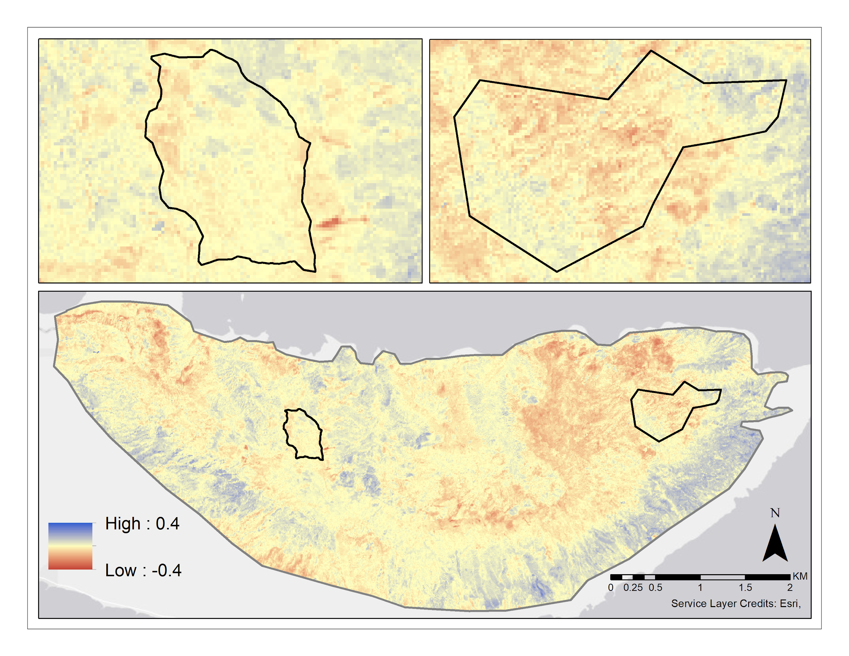
Change
Appendix A. Landsat 8 NDMI Change Detection 2014 to 2019. Negative change in NDMI is shown in red areas and positive change in shown in blue.

Appendix B:
Time Series Exclosure 2
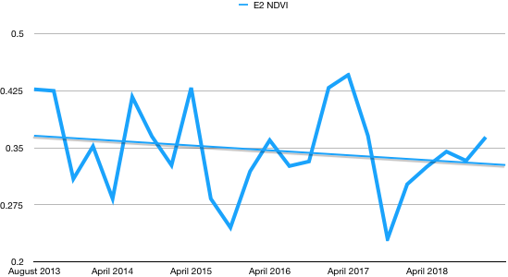
0.2
0.25
0.35
0.425
0.5
2019
2018
2017
2016
2015
2014
2013

Appendix B1. The NDVI time series for Exclosure 2, each value indicates the mean NDVI value of the 500 generated points within the exclosure.

Exclosure 3
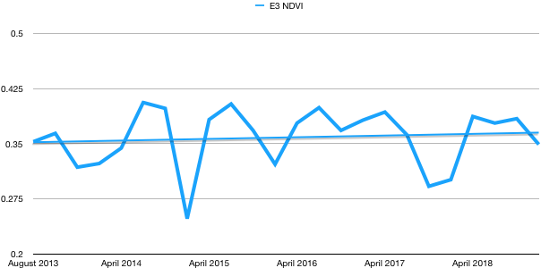
0.2
0.25
0.35
0.5
0.425

2015
2013
2014
2016
2017
2018
2019

Appendix B2. The NDVI time series for Exclosure 3, each value indicates the mean NDVI value of the 500 generated points within the exclosure.

Exclosure 4

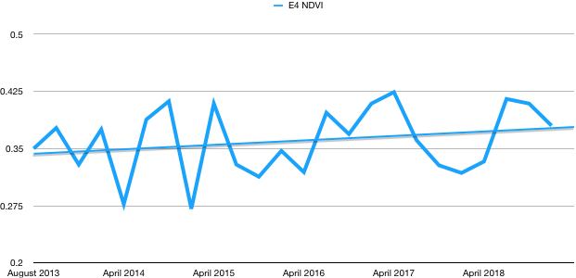
0.425
0.5
0.35
0.25
0.2

2015
2013
2014
2016
2017
2018
2019
A
Appendix B3. The NDVI time series for Exclosure 4, each value indicates the mean NDVI value of the 500 generated points within the exclosure.

Appendix C:
Turbidity Feasibility Assessment
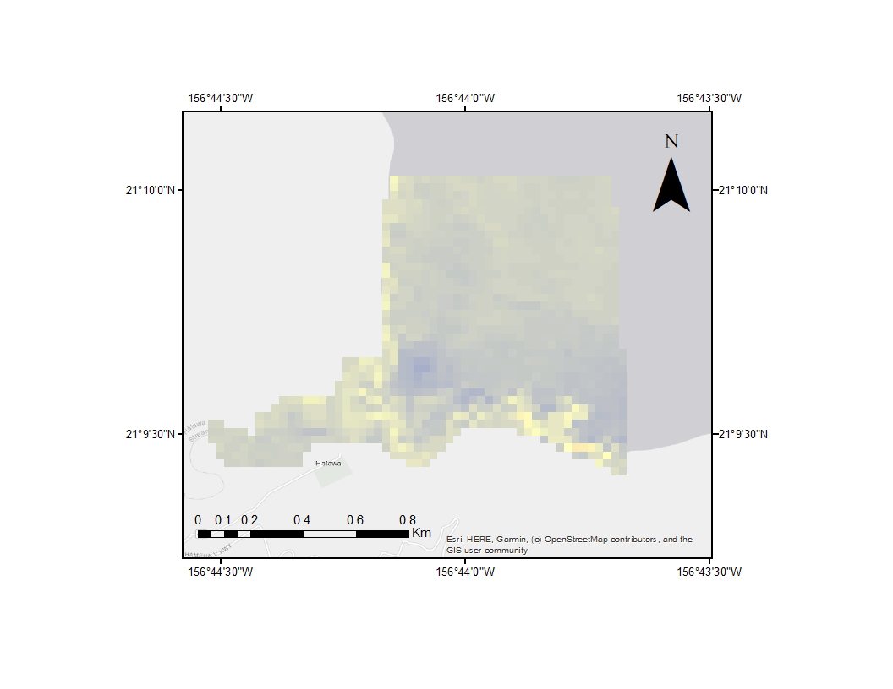
NDTI
Low: -0.2
High: 0.2
Appendix C1. Non-Turbid event, NDTI (Landsat 8): Image of a non-turbid scene from February 2, 2017

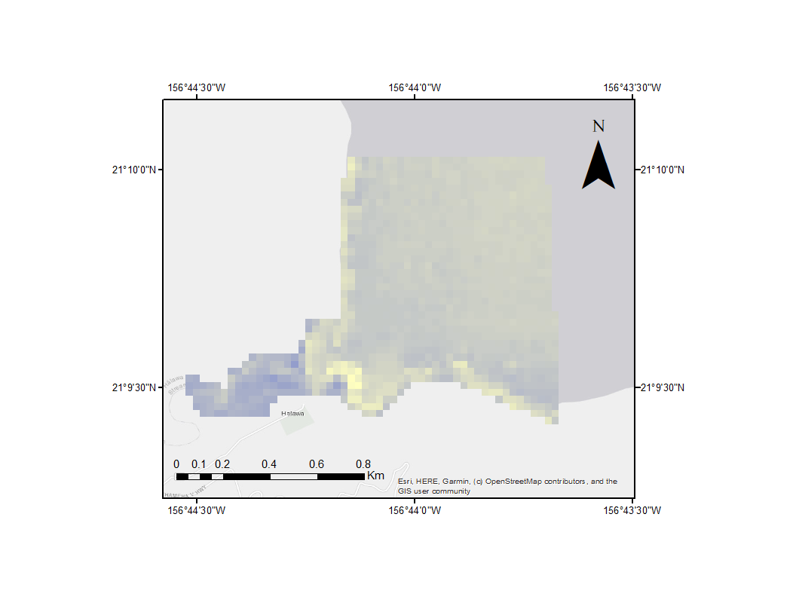
NDTI
Low: -0.2
High: 0.2
Appendix C2. Turbid Event, NDTI (Landsat 8): Image of a turbid scene following a flood event, September 17, 2017

Appendix D:
Confusion Matrix

 | Water | Soil/Agriculture | Shadow | Clouds/Waves | Grass | Healthy Veg | Rust
Water | 1386 | 0 | 0 | 0 | 0 | 0 | 0
Soil/Agriculture | 0 | 66 | 1 | 1 | 3 | 10 | 1
Shadow | 0 | 0 | 104 | 0 | 0 | 0 | 0
Clouds/Waves | 0 | 0 | 0 | 46 | 0 | 0 | 0
Grass | 0 | 6 | 0 | 0 | 57 | 13 | 18
Healthy Veg | 0 | 3 | 0 | 0 | 6 | 55 | 0
Rust | 0 | 5 | 2 | 0 | 32 | 5 | 56
SUM | 1386 | 80 | 107 | 47 | 98 | 83 | 75
Accuracy | 100 | 82.5 | 97.19626168 | 97.87234043 | 58.16326531 | 66.26506024 | 74.66666667

Appendix D. Confusion Matrix for supervised classification for Worldview 3 Imagery (2017). Overall accuracy is 94.3% and accuracy of rust affected class is 74.6%.

Appendix E:
Supervised Classification with Rust Polygons

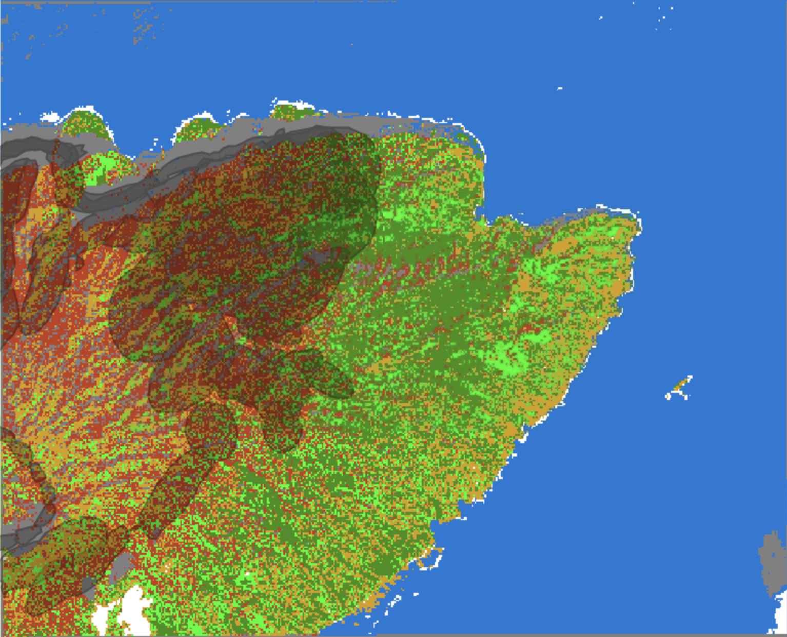
1 km

Appendix E. Supervised classification for Worldview 3 Imagery (February 2017) overlaid with rust survey polygons (shown in gray vectors).

Appendix F:
Rust Polygons over Study Area

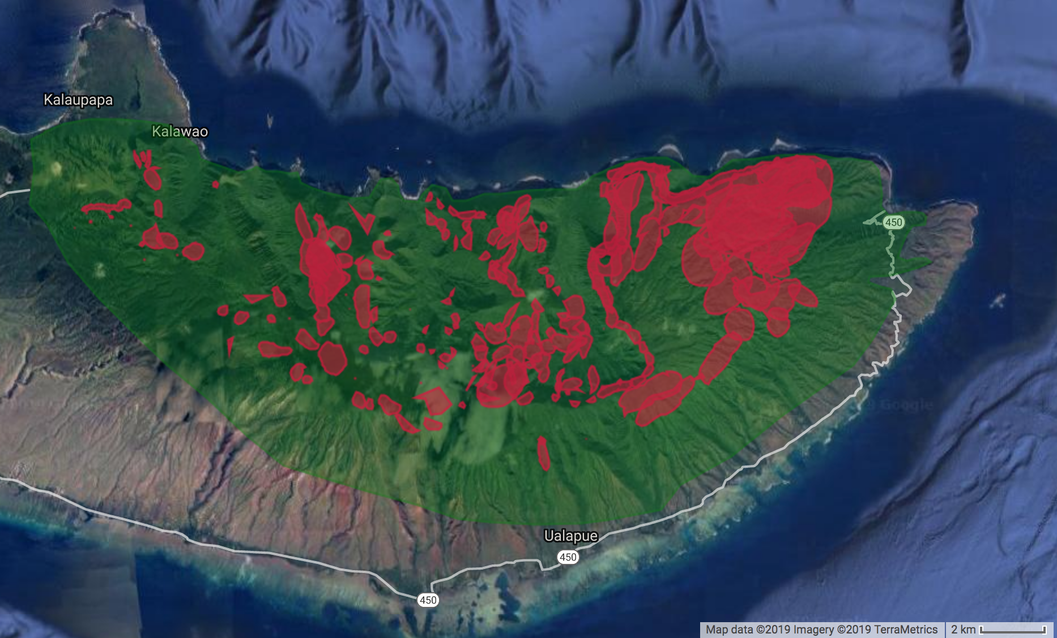
Appendix F: Rust survey polygons overlaid on our study area. Rust impacts indicated in red, study area indicated in green.

