Tonlé Sap Food Security and Agriculture II

Evaluating Changes in Ecosystem Vitality and Freshwater Health in the Tonlé Sap Basin using Remotely Sensed Data

 **Technical Report**

Final Draft – August 12th, 2021

Justine Spore (Project Lead)

Brian Place

Nick Pelaccio

Joey Lindsay

Molly Farrell

***Advisors:***

Dr. Venkataraman Lakshmi (University of Virginia, Department of Engineering Systems and the Environment)

Dr. Kenton Ross (NASA Langley Research Center)

Dr. Derek Vollmer (Conservation International)

***Previous Contributors:***

Marco Vallejos

Jenna Johnston

Sonnet Phelps

Joseph Scarmuzza

# 1. Abstract

The Tonlé Sap Lake and river basin in central Cambodia provide critical ecosystem services to the region, including fisheries, agricultural irrigation, hydropower, and biodiverse habitats. Deforestation, increased pumping for farming, and effects of climate change such as droughts and forest fires threaten the health of the lake and food security in the region. This project built upon the previous term through a partnership with Conservation International (CI), the Cambodian Ministry of Water Resources and Meteorology, and the Tonlé Sap Authority to assess ecosystem vitality and implement CI’s Freshwater Health Index (FHI) tool, in an effort to prioritize resource expenditure and highlight areas of concern. Due to the COVID-19 pandemic and related travel restrictions, partners had not been able to readily collect in situ data for the past year, which make up the majority of FHI inputs. To help fill this data gap, we developed a methodology for using Gravity Recovery and Climate Experiment (GRACE) satellite data to calculate groundwater storage depletion, and a Python Application Programming Interface for processing and formatting remotely-sensed data for the Soil and Water Assessment Tool (SWAT) model. We then used SWAT to model nutrient flows and phosphorous, nitrogen and suspended sediments amounts in the basin from October 2000 to December 2020. These outputs, when validated, will serve as inputs for the FHI and provided policy makers with robust monitoring information to aid decision-making in the area and safeguard the lake’s vital fisheries and biodiversity.

**Key Terms**

SWAT, Hydrology Modeling, GRACE, Freshwater Health Index, Dams, Lake Level Change, Fisheries

# 2. Introduction

***2.1 Background Information***

The Tonlé Sap Basin (Figure 1) is a unique ecosystem that provides hydrological, biological, nutritional, and cultural value to the lower Mekong region and the country of Cambodia. The lake borders five Cambodian provinces: Siem Reap, Battambang, Pursat, Kampong Chhnang, and Kampong Thom. The basin is home to 4.5 million people, many of whom rely directly on the Tonlé Sap Lake for critical ecosystem services, most notably fisheries that drive the economy of the region and provide up to 80% of the protein consumed by the Cambodian population of 16.5 million people (Arias et al., 2014). The Tonlé Sap River changes its flow direction twice a year, accounting for approximately 72% of the sediment flux into the Tonlé Sap Lake. This sediment provides essential nutrients for the lake’s productive ecosystem, even though the sources, transport, and transformation processes of nutrients in the Tonlé Sap Lake are poorly understood (Uk et al., 2018).

During the study period from 2000-2020, many compounding factors have affected the ecosystem health of the Tonlé Sap Basin, including deforestation, changes in precipitation patterns, potential increase in drought frequency, and increases in agricultural activity and hydropower development. The flooded forest surrounding the Tonlé Sap Lake, which plays a significant role in aquatic system health, has lost 31% of its total area since 1993, compared to 18% area loss for the upland forest. Flooded forests hold more potential for carbon absorption than dry forests, so this deforestation represents a considerable loss of sequestered carbon (Lohani, Dilts, Weisberg, Null, & Hogan, 2020). In addition, compounded by climate variability, the frequency and intensity of drought and flood events in the region have become more severe and have led to the destruction of irrigation fields and civilian casualties (Tangdamrongsub, Ditmar, Steele-Dunne, Gunter, Sutanudjaja, 2016). Construction of upstream dams and reservoirs, despite their benefits to water and energy security, may also lead to significant trapping of sediments and nutrients and reduction in fertility of the Tonlé Sap system (Sarkkula et al., 2003).

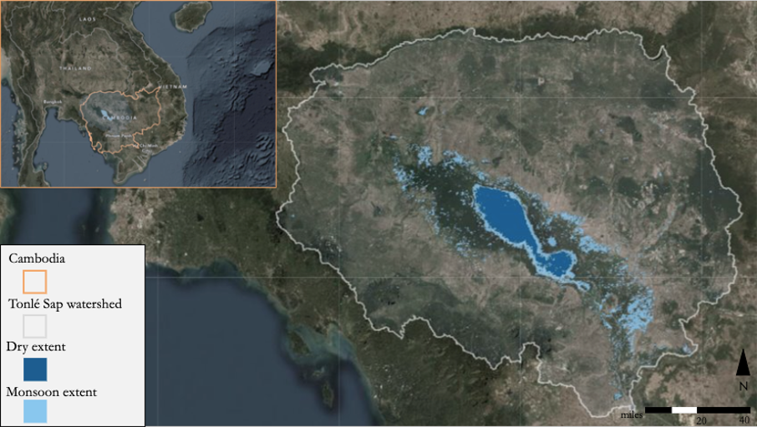

*Figure 1.* Map of the Tonlé Sap Lake and basin, with dry season lake extent and monsoon season lake extents visualized on the lake (Vallejos, Johnston, Phelps, & Scarmuzza, 2021).

The Freshwater Health Index (FHI), developed by Conservation International, is a framework that scores watersheds across ecosystem vitality, ecosystem services, and governance and stakeholders (Vollmer et al., 2014). FHI scores provide policy makers with robust information to aid decision-making in the area and safeguard important ecosystems. Evaluating ecosystem vitality through the FHI requires data about the basin, including groundwater storage depletion and nutrient flows into and out of the basin. Due to the COVID-19 pandemic and related travel restrictions, partners have not been able to readily collect *in situ* data for the past year. However, remote sensing applications can fill these data gaps, and are potentially relevant in non-pandemic times as *in situ* data collection can be costly and time-consuming. The NASA Gravity Recovery and Climate Experiment (GRACE) mission measures changes in terrestrial water storage by satellite, and “can be considered as an effective tool for monitoring certain small-scale (82,000 km2 ) hydrological basins” (Tangdamrongsub et al., 2016). Similarly, when using a Soil and Water Assessment Tool (SWAT) for modeling water quality and nutrient flows in the basin, the inputs required by the model can be gathered from remotely sensed datasets, reducing the need for *in situ* collection. The SWAT model has been successfully applied to the Mekong River Basin previously, and aids in the establishment of a hydrologic baseline (Rossi et al., 2009).

The first term project, Tonlé Sap Food Security and Agriculture I (hereafter referred to as Tonlé Sap I), analyzed land cover naturalness and deviation from natural flow as sub indicators for the FHI using satellite and *in situ* data. A decrease in both landcover naturalness and regularity and volume of water in the lake were found throughout the study period of 2000-2020. Tonlé Sap I calculated that during the study period, about 8% of the forest in the river basin was lost to deforestation along with a subsequent increase in rice harvest intensity (Vallejos, Johnston, Phelps, & Scarmuzza, 2021).

***2.2 Project Partners & Objectives***

For this project we partnered with Conservation International (CI), the Cambodia Ministry of Water Resources and Meteorology (MoWRaM), and the Tonlé Sap Authority (TSA). CI is an international nonprofit organization primarily concerned with research, conservation, and sustainability of ecosystems around the world, and has been involved in the Tonlé Sap region since 2008. Their focus is to make sure the ecosystem remains healthy enough to support the population of more than three million people living within the Tonlé Sap floodplain (Conservation International 2021). Our project results will be used by the CI team in collaboration with MoWRaM and the TSA, two Cambodian governmental organizations centered around water resources management and sustainable ecosystem management. The collaboration between these three organizations will inform policy makers in crafting policy, managing resources, and coordinating development projects around the Tonlé Sap Lake to benefit the overall health of the lake and the people living within the basin.

This project focused on two sub-indicators in the FHI, groundwater storage and water quality, and aimed to test the feasibility of using remotely sensed data to assess their vitality. We created a methodology for calculating groundwater storage with data from the GRACE satellite, and modeled nutrient flows in the basin with the SWAT tool using remotely sensed and *in situ* data from 2000-2020. We also developed a tool in Google Earth Engine (GEE) Python Application Programming Interface (API) to integrate remotely sensed data into future freshwater analyses, specifically in relation to the FHI.

# 3. Methodology

***3.1 Data Acquisition***

Table 1 outlines each parameter this analysis required and where the data was sourced from. Most of the data was acquired through GEE as open-source, pre-processed datasets. Our global soil map came from the UN’s Food and Agriculture Organization and was downloaded as a raster. We also accessed and received resources through data handoffs from the Tonlé Sap I team, including the land cover classification of our study area that was developed using CCI (European Space Agency’s (ESA’s) Climate Change Initiative) data. Specific NASA earth observations used for this project include GRACE Tellus for terrestrial water anomaly and the Shuttle Radar Topography Mission (SRTM) for a Digital Elevation Model (DEM). We also used data from the ESA), specifically ERA5 for a number of land and atmospheric variables. Lastly, we used *in situ* water quality data provided by our contacts at Conservation International to validate the outputs from the SWAT model.

Table 1

*This table lists parameters used for our analysis and their sources.*

|  |  |  |  |  |  |
| --- | --- | --- | --- | --- | --- |
| **Parameter** | **Platform & Sensor** | **Data Product** | **Resolution** | **Dates** | **Acquisition Method** |
| Change in Terrestrial Water Storage (ΔTWS) | GRACE Tellus, K-band Ranging System (KBR) | GRACE Monthly Mass Grids - Land | 1 degree | 2002/04/01 - 2017/02/03 | Retrieved as Google Earth Engine Dataset |
| Digital Elevation Model (DEM) | Shuttle Radar Topography Mission (SRTM), Radar | NASADEM | 30 meters | 2000 | Retrieved as Google Earth Engine Dataset |
| Land Cover Classification for Tonlé Sap Basin | N/A  (See Tonlé Sap I Tech Paper for additional information) | N/A | 300 meters from 2000-2015  100 meters from 2016-2020 | 2000-2020 | Retrieved from the Tonlé Sap Food Security and Agriculture I team’s data products. They utilized CCI Land Cover to compute landcover for the study area for the years 2000-2020 |
| Soil Classification for Tonlé Sap Basin | N/A | FAO Digital Soil Map of the World (DSMW) | 30 arc-seconds | N/A | Food and Agriculture Organization of the United Nations  <http://www.fao.org/soils-portal/data-hub/soil-maps-and-databases/harmonized-world-soil-database-v12/en/> |
| Precipitation, Maximum and Minimum Air Temperature, Humidity, Wind Speed | Copernicus Climate Change Service (C3S) for European Centre for Medium- Range Forecasts (ECMWF)  Reanalysis 5th  Generation (ERA5) | Global Precipitation Measurement v6 | 0.25 degrees | 2000/01/01 - 2021/07/05 | Retrieved as Google Earth Engine Dataset |
| Nitrogen, Phosphorous, Total Suspended Solids in the Tonlé Sap basin | N/A | *In situ* Water Quality | N/A | 1995-2017 | Acquired from Conservation International records with permission from Derek Vollmer |

***3.2 Data Processing***

*3.2.1 SWAT Inputs*

Remotely sensed data products were gathered and processed through Google Earth Engine’s Python Application Programming Interface (API). This API not only grants access to GEE services, but additionally allows for the use of powerful Python data-processing tools. This was completed through a Google Colaboratory (colab) workbook, a Google-specific fork of the popular Jupyter Notebook interface. Colab allows for dynamic editing by multiple users and easy access to Google Drive.

Data processing began by defining our study area and desired time range. We continued by loading in each of our input datasets: NASADEM and ERA5 data from GEE, the FAO DSMW raster, and land cover classification from Tonlé Sap I’s GEE repository. Within the ERA5 data, we selected maximum air temperature, minimum air temperature, dewpoint, u component of wind, v component of wind, and precipitation bands.

After clipping and displaying the above data, all ERA5 data was converted from the GEE ImageCollection class to the GEE FeatureCollection class. This was done through the image.sample(scale) method, with our scale being defined by the number of pixels in the study area. All data was then exported from GEE to Google Drive for continued processing using Python tools.

After clipping to our study area and defining the desired time range, the preprocessing methods run on each data type are listed below in Table 2.

Table 2.

*Preprocessing methods run on each data type after clipping to project study area and defined time range*

|  |  |
| --- | --- |
| **Data Type** | **Preprocessing Methods Run** |
| Digital Elevation Model | None – exported as a .tif file |
| Landcover | Reclassified to meet SWAT specifications – all land cover types were converted from CCI classes to the classes outlined in the SWAT global_landuses table. |
| Soil Data | Reclassified to meet SWAT specifications – all soil types were converted from FAO classes to the classes outlined in the SWAT global_soils table. |
| Precipitation | Rescaled from m/day to mm/day, as per SWAT specification. Written out as both a .csv file and as a series of .txt files, as per SWAT specifications. |
| Maximum and Minimum Air Temperature | Converted from Kelvin to Celsius. Written out as both a .csv file and as a series of .txt files. |
| Humidity | As ERA5 provides dewpoint rather than relative humidity data, dewpoint was converted to relative humidity using the Magnus approximation. Written out as both a .csv file and as a series of .txt files. |
| Wind Speed | v-component and u-component of wind speed were converted into a single windspeed value in m/s by utilizing the Pythagorean theorem. |

This notebook is not limited to providing data for the Tonlé Sap region — by changing the study timeframe and study area variables at the top of the notebook, it can provide remotely sensed data for any desired location at any timeframe within the ranges of the respective satellites.

Next, we began setting up and running the SWAT model within QGIS, an open-source geographic information system application. Steps required for running the SWAT model are as follows:

1. Creating streams from the DEM
2. Selecting inlets, outlets and reservoirs, and creating the subbasins
3. Selecting and merging subbasins
4. Loading soil classification and land cover data into SWAT
5. Creating Hydrologic Response Units (HRUs)
6. Creating a weather generator (WGN file)
7. Loading weather observations and WGN file into the SWAT inputs section
8. Defining warmup period and running SWAT
9. Validation via comparisons to *in situ* hydrology information
10. Calibration of the model with *in situ* observations

At the beginning of our SWAT run, we began with weather data (precipitation, humidity, wind speed, and maximum and minimum air temperature) formatted as both .csv files and .txt files. The land cover, soil, and elevation models were formatted as .tif files. The .csv files were fed into the WGN creator, an external utility program for SWAT in the form of a Microsoft Access macro. This program reads in our weather data in the .csv files and outputs what SWAT calls a “weather generation file.” This file is used by SWAT to generate missing data values. Since ERA5 daily aggregates do not contain missing values within our time range, the weather generation file was not utilized by the model but was still a necessary step for starting SWAT. The remainder of our inputs were placed directly into the model with no additional processing.

For the selection of inlets, due to a lack of *in situ* observations, only a single outlet was defined at the furthest downstream point of our study area. Subbasins within Tonlé Sap Lake were merged into a single subbasin. As Solar Radiation weather values were not available, they were not simulated by the weather generator file. The warmup period was set to two years, the recommended minimum. SWAT data was validated by comparing the model-generated total suspended sediments information with *in situ* observations, which is discussed in section 3.3. However, the SWAT results and the in situ data were not in agreement. Based on the discussion provided in section 4.1, our conclusion is that the results from the calibration step of the model was inconclusive..

*3.2.1 GRACE Groundwater Methodology*

For our groundwater sub-indicator, we created a methodology to calculate groundwater from the GRACE satellite using GLDAS data, the JRC Monthly Water Recurrence dataset, and lake level data from Tonlé Sap I to aggregate surface water sources and isolate groundwater. Figure 2 shows a graphic flowchart representation of our methodology.

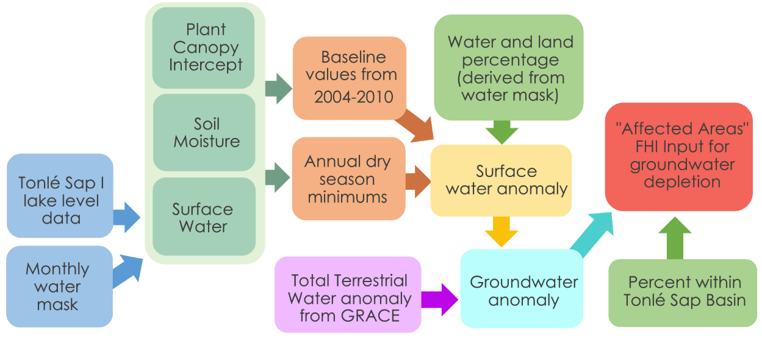

*Figure 2.* Graphic flowchart of methodology to calculate groundwater storage from GRACE satellite data. Created by Tonlé Sap II team.

The GRACE satellite provides data in the form of total terrestrial water anomaly, based on a baseline of terrestrial water from 2004-2010. The basic equation used to complete this methodology is: change in groundwater (GW) = change in terrestrial water storage (TWS) – change in soil moisture (SM) – change in plant canopy water (PCI) – change in surface water (SW) (Equation 1).

ΔGW = ΔTWS - ΔSM - ΔPCI - ΔSW

(1)

Because GRACE does not have groundwater isolated and provides its values in terms of anomaly, the first two steps to looking at groundwater are to 1) locate datasets for soil moisture, plant canopy water and surface water, and 2) create baseline values of each for 2004-2010 against which to measure anomaly.

For this methodology, soil moisture and plant canopy water values were acquired from the Global Land Data Assimilation System (GLDAS). To calculate a surface water volume, we used lake level altimetry data from the Tonlé Sap I team and multiplied by a lake area value calculated from a Monthly Water Recurrence dataset from the European Joint Resource Commission (JRC). Information associated with these additional datasets can be found in Table A1. For each of the three terrestrial water sources (soil moisture, plant canopy intercept and surface water), we calculated baseline values from 2004-2010 to match with the GRACE baseline, and then used reducer functions to extract dry season minimums. We chose to focus on the dry season — January-March for this analysis — to best address the FHI requirements for groundwater storage. The FHI asks for areas affected by groundwater storage depletion, and due to the region’s seasonality, focusing on dry season minimums would provide the time and areas that are most likely to experience water scarcity and be the most affected. To calculate anomaly, we took our dry season minimums for each year and subtracted the baseline value, this resulted in a delta value for soil moisture, plant canopy intercept and surface water for each year.

The next step was to account for the coarse resolution of the GRACE data and spread each surface water source evenly across the pixel. GRACE’s image resolution is 1 arc degree, which means there were only eight to ten pixels within our study area, and that most of those pixels included some of the lake and some land. To accomplish this, we created polygons for each GRACE pixel and using the JRC water mask created a multiplier of percentage land for each pixel. For soil moisture and plant canopy intercept, we used the GRACE land proportion as a multiplier to spread it equally over the land within the pixel, and for surface water we did the same with the water proportion multiplier. This resulted in three layers of annual anomaly for soil moisture, plant canopy intercept and surface water. Adding these three together created a total surface water anomaly, and when subtracted from GRACE provides groundwater storage anomaly.

The last task was to convert this groundwater storage anomaly into an “affected areas” value for use in the FHI. To do this, we first created a threshold groundwater value, under which an area would be deemed “affected” by groundwater storage depletion. Then, we used the GRACE pixel polygons created in an earlier step to weight each anomaly value again, this time by a multiplier based on how much of the pixel was included in our study area. This meant that when we clipped the GRACE data to our study area, the groundwater anomaly would be spread evenly throughout the whole pixel, including what was clipped away. Based on this weighting and the “affected area” threshold, we can identify pixels in the basin that indicate groundwater storage depletion on an annual basis.

***3.3 Data Analysis***

We validated our SWAT outputs by comparing them with *in situ* data at the Kampong Chhnang station, provided by our partners at CI. We decided to look at total suspended solids (TSS), since our other two outputs, nitrate and phosphorus, give a in and out flow number separately in the SWAT output, while TSS provided us with one value in our SWAT output and *in situ* data.

To validate the SWAT output with *in situ* data, our team took daily TSS values from the SWAT output and monthly values from the *in situ* data to create summed yearly TSS values for each year from 2002-2019. Figure 3 shows that after our first attempt of validating the SWAT model, that the model does not accurately calculate total suspended solids in the Tonle Sap Basin. Further and more extensive validation studies should be carried out.

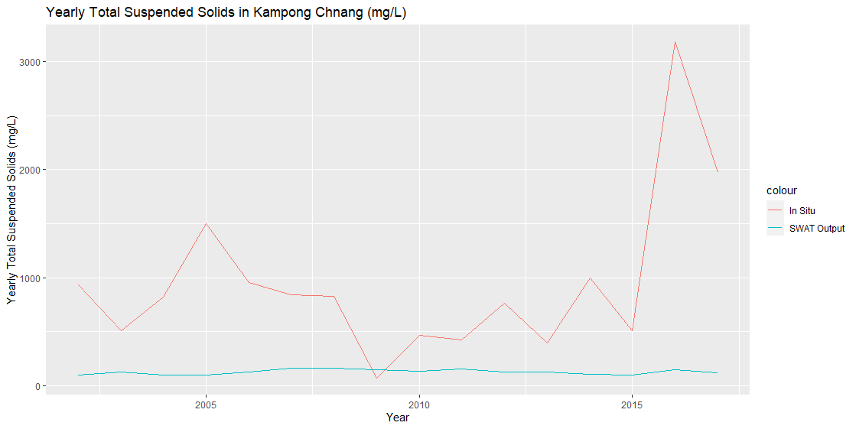

*Figure 3.* Yearly Total Suspended Solids totals in mg/L from 2002-2019, measured at the Kampong Chhnang station compared with SWAT outputs in the same basin.

# 4. Results & Discussion

***4.1 Analysis of Results***

We conclude that without more extensive validation and calibration, we cannot recommend using the SWAT model in the current state to accurately assess water quality in the Tonle Sap Basin. However, there are several caveats to this conclusion. Firstly, the *in situ* data we received had one variable called ‘SDATE’, which gave a specific day for each month, and each month had only one TSS value. If the data was only collected on one day each month and subsequently given as the value for the entire month, that would provide an inaccurate assessment of TSS and other nutrients in the Tonle Sap Basin. Furthermore, the SWAT output provides over 600 subbasins in the model, and while we had coordinates for the Kampong Chhnang station, we had to make an educated guess as to which of the 600 subbasins the Kampong Chhnang station is in. There are ways to calibrate the SWAT model with different parameters with a software called SWAT CUP. One potential parameter adjustment would be a starting number of sediments in the water system, which would explain why the SWAT output values for TSS start and end so low, when that value is actually much higher than the model predicted. SWAT CUP also requires *in situ* streamflow data, which as far as our team is aware of, is not available in the Tonle Sap Basin.

Below are the outputs on Total Suspended Solids, Nitrate, and Phosphorus we received from the SWAT model. We believe these numbers to be inaccurate based on our initial assessment of model validity and lack of any parametric calibration.

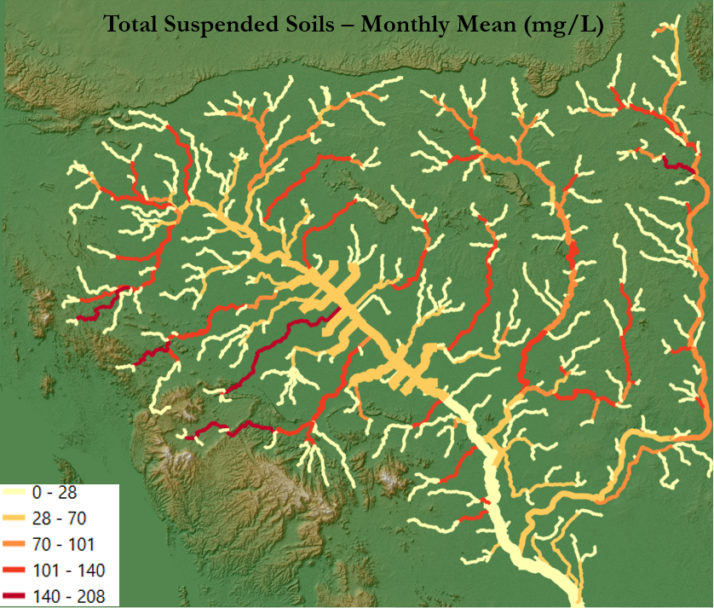

*Figure 4.* SWAT output showing monthly means of Total Suspended Solids (mg/L) in the Tonle Sap Basin

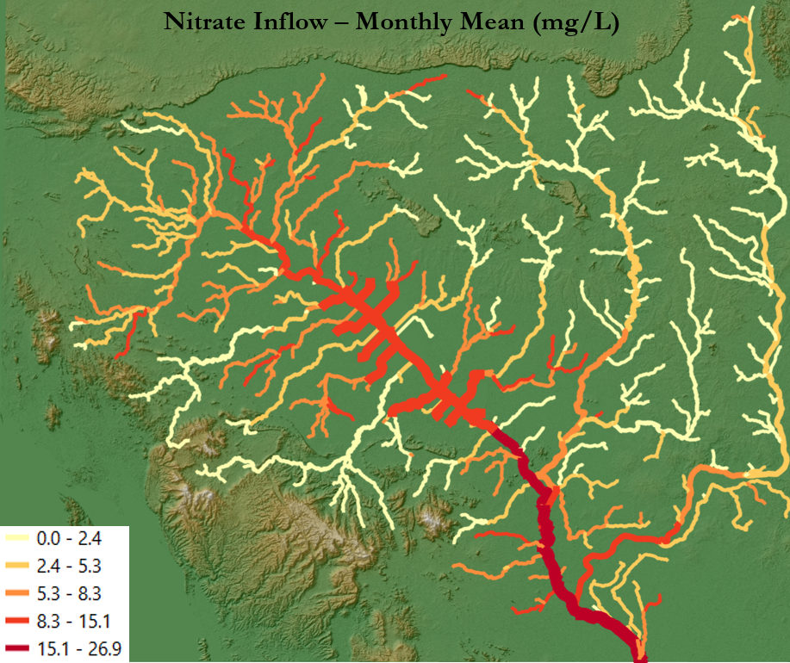

*Figure 5.* SWAT output showing monthly means of nitrate inflows (mg/L) in the Tonlé Sap Basin.

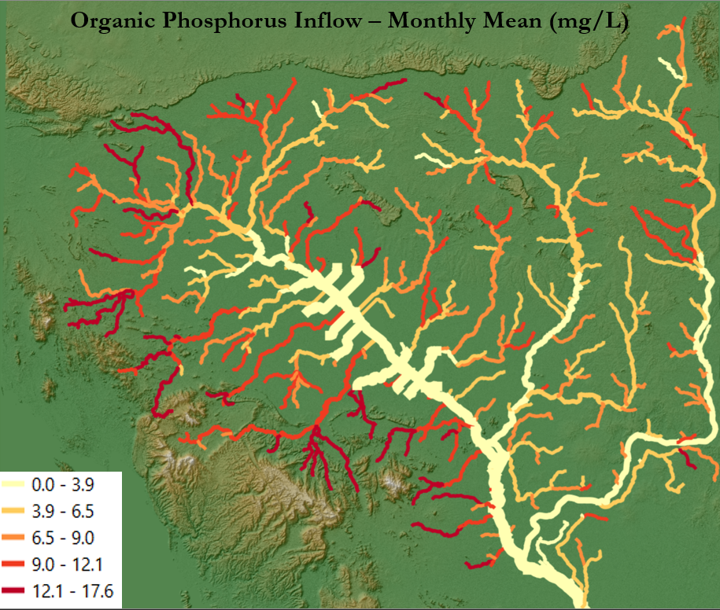

*Figure 6.* SWAT output showing the monthly mean inflow of organic phosphorus (mg/L) in the Tonlé Sap Basin.

***4.2 Limitations***

One of the main limitations of our work was the requirement of *in situ* data for validation and calibration of the SWAT model. While our objective was to calculate FHI sub-indicators solely with remotely sensed data, the soil classification input for SWAT could not be acquired by satellite. Additionally, while we believe our SWAT outputs are valid, the simulated results are different from the limited *in situ* data . Without *in situ* data to compare and validate, the results can be off by several orders of magnitude. Remotely sensed data brought in with the tools created this term can help fill data gaps and support existing monitoring but are not a replacement for *in situ* analysis and data collection.

Another limitation with the SWAT model is that it does not account for the Tonlé Sap’s unique hydrologic cycle in which the river flow direction reverses seasonally. Our outputs were created using the model’s assumption that water in the basin only flows one direction, from northwest to southeast. If users were interested in considering this flow reversal in the analysis, it would require a hydraulic model in addition to the SWAT model. The SWAT model also requires a significant warm-up period, which means that we were unable to produce outputs for the entire study period, only the last 18 years. Validation and calibration in SWAT CUP further limit the number of output years.

Limitations related to our GRACE methodology include data availability and exclusion of groundwater quality data. Our study period for this analysis was 2000-2020, however, GRACE data is only available from 2002-04-01 through 2017-02-03, so our methodology only accounts for 15 years of the study period. Additionally, the GRACE methodology only considers groundwater *quantity,* not *quality.* This means that although our methodology can highlight areas with plentiful groundwater, it cannot tell us whether that groundwater is drinkable or suitable for crop irrigation, for example.

***4.3 Future Work***

As this project continues into a third term, the Tonlé Sap III team will be tasked with completing a code and software package that contains organized and accessible versions of script and tools from both Tonlé Sap I and II teams. Tonlé Sap III will also calculate groundwater storage depletion in the basin using the methodology developed this term. A potential area for additional attention would be validation of the SWAT model, specifically with the inclusion of *in situ* streamflow data and SWAT CUP software.

Our partners at Conservation International are working on calculating FHI sub-indicators for the Tonlé Sap Basin, and additional work will include continuing to test the feasibility of using remotely sensed data to do so. While *in situ* data is likely to be necessary for some portions of the FHI, using remotely sensed data can fill data gaps and support monitoring efforts in the basin.

# 5. Conclusions

Our feasibility study has found that while creating a SWAT model with only remotely sensed data is possible, there is not enough *in situ* data for calibration and validation. *In situ* data collection is very costly and time consuming, and together with the lack of preexisting monitoring systems in the basin, water quality and quantity measurements are nonexistent. Without calibrating the model with *in situ* data, the SWAT model does not fully understand the baseline measurements of the Tonlé Sap River Basin, and so will come up with faulty measurements to substitute in for this lack of data. The Python API coding tool the team created to create SWAT outputs will greatly increase the efficiency of using the SWAT model, but it cannot replace *in situ* data needed for the calibration step. These calculations are key to determining policy issues such as overfishing, deforestation, and increasing irrigation along the Tonlé Sap Lake, so accuracy is of the highest importance. Increased agriculture and runoff from deforestation create eutrophication in the lake, which can lead to anoxic areas in the lake, which are kill off fish in large numbers.

In addition, we developed a methodology for calculating groundwater storage using remotely sensed data in the Tonlé Sap basin, which contributes to water resources monitoring and provides information about dry-season water scarcity in the region. It is vital to have these issues under surveillance for the health and prosperity not only the areas immediately surrounding the Tonlé Sap Lake, but also the entire region. Conservation International can use the code structure created by the team to construct SWAT models across the world in areas of limited available *in situ* data, as long as some in situ data already exists for the SWAT model to calibrate. Understanding the limit and scope of the SWAT model will help our partners to decide whether this model is worth putting more time and energy into to get that *in situ* data, or if another model is a better option to explore.

# 

# 6. Acknowledgments

* Adriana Le Compte, NASA DEVELOP LaRC
* Dr. Venkataraman Lakshmi, University of Virginia
* Manh-Hung Le, University of Virginia
* Dr. Derek Vollmer, Conservation International
* Dr. Kenton Ross, Langley Research Center

This material contains modified Copernicus Sentinel data (2000-2019), processed by ESA.

Any opinions, findings, and conclusions or recommendations expressed in this material are those of the author(s) and do not necessarily reflect the views of the National Aeronautics and Space Administration.

This material is based upon work supported by NASA through contract NNL16AA05C.

# 

# 7. Glossary

**AIRS –** Atmospheric Infrared Sounder

**API –** Application Programming Interface; project utilized a Python API

**CI –** Conservation International

**DEM –** Digital Elevation Model

**FAO –** Food and Agriculture Organization of the United Nations

**FHI –** Freshwater Health Index, a tool for assessing basins developed by Conservation International.

**GEE –** Google Earth Engine

**GRACE –** Gravity Recovery and Climate Experiment

**Groundwater –** Water that is present underground in saturated zones beneath the Earth’s surface. It exists in rock and soil pore spaces and in fractures of rock formations.

**HWSD –** Harmonized World Soil Database

***In situ –*** Data collected with local, on-the-ground sensors.

**MoWRaM –** Ministry of Water Resources and Meteorology, Cambodian government.

**Remote sensing –** Data that has been acquired through non-physical contact of a subject, usually through a sensor built onto a satellite.

**SRTM –** Shuttle Radar Topography Mission

**SWAT –** Soil and Water Assessment Tool

**TSA –** Tonlé Sap Authority, part of MoWRaM.

# 8. References

Arias, M. E., Cochrane, T. A., Kummu, M., Lauri, H., Holtgrieve, G. W., Koponen, J., & Piman, T. (2014). Impacts of hydropower and climate change on drivers of ecological productivity of Southeast Asia’s most important wetland. *Ecological Modelling*, *272*, 252–263. <https://doi.org/10.1016/j.ecolmodel.2013.10.015>

Conservation International. (n.d.). *Tonlé Sap Lake: Cambodia’s Fish Factory*. Retrieved July 1, 2021, from [https://www.conservation.org/projects/Tonlé-sap-lake-conserving-cambodias-fish-factory](https://www.conservation.org/projects/tonle-sap-lake-conserving-cambodias-fish-factory)

F Landerer. 2021. TELLUS_GRAC_L3_CSR_RL06_LND_v04. Ver. RL06 v04. PO.DAAC, CA, USA. Dataset accessed [2021-07-01] at <https://doi.org/10.5067/TELND-3AC64>

Lohani, S., Dilts, T., Weisberg, P., Null, S., & Hogan, Z. (2020). Rapidly Accelerating Deforestation in Cambodia’s Mekong River Basin: A Comparative Analysis of Spatial Patterns and Drivers. *Water*, *12*(8), 2191. <https://doi.org/10.3390/w12082191>

NASA Shuttle Radar Topography Mission (SRTM)(2013). Shuttle Radar Topography Mission (SRTM) Global. Distributed by OpenTopography. Accessed: 15 June 2021. <https://doi.org/10.5069/G9445JDF>

Rodell M, P. R. Houser, U. Jambor, J. Gottschalck, K. Mitchell, C.-J. Meng, K. Arsenault, B. Cosgrove, J. Radakovich, M. Bosilovich, J. K. Entin, J. P. Walker, D. Lohmann, and D. Toll (2004). The Global Land Data Assimilation System. Bulletin of the American Meteorological Society, vol 85 (3), pp 381-394. Accessed 20 July 2021. The GLDAS data retrieved from "<http://grace.jpl.nasa.gov>", which used the "Goddard Earth Sciences Data and Information Services Center".

Rossi, C. G., Srinivasan, R., Jirayoot, K., Duc, T. L., Souvannabouth, P., Binh, N., & Gassman, P. W. (2009). *HYDROLOGIC EVALUATION OF THE LOWER MEKONG RIVER BASIN WITH THE SOIL AND WATER ASSESSMENT TOOL MODEL*. International Agricultural Engineering Journal, 18, pp. 1-13 13.

Sarkkula, J., Kiirikki, M., Koponen, J., & Kummu, M. (2003). *Ecosystem processes of the Tonlé Sap Lake*.

Tangdamrongsub, N., Ditmar, P., Steele-Dunne, S., Gunter, B. and Sutanudjaja, E. (2016). Assessing total water storage and identifying flood events over Tonlé Sap basin in Cambodia using GRACE and MODIS satellite observations combined with hydrological models. *Remote Sensing of Environment*, 181, pp.162-173. <http://dx.doi.org/10.1016/j.rse.2016.03.030>

Uk, S., Yoshimura, C., Siev, S., Try, S., Yang, H., Oeurng, C., Li, S., & Hul, S. (2018). Tonlé Sap Lake: Current status and important research directions for environmental management. *Lakes & Reservoirs: Science, Policy and Management for Sustainable Use*, *23*(3), 177–189. <https://doi.org/10.1111/lre.12222>

Vallejos, M., Johnston, J., Phelps, S., Scarmuzza, J. (2021). Tonlé Sap Food Security and Agriculture: Evaluating the Effects of Land Use and Hydrological Change on Ecosystem Vitality using Remotely Sensed Data in the Tonlé Sap Lake Basin.

Vollmer, D., Shaad, K., Souter, N., Farrell, T., Dudgeon, D., Sullivan, C., Fauconnier, I., MacDonald, G., McCartney, M., Power, A., McNally, A., Andelman, S., Capon, T., Devineni, N., Apirumanekul, C., Ng, C., Rebecca Shaw, M., Wang, R., Lai, C., Wang, Z. and Regan, H. (2018). Integrating the social, hydrological and ecological dimensions of freshwater health: The Freshwater Health Index. *Science of The Total Environment*, 627, pp.304-313. <https://doi.org/10.1016/j.scitotenv.2018.01.040>

# 9. Appendix

Table A1

*Additional datasets required for analysis with GRACE methodology*

|  |  |  |  |  |  |
| --- | --- | --- | --- | --- | --- |
| **Parameter** | **Platform & Sensor** | **Data Product** | **Resolution** | **Dates** | **Acquisition Method** |
| Soil Moisture and Plant Canopy Intercept | N/A | GLDAS 2.1 | 0.25 arc degrees | 2000-01-01 – 2021-07-10 | Retrieve as Google Earth Engine Dataset |
| Water mask | Landsat 5, 7 and 8 | JRC Monthly Water Recurrence | 30 meters | N/A | Retrieve as Google Earth Engine Dataset |
| Tonlé Sap Lake level | N/A  (See Term I Tech Paper for additional information) | Tonlé Sap altimetry time series | N/A/ | 2000-2020 | Retrieve from Tonlé Sap I Colab notebook |