**NASA DEVELOP National Program**



International Research Institute for Climate and Society

*Fall 2015*

New Jersey Health &Air Quality

*Modeling of Near Surface Air Temperature Profile of Complex Urban Systems Based on Land Surface Properties*

 **Technical Report**

Rough Draft – October 8, 2015

Maryam Karimi, (Project Lead, NOAA Crest Institute of CUNY)

Jerrod Lessel (Center Lead, International Research Institute for Climate and Society)

Pietro Ceccato (Science Advisor, International Research Institute for Climate and Society)

# I. Abstract

Urbanization has created an increase in what is known as the urban heat island (UHI) effect. The excess heat in these urban environments has led to a rise in heat related illnesses and mortality. There is little understanding of urban microclimate. To better understand the impact of different land surfaces in an urban system a quantitative study was completed, analyzing on-site locations representing varied microclimates and analyzing satellite imagery of Glassboro Township of New Jersey. A correlation is being developed to measure surface and near surface air temperatures of microclimate in different environments. The on-site study revealed that varied environments (grass, water, and concrete) result in different temperature profiles within the range of 0 to 3 meters. Results indicate: grass was the coolest environment, water was the most temperate, and concrete had the highest peak temperatures. The satellite study revealed that increased levels of urbanization, with no methods of heat mitigation, resulted in higher average temperatures. Both the on-site and satellite data confirm that the increased urbanization leads to increased temperatures within microclimates.

**Keywords**

Microclimate, Urban Heat Island, Heat Mitigation, Urban Environment, Remote Sensing, On-Site Temperature Monitoring

# II. Introduction

Urbanization has created an increase in what is known as the urban heat island (UHI) effect. UHI reflects an elevated temperature in cities as compared with nearby rural areas. This is due to landscapes changing from permeable moist surfaces to impermeable dry surfaces (EPA, 2015), and is most prevalent in large cities in which the surface type is mainly impermeable concrete. Along with the change in surface type, the landscape has been altered and is now three-dimensional landscape and there is a lack of vegetation. These changes can lead to heat being trapped within the urban environments. UHI can create numerous health problems including respiratory difficulties, heat cramps, heat stroke, and heat-related mortality (Li et al., 2013).

The term “heat island” describes urban areas that are hotter than the nearby rural areas (Taleghani et al., 2015). This is due to change of landscapes from grass with high reflectance/diffusion rate in rural areas to predominantly concrete and asphalt with high absorption rate in the cities (Taleghani et al,. 2014). Heat islands can significantly change the energy demand seasonally, increase heat related illness and mortality, and even have negative impact on water quality (Taleghani et al., 2015). The increased energy demand creates pressure on power grids, which can also lead to elevated emissions of air pollutants and greenhouse gases (Taleghani et al., 2014).

Heat-related mortality is a function of temperature and a population’s sensitivity to temperature. Both vary on the neighborhood scale: temperature varies due to physical characteristics of surface cover; temperature sensitivity varies mainly due to socio-economic factors such as age, income, race and education (Li et al, 2013). As temperature increases above the heat threshold, mortality is seen to become increasingly sensitive to small changes in temperature. The increased temperature of pavements and rooftop surfaces transfer their excess heat to storm water, which drains into streams, rivers, and ponds. This causes the temperature of the aquatic ecosystems to rise, creating stress on the environment (EPA, 2015). With these changes and environmental impact, studies focusing on microclimate and heat measurement have improved knowledge of thermal behavior.

These changes in temperatures are creating a change in the microclimate. While humans live in a microclimate, research on the change of temperature of the Earth’s surface has focused primarily on macroclimates. Suggestions for reducing the impact of urban heat island within a microclimate include increasing vegetation in an area, using reflective materials for roof tops, and using pavements that are modified to absorb less heat (EPA, 2015).

Research has shown that increased rates of heat mortality are a result of areas being more vulnerable to its effects. Differences in vulnerability exist depending on climate, culture, infrastructure, and other factors (Kovats et al., 2008). Reid et al. 2009 mapped and analyzed 10 vulnerability factors for heat-related mortality within the United States and found that urban areas showed the highest vulnerability to heat (Reid et al., 2009). This vulnerability to heat then leads to extremes in temperature, which are associated with short-term increases in daily mortality (Medina-Ramon et al., 2006).

Thermal indices have been developed in order to describe the effect humans feel on their body based on the environment. This is used to attempt to quantify the exact effects that are felt on humans due to excess heat in urban environments. Gulyás et al. (Gulyas et al., 2006) conducted two field-surveys in Szeged, a South-Hungarian city. The study placed special emphasis to the human-biometeorological assessment of the microclimate of complex urban environments through the application of the thermal index Physiological Equivalent Temperature (PET). The study resulted in differences in the PET index as high as 15-20 °C due to the different irradiation and that the different modelled environments (only buildings, buildings and trees, and only trees) revealed significant alterations in the human comfort sensations between the situations (Gulyas et al., 2006). Taleghani et al., 2015 modeled different thermal environments to understand how PET can change based on the layout of an urban environment. It was found that the duration of direct sun and mean radiant temperature (influenced by urban form) play the most important role in thermal comfort (Taleghani et al., 2015). Nastos et al., 2012 analyzed the region of Athens, Greece by comparing the daily mortality with the daily values of PET and Universal Thermal Climate Index (UTCI). The comparison was completed by applying Pearson’s chi-squared test to find the probability of mortality relating to the thermal indices. It was concluded that the air temperature and PET/UTCI exceedances over specific thresholds reveal that very hot conditions are risk factors for the daily mortality (Norton et al., 2015).

The heat mitigation strategies can only be confirmed once monitored over long periods of time, and proper monitoring methods have yet to be developed. Voogt et al., 2003 performed a review on thermal remote sensing of urban areas and found that it is mainly a qualitative description of thermal patterns and simple correlations. Improvements in the spatial and spectral resolution of current and next generation satellite-based sensors and high resolution portable thermal scanners will allow for the progress in the application of urban thermal remote sensing to study the climate of urban areas (Voogt et al., 2003) . A new method was introduced by Huang et al., 2013 in which a spatiotemporal image fusion model is used to produce high spatiotemporal resolution LST data. This is done by combining the high spatial resolution of Landsat images the frequent coverage of Moderate Resolution Imaging Spectroradiometer (MODIS) images. This method accounts for the warming and cooling effect of ground objects in urban areas and establishes a new weight function to account for the effect of neighboring pixels (Huang et al., 2013).

# III. Methodology

In order to model the behavior of air temperature within the microclimate, Dr. Rouzbeh Nazari and his students from College of Civil and Environmental Engineering of Rowan University set up a temperature probe which was designed to acquire the temperature, relative humidity and luminosity data at four different microclimates throughout the campus. The setup included 21 data logger/ HOBO Pendant Temp/Light, 64K sensors. The sensors were spaced at half-foot increments on a 10-ft pole. By doing so, the probes would be able to obtain data at varying heights above the land surface (Figure 1). The chosen microclimates exhibited four different surface types: mainly grass surface, area with a water surface, and a mainly concrete and asphalt surfaces.

Analyzed data are then compared to Landsat 8 temperature map (Figure 2) for the months of May and July 2015. Landsat temperature for each microclimate’s latitude and longitude is compared to the average data for each probe of the same location at different levels of altitude. The spatial and temporal analysis of each of these locations will enables us to understand different microclimates behavior towards changes in heat. By comparing our analysis to Landsat images, a wider spatial distribution of temperature can be reached for better understanding different microclimates and affects in cities.



Figure 1: Temperature Probe Setup

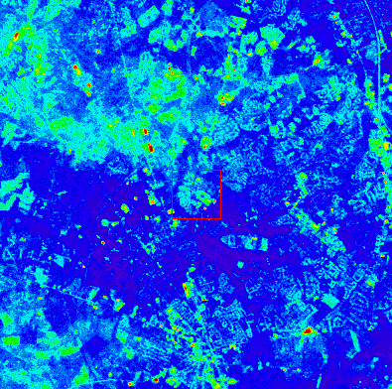

Figure 2: Example of a Landsat temperature scene used to compare against the probe data.

The main analysis of this project dealt with the recorded air temperatures from the temperature probe setup. The near surface air temperatures was gathered from the Onset Temperature Pendants. Each pendant was set to acquire data every 10 minutes.

Each of the HOBO Pendant Temp/Light had the ability to measure and records the light intensity at each height above the ground surface. The light intensity at each height was measured in units of lux. This data was used in further analysis of the urban heat island effect; however, this research focused on the air temperature obtained using the HOBO Pendant Temp/Light sensors.

The raw data was combined utilizing Matlab software and then analyzed using Microsoft Excel. The raw data contained temperature readings at every 0.5’ that were taken every 10 minutes over the time period of May 22, 2015 to July 25, 2015. The first day and last day of deployment of the probes were omitted from analysis due to false data readings caused by set up of the probes and removal of the probes from their environment. This data was then separated into daily readings to further analyze the differences between the environments that the temperature probe setups were placed.

The temperature pendant data was analyzed using a three-dimensional of height, time and temperature graph. The graph depicts the time of day along the x-axis, the height in feet at which the temperature data was recorded along the y-axis, and the temperature in Celsius as a color gradient ranging from blue as cold to red as hot.

# IV. Results & Discussion

The analysis of the probe data for May 22 and July 25th, match Landsat 8 temperature data at different level of elevation for the four microclimate used in this project. Figures 3, 4, 5, and 6 show how each microclimate behaves during 24 hours’ time period of July 25, 2015. The results indicate that the air temperature does in fact vary based on a number of factors such as time of day, height of the instrument and the environment. The grass and water microclimates are the coolest in compare to asphalt and concrete microclimates with water having least fluctuation due to reflectivity.

Concrete microclimate has the highest pick temperature while most absorption of heat happen in asphalt microclimate. Temperature inversion is also noticeable in asphalt microclimate at the height of 0-0.5 feet.

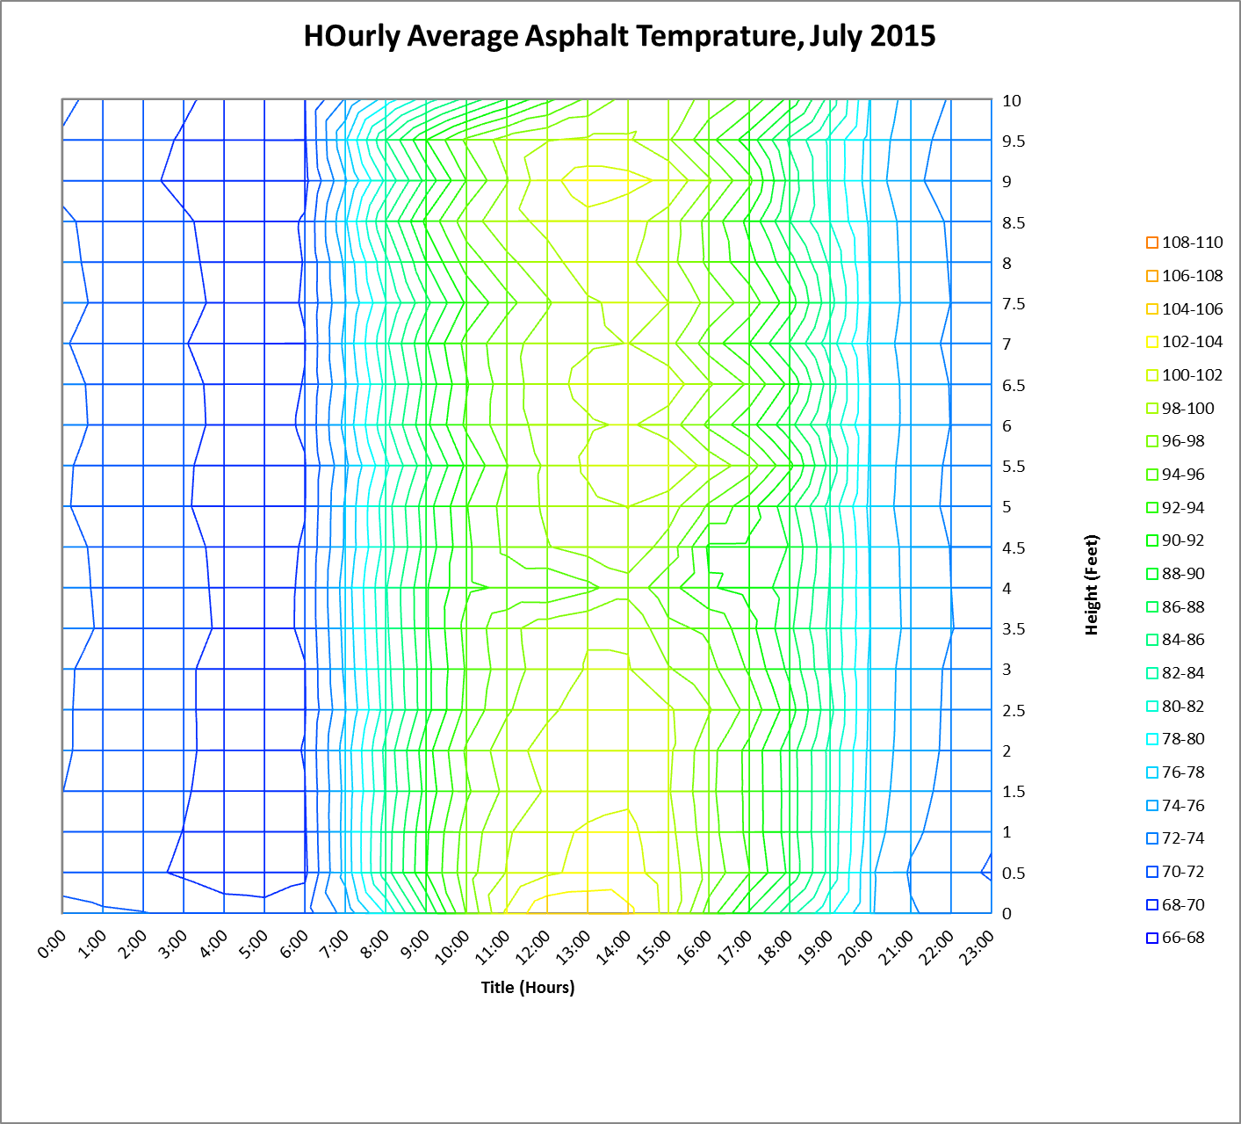

Figure 3: Hourly Average Temperature over time and height

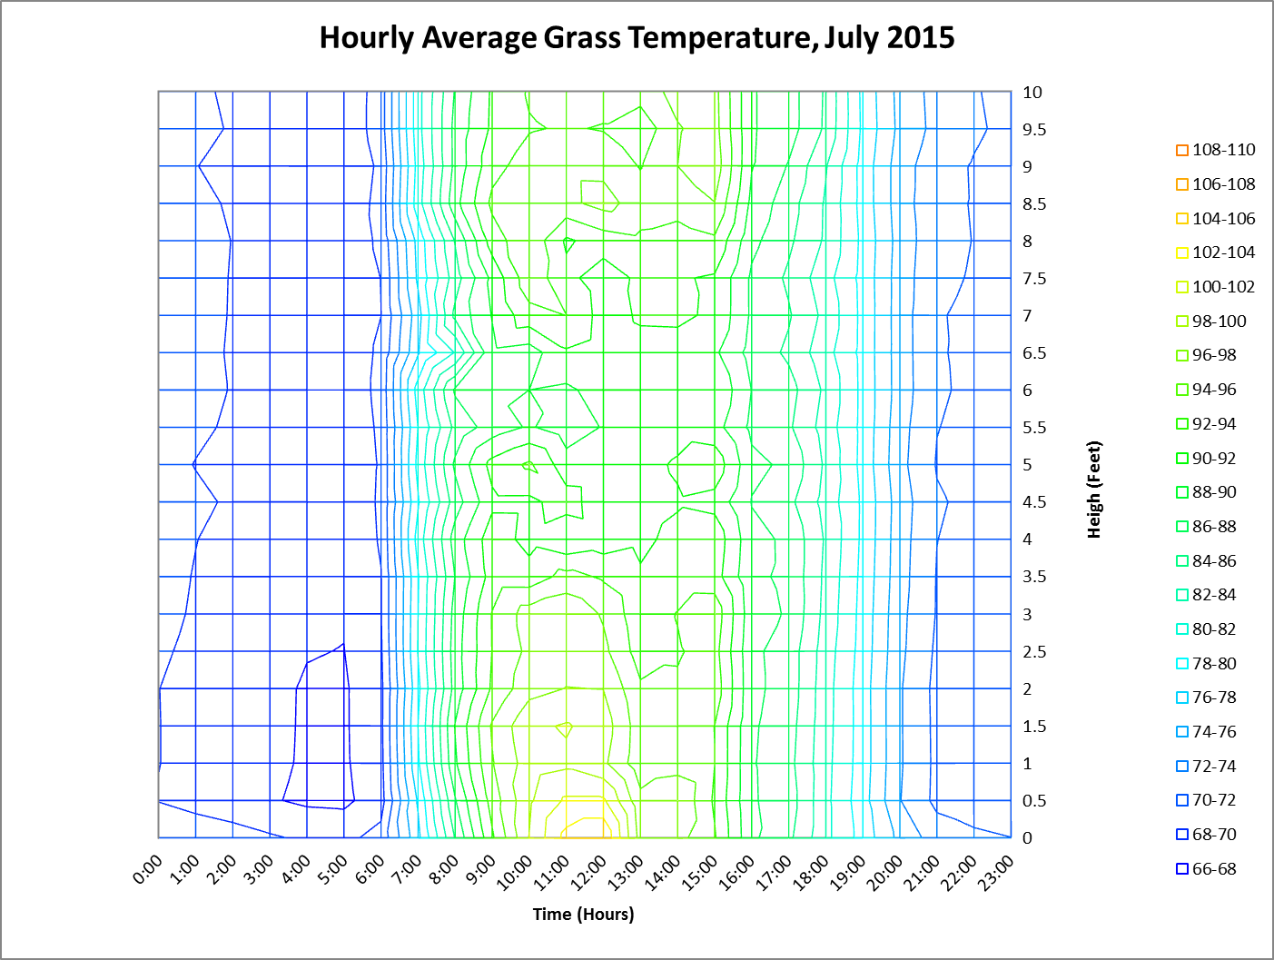

Figure 4: Hourly Average Temperature over time and height

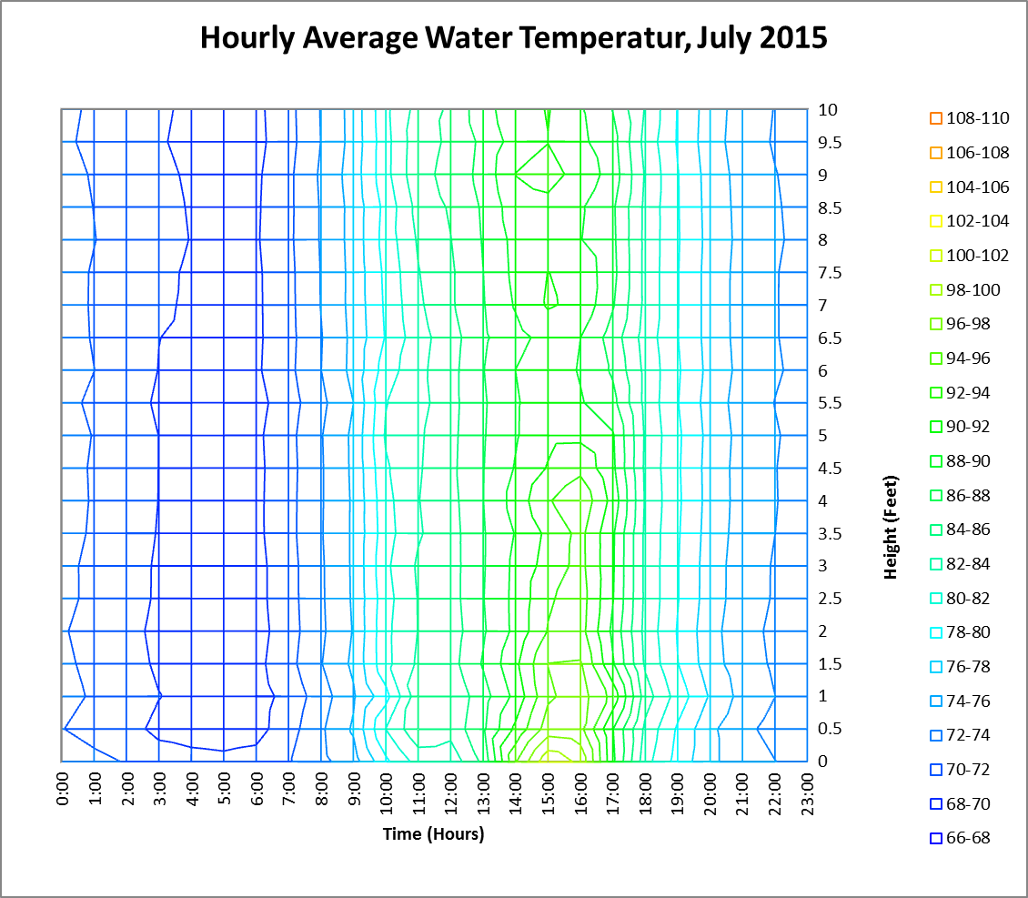

Figure 5: Hourly Average Temperature over time and height

# 

Figure 6: Hourly Average Temperature over time and height

The probe reading for each day at different elevations are compared to the Landsat 8 temperature extracted for the same latitude and longitude. The results of this comparison are shown in Table 1.

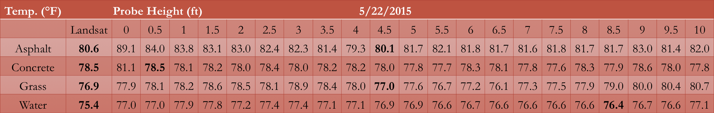

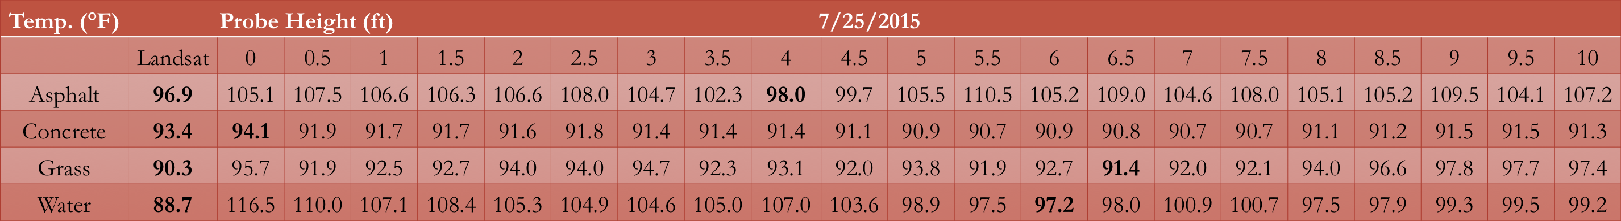

Table 1: Probe Temperatures at different elevation compares to Landsat 8.

The comparison of Landsat 8 temperature data and probes for May 22, 2015 show that there is a difference of less than 1 °F between probe readings and Landsat at 0.5, 3.5, 6.5, and 8.5 ft elevations. Bigger gaps in temperature difference can be seen in July 25, 2015 readings with Landsat 8 as shown in table 1.

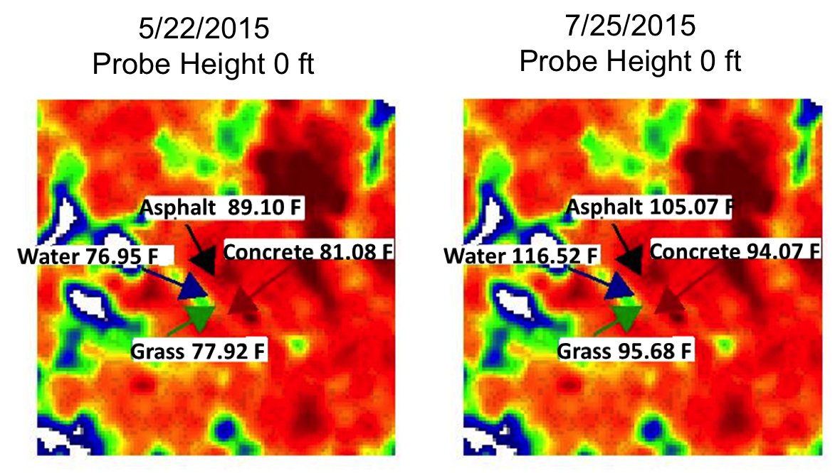

Figure 7. Landsat Temperature maps for May and July 2015

Figure 7 shows a short summary for reported probe temperature at 0 elevations for both days of study for each microclimate on Landsat temperature map for the same time period.

# V. Conclusions

In our analysis over the study period of May 2015 through July 2015, we found that the different Landsat images matched the different microclimates at varying vertical heights. For asphalt, at the vertical height of 3.5 to 4ft, the Landsat imagery most closely matched the probe data with only 0.833 to 1.17 °F difference. For concrete, at the vertical height of 0 to 0.5ft, the Landsat imagery most closely matched the probe data with only 0.032 to 0.708 °F difference. For grass microclimates, at the vertical height of 6.5ft the Landsat imagery most closely matched the probe data with only 0.81 to 1.062 °F difference. Finally for mainly water microclimates, at a vertical height of 6 to 8.5ft the Landsat imagery most closely matched the probe data with only 0.912 to 8.473 °F difference.

Using results from this work and future work on additional locations, different constants could be calculated in order to complete an empirical formula. However, even after such a formula is completed there may still be errors due to changes in conditions from those that were used to find the formula’s constants.  As such, an offset table should be included in order to correct for weather types and surface types in different environments.

The spatial and temporal analysis of each of these locations will enables us to understand different microclimates behavior towards changes in heat. By comparing our analysis to Landsat images, a wider spatial distribution of temperature can be reached for better understanding different microclimates and affects in cities.

# VI. Acknowledgements

Thank you very much to Dr. Pietro Ceccato for being an outstanding advisor on this project. We also wish to thank the project partners and collaborators: the Bureau of Environmental Surveillance and Policy, New York City Department of Health and Mental Hygiene; We Act for Environmental Justice; Columbia University, Mailman School of Public Health; Consortium for Climate Risk in the Urban Northeast (CCRUN); and Rowan University, College of Civil and Environmental Engineering.

# VII. References

Gulyás, Ágnes, János Unger, and Andreas Matzarakis. "Assessment of the Microclimatic and Human Comfort Conditions in a Complex Urban Environment: Modelling and Measurements." Building and Environment 41.12 (2006): 1713-722. Web.

Huang, Bo, Juan Wang, Huihui Song, Dongjie Fu, and Kwankit Wong. "Generating High Spatiotemporal Resolution Land Surface Temperature for Urban Heat Island Monitoring."IEEE Geoscience and Remote Sensing Letters 10.5 (2013): 1011-015. Web.

Kovats, R. Sari, and Shakoor Hajat. "Heat Stress and Public Health: A Critical Review." Annual Review of Public Health 29.1 (2008): 41-55. Web.

Li, Tiantian, Radley M. Horton, and Patrick Kinney. “Future Projections of Seasonal Patterns in Temperature-Related Deaths for Manhattan.” Nature Climate Change 3 (2013): 717–721. PMC. Web.

Medina-Ramón, Mercedes, Antonella Zanobetti, David Paul Cavanagh, and Joel Schwartz. "Extreme Temperatures and Mortality: Assessing Effect Modification by Personal Characteristics and Specific Cause of Death in a Multi-City Case-Only Analysis." Environmental Health Perspectives 114.9 (2006): 1331-336. Web.

Norton, Briony A., Andrew M. Coutts, Stephen J. Livesley, Richard J. Harris, Annie M. Hunter, and Nicholas S.g. Williams. "Planning for Cooler Cities: A Framework to Prioritise Green Infrastructure to Mitigate High Temperatures in Urban Landscapes." Landscape and Urban Planning 134 (2015): 127-38. Web.

Reid, Colleen, Marie O'neill, Carina Gronlund, Shannon Brines, Dan Brown, Ana Diez-Roux, and Joel Schwartz. "Mapping Community Determinants of Heat Vulnerability." Environmental Health Perspectives (2009): n. pag. Web.

Taleghani, Mohammad, Laura Kleerekoper, Martin Tenpierik, and Andy Van Den Dobbelsteen. "Outdoor Thermal Comfort within Five Different Urban Forms in the Netherlands." Building and Environment 83 (2015): 65-78. Web.

Taleghani, Mohammad, David J. Sailor, Martin Tenpierik, and Andy Van Den Dobbelsteen. "Thermal Assessment of Heat Mitigation Strategies: The Case of Portland State University, Oregon, USA." Building and Environment 73 (2014): 138-50. Web.

United States Environmental Protection Agency. “Heat Island Effect.” EPA. EPA. Web. http://www.epa.gov/heatisland/

United States Environmental Protection Agency. “Heat Island Effect: Basic Information.” EPA. EPA. Web. http://www.epa.gov/heatisland/about/index.htm

Voogt, J.a, and T.r Oke. "Thermal Remote Sensing of Urban Climates." Remote Sensing of Environment 86.3 (2003): 370-84. Web.

Nastos, Panagiotis T., and Andreas Matzarakis. "The Effect of Air Temperature and Human Thermal Indices on Mortality in Athens, Greece." Theoretical and Applied Climatology 108.3-4 (2012): 591-99. Web.