NASA DEVELOP National Program
NASA Langley Research Center
Summer 2015

Alaska Disasters
Utilizing NASA Earth Observations to Identify Oil Spills and Natural Oil Seeps off the Northern Coast of Alaska


Technical Report
Final Draft – August 6, 2015

Will Manion (Project Lead)
Amy Ferguson
Jordan Vaa
Kristen Noviello
Nicole MacDonald
Katelynn Quinn

Dr. Kenton Ross, DEVELOP National Program (Science Advisor)

I. Abstract
Sea ice is rapidly decreasing in the Arctic, encouraging a surge in maritime transportation and energy exploration in the region. This increase in traffic, combined with challenges unique to an Arctic environment, escalates the risk of an oil spill. In addition to human activity, oil enters the marine environment through natural oil seeps. The United States Coast Guard (USCG) is the lead response agency for oil spills in U.S. coastal waters. Ancillary responsibilities of the USCG include monitoring natural oil seeps in order to rule out anthropogenic sources. Complexities inherent to an Arctic oil spill, ice-infested waters, strong currents, cloud cover, and extended darkness, require a combination of sensors operating across the electromagnetic spectrum to accurately portray an incident. NASA DEVELOP partnered with the USCG Auxiliary University Program to create a Python-based tool that automates access to optical and radar imagery. The project incorporated near real-time optical data from the NASA’s Aqua, Terra and Landsat 8, and radar data from the European Space Agency platform, Sentinel-1. Additionally, the study constructed a natural oil seeps map using ArcGIS 10.3.1 by geo-referencing data discovered in historical literature. The resultant dataset was incorporated into the interactive Arctic Environmental Response Management Application to facilitate fast visualization and coordination for emergency responders. Finally, the project team attempted to confirm oil seeps using spectral band combinations and image enhancement techniques cited in oil detection literature. The sum of products will be used by the USCG to improve strategic oil spill response planning for coastal Alaska.

Keywords
Remote Sensing, Alaska, Oil Spills, Natural Seeps, Sea Ice, Sentinel-1, MODIS, Landsatt

II. Introduction
Satellite data show a dramatic decrease in Arctic sea ice over the last thirty years (Zigmuntowska et al., 2014; Laxon et al., 2013). As a result, maritime transportation and energy exploration is expected to increase in the region (National Oceanic and Atmospheric Administration [NOAA], 2015). A recent development in May 2015 saw the United States Bureau of Ocean Energy Management (BOEM) conditionally approve offshore oil exploration north of Alaska. This overall increase in traffic, combined with challenges unique to an Arctic environment, escalates the risk of oil spills. Perils significant to operations in the Arctic include extended periods of darkness, lack of support infrastructure, and severe environmental conditions (e.g., low temperatures, sea ice, poor visibility, strong wind and sea currents) (Tunaley, 2010). These hazardous conditions make oil spill discovery difficult and recovery efforts dangerous (Bureau of Safety and Environmental Enforcement [BSEE], Arctic Oil Spill Response Research [OSRR], 2015).

An oil spill in the Arctic represents both an ecologic and economic disaster. Oil behavior in freezing environments is complex due to its spreading on and under ice, absorption in snow, containment on and in ice, and spreading over ice-infested water (Fingas and Hollebone, 2003). In addition, lower temperatures slow the rate of dissipation, dispersion, and degradation of hydrocarbons, so oil persists longer and has a higher potential for greater impact to the environment (Tunaley, 2010; Atlas, 1972). The Arctic marine ecosystem is a region of high biological productivity, supporting a wealth of life from the water column to the coastal plain and even above, below and within sea ice (National Snow and Ice Data Center [NSIDC], 2015; Geiselman et al., 2012). Biological and environmental damage due to an oil spill can create critical challenges to human health, food security, and the survival of indigenous cultures who depend on Arctic species availability for their livelihood (NSIDC, 2015). As the Arctic nations - Canada, Denmark, Finland, Iceland, Norway, Russia, Sweden, and the United States - continue to grow in commercial shipping, fisheries, tourism, and energy exploration, an oil spill heralds a serious economic disturbance (United States Coast Guard [USCG], 2015; Clark et al., 2010).

In addition to human activities, oil enters the marine environment through natural seepage, a geographically common, natural phenomena active throughout geologic time (Kvenvolden and Cooper, 2003). A natural seep is defined as visible evidence of past or present oil, gas or bitumen leakage on the surface of the Earth (Hunt, 1979). NOAA’s Alaska Office Assessments Division identified 29 seepage areas that occur within the coastal areas of Alaska, seven of which are located along its northern shore (Becker and Manen, 1988). 47% of crude oil entering the marine environment is from natural seeps; therefore, given the deleterious impact oil has on the environment, detecting and monitoring these coastline and oceanic seeps is appropriate (Kvenvolden and Cooper, 2003).

The project partner for this study, the US Coast Guard (USCG), faithfully executes its mission in the Arctic to serve and safeguard the public, protect the environment and its resources, and defend the Nation’s interests in the maritime region. US Federal Law requires all citizens to report an oil spill to the National Response Center immediately upon discovery. Once a spill is reported, the USCG will investigate the location and formulate a cleanup or dispersal plan. The USCG currently conducts remote sensing assessments in an effort to locate any unreported oil spills. Modern remote sensing techniques, including NASA EOS, can assist USCG response personnel in detecting, mapping and monitoring oil spills and natural oil seeps.

Due to the complexity of the study area, the northern shore of Alaska, remotely sensing the presence of oil in an ice-infested region requires a mix of sensors, both passive and active, operating across the electromagnetic spectrum (Fingas and Brown, 2014). Moderate Resolution Imaging Spectroradiometer (MODIS), Landsat 4-5 Thematic Mapper (TM) and Landsat 7 Enhanced Thematic Mapper Plus (ETM+), and Synthetic Aperture Radar (SAR) are reported as suitable space-borne sensors for oil detection (Hu et al., 2009; Polychronis and Vassilia, 2013; Brekke and Solberg, 2005). Due to individual sensor limitations (e.g., all-weather, revisit frequency, coverage, resolution) and the unique Arctic environmental challenges, a mixture of sensors is desirable (Tunaley, 2010). Thus, access to spectral imagery from NASA Earth Observations (EO), specifically from Aqua and Terra MODIS and from Landsat 8, combined with radar imagery from European Space Agency (ESA) Sentinel-1, could support effective strategic response planning for the USCG in the event of an Arctic oil spill.

The Alaska Disasters project addressed the NASA Applied Sciences Program Disasters application area. By familiarizing the USCG with the use of NASA and ESA EO, the organization will be able to improve coastal management practices and emergency preparedness and response. Of note, although the SAR data used in this study were provided by the ESA, its effectiveness as an oil detection remote sensing technique showcases a future NASA sensor, NASA Indian Space Research Organization SAR (NISAR), expected to launch in 2020 as the first dual frequency radar imaging satellite.

The objective of this study was to provide the USCG with a Python-based, graphical user interface (GUI) to retrieve imagery data in order to quickly visualize spectral and radar information to detect, map, and monitor oil spills and natural oil seeps within the coastal area of Alaska. In addition, a static map displaying known natural oil seeps gives the USCG the ability to monitor and account for background pollution in the study area. Ultimately, the project aimed to inject all final deliverables into the Arctic Environmental Response Management Application (ERMA), a NOAA sponsored, web-based Geographic Information System (GIS) tool, in order to improve USCG communication and coordination efforts.

III. Methodology

Identify Natural Oil Seeps

The first step of the project involved identifying and digitizing known natural oil seeps across coastal Alaska. Although Alaskan oil seeps are not fully documented, the team was able to exploit a robust report published by NOAA’s Alaska Office Assessments Division to build the oil seep dataset (Becker and Manen, 1988). From this report, the team aligned spatial data with historical, hand-drawn maps by assigning real-world coordinates to each reported oil seep. The team leveraged labeled natural landmarks on Google Maps, satellite imagery on Google Earth, and current imagery from Landsat 8, to plot and verify the oil seep points. By geo-referencing this data to a map coordinate system, the dataset can now be viewed, queried, and analyzed with other geographic data.

The new oil seep dataset was compiled as XY data in an Excel spreadsheet and displayed in ArcMap 10.3.1. The team used the Landsat Shaded Basemap Image Service, a natural color, 15-meter resolution, pansharpened Landsat imagery service enhanced with topographic hillshading and color balancing, as the base layer (Esri, 2014). After adding additional spatial information downloaded from Arctic ERMA – oil and gas exploration wells and the Trans Alaskan Pipeline – a final map was exported as a PDF (See Appendix A).

Inject Natural Oil Seeps Dataset

After coordinating with the NOAA Office of Response and Restoration, the team prepared the oil seep dataset in accordance with Arctic ERMA metadata, attribute and product summary requirements. The team then provided the Arctic ERMA Spatial Data Branch a zipped Shapefile which was then uploaded into their web-based, interactive map. The USCG, and other emergency responders and environmental stakeholders, can now quickly access and visualize the oil seep dataset for use as an oil spill response planning and coordination tool (See Appendix B).

Confirm Natural Oil Seeps

The next step of the project was to investigate the possibility of using band combinations and image enhancement techniques to confirm the presence of natural oil seeps. Three study sites were selected: Cape Simpson, Oil Lake and Puale Bay (figure 1). Of note, persistent cloud cover is a challenge for optical imagery in the Arctic region, so the team used NASA Worldview (https://earthdata.nasa.gov/labs/worldview) to identify dates during which Terra and Landsat 8 collected over cloud-free conditions. For each site, the team downloaded Landsat 8 Operational Land Imager (OLI) and Thermal Infrared Sensor (TIRS) data, Sentinel-1 SAR data, and Terra MODIS data for analysis. The band combinations and image enhancement techniques outlined below were applied based on successful oil detection reported in remote sensing literature.
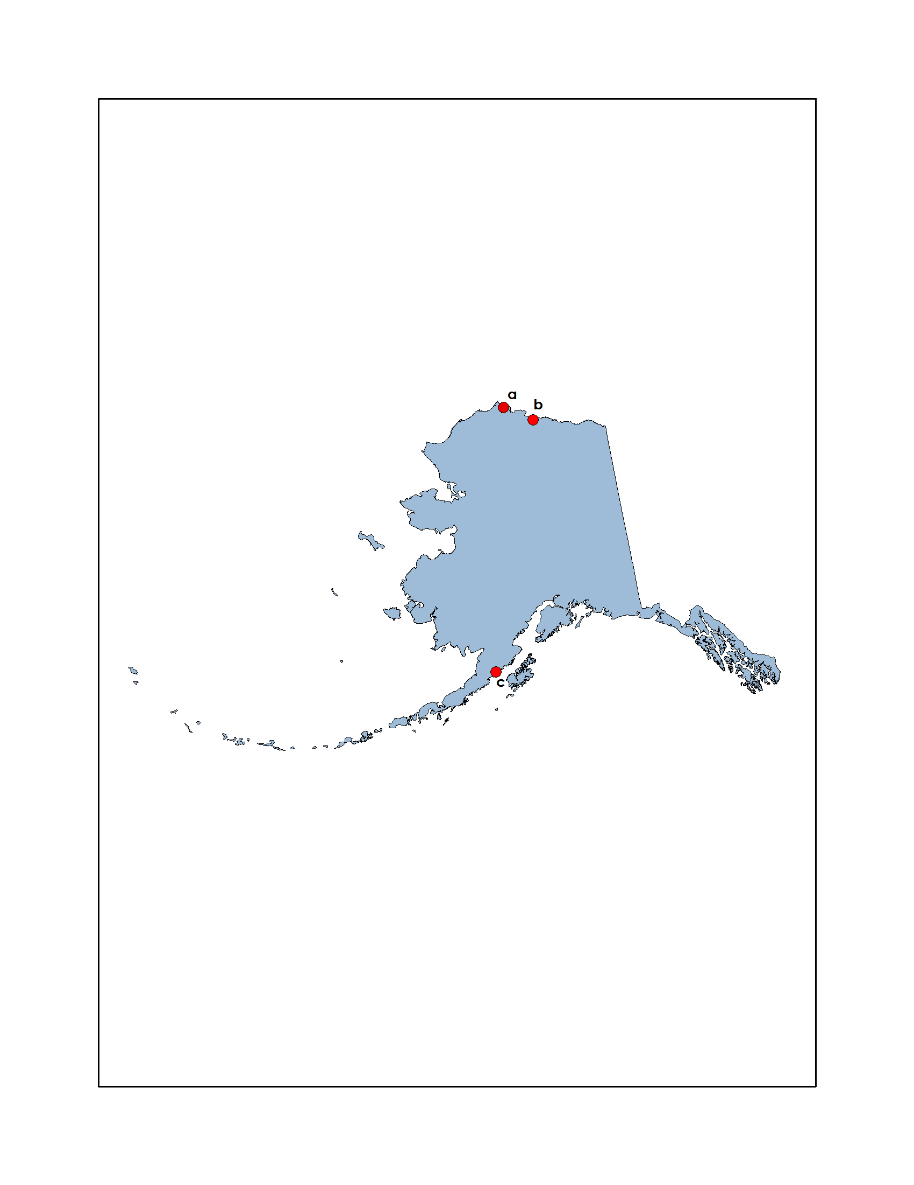

Figure 1. This map depicts the study sites; Cape Simpson (a), Oil Lake (b), and Puale Bay (c).

Landsat 8 OLI and TIRS Data:
Landsat Combined (LC = OLI and TIRS) Level 1 Terrain-Corrected data were downloaded from EarthExplorer (http://earthexplorer.usgs.gov) and displayed for analysis in ArcMap using Band 4 (Red). The spectral region between 660nm and 760nm was reported as best for oil spill identification in coastal areas (Polychronis and Vassilia, 2013). For Landsat 8, these wavelengths translate most closely to Band 4 (Red: 640-670 nm).

Terra MODIS Land Surface Reflectance Data:
Terra MODIS Gridded Level-2 Land Surface Reflectance Daily 1km and 500m data products (MOD09GA) were downloaded from EarthExplorer and displayed for analysis in ArcMap using Bands 1, 4, and 3 (True Color). Using ENVI Classic 5.0 (32-bit), the team applied a Gaussian Stretch to the data. Color stretching through Gaussian enhancement was reported as useful in showing dark slicks and patches (Hu et al., 2011). The resultant color stretched images were exported from ENVI Classic to ArcMap for further analysis. Of note, MOD09GA products are composed of bands defined for land surface reflectance and, as such, are developed using land-based algorithms. The project team decided to use these products despite this fact because they offer higher spatial resolution necessary for oil detection.

Sentinel -1 SAR Data:
SAR Level 1 Single Look Complex (SLC) data were downloaded from Sentinel-1 Scientific Data Hub (SciHub) operated by the ESA (https://scihub.esa.int/dhus). Horizontal-Horizontal (HH), Vertical-Vertical (VV) and Horizontal-Vertical (HV) polarized data were collected based on availability per site, but VV was preferred based on its reported suitability in oil slick detection (Brekke and Solberg, 2005). Due to acquisition geometry, all images downloaded from SciHub appeared mirrored when opened in ENVI 5.0. This was corrected using the Raster Management Tool: “Rotate/Flip Data”. Next, a speckle filtering technique, the Lee filter, was applied to the data. The Lee filter smoothes speckle (i.e., granular noise that can cause issues with image interpretation) while preserving image sharpness and detail. This kind of adaptive filtering was utilized successfully in an oil slick detection algorithm to minimize noise and maximize contrast (Suresh et al, 2013). The resultant flipped and speckle-filtered images were imported into ArcMap for further analysis.

Terra MODIS Calibrated Radiance Data:
MODIS Level 1B Calibrated Radiance 250 m data products (MOD02QKM) and associated Geolocation 1 km data products (MOD03) were downloaded from Level 1 and Atmosphere Archive and Distribution System (LAADS) Web (https://ladsweb.nascom.nasa.gov/data/search.html). In addition to data for each site, an additional product was downloaded from an area displaying confirmed sun glint off the coast of Hawaii to be used as ground truth for image analysis. The data were reprojected from native swath form to a Polar Stereographic projection using the MODIS Reprojection Tool Swath (MRTSwath) available via the Land Processes Distributed Active Archive Center. The images were displayed for analysis in ArcMap using Bands 1, 0, and 0 (False Color). Using the Image Analysis window in ArcMap, a Minimum-Maximum stretch was applied to increase visual contrast of the image. The maximum threshold was set at 1500 for each band in order to enhance color contrast in an attempt to highlight the sun glint phenomenon. It has been reported that when MODIS imagery contains the sun glint phenomenon, oil slicks can be differentiated from background water (Hu et al., 2009).

Finally, a quad chart map product displaying the above listed band combinations and image enhancement techniques was created for each study site using ArcMap.

Imagery Retrieval Tool

The project team utilized Python 2.7 to create a graphical user interface (GUI) that facilitates on-demand acquisition and visualization of Aqua and Terra MODIS, Landsat 8 OLI and TIRS, and Sentinel-1 data (Figure 2). Python was used because of its open-source nature; its ability to use several packages within a single, interpreted environment; and its interconnected ability to apply innovative packages from the science community (Lin, 2012). The imagery retrieval tool was written in Python 2.7, using the modules Shapely, pycURL, elementTree, gdal, urllib, and Tkinter. Shapely was used for manipulation and analysis of planar geometric objects and, while not concerned with data formats or coordinate systems, Shapely can be integrated with packages that are (Python Software Foundation [PSF], 2015). The pycURL module provides bindings for the cURL library (PSF, 2015). ElementTree stores hierarchical data structures in memory that can be converted to and from XML (PSF, 2015). The gdal module is used to manipulate geospatial raster data (PSF, 2015). The urllib module is an HTTP library with thread-safe connection pooling and file post support (PSF, 2015). Tkinter is a module used for building widgets in Python, which is essential for building a GUI (PSF, 2015).

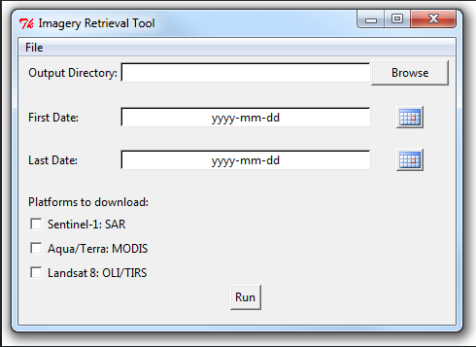
Figure 2. The Python-based Imagery Retrieval Tool graphical user interface provides expedient access to optical and radar data.

In addition to these publicly available modules, the team utilized the DEVELOP National Program Python Package (dnppy) (https://github.com/nasa/dnppy/) which is a collection of python scripts written for use within the DEVELOP program to assist with common tasks, such as downloading data from remote servers.

The imagery retrieval tool allows the user to specify a desired download directory, date range, and choose between three platforms. Currently, these three selections are Aqua/Terra MODIS, Landsat OLI and TIRS, and Sentinel-1 SAR. Once all these criteria are selected, the script runs several tasks to fetch each data type from its respective repository. Aqua and Terra MODIS data (MYD09GA and MOD09GA) are acquired from the USGS (http://e4ftl01.cr.usgs.gov) and NSIDC (ftp://n5eil01u.ecs.nsidc.org) data repositories. Landsat 8 OLI and TIRS data are retrieved from the USGS through the Amazon Web Service. SAR data are retrieved from SciHub. Of note, the script does not groom the data in any way; and, in most cases, the data will require formatting in another program before use (e.g., Modis Reprojection Tool, ENVI, etc.).

IV. Results & Discussion

Analysis of Results

Cape Simpson Imagery Analysis Results:
Cape Simpson is reportedly the best-known oil seepage on the North Slope of Alaska (Becker and Manen, 1988). However, the ability to positively identify oil seeps was limited by spatial resolution and lack of ground truth data. See Appendix C.

Oil Lake Imagery Analysis Results:
Oil Lake was chosen because it presented an opportunity to investigate the detection of an oil slick on the surface of water. However, the ability to positively identify oil seeps was limited by spatial resolution and lack of ground truth data. See Appendix D.

Puale Bay Imagery Analysis Results:
Puale Bay contains numerous oil seeps known since the early 1900’s (Becker and Manen, 1988). However, the ability to positively identify oil seeps was limited by spatial resolution and lack of ground truth data. See Appendix E.

Sun Glint Imagery Analysis Results:
The sun glint phenomenon present in some MODIS data is caused by specular reflection of the solar beam (Hu et al., 2011). This phenomenon is useful because it captures the contrast between oil and water through oil-modulation of surface waves (Hu et al., 2011). With this in mind, the project team searched for instances of sun glint across coastal Alaska. However, after careful imagery analysis and conversations with the MODIS Science Team, it is clear that the sun glint phenomenon is absent at higher latitudes because the MODIS sensor faces away from the sun in its orbit. Thus, sun glint was not observed at any of the three sites and, consequently, oil seeps were not confirmed. See Appendix F.

Errors and Uncertainty

Spatial Resolution:
The amount of natural oil seepage in the Alaskan marine environment is small, especially compared to other regions of North America like the Gulf of Mexico and southern California (Kvenvolden and Cooper, 2003). All documented Alaskan oil seeps are located above the low-tide line or at inland sites and can only influence the marine environment through transport in freshwater streams (Kvenvolden and Cooper, 2003). Some oil seeps are reported as being merely inches across or producing sheens of up to 30 square feet (Becker and Manen, 1988); ultimately, a scale too small to detect with the spatial resolutions available from the selected platforms. See Table 1 for NASA and ESA spatial resolution rollup.

Table 1. Spatial Resolution for NASA and ESA Platforms.

Platform, Sensor | Product Used | Spatial Resolution
Landsat 8 OLI and TIRS | LC | 30 m
Terra MODIS | MOD09GA | 250 m, 500 m, 1000 m
Terra MODIS | MOD02QKM | 250 m
Sentinel-1 SAR | SLC | 5 x 20 m

Ground Truth Data:
The project team conducted a thorough investigation of oil detection literature and a common theme became clear: in order for any oil detection technique to work and be meaningful, understanding the ground truth is essential (Rauschkolb, 2003). It is only with ground truth information that a researcher can be sure that oil seepage, and not some other natural feature, is being identified. Interpretation of oil spill occurrences has been successfully carried out by using images that present known spill or seep events and by utilizing coordinated satellite and aerial overpasses (Polychronis and Vassilia, 2012; Suresh et al., 2013; Brekke and Solberg, 2005). Consequently, the project team was not able to positively confirm any natural oil seeps across coastal Alaska using NASA and ESA EO.

Future Work

Future work for this project could include scheduling data collection by the NASA Airborne Visible/Infrared Imaging Spectrometer (AVIRIS), an optical sensor flown on a variety of aircraft capable of collecting 4-20 m spatial resolution data. In addition, the Imagery Retrieval Tool could be improved with an expanded search area and the incorporation of sensor-specific band combinations and image enhancement technique parameters. Finally, once available after 2020, incorporating NISAR data into the Imagery Retrieval Tool will give the USCG access to unprecedented, advanced radar imaging.

V. Conclusions

The use of remote sensing for identifying oil seeps and spills in the Arctic requires a suite of sensors, beyond even the robust compliment used in this study, to overcome individual sensor limitations and accurately capture the ground situation. Although the results from this analysis did not succeed in positively confirming the presence of oil seeps, the oil seep dataset uploaded in Arctic ERMA will provide the USCG with a starting point for understanding natural background pollution and attributing anthropogenic sources to oil spill reports. This capability, combined with expedient access to site-specific optical and radar data through the Imagery Retrieval Tool, will empower the USCG in strategic oil spill response planning.

VI. Acknowledgments

The Alaska Disasters Team would like to thank MST1 Justin Hoffer, USCG, for partnering with us and providing project guidance and suggestions. We would like to thank Dr. Kenton Ross, NASA DEVELOP National Program, for his patience in providing advice on imagery preparation and analysis. Thank you to Jeff Ely, Langley DEVELOP, for all his help with data acquisition and code writing. We would also like to thank Dr. Amy Merten and Zachary Winters-Staszak, NOAA Office of Response and Restoration, for incorporating our dataset into Arctic ERMA. Finally we would like to thank Emily Adams, Langley DEVELOP, and Daniel Wozniak, Langley DEVELOP, for supporting us through the summer term.

This material is based upon work supported by NASA through contract NNL11AA00B and cooperative agreement NNX14AB60A.

VII. References
Atlas, R., and Bartha, R., 1972, Biodegradation of petroleum in seawater at low temperatures: Canadian Journal of Microbiology, v. 18(12), p. 1851-1855, doi: 10.1139/m72-289.

Becker, P.R., and Manen, C.A., 1988, Natural oil seeps in the Alaskan marine environment: Outer Continental Shelf Environmental Assessment Program, Research Unit 703.

Brekke, C., Holt, B., Jones, C., and Skrunes, S., 2014, Discrimination of oil spills from newly formed sea ice by synthetic aperture radar: Remote Sensing of Environment, v. 145, p. 1-14.

Brekke, C., and Solberg, A.H.S., 2005, Oil spill detection by remote sensing: Remote Sensing of Environment, v. 95, p. 1-13.

Bureau of Safety and Environmental Enforcement, 2015, Arctic Oil Spill Response Research (OSRR): http://www.bsee.gov/Technology-and-Research/Oil-Spill-Response-Research/Categories/Arctic-Oil-Spill-Response-Research (accessed June 2015).

Clark, R., Ott, A., Rabe, M., Vincent-Lang, D., and Woodby, D., 2010, The effects of changing climate on key habitats in Alaska: Alaska Department of Fish and Game Special Publication No. 10-14.

Esri, 2014, Landsat Shaded Basemap: http://doc.arcgis.com/en/living-atlas/item/?itemId=e41378aa89fa46e3a58708ea4115468f (accessed June 2015).

European Space Agency, 2015, Sentinel-1 Emergency Response: http://www.esa.int/Our_Activities/Observing_the_Earth/Copernicus/Sentinel-1/Emergency_response (accessed June 2015).

Fingas, M.F., and Brown, C., 2014, Review of oil spill remote sensing: Marine Pollution Bulletin, v. 83, p. 9-23.

Fingas, M.F. and Hollebone, B.P., 2003, Review of behaviour of oil in freezing environments: Marine Pollution Bulletin, v. 47, p. 333-340.

Geiselman, J, DeGange, T., Oakley, K., Derksen, D., and Whalen, M., 2012, Changing Arctic ecosystems: Research to understand and project changes in marine and terrestrial ecosystems of the Arctic: United States Geological Survey Fact Sheet 2011-3136, 4 p.

Hu, C., Li, X., Pichel, W.G., and Muller-Karger, F.E., 2009, Detection of natural oil slicks in the NW Gulf of Mexico using MODIS imagery: Geophysical Research Letters, v. 36, L01604, doi: 10.1029/2008GL036119.

Hu, C., Li, X., and Pichel, W.G., 2011, Detection of oil slicks using MODIS and SAR imagery: Handbook of Satellite Remote Sensing Image Interpretation, Applications for Marine Living Resources Conservation and Management, p. 21-34.
Hunt, J.M., 1979, Petroleum Geochemistry and Geology: Freeman, San Francisco, CA.

Kvenvolden, K.A. and Cooper, C.K, 2003, Natural seepage of crude oil into marine environment: Geo-Marine Letters, v. 23, p. 140-146, doi: 10.1007/s00367-003-0135-0.

Laxon, S.W., Giles, K.A., Ridout, A.L., Wingham, D.J., Willatt, R., Cullen, R., Kwok, R., Schweiger, A., Zhang, J., Haas, C., Hendricks, S., Krishfield, R., Kurtz, N., Farrell, S., and Davidson, M., 2013, CryoSat-2 estimates of Arctic sea ice thickness and volume: Geophysical Research Letters, v. 40, p. 732-737, doi: 10.1002/grl.50193.

Lin, J.W., 2012, Why Python is the next wave in earth science computing: American
Meteorological Society, v. 93, p. 1823-1824, doi: 10.1175/BAMS-D-12-00148.1.

National Oceanic and Atmospheric Administration, 2015, Arctic Environmental
Response Management Application:
http://response.restoration.noaa.gov/maps-and-spatial-data/environmental-response-management-application-erma/arctic-erma.html (accessed June 2015).

National Snow and Ice Data Center, 2015, All about sea ice:
http://nsidc.org/cryosphere/seaice/index.html (accessed June 2015).

Norwegian Clean Seas Association for Operating Companies, 2015, OPV 2015:
http://translate.google.com/translate?hl=en&sl=no&u=http://www.nofo.no/&prev=search (accessed June 2015).

Polychronis, K., and Vassilia, K., 2013, Detection of oil spills and underwater natural oil outflow using multispectral satellite imagery: International Journal of Remote Sensing Applications, v. 3, p. 145-154.

Python Software Foundation, 2015, Python Package Index: https://pypi.python.org/pypi (accessed June 2015).

Rauschkolb, J., 2003, Using GIS and Satellite Imagery to Locate Hydrocarbons: ESRI International User Conference, San Diego, CA, Paper #868.

Suresh, G., Heygster, G., Bohrmann, G., Melsheimer, C., and Korber, J., 2013, An automatic detection system for natural oil seep origin estimation in SAR images: Geoscience and Remote Sensing, p. 3566-3569.

Tunaley, J.K.E., 2010, Detection of oil spills in or with ice using SAR: London Research and Development Corporation.

United States Coast Guard, 2015, U.S. Coast Guard Arctic training activities 2015: http://www.uscg.mil/d17/docs/Draft_2015_USCG%20Arctic%20EA_public.pdf (accessed June 2015).

United States Geologic Survey, 2012, A global land-imaging mission: USGS Survey Fact Sheet 2012-3072, 4 p., revised July 19, 2012.

Zygmuntowska, M., Rampal, P., Ivanova, N., & Smedsrud, L.H., 2014, Uncertainties in Arctic sea ice thickness and volume: new estimates and implications for trends: The Cryosphere, v. 8, p. 705-720. doi: 10.5194/tc-8-705-2014.

VIII. Content Innovation
Interactive Map Viewer
File Name: 2015Sum_LaRC_AlaskaDisasters_ContentInnovation_InteractiveWebViewer

Data Profile
File Name: 2015Sum_LaRC_AlaskaDisasters_ContentInnovation_DataProfile

Dataset Description: Physical location of oil seeps on the Alaska coast.

Detailed Description: The Alaska Disasters team exploited a robust report published by NOAA’s Alaska Office Assessments Division to build this oil seep dataset (Becker and Manen, 1988). From this report, the team aligned spatial data with historical, hand-drawn maps by assigning real-world coordinates to each reported oil seep. The team leveraged labeled natural landmarks on Google Maps, satellite imagery on Google Earth, and current imagery from Landsat 8, to plot and verify the oil seep points. By geo-referencing this data to a map coordinate system, the dataset can now be viewed, queried, and analyzed with other geographic data. The dataset is also available for public use on the Arctic Environmental Response Management Application (https://erma.noaa.gov/arctic).

IV. Appendices

Appendix A: Identify Natural Oil Seeps 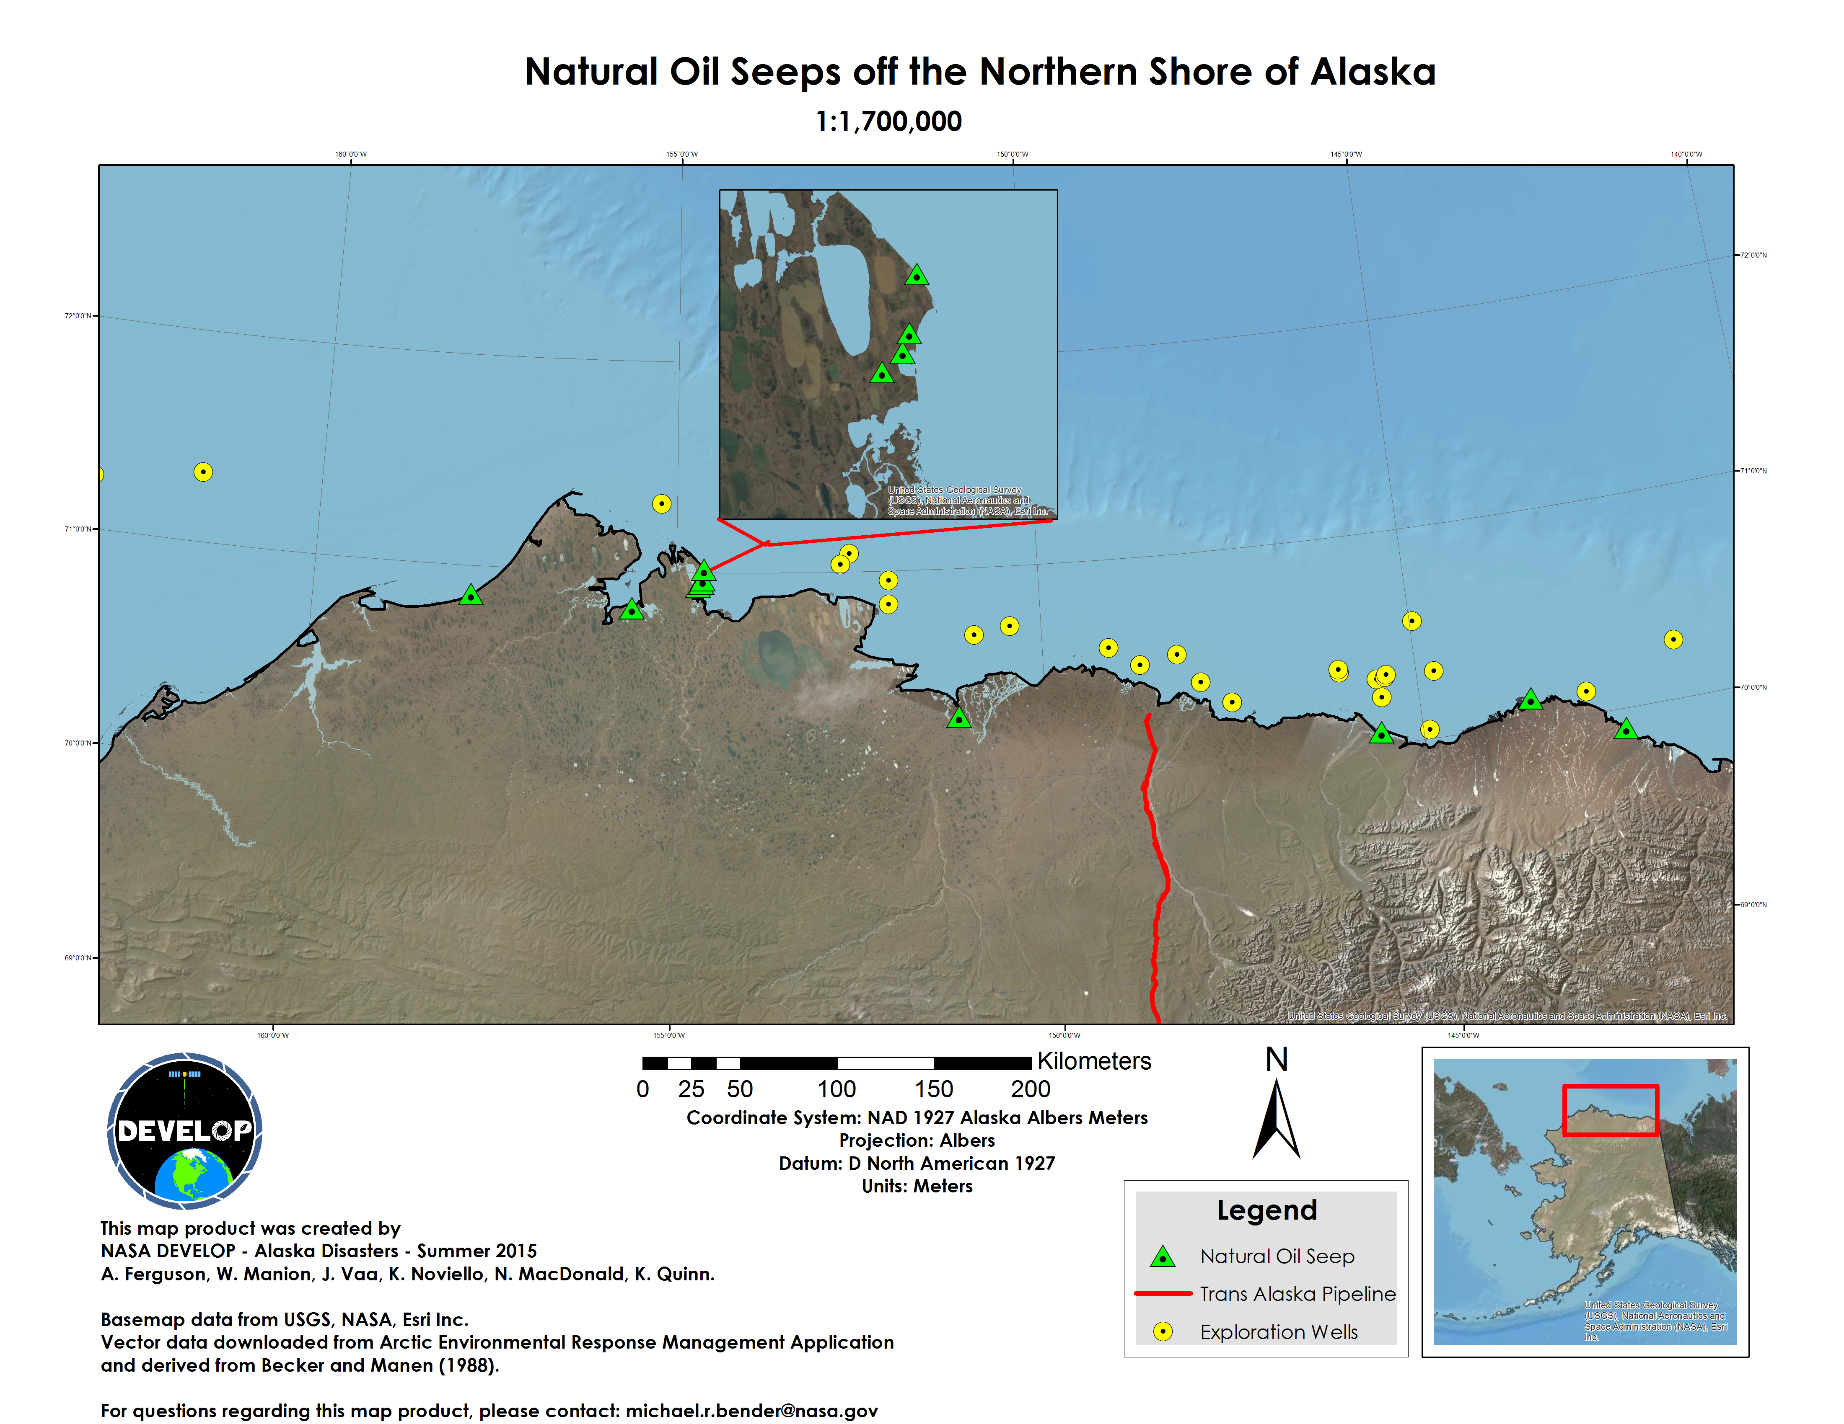
Appendix B: Inject Natural Oil Seep Dataset
The Arctic Environmental Response Management Application is a web-based, GIS tool that assists emergency responders in dealing with environmental incidents. The image above displays the oil seep dataset created by the Alaska Disasters Team. Green symbols represent confirmed oil seeps, red symbols represent unconfirmed oil seeps, and yellow symbols represent inactive oil seeps. Each point is selectable and contains attribute data for latitude, longitude, status, and site-specific notes.

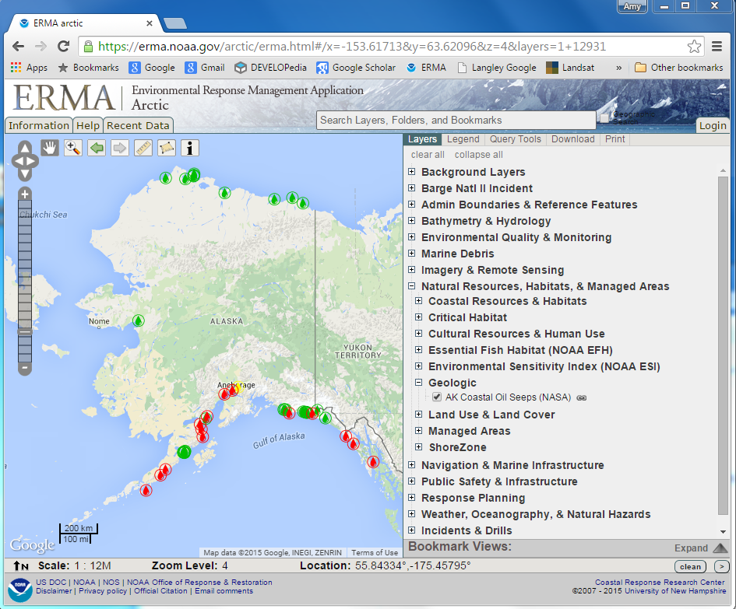

Appendix C: Cape Simpson Imagery Analysis
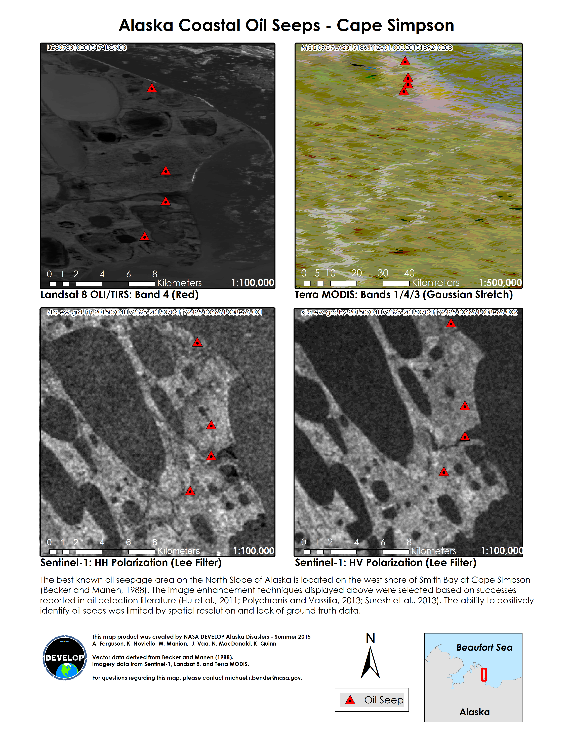
Appendix D: Oil Lake Imagery Analysis
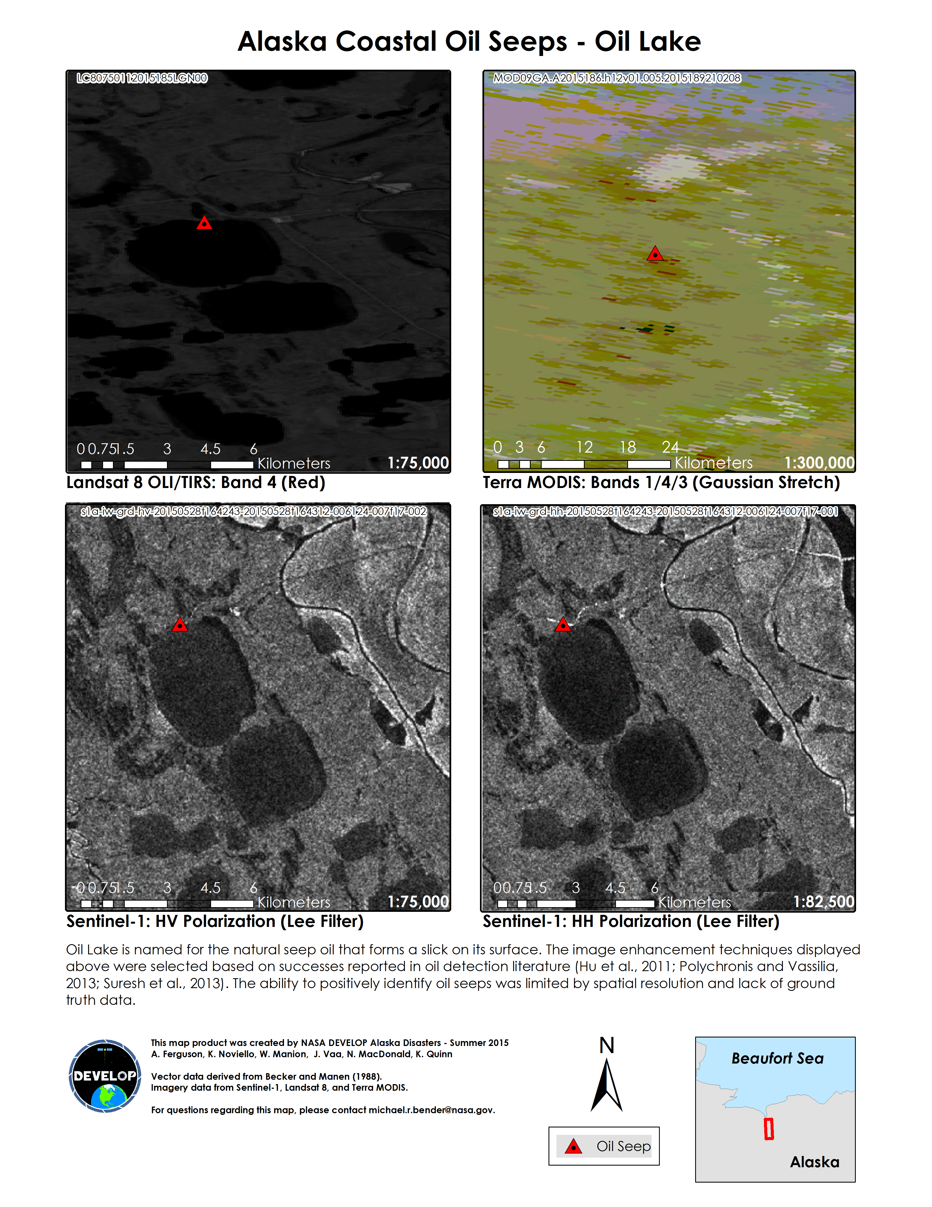
Appendix E: Puale Bay Imagery Analysis
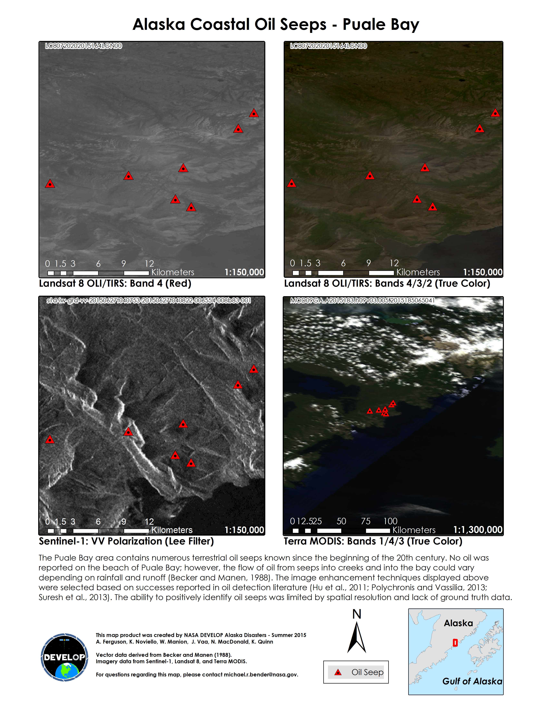
Appendix F: Sun Glint Analysis
