Maldives Climate
Monitoring Shoreline Changes and Island Loss in Response to Climate Change


Technical Report
Final – November 14th, 2022

Aidan Harvey (Project Lead)
Daniel Lopez
Derek Chin
Mitch Porter

Advisors:
Dr. Juan Torres-Pérez (NASA – Ames Research Center)

Fellow:
Lisa Tanh (California - Ames)

1. Abstract
Global sea level rise as a result of climate change continues to pose a critical threat to coastal ecosystems and populations. The archipelagic country of the Maldives is of critical concern due to being one of the lowest lying areas in the world. The development of reclaimed land in the Maldives by sand dredging has been a frequent response to both increasing sea levels and population increase. Such disturbance can lead to increased sedimentation off the coast and negatively impact coastal environments. Remote sensing tools such as satellite imagery have proved to be an effective tool in observing coastal changes in response to climate change and development. NASA DEVELOP created a methodology to analyze both water quality and shoreline erosion in the Maldives utilizing satellite imagery. Methods relied on open-source software such as QGIS and Google Earth Engine (GEE) and Satellite Imagery from PlanetScope, Landsat 8 Operational Land Instrument (OLI), Sentinel-2 Multi Spectral Instrument (MSI), and Aqua & Terra Moderate Resolution Imaging Radiospectrometer (MODIS) to analyze the changes in shorelines and assess water quality of select atolls within the Maldives. Findings show less shoreline change in developed parts of the island and more shoreline change in natural parts of the island. Additionally, water quality varies throughout the year and our data did not indicate seasonal trends. The methodology will be replicated to continue to monitor island erosion and water quality with the Maldives and will be applicable to other island and coastal systems.

Key Terms
remote sensing, Google Earth Engine, QGIS, shoreline change, sea level rise, NDWI, chlorophyll-a, turbidity

2. Introduction
2.1 Background Information
As climate change continues to affect the world’s oceans, there is increased concern over the well-being of island countries. Globally, some small islands have increased man-made landmass as a mitigation strategy to further sea level rise (Holdaway et al., 2021). One such group of islands, the Maldives, is an archipelagic nation in the Indian Ocean made up of 1,192 islands. Human populations reside entirely on approximately 200 of the islands, all of which are threatened by shoreline erosion. One survey study found: “More than 50% of respondents perceive future sea-level rise to be a serious challenge at the national level and they accept that migration from islands to other countries might be a potential option” (Stojanov et al., 2017). Since most of the country is at or near sea level, even small changes in ocean levels have large effects on the inhabitants of the islands. Land cover of islands is in constant flux due to natural and human factors. As sea level rises, erosion of the island encroaches on the space to support human populations. In response, island residents are further changing island coastlines to increase living space, facilitate air and sea transport, and fortify shorelines (Duvat & Magnan, 2019). Currently, more space than ever is being dedicated to human needs, sometimes interfering with the local ecosystem (Galli et al., 2017).

In consultation with partners in the Maldives, the NASA DEVELOP team set out to address these concerns and chose to study the Haa Alifu, Haa Daalu, and Kaafu Atolls using remote sensing from 2016-2022 (Figure 1). Located in the north, the Haa Alifu and Daalu Atolls make up an island chain which has a variety of uninhabited and populated islands. This diversity in island land use coupled with its needs for information on a large scale made this chain a promising area of study for shoreline change. For Haa Alifu we studied Mulhadhoo (about 1.2 km² area) and Hoarafushi (about .7km²). In Haa Daalu we studied Kulhudhuffushi (about 2.4 km²). Our team also chose to analyze water quality in the Kaafu Atoll which contains the most populous island and capital, Malé. Classifying a successful methodology to track shoreline disturbances and water quality changes in these study areas allowed our partners to expand this study to other atolls.

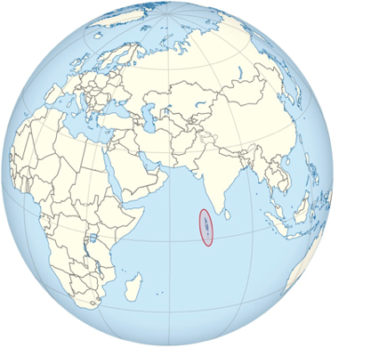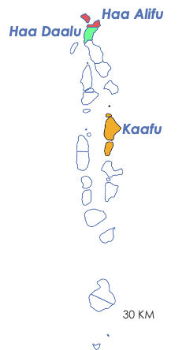

Figure 1. The location of the Maldives is shown left (TUBS, licensed by CC by-SA 3.0). The study areas are shown at right.

Remote sensing has proven an effective tool at discerning shoreline change (García-Rubio et al., 2015). However, analyzing satellite imagery of shoreline and water quality in the Maldives poses several unique challenges. The country is geographically large when including water features but has a small amount of habitable land. Generalizing the effects of climate change is difficult since each island may experience different effects and severity. Additionally, the small island size means that some satellites do not have the resolution necessary to reveal ground details. Furthermore, cloud cover frequently obscures satellite imagery. Finally, there are historical gaps in in-situ data as many islands have not been subject to shoreline and water quality analysis over time.

2.2 Project Partners & Objectives
The United States Agency for International Development (USAID), Maldives Ministry for Environment Climate Change and Technology (MMECCT), and the US Department of State, Bureau of South and Central Asian Affairs, Office of Bangladesh, Nepal, Sri Lanka, Maldives, and Bhutan are the end users and collaborators of this project. USAID has several programs working on environmental issues in the Maldives which include the Climate Change Adaptation Program and Project REGENERATE (Project Reefs Generate Environmental and Economic Resilience in Atoll Ecosystems). The US Department of State aims to support the Climate Change Adaptation Program and Maldives’ adaptation efforts by identifying areas of future development assistance that the United States can provide to the Maldives. The MMECCT is interested in developing their capacity to utilize satellite imagery to assess shoreline erosion and water quality in the Northern region of the Maldives and other study areas. This project gave the MMECCT the ability to assess development impacts on the surrounding islands and produce time series analyses of shoreline change.

The ultimate goal of this project was twofold. First, we aimed to produce maps that indicate the change in shoreline and water quality over time in certain atolls the Maldives. Second, we wanted to create a detailed tutorial that will allow our partners to replicate our analysis on other atolls across the country.

3. Methodology
3.1 Data Acquisition
Our team obtained imagery through the Optical Reef and Coastal Area Assessment (ORCAA) tool in Google Earth Engine (GEE) and the Planet Explorer web browser tool for 2016 to 2022. From GEE, we acquired Landsat 8 Optical Land Imager (OLI) Level 2 Surface Reflectance, Terra and Aqua Moderate Resolution Imaging Radiospectrometer (MODIS), and Sentinel-2 Multispectral Instrument (MSI) level 2A surface reflectance; and from Planet Explorer we acquired PlanetScope imagery.

Table 1
Sensor and imagery dates used for the shoreline and water quality analysis
Sensor | Spatial Resolution | Imagery Dates | Data Source
PlanetScope: Dove Classic, Dove R, and SuperDove | 3 m | Yearly: 2017 - 2022 | Planet Explorer Web Tool
Landsat 8 OLI | 30 m | Monthly: 2016 - 2022 | United States Geological Survey (USGS) through GEE
Sentinel-2 MSI | 10 m | Monthly: 2016 - 2022 | European Space Agency (ESA) through GEE
Aqua MODIS | 1 km | Monthly: 2016 - 2022 | United States Geological Survey (USGS) through GEE
Terra MODIS | 1 km | Monthly: 2016 - 2022 | United States Geological Survey (USGS) through GEE

3.2 Data Processing
3.2.1 Water Quality Changes
To assess water quality changes in the study area, we processed satellite imagery from Landsat 8 OLI, MODIS, and Sentinel-2 MSI for Chl-a, turbidity, and sea surface temperature. Our team obtained Chl-a concentration and turbidity data through the ORCAA tool in GEE (Devine et al. 2019; Pippin et al. 2019). Data was then exported as a Geo TIFF and uploaded to QGIS to create a color palette which highlights potential turbidity and chlorophyll concentrations.

ORCAA uses Sentinel-2 imagery to produce a Normalized Difference Chlorophyll Index (NDCI), an algorithm developed by Mishra & Mishra (2012). The indices utilized the remote sensing reflectance of Red and Near Infrared (NIR) wavelengths. Equation 1 shows the used NIR R_{rs} (708) and Red R_{rs} (665).

$NDCI=\frac{NIR \left(708\right)-Red \left(665\right)}{NIR \left(708\right)+Red \left(665\right)}$ (1)

The benefit of using this formula is that it can directly measure Chl-a concentration (mg/m³) without utilizing in-situ data. An additional formula to convert NDCI values into concentration of data was derived (Pippin et al 2019) and shown in Equation 2

$chlorophyll a =a_{o}+(a_{1}*NDCI)+(a_{2}*{NDCI}^{2}$) (2)

where a_{o}, a₁, and a₂ are model coefficients values of 14.039, 86.115, 194.325 respectively. Equation 2 was applied to Sentinel-2 MSI imagery.

We utilized ORCAA for Landsat 8 OLI and Sentinel-2 imagery and produced a turbidity index using an algorithm developed by Nechad et al. (2010). The algorithm uses the NIR and red wavelength reflectance to measure the optical properties calibrated by Formazin. Turbidity was measured through Formazin Nephelometric Units (FNUs), which is a unit on a scale of 0-100 measured by scattered infrared light at 90 degrees from the incident light beam and calculated from Equation 3 (Pippin et al. 2019)

$Turbidity (FNUs)= \frac{A_{T*Q_{w}}}{1-Q_{w}/C}$ (3)

where the A_{T} and C are calibrated wavelength dependent coefficients, and Q_{w} is the water leaving reflectance at a specified wavelength. This formula was applied to both Landsat 8 OLI and Sentinel-2 MSI Imagery.

Our team obtained through ORCAA processed temperature datasets from Aqua and Terra MODIS from the Google Earth Engine data catalog and displayed the imagery (Devine et al. 2019).

3.2.2 Shoreline change
For shoreline erosion calculations, we used NIR (845-885nm) and Green (547-583nm) wavelengths to create Normalized Difference Water Index (NDWI) (Equation 4) images of the study area using PlanetScope Imagery (Pham and Prakash, 2018). These NDWI images were then separated into land or water classifications by selecting pixels with values less than or greater than zero. Values greater than zero indicated water, and values less than zero indicated land. This resulting land/water extraction was then converted into a vector feature using the raster to polygon tool in QGIS. The extracted shorelines were then analyzed to quantify shoreline change.

$NDWI=\frac{Green-NIR}{Green+NIR}$ (4)

3.3 Data Analysis
3.3.1 Water Quality Changes
After our team used ORCAA to collect water quality satellite imagery in TIF format, we imported the imagery into QGIS for visualization and analysis. Our team visualized our imagery with a single band pseudo color render type in QGIS and created custom color palettes. We obtained timeseries plots for Chl-a, turbidity, and SST from the ORCAA tool in the form of graphs and data sets for the years 2016 – 2022. Our team performed a 5-point smoothing method on the for turbidity and Chl-a results to remove anomalies and improve accuracy.

3.3.2 Shoreline change
The shoreline change time series was produced for the years 2017 – 2022. Our team extracted polygons, of each year’s shoreline, using NDWI. Analyses conducted in QGIS used PlanetScope, Sentinel-2, and Landsat 8 imageries to calculate a NDWI and delineate water from islands to enable an analysis of shoreline changes over time. Our team measured total changes using two methods. First, area change was measured in square kilometers. The field calculator tool in QGIS tool was used to calculate land area, then the area change calculated were plotted in a time series to calculate change across the study period. Second, the average distance from the previous year’s shoreline to the next year’s shoreline was measured in meters. We used the ‘points along lines’ tool to generate equally distanced points along each year’s coastline at ten-meter increments. These point layers were used to calculate the distance shoreline moved between each year using the ‘NN Join' tool. Results from the first method are discussed below in section 4.1.1.

4. Results & Discussion
4.1 Analysis of Results
4.1.1 Shoreline Change
We assessed shoreline change at the islands of Mulhadhoo in Haa Alifu and Hoarafushi in Haa Daalu atolls in the northern Maldives. Shoreline change was assessed to understand island dynamics, because it captures both natural and anthropogenic processes associated with erosion and accretion.

For Mulhadhoo, our team analyzed PlanetScope imagery between 2018 and 2022 (as the 2017 imagery for the island was unavailable on PlanetScope). When Mulhadhoo’s area was calculated for those years, there was a clear trend of shoreline erosion occurring on the island. Between 2018 and 2020, Mulhadhoo experienced an area loss of approximately 0.08 km² (Figure 2).

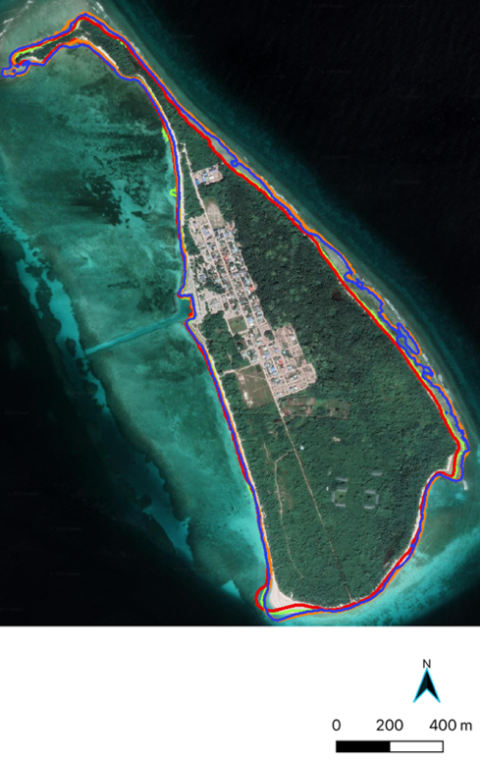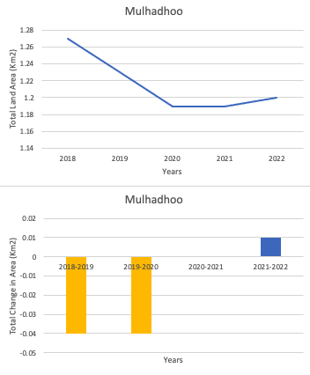
2018
2019
2020
2021
2022
Figure 2. Mulhadhoo with shoreline from 2018 – 2022 (left). Between 2018 – 2020, the island’s area decreased by 0.6 km² (top right). The island experienced an increase in area of 0.01 km² between 2021 and 2022 (bottom right). Includes copyrighted material of Planet Labs PBC. All rights reserved.

The island of Kulhudfushi experienced an overall increase in area of 0.1 Km between 2017 and 2022. While there were certain areas on the island where shoreline erosion was evident, there were several instances where mass was added to the island through human development on the coast (Figure 3). Between 2021-2022 there was a sizable portion of runway added to an airport on the island. Additional human development on the western coast of Kulhudfushi added to the island’s area as well. Some of the land area increase we observed on Kulhudfushi can be attributed to this development, but there are sections of the island where natural processes seem responsible for slight increases in area. Deposits of sediment brought in by storms, as well as events such as landslides are some of the possible explanations for this phenomenon.

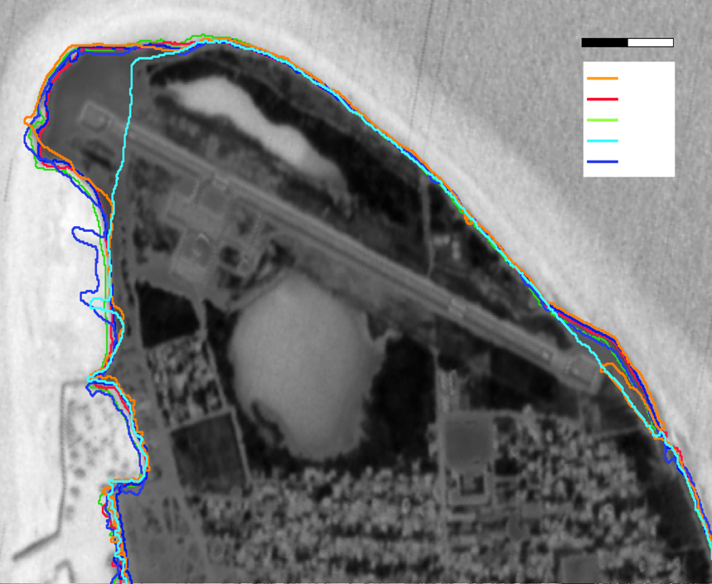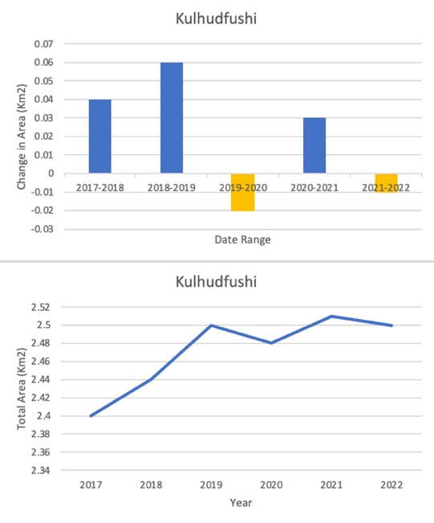
200m
2021
2018
2019
2020
2021
2022
2020
2018
2019
2020
2021
2022
2019
2018
2019
2020
2021
2022
2018
2018
2019
2020
2021
2022
2017
2018
2019
2020
2021
2022
Figure 3. Kulhudfushi with shoreline extractions from 2017 – 2022 (left). Change in area each year shows shoreline increase most years (top right). Kulhudfushi saw an overall increase in area of 0.1 Km² (bottom right). Includes copyrighted material of Planet Labs PBC. All rights reserved.

Much like we saw on Kulhudfushi, the island of Hoarafushi also saw an overall increase in area between 2017 and 2022 (Figure 4). Between 2019 and 2020, the island saw its greatest area change during our study period, resulting from a large airport being constructed in 2019. This airport added approximately 0.4 Km² to the island's total area. Hoarafushi was the most developed island that we conducted shoreline analysis on, and it is likely that there was a minimal amount of shoreline change due to this. Especially in the case of Hoarafushi, there is often coastal fortification in areas close to human developments. This, along with the construction of marinas, tends to increase the island’s resistance to erosion.

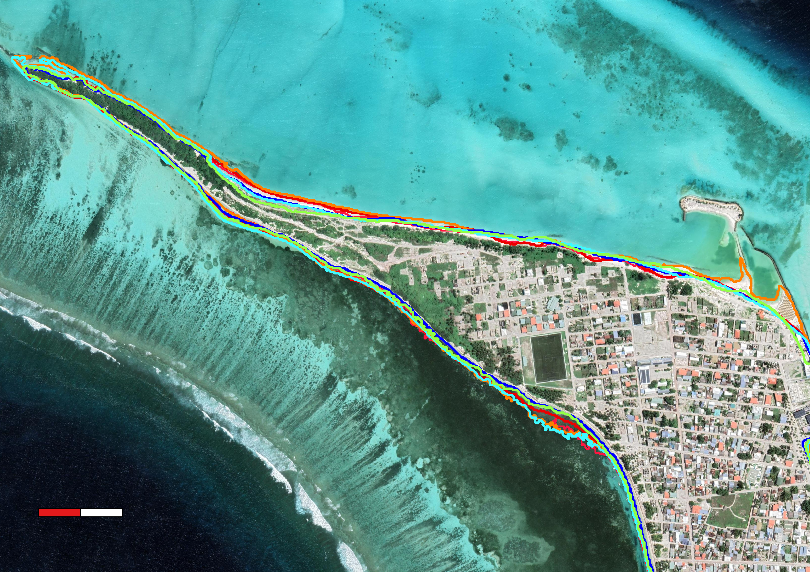
200m
Figure 4. Map of the northern tip of Hoarafushi. The multicolor boundary lines are the shorelines delineated for the years 2018-2022. This map shows the proximity of human development to the coastline. Includes copyrighted material of Planet Labs PBC. All rights reserved.

4.1.2 Chlorophyll-a
Chl-a concentration is an important water quality parameter because it is the active chemical in photosynthesis, and concentration values are indicative of the primary productivity within the water column. Chl-a concentrations were calculated and averaged, by month, using the ORCAA tool, and are measured in mg/m³. Satellite imagery for each month from March 2016 through September 2022 was downloaded and analyzed for Chl-a concentrations. Figure 5 shows Chl-a concentrations for March 2022 surrounding the Huraa Island within the Kaafu Atoll. In shallow coastal waters surrounding Huraa, Chl-a concentrations in the imagery reach upwards of 50 mg/m³. In clear coastal tropical waters (Torres-Pérez, et al., 2021), like those surrounding islands and atolls in the Maldives, Chl-a readings are typically less than 1-3 mg/m³. The satellite imagery we collected overestimates the Chl-a concentrations due to the influence of bottom reflectance. Light reflected by the shallow bottom components (e.g., reef corals, algae, seagrasses, sand, etc.) contributes significantly to the remotely sensed values obtained from above-water reflectance when using multi-spectral satellite ocean data, resulting in overestimation of Chl-a concentrations within the water column (Cannizzaro and Carder, 2006). This indicates that using multispectral images retrieved from Sentinel-2 and the ORCAA tool do not allow for an accurate assessment of Chl-a concentrations in shallow coastal waters within the Maldives in the absence of concurrent in-situ spectral data for validation.

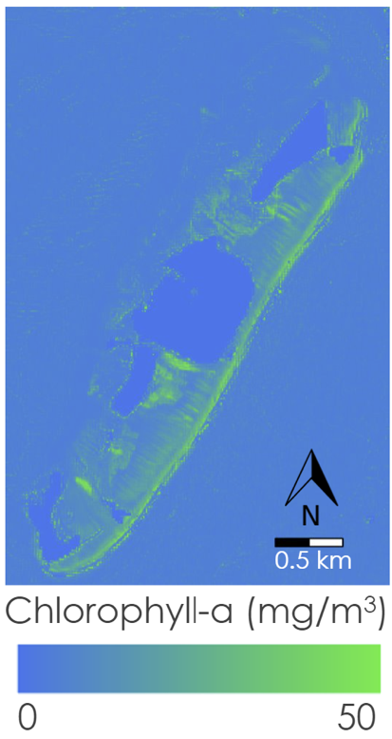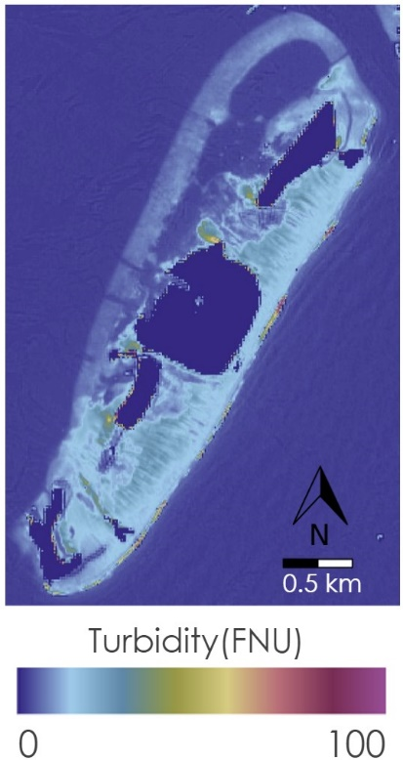
Figure 5. Huraa Island, Chloprophyll-a concentrations for March 2022 (left). Turbidity values for March 2022 (right).

A time series analysis of Chl-a was conducted at the Kaafu Atoll. The Chl-a concentrations in the time series in Figure 6 are average concentrations for the entire Kaafu atoll, which explains why concentrations in the time series are much lower than values seen in shallow waters surrounding Huraa Island. Our time series analysis yielded inconclusive results, with no trends or seasonality identified within our study period. Overall, results from utilizing multispectral satellite imagery and the ORCAA tool to monitor Chl-a and detect trends at the monthly timescale has errors due to high influence of bottom reflectance in shallow reef waters.

4.1.3 Turbidity
Results from analyzing turbidity imagery and time series at Huraa Island were similar to the Chl-a results. Bottom reflectance was a major limitation in measuring turbidity in the Kaafu Atoll. In the imagery shown in Figure 5, the turbidity values do not display turbid waters but return the sandy bottom of the sea floor as mildly turbid waters, and high turbidity values are shallow waters. The turbidity values for clear coastal waters surrounding the Kaafu Atoll and Huraa Island are likely overestimated by ORCAA. When analyzing the turbidity time series (Figure 6), we were not able to detect seasonal or annual trends. Additionally, with the limitations posed by bottom reflectance, we could not confidently draw conclusions from the time series. Without in situ data validation, utilizing multispectral satellite imagery and the ORCAA tool did not provide accurate methods for monitoring turbidity in the Maldives at the monthly time scale. Nonetheless, some of the intra-annual variations seen in both Chl-a and turbidity might be related to specific climatological events that may have happened close to the image acquisition dates. This requires further analysis for confirmation.

Average Chlorophyll-a Concentration at Kaafu Atoll: 2016-2022
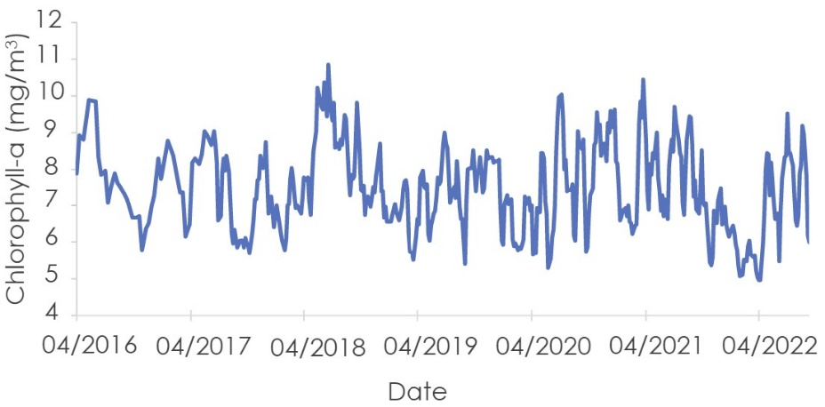
Average Turbidity at Kaafu Atoll: 2016-2022
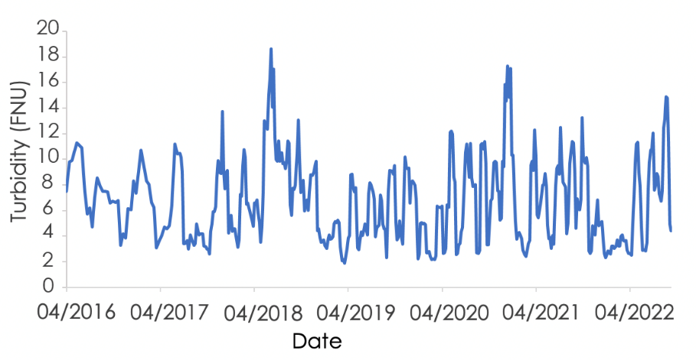
Figure 6. Average chlorophyll-a values at the Kaafu Atoll from March 2016 through September 2022 measured in mg/m³ (top). Average turbidity values at the Kaafu Atoll from March 2016 through September 2022 measured in FNU (bottom).

4.2 Future Work
Future work on this project should aim to expand upon our work through a more expansive look at the archipelago. While we focused on monitoring water quality and shoreline erosion, there was little focus on human developments in the Maldives. The second term of this project would benefit from connecting how human developments have impacted climate change related forces. That project will highlight human development and coastal infrastructure in the Maldives, with specific study sites coordinated by the upcoming team and partners. Additionally, expanding on both the shoreline erosion and water quality results to further understand the island dynamics is important. Land classification using remotely sensed imagery would be beneficial to end users, as well as incorporating in situ data to add validation values and confidence to results. Finally, including more information on the effects of weather events on results would be valuable in understanding the interannual dynamics seen by shoreline change results.

5. Conclusion
This project was able to conduct detailed analysis of shoreline change in the Maldives and create a repeatable methodology. Shoreline change analyses using high resolution data highlighted the dynamic nature of atolls in the Maldives, with shorelines decreasing and increasing in extent from year to year. Results also indicate that shorelines are influenced by both anthropogenic and natural forces. Water quality assessments conducted through ORCAA were inconclusive in detecting long term or seasonal trends in both chlorophyll-a and turbidity but did provide valuable imagery for understanding and monitoring water quality at a monthly time scale. These results benefited the end users by highlighting areas most affected by shoreline erosion and water quality variation. Partners will be able to replicate this methodology in order to assess more islands and further expand identification of areas most impacted by climate change. In the long term, they will be able to focus their mitigation efforts on the most vulnerable areas.

6. Acknowledgments
The Maldives team would like to thank the following for their continued support and guidance throughout the term, this project would not have been possible without their contributions: Lisa Tanh (Science Systems and Applications, Inc.), Dr. Juan Torres-Pérez (NASA Ames Research Center), and Britnay Beaudry (Bay Area Environmental Research Institute) We would also like to thank our partners at the Ministry of Environment, Climate Change, and Technology; The US Department of State, Bureau of South and Central Asian Affairs, Office of Bangladesh, Nepal, Sri Lanka, Maldives and Bhutan; and the USAID, Maldives office for their interest and support through this project.

This material contains modified Copernicus Sentinel data 2022 processed by ESA.

This work utilized data made available through the NASA Commercial Smallsat Data Acquisition (CSDA) program.

Any opinions, findings, and conclusions or recommendations expressed in this material are those of the author(s) and do not necessarily reflect the views of the National Aeronautics and Space Administration.

This material is based upon work supported by NASA through contract NNL16AA05C.

7. Glossary
Earth observations – Satellites and sensors that collect information about the Earth’s physical, chemical, and biological systems over space and time
Formazin – A suspension of materials in water. Turbidity measuring units are named Formazin Nepheolometric Unit or “FNU”.
GEE – Google Earth Engine
MNDWI – Modified Normalized Difference Water Index
MODIS – Moderate Resolution Imaging Spectroradiometer
NDCI – Normalized Difference Chlorophyll Index
NDTI – Normalized Difference Turbidity Index
NDVI – Normalized Difference Vegetation Index
NDWI – Normalized Difference Water Index
NICFI – Norway’s International Climate & Forests Initiative
QGIS – Open-source geographic information systems software
PlanetScope – Commercial ultra-high resolution satellite imagery
ROI – Region of Interest
SST – Sea Surface Temperature
Turbidity – Measure of the cloudiness of water caused by organic and inorganic suspended solids

8. References
Cannizzaro, J. P., & Carder K. L. (2006). Estimating chlorophyll a concentrations from remote-sensing reflectance in optically shallow waters. Remote Sensing of Environment, 101(1), 13-24. https://doi.org/10.1016/j.rse.2005.12.002
Devine, C., Line, A., Higgins, A., Skoglund, S. (2019) A Google Earth Engine Dashboard for Assessing Coastal Water Quality in Belize’s Coral Reefs to Identify Sustainable Development Goals for Achieving Sustainable Use of Natural Resources. https://appliedsciences.nasa.gov/what-we-do/projects/a_google_earth_engine_dashboard_for_assessing_coastal_water_quality_in_belize_s_coral_reefs_to_identify_sustainable_development_goals_sdgs_for_achieving_sustainable_use_of_natural_resources
Duvat, V. K., & Magnan, A. K. (2019). Rapid human-driven undermining of atoll island capacity to adjust to ocean climate-related pressures. Scientific Reports, 9(1). https://doi.org/10.1038/s41598-019-51468-3
European Space Agency. (2015) Sentinel 2 Multispectral Imagery (MSI)/ Level-2 Surface Reflectance [Dataset]. https://sentinels.copernicus.eu/web/sentinel/user-guides/sentinel-2-msi/processing-levels/level-2
Fallati, L., Savini, A., Sterlacchini, S., & Galli, P. (2017). Land use and land cover (LULC) of the Republic of the Maldives: First National Map and LULC change analysis using remote-sensing data. Environmental Monitoring and Assessment, 189(8). https://doi.org/10.1007/s10661-017-6120-2
García-Rubio, G., Huntley, D., & Russell, P. (2015). Evaluating shoreline identification using optical satellite images. Mar. Geol. 359, 96–105. https://doi.org/10.1016/j.margeo.2014.11.002.
Holdaway, A., Ford, M., & Owen, S. (2021). Global-scale changes in the area of Atoll Islands during the 21st Century. Anthropocene, 33, 100282. https://doi.org/10.1016/j.ancene.2021.100282
NASA Goddard Space Flight Center, Ocean Ecology Laboratory, Ocean Biology Processing Group. (2018). Moderate-resolution Imaging Spectroradiometer (MODIS) Aqua Chlorophyll Data [Dataset]. NASA OB.DAAC, Greenbelt, MD, USA. https://doi.org/10.5067/AQUA/MODIS/L3M/CHL/2018
NASA Goddard Space Flight Center, Ocean Ecology Laboratory, Ocean Biology Processing Group. (2014). Moderate-resolution Imaging Spectroradiometer (MODIS) Aqua SST Data [Dataset]. NASA OB.DAAC, Greenbelt, MD, USA. https://doi.org/10.5067/AQUA/MODIS/L3M/SST/2014
NASA Goddard Space Flight Center, Ocean Ecology Laboratory, Ocean Biology Processing Group. (2018). Moderate-resolution Imaging Spectroradiometer (MODIS) Terra Chlorophyll Data [Dataset]. NASA OB.DAAC, Greenbelt, MD, USA. https://doi.org/10.5067/TERRA/MODIS/L3M/CHL/2018
NASA Goddard Space Flight Center, Ocean Ecology Laboratory, Ocean Biology Processing Group. (2014). Moderate-resolution Imaging Spectroradiometer (MODIS) Terra SST Data [Dataset]. NASA OB.DAAC, Greenbelt, MD, USA. https://doi.org/10.5067/TERRA/MODIS/L3M/SST/2014
Nechad, B., Ruddick, K. G., & Neukermans, G. (2009). Calibration and validation of a generic multisensor algorithm for mapping of turbidity in coastal waters. In C. R. Bostater Jr., S. P. Mertikas, X. Neyt, & M. Velez-Reyes (Eds.), SPIE Remote Sensing of the Ocean, Sea Ice, and Large Water Regions 2009 (Proceedings Volume 7473, 74730H). https://doi.org/10.1117/12.830700
Pham, B. T., & Prakash, I. (2018, October 20). Application of simple remote sensing techniques for the detection and ... Retrieved November 9, 2022, from https://www.researchgate.net/profile/Indra-Prakash-4/publication/329964230_Application_of_Simple_Remote_Sensing_Techniques_for_the_Detection_and_Extraction_of_Coastline-A_Case_Study_of_Diu_Island_India/links/5c2606e592851c22a34a7485/Application-of-Simple-Remote-Sensing-Techniques-for-the-Detection-and-Extraction-of-Coastline-A-Case-Study-of-Diu-Island-India.pdf
Planet Team (2022). Planet Application Program Interface: In Space for Life on Earth. San Francisco, CA. https://www.api.planet.com

Pippin, H., Olarte, A., Pilot, R., & Valenti, V. (2019) Developing a Google Earth Engine Dashboard for Assessing Coastal Water Quality in the Belize and Honduras Barrier Reefs to Identify Adequate Waste Control and Inform Coastal Resource Monitoring and Management.
Rasheed, S., Warder, S. C., Plancherel, Y., & Piggott, M. D. (2021). An improved gridded bathymetric data set and tidal model for the Maldives archipelago. Earth and Space Science, 8. https://doi.org/10.1029/2020EA001207
Stojanov, R., Duží, B., Kelman, I., Němec, D., & Procházka, D. (2016). Local perceptions of climate change impacts and migration patterns in Malé, Maldives. The Geographical Journal, 183(4), 370–385. https://doi.org/10.1111/geoj.12177
Torres-Perez, J. L., Ramos-Scharron, C. E., Hernandez, W. J., Armstrong, R. A., Barreto-Orta, M., Ortiz-Zayas, J., Guild, L. S., & Viqueira, R. (2021). River Streamflow, Remotely Sensed Water Quality, and Benthic Composition of Previously Undescribed Nearshore Coral Reefs in Northern Puerto Rico. Frontiers in Marine Science, 8 https://doi.org/10.3389/fmars.2021.720712
TUBS. (2012). Maldives on the globe (Afro-Eurasia centered) [.svg image]. Wikimedia Commons. https://commons.wikimedia.org/wiki/File:Maldives_on_the_globe_%28Afro-Eurasia_centered%29.svg
US Geological Survey Earth Resources Observation and Science Center. (2014). Landsat 8 OLI/TIRS Level-2 Data Products - Surface Reflectance [Dataset]. https://doi.org/10.5066/F78S4MZJ

