NASA DEVELOP National Program
NASA Goddard Space Flight Center
Fall 2015

Montana Ecological Forecasting
Utilizing NASA Earth Observations to Forecast the Effects of Climate Change on Northern Goshawk Nesting Habitat


Technical Report
Final Draft – November 19, 2015

Erika Higa (Project Lead)
Sean McCartney
Amanda Clayton

Dr. Ross Nelson, NASA Goddard Space Flight Center (Science Advisor)
Dr. John Bolten, NASA Goddard Space Flight Center (Science Advisor)

I. Abstract
The northern goshawk (Accipiter gentilis) is currently identified as both a Sensitive Species and a Management Indicator Species in the Lewis and Clark National Forest (LCNF) land and resource management plans. Goshawks are important top-tier predators in the LCNF and changes in forest habitat greatly affect their survival and population. We examined the potential of using NASA Earth observations to locate and model suitable nesting habitat for the goshawk. Currently, Dr. Nate Bickford and the US Forest Service (USFS) do not use remote sensing to identify or forecast goshawk nesting habitat, and the tools they use are limited to topographic maps and in situ data. We identified various environmental variables measured by Landsat 8 Operational Land Imager (OLI), Shuttle Radar Topography Mission (SRTM), Tropical Rainfall Measurement Mission (TRMM) Precipitation Radar (PR), and Global Precipitation Measurement (GPM) Dual-frequency Precipitation Radar/Global Microwave Imager (DPR/GMI). These derived variables, along with ancillary vegetation data, were input into several habitat suitability models, using BioMapper, Maxent, and Mahalanobis Typicality, and a consensus map was made to identify areas of suitable habitat for nesting goshawks. Fire frequency and mountain pine beetle risk were used as ancillary data to determine the likelihood of available nesting habitat for the future under different climate change scenarios. The Goddard Institute for Space Studies ModelE/Russell Model was used in forecasting different climate change scenarios. The results from this project will augment current decision making practices in forest management in the LCNF and assist in understanding how climate change will affect the goshawk nesting habitat in the future.

Keywords
Accipiter gentilis, Climate Change, Ecological Forecasting, Habitat Suitability, Lewis and Clark National Forest, Montana, Remote Sensing

II. Introduction
Background Information
The northern goshawk (Accipiter gentilis) is the largest of the three forest raptors in the Accipiter family. The species occupies boreal and temperate forests in the Holarctic and it breeds in mountainous and coniferous regions throughout Montana (Brewer, 2009). The goshawk has been a concern for conservationists in North America due to the potential impact of forest management practices on their habitat and the uncertainty in their population trends. Consequently, in 2009, the species was listed as “Sensitive” by Region 1 of the US Forest Service. While goshawks are designated as an Animal Species of Concern and hold a S3 state conservation rank in Montana, a G5 conservation rank (see Appendix A for definitions) indicates they are widespread throughout their global range (Montana Natural Heritage Program, 2009). The goshawk is also designated as a Management Indicator Species in the Lewis and Clark National Forest and is protected under the Migratory Bird and Treaty Act (Brewer, 2009).

The goshawk has been a focus for conservationists and researchers due to the threat of habitat and climate change. Goshawks hunt in heavily forested areas and nest in mature forests where there is high canopy cover and an open understory (Miller et al., 2013). However, nest site locations are limited due to their preference for moderately sloped areas that are north to east facing (Squires and Reynolds, 1997). Goshawk nests are typically found in forests between 1500 to 2000 meters in elevation with an average of 350 millimeters of precipitation per year (Clough, 2000). It is believed that weather can affect egg and fledgling survival since cold wet springs and delayed snowmelt at higher elevations can delay the time goshawks lay their eggs (Squires and Kennedy, 2006). Past research has shown that goshawks are sensitive to drastic changes in weather—particularly its effect on forest ecosystem dynamics (Keane et al., 2006). Climate change can, over time, affect the forest composition, cover, structure, and prey densities in the ecosystem, and this can adversely affect the goshawk species since it is a top-tier predator. It is presumed that a change in weather, more than any other factor, in addition to habitat change, will affect the egg and nestling survival of the goshawk species (Keane et al., 2006).

Additionally, the impact of climate change with warmer and drier weather can increase mountain pine beetle (Dendroctonus ponderosae) outbreaks, causing higher tree mortality, and thus pose a risk to the goshawk population due to habitat change and loss (Brewer, 2009). Another threat to reducing the quality of nesting and foraging habitat of goshawks is timber management practices that involve removing nest trees, modifying nest stands, and removing portions of the canopy. Due to these specific habitat requirements, it is necessary to model areas that could be used by goshawks for breeding and nesting. This will allow forest managers and conservationists to maintain quality habitat to support future goshawk populations.

Project Objectives and Partners
The first objective of this project was to assess the use of NASA Earth observations along with other ancillary data, as inputs for habitat suitability modeling. The second objective was to create and analyze three different habitat suitability models and form a consensus map to identify potential nesting habitat for the northern goshawk in the Lewis and Clark National Forest (LCNF). It is believed that climate change will affect nesting range and breeding phenology resulting in a delayed and shorter incubation period (Bechard et al., 2006). The final objective was to forecast the impacts on nesting habitat due to climate change, potential mountain pine beetle encroachment, and fire risk by the year 2050. The team examined different environmental variables that directly affect goshawk nesting habitat, including: elevation, slope, aspect, precipitation, land cover, vegetation height, canopy cover, and basal area.

The partners for this project were Dr. Nate Bickford from the University of Nebraska at Kearney, Dr. Risto Tornberg from the University of Oulu in Finland, and Victor Murphy of the US Forest Service. These partners are interested in the project because they have not utilized remote sensing methods to analyze and forecast goshawk nesting sites. Dr. Bickford and his team of researchers conduct time-consuming field observations of nest site locations and surrounding vegetation. He and his colleague, Dr. Risto Tornberg, will be able to apply the methods from this project to model habitat suitability for northern goshawks in other regions, and project how climate change will affect forest habitat in these areas. Victor Murphy will use the results from this project to advise forest managers on timber management best practices to maintain vegetation structure in areas of critical goshawk nesting habitat.
Study Area and Study Period
The LCNF encompasses 7,300 km2 of land in central Montana. The forest is separated into two management areas: the Jefferson and Rocky Mountain Divisions. The 4,900 km2 Jefferson Division is further divided into five geographic areas (GAs): Castles, Crazies, Highwoods, Little Belts, and Snowies. Many of these geographic areas are discrete geologic units with unique landform and vegetation types, cultural histories, and recreation opportunities. The forest elevation ranges from 1,370 to 2,850 meters. Primary forest types consist of lodgepole pine (Pinus contorta), Douglas fir (Pseudotsuga menziesii), ponderosa pine (Pinus ponderosa), and aspen (Populus tremuloides); all of which are common trees where goshawks nest. The US Forest Service oversees forest management practices within the study area including timber, fire, and recreational activities.

This study utilized 190 historical and active goshawk nest sites located in the Jefferson Division of the LCNF from 1985 to 2013. Because the nest site data were limited to the Jefferson Division, we excluded the Rocky Mountain Division of the LCNF from our study area.

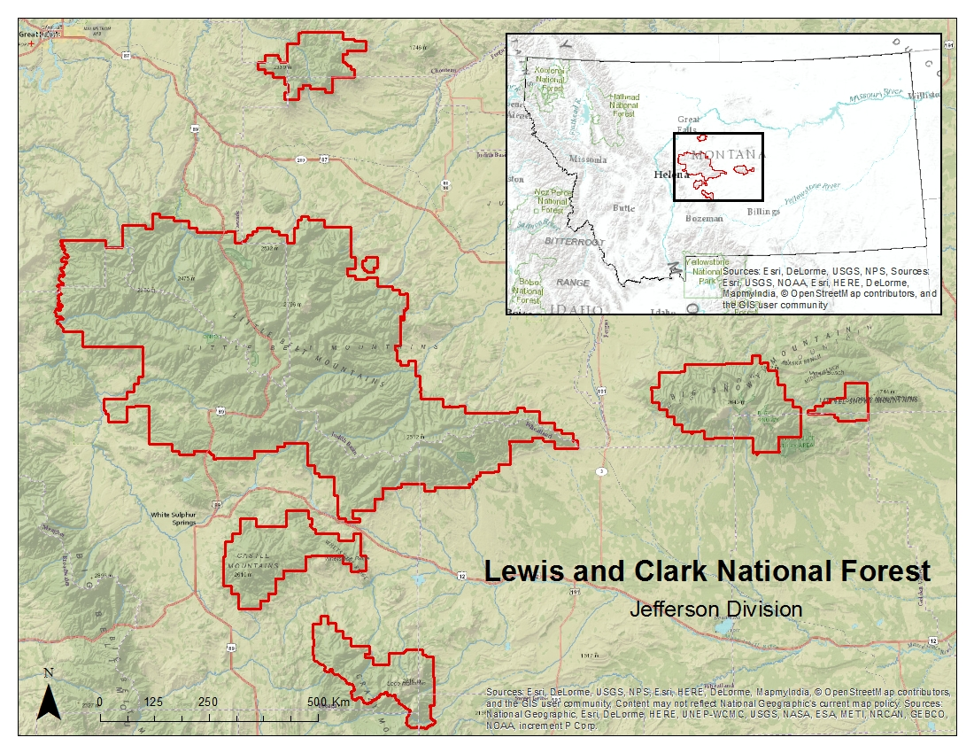
Figure 1: Study area map of the Lewis and Clark National Forest, Jefferson Division. Study area is outlined in red.

National Application Area Addressed
This project addressed the Ecological Forecasting Application Area within NASA’s Applied Sciences Program. This project utilized NASA Earth observations to analyze land cover, precipitation, and to derive environmental variables provided by ancillary datasets to model potential areas of goshawk nesting sites. This study assisted our project partners to provide methods for habitat suitability analysis using remotely sensed data and to forecast how climate change will affect the goshawk habitat and nesting behavior by the year 2050. The information provided by this project will augment current decision-making practices regarding forest management in the LCNF.

III. Methodology
Habitat Suitability Modeling
Data Acquisition
Two sets of northern goshawk nesting sites from 1985 to 2013 were provided by project collaborator, Dr. Nate Bickford, of the University of Nebraska at Kearney, and by Laura Conway of the US Forest Service. GPS coordinates, elevation, and the active years of each nest site location were recorded by Dr. Bickford, Ms. Conway, and their staff. These datasets were checked for redundancy, by removing overlapping nest sites within a 5m buffer to account for GPS error, and combined into one set of 190 nesting sites. Specific nest site locations are shown in Figure 5 (see Appendices).

The US Forest Service maintains a large geospatial library containing data for Region 1 national forests. We utilized this library to obtain ancillary data on vegetation characteristics within the LCNF to derive a set of nesting habitat variables for the northern goshawk. The US Forest Service Vegetation Map (VMap) and Forest Inventory and Analysis (FIA) programs survey, analyze, and produce geospatial data layers for various forest attributes. We used the VMap product to obtain vegetation metrics in vector format for tree canopy cover class size. Tree canopy cover is classified by percent canopy cover. Basal area, in square meters per hectare, was downloaded from the FIA product at 250 m resolution. An Existing Vegetation Height (EVH) layer was downloaded from the United States Geological Survey (USGS) Landscape Fire and Resource Management Planning Tools (LANDFIRE) program. This layer provides an average height of the dominant vegetation at a 30 m resolution.

Using USGS Earth Explorer, we acquired Shuttle Radar Topography Mission (SRTM) 1 arc-second data (30 m) which were used to derive terrain elevation, slope, and aspect. Landsat 8 Operational Land Imager (OLI) data were acquired as three separate tiles for the dates of September 7, 2014, and August 2, 2015. All tiles were downloaded from the USGS Earth Resources Observation and Science Center (EROS). The tiles were used in creating a forest cover map of the study area for use as an environmental variable in habitat suitability modeling. Precipitation data was acquired from Precipitation Measurement Missions (PMM), Tropical Rainfall Measuring Mission (TRMM), and Global Precipitation Measurement (GPM), for the months of February to June, 2010 to 2015. TRMM data were acquired as a level 3 product (3B43) at 0.25 degree spatial resolution and one month temporal resolution. GPM data were acquired as a level 3 product (3IMERGM) at 0.1 degree spatial resolution and one month temporal resolution. Both data sets were downloaded from the Science Team On-Line Request Module (STORM), a web-based data access interface hosted by NASA Goddard Space Flight Center (GSFC).

Data Processing
Data layers for each environmental variable were created to model suitable habitat for northern goshawk nesting sites. These variables included: elevation, slope, aspect, precipitation, land cover, vegetation height, canopy cover, and basal area. Each environmental variable was specifically chosen after extensive literature review on goshawk ecology and with suggestions from our project partners. ArcGIS 10.3 was used to prepare the environmental data for habitat suitability modeling. Five individual SRTM elevation tiles spanning the study area were mosaicked and topographic layers for slope and aspect were derived from this 30 m DEM using the Slope and Aspect tools in ArcMap. VMap data were converted to a 30 m raster format to create separate layers for canopy cover class. FIA data for basal area were resampled from 250 m to 30 m spatial resolution to match the spatial resolution of the other environmental variables. TRMM and GPM data were resampled from 2.5 km spatial resolution, and 1 km spatial resolution respectively, to 30 m spatial resolution using the Resample tool in ArcMap software. Precipitation averages for each month from 2010 to 2015 were then calculated as inputs into each model. For creating a land cover map of the study area, three tiles of Landsat 8 data were mosaicked together. Each data layer was subset to match the spatial extent of the LCNF, Jefferson Division, and projected to NAD 1983 UTM zone 12 N in raster format (see Figure 6 in Appendices).

Data Analysis
Once pre-processing of the Landsat OLI data was complete, further analysis was carried out to create a land cover classification for the LCNF; the results of which were two categories: forest and non-forest. Three separate hard classifications were undertaken using different methods in creating land cover maps for modeling. Maximum likelihood and Segmentation classifications were carried out using TerrSet software, and Monte Carlo Unmixing and subsequent hard classification was carried out using CLASlite software. Once all classifications were completed, 200 random samples were generated in a GIS and converted to a KML point file. These randomly generated points were then brought into Google Earth and verified as being either forest or non-forest. The resulting text file was used as ‘ground truth’ and brought back into a GIS and converted to a raster file where an accuracy assessment was performed with each hard classification. The object-based classification (segmentation) resulted in the highest accuracy rate of 88% and was subsequently used in the running of habitat suitability models. Results from the accuracy assessment are found in Figure 7 in the Appendices.

We utilized three presence-only modeling software to construct a habitat suitability model for northern goshawk nesting habitat. We ran the Maximum Entropy (Maxent) and Mahalanobis Typicality models through TerrSet’s Habitat and Biodiversity Modeler application. Maxent is a widely used program that estimates the probability distribution of a species using a maximum entropy approach, where the expected value of each environmental variable matches the empirical average (Phillips et al., 2010). Mahalanobis Typicality expresses the likelihood that a set of environmental variables at a specific location is typical to the known location of the species, or that the species distribution is normal with respect to environmental gradients (Hernandez et al., 2008). The stand-alone program, BioMapper 4.0, was used for the third model. BioMapper is based off of Ecological Niche Factor Analysis (ENFA), which computes the environmental factors that most explain the ecological distribution of the species (Hirzel et al., 2002).

The following 8 environmental variables were input into each model: elevation (m), slope (percent), aspect (degrees), land cover (forest/non-forest), vegetation height (m), tree canopy cover class (percent cover), precipitation (mm), and basal area (m2/hectare). The outputs of each individual model (see Figures 8, 9, and 10 in Appendices) were combined to create a single, composite model with different levels of predictive power.

Based on the results of each habitat suitability model for goshawk nesting sites, a consensus map was created showing a gradation of probabilities for nesting sites in the study area. The consensus map was created by calculating the mean pixel value from all three habitat suitability models. The consensus map was classified using equal interval classification to display areas of optimal, marginal, and unsuitable nesting habitat.

Ecological Forecasting
Data Acquisition
To capture current bioclimatic conditions, in situ data was was obtained online for the Onion Park Natural Resource Conservation Service snow telemetry (SNOTEL) site. This site is located within the Tenderfoot Creek Experimental Forest of the Jefferson division of the LCNF. Average monthly minimum temperature and precipitation data during the goshawk nesting season from February through June were collected for the years 2010 to 2015. Data from these five years were averaged for each month to create a baseline measurement of current conditions for comparison to climate model projections. Temperature and precipitation data obtained from the Onion Park site better represented current conditions of the study area than available remotely sensed data.

Data were acquired for climate projections from the Goddard Institute for Space Studies ModelE/Russell Model (GISS-E2-R) for three representative concentration pathways (RCPs). Each RCP describes possible global climate scenarios based on greenhouse gas concentration trajectories adopted by the Intergovernmental Panel on Climate Change (IPCC) for its fifth Assessment Report (IPCC, 2014). The three possible climate scenarios reflect possible changes in greenhouse gas (GHG) emissions measured in CO2 equivalents. RCP 2.6 assumes the global GHG emissions will peak between 2010 and 2020, with emissions declining thereafter; RCP 4.5 assumes emissions will peak around 2040 and then decline; and RCP 8.5 assumes emissions will continue to rise throughout the rest of the 21st century. These datasets, which are in 2-3 degree spatial resolution, were downloaded from the WorldClim - Global Climate Data website after being averaged to the year 2050. We chose to examine bioclimatic variables, GISS-E2-R minimum temperature and precipitation modeled to 2050, to forecast changes to suitable nesting habitat.

Mountain pine beetle infestation projections were downloaded from the US Forest Service 2012 National Insect and Disease Risk Maps/Data. Raster data measuring total projected basal area loss in square feet per acre through 2027 were used. Mean fire return interval data were downloaded from the USGS LANDFIRE program displaying historical fire regimes by categories of varying temporal length (years).

Data Processing
The pixels from the GISS-E2-R model were reprojected and resampled to 30 m. The modeled monthly precipitation and average monthly minimum temperature values for all three RCP scenarios for the year 2050 were determined by taking the average of all pixels within the study area. This produced an average value for precipitation and minimum temperature for the goshawk nesting season, February through June.

The mountain pine beetle and mean fire return interval data was resampled to 30 m spatial resolution and georeferenced to NAD UTM zone 12N. The mountain pine beetle risk map was reclassified so each pixel with projected basal area loss (range, 1 ft2/acre - 214 ft2/acre) was considered at risk. A fire frequency risk map was created by combining the following mean fire return interval classes: 11-15 years, 16-20 years, 21-25 years, 26-30 years, and 31-35 years. This risk map identifies areas that could be affected by natural wildfire by 2050.

Data Analysis
As disturbances such as beetle blight and wildfire adversely affects the integrity of forest health, and therefore goshawk nesting habitat, we forecasted what areas of the LCNF will be viable for nesting based on the current conditions and future scenarios. To see how bioclimatic conditions will differ in the future, we compared current average precipitation and minimum temperature data to the projected data extracted from the GISS-E2-R climate model for RCP 2.6, RCP 4.5, and RCP 8.5. Additionally, we overlaid the mountain pine beetle risk map and the fire risk map to areas of optimal nesting habitat as determined by the aforementioned habitat suitability modeling.

IV. Results & Discussion
Habitat Suitability Modeling
In the final consensus suitability map (see Figure 2 below), approximately 350 km2 of the Jefferson Division of the Lewis and Clark National Forest was classified as optimal nesting habitat for the northern goshawk. This is approximately 7% of the study area. There are approximately 725 km2 of marginal nesting habitat (15% of the study area), while the remaining 78% of the LCNF Jefferson Division was modeled unsuitable for goshawk nesting sites.
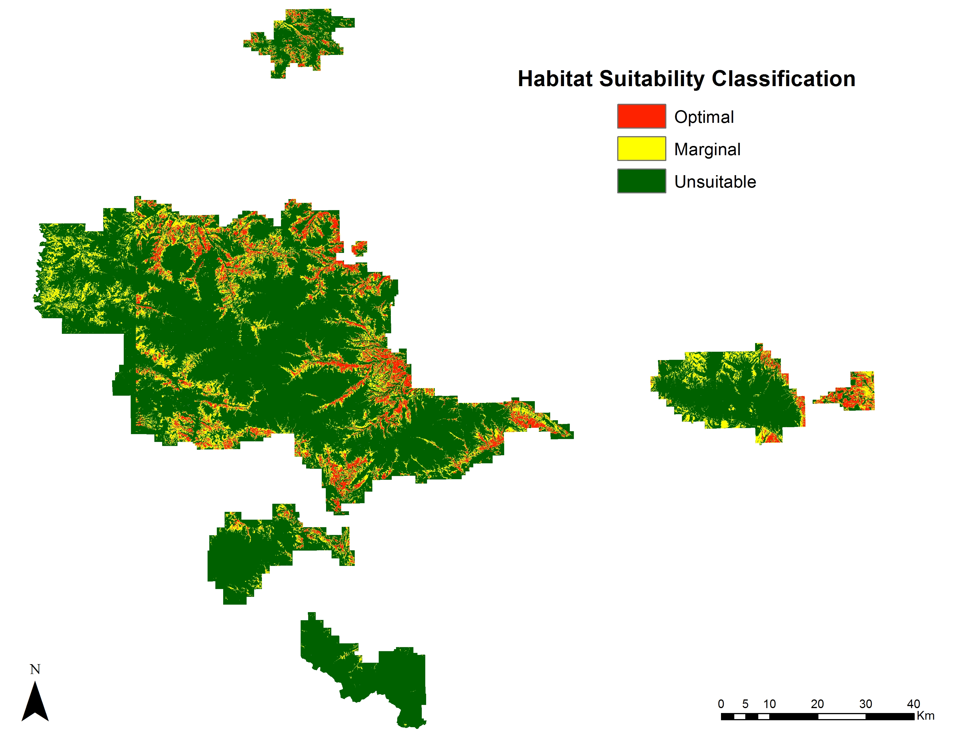
Figure 2. Consensus map combining BioMapper, Maxent, and Mahalanobis Typicality habitat suitability maps to show areas of optimal, marginal, and unsuitable nesting habitat for northern goshawks within the Lewis and Clark National Forest, Jefferson Division.

We extracted the habitat suitability values in the consensus map based on the 190 nest locations to check the performance of the habitat suitability model (see Table 1). 103 nests coincided with optimal areas and 66 nests were located in marginal areas. There is some uncertainty in the habitat suitability map since not all models are absolute and that 21 nests were found in areas modeled as unsuitable. Overall, the consensus map is fairly reliable since 169 nests out of 190 were located on modeled optimal and marginal suitable areas.

 | Number of Nest Sites (percentage of total nests, n=190)
Optimal | 103 (54%)
Marginal | 66 (35%)
Unsuitable | 21 (11%)
Range of suitability values | 0.022 to 0.986
Mean suitability | 0.655
Median suitability | 0.698
Table 1. Validation of the consensus map by extracting the habitat suitability values on the basis of the 190 nest locations.

The limiting factor that could not be accounted for in this project was to exactly locate the nesting habitat that goshawks prefer to nest in. While we utilized eight major environmental variables that influence goshawk nesting habitat in our habitat modeling, there is some uncertainty in our results. We were not able to incorporate an important requirement for nesting habitat in our modeling; goshawks prefer to nest in forested areas that have a closed canopy and an open understory. We did use a tree canopy percent cover dataset in our modeling, but this was a generalized dataset and does not contain sufficient understory information. This requires our end-users go in the field and check if the modeled optimal habitat from our consensus map includes areas that have closed canopy and an open understory. In future studies, Light Detection and Ranging (LiDAR) data will need to be incorporated to distinguish areas that have a closed canopy and an open understory. LiDAR will also be useful to locate suitable nesting habitat with its high spatial resolution. The use of LiDAR would have greatly improved our habitat suitability modeling and ability to further quantify the nesting habitat, however a complete LiDAR dataset was not available for the study area.

Ecological Forecasting
The representative concentration pathways (RCP 2.6, RCP4.5, and RCP8.5) modeled by GISS-E2-R climate model show an increase in average monthly minimum temperature for February through June compared to current conditions (Figure 3, top). Average monthly precipitation is projected to decrease for the months of February through June (Figure 3, bottom).

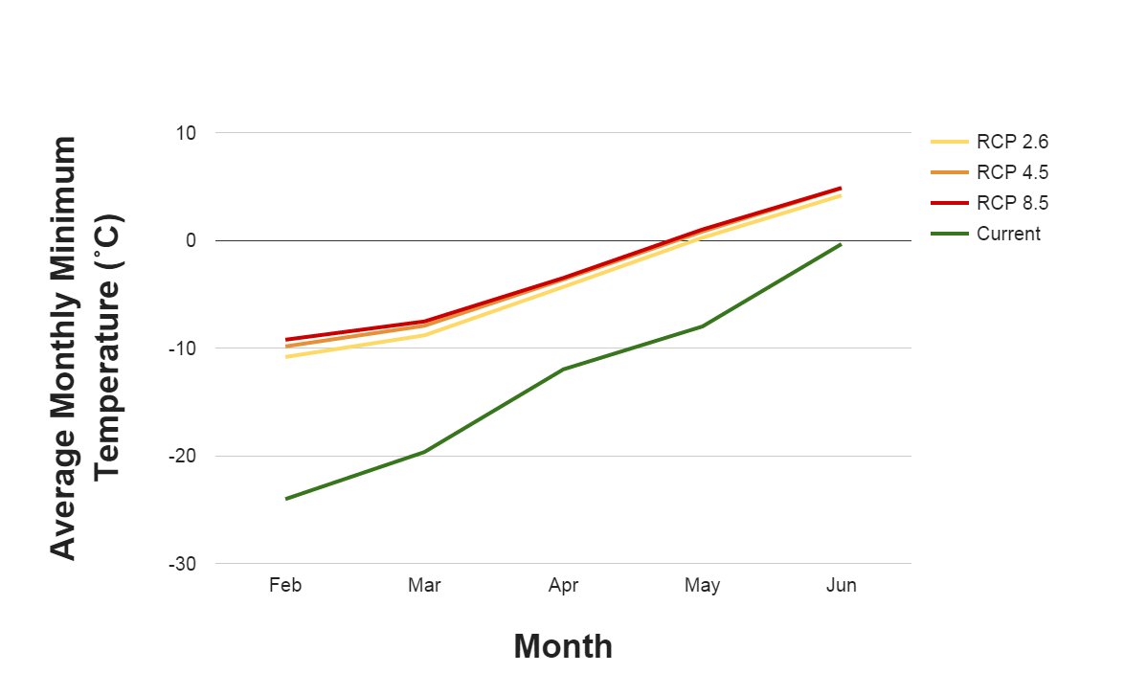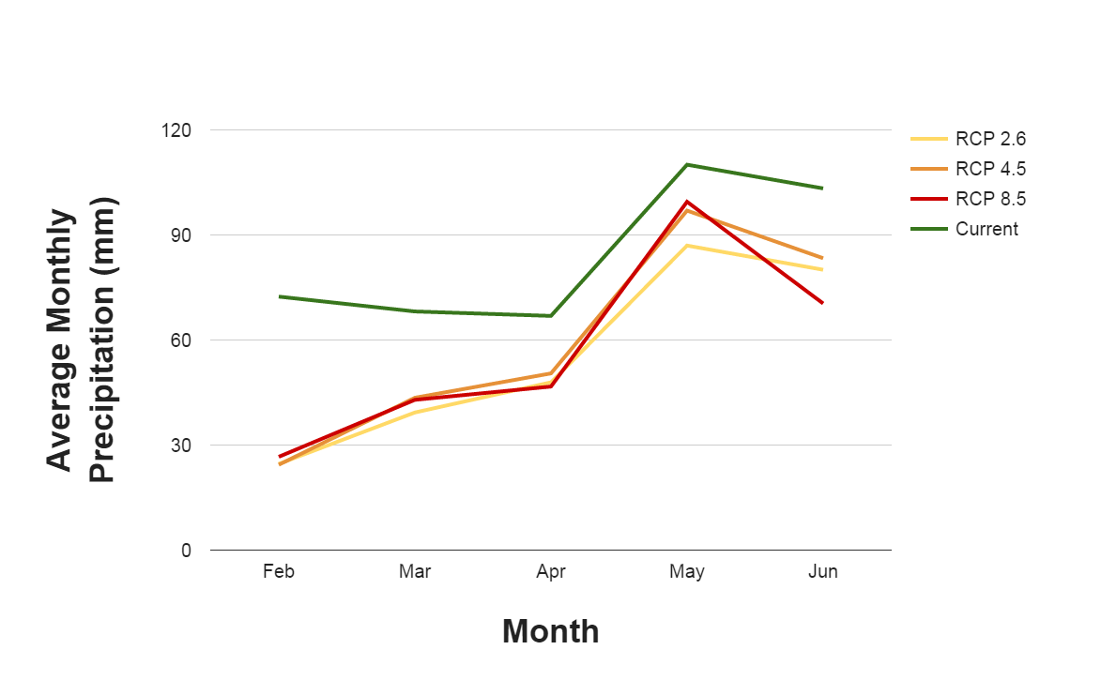

Figure 3. The projected average monthly minimum temperature (top) and average monthly precipitation (bottom) in the LCNF under three different scenarios for the year 2050, compared to the current conditions for the goshawk nesting season, February through June.

We assume that the increase in temperature and decrease in precipitation by 2050 will have an impact on mountain pine beetles. It is believed that warmer temperatures will permit mountain pine beetles to extend their range to higher altitudes and latitudes and speed up the beetle’s reproductive and growth cycles (Bentz et al., 2009). Warmer winter and spring seasons and drier conditions will also reduce cold-induced beetle mortality, and thus allow higher populations of pine beetles than in cooler conditions (Bentz et al., 2009). We analyzed the reclassified 2027 projected mountain pine beetle risk map (see Figure 11 in Appendices) and can see that almost all of the LCNF is at risk. We overlaid the modeled optimal habitat with the mountain pine beetle risk map (see Figure 12 in Appendices) and calculated that 52% may be at risk for mountain pine beetle blight. By 2050, we assume that there may be more optimal habitat at risk since continued warming will fuel beetle attacks in areas where the beetle outbreak has not occurred. However, there is uncertainty in the actual risk mountain pine beetles may have in the future since the extent of the pine beetle blight is variable year by year.

Warmer and drier climate will also create conditions that make forested areas more susceptible to wildfires and possibly increase the frequency of fires. We observed the reclassified fire frequency risk map (see Figure 13 in Appendices) and overlaid the modeled optimal habitat with this map (see Figure 4 right, and Figure 14 in Appendices) and found that 66% of modeled optimal habitat may be at risk for frequent wildfires. There is also uncertainty in the fire frequency risk map from the USGS LANDFIRE program since it is a generalized product. It is not guaranteed that wildfires will occur at the modeled optimal goshawk nest sites because wildfires do occur at random.

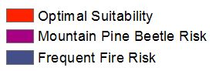
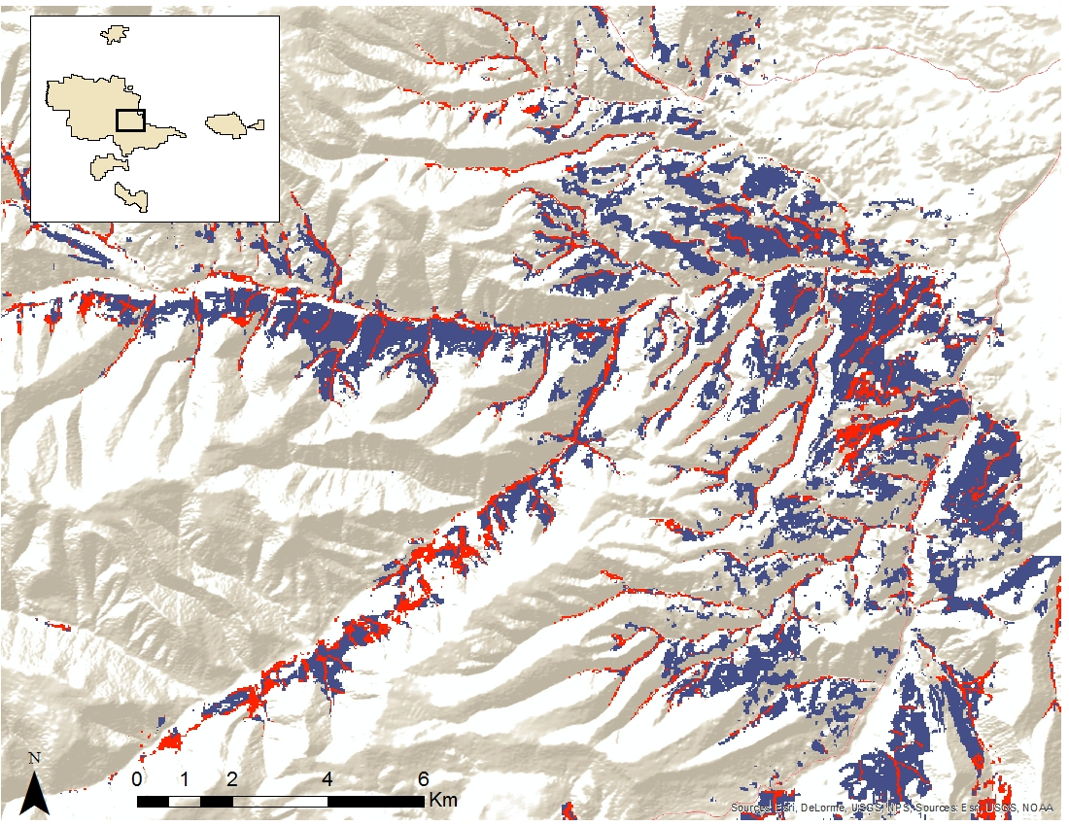
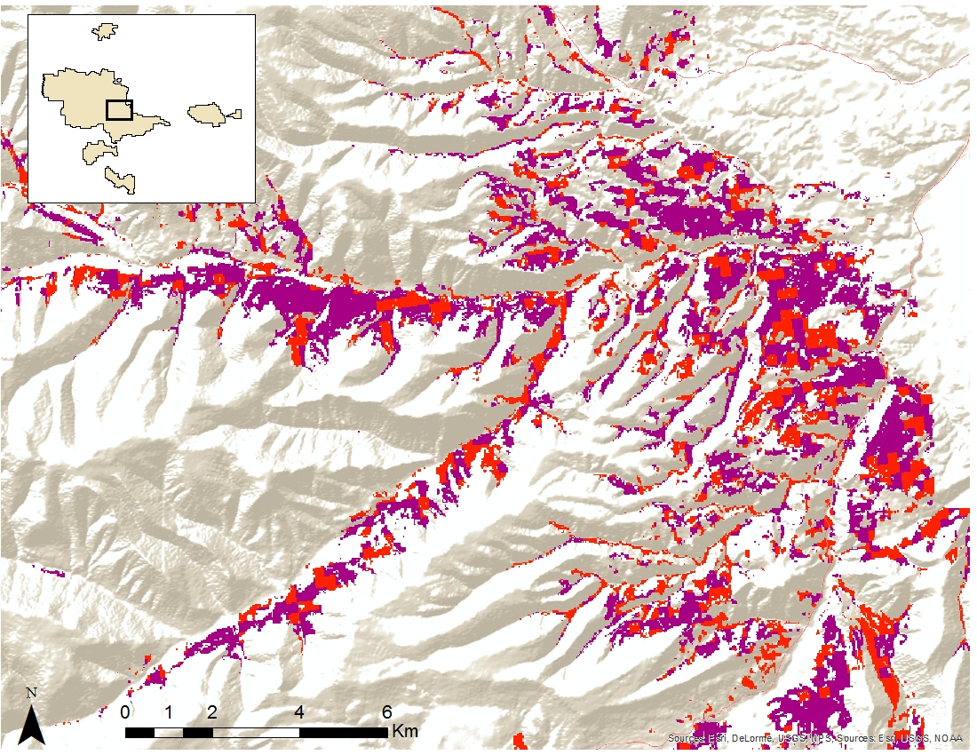
Figure 4. The map on the left shows the amount of optimal habitat at risk due to mountain pine beetle blight projected to 2027. The map on the right shows amount of optimal habitat at risk for frequent fires by 2050.

It is important to note that the mountain pine beetle risk and fire risk will act independently from each other in impacting the nesting habitat. This is because the extent of the mountain pine beetle blight is correlated with the increase in susceptible forest strands due to less wildfire events (Taylor and Carroll, 2003). The mountain pine beetle prefer dense stands with tree canopies that touch, and wildfire suppression will change the forest composition by creating dense forests full of mature trees that are thus more susceptible the beetle blight (Bentz et al., 2009). Overall, either the beetle blight or fires will impact the availability of future goshawk nesting sites by the year 2050.

V. Conclusions
As a Management Indicator Species in the LCNF, the methods used in this study incorporating Earth observations and ancillary data into several habitat suitability models were effective in creating a consensus map of nesting habitat for the northern goshawk. This methodology is important in communicating to forest management in the LCNF areas for conservation when planning future timber harvests in the study area. Concentrating field inventories on areas based on modeled nesting habitat not only improves the efficacy of field teams searching for goshawk nests during the nesting season, it leads to better planning and management of the LCNF for conservation efforts for this indicator species. In turn, these practices will allow forest managers, researchers, and conservationists the means to maintain suitable habitat to support future goshawk populations.

As nest site locations are limited due to goshawk preference for specific biophysical conditions, climate change can affect the forest composition and prey densities in the LCNF, and this can adversely affect goshawk nest sites. Our study determined climate change is forecast to decrease nesting habitat by 2050. The climate projections based on the GISS-E2-R model show there will be warmer and drier conditions in the future for all RCP scenarios. This means the geographic extent of the mountain pine beetle and its populations will increase and thus pose a threat limiting the available nesting habitat for the goshawk. In addition, warmer and drier conditions may lead to an increased frequency of fires, and this will also reduce the extent of optimal goshawk nesting habitat.

The importance of this study is realizing how freely-available Earth observing data, along with ancillary data, can be used as variables with modeling software to replicate this methodology in other regions of the Holarctic. Earth observations provide global and continuous coverage for biophysical variables, and two of the modeling software used in this study were open source. Northern goshawk nesting sites can therefore be modeled anywhere in the world using the methodology from this study with open source data and software.

VI. Acknowledgments
This project was made possible with great support and guidance from our science advisors and partners. We would like to thank the following individuals for their input into this project:
- Dr. Ross Nelson (NASA GSFC Science Advisor)
- Dr. John Bolten (NASA GSFC Science Advisor)
- Dr. Nate Bickford (Project Partner)
- Laura Conway (US Forest Service)
- Dr. Lee Vierling (University of Idaho)
- Dr. Jeff Hicke (University of Idaho)

Any opinions, findings, and conclusions or recommendations expressed in this material are those of the author(s) and do not necessarily reflect the views of the National Aeronautics and Space Administration.

This material is based upon work supported by NASA through contract NNL11AA00B and cooperative agreement NNX14AB60A.

VII. References
Bechard, M. J., Fairhurst, G. D., & Kaltenecker, G. S. (2006). Occupancy, productivity, turnover, and dispersal of northern goshawks in portions of the northeastern Great Basin. Studies in Avian Biology, 31, 100-108.

Bentz, B., Logan, J., MacMahon, J., Allen, C. D., Ayres, M., Berg, E., ... & Wood, D. (2009). Bark beetle outbreaks in western North America: Causes and consequences. Bark Beetle Symposium. Snowbird, UT. Salt Lake City, UT.

Brewer, L. T., Bush, R., Canfield, J. E., & Dohmen, A. R. (2009). Northern goshawk Northern Region overview: key findings and project considerations. US Forest Service. Missoula, MT.

Clough, L. T. (2000). Nesting habitat selection and productivity of northern goshawks in west-central Montana (Doctoral dissertation). University of Montana, Missoula.

Eastman, J.R., (2014) TerrSet Geospatial Monitoring and Modeling System [Software]. Worcester, MA: Clark University.

Hernandez, P. A., Franke, I., Herzog, S. K., Pacheco, V., Paniagua, L., Quintana, H. L., ... & Young, B. E. (2008). Predicting species distributions in poorly-studied landscapes. Biodiversity and Conservation, 17 (6), 1353-1366.

Hijmans, R.J., S.E. Cameron, J.L. Parra, P.G. Jones & Jarvis, A. (2005). Very high resolution interpolated climate surfaces for global land areas. International Journal of Climatology, 25, 1965-1978.

Hirzel, A. H., Hausser, J., Chessel, D., & Perrin, N. (2002). Ecological-niche factor analysis: How to compute habitat- suitability maps without absence data? Ecology, 83 (7), 2027-2036.

Hirzel, A. H., Hausser, J., & Perrin, N. (2004). Biomapper 4.0. [Software]. Lab. of Conservation Biology, Department of Ecology and Evolution, University of Lausanne. Available from http://www.unil.ch/biomapper.

IPCC. (2014) Climate Change 2014: Synthesis Report. Contribution of Working Groups I, II and III to the Fifth Assessment Report of the Intergovernmental Panel on Climate Change [Core Writing Team, R.K. Pachauri and L.A. Meyer (eds.)]. IPCC, Geneva, Switzerland, 151 pp.

Keane, J. J., Morrison, M. L., & Fry, D. M. (2006). Prey and weather factors associated with temporal variation in northern goshawk reproduction in the Sierra Nevada, California. Studies in Avian Biology, 31, 85-99.

Miller, R., Carlisle, J., Bechard, M., & Santini, D. (2013). Predicting nesting habitat of Northern Goshawks in mixed aspen-lodgepole pine forests in a high-elevation shrub-steppe dominated landscape. Open Journal of Ecology, 3 (2), 109-115.

Montana Natural Heritage Program and Montana Fish Wildlife and Parks. (2009). Montana animal species of concern. Helena, MT: Montana Natural Heritage Program and Montana Department of Fish Wildlife and Parks. 17 pp. Retrieved from http://mtnhp.org/Reports.asp?key=0

Phillips, S., Dudik, M. & Schapire, R. (2010). Maxent Software, ver. 3.3.3e [Software]. Available from https://www.cs.princeton.edu/~schapire/maxent/.

Squires, J. R., & Kennedy, P. L. (2006). Northern Goshawk ecology: an assessment of current knowledge and information needs for conservation and management. Studies in Avian Biology, 31, 8-62.

Squires, J. R., & Reynolds, R. T. (1997). Northern Goshawk (Accipiter gentilis). The Birds of North America Online (A. Poole, Ed.). [Database]. Ithaca: Cornell Laboratory of Ornithology; Available from f database http://bna.birds.cornell.edu.

Taylor, S. W., & Carroll, A. L. (2003). Disturbance, forest age, and mountain pine beetle outbreak dynamics in BC: A historical perspective. In Mountain Pine Beetle symposium: challenges and solutions. Natural Resources Canada, Canadian Forest Service, Pacific Forestry Centre, Information Report BC-X-399, Victoria, BC.

United States Department of Agriculture Forest Service. (2011). 2012 National insect and disease risk map/data. [Raster digital data]. Ft. Collins, CO: Forest Health Technology Enterprise Team. Available from http://www.fs.fed.us/foresthealth/technology/nidrm2012.shtml.

United States Department of Agriculture Forest Service. (2011). VMap base-level database (Version 11). [Vector digital data]. Missoula, MT: Northern Region, Engineering, Geospatial Group. Available from http://www.fs.fed.us/r1/gis/VMapWebPage.htm.

United States Department of Agriculture Natural Resources Conservation Service. (2015). Onion Park SNOTEL Site. [Monthly accumulated precipitation and temperature data]. Available from http://wcc.nrcs.usda.gov/nwcc/site?sitenum=1008&state=mt.

United States Geological Survey. (2012). LANDFIRE existing vegetation height. [Raster digital data]. Sioux Falls, SD: Wildland Fire Science, Earth Resources Observation and Science Center. Available from http://landfire.cr.usgs.gov/viewer/.

United States Geological Survey. (2012). LANDFIRE mean fire return interval. [Raster digital data]. Sioux Falls, SD: Wildland Fire Science, Earth Resources Observation and Science Center. Available from http://landfire.cr.usgs.gov/viewer/.

United States Geological Survey. (2014). SRTM 1 arc-second global. [Raster digital data]. Sioux Falls, SD: Earth Resources Observation and Science Center. Available from http://earthexplorer.usgs.gov/.

WorldClim. (n.d). CMIP5 30-seconds. [Raster digital data]. Available from http://www.worldclim.org/cmip5_30s.

VIII. Content Innovation
AudioSlides
One (1) Powerpoint Slide:
Fall2015_GSFC_MontanaEco_ContentInnovation_AudioSlides.pptx

Seven (7) Audio Files (file number corresponds with slide number):
Fall2015_GSFC_MontanaEco_ContentInnovation_AudioSlides_Audio2.mp3
Fall2015_GSFC_MontanaEco_ContentInnovation_AudioSlides_Audio3.mp3
Fall2015_GSFC_MontanaEco_ContentInnovation_AudioSlides_Audio4.mp3
Fall2015_GSFC_MontanaEco_ContentInnovation_AudioSlides_Audio5.mp3
Fall2015_GSFC_MontanaEco_ContentInnovation_AudioSlides_Audio6.mp3
Fall2015_GSFC_MontanaEco_ContentInnovation_AudioSlides_Audio7.mp3
Fall2015_GSFC_MontanaEco_ContentInnovation_AudioSlides_Audio8.mp3

Data Profile
2015Fall_GSFC_MontanaEco_ContentInnovation_DataProfile.xml

Interactive Map Viewer
Four (4) Map Files

Fall2015_GSFC_MontanaEco_ContentInnovation_MapViewer_NestSites.kmz
Fall2015_GSFC_MontanaEco_ContentInnovation_MapViewer_HSM.kmz
Fall2015_GSFC_MontanaEco_ContentInnovation_MapViewer_FireRisk.kmz
Fall2015_GSFC_MontanaEco_ContentInnovation_MapViewer_MountainPineBeetleRisk.kmz

IV. Appendices

Appendix A

Heritage Program Ranks
The international network of Natural Heritage Programs employs a standardized ranking system to denote global and state status. Species are assigned numeric ranks ranging from 1 (highest risk) to 5 (least concern). Rank definitions are given below.

Global Rank Definitions

G1 | At high risk to extinction because of limited and/or rapidly declining numbers and range and/or habitat.
G2 | At risk because of very limited or potentially declining numbers and/or range and habitat
G3 | Vulnerable because of rarity or restricted range, even though it may be abundant in some other areas
G4 | Secure, though it may be rare in parts of its range and suspected to be declining.
G5 | Common, widespread, and abundant, though it may be rare in parts of its range.

State Rank Definitions

S1 | At high risk to extinction because of extremely limited numbers and extent of habitat in the state.
S2 | At risk because of very limited numbers and extent of habitat in the state.
S3 | Potentially at risk because of limited numbers and extent, though it may be abundant in some areas.
S4 | Uncommon but not rare. Not vulnerable in most of its range, but could be of long-term concern.
S5 | Common, widespread, and abundant. Not vulnerable in most of its range.

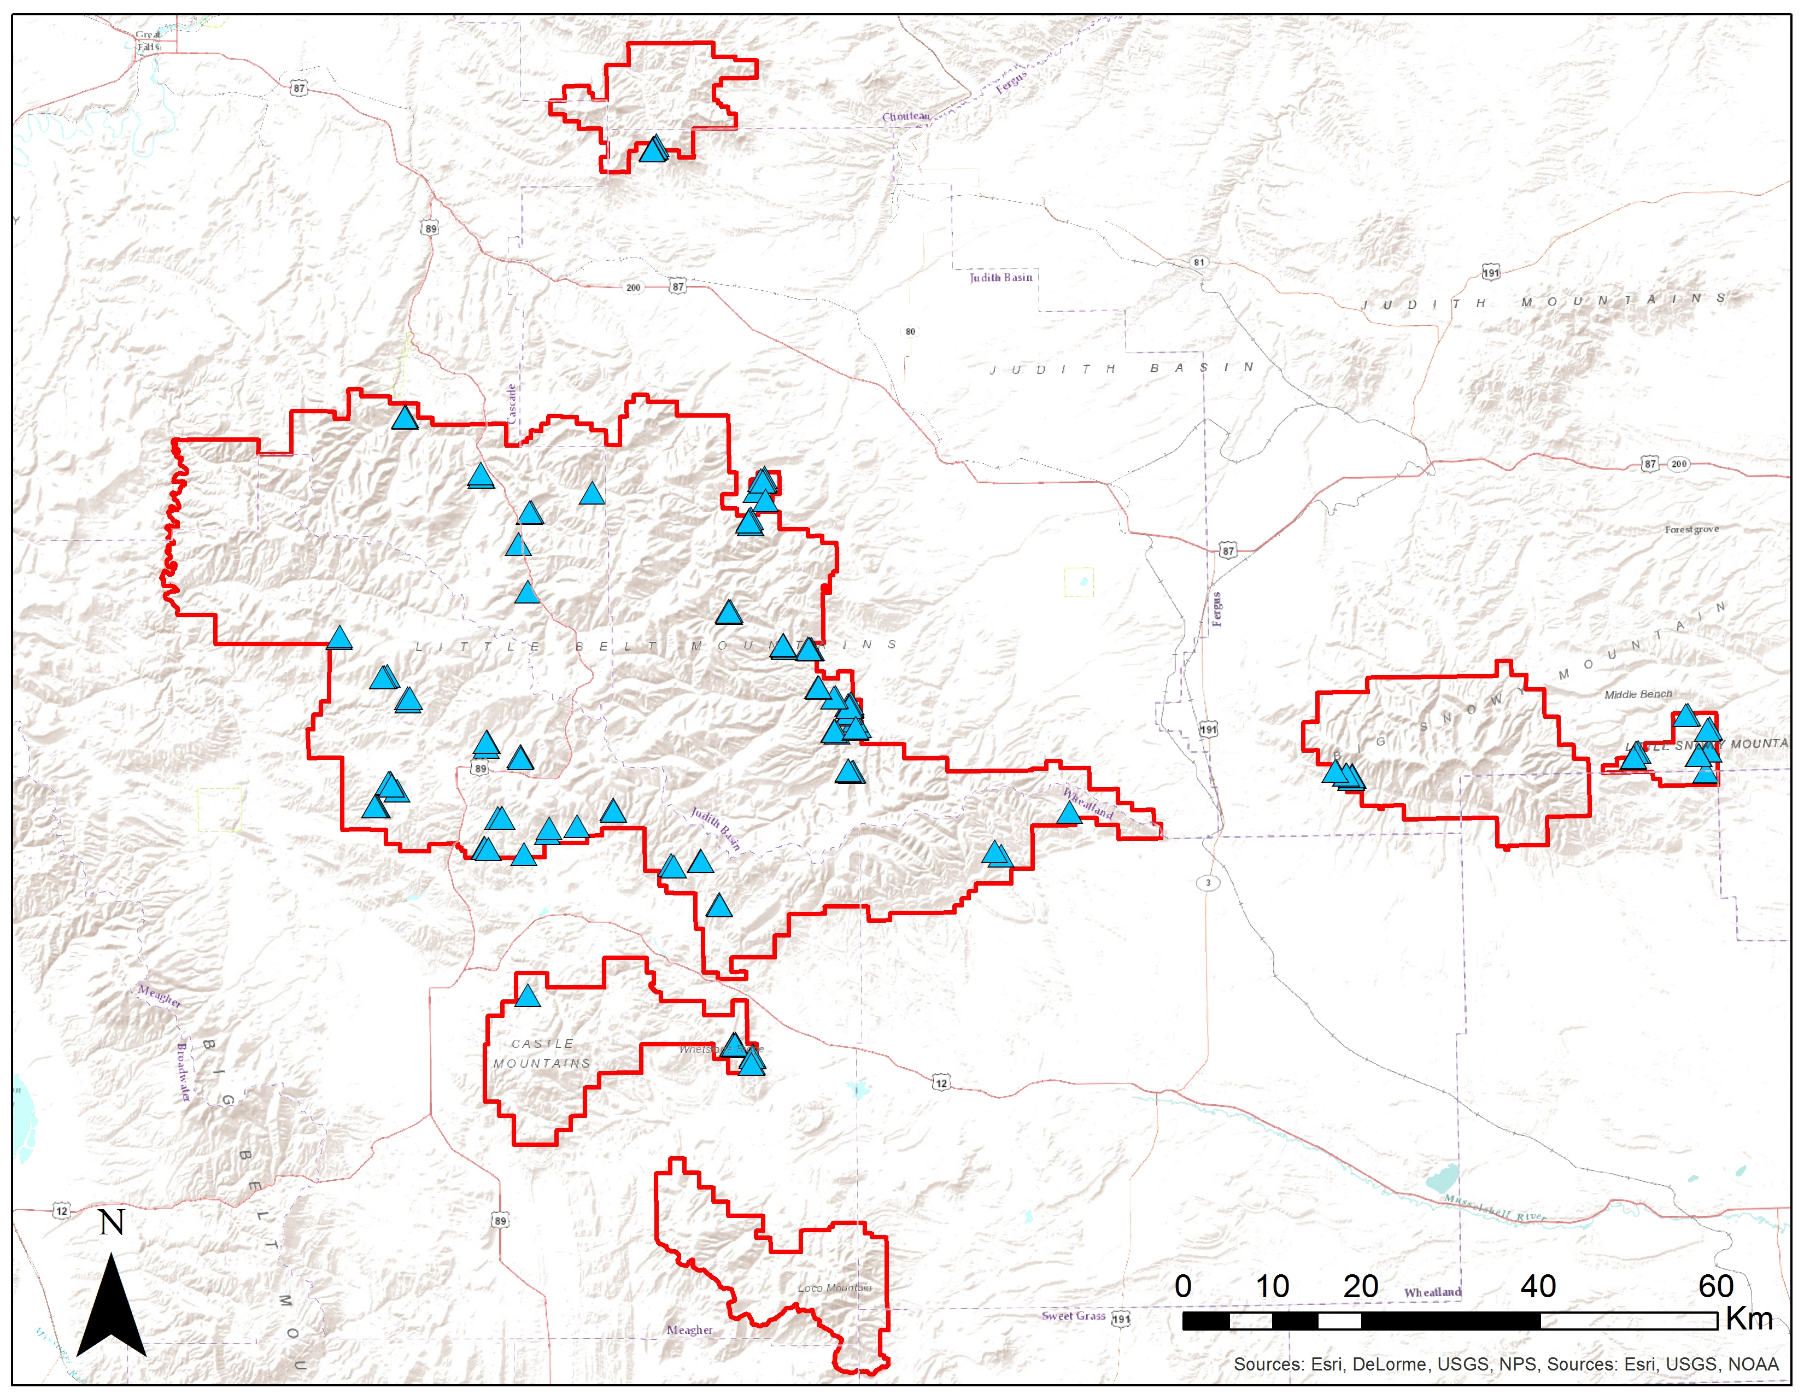
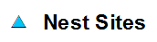
Figure 5. Northern goshawk nesting locations in the Lewis and Clark National Forest, Jefferson Division.

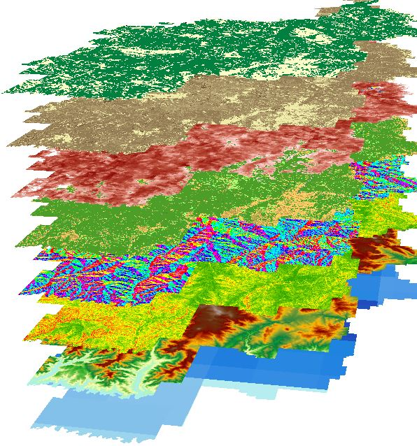
Habitat Suitability Modeling
Environmental Variables Used

Forest/Non-forest Land Cover
Tree Canopy Cover
Basal Area
Vegetation Height
Aspect
Slope
Elevation
Precipitation
Figure 6. Environmental variable layers used in the habitat suitability modeling for northern goshawk nesting habitat.

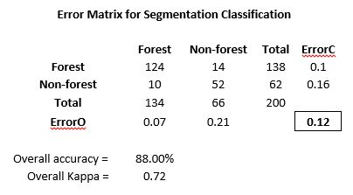
Figure 7. Error matrix created from object-based land cover classification in the LCNF.

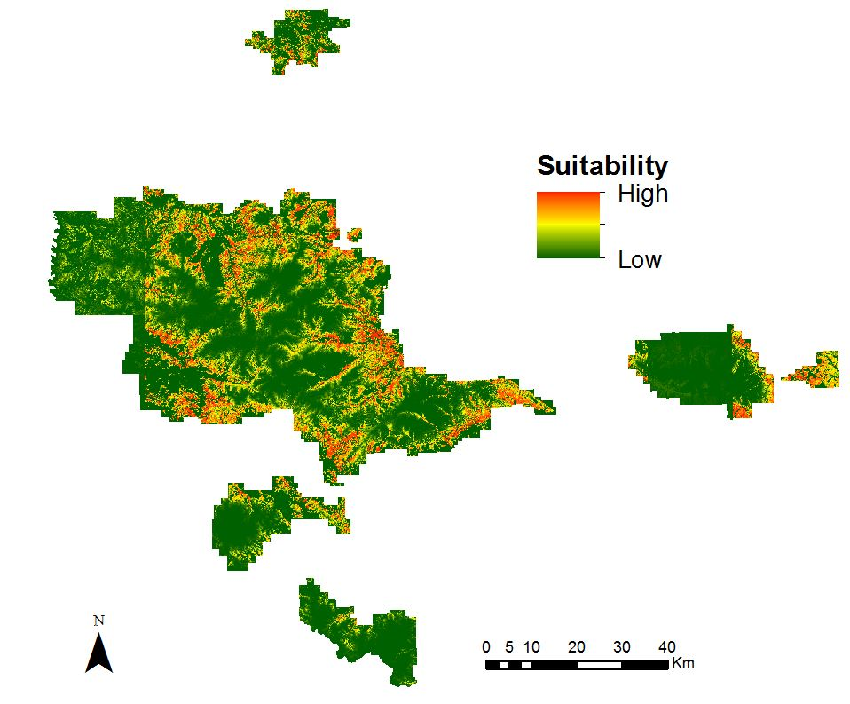
Figure 8. Output habitat suitability map produced from Mahalanobis Typicality. Areas in red are locations of high suitability for nest sites while areas in green are locations of low suitability.

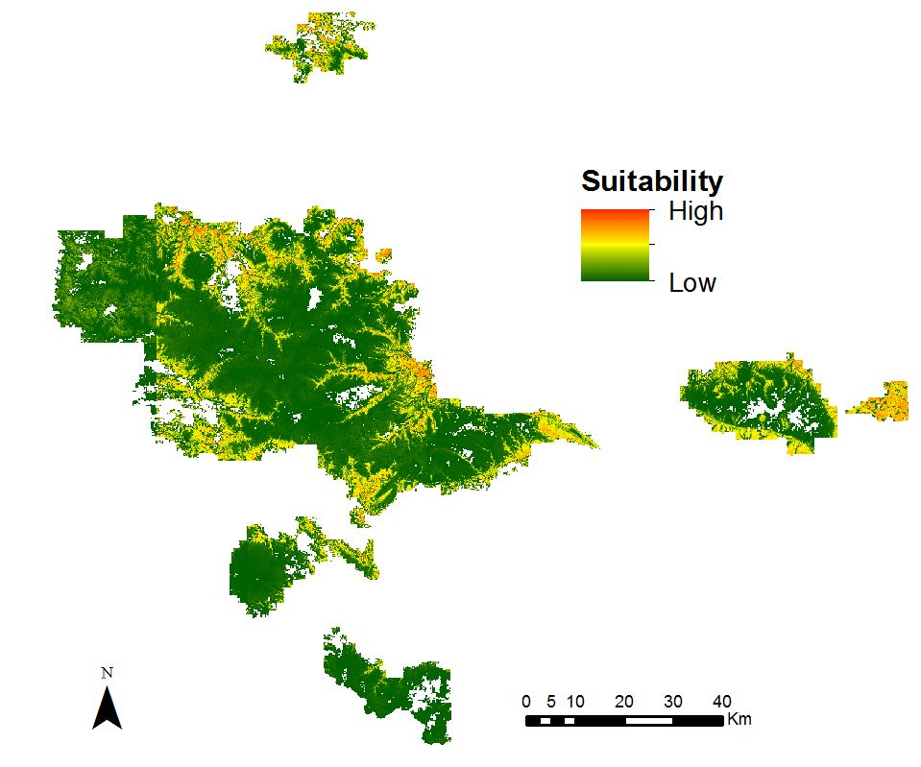
Figure 9. Output habitat suitability map produced from Maxent. Areas in red are locations of high suitability for nest sites while areas in green are locations of low suitability.

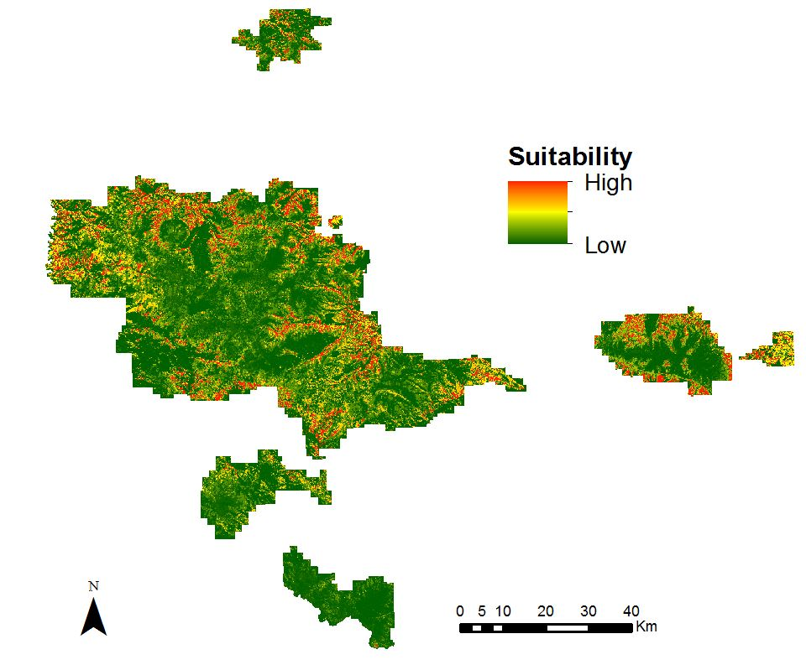
Figure 10. Output habitat suitability map produced from BioMapper. Areas in red are locations of high suitability for nest sites while areas in green are locations of low suitability.

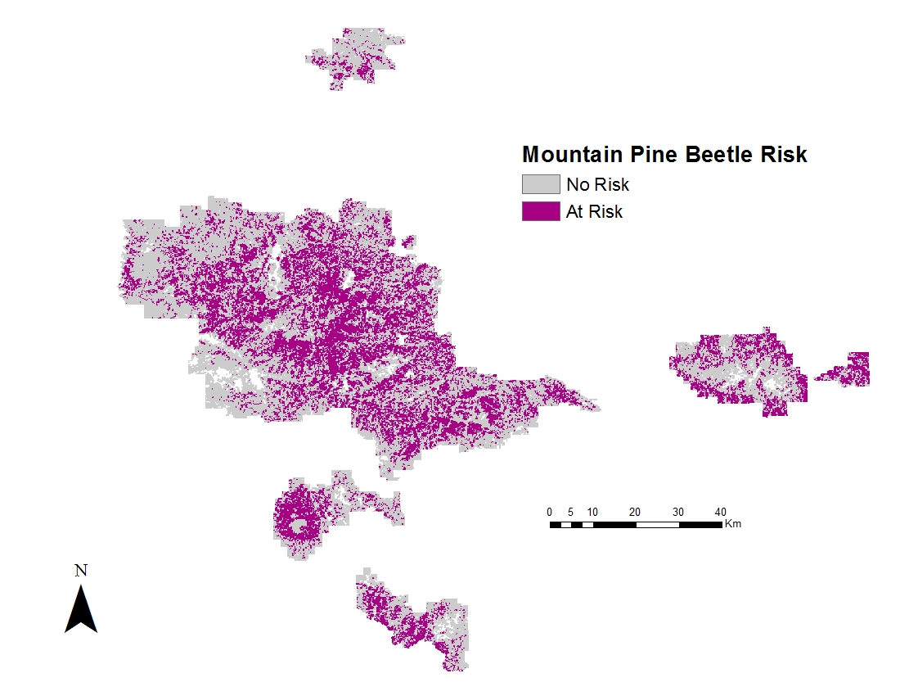
Figure 11. The above map shows the projected basal area loss by mountain pine beetle by 2027.

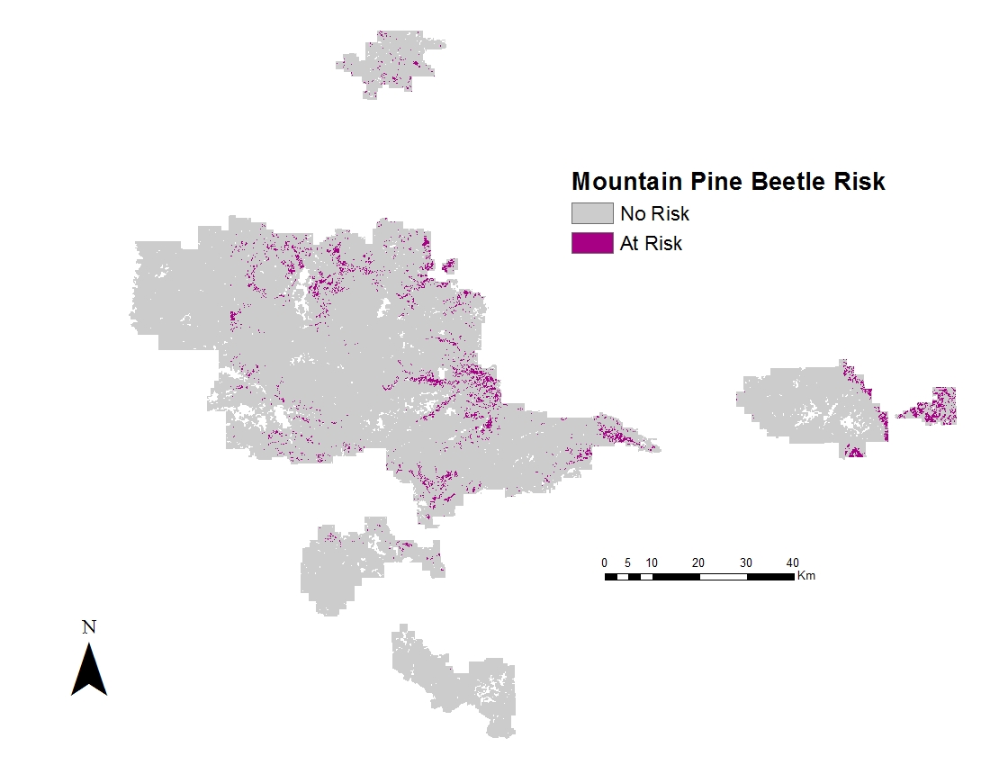
Figure 12. The above map shows modeled optimal nesting habitat at risk by the mountain pine beetle, based on the 2027 projected mountain pine beetle risk map.

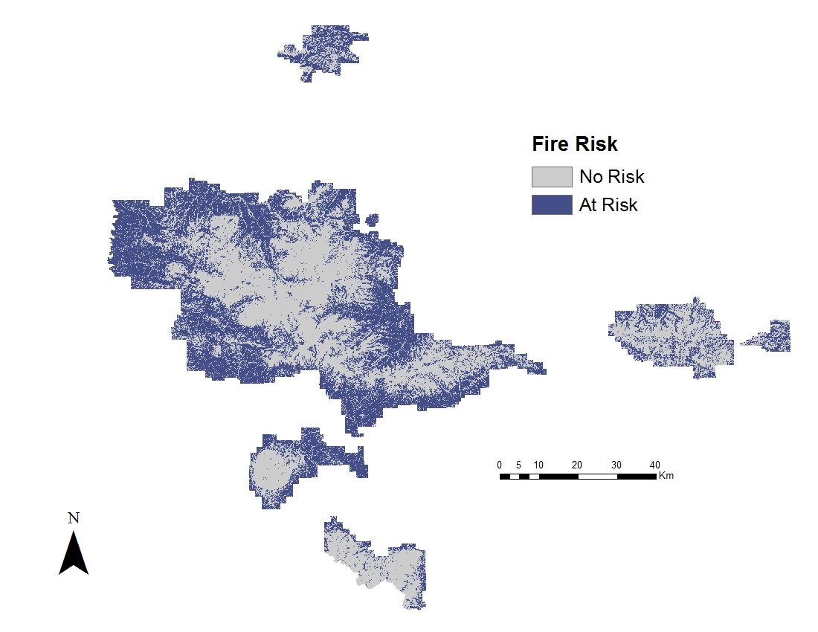
Figure 13. The above map shows the reclassified fire interval map from the USGS LANDFIRE program in which all areas having a mean fire interval between 11 to 35 years are classified as high risk areas for fires.

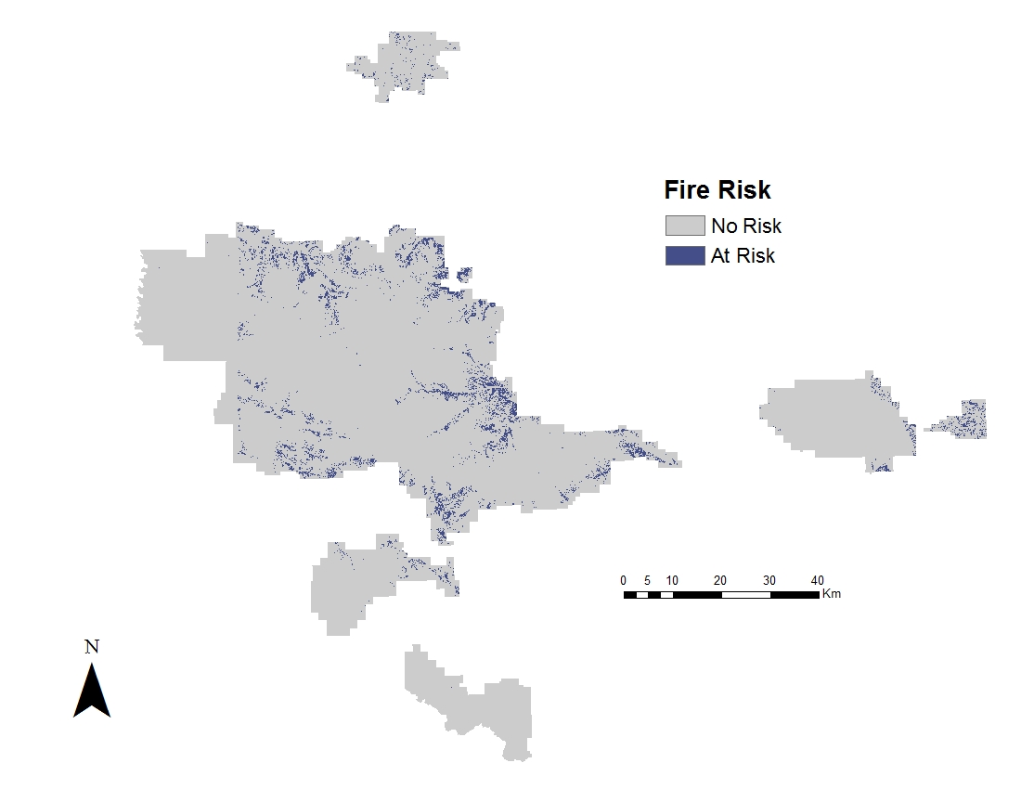
Figure 14. The above map shows modeled optimal nesting habitat at risk of fires based on the reclassified USGS LANDFIRE mean fire interval risk map.

