**NASA DEVELOP National Program**



University of Georgia

*Fall 2015*

Georgia Water Resources

Assessing Groundwater Storage Change and Contamination Risk in Southwest Georgia



**Technical Report**

Final Draft – November 19, 2015

Wenjing Xu (Project Co-Lead)

Jason Reynolds (Project Co-Lead)

Doori Oh

Mingshu Wang

Linli Zhu

Adam Milewski, University of Georgia (Science Advisor)

Matthew Cahalan, University of Georgia (Science Advisor)

Previous Contributors:

Mohamed Amin

Kimberly Berry

Tunan Hu

# I. Abstract

Groundwater from karst aquifers is the primary water source for domestic, industrial and agricultural use in southwest Georgia. However, these aquifers are highly vulnerable to pollution due to their high geological conductivity. Groundwater storage and contamination risk monitoring can improve water consumption and protection management decisions. This project used an applied methodology that incorporated remote sensing data for groundwater monitoring. Specifically, the Gravity Recovery and Climate Experiment (GRACE) was used to estimate groundwater depth change from 2002 to 2009, which was correlated with sinkhole inventory data during this time period. The DRASTIC model was combined with sinkhole susceptibility maps generated by the Summer 2015 DEVELOP Georgia Disasters team to create corresponding groundwater contamination vulnerability maps. Building upon the traditional DRASTIC model, sinkhole susceptibility was incorporated as a multiplier term to calculate a final, modified DRASTIC index (DRASTICS). This augmented DRASTIC model will provide end-users working in karst aquifer systems a tool designed to enhance decision-making processes associated with managing groundwater contamination risks.

**Keywords**

Groundwater, Georgia, Water Quality, Water Quantity, Sinkholes, Remote Sensing, Hydrology

# II. Introduction

**Background**

An aquifer is a geologic formation that can store and transmit significant quantities of water. Due to the Floridan Aquifer’s limestone composition, groundwater seeps through the bedrock and has widened natural fractures and bedding planes to create an extremely permeable layer (Hicks et al., 1987). The Floridan Aquifer (FA) lies entirely within the Dougherty Plain and is widely exposed in southwest Georgia. According to the Dougherty County Health Department, the uppermost portion of the FA supports the majority of domestic, industrial and agricultural water supplies. Therefore, monitoring and maintaining groundwater storage in the FA to meet supply requirement is a primary concern for local water resource managers. Groundwater levels are generally higher where aquifers are recharged and lower in areas where the groundwater discharges naturally to rivers or pumping stations. In the FA, however, it is hard to predict groundwater response times to changes in precipitation or drought conditions because of its location in a karst landscape.

The extensive karst region of southwest Georgia is highly fractured and experiences active sinkhole formation and local well development, resulting in an increased permeability. Both sinkhole formation and well development promote the transmission of groundwater in the aquifer (Torak et al., 1993). Dramatic groundwater level changes have occurred in this area of Georgia due to heavy pumping from wells, which have added to the concerns of local and state water resource officials. An efficient monitoring approach is necessary to capture real-time changes in Dougherty County and the surrounding area.

Water in the FA generally is hard and less mineralized than water in deeper aquifers (Hicks et al., 1981). Researchers have shown that some of their sample regions are subject to contamination related to land-use practices. Organic components were detected in groundwater when sample sites were close to agriculture lands with pesticide application. The FA is directly connected to much of the local surface drainage networks such that any contamination going into surface water will eventually flow into the FA, further expanding contaminated zones (Hicks et al., 1987).

Before NASA’s Gravity Recovery and Climate Experiment (GRACE) mission began, it was extremely difficult to measure changes in water quantity over large regions (Rezaie-Boroon and Fisher, 2012). Groundwater study was one of the last research areas to benefit from remote sensing applications (Becker, 2006). Multiple studies have demonstrated the value of GRACE data to water resources science and management (Rodell et al., 2004; Chen et al., 2005; Swenson and Wahr, 2006; Rodell et al., 2007). In particular, Rodell et al. (2007) first demonstrated the use of GRACE total water storage data with soil moisture and snow water equivalent data to quantify groundwater changes for a given region. With innovate technology, NASA Earth observations will help influence decisions made by the end users of this project.

**Study Area**

To quantify groundwater storage changes using GRACE data, it is necessary to have a study area of over 150,000 km² (Rodell et al., 2004). Our study looks at the whole Floridan Aquifer, which lies within the states of Georgia, Florida, South Carolina and Alabama. The extent of the Floridan Aquifer expands about 250,000 km², a sufficient area to properly analyze GRACE data with.

To assess the quality of groundwater, our study narrowed its focus to Dougherty County, Georgia. Dougherty County is located within the Dougherty Plain of southwest Georgia and is at the northern edge of Georgia’s portion of the FA (Figure 1). The county has a growing population that relies on groundwater resources from the FA, the Flint River and Lake Chehaw. Albany is Dougherty County’s largest metropolitan area with a population of approximately 76,000 residents. The local topography is generally flat and underlain by the Ocala Limestone, making this area an important source of groundwater quantity change and sensitive to contamination. To address the increased demand for sustainable groundwater supply in Dougherty County, an effective groundwater monitoring and evaluation tool is critical for local water resources management.

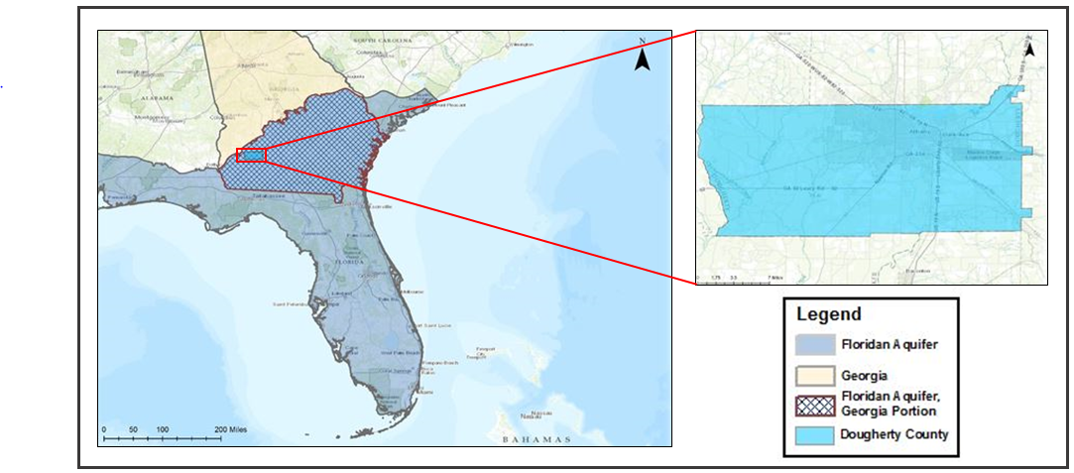

Figure 1: Study Area

**Objectives**

Evaluation of groundwater resources quantity and quality is necessary to facilitate sustainable consumption and management decisions. This project aims to develop an applied methodology that incorporates remote sensing data and ecological modeling for groundwater resources evaluation. To generate a comprehensive water resources evaluation tool, two complementary perspectives will be examined in this methodology: 1) build groundwater storage change records using GRACE. These quantitative evaluations will estimate groundwater depth changes from 2002 to 2009 in the FA portion of southwestern Georgia (Figure 1); and 2) the DRASTIC model will be applied to create corresponding groundwater contamination vulnerability maps using Dougherty County as the focal area. Building upon the traditional DRASTIC model, sinkhole susceptibility data will be added, creating a DRASTICS model. The sinkhole susceptibility data was generated by the Summer 2015 NASA DEVELOP Georgia Disasters team.

**National Application Area**

The national application addressed in this project is water resources. NASA’s Applied Sciences Water Resources Program addresses concerns and decision processes related to water availability, water forecast and water quality. The goal of this application area is to apply NASA satellite data to improve decision support tools to project partners that manage water resources in Georgia.

**Project Partners**

The project partner, Randy Weathersby is associated with the City of Albany and Dougherty County Planning and Development Services and the Southwest Georgia Water Resources Task Force. This project will provide both organizations with a tool designed to enhance decision-making processes associated with managing groundwater consumption and contamination risks. The GRACE-based groundwater storage monitoring will enable the end-users to monitor up-to-date groundwater storage change in a relatively large region. While water storage is a geographically larger-scale phenomenon, water quality is more regionally specific and local groundwater quality evaluation is more practical for water resource managers to develop adaptive policies. With the quantity change information at a broad scale, the augmented DRASTIC model will allow end-users to take a closer look at the focal area with local details.

# III. Methodology

**Objective 1: Groundwater quantity assessment using GRACE**

**GRACE data acquisition:**

To calculate the total groundwater storage in our study area region, we downloaded datasets from the GRACE mission and the North American Land Data Assimilation System (NLDAS) data platforms. The team acquired monthly averages from the years 2002 and 2009. Level-3 monthly mass land grids of GRACE data were downloaded from NASA’s Jet Propulsion Laboratory website. The soil moisture and snow water equivalent parameters were acquired from the NLDAS-2 MOSAIC land surface model. The spatial resolution of the NLDAS imagery is about 140 km with a monthly temporal resolution.

**GRACE data processing:**

The team re-projected the data files of both GRACE and NLDAS parameters from the original WGS84 datum to the North America Albers Equal-Area Conic. This was necessary to resample the cell size to 140 km for all the datasets. After resampling, all data files were clipped to the study area with a 10 km buffer area to ensure full coverage. The soil moisture and snow water equivalent NLDAS-2 parameters have a different unit of measurement (kg/m²) than the GRACE data (cm). To convert the NLDAS-2 parameters from (kg/m²) to (cm), the data was multiplied by a 0.1 factor. We then used the ArcGIS Raster Caluclator to perform the following equation taken from the Rodell et al. paper (2007):

$$∆GW=∆TWS-\left(∆SM+∆SWE\right)$$

Equation 1

Equation 1 isolates the changes in groundwater storage from the GRACE data (total water storage). The mean groundwater storage of all pixels in the study area were computed in ArcGIS and the output of each month was used for data analysis.

**GRACE data analysis:**

Computation of mean anomalies in groundwater storage were visually represented through Microsoft Excel. Groundwater storage variation maps were created in ArcGIS to show a time series of groundwater changes in the study area from 2002 - 2009.

**Objective 2: Groundwater contamination vulnerability using DRASTIC**

The goal of groundwater vulnerability assessment is to identify areas which are more susceptible to pollution than others (Piscopo, 2001). Generally, process-based methods, statistical analyses and overlay and indexing techniques are used in the assessment process. Overlay and indexing methods are most-suitable for overcoming the limitations of both statistical and process-based methodologies (Shirazi et al., 2012). Usage of overlay and indexing techniques does not require extensive datasets to capture physical, chemical and biological reactions that are required by process-based methods (Shirazi et al., 2012). The DRASTIC model, which employs overlay and indexing methodologies, is widely-recognized and used to assess groundwater vulnerability. DRASTIC was first developed by the United States Environmental Protection Agency (EPA) and later modified by researchers to account for a range of different environmental settings (Shirazi et al., 2012). This study followed the traditional DRASTIC model considering seven hydrogeological parameters: depth to groundwater (D), net recharge (R), aquifer media (A), soil media (S), topography (T), impact of vadose zone (I) and hydraulic conductivity (C). An additional term, corresponding to sinkhole susceptibility, was then incorporated into the model.

**DRASTIC data acquisition**:

Implementation of the DRASTIC model required obtaining multiple datasets (Figure 2; Table 1) from different sources. The depth to water dataset was collected and compiled from the United States Geologic Survey (USGS) National Water Information System (NWIS) showing monthly and yearly average values from wells in 2002 and 2009. A total of 29 well sites located either within or around Dougherty County boundary were selected in this manner. Next, 4 km resolution precipitation data from PRISM Climate Group and 1 km evapotranspiration (ET) data from Numerical Terradynamic Simulation Group (NTSG) were incorporated for calculation of net recharge in both 2002 and 2009. An aquifer extent shapefile for the FA from the USGS was used as reference to obtain information about aquifer media in Dougherty County. The Gridded Soil Survey Geographic (gSSURGO) database provided 10 m resolution soil maps and was used to obtain the soil media parameters within Dougherty County. Topographic data was derived from the USGS National Elevation Dataset (NED) 1 km Digital Elevation Model (DEM) product. The vadose zone and hydraulic conductivity information were derived from geologic maps of Georgia available through USGS Mineral Resources.

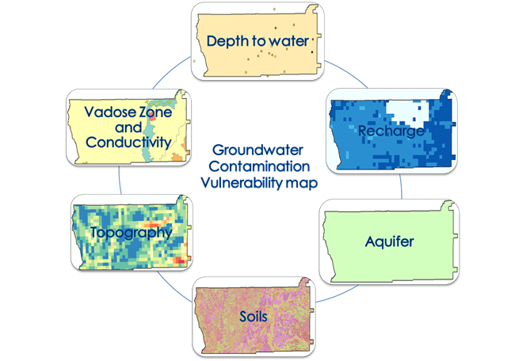

Figure 2: Conceptual Data Used in the DRASTIC model

|  |  |  |  |
| --- | --- | --- | --- |
| **Source** | **Description Parameter** | **Date** | **Role in DRASTIC** |
| USGS NWIS | Average Depth to water | 2002 and 2009 | D |
| PRISM Climate Group | Annualized accumulated Precipitation | 2002 and 2009 | R |
| MODIS  MOD16 | Annualized accumulated Evapotranspiration (ET) | 2002 and 2009 | R |
| USGS | Aquifer Media, DEM, Vadose Zone, Hydraulic conductivity | 2005 | A, T, I, C |
| USDA Natural Resources Conservation Service (NRCS) | Soil Media | 2014 | S |

Table 1: Description of datasets required in DRASTIC model

**DRASTIC data processing**:

Well log data was geocoded and interpolated using Inverse-Distance Weighted (IDW) interpolation and Kriging techniques to create a continuous surface showing predicted values of depth to water. Aquifer media, soil media and geologic map shapefiles were clipped to study area. For all raster data, a 10 km buffer around Dougherty County was created to mask raster images for full coverage of study area. To calculate net recharge, resampling was performed to transform 4 km resolution precipitation files to 1 km datasets to match the ET data resolution. Sea-Viewing Wide Field-of-View Sensor Data Anlaysis System (SeaDAS) was applied to reproject and transform ET data, making it compatible in resolution with precipitation data. SeaDAS is a comprehensive image analysis package originally developed by NASA to support the SeaWiFS mission and is now applied to many satellite-based earth science data analysis. Calculation of net recharge was done by subtracting total ET from total precipitation using the Raster Calculator tool in ArcGIS. To extract required information from soil data, gSSURGO spatial data was joined to the attribute table using the MUKEY field, allowing identification of soil series by pixel. Because the DRASTIC model requires soil media as input, all soil series in Dougherty County have were reclassified into soil media types according to USDA-NRCS official soil series descriptions.

$$Contamination Vulnerability=D_{r}D_{w}+R_{r}R_{w}+A_{r}A_{w}+S_{r}S_{w}+T_{r}T_{w}+I_{r}I_{w}+C_{r}C_{w}$$

Equation 2

The influences of seven DRASTIC parameters on groundwater pollution vulnerability were combined following Equation 2. A DRASTIC model value, including the rate (r) and weight (w), recommended by Aller et al. (1987) was assigned to each parameter for each pixel (1 km). Once the DRASTIC ratings were assigned, the pollution vulnerability for each pixel was estimated by calculating the DRASTIC Index value, from which the groundwater susceptibility map was generated for the years 2002 and 2009. Building upon the traditional DRASTIC model, sinkhole density maps was incorporated as a multiplier term to calculate a final, modified DRASTIC index (DRASTICS).

**DRASTIC data analysis**:

We compared the 2002 and 2009 DRASTICS maps and calculated the overall average of the DRASTICS values to assess the groundwater contamination risk of Dougherty County. To identify the land use of the high risk areas, we overlayed high resolution aerial imagery of Dougherty County.

# IV. Results & Discussion

**Groundwater quantity:**

Our results of groundwater storage trends in the Floridan Aquifer displayed a distinct negative trend from 2002 – 2009. Groundwater storage anomalies averaged about -13.2 cm/year during this time period (Figure 3).

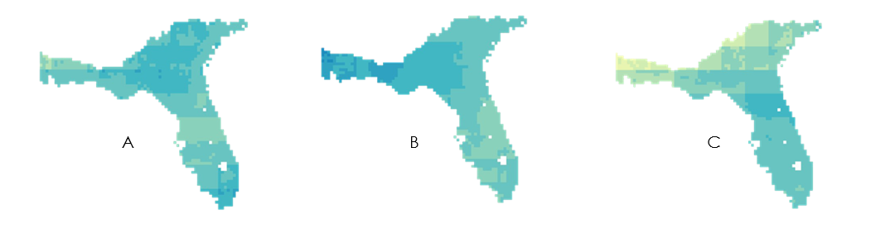



High Anomaly

Low Anomaly

Figure 3: Maps of groundwater storage variation in the Floridan Aquifer from 2002 (A), 2005 (B) and 2009 (C).

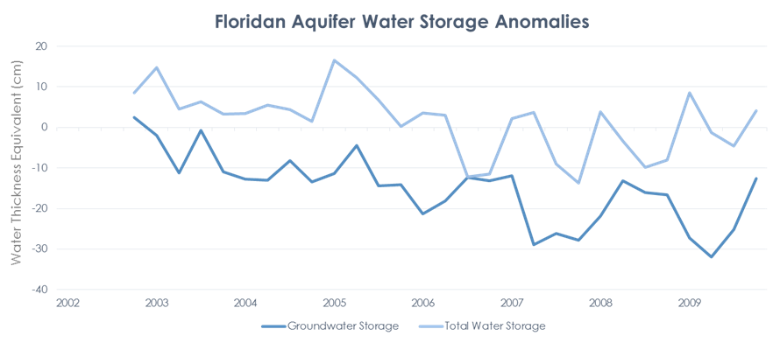

Figure 4: Water storage trends in the Floridan Aquifer from 2002 - 2009.

Total water storage anomalies in the Floridan Aquifer had a significant decrease from 2005 – 2007 averaging about -4.3 cm per three months (Figure 4).

The substantial decrease in total water storage from 2005 – 2007 and its significant effect on groundwater storage depletion is largely due to the severe drought that affected the Southeastern United States during this time period (Seager et al., 2008). The states of Florida, Alabama and Georgia, all of whom have areas residing in the Floridan Aquifer, issued strict regulations on water use and groundwater withdrawals during this time period (Manuel, 2008). The drought affected millions of people and reinforced the importance of water management in the region.

The results from our groundwater storage change analysis gave us further insight on how to conduct research of our second project objective of groundwater contamination vulnerability. A decrease in groundwater storage, as shown in our results, may increase the risk of groundwater contamination. This assumption is answered in further detail in our groundwater contamination vulnerability evaluation of Dougherty County.

Errors for Level-3 GRACE data have been found to be +/- 1.5 cm (Swenson and Wahr, 2006). This error can be attributed to various filtering and rescaling factors used in pre-processing the data. Errors and uncertainties in the GRACE data increase as the region of interest decreases. The ideal study area is about 900,000 km² with accuracies plummeting in regions lower than 150,000 km² (Rodell et al., 2007). The region used in this study was about 250,000 km², sufficiently above the 150,000 km² minimum.

The benefits of GRACE data can help areas with few resources to measure groundwater storage changes. These areas of interest include developing countries with minimal groundwater data and resources. Future studies should take advantage of the capabilities of GRACE and remote sensing applications to provide sufficient research regarding water management protocols for local and national government agencies.

**Groundwater quality:**

Using the DRASTICS model, we have produced ground water contamination maps of two years, 2002 and 2009, respectively (Figure 5). Consistent with the original DRASTIC model, our modification of DRASTICS model is an additive risk assessment model, where the higher the final score is, the more risky the area will be. We can see the final DRASTICS score varies largely, with a range from 99.8 to 257.1. Although there is not a universal cut-off value of the DRASTICS score to segment areas into different risk categories, the differences in these values effectively unveil the contamination risk of groundwater in this area. With an overall average score of 190.6 in 2002 and 206.6 in 2009, there is an increasing trend of groundwater contamination risk in the Dougherty County, Georgia. Moreover, the spatial variation of groundwater contamination risk has also increased from 2002 to 2009, as more local extreme risk value emerges in the 2009 map.

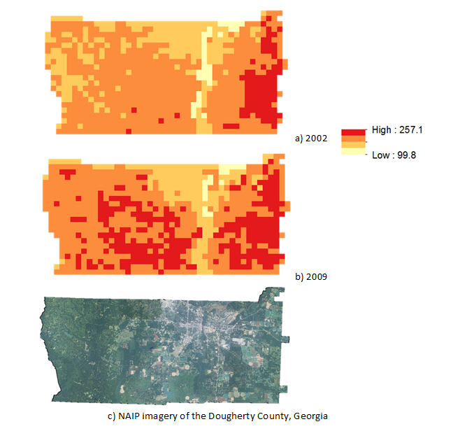

Figure 5: Groundwater contamination risk map from DRASTICS model: a) denotes the groundwater contamination risk map in 2002; b) denotes the groundwater contamination risk map in 2009; c) denotes the aerial imagery from National Agriculture Imagery Program (NAIP) of the study areas.

Importantly, while areas in the eastern Dougherty County are high risk regions for both years, a growing high risk area in western Dougherty County is observed from 2002 to 2009. Although all high groundwater contamination risk areas are dominated by agricultural land that is close to impervious surfaces, the underlying spatial process of the eastern and western part of the study area may not be the same. The spatial growth high risk area in the eastern part of the county is from city perimeter towards the urban core, allowing high water contamination to diffuse from agricultural land towards urban areas. This phenomenon may be explained by the expansion of agriculture poses potential risks to groundwater. However, the directionality of the spatial growth of risk area in the western part of the county is reversed. It expands from the urban core towards the city perimeter, which may result from the urban development of the city of Albany, GA (the center city of Dougherty County, Georgia). According to the U.S. Decennial Census, there is approximately a 1% population growth in Albany, GA from 2000 to 2010. The urbanization process, which is coupled with population growth and urban land expansion may facilitate increasing levels of high groundwater contamination risk in this area.

In the future, the results can be expanded in the following ways. First, given there is not a meaningful universal cut-off value of the DRASTICS score, research can be done by examining different sites of Karst landscape across the U.S. and compose an empirical segmentation schema to facilitate the standardization of DRASTIC-based approach. Second, groundwater contamination is a critical concern from both a geological perspective and socioeconomic aspect. A natural extension of this study would be incorporating societal and economic parameters into the next version of DRASTICS model to delineate the process in a coupled human-and-environment standpoint. Third, we only include two snap years in our groundwater contamination risk maps. Future studies can extend the temporal granularity, at a yearly interval, to capture detailed process of changes of the risk. Moreover, risk growth simulation and forecasting of potential risky areas based on cellular automata and/or agent-based modeling will inform water resource management and environmental hazard preparedness strategies for different levels of authorities.

# V. Conclusions

GRACE-based groundwater storage analysis indicated that a significant decline in groundwater storage occurred in Floridan Aquifer from 2002 to 2009. Our analysis supports the importance of water management in times of drought, as significant decreases in total water storage can deplete groundwater reserves in the Floridan Aquifer. Depletion of groundwater also encourages sinkhole development and increase risk of water quality contamination (Sinclair, 1982). Groundwater storage fluctuated significantly over 2002-2009 which can also contribute to sinkhole development in karst landscapes such as Dougherty County ([Waltham](http://www.geoscienceworld.org/search?author1=Waltham,Tony&gswsubscriber=true&src=gr), 2008). Our analysis of GRACE data also offers the end-user an alternative low-cost and long term water storage monitoring of large areas, such as the Floridan Aquifer.

The DRASTICS model developed in this project has limitations such as simplifying the groundwater contamination process. However, it still has the ability to reveal potential factors that influence the mechanism and process of contamination, in terms of depth to groundwater (D), net recharge (R), aquifer media (A), soil media (S), topography (T), impact of vadose zone (I), hydraulic conductivity (C) and sinkhole density (S). The comparison of our contamination vulnerability maps suggests a need for environmental protection for specific areas of Dougherty County. In response to the dramatic increases of groundwater contamination risk in the western part of Dougherty County, we recommend detailed monitoring of this area. For eastern Dougherty County, areas with high groundwater contamination vulnerability appeared in both 2002 and 2009. It is alarming that these high risk areas were dominated by agricultural land in close proximity to urban areas. Therefore, further research, long-term monitoring and restrictions are suggested for the use of pesticides and wastewater discharge in this particular area.

# VI. Acknowledgments

* Advisors: Dr. Adam Milewski, Water Resources and Remote Sensing Laboratory,Department of Geology, The University of Georgia; Matthew Cahalan, The University of Georgia
* Partners: Randy Weathersby, City of Albany and Dougherty County Planning and Development Services, Southwest Georgia Water Resources Task Force
* Past Contributors: Kimberly Berry, Mohamed Amin and Tunan Hu, Georgia Disasters and Water Resources Team, DEVELOP Summer 2015
* Other Contributor: Christopher Cameron, Assistant Center lead, NASA DEVELOP

Any opinions, findings and conclusions or recommendations expressed in this material are those of the author(s) and do not necessarily reflect the views of the National Aeronautics and Space Administration.

This material is based upon work supported by NASA through contract NNL11AA00B and cooperative agreement NNX14AB60A.

# VII. References

Aller, L., Bennett, T., Lehr, J. H., Petty, R.J., and Hackett G. (1987). DRASTIC: A standardized system for evaluating groundwater pollution potential using hydrogeologic settings*. NWWA/EPA Series,* EPA-600.

Becker, M. (2006). Potential for satellite remote sensing of ground water*. Ground Water,* 44.

Chen, J., Wilson, C., Tapley, B., Famiglietti, J., & Rodell, M. (2005). Seasonal global mean sea level change from satellite altimeter, GRACE, and geophysical models. *Journal of Geodesy*, 79, 32-539.

Landerer, F., & Swenson, S. (2012). Accuracy of scaled GRACE terrestrial water storage estimates*. Water Resources Research*, 48.

Manuel, J. (2008). Drought in the Southeast: Lessons for Water Management. *Environmental Health Perspectives*, 116.

NASA Earth and Science Division. (October 2015). NLDAS MOSAIC Data Search [Data files*]. Retrieved from http://giovanni.sci.gsfc.nasa.gov/giovanni/*

NASA Jet Propulsion Laboratory. (September 2015) GRACE Data Search [Data files]. Retrieved from [*ftp://podaac*](ftp://podaac)*-*[*ftp.jpl.nasa.gov/allData/tellus*](ftp://ftp.jpl.nasa.gov/allData/tellus)*/L3/land_mass/RL05 netcdf.*

Piscopo, G. 2001. Groundwater vulnerability map explanatory notes: Lachlan Catchment, New South Wales. *Department of Land and Water Conservation, Parramatta, New South Wales, Australia*.

Rezaie-Boroon, M., & Fisher J. (2011). Linking Groundwater Quality and Quantity: An Assessment of Satellite-Based Groundwater Storage Anomalies from GRACE against Ground Measurements of Contaminants in California. *AGU Fall Meeting Abstracts*, 1.

Rodell, M., Chen, J., Kato, H., Famiglietti, J.S., Nigro, J., & Wilson, C.R. (2007). Estimating ground water storage changes in the Mississippi River basin (USA) using GRACE. *Hydrogeology Journal*, 15, 159–166

Rodell, M., Famiglietti J., Chen J., Seneviratne J.S., Viterbo P., Holl S., & Wilson C.R. (2004). Basin scale estimates of evapotranspiration using GRACE and other observations. *Geophysical Research Letters*, 31.

Seager, R., Tzanova, A., & Nakamura, J. (2008). Drought in the Southeastern United States: Causes, Variability over the Last Millennium, and the Potential for Future Hydroclimate Change. *Journal of Climate*, 5021-5045.

Shirazi, S., Imran, H., Akib, S. (2012). GIS-based DRASTIC method for groundwater vulnerability assessment: a review. *Journal of Risk Research*, 15.

Sinclair, W. (1982). Sinkhole development resulting from ground-water withdrawal in the Tampa area, Florida. *US Geological Survey Water-Resources Investigations U.S. Geological Survey*, 81.

Swenson, S., & Wahr, J. (2006). Post-processing removal of correlated errors in GRACE data. Geophys. Res. Lett. *Geophysical Research Letters*, 33.

Tapley, B.D., Bettadpur, S.V., Watkins, M., and Reigber C. (2004) The gravity recovery and climate experiment: Mission overview and early results. *Geophysical Research Letters*, 31, 9.

Torak, L. (1991). Geohydrology and evaluation of water-resource potential of the Upper Floridan aquifer in the Albany area, southwestern Georgia*. US GPO*, 2391.

Waltham, T. (2008). Sinkhole hazard case histories in karst terrains. *Quarterly Journal of Engineering Geology and Hydrogelogy*, 41, 291-300.

# VIII. Content Innovation

**Data Profile:**

2015Fall_UGA_GeorgiaWaterResources_DataProfile.xml

**Interactive Plot using Infogram:**

2015Fall_UGA_GeorgiaWaterResources_InteractivePlot.csv (<https://infogr.am/acb-0507774471415>)

**Interactive Map Viewer:**

2015Fall_UGA_GeorgiaWaterResources_InteractiveMapFloridanAquifer.kmz

2015Fall_UGA_GeorgiaWaterResources_InteractiveMapDougherty.kmz

<http://bit.ly/1MT8GgG>