**NASA DEVELOP National Program**



NASA Jet Propulsion Laboratory

*Spring 2016*

Bolsa Chica Ecological Forecasting

Analyzing the Success of the Bolsa Chica Wetland Restoration Using Multi-spectral NASA Earth Observations

 **Technical Report**

Rough Draft – Feb 18, 2016

Christine Elowitt (Project Lead)

Steven Kerns

Nick Rousseau

Cedric Fichot, NASA Jet Propulsion Laboratory (Science Advisor)

Benjamin Holt, NASA Jet Propulsion Laboratory (DEVELOP Mentor)

# I. Abstract

[Placeholder - do not put anything here until the final draft submission. The abstract in the project summary is where the working draft of the abstract should “live”]

**Keywords**

Wetlands, Restoration, Remote Sensing, Bolsa Chica, Landsat, AVIRIS

# II. Introduction

During the last two centuries, the contiguous United States has lost over half of its wetland habitats; averaging a rate of 60 acres lost per hour (Dahl 1990). California leads the nation in this historic loss of wetlands, sustaining as much as 91% of environmental degradation and human–induced changes to wetland habitats (Zedler 1996). The San Francisco Bay and the southern regions of the state are home to the most significant losses in wetland habitats (Larson 2001, Goodwin et al. 2001). In an effort to mitigate wetland loss in the Bolsa Chica Ecological Reserve, several conservation and restoration projects have been created. The wetlands of Bolsa Chica are an endangered ecoregion in Southern California that have been steadily increasing in size and provide a large number of ecosystem services (Noss 1995). Efforts in management and maintenance practices of the wetlands have achieved vast improvements since the efforts began in 1976, however, no attempt has been made to develop a qualitative assessment of the extent of restoration efforts or whether the restoration has been truly successful.

The objective of this project is to enhance the information available to the Amigos de Bolsa Chica advocacy group, founded in 1976, by incorporating NASA Earth observations. This information, delivered in the form of time series maps for water extent and vegetation cover, a more detailed vegetation classification map, and an interactive web map, allows the Amigos to assess the success of the restoration efforts. Our results will also provide the Amigos a means to help educate and engage the public while establishing a current baseline to compare future changes within the ecological reserve.

The study area consists of the 2.67 square mile Bolsa Chica Ecological Reserve in Huntington Beach, California (Figure 1). The site lies at approximately 33.7°N, 118.04°W along the Pacific Coast in the northern part of Orange County in Southern California. The study period is between 1984 and 2015.

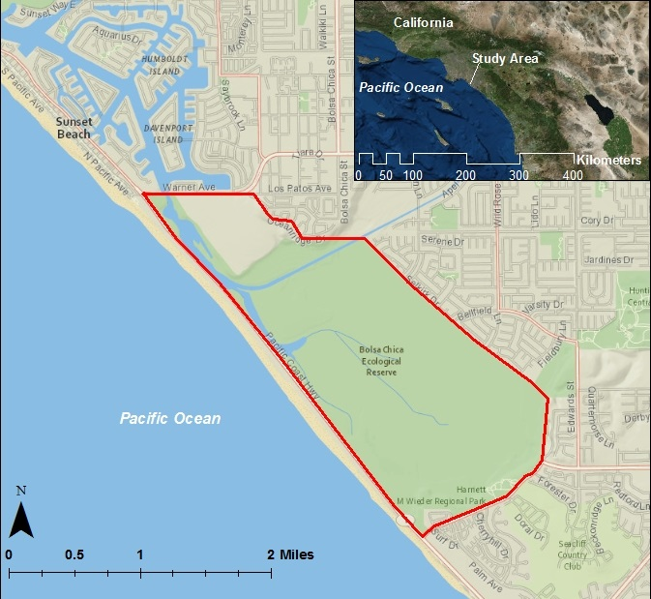

Figure 1. Bolsa Chica Ecological Reserve, CA.

The Bolsa Chica Wetlands are home to several endemic species and provide critical habitat for migratory and endangered avifauna. Migratory bird populations traveling along the Pacific Flyway were once estimated at 60 million but now oscillate between 2-4 million waterfowl and 1-2 million shorebirds (Bryant 2003, Larson 2001). Given the dramatic drop in avifauna population, wetlands such as Bolsa Chica serve an increasingly important role in sustaining migratory bird populations along the Pacific Flyway.

The Bolsa Chica wetlands are also home to many threatened plant species including *Zostera*, commonly known as eel-grass. Eel-grass is a key metric for the California Rapid Assessment Method for Wetlands (CRAM), which is employed to quantify wetlands health and restoration. Eel-grass serves as an important primary producer in coastal marine ecosystems and is an essential habitat for breeding fish (Lee et al. 2001, Mann 1982). The presence of eel-grass allows a more stable and diverse ecosystem to develop (Heck 1995, Lee et al. 2001). As well as being a biodiversity hotspot, wetlands also sequester significant amounts of carbon dioxide (CO2) by creating new plant biomass. Wetlands are responsible for globally sequestering close to 830 Tg/year of carbon and despite their methane production, they function as important net carbon sinks. (Mitsch et al. 2012). Further ecosystem services include: high net productivity, ground-water recharge, nutrient cycling, and overall human well-being (Butchart et al. 2005). Given their endangered status and immense ecological value, support for wetland restoration efforts is currently a major environmental concern within the United States.

This project was centered on NASA’s Applied Science’s Ecological Forecasting National Application Area and used NASA remote sensing technologies to determine the restoration success of the Bolsa Chica Ecological Reserve, as well as provided satellite-based educational and public outreach materials for the project partner. This project was created via a joint proposal between former DEVELOP Center Lead Gwen Miller, and partner organization Amigos de Bolsa Chica, led by President Jerry Donohue and Joana Tavares Reager. The results of the project are of interest to the Amigos as it allows them to better inform the public on the wetland’s restoration success, as well as expand their citizen scientist education program. The Amigos will decide how to best implement the end products into their education programs and public outreach campaigns. Findings will be shared with the CA Department of Fish and Wildlife; the management organization responsible for the Bolsa Chica Ecological Reserve. The Amigos will directly benefit from being provided with NASA remote sensing data, enabling them to better understand, share, and protect the Bolsa Chica Ecological Reserve.

# III. Methodology

**Data Acquisition:**

Using the USGS Earth Explorer portal, we downloaded level 1 imagery for Landsat 5 TM, Landsat 7 ETM+, and Landsat 8 OLI. Landsat 5 was used to establish baseline data and what the site contained prior to any restoration work. Then Landsat 7 pre-scan line corrector error and the most recent Landsat 8 imagery were acquired to show the changes before and after the Bolsa Chica restoration efforts, with emphasis on a change detection analysis when the wetlands were reintroduced to tidal influences in 2006. Images from dry months, mainly August and September, were used in order to minimize the effects of rainfall on water extent maps.

Another source of imagery for this project was AVIRIS, the hyper-spectral instrument on board NASA’s ER-2 aircraft. Images including the Bolsa Chica wetlands are available from several passes the ER-2 made over Southern California in 2014 and 2015. These datasets were accessed and downloaded from the AVAIRIS Flight Locator Tool on the Jet Propulsion Laboratory website.

To supplement the Landsat and AVIRIS imagery, the United States Department of Agriculture Farm Service Agency’s National Agriculture Imagery Program (NAIP) was utilized. The resolution of this imagery is 1-meter, allowing the study site to be seen in closer detail. This imagery was acquired from 2005 and 2014.

**Data Processing:**

All Landsat images required compositing the Red, Green, Blue, and near-infrared bands, which was done utilizing ArcMap 10.3. Also, within this same software, all imagery from Landsat 7 and 8 was sharpened using the higher resolution panchromatic band. It was then possible to calculate the Normalized Difference Vegetation Index (NDVI), using the Image Analysis tools.

All AVIRIS images were preprocessed for radiance and reflectance using ENVI 5.1 software. Also in ENVI, we classified the images to show various vegetation types, as well as the extent of water features. [Further processing with AVIRIS remains to be determined.]

The NAIP imagery does not require any processing. The format it was downloaded in was a three-band—red, green, blue—GeoTIFF file.

**Data Analysis:**

Each set of before-and-after Landsat images were compared using Raster Calculator in ArcMap. This created a new image showing the change in NDVI for each pixel over time to show where vegetation has increased due to the restoration efforts and where it has been supplanted by water.

In order to create before and after land cover maps, a land-use layer for each year being compared in ArcMap was generated. Utilizing the 1984 Landsat and 2002/ 2014 NAIP imagery for reference, polygons representing vegetation, water, bare ground, and man-made features were drawn around the four different types of areas in each year. A finished map was created for each year, to be utilized by our project partner in their educational materials. In addition, each year’s land use layers and aerial imagery was combined into an interactive web map using open-source software called Leaflet. This web map will be featured on the project partner’s website.

The pre-processed AVIRIS images were classified using ENVI. Due to the quantity of bands in AVIRIS images, it can detect different types of vegetation better than most other sensors. A detailed land cover map for 2015 was created in ArcMap using the classification results. This detailed map’s purpose is to allow the project partner to assess vegetation in inaccessible areas, and to establish a baseline against which future changes can be compared.

# IV. Results & Discussion

Not available yet. Will be included in the final draft.

Insert images, graphs, maps, charts, etc. here. Choose the most important results to highlight here. No word cap, but two to six pages is a good range.

Things to discuss:

* Analysis of Results: What can you tell from your graphs, images, etc? What does this mean for your project?
* Errors & Uncertainty: What factors could you not account for, what things didn’t work out like you expected they would, etc.
* Future Work: If this project was to be selected for another term, what would be the focus? What other areas would be of interest?

# V. Conclusions

Not available yet. Will be included in the final draft.

Final conclusions. Word count: 200-600 (~a page).

# VI. Acknowledgments

* Joana Tavares-Reager, Jerry Donohue, and Vic Leipzig of Amigos de Bolsa Chica
* Bruce Chapman of NASA Jet Propulsion Laboratory

Any opinions, findings, and conclusions or recommendations expressed in this material are those of the author(s) and do not necessarily reflect the views of the National Aeronautics and Space Administration.

This material is based upon work supported by NASA through contract NNL11AA00B and cooperative agreement NNX14AB60A.

# VII. References

Bryant, Peter J. *Biodiversity and Conservation*. School of Biological Sciences University California Irvine, 2003. Print.

Butchart, S. "Ecosystems and Human Well-being Wetlands and Water Synthesis." *Millennium Ecosystem Assessment*. World Resources Institute, 2005. Web. 16 Feb. 2016.

Dahl, T.E. Wetlands Losses in the United Sates 1780’s To 1980’s. U.S. Department of the Interior, Fish and Wildlife Service, (1990) 13pp.

Goodwin, Peter. Mehta, Ashish J. Zedler, Joy B. "Tidal Wetland Restoration." *Journal of Coastal Research* Special Issue No. 31. TIDAL DYNAMICS. Volume II: Extreme Tidal Peaks & Coastal Flooding.27 (2001): 1-6. *JSTOR*. Web. 11 Feb. 2016.

Heck, K. L., Jr., K. W. Able, C. T. Roman, and M. P. Fahay. "Composition, Abundance, Biomass, and Production of Macrofauna in a New England Estuary: Comparisons Among Eelgrass Meadows and Other Nursery Habitats." *Estuaries* 18.2 (1995): 379-1995. Web. 11 Feb. 2016.

Larson, Eric J. "California's Living Marine Resources: A Status Report." *California Department of Fish and Game* (2001): 483-86. Web. 16 Feb. 2016.

Lee, S.Y, C.W Fong, and R.S.S Wu. "The Effects of Seagrass (Zostera Japonica) Canopy Structure on Associated Fauna: A Study Using Artificial Seagrass Units and Sampling of Natural Beds." *Journal of Experimental Marine Biology and Ecology* 259.1 (2001): 23-50. *Science Direct*. Web. 11 Feb. 2016.

Mann, K. H. *Ecology of Coastal Waters: A Systems Approach*. Berkeley: U of California, 1982. Print.

Mitsch, William J., Blanca Bernal, Amanda M. Nahlik, Ülo Mander, Li Zhang, Christopher J. Anderson, Sven E. Jørgensen, and Hans Brix. "Wetlands, Carbon, and Climate Change." *Landscape Ecology* 28.4 (2012): 583-97. Web. 11 Feb. 2016.

Noss, Reed F., Edward T. LaRoe, III, and Michael J. Scott. "Endangered Ecosystems of the United States: A Preliminary Assessment of Loss and Degradation." *Department of Fish and Wildlife* (1995): 1-95. Web. 16 Feb. 2016.

Zedler, Joy B. “Ecological Issues in Wetland Mitigation: An Introduction to the Forum”. *Ecological Applications* 6.1 (1996): 33–37. Web. 11 Feb. 2016.

# VIII. Content Innovation

**Some options include:**

Glossary Viewer

Featured Multimedia for this Article (VPS Video)

Interactive Map Viewer