**NASA DEVELOP National Program**

**2019 Spring Project Proposal**

**California – Ames**

**Chile Water Resources**

*Monitoring the Extent and Distribution of Saline Systems in Chile’s Atacama Desert by Utilizing Landsat and Sentinel Imagery*

**Project Overview**

***Project Synopsis*:** Northern Chile contains the country’s most important saline systems (i.e., salt flats, ponds, and marshes) that are vital to the region’s environment and water resources. Currently, mineral extraction and the changing climate threaten the existence of these ecosystems, and their remote location makes it difficult for land managers to actively monitor their conditions. The DEVELOP Chile Water Resources team will partner with the Servicio Nacional de Geología y Minería (SERNAGEOMIN) and the Centro de Información de Recursos Naturales (CIREN) of Chile to monitor the extent and distribution of saline systems in the Atacama Desert and the nearby Andes mountain range over time by utilizing Landsat and Sentinel imagery. The project end products will provide partners with a 30-year baseline of the conditions of these saline systems that will aid in the future sustainable management of these important resources.

***Community Concern:*** Located in and around the Atacama Desert — the driest nonpolar place on the planet — Chile’s saline systems are considered an oasis due to their biotic richness and limited water accumulation. However, over the past decades, the extent of northern Chile’s unique saline systems has diminished. In addition to climate-related factors, this shrinkage is a result of mining for lithium, potassium, and boron. Currently, the Chilean government does not have data documenting the decrease in the extent of these systems. This project will provide historical extents of the Atacama Desert salt flats, salt ponds, Andean salt marshes, and associated watersheds to better inform the partners’ management decisions regarding the conservation of these important ecosystems.

***Source of Project Idea:*** This project originated from conversations between the Ames Science Advisor, Dr. Juan Torres-Pérez, and personnel from SERNAGEOMIN and CIREN at several conferences in Chile and Argentina.

***National Application Area Addressed:*** Water Resources

***Study Location:*** Atacama Desert, Chile

***Study Period:*** September1985 – September 2018

***Advisor:*** Dr. Juan Torres-Pérez (Bay Area Environmental Research Institute, NASA Ames Research Center)

**Partner Overview**

***Partner Organizations:***

|  |  |  |  |
| --- | --- | --- | --- |
| **Organization** | **POC (Name, Position/Title)** | **Partner Type** | **Boundary Org?** |
| **Servicio Nacional de Geología y Minería (SERNAGEOMIN) (Chile)** | Paula Olea Encina, Geographer | End User | No |
| **Centro de Información de Recursos Naturales (CIREN) (Chile)** | Sergio Maldonado, Geomatics Manager | End User | No |
| **Universidad de La Serena, Chile** | Dr. Ricardo Cabezas, Professor | Collaborator | No |

***End-User Overview***

***End Users’ Current Decision-Making Processes:***SERNAGEOMIN and CIREN are the two main agencies in charge of monitoring and managing Chile’s geologic and mining services, including the saline systems of the Atacama Desert. However, limited manpower and the remoteness of the study area greatly limit the information that these two agencies can collect on the current and historical conditions of these saline systems.

***End User’s Capacity to Use NASA Earth Observations:***

*Servicio Nacional de Geología y Minería (SERNAGEOMIN) (Chile)* – SERNAGEOMIN personnel are trained in GIS and remote sensing. While they are familiar with NASA Earth observations, their capacity to acquire, process, and analyze historical datasets and imagery is extremely limited. The project will provide a set of analyses that monitor the extent and distribution of the saline ecosystems over time and potentially estimate their future changes to assist the end user with their current and future resource management decisions.

*Centro de Información de Recursos Naturales (CIREN) (Chile)* – CIREN personnel are trained in GIS and remote sensing and have worked closely with the DEVELOP Ames node on previous projects, but their capacity to acquire, process, and analyze satellite imagery in this application is limited. The project will provide a set of analyses that monitor the extent and distribution of the saline ecosystems over time and potentially estimate their future changes to assist the end user with their current and future resource management decisions.

***Collaborator & Boundary Organization Overview***

***Collaborator Support:***

*Universidad de La Serena* – Dr. Ricardo Cabezas is a remote sensing expert who studies the saline systems in Chile’s Atacama Desert. He will share his scientific expertise with the team and provide them with resources that they can use in the project, such as literature review materials and ancillary datasets.

***Project Communication & Transition Overview***

***In-Term Communication Plan*:** During the term, the team will have bi-weekly teleconferences with the partners to provide updates on project methodologies and analysis. Additionally, an in-term remote sensing and GIS webinar may be arranged to further enhance the end users’ capacity in geospatial applications. The Ames Science Advisor, Dr. Juan Torres-Pérez, is fluent in Spanish and will aid with translations during partner communications.

***Transition Plan*:** A formal end-user handoff will take place at the end of the research term in the form of a WebEx teleconference. Results will be sent via NASA Large File Transfer (LFT). This project may require a software release along with adopting code from the Hydrological Anomaly Index tool generated by the spring 2017 Chile Water Resources team. Dr. Juan Torres-Pérez is fluent in Spanish and will aid with translations of the technical paper, presentation, and any tutorials resulting from this project.

**Earth Observations Overview**

***Earth Observations:***

|  |  |  |
| --- | --- | --- |
| **Platform & Sensor** | **Parameters** | **Use** |
| **Landsat 5 TM** | Normalized Difference Vegetation Index (NDVI), Normalized Difference Water Index (NDWI), land surface temperature (LST) | NDVI will be used to assess seasonal and annual vegetation changes to monitor the extent of saline marshes from 1985 to 2013. NDWI will be calculated to classify saline ponds and surrounding watersheds to understand the impact that the changing climate and mining have had on the area’s water resources over time. Additionally, LST will be calculated to determine the impact of temperature variations on the extent of the salt flats and nearby Andean salt marshes from 1985 to 2013. |
| **Landsat 8 TIRS** | LST | LST will be calculated to determine the impact of temperature variations on the extent of the saline systems in the Atacama Desert from 2013 to 2018. |
| **Landsat 8 OLI** | NDVI, NDWI | NDVI will be used to assess seasonal and annual vegetation changes to monitor the extent of saline marshes since 2013. Additionally, NDWI will be calculated to classify saline ponds and surrounding watersheds to understand the impact that the changing climate and mining have had on the area’s water resources from 2013 to 2018. |
| **Sentinel-2 MSI** | NDVI, NDWI | NDVI will be used to assess seasonal and annual vegetation changes to monitor the extent of saline marshes since 2015. Additionally, NDWI will be calculated to classify saline ponds and surrounding watersheds to understand the impact that the changing climate and mining impacts have had on the area’s water resources from 2015 to 2018. |

***Ancillary Datasets:***

Drought and Dryland Atlas of Latin America and the Caribbean, Chile Climate Data Library – Collection of maps used to delineate dryland distribution in the study area

LAC Dryland Areas, Chile Climate Data Library – Atlas used to identify arid, semi-arid and sub-humid zones in the study area

***Software & Scripting:***

Esri ArcGIS Pro 2.0.0 – Raster manipulation, map product generation, and image classification development

Google Earth Engine API – Construct a web-based tool for calculating trends in NDVI classifications to monitor the extent of salt marshes

**Decision Support Tool & End Product Overview**

***End Products:***

|  |  |  |  |
| --- | --- | --- | --- |
| **End Products** | **Partner Use** | **Datasets & Analyses** | **Software Release Category** |
| **Salt Marsh Vegetation Index** | The product will assist the partners in detecting changes in vegetation greenness to better monitor the extent of salt marshes over time on a seasonal and yearly basis. | Using the Landsat historical catalog and Sentinel imagery, NDVI will be integrated with a supervised classification layer to provide a decadal analysis of vegetation greenness from 1985 to 2018. | I |
| **Saline Systems Extent Analysis** | The product will assist the partners in monitoring the changes in the extent of the saline systems over time, identifying vulnerable areas based on a 30-year record, and understanding the impact of the changing climate and mining on the area’s water resources. | NDWI and LST will be calculated from Landsat and Sentinel imagery to further estimate the temporal changes in the extent of the saline systems throughout the Atacama Desert and associated Andean watersheds. | I |
| **Saline Analysis Tool (SalT)** | A Google Earth Engine product will be generated to help partners at SERNAGEOMIN and CIREN access, process, and visualize changes in salt marsh vegetation greenness, albedo, and the extent of salt flats and ponds. For management purposes, this tool can help monitor the “health” of salt marshes and detect changes in the coloration of salt flats and ponds due to mining. | The tool will utilize Landsat imagery to classify the topography of the saline systems. Furthermore, any changes in albedo detected by the tool can be related to the presence/absence of brine organisms, an indicator of how well ecosystems are functioning. | III |

***End-User Benefit*:** The project will provide SERNAGEOMIN and CIREN with a set of analyses that determine both current and historical extents of remote saline systems in the Atacama Desert and the nearby Andes mountain range. These ecosystems are vital to the region’s environment and water resources; however, they are currently impacted by mining, increased temperatures, and drought. The SalT tool developed during the project term will further provide partner organizations with the ability to continually monitor the saline systems, thus enabling them to make informed decisions regarding resource management well into the future.

**Project Timeline & Previous Related Work**

***Project Timeline:*** 1 Term: Spring 2019

***Related DEVELOP Work:***

2017 Spring (ARC) – Chile Water Resources: Integrating NASA Earth Observations into the Google Earth Engine Platform to Enhance Drought Monitoring in Chile

2017 Summer (ARC) – Chile Water Resources II: Remote Monitoring of Glacier Dynamics and Hydrologic Indicators in Chile’s Aconcagua River Valley

2014 Spring (LaRC) – Chile Water Resources: Modeling of Snow Melt from Andean Snowpack for More Effective Water Allocation and Planning in the Atacama Region of Chile

**Notes & References:**

***Notes*:** A Google Earth image with the proposed study areas (provided by SERNAGEOMIN personnel) is provided below.

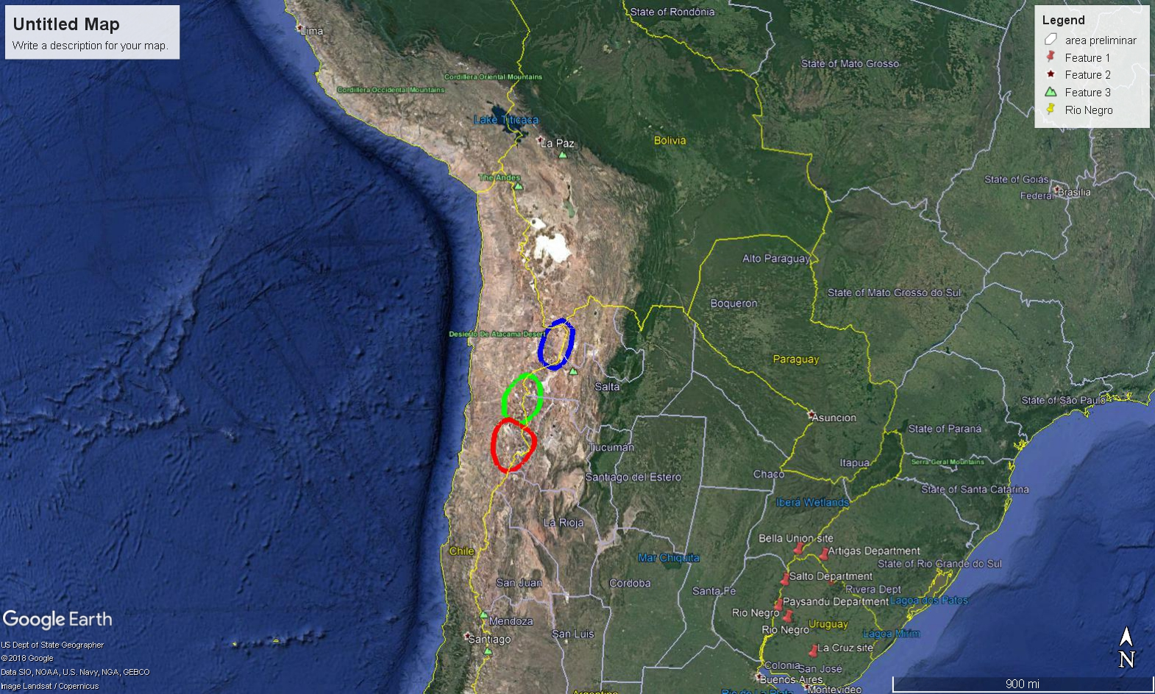

***References:***

Ericksen, G.E., Chong, G., & Vila, T. (1976). Lithium resources of salars in the Central Andes. In J. D. Vine (Ed.), *Lithium resources and requirements by the year 2000* (Geological Survey Professional Paper 1005, pp. 66-74). Retrieved from https://pubs.usgs.gov/pp/1005/report.pdf#page=73

Ide, F., & Kunasz, I. A. (1990). Origin of lithium in Salar de Atacama, Northern Chile. In G. E. Ericksen, M. T. Cañas Pinochet, & J. A. Reinemund (Eds.), *Circum-Pacific Council for Energy and Mineral Resources Earth Science Series.* (Vol. 11). Retrieved from http://archives.datapages.com/data/circ_pac/0012/0165_f.htm

Mora Morgado, M. E. (2003). *Análisis de la estructura mundial de la industria del litio y criterios de priorización de proyectos de investigación científica y tecnológica* (Final report for the title of Industrial Engineer). Retrieved from SSRN at https://papers.ssrn.com/sol3/papers.cfm?abstract_id=2916581

Sevares, J., & Krzemien, J. P. (2012). El litio en la Argentina: oportunidades y desafíos de un recurso estratégico. *Realidad Económica, 272,* 127-157. Retrieved from http://www.sidalc.net/cgibin/wxis.exe/?IsisScript=bibunfa.xis&method=post&formato=2&cantidad=1&expresion=mfn=021818

Zicari, J., & Fornillo, B. (2017). The power of lithium in South America. *Entreciencias: diálogos en la Sociedad del Conocimiento, 5*(12). doi:/10.21933/J.EDSC.2017.12.197