**NASA DEVELOP National Program**



NASA Goddard Space Flight Center

*Spring 2016*

Great Lakes Ecological Forecasting

Utilizing NASA Earth Observations to Monitor and Forecast the Spread of *Phragmites australis* in the Great Lakes Basin

 **Technical Report**

Rough Draft – Feb 18, 2016

C. Issac Kinton (Project Lead)

Peter Jacobs

Sean McCartney

Laura Bourgeau-Chavez, Michigan Tech Research Institute (Science Advisor)

Kurt Kowalski, USGS Great Lakes Science Center (Science Advisor)

# I. Abstract

[Placeholder - do not put anything here until the final draft submission. The abstract in the project summary is where the working draft of the abstract should “live”]

**Keywords**

Remote Sensing, Invasive Species, Phragmites australis, Great Lakes, St. Lawrence River, Ecological Forecasting, Maxent

# II. Introduction

**Background Information**:

*Phragmites australis* subsp. *australis*, also known as the common reed, is an invasive freshwater or brackish-tidal wetland perennial grass native to Eurasia. It is one of the most widely distributed flowering plants, occurring on every continent but Antarctica (Gucker, 2008). *Phragmites australis* subsp. *americanus* is a native haplotype found in North America,though it spreads less vigorously than its non-native Eurasian cousin (Tulbure et al., 2007). Henceforth, all references to Phragmites will be referring to the non-native subspecies*.* Phragmites has been a concern in the Great Lakes and St. Lawrence River Basin due to its ability to outcompete and displace native wetland flora (Catling, 2011). Left untreated, Phragmites will result in monotypic stands (Bourgeau-Chavez et al., 2012) creating unsuitable habitat for native fish and wildlife, decreased biodiversity (Ailstock et al., 2001), increased fire risk (OMNR, 2011), and increased elevation of the landscape (Chambers et al., 1999). Once Phragmites is established in an area, it is difficult to eradicate, necessitating extensive application of herbicides, mowing, prescribed burning, flooding, tarping, and grazing (Ailstock et al., 2001; Carlson et al., 2009). Invasive non-native species such as Phragmites are estimated to cause over $5 billion USD in ecological and economic damages in the Great Lakes region every year (Federal, Provincial, and Territorial Governments of Canada, 2010).

Detecting Phragmites is a first line of defense in limiting the spread of this invasive species. Most studies attempting to map the extent of Phragmites along the Great Lakes and St. Lawrence River rely on field teams to collect seasonal, *in situ* data (Bourgeau-Chavez et al., 2012). This process is both time and resource intensive, and it is impractical when conducting a landscape-scale study. Data from NASA Earth observations (EO) and other non-commercial entities permit analyses to be performed without the high costs associated with extensive field collection. Previous work related to mapping Phragmites in the Great Lakes basin has been achieved with varying degrees of success using remotely sensed data (Bourgeau-Chavez et al., 2012; Lantz et al., 2013; Pengra et al., 2007). Work completed by the Michigan Tech Research Institute (MTRI) created a land cover map of the 10 km coastal zone for the entire Great Lakes Basin using the Japan Aerospace Exploration Agency’s (JAXA) Advanced Land Observing Satellite (ALOS) Phased Array type L-band Synthetic Aperture Radar (PALSAR) data (Bourgeau-Chavez et al., 2012; Bourgeau-Chavez et al., 2015). This work found that L-band Synthetic Aperture Radar (SAR) was able to penetrate vegetative cover to derive plant height and density and accurately map wetlands at the species level, and thus able to identify Phragmites. Limitations of using L-band radar in a methodology are obtaining free, non-commercial radar imagery to map the current extent of Phragmites. ALOS-2 was launched by JAXA in 2014 and provides current L-band SAR data, but is only commercially available at the time of this research.

Previous work in generating suitability maps of Phragmites in the Great Lakes Basin was completed on the U.S. side by researchers from Bellarmine University and the USGS Great Lakes Science Center by Mazur et al. (2014). Using a basin-scale map of Phragmites distribution in the U.S. coastal zone provided by MTRI, along with environmental data and climate predictions for 2050, suitable coastal habitat was modeled and forecast to 2050. This analysis was undertaken for the U.S. side of the Great Lakes alone.

**Project Objectives**:

The first objective of this project was to model a suitability risk map for Phragmitesthroughout the Great Lakes and St. Lawrence River Basin. The second objective was to forecast the suitability of Phragmites for 2020 and create a risk map for the same area. These objectives were met by examining different explanatory variables, including: LULC change, proximity to roads, topography, soil type, temperature, precipitation, and maximum lake ice cover (a proxy for lake depth). Driver variables along with training sites of known Phragmites locations for the years 2010 and 2011 were used to validate each model and assess their accuracy.

**Study Area and Study Period**:

The study area for this project is the Great Lakes and St. Lawrence River Basin, encompassing Lakes Superior, Huron, Michigan, Ontario, and Erie, as well as the St. Lawrence River (Figure 1). The basin encompasses land in the U.S. states of Illinois, Indiana, Michigan, Minnesota, New York, Ohio, Pennsylvania, and Wisconsin, as well as the Canadian provinces of Ontario and Quebec.

The study utilized LULC maps and environmental variables from 1996 to 2011, with ecological forecasting completed to 2020. Climate data from 1985 - 2015 was modeled with current trends to indicate 2020 data and was used for the forecast model.

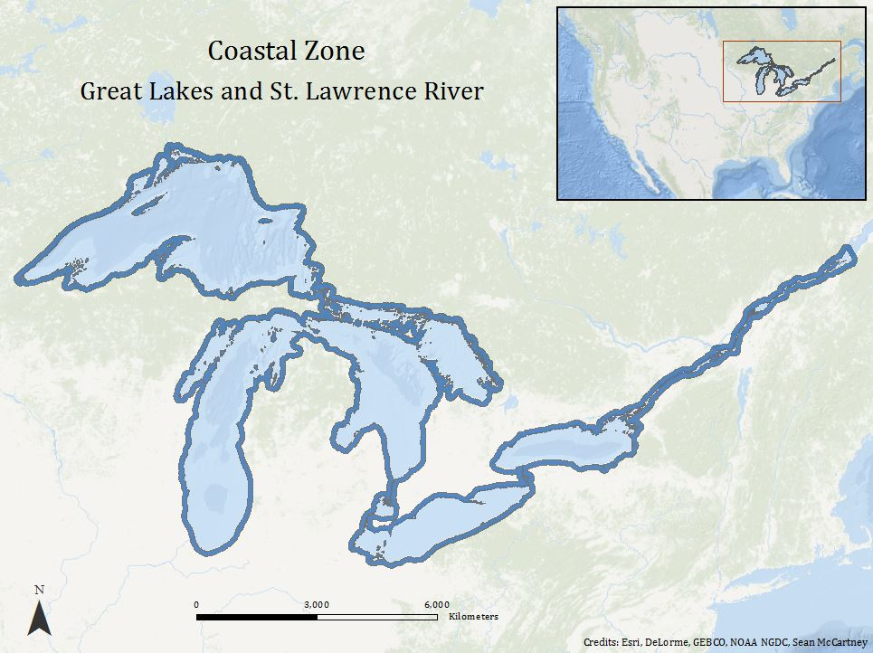

Figure 1. Study area map of the coastal zone for the Great Lakes and St. Lawrence River.

**National Application Addressed:**

This project addressed the Ecological Forecasting Application Area within NASA’s Applied Sciences Program.  This project utilized NASA EO to analyze land cover and derive environmental variables provided by ancillary datasets to model potential areas of Phragmites distribution. The information provided by this project will augment current decision-making practices regarding Phragmites management in the Great Lakes and St. Lawrence River Basin.

**Project Partners**:

The project partners included the Michigan Tech Research Institute (MTRI) and the Great Lakes St. Lawrence Cities Initiative (GLSLCI). MTRIwas a collaborator on the project and has been heavily involved in the remote sensing of Phragmites in the Great Lakes using PALSAR data (Bourgeau-Chavez et al., 2012; Bourgeau-Chavez et al., 2015). Dr. Bourgeau-Chavez served as the point of contact (POC) at MTRI and wasalso a science advisor for this project. MTRI was interested in this research as it provided an updated risk map of Phragmites as well as showcased an alternative method of Phragmites mapping that does not rely on commercial data. MTRI will use this data to support their Phragmites monitoring initiative throughout the Great Lakes. The GLSLCI was a boundary organization encompassing cities that reside near the Great Lakes in both the U.S. and Canada. Laura Bretheim and Simon Belisle served as POC for GLSLCI. The GLSLCI was interested in distributing risk maps resulting from this project to its member cities. In this way, informed policy decisions based on Phragmites distributions can be made on a basin-wide scale. The goal of the GLSLCI is to work with mayors and municipal staff to protect and preserve the Great Lakes and St. Lawrence region at the local, regional, and basin-wide levels.

# III. Methodology

**Data Acquisition:**

In order to model Phragmites extents, multiple raster and vector layers were needed as inputs for the Maximum Entropy (Maxent) modeler and Land Change Modeler. Proximity to roads is a known Phragmites explanatory variable (Mazur et al., 2014) and was obtained from the Digital Chart of the World for the year 1992 through the DIVA-GIS data portal. The roads file was downloaded in vector format as an ESRI shapefile in a World Geodetic System (WGS) 1984 coordinate system. Queries were run to select a subset of only primary and secondary roads within both Canada and the U.S. These road classifications are known to positively correlate with Phragmites (Carlson et al., 2009).

LULC maps for the U.S. Great Lakes were obtained in raster format from the National Oceanic and Atmospheric Administration’s (NOAA) Coastal Change Analysis Program (C-CAP) (NOAA, 2015). C-CAP produces national standardized land cover and change products for the coastal regions of the U.S. C-CAP products inventory coastal intertidal areas, wetlands, and adjacent uplands with the goal of monitoring changes in these habitats, on a one-to-five year repeat cycle. C-CAP products are derived from Landsat TM images with a 30 meter spatial resolution. They come georeferenced to the North American Datum (NAD) of 1983 and projected to Albers Conical Equal Area. LULC maps used for this project included data from the years 1996, 2005, 2010, and 2011.

On the Canadian side of the Great Lakes, LULC maps were obtained in raster format from the Canada Center for Remote Sensing (CCRS) Natural Resources Canada (NRC) data portal (NRC, 2015). LULC maps were derived from Moderate Resolution Imaging Spectroradiometer (MODIS) imagery in 0.25 km spatial resolution, and came georeferenced to the Geodetic Reference System (GRS) of 1980 and projected in Lambert Azimuthal Equal-Area. The LULC maps include 25 classes and were obtained for the years 2000 - 2011. These LULC maps were used as inputs to the Land Change Modeler and used to derive proximity to agriculture and developed lands.

Shuttle Radar Topography Mission (SRTM) Interferometric Synthetic Aperture Radar (IFSAR) maps were downloaded in raster format from the USGS EarthExplorer data portal as Void Filled and came georeferenced using the WGS 1984 datum. This data was used as a topographic variable for running suitability models. SRTM Void Filledelevation data are the result of additional processing using interpolation algorithms in conjunction with other sources of elevation data. The resolution for SRTM Void Filled data is 1 arc-second for the United States and Canada.

Near surface (2m) air temperature data was taken from the NASA Modern Era Reanalysis for Research and Applications Version-2 (MERRA-2) reanalysis, which uses Goddard Earth Observing System Data Assimilation System Version 5 (GEOS-5) to assimilate disparate satellite data products into a single observational product, at 0.5° spatial resolution. Precipitation data was taken from the Global Precipitation Climatology Project version 2.2 (GPCPv2.2), produced by NOAA/OAR/ESRL PSD, which integrates several satellite precipitation records with long term surface rain gauge measurements. Maximum lake ice extent data was taken from the NOAA Great Lakes Environmental Research Laboratory (GLERL), which expand upon the original Atlas of Great Lakes Ice Cover produced by GLERL.

Finally, Great Lakes soil classifications were necessary for determining the soil drainage of areas within the basin. The Food and Agricultural Organization of the United Nations (FAO UN) created a world map of soil classifications titled the Harmonized World Soil Database. Soil data for the Great Lakes Basin collected is in raster format and is at 1 km resolution.

Table 1 in the Appendices summarizes the variables used, their time period, and their source to model Phragmites habitats using Maxent modeling software.

**Data Processing**

Elevation data was converted into a topography roughness variable, and a soil drainage variable was created using the FAO UN soil classifications and following the methods described in Mazur et al*.* (2014).

MERRA-2 temperature and GPCP v2.2 precipitation data were converted to monthly anomalies by subtracting the mean values for each month over a baseline period of 1981-1995 from each gridcell. Lake ice extent anomalies were similarly produced by subtracting the mean annual maximum extent value for the years 1981-1995 from annual maximum extents for each of the Great Lakes.

Proximity variables including roads, agriculture, and developed land were created using the Euclidian distance tool in ArcGIS where high proximity to these variables was seen as a positive influence on Phragmites. Proximity to roads data was created by selecting all primary and secondary road classifications within the Great Lakes Basin on both the U.S. and Canadian side. The variables proximity to developed land and proximity to agriculture were found using LULC classifications as defined by NOAA C-CAP in the U.S. and Natural Resources Canada for the Canadian portion of the Basin.

To import the variables into Maxent, it was necessary to re-grid each dataset to a common basemap and cell size, and output each as an ASCII map file, to be read in as a separate environmental layer. This was performed using the Python (v2.7) programming language, utilizing the arcpy module.

# IV. Results & Discussion

Insert images, graphs, maps, charts, etc. here. Choose the most important results to highlight here. No word cap, but two to six pages is a good range.

Things to discuss:

* Analysis of Results: What can you tell from your graphs, images, etc? What does this mean for your project?
* Errors & Uncertainty: What factors could you not account for, what things didn’t work out like you expected they would, etc.
* Future Work: If this project was to be selected for another term, what would be the focus? What other areas would be of interest?

# V. Conclusions

Final conclusions. Word count: 200-600 (~a page).

# VI. Acknowledgments

The Great Lakes Ecological Forecasting team would like to thanks the mentors, advisors, and partners who contributed time and assistance with making this project possible.

Mentors & Advisors

* Dr. Laura Bourgeau Chavez, The Michigan Technical Research Institute
* Dr. Kurt Kowalski, USGS

Partners

* Laura Bretheim, The Great Lakes St. Lawrence Cities Initiative
* Simon Belisle, The Great Lakes St. Lawrence Cities Initiative

All opinions, findings, and conclusions expressed in this article are those of the authors and do not necessarily reflect the views of the National Aeronautics and Space Administration.

This material is based upon work supported by NASA through contract NNL11AA00B and cooperative agreement NNX14AB60A.

# VII. References

Ailstock, S. M., Norman, M. C., & Bushmann, P. J. (2001). Common Reed Phragmites australis: Control and Effects Upon Biodiversity in Freshwater Nontidal Wetlands. *Restoration Ecology,* *9*(1), 49-59

Bourgeau-Chavez, L.L., et al., Mapping invasive Phragmites australis in the coastal Great Lakes with ALOS PALSAR satellite imagery for decision support, J Great Lakes Res (2012), http://dx.doi.org/10.1016/j.jglr.2012.11.001

Bourgeau-Chavez, L., Endres, S., Battaglia, M., Miller, M., Banda, E., Laubach, Z., Marcaccio, J. (2015). Development of a Bi-National Great Lakes Coastal Wetland and Land Use Map Using Three-Season PALSAR and Landsat Imagery. *Remote Sensing*, 7(7), 8655-8682. Retrieved January 28, 2016, from

<http://www.mdpi.com/2072-4292/7/7/8655/htm>

Carlson, M. L., Kowalski, K. P., & Wilcox, D. A. (2009). Promoting species establishment in a Phragmites-dominated Great Lakes coastal wetland. *Natural Areas Journal,* *29*(3), 263-280.

Catling, Paul M., and Gisèle Mitrow. (2011). The recent spread and potential distribution of Phragmites australis subsp. australis in Canada. *Canadian Field-Naturalist* 125, 95–104.

Chambers, R. M., Meyerson, L. A., & Saltonstall, K. (1999). Expansion of Phragmites australis into tidal wetlands of North America. *Aquatic Botany,* *64*, 261-273.

Federal, Provincial and Territorial Governments of Canada. (2010). Canadian Biodiversity: Ecosystem Status and Trends 2010. Canadian Councils of Resource Ministers. Ottawa, ON. vi + 142 p

Gucker, Corey L. (2008). Phragmites australis. In: Fire Effects Information System, [Online]. U.S. Department of Agriculture, Forest Service, Rocky Mountain Research Station, Fire Sciences Laboratory (Producer). Available: http://www.fs.fed.us/database/feis/ [2016, February 18].

King, M. D. (2006). *Earth Science Reference Handbook - A Guide to NASA's Earth Science Program and Earth Observing Satellite Missions* (C. L. Parkinson & A. Ward, Eds.). Washington, D.C.: National Aeronautics and Space Administration.

Lantz, N. J., & Wang, J. (2013). Object-based classification of Worldview-2 imagery for mapping invasive common reed, Phragmites australis. *Canadian Journal of Remote Sensing,* *39*(4), 328-340.

Mazur, M. C., Kowalski, K., & Galbraith, D. D. (2014). Assessment of suitable habitat for Phragmites australis (common reed) in the Great Lakes coastal zone. *Aquatic Invasions AI*, *9*(1), 1-19. Retrieved February 17, 2016, from <http://www.aquaticinvasions.net/2014/AI_2014_CarlsonMazur_etal.pdf>

NOAA (2013), NOAA's Coastal Change Analysis Program (C-CAP) 1996 to 2010 Regional Land Cover Change Data - Coastal United States,  <https://coast.noaa.gov/dataregistry/search/collection/info/ccapregional>, NOAA's Ocean Service, Office for Coastal Management (OCM), Charleston, SC.

Natural Resources Canada (NRC) (2015), Characterization and Monitoring Change of Canada's Land Surface. Retrieved February 18, 2016, from http://www.nrcan.gc.ca/earth-sciences/land-surface-vegetation/land-cover/north-american-landcover/9146#_North_American_Land

Ontario Ministry of Natural Resources (OMNR), Invasive Phragmites – Best Management Practices, Ontario Ministry of Natural Resources, Peterborough, Ontario. Version 2011. 17p.

Pengra, B. W., Johnston, C. A., & Loveland, T. R. (2007). Mapping an invasive plant, Phragmites australis, in coastal wetlands using the EO-1 Hyperion hyperspectral sensor. *Remote Sensing of Environment,* *108*, 74-81.

Tulbure, M. G., Johnston, C. A., & Auger, D. L. (2007). Rapid Invasion of a Great Lakes Coastal Wetland by Non-native Phragmites australis and Typha. *Journal of Great Lakes Research, 33*(3), 269-279. Retrieved February 14, 2016.

# VIII. Content Innovation

Data Profile

Inline Supplementary Material (figures, tables, computer code)

Interactive Map Viewer

# IV. Appendices

**Table 1.** Variables used to model Phragmites in the Great Lakes basin.

|  |  |  |  |
| --- | --- | --- | --- |
| Category | Variable | Time Period | Source |
| Climate | Temperature | 1981-2015 | MERRA-2 |
|  | Precipitation | 1981-2015 | GPCP v2.2 |
| Lake ice Cover | 1981-2015 | GLERL |
| Disturbance | Proximity to roads | 1992 | DIVA-GIS |
|  | Proximity to agriculture | 2001, 2005, 2010 (U.S); 2000-2011 (Canada) | NOAA C-CAP (U.S), DUC CWI, OMNR OGLCWA, and MODIS 250m Land Cover, Natural Resources Canada (Canada) |
|  | Proximity to developed land | 2001, 2005, 2010 (U.S); 2000-2011 (Canada) | NOAA C-CAP (U.S), DUC CWI, OMNR OGLCWA, and MODIS 250m Land Cover, Natural Resources Canada (Canada) |
| Topography | Elevation | 2000 | NASA SRTM Plus Void-Filled |
| Soil | Soil drainage class | 2006 | Food and Agricultural Organization United Nations (FAO UN) World Resource Base Map of Soil Resources |