**NASA DEVELOP National Program**



NASA Langley Research Center

*Spring 2016*

El Salvador Ecological Forecasting II

Utilizing NASA Earth Observations to Predict Deforestation and Forest Degradation in El Salvador

 **Technical Report**

Rough Draft – March 31, 2016

Britta Dosch (Project Lead), britta.c.dosch@nasa.gov

Garrett Kidd

Labreshia Mims

Rebekke Muench

Jacob Patrick

Amy Wolfe

Dr. Kenton Ross, NASA DEVELOP National Program (Science Advisor)

Previous Contributors:

Courtney Duquette

Clarence Kimbrell

Susannah Miller

Jordan Ped

Stephen Zimmerman

# I. Abstract

Tropical forests are vital ecosystems because of their rich biodiversity and carbon sequestration abilities. Unfortunately, due to a number of factors, these forests are threatened by deforestation and forest degradation and are in need of comprehensive management strategies. The conservation of forests is not only vital for biodiversity but also for the ecosystem services they provide. The micro-region of La Mancomunidad La Montañona in Chalatenango, El Salvador is a hilly area with a population dependent upon subsistence and livestock farming, often utilizing slash and burn agricultural techniques. Using NASA Earth observations in collaboration with El Salvador’s ministry of the environment, Ministerio de Medio Ambiente y Recursos Naturales (MARN), the Earth Institute at Columbia University’s Agroforestry for Biodiversity and Ecosystem Services (ABES) Project, a methodology was developed for stakeholders and policy makers to monitor long-term changes in land cover and to predict significant changes in woody forest biomass. A baseline time series showing forest cover and land use land cover (LULC) from December 1986 to January 2016 was used to forecast forest cover change through the year 2030. These predictions will allow stakeholders to identify regions at-risk of deforestation to focus forest conservation efforts and management strategies.

**Keywords**

Remote sensing, GIS, Google Earth Engine, TerrSet, Land Change Modeler, Chalatenango, REDD+

# II. Introduction

Tropical forests provide vital environmental and ecosystem services. As carbon sinks, forests remove 3.6 billion metric tons of carbon per year (Reich, 2011). Tropical deforestation reduces the yearly net forest carbon sink to about 1 billion metric tons, one-seventh of yearly global fossil fuel emissions (Reich, 2011). Forests also play a crucial role in regulating the nutrient cycle and maintaining soil stability. Deforestation for agricultural purposes often leads to soil erosion and nutrient leaching. Organic matter from fallen leaves and branches provide essential nutrients which help maintains soil quality. Their roots anchor the soil and prevent it, and the nutrients within it, from washing away, also helping to maintain watersheds (Vitousek & Sanford, 1986). Additionally, tropical forests are essential to global biodiversity as they are home to over 50% of the world’s species, including 80% of insects and 90% of primates (Houghton, Skole, & Lefkowitz, 1991).

Central America is home to 22,411 hectares of tropical forest. From 1990 to 2005 Central American forest cover decreased by approximately 20% (Khatun, 2011). The primary causes of this deforestation were population growth and land use changes (Redo et. al., 2012; Kahtun, 2011). The effects of deforestation in Central America are not just restricted to this region. Biologists have linked the decline in North American migratory bird species, such as the wood thrush, to the loss of forests in Central America given that three of the four major flyways connecting the Americas pass through Central America (Finch, 1991).

Like much of Central America, El Salvador has experienced extensive deforestation. High population density, coupled with poor enforcement of environmental regulations and unsustainable farming techniques, such as slash and burn, have been driving forces of forest loss (World Bank, 2014). Today, only 2% of El Salvador’s primary forest remains, the smallest amount in Latin America (Rainforest Alliance, n.d.). Slash and burn farming is exceptionally harmful because it quickly depletes soils of their nutrients. This not only creates a need for plot expansion, but also makes it difficult for forest regrowth efforts to be successful (Hetch & Sattchi, 2007).

From 1980 to 1992, El Salvador experienced a civil war that led to a mass emigration of 25% of the population (Hetch & Sattchi, 2007; Gammage, 2007). Carpet bombing and destructive land campaigns resulted in the desolation of crops and forests (Weinberg, 1997). However, the declining population led to a reduction in agricultural and pastoral practices which allowed for some successional forests to emerge in previously cultivated areas. The conclusion of the civil war led to rapid urbanization with the return of the war refugees (Hetch & Sattchi, 2007). In the post war era, environmental conservation started to become a priority. The national government signed the United Nations Framework Convention on Climate Change (UNFCCC, n.d.) in 1992 and the Kyoto Protocol in 1998 (UNFCCC, n.d.). In 1997, President Armando Calderon Sol issued a presidential decree creating a national ministry of the environment, Ministerio de Medio Ambiente y Recursos Naturales (MARN) (Foley & Hapipi, 2005). More recent initiatives include a push to implement sustainable farming techniques, such as agroforestry, preparations for REDD+ implementation, a United Nations program focused on reducing emissions from deforestation and forest degradation in developing countries, and development of a payment for ecosystem services (PES) plan. These programs are essential to ensuring the preservation of what little primary forest remains in El Salvador.

The micro-region of La Mancomunidad La Montañona in Chalatenango, El Salvador is home to a pine oak forest with both ecological and cultural importance. The communities of La Montañona, the country’s capital of San Salvador, and other regions downstream, rely on the pine oak forests to maintain local stream and river quality (Balkan, n.d.). However, the ecosystem services provided by this forest are threatened by traditional farming practices. The population of this hilly area is dependent upon subsistence and livestock farming, often utilizing slash and burn agricultural techniques which threaten the surrounding forest (Balkan, n.d.).

This project addressed the National Application Area of Ecological Forecasting. It contributes to this application area by utilizing historical land classifications and providing the partner with forecasted land classifications. This data can be used to develop a REDD+ strategy. The overall objective of the project was to develop a methodology for monitoring and forecasting ecological change in the La Mancomunidad La Montañona region in El Salvador by analyzing data from December 1986 - January 2016. MARN and other end-users can utilize this methodology to anticipate potential locations at risk of deforestation, allowing them to determine where to focus land use management and future conservation strategies at a national level.

# III. Methodology

**Data Acquisition**

Atmospherically corrected images from the Landsat 5 Thematic Mapper and Landsat 8 Operational Land Imager satellites were extracted from the United States Geological Survey (USGS) for path 19, row 50 for the six focus years during the study period: 1986, 1996, 2000, 2009, 2014, and 2015. These images were representative of the dry seasons for the study area which occurs from November to April. For consistency with the fall 2015 term, additional images chosen were those with minimal cloud cover over the area of interest and as close to the month of December for each new year selected, 2009 and 2015. The 2009 image filled in a gap in the historical timeline and 2015 was the most recent image available. ABES provided RapidEye imagery for the 2015 season in addition to plot data in vector format which contained ground reference information at each point (Table 1).

**Table 1. Earth Observing Systems and High Resolution Satellite Imagery**

|  |  |  |  |  |
| --- | --- | --- | --- | --- |
| **Satellite** | **Source** | **Resolution** | **Research Use** | **Year Acquired** |
| **Landsat 4/5 TM** | USGS GLOVIS | 30 m | Land Use/Land Cover | December 1986, January 1997, February 2001, January 2010 |
| **Landsat 8 OLI** | USGS GLOVIS | 30 m | Land Use/Land Cover | January 2014, January 2016 |
| **RapidEye** | Project Collaborators (ABES) | 5 m | Ground Truth for Land Use Land Cover | December 2015 |

Data used for the forecasting model were collected from various open-source resources. The digital elevation model (DEM) and municipalities and country outlines were obtained by the fall 2015 team from the Shuttle Radar Topography Mission (SRTM-1 Arc-Second Global, 2000) and the Global Administrative Areas Database respectively. The shapefile containing information of the roads system within the study area was collected from Open Street Map.

**Land Use/Land Cover Classification – Data Processing**

Google Earth Engine API (GEE) was used to perform LULC classifications. Preprocessing and projection of the images were unnecessary for this project since GEE provides a simplistic platform in which top of the atmosphere (TOA) images are mirrored from USGS and automatically projected onto the base map. Images were cropped to the extent of the classified 2015 RapidEye imagery using a Google Fusion Table. Images were filtered to remove any ‘null’ value pixels.

**Land Use/Land Cover Classification – Data Analysis**

The GEE platform, using maximum entropy and random forest classification methods, produced LULC maps for the six NASA Landsat images and for the 2015 RapidEye image. While GEE is a user-friendly software, some knowledge of JavaScript or Python language is necessary to utilize the platform to its full potential. Provided scripts from GEE’s API guide were modified for use to produce the LULC maps. Review and refinement of the training sites, polygons drawn by the analyst to capture a sample of each land category, created during the Fall 2015 term for class categories was performed. A minimum of 30 training sites for each class were created using ArcGIS. The increase to 30 training sites for each category was chosen in order to improve overall classification accuracy.

Class categories were reduced from five to four due to complications of differentiating between pasture and croplands caused by the similarities of spectral reflectance. Pasture and croplands were combined into one class, Rural/Non-Forest (RNF), leaving all others the same. The categories used were: water, RNF, forest, and urban. Classes were identified by referencing a combination of high-resolution imagery, historical imagery, ABES ground reference data, and Google Earth. Various band composites enabled the visual distinction between closely related classes (Table A1). After the optimal training sites were drawn, a supervised classification was performed in GEE for both classification methods. GEE could access the dataset through Google Fusion Tables created using the training sites. Various bands from the Landsat 5 TM and Landsat 8 OLI were used for the classification process (Table A2). Since for-loops are discouraged within GEE, each year was assigned an individual code for classification purposes.

**Accuracy Assessment – Land Cover Validation**

Confusion matrices, kappa coefficients, producers, and consumers accuracies for the seasonal years of 2014 and 2015 were produced using GEE by incorporating the appropriate scripts to compare the accuracy of the classified Landsat images to the classified 2015 RapidEye imagery. The RapidEye imagery was resampled to a pixel size of 30 meters during this process for consistent resolution and comparison. Results of the overall accuracy, confusion matrix tables, and kappa coefficients were extracted from the console within GEE. No accuracy assessments were performed for the earlier images due to a lack of ground reference data prior to 2012.

**Quantifying Land Use Changes**

GEE supplied the ability to quantify the land use classifications by calculating the area of each pixel located within a vector shapefile outlining the area of interest. The water basin shapefile, in conjunction with statistical analysis in ArcGIS, was used to count the pixels in each category, producing area in square kilometers. A line graph using the adjusted numbers was produced to visualize the changes in land use over the historical time-line. This line graph was created through Excel using the areas calculated in GEE in square kilometers.

Rate of change for RNF, forest, and urban was calculated using the equation Rate of Change= [(Area Latter-Area Former)/(Area Former)]*100. The rate of change for each class was used to produce a line graph in Excel.

**Land Change Forecast – Data Processing**

Preprocessing of the data used in the forecasting model were conducted within ArcGIS. Classified images were exported from GEE into a tiff file, uploaded into ArcGIS, and reclassified as follows: 1 - Water, 2 - RNF, 3 - Forest, 4 - Urban, 0 - No Data. These images were then exported as an ‘Imagine Image’ for use in TerrSet. The DEM was corrected for the sinks identified within the image. This allowed for the delineation of the watershed and drainage areas using spatial analyst and hydrology tools.

Variables used in the forecasting model were: distance to water, distance to roads, elevation, slope, aspect, and land cover change. Distance to water and distance to roads were calculated using the roads and water files with the Euclidean Distance tool. Slope and aspect were derived from the corrected digital elevation model utilizing the slope and aspect tools. The roads and the waterbodies shapefiles were converted to a raster file. Since land cover is a qualitative variable, it was converted to a quantitative variable using Evidence Likelihood which calculated the relative frequency that the land categories transitioned between the earlier and later images. All raster images were then exported as an ‘Imagine Image’, imported into TerrSet, and converted to a raster file.

**Land Change Forecast – Data Analysis**

TerrSet Land Change Modeler was used to forecast land change in the study area to the 2030 dry season. Due to uncorrectable errors in the 1986 land classification, 1996 was used as the base year for the prediction. The Multi-Layer Perceptron (MLP) algorithm was utilized to model the relationships between the variables and the transition submodels (Table 2). Two transition submodels were used to incorporate the inclusion and exclusion of reforestation. A forecasted LULC map was created for the 2030 dry season as well as a video which shows the land change transition from 2015 to 2030 in five year intervals.

**Table 2. Transition Sub-models and Variables Used**

|  |  |  |  |  |  |  |  |
| --- | --- | --- | --- | --- | --- | --- | --- |
| **From** | **To** | **Model Variable** | | | | | |
| **1996 Class** | **2015 Class** | ***Elevation*** | ***Dist. to Water*** | ***Dist. to Roads*** | ***Slope*** | ***Aspect*** | ***Land Cover Transition*** |
| **Forest** | RNF | x | x | x | x | x | x |
| **Forest** | Urban | x | x | x | x | x | x |
| **RNF** | Forest* | x | x | x | x | x | x |
| **RNF** | Urban | x | x | x | x | x | x |

*Reforestation was excluded for one of the transition sub-models.

# IV. Results & Discussion

**Land Use/Land Cover Classification – Results**

The random forest supervised classification was determined to have the best representation of the land use categories for the Landsat 5 TM images while maximum entropy method performed best for the 2015 RapidEye image through visual interpretation. The maximum entropy classification method was determined to have the most success for the Landsat 8 OLI based on accuracy assessments performed using RapidEye 2015 imagery. Land cover errors in both classification methods were observed throughout all images. A likely source for these inconsistencies could be the result of a large amount of green biomass in the large body of water in the south west of the study area, the Embalse Cerron Grande water basin, which produced a misclassification of water as forest (Figure 1). A probable cause to the confusion of urban classifications was the presence of uncultivated agricultural areas of bare soil within the study region. Additionally, since these Landsat images were acquired during the dry season, low river level exposed much of the river bank, causing these areas to be misclassified as urban (Figure 1). Lastly, the training sites themselves are possible sources to the class variations since classifications contain strong elements of subjectivity.

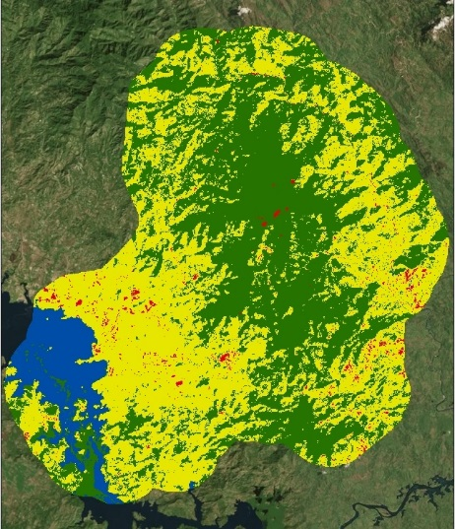 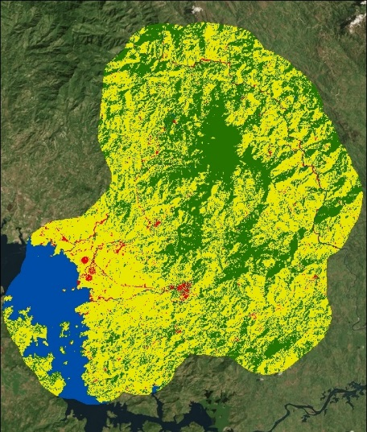 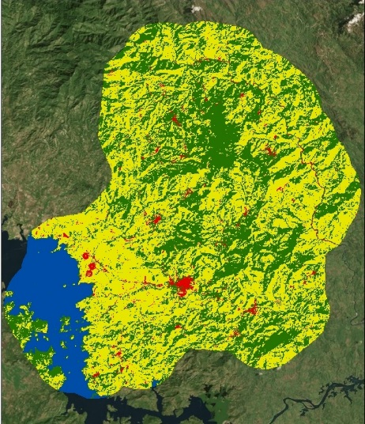

Figure 1. Classified images of the four predominant categories: water, rural/non-forest, forest, and urban. From left to right: 1986, 2000, 2015. Color representations: Blue = water, yellow = rural/non-forest, green = forest, and red = urban.

During the study period, deforestation appeared to be concentrated along the edges of the centrally located forested area. The largest visible reforestation appeared in the eastern region of the study area, as well as the south western banks of the Embalse Cerron Grande water basin. Forest gain was speckled throughout the region rather than concentrated in one area (Figure A1). Urban expansion was seen around already established communities but appeared minor overall. RNF areas displayed the most prevalent growth in the study area during the study period. It is possible that the reforestation observed on the south west side of the Embalse Cerron Grande water basin was influenced by the presence of a national park in the region. On average the results showed a decrease in forested areas by 3% during the study period while RNF area increased by an average rate of 2.4% and urban areas increased by 8.4% during the study period (Table 3). The overall accuracies of the 2014 and 2015 dry season classified Landsat images using maximum entropy were 71.4% and 81.5% respectively, indicating the percentages of correctly identified pixels in each category (Tables A3 & A4). The Kappa Coefficients for both years indicate a moderate agreement (0.8 > KHAT > 0.4) between the classification results and the 2015 RapidEye imagery ground reference image. Random forest classification method produced results with lower accuracies (Tables A5 & A6).

**Table 3. Rate of Change (%) Rural Non-Forest, Forest, and Urban**

|  |  |  |  |  |  |  |  |
| --- | --- | --- | --- | --- | --- | --- | --- |
|  | **1986\*** | **1996** | **2000** | **2009** | **2014** | **2015** | **Average** |
| **RNF** | N/A | 12.09 | 0.04 | 0.01 | -0.09 | 0.008 | 2.41 |
| **Forest** | N/A | -15.26 | -0.08 | -0.004 | 0.18 | -0.02 | -3.04 |
| **Urban** | N/A | 41.62 | -0.04 | 0.35 | -0.51 | 0.6 | 8.40 |

*Calculations have been adjusted for the 1986 year for the misclassifications in the ‘Water’ class.

Using the classified images, calculated areas, and graphs produced by TerrSet, RNF was determined to be the greatest driver of deforestation over the historical timeline (Figures 2 & 3). This deforestation occurred primarily along the edges of the forests where RNF areas were already established with the largest amount occurring between 1986 and 1996 (Figure 1 and Table A7). This period of time overlaps the end of the civil war and it was therefore a logical and probable reason for the large rate of deforestation as many refugees returned to their homeland to rebuild their communities. Due to the problems surrounding the water and urban classifications, the water and urban categories were shown to increase the net change in forest (Figure 2). This resulted in an inaccurate representation of the contribution of these classes to their effect on forest change.

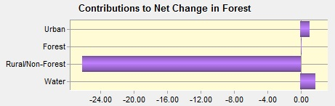

Figure 3. Contributors to the net change in forest cover area in km2 from 1996 to 2015. Rural/Non-Forest contributes the largest amount of reduction in forest change.

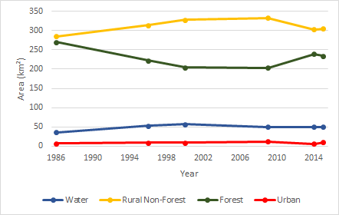

Figure 4. The area of land use classes estimated for each year of interest (km2).

Limitations were identified that affected the historical baseline and prediction results. One of the limitations faced was the lack of imagery before the year 1986 which restricted the historical starting point. In addition, difficulties arose in collecting imagery through the time series during the dry season that was void of clouds over the study area. Uncorrectable errors in the water class for the 1986 image caused visible errors in the final prediction image and estimated area result. This affected the rate of change from 1986 to 1996 and inadvertently the average rate of change for the forested class. With similarities in forest and RNF reflectance, minor misclassifications were unavoidable but the overall LULC trend was as expected. Finally, a lack of ground reference plot data or high resolution imagery earlier than 2012 prevented any accuracy assessment of the earlier classified images.

**Land Change Forecast – Results**

The variables used to predict changes in LULC were run in TerrSet Land Change Modeler to display how the study area may appear in 2030 with the explanatory variables remaining constant. The association between the variables and the distribution of land categories was measured using Cramer’s V. Land cover presented the highest value, followed by elevation and distance to water. Slope and aspect had the lowest predictive associations (Table A8). Incorporating reforestation into the forecasting model resulted in an overestimation of the expected amount of forest and urban expansion based on the historical baseline created (Figure 4). Therefore, a forecasting model excluding reforestation was also used to estimate the predicted forest cover. The exclusion of reforestation over-estimated the deforestation that will likely occur (Figure 5). The predictions displayed a consistent pattern that many areas of forest would continue to see deforestation at a rapid rate with the main contributor being RNF and, to a lesser extent, urban expansion (Figures A2 & A3). A transition potential based on each class identified areas that would be at the highest risk for land change on a scale of 0-100% (Figures 4 & 5). The edges of forests adjacent to RNF areas were identified as having the highest risk of deforestation.

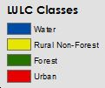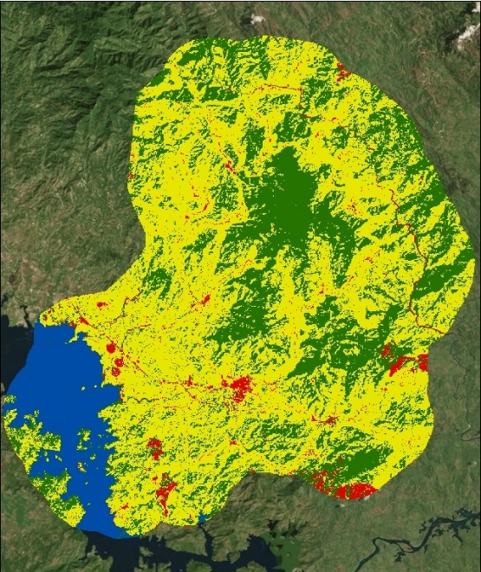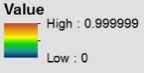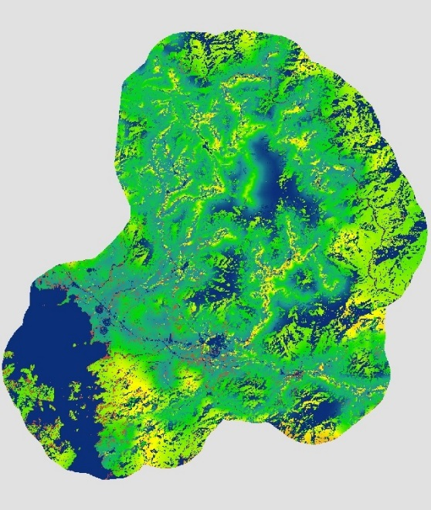

Figure 6. Land change predicted to 2030 with reforestation. Left: projected land cover. Right: projected transition potential for each land category to transition to another category from 0 to 100%.

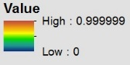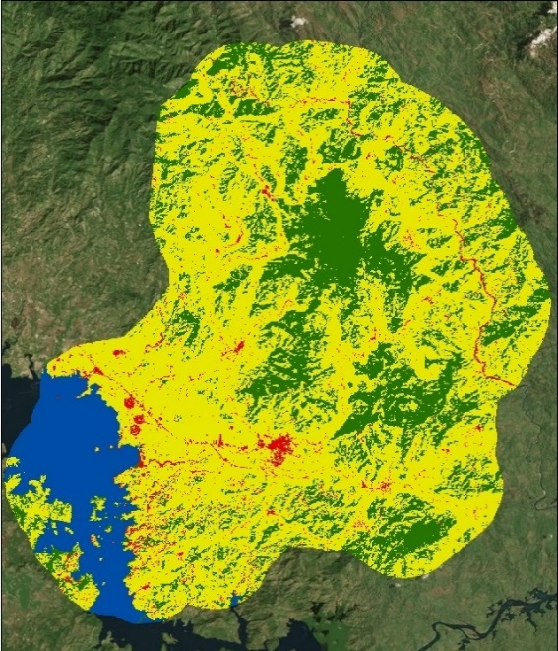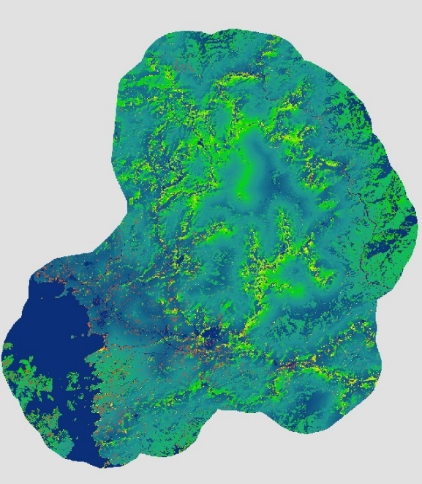

Figure 7. Land change predicted to 2030 with no reforestation. Left: projected land cover. Right: projected potential for each land category to transition to another category from 0 to 100%.

The 2030 TerrSet predictions showed that if all of the variables stay constant over the next 15 years, the Chalatenango region of El Salvador could continue to see an increased amount of forest reduction. These images, although not accurate by themselves, provide a general understanding to the trends that the forest cover could follow in the absence of effective management strategies.

# V. Conclusions

NASA Landsat imagery coupled with Google Earth Engine proved to be easily accessible and useful tools for identifying changes in land cover. Using remotely sensed imagery reduced the time spent on data collection and allowed for analysis where there was a lack of ground reference data. The software created through Google Earth Engine provided the ability to run multiple analyses and calculations in an easy to use form. This software could be modified to extend the size of the study area and could be an invaluable tool for research where there is limited or no ground reference data.

Improvements to the classified images could be acquired by reducing the number of predominant land classes. Decreasing the number of classes had the potential to increase the accuracy of the images since it produces a simplified image with broader categories which presents less room for error. Modification and refinement of the training sites was another option for enhancement. While the ground reference plot data was beneficial in classifying the 2015 RapidEye image, obtaining more current data would have improved the validity of the classifications and accuracy assessment.

The results of this project may be used to better understand how the landscape of the study area has changed which can help in the development of environmental initiatives, such as REDD+ and payments for ecosystem services (PES). In order to implement a REDD+ program, certain preparations must be made, including the creation of a regional forest inventory, to which this project contributes. PES provides economic incentive for forest conservation. This project allows for the identification of where PES efforts could be effective. More recent initiatives include a push to implement sustainable farming techniques, such as agroforestry, at a community level. These programs are necessary to the preservation of what little primary forest remains, reduced soil erosion and nutrient depletion, and to expand environmental conservation efforts.

# VI. Acknowledgments

Dr. Kenton Ross - National Science Advisor, NASA DEVELOP National Program

Dr. Sean Smukler & Sean Kearney - The Earth Institute, Columbia University (ABES Project)

Arnulfo Alberto - La Mancomunidad La Montañona, Chalatenango

Giovanni Molina - Ministerio de Medio Ambiente y Recursos Naturales (MARN)

Rolando Barillas, ABES Project Manager

Mary Rodriguez, Environment Officer, USAID/El Salvador

Dr. Jason Paul Landrum, Regional Science and Technology Advisor, USAID/El Salvador

This material is based upon work supported by NASA through contract NNL11AA00B and cooperative agreement NNX14AB60A.

# VII. References

Balkan, Neşecan. "Analysis of the "Economic Change, Poverty, and the Environment Project” In La Montañona, Chalatenango, El Salvador." Web.

Daniel J. Redo, H. Ricardo Grau, T. Mitchell Aide, and Matthew L. Clark. Asymmetric forest transition driven by the interaction of socioeconomic development and environmental heterogeneity in Central America in: Proc Natl Acad Sci U S A. Jun 5, 2012; 109(23): 8839–8844.

Finch, Deborah M. Population Ecology, Habitat Requirements, and Conservation of N Eotropical Migratory Birds. Rep. Fort Collins, CO: United States Department of Agriculture, 1991. Print.

Foley, E., & Hapipi, R. (2005). El Salvador. New York: Marshall Cavendish Benchmark.

Gammage, Sarah. "El Salvador: Despite End to Civil War, Emigration Continues." Migrationpolicy.org. 2007. Web. 11 Feb. 2016.

Hecht, S. B., & Saatchi, S. S. (2007). Globalization and Forest Resurgence: Changes in Forest Cover in El Salvador. BioScience, 57(8), 665. Retrieved February 4, 2016.

Houghton R.A., D.L. Skole, and D.S. Lefkowitz. 1991. Changes in the landscape of Latin America between 1850 and 1985: II a net release of CO2 into the atmosphere. Journal of Forest Ecology and Management, 38:133-199.

Khatun, Kaysara. "Reconciling Timber Provision with Carbon Sequestration Opportunities in the Tropical Forests of Central America." Environmental Science & Policy 14.8 (2011): 1091-102. Web.

Rainforest Alliance. Bosque El Imposible, El Salvador. Retrieved February 10, 2016, from http://www.rainforest-alliance.org/adopt/projects/el-salvador

Reich, Peter B. (2011). Biogeochemistry: Taking stock of forest carbon. Nature Climate Change, 1, (346-347). Retrieved February 4, 2016.

UNFCCC: El Salvador. (n.d.). Retrieved February 10, 2016, from http://unfccc.int/parties_and_observers/parties/items/country_SV.php

Vitousek, P. M., and R. L. Sanford. "Nutrient Cycling in Moist Tropical Forest." Annual Review of Ecology and Systematics 17.1 (1986): 137-67. Web.

Weinberg, S. (1997, May). ICE Case Studies, El Salvador Civil War. Retrieved February 10, 2016, from http://www1.american.edu/ted/ice/elsalv.htm

World Bank, 2014. Population density (people per sq. km of land area). Retrieved from http://data.worldbank.org/indicator/EN.POP.DNST/countries?display=default

# VIII. Content Innovation

Interactive Google Earth Engine Map Viewer

Interactive Google Earth Engine Plot Viewer

Google Earth Engine JavaScript Code Viewer

VPS Video

# IV. Appendix A

**Table A1. Band Combinations Used to Identify Land Cover Classes**

|  |  |  |  |  |  |
| --- | --- | --- | --- | --- | --- |
|  | Land Use/Land Cover Class | | | | |
| **Composite/Ratio** | **Water** | **Pasture** | **Forest** | **Urban** | **Crop** |
| TM 3/2/1 (‘True Color’) | x | x | x | x | x |
| TM 4/3/2 (‘False Color’) |  |  | x | x |  |
| TM 5/4/3 | x | x | x |  | x |
| TM 5/4/1 |  | x |  |  | x |
| OLI 4/3/2 (‘True Color’) | x | x | x | x | x |
| OLI 5/4/3 (‘Color Infrared’) |  | x | x |  | x |
| OLI 7/6/4 |  |  |  | x |  |
| OLI 6/5/2 |  | x |  |  | x |

**Table A2. Spectral Bands for Satellites Used in Classifications**

|  |  |  |  |
| --- | --- | --- | --- |
| **Satellite** | **Bands** | **Wavelength (micrometers)** | **Resolution (meters)** |
| **Landsat 5 Thematic Mapper (TM)** | Band 1 - Blue | 0.45-0.52 | 30 |
| Band 2 - Green | 0.52-0.60 | 30 |
| Band 3 - Red | 0.63-0.69 | 30 |
| Band 4 - NIR | 0.76-0.90 | 30 |
| Band 5 - mid-IR | 1.55-1.75 | 30 |
| Band 6 - Thermal | 10.40-12.50 | 120* (30) |
| Band 7 - SWIR | 2.08-2.35 | 30 |
| **Landsat 8 Operational Land Imager (OLI)** | Band 2 - Blue | 0.45 - 0.51 | 30 |
| Band 3 - Green | 0.53 - 0.59 | 30 |
| Band 4 - Red | 0.64 - 0.67 | 30 |
| Band 5 - NIR | 0.85 - 0.88 | 30 |
| Band 6 - SWIR 1 | 1.57 - 1.65 | 30 |
| Band 7 - SWIR 2 | 2.11 - 2.29 | 30 |
| Band 8 - Panchromatic | 0.50 - 0.68 | 15 |

*Landsat 5 TM Band 6 was acquired at 120-meter resolution and then resampled to 30-meter resolution.

**Table A3. Confusion Matrix for 2014 Using Maximum Entropy Classification**

|  |  |  |  |  |  |  |
| --- | --- | --- | --- | --- | --- | --- |
| **Prediction** | **Ground Reference** | | | | | |
| ***Class*** | **Water** | **RNF** | **Forest** | **Urban** | **Total** |
| **Water** | **8** | **0** | **0** | **0** | **8** |
| **RNF** | **0** | **25** | **10** | **1** | **36** |
| **Forest** | **0** | **11** | **22** | **0** | **33** |
| **Urban** | **0** | **0** | **0** | **0** | **0** |
| **Total** | **8** | **36** | **32** | **1** | **77** |
|  |  | | | | | |
|  | **Class** | **Commission (%)** | **Omission (%)** | **Prod. Acc. (%)** | **User Acc. (%)** |  |
| **Water** | 0 | 0 | 100 | 100 |
| **RNF** | 31 | 31 | 69 | 69 |
| **Forest** | 33 | 31 | 69 | 67 |
| **Urban** | 0 | 100 | 0 | 0 |

Table A3 shows the confusion matrix with commission and omission for 2014 using maximum entropy classification. The overall accuracy: (55/77)*100 = 71.4% and the Kappa Coefficient (KHAT): 0.518.

**Table A4. Confusion Matrix for 2015 Using Maximum Entropy Classification**

|  |  |  |  |  |  |  |
| --- | --- | --- | --- | --- | --- | --- |
| **Prediction** | **Ground Reference** | | | | | |
| ***Class*** | **Water** | **RNF** | **Forest** | **Urban** | **Total** |
| **Water** | 4 | 0 | 0 | 0 | 4 |
| **RNF** | 0 | 33 | 6 | 0 | 39 |
| **Forest** | 0 | 9 | 28 | 0 | 37 |
| **Urban** | 0 | 0 | 0 | 1 | 1 |
| **Total** | 4 | 42 | 34 | 1 | 81 |
|  |  | | | | | |
|  | ***Class*** | Commission (%) | Omission (%) | Prod. Acc. (%) | User Acc. (%) |  |
| **Water** | 0 | 0 | 100 | 100 |
| **RNF** | 15 | 21 | 79 | 85 |
| **Forest** | 24 | 18 | 82 | 76 |
| **Urban** | 0 | 0 | 100 | 100 |

Table A4 shows the confusion matrix with commission and omission for 2014 using maximum entropy classification. The overall accuracy: (66/81)*100 = 81.5% and the Kappa Coefficient (KHAT): 0.667.

**Table A5. Confusion Matrix for 2014 Using Random Forest Classification**

|  |  |  |  |  |  |  |
| --- | --- | --- | --- | --- | --- | --- |
| **Prediction** | **Ground Reference** | | | | | |
| ***Class*** | **Water** | **RNF** | **Forest** | **Urban** | **Total** |
| **Water** | 8 | 0 | 0 | 0 | 8 |
| **RNF** | 0 | 26 | 9 | 1 | 36 |
| **Forest** | 0 | 14 | 19 | 0 | 33 |
| **Urban** | 0 | 0 | 0 | 0 | 0 |
| **Total** | 8 | 40 | 28 | 1 | 77 |
|  |  | | | | | |
|  | ***Class*** | Commission (%) | Omission (%) | Prod. Acc. (%) | User Acc. (%) |  |
| **Water** | 0 | 0 | 100 | 100 |
| **RNF** | 28 | 35 | 65 | 72 |
| **Forest** | 42 | 32 | 68 | 58 |
| **Urban** | 0 | 100 | 0 | 0 |

Table A5 shows the confusion matrix with commission and omission for 2014 using random forest classification. The overall accuracy: (53/77)*100 = 68.8% and the Kappa Coefficient (KHAT): 0.472.

**Table A6. Confusion Matrix for 2015 Using Random Forest Classification**

|  |  |  |  |  |  |  |
| --- | --- | --- | --- | --- | --- | --- |
| **Prediction** | **Ground Reference** | | | | | |
| ***Class*** | **Water** | **RNF** | **Forest** | **Urban** | **Total** |
| **Water** | 4 | 0 | 0 | 0 | 4 |
| **RNF** | 0 | 32 | 6 | 1 | 39 |
| **Forest** | 0 | 11 | 26 | 0 | 37 |
| **Urban** | 0 | 0 | 0 | 1 | 1 |
| **Total** | 4 | 43 | 32 | 2 | 81 |
|  | | | | | | |
|  | ***Class*** | Commission (%) | Omission (%) | Prod. Acc. (%) | User Acc. (%) |  |
| **Water** | 0 | 0 | 100 | 100 |
| **RNF** | 18 | 26 | 74 | 82 |
| **Forest** | 30 | 19 | 81 | 70 |
| **Urban** | 0 | 50 | 50 | 100 |

Table A6 shows the confusion matrix with commission and omission for 2015 using random forest classification. The overall accuracy: (63/81)*100 = 77.8% and the Kappa Coefficient (KHAT): 0.604.

**Table A7. Area for Land Use and Land Cover Classifications (km2)**

|  |  |  |  |  |  |  |
| --- | --- | --- | --- | --- | --- | --- |
|  | **1986\*** | **1996** | **2000** | **2009** | **2014** | **2015** |
| **Water** | 49.49 | 52.72 | 56.9 | 50.1 | 50.2 | 49.6 |
| **Rural/ Non-Forest** | 280.44 | 314.34 | 328.15 | 332.6 | 302.9 | 305.3 |
| **Forest** | 261.74 | 221.81 | 204.17 | 203.4 | 239.3 | 233.9 |
| **Urban** | 6.72 | 9.52 | 9.17 | 12.34 | 6 | 9.6 |

*Calculations have been adjusted for the 1986 year for the misclassifications in the ‘Water’ class.

**Table A8. Cramer’s V using Explanatory Variables to Forecast Land Change**

|  |  |  |  |  |  |  |
| --- | --- | --- | --- | --- | --- | --- |
| **Cramer's V** | | | | | | |
| *Cover Class:* | Aspect | Slope | Elevation | Dist. To Roads | Dist. To Water | LULC Transition |
| Overall V | 0.0050 | 0.0043 | 0.4276 | 0.2541 | 0.3772 | 0.5805 |
| RNF | 0.0093 | 0.0067 | 0.8160 | 0.4374 | 0.7259 | 0.9713 |
| Urban | 0.0057 | 0.0053 | 0.3335 | 0.1712 | 0.2937 | 0.6437 |
| Forest | 0.0040 | 0.0042 | 0.3279 | 0.1577 | 0.2600 | 0.6195 |
| Water | 0.0000 | 0.0000 | 0.0000 | 0.0000 | 0.0000 | 0.0000 |
| **P-value** | | | | | | |
| *Cover Class:* | Aspect | Slope | Elevation | Dist. To Roads | Dist. To Water | LULC Transition |
| Overall V | 0.0000 | 0.0003 | 0.0000 | 0.0000 | 0.0000 | 0.0000 |
| RNF | 0.0000 | 0.0000 | 0.0000 | 0.0000 | 0.0000 | 0.0000 |
| Urban | 0.0007 | 0.0019 | 0.0000 | 0.0000 | 0.0000 | 0.0000 |
| Forest | 0.9997 | 0.0402 | 0.0000 | 0.0000 | 0.0000 | 0.0000 |
| Water | 1.0000 | 1.0000 | 1.0000 | 1.0000 | 1.0000 | 1.0000 |

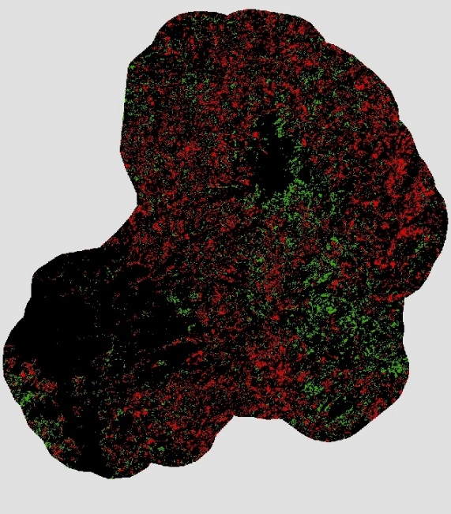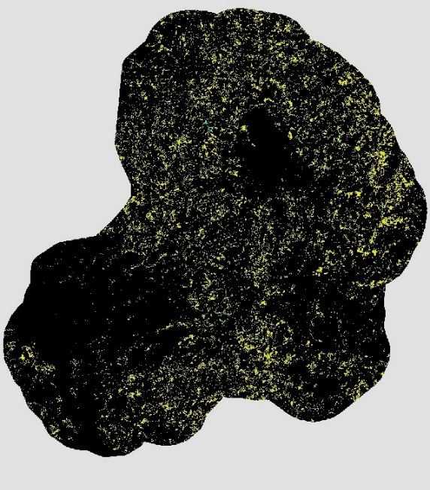

Figure A1. Forest changes from 1986 - 2015. Left: Forest gains (green) and losses (red). Right: Forest losses to RNF (yellow) and urban (red).

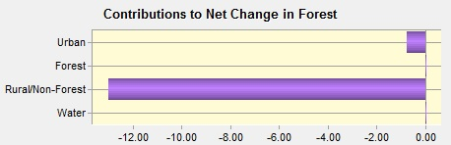

Figure A2. Predicted contributors to the net change in forest cover area in km2 with reforestation included.

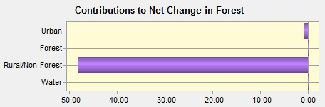

Figure A3. Predicted contributors to the net change in forest cover area in km2 with reforestation excluded.