**NASA DEVELOP National Program**



Wise County Clerk of Court’s Office and NASA Langley Research Center

*Fall 2015*

Virginia Water Resources II

Utilizing NASA Earth Observations to Monitor the Extent of Harmful Algal Blooms in Lower Chesapeake Bay Watersheds

 **Technical Report**

Rough Draft – October 8, 2015

Wise County Clerk of Court’s Office

Arika Egan (Project Lead)

Jakub Blach

Zachary Tate

NASA Langley Research Center

Jessica Jozwik

Tyler Rhodes

Dr. Kenton Ross, NASA DEVELOP National Program (Science Advisor)

Bob VanGundy, University of Virginia’s College at Wise (Science Advisor)

Dr. DeWayne Cecil, Global Science and Technology, Inc. (Science Advisor)

Previous Contributors:

Sara Lubkin

Cassandra Morgan

# I. Abstract

[Placeholder - do not put anything here until the final draft submission. The abstract in the project summary is where the working draft of the abstract should “live”]

**Keywords**

Lower Chesapeake Bay, Remote Sensing, Harmful Algal Blooms, James River, York River, Landsat 8 OLI, Chlorophyll-a, Aqua MODIS

# II. Introduction

The population of the Chesapeake Bay Watershed has doubled since 1950 and is currently nearing 18 million people (Chesapeake Bay Program year?). As a result, increases in urban and agricultural land use have led to higher concentrations of nutrient runoff into the Chesapeake Bay and its estuaries (Ondrusek et al 2012). High concentrations of nitrogen and phosphorus in the water trigger the excessive growth of algae. These excessive growths are referred to as harmful algal blooms (HABs). HABs have costly, negative impacts on water quality in the Chesapeake Bay. They deprive the ecosystem of sunlight and oxygen, produce harmful toxins, and mutate underwater organisms (Lim and Choi 2015). Thus, the economic and ecological health of the fishing and tourism industries in the Chesapeake Bay Area are threatened by increasing frequencies and magnitudes of HABs.

In response to the drastically degraded water quality in the Chesapeake Bay, President Obama signed Executive Order 13508 in 2009 “to protect and restore the health, heritage, natural resources, and social and economic value” of the Chesapeake Bay Watershed. This Executive Order, in conjunction with the Clean Water Act of 1972, calls for federal, state, and local agencies to control pollution of the Chesapeake Bay Area. The order identifies several challenges agencies face in pursuit of this goal. Agencies must:

· Target resources to better protect the Chesapeake Bay and its tributary waters

· Define the next generation of tools and actions to restore water quality in the Chesapeake Bay

· Strengthen scientific support for decision-making, including expanded environmental research and monitoring and observing systems

· Develop focused and coordinated habitat and research activities that protect and restore living resources and water quality.

Realizing the goals established in EO 13508 requires collaboration, innovation, and action.

Currently, a Harmful Algal Bloom Task Force, comprised of representatives from the Virginia Department of Health, Virginia Institute of Marine Science (VIMS), Virginia Department of Environmental Quality (DEQ), the Marine Resource Commission, and Old Dominion University, is tasked with identifying, monitoring, and researching HABs in an attempt to improve the water quality of the Chesapeake Bay. They focus on Virginia’s Chesapeake Bay, the James River, the York River, the Elizabeth River, and Mobjack Bay.

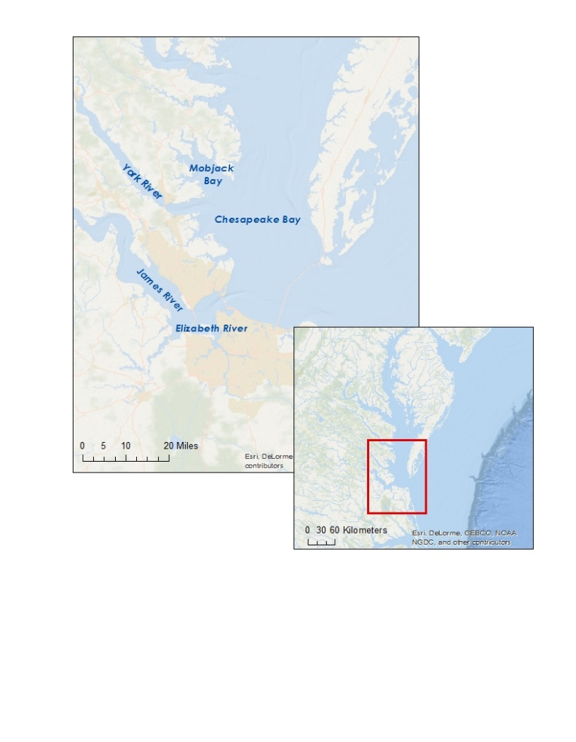The HAB Task Force maintains 20 fixed testing stations throughout the region where various water quality parameters (chlorophyll-*a* content, salinity, temperature and turbidity), genetic molecular analysis, and HAB/phytoplankton identification tests are conducted monthly from May to November (VECOS). Additionally, a 24 hour HAB hotline has been established for community members to report suspicious colors, smells or fish kills. When a HAB is detected or reported, the response team collects samples that are analyzed at different institutions depending on the nature of the report. Then, VA Health Department determines future actions based on guidelines set by the Clean Water Act and State of VA Water Quality Standards.

Figure 1: Map of study area and the greater Chesapeake Bay Area

While these resources exist, the total area of the Bay is too large to continuously monitor, and current methods do not allow for the desired real-time monitoring of the area. A more efficient, cost-effective method of identifying and studying HABs is necessary to assist local, state, and federal agencies and research institutions in their efforts to protect the Chesapeake Bay.

Our goal is to provide a method of identifying HABs in real time to our various partner organizations. Building upon the work done by the Virginia Water Resources project from summer 2015 of NASA DEVELOP, we integrate Landsat 8, Aqua MODIS, and historical *in-situ* data to create a python tool that highlights high concentrations of chlorophyll in the Chesapeake Bay and its estuaries. With this tool, our users will be able to locate and monitor the timing, magnitude, duration, and frequency of HABs quickly and efficiently. This project addresses NASA’s Earth Science Water Resources application area and aligns with the goals of Executive Order 13508 to target resources, define tools, strengthen scientific support for decision making, and develop focused and coordinated research programs to improve water quality of the Chesapeake Bay.

# III. Methodology

**Data Acquisition:***Landsat Data*  
Landsat 8 data products were obtained from the United States Geological Survey’s (USGS) Earth Explorer for dates ranging from May 2011 through September 2015. Path 14, Row 34 was used as the search criteria, to obtain cloud free images of the James, York, and Elizabeth Rivers, Mobjack Bay, and the Chesapeake Bay.

*Aqua Modis*Aqua Moderate Resolution Imaging Spectroradiometer (MODIS) Level 2 data for the Chesapeake Bay were obtained from the National Oceanic and Atmospheric Administration’s Coastwatch’s East Coast Node. The data were processed using the NOAA 3-band ocean color algorithm (OC3) with a combined NIR-SWIR atmospheric correction (NOAA CoastWatch).

*Ancillary Data*  
Ancillary data were collected from the Virginia Institute of Marine Science’s Virginia Estuarine and Coastal Observing System (VECOS). VECOS produces a variety of data collections, including the high resolution mapping of surface water quality (DATAFLOW) we used. We received a DATAFLOW for August 17th, 2015, which provided detailed chlorophyll-*a* measurements (in µg/L) for 3050 locations all along the York River.

*Bathymetric Data:*  
Processed bathymetric data were obtained from the first term of this project.

**Data Processing:** *MODIS*:  
We imported the MODIS chlorophyll-*a* estimates in ArcGIS, then converted the .hdf rasters into point clouds using the “raster to point” tool.

*Landsat:*   
True reflectance composites were compiled by dividing the pixel values by 10,000 for bands 1-5 of the Landsat 8 data. We then applied several masks to the data to remove land and cloud pixels. Since we’re interested in studying the chlorophyll in the water, we needed to throw away any land pixels in the data. We achieved this using the method and ArcGIS tool created by the previous team, which uniquely identifies water pixels from each rescaled band and extracts them to a “water only” mask for each band.

Clouds will be removed using a cloud mask, created with the cf_mask_layer from the Landsat data download. Pixel values in the cf_mask_layer with a value of “2” or “3” were reclassified to “0”. All other pixels were given a value of 1. Missing values were given a value of “no-data”.

In order to cross calibrate the data with the Aqua MODIS chlorophyll data, they need to have the same resolution. We will use the reclassified Landsat data to the resolution of the MODIS data using the “focal” statistics tool. The mean value of each 47 x 47 pixel window on the Landsat data was found. Null values will be removed to prevent underestimation of chlorophyll-*a*. This will create a shore-buffer effect and allowed us to cross-calibrate the processed Landsat and MODIS data.  
  
We plan to follow the method outlined by the previous team for the continual reduction and calibration of our data.

*Bathymetry*  
Processed bathymetry data from the summer term will be used in the extraction of the bathymetry data from the smoothed and reclassified Landsat data.

*Preparation for Cross Calibration:*  
We plan to use the “Extract by Value” to add bathymetry data to the Landsat data layers, which should result in MODIS Chlorophyll values + processed and blurred Landsat values + processed and blurred bathymetry data.  
  
In a table, we will use the “exponential transform tool” because small changes in depth in shallow water are more prevalent and provide more sensitivity than changes in moderate to deep water. We will then export this table to excel in a .dbf format, save it as a .csv file, and import that file into R for statistical analysis.

**Data Analysis**

In 2015, researchers in Korea used Landsat 8 OLI reflectances to assess water quality in Korean Rivers (Lim and Choi 2015). We based our methodology on their findings and cross calibrated Landsat Data with Aqua Modis data and *in-situ* data.

On August 17, 2015, researchers from VIMS collected additional *in-situ* data in the James and York River, and Landsat 8 captured images of our study area. Landsat 8 also provided virtually cloud free data for that date. Because of the availability and quality of the data, we chose August 17, 2015 as our initial cross-calibration date. To make our model more robust, we also selected July 19, 2013 because there were few clouds and most of the study area is visible in Landsat 8 and Aqua MODIS imagery.

We will run multiple linear and nonlinear regression models in R to identify the most accurate algorithm for producing the location of algal hotspots present in a given Landsat data set.

# IV. Results & Discussion

Insert images, graphs, maps, charts, etc. here. Choose the most important results to highlight here. No word cap, but two to six pages is a good range.

Things to discuss:

* Analysis of Results: What can you tell from your graphs, images, etc? What does this mean for your project?
* Errors & Uncertainty: What factors could you not account for, what things didn’t work out like you expected they would, etc.
* Future Work: If this project was to be selected for another term, what would be the focus? What other areas would be of interest?

# V. Conclusions

Final conclusions. Word count: 200-600 (~a page).

# VI. Acknowledgments

We would like to thank the following people for their assistance in the research and development of our tool:

* Sara Lubkin and Cassandra Ross for their work on the first half of this project
* Dr. Kenton Ross - *National Program Science Advisor*
* Dr. Kim Reece, Dr. Jian Shen, Dr. Wolf Vogelbein - *Virginia Institute of Marine Science*
* Bob Vangundy – *University of Virginia at Wise Science Advisor*
* Dr. DeWayne Cecil – *Global Science and Technology, Inc. Science Advisor*

Any opinions, findings, and conclusions or recommendations expressed in this material are those of the author(s) and do not necessarily reflect the views of the National Aeronautics and Space Administration.

This material is based upon work supported by NASA through contract NNL11AA00B and cooperative agreement NNX14AB60A.

# VII. References

Lim,J & Choi, M (2015) - Multiple regression models of spectral reflectance and water quality parameters. Environmental Monitoring Assessment 187: 384.

Ondrusek, M et al (2012) - The development of a new optical total suspended matter algorithm for the Chesapeake Bay. Remote Sensing of Environment 119.

ChesapeakeBay.net (2015) – Population Growth. http://www.chesapeakebay.net/issues/issue/population_growth#inline

# VIII. Content Innovation

In preparation for DEVELOP’s coming microjournal, please select three content innovation features to support your paper. For each item, please list the name of the feature, and include the tool itself if possible (eg. glossary terms and definitions). If the tool does not work in Microsoft Word (eg. Interactive MATLAB Figure Viewer), please list the file name and upload the related file to the DEVELOP Exchange. If you choose to use Inline Supplementary Material, please also include where the material should appear in the text.

**Some options include:**

AudioSlides

Database Linking Tool

Data Profile

Executable Papers

Featured Author Videos

Featured Multimedia for this Article (video and podcast options)

Glossary Viewer

Inline Supplementary Material (figures, tables, computer code)

Interactive Map Viewer

Interactive MATLAB Figure Viewer

Interactive Plot Viewer

Nomenclature Viewer

# IV. Appendices

Insert here