NASA DEVELOP National Program
Wise County Clerk of Court’s Office
Fall 2015

African Great Lakes Weather
Utilizing NASA Earth Observations to Identify Indicators to Help Predict Deadly Storms over African Great Lakes


Technical Report
Rough Draft – October 8, 2015

William Wilson (Project Lead)
Annabel White
Grant Bloomer
Juan Antonio

Dr. Kenton Ross, NASA DEVELOP National Program (Science Advisor)
Kristopher Bedka, NASA Applied Sciences Climate Science Branch (Science Advisor)
Dr. DeWayne Cecil, Global Science and Technology, Inc. (Science Advisor)
Professor Robert VanGundy, University of Virginia’s College at Wise (Science Advisor)
Melanie Salyer, NASA DEVELOP at Wise County Clerk of Court’s Office (Mentor)

I. Abstract
The African Great Lakes lie along the East African rift valleys and play an important role in the economy and culture of the millions of people in the region. The regional governance of the lakes’ climate and weather, while less understood, is just as profound. Intense storms occur around the lakes with little warning and can create life-threatening hazards to unsuspecting fisherman, causing their fishing vessels to capsize or wreck. Finding correlations between climatic indicators that precede the onset of these storm events will aid the Kenya Meteorological Department in their ability to improve the forecasting efforts of local and regional authorities. Utilizing the overshooting top (OT) detections within the Hazardous Storm Event Database (derived from the SEVIRI sensor on the METEOSAT satellite), certain times of heightened detection were used as temporal study areas around which an assortment of meteorological data was compiled. MERRA products and TRMM LIS data were used in this term project as mediums of analysis for which intensity levels of OT frequency were compared statistically and spatially.

Keywords
Earth Observations, Lake Victoria, weather, hazardous storms, natural disasters, MERRA, SEVIRI, LIS

II. Introduction
The African Great Lakes region spans Eastern Africa’s tropical rift valleys, including parts of sovereign states such as Kenya, Tanzania, Uganda, Burundi, Rwanda, and the Democratic Republic of the Congo. Of these great lakes, the most significant are Lake Victoria, which is the second largest freshwater lake in the world in terms of surface area, as well as Lake Tanganyika, which holds the same distinction but in terms of volume. These lakes are so large that they significantly influence regional climate conditions. Furthermore, Lake Victoria serves a vital role in the economic livelihood for the 30 million people living along its coastline, of which almost 1/3 of the food supply is sourced from the lake by more than 200,000 fishermen (Thiery, 2015).

While much is already known about how these large lakes regulate climate and contribute to the diurnal cycles of lake/land breezes and the thermal gradient surrounding the lake, less is understood about the provenance of hazardous weather events in the lakes’ immediate vicinity. Part of this is due to the area’s tropical conditions, where tumultuous storm events arise suddenly and are not always accompanied by larger, more comprehensive storm movements. Thunderstorms that arise over these lakes, especially Lake Victoria, are severe; their convective activity commonly approaching altitudes extending 6 km into the sky, producing gale-like conditions of high winds, and having some of the most dense and frequent lightning strikes in the world. It is estimated that around 5,000 fisherman die every year on the lake as a result of these storms (Barnett, 2013).

This project aims to better understand the meteorology of these storm events by analyzing atmospheric conditions that surrounded some of the most severe storms during the study period of 2005 – 2013. Data compiled into a ‘Hazardous Storm Event Database’ over the African Great Lakes region were utilized for this research. This Hazardous Storm Event Database, maintained by Kristopher Bedka at the NASA Langley Research Center, is a directory of pixels that have been classified as ‘overshooting tops’ (OT’s) by a detection algorithm developed by NASA’s Applied Sciences Program and the GOES-R Aviation Algorithm Working Group. The designation of OT refers to the convective phenomenon in which strong updraft currents punch through into the lower stratosphere, above the storm equilibrium level. Storm events that feature overshooting tops yield especially hazardous conditions at ground level. Employing infrared brightness temperatures from the SEVIRI sensor onboard EUMETSAT’s METEOSAT satellite, this algorithm analyzed 15-minute geostationary images during the aforementioned time period, and thus set the terms for the temporal study area as a byproduct of what was included in the database (Bedka, K. et. al. 2010), (Bedka, K. 2011)

The partner for this project is the Kenya Meteorological Department (KMD), whose mission is, “to facilitate accessible meteorological information and services and infusion of scientific knowledge to spur socio-economic growth and development.” The KMD is a new partner to DEVELOP, but it has worked closely with NASA SERVIR in the past. NASA’s Short-term Prediction Research and Transition Center (SPoRT) worked with the KMD on inserting data from NASA LIS into KMD weather prediction models. SERVIR has previously had a presence at the department; helping train KMD personnel in using NASA Earth observations for better integration into modeling changes.

This project will assist both the project partner and the researchers at NASA Climate Sciences Division by expanding on the knowledge associated with the detection of overshooting tops. Thus, by nature of the scope of this initial term, the project falls most directly into the Weather application area. However, the application areas of ecological forecasting and disasters are the inspiring source on which the project is grounded and subsequent terms might be better classified within these application areas.

III. Methodology

Pixel directories, which spanned from 2005 – 2013, were acquired from this Hazardous Storm Event Database (HSED). Each row in the data corresponded to a pixel that had been classified from the SEVIRI images as an OT by the detection algorithm mentioned in the introduction. The rows were set up with 7 columns with the following information:

- Column 1: YYYY-MM-DD-HHmm; HHmm=time of satellite scan in UTC
- Column 2-3: Latitude/Longitude of pixel with storm detection
- Column 4: Satellite-observed infrared temperature of pixel
- Column 5: The temperature difference between the pixel with storm detection and the surrounding cirrus anvil cloud.
- Column 6: A quality control parameter
- Column 7: The “ID number” for the storm detection within the satellite image at a particular date and time. There are multiple pixels within each storm and the ID number helps one to cluster them together.

MATLAB r2015a was used to compile the raw data from the Hazardous Storm Event Database. The initial data contained multiple OT detections for almost every day over the 9-year study period, totaling tens of millions of data points. This data was imported into MATLAB and summarized by day, reducing the amount of data points to fewer than 3,500.

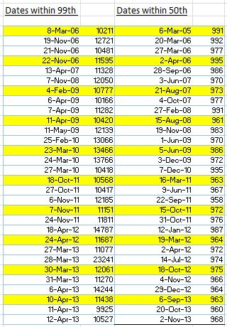
After processing in MATLAB, the data was imported into Microsoft Excel for further consolidation. Using the Percentile function within Excel, days that recorded within the 99th percentile were extracted from the database’s temporal span. The same was done at the 50th percentile to use as a baseline for comparison. From these subsets, 10 days were chosen through a systematic random sample amongst the group to use as study cases. With 30 days at each percentile the dates and their associated count statistic were listed chronologically and then every third date at each level was selected into what would become the sample set (See Figure 1).

From here forward, the 99th percentile or intensity level will be referenced as ‘IL99’ while the 50th percentile or intensity level will be references as ‘IL50’. When both are being referred to, the term ‘intensity percentile’ will be used.

With these sample dates at IL50 and IL99 selected to represent the temporal span of the study, the x.yy location of these OT tops were plotted to generally assess their distribution relative to the lakes.
Figure 1: systematic sampling of the intensity percentile dates

Initially, the entirety of the data contained in the HSED was used, however, by plotting the points derived from this initial extent, the conclusion was reached that this extent was not practical for the scope of the project.

While using the entirety of the HSED, the phenomenon occurring over the lakes was diluted by storm events which occurred in other areas of the East African region. It was observed that the drive in differences between intensity percentiles was not lake centric, given that the IL99 percentile plots were consolidated over the Mitumba highlands in the eastern Democratic Republic of the Congo and away from the East African rift valleys.

Thus, the study area was substantially narrowed in a subsequent trial so that other geomorphologies could not convolute research in regards to lake centric weather phenomenon. To achieve this, a single lake was chosen instead of trying to encompass everything that could be said to be a part of the “African Great Lakes”. Since the partners for this project are from the Kenya Meteorological Department, the obvious choice was to selectively study the area around Lake Victoria; the same lake that initially inspired this project . It should be noted here that the dates in Figure 1 are from this revised study area. This study area is shown in Figure 2 and extends from 31°E to 38°E by 3°S to 2°N.

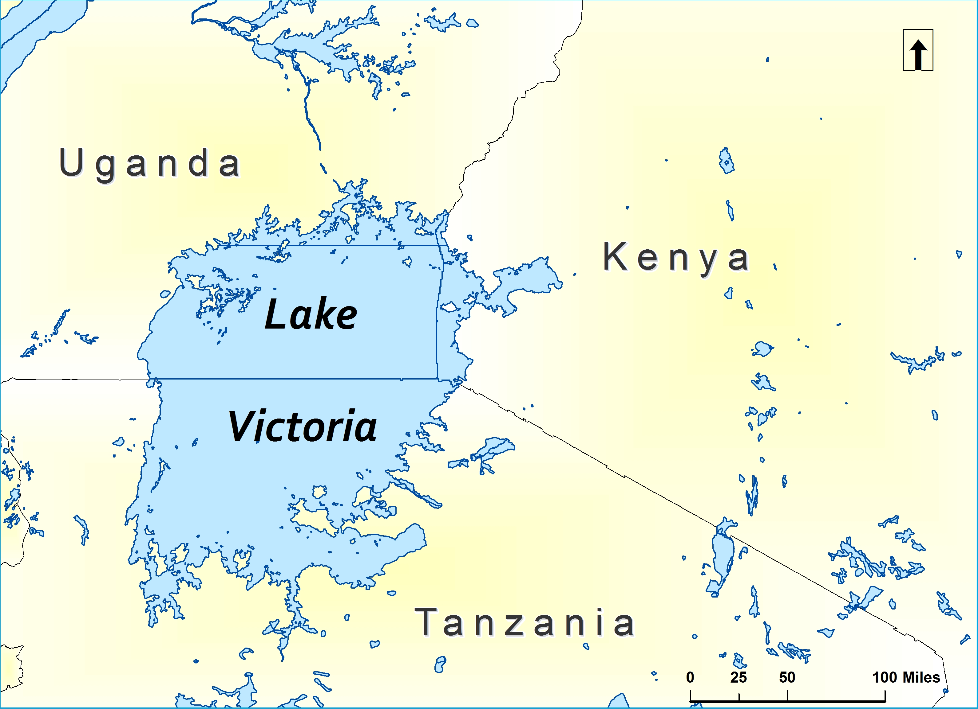
Here again, the OT detections were plotted which fell within the study area. (Figure 3).

For doing this, a separate MATLAB script was created from the original, wide extent script, which not only preserved attribute information when summarizing by day, but also narrowed the extent of the data to include OT detections that were within the new study boundaries.

After creating this script and sub setting the data with MATLAB, data tables were created in Excel for ease of manipulation, where they were then separated and exported into two CSV files (one for each intensity percentile) for compatibility with ArcMap 10.1. Using the Create XY Event layer tool in ArcMap 10.1, these OT’s were plotted based off latitude and longitude data contained within the attribute information. Maps showing these raw OT’s and associated point density maps are shown below.
Figure 2: revised area of study, centered on Lake Victoria, offset slightly to include parts of Eastern Kenya more relevant to our partner organization.

The point density maps were made using the Point Density tool in ArcMap and were classified with a stretch over 2.5 standard deviations. This highlighted greater variability at IL99. Default neighborhood and output cell size were maintained.

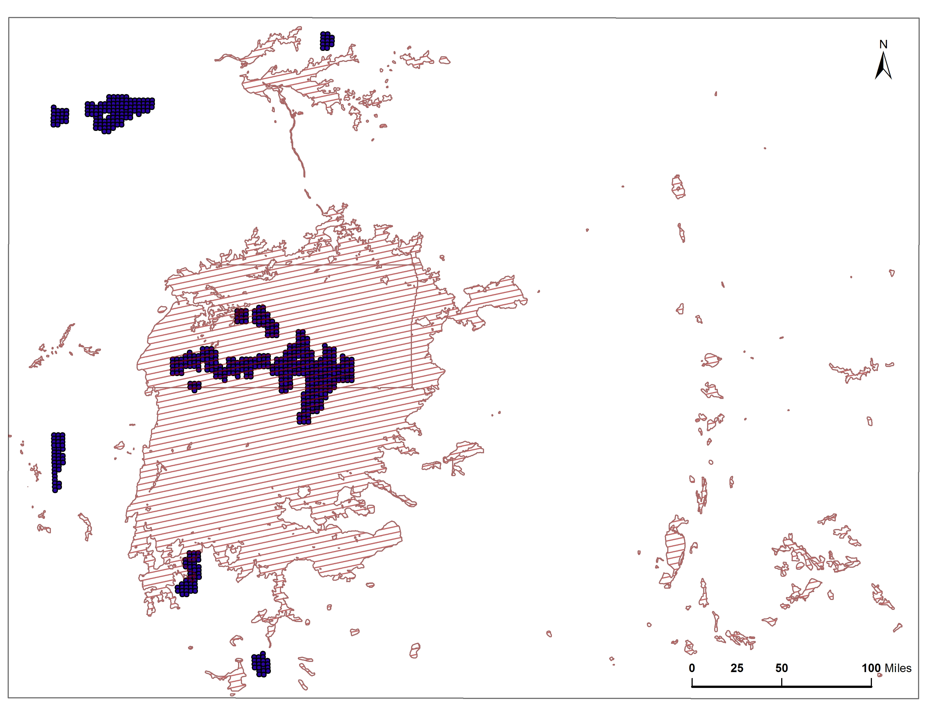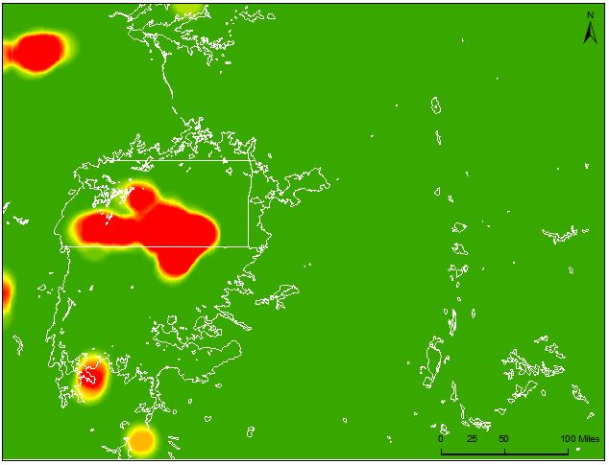
OT point density@ IL50
OT raw points @ IL50

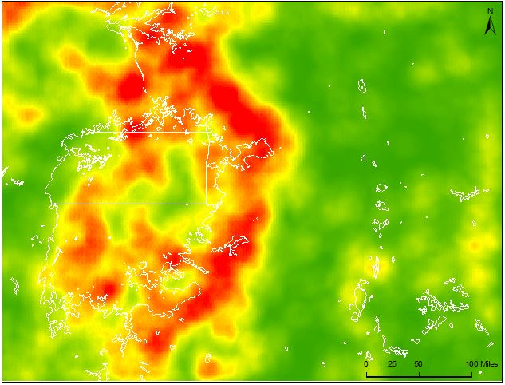
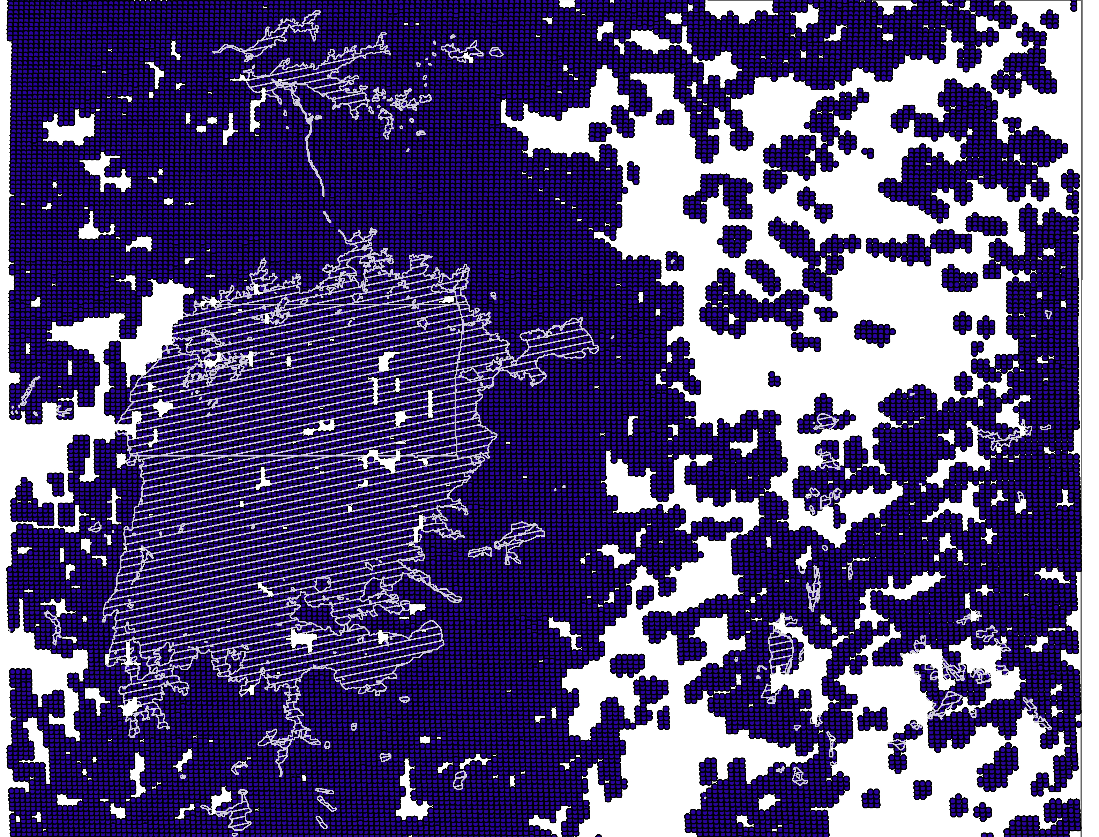
OT raw points @ IL99
OT point density @ IL99
Figure 3: Raw OT points & associated point density displays

Partly to reconfirm this algorithm and partly to explore LIS sensor data for future use, LIS data products were obtained and lightning strikes were plotted as data points to visually assess how to the data ‘lay’ in relation to these OT’s.

LIS data were accessed by way of a file transfer protocol directory using FileZilla. This file transfer protocol was publicly accessed from the NASA’s Global Hydrology Resource Center (GHRC) website. Organized by day with 16 HDF files each, all data for the days corresponding to the 20 that were used as study dates – 10 at each intensity percentile – were obtained. The raw hdf formatted files had to be reformatted into HDF4 format before they could be handled by HDFView. This was done manually by simply adding ‘.hdf’ as an extension to each file.

These files were brought into HDF view one study day at a time. Here, the raster image could be viewed for each file which displayed the associated swath and the detections therein.

LIS data are compiled at 4 levels based on how the optical pulse events detected by the sensor are aggregated. At the most basic level are individual pulse ‘events,’ while the next higher order aggregation are ‘groups.’ The group level was used in this project due to its interpretability as individual lightning strikes. The following excerpt from the user manual details these layers in detail:

"Groups are collections of observed pulse events (see below)
occuring during the same 2 ms time frame, which are also adjacent to each other in sensor CCD pixel space. Groups may be interpreted as individual lightning strokes or K-changes. They are the basic building blocks of
ashes, and hence ofareas. The algorithm which clusters events into groups is robust, well defined and stable, so users may wish to consider groups, rather than events, as the lowest level lightning data." – LIS User’s Guide.

Although the detections were displayed in the raster image at the ‘flash’ level in HDFView, the swath position and presence of flashes were used as indicators of LIS ‘group’ information. The group data corresponding to the correct swath position were then exported into Microsoft Excel.

From Microsoft Excel, the group data from each swath were organized and narrowed in extent to match the study bounds. With two compiled text files (for each intensity percentile) that included latitude and longitude attributes, the LIS data were plotted as points in ArcMap 10.1, similar to the OT detections. A visual side-by-side map series is displayed below.

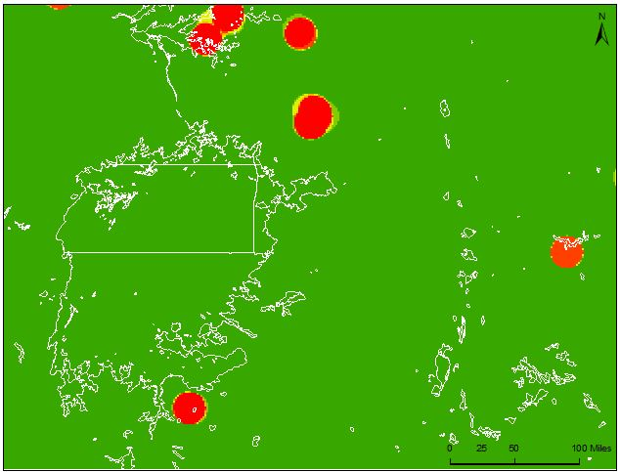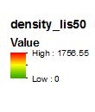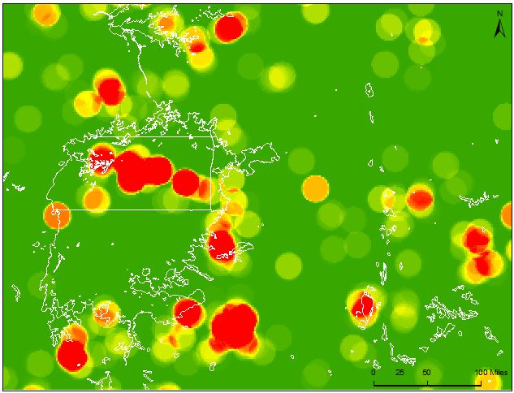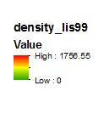
LIS point density @ IL99
LIS point density @ IL50

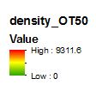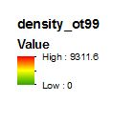
OT point density @ IL99
OT point density @ IL50

Figure 4: LIS point density & OT point density displays

From this map series, a visual correspondence of the IL99 OT and LIS point densities can be observed. While the IL50 wasn’t necessarily expected to correspond over these ‘average’ conditions that might be less spatially tied, stronger conditions at the upper tier (the IL99) were generally expected to be more tightly defined. This exploration of the LIS data was used to gauge how well OT and LIS indicators of intense storm activity aligned or ‘overlapped’.

With the study dates set, the project began to probe the differences between conditions at the IL50 and IL99 sets. To do this the Modern Era Retrospective Analysis for Research and Applications (MERRA) data structure from the Global Modeling and Assimilation office at the Goddard Space Flight Center was employed.. From the Goddard Earth Sciences Data Information Services Center (GES – DISC) (MERRA) products were downloaded as zipped NetCDF files for each study case at the 99th and 50th percentile study cases.

This data product information is described below.

Product name: tavg1_2D_slv_Nx
Short name: MAT1NXSLV
Long name: MERRA IAU 2d atmospheric pressure single level diagnostics

This global coverage data product contained 42 gridded variables at the MERRA ‘native resolution’ of ½° by 2/3°. ‘Single level’ diagnostics refer to a single vertical level of recorded data. There are 72 vertical levels in GEOS-5 that extend through the stratosphere. (GEOS-5 is the data assimilation system used by the MERRA re-analysis). Of these 42 variables in this product, this project used 7 of them – all of them, with the exception of surface skin temperature (TS) – taken from the 500mb pressure level. This is because 500mb occurs at around a 6 km altitude and circulations, winds, and/or localized regions of cold temperatures at that altitude have strong impacts on what happens with regards to thunderstorms at the surface.

The following variables were downloaded over our IL50 and IL99 study dates:

- H500 Height at 500mb (m) : 19
- U500 Eastward wind at 500mb (m/s) : 6
- V500 Northward wind at 500mb (m/s) : 9
- Q500 Specific humidity at 500mb (m/s) : 15
- OMEGA500 Vertical pressure velocity at 500mb (Pa/s): 21
- T500 Temperature at 500mb (K): 12
- TS Surface Skin Temperature (K): 32

The index numbers listed after the descriptions are useful for extraction purposes and were used in MATLAB codes to extract the necessary data from the larger MAT1NXSLV product. The MATLAB code extracted six hour summaries from this data, which was then compiled into a working document in Microsoft Excel.

After extracting the necessary data, each data product at each intensity percentile contained 40 average values. These were quarterly averages over each of the 10 days at the respective intensity percentile. This data was used to generate summary statistics and for later use with JMP 12 software.

Sticking within the MATLAB suite, a script was created, here called “Daily Average Contours,” which summarized a single day’s data and output a contour map showing the average conditions of that variable over that day. This script is easily editable so that the time-step could be sliced differently for future analyses. An example of the contour output is shown in Figure 5. Note Lake Victoria is shaded for reference.

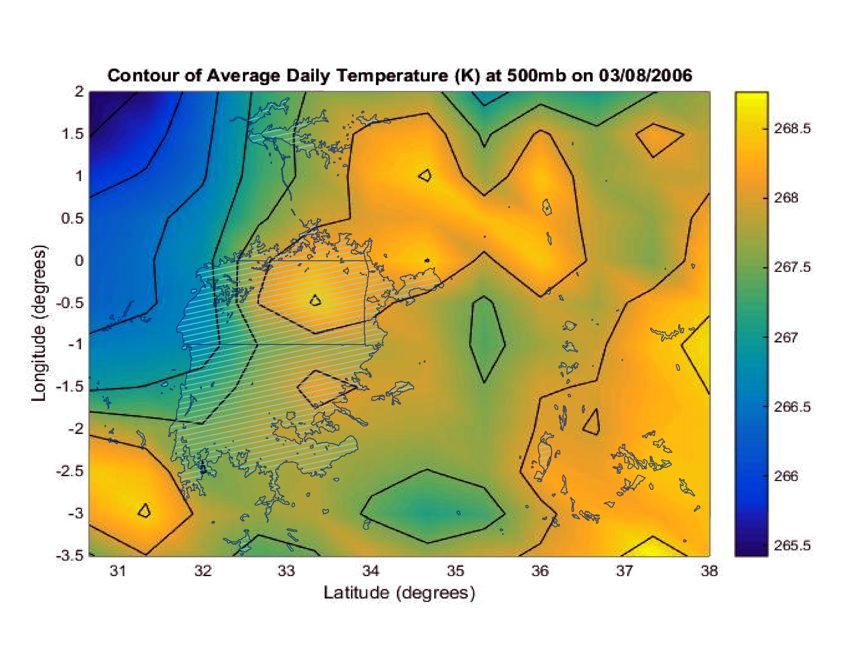
Latitude (degrees)
Longitude (degrees)

Figure 5: Script output example

Daily maps for each variable at each intensity percentile have been compiled into a document for reference.

The data behind these maps was analyzed by using the JMP 12 statistical software package. Within JMP 12, first the One-way analysis platform was utilized to examine the distribution of the continuous response variables within the categorical IL50 and IL99 sets.

To do this, the data was assembled appropriately into a JMP data table format, which for this type of analysis required only two columns – one with the response values and one with the associated categorical information. The One-way platform processes this table into an interactive plot from which statistics can be drawn. An example plot is shown in Figure 6.

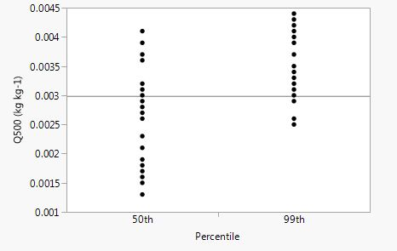
Figure 6 : Response Plot

This plot shows the raw response values as points. There are 40 points for each intensity percentile – many are these overlapped at the same ‘level’ on the graph.

This distribution was also visualized using quantile plots which summarize the distribution of these responses at each categorical level (Figure7). These quantile plots were useful for looking at the spread of values within a categorical level, but the further analysis of variance tested whether these spreads of data were significantly different or not (Figure 8). An analysis of variance essentially looks at the total response of the data and then uses this as a base to assess between-group variability and within-group variability. If the between–group variability is a lot larger than the within-group variability, then there is significant difference. An F-Ratio statistic and a probability (p-value) statistic determine whether there is significance between group means.

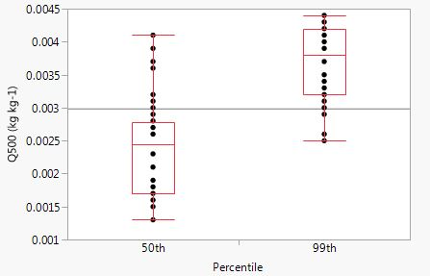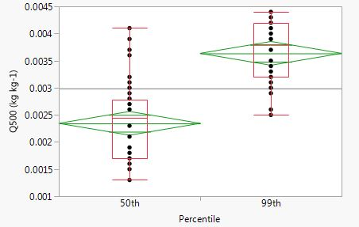
Figure 7: Quantile Plot
Figure 8: Analysis of Variance Plot

While the one-way analyses look at the distribution of variables at different categorical levels, multivariate correlations are used to look at relationships between continuous response variables. We generated multivariate scatterplot matrices and Pearson coefficient matrices at the IL50 and IL99 levels. The scatterplot matrices are below as Figures 9 & 10.

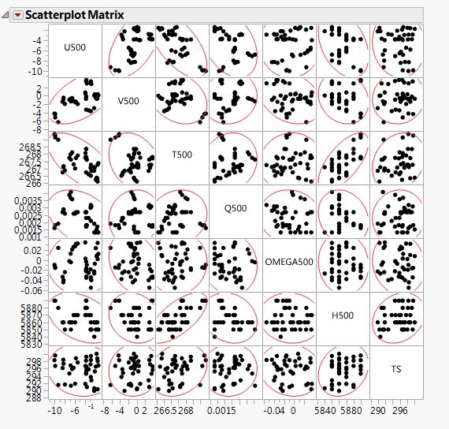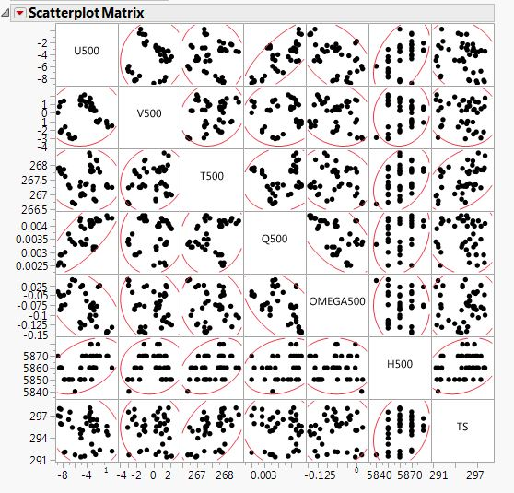
Figure 10: Scatterplot Matrix, IL99
Figure 9: Scatterplot Matrix, IL50

The scatterplot matrices with the density ellipses included are useful for getting acquainted with trends in the data. From there we were able to set up more specific plots tailored to individual trends but fell back on using the Correlation report as the main object of our discussion. The correlation report contains the Pearson coefficient matrices that put a number on the plots above. The Pearson product-moment correlation coefficient summarizes the strength of a linear relationship between two variables. The closer the number is to 1 the more positive the correlation, while the closer to -1 denotes and more negative correlation. Any value closer to zero speaks to a lack of correlation between the variables.

IV. Results & Discussion

Significant differences were found within the sample measurements denoting atmospheric moisture content (Q500) and kinematic vertical pressure velocity (OMEGA500). This is a good sign, along with the point density analysis, that generating the study sets based on OT frequency has grounding in conditions on the ground. Atmospheric moisture and vertical pressure velocity are two environmental aspects that undergo drastic alteration in the vicinity of turbulent storm activity. Other variables here might have more contingent factors that would affect the magnitude of their divergence.
From the multivariate correlation reports, five interesting trends stuck out from the matrices. ‘P-cor’ refers to the Pearson correlation coefficient in the following summaries.
- Strong positive correlation (P-cor: 0.5399) between northward and eastward wind components (at 500mb) at IL50 conditions diminishes almost entirely (P-cor: 0.1179) at IL99 level.
- Strong positive relationship (P-cor: 0.6695) between height and temperature (at 500mb) at IL99 is diminished (P-cor: 0.3620) from IL50.
- Strong negative correlation (P-cor: -0.6243) between temperature and east-ward wind at IL50 has evaporated (P-cor: -0.0716) at IL99.
- Reasonably strong negative correlation (P-cor: -0.3467) between atmospheric moisture content and eastward winds (at 500mb) at IL50 has become a very strong positive correlation (P-cor: 0.7756) at IL99.
- Reasonably strong negative correlation (P-cor: -0.3700) between height (at 500mb) and eastward winds has become a mildly strong positive correlation (P-cor: 0.4502) at IL99.

V. Conclusions

As this project moves into the second term, in lieu of considerable partner input, work can expand on the workflows above. The scripts and extraction methods will be well documented so future teams should be freed up to generate more output.
Future work on this project can revolve around these items:
- Analysis should be performed at different pressure levels in the lower atmosphere, most notably at 700mb and 850mb.
- Statistical analysis and aggregation should be performed at different time-steps to capture events that are limited to certain stretches of the diurnal cycle. Night-day could be a start.
- Contours need to summarize more. Contours that show grand conditions across more study dates would be useful to capture prevailing controls to thunderstorm development. These grand means can then be split into smaller time slices of the diurnal. This would help to better define an ‘environment’ that persists along IL50 and IL99 conditions.
- The study area needs to be taken back out in order to more properly capture what controls thunderstorm development. The narrow extent was useful as far as isolating the study dates, but with those dates selected the project can be more flexible in its spatial range of analysis.

VI. Acknowledgments
We’d like to acknowledge the following people for their assistance:
- Dr. Kenton Ross – NASA DEVELOP
- Kristopher Bedka – Climate Science Branch at NASA Langley’s Science Directorate
- Dr. DeWayne Cecil – Global Science and Technology, Inc.
- Professor Robert VanGundy – University of Virginia’s College at Wise
- Melanie Salyer – NASA DEVELOP

VII. References
Barnett, E. (2013, January 17). Lethal weather on 'world's most dangerous lake' - CNN.com. Retrieved October 7, 2015, from http://www.cnn.com/2013/01/17/world/africa/lake-victoria-weather-deaths/index.html

Bedka, K. (2011). Overshooting cloud top detections using MSG SEVIRI Infrared brightness temperatures and their relationship to severe weather over Europe. Atmospheric Research, 175-189.

Bedka, K., Brunner, J., Dworak, R., Feltz, W., Otkin, J., & Greenwald, T. (2010). Objective Satellite-Based Detection of Overshooting Tops Using Infrared Window Channel Brightness Temperature Gradients. J. Appl. Meteor. Climatol. Journal of Applied Meteorology and Climatology, 181-202.

Burleyson, C., Yuter, S., & Rose, L. (2011). Athmospheric Observations Feasibility Study - Final Report.

Improving Kenya Meteorological Department Numerical Weather Prediction. (n.d.). Retrieved October 7, 2015.

Chamberlain, J., Bain, C., Boyd, D., Mccourt, K., Butcher, T., & Palmer, S. (2013). Forecasting storms over Lake Victoria using a high resolution model. Meteorological Applications, (21), 419-430. doi:10.1002/met.1403

Thiery, W., Davin, E., Panitz, H., Demuzere, M., Lhermitte, S., & Lipzig, N. (n.d.). The Impact of the African Great Lakes on the Regional Climate. Journal of Climate J. Climate, 4061-4085.

