Idaho and Oregon Agriculture

Monitoring Vegetation Impacts of Livestock Management Practices Used to Reduce Predator Conflicts on Idaho and Oregon Grazing Allotments



**Technical Report**

March 29th, 2024

Garret Weichel (Project Lead)

Aarushi Jhatro

Jack Hagenbuch

Hannah Willis

***Advisors:***

Dr. Paul Evangelista, Colorado State University, Natural Resource Ecology Laboratory (Science Advisor)

Dr. Catherine Jarnevich, United States Geological Survey, Fort Collins Science Center (Science Advisor)

Dr. Anthony Vorster, Colorado State University, Natural Resource Ecology Laboratory (Science Advisor)

Nicholas Young, Colorado State University, Natural Resource Ecology Laboratory (Science Advisor)

Christopher Tsz Hin Choi, Colorado State University, Natural Resource Ecology Laboratory (Science Advisor)

***Lead:***  
Truman Anarella (Colorado – Fort Collins)

# 1. Abstract

The practice of night penning, which involves corralling livestock into a fenced, secure area overnight, aims to safeguard animals from predators. Although this method has proven successful in minimizing interactions between livestock and wildlife, the extent of its impact on vegetation communities is still being explored. This project examines the feasibility of using Net Primary Productivity (NPP) values from the Rangeland Analysis Platform (RAP) to quantify the impacts of night penning on rangeland vegetation communities. RAP provides spatially distributed values of vegetation composition, cover and productivity, derived from LANDSAT 5, 7 & 8, at a 30m resolution for rangelands across the United States. Our DEVELOP team partnered with Alderspring Ranch, Krebs Livestock, and the U.S Department of Agriculture Animal & Plant Health Inspection Service (APHIS) to analyze the impacts of night penning on vegetation communities. We identified control sites that captured the topographic characteristics of night pen sites used by our partners. We then quantified and compared changes in annual NPP between night pen and control sites. Our analysis of RAP NPP data, using a control-treatment design did not find impacts of night penning on vegetation. However, this was a preliminary analysis, and does not conclusively quantify the impacts of night penning on rangeland vegetation. Our analysis indicated that RAP may be a feasible tool to study livestock management impacts on rangeland vegetation; however, any such studies must be validated through ground observations.

**Key Terms**

Rangland Analysis Platform (RAP), Rangeland production (RP), cover composition (CC), net primary production (NPP), Compound Topographic Index (CTI), Heat Load Index (HLI), Night Penning.

# 2. Introduction

***2.1. Background Information***

Rangelands are ecosystems dominated by grass, forb, and shrub vegetation communities, and cover approximately 25% of the earth’s terrestrial area (Alkemade et al., 2013). These ecosystems support over half of the global livestock populations (Havstad et al., 2009), and provide essential ecosystem services for over two billion people (Sala et al., 2017). Additionally, these ecosystems provide habitat to sustain a diverse array of biodiversity and can be some of the most species-rich systems across the world (Alkemade et al., 2013).

Livestock farming is the dominant land use in rangeland systems, with over 200 million pastoralists relying on rangeland ecosystems for their livelihood (Bank, 2009). Livestock producers across the world are facing the complex effects of climate change on resource availability, such as declining biodiversity, decreased forage production, and altered hydrologic regimes, which have impacted their ability to maintain livestock-based livelihood (Jablonski et al., 2020). These impacts include increasing conflicts with wildlife competing for scarce resources in rangeland systems, such as elk eating livestock feed, or bears and wolves preying on livestock. There is an increased usage of intensive livestock management practices that can reduce livestock-wildlife conflicts and beneficially manage vegetation communities by mimicking the historic grazing patterns of herbivores.

***2.2 Scientific Basis***

Night penning is a form of intensive livestock management, where after a day of grazing, animals are corralled into a fenced, defendable space. While night penning has been found to be effective at reducing livestock-wildlife interactions, its impact on vegetation communities is still being explored. One study at the Guizhou Weining Pasture Experimental Station in Guizhou, China, found that sheep night penning significantly reduced live shrubs within the pastures; vegetation sown post-penning grew faster within the night penning sites, than at sites without the combined effects of urine, dung and treading found at night penning sites (Zhang et al., 2021). Another study in semi-arid Mediterranean planted forests, found that night pens had higher levels of soil nutrients (nitrogen, phosphorus, and potassium), and herbaceous biomass production for 15-20 years after the sites were abandoned (Vinograd et al., 2019). While both studies indicate that night penning might benefit vegetation regeneration in the long-term, their conclusions are limited to sown vegetation (Zhang et al., 2021) and managed forest systems (Vinograd et al., 2019).

Net primary productivity (NPP) is the rate at which plants generate biomass through photosynthesis, and represents an essential ecosystem service upon which livestock, wildlife, and humans depend. The Rangeland Analysis Platform (RAP) is a gridded dataset, with a 30 m spatial resolution, that provides annual estimates of NPP across four vegetation groups found across rangelands – perennial forbs & grasses, annual forbs & grasses, shrubs and trees (Jones et al. 2020). This feasibility study sought to understand the long-term impacts of night penning on vegetation communities in temperate rangelands of North America using RAP data. Specifically, we worked with partners to analyze trends in NPP before, during, and after night pen establishment.

***2.3 Project Partners & Study Area***

Our DEVELOP team partnered with Alderspring Ranch, Krebs Livestock, the U.S Department of Agriculture Animal & Plant Health Inspection Service (APHIS), and the National Wildlife Research Center (NWRC) to analyze the impacts of night penning on vegetation communities. Alderspring Ranch and Krebs Livestock ranching operations are leaders in testing, refining, and implementing grazing management practices that reduce conflicts with predators and improve rangeland ecosystems. They both aim to maintain successful businesses producing food and fiber while stewarding the natural environment. The U.S Department of Agriculture works to ensure a safe and sufficient food supply, while enhancing agricultural trade through efficient management, with a commitment to environmental sustainability. The Animal & Plant Health Inspection Service and The National Wildlife Research Center address wildlife conflict to help people and wildlife coexist.

For this project, the study area included two grazing allotments; one located in northeastern Oregon (grazed by Krebs Livestock), and the other in central Idaho (grazed by Alderspring Ranch). Each grazing allotment contains multiple night penning sites, which have been utilized from 2015-2023 by Alderspring and 2017-2023 by Krebs. These night penning sites are the primary study areas (Figures 1 & 2). Additionally, control points for each night penning site are included in the study area.

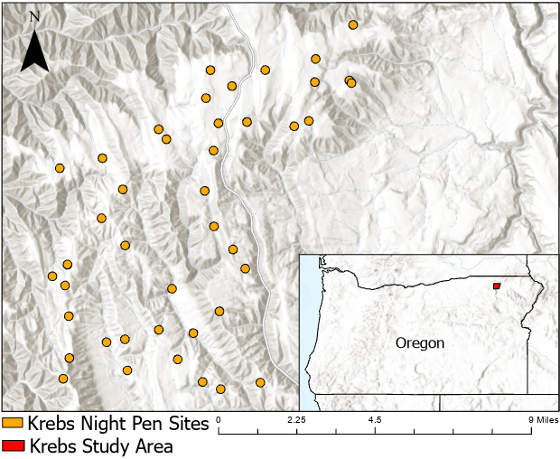

*Figure 1. Krebs Livestock night penning sites located in northeastern Oregon. Sites are enlarged for reference. Basemap: ESRI.*

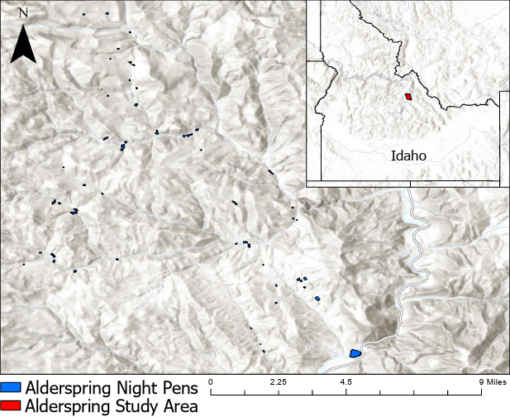

*Figure 2. Alderspring Ranch night penning sites located in central Idaho. Basemap: ESRI*

***2.4 Project Objectives***

The partner ranching operations have developed effective solutions to reduce predation on their livestock through night penning but have questions about how this management practice influences rangeland vegetation. Remote sensing data can offer insights into vegetation response to night penning by providing information on spatial-temporal trends and correlations between vegetation, topography, and management. Specifically, a quantitative assessment of the annual changes in net primary production will support partners in understanding how night penning influences vegetation response, and if there is an underlying correlation between vegetation response and topographic variables.

The objectives of this project were to identify for each night pen site, a control site that captures topographic controls on vegetation response, and to provide partners with a visualization of trends in vegetation response at night penning and control sites over a 13-year study period between 2000 and 2023. We also created a two-page document to help partners communicate the impacts of night penning with stakeholders, such as the US Forest Service, who would like to see data to quantify the effects of these practices.

# 3. Methodology

***3.1 Data Acquisition***

The project partners provided the team with night pen locations; with Alderspring providing night pen corrals depicted as polygons, and Krebs providing latitude and longitude data for night pens between. We imported the Alderspring locations as polygons and the Krebs data as points into ArcGIS Pro 3.1.0. Based on conversations with Krebs, we created circular night pen polygons with a diameter of 165 ft around the point locations to mimic night penning practice on the ground. These Alderspring and Kreb night pen polygons constituted the night pen study sites for this project.

We downloaded 1 arc-second (~30m) digital elevation models (DEM) from The National Map Viewer (USGS) for two distinct regions covering our study sites (USGS 2023). We used Google Earth Engine (GEE) (Gorelick et al., 2017) to access aerial imagery for the study sites from National Agriculture Imagery Program (NAIP) dataset. Due to inconsistencies in temporal coverage in the NAIP dataset, we used NAIP 2022 for Krebs study sites, and NAIP 2021 for the Alderspring sites.

We identified Net Primary Productivity (NPP; Allred et al. 2021) from the Rangeland Analysis Platform (RAP; Jones et al. 2020), as a variable of interest to study vegetation response to night penning. We used GEE to access the Net Primary Productivity data for the study sites between 2000 and 2023.

Table 1.

*Remotely Sensed Data Used To Study Impact of Night Penning on Vegetation*

|  |  |  |  |  |  |  |
| --- | --- | --- | --- | --- | --- | --- |
| **Index** | **Dataset** | **Variables** | **Sensor** | **Resolution** | **Dates for which Data was Acquired** | **Aquisition Method** |
| 1 | DEM  (USGS 3DEP) | Elevation, Slope, Aspect, Heat Load Index, Compound Topographic Index | LIDAR | 30 m | - | The National Map Viewer (USGS) |
| 2 | NAIP | Vegetation Cover | Airborne Camera | 0.6 m | 2021 & 2022 | GEE |
| 3 | Rangeland Analysis Platform | Vegetation Cover (%), Net Primary Productivity | LANDSAT 5 TM (bands 1-5,7)  LANDSAT 7 ETM+ (bands 1-5,7)  LANDSAT 8 OLI (bands 2-7) | 30 m | 2000 - 2023 | GEE |

***3.2 Data Processing***

*3.2.1* *Night Pen Validation*

We observed vegetation patches through NAIP infrared imagery that matched night pen dimensions but did not align with night pen locations (Figure 3). Project partners agreed that these vegetation patches could in-fact be night pen locations, since night pen GPS points were often dropped outside the night pen. We used NAIP infrared imagery to co-validate night pen locations with project partners and re-located 8-night pens.

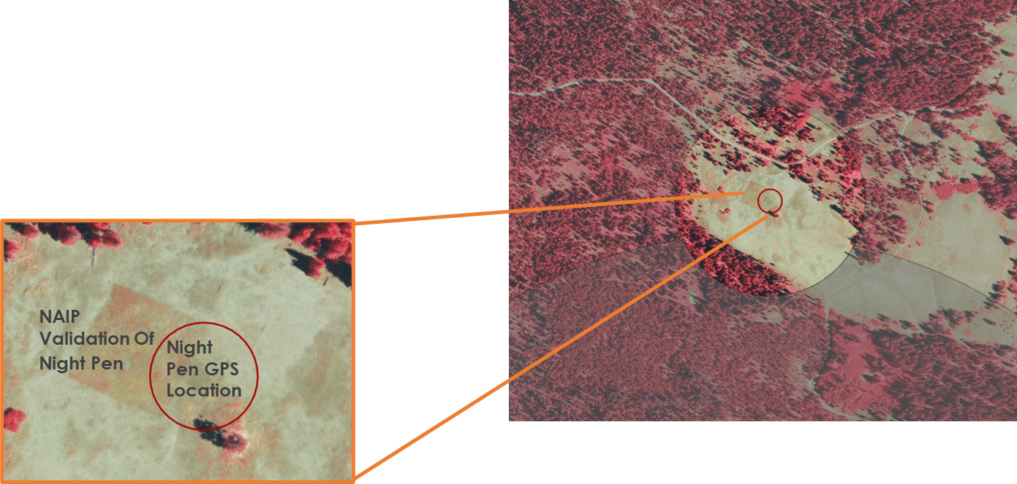

*Figure 3. False color NAIP imagery comparing vegetation patches and original GPS points.*

*3.2.2* *DEM Processing*

To process our data, we first reprojected all acquired data into WGS_1984_UTM_Zone_11N in ArcGIS Pro. We worked in ArcGIS Pro to process DEMs to obtain site topography data. We combined DEMs into two regional DEMs covering the Idaho and Oregon study areas. We then created Slope and Aspect rasters from the regional DEMs, using ‘Slope’ and ‘Aspect’ tool from the 3D Analyst Toolset. We identified two indices, the Heat Load Index (HLI; McCune & Keon, 2002) and the Compound Topographic Index (CTI; Evans et al., 2014), to measure topographic controls on incident solar radiation and hydrologic processes, which are both important drivers of vegetation response. We used the Quantitative Methods in Spatial Ecology toolbox (Evans et al., 2014) to derive the study area CTI and HLI in ArcGIS Pro.

The Heat Load Index (HLI) rescales Aspect (which ranges from 0-360°) to a 0-1 scale, such that the highest values are southwest, and the lowest values are northeast (Equation 1).

$HLI = 1-\frac{\cos\left(Θ-45\right)}{2}$**Equation 1.**

*Where, $Θ$ is the aspect in degrees east of north.*

The Compound Topographic Index (CTI) is a steady state wetness index calculated using slope and upstream contributing area (E2quation 2). A higher value indicates more moisture accumulation at a site.

$CTI = \ln\left(\frac{As}{\tan\left(β\right)}\right)$**Equation 2.**

*Where, $β$ is the slope in radians, and*

*As is the Area Value = $\left(Flow Accumulation+1\right)×Pixel Area \left(m2\right)$*

*Flow Accumulation is calculated from the DEM.*

*3.2.3 Control Site Selection*

Our objective was to identify control sites that captured the topographic controls on vegetation response at night pen sites. We chose control sites by visually selecting areas with similar conditions to night pen sites based on the topographic indices (CTI and HLI). We created a distance buffer that displayed the minimum (200m) and maximum (1000m) distance a control site could be from the night pen it represented. The night pen polygon and distance buffer were then overlayed in Google Earth Engine onto the CTI and HLI raster for each index.

Two or more of our team members viewed the raster layers, and plotted a point that most closely represented each night pen. After that point was placed, we compared it to the represented night pen using a false color NAIP layer, and re-plotted the point if it had a significantly different vegetation type. For the Alderspring control sites, we placed a copy of the night pen polygon over each control point, and for the Krebs sites, we buffered each point to form a circular polygon with a diameter of 165 ft.

Control sites were intentionally spaced at varying distances within the 200m-1000m range to account for ingress/egress of livestock on control sites. Project partners further validated the control site selection using on-the ground knowledge of livestock movement and impact.

*3.2.4**Vegetation Response*

We imported the validated night pen and control site polygons into Google Earth Engine (GEE). After importing our partner data, we also imported partitioned NPP (the net increase in total plant carbon) from the Rangeland Analysis Platform from 1986 to present. NPP Estimates are partitioned into the following functional groups in RAP: annual forb and grass, perennial forb and grass, shrub, and tree. Using script written in JavaScript programming language, a function was defined to clip NPP data based on night-pen names from the imported shapefiles. Another function was written to compute NPP statistics for each night pen and control site polygon according to the functional groups described. NPP statistics were calculated over specific time periods before, during, and after night-penning took place. All the results were merged into a feature collection and then the final NPP statistics were printed and exported as a CSV file to be further analyzed in R Studio.

***3.3 Data Analysis***

We imported the summarized annual NPP data for night pen and control sites into R Studio for further analysis. We extracted the mean annual NPP data from the summarized annual NPP dataset to create time series plots for each site, and to create NPP response distribution plots for all sites together. Our analysis categorized sites used for one year and those used for many years (Table 2). We found 105 unique sites across Idaho and Oregon. While we differentiated sites by usage for assessing differences in NPP response (Figure 9), our analysis considered each site-year combination as its own data point.

Table 2

*Count of night pen sites by frequency of annual usage*

|  |  |  |  |
| --- | --- | --- | --- |
| **State** | **Used Multiple Years** | **Used One Year** | **TOTAL** |
| Idaho | 12 | 55 | 67 |
| Oregon | 33 | 5 | 38 |
| **TOTAL** | **45** | **60** | **105** |

*3.3.1 NPP Time Series*

We created a time series plot for each site that visualized the mean annual NPP between 2000 and 2023 for four vegetation groups – perennial forbs & grasses, annual forbs & grasses, shrubs and trees. We visualized data for both the night pen and the associated control site.

*3.3.2 Relative NPP Distribution*

To assess NPP trends across the sample set, we calculated the relative NPP for a baseline (“*Baseline*”) time period, and for four response years - penning year (“*Penning Year”*), one year after night penning (“*Year 1*”), two years after night penning (“*Year 2”*) and three years after night penning *(“Year 3”).* The baseline period was identified as the five-year period before the first year the night pen was placed. The relative value for NPP was calculated as the NPP from the response year divided by the average NPP during the 5-year baseline period.

# 4. Results & Discussion

***4.1 Analysis of Results***

We calculated the average annual Net Primary Productivity (NPP) for each night pen site and its corresponding control site polygon from 2000 to 2023, and graphically represented these annual averages as a time series for each location. Although the RAP NPP data offered insights into the vegetation composition at each site, a closer examination of the time series data revealed inconsistencies between the vegetation groups identified through NAIP imagery and those determined from the RAP data (Figure 4). For example, the site in Figure 4 is clearly in a meadow. However, RAP data indicates that trees are present within the night pen site. Quantifying these discrepancies was beyond the project's scope, but we acknowledge that the difference in actual on-the ground vegetation composition and RAP vegetation composition likely introduces error into our analysis. Additionally, our analysis aggregated the values of all pixels overlaying a polygon, including pixels outside the actual boundaries of night pen and control polygons. An alternative approach would involve extracting only point values that precisely fall within the polygons.

*Figure 4. Top Left: The GPS Coordinates of the night pen “Looking Glass Camp 1”, collected in the field, viewed with a 165ft buffer next to the real night-pen site- validated with partner feedback and NAIP Imagery. Bottom Left. The night pen site moved to fit the true area, overlayed with RAP NPP dataset imagery to visualize pixels that may fall mostly outside of the night penning area. Right. Time series of the NPP statistics of Looking Glass Camp 1 from 2020-2023.*

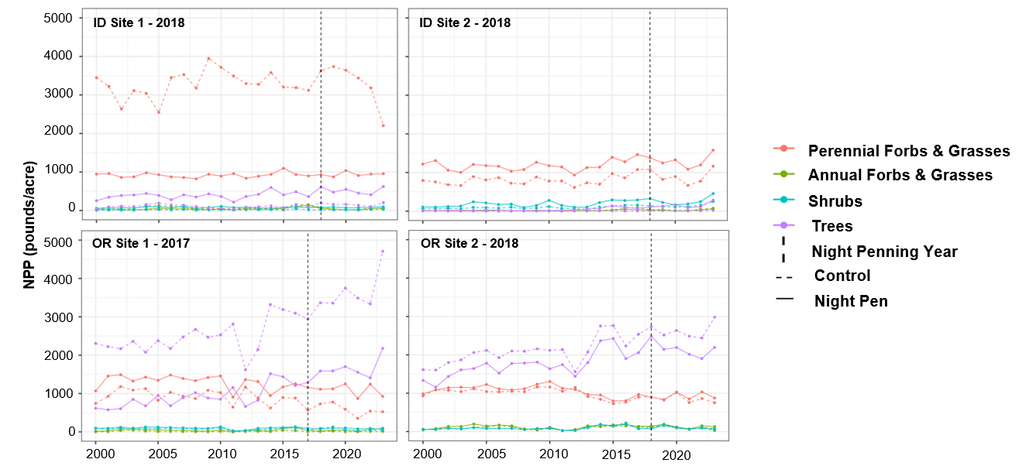

*Figure 5.* *Net primary productivity at four-night pen sites and their associated control sites.*

The time series of four sites are shown in Figure 5. Our analysis revealed variability in Net Primary Productivity (NPP) trends across different sites following the establishment of a night pen. Additionally, the NPP trends observed between a night pen site and its corresponding control site varied across the study area. Although these time series analyses offer an initial evaluation of the response of different vegetation groups to night pen placement, we wanted to identify trends across the entire dataset (Figure 6).

*Figure 6. Timeseries of annual NPP at all night pen and control sites.*

The analysis of NPP at both night pen and control sites, categorized by geographic location (Idaho and Oregon), uncovered long-term vegetation group trends potentially indicative of regional climate effects, like drought. For instance, as shown in Figure 6, a noticeable decline in shrubs and trees was observed at both night pen and control sites within Idaho and Oregon from 2010 to 2015. Perennial forbs & grasses in Oregon have shown a continuous decline, possibly attributed to climatic impacts or land management practices. These findings underscore the significance of considering regional climate and management practices when analyzing vegetation trends.

To further assess vegetation response to night penning practices, we analyzed the distribution of relative Net Primary Productivity (NPP) across both night pen and control sites for each of the four vegetation groups, spanning five distinct time periods (Figure 7). Our visual inspection did not reveal noticeable differences in the relative NPP between the night pen sites and control sites for any of the vegetation groups, across all evaluated time frames, both during and after the implementation of night pens. However, it is important to underscore that these observations are derived from a visual analysis. A rigorous statistical analysis is recommended to accurately quantify and validate the differences between the night pen and control sites.

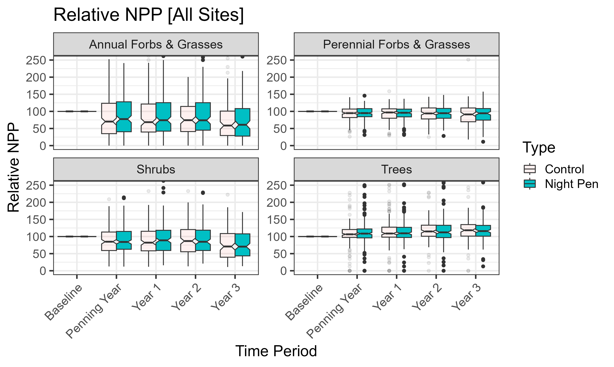

*Figure 7. Distribution of relative annual Net Primary Productivity (pounds/acre) for four vegetation groups across all night pen and control sites analyzed in the study. The y-axis has been rescaled to exclude outliers.*

To evaluate spatial variations in NPP across different locations (Idaho versus Oregon), we visualized the NPP distribution by generating box plots differentiated by location (Figure 8). Initial observations suggest that the trends in NPP over the response years differ across the Idaho and Oregon sites. However, when comparing the NPP at night pen sites to that at the control sites within the four vegetation groups, no discrepancies were observed during and after the establishment of the night pens. These findings are based on a preliminary visual analysis; for a more definitive conclusion regarding the absence or presence of significant differences between the night pen and control sites, a comprehensive statistical evaluation is warranted.

*Figure 8. Distribution of relative annual Net Primary Productivity (pounds/acre) for four vegetation groups across night pen and control sites differentiated by location. The y-axis has been rescaled to exclude outliers.*

Furthermore, we categorized the sites based on their frequency of use - distinguishing between sites utilized for a single year and those used across multiple years (Table 1). A notable challenge in our analysis occurred during data summarization in extracting data for night pen (n = 28) and control site locations (n = 29). Although these sites were omitted from our analysis, their counterpart night pen or control sites were inadvertently included, thereby introducing potential inaccuracies into our night pen versus control site comparisons. Except for two sites all omitted sites were in Oregon.

*Figure 9. Distribution of relative annual Net Primary Productivity (pounds/acre) for four vegetation groups across night pen and control sites differentiated by location and frequency of use. The y-axis has been rescaled to exclude outliers. The plot for Oregon sites that were used once has been excluded due to errors in data summarization.*

The distribution of relative NPP, stratified by both geographic location and frequency of use, is illustrated in Figure 8. We did not find discernable differences between the relative NPP at night pen sites and relative NPP at control sites when differentiated by location and by the number of times a night pen was used. These analyses are visual, and the difference between control and night pen sites should be further quantified through statistical analysis.

Project partners have noted that night pens are sometimes established on sites already subjected to disturbances, such as rock quarries and logging areas, to minimize impact on undisturbed vegetation. These previously disturbed sites were not specifically identified or marked in our study, potentially introducing additional uncertainty into our findings.

***4.2 Feasibility for Partner Use***

Project partners expressed interest in leveraging remote sensing data to evaluate the effects of night penning on vegetation. Our project used the annual Net Primary Productivity (NPP) of four vegetation groups, sourced from the Rangeland Analysis Platform, to measure vegetation response. We established a framework for extracting and visualizing NPP trends differentiated by vegetation group, which aligns with our partners interest in managing specific vegetation types through night penning. However, our method aggregates values from all pixels overlapping a night pen polygon, inadvertently including areas beyond the night pen boundaries (Figure 4). We suggest exploring an alternative approach that involves summarizing RAP pixel values by extracting data from a representative point within each night pen polygon. Perhaps future analysis using the alternate approach might provide insight into site specific vegetation response, allowing partners to evaluate the success of night penning as a vegetation management tool.

***4.3 Future Recommendations***

Based on our preliminary analysis, night penning proves to be an effective management tool, which has no visually discernable impacts on vegetation. However, going forward, partners should continue to critically observe possible impacts of night penning practices on vegetation. While these data further our understanding of intensive cattle management, they are not comprehensive, and future research would be beneficial. Remote sensing models have certain limitations that would be well addressed by on the ground validation of these findings. In addition to ground truthing, further analysis could be performed to these data. Our analysis differentiated between night pen sites based on their usage frequency (single year versus multiple years), however, we did not directly investigate how repeated usage of a night pen site affects vegetation response. Additionally, the NAIP imagery shows a clear vegetation response; future analysis should explore the use of alternate parameters such as NDVI to quantify veg response. Vegetation cover & bare ground percentage could be measured between night pen & control sites. Sites could be studied at finer temporal resolution to capture any changes within night penning years. More robust statistical analysis of these data could also be performed.

# 5. Conclusions

Control site selection plays a vital role in remote sensing research on intensive cattle management. Whenever possible, ground truthing of control site quality should be performed. After discussing our initial control sites with Krebs and Alderspring, they suggested some be relocated to more representative areas. Visual analysis of our false color NAIP imagery shows clear impacts of night penning on vegetation communities (Figure 3); sites were seen to produce more vegetation 2+ years after night penning. Once analyzed quantitatively, night pen sites showed variability in NPP before & after night penning; however, there were no visually discernible differences between night pen sites and control sites. Climate can play a significant role in NPP measurements. In figure 6, climatic factors caused a significant short-term decline in NPP around 2012. This decline could possibly dwarf any impacts that management practices have on vegetation communities. Remote sensing has spatial and temporal limitations that can affect modeling. Pixel resolution size can pose challenges when analyzing small polygons. The Rangeland Analysis Platform may also have some possible inaccuracies when representing vegetation coverage on small scales. Overall, there were no significant impacts of night penning on vegetation observed in our preliminary analysis; further statistical analysis of these data is needed to find more conclusive results. Partners should continue to utilize night penning as an intensive management tool while critically observing possible impacts as they arise.

# 6. Acknowledgements

Dr. Paul Evangelista, Colorado State University, Natural Resource Ecology Laboratory (Science Advisor)

Dr. Catherine Jarnevich, United States Geological Survey, Fort Collins Science Center (Science Advisor)

Dr. Anthony Vorster, Colorado State University, Natural Resource Ecology Laboratory (Science Advisor)

Nicholas Young, Colorado State University, Natural Resource Ecology Laboratory (Science Advisor)

Christopher Choi, Colorado State University, Natural Resource Ecology Laboratory (Science Advisor) Truman Anarella, Fort Collins, CO (Node Fellow)

This material contains modified Copernicus Sentinel data (2024), processed by ESA. This work utilized data made available through the NASA Commercial Smallsat Data Acquisition (CSDA) program. Any opinions, findings, and conclusions or recommendations expressed in this material are those of the author(s) and do not necessarily reflect the views of the National Aeronautics and Space Administration. This material is based upon work supported by NASA through contract 80LARC23FA024.

# 

# 7. Glossary

**NDVI** – Normalized Difference Vegetation Index

**NAIP** – National Agricultural Imagery Program

**USGS** – United States Geological Survey

**MODIS** – Moderate Resolution Imaging Spectroradiometer

**Landsat** – NASA/USGS satellite program that captures information about Earth’s natural resources

**Ground truthing** – On the ground sampling meant to validate remotely sensed data

**Grazing allotments** – federally provided grazing areas for ranchers

**Cover composition** – What plant groups make up the coverage of an area (in this study: perennial forb/grass, annual forb/grass, shrub, and tree)

**Rangeland production** – The biomass production within rangeland systems

**Earth observations** – Satellites and sensors that collect information about the Earth’s physical, chemical, and biological systems over space and time

# 8. References

Alkemade, R., Reid, R. S., van den Berg, M., de Leeuw, J., & Jeuken, M. (2013). Assessing the impacts of livestock production on biodiversity in rangeland ecosystems. Proceedings of the National Academy of Sciences, 110(52), 20900–20905. <https://doi.org/10.1073/pnas.1011013108>

Allred, B.W., B.T. Bestelmeyer, C.S. Boyd, C. Brown, K.W. Davies, M.C. Duniway, L.M. Ellsworth, T.A. Erickson, S.D. Fuhlendorf, S.D., T.V. Griffiths, V. Jansen, M.O. Jones, J. Karl, A. Knight, J.D.

Maestas, J.J. Maynard, S.E. McCord, D.E. Naugle, H.D. Starns, D. Twidwell, and D.R. Uden. (2021). Improving Landsat predictions of rangeland fractional cover with multitask learning and uncertainty. Methods in Ecology and Evolution <https://doi.org/10.1111/2041-210X.13564>

Bank, W. (2009). Awakening Africa’s Sleeping Giant: Prospects for Commercial Agriculture in the Guinea Savannah Zone and Beyond. World Bank. <https://doi.org/10.1596/978-0-8213-7941-7>

Evans, J. S., Oakleaf, J., & Cushman, S. A. (2014). An ArcGIS Toolbox for Surface Gradient and Geomorphometric Modeling (Version 2.0-0). Retrieved from <http://evansmurphy.wix.com/evansspatial> Accessed: 2024-02-13.

Gorelick, N., Hancher, M., Dixon, M., Ilyushchenko, S., Thau, D., & Moore, R. (2017). Google Earth Engine: Planetary-scale geospatial analysis for everyone. *Remote Sensing of Environment*, *202*, 18–27 <https://doi.org/10.1016/j.rse.2017.06.031>

Havstad, K., Peters, D., Allen-Diaz, B., Bartolome, J., Bestelmeyer, B., Briske, D., Brown, J., Brunson, M., Herrick, J., & Huntsinger, L. (2009). The Western United States Rangelands: A Major Resource. Grassland: Quietness and Strength for a New American Agriculture, 75–94. [https://doi.org/10.2134](https://doi.org/10.2134/2009.grassland.c5) /2009.grassland.c5

Jablonski KE, Merishi J, Dolrenry S and Hazzah L (2020) Ecological Doctors in Maasailand: Identifying Herding Best Practices to Improve Livestock Management and Reduce Carnivore Conflict. Front. Sustain. Food Syst. 4:118. <https://doi.org/10.3389/fsufs.2020.00118>

Jones, M.O., N.P. Robinson, D.E. Naugle, J.D. Maestas, M.C. Reeves, R.W. Lankston, and B.W. Allred. Annual and 16-day rangeland production estimates for the western United States. bioRxiv 2020.11.06.343038 <https://doi.org/10.1016/j.rama.2021.04.003>

McCune, B., & Keon, D. (2002). Equations for potential annual direct incident radiation and heat load. Journal of Vegetation Science, 13(4), 603–606.

<http://doi.org/10.1111/j.1654-1103.2002.tb02087.x>

Sala, O., Yahdjian, L., Havstad, K., & Aguiar, M. (2017). Rangeland Ecosystem Services: Nature’s Supply and Humans’ Demand. <https://doi.org/10.1007/978-3-319-46709-2_14>

U.S. Department of Agriculture's Farm Production & Conservation Business Center (FPAC-BC) Geospatial Enterprise Operations (GEO). <https://doi.org/10.5066/F7QN651G>

U.S. Geological Survey, 2023, USGS 3D Elevation Program Digital Elevation Model, accessed February 13, 2024 at <https://apps.nationalmap.gov/downloader/>

U.S. Geological Survey, 2013. Landsat 5 Thematic Mapper imagery data. U.S. Geological Survey Earth Resources Observation and Science (EROS) Center. <https://earthexplorer.usgs.gov/>

U.S. Geological Survey, 2022. Landsat 7 Enhanced Thematic Mapper Plus imagery data. U.S. Geological Survey Earth Resources Observation and Science (EROS) Center. <https://earthexplorer.usgs.gov/>

U.S. Geological Survey, 2023. Landsat 8 Operational Land Imager imagery data. U.S. Geological Survey Earth Resources Observation and Science (EROS) Center. <https://earthexplorer.usgs.gov/>

Vinograd, A., Zaady, E., & Kigel, J. (2019). Dynamics of soil nutrients in abandoned sheep corrals in semi- arid Mediterranean planted forests under grazing. Journal of Arid Environments, 164, 38–45. https://doi.org/10.1016/j.jaridenv.2019.02.007

Y. J. Zhang, W. L. Jiang & J. Z. Ren (2001) Effects of sheep night penning on soil nitrogen and plant growth, *New Zealand Journal of Agricultural Research*, 44:2-3, 151-157, DOI: <https://doi.org/10.1080/00288233.2001.9513471>

# 9. Appendices

Appendix A: Looking Glass Camp 1 Site Imagery

*Figure A1. False color NAIP imagery comparing vegetation patches and original GPS points.*

*Figure A2. Top Left: The GPS Coordinates of the night pen “Looking Glass Camp 1”, collected in the field, viewed with a 165ft buffer next to the real night-pen site- validated with partner feedback and NAIP Imagery. Bottom Left. The night pen site moved to fit the true area, overlayed with RAP NPP dataset imagery to visualize pixels that may fall mostly outside of the night penning area. Right. Time series of the NPP statistics of Looking Glass Camp 1 from 2020-2023.*

Appendix B: Net Primary Productivity Analysis

*Figure B1. Net primary productivity at four-night pen sites and their associated control sites.*

*Figure B2. Timeseries of annual NPP at all night pen and control sites.*



*Figure B3. Distribution of relative annual Net Primary Productivity (pounds/acre) for four vegetation groups across all night pen and control sites analyzed in the study. The y-axis has been rescaled to exclude outliers.*

*Figure B4. Distribution of relative annual Net Primary Productivity (pounds/acre) for four vegetation groups across night pen and control sites differentiated by location. The y-axis has been rescaled to exclude outliers.*

*Figure B5. Distribution of relative annual Net Primary Productivity (pounds/acre) for four vegetation groups across night pen and control sites differentiated by location and frequency of use. The y-axis has been rescaled to exclude outliers. The plot for Oregon sites that were used once has been excluded due to errors in data summarization.*