**NASA DEVELOP National Program**



Maricopa County Department of Public Health and Arizona State University

*Summer 2017*

Las Cruces Health & Air Quality

Assessing the urban heat island and the impact of urbanization in Las Cruces, New Mexico

 **Technical Report**

Final Draft – August 10, 2017

Jonathan O’Brien (Project Lead)

Rebia Khan

Christopher Wilson

Fanqi Jia

Dr. David Hondula, Arizona State University (Science Advisor)

# 1. Abstract

Extreme heat during the summer months is a major public health issue in many cities worldwide. Local governments are increasing efforts to mitigate heat in cities through the implementation of infrastructure adaptations, including expansion of the urban tree canopy and white roofing, as well as revising design guidelines and principles for new construction. These strategies will be most beneficial for public health if they are deployed in places where risks of heat exposure are elevated as a result of higher temperatures and higher social vulnerability. Spatial variability in heat in the city arises because of the different ways in which the built environment impacts energy exchange between the surface and atmosphere. Social vulnerability is also unevenly distributed across urban areas and previous research demonstrates that socially disadvantaged populations often live in the hottest parts of the city. In this project, we used Landsat and Advanced Space-borne Thermal Emission and Reflection Radiometer (ASTER) data to construct a time series of Las Cruces’ urban heat patterns and assess the influence that urban morphology has on those patterns. Extreme heat vulnerability indicators were developed utilizing census and health records and aerial imagery from the National Agriculture Imagery Program (NAIP). These heat vulnerability indicators describe the sensitivity of the population to extreme heat and identify where vulnerable populations reside. The Las Cruces Sustainability Office will use the heat vulnerability indicators, urban heat island assessment, and urban heat island morphology comparison to improve the city’s resilience and mitigation efforts.

**Keywords**

Urban Heat Island (UHI), Principal Component Analysis (PCA), Heat Vulnerability Index (HVI), Land Surface Temperature (LST), Normalized Difference Vegetation Index (NDVI), Landsat, Green Infrastructure, Supervised Classification, Object-Based Classification

# 2. Introduction

* 1. ***Background Information***

Extreme heat is an important public health concern, accounting for over 600 fatalities in the United States per year (National Vital Statistics System, 2017). Heat stress can also exacerbate existing medical conditions, such as diabetes, respiratory illnesses, and cardiovascular conditions (Schwartz, Samet, and Patz, 2004; Semenza et al., 1996). Aside from its well-documented health impacts, extreme heat is also an important well-being concern, making cities less walkable and less comfortable.

Differences in demographic and socioeconomic inequalities can cause some populations to be more vulnerable to extreme heat events than others. Factors such as education level, poverty, social isolation, and race can influence a community’s ability to prepare for and cope with extreme heat (Bao et al. 2015; Harlan et al 2013; Reid et al. 2009). In the city of Las Cruces, New Mexico, an area of particular concern for social vulnerability is the Infill District. In this region, over 25 percent of families live below the poverty line, 33 percent of individuals over 65 live alone, and almost 20 percent of the population does not have health insurance (Sikdar, 2017). These risk factors make residents of the Infill District especially vulnerable to above-normal temperatures. These risk factors are also exacerbated by the expected increase in consecutive nights of above-average minimum temperatures, as the human body cannot sufficiently cool and recover without adequate artificial cooling mechanisms such as air conditioning (LeRoy and Garfin, 2017).

The city has experienced rapid urban growth in the last 20 years, causing both the population and the temperatures to rise in its urban areas. Urbanization increases the abundance of impervious surfaces, such as asphalt and concrete, which absorb and slowly re-emit heat from the sun’s rays. These surfaces retain heat and increase nighttime minimum temperatures. Daytime conditions can be more thermally stressful in certain urban areas as well because of added heat load from warm surfaces. Temperatures in urban areas therefore tend to be higher than surrounding rural areas, a phenomenon called the urban heat island (UHI) effect (LeRoy and Garfin, 2017).

Controllable factors that contribute to the UHI effect are mostly planning-related (Rizwan et al., 2008), and in the absence of any adaptive urban design, megapolitan expansion could potentially raise near-surface temperatures 1–2 °C at a regional scale (Georgescu et al., 2014). Typically, city-wide adaptation has occurred through the implementation of various strategies, such as improving building standards, weather stripping, white roofing, and increasing the amount of urban tree canopy area, providing cooling benefit to people through evapotranspiration processes and shading. Green infrastructure, such as strategic planning of native trees, is a cost-effective method to reduce urban heat island in the arid southwest, as it shades and prevents the sun’s energy from being absorbed by dark surfaces such as buildings and roads.

* 1. ***Project Partners & Objectives***

The Las Cruces Health and Air Quality team worked in conjunction with the City of Las Cruces Sustainability Office, the Climate Assessment for the Southwest (CLIMAS), and Arizona State University’s Urban Climate Research Center (UCRC). The primary objective of the project was to highlight areas where the heat island is the most damaging to the population so that mitigation efforts can be properly targeted. The City of Las Cruces Sustainability Office will use these data to better direct heat mitigation efforts and green infrastructure. The City of Las Cruces Sustainability Office plans to increase green infrastructure in heat vulnerable areas in a new initiative called “Cool Corridors.” NASA satellite imagery will help them identify areas of both extreme heat and social vulnerability in order to place Cool Corridors where they are most needed.

* 1. ***Study Area and Study Period***

The study included the city limits for the City of Las Cruces. Las Cruces is the second largest city in New Mexico, with a metropolitan population slightly above 200,000 (LeRoy and Garfin, 2017). The hottest months are June and July, when monthly average maximum temperatures reach almost 95 °F. The changing climate is only projected to increase the number of days producing excessive heat across the southwestern United States, increasing population exposure to extreme heat events (Hayden et al., 2011). Like many cities in the Southwest, Las Cruces has also experienced rapid urban growth in the last 20 years. To capture the time period in which this growth occurred, our study period ranged from 1999 to 2016.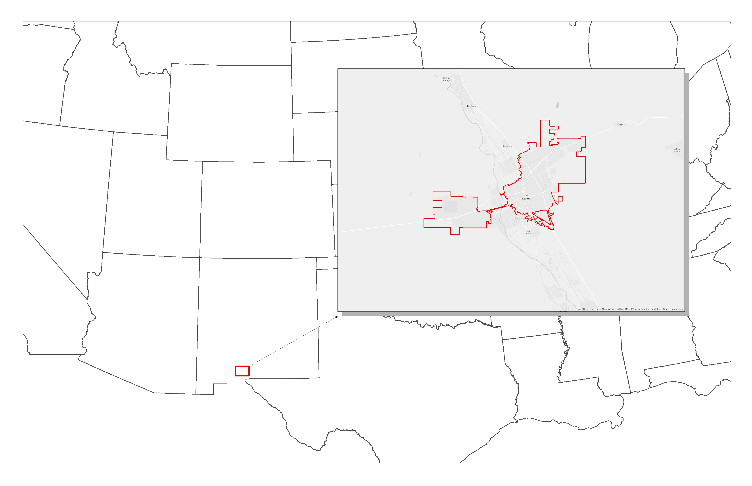

City of Las Cruces

New Mexico

*Figure 1.* Map of study area.

* 1. ***National Application Area***

This study addressed the Health and Air Quality application area as well as Climate. This project utilized NASA Earth Observations to help the city of Las Cruces address the health effects of extreme heat and improve the city’s resiliency planning for extreme heat.

# 3. Methodology

***3.1 Data Acquisition***

The main source for satellite imagery was the United States Geological Survey (USGS) EarthExplorer portal. Landsat 5 Thematic Mapper (TM) and Landsat 8 Operational Land Imager (OLI) Level-1 imagery between May and September from 1999-2011 and 2013-2016 was acquired for path 33, row 38 from the EarthExplorer portal. A total of 121 Landsat images, each taken at approximately 11:30 AM Mountain Time, were collected, of which 92 were used in land surface temperature calculations. Selectivity was based solely on cloud cover over the study area. In addition, National Agriculture Imagery Program (NAIP) aerial imagery with 1-meter resolution, acquired with less than 10% cloud cover per quarter quad tile in GEOTIFF format, was downloaded through the USGS EarthExplorer portal, in which 4-band imagery for the New Mexico region is available for the years of 2011, 2014, and 2016. All imagery is examined for horizontal accuracy and tonal quality by the US Department of Agriculture’s Farm Service Agency.

US Census data were downloaded from American FactFinder. 2015 American Community Survey 5 Year Estimates by census tract were used for social vulnerability assessment. Health data were collected from CDC Behavioral Risk Factors, NM Cities, 2013-2014, a dataset which was a part of The 500 Cities Project: Local Data for Better Health. A shapefile of the city of Las Cruces was extracted from Census Current Designated Places for Dona Ana County 2006se TIGER Files. A Las Cruces urban area shapefile was extracted from Census Current Urban Areas for Dona Ana County, New Mexico 2006se TIGER Files. These shapefiles were used as a reference in determining intersecting census tracts and developing a study area.

***3.2 Social Vulnerability***Social vulnerability indicators were chosen through literature review and discussion with partners. These final indicators were extracted from census and health datasets, and limited to just the census tracts that intersect the boundary of Las Cruces (25 census tracts total). Census data were normalized by total population of census tracts when applicable. Indicators were grouped into themes and scored in a similar process to the CDC SVI methodology (https://svi.cdc.gov/). Indicators were grouped into the following themes: Household Composition, Minority Status, Economic Stability, Transportation and Housing, and Health. Each census tract’s value for each indicator was converted to percentile rank against all other census tracts in Las Cruces. For indicators with an inverse relationship to vulnerability, such as Mean Household Income, the percentile ranks of each census tract were subtracted from one. Percentile rank values for all indicators in each theme were added together and then the sum value was percentile ranked in order to arrive at the final theme score. Thus, the final theme scores were values from zero to one, with higher values meaning higher vulnerability. Theme scores were then attached to census tract shapefiles in ArcMap 10.3.

|  |  |
| --- | --- |
| Theme 1 – Household Composition | * % over 65 years old * % under 5 years old * % of households with children under 18 years old and one parent * % over 65 year olds and living alone |
| Theme 2 – Minority Status | * % Black * % American Indian * % Asian * % Hispanic * % limited English speaking households |
| Theme 3 – Economic Stability | * % over 25 years old with less than high school diploma * % over 25 years old with high school diploma * Mean retirement income (dollars) * % unemployed * % of all families whose income in the past 12 months is below poverty level * Mean household income (dollars) |
| Theme 4 – Housing and Transportation | * % whose means of transportation to work is public transportation * % whose means of transportation to work is walking * % whose means of transportation to work is biking * % with no vehicle * % who walk to work with a commute time over 10 minutes * % renter occupied tenure * Median structure age of house * % of housing structures with 10 or more units * % of housing structures that are mobile homes |
| Theme 5 – Health | * % Current lack of health insurance among adults aged 18–64 Years * % Binge drinking among adults aged >=18 Years * % High blood pressure among adults aged >=18 Years * % Current asthma among adults aged >=18 Years * % Coronary heart disease among adults aged >=18 Years * % Chronic obstructive pulmonary disease among adults aged >=18 Years * % Current smoking among adults aged >=18 Years * % Diagnosed diabetes among adults aged >=18 Years * % Chronic kidney disease among adults aged >=18 Years * % Mental health not good for >=14 days among adults aged >=18 Years * % Obesity among adults aged >=18 Years * % Stroke among adults aged >=18 Years * % Percent with disability (from Census) |

*Table 1.* Social Vulnerability variables by theme.

***3.3 Land Cover Classification and Vegetation Detection***

To detect urban vegetation coverage and vegetation health, we used the 92 images collected from Landsat 5 and 8 to calculate Normalized Differential Vegetation Index (NDVI) for the study period. Using the corresponding near-infrared and red bands of each sensor, the NDVI of each image was obtained and used as an intermediate step to produce land surface temperature values.

$\text{NDVI=}\frac{\text{NIR-RED}}{\text{NIR+RED}}$ (1)

*Equation 1*

We classified the land cover for the years of 2011, 2014 and 2016 to detect tree canopy cover and impervious surfaces in the city. For the purpose of land cover classification we used NAIP one meter resolution aerial imagery. Before classification, we pre-processed the imagery by registering and sub-setting images. Pre-processing reduces the distortion due to “sensor, solar, atmospheric, and topographic effects” (Young et al., 2017). We projected the NAIP imagery from the default Universal Transverse Mercator (UTM) coordinate system to NAD 1983 State Plane, New Mexico, Central, US Feet and subset 16 NAIP images to cover the entire study area.

Supervised classification and object-based classification are commonly used methods for classifying land cover. Supervised classification is a method of classification relying on the ground data of the original image. Object-based classification is a classification method in which the original image is segmented by spectral and geometric characteristics before using other methods such as supervised classification to classify the image. These two methods are based on user-defined sample data that is used as a basis for comparison to categorize all pixels. By referring to the legend of NLCD 2011, National Land Cover Database, we defined 8 different classes demonstrated (Table 2).

|  |  |
| --- | --- |
| **Class** | **Description** |
| Water | Includes all water bodies (rivers, lakes, streams, canals). |
| Green Trees | Includes all forest vegetation types (evergreen, deciduous and  wetland). |
| Buildup | Includes all residential, commercial, and industrial features. |
| Open Area | Includes all parking lots, roads, and transportation features. |
| Urban Grass | Includes grass and green space in urban areas. |
| Agriculture | Includes all agricultural land. |
| Barren Area | Includes barren or sparsely vegetated areas; including rock, sand, clay, and other accumulations of earthen material. Generally, vegetation accounts for less than 15% of total cover. |
| Shrub | Area dominated by shrubs. |

*Table 2.* Land cover classes derived from the National Land Cover Database.

Both supervised classification and object-based classification are processes that involve assigning pixels to specific classes based on the user-defined spectral signature of the sample pixels or training sites. Training sites are representative samples of each land cover class with homogeneous surface composition in the image. These training sites provided the reference to classify uncertain pixels. Training sites were collected using false-color NAIP images to detect vegetation cover, Google Earth satellite imagery to differentiate regions that share the similar spectral characteristics in the image, and the user’s knowledge of the City of Las Cruces.

The Maximum Likelihood Algorithm was used for the land cover classification. This algorithm is based on the assumption that the cells in each class for each band are normally distributed. Then, it will guide the program to compute the probability of each pixel for all classes, and then assign it to the class with the highest probability. To minimize classification error, we collected ground truth points for each class from the true-color NAIP imagery, and then performed an accuracy assessment to identify and quantify errors. To focus on land cover classes of interest, we separated the “green trees” class corresponding to tree canopy cover. We then intersected these pixels with a 30-meter fishnet to calculate the percentage of the area of 1-meter-resolution land cover within 30 by 30 meter pixels to detect the density and visualize the distribution of trees in the city. We combined the “buildup” class and “open area” class corresponding to impervious surfaces by merging these classes together.

***3.4 Land Surface Temperature Calculation***

Prior to calculating land surface temperature, a cloud mask was developed and applied to all images in order to reduce the amount of otherwise unusable images due to minimal yet data-skewing cloud cover. Pixel descriptions provided by the respective quality assessment band of each image were used to filter out everything except that of which was categorized as clear terrain, clear terrain with some saturation, clear terrain with moderate saturation, and clear terrain with frequent saturation. Images with less than 10% cloud cover over the study area were then chosen to be converted into surface temperature values. Out of 121 images, 29 were removed due to an overwhelming presence of clouds over the study area.

A single-channel method was used to retrieve land surface temperature values from Landsat images. Corresponding thermal infrared bands for each satellite sensor were converted into top-of-atmosphere radiance values according to rescaling factors provided in the metadata for each individual image. At-satellite brightness temperatures were then calculated utilizing thermal conversion constants also provided via metadata files. An estimation of proportional vegetation was subsequently calculated using NDVI values, which were then used to estimate ground emissivity according to Sobrino et al., 2004. Lastly, land surface temperature values in Kelvin were then calculated using at-satellite brightness temperature, the average wavelength of the respective thermal band, and ground emissivity values. Resulting temperatures were then converted from Kelvin into Fahrenheit.

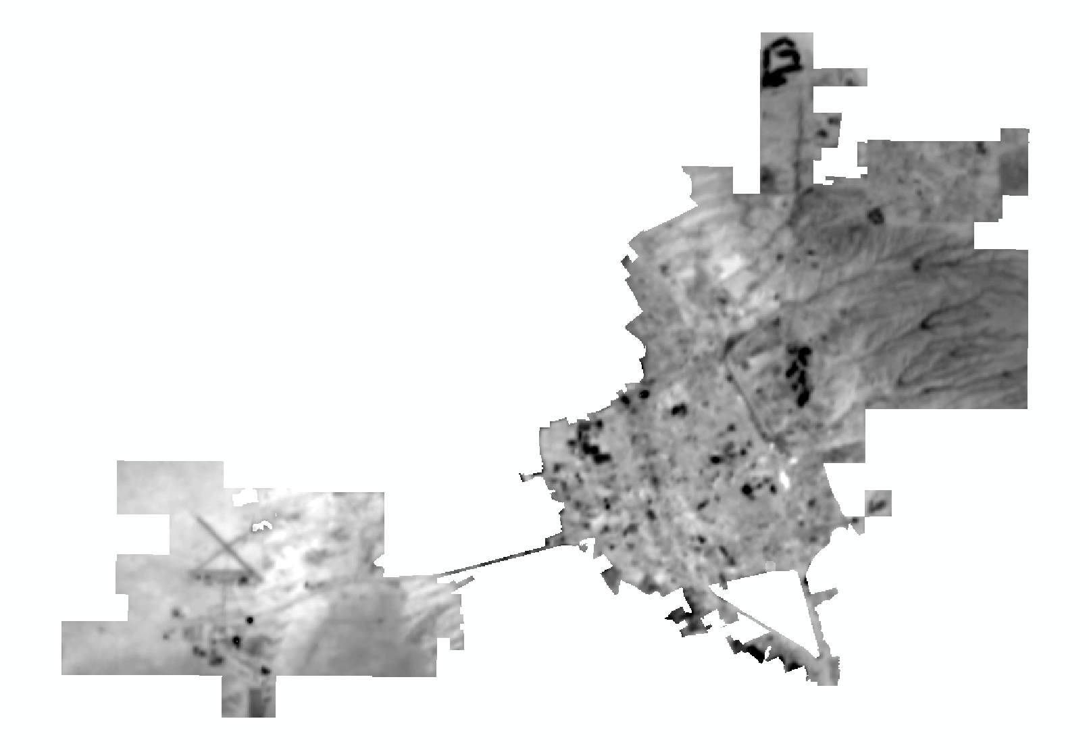

*Figure 2.* Mean land surface temperature for 2014 clipped to city boundaries.

***3.5 Data Analysis***

Social Vulnerability was compared across census tracts in ArcMap to identify areas of highest vulnerability. Variables were grouped into themes and mapped out in ArcMap so that the Las Cruces Office of Sustainability could not only see which areas were vulnerable, but in what ways (e.g. financially, by health, etc.). Social vulnerability layers, tree canopy percentage layers, impervious surface percentage layers, and land surface temperature layers for each theme and focus year were all converted to 30 meter raster format and all values were set on a scale from 0 to 1. These layers were then combined with equal weights using raster calculations in ArcMap. The combination formula is shown in Equation 2.

$$Total Vulnerability=LST+Social Vulnerability Score+\% Impervious-\% Tree Canopy$$

*Equation 2*

In order to gain a better understanding of the temporal variance within our study period, land surface temperature images were averaged by year. An average composite of all 92 images was also created and then symbolized by difference from the average value of each pixel. The resulting map was then divided into 10 classes by equal interval in order to produce an easily digestible output of which areas were consistently producing above or below average surface temperatures.

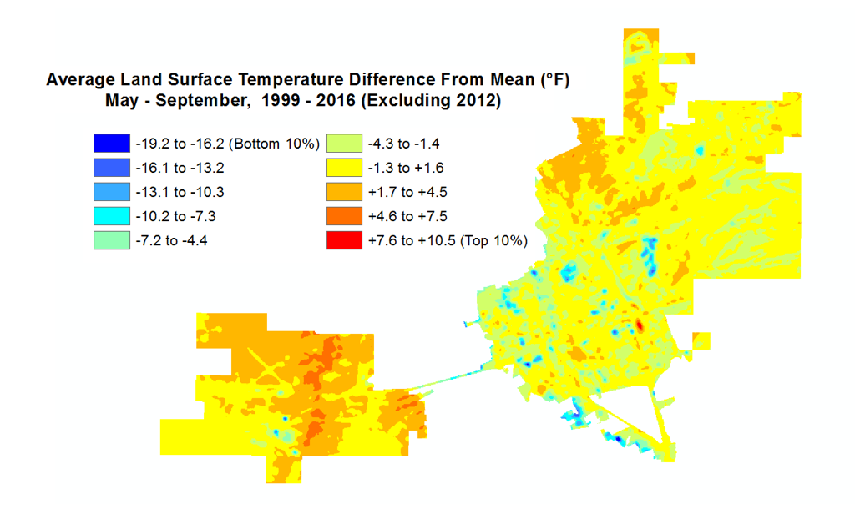

*Figure 3.* Aggregated land surface temperature map shown by difference from average. Values are grouped by percentile ranking, with the top 10% being the difference from mean values that fall above the 90th percentile.

# 4. Results & Discussion

***4.1 Results***

Aggregate heat vulnerability maps included land surface temperature, percent of impervious surfaces, percent of tree canopy cover, and social vulnerability. Spatial variation exists depending on the social vulnerability theme, in which the spatial variation by theme is consistent across all three focus years, 2011, 2014, and 2016 (e.g. spatial distribution of high values for Theme 2, Minority Status layers is concentrated in the Southwest part of the Infill District for all three years). Although this variation by theme occurs, there are invariably concentrations of higher values throughout the central part of the city known as the Infill District. Although the surrounding areas, comprised mostly of barren land and shrubs, have consistently high daytime land surface temperature, the lack of impervious surfaces and typically lower social vulnerability scores lead to lower overall heat vulnerability values. Distinct concentrations of lower land surface temperature values can be seen wherever there are concentrations of trees or green space.

|  |  |
| --- | --- |
| **Social Vulnerability Theme** | **Aggregate Heat Vulnerability Map for 2016** |
| Economic Stability |  |
| Housing & Transportation |  |
| Health |  |
| Household Composition |  |
| Minority Status |  |

*Table 3.* Heat vulnerability maps for 2016. Higher values are shown in white. These maps are comprised of exposure layers (LST, percent impervious, & percent tree canopy cover) aggregated with social vulnerability data.

The estimated densities of tree canopy cover in Las Cruces in 2011, 2014, and 2016 were 1.89%, 2.63%, and 3.31% respectively (1.67%, 2.47%, and 3.04% excluding the airport area). Most urban tree canopy was dispersed throughout built-up areas, especially in residential areas. The highest-density tree canopy within the city was located in the Southwestern part of the city, corresponding to low LST and high NDVI values. In 2016 there is an estimated 26.76% impervious surface within the city limits, including the airport. The overall accuracy for our classification, computed using a reference layer, was over 75%, and the accuracies for the classes of green trees, buildup, and open area were over 80%.

After examining the average land surface temperature difference from the mean for our study period, certain “hot spots” and “cold spots” became apparent. Cold spots were generally associated with clusters of trees or vegetated areas. Hot spots that fell within the urban area of the city were generally associated with areas with a high proportion of impervious surfaces, a low proportion of tree canopy cover, or both. There are no discernible trends in land surface temperature yearly mean throughout the duration of the study period, with the lowest in 2015 at 91.99° F, the highest in 2006 at 111.11° F, and all other mean surface temperatures fluctuating in between. The overall mean land surface temperature for Las Cruces over the span of our study period (from 1999 to 2016) was 102.89° F, with no clear patterns of change over time.

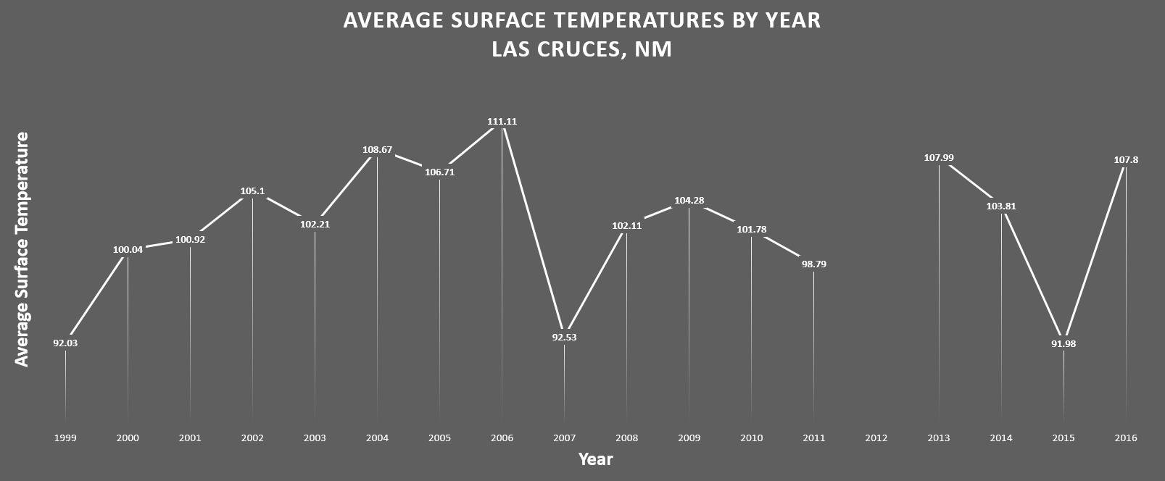

*Figure 4.* Graph of average land surface temperature in Las Cruces from 1999 to 2016.

***4.2 Limitations***

There is some spatial variation of socially vulnerable populations by census tract, but there is a clear concentration of census tracts with higher percentile scores for all vulnerability themes in the center of the city, which all fall within the boundaries of the historical Infill District. When combined with our exposure layers (LST, percent tree canopy, and percent impervious), this concentration is emphasized, with clustering of high values all throughout the Infill District area.

Errors in our classification might be due to the disproportion of land cover within the city. In the original image, some types of land cover are not as dominant and less obvious, and only cover a small portion in the city. This resulted in fewer samples collected for these classes and they were more likely to be mistaken for other, more dominant classes. In addition, for the supervised classification, since the resolution of the NAIP is 1 meter, the program could not specify objects under 1 meter scale. Because of this, the maximum likelihood algorithm assigned each pixel to the class with highest probability according to its dominant spectral profile, which might not be reflective of reality.

It is worth noting that all 92 images used to calculate land surface temperature were taken during the daytime, and data for the year 2012 is missing due to lack of temporal overlap between Landsat 5 and Landsat 8 and a band failure on Landsat 7. Since the urban heat island is largely a nighttime phenomenon, the data used for this study do not emphasize temperature variance between the city and the surrounding areas. What these results show is the spatial variation of land surface temperature within the city. Large fluctuations in year-to-year LST mean may have been due to the variable amount of images for each year, with some years including a greater sample size than other years. Data for the year 2012 is also completely absent from this study due to lack of temporal overlap between Landsat 5 and Landsat 8 and a band failure on Landsat 7. The cloud cover mask that was applied before calculating land surface temperatures had difficulties removing some values that would have otherwise been deemed unusable. In certain images, traces of clouds or other particulate matter were not picked up by the mask. This may have been because of the decision to include the categories of clear terrain with varying levels of saturation. The impact of the inclusion of these values is not explicitly known, however, it is likely that it would have impacted select surface temperature images.

***4.3 Future Work***

The results of this study, namely the land cover classification and temperature data, could greatly benefit from in-situ validation. Land surface temperature does not perfectly correlate with ambient temperature, therefore ambient temperature measurements could provide results that are more representative to actual temperatures experienced by individual residents. Land cover frequently changes, and many forms of land cover are spectrally similar. In-situ validation could help to determine the practical accuracy and usability of our classified land cover layers. In addition, our social vulnerability study excludes certain groups, such as the homeless, that are not captured by US Census data. Furthermore, social vulnerability that is calculated through the use of US Census and CDC Behavioral Risk Factor data does not fully capture adaptive practices of residents, such as temporary relocation during instances of high heat and hydration practices. Further study is required to fully understand individual adaptive practices in Las Cruces and excluded demographics such as the homeless.

# 5. Conclusions

Through the utilization of NASA Earth Observations, we were able to estimate the morphology and relative intensity of the urban heat island in the city of Las Cruces, New Mexico. Paired with commonly available imagery and socioeconomic data, we created a wealth of data that will be used by our partners in multiple ways to assess urban heat and vulnerability to heat in the city. Overall, we created data in four categories relevant to heat mitigation, land surface temperature, impervious surfaces, tree canopy coverage, and social characteristics. When used in combination with other layers or used as stand-alone map layers, these vulnerability maps and exposure layers serve as a solid foundation to build on when assessing the local urban heat situation. The difference in the physical effects of terrain features like trees and asphalt have been clearly demonstrated as evidenced by the spatial distribution of land surface temperature. Cooler spots coincide with vegetated areas and hotter spots coincide with areas with high concentrations of impervious surfaces. In addition, patterns of social vulnerability to heat specific to Las Cruces have been clearly mapped by theme. This information, in conjunction with physical surface characteristics, provides a clear and easily communicable basis on which decisions can be made, and problem areas as well as contributing factors have been identified.

# 6. Acknowledgments

* Lisa LaRocque, Sustainability Officer, City of Las Cruces Sustainability Office
* Dr. Gregg Garfin, Associate Professor, Climate Assessment of the Southwest
* Sarah Leroy, Research Staff, Climate Assessment of the Southwest
* Dr. David Sailor, Director, Arizona State University Urban Climate Research Center

Any opinions, findings, and conclusions or recommendations expressed in this material are those of the author(s) and do not necessarily reflect the views of the National Aeronautics and Space Administration.

This material is based upon work supported by NASA through contract NNL16AA05C and cooperative agreement NNX14AB60A.

# 7. Glossary

**Earth Observations** – Satellites and sensors that collect information about the Earth’s physical, chemical, and biological systems over space and time.

**EOSDIS** – Earth Observing System Data and Information System; provides end-to-end capabilities for managing NASA’s Earth science data from various sources – satellites, aircraft, field measurements, and various other programs.

**GEOTIFF** – An image file in TIFF format with a geographic reference.

**Green Infrastructure** – An approach to water management that protects, restores, or mimics the natural water cycle.

**LST** – Land Surface Temperature; calculated from measured radiance.

**NAIP** – National Agriculture Imagery Program; the National Agriculture Imagery Program (NAIP) acquires aerial imagery during the agricultural growing seasons in the continental U.S.

**NDVI** – Normalized Difference Vegetation Index; a simple graphical indicator that can be used to analyze remote sensing measurements, typically but not necessarily from a space platform, and assess whether the target being observed contains live green vegetation or not.

**NIR** – Near Infra-Red; the near-infrared region of the electromagnetic spectrum.

**NLCD** – National Land Cover Database; database produced through a cooperative project conducted by the Multi-Resolution Land Characteristics Consortium (MRLC).

**Object-Based Classification** – A method of supervised classification where the original image is segmented using spectral and spatial algorithms before being classified.

**OLI** – Operational Land Imager; built by the Ball Aerospace & Technologies Corporation, measures in the visible, near infrared, and short wave infrared portions of the spectrum.

**PCA** – Principal Component Analysis; a technique used to emphasize variation and bring out strong patterns in a dataset.

**Shapefile** – A popular geospatial vector data format for geographic information system (GIS) software.

**SoVI** – Social Vulnerability Index; calculated from a variety of demographic and socioeconomic variables.

**Supervised Classification** ­– A classification method in which the user defines sample classes and the computer assigns pixels to the closest class based on the sample data.

**TM** – Thematic Mapper; one of the Earth observing sensors introduced in the Landsat program.

**UHI** – Urban Heat Island; phenomenon in which urban areas have higher temperatures than surrounding areas.

# 8. References

Bao, Junzhe, Xudong Li, and Chuanhua Yu. “The Construction and Validation of the Heat Vulnerability Index, a Review.” International Journal of Environmental Research and Public Health 12, no. 7 (June 26, 2015): 7220–34. doi:10.3390/ijerph120707220.

Georgescu, M., Morefield, P. E., Bierwagen, B. G., & Weaver, C. P. (2014). Urban adaptation can roll back warming of emerging megapolitan regions. Proceedings of the National Academy of Sciences, 111(8), 2909-2914. doi:10.1073/pnas.1322280111

Harlan, Sharon, Juan Declet-Barreto, William Stefanov, and Diana Petitti. “Neighborhood Effects on Heat Deaths: Social and Environmental Predictors of Vulnerability in Maricopa County, Arizona.” Environmental Health Perspectives 121, no. 2 (2013): 197–204. doi:10.1289/ehp.1104625.

Hayden, M., Brenkert-Smith, H., & Wilhelmi, O. (2011). Differential Adaptive Capacity to Extreme Heat: A Phoenix, Arizona, Case Study. Weather, Climate, and Society, 3(4), 269-280. Retrieved from <http://www.jstor.org/stable/24907429>

LeRoy, S., and G. Garfin. “The Climate of Las Cruces, New Mexico. Produced in Conjunction with the Project, Using Critical Thresholds to Customize Climate Projections of Extreme Events to User Needs and Support Decisions.” Tucson, AZ: CLIMAS (2017): 24. Print.

“QuickStats: Number of Heat-Related Deaths,* by Sex — National Vital Statistics System, United States,† 1999–2010§.” N.p., n.d. Web. 28 June 2017.

Reid, Colleen et al. “Mapping Community Determinants of Heat Vulnerability.” Environmental Health Perspectives (2009): n. pag. CrossRef. Web. 13 Feb. 2016.

Rizwan, A. M., Dennis, L. Y., & Liu, C. (2008). A review on the generation, determination and mitigation of Urban Heat Island. Journal of Environmental Sciences, 20(1), 120-128. doi:10.1016/s1001-0742(08)60019-4

Schwartz, Joel, Jonathan M. Samet, and Jonathan A. Patz. “Hospital Admissions for Heart Disease: The Effects of Temperature and Humidity.” Epidemiology (Cambridge, Mass.) 15.6 (2004): 755–761. Print.

Semenza, Jan C. et al. “Heat-Related Deaths during the July 1995 Heat Wave in Chicago.” New England Journal of Medicine 335.2 (1996): 84–90. Taylor and Francis+NEJM. Web.

Sikdar, Kieran. Extreme Weather Mitigation In The Las Cruces Infill District Through Green Stormwater Infrastructure. Tuscon, Arizona: Watershed Management Group, 2017. Print.

Sobrino, J. A., Jiménez-Muñoz, J. C., & Paolini, L. (2004). Land surface temperature retrieval from LANDSAT TM 5. Remote Sensing of Environment, 90(4), 434–440. https://doi.org/10.1016/j.rse.2004.02.003

US Geological Survey. (2014). Provisional Landsat OLI Surface Reflectance [Data set]. US Geological Survey Earth Resources Observation and Science Center. https://dx.doi.org/10.5066/F78S4MZJ

Young, N., Anderson, R., Chignell, S., Vorster, A., Lawrence, R., & Evangelista, P. (2017). A Survival Guide to Landsat Preprocessing. Wiley Periodicals, Inc., Ecological Society of America.