**NASA DEVELOP National Program**



USGS at Colorado State University

*Spring 2017*

Arizona Water Resources

Utilizing NASA Earth Observations to Delineate Riparian Corridors and Evaluate Invasive Species Cover in the Verde River Watershed

**Technical Report** 

Final Draft – March 31, 2017

Sarah Carroll and Amandeep Vashisht (Project Leads)

Leana Schwartz

Chanin Tilakamonkul

Dr. Paul Evangelista, Natural Resource Ecology Lab, Colorado State University (Science Advisor)

Dr. Amanda West, Natural Resource Ecology Lab, Colorado State University (Science Advisor)

Brian Woodward, NASA DEVELOP, USGS at Colorado State University (Center Lead)

# 1. Abstract

Riparian corridors in the semiarid Colorado River Basin act as an interface between terrestrial and aquatic systems, play an important role in maintaining biodiversity and wildlife habitat, and contribute to controlling erosion and buffering pollutant and nutrient runoff. However, the proliferation of invasive species such as tamarisk (*Tamarix spp.*) within these corridors disrupts biodiversity and essential ecological and hydrogeomorphic processes, including water balance and sediment and nutrient loads. This project utilized terrain data from SRTM, spectral and thermal indices derived from NASA’s Landsat 5 TM, and Landsat 8 OLI & TIRS multispectral imagery to map the current maximum potential riparian corridor area and riparian vegetation cover in the Verde River watershed which feeds major Colorado River tributaries in the lower Colorado River Basin. Potential riparian corridors and riparian vegetation cover were mapped for both 2015 and 2010 to enable partners at the Walton Family Foundation to prioritize future ecological restoration areas as well as to evaluate the efficacy of previous riparian habitat management efforts in the Verde watershed. In addition, this project methodology can be replicated by partners to support their efforts to manage riparian habitat and invasive species across the entire Colorado River Basin and in future years.

**Keywords**

Riparian delineation, invasive species mapping, habitat suitability modeling, Landsat, Random forests

# 2. Introduction

* 1. ***Background Information***

Riparian areas are generally defined as ecosystems that are distinct from surrounding land areas due to their unique soil-vegetation complex primarily affected by surface and subsurface hydrologic features, including perennial and intermittent streams and rivers (NRC, 2002; FWS, 1998). Riparian corridors act as an interface between terrestrial and aquatic systems, playing an important role in maintaining biodiversity and wildlife habitat, facilitating groundwater recharge and floodwater storage, controlling erosion, and buffering pollutant and nutrient runoff (Hawes & Smith, 2005; Salo et al., 2016). Despite supporting up to 80% of terrestrial animals in the western United States, riparian ecosystems cover less than 5% of the land area (Johnson, 1989; Swift 1984; Dahl, 1990), and are often the most threatened ecosystems in semi-arid regions (Poff et al., 2011). In addition to their ecological benefits, riparian zones along river systems also have numerous anthropogenic benefits, including maintaining water quality and quantity, and supporting agricultural and recreational activities (Salo & Theobald, 2016).

In the semiarid western U.S., the Colorado River Basin is one of the most prominent river systems, stretching over 2,300 kilometers through seven states, providing water to more than 30 million people and irrigating 4 million acres of agricultural lands in the U.S. and Mexico (USGS, 2016). Over time, these demands have increased, putting pressure on water resources and modifying riparian zones. While the native riparian vegetation is threatened under these conditions, invasive species often thrive because of their adaptability (Poff et. al, 2011). Common invasive species like tamarisk (*Tamarix* spp.) and Russian olive (*Elaeagnus angustifolia)* threaten riparian corridors within the Colorado River and its tributaries because of their ability to out-compete native species, alter ecosystem processes, and exploit water resources (Salo et al., 2016, Evangelista et al*.*, 2009; DiTomaso, 1998). Because of this, both public and private land management organizations are engaged in restoration and management efforts throughout the entirety of the Colorado River Basin.

The Colorado River is often referred to as the lifeblood of the American Southwest because it is the longest and largest river within the region (Boepple, 2012). The River is fed by major tributaries including the Salt and Gila River in Northern Arizona, which are fed by the Verde River, a complex hydrological network which supports over 5,500 square miles, creating a distinct watershed area (Boepple, 2012). The Verde River watershed (Figure 1) covers approximately 14,000 square km of north-central Arizona, with altitudes ranging from 900 m where the Verde River meets the Salt River, to 4,000 m at the headwaters (Leake & Pool, 2010). The primary vegetation along the Verde water channels include common native species of woody riparian vegetation such as cottonwood, willow, sycamore and mesquite (Pool et. al, 2011). Moving outwards and upslope from the water channel banks, major vegetation types include desert scrub at low altitudes, pinon-juniper woodlands at intermediate altitudes, and conifer forests at high altitudes (Leake & Pool, 2010). Designated in 1984 as a National “Wild and Scenic” river, the Verde is a unique resource, providing a perennial flow of water and an extensive riparian corridor within the surrounding arid landscape.



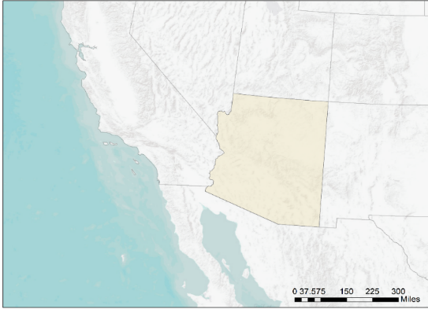

AZ

UT

NV

CA

NM

CO

Mexico

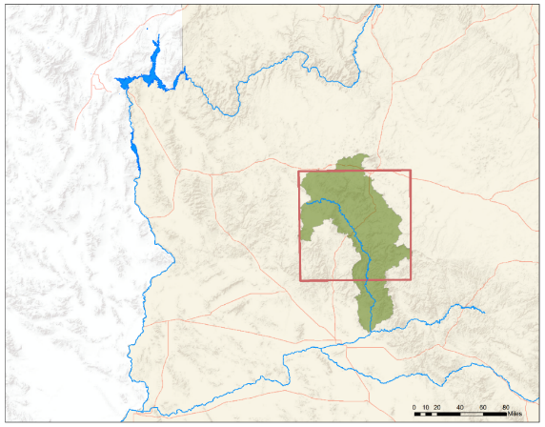

Flagstaff

Phoenix

Grand

Canyon

Lake Mead

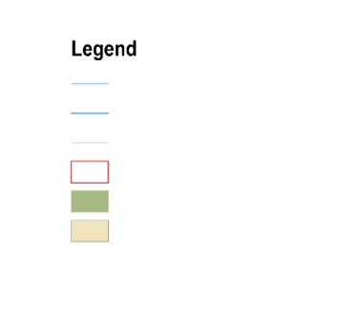

Legend

Stream/River

National Wild & Scenic River

Major Roads and Highways

Study Area

Verde Watershed River

Arizona

*Figure 1.* Study area map and insets depicting the extent of two sub-basins of the Verde River watershed in Arizona.

* 1. ***Project Partners & Objectives***

The Arizona Water Resources team collaborated with the USGS Fort Collins Science Center and the North Central Climate Science Center (NCCSC) to address the needs of partners at the Walton Family Foundation (WFF). The WFF has acted as a private granting organization for multiple Verde River conservation organizations that work to restore, preserve, and promote the value of the Verde by exploring management practices that focus on sustaining the river system. Currently, these organizations rely on a patchwork of publically available data and associated information regarding the locations of riparian corridors and vegetation cover within the watershed.

In order to support riparian restoration and management efforts by the WFF, the central objectives of the project were to delineate the maximum potential riparian corridor area and to map riparian vegetation cover in the Verde River Watershed for 2010 and 2015. These maps will provide a decision-support tool for end-users to evaluate the efficacy of previous management efforts and to prioritize future ecological restoration efforts within the watershed.

# 3. Methodology

***3.1 Data Acquisition***

To identify potential riparian areas in the Verde River Watershed, high-resolution streamflow data (Hydrologic Unit Code (HUC) 8, 1:24,000) from the National Hydrography Dataset (NHD) were downloaded using the USGS National Map webpage. A 10-meter digital elevation model (DEM) from the National Elevation Dataset (NED) was also downloaded from the USGS National Map webpage. Landsat 5 Thematic Mapper (TM), and Landsat 8 Operational Land Imager (OLI) and Thermal Infrared Sensor (TIRS) data were selected for WRS-2 Path 37/Row 36. Imagery for the growing season (April-November) was reviewed and cloud-free images were chosen for 2010 and 2015. October data products for both years were selected and downloaded from the USGS Earth Resources Observation and Science (EROS) Center Science Processing Architecture (ESPA) on-demand interface (USGS, 2016). In addition to the Landsat surface reflectance (SR) and brightness temperature products, Normalized Difference Vegetation Index (NDVI), Soil Adjusted Vegetation Index (SAVI), Normalized Difference Moisture Index (NDMI) and Enhanced Vegetation Index (EVI) spectral indices were acquired. High-resolution (1m) National Agriculture Imagery Program (NAIP) aerial photographs collected in June – August were accessed for the study area through the ESRI ArcGIS Online Image Layers and Google Earth Engine API.

***3.2 Data Processing***

*3.2.1 Valley-Bottom Extraction Tool Inputs*

The Valley Bottom Extraction Tool (V-BET), developed for ESRI ArcMap 10.4 by the Department of Watershed Sciences at Utah State University, was applied to map the valley bottoms (Gilbert, 2016). Potential riparian areas are shaped and bounded by the same lateral topographic and hydrologic processes that define the topography of valley bottoms (Reeves *et al.,* 2004), thus making the valley bottoms representative of the maximum riparian corridor extent (Gilbert et al., 2016). The V-BET tool requires elevation data and hydrologic flowline data as inputs. To prepare the hydrological network data, hydrologic flowline data were limited to the extent of upper and lower Verde sub-basins. Using the NHD Network Builder (available at USGS NHD website), flowlines representing ephemeral streams, storm water infrastructure, canals, aqueducts, and artificial hydrologic paths were removed. Final refinement was done to limit the flowlines to perennial and intermittent hydrologic features, due to their integral role in supporting riparian vegetation (NRC, 2002; Salo et al., 2016). To prepare the elevation data inputs, DEM sinks were filled in to remove local depressions. Additionally, slope, aspect, flow direction, flow accumulation and drainage area rasters were created. As a standard, all spatial data were projected to WGS 1984 UTM 12 N before preprocessing.

*3.2.2 Classification Modeling Inputs*

To supplement the indices included in the acquired Landsat 5 & 8 data, Tasseled Cap transformations were derived in ArcMap to obtain Brightness (TCB), Greenness (TCG), and Wetness (TCW) for each Landsat scene (Crist and Cicone, 1984; Baig et al., 2014). Additionally, terrain roughness was calculated from the DEM (Evans et al., 2014). All inputs obtained from Landsat and NED data products were clipped to the V-BET output and snapped to a common Landsat 8 image to preclude any possible minor spatial discrepancies between datasets.

Random Forests (Breiman, 2001) was used to classify and map riparian vegetation cover within the Verde watershed. Random Forests is an ensemble classification model that constructs multiple decision or classification trees that are each constructed with different random samples from the original dataset. The results of which are combined through a voting process in which the final classification is determined by a majority vote in order to describe predictive trends between observed values and a response variable of interest (Breiman, 2001; Gislason, 2006). To create a training dataset for the classification models, a grid geospatially matched to the 30m2 Landsat pixel boundaries for the Path 36/ Row 37 scene was constructed in ArcMap for the V-BET output extent. A set of 1,000 points were randomized within this grid in which each point was assigned to the center of a Landsat pixel in order to align sampling points with Landsat data and to provide extensive sampling of the heterogeneous landscape. These random points and the accompanying pixel boundary grid were overlaid on NAIP imagery in Google Earth Engine API and visually sampled to assess the relative percent cover of different land cover types (i.e., water, agriculture, vegetation, & other) within each pixel for both 2010 and 2015. After removing the points that were not reliably sampled (e.g., due to shadows), the total numbers of sampling points resulted n = 798 for 2010 and n = 821 for 2015.

***3.3 Data Analysis***

*Table 1*. Final predictors and importance contribution to the final 2010 and 2015 models.

|  |  |  |
| --- | --- | --- |
| Predictor Variable | Importance | |
| 2010 | 2015 |
| Blue band | 41 % | 40 % |
| SAVI | 38 % | 31 % |
| TCW | 8 % | 17 % |
| Roughness | 13 % | 12 % |

Sixteen spectral and terrain predictor

variables that have potential to provide

information to distinguish riparian vegetation from other land cover types were initially tested for covariate correlation. These predictors included: elevation, slope, terrain roughness, Landsat blue, green, red, near infrared, short-wave infrared, short-wave infrared, Brightness temperature, NDVI, SAVI, EVI, TCB, TCG, and TCW. Predictor variables were selected based on correlation and individual predictor importance. When two predictors had a Pearson correlation coefficient higher than 0.70, the predictor with a lower prediction importance was eliminated. This threshold of 0.70 was selected based on previous literature, citing that a high correlation amongst predictors can create “unstable model fits” (Morisette et al., 2013). The final predictors selected had low within-predictor correlation and significant variable importance. These included SAVI, Blue (SR band 1), TCW, and terrain roughness (Table 1).

These final predictor variables were utilized in conjunction with the training data in a two-step classification modeling approach. First, a continuous vegetation cover model was developed using multivariate regression in Random Forests to predict percent vegetation cover across the entire Verde riparian corridor. The second step was to construct a binary or presence/absence (P/A) classification model. This was achieved by dividing the training dataset into presence and absence points by a threshold (or percent vegetation cover value). Thresholds of 40, 20, and 25 percent were tested to evaluate their effect on model results in which pixels observed to be equal or lesser than the threshold value were considered absence points, and pixels with a greater value were considered presence points. The 25% threshold was selected for the final binary models resulting in n = 304 presence and n = 494 absence training points for 2010, and n = 528 presence and n = 293 absence training points for 2015. Finally, the continuous and binary models were combined to produce the two-step classification maps in which all pixels classified as absence by the binary classification were removed from the continuous classification model output. The final maps display predicted continuous percent vegetation cover for predicted presence pixels.

# 4. Results and Discussion

***4.1 Analysis of Results***

*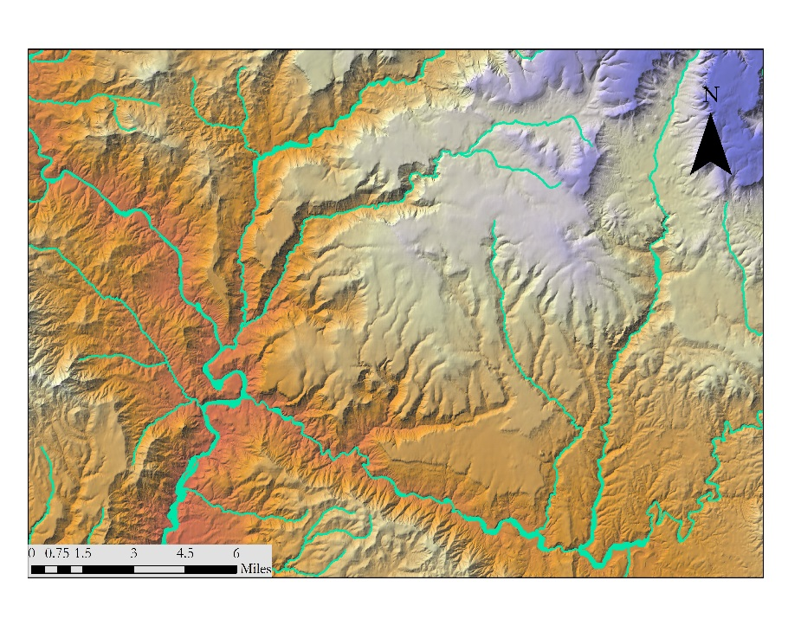4.1.1 V-BET Results Analysis*

Due to the absence of field measurements and the lack of a standardized measure of “valley bottomness”, the V-BET outputs were compared with high-resolution imagery and 3-D relief maps in Google Earth. In addition, ancillary geospatial datasets including FEMA’s 100 year flood hazard layer, and a 1m NAIP NDVI image obtained through the ArcMap GIS data server were also used for validation. Visual comparison suggested that the V-BET tool was generally successful in delineated valley-bottom extent across the study area (Figure 2). One commonly observed error in the resulting V-BET polygon was the over-estimation of the valley-bottom extent in some areas. Because the V-BET algorithm relies solely on terrain data and user-set slope and buffer-width thresholds, surface land-cover change and topographic features that fall outside of threshold values are not accounted for in the output. In the Verde, these errors occurred most commonly in low-elevation, flat-floodplain areas in which historic floodplain and riparian habitat had been converted to agriculture or otherwise altered by human use. This also occurred in high-elevation, high relief headwater regions in which stream gradients were steep and some stream contours were narrower than the user-set minimum buffer width. As suggested by Gilbert et al. (2015), the resulting V-BET polygon will be manually edited to remove these and other minor errors in order to refine this result to the current potential riparian corridor for the Verde Watershed.

*Figure 2*. Image depicting V-BET output (green) overlaid with shaded elevation relief in the SE Verde Watershed.

Figure 2. Image depicting V-BET output (green) overlaid with shaded elevation relief in the SE Verde Watershed.

*4.1.2 Analysis of classification modeling results*

|  |  |  |  |  |
| --- | --- | --- | --- | --- |
| Continuous Classification | 2010 | | 2015 | |
| R2 | RMSE | R2 | RMSE |
| 0.50 | 20.26 | 0.54 | 19.2 |

The predictive performance of the classification models was first evaluated on the basis of statistical metrics and then by visually inspecting the resulting prediction maps compared with NAIP imagery. Both the 2010 and 2015 continuous (multivariate regression) models performed reasonably well reporting an R2 of 0.50 and 0.54, respectively (Table 2). The Root Mean Square Error (RMSE) was slightly higher for the 2010 model than for the 2015 model, however in general both continuous models had less predictive power at low values of vegetation cover (i.e. 20 percent or less). The predictive performance of the 2010 and 2015 binary classification models were evaluated on the basis of the out-of-bag estimate of error and the classification error rate for presence and absence points (Table 3). The out-of-bag error was just over 20 percent for both the 2010 and the 2015 models. The absence classification error for both models was twice as high as that of presence. This may be due the fewer absence points relative to presence points in the training data, and the high variability of non-vegetated land-cover types in the study area.

*Table 2*. Reported statistical metrics for multivariate regression models.

Visual inspection of the prediction maps revealed that overall the two-step model successfully distinguished vegetation from other land-cover types, including agricultural fields (Figure 3). Some errors were identified in the resulting two-step prediction map in which irrigated agriculture and suburban vegetation was classified as presence of vegetation. However, in several observed cases, the models correctly classified adjacent agriculture as absence of vegetation cover. This could be the result of utilizing spectral information from October, when non-irrigated agriculture might be drying out, making it more distinct from natural vegetation.

*Table 3*. Reported statistical metrics for binary classification models.

|  |  |  |  |  |  |  |
| --- | --- | --- | --- | --- | --- | --- |
| Binary Classification | 2010 | | | 2015 | | |
| Out of bag error | Presence Error | Absence Error | Out of bag error | Presence Error | Absence Error |
| 22. 06% | 16% | 31% | 21.02% | 15% | 31% |

Table 3. Reported statistical metrics for binary classification models.

|  |  |  |  |  |  |  |
| --- | --- | --- | --- | --- | --- | --- |
| Binary Classification | 2010 | | | 2015 | | |
| Out of bag error | Presence Error | Absence Error | Out of bag error | Presence Error | Absence Error |
| 22. 06% | 16% | 31% | 21.02% | 15% | 31% |

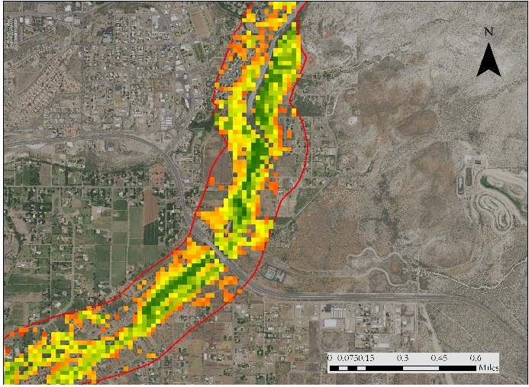

**2010**

92.1 %

4.6 %

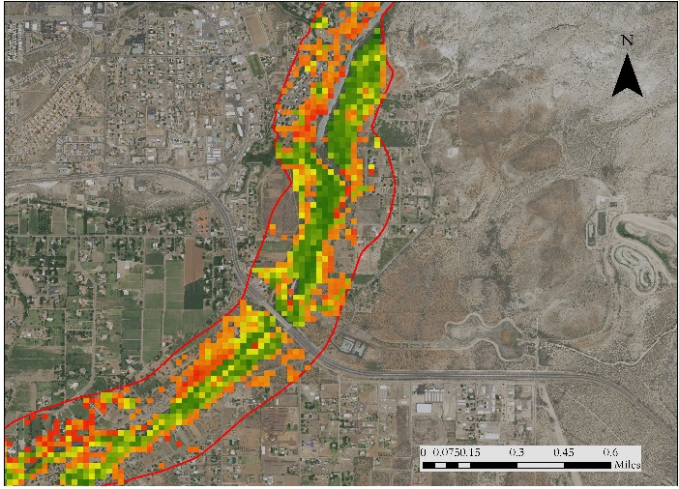

**2015**

83.4 %

7.5 %

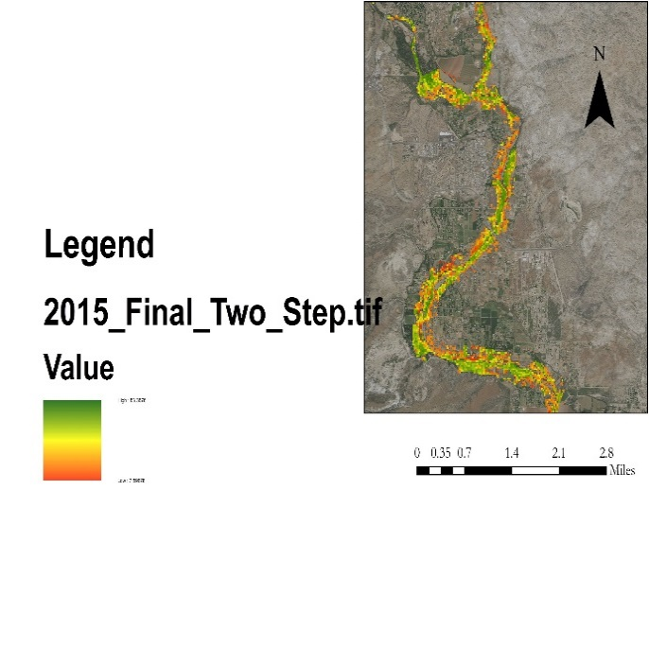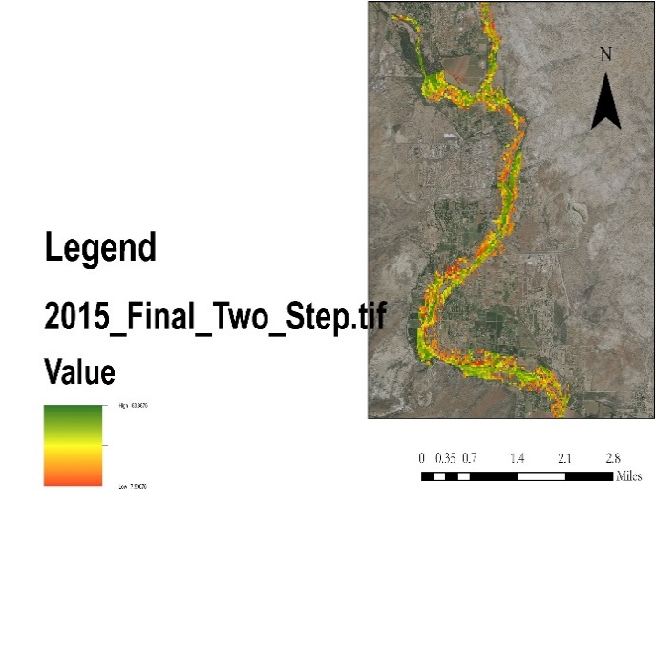

*Figure 3*. Predicted percent vegetation cover for both 2010 and 2015 resulting from the two-step model.

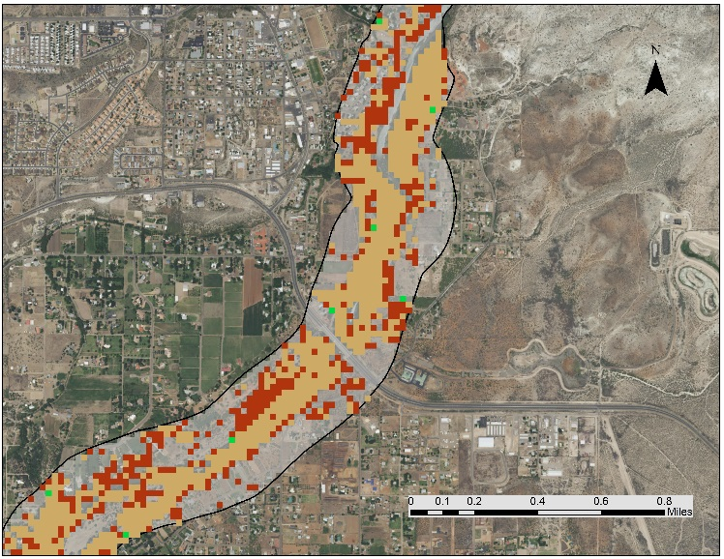

A final analysis of interest was to investigate change in predicted vegetation between 2010 and 2015 to observe vegetation cover loss throughout the study area. Figure 4 displays vegetation cover change from 2010-2015, in which change is defined ≥ 50% cover in either direction (gain or loss). A visual assessment of the vegetation cover change map revealed that no significant change was most commonly observed, however, vegetation loss was more common than vegetation gain throughout the study area. This may be the result of land-use change, differences in environmental conditions between years, or habitat management actions and invasive species control.

**Percent Vegetation**

**Cover Change**

V-BET output

Predicted

Absence

Vegetation Gain

No Change

Vegetation Loss

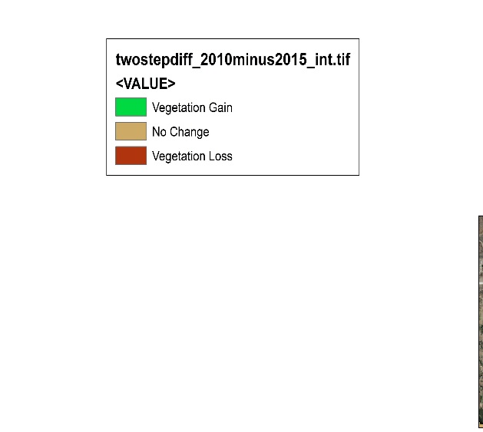

*Figure 4*. Predicted percent Vegetation Cover Change from 2010 to 2015.

***4.2 Future Work***

Important future work will involve refining the V-BET output to remove agriculture and other converted land-cover types from the riparian corridor extent. Additionally, expanding the study are to a larger spatial extent in order to map the riparian corridor for a larger, and more complex system such as the entire Colorado River Basin would be of interest. Another next step would be to map cover of invasive species such as tamarisk (*Tamarix* spp.) and Russian olive (*Elaeagnus angustifolia)* within the riparian corridor. Future field validation studies would provide an opportunity to evaluate the methodology and guide further improvements. Finally, studies attempting to quantify the water consumption of these invasive species in the study area could support local and regional water management.

# 5. Conclusions

# This project successfully utilized the Valley Bottom Extraction Tool to delineate the current maximum riparian corridor extent in the topographically diverse Verde watershed. In addition, NASA Earth Observation data were integrated into a two-step Random Forest land cover classification model to successfully map percent riparian vegetation cover in the Verde River Watershed. The resulting map products provide a comprehensive and detailed representation of riparian corridor extent and vegetation cover in the Verde River watershed, and will support riparian habitat management and restoration efforts by project partners at the Walton Family Foundation. Finally, this project demonstrated that this methodology can be utilized in future efforts to map riparian corridor extent and vegetation cover for the entire Colorado River Basin.

# 6. Acknowledgments

Dr. Paul Evangelista (Colorado State University, Natural Resource Ecology Laboratory)

Dr. Amanda West (Colorado State University, Natural Resource Ecology Laboratory)

Brian Woodward (Colorado State University, Natural Resource Ecology Laboratory)

Any opinions, findings, and conclusions or recommendations expressed in this material are those of the author(s) and do not necessarily reflect the views of the National Aeronautics and Space Administration.

This material is based upon work supported by NASA through contract NNL11AA00B and cooperative agreement NNX14AB60A.

# 7. Glossary

**Digital Elevation Model** **(DEM)** – A 3-D representation indicating elevation at any given point on the surface of the Earth.

**Ephemeral Stream** – Streams that flow only as a result of precipitation.

**EVI** (Enhanced Vegetation Index) – Indicator designed to optimize detection of vegetation in high biomass regions that is derived from near infrared, red, and blue spectral bands.

**Hydrogeomorphic Processes** – The interactions between hydrologic processes and landforms and the interactions between geomorphic processes and water.

**Hydrologic Unit Code (HUC)** – Boundary layers that delineate watersheds and other hydrological based land features. The higher number designated to a HUC, the more narrowly refinements are established in a feature.

**Intermittent Stream** – Streams that cease flowing for periods of the year.

**NDMI** (Normalized Difference Moisture Index) – Indicator associated with vegetation moisture that is derived from near infrared and shortwave infrared spectral bands.

**NDVI** (Normalized Difference Vegetation Index) – Indicator of green vegetation abundance derived from visual and near infrared spectral bands.

**Out-of-bag error** - Indicator of prediction error for machine learning models that utilizes bootstrap aggregating to sub-sample data samples used for training.

**Perennial Stream/River** – A stream or river that continually flows throughout years that have normal amounts precipitation.

**Random Forests** – A classification model that creates decision trees to delineate classes

**Riparian Corridor** – An area representing the maximum potential limit of riparian extent.

**SAVI** (Soil Adjusted Vegetation Index) - A transformation technique that minimizes soil brightness influences from spectral vegetation indices involving red and near-infrared wavelengths

**Tasseled-Cap transformation** – A conversion in original bands into a new set of bands, i.e., tcap brightness, tcap greenness, and tcap wetness, that are useful for vegetation mapping.

**Tributary** – A river or stream that flows into a larger river or water body.

**Watershed** – An area of land, defined by topographic features, that drains into a common outlet point.

# 8. References

Boepple, Brendan (2012). The Colorado River Basin: An Overview. *The 2012 Colorado College State of the Rockies Report Card.*

Breiman, L. (2001). Random Forests. Machine learning, 45(1), 5-32.

Breton, B.W. (2012). WaterSMART--The Colorado River Basin Focus-Area Study: *U.S. Geological Survey Fact Sheet 2012-3114, 6p.*

Dahl, T. E. (1990). Wetlands losses in the United States, 1780's to 1980's. Report to the Congress (No. PB-91-169284/XAB). *National Wetlands Inventory, St. Petersburg, FL (USA).*

Dalton, M. (2016).National Water Census: Colorado River Basin Study Area. *U.S. Department of the Interior & U.S. Geological Survey.*

Di Tomaso, J. M. (1998). Impact, biology, and ecology of saltcedar (Tamarix spp.) in the southwestern United States. *Weed technology*, *326-336.*

Evans JS, Oakleaf J, Cushman SA, Theobald D (2014). An ArcGIS Toolbox for Surface Gradient and Geomorphometric Modeling, version 2.0-0. Available:<http://evansmurphy.wix.com/evansspatial> Accessed: 2015 Dec 2nd.

Evangelista, P. H., Stohlgren, T. J., Morisette, J. T., & Kumar, S. (2009). Mapping invasive tamarisk (Tamarix): a comparison of single-scene and time-series analyses of remotely sensed data. *Remote Sensing*, *1(3), 519-533.*

Fish and Wildlife Service (FWS). 1998. A system for mapping riparian areas in the western U.S. *Fish and Wildlife Service, Department of Interior. Washington, DC.*

Gilbert, J. T., Macfarlane, W. W., Wheaton, J. M. (2016). The Valley Bottom Extraction Tool (V-BET): A GIS tool for delineating valley bottoms across entire drainage networks. *Computers and Geosciences*, 97, 1-14.

Hawes, E., & Smith, M. (2005). Riparian Buffer Zones. *Yale School of Forestry and Environmental Studies. Eightmile River Wild and Scenic Study Committee.*

Huang, C., Wylie, B., Yang, L., Homer, C., & Zylstra, G. (2002). Derivation of a tasselled cap transformation based on Landsat 7 at-satellite reflectance. *International Journal of Remote Sensing*, *23*(8), 1741-1748.

Johnson, A. S. (1989). The thin green line: riparian corridors and endangered species in Arizona and New Mexico. In: Mackintosh, G (ed.), In defense of wildlife: preserving communities and corridors*. Defenders of Wildlife, Washington, DC*, 35-46.

Leake, S. A., & Pool, D. R. (2010). Simulated effects of groundwater pumping and artificial recharge on surface-water resources and riparian vegetation in the Verde valley sub-basin, central Arizona, *U.S. Geological Survey Science Investigation Report 2010-5147, Reston, Va.*

National Research Council (NRC). 2002. Riparian areas: functions and strategies for management. *National Academy Press*. Washington D.C.

Pimentel, D., Zuniga, R., & Morrison, D. (2005). Update on the environmental and economic costs associated with alien-invasive species in the United States. *Ecological economics*, *52*(3), 273-288.

Poff, B., Koestner, K. A., Neary, D. G., & Henderson, V. (2011). Threats to riparian ecosystems in Western North America: an analysis of existing literature. *JAWRA Journal of the American Water Resources Association*, *47*(6), 1241-1254.

Pool, D. R., Blasch, K. W., Callegary, J. B., Leake, S. A., & Graser, L. F. (2011). Regional groundwater-flow model of the Redwall-Muav, Coconino, and alluvial basin aquifer systems of northern and central Arizona: *US Geological Survey Scientific Investigations Report 2010-5180, v. 1.1, 101p.*

Salo, J. A., & Theobald, D. M. (2016). A Multi‐scale, Hierarchical Model to Map Riparian Zones. *River Research and Applications*, *32*(8), 1709-1720.

Salo, J. A., Theobald, D. M., & Brown, T. C. (2016). Evaluation of Methods for Delineating Riparian Zones in a Semi‐Arid Montane Watershed. *JAWRA Journal of the American Water Resources Association*, *52*(3), *632-647*.

Swift, B. L. (1984). Status of Riparian Ecosystems in the United States. *Water Resources Bulletin, 20: 223-228.*

U.S. Geological Survey Earth Resources Observation and Science Center. (2012). Provisional Landsat TM Surface Reflectance. US Geological Survey. https://doi.org/10.5066/F7KD1VZ9

U.S. Geological Survey Earth Resources Observation and Science Center. (2014). Provisional Landsat OLI Surface Reflectance. US Geological Survey. https://doi.org/10.5066/F7KD1VZ9