**NASA DEVELOP National Program**

****BLM at Idaho State University GIS TReC

**Fall 2015**

**Short Title: Southeast Idaho Disasters**

**Subtitle:** Juniper Encroachment and Management in the Western U.S. Relative to Catastrophic Wildfires

**VPS Title:** The Wildland Urban Interface: People on the Edge

**Project Team & Partners**

**Project Team:**

Zachary Simpson (Project Lead), simpzach@isu.edu

Jenna Williams

Sara Ramos

**Advisors & Mentors:**

Keith Weber (GIS TReC Idaho State University)

Mark Carroll (NASA Goddard Space Flight Center)

John Schnase (NASA Goddard Space Flight Center)

**Partner Organizations:**

Bureau of Land Management, Idaho State Office and cooperating District Offices, End-User,

POCs: Steve Jirik & Mike Kuyper & Shelli Mavor

Idaho Department of Lands, Boise Field Office, End-User, POCs: Dixie Booker-lair & Robin Dunn

NASA RECOVER, Boundary Organization, POCs: Keith Weber, John Schnase, & Mark Carroll

Idaho Fish and Game, Collaborator, POCs: Mark Hurley & Evan DeHamer

Forest Service, Collaborator, POC: Chris Colt

**Project Details**

**Applied Sciences National Applications Addressed:** Disasters

**Study Area:** Southeast Idaho, United States

**Study Period:** August 1990 to October 2015

**Earth Observations & Parameters:**

Landsat 8, OLI - Calculate current juniper land cover

**Ancillary Datasets Utilized:**

Provider & Dataset

* RECOVER Geodatabase, ISU GIS TReC, Historic Fire polygons – fire history
* Remote Sensing Application Center (RSAC)- Caribou-Targhee NF Existing vegetation map – land cover validation
* Multi-Resolution Land Characteristics Consortium (MRLC) – land cover
* USGS Natonal Gap Analysis Program (GAP) – land cover
* NAIP, Digital CIR – Aerial imagery to collect training data

**Models Utilized:**

Agency & Model Name

* Clark Labs – GINI Classification Tree Analysis (IDRISI)

**Software Utilized:**

ArcGIS 10.3 - Image enhancement, map creation of Landsat 8 OLI, post-image processing

IDRISI TerrSet - Image processing, Classification Tree Analysis, Atmospheric correction, and image

classification

Hawth’s Analysis Tools - Random selection of class subsets for training and validation sites

**Project Overview**

**80-100 Word Objectives Overview:**

Past fire suppression efforts have led to juniper species (*Juniperus spp*.) expansion from their native habitats during the last century. This has led to an increase in fuel loads, altered fire regimes, and intensified the severity of wildfires. Land management agencies are interested in mapping junipers in order to manage risk in areas with large fuel loads and allocate pre- and post-fire resources efficiently. Using NASA Earth observations, the Southeast Idaho Disasters project mapped junipers to determine overall land cover, as well as tree density and frequency.

**Abstract:**

The expansion of junipers from their original rocky terrain into herbaceous communities has altered fire regimes and increased fire intensity not only in Idaho but throughout the Great Basin and Intermountain West. As junipers are actively expanding they begin to co-dominate communities resulting in the die-off of shrubs, grasses, and forbs. This expansion alters many habitat structures, effects soil erosion rates, human life and property, and other species such as the threatened Greater Sage Grouse (*Centrocercus urophasianus)*. Land Management agencies have a strong desire to find areas that are vulnerable to juniper encroachment so that these areas can be studied and effectively managed. Juniper classification maps and models created through this project assisted these agencies in management practices. These results incorporate Landsat and orthophotography with varying resolutions which were used in encroachment and density models.

**Community Concerns:**

* Over the past 130 years the Great Basin and Intermountain West has seen pinyon-juniper stands increase 10-fold.
* Juniper encroachment has altered many ecosystems of the Idaho rangelands and decreases the evolutionary health of a multitude of species.
* Encroachment of juniper species increase fuel loads and has created an increase in the size and severity of wildfire.
* Urban sprawl has increased the size of the Wildland Urban Interface (WUI), placing more human life and property at risk of wildfire devastation.
* In 2012, Idaho spent $211 million dollars combating fires that burned 1.75 million acres resulting in the destruction of 96 structures

**Current Management Practices & Policies**:

Currently, the Bureau of Land Management (BLM) primarily use aerial photography to estimate densely covered juniper stands. The BLM does not have a way to monitor the expansion of juniper or any way to predict the spread of juniper. After juniper thinning areas are established, mechanical treatments to manage junipers are implemented. Their methods include systematically cutting (removing a proportion of trees within a dense stand) or limbing (removing the lower limbs on all trees within a stand to reduce the potential for a fire to enter the crown) and shredding juniper stands. Controlled burning is another management practice in the broader land management community but this can create a water repellent layer in the soil under juniper canopies. Land rehabilitation practices include aerial seeding and seed drilling (coring holes and dropping in seeds). Seed drilling is one of the most effective ways to ensure seeds take root. Efforts by the BLM to mitigate juniper expansion have been met with mixed success in part because pre- and post-treatment of juniper density and frequency is unknown, subsequently the effectiveness of the effort is unknown.

**Decision Support Tools & Benefits:**

|  |  |  |
| --- | --- | --- |
| **End-Product** | **Earth Observations Used** | **Benefit & Impact** |
| Juniper distribution map | Landsat 8 OLI | Provide end-users valuable information regarding fuel distribution in Idaho rangelands to support resource allocation and fuel load reduction programs |

**Project Imagery**

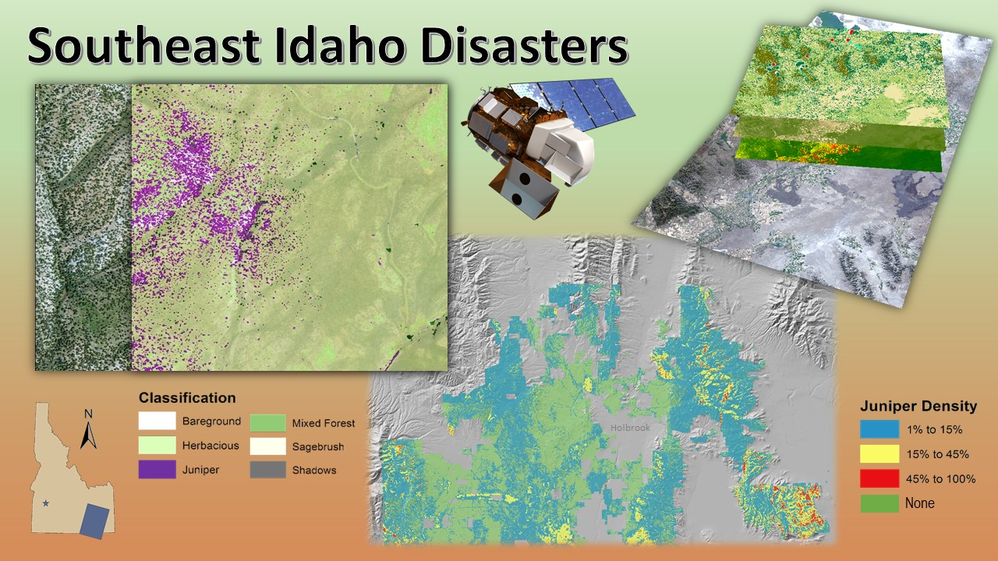

**Caption:** The Southeast Idaho Disasters team took a multi-scaled approach to identify juniper encroachment in southeast Idaho to aid land managers. Image Credit: Southeast Idaho Disasters Team.

**Image:** 2015Fall_Pocatello_SEIdahoDisasters_FinalImage_FD

**Software Release Requirements**

What category do the tools your project is creating fall within? Category I