Southern Wyoming Ecological Conservation II

Improving Invasive Species Detection Mapping with Novel Phenology Approaches

 **Technical Report**

August 11th, 2023

Bryan Graybill

Estelle Lindrooth

Lillian Gordon

Sarah Sathe

***Advisors:***

Dr. Paul Evangelista, Colorado State University, Natural Resource Ecology Lab

Dr. Catherine Jarnevich, United States Geological Survey

Dr. Anthony Vorster, Colorado State University, Natural Resource Ecology Lab (Primary Science Advisor)

Dr. Brian Woodward, Colorado State University, Natural Resource Ecology Lab (Primary Science Advisor)

Peder Engelstad, Colorado State University, Natural Resource Ecology Lab

Nicholas Young, Colorado State University, Natural Resource Ecology Lab

***Previous Contributors:***

Dahlia Shahin

Emily Snyder

Sanju Khatri

Kyle Paulekas

Michael Segala

***Fellow:***  
Sarah Hettema (Colorado-Fort Collins)

# 1. Abstract

Cheatgrass (*Bromus tectorum*)is an invasive annual grass species across the United States. Due to its ability to establish itself in disturbed landscapes, outcompete native species, and generate novel fire regimes that benefit its reproduction, cheatgrass can quickly dominate the landscape, threatening an ecosystem's integrity. Our partner, the United States Geological Services (USGS) Fort Collins Science Center, is tasked with detecting species through novel research methods that use remote sensing in varied landscapes to more accurately support land management decisions. Disturbed landscapes like the 2020 Mullen Fire burn scar (176,878 acres) in Wyoming present major concerns due to the vulnerability to invasive species. They also present an opportunity to study the presence and spread of cheatgrass post-fire. Using a date-based approach, we developed a detection method to match satellite images captured on or near dates corresponding to the unique phenology of cheatgrass green-up and senescence phases. Using phenology data provided by our partners, we analyzed the most common date pairs for the 2021 and 2022 growing seasons. We used Landsat 8 Operational Land Imager, Sentinel-2 MultiSpectral Instrument, and Harmonized Landsat and Sentinel-2 surface reflectance data to predict cheatgrass presence based on normalized difference vegetation index (NDVI) differencing between greenness and senescence dates. We found a negative correlation between cheatgrass cover and an increase in NDVI between predicted peak greenness and senescence dates. The 2021 pixel-by-pixel method had an r2 value of 0.250 and the scene-by-scene had an r2 value of 0.130. 2022 pixel-by-pixel r2 was –0.025 and scene-by-scene had an r2 of 0. The values for 2022 were lower than 2021 due to limited data from cloud cover and fewer field sites with detectable cheatgrass. Our method considers the impact of site conditions on phenological timing, giving it greater applicability over more diverse landscapes.

**Key Terms**

Cheatgrass (*Bromus tectorum*), NDVI differencing, Landsat 8, Sentinel-2, Phenology, remote sensing, greenness, senescence

# 2. Introduction

***2.1 Background Information***

In September 2020, the Mullen Fire burned 176,878 acres across the Medicine Bow-Routt National Forest in southern Wyoming and northern Colorado (Figure 1). This fire presented a prime opportunity to study the distribution and predicted spread of cheatgrass (*Bromus tectorum*). This invasive annual grass species thrives in post-fire and other disturbed landscapes. Cheatgrass is native to Eurasia but was introduced to the United States in the late 19th century via grain seed and packing material and has since spread rapidly throughout the West (Bradford & Lauenroth, 2006; West et al., 2017). Due to its aggressive early growth, this invasive has caused much trouble for native grass and forb species such as the Silver Sagebrush (*Artemisia cana*), Indian rice grass (*Achnatherum hymenoides*), and Great Basin wildrye (*Leymus cinereus*) by dominating landscapes (Zouhar, 2003.

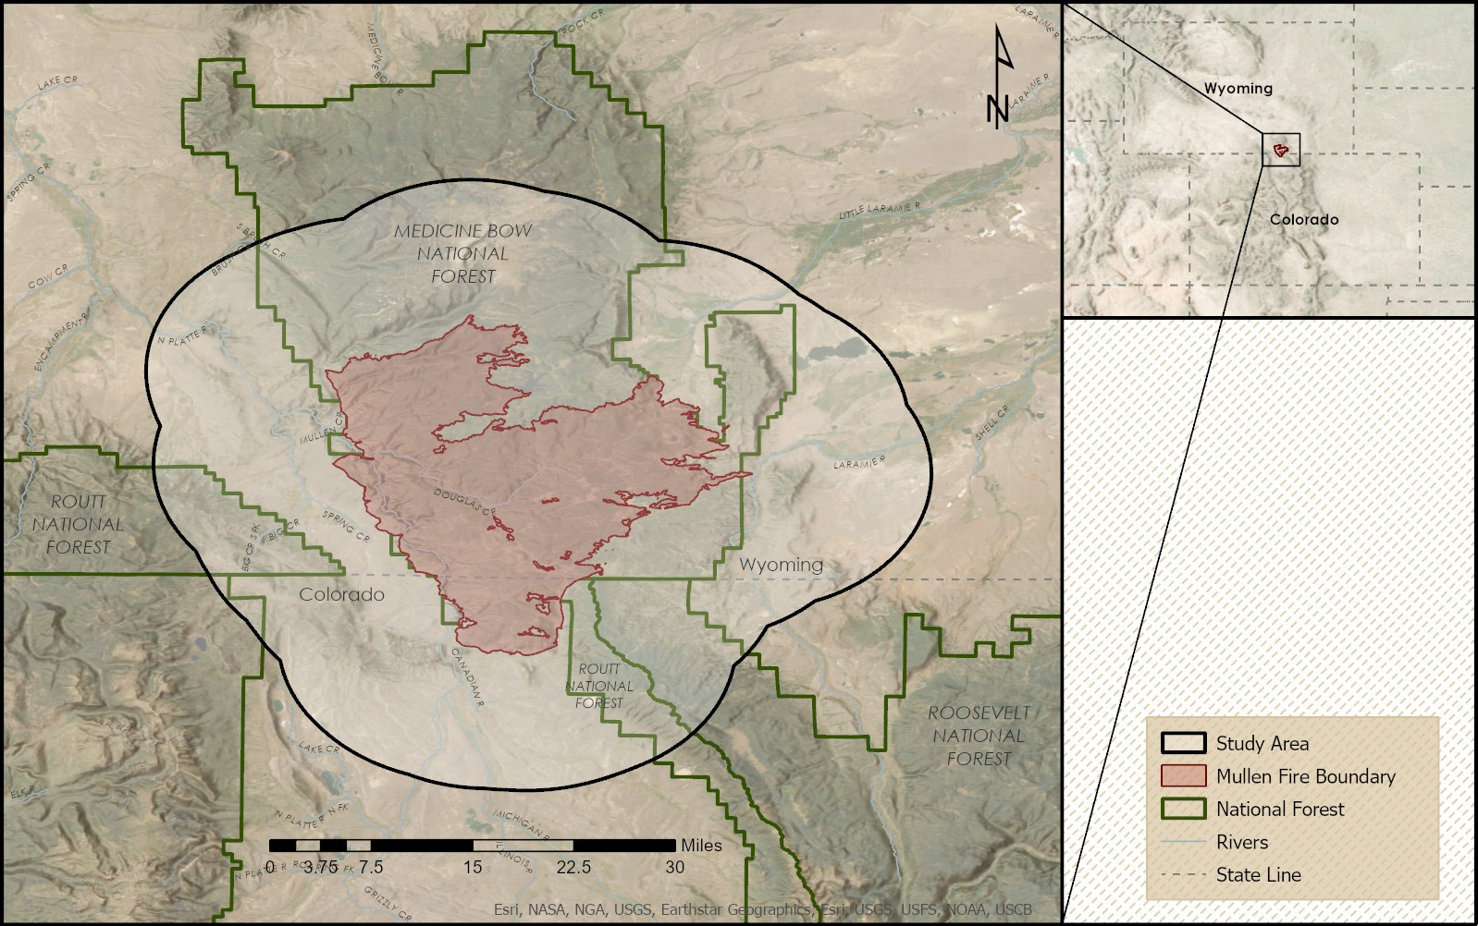

Figure . Southern Wyoming Ecological Conservation II study area. The study area includes the Mullen Fire (2020) boundary encompassing parts of the Medicine Bow and Routt National Forests and surrounding areas.

The competitive advantage of cheatgrass stems from its ability to utilize winter precipitation during the cooler months to grow and distribute a large seed bank before the growth of native species during its most productive growth phase, known as peak greenness or green-up (Mack & Pyke, 1983). It can also uptake nitrogen more effectively than native vegetation, yielding higher growth rates in burned soils versus unburned soils, increasing the likelihood of developing a dominant presence (Johnson et al., 2010). However, the risk of cheatgrass dominance is highly variable with climatic and topographic conditions (Sofaer et al., 2022). Cheatgrass die-off, known as senescence, begins by late spring to mid-summer, leaving behind swathes of dried fuel that can increase the frequency and intensity of wildfires. With more frequent fires, cheatgrass may spread into vulnerable landscapes (such as the Mullen fire burn scar), where native vegetation may be unable to adapt to the reduced fire return interval (D'Antonio & Vitousek, 1992). The reduction of native vegetation impairs habitat and food quality for wildlife such as elk and mule deer, which are left to rely more heavily on forage with lower nutritional value, potentially leading to a decrease in biodiversity across the landscape (Kohl et al., 2012; West et al., 2017). This impact increases challenges for land management agencies tasked with decision-making in degraded environments.

Field surveys, although extremely valuable, can be resource intensive. Therefore, the part one DEVELOP team used unique spectral signatures created with field data and satellite imagery in a normalized difference vegetation index (NDVI) time series of vegetation recovery patterns. The previous DEVELOP team built a random forest model from this data to detect cheatgrass and create a burn severity map (Shahin et al., 2021). They observed that NDVI differed from the start of the growing season (June) to the middle of the growing season (July). These NDVI values were the top predictors for inputs into their random forest model used to detect the different phenological trends of cheatgrass (Shahin et al., 2021).

Multiple studies have explored other phenologically based modeling methods focusing on unique spectral signatures to differentiate between native and non-native vegetation across a landscape (Bradley, 2013; Pastick et al., 2020; Sofaer et al., 2022; West et al., 2017). We utilized USGS-generated phenological data, which predicted both the green-up and senescence of cheatgrass. From these data, we generated differenced NDVI indices that we used to predict cheatgrass presence on the landscape. To assess accuracy, we compared our results to existing field data for the Mullen Fire burn scar in 2021 and 2022. This date-based approach represents a novel methodology for tackling the cheatgrass problem.

***2.2 Project Partners & Objectives***

The partners for this project include researchers with USGS and land managers with the United States Forest Service (USFS). Both partners are interested in identifying and mitigating cheatgrass introduction and growth and the Mullen Fire recovery area. To do so, they need accurate detection maps of cheatgrass to monitor yearly changes in abundance and extent to help determine treatment priority areas. Work conducted by the USGS found peak greenness and senescence dates for cheatgrass within the study area derived from phenological data collected by camera traps and the landscape's varied topographic and climactic aspects. Janet Prevéy, our research partner at USGS, used these dates to create raster maps that show these dates across the study area. Field data is extremely valuable but can be difficult to acquire spatially and temporally. Our partners have expressed that current methodologies to map cheatgrass are less effective across elevational gradients due to differences in temporal phenology that vary with elevation and climate conditions. Therefore, our partners asked us to collaborate on a novel methodology that combines phenology-based data and remotely sensed imagery to improve the detection of cheatgrass in a topographically varied landscape to better support management practices.

# 3. Methodology

***3.1 Data Acquisition***

USFS and Colorado State University (CSU) provided two data sets containing vegetation sampling data collected in the study area between May 24th and August 18th, 2021, and May 31st and August 23rd, 2022. USFS and CSU sampled 150 plots in 2021 and 169 plots in 2022. Each plot had a 10-meter fixed radius where the percent coverage of cheatgrass, perennial forbs/grasses, shrub/woody species, bare ground, and rock was recorded. The cheatgrass coverage varied between years, in 2021, 46 plots had no cheatgrass (31%), and in 2022, 65 plots had no cheatgrass (38%).

USGS contributed eight rasters for an area encompassing the study area across Colorado and Wyoming, representing key phenological dates of peak greenness and senescence for cheatgrass. USGS created these rasters for 2021 and 2022, using two different methodologies to calculate different date estimates for each year. Both prediction models used spectral data from camera trap observations of the lifecycle of cheatgrass with climate data in the Mullen Fire boundary. Then they supplemented the primary prediction method with a continuous heat-insolation load index (CHILI). CHILI is a heat load metric that combines elevation, slope, and latitude to estimate the average amount of sunlight exposure an area receives (Elsen et al., 2021). This resulted in rasters with information embedded in each pixel containing dates that predicted the day of the year when cheatgrass would be at peak greenness or senescence if present (see Appendix A, Figure A1).

We used the Harmonized Landsat and Sentinel-2 surface reflectance data set (HLS) from NASA’s Earthdata Search for our study area. We filtered the 2021 and 2022 growing seasons of May–October for less than 80% cloud cover. Earthdata Search downloads each band in a scene as individual images; these images were then batch uploaded into Google Earth Engine (GEE) using API calls for processing.

We also used available Landsat 8 Level 2, Collection 2, Tier 1 (LS8), and Sentinel-2 MSI: MultiSpectral Instrument, Level-2A (S2) acquired from GEE. We filtered the 2021 and 2022 growing seasons of May–October for less than 80% cloud cover. These alternative datasets provided valuable comparisons on the selection imagery to inform our partners on available images to meet their data goals accurately.

Table 1.

*Data Specifications for partner data.*

|  |  |  |  |  |  |
| --- | --- | --- | --- | --- | --- |
| **Partner Data** | | | | | |
| **Data** | **Data Source** | **Data type** | **Spatial Resolution** | **Acquisition Date** | **Julian Date** |
| Mullen Cheatgrass Field Monitoring Data | USFS | Table | NA | 05/24/2021 – 08/18/2021 | 144 – 230 |
| 05/31/2022 – 08/23/2022 | 151 – 235 |
| Predicted dates of peak greenness of cheatgrass | USGS | Raster | 1km | 06/06/2021 – 07/06/2021 | 157 – 187 |
| 06/18/2022 – 08/07/2022 | 169 – 219 |
| Predicted dates of senescence of cheatgrass | USGS | Raster | 1km | 06/17/2021 – 07/29/2021 | 168 – 210 |
| 07/09/2022 – 09/21/2022 | 190 – 264 |
| Predicted dates of peak greenness of cheatgrass using CHILI | USGS | Raster | 30m | 05/27/2021 – 08/13/2021 | 147 – 225 |
| 06/08/2022 – 09/12/2022 | 159 – 255 |
| Predicted dates of senescence of cheatgrass using CHILI | USGS | Raster | 30m | 06/07/2021 – 09/03/2021 | 158 – 246 |
| 07/01/2022 – 10/15/2022 | 182 – 288 |

Table 2.

*Data specifications for satellite data*

|  |  |  |  |  |
| --- | --- | --- | --- | --- |
| **Satellite Data** | | | | |
| **Data** | **Data Source** | **Spatial Resolution** | **Acquisition date** | **Julian Date** |
| Landsat 8 OLI/TIRS Level 2, Collection 2, Tier 1 (LS8) | USGS and NASA Earth Observing Systems | 30 m | 05/01/2021 – 10/31/2021 | 121 – 304 |
| 05/01/2022 – 10/31/2022 | 121 – 304 |
| Harmonized Sentinel-2 MSI: MultiSpectral Instrument, Level-2A (S2) | European Space Agency | 10 m | 05/01/2021 – 10/31/2021 | 121 – 304 |
| 05/01/2022 – 10/31/2022 | 121 – 304 |
| Harmonized Landsat and Sentinel-2 surface reflectance data set (HLS) | USGS/NASA/ European Space Agency | 30 m | 05/01/2021 – 10/31/2021 | 121 – 304 |
| 05/01/2022 – 10/31/2022 | 121 – 304 |

***3.2 Data Processing***

*3.2.1 Most Common Date Pairs ~ R*

We began processing our data by counting the number of pixels that shared the same predicted peak greenness and trough senescence dates and identifying which date pairs were most common across our study area. We obtained the greenness and senescence rasters from USGS, which covered a vast area in Colorado and Wyoming, and clipped them to our study area. We then utilized RStudio (R 2023.06.0+42) to extract the date pairs and the number of pixels sharing a specific date pair between rasters. For our study area, we found that using the CHILI raster was the most helpful in approximating phenological variations at different elevations and on slope sides due to the topographical differences.

We determined the earliest and latest dates for both green-up and senescence for CHILI raster maps by identifying pairs that matched predicted dates with at least 10,000 pixels. The Julian date range for 2021 was 155 to 219, while 2022 had a range of 168 to 263.

*3.2.2 Image Preparation*

Our study area was divided between different satellite tiles resulting in a larger number of individual images than dates due to having more than one tile image per date. When we had multiple useable tiles for a single date, these images were mosaicked together. Table 3 summarizes the number of images available during each step of the filtering and selection process. Figure 2 compares the phenology dates from our partners with the available images from all three satellite products. Gaps in the points appear where images were filtered out for excessive cloud cover (> 80%).

Table 3.

Summary of image availability for each year and imagery dataset, including the total number of images and the number of days with available imagery.

|  |  |  |  |  |
| --- | --- | --- | --- | --- |
|  | **2021** | | **2022** | |
| Images | Total | <80% Cloud Cover | Total | <80% Cloud Cover |
| **Landsat 8** | 42 | 16 | 46 | 14 |
| *Image Days* | ***21*** | ***9*** | ***23*** | ***9*** |
|  |  |  |  |  |
| **Sentinel 2** | 112 | 29 | 106 | 39 |
| *Image Days* | ***71*** | ***23*** | ***70*** | ***28*** |
|  |  |  |  |  |
| **Harmonized LS8/S-2** | 153 | 115 | 198 | 152 |
| *Image Days* | ***84*** | ***67*** | ***102*** | ***84*** |

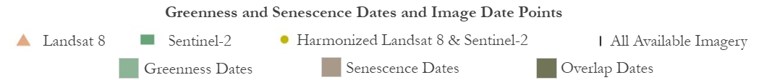

Figure a: 2021 phenology dates and image availability. 2b: 2022 phenology dates and image availability. Histogram of phenological date occurrences on greenness and senescence dates and their overlap in the study area compared with cloud-filtered image availability for each data set.

*3.2.3 Cloud Masking*

We utilized GEE to run cloud masks that removed clouds and cloud shadows. For LS8, we applied a bitwise mask using the QA_PIXEL band. For S2, we generated a cloud mask using the SCL band classifications. For the HLS data, we used the Fmask band to create a bitwise mask. Then we applied these masks to all images in their datasets, effectively removing any clouds. Lastly, we replaced the removed clouds with NA values, allowing for accurate NDVI values and differencing.

*3.2.4 NDVI Calculations/Greenness and Senescence Differencing*

We calculated NDVI on all three datasets in GEE. NDVI is used to measure the health and density of vegetation using spectral information from the red and near-infrared (NIR) bands (Huang et al., 2020). NDVI values range from –1 to 1, with higher values corresponding to peak vegetation greenness and growth. After completing the NDVI indices in GEE, we exported the processed images for additional processing in R. Using R; we completed NDVI differencing by subtracting the green images from the senescence images for analysis.

$$NDVI = \frac{\left(NIR -Red\right)}{\left(NIR + Red\right)}$$

***3.3 Data Analysis***

*3.3.1 NDVI Over-Time*

We graphed the mean NDVI during the growing season, specifically for point locations of USFS field plots with more than 40% of the cover types: cheatgrass, grasses/forbs, and bare ground. We also included a mean NDVI for the entire study site. To perform this analysis, we utilized the Landsat 8 and Sentinel-2 data without prefiltering images, which enabled us to compare the results based on the total image availability of each dataset. A 40% cover threshold for cheatgrass detection is consistent with other studies as the lowest limit for reliable cheatgrass detection using remote sensing tools (West et al., 2017).

*3.3.2 Scene-by-Scene NDVI Difference Maps*

We created scene-by-scene maps of NDVI difference values based on the Julian date 156 for greenness and 171 for senescence in 2021 using R; for 2022, we used dates 189 for greenness and 206 for senescence. The scene-by-scene map shows the difference in NDVI on one specified date pair across the landscape. We focused on these dates because they correspond closely with the predicted green-up and senescence dates for field data collection points and had minimal cloud cover. This date selection provided the opportunity for comparison to field data to validate our NDVI difference result.

*3.3.3 Pixel-by-pixel NDVI Difference Maps*

We generated a pixel-by-pixel map of our study area using R. This involves selecting the satellite image captured closest to each pixel's greenness and senescence date to extract the NDVI value. We did not pre-filter for cloud cover, but we did include a cloud mask to capture all possible images. This method then creates a new mosaicked NDVI map containing NDVI values from each satellite image available. NDVI differencing is done individually on each pixel rather than on the entire scene, allowing for more accurate analysis. When we encountered NA values from cloud cover, the script performed a single round of image substitution with the next closest date. This complexity resulted in a more accurate representation of potential cheatgrass presence across the landscape. In 2021, the pixel-by-pixel differenced map contained NDVI differences from 43 different image pairs, and in 2022, the map contained 172 different date pairs based on the images available in our date range. The pixel-by-pixel approach accounts for the varied topography of our study area, affecting cheatgrass's phenology patterns.

*3.3.4 Image Acquisition: Differences in image capture date from selected phenology date*

We created uncertainty matrices that illustrate the variability in image availability based on the number of days before or after the chosen greenness and senescence date (Appendix B, Figures B1 & B2). Since cheatgrass has a fast lifecycle, matching image availability to the desired greenness and senescence dates is challenging when creating scene-by-scene or pixel-by-pixel maps. By visualizing image availability across the study area with different thresholds for acceptable days off, we can effectively demonstrate that the further away we are from our desired phenology date, the less likely we are to capture the phenology of cheatgrass when it is the most different from native vegetation.

*3.3.5 NDVI Differences vs. Field Data*

To test if NDVI difference values correlate with high cheatgrass cover, we compared the differencing values to the observed cheatgrass cover field data. Each field plot has a specific pair of coordinates, and we extracted the differenced NDVI value for each plot from the differenced raster corresponding to that point.

We plotted the percent cheatgrass cover against the extracted differenced NDVI values for a visual representation and calculated the correlation between the two variables. We ran linear models with different filters for predictor variables to see if any spurious or confounding variables affected the relationship between differenced NDVI and percent cheatgrass cover.

Given the resolution of the imagery, spectral footprints of individual species are more accurate when the species is in dense patches or widespread across the landscape (Bradley, 2013). A study by West et al. (2017) tested a series of cheatgrass cover thresholds and found that 40% was the best minimum threshold for detecting cheatgrass using images from Landsat 8 OLI.

# 

# 4. Results & Discussion

***4.1 Analysis of Results***

*4.1.1 NDVI Over Time*

Based on our analysis of NDVI over time for 2021 and 2022, we expected to observe a clear trend of higher NDVI values for cheatgrass during early spring green-up, followed by a decline during senescence, and then a later green-up trend for native vegetation. We could roughly identify these seasonal phenology trends for our vegetation cover types but did not observe the expected timing differences between native vegetation and cheatgrass plot locations. The native vegetation plot locations appeared to green up at a similar time to cheatgrass plot locations, which was unexpected and did not align with trends observed by our partners in the same study area.

We also noticed that the trends appeared different between the LS8 and S2 datasets. For example, using 2021 data, Figure 3 contrasts the different outcomes from each dataset. The scale of our observations makes it difficult to detect cheatgrass at lower percent cover. Even at an abundance of 40% cover, cheatgrass may be sporadically growing between and amongst native vegetation, which could heavily impact the spectral signatures during observation. Cloud masking also limits the number of observations over each plot. The spacing between points and the erratic lines on our visual representation indicates data limitations. In 2022, we observed similar trends yet had fewer applicable field data points for our observations.

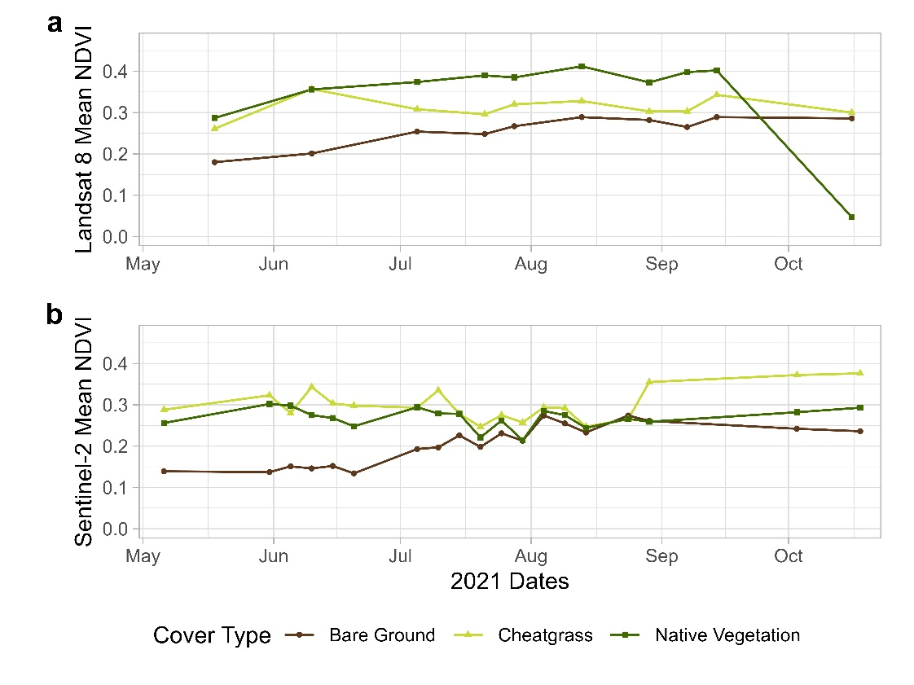

Figure a. Landsat 8 NDVI 2021 timeseries 3b. Sentinel-2 NDVI 2021 time series by ground cover type. Mean NDVI corresponding with USFS ground cover field plots with greater than 40% cover of each type.

*4.1.2 Scene-by-Scene NDVI Difference Maps*

Our scene-by-scene NDVI difference map highlights changes in greenness based on one pair of selected green-up and senescence dates applied over the entire study area. If the difference was positive, the landscape became greener between those dates. A negative difference indicated that the landscape had become less green within those dates. NDVI values fall between –1 and 1, so the differencing values should fall between –2 and 2. We filtered out the pixels with an NDVI difference outside of that range, but for each image, the percentage of pixels outside that range was less than 0.0001%. Figure 4 shows the results of scene-by-scene differences in 2021 and 2022. Clear differences appear in the change in NDVI between the two years and differences in available cloud-free images. 2022 had extensive cloud cover limiting the coverage of our study area. Looking at one date pair across the entire landscape may show differenced NDVI values, but most of these values are taken too far from the predicted cheatgrass green-up and senescence dates at many locations, which is a limitation of this method. Cheatgrass does not green up and senescence simultaneously in all site conditions. Without considering the phenological timing at different elevations and aspects, this method is likely unsuitable for large areas of interest with significant topographical variation.

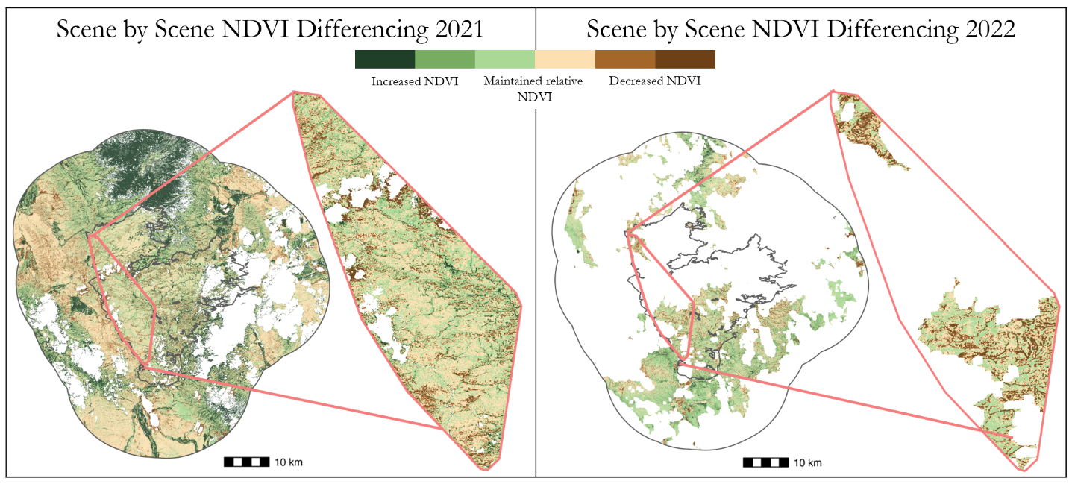

Figure . Scene-by-scene normalized difference vegetation index (NDVI) differencing plots for 2021 and 2022 using the HLS dataset. The enlarged section covers the study area where filed data was collected. Green areas increased their NDVI value, and brown areas decreased their NDVI value between dates.

*4.1.3 Pixel-by-pixel NDVI Difference Maps*

Using the pixel-by-pixel method, we selected the closest available imagery for each pixel to improve detection based on site conditions and phenological timing. Since cheatgrass has a short lifecycle, distinguishing it from native vegetation is only feasible within 10–14 days total days off from the predicted peak greenness and senescence dates. Figure 5 shows the result of pixel-by-pixel differencing for 2021 and 2022. Green areas indicate an increase in NDVI, and brown areas indicate a decrease in NDVI, with darker shades representing a larger change. Some NA values remain in white, and additional substitutions would result in images too far from the target date to capture the desired condition. Places that decreased in NDVI between the phenology dates indicate areas with potential cheatgrass. Due to the phenological patterns of early growth and senescence of cheatgrass relative to native vegetation, this decrease in NDVI potentially captures the unique lifecycle timing of cheatgrass. Increases in NDVI potentially capture the phenology timing of native vegetation. Due to limited cloud-free image availability for 2022, this map has a larger number of NA pixels resulting in less information available for our study area. Additional ground truthing would be required to confirm whether these areas with NDVI decrease were cheatgrass or some other vegetation with a similar early growth habit.

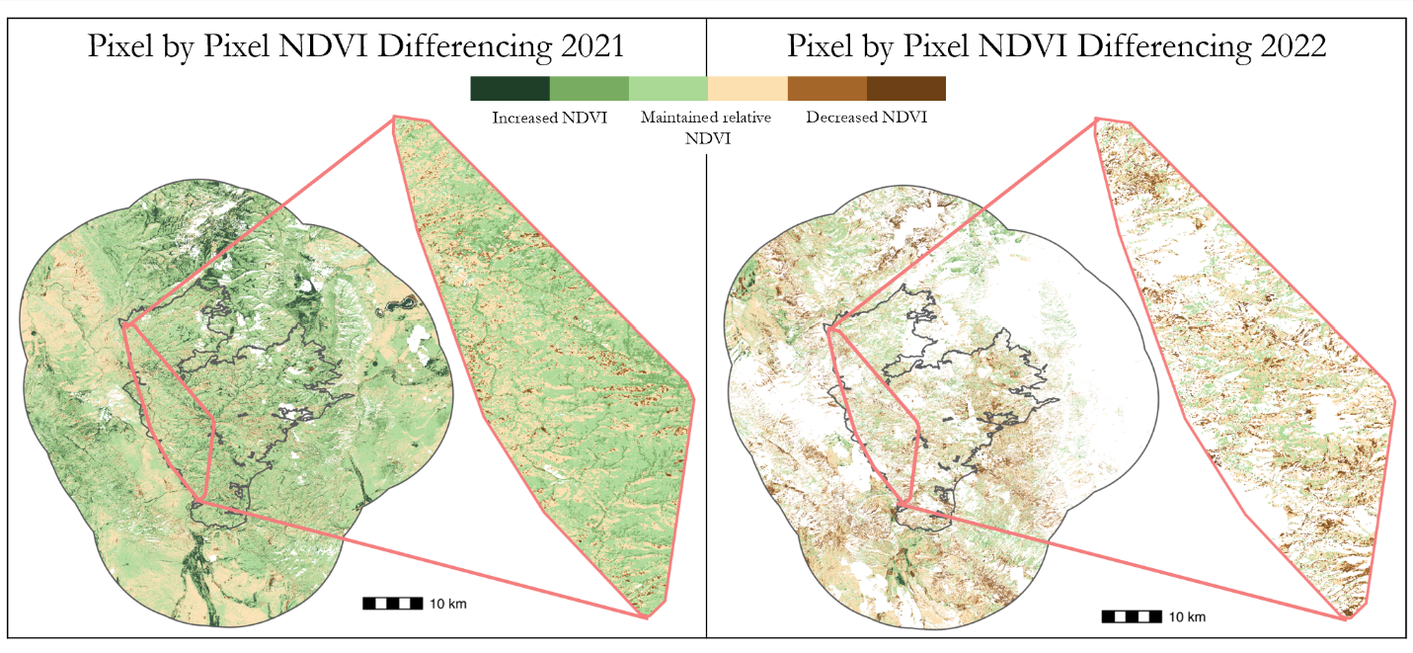

Figure . Pixel-by-pixel NDVI differencing plots for 2021 and 2022 using the HLS dataset. The enlarged section covers the study area where filed data was collected. The 2021 map uses 43 different image pairs, and the 2022 uses 172 image pairs. Green areas increased their NDVI value, and brown areas decreased their NDVI value between dates. Darker brown areas indicate areas with potential cheatgrass presence.

*4.1.4 Phenology Date Importance / Image Acquisition Differences in Days Off*

If the images used are too far from the predicted peak green-up and senescence dates for cheatgrass, NDVI differences may not show the ideal phenological signature of cheatgrass due to its short lifecycle. In such cases, changes in NDVI could be more closely related to growth in native vegetation. Our partners at USGS suggest that the ideal satellite imagery for detecting cheatgrass may be within four days before the predicted green-up date and two days before or seven days after the predicted senescence date. While up to 14 days is an acceptable range, this timeframe is not optimal for accurate detection. The uncertainty matrix for the pixel-by-pixel method shown in Figure 6 illustrates the availability of images for each pixel based on the difference between the prediction dates and the image dates. The maximum unfiltered image distance in 6a is 21 days from the ideal dates. In 6b, the images are filtered to the more specific recommended range, decreasing the number of pixels with available imagery. Pixels without available imagery will result in a null value on the map. When compared to the scene-by-scene method in Appendix B Figure B2, the number of pixels with available imagery is much higher for the pixel-by-pixel method, providing more evidence that the pixel-by-pixel method can better capture the lifecycle of cheatgrass in a topographically varied landscape. Capturing the desired phenology is more likely when a narrow range of dates is used, but a larger range can offer more flexibility in analysis if image availability is limited. However, using a larger range also risks reducing the accuracy of capturing phenological changes.

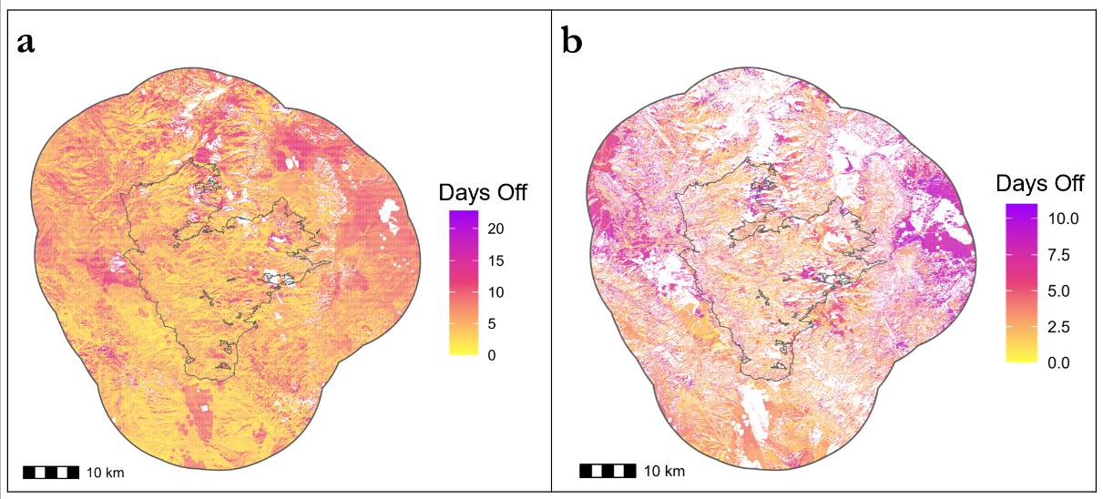

Figure a. Uncertainty Matrix for pixel-by-pixel unfiltered image availability up to 21 days from phenology dates 2021 6b. Uncertainty matrix for pixel-by-pixel 2021 image availability filtered within four days before the predicted green date and two days before to seven days after the predicted senescence date.

*4.1.5 Field Data Validation Results*

We hypothesized that a decrease in an NDVI pixel's value between the green up and senescence dates would increase the probability of cheatgrass presence. We observed a negative correlation between cheatgrass cover and NDVI difference, where a decrease in NDVI difference value correlated to an increase in the recorded percentage of cheatgrass cover and vice versa. This is reflected on our maps, which show browner areas indicating possible cheatgrass presence. We compared different image date filters to analyze specific image selection outcomes. In Figure 7a, we limited the images to within ten days of the phenology dates, providing an r2 value of 0.252. In Figure 7b, we increased the specificity of our date filter to select only images within four days of our greenness date and only two days prior and seven days post senescence date resulting in an r2 value of 0.250. The 2021 scene-by-scene comparison resulted in an r2 value of 0.029 with 10-day image limits and an r2 of 0.130 when we applied the narrower date range filter.

When we conducted the same analysis on the data for 2022, we were not able to observe the same linear trend. A comparison of results from both years is in Appendix B. Appendix B, Figure B3, and Figure B4 compare scene-by-scene results. The field data from 2022 had fewer plots with a 40% or greater cheatgrass threshold for detection and fewer usable images due to extensive cloud cover, preventing a robust comparison. Nonetheless, our results from 2021 show a promising outcome for using cheatgrass cover's phenological characteristics to map cheatgrass on a large scale with the pixel-by-pixel method. As the total days between the image date and the predicted date decrease, the variability of the NDVI differences for high-cheatgrass-cover plots also decreases, revealing a clearer trend in the data. When examining areas with lower cheatgrass cover, we observe a dispersed range of different NDVI values, which may represent different native vegetation growing and becoming greener as the growing season progresses.

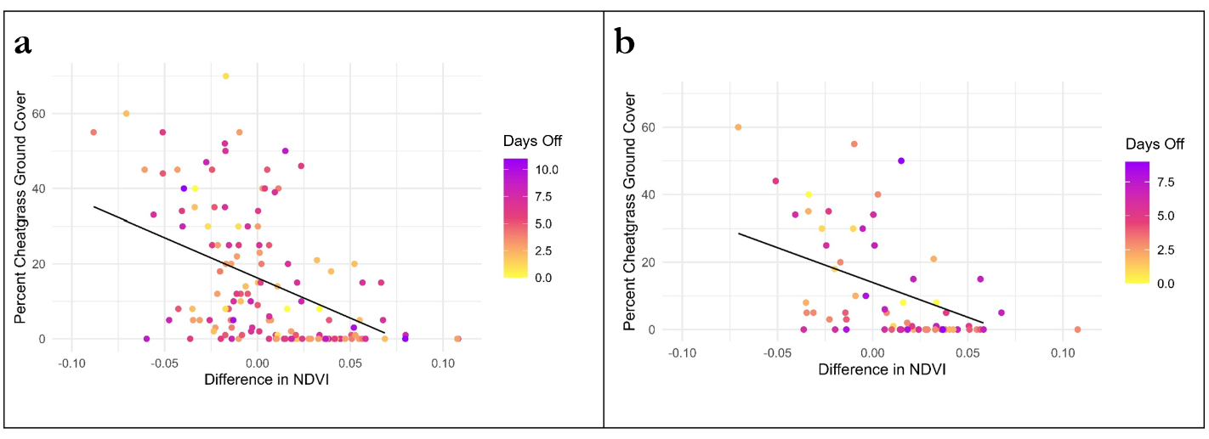

*Figure 7a.* Comparison of field plot cheatgrass cover to NDVI differenced values for the pixel-by-pixel method with images up to 10 days off from greenness or senescence. (r2 = 0.252, n = 148)

*7b.* Comparison of field plot cheatgrass cover to NDVI differenced values with images filtered for four days before the green date and between -2 and 7 after the senescence date. (r2 = 0.250, n = 69)

***4.2 Feasibility Assessment***

The effectiveness of mapping cheatgrass using the pixel-by-pixel technique depends on the available data quality. Detecting cheatgrass requires cloud-free images captured as close to the phenological phases as possible. Combined with USGS CHILI phenology date predictions, this method has produced promising results, provided useful images are accessible. This approach can be used in other regions as the CHILI phenology data covers a wide range of dates, providing insight into site conditions such as aspect and elevation that impact cheatgrass's phenological timing.

It is possible to use this technique to track cheatgrass over several years. However, it relies on site and atmospheric conditions during each period, and cloud-free images may not always be available. We could not effectively compare 2021 and 2022 due to the high number of cloudy images in 2022. Furthermore, the field data points were not in the same locations yearly, making it challenging to validate across years. As a result, it was difficult to compare the 2021 and 2022 field data, making it unclear if there was any change. The extent to which this limitation may impact the use of these methods for future monitoring of cheatgrass spread or treatment effectiveness depends on the availability of images and field data.

***4.3 Future Work***

We recommend conducting a longer-term analysis to enhance the accuracy and usefulness of the pixel-by-pixel method for cheatgrass detection. Extending the study period beyond two years may provide valuable insights into the detection map's precision and effectiveness for continuous monitoring. Locating and collecting additional plots with greater than 40% cheatgrass cover would improve the training and comparison for this detection model. Testing the method by exploring pixel averaging around field plot coordinates could also provide additional insights. Expanding this method in additional locations would be beneficial to gather stronger evidence for its usefulness in varied landscapes. However, expanding this method's temporal and spatial scope depends on the availability of ground data and phenology date prediction data. This method could also be used as an additional layer in random forest models to improve those techniques. If phenology date predictions are available, this method could also be expanded for other species.

# 5. Conclusions

Our partner at USGS proposed a novel method for detecting and mapping cheatgrass based on phenological characteristics by observing its growth timing in different site conditions such as elevation, aspect, and slope. We compared the NDVI values between peak greenness and senescence to distinguish the presence of cheatgrass in the Mullen Fire scar. Our research indicates that this approach is feasible for detecting and monitoring cheatgrass in large areas where it has established a dominant presence. The pixel-by-pixel method was successful and produced a product that is more correlated to independent field observed data than the traditional two-date scene-by-scene differencing. This method overcomes challenges associated with elevation and topography when mapping cheatgrass using phenology. It achieves this by matching a wider range of image dates with the distinctive conditions of each site. However, we observed significant interannual variability in image availability and quality, which can have significant impacts when comparing results between years. It is important to have high image availability within the growing season of your desired year, as cheatgrass may only be in a specific phenophase for a few days, and capturing this critical period is vital to the success of this method. Therefore, the choice of image source (Landsat 8, Sentinel-2, or Harmonized Landsat 8 Sentinel-2) is an important decision. The phenology date prediction maps are an essential component and make the pixel-by-pixel method possible, which may be suitable for use with other species or in other study areas. This innovative phenological approach to mapping invasive species is a promising tool for monitoring cheatgrass in topographically varied landscapes.

# 

# 6. Acknowledgements

We want to thank our Location Fellow Sarah Hettema, our Project Coordination Fellow Olivia Landry, and our science advisors Nicholas Young, Peder Engelstad, Christopher Tsz Hin Choi, Dr. Anthony Vorster, and Dr. Paul Evangelista. Their support, insights, and knowledge were invaluable to completing this project.

We want to thank our partners, Janet Prevey and Dr. Catherine Jarnevich, at USGS, and Jacquilyn Roaque, at USFS. Their direction, feedback, and creative freedom laid the foundation for the project’s success.

We would also like to thank our previous contributors from the Southern Wyoming Ecological Conservation I DEVELOP term: Dahlia Shahin, Emily Snyder, Sanju Khatri, Kyle Paulekas, and Michael Segala. Their project provided valuable insight and context for this continuing work.

This material contains modified Copernicus Sentinel data 2021 and 2022, processed by ESA.

Any opinions, findings, and conclusions or recommendations expressed in this material are those of the author(s) and do not necessarily reflect the views of the National Aeronautics and Space Administration.

This material is based upon work supported by NASA through contract NNL16AA05C.

# 

# 7. Glossary

**Continuous heat-insolation load index (CHILI) -** A heat load metric that combines elevation, slope, and latitude to estimate the average amount of sunlight exposure an area receives.

**Earth observations -** Satellites and sensors that collect information about the Earth’s physical, chemical, and biological systems over space and time

**GEE -** Google Earth Engine

**Greening-up -** The process of a plant growing and increasing its NDVI value on its way to peak greenness.

**Greenness -** The stage in a plant's lifecycle where it reaches its peak growth and attains its mature size. During this phase, the plant's tissues are rich in active green chlorophyll.

**HLS -** Harmonized Landsat 8 and Sentinel-2 dataset

**Julian Date -** the continuous count of days since the beginning of a specific year

**LS8 -** Landsat 8 dataset

**Normalized Difference Vegetation Index (NDVI) -** A vegetation index that measures vegetation health using near-infrared and red spectrometer data.

**Phenology -** The study of the lifecycle phases of a plant or organism, including growth and development, maturity (peak/greenness), seed production, and senescence (brownness).

**Remote Sensing -** The method of observing and tracking the physical features of a region by measuring the radiation that it reflects and emits from a distance, usually through satellite or aircraft.

**S2 -** Sentinel-2 dataset

**Senescence -** The deterioration at the end of the plant lifecycle generally after seed production resulting in loss of green chlorophyll in the tissues.

# 8. References

Bradford, J. B., & Lauenroth, W. K. (2006). Controls over invasion of Bromus tectorum: The importance of climate, soil, disturbance and seed availability. *Journal of Vegetation Science*, *17*(6), 693. [https://doi.org/10.1658/1100-9233(2006)17[693:coiobt]2.0.co;2](https://doi.org/10.1658/1100-9233(2006)17%5b693:coiobt%5d2.0.co;2)

Bradley, B. A. (2013). Remote detection of invasive plants: A review of spectral, textural and phenological approaches. *Biological Invasions*, *16*(7), 1411–1425. [https://doi.org/10.1007/s10530-013-0578-9](https://doi.org/10.1007/s10530-013-0578-9%20%20)

D’Antonio, C. M., & Vitousek, P. M. (1992). Biological invasions by exotic grasses, the grass/fire cycle, and Global Change. *Annual Review of Ecology and Systematics*, *23*(1), 63–87. <https://doi.org/10.1146/annurev.es.23.110192.000431>

Elsen, P.R, Farwell L.S., Pidgeon, A.M., Radeloff, V.C. (2021). Contrasting seasonal patterns of relative temperature and thermal heterogeneity and their influence on breeding and winter bird richness patterns across the conterminous United States. *Ecography, 44 (6),* 953-965

European Space Agency Sentinel Online (2021, 2022). Harmonized Sentinel-2 MSI: MultiSpectral Instrument, Level-2A [Data set]. European Space Agency. <https://developers.google.com/earth-engine/datasets/catalog/COPERNICUS_S2_SR_HARMONIZED>

Huang, S., Hupy, J. P., Shao, G., Tang, L., Wang, Y. (2020). A commentary review on the use of normalized difference vegetation index (NDVI) in the era of popular remote sensing. Journal of Forestry Research, 32, 1-6. <https://doi.org/10.1007/s11676-020-01155-1>

Johnson, B. G., Johnson, D. W., Chambers, J. C., & Blank, R. R. (2011). Fire effects on the mobilization and uptake of nitrogen by cheatgrass (Bromus tectorum L.). *Plant and Soil*, *341*, 437-445. <https://doi.org/10.1007/s11104-010-0656-z>

Kohl, M. T., Hebblewhite, M., Cleveland, S. M., & Callaway, R. M. (2012). Forage value of invasive species to the diet of Rocky Mountain Elk. *Rangelands*, *34*(2), 24–28. <https://doi.org/10.2111/rangelands-d-11-00055.1>

Mack, R. N., & Pyke, D. A. (1983). The demography of Bromus tectorum: Variation in time and space. *The Journal of Ecology*, *71*(1), 69. <https://doi.org/10.2307/2259964>

Masek, J., Ju, J., Roger, J., Skakun, S., Vermote, E., Claverie, M., Dungan, J., Yin, Z., Freitag, B., Justice, C. (2021). *HLS Sentinel-2 Multi-spectral Instrument Surface Reflectance Daily Global 30m v2.0* [Data set]. NASA EOSDIS Land Processes DAAC. <https://doi.org/10.5067/HLS/HLSS30.002>

Pastick, N. J., Dahal, D., Wylie, B. K., Parajuli, S., Boyte, S. P., & Wu, Z. (2020). Characterizing land surface phenology and exotic annual grasses in dryland ecosystems using landsat and sentinel-2 data in Harmony. *Remote Sensing*, *12*(4), 725. [https://doi.org/10.3390/rs12040725](https://doi.org/10.3390/rs12040725%20%20)

Prevey, J. (2023) *Cheatgrass Greeness and Senescence Raster Set CHILI and Non-CHILI* [Data set] USGS [Unpublished dataset].

Shadin, D., Snyder, E., Khatri, S., Paulekas, K., Segala, M. (2021). Monitoring Cheatgrass in Southern Wyoming and Northern Colorado to Inform Management Efforts Post-Mullen Fire [Unpublished Manuscript]. *NASA DEVELOP National Program.*

Sofaer, H. R., Jarnevich, C. S., Buchholtz, E. K., Cade, B. S., Abatzoglou, J. T., Aldridge, C. L., Comer, P. J., Manier, D., Parker, L. E., & Heinrichs, J. A. (2022). Potential cheatgrass abundance within lightly invaded areas of the Great Basin. *Landscape Ecology*, *37*(10), 2607–2618. [https://doi.org/10.1007/s10980-022-01487-9](https://doi.org/10.1007/s10980-022-01487-9%20%20)

US Geological Survey Earth Resources Observation and Science Center. (2020). Collection 2 Landsat 8-9 OLI (Operational Land Imager) and TIRS (Thermal Infrared Sensor) Level-2 [Data set]. US Geological Survey. https://doi.org/10.5066/P9OGBGM6

West, A. M., Evangelista, P. H., Jarnevich, C. S., Kumar, S., Swallow, A., Luizza, M. W., & Chignell, S. M. (2017). Using multi-date satellite imagery to monitor invasive grass species distribution in post-wildfire landscapes: An iterative, adaptable approach that employs open-source data and software. *International Journal of Applied Earth Observation and Geoinformation*, *59*, 135–146. <https://doi.org/10.1016/j.jag.2017.03.009>

Zouhar, Kris. 2003. Bromus tectorum. In: Fire Effects Information System, [Online]. U.S. Department of Agriculture, Forest Service, Rocky Mountain Research Station, Fire Sciences Laboratory (Producer). Available: https://www.fs.usda.gov /database/feis/plants/graminoid/brotec/all.html [2023, August 28].

# 9. Appendices

**Appendix A - Methodology**

|  |  |
| --- | --- |
| **Peak Greeness Prediction Dates CHILI** | **Peak Senescence Prediction Dates CHILI** |
| a. 2021 Greenness | b. 2021 Senescence |
| c. 2022 Greenness | d. 2022 Senescence |

Figure A. USGS Phenology Prediction Dates for greenness and senescence using the CHILI method for 2021 and 2022 clipped to the study area. Lighter shades indicate earlier dates, while darker shades indicate later ones. The variation in shading on each map mimics the terrain, as phenology dates vary depending on factors like slope, aspect, and elevation that the CHILI metric considers.

**Appendix B – Result Comparisons**

|  |  |
| --- | --- |
| **Pixel-by-Pixel Unfiltered Image Dates** | **Pixel-by-Pixel Filtered Image Dates** |
| a. 2021 | b. 2021 |
| c. 2022 | d. 2022 |

Figure B. Uncertainty Matrix Comparison for pixel-by-pixel unfiltered image availability and filtered image availability within four days before the predicted green date and two days before to seven days after the predicted senescence date for 2021 and 2022.

|  |  |
| --- | --- |
| **Scene-by-Scene Unfiltered Image Dates** | **Scene-by-Scene Filtered Image Dates** |
| a. 2021 – Green date 189 Senescence date 206 | b. 2021 – Green date 189 Senescence date 206 |
| c. 2022 – Green date 156 Senescence date 171 | d. 2022 – Green date 156 Senescence date 171 |

Figure B. Uncertainty Matrix Comparison for scene-by-scene unfiltered image availability and filtered image availability within four days before the predicted green date and two days before to seven days after the predicted senescence date for 2021 and 2022.

|  |  |
| --- | --- |
| **Field Plot Cheatgrass Cover and Difference in NDVI Pixel-by-Pixel** | |
| **Images up to 10 days off from greenness or senescence** | **Images filtered up to 4 days before green date and between -2 and 7 after senescence date** |
| **a.** 2021 r2 = 0.252 n = 148 | **b.** 2021 r2 = 0.250 n = 69 |
| **c.** 2021 r2 = -0.019 n = 49 | **d.** 2022 r2 = -0.025 n = 33 |

Figure B. Comparison of field plot cheatgrass cover to NDVI differenced values using the pixel-by-pixel method. The lower r2 values in 2022 resulted from fewer field plots containing 40% or greater cheatgrass cover and fewer cloud-free images available.

|  |  |
| --- | --- |
| **Field Plot Cheatgrass Cover and Difference in NDVI Scene-by-Scene** | |
| **Images up to 10 days off from greenness or senescence** | **Images filtered up to 4 days before green date and between -2 and 7 after senescence date** |
| **a.** 2021 r2 = 0.029 n = 128 | **b.** 2021 r2 = 0.130 n = 36 |
| **c.** 2021 r2 = -0.002 n = 38 | **d.** 2022 r2 = 0 n = 2 |

Figure B. Comparison of field plot cheatgrass cover to NDVI differenced values using the scene-by-scene method. The lower r2 values in 2022 resulted from fewer field plots containing 40% or greater cheatgrass cover and fewer cloud free images available.