Georgia Energy III
Identifying Habitat and Solar Site Conflict in Georgia by
Developing an Environmental Sensitivity Public Mapping Tool


Technical Report
Final Draft – August 6th, 2020

Samantha Trust (Project Lead)
Alexander Burke
Jannatul Ferdush
Vineeth Jason Putti

Dr. Marguerite Madden, University of Georgia (Science Advisor)

Previous Contributors:
Lynn Abdouni
Emad Ahmed
Amanda Aragón
Natalia Bhattacharjee
Roger Bledsoe
Marie Bouffard
Christopher Cameron
Fabiola Clermont
Peter Hawman
Nick Morgan
Caren Remillard
Suravi Shrestha
Austin Stone

1. Abstract
The rapid expansion of the solar industry across the state of Georgia has a detrimental effect on the habitats of keystone and threatened species, such as the gopher tortoise (Gopherus polyphemus) and the American black bear (Ursus americanus). NASA DEVELOP collaborated with the Georgia Chapter of The Nature Conservancy (TNC) and the Georgia Department of Natural Resources to continue the research from two previous NASA DEVELOP projects in 2017. The team worked to assess the conflict between solar suitability and environmentally sensitive areas with the Land-Use Conflict Identification Strategy (LUCIS) and to analyze how conflict has changed since the last term in Fall 2017. The project utilized Terra/Aqua Clouds and the Earth's Radiant Energy System (CERES) satellite data and other ancillary datasets to conduct and compare a general statewide LUCIS analysis from 2017 to 2019 and to complete an in-depth LUCIS analysis of Georgia’s fastest-growing solar counties—Taylor, Twiggs, Decatur, and Brooks. Our analysis indicated that between 2017 and 2019, the entire state saw high conflict areas increase by 38.18%. Our partners will use these findings to target areas for promotion of conservation policy and education efforts. The team also provided TNC with a publicly available web application, called the Environmental Sensitivity Mapping Tool (ESMT), that can be updated as new data are released. The ESMT will be used to educate interest groups, such as solar developers and conservationists, to help them recognize and mitigate the negative effects of solar development on the environment.

Key Terms
solar energy, gopher tortoise, American black bear, Terra/Aqua CERES, LUCIS, web application

2. Introduction
  - Background Information
As the demand for global energy increases, alternative energy sources are becoming more critical for the future. To combat climate anomalies onset by greenhouse gases, solar energy has become a leader in renewable energy sources in the United States. The number of solar installations in the US has significantly increased in the last decade, with production rates said to have increased by about 35-fold (US Department of Energy, 2020).
The state of Georgia stands at a unique position in national rankings for solar capacity, ranking 5th in 2019 and 9th in 2020 (Solar Energy Industries Association, 2020). This ranking derives from various factors like its geographic location in the southeast, which provides sufficient sunlight, large amounts of suitable flat lands, as well as local material supply lines (Hsu & Kelly, 2019). While solar energy is an affordable and accessible potential energy source in Georgia, policymakers still have to make considerations on environmental trade-offs before developing utility-scale solar farms. Large-scale solar installations often take place on rural lands which may significantly alter the environment and could lead to habitat loss of native species (Hernandez et al., 2014). Georgia Conservancy (2020) has become increasingly concerned about the overlap between suitable solar development sites and the habitat of the vulnerable gopher tortoise (Gopherus polyphemus) within the state. Additionally, concerns have increased due to a recent ground break in Twiggs County for the largest solar plant in the southeast US, which is home to one of the fastest-growing populations of American black bears (Ursus americanus) in Georgia.
The gopher tortoise, the official state reptile of Georgia, is a candidate for the federal endangered species list and a keystone species that plays a critical role in the coastal plain ecosystem (Chapman, 2017). During forest fires, this reptile provides shelter and protection in its burrows to about 300 different species of birds, reptiles, and amphibians (US Fish and Wildlife Service, 2017). As apex predators, black bears are integral to maintaining structure and health within the ecosystem by providing benefits such as population control and seed dispersal (Sierra Club, n.d.). The construction of solar plants has altered the habitats of the gopher tortoise and black bear and therefore threatens the vitality of these species. However, solar construction in mutually suitable areas can help conserve sensitive wildlife habitat and assure ongoing sustainable solar practices (Energysage, 2020).
The Land-Use Conflict Identification Strategy (LUCIS) can assist in identifying potential conflict between certain land characteristics according to user-defined criteria (University of Florida, 2007). LUCIS is a raster-based land suitability analysis method that utilizes Esri ArcGIS software (Carr & Zwick, 2007), guided by a hierarchical set of goals and weights that are assigned by stakeholders according to their relative preference of the land (University of Florida, 2007). The model begins with the weighted suitability analysis of each major land-use category, for this project these categories are solar development and environmental sensitivity, then combines the results using raster calculations to show preferences of land use and highlight areas of the most conflict between land uses (Carr & Zwick, 2007; Collins, Steiner, & Rushman, 2001).
NASA Earth observation data have been used in many suitability and land use studies. Uyan (2013) utilized GIS and an analytic hierarchy process, similar to LUCIS, to determine logical locations for solar farms in Konya, Turkey. Uyan (2013) acquired data for terrain, land use, roads, and transmission lines to develop a suitability map, for which terrain data were provided by NASA’s Shuttle Radar Topography Mission. To date, solar suitability projects have continuously utilized data types such as those previously named, but Clouds and the Earth’s Radiant Energy System (CERES) FLASHFlux Version 3C data gathered from the NASA Prediction Of Worldwide Energy Resources (POWER) dataset has not been utilized. These data provide vital solar insolation measurements that tell us how much solar energy hits the earth’s surface.
The entire state of Georgia was considered as the study area for this project (Figure 1). In addition to state-wide LUCIS analysis, an in-depth analysis was also conducted for Georgia’s top four fastest growing solar counties: Taylor, Twiggs, Decatur and Brooks. This project’s study period followed the time frame of recent solar farm development and the most recently available data, which spanned from July 2017 to December 2019.
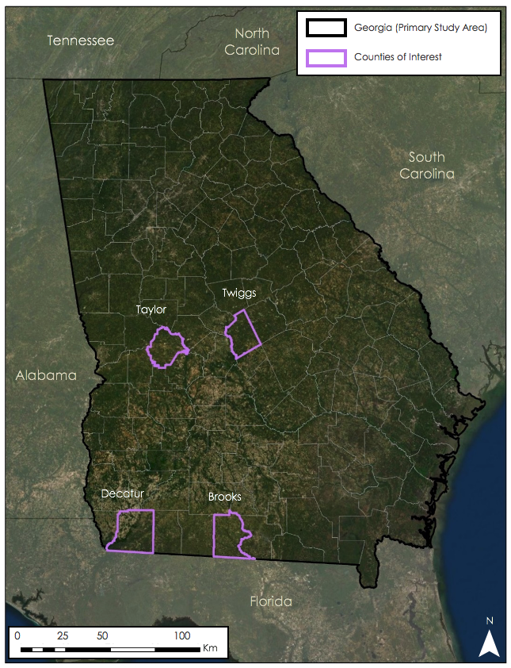

Figure 1. The study area of Georgia with the quickest growing solar counties, which were used as focus counties in this project.
This term continues upon the research of the Georgia Energy I and II teams that focused on the effects of solar development on gopher tortoise habitats by conducting solar suitability and LUCIS analyses across the state of Georgia, and specifically within Taylor County and Decatur County. The first term was able to conclude that “there is adequate space throughout Georgia that is suitable for abundant solar energy development that minimizes environmental impacts,” (Abdouni, Ahmed, Bhattacharjee, Bledsoe, et al., 2017), while the second term added that Decatur county contained more highly suitable areas than Taylor County (Shrestha, Ahmed, Aragón, Bouffard, et al., 2017). The Georgia Energy III team has expanded the research of the two previous terms by adding Brooks and Twiggs counties to our county analyses and utilizing opinions and feedback from solar developers in Georgia for the LUCIS model.
  - Project Partners & Objectives
The Summer 2020 Georgia Energy III team partnered with The Nature Conservancy (TNC) and the Georgia Department of Natural Resources (GADNR) to contribute to the available resources for sustainable solar energy development, engaging both solar energy stakeholders and wildlife experts. TNC uses the “Conservation by Design” framework for decision making and planning for conservation projects. This framework focuses on making decisions utilizing science-based knowledge and data from on-the-ground surveys, remote sensing or expert opinion. This project fits into TNC’s framework by working to conserve the ecologically important areas using geospatial analysis (A. Gutierrez, personal communication, June 8, 2020). This project compared solar suitability and environmental sensitivity in Georgia for 2017 and 2019 and utilized LUCIS to highlight areas of conflict between solar development suitability and environmental sensitivity to mitigate the conflict between the natural environment and solar farms. This project also generated a story map and a web application to assist decision makers in visualizing conflict and selecting sustainable solar development sites.

3. Methodology
3.1 Data Acquisition
The team collected the solar insolation data through the NASA POWER dataset that uses the CERES instruments on the Aqua and Terra satellites to show levels of solar radiation on the earth’s surface. Land use and land cover (LULC) classifications were acquired from the United States Department of Agriculture (USDA) CropScape dataset for the years 2017 and 2019. CropScape data was based on Landsat 8 Operational Land Imager (OLI) and Sentinel-2 MultiSpectral Imager (MSI) imagery and classified based on type of crop, intensity of development and types of green cover. These datasets, in addition to a Digital Elevation Model (DEM) to calculate aspect and slope, and transmission lines to calculate proximity were used as inputs in the statewide LUCIS comparison between 2017 and 2019 (Appendix A). The team also used these data as solar suitability inputs to the bivariate conflict model created with LUCIS and included roads, floodplains, and parcels data for the four counties of focus (Appendix B). For the environmentally sensitive areas input of the bivariate conflict map, the team acquired data for protected lands, conservation lands, land trusts, critical habitats, prime farmlands and resilient landscapes (Appendix B). These data would help calculate areas of conflict between suitable areas for solar development and environmentally sensitive areas. The team also wanted to include American black bear habitats in the environmental sensitivity map as an additional variable. Unfortunately, due to lack of current data, it could not be included in the analyses, however, many of the parameters used to create the black bear habitats data (such as LULC, river corridors, and agricultural lands) overlap with data that was already used in the model.

3.2 Data Processing
Every data layer collected was projected to NAD 1983 (2011) State Plane Georgia West, clipped to the state and/or county boundary, and eventually converted to raster format to complete our analyses (Appendices A and B). The DEM from USGS was downloaded in 15 separate TIFF files, which were then combined using the Mosaic to New Raster tool and clipped to the Georgia state boundary. CropScape LULC classifications needed to be reclassified to show one “Agriculture” category, instead of each individual type of crop. This reclassification was done by creating a new field within the attributes table to rename the attribute. The team also created a new field in the county-level parcels data to calculate the area for each shape using the Calculate Geometry function in the attribute table. Finally, CERES data were collected in NetCDF format, which had to be converted to a raster before continuing to project, clip, and reclassify based on equal interval classification with 3 classes.

3.3 Data Analysis
After consulting with experts in the solar industry, conducting literature review, and discussing with our project partners, data were reclassified with new values for the statewide solar suitability and environmental sensitivity LUCIS bivariate conflict map between 2017 and 2019 to show suitable areas for development that overlap with environmentally sensitive areas (Appendix C). Solar suitability was calculated using five variables, proximity to transmission lines, slope, aspect, solar insolation and land use and cover; values were reclassified on a scale of 1 to 3, with 3 being most suitable, indicating a preference for utility-scale solar development (Appendix D). The environmentally sensitivity analysis used gopher tortoise habitats, land use and land cover, landscape connectivity, protected areas and prime farmlands as the inputs and uses the same methods and scale as the solar suitability analysis, 1 to 3, but in this map, 3 indicates the most environmentally sensitive landscape (Appendix D). After reclassification, each raster was assigned a weight, using the Weighted Overlay tool, which allows for more important factors, like slope and aspect, to have a higher influence within the model. During the weighted overlay, the team scaled the suitability/sensitivity values to a scale of 1 to 9, 1 values stayed as one, 2 values became 5, and 3 became 9; this was done to give more variability within the results instead of just three total rankings.

Next, the resulting rasters were combined in Raster Calculator to create a two-digit conflict value (Table 1). The solar suitability score is multiplied by 10, then added to the environmental sensitivity score to create the Bivariate Conflict Map. By multiplying the solar raster by 10, that creates a second digit place representing the level of suitability and does not affect the weight of the layer (Figure 2). Conflict values of same number in both places, 33, 22, and 11 indicate high levels of conflict. Numbers like 31, indicate high solar suitability and low sensitivity, making it the most ideal location for development, while numbers like 13 represent areas of high environmental sensitivity and low solar suitability. However, at a quick glance it is not easy to digest the results of our analyses through these classes. To make these results more comprehensible, conflict values were reclassified into levels of preference for solar development (Table 2). Green areas indicate high preference for solar development, while red indicates low preference. Grey represents restricted areas like conservation lands, land trusts, and lands managed by GADNR. Something to note is that areas of high sensitivity were reclassified as low preference despite their solar suitability. This was done in order to prioritize conservation of environmentally significant regions (Figure 3). The same process of creating the solar suitability and environmental sensitivity analyses, creating the bivariate conflict map, and reclassifying was followed for the county-level LUCIS analysis for Brooks, Decatur, Taylor and Twiggs counties, however additional data layers, like parcel data, roads and floodplains, were added for in-depth analyses.

Table 1
LUCIS conflict values and their descriptions.
Conflict Value | Conflict Description
11 | Major Conflict, Low Preference
12 | Moderately Sensitive, Unsuitable for Development
13 | No Conflict, Very Environmentally Sensitive
21 | Moderately Suitable for Development, Not Sensitive
22 | Major Conflict, Moderately Suitable and Sensitive
23 | Moderately Suitable, Highly Sensitive
31 | Ideal for Development, Not Sensitive
32 | Highly Suitable, Moderately Sensitive
33 | Major Conflict, High Preference for Development, Very Sensitive

Table 2
LUCIS conflict values reclassified.
Conflict Value | New Value
11 | 1
12 | 2
13 | 1
21 | 3
22 | 2
23 | 1
31 | 3
32 | 3
33 | 1

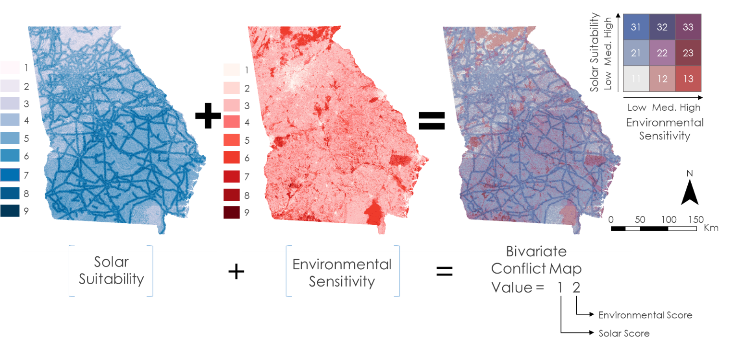

Figure 2. Visualization of Raster Calculator equation.
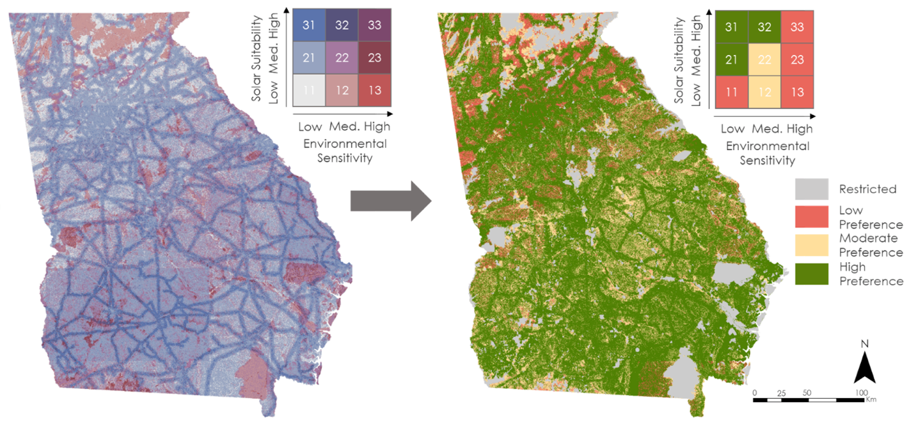
Figure 3. Original LUCIS results (on left) for the state of Georgia reclassified to levels of preference (on right).

3.4 Data Visualization and Dissemination
During initial discussions, our project partners conveyed interest in a public facing web application that could showcase the results of our analysis and aid stakeholders in the decision-making process of siting new solar facilities. Our team decided to utilize the organizational use of Esri ArcGIS Online by both NASA DEVELOP and TNC to build a web mapping application that would meet these goals. After considering alternative Esri web products, like ArcGIS Dashboards, we chose to use ArcGIS WebApp Builder due to the variety of templates and built-in widgets that the platform offers. We worked closely with our partners to define the functionality, data content, and lay out of the application.

After analyzing solar suitability and potential areas of conflict between solar development and sensitive habitats for the entire state of Georgia, these model outputs, along with several key ancillary datasets, were uploaded to a team member’s NASA ArcGIS Online account as hosted tile packages and feature services. Our team added these layers to a web map and consulted with our partners to configure the map with their desired symbology and layout. Within ArcGIS WebApp Builder, our team selected the pre-configured web map to base the application on. After selecting the underlying web map, we configured a series of Esri Widgets within the application to achieve the functionality desired by the project partners. Aside from viewing our input datasets and results in the web application, our partners indicated that we should include features that allow end users to temporarily add their own data, print a copy of the map, and swipe layers to compare results between the three study years. Our team attempted to balance the functionality of the final product so that the application remains useful for both technical and general audiences.

4. Results & Discussion
4.1 Analysis of Results
Using the results from the solar suitability analysis, we observed that most of the suitable sites were located in the southern part of the state in both of 2017 and 2019, shown in the darker shades of blue (Figure F2). Georgia Energy II team found the southern part as geographically flat with good aspect and slope ratio which was suitable for solar farm development (Hsu & Kelly, 2019; Shrestha, Ahmed, Aragón, Bouffard, et al., 2017). The number of suitable sites had increased rapidly in 2019 though the values for each suitability class varies differently (Figure F2, Figure F7). They estimated that transmission lines had notable impacts on solar suitability, as closer proximity of electricity lines reduce the cost of solar development. Solar developers also found the cost of transferring transmission lines economically beneficial when the sites were in closer proximity (Uyan, 2013; Mierzwiak & Calka, 2017). The county-level solar suitability was also performed for Brooks, Decatur, Taylor, and Twiggs counties (Figure G2, Figure H2, Figure I2, Figure J2).

Results from the environmental sensitivity analysis showed a rising trend for all sensitivity classes except for sensitivity scores of 1 and 2 from 2019 to 2017 (Figure F6). Scores are shown on red color ramp, the darkest red indicates the most sensitive areas. Unlike 2017, the major environmentally sensitive areas were concentrated on south-east and north-east corner of Georgia, whereas the middle of the state showed the least sensitivity in 2019 (Figure F1). However, the entire state had less environmental sensitive areas in both years (Figure F1). The team observed that the most environmentally sensitive areas were covered by Coastal Plain and wetlands of the Okefenokee Swamp in southeast Georgia, and the Appalachian Mountains in northeast Georgia. The southern regions overlapped with Gopher Tortoise habitats (Figure F5) which, if lost, could drastically alter the biodiversity of this species including other supported species (Chapman, 2017; US Fish and Wildlife Service, 2017). The sensitive areas in northeastern Georgia were mainly within the Chattahoochee-Oconee National forest, a primary habitat for the American black bear (Carlock et al., 1999). Alternatively, the least sensitive areas of Georgia were urban areas and agricultural lands (Figure F1). The team also conducted county-level environmental sensitivity analyses in Brooks, Decatur, Taylor and Twiggs counties using same variables comparing 2017, 2018, and 2019 (Figure G1, Figure H1, Figure I1, Figure J1).

Using the results from these two categories, solar suitability and environmental sensitivity, the team created bivariate map (LUCIS map) showing potential areas of conflict across the of state of Georgia in 2017 and 2019 (Figure F3). Shades of blue represent levels of solar suitability; shades of red represent levels of environmental sensitivity, while shades of purple represent conflict. As previously mentioned, a score of 31 represents the highest level of solar suitability and the lowest level of environmental sensitivity, therefore it would be the most ideal place for new utility scale solar farms and received a high preference for solar development due to the minimal environmental impact and maximum benefits for solar development. The LUCIS bivariate conflict maps of 2019 had showed increasing pattern compared to 2017; the rapid development of suitable solar areas was increasingly overlapping the habitats of different species, conservation lands, and agricultural lands. They also generated the reclassified LUCIS bivariate maps according to solar preference for 2017 and 2019, where high preference lands showed high solar suitability with low environmental sensitivity (Figure F4). The number of high preference zones had increased by 3% and the low preference zones had increased by 17% in 2019 than 2017 across the state of Georgia. Although the preferred solar sites were widely distributed across the state of Georgia, there were some restricted lands, like conservation and GADNR managed lands, that were out of analyses. Further county-level analyses were also performed for in-depth analyses comparing conflict in 2017, 2018, and 2019 for all counties of interest (Figure G3, Figure G4, Figure H3, Figure H4, Figure I3, Figure I4, Figure J3, Figure J4).

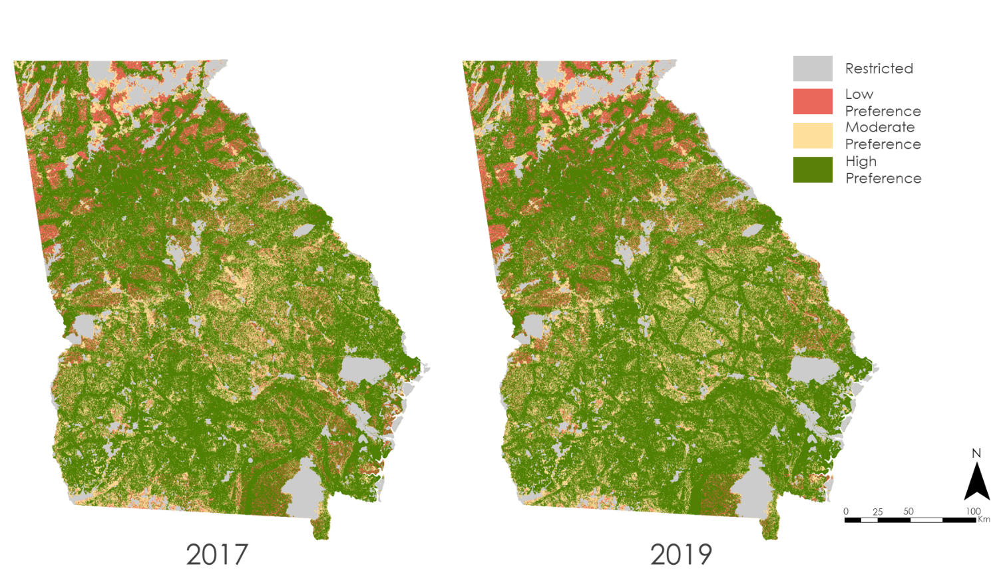

Figure 4. Statewide Reclassified LUCIS Results.

To further understand the differences in the classes of the LUCIS and the Reclassified outputs, statistical analyses was carried out on the data to determine trends and relationships. The difference in area for each class through time (2017 and 2019 for the statewide outputs and 2017, 2018, and 2019 for the county level outputs) was analyzed. It was observed that there was an overall increase in the land area under classes where there was high solar suitability (i.e. class values starting with 3 - 31, 32, 33). Conversely, an overall decrease in the land area was observed in the classes where there was a high level of environmental sensitivity (i.e. class values that started with 1 - 11, 12, 13). While an accurate description of the reasons behind this cannot be made, we can attribute the overall change to the changes in the solar insolation and LULC data layers.
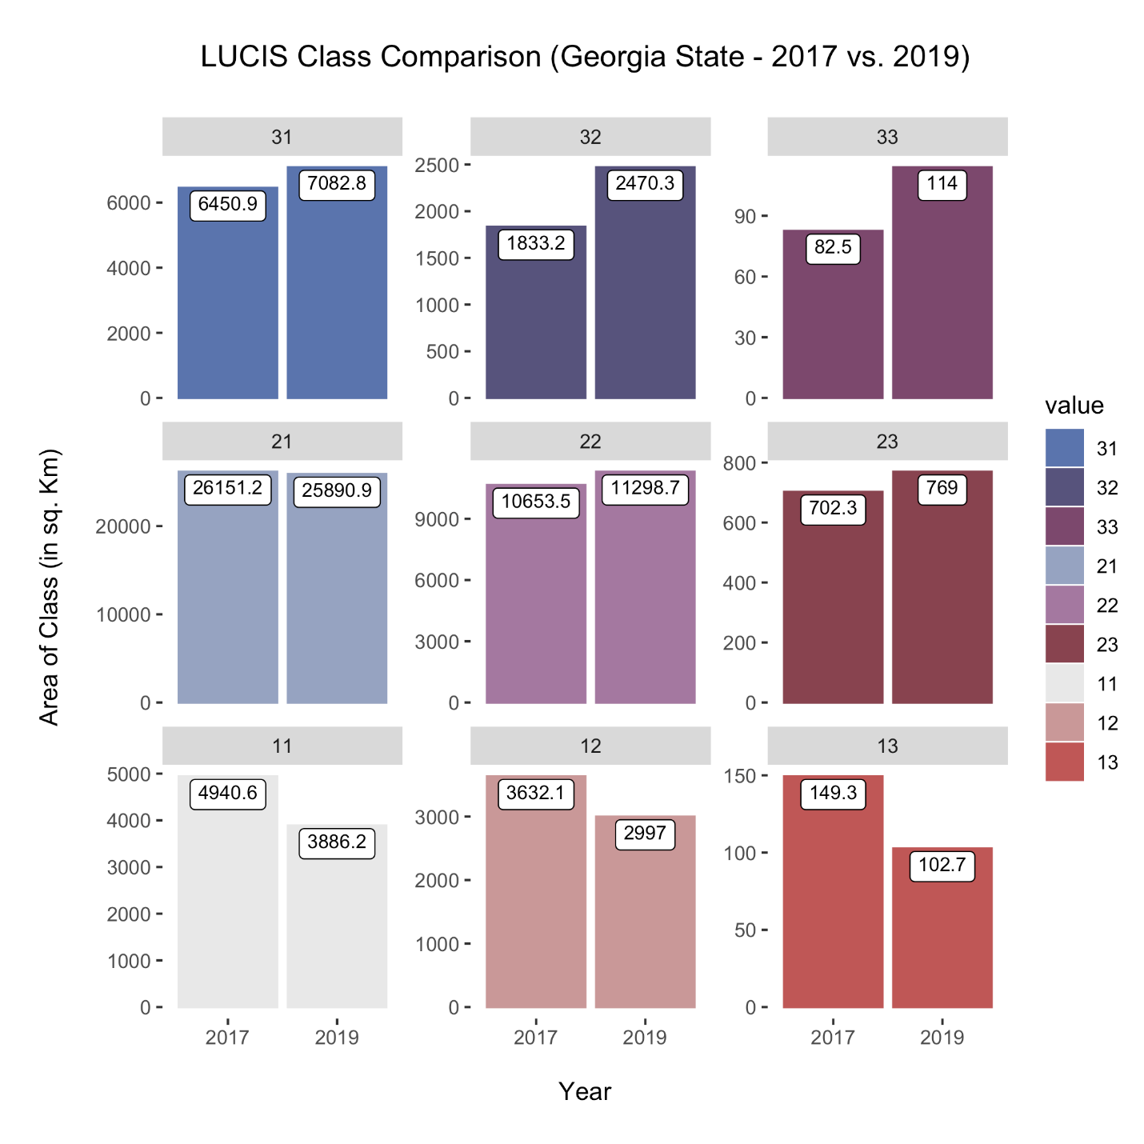
Figure 5. Statewide LUCIS Class Comparison Analyses 2017 vs. 2019.
A graphical representation of the reclassified values of the LUCIS output shows similar trends in the change in area under each class between years. The area under the region of low preference decreased by 17% (17.069%) in 2019 when compared to 2017. About 8.06% of the land area of Georgia in 2019 was classified under regions of low preference reducing by about 1.66% from 9.73% in 2017. The area under the region of high preference increased by about 3% (2.92%) in 2019 when compared to 2017. About 58.71% of the land area of Georgia was classified under regions of high preference in 2019, up by about 1.65% from 57.05% in 2017.
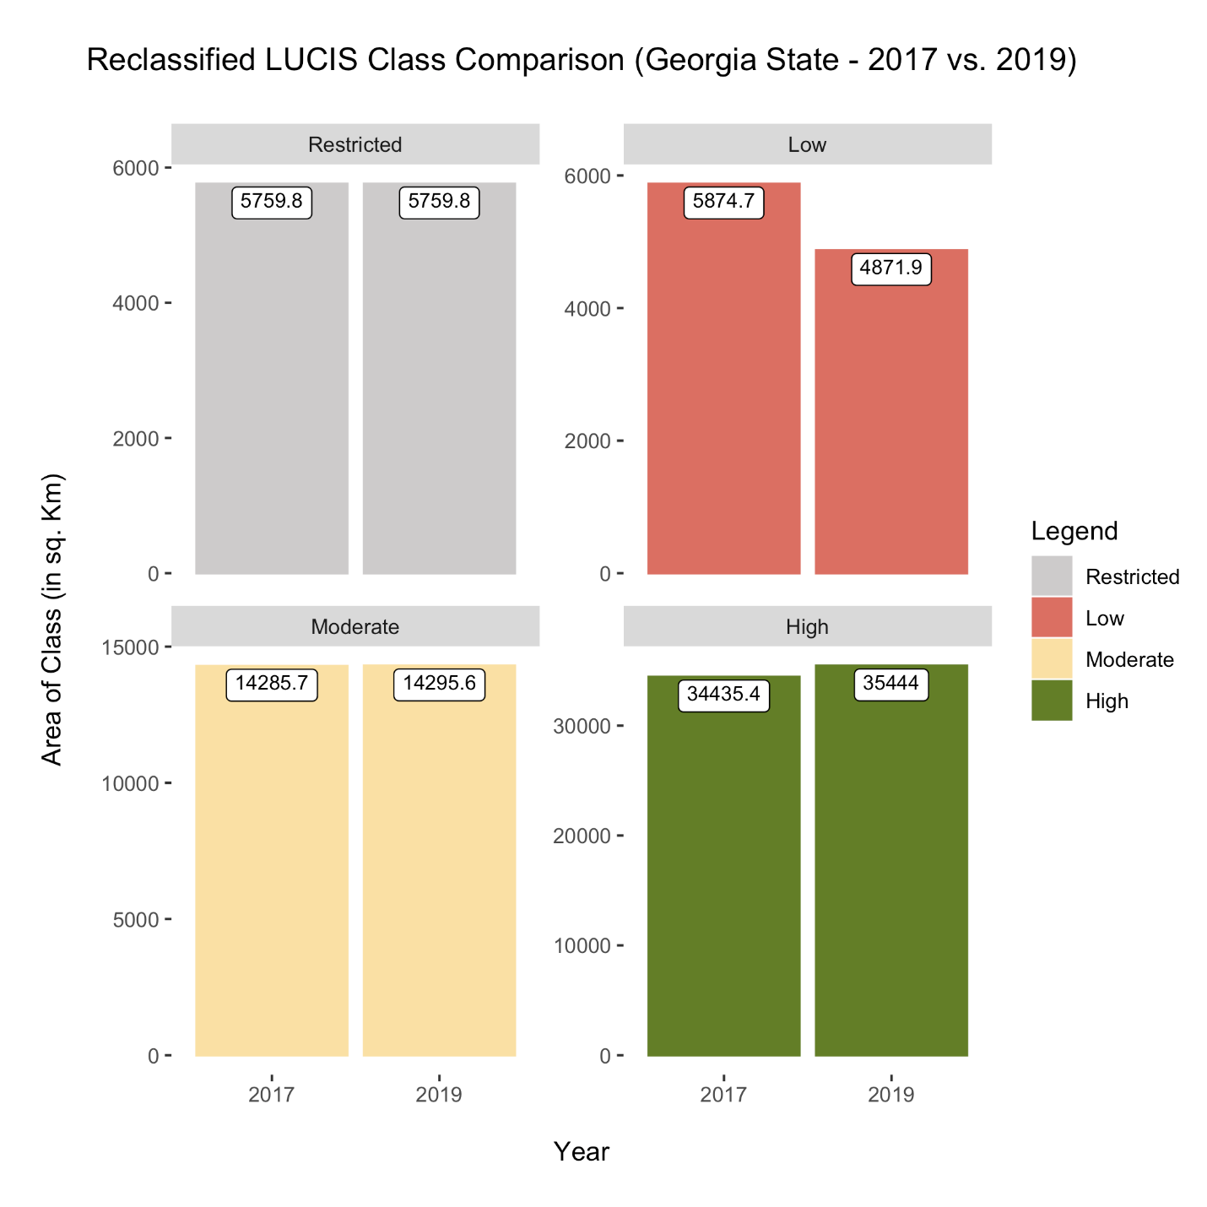
Figure 6. Statewide Reclassified LUCIS Class Comparison Analyses 2017 vs. 2019
The overall statewide suitability score was calculated for each year, and subsequently the overall change in preference for solar development was calculated using the formula shown below (Equation 1).

$$\text{Area (in }\text{Sq.Km}\text{)} \text{x Class Value} \text{=} \text{Suitability Score}$$$\text{Percent Suitability Increase=}\left[\frac{\left(\sum{\text{2019 Score}}\right) \text{-} \left(\sum{\text{2017 Score}}\right)}{\left(\sum{\text{2019 Score}}\right)}\right]\text{*100}$ (1)

It was observed that between 2017 and 2019 there was an overall increase in preference by about 1.5%.
Statistical analyses from county level data for the reclassified LUCIS outputs revealed that for the most part, if a parcel of land belonged to a particular class in 2017, it would continue being in the same class in 2019. Further analysis is needed to see if this phenomenon would hold true spatially. Notable exceptions to these results include:
- Brooks county (Moderate to High) - About 102.1 square kilometers (about 8% of the county’s land area) of land that was of moderate preference in 2017 appeared to become land that was of high preference in 2019.
- Decatur county (High to Moderate) - About 142.2 square kilometers (about 8.83% of the county’s land area) of land that was of high preference in 2017 appeared to become land that was of moderate preference in 2019.
- Twiggs county (Moderate to High) - About 82.8 square kilometers (about 8.83% of the county’s land area) of land that was of moderate preference in 2017 appeared to become land that was of high preference in 2019.

Figure 6. Reclassified LUCIS Class Change Comparison for 2017 vs. 2019; A) Brooks County, B) Decatur County, C) Taylor County, D) Twiggs County.

4.2 Future Work
Our main goal for future work related to this project revolves around identifying the causes of changes in suitability classes of solar development and environmental sensitivity. We observed several changes through the study period in various classes and feel that further explanatory research is warranted. Future studies could benefit from raster analyses to conclude on exactly why suitability, sensitivity, and conflict are changing between the years. Having a better understanding of these changes will enable our partners to focus their efforts in promoting low-impact solar development throughout the state. The black bear habitats data provided by the partner organization were from 2007 and therefore not the most current, so we made the decision to not include it in the LUCIS model for analysis. Ideally, we would like to rerun the analyses with an updated model using current black bear habitats data. Finally, this is a project that we believe can be modified and replicated in any state or county, so we would love to see this project continued for other counties in the state of Georgia and other leading states in the solar industry like Texas, North Carolina or California.

5. Conclusions
This project has estimated that overall, there was an increase in preference of the regions of the entire state of Georgia from 2017 to 2019, even though the value was relatively small. It is possible to derive a conclusion that the increase in preference indicates that the environmental and solar factors are in favor of increased solar capacity. Most of the change in the preference was seen in the southern half of the state and the factor that affected the change the most was construction of new transmission lines. This can be attributed to the fact that proximity to transmission lines plays an essential role in the setup and running of new solar farms. County level analysis revealed that Twiggs County experienced highest solar suitability in 2019, while Decatur county experienced highest solar suitability in 2018 and 2017. While further county level land cover change detection is essential to ascertain the reasoning behind these changes, a precursory analysis revealed that the LULC data layer played an important role in bringing about the differences in suitability over time. Overall, in terms of suitability the counties ranked in the following order: Twiggs, Decatur, Taylor, and Brooks.

The resulting maps and outputs from the project will aim to help the partners in terms of their ability to make an informed decision on the siting of utility scale solar development. The flexible and modular nature of the Environmental Sensitivity Mapping Tool (ESMT) will provide the partners a decision support tool that is versatile in any situation and that will enable them to address a wider range of community stakeholders than before. The flexible nature of the ESMT also means that the partner organizations will have the ability to broaden (by including additional parameters and regions of interest) or narrow (by creating a more detailed and robust model) the scope of their future projects. The story map will serve as a narrative to an even greater audience that may not have the technical knowledge to use the ESMT. It would also accomplish to be a communication tool that speaks to the creation, necessity, and the usefulness of the ESMT. Developers in other states and counties of US can use the LUCIS mapping guide and ESMT guide to develop an environmental sensitivity web portal for future species studies.

6. Acknowledgments
The Georgia Energy Team III would like to acknowledge their science advisor Dr. Marguerite Madden at University of Georgia (UGA). We are also thankful for our partners, Amy Gutierrez at The Nature Conservancy, and Matt Elliott at the Georgia Department of Natural Resources for their continuous involvement and communication with the project. The team also appreciates and gives thanks to Shelby Ingram, NASA DEVELOP GA Lead/Fellow for her timely support and feedback. Additionally, the team would like to give special thanks to Dr. Sergio Bernardes at UGA’s Center for Geospatial Research, Paul Stackhouse and Bradley Macpherson at NASA POWER, Amanda Aragon (Georgia Energy II participant), and Austin Stone (Georgia Energy Term I and II participant) for their assistance with data and software.

This material contains modified Copernicus Sentinel data (2017, 2018, and 2019), processed by ESA.

Any opinions, findings, and conclusions or recommendations expressed in this material are those of the author(s) and do not necessarily reflect the views of the National Aeronautics and Space Administration.

This material is based upon work supported by NASA through contract NNL16AA05C.

7. Glossary
Bivariate map – A map showing two variables at the same time
CERES – Clouds and the Earth’s Radiant Energy System instrument aboard the Aqua and Terra NASA satellites; collects data about solar radiation, vegetation, and water within Earth’s system
CropScape – Cropland data layer (CDL) of continental US which is created annually using moderate resolution satellite imagery and extensive agricultural ground truth.
Earth observations – Satellites and sensors that collect information about the Earth’s physical, chemical, and biological systems over space and time
Endangered Species – A species threatened by extinction in the near future
Habitat – The natural home of a species
HILFD – Homeland Infrastructure Foundation Level Data; established in 2002 for moderating the improvements and protection of national geospatial information across multiple levels of government
Keystone species – A species which support other species in an ecosystem and acts as a substitute for the ecosystem; absent of the species can change the ecosystem drastically
Land cover – The physical material found on the surface of the earth, includes vegetation and urban features
Landsat 8 OLI – Operational Land Imager; sensor carried on Landsat 8 spacecraft launched on February 11, 2013 to continue acquisition of earth observation and imagery collection
Land use – The management of natural resources and modification of the environment to fit a specified role
LUCIS – Land-Use Conflict Identification Strategy; developed at the University of Florida’s Department of Urban and Regional Planning to explore land use scenarios
NFHL – National Flood Hazard Layer; geodatabase by the federal emergency management agency (FEMA)
POWER - NASA Prediction of Worldwide Energy Resources; processed meteorological data for supporting renewable energy, building energy efficiency and agricultural needs
TIGER – Topologically Integrated Geographic Encoding and Referencing GIS; publicly available, database created by the US Census Bureau
Sentinel 2 MSI – MultiSpectral Instrument; Spacecraft launched on June 23, 2015, equipped with an opto-electronic multispectral sensor for delivering a wealth of data and imagery
Terra ASTER – Advanced Spaceborne Thermal Emission and Reflection Radiometer; sensor carried on board Terra satellite launched by NASA December 18th, 1999 to provide global data on the state of the atmosphere, land and oceans

8. References
Abdouni, L., Amed, E., Bhattacharee, N., Bledsoe, R., Cameron, C., Shrestha, S., & Stone, A. (2017). Georgia Energy Identifying Sensitive Habitats and Wildlife and Populations in Areas with High Solar Power Potential [Unpublished Manuscript]. NASA DEELOP National Program.
Carlock, D. M., Ezell, J. C., Balkcom, G. D., Aler, W. A., Dupree, P., & Forster, D. L. (1999). Black bear management plan for Georgia. Georgia Department of Natural Resources, Semi-annual Progress Report, Atlanta, Georgia, USA.
Carr, M., & Zwick, P. (2007). Smart land-use analysis: The LUCIS model land use identification system. Redlands: ESRI Press.
Chapman, D. (2017, August 22). Boosting the gopher tortoise. Retrieved September 28, 2020, from https://www.fws.gov/southeast/articles/boosting-the-gopher-tortoise/
Collins, M. G., Steiner, F. R., & Rushman, M. J. (2001). Land-use suitability analysis in the United States: historical development and promising technological achievements. Environmental management, 28(5), 611-621.
Energysage. (2020, June 27). Solar in Georgia. Retrieved June 29, 2020, from https://www.energysage.com/solar-panels/ga/#
Georgia Conservancy. (2020). The Georgia Gopher Tortoise Conservation Initiative. Retrieved June 29, 2020, from https://www.georgiaconservancy.org/gophertortoise
Hernandez, R. R., Easter, S. B., Murphy-Mariscal, M. L., Maestre, F. T., Tavassoli, M., Allen, E. B., ... & Allen, M. F. (2014). Environmental impacts of utility-scale solar energy. Renewable and sustainable energy reviews, 29, 766-779.
Hsu, A., & Kelly, M. (2019, June 24). How Georgia became a surprising bright spot in the United States Solar Industry. Retrieved June 29, 2020, from https://www.npr.org/2019/06/24/733795962/how-georgia-became-a-surprising-bright-spot-in-the-u-s-solar-industry
Mierzwiak, M., & Calka, B. (2017). Multi-criteria analysis for solar farm location suitability. Reports on Geodesy and Geoinformatics, 104(1), 20-32.
Sierra Club. The Ecological Role of Coyotes, Bears, Mountain Lions, and Wolves. Retrieved August 3, 2020, from https://www.sierraclub.org/sites/www.sierraclub.org/files/sce/rocky-mountain-chapter/Wolves-Resources/The%20Ecological%20Role%20of%20Coyotes,%20 Bears,%20Mountain%20Lions,%20and%20Wolves.pdf
Solar Energy Industries Association (SEIA). (2020, June 11). US solar market insight. Retrieved June 17, 2020, from https://www.seia.org/state-solar-policy/georgia-solar
Shrestha, S., Amed, E., Aragon, A., Bouffard, M., Clermont, F., Hawman, P., Morgan, N., Remillard, C., & Stone, A. (2017). Georgia Energy II: Reducing Conflicts in Siting Solar Power Facilities by Identifying Sensitive Habitats and Wildlife and Populations in Areas with High Generation Potential [Unpublished Manuscript]. NASA DEVLOP National Program.
Uyan, M. (2013). GIS-based solar farms site selection using analytic hierarchy process (AHP) in Karapinar region, Konya/Turkey. Renewable and Sustainable Energy Reviews, 28, 11-17. http://dx.doi.org/10.1016/j.rser.2013.07.042
University of Florida. (2007). Land-Use Conflict Identification Strategy (LUCIS) Technical Report. Department of Housing and Urban Development. The University of Florida.
US Department of Energy. (2020). Solar Energy in the United States. Retrieved June 17, 2020, from https://www.energy.gov/eere/solarpoweringamerica/solar-energy-united-states
CERES Science Team. (2017). Fast Longwave and Shortwave Radiative Flux (FLASHFlux) Products From CERES and MODIS Measurements, Version 3C. NASA Prediction of Worldwide Energy Resources, accessed 1 July 2020. DOI: 10.5067/Terra+Aqua/CERES/FLASH_TISA_L3.003C

CERES Science Team. (2018). Fast Longwave and Shortwave Radiative Flux (FLASHFlux) Products From CERES and MODIS Measurements, Version 3C. NASA Prediction of Worldwide Energy Resources, accessed 1 July 2020. DOI: 10.5067/Terra+Aqua/CERES/FLASH_TISA_L3.003C

CERES Science Team. (2019). Fast Longwave and Shortwave Radiative Flux (FLASHFlux) Products From CERES and MODIS Measurements, Version 3C. NASA Prediction of Worldwide Energy Resources, accessed 1 July 2020. DOI: 10.5067/Terra+Aqua/CERES/FLASH_TISA_L3.003C

Crawford, B.A., Maerz, J.C., and Moore, C.T. (2020, January 22). Range-wide habitat suitability maps for at-risk species in the longleaf system. U.S. Geological Survey data release, accessed 25 June 2020. https://doi.org/10.5066/P92PZN7G

ESRI. (2020). USA States (Generalized) [feature service]. ESRI ArcGIS Living Atlas of the World, accessed 30 June 2020.

ESRI. (2020). World Imagery [basemap]. ESRI ArcGIS Living Atlas of the World, accessed 30 June 2020.

Federal Emergency Management Agency (FEMA). (2009, September 2). National Flood Hazard Layer, Brooks County, Georgia. Federal Emergency Management Agency (FEMA) Flood Map Service Center accessed 15 June 2020.

Federal Emergency Management Agency (FEMA). (2009, September 2). National Flood Hazard Layer, Taylor County, Georgia. Federal Emergency Management Agency (FEMA) Flood Map Service Center accessed 15 June 2020.

Federal Emergency Management Agency (FEMA). (2009, September 25). National Flood Hazard Layer, Decatur County, Georgia. Federal Emergency Management Agency (FEMA) Flood Map Service Center, accessed 15 June 2020.

Federal Emergency Management Agency (FEMA). (2010, December 17). National Flood Hazard Layer, Twiggs County, Georgia. Federal Emergency Management Agency (FEMA) Flood Map Service Center, accessed 15 June 2020.

Georgia Department of Natural Resources, WRD Nongame Conservation Section. (2020, March). Conservation Lands 2020. Georgia GIS Clearinghouse, accessed 29 June 2020.

Georgia Department of Natural Resources, WRD Nongame Conservation Section. (2020, April 24). Land Trusts and Other Private Lands. Georgia GIS Clearinghouse, accessed 16 June 2020.

Georgia Department of Natural Resources, WRD Wildlife Conservation Section. (2019, December 13). Department of Natural Resources Managed Lands, 2020. Georgia GIS Clearinghouse, accessed 29 June 2020.

HIFLD Support Team. (2019). Electric Power Transmission Lines. Homeland Infrastructure Foundation-Level Data (HIFLD), accessed 15 June 2020.

CoreLogic. (2020). Brooks County, Georgia Parcels 2020. ParcelPoint, accessed 1 July 2020.

CoreLogic. (2020). Decatur County, Georgia Parcels 2020. ParcelPoint, accessed 1 July 2020.

CoreLogic. (2020). Taylor County, Georgia Parcels 2020. ParcelPoint, accessed 1 July 2020.

CoreLogic. (2020). Twiggs County, Georgia Parcels 2020. ParcelPoint, accessed 1 July 2020.

The Nature Conservancy, Eastern Conservation Science, Eastern Regional Office. (2016). Resilient and Connected Landscapes for Terrestrial Conservation – 2016. The Nature Conservancy Conservation Gateway, accessed 16 June 2020.

United States Census Bureau, Geography Division. (2017). 2017 TIGER/Line Shapefiles: Roads. TIGER/Line Shapefiles, accessed 16 June 2020.

United States Census Bureau, Geography Division. (2018). 2018 TIGER/Line Shapefiles: Roads. TIGER/Line Shapefiles, accessed 16 June 2020.

United States Census Bureau, Geography Division. (2019). 2019 TIGER/Line Shapefiles: Roads. TIGER/Line Shapefiles, accessed 16 June 2020.

United States Census Bureau, Geography Division. (2019). 2019 TIGER/Line Shapefiles: County Boundaries. TIGER/Line Shapefiles, accessed 16 June 2020.

United States Census Bureau, Geography Division. (2019). 2019 TIGER/Line Shapefiles: State Boundaries. TIGER/Line Shapefiles, accessed 16 June 2020.

United States Department of Agriculture (USDA), National Agricultural Statistics Service (NASS), Research and Development Division (RDD), Geospatial Information Branch (GIB), Spatial Analysis Research Section (SARS). (2018, January 26). 2017 Georgia Cropland Data Layer, NASS/USDA. United States Department of Agriculture (USDA), National Agricultural Statistics Service (NASS), accessed 15 June 2020.

United States Department of Agriculture (USDA), National Agricultural Statistics Service (NASS), Research and Development Division (RDD), Geospatial Information Branch (GIB), Spatial Analysis Research Section (SARS). (2019, February 15). 2018 Georgia Cropland Data Layer, NASS/USDA. United States Department of Agriculture (USDA), National Agricultural Statistics Service (NASS), accessed 15 June 2020.

United States Department of Agriculture (USDA), National Agricultural Statistics Service (NASS), Research and Development Division (RDD), Geospatial Information Branch (GIB), Spatial Analysis Research Section (SARS). (2020, February 3). 2019 Georgia Cropland Data Layer, NASS/USDA. United States Department of Agriculture (USDA), National Agricultural Statistics Service (NASS), accessed 15 June 2020.

United States Department of Agriculture (USDA), Natural Resources Conservation Science (NRCS). (2019, October 1). USA Soils Farmland Class. ESRI ArcGIS Living Atlas of the World, accessed 29 June 2020.

United States Geological Survey. (2013). USGS 1/3 arc-second n31w082 1 x 1 degree. The National Map Download (Version 1.0), accessed 17 June 2020.

United States Geological Survey. (2013). USGS 1/3 arc-second n32w082 1 x 1 degree. The National Map Download (Version 1.0), accessed 17 June 2020.

United States Geological Survey. (2013). USGS 1/3 arc-second n32w083 1 x 1 degree. The National Map Download (Version 1.0), accessed 17 June 2020.

United States Geological Survey. (2013). USGS 1/3 arc-second n34w084 1 x 1 degree. The National Map Download (Version 1.0), accessed 17 June 2020.

United States Geological Survey. (2013). USGS 1/3 arc-second n35w084 1 x 1 degree. The National Map Download (Version 1.0), accessed 17 June 2020.

United States Geological Survey. (2017, March 9). USGS 1/3 arc-second n35w083 1 x 1 degree. The National Map Download (Version 1.0), accessed 17 June 2020.

United States Geological Survey. (2018, March 13). USGS 1/3 arc-second n33w082 1 x 1 degree. The National Map Download (Version 1.0), accessed 17 June 2020.

United States Geological Survey (2018, March 13). USGS 1/3 arc-second n33w083 1 x 1 degree. The National Map Download (Version 1.0), accessed 17 June 2020.

United States Geological Survey. (2018, March 13). USGS 1/3 arc-second n34w083 1 x 1 degree. The National Map Download (Version 1.0), accessed 17 June 2020.

United States Geological Survey. (2018, October 12). USGS 1/3 arc-second n31w083 1 x 1 degree. The National Map Download (Version 1.0), accessed 17 June 2020.

United States Geological Survey. (2018, October 29). USGS 13 arc-second n32w084 1 x 1 degree. The National Map Download (Version 1.0), accessed 17 June 2020.

United States Geological Survey. (2018, October 29). USGS 1/3 arc-second n33w084 1 x 1 degree. The National Map Download (Version 1.0), accessed 17 June 2020.

United States Geological Survey. (2018, October 29). USGS 1/3 arc-second n34w085 1 x 1 degree. The National Map Download (Version 1.0), accessed 17 June 2020.

United States Geological Survey. (2019, June 24). USGS 1/3 arc-second n34w082 1 x 1 degree. The National Map Download (Version 1.0), accessed 17 June 2020.

United States Geological Survey. (2019, September 13). USGS 1/3 arc-second n33w081 1 x 1 degree. The National Map Download (Version 1.0), accessed 17 June 2020.

United States Geological Survey. (2019, October 25). USGS 1/3 arc-second n31w084 1 x 1 degree. The National Map Download (Version 1.0), accessed 17 June 2020.

United States Geological Survey. (2019, October 25). USGS 1/3 arc-second n31w085 1 x 1 degree. The National Map Download (Version 1.0), accessed 17 June 2020.

United States Geological Survey. (2020, March 12). USGS 1/3 arc-second n31w086 1 x 1 degree. The National Map Download (Version 1.0), accessed 17 June 2020.

United States Geological Survey. (2020, March 12). USGS 1/3 arc-second n32w085 1 x 1 degree. The National Map Download (Version 1.0), accessed 17 June 2020.

United States Geological Survey. (2020, March 13). USGS 1/3 arc-second n35w086 1 x 1 degree. The National Map Download (Version 1.0), accessed 17 June 2020.

United States Geological Survey. (2020, March 16). USGS 1/3 arc-second n32w086 1 x 1 degree. The National Map Download (Version 1.0), accessed 17 June 2020.

United States Geological Survey. (2020, March 19). USGS 1/3 arc-second n34w086 1 x 1 degree. The National Map Download (Version 1.0), accessed 17 June 2020.

United States Geological Survey. (2020, March 23). USGS 1/3 arc-second n33w085 1 x 1 degree. The National Map Download (Version 1.0), accessed 17 June 2020.

United States Geological Survey. (2020, March 23). USGS 1/3 arc-second n33w086 1 x 1 degree. The National Map Download (Version 1.0), accessed 17 June 2020.

9. Appendices
Appendix A. Statewide Suitability Data Sources and Methodology.
Table A1
Data sources and processing methodology for statewide suitability analyses for 2017 and 2019
Layer Name | Data Source | Scale | Years Acquired | Methodology
Solar Insolation | NASA Prediction Of Worldwide Energy Resources (POWER) | Global | 2017  2019 | - Convert to Raster from NetCDF  - Project to State Plane GA West  - Clip to Georgia State Boundary  - Reclassify based on 3 equal interval classes
Slope | Digital Elevation Model from United States Geological Survey | Degree Block | 2019 | - Mosaic to New Raster  - Project to State Plane GA West  - Clip to Georgia State Boundary  - Calculate Slope tool  - Reclassify with suitability values
Aspect | Digital Elevation Model from United States Geological Survey | Degree Block | 2019 | - Mosaic to New Raster  - Project to State Plane GA West  - Clip to Georgia State Boundary  - Calculate Slope tool  - Reclassify with suitability values
Transmission Lines | Homeland Infrastructure Foundation Level Data (HIFLD) | Nationwide | 2017  2019 | - Clip to Georgia State Boundary  - Project to State Plane GA West  - Run Multi-Ring Buffer tool  - Convert to raster using Feature to  Raster tool  - Reclassify with suitability values
Land Cover/Land Use | United States Department. of Agriculture CropScape | Nationwide | 2017  2019 | - Clip to Georgia State Boundary  - Project to State Plane GA West  - Reclassify to simplified categories  - Reclassify with suitability values

Appendix B. Bivariate Conflict Map Data Sources and Methodology.
Table B1
Data sources and processing methodology for habitat inputs in County Level Bivariate Conflict Map for 2017, 2018, and 2019
Bivariate Conflict Input | Layer Name | Data Source | Scale | Years Acquired | Processing Methodology
Solar Suitability | Solar Insolation | NASA Prediction Of Worldwide Energy Resources (POWER) | Global | 2017  2019 | - Convert to Raster from NetCDF  - Project to State Plane GA West  - Clip to Georgia State Boundary  - Reclassify based on 3 equal interval classes  - Clip to county boundaries
 | Slope | Digital Elevation Model from United States Geological Survey | Degree Block | 2019 | - Mosaic to New Raster  - Project to State Plane GA West  - Clip to Georgia State Boundary  - Calculate Slope tool  - Reclassify with suitability values  - Clip to each county boundaries
 | Aspect | Digital Elevation Model from United States Geological Survey | Degree Block | 2019 | - Mosaic to New Raster  - Project to State Plane GA West  - Clip to Georgia State Boundary  - Calculate Aspect tool  - Reclassify with suitability values  - Clip to each county boundaries
 | Transmission Lines | Homeland Infrastructure Foundation Level Data (HIFLD) | Nationwide | 2017  2018  2019 | - Project to State Plane GA West  - Clip to Georgia State Boundary  - Run Multi-Ring Buffer tool  - Convert to raster using Feature to  Raster tool  - Reclassify with suitability values  - Clip to each county boundaries
Solar Suitability | Land Cover/Land Use | United States Department. of Agriculture (USDA) CropScape | Nationwide | 2017  2018  2019 | - Clip to Georgia State Boundary  - Project to State Plane GA West  - Reclassify to simplified categories  - Reclassify with suitability values  - Clip to each county boundaries
 | Roads | US Census Bureau Topologically Integrated Geographic Encoding and Referencing (TIGER) database | County Level | 2017  2018  2019 | - Project to State Plane GA West  - Multi-Ring Buffer Tool  - Convert to raster with Feature to  Raster tool  - Reclassify with suitability values
 | Floodplains | Federal Emergency Management Agency (FEMA) National Flood Hazard Layer | County Level | 2009 | - Project to State Plane GA West  - Extract floodplains using Select by  Attribute tool  - Convert to raster with Feature to  Raster tool  - Reclassify with suitability values
 | County Parcels | CoreLogic ParcelPoint via partners at The Nature Conservancy | County Level | 2020 | - Project to State Plane GA West  - Add field in attribute table  - Use Calculate Geometry function to calculate the area of each parcel in acres  - Convert to raster with Feature to Raster tool using acres attribute  - Reclassify based on acreage of parcel

Table B2
Data sources and processing methodology for solar inputs in County Level Bivariate Conflict Map for 2017, 2018, and 2019
Bivariate Conflict Input | Layer Name | Data Source | Scale | Years Acquired | Processing Methodology
Environmentally Sensitive Areas | Gopher Tortoise Habitat | United States Geological Survey | Southeastern Region | 2019 | - Project to State Plane GA West  - Clip to Georgia State Boundary  - Convert to raster with Feature to  Raster tool  - Reclassify with suitability values  - Clip to each county boundary
 | Protected Lands | Georgia Department of Natural Resources | Statewide | 2020 | - Union with Conservation Lands and  Land Trust data  - Convert to raster with Feature to  Raster tool  - Reclassify with suitability values  - Clip to each county boundary
 | Conservation Lands | Georgia Department of Natural Resources | Statewide | 2020 | - Union with Protected Lands and  Land Trust data  - Convert to raster with Feature to  Raster tool  - Reclassify with suitability values  - Clip to each county boundary
 | Land Trusts | Georgia Department of Natural Resources | Statewide | 2020 | - Union with Protected Lands and  Conservation Lands data  - Convert to raster with Feature to  Raster tool  - Reclassify with suitability values  - Clip to each county boundary
 | Prime Farmland | ESRI USA Soils Farmland | Nationwide | 2019 | - Extract data from ArcGIS Online Layer  - Clip to County Boundary  - Reclassify with suitability values
 | Sensitive Land Use Classifications | United States Department. of Agriculture (USDA) CropScape | Nationwide | 2017  2018  2019 | - Clip to Georgia State Boundary  - Project to State Plane GA West  - Reclassify to simplified categories  - Reclassify with suitability values  - Clip to each county boundary
 | Resilient Lands | The Nature Conservancy Resilient Landscape Dataset | Eastern  Coast | 2016 | - Clip to Georgia State Boundary  - Project to State Plane GA West  - Reclassify with suitability values  - Clip to each county boundary

Appendix C. Methodology Diagram.

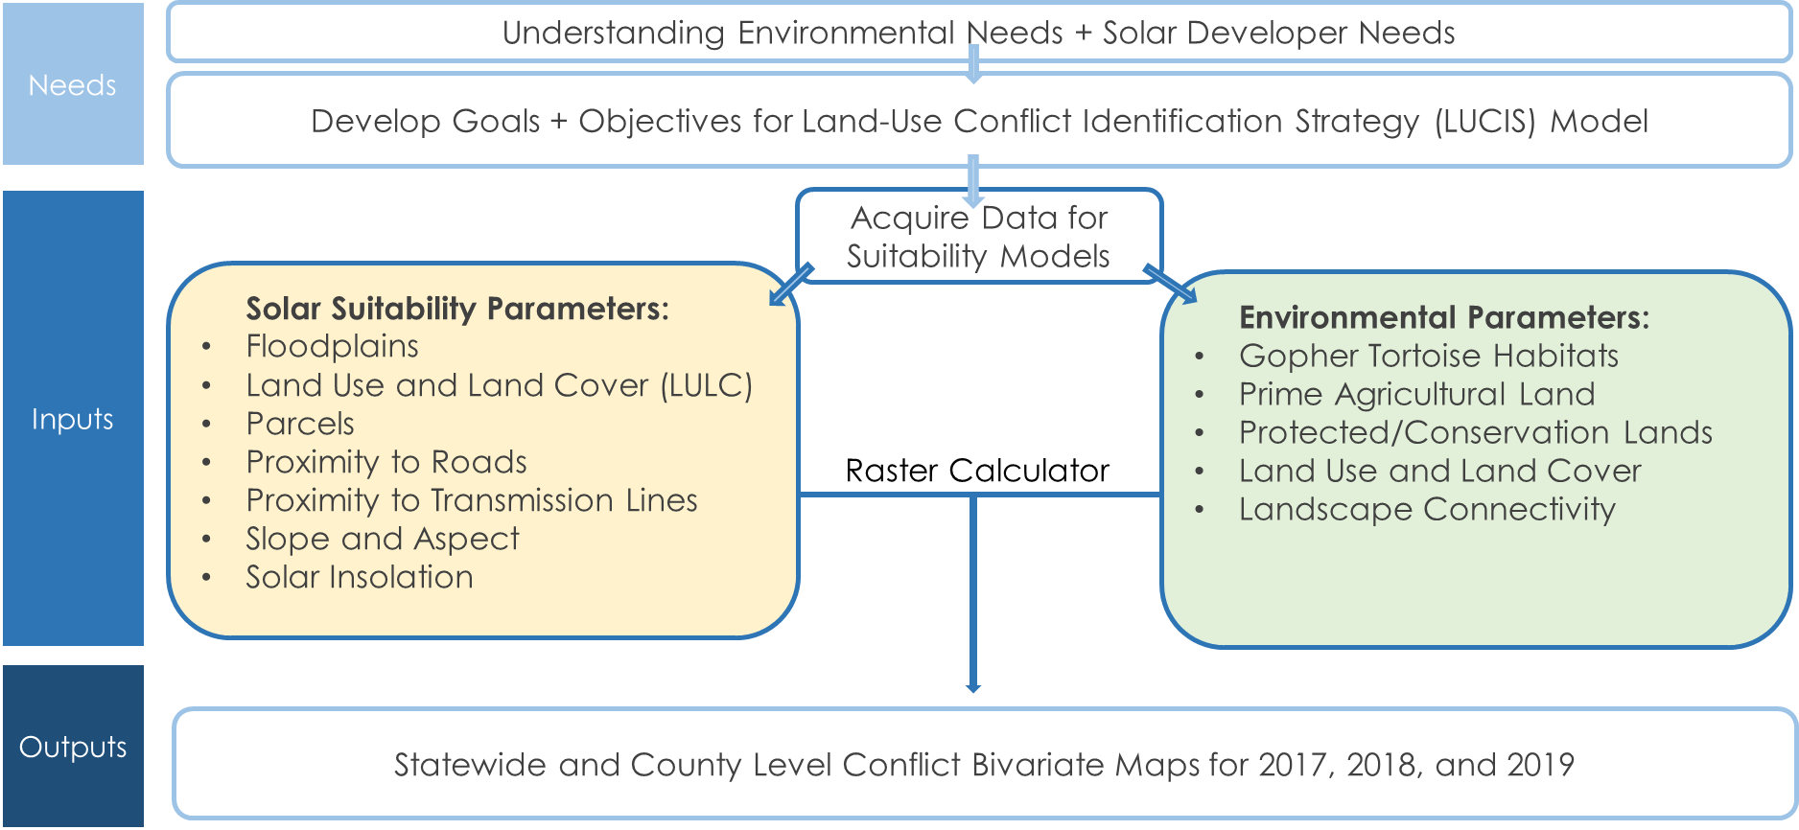
Figure C1. Methodology diagram for data analysis.
Appendix D. Suitability Scores for Statewide LUCIS Analysis.
Table D1
Solar Suitability Reclassification Values for Statewide LUCIS Analysis
Bivariate Conflict Input | Layer Name | Original Classifications | New Value
Solar Suitability | Solar Insolation | Lowest Class | 1
 |  | Middle Class | 2
 |  | Highest Class | 3
 | Slope | Over 5% Slope | 1
 |  | 2% - 5% | 2
 |  | 0% < 2% | 3
 | Aspect | North, East, West, Northeast, Northwest | 1
 |  | Southeast and Southwest | 2
 |  | Flat and South | 3
 | Transmission Lines | Over 2 miles | 1
 |  | Between 1 and 2 miles | 2
 |  | Less than 1 mile | 3
 | Land Cover/Land Use | Water, Wetland, Developed | 1
 |  | Forest | 2
 |  | Barren, Shrubland, Grassland/Pasture, Agriculture | 3
Table D2
Environmental Sensitivity Reclassification Values for Statewide LUCIS Analysis
Bivariate Conflict Input | Layer Name | Original Classifications | New Value
Environmental Sensitivity | Gopher Tortoise | Outside of habitat | 1
 |  | Within habitat | 3
 | GADNR Managed Lands, Conservation Lands, Land Trusts | Outside of Protected Lands | 1
 |  | Protected Lands | 3
 | Prime Farmland | Outside of prime farmland | 1
 |  | Farmland of Local Importance, Farmland of Statewide Importance | 2
 |  | Prime Farmland | 3
 | Landscape Connectivity | Vulnerable | 1
 |  | Climate Corridor, Resilient Area, Climate Flow Zone | 2
 |  | Climate Corridor with Confirmed Diversity, Resilient Area with Confirmed Diversity, Climate Flow Zone with Confirmed Diversity | 3
 | Land Cover/Land Use | Barren and Developed | 1
 |  | Agriculture, Pasture, Shrubland | 2
 |  | Water, Wetland, Forest | 3

Appendix E. Suitability Scores for County-Level LUCIS Analysis.
Table E1
Solar Suitability Reclassification Values for County-Level LUCIS Analysis
Bivariate Conflict Input | Layer Name | Original Classifications | New Value
Solar Suitability | Solar Insolation | Lowest Class | 1
 |  | Middle Class | 2
 |  | Highest Class | 3
 | Slope | Over 5% Slope | 1
 |  | 2% - 5% | 2
 |  | 0% < 2% | 3
 | Aspect | North, East, West, Northeast, Northwest | 1
 |  | Southeast and Southwest | 2
 |  | Flat and South | 3
 | Transmission Lines | Over 2 miles | 1
 |  | Between 1 and 2 miles | 2
 |  | Less than 1 mile | 3
 | Land Cover/Land Use | Water, Wetland, Developed | 1
 |  | Forest | 2
 |  | Barren, Shrubland, Grassland/Pasture, Agriculture | 3
 | Roads | Over 1 mile | 1
 |  | Between .5 and 1 miles | 2
 |  | Less than.5 miles | 3
 | Floodplains | Within 100-year floodplain | 1
 |  | Outside of floodplain | 3
 | County Parcels | 0 – 5 acres | 1
 |  | 5 – 15 acres | 2
 |  | Over 15 acres | 3

Table E2
Environmental Sensitivity Reclassification Values for County-Level LUCIS Analysis
Bivariate Conflict Input | Layer Name | Original Classifications | New Value
Environmental Sensitivity | Gopher Tortoise | Outside of habitat | 1
 |  | Within habitat | 3
 | GADNR Managed Lands, Conservation Lands, Land Trusts | Outside of Protected Lands | 1
 |  | Protected Lands | 3
 | Prime Farmland | Outside of prime farmland | 1
 |  | Farmland of Local Importance, Farmland of Statewide Importance | 2
 |  | Prime Farmland | 3
 | Landscape Connectivity | Vulnerable | 1
 |  | Climate Corridor, Resilient Area, Climate Flow Zone | 2
 |  | Climate Corridor with Confirmed Diversity, Resilient Area with Confirmed Diversity, Climate Flow Zone with Confirmed Diversity | 3
 | Land Cover/Land Use | Barren and Developed | 1
 |  | Agriculture, Pasture, Shrubland | 2
 |  | Water, Wetland, Forest | 3

Appendix F. Statewide Results.
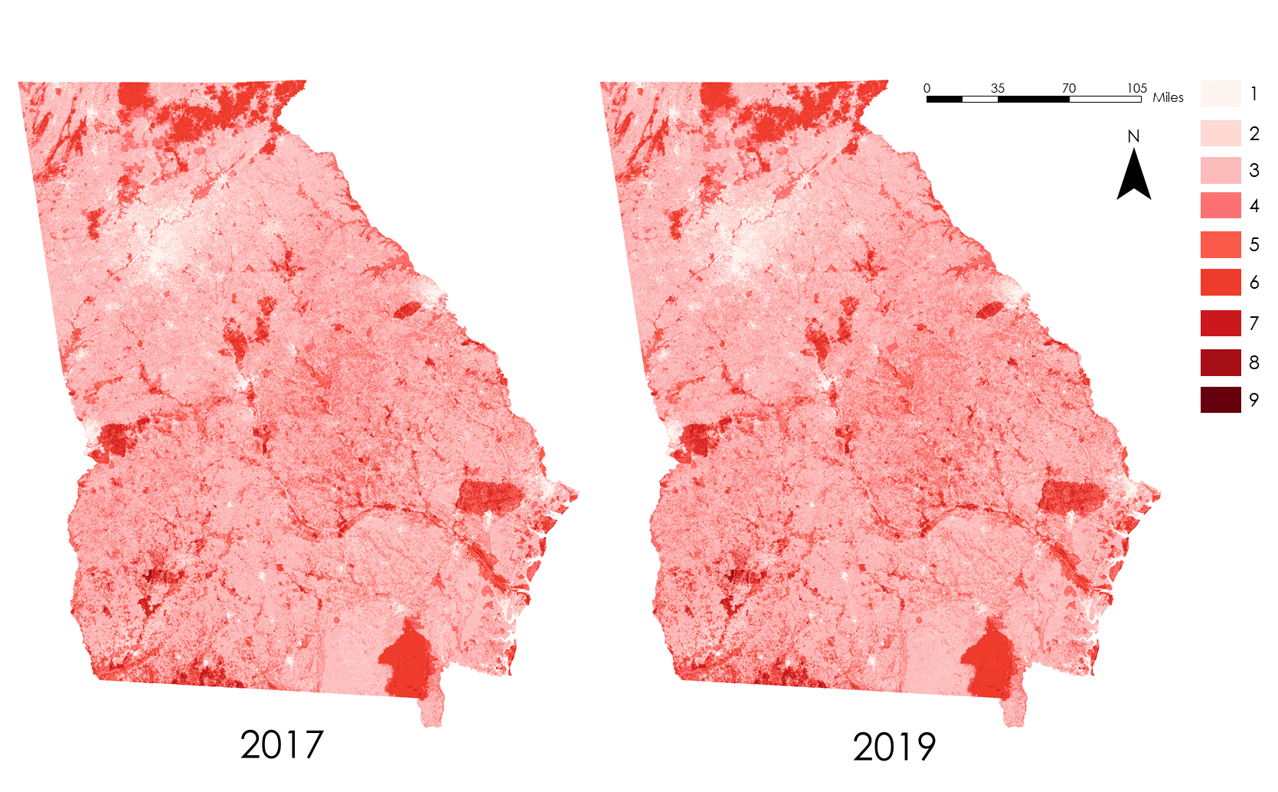
Figure F1. Statewide Environmental Sensitivity results for 2017 (on the left) and 2019 (on the right).
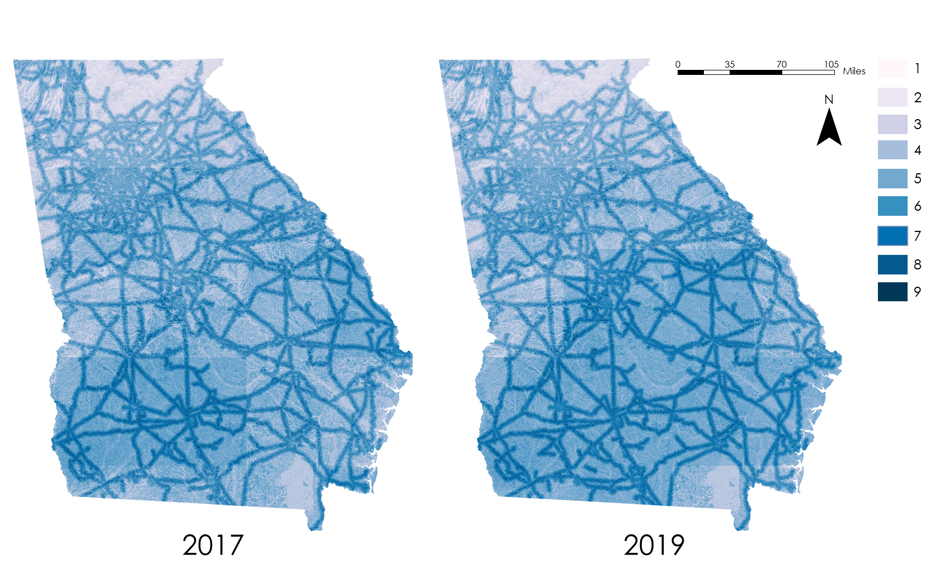

Figure F2. Statewide Solar Suitability results for 2017 (on the left) and 2019 (on the right).
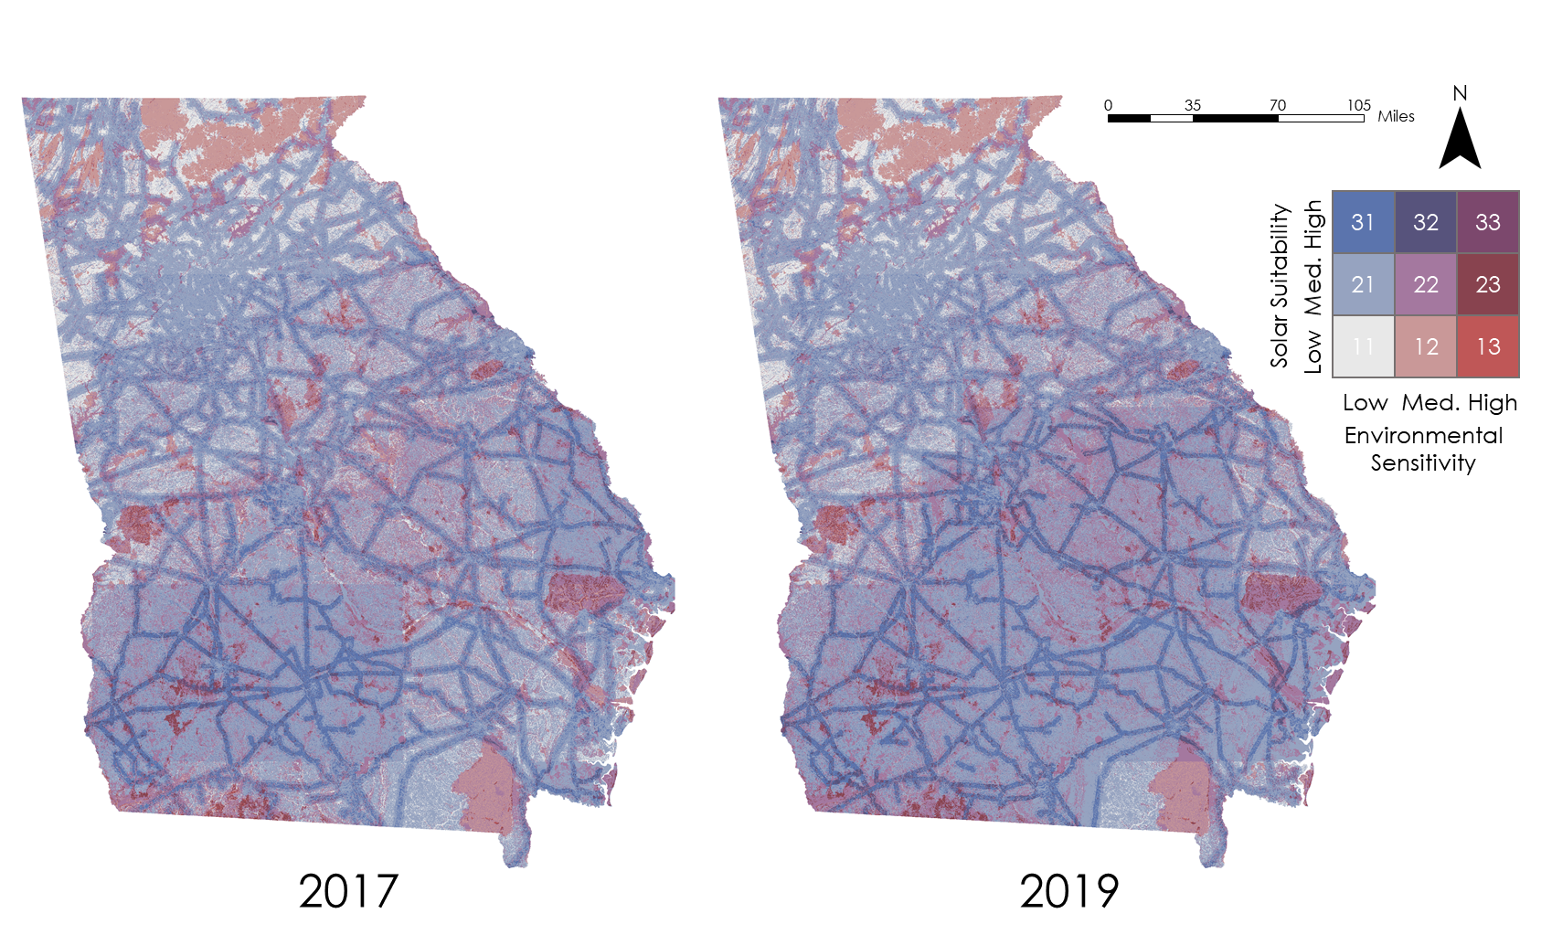

Figure F3. Statewide LUCIS results for 2017 (on the left) and 2019 (on the right).
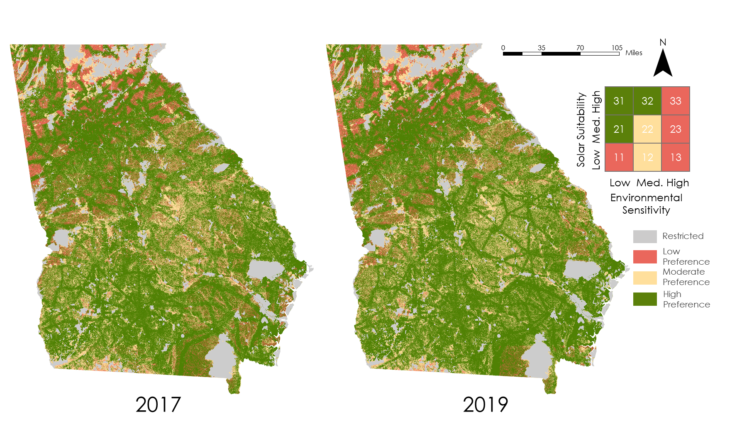
Figure F4. Statewide reclassified LUCIS results for 2017 (on the left) and 2019 (on the right).
Figure F5. Statewide Gopher Tortoise habitats.
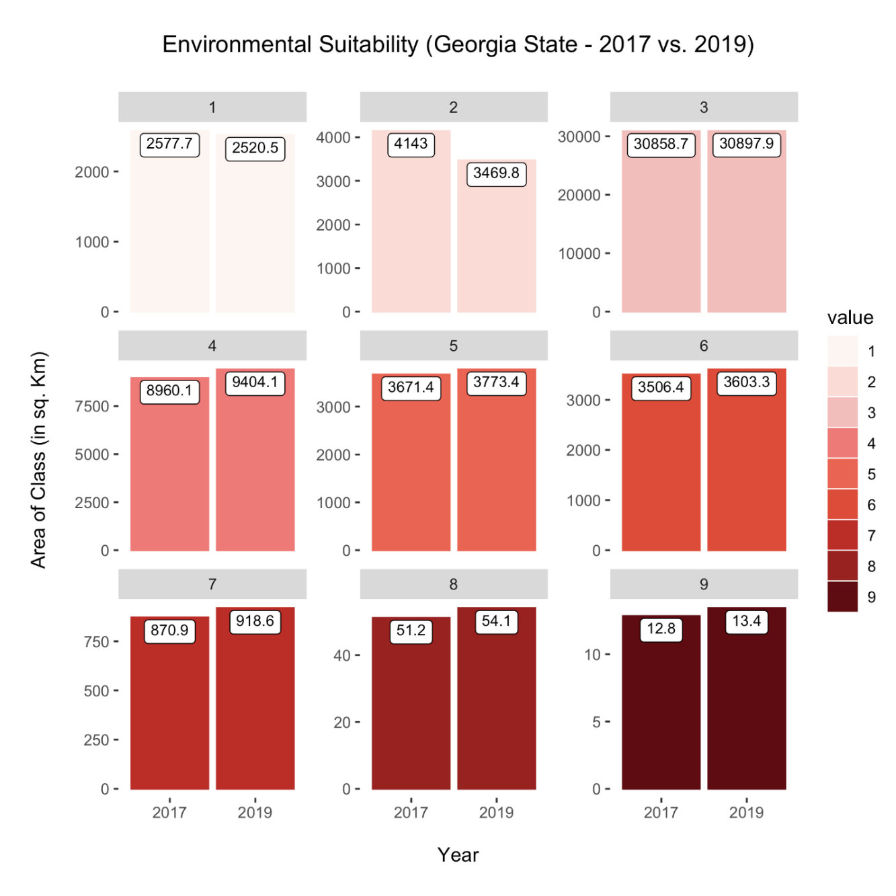
Figure F6. Statewide Environmental Sensitivity Change Analysis 2017 vs. 2019
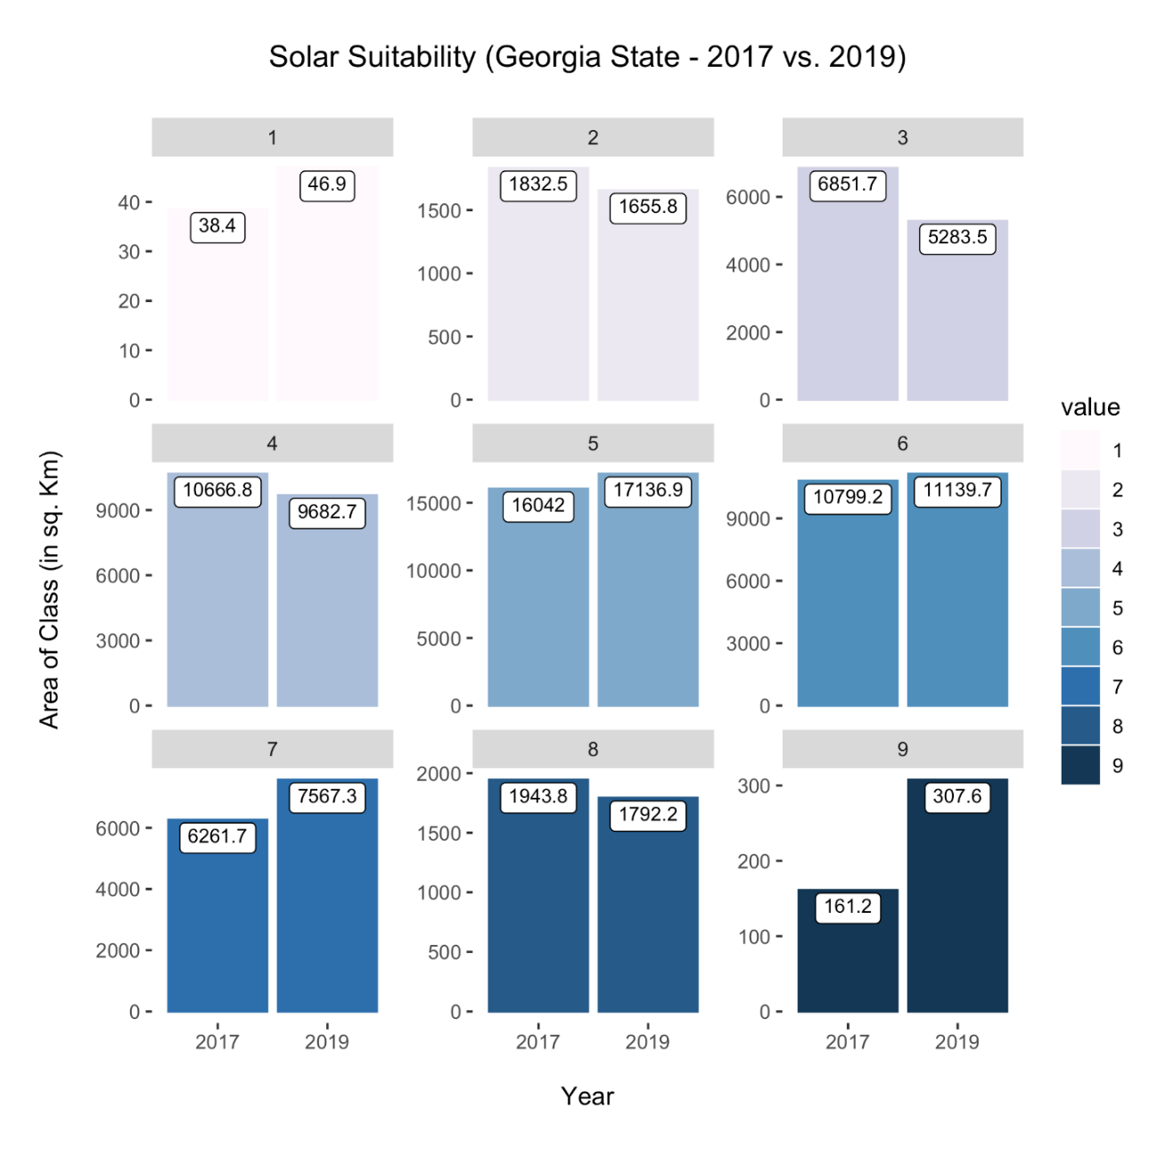
Figure F7. Statewide Solar Suitability Change Analysis 2017 vs. 2019
Appendix G. Brooks County Results.

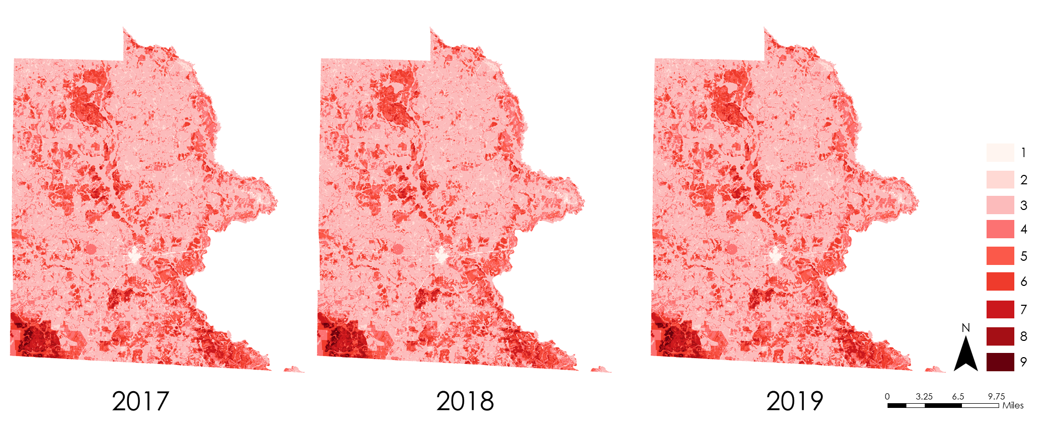

Figure G1. Brooks County Environmental Sensitivity results for 2017 (on the left), 2018 (middle), and 2019 (on the right).

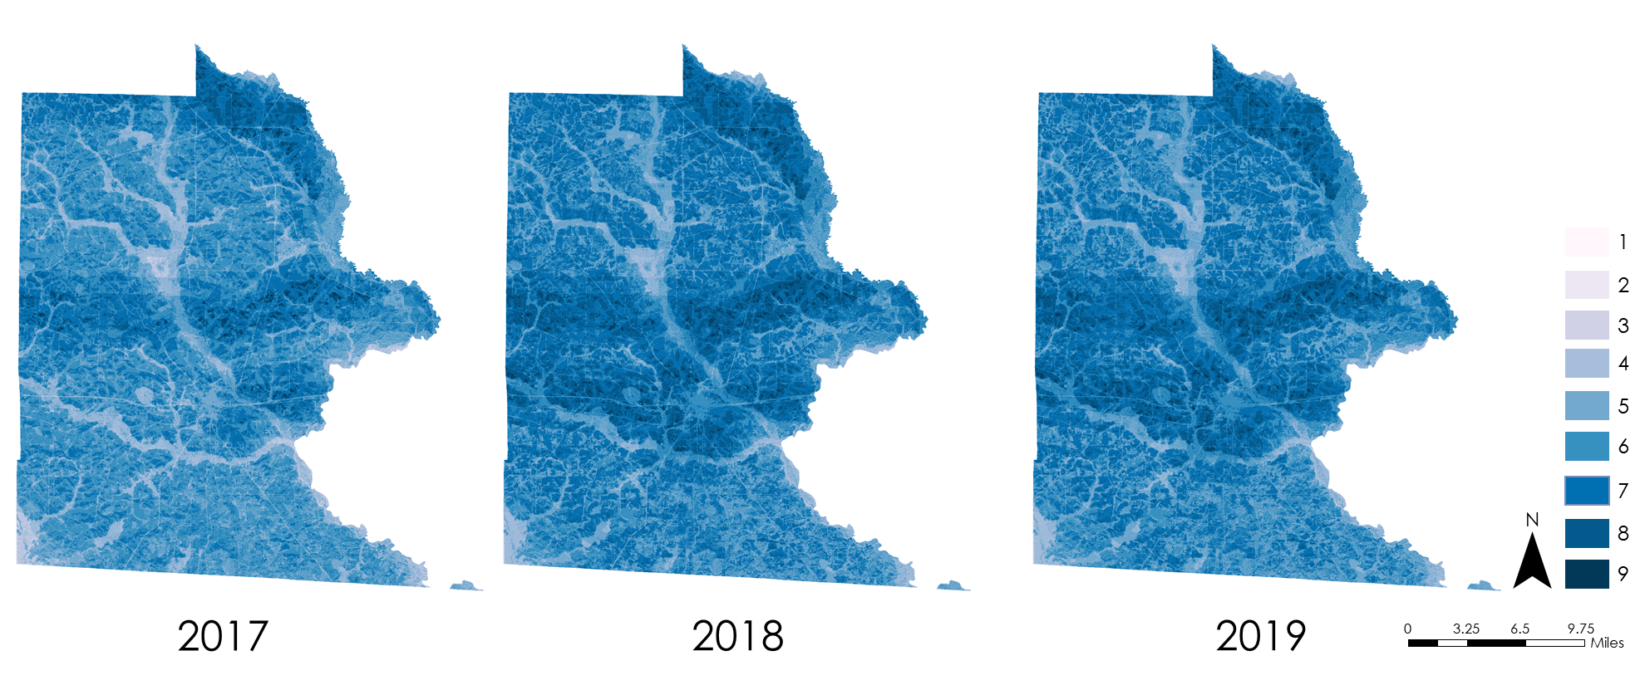

Figure G2. Brooks County Solar Suitability results for 2017 (on the left), 2018 (middle), and 2019 (on the right).

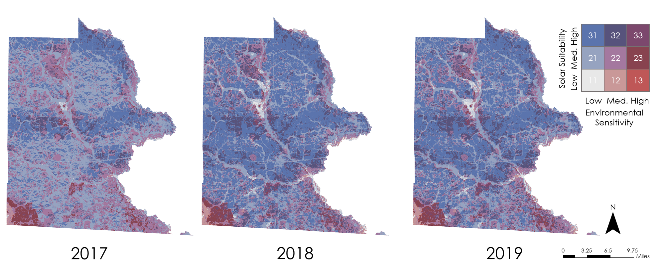

Figure G3. Brooks County LUCIS results for 2017 (on the left), 2018 (middle), and 2019 (on the right).

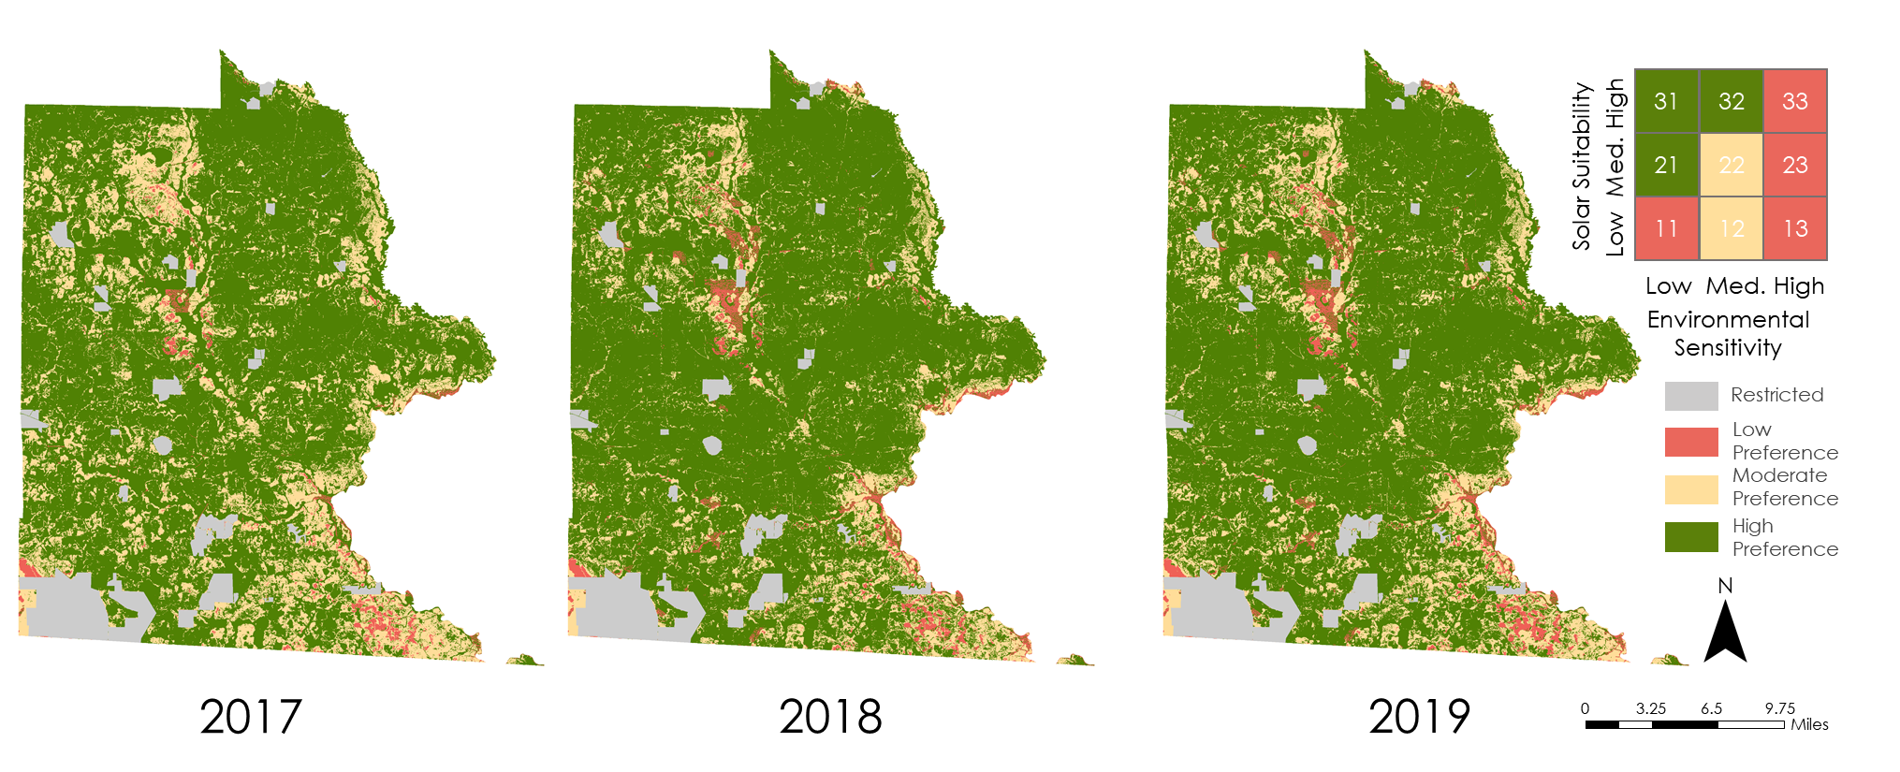

Figure G4. Brooks County reclassified LUCIS results for 2017 (on the left), 2018 (middle), and 2019 (on the right).
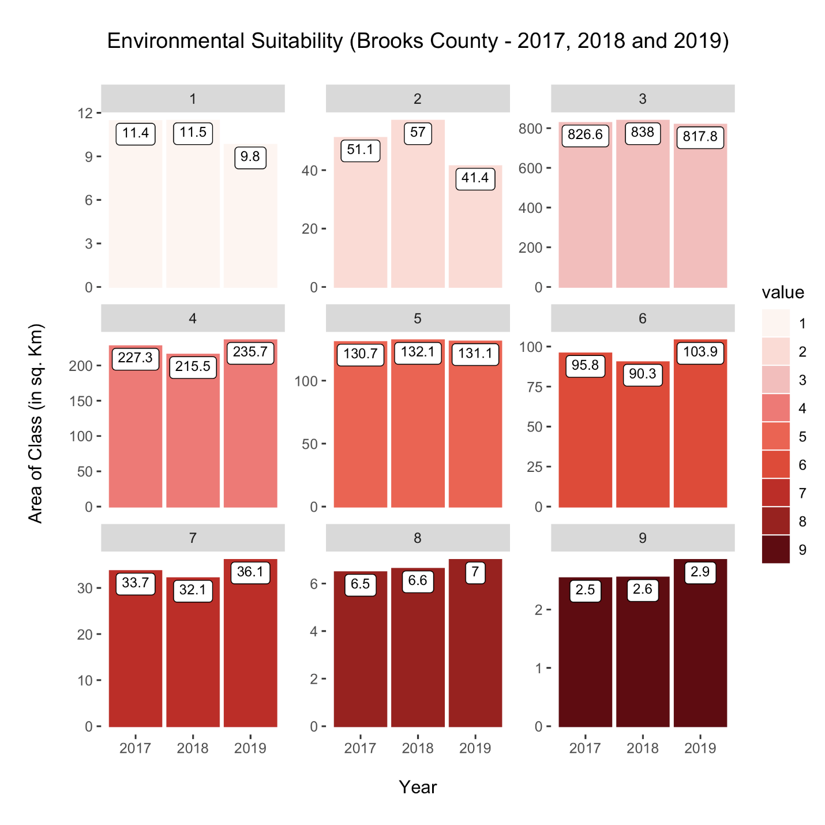
Figure G5. Brooks County Environmental Sensitivity Changes for 2017 vs. 2018 vs. 2019
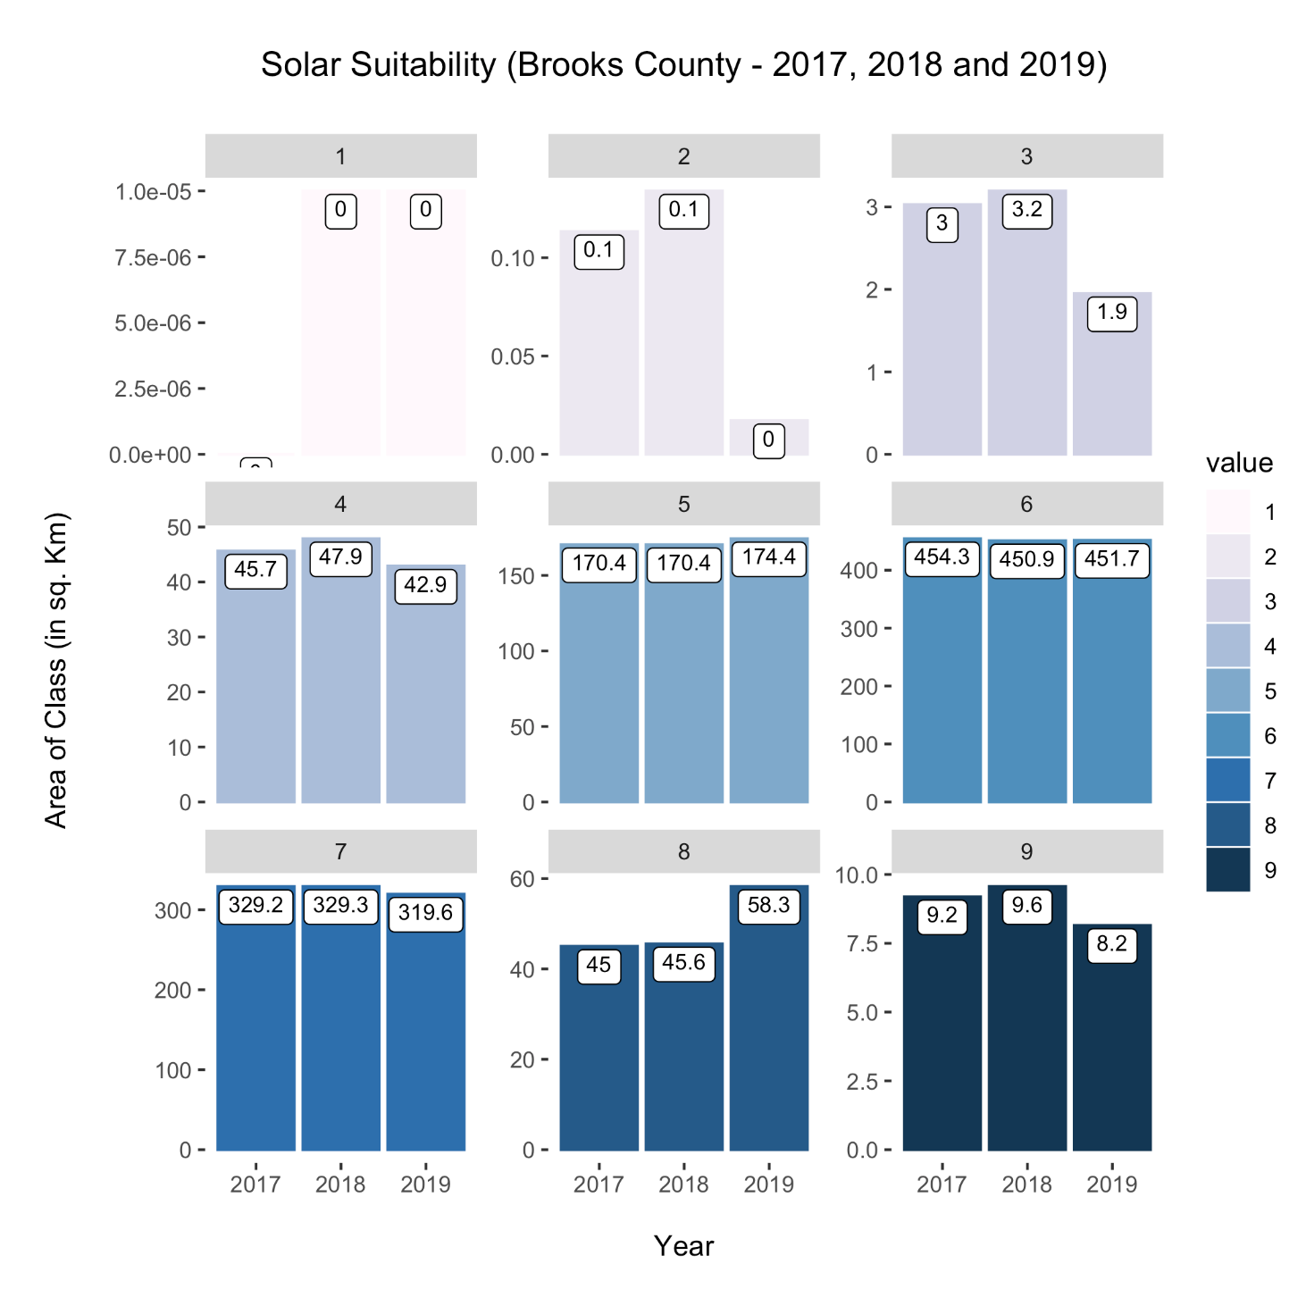
Figure G6. Brooks County Solar Suitability changes for 2017 vs. 2018 vs. 2019
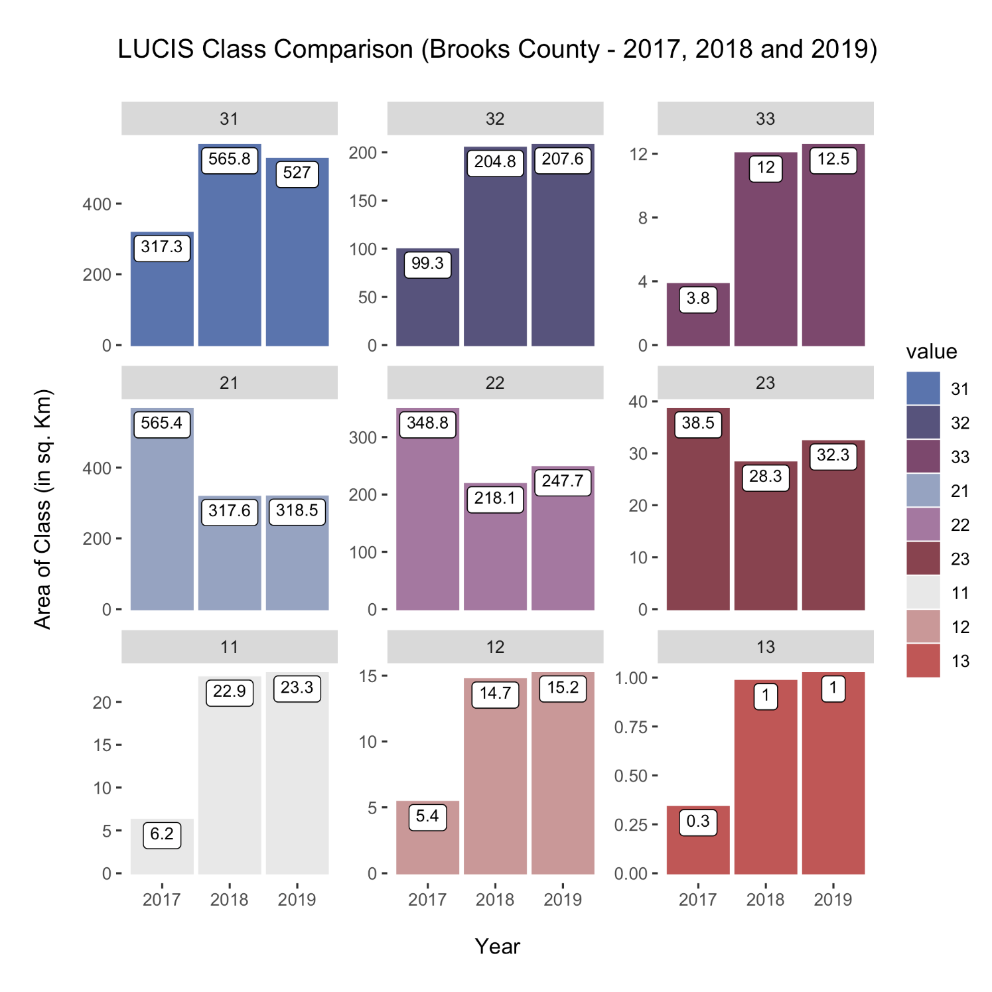
Figure G7. Brooks County LUCIS Class Comparison for 2017 vs. 2018 vs. 2019
Appendix H. Decatur County Results.

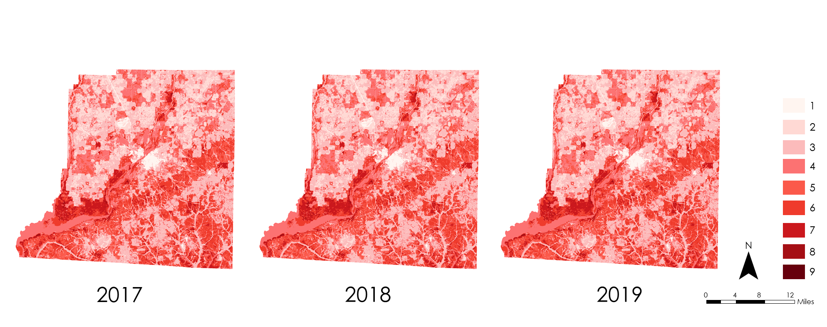

Figure H1. Decatur County Environmental Sensitivity results for 2017 (on the left), 2018 (middle), and 2019 (on the right).

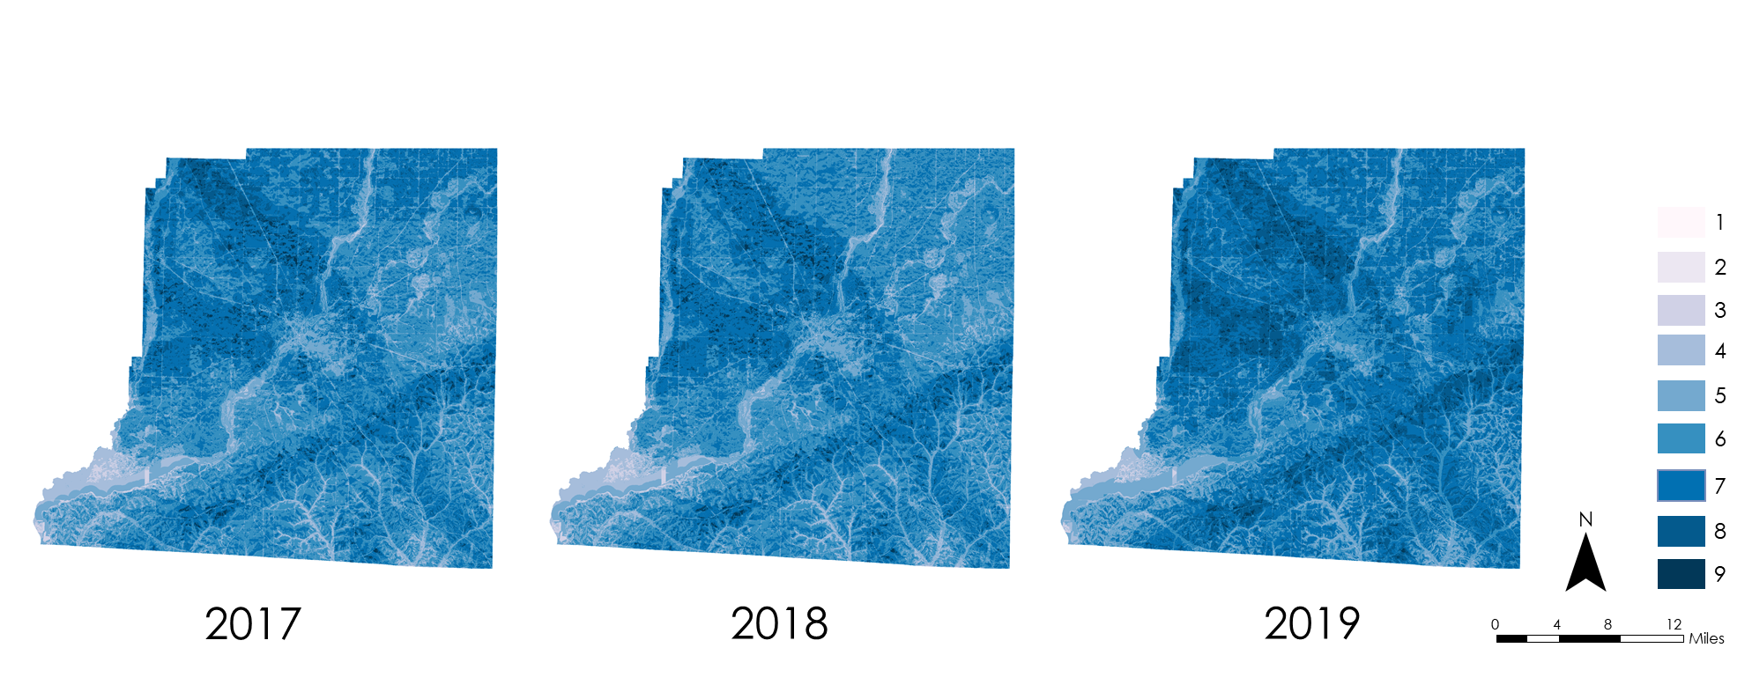

Figure H2. Decatur County Solar Suitability results for 2017 (on the left), 2018 (middle), and 2019 (on the right).

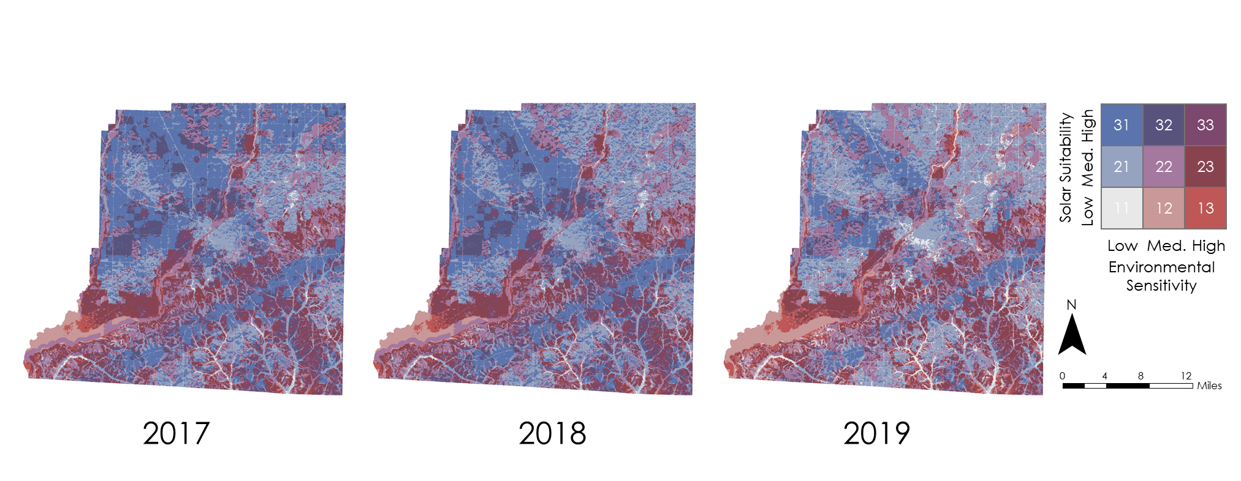

Figure H3. Decatur County LUCIS results for 2017 (on the left , 2018 (middle), and 2019 (on the right).

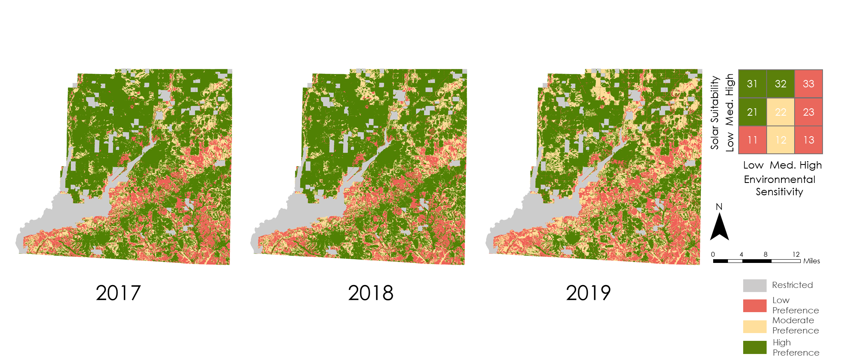

Figure H4. Decatur County reclassified LUCIS results for 2017 (on the left), 2018 (middle), and 2019 (on the right).
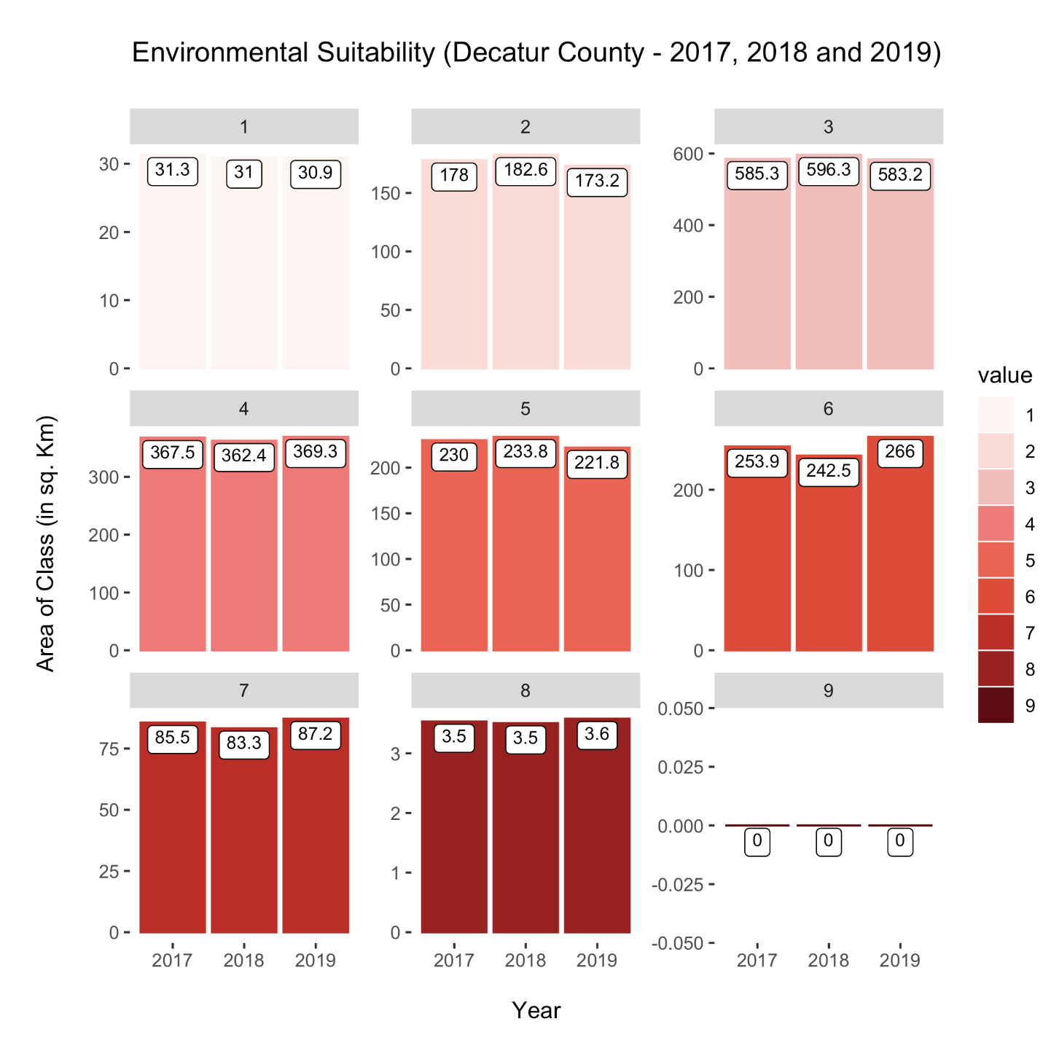
Figure H5. Decatur County Environmental Sensivity changes for 2017 vs. 2018 vs. 2019
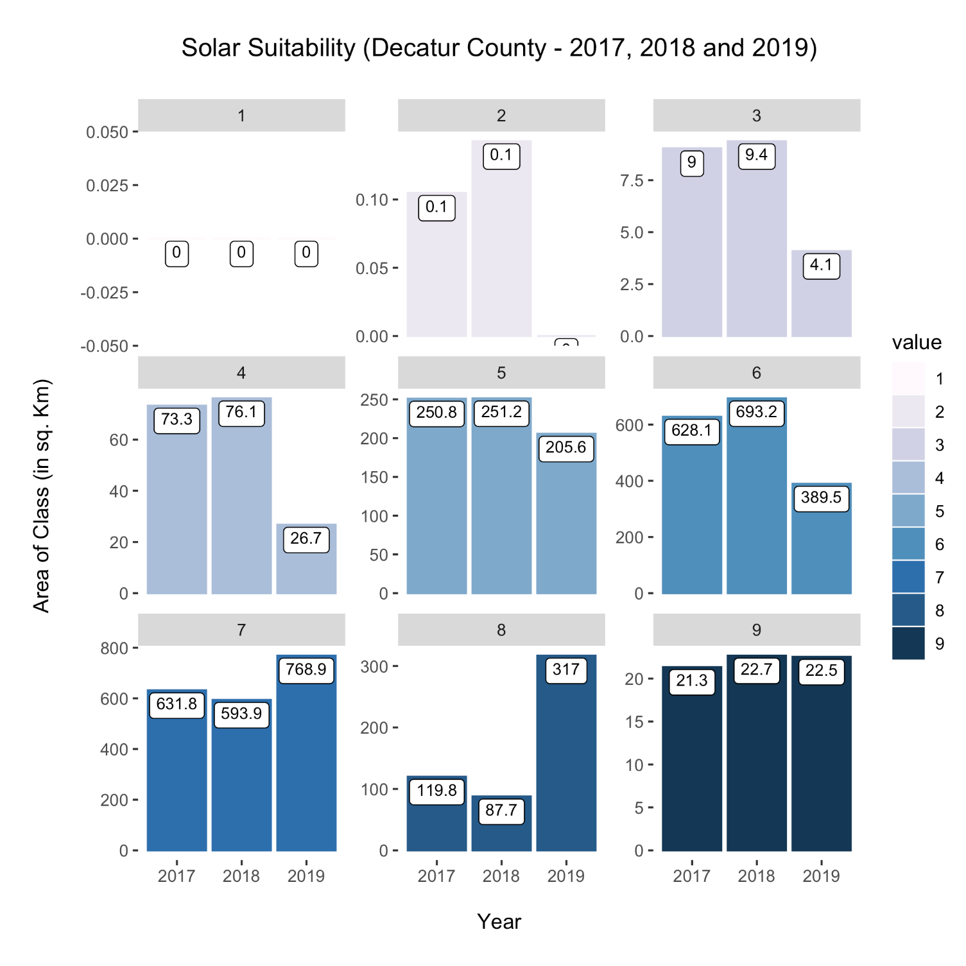
Figure H6. Decatur County Solar Suitability changes for 2017 vs. 2018 vs. 2019
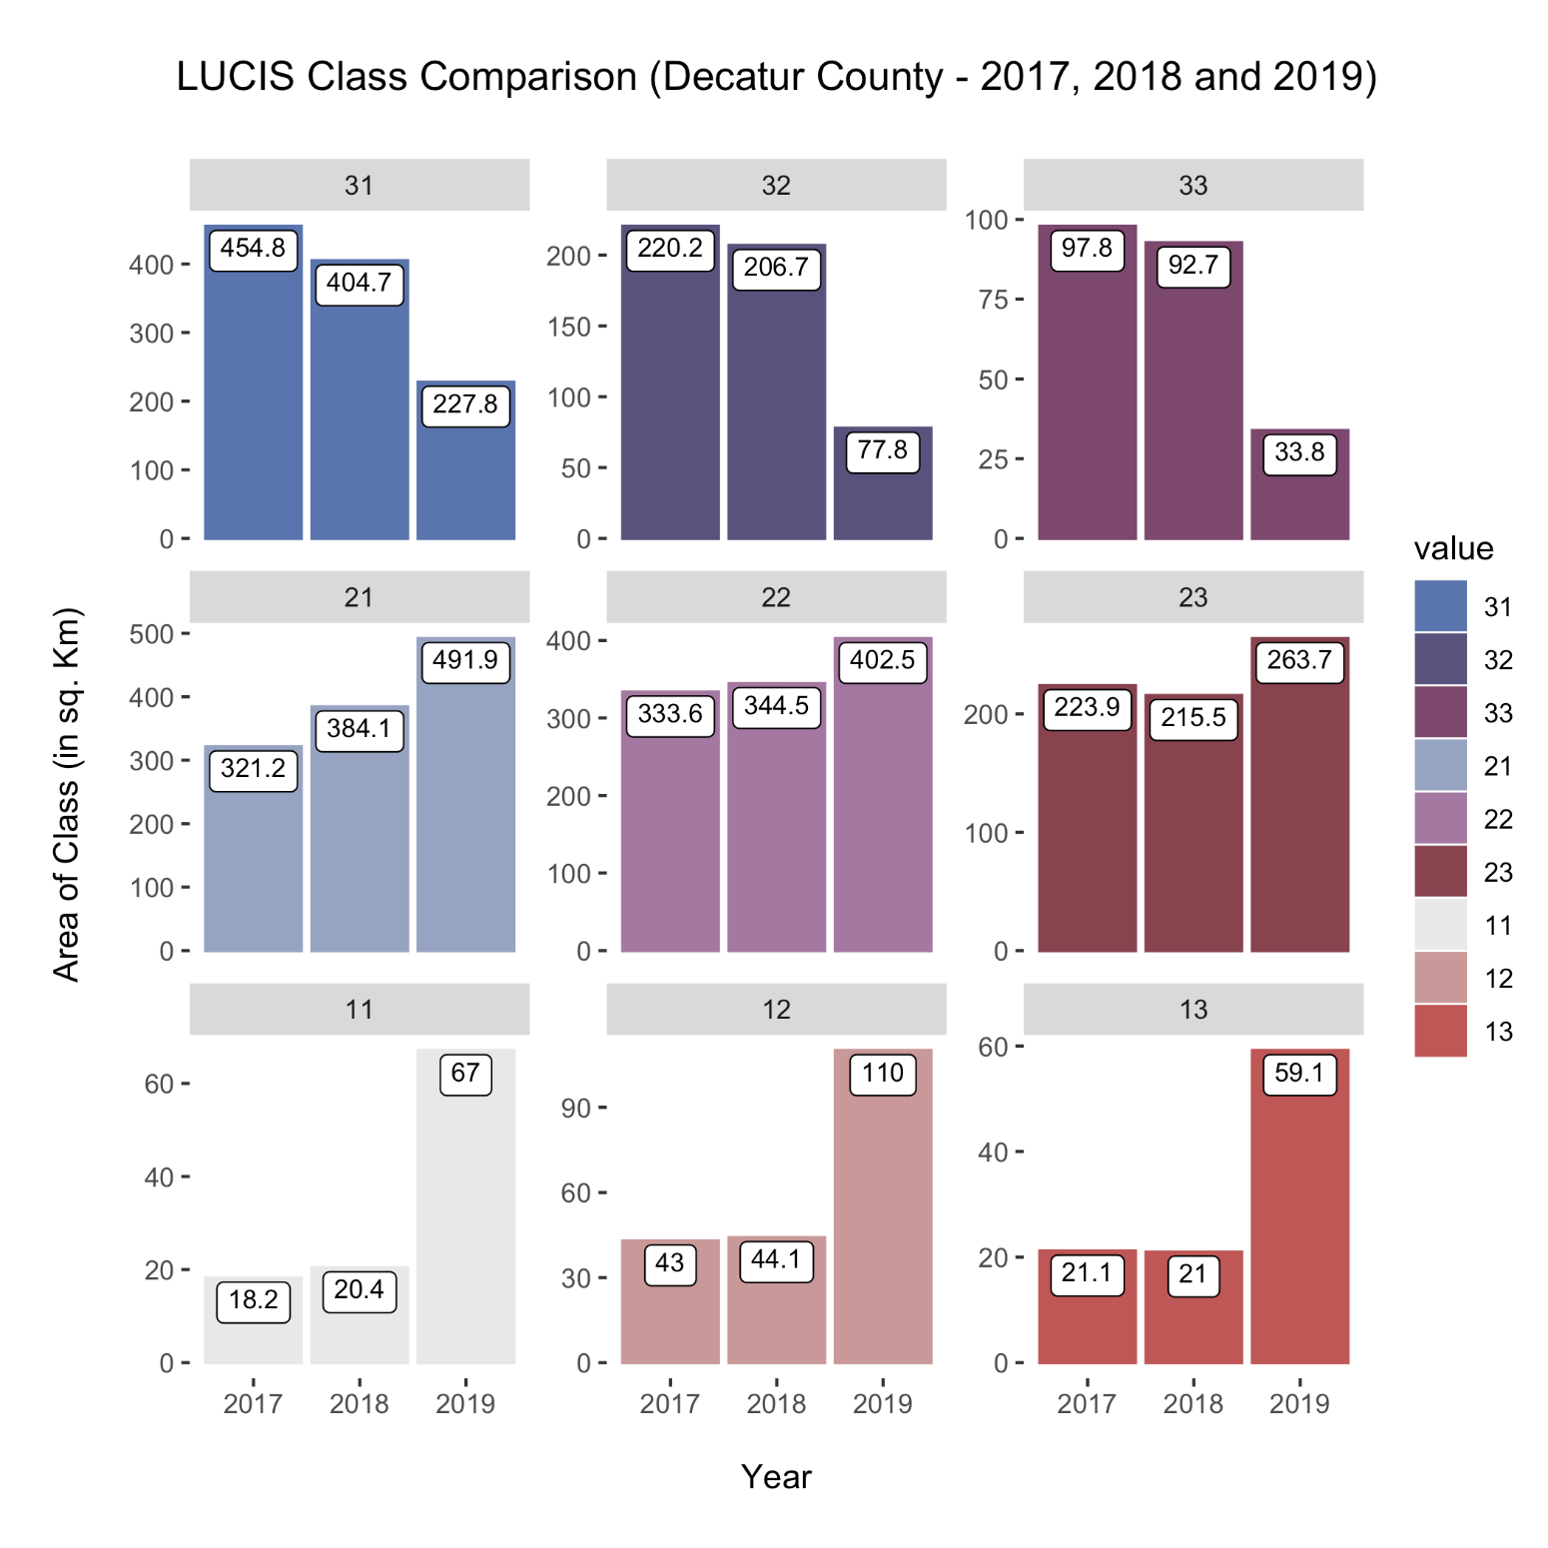
Figure H7. Decatur County LUCIS Class Comparison for 2017 vs. 2018 vs. 2019
Appendix I. Taylor County Results.

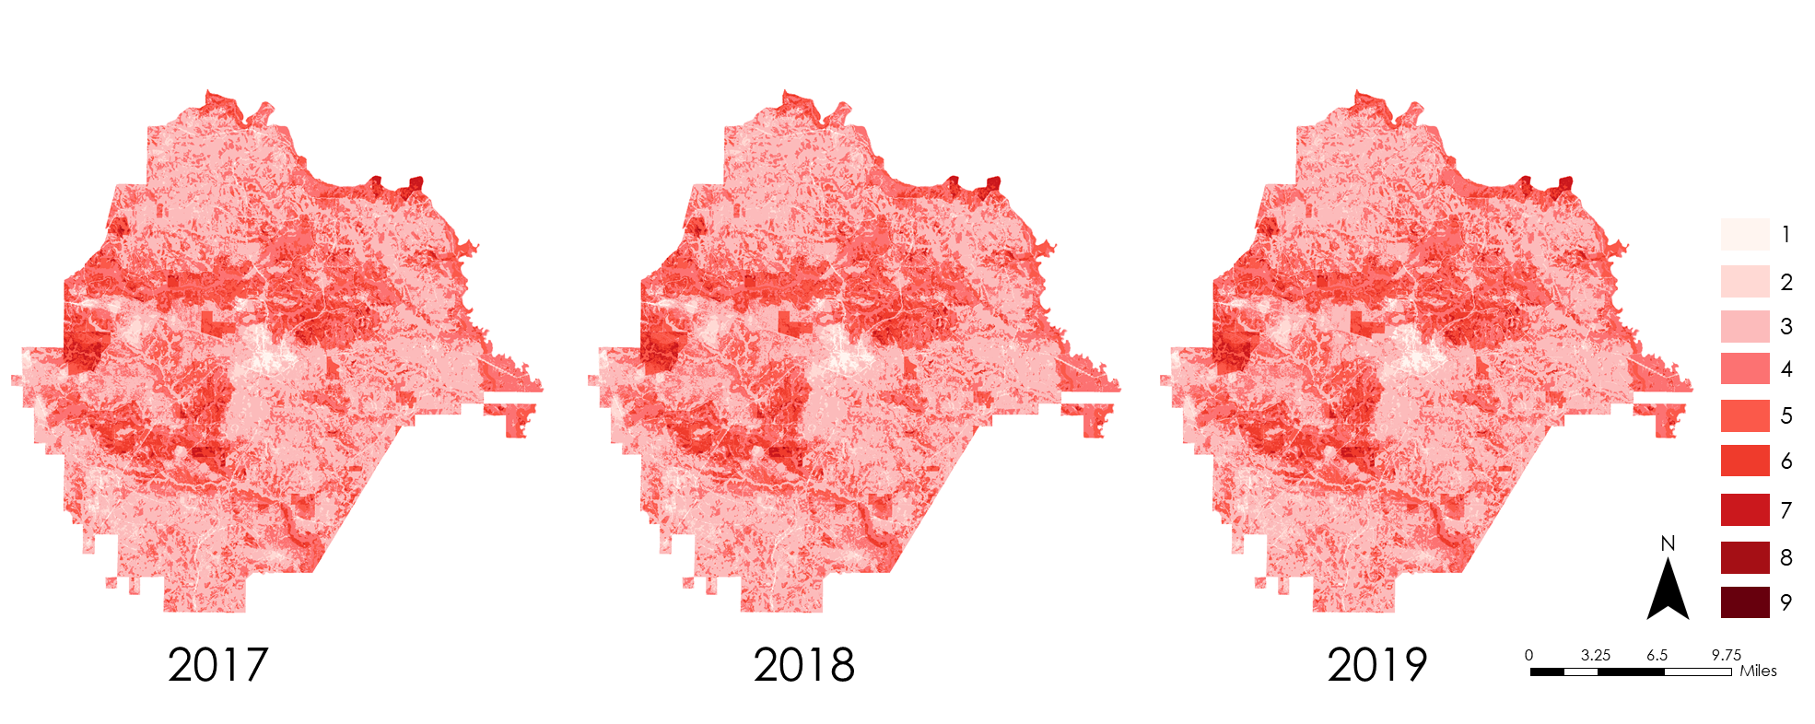

Figure I1. Taylor County Environmental Sensitivity results for 2017 (on the left), 2018 (middle), and 2019 (on the right).

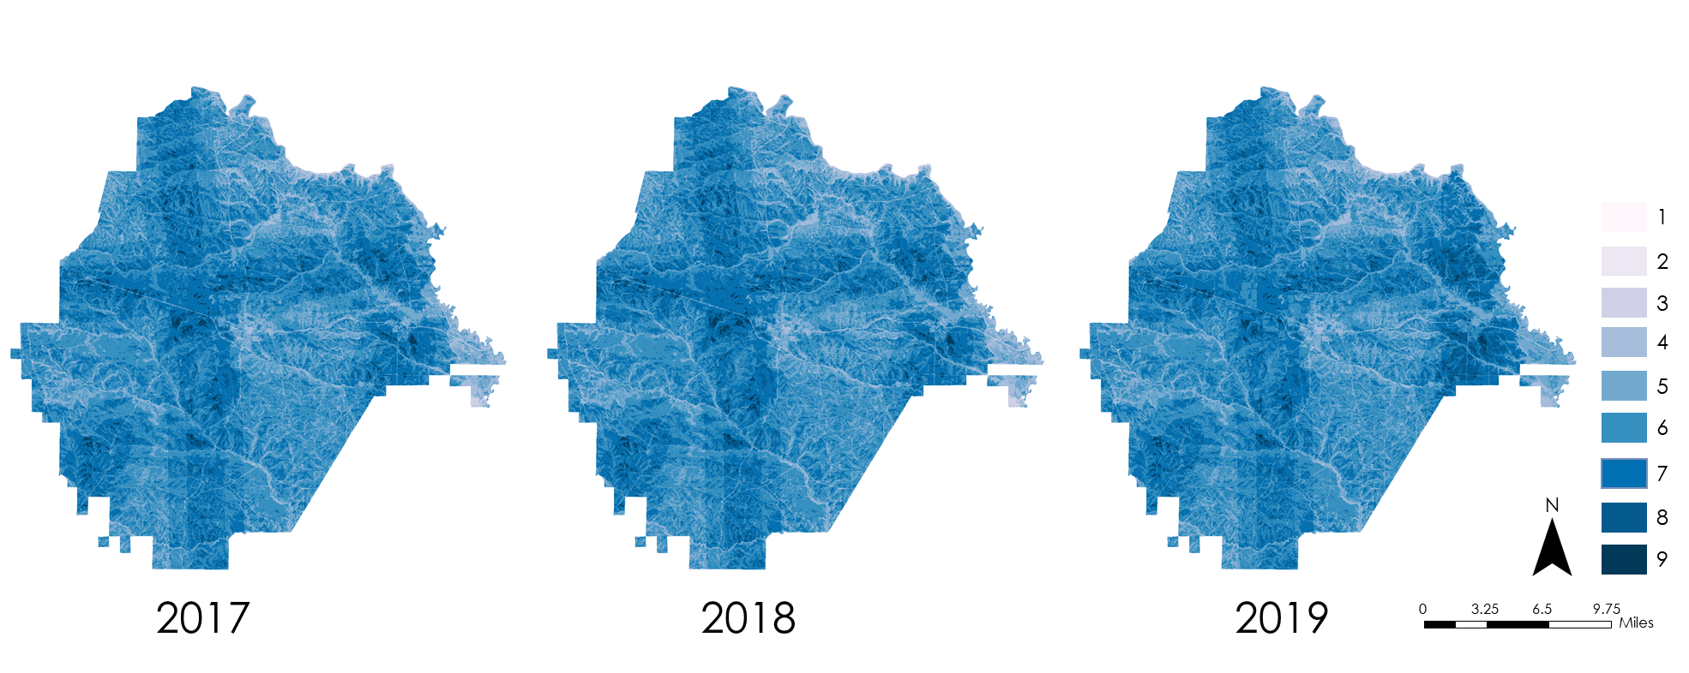

Figure I2. Taylor County Solar Suitability results for 2017 (on the left), 2018 (middle), and 2019 (on the right).

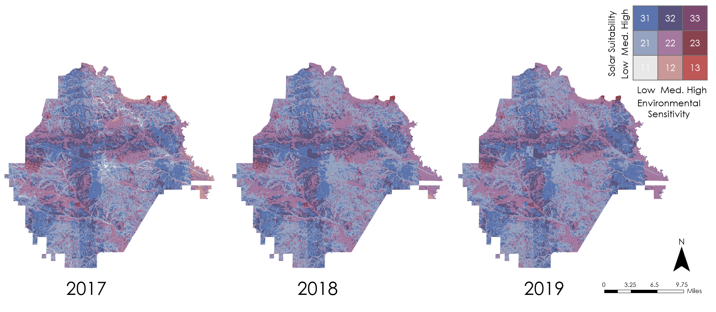

Figure I3. Taylor County LUCIS results for 2017 (on the left), 2018 (middle), and 2019 (on the right).

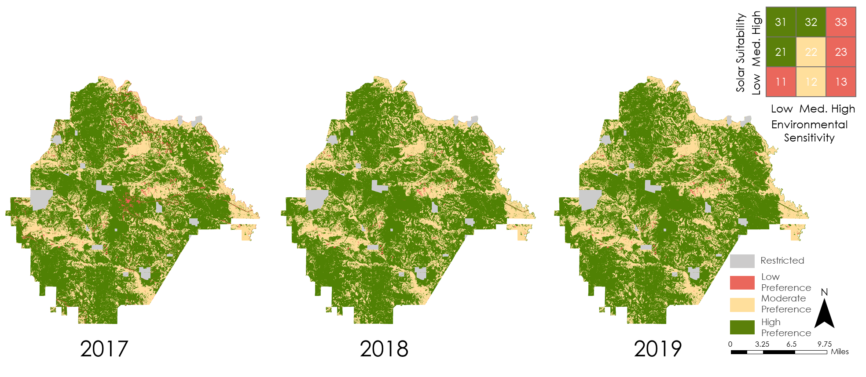

Figure I4. Taylor County reclassified LUCIS results for 2017 (on the left), 2018 (middle), and 2019 (on the right).
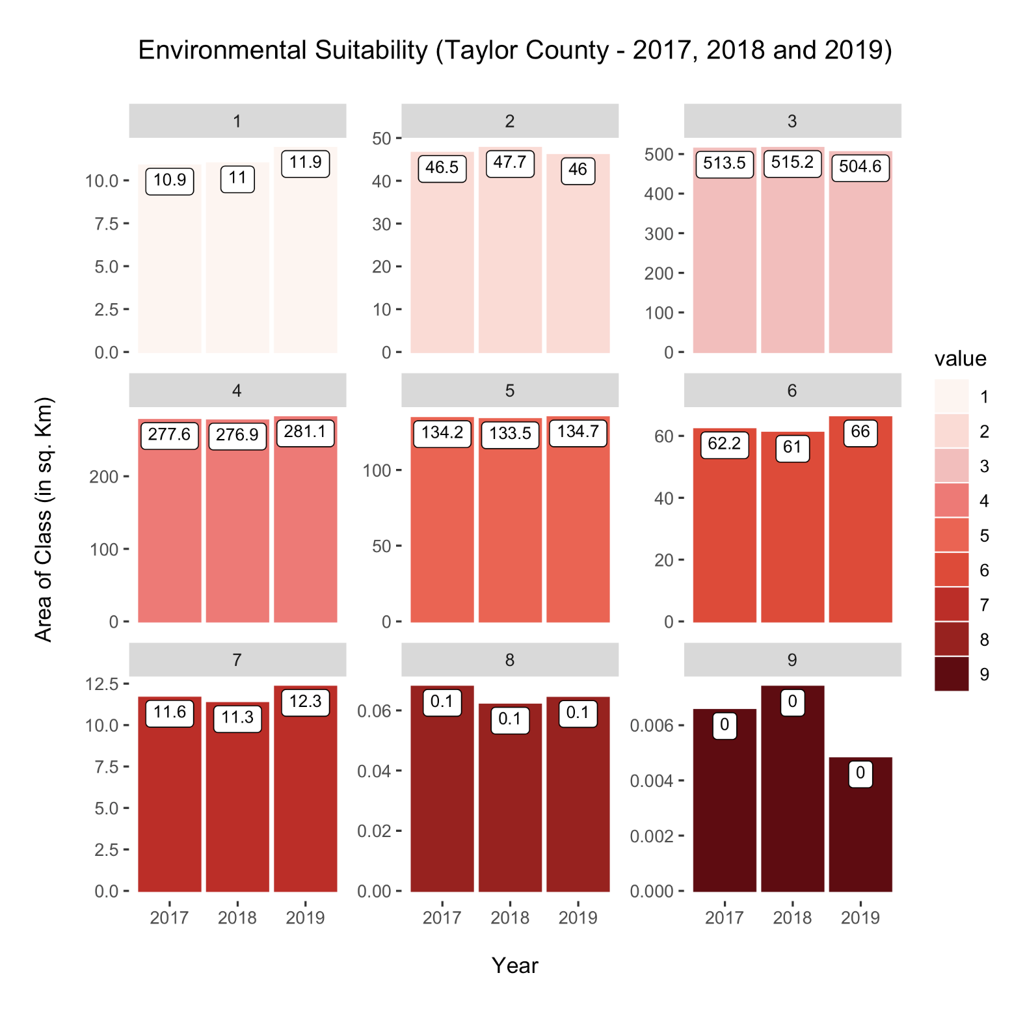
Figure I5. Taylor County Environmental Sensivity changes for 2017 vs. 2018 vs. 2019
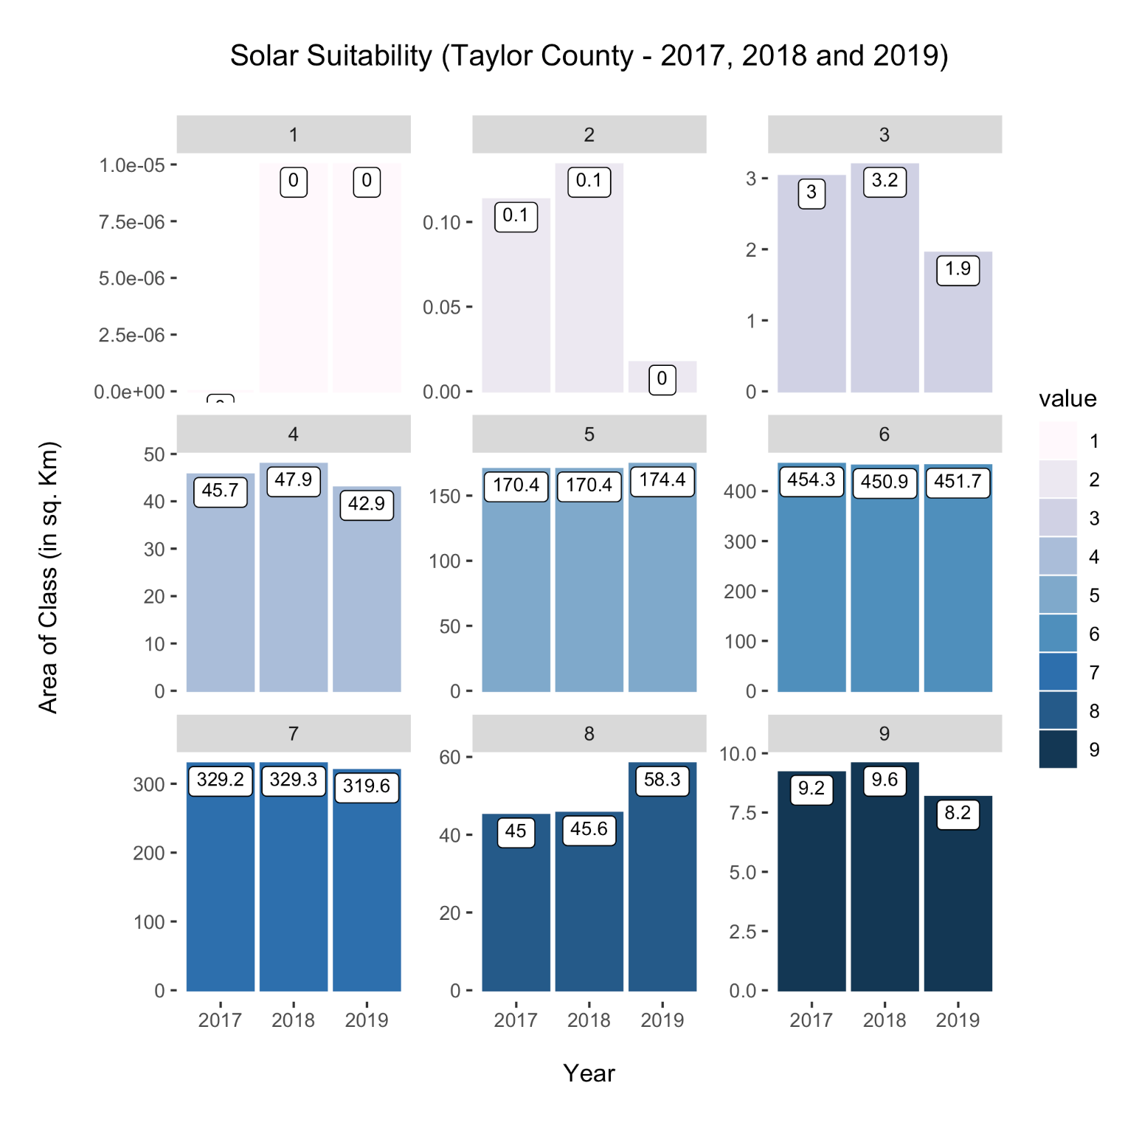
Figure I6. Taylor County Solar Suitability changes for 2017 vs. 2018 vs. 2019
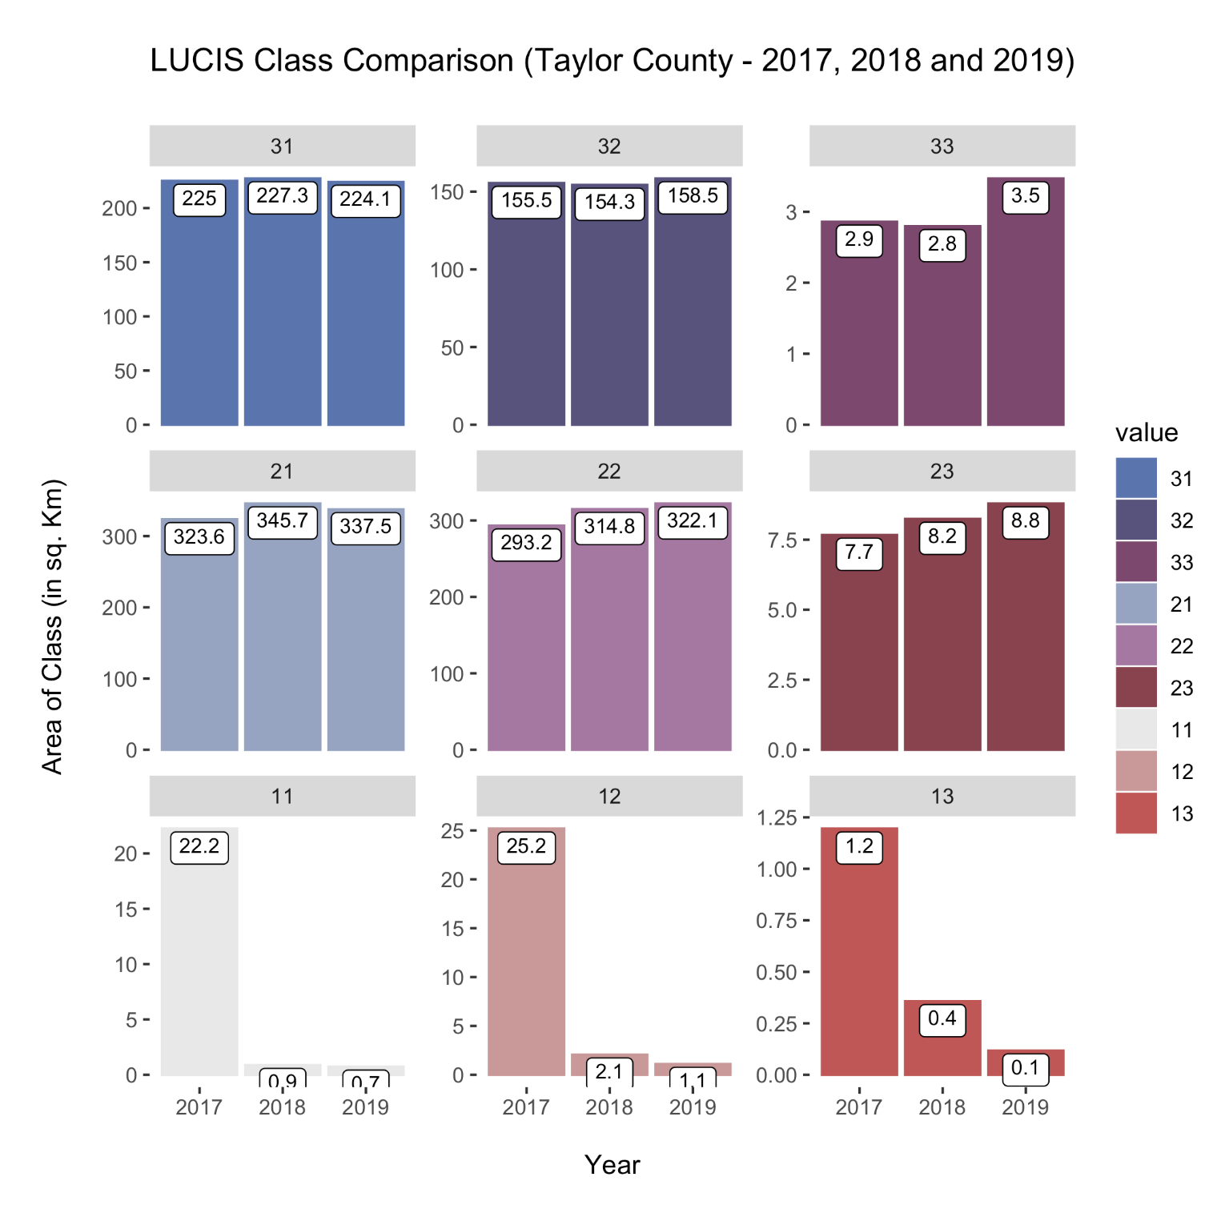
Figure I7. Taylor County LUCIS Class Comparison for 2017 vs. 2018 vs. 2019
Appendix J. Twiggs County Results.

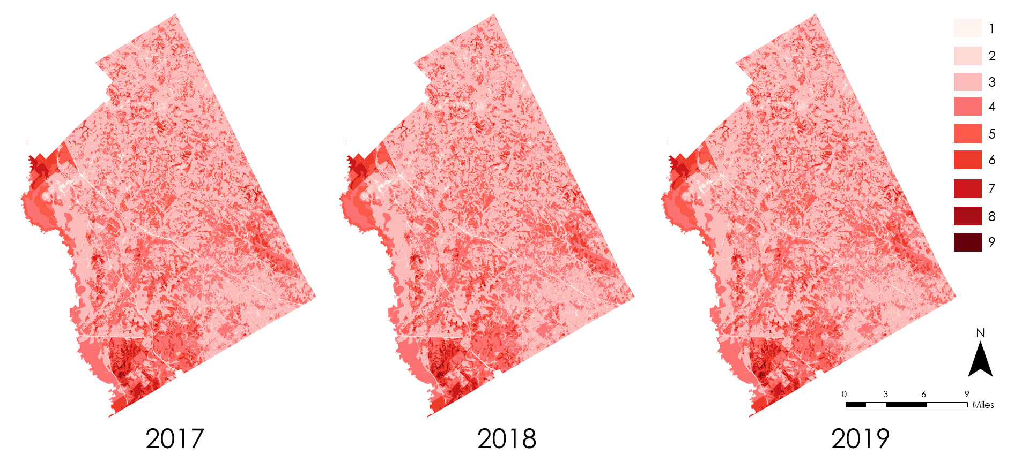

Figure J1. Twiggs County Environmental Sensitivity results for 2017 (on the left), 2018 (middle), and 2019 (on the right).

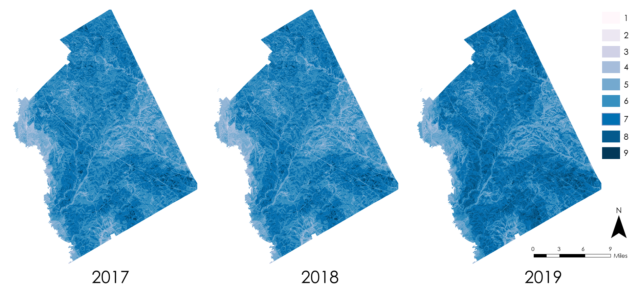

Figure J2. Twiggs County Solar Suitability results for 2017 (on the left), 2018 (middle), and 2019 (on the right).

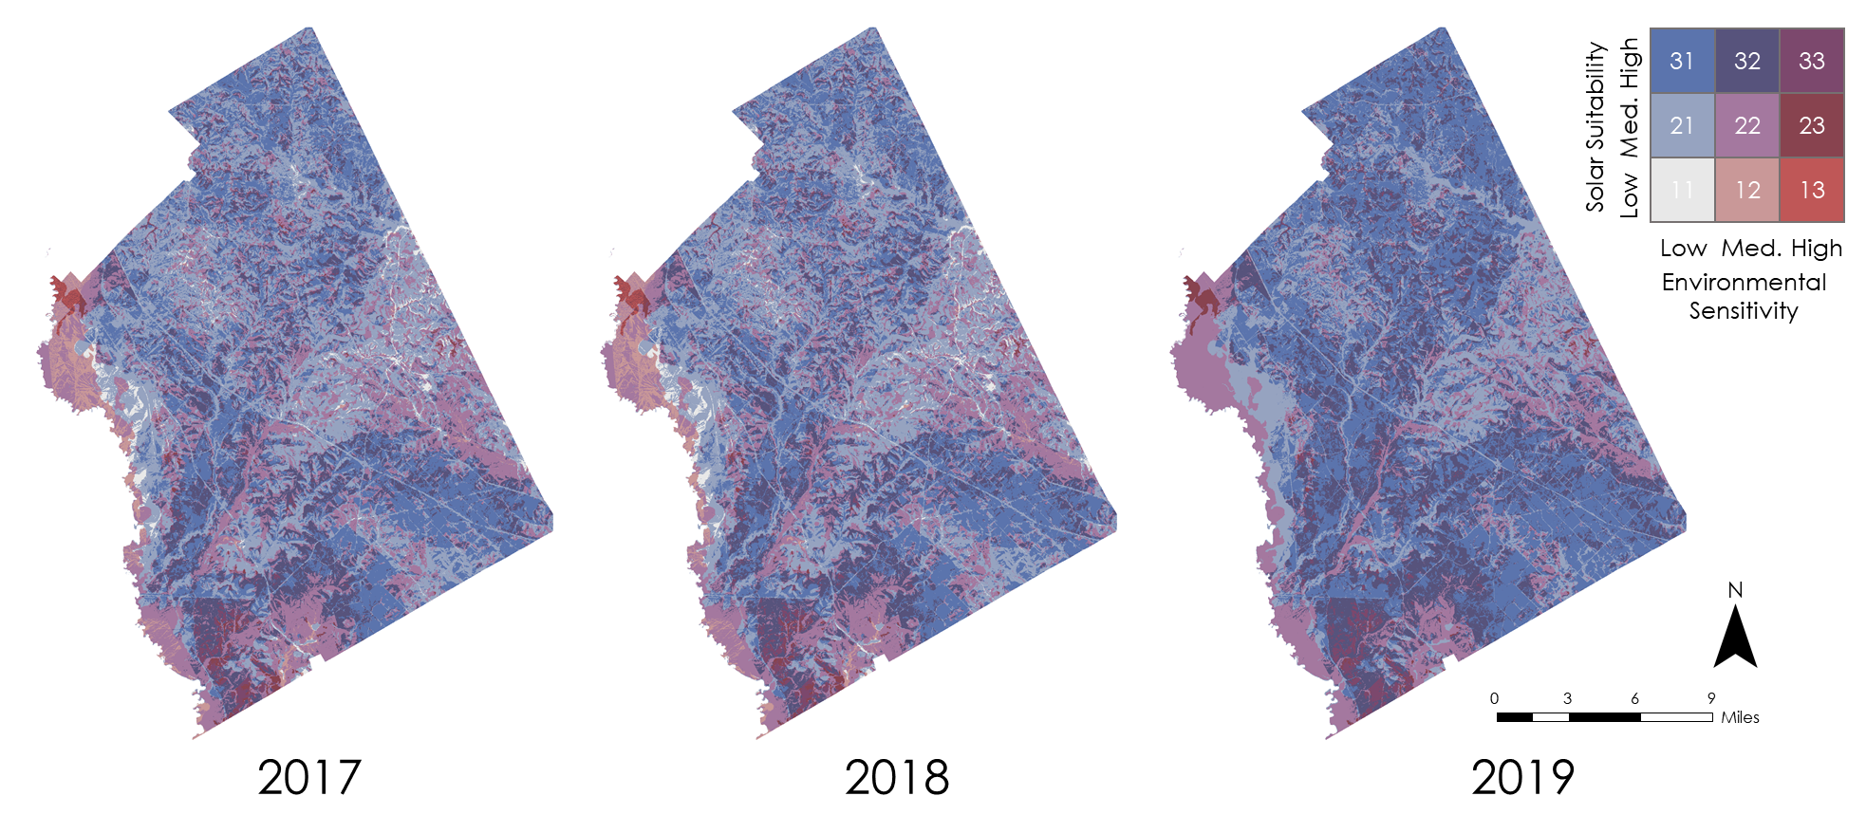

Figure J3. Twiggs County LUCIS results for 2017 (on the left), 2018 (middle), and 2019 (on the right).

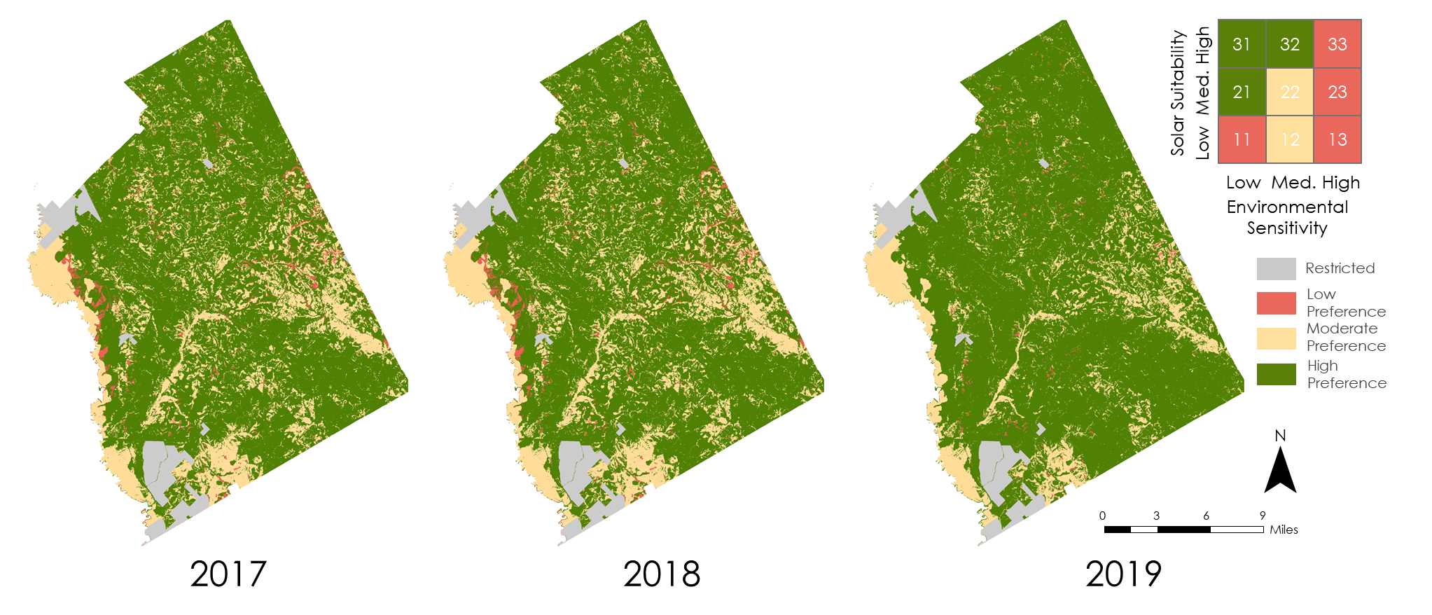

Figure J4. Twiggs County reclassified LUCIS results for 2017 (on the left), 2018 (middle), and 2019 (on the right).
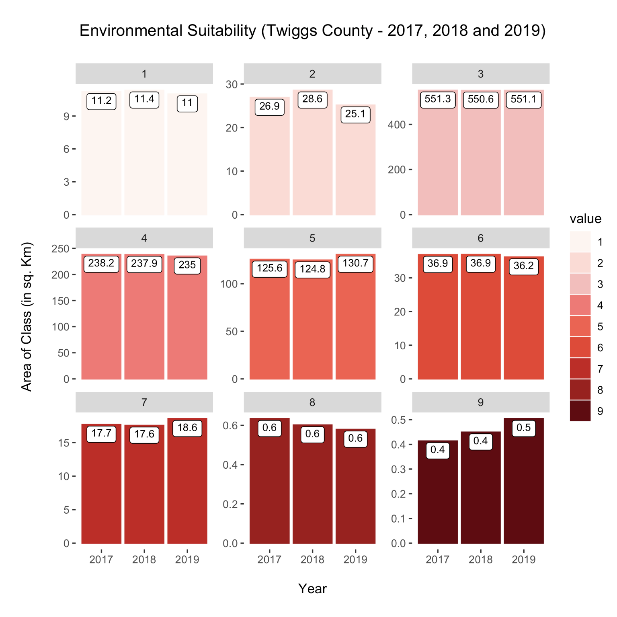
Figure J5. Twiggs County Environmental Sensivity changes for 2017 vs. 2018 vs. 2019.
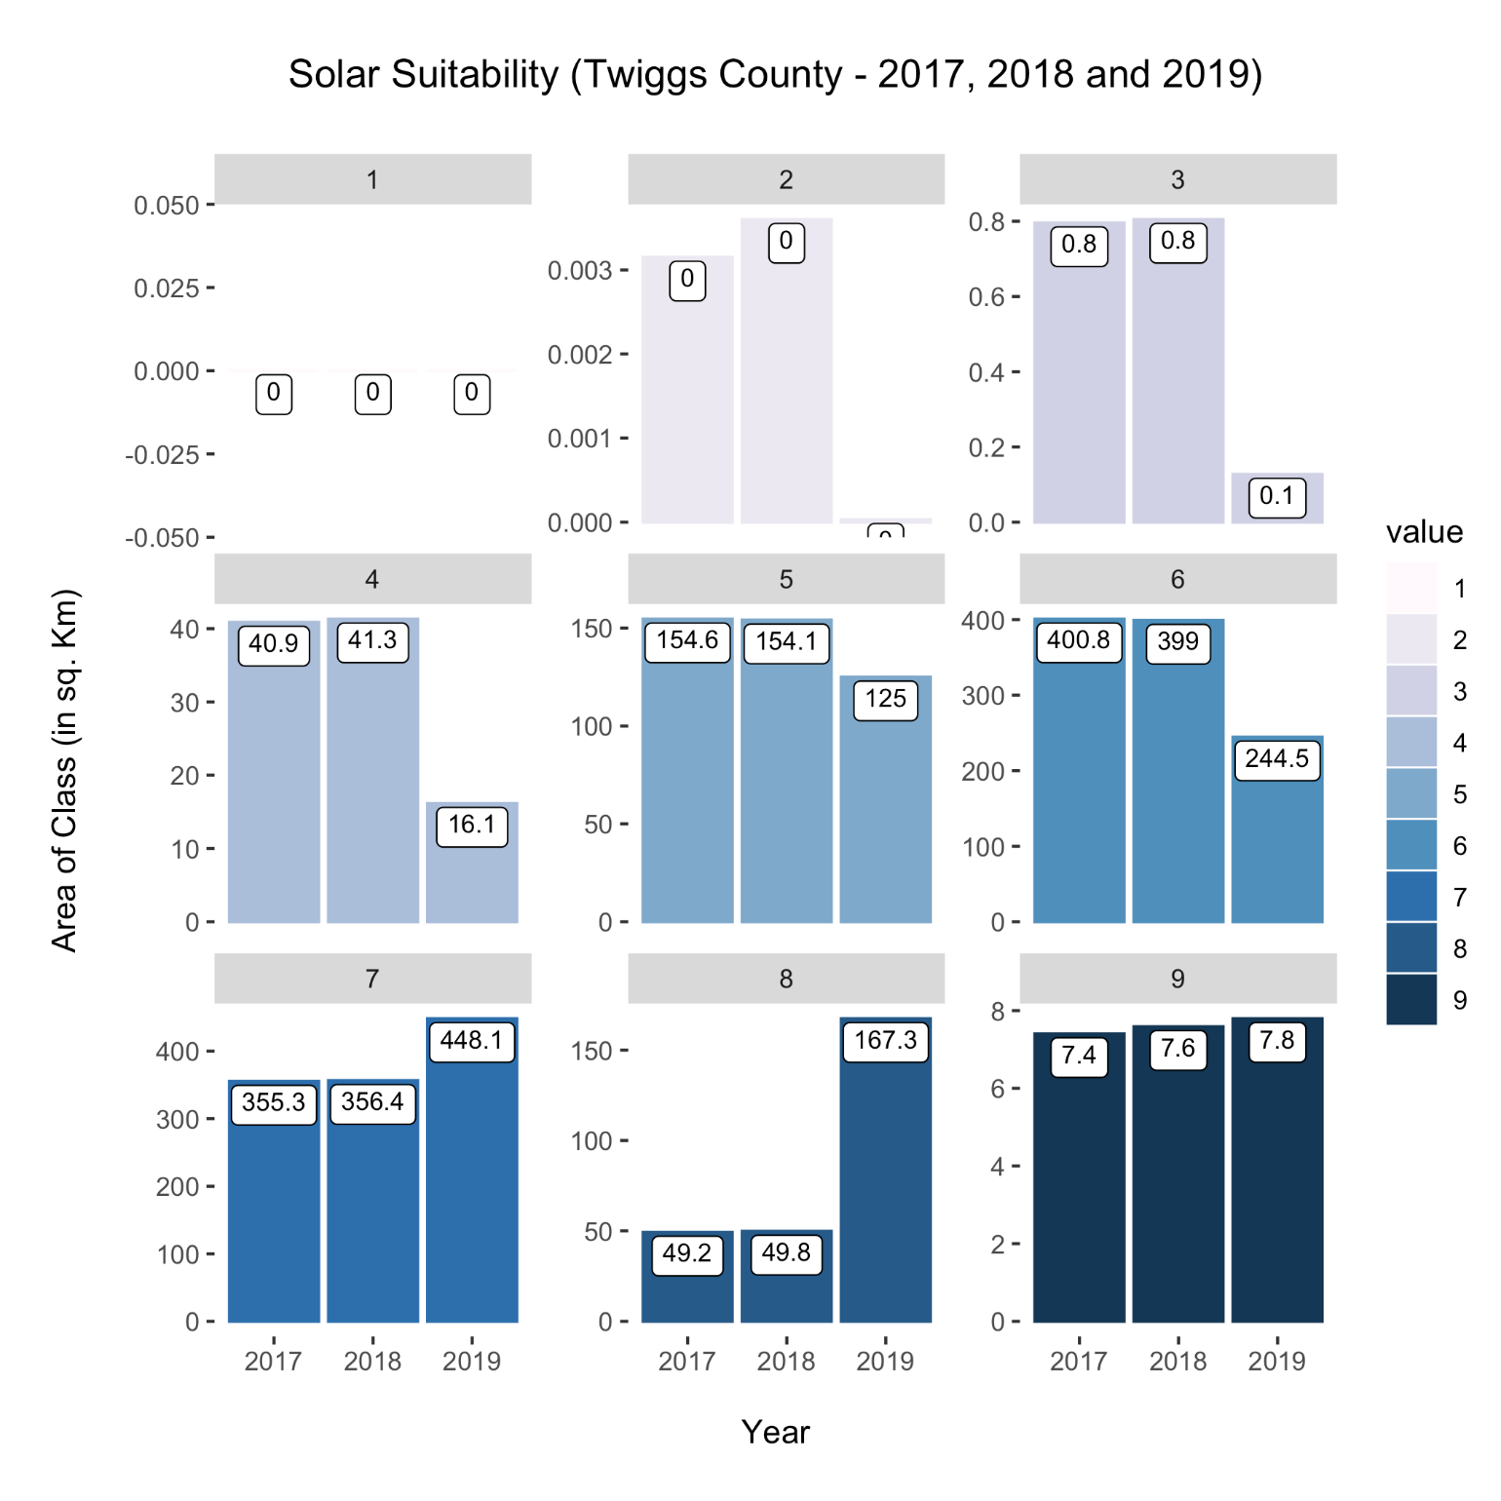
Figure J6. Twiggs County Solar Suitability changes for 2017 vs. 2018 vs. 2019.
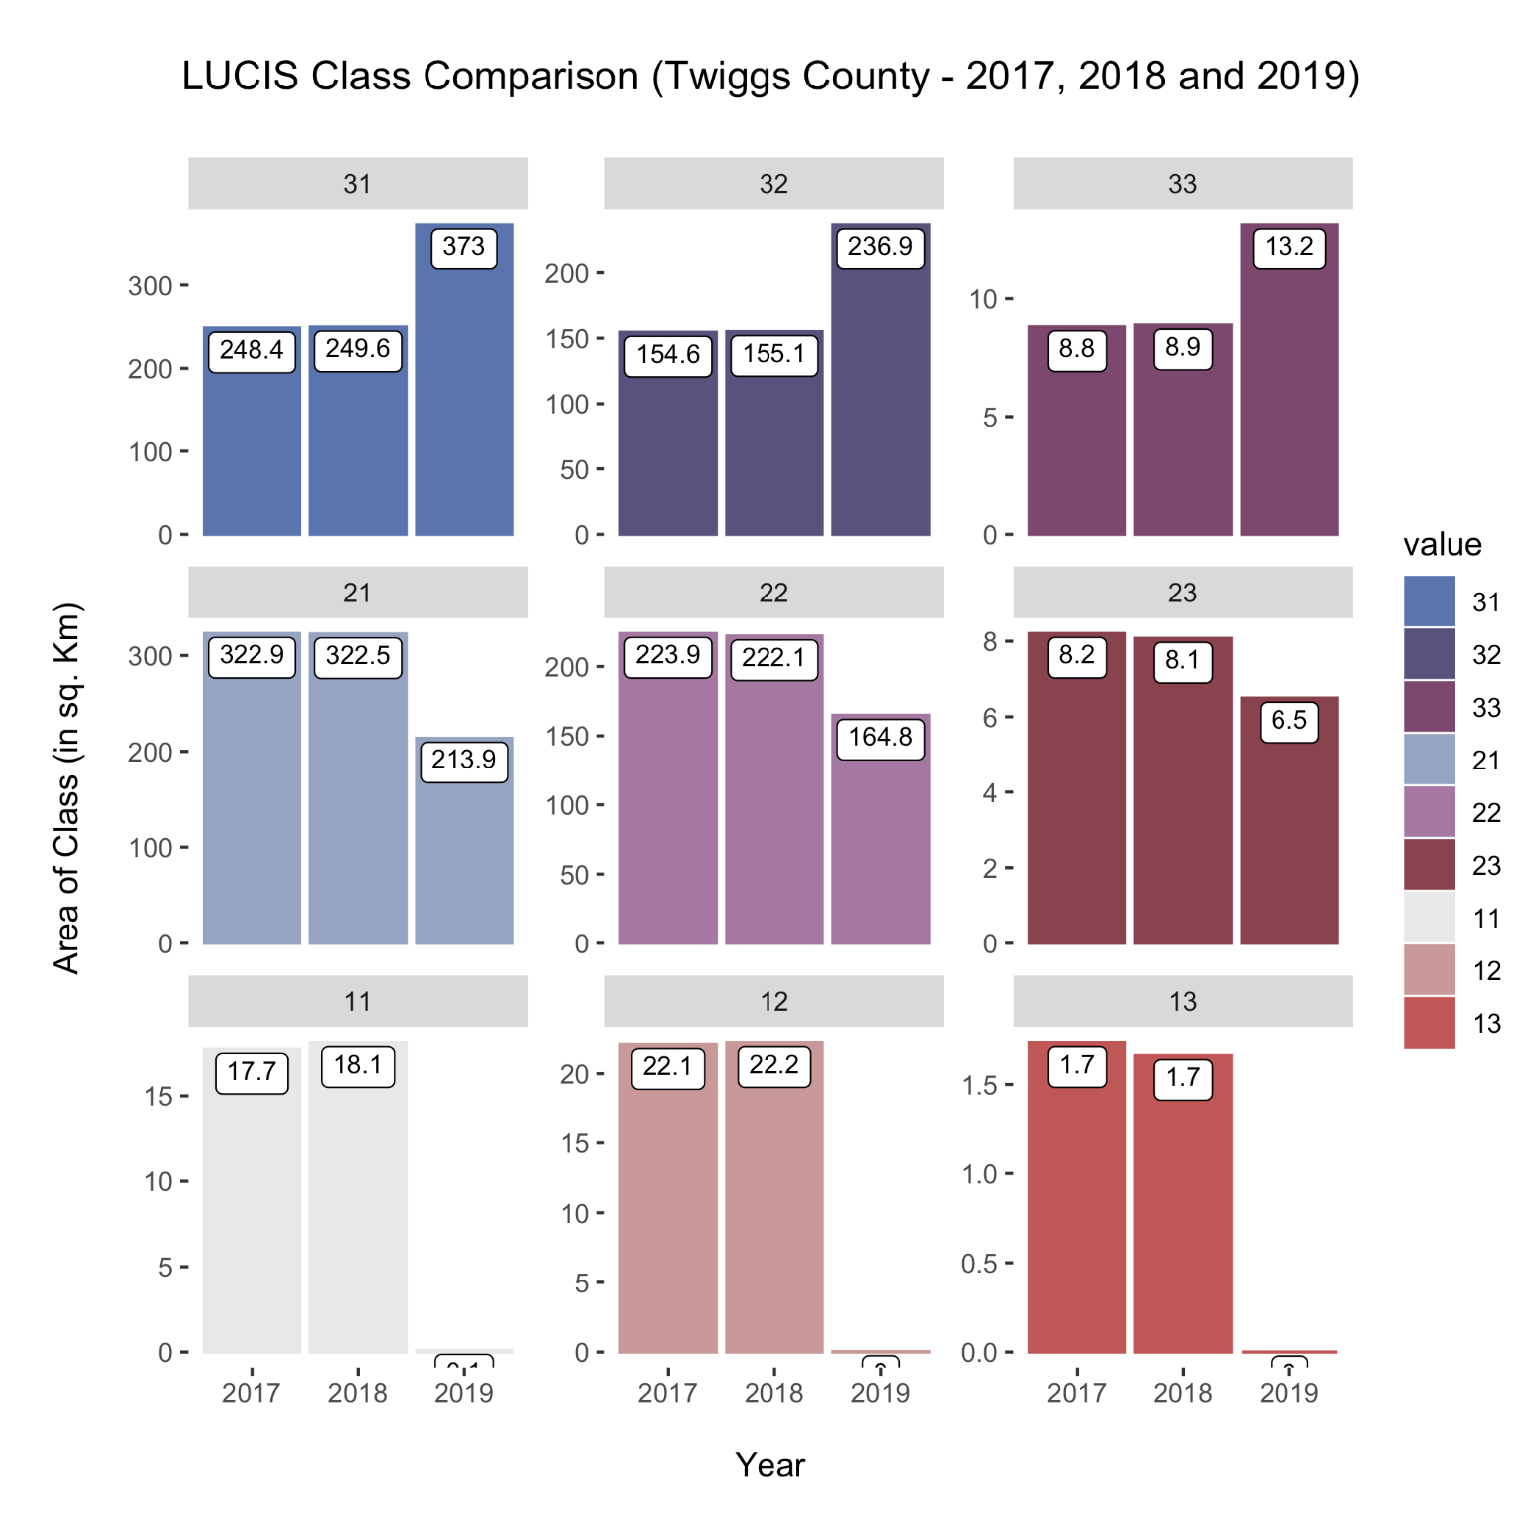
Figure J7. Twiggs County LUCIS Class Comparison for 2017 vs. 2018 vs. 2019.

