**NASA DEVELOP National Program**



NASA Marshall Space Flight Center

*Spring 2016*

Alabama Ecological Forecasting

Assessing Southern Pine Beetle Epidemics in the Bankhead National Forest Using NASA Earth Observations

 **Technical Report**

Rough Draft – Feb 18, 2016

Ryan Schick (Project Lead)

Kelsey Herndon

Maggi Klug

Leigh Sinclair

Dr. Jeffrey Luvall, NASA at National Space Science Technology Center (Science Advisor)

Dr. Robert Griffin, University of Alabama in Huntsville (Science Advisor)

# I. Abstract

[Placeholder - do not put anything here until the final draft submission. The abstract in the project summary is where the working draft of the abstract should “live”]

**Keywords**

Remote Sensing, Southern Pine Beetle, Outbreaks, Economy, Alabama, Ecological Forecasting, National Forest

# II. Introduction

The Southern Pine Beetle (SPB), or *Dendroctonus frontalis*, is an opportunistic species that attacks stressed trees weakened by drought, storm damage, or fire. The SPB is considered the most destructive pest throughout pine forests in the southern United States (Bridges 1987). A SPB outbreak typically has a six to twelve year interval and is estimated to destroy about 60,000 pine trees per year in Alabama, causing about $800,000 in damages annually. Bankhead National Forest, itself, has lost over $20 million in ecological goods between 1981 and 2001 (Stanturf et al. 2012). Fluctuations in SPB outbreaks are believed to be caused by variations in climate, both directly and indirectly. For example, severe drought conditions reduce the pressure of oleoresin exudation, as well as lower the amount and duration of resin flow, in pine trees enhancing the susceptibility of a SPB outbreak (Turchin et al. 1991). Efforts are being made by the United States Forest Service (USFS) to mitigate outbreaks in Alabama and Bankhead National Forest by identifying areas susceptible to SPB infestations.

**Project Objectives**

The objectives of this project were to create a Historical Pine Beetle Coverage Map, a Pine Beetle Prediction Map, and a Near Real-Time Pine Beetle Susceptibility Model. The Historical Pine Beetle Coverage Map locates previous SPB infestations throughout Alabama, focusing within the Bankhead National Forest, to determine what environmental thresholds SPB thrives at. The Pine Beetle Prediction Map was created using the information gathered from the Historical Pine Beetle Coverage Map using the Maximum Entropy Distribution Model (MaxEnt) developed at Princeton University. The Near Real-Time Pine Beetle Susceptibility Model determines which areas are susceptible to a SPB outbreak in near real-time by automatically downloading and analyzing the most recent satellite imagery. Project partners will use these methodologies and end products to help with SPB mitigation efforts. This project addressed the ecological forecasting section of NASA Applied Science’s application areas.

**Study Area**

The study area includes Alabama, with a focus on the Bankhead National Forest (Figure 1), which is one of the four National Forests in Alabama (US Forest Service). The area in Alabama is estimated to have 67% forest consisting of mostly hardwoods and pine trees. Specifically, Bankhead National Forest contains mostly loblolly and longleaf pines (Alabama Forestry Commission).

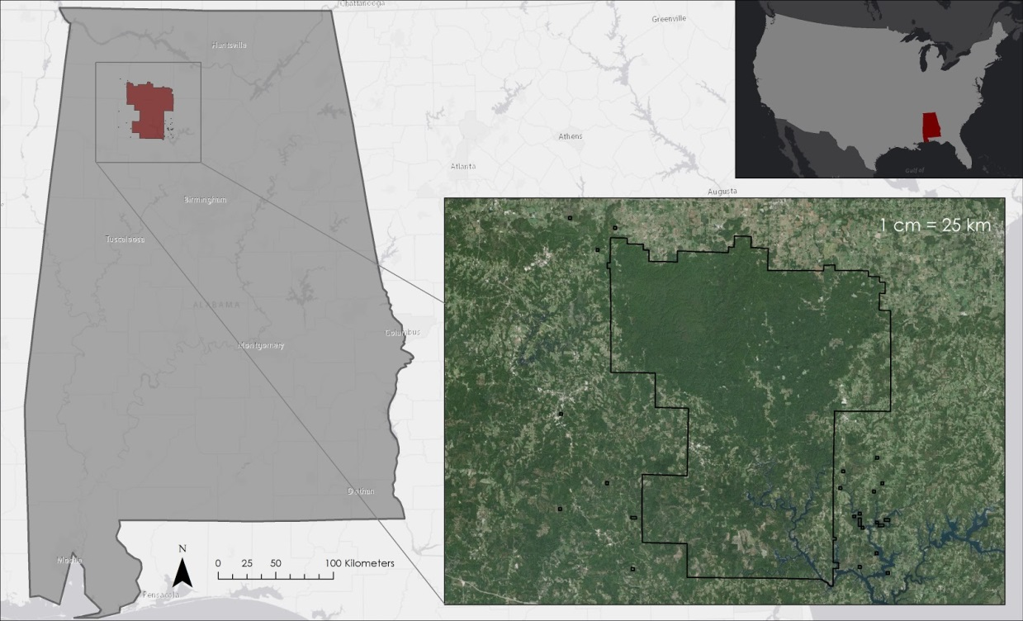

**Figure 1: Study area**

**Study Period**

The study period was from May 1995 to December 2015; forecasting SPB outbreaks to 2050. These months were chosen since the peak of the SPB lifecycle is during the summer months of May to October before the onset of winter conditions.

**Project Partners**

The project partners for this project were Dave Casey, Dr. John Nowak, and Dr. Chris Asaro from the USFS. Currently, the USFS uses expensive manned aerial surveys, such as aerial photographs and Light Detection and Ranging (LiDAR), as well as Moderate Resolution Imaging Spectroradiometer (MODIS) ForWarn and Forest Disturbance Monitor data. With the aerial data, field surveys must also be used since the species of beetle must be positively identified before conservation efforts can be implemented. For each species of beetle, specific management control and recommendations are needed as the beetles attack different pine trees at varying health and stress levels. During the winter months, suppression techniques include the removal of infested trees by salvage, piling and burning, or chemical control.

# III. Methodology

**Data Acquisition**

Landscape Fire and Resource Management Planning Tools (LANDFIRE) tree species 30 m data were downloaded from the LANDFIRE website. Landsat 5 Thematic Mapper (TM),  Landsat 8 Operational Land Imager (OLI), and Shuttle Rada Topography Mission (SRTM-v2) Digital Elevation Model (DEM) 30 m data were downloaded from United States Geological Survey’s (USGS) EarthExplorer. Bioclim climatic variables and future climate predictions were downloaded from the Worldclim website. Tropical Rainfall Measuring Mission (TRMM) and Global Precipitation Measurement (GPM) data were downloaded from the Goddard Earth Sciences Data and Information Services Center (GES DISC). National Agriculture Imagery Program (NAIP) 10 m data were downloaded from USGS EarthExplorer. SPB spot location data for 2010 through 2015 were acquired from the Alabama Forestry Commission. *In situ* SPB data for 2015 were downloaded from the USFS website.

**Data Processing**

LANDFIRE tree species data were reclassified to only show tree species the SPB prefers to attack, including Eastern White Pines, Longleaf Pines, Shortleaf Pines, Slash Pine, Loblolly Pine, Pitch Pine, Pond Pine, Virginia Pine, and mixed pine, by using the “Reclassify” tool in ArcMap 10.3. The data were then projected to WGS 1984 UTM zone 16N by using the “Project Raster” tool and clipped to Alabama by using the “Clip” tool.

*In situ* SPB data were projected to WGS 1984 UTM Zone 16N by using the “Project” tool in ArcMap 10.3.

*Historical Pine Beetle Coverage Map*

In-situ SPB data were verified using NAIP data. To understand what variables SPB prefers, in-situ data were overlapped with Normalized Vegetation Difference Index (NDVI), Green Red Vegetation Index (GRVI), precipitation, elevation, and slope. NDVI was calculated by using the following equation:

$$\frac{NIR-RED}{NIR+RED}$$

With,

*RED* = red band

*NIR* = near infrared band

GRVI was calculated by using the following equation:

$$\frac{GREEN-RED}{GREEN+RED}$$

With,

*GREEN* = green band

*RED* = red band

*Pine Beetle Prediction Map*

In-situ SPB data and the SPB outbreak thresholds determined in the Historical Pine Beetle Coverage Map were put in the MaxEnt model to show which areas are predicted to be susceptible to a SPB outbreak in 2050.

*Near Real-Time Pine Beetle Susceptibility Model*

The Near-Real Time Pine Beetle Susceptibility Model was created through a python code. The model is scheduled to run twice a week, on Saturdays and Sundays, by using Window’s Task Scheduler. The code automatically downloads Landsat 8 OLI 30 m data and extracts the clouds out of the imagery. Next, the model calculates the NDVI and GRVI, and then mosaics all the tiles. Finally, it clips the mosaicked image to the state of Alabama.

**Data Analysis**

*Historical Pine Beetle Coverage Map*

Landsat 5 TM data were used for the identification of pine species. Data from December of each year were used to determine tree species as this was the best time to distinguish pine species from other deciduous species. SPB spot location data were overlaid on 2015 NAIP 1 m imagery and compared to Landsat 30 m imagery to compare the ability to detect spots.

*Pine Beetle Prediction Map*

TBD

*Near Real-Time Pine Beetle Susceptibility Map*

TBD

# IV. Results & Discussion

**Errors and Uncertainties**

One potential source of error comes from the in-situ SPB data. The data provided by the Alabama Forestry Commission included infestations of beetle species other than the SPB, such as the Engraver Beetle. It was not possible to differentiate between infestations from different species. GPS points of this data were taken from an aircraft and thus are not always located directly over the infestation spot. Another possible source of error is cloud cover in the imagery, as well as dashes of erroneous data in the Landsat 5 imagery.

# V. Conclusions

TBD

# VI. Acknowledgments

The Alabama Ecological Forecasting team would like to acknowledge their advisors and project partners for their guidance and support for this project:

Science Advisors:

* Dr. Jeffrey Luvall, NASA at the National Space Science and Technology Center
* Dr. Robert Griffin, the University of Alabama in Huntsville

Project Partners:

* Dave Casey, Dr. Chris Asaro, and Dr. John Nowak from USFS

Other:

* Daryl Ann Winstead, NASA DEVELOP
* Tim Klug, the University of Alabama in Huntsville Graduate Research Assistant
* Alabama Forestry Commission

Any opinions, findings, and conclusions or recommendations expressed in this material are those of the author(s) and do not necessarily reflect the views of the National Aeronautics and Space Administration.

This material is based upon work supported by NASA through contract NNL11AA00B and cooperative agreement NNX14AB60A.

# VII. References

"Alabama Forest Facts." Alabama Forestry Commission. Web. 17 Feb. 2016

Bridges, J. Robert. “Effects of Terpenoid Compounds on Growth of Symbiotic Fungi Associated with the Southern Pine Beetle.” *Phytopathology* 77.1 (1987): 83-85. 1 Nov. 1987. Web. 26 Jan. 2016.

“National Forests in Alabama.” *National Forests in Alabama*. United States Department of Agriculture Forest Service, n.d. Web. 26 Jan. 2016.

Turchin, P., P. L. Lorio, A. D. Taylor, and R. F. Billings. “Why Do Populations of Southern Pine Beetles (Cleoptera: Scolytidae) Fluctuate?” *Environmental Entomology* 20.2 (1991): 401-09. Web. 26 Jan. 2016.

Stanturf, John A., Palle Madsen, David Lamb, Weimin Xi, et. al. “Chaper 12: Restoration of Southern Pine Forests After the Southern Pine Beetle.” A Goal-oriented Approach to Forest Landscape Restoration. Dordrecht: Springer Verlag, 2012. 322. Web. 10 Feb 2016.

# VIII. Content Innovation

VPS

Interactive Map Viewer

AudioSlides

# IV. Appendices

TBD