Oregon Wildfires
Integrating ECOSTRESS to Map and Analyze Vegetation Moisture for Wildfire Modeling


Technical Report
Final – August 12th, 2022

Brenna Hatch (Project Lead)
Kenya Creer
Jennifer Sobolewski
Nicole Roberts

Advisors:
Dr. Kerry Cawse-Nicholson, NASA Jet Propulsion Laboratory, California Institute of Technology (Science Advisor)
Dr. Madeleine Pascolini-Campbell, NASA Jet Propulsion Laboratory, California Institute of Technology (Science Advisor)

1. Abstract
Wildfire season in the western USA is starting earlier and gaining in intensity. The Bootleg Fire in Southern Oregon began on July 6th, 2021 and burned over 1675 km² before it was fully contained on August 15th, 2021. Evapotranspiration (ET) is one indicator of vegetation moisture and there is interest in using high-resolution ET products from ECOsystem and Spaceborne Thermal Radiometer Experiment on Space Station (ECOSTRESS) in future wildfire modeling. In partnership with the Pacific Northwest National Laboratory and US Forest Service, the team examined ECOSTRESS ET for the two years before the Bootleg Fire and assessed the relationship between ET, topography, and vegetation. Remotely sensed data from Shuttle Radar Topography Mission (SRTM) and Global Ecosystem Dynamics Investigation (GEDI) along with ancillary data from the National Land Cover Database (NLCD) and Landscape Fire Resource Management Planning Tools (LANDFIRE) were incorporated. The team examined data in relation to soil burn severity from the Burned Area Emergency Response (BAER) program. From ET median composites for April 1st – July 5th, 2021 and 2019, the Bootleg Fire area showed a 7 mm/day decrease in ET and a relative 75% decrease in ET between 2019 and 2021. Approximately 6% of the Bootleg Fire area was identified as having a high soil burn severity and these areas were found predominantly in the evergreen forest land cover class and northward facing slopes with a mean ET decrease of 3 mm/day between 2019 and 2021. The team also analyzed ECOSTRESS Water Use Efficiency products as an additional vegetation moisture indicator of pre-fire conditions in the study area. The end products will allow the partners to assess if higher resolution vegetation moisture datasets from ECOSTRESS will improve wildfire modeling for other susceptible areas.
Key Terms
Evapotranspiration, water use efficiency, topography, aboveground biomass density, landcover classification, burn severity

2. Introduction
2.1 Background Information
Wildfire activity across the western United States has grown in the past 50 years, with the number of large fires and burn area increasing alongside the lengthening of the fire season (Abatzoglou & Williams, 2016). In California, the likely driver of a five-fold increase in annual burned area and the increased occurrence of large, destructive wildfires since the 1970s is the drying of vegetation promoted by global warming (Williams et al., 2019). Recent research has found that for southwestern and western North America—which includes California, Oregon, and other states in the western half of the United States and northern Mexico—the period between 2000-2021 has been the driest since the year 800, with exceptional drought conditions expected to continue into 2022 (Williams et al., 2022).

Vegetation moisture is the main pathway by which drought impacts the behavior of wildfires and can be an important predictor of wildfire burn severity (Coen et al., 2018; Pascolini-Campbell et al., 2022). However, the drying of vegetation in response to increasing temperatures and drought conditions is not uniform, and along with topography and vegetation type, vegetation moisture can influence the pattern of burn severity from wildfires (Pascolini-Campbell et al., 2022). Understanding the pre-fire vegetation moisture conditions of an area can help identify places susceptible to wildfires and aid in monitoring.

Vegetation moisture conditions can be analyzed through a remote sensing approach using evapotranspiration (ET) and water use efficiency (WUE) products obtained from the ECOsystem and Spaceborne Thermal Radiometer Experiment on Space Station (ECOSTRESS; Pascolini-Campbell et al., 2022). ECOSTRESS derives ET products by measuring the thermal infrared brightness of plants at 70 m resolution every 1-5 days. WUE is derived from the ECOSTRESS Level-3 ET product plus observations of gross primary production (GPP) from the Moderate Resolution Imaging Spectroradiometer (MODIS; Fisher & Halverson, 2019; Fisher et al., 2020). ET is one measure of plant water stress and is the hydrologic variable that best describes the response of vegetation to changing water conditions (Fisher, 2018). WUE is the ratio of carbon fixed through photosynthesis to water lost through ET and indicates how vegetation may respond to stressors such as drought and high temperatures (Fisher & Halverson, 2019; Pascolini-Campbell et al., 2022). Previous studies have utilized plant stress indicators to investigate pre-fire vegetation moisture as a control on burn severity (Coen et al., 2018; Fang et al., 2018; Huang et al., 2020), with one recent study using ECOSTRESS ET and WUE products to analyze how plant stress impacted burn severity over different time periods and vegetation types for six California wildfires (Pascolini-Campbell et al., 2022).

The team focused on analyzing vegetation moisture in Klamath and Lake counties in southern Oregon for 2019–2021 using ECOSTRESS daily ET products. WUE was incorporated as a supporting vegetation moisture parameter for pre-fire conditions in the study area. Both Oregon counties were affected by the Bootleg Fire, a massive wildfire in the Fremont-Winema National Forest which began on July 6th, 2021, and burned approximately 1675 km² before it was fully contained on August 15th, 2021 (Inciweb, n.d.; Figure 1). Due to changes in the fire’s perimeter over its duration, the team used the heat perimeter established on August 5th, 2021 as the Bootleg Fire extent for analysis. The Bootleg Fire area covers a variety of vegetation types, including areas with mixed grasses and shrubs, open and dense timber stands, as well as dry meadows (Inciweb, n.d.). Elevations in the Bootleg Fire area ranged from approximately 1,300 to 2,500 m, with higher burn severity in areas with higher elevation (Inciweb, n.d.). The team explored how topography and different vegetation characteristics interacted with vegetation moisture during the Bootleg Fire and how these parameters impacted soil burn severity within the wildfire perimeter. Soil burn severity was classed as unburned, low, moderate, and high, and was determined from the Burn Area Emergency Response (BAER) Soil Burn Severity (SBS) Map. For topography and biomass density, we used Earth observations from the Shuttle Radar Topography Mission (SRTM) and Global Ecosystem Dynamics Investigation (GEDI). Ancillary data from the National Landcover Database (NLCD) developed by the Multi-Resolution Land Characteristics (MRLC) and Existing Vegetation Type (EVT) from the Landscape Fire Resource Management Planning Tools (LANDFIRE) was incorporated for land cover classification and existing vegetation type.

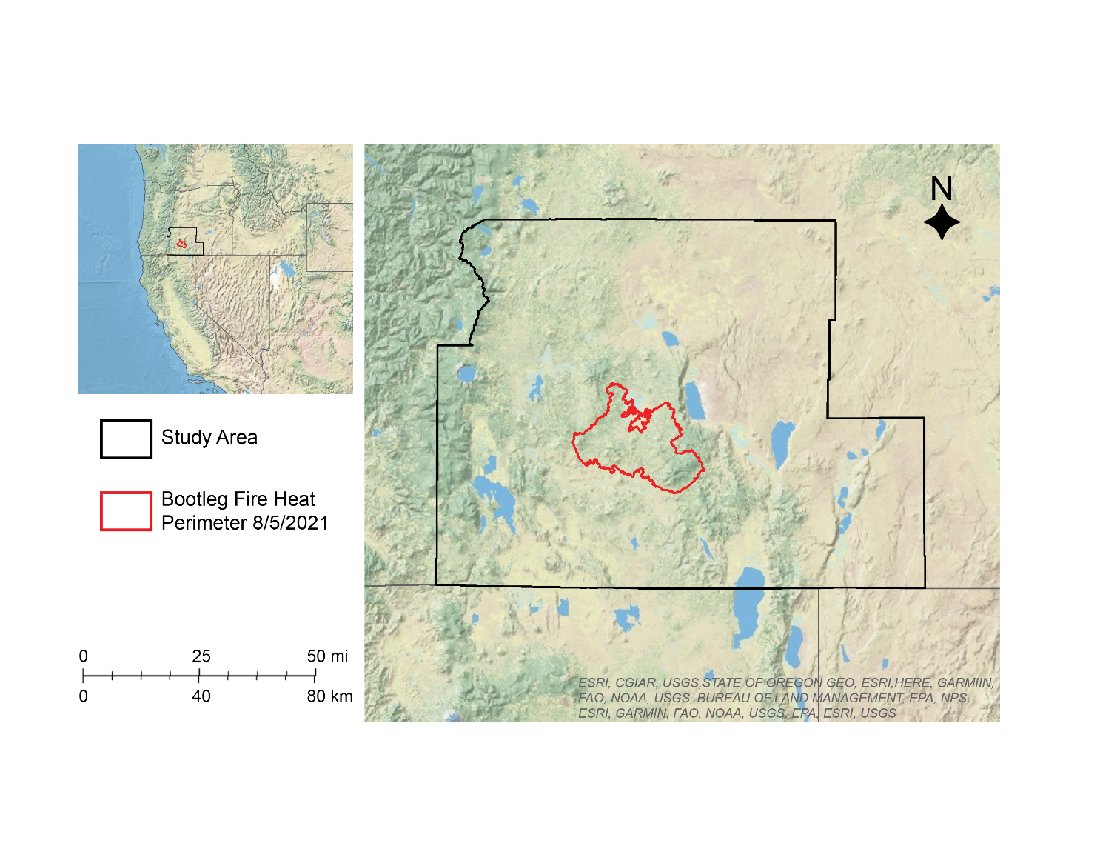
Figure 1. Study area encompassing Klamath and Lake counties in southern Oregon. The Bootleg Fire area is situated in the middle of these two counties in the Fremont-Winema National Forest.
2.2 Project Partners & Objectives
The US Forest Service (USFS) strives to protect the health, diversity, and productivity of the nation's forests and grasslands by managing wildfire. The Pacific Northwest National Laboratory (PNNL) is a multi-disciplinary research organization supporting the USFS in the prediction of wildfire behavior through the use of satellite imagery. These project partners want updated data to use in wildfire monitoring across the western United States. With the guidance of PNNL, the team used ECOSTRESS daily ET and WUE products in a case study of the 2021 Bootleg Fire to analyze vegetation moisture as a fire risk indicator. The team created maps and time series with high resolution ECOSTRESS data, assessed ET as a fire risk indicator, and demonstrated the feasibility of using ECOSTRESS data to better characterize pre-fire vegetation moisture. The results of the team’s analysis will allow the partners to assess if high resolution vegetation moisture datasets from ECOSTRESS will improve wildfire modeling for other susceptible areas.

3. Methodology
3.1 Data Acquisition
The team acquired Earth observation data products from the Land Processes Distributed Active Archive Center Application for Extracting and Exploring Analysis Ready Samples (LP DAAC AppEEARS) and the Oak Ridge National Laboratory Distributed Active Archive Center (ORNL DAAC) (Table 1). Ancillary data were also used in the team’s analysis (Table 2).

Table 1.
List of sensors and data products utilized for this project.
Platform and Sensor | Data Products | Parameters | Dates | Acquisition Methods
ECOSTRESS | ECOSTRESS Evapotranspiration dis-ALEXI Daily L3 CONUS 70 m | Daily evapotranspiration, daily water use efficiency | April 1st – July 5th (2019, 2020, 2021),  June (2019, 2020, 2021) | LP DAAC AppEEARS
Shuttle Radar Topography Mission (SRTM) | SRTM Version 3.0, 1-arc second | Topography, aspect, slope | February 11, 2000 | LP DAAC AppEEARS
GEDI | GEDI L4B Gridded Aboveground Biomass Density, Version 2 | Biomass density | April 18, 2019 – August 24, 2021 | ORNL DAAC

Table 2.
List of ancillary data products utilized for this project.
Platform | Data Products | Parameters | Dates | Acquisition Methods
NLCD | NLCD 2019 Land Cover CONUS | Land cover classes | 2019 | Multi-Resolution Land Characteristics (MRLC) Consortium
LANDFIRE | Existing Vegetation Type (EVT) | Land cover types | 2020 | LANDFIRE (LF 2020 2.2.0).
BAER | BAER Soil Burn Severity Map | Soil burn severity layer with 4 classes | August 2021 | US Forest Service

3.2 Data Processing
ECOSTRESS Level 3 daily ET is derived from the ECOSTRESS Level 2 land surface temperature and emissivity product. For our analysis, the team utilized the daily ET product which uses the Atmosphere Land Exchange Inverse (ALEXI) Disaggregation algorithm (dis-ALEXI) and has units of mm/day. ECOSTRESS WUE is a Level 4 product and is reported as a ratio between ECOSTRESS Level 3 ET derived from the Priestley-Taylor Jet Propulsion Laboratory (PT-JPL) algorithm and gross primary production (GPP) from MODIS. Both daily ET and WUE were projected in WGS 1984 Mercator and pre-processed before download to remove cloud cover. After downloading, the team processed ECOSTRESS daily ET and WUE in Python 3.9. Fill values caused by bad pixels or sensor errors from cloud cover, smoke and atmospheric vapor concentrations, that were either greater than 9000 or less than zero were removed. The team removed outliers that were less than 8% and greater than 98% percentile as well as any images where the proportion of missing pixels was greater than 50%. This resulted in 20 raster images for daily ET and 19 for the WUE analysis.
The SRTM digital elevation model (DEM) of Klamath and Lake counties was projected to WGS 1984 Mercator and was processed in ArcGIS Pro 2.9.3. This projection caused a slight pixel distortion and the DEM was resampled from 31 to 30 m and then to a coarser resolution to match ECOSTRESS. Noise in the DEM was reduced by a 7x7 kernel with a median filter and the team used the Raster Surface Toolbox to create three map layers: classified elevation, slope, and aspect. The DEM was divided into seven classes based on the Jenks Natural Breaks algorithm. For the slope layer, the team used the 3D Analyst Slope tool to calculate the percent change in elevation from one cell of the DEM to the next and used the Reclassify tool to divide the slope map into 10 categories based on the United States Department of Agriculture’s slope gradient classification, which ranges from “Flat” to “Very Steep” (Pamela et al., 2018). For the aspect layer, the team used the Aspect tool, which employs a moving 3 x 3 kernel to identify the direction of each downhill slope face.
The GEDI Level-4B gridded mean aboveground biomass density (AGBD) product estimates the mean AGBD in megagrams per hectare (Mg/ha) for each 1 km cell in a global (51.6°S – 51.6°N) grid for the period April 18, 2019 – August 4, 2021. The team used ArcGIS Pro to resample the AGBD product to 30 m resolution to match the resolution of the BAER soil burn severity map. The global mean AGBD was then clipped to the study area and Bootleg Fire heat perimeter.
NLCD and EVT data were processed in ArcGIS Pro. The team reprojected the data to WGS 1984 Mercator and resampled from 30m to a coarser ~81m spatial resolution to more precisely calculate the extent of land cover classes and existing vegetation types (collectively referred to as “vegetation”) in the study area and Bootleg Fire heat perimeter. For each SBS class, the team used Raster Calculator to create a binary map with two values: “1” for areas in the burn class under analysis and “0” for all other areas. The Extract by Mask tool was used to clip the classified SBS map and dNBR data to the Bootleg Fire heat perimeter.

3.3 Data Analysis
The team mosaicked the daily ET images in Python 3.9 to create median seasonal summer composites of the study area for April 1st – July 5th 2019, 2020, and 2021. WUE was merged to create a median June composite for 2019, 2020, and 2021. The team calculated zonal statistics for ET and WUE inside the SBS class to find the minimum, maximum, range, mean, median and standard deviation. The team analyzed the change in ET for the study area by using the ArcGIS Pro Raster Calculator calculating the difference between the median summer seasonal composites for 2019, 2020, and 2021 (Equation 1; Berry & Ayers 2006). The team then calculated the percent change between the median seasonal summer ET composites for 2019, 2020, and 2021 (Equation 2; Berry & Ayers 2006).

$$Difference = ET_{final}-ET_{intial}$$
(1)

$$Percent Change = \frac{\left(ET_{final}-ET_{intial}\right)}{ET_{intial}}×100$$
(2)

The team calculated zonal statistics for the median ET in each SBS class for 2019, 2020, and 2021 inside the Bootleg Fire heat perimeter and tested the 2021 median seasonal summer ET composite for spatial autocorrelation using the Cluster and Outlier Analysis (Anselin Local Moran’s I) tool. This exploratory analysis identified areas of statistical significance by calculating the distance between ET values using Euclidean (straight line) distance and defined spatial relationships by inverse distance (nearby neighbors have greater influence). The pseudo p-value was set at 0.002. Additionally, the team created the median ET time series for the Bootleg Fire by clipping the individual ECOSTRESS daily ET images and calculating summary statistics for the Bootleg Fire heat perimeter area using Python 3.9 and the Rasterio 1.2.10, Rioxarray 0.11.1, GeoPandas 0.11.0, NumPy 1.21.5, and Matplotlib 3.5.1 packages.

For the topography parameters derived from the SRTM DEM, the team overlayed the elevation and slope layers with the BAER SBS map. The ArcGIS Pro Tabulate Area function was used to calculate the area of each SBS classification for all elevation, aspect, and slope classes. The team then applied Zonal Statistics to find the minimum, maximum, range, mean, median and standard deviation of elevation and slope values within the different SBS class. The Tabulate Area and Reclassify Raster tools were used to assess slope, aspect, and elevation coverage within SBS classes. These tools were reapplied with the purpose of understanding the relative proportion of unburned, low, moderate, and high SBS areas across aspect, slope, and elevation ranges. For the GEDI mean AGBD, the team used the Zonal Statistics tool in ArcGIS Pro to calculate summary statistics for biomass density in each of the SBS classifications.

The team analyzed vegetation, SBS, ET and WUE to determine how vegetation was affected during the active fire as well as the relationship between pre-fire vegetation moisture and the percentage of vegetation in an area. SBS data were first reprojected and resampled (to 80m), and the different SBS categories were then reclassified to calculate the extent of vegetation in each SBS class. ET and WUE values were also reprojected (WGS 1984 Mercator), resampled (to 80m), and divided into equal interval bins (low = lower third, moderate = middle third, high = upper third) to determine the extent of vegetation for each parameter. The team used the Zonal Statistics as a Table and Tabulate Area tools to calculate majority and minority vegetation, as well as the percent area of each specific vegetation within the study area and Bootleg Fire heat perimeter. This process was repeated to analyze how areas with different SBS, ET, and WUE were affected by the Bootleg Fire. The team also analyzed wildfire intensity in different vegetation by calculating the difference between total percent area of vegetation in the heat perimeter and high SBS areas.

4. Results & Discussion
4.1 Analysis of Results
4.1.1 Evapotranspiration
The team examined the ET response within the Bootleg Fire heat perimeter and the wider study area for the two years prior to the start of the Bootleg Fire on July 6, 2021 (Figure 1). A time series of median daily ET beginning in May 2019 and ending in September 2021, approximately one month after the fire was fully contained, indicates some seasonality in the area of the Bootleg Fire (Figure 2). In the spring of 2020 and 2021, there was an increase in the median daily ET while ET decreased in the fall-winter of 2019-2020 and 2020-2021. It is expected that warming temperatures and leaf emergence would increase ET from fall and winter rates. For summer 2021, the median daily ET in the Bootleg Fire area dropped to zero on several days in June. During the fire, ECOSTRESS products were not available due to smoke interference, however, post-fire images from late August and September 2021 show median daily ET was also near zero. This is the expected response to the destruction of vegetation and changes in the hydraulic conductance of soils from fire.
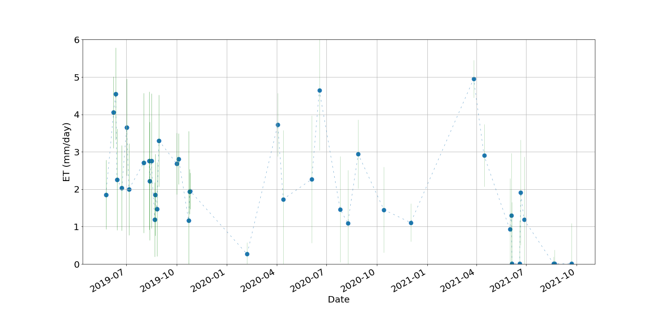
Figure 2. Time series of median daily ET for May 25, 2019 – September 22, 2021 for the area inside of the Bootleg Fire heat perimeter. Dashed lines indicate the apparent trend between data points, due to gaps in the data. Green bars indicate the standard deviation.
The team created median ET summer seasonal composites for April 1st – July 5th 2019 and 2021 which showed a decrease in median ET between 2021 and 2019 (Figure 3). This shift to drier conditions was especially noticeable inside the southern part of the Bootleg Fire heat perimeter, where there was a decline in median ET of ~7 mm/day. The decrease in median ET for this area inside of the Bootleg Fire heat perimeter was 75% or greater (Figure 4). Summer seasonal composites for April 1st – July 5th, 2019 and 2020 showed minimal decreases in median ET between the two years, although some locations decreased up to 4 mm/day in the southern part of the Bootleg Fire (Figure A4). However, analysis of the 2020 and 2021 summer seasonal composites showed a decrease in median ET of 75% or more, similar to the decrease between 2019 and 2021 (Figure A2). This indicates that for the two years preceding the Bootleg Fire, drier conditions persisted and that there was a much stronger loss of vegetation moisture between 2020 and 2021 (Figure A1; Figure A2). Exploratory testing of the 2021 median ET composite for spatial autocorrelation shows statistically significant clusters of low ET and high ET in the Bootleg Fire area as well as high-low and low-high ET outliers (Figure A5). This indicates that spatial similarity in ET values as well as the presence of outliers is not by chance.

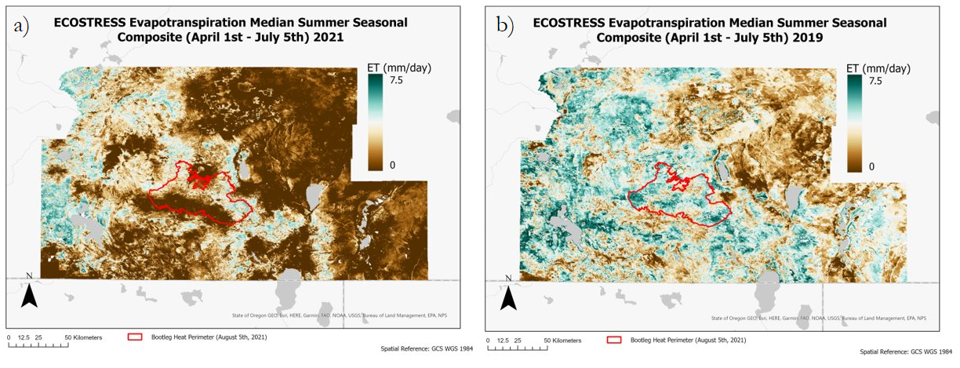Figure 3. Median ET summer seasonal composites for April 1st – July 5th in a median ET composite 2021 (a), and the median ET composite for 2019 (b). High ET is shown in dark green and low ET is shown in brown coloring. The Bootleg Fire heat perimeter boundary is shown in red.

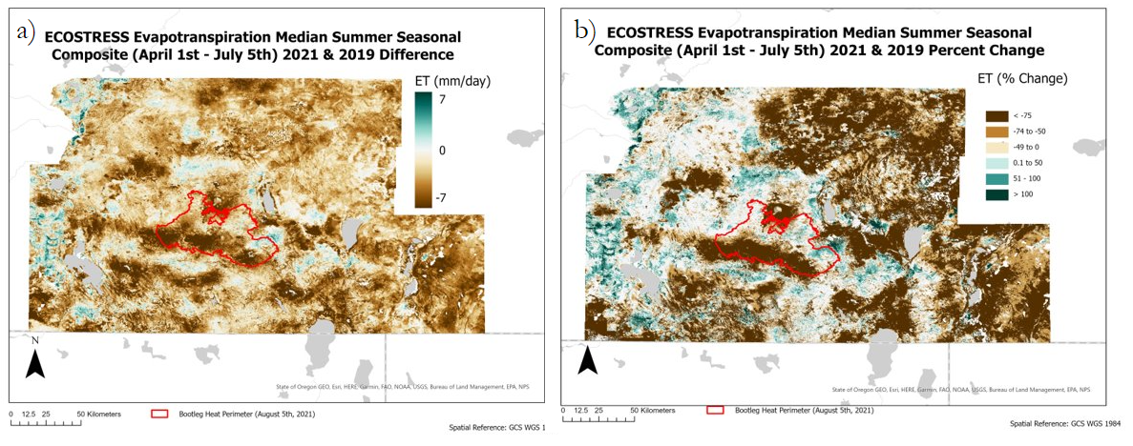
Figure 4. Comparison of the median ET summer seasonal composites for April 1st – July 5th 2021 and 2019. The difference in the median ET composite 2021 and 2019 (a), and the percent change between median ET composite 2021 and 2019 (b). Increase in ET is shown in dark green and decrease in ET is shown in brown. The Bootleg Fire heat perimeter boundary in red.

The team analyzed ET in each of the SBS classes for the two years prior to the start of the Bootleg Fire. The median ET decreased each year for all of the SBS categories, with the largest decrease between 2019 and 2021. High SBS areas showed the largest decrease in median ET with 3.6 mm/day (Table A1). This indicates that areas with the highest severity soil burns had become drier and more water stressed. The US Drought Monitor reports that the majority of Klamath and Lake counties were under extreme or exceptional drought conditions in the summer of 2021 (National Drought Mitigation Center et al., 2022). However, the effect of drought on ET is complex, with research suggesting that declines in ET from drought can strongly vary depending on vegetation type and species (Zha et al., 2010).

4.1.2 Vegetation and Topography
The team used vegetation data and topography variables (elevation, slope, and aspect) to investigate the relationship between SBS and pre-fire ET/WUE within the study area and the Bootleg Fire heat perimeter.
Because of the link between the amount of vegetation and wildfire burn intensity, the team examined the amount of biomass in each SBS class for the Bootleg Fire heat perimeter using the GEDI AGBD estimation (Table 4). The average AGBD for each SBS class followed the expected pattern: high SBS areas had the largest average AGBD and low SBS/unburned areas had the smallest average AGBD. Since the standard deviations show overlap between many of the classes, the median AGBD corroborated that for high SBS areas, AGBD was generally higher than in other SBS classifications. Additionally, the area for each SBS classification shows that the majority of the Bootleg Fire area fell within low and moderate SBS areas.

Table 4.
Aboveground Biomass Density Mean for each soil burn severity class.
Soil Burn Severity | Area (km²) | Aboveground Biomass Density Mean (Mg/ha) | AGBD Std Dev (Mg/ha) | AGBD Median (Mg/ha)
High | 177 | 86.3 | 35.4 | 79.2
Moderate | 1414 | 61.6 | 27.2 | 55.8
Low | 1048 | 54.2 | 26.8 | 49.2
Unburned | 495 | 43.4 | 25.9 | 42.2

Vegetation is the fuel for wildfires, and different fuels have different potential impacts on wildfires and SBS due to varying moisture content, location, and dispersal on land. The team identified the main land cover classes for the Bootleg Fire area as evergreen forest (70%), followed by shrub/scrub (24%). Topography is also an important wildfire parameter, as it influences temperature, vegetation moisture, and wildfire spread. Evergreen vegetation exists in high proportions across different slope gradients and directions in the Bootleg fire perimeter and was the majority land cover in high (94%), moderate (84%), and low (61%) SBS classes (Table B1). Evergreen vegetation is also present for the entire range of elevations inside the fire perimeter (1316 m – 2523 m), reducing only slightly in area at elevation extremes.

The team examined pre-fire ET to understand how vegetation in the Bootleg Fire area responded to water stress and used the April 1 – July 5, 2021 median ET composite for analysis (Figure 4). Evergreens were the dominant land cover for low, moderate, and high ET areas within the Bootleg Fire perimeter, and comprised 62% of low ET areas (Table B2). This ET variability in the evergreen landcover class may indicate the influence of topographic parameters such as slope, aspect, and elevation on the spread of the fire. In high SBS areas, 65% of vegetation corresponded to low ET, indicating dry conditions for the ample fuels found in woodlands (Table B3). However, there are differences in the mix of vegetation types within the evergreen landcover class. For example, high SBS areas have a larger percentage of Sierran-Intermontane Desert/Western White Pine - White Fir Woodland that occupied both high SBS (42%) and high ET (47%) regions in the Bootleg Fire area (Table B1; Table B2). This woodland system has a more open and dry undergrowth than forest ecosystems, perhaps explaining why they appear in high SBS areas. More research is needed to understand why White Pine – White Fir Woodland was higher in ET than other evergreen types and the subsequent effects on wildfire intensity. The largest class of evergreens in moderate and low SBS areas was the Northern Rocky Mountain Ponderosa Pine Woodland and Savanna, which made up 36% of moderate ET and 27% of low ET (Table B2). For shrub-scrub landcover, the Colombia Plateau Low Sagebrush Steppe was the majority type in unburned SBS areas (21%), and did not comprise a substantial portion of low, moderate, or high ET areas (Table B1; B2).
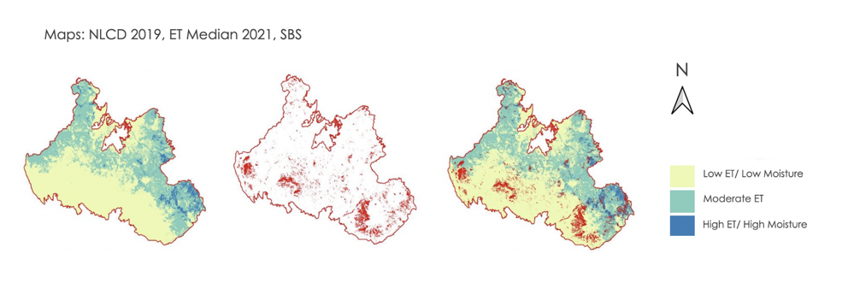
Figure 4. Bootleg Fire heat perimeter and areas of low ET and high SBS. Analysis of the Bootleg Fire heat perimeter revealed that within high SBS areas, 65% of all vegetation had low ET, indicating low moisture before the start of the fire.

Vegetation moisture is just one wildfire indicator, and the dynamics of wildfire spread and SBS are complex. The team explored how vegetation may have potentially influenced wildfire intensity (Figures B4; Figure B5). Within the Bootleg fire perimeter, the largest class of evergreens consisted of Northern Rocky Mountain Ponderosa Pine Woodland and Savanna (29%), but this type had the least propensity to contribute to overall wildfire intensity (-14%) (Table B4; Figure B4). Ponderosa Pine woodlands are generally found at lower tree lines between grasslands or shrublands in warm, dry, and exposed sites which may not occupy significant portions of high SBS areas. In high SBS areas, the Sierran-Intermontane Desert Western White Pine - White Fir Woodland was the dominant vegetation type (42%), and had the highest wildfire intensity score (27%) (Table B4; Figure B4). However, considering that White Pine – White Fir woodlands were primarily found in areas with high ET, this may indicate substantial differences in drought tolerance for vegetation in these areas. Spatial autocorrelation found statistically significant high-low and low-high ET outliers in the Bootleg fire area. For shrub-scrub landcover, Columbia Plateau Low Sagebrush Steppe vegetation type occupied very little of the high SBS areas (4%), and did not appear to contribute to wildfire intensity (Table B4; Figure B4). Research indicates that trees have a greater fire intensity potential than shrubs and grasslands (Jensen et al., 2018; Pascolini-Campbell et al., 2022). For comparison, this process was repeated for evergreen, shrub-scrub, grassland, and wetland landcover classes within the Bootleg fire perimeter (Table B4; Figure B5).
The team identified high SBS areas within the Bootleg fire perimeter and analyzed the effects of topography, vegetation, biomass, and ET on SBS. A visual assessment of the BAER SBS map revealed that high SBS areas were small in extent and mostly present in the north and south-west area of the Bootleg perimeter. These areas were coincident with low ET (Figure B1). Zonal statistics and area calculations identified northwest slopes as the majority aspect class within high SBS areas, while southwest-facing slopes were the majority aspect class in unburned, low, and moderately burned areas (Table 6; Figure B2). The team’s results were unexpected as southern slopes receive more solar radiation and tend to be warmer and drier. However, northern aspects tend to have denser vegetation and therefore more fuel for fire under extreme drought conditions (Miller et al. 2009).
The team also examined the percentage of high, moderate, and low SBS areas within all aspect classes, which showed small areas of high SBS across the landscape (Table B5). Most of the Bootleg fire area experienced moderate SBS, as discussed in the section on AGBD (Figure A4). In moderate SBS areas, average biomass density was 61.6 ± 27.2 Mg/ha, the second largest AGBD after high SBS areas at 86.3 ± 35.4 Mg/ha. This points to northwest slopes tending towards higher AGBD and therefore more potential wildfire fuel. Evergreen landcover was the majority vegetation in high SBS areas (Table B1) and also corresponded with areas of low ET (Table B2). As mentioned earlier, trees have a greater fire intensity potential than shrubs and grasslands, and there may also have been an accumulation of dry vegetation from overgrown, water-stressed vegetation on these northwest slopes.

Table 6.
Percentage of SBS type within the Bootleg fire perimeter. Lists the majority aspect and slope type and mean elevation within each soil burn severity class.
Soil Burn Severity | Area Coverage (%) | Majority Aspect Class | Majority Slope Class | Mean  elevation
Unburned | 13% | Southwest | Flat | 1645 m
Low | 34% | Southwest | Undulating | 1708 m
Moderate | 47% | Southwest | Undulating | 1718 m
High | 6% | Northwest | Hilly | 1800 m

The team also analyzed slope and elevation information within each SBS classification to better understand the spatial patterns of SBS in the Bootleg fire. Fire severity tends to be generally highest on steep slopes, which can increase the spread of fire by pre-heating upslope fuel (Lindenmayer, 2021). The majority slope class within high SBS areas was “Hilly” (15 % to 30% gradient) at 37%. Area calculations revealed high proportions of high soil burn areas within Hilly, Moderate (30 – 45% gradient) and Steep (45% – 65 %) slope classes. Evergreen trees made up a higher proportion of these slope classes than shrubs. Similar to aspect, all slope classes predominantly experienced moderate burn.
High SBS areas also had a higher median elevation as well as a narrower elevation range, between 1318 m – 2359 m (Table B6). The team examined ET and vegetation area across elevation gradients and SBS classes, finding vegetation type and spacing to be plausible explanations for this restricted elevation range. For the Bootleg fire area, the proportion of shrubs to trees increases at elevation extremes. Low-lying areas have higher shrub coverage and very high elevations have an almost equal proportion of shrubs to trees, signifying an elevation-controlled shift in vegetation patterns. This shift is important as Miller et al. (2009) found moderate and low SBS to be linked to reduced plant size and discontinuity of vegetation at elevation extremes. A visual assessment of land cover within SBS classes indicated a strong relationship between shrubs and unburned areas on flat, low elevation areas. Despite shrubs having a lower ET than evergreens at elevations less than 1491 m, shrubs remained unburned. This indicates some relationship between vegetation structure, elevation, and SBS. At higher elevations, the connection between SBS and elevation is more complex, incorporating other parameters like vegetation moisture.
Higher elevations often have cooler temperatures and increased precipitation, which influences vegetation moisture and biomass (Dehum 2015). However, above a certain elevation, the air becomes too dry and cold to support dense tree growth, creating a tree line. The team performed area calculations for the Bootleg fire area which revealed an increase in evergreen forest coverage with an increase in elevation as well as a decline in evergreen coverage at the highest elevations (Figure B3). ET followed this same curved trend with respect to elevation. The mean ET for evergreen trees and shrubs increased with elevation and dropped-off sharply above 2276 m (Figure B3). Lower ET, along with a decline in evergreens and an increase in shrubs at elevation extremes, may point to elevation-driven controls influencing vegetation structure and SBS within the Bootleg fire perimeter. However, the connection between SBS, elevation, and vegetation structure should be made with caution as there are multiple variables that influence how a fire behaves over a landscape and no regression or correlation analysis was conducted for this project.
4.1.3 Water Use Efficiency
The team created median WUE composites for June 2019, 2020, 2021 and used the same symbology of 0.1 GPP/ET in brown to 4.9 GPP/ET in dark green for each image (Figure 5c). Visual analysis of the 2021 median WUE composite followed the same split between vegetation types described in other sections (Figure 5a) which the team corroborated using zonal statistics of NLCD, EVT, and WUE (Figure 5a). Low, moderate and high values for WUE represent the lower, middle, and upper third intervals of the median WUE composite. High SBS areas consisted mainly of evergreen landcover, which occupied the majority of low (77%) and moderate (53%) WUE areas (Table B2). High SBS areas also had lower ET than other SBS classes, indicating water-stressed vegetation. Evergreen landcover is a fuel source with the potential for greater wildfire intensity, although fire and drought resistance vary by evergreen type. For example, the Northern Rocky Mountain Ponderosa Pine Woodland and Savanna was the largest evergreen type represented in low (29%) and moderate (30%) regions of WUE, however previous analysis indicates it had the least propensity to contribute to overall wildfire intensity (Table B2). Unburned and very low SBS areas had a greater percentage of shrub-scrub vegetation, and although shrub-scrub had lower ET than evergreens, showed higher WUE (87%). This indicates that shrub-scrub vegetation may have a greater resiliency to drought conditions. Colombia Plateau Low Sagebrush Steppe was the majority type in both unburned SBS (21%) and high WUE (54%) regions (Table B1; Table B2). Within the moderate and low SBS classifications, WUE was generally low and ET was variable. This could potentially be due to an overgrowth of different vegetation types in 2019 and 2020 (indicated by higher ET in these years), leading to an abundant mix of fuel types which together created less wildfire intensity.
WUE can show the vulnerability of plants to climate stressors by looking at plant productivity and water use. Median WUE between 2019 and 2021 increased or stayed the same for all SBS classes except high SBS (Table A2). Plants less efficient at assimilating carbon under water stress are expected to be more susceptible to short-term drought and temperature shocks and this may increase their susceptibility to wildfire (Pascolini-Campbell et al., 2022). Zonal statistics of pre-fire WUE and high SBS show that 80% of all vegetation had low WUE in high SBS areas within the Bootleg fire perimeter (Table B3), further suggesting a possible relationship between low WUE/low ET vegetation and high SBS areas. Low WUE may indicate the effects of drought in the area; however, WUE depends on vegetation type and an individual plant’s physiological response to increasing carbon dioxide concentrations, surface temperature, precipitation, and humidity, which may explain the varying WUE in the fire area (Hatfield & Dold, 2019). This exploratory analysis suggests more research into vegetation in low ET and low WUE regions may be useful future investigations of wildfire dynamics.
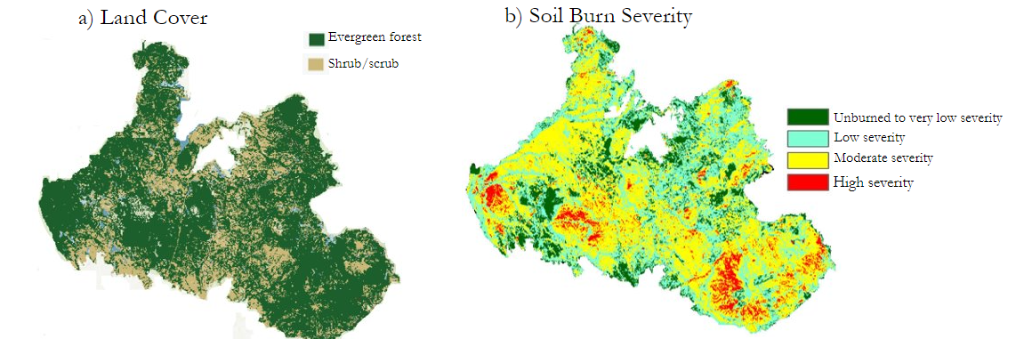
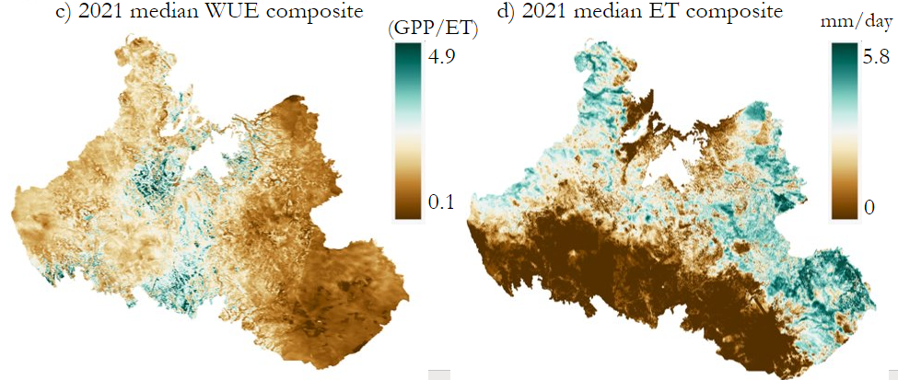
Figure 5. Comparison of median ET and WUE composites of 2021 with a land cover (a) and a soil burn severity map of the Bootleg fire heat perimeter (b). The Median WUE June seasonal composites for 2021 have high WUE in dark green and low WUE in brown coloring (c) and the 2021 median ET composite of the Bootleg fire heat perimeter have high ET shown in dark green and low ET shown in brown coloring.

4.2 Errors and Uncertainties
The largest source of errors and uncertainties is in the ECOSTRESS ET and WUE observations. The product is derived by measuring the thermal infrared brightness of plants and is affected by cloud cover, smoke, the diurnal cycle, and instrument error. Although ECOSTRESS passes over an area every 1-5 days, there were far fewer images that could be analyzed, leaving gaps in the data. Calculations used to create the ET product make certain assumptions which also introduce uncertainty and error. ECOSTRESS observations are also only available since 2018, which is not long enough to determine if pre-Bootleg fire ET was anomalous on longer timescales. Error may also have been introduced by reprojecting NLCD and EVT datasets from their native coordinate system (Albers equal area conic) to WGS 1984 Mercator to match ECOSTRESS and SRTM analyses. Additionally, our analysis was limited to vegetation datasets from 2019 and 2020 which may not be indicative of land cover composition in 2021, the year of the Bootleg fire.

4.3 Future Work
Future work evaluating ECOSTRESS ET products and other vegetation moisture indicators such as WUE for wildfire behavior modeling should expand from this case study of the Bootleg fire to more fires. The team found the dynamics between pre-fire ET and vegetation/topography provided a first-order explanation of soil burn severity in areas affected by the Bootleg Fire. Scaling the team’s work to more fires would test whether these results for the Bootleg Fire are generalizable and if ECOSTRESS ET in connection with the topographic, biomass, and landcover characteristics identified by the team can explain other fires in similar ecosystems. This larger baseline could then be used as a means to screen the susceptibility of an area to wildfire. Additionally, testing the significance of the parameters identified as the most important from the case study would corroborate the team’s analysis.

5. Conclusions
This exploratory project utilized Earth observations, remote sensing techniques, and ancillary data to demonstrate how vegetation moisture products like ECOSTRESS ET can explain soil burn severity. The team analyzed how vegetation moisture changed before the Bootleg fire and the potential impact of topographic variables (elevation, slope, and aspect) and vegetation (land cover, vegetation type, biomass) on ET and wildfire behavior. The pre-fire variables indicated as important in explaining burn severity and wildfire spread are vegetation moisture, landcover type, elevation, and slope. Median ET decreased between 2019 and 2021, with much of the vegetation in the Bootleg fire area experiencing water stress and dry conditions. ET gave a broad picture of vegetation moisture conditions in the study area, but the team’s preliminary work on WUE indicates it might provide a more subtle explanation for SBS. High SBS areas showed both lower ET and WUE values when compared to other SBS classes, indicating water-stressed plants which were not compensating for dry conditions with increased WUE. Many areas within the Bootleg perimeter classed as low SBS or unburned had low ET, but higher WUE values, indicating this vegetation had more resiliency to drought conditions. The vast majority of high SBS areas consisted of evergreen forests, with lower SBS areas containing a higher percentage of shrub-scrub vegetation. 65% of all the vegetation in high SBS areas had low ET values. The team also found that elevation had a strong impact on SBS, with SBS increasing with elevation, most likely due to the increase in evergreen forest and decrease in shrub-scrub vegetation with elevation. Slope also showed a difference between soil burn severity classes. High SBS areas occurred on steeper gradients, which primarily consist of evergreens. Lower, almost flat gradients were typical of low and moderate SBS areas in the Bootleg fire area or remained unburned. Considering that high SBS zones also had the most AGBD, these areas likely consisted of higher density, water-stressed evergreen forest, and heat from the wildfire exacerbated dry conditions upslope as it spread to steeper terrain. Southwestern slopes dominate each SBS classification, which is expected as these areas tend to be warmer and drier. However, for the Bootleg fire, there was a high percentage of northwestern-facing slopes in high SBS areas. This may indicate that higher density forests under water stress were found on these slopes, impacting fire intensity.

A 2022 study of six California wildfires also used ECOSTRESS vegetation moisture products as a predictor of burn severity and provides some corroboration of the team’s analysis (Pascolini-Campbell et al., 2022). This larger study used spatial autocorrelation and random forest regression modelling, finding that vegetation moisture indicators such as ET and WUE varied with different vegetation and topographic parameters, and influenced SBS patterns. The team’s case study of the Bootleg fire adds to the growing research on using ECOSTRESS vegetation moisture products to explain wildfire behavior. Wildfires can destroy livelihoods and wildlife habitats and are a community concern. The team’s vegetation moisture, topography, and vegetation structure maps can be used as a baseline for further study by our partners at the US Forest Service and the Pacific Northwest National Laboratory on integrating ECOSTRESS products to find areas susceptible to wildfires and assist local authorities with planning and resource allocation efforts.

Acknowledgments
The team would like to thank everyone involved in the Washington Wildfires project for their support and guidance—especially our science advisors, Madeleine Pascolini-Campbell, Kerry Cawse-Nicholson, and Ben Holt at NASA Jet Propulsion Laboratory, California Institute of Technology, and Erica Carcelén, our NASA DEVELOP JPL Fellow. Special thanks also go to our project partners, Andre Coleman (Senior Research) and Lee Miller (Earth Scientist) from the Pacific Northwest National Laboratory, who provided us with resources and expertise throughout the Summer 2022 term.
Any opinions, findings, and conclusions or recommendations expressed in this material are those of the author(s) and do not necessarily reflect the views of the National Aeronautics and Space Administration. This material is based upon work supported by NASA through contract NNL16AA05C.

7. Glossary

Burn Area Emergency Response (BAER) – a US Forest Service program designed to identify, assess, and manage potential risk to resources on Federal Lands as a result of fire. Post-fire, BAER is responsible for assessing watershed conditions and producing Burn Area Reflectance Classification (BARC) products, including the Soil Burn Severity Map

Digital Elevation Model (DEM) – a digital representation of bare-ground terrain

Earth observations – Satellites and sensors that collect information about the Earth’s physical, chemical, and biological systems over space and time

Ecosystem Spaceborne Thermal Radiometer Experiment on Space Station (ECOSTRESS) –

Evapotranspiration (ET) – the process by which water is transferred from the land to the atmosphere by evaporation from the soil and other surfaces and by transpiration from plants

Existing Vegetation Type (EVT) – represents the current distribution of the terrestrial ecological systems classification, developed by NatureServe for the western hemisphere, through 2016. Describes associations that tend to co-occur within landscapes with similar ecological processes, substrates, and/or environmental gradients

Global Ecosystem Dynamics Investigation (GEDI) – a full-waveform lidar instrument on the International Space Station (ISS) to provide detailed measurements of ecosystem structure. GEDI can measure canopy height, canopy vertical structure, surface elevation, and vegetation biomass

Moderate Resolution Imaging Spectroradiometer (MODIS) – an instrument that operates aboard Terra and Aqua satellites to acquire data in 36 bands at 250 m, 500 m, and 1,000 m resolution

National Land Cover Database (NLCD) – provides nationwide data on land cover and land cover change at the Landsat Thematic Mapper (TM) 30-meter resolution

Soil burn severity (SBS) – the damage done to vegetation and soil from wildfire

Shuttle Radar Topography Mission (SRTM) – a synthetic aperture radar that obtained high resolution elevation data during an 11-day mission aboard the Space Shuttle Endeavour in February of 2000

Water use efficiency (WUE) – a ratio of carbon stored by plants to water evaporated by plants and the ratio is given as grams of carbon stored per kilogram of water evaporated over the course of the day

8. References

Abatzoglou, J. T., & Williams, A. P. (2016). Impact of anthropogenic climate change on wildfire across western US forests. Proceedings of the National Academy of Sciences, 113(42), 11770–11775. https://doi.org/10.1073/pnas.1607171113

Berry, D. A., & Ayers, G. D. (2006). Symmetrized percent change for treatment comparisons. The American Statistician, 60(1), 27-31. https://doi.org/10.1080/03610910802506648

Coen, J. L., Stavros, E. N., & Fites‐Kaufman, J. A. (2018). Deconstructing the King megafire. Ecological applications, 28(6), 1565–1580. https://doi.org/10.1002/eap.1752

Dehum, S.M. (2015). Spatial analysis and modelling of fire severity and vegetation recovery on and around Mt Cooke, south-western Australia. Environmental Science.

Dubayah, R.O., Armston, J., Healey, S.P., Yang, Z., Patterson, P.L., Saarela, S., Stahl, G., Duncanson, L., and Kellner, J.R. 2022. GEDI L4B Gridded Aboveground Biomass Density, Version 2. ORNL DAAC, Oak Ridge, Tennessee, USA. https://doi.org/10.3334/ORNLDAAC/2017

Fang, L., Yang, J., White, M., & Liu, Z. (2018). Predicting potential fire severity using vegetation, topography and surface moisture availability in a Eurasian boreal forest landscape. Forests, 9(3), 130 –156. https://doi.org/10.3390/f9030130
Fisher, J. B. (2018). Level-4 Evaporative Stress Index L4(ESI_PT-JPL) Algorithm Theoretical Basis Document (ECOSTRESS Science Document no. D-94647). Jet Propulsion Laboratory / National Aeronautics and Space Administration. https://ecostress.jpl.nasa.gov/downloads/atbd/ECOSTRESS_L4_ESI_PT-JPL_ATBD_20180531.pdf
Fisher, J. B., & Halverson, G.H. (2019). Level-4 Water Use Efficiency L4(WUE) Algorithm Theoretical Basis Document (ECOSTRESS Science Document no. D-94649). Jet Propulsion Laboratory / National Aeronautics and Space Administration. https://ecostress.jpl.nasa.gov/downloads/atbd/ECOSTRESS_L4_WUE_ATBD_20190430.pdf
Fisher, J. B., Lee, B., Purdy, A. J., Halverson, G. H., Dohlen, M. B., Cawse‐Nicholson, K., ... & Hook, S. (2020). ECOSTRESS: NASA's next generation mission to measure evapotranspiration from the international space station. Water Resources Research, 56(4), e2019WR026058. https://doi.org/10.1029/2019WR026058
Hatfield, J. L., & Dold, C. (2019). Water-use efficiency: advances and challenges in a changing climate. Frontiers in plant science, 10, 103. https://doi.org/10.3389/fpls.2019.00103
Hook, S., Cawse-Nicholson, K. (2021). ECOSTRESS Evapotranspiration dis-ALEXI Daily L3 CONUS 70 m V001 [Data set]. NASA EOSDIS Land Processes DAAC. Accessed 2022-06-30 from https://doi.org/10.5067/ECOSTRESS/ECO3ETALEXI.001

Hook, S., Fisher, J. (2019). ECOSTRESS Water Use Efficiency Daily L4 Global 70 m V001 [Data set]. NASA EOSDIS Land Processes DAAC. Accessed 2022-08-04 from https://doi.org/10.5067/ECOSTRESS/ECO4WUE.001

Huang, Y., Jin, Y., Schwartz, M. W., & Thorne, J. H. (2020). Intensified burn severity in California’s northern coastal mountains by drier climatic condition. Environmental Research Letters, 15(10), 104033. https://dx.doi.org/10.1088/1748-9326/aba6af
Inciweb.(n.d.). Bootleg Fire. https://inciweb.nwcg.gov/incident/7609/
Jensen, D., Reager, J. T., Zajic, B., Rousseau, N., Rodell, M., & Hinkley, E. (2018). The sensitivity of US wildfire occurrence to pre-season soil moisture conditions across ecosystems. Environmental research letters, 13(1), 014021. https://doi.org/10.1088/1748-9326/aa9853
LANDFIRE, 2020, Existing Vegetation Type Layer, LANDFIRE 2.2.0, U.S. Department of the Interior, Geological Survey, and U.S. Department of Agriculture. Accessed 22 July 2022 at http://www.landfire/viewer

Lindenmayer, D., Taylor, C., & Blanchard, W. (2021). Empirical analyses of the factors influencing fire severity in southeastern Australia. Ecosphere, 12(8). https://doi.org/10.1002/ecs2.3721
McEvoy, D. J., Pierce, D. W., Kalansky, J. F., Cayan, D. R., & Abatzoglou, J. T. (2020). Projected changes in reference evapotranspiration in California and Nevada: Implications for drought and wildland fire danger. Earth's Future, 8(11), e2020EF001736. https://doi.org/10.1029/2020EF001736
Miller, J. D., Knapp, E. E., Key, C. H., Skinner, C. N., Isbell, C. J., Creasy, R. M., & Sherlock, J. W. (2009). Calibration and validation of the relative differenced normalized burn ratio (rdnbr) to three measures of fire severity in the Sierra Nevada and Klamath Mountains, California, USA. Remote Sensing of Environment, 113(3), 645–656. https://doi.org/10.1016/j.rse.2008.11.009
MRLC (2019). NLCD 2019 Land Cover (CONUS). https://www.mrlc.gov/data/nlcd-2019-land-cover-conus
NASA JPL (2013). NASA Shuttle Radar Topography Mission Global 1 arc second NetCDF. NASA EOSDIS Land Processes DAAC. Accessed 2022-06-23 from https://doi.org/10.5067/MEaSUREs/SRTM/SRTMGL1_NC.003

National Drought Mitigation Center, National Oceanic and Atmospheric Administration (NOAA), United Stated Department of Agriculture (USDA). (2022). US Drought Monitor (2000 – Present). [Data file]. Retrieved from https://droughtmonitor.unl.edu/DmData/GISData.aspx

Pamela, Yukni, A., Imam, S. A., & Kartiko, R. D. (2018, July). The selective causative factors on landslide susceptibility assessment: Case study Takengon, Aceh, Indonesia. In AIP Conference Proceedings (Vol. 1987, No. 1, p. 020089). AIP Publishing LLC. https://doi.org/10.1063/1.5047374

Pascolini‐Campbell, M., Lee, C., Stavros, N., & Fisher, J. B. (2022). ECOSTRESS reveals pre‐fire vegetation controls on burn severity for Southern California wildfires of 2020. Global Ecology and Biogeography. https://doi.org/10.1111/geb.13526

Williams, A. P., Abatzoglou, J. T., Gershunov, A., Guzman‐Morales, J., Bishop, D. A., Balch, J. K., & Lettenmaier, D. P. (2019). Observed impacts of anthropogenic climate change on wildfire in California. Earth's Future, 7(8), 892-910. https://doi.org/10.1029/2019EF001210

Williams, A. P., Cook, B. I., & Smerdon, J. E. (2022). Rapid intensification of the emerging southwestern North American megadrought in 2020–2021. Nature Climate Change, 12(3), 232-234. https://doi.org/10.1038/s41558-022-01290-z

USDA Forest Service, Geospatial Technology and Applications Center, BAER Imagery Support Program (2021). Soil Burn Severity Dataset for the BOOTLEG Fire occurring on the Fremont-Winema National Forest National Forest. Burn Severity Portal. Accessed 2022- 06-16. https://burnseverity.cr.usgs.gov/baer/baer-imagery-support-data-download

Zha, T., Barr, A. G., van der Kamp, G., Black, T. A., McCaughey, J. H., & Flanagan, L. B. (2010). Interannual variation of evapotranspiration from forest and grassland ecosystems in western Canada in relation to drought. Agricultural and Forest Meteorology, 150(11), 1476-1484. https://doi.org/10.1016/j.agrformet.2010.08.003

9. Appendices
Appendix A: Vegetation Moisture
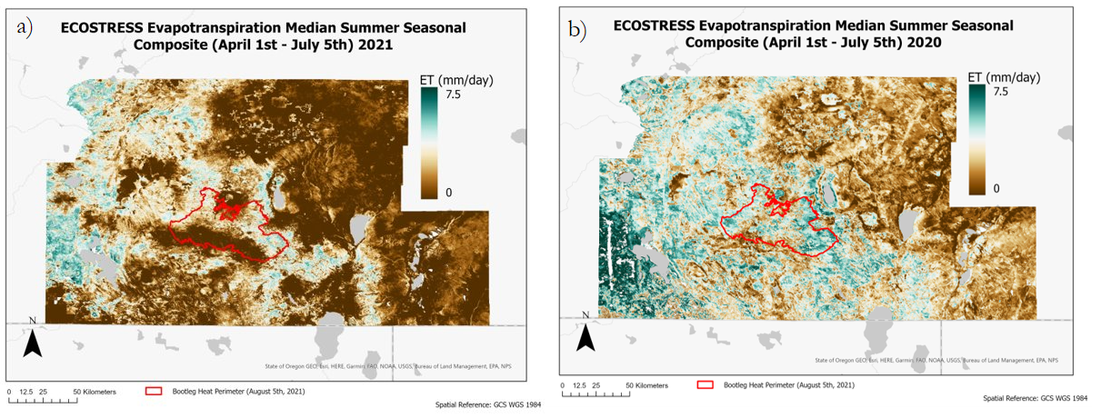Figure A1. Median ET summer seasonal composites for April 1st – July 5th in a median ET composite 2021 (a), and the median ET composite for 2020 (b). High ET is shown in dark green and low ET is shown in brown coloring. The Bootleg Fire heat perimeter boundary is shown in red.

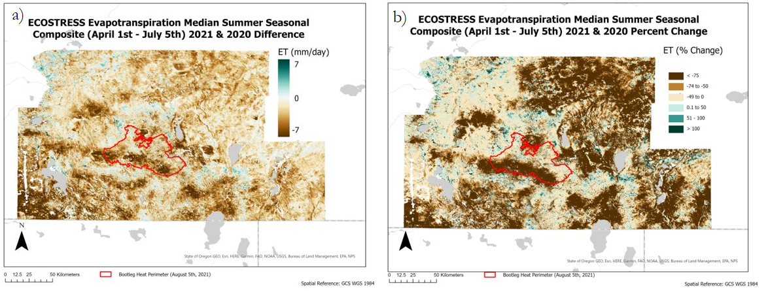
Figure A2. Comparison of the median ET summer seasonal composites for April 1st – July 5th 2021 and 2020. The difference in the median ET composite 2021 and 2020 (a), and the percent change between median ET composite 2021 and 2020 (b). Increase in ET is shown in dark green and decrease in ET is shown in brown. The Bootleg Fire heat perimeter boundary is shown in red.

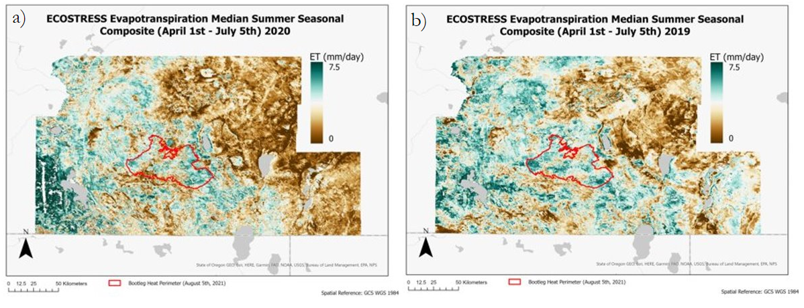Figure A3. Median ET summer seasonal composites for April 1st – July 5th in a median ET composite 2020 (a), and the median ET composite for 2019 (b). High ET is shown in dark green and low ET is shown in brown coloring. The Bootleg Fire heat perimeter boundary is shown in red.

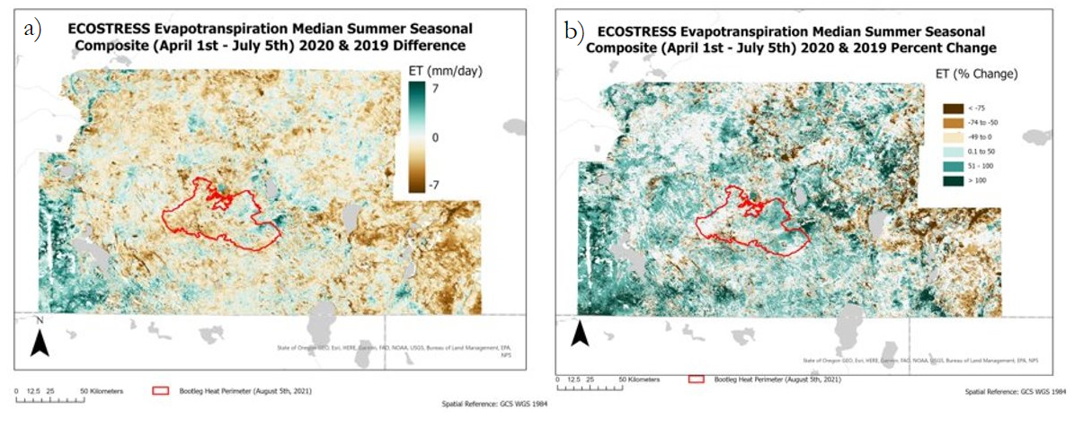
Figure A4. Comparison of the median ET summer seasonal composites for April 1st – July 5th 2020 and 2019. The difference in the median ET composite 2020 and 2019 (a), and the percent change between median ET composite 2020 and 2019 (b). Increase in ET is shown in dark green and decrease in ET is shown in brown. The Bootleg Fire heat perimeter boundary is shown in red.

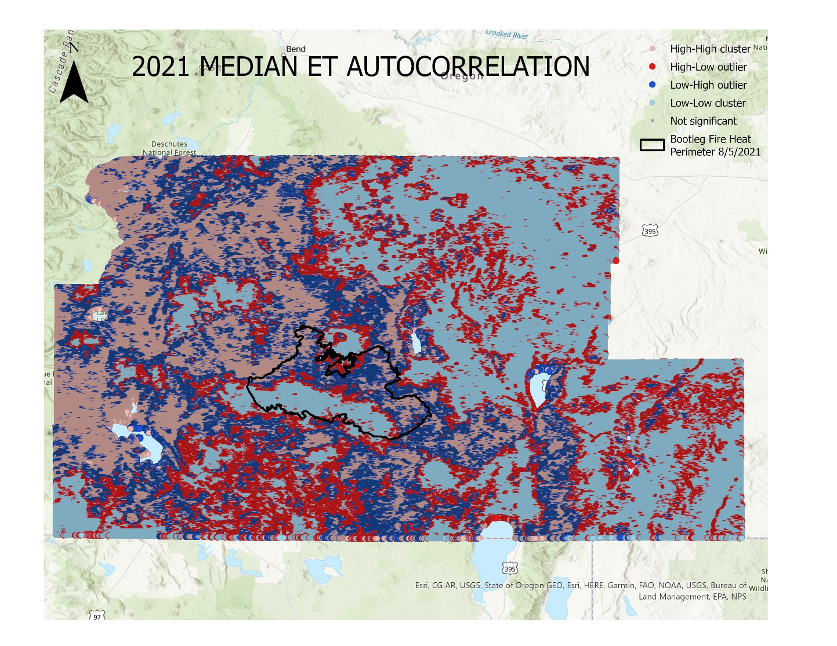Figure A5. Results of spatial autocorrelation testing of the 2021 median ET summer seasonal composite.

Table A1.
Median ET for each soil burn severity class.
Soil Burn Severity | 2019 ET median (mm/day) | 2020 ET median (mm/day) | 2021 ET median (mm/day)
Unburned to very low severity | 2.8 | 2.2 | 0.9
Low severity | 3.5 | 3.0 | 1.4
Moderate severity | 3.9 | 3.6 | 1.7
High severity | 4.5 | 4.3 | 0.9

Table A2.
Median WUE for each soil burn severity class.
Soil Burn Severity | 2019 WUE median (GPP/ET) | 2020 WUE median (GPP/ET) | 2021 WUE median (GPP/ET)
Unburned to very low severity | 1.2 | 0.9 | 1.5
Low severity | 1.2 | 0.9 | 1.3
Moderate severity | 1.3 | 1.0 | 1.3
High severity | 1.3 | 1.0 | 1.1

Appendix B: Vegetation Structure and Topography

Table B1.
SBS and % area vegetation in the Bootleg Fire
Within the Bootleg Fire
 | % Area Evergreens |  |  | % Area Shrubs
SBS | Evergreens | Sierran-Intermontane Desert/Western White Pine - White Fir Woodland | Northern Rocky Mountain Ponderosa Pine Woodland and Savanna | Shrubs | Colombia Plateau Low Sagebrush Steppe
High | 94% | 42% | 15% | 3% | *
Moderate | 84% | 15% | 36% | 12% | 0.1%
Low | 61% | 12% | 28% | 30% | 4%
Unburned | 33% | 11% | 15% | 55% | 21%
* = negligible (3.68311E-05)

Table B2.
ET and WUE regions and % area vegetation in the Bootleg Fire
Within the Bootleg Fire
 | % Area of Majority Vegetation* in ET regions
ET | Land Cover Class | % Land Cover in ET region | EVT | % EVT in ET region
Low | Evergreen | 62% | Northern Rocky Mountain Ponderosa Pine Woodland and Savanna | 27%
Moderate | Evergreen | 80% | Northern Rocky Mountain Ponderosa Pine Woodland and Savanna | 36%
High | Evergreen | 92% | Sierran-Intermontane Desert Western White Pine - White Fir Woodland | 47%
 | % Area of Majority Vegetation in WUE regions
WUE | Land Cover Class | % Land Cover in WUE region | EVT | % EVT in WUE region
Low | Evergreen | 77% | Northern Rocky Mountain Ponderosa Pine Woodland and Savanna | 29%
Moderate | Evergreen | 53% | Northern Rocky Mountain Ponderosa Pine Woodland and Savanna | 30%
High | Shrubs | 87% | Colombia Plateau Low Sagebrush Steppe | 54%
* “Vegetation” = Land Cover Class and Existing Vegetation Type

Table B3.
% Area of all vegetation in all ET/WUE and High SBS areas in the Bootleg Fire
Within the Bootleg Fire
Total Vegetation | % Area of all vegetation in all ET/High SBS areas
Low ET | 65%
Moderate ET | 25%
High ET | 8%
Total Vegetation | % Area of all vegetation in all WUE/High SBS areas
Low WUE | 80%
Moderate WUE | 20%
High WUE | *
* = negligible amount (3.68E-5)

Table B4.
Propensity for wildfire intensity is calculated as the difference between percent vegetation in high SBS areas and percent vegetation in the heat perimeter. Positive values reflect a greater propensity for vegetation to contribute to wildfire intensity, while negative values are less likely to contribute to wildfire intensity.
Within the Bootleg Fire
EVT | Percent EVT Cover
Sierran-Intermontane Desert Western White Pine - White Fir Woodland | 15%
Northern Rocky Mountain Ponderosa Pine Woodland and Savanna | 29%
Colombia Plateau Low Sagebrush Steppe | 4%
EVT | Percent EVT in High SBS areas
Sierran-Intermontane Desert Western White Pine - White Fir Woodland | 42%
Northern Rocky Mountain Ponderosa Pine Woodland and Savanna | 25%
Colombia Plateau Low Sagebrush Steppe | 0%
EVT | Propensity for Intense Wildfire
Sierran-Intermontane Desert Western White Pine - White Fir Woodland | 27%
Northern Rocky Mountain Ponderosa Pine Woodland and Savanna | -14%
Colombia Plateau Low Sagebrush Steppe | -4%
Land Cover | Percent Land Cover
Evergreen | 70%
Shrub | 24%
Emergent Herbaceous Wetlands | 3%
Grassland/Herbaceous | 2%
Woody Wetlands | 1%
Land Cover | Percent Land Cover in High SBS
Evergreen | 94%
Shrub | 3%
Emergent Herbaceous Wetlands | 0%
Grassland/Herbaceous | 0%
Woody Wetlands | 2%
Land Cover | Propensity for Intense Wildfire
Evergreen | 24%
Shrub | -21%
Emergent Herbaceous Wetlands | -3%
Grassland/Herbaceous | -2%
Woody Wetlands | 1%

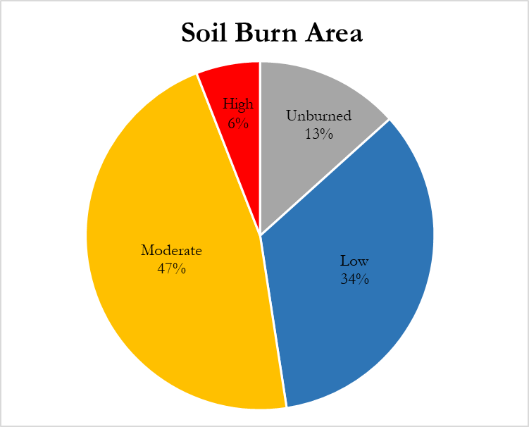

Figure B1. SBS coverage within the Bootleg fire heat perimeter.

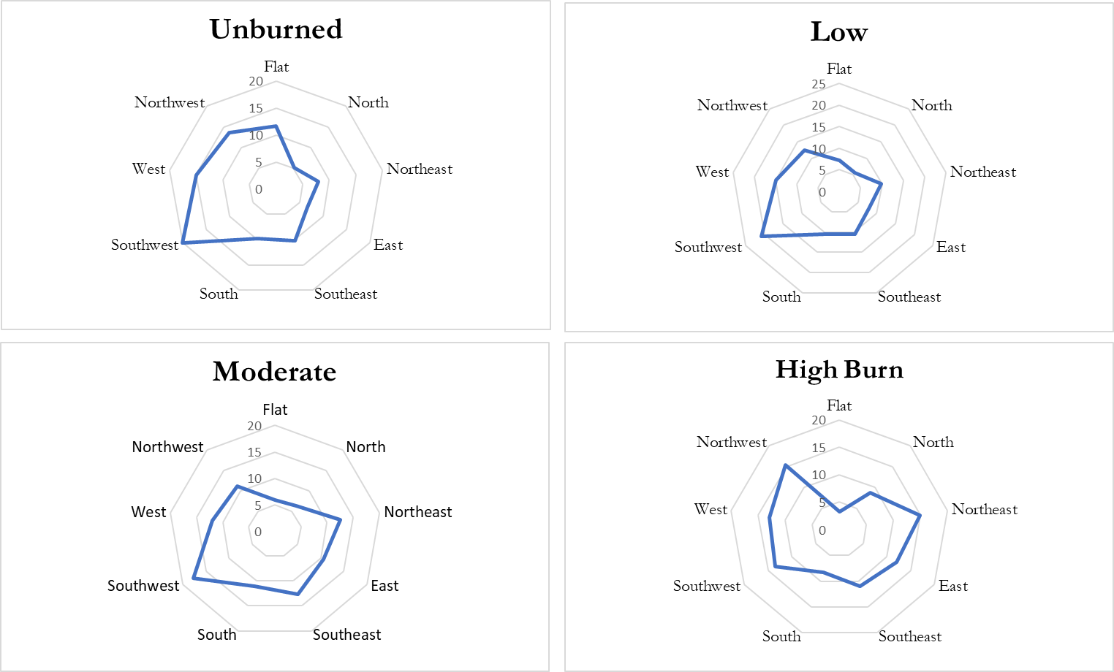

Figure B2. Majority aspect types within unburn, low, moderate, and high burn severity classes.

Table B5.
Percent of SBS type across aspect.
Aspect | Area of Unburn  (%) | Area Low Burn  (%) | Area of Moderate Burn  (%) | Area of High Burn  (%)
Flat | 22 | 36 | 39 | 3
North | 11 | 32 | 48 | 9
Northeast | 9 | 30 | 53 | 8
East | 9 | 29 | 54 | 8
Southeast | 12 | 31 | 51 | 6
South | 12 | 34 | 49 | 5
Southwest | 14 | 38 | 44 | 4
West | 14 | 38 | 42 | 6
Northwest | 15 | 35 | 43 | 7

Table B6.
The elevation range of the Bootleg fire.
Elevation
Soil Burn Severity | Minimum (m) | Mean (m) | Maximum (m)
Unburned | 1316 | 1645 | 2523
Low | 1316 | 1708 | 2523
Moderate | 1316 | 1718 | 2520
High | 1318 | 1800 | 2359

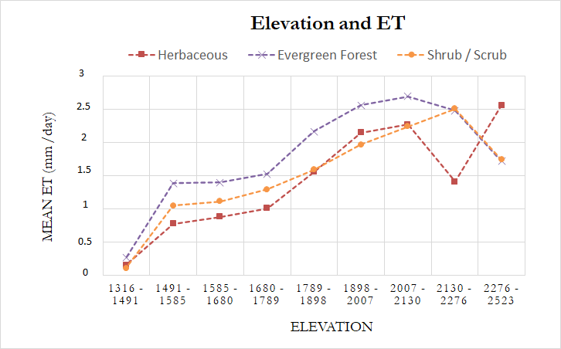

Figure B3. ET of vegetation types across elevation.

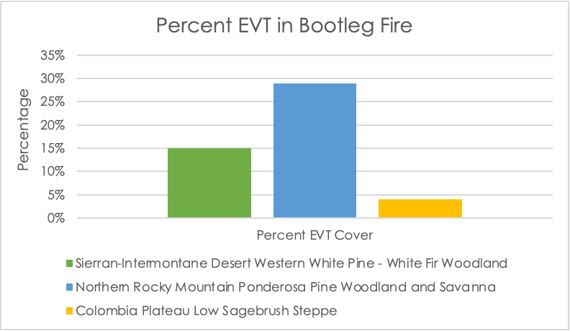
(a)
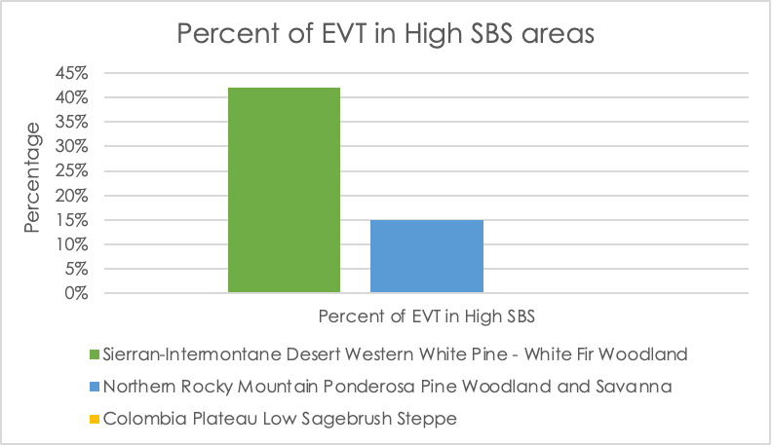
(b)
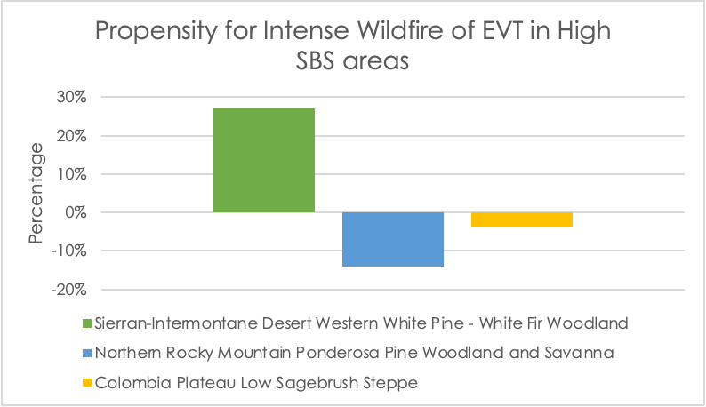
(c)

Figure B4. Comparison of wildfire intensity of three existing vegetation types (EVTs) in High SBS areas of the Bootleg Fire on August 5, 2021. The percent areas for two evergreen (Sierran-Intermontane Desert, Northern Rocky Mountain Ponderosa Pine), and one shrub-scrub (Colombia Plateau) type in the heat perimeter are shown in (a), and percent areas of these EVTs in high SBS areas are shown in (b). Determination of wildfire intensity is shown in (c), and is calculated as the difference between (b) and (a). Positive values indicate a higher propensity for igniting intense wildfires, negative values indicate a lower propensity. All values are summarized in Table B4.

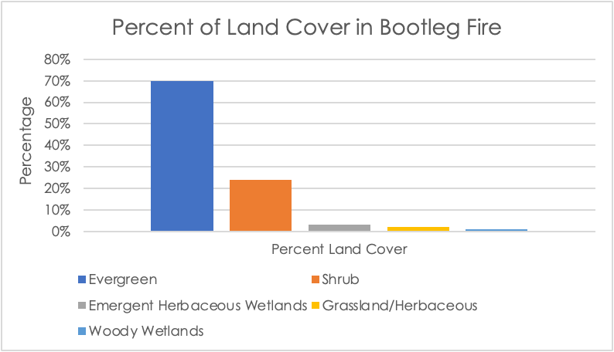
(a)
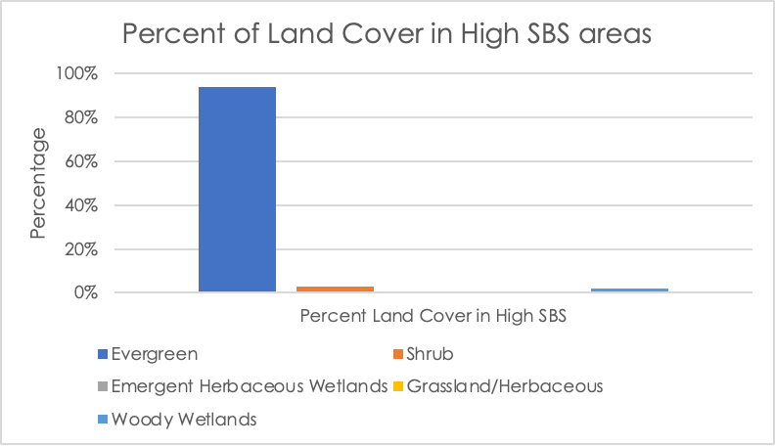
(b)
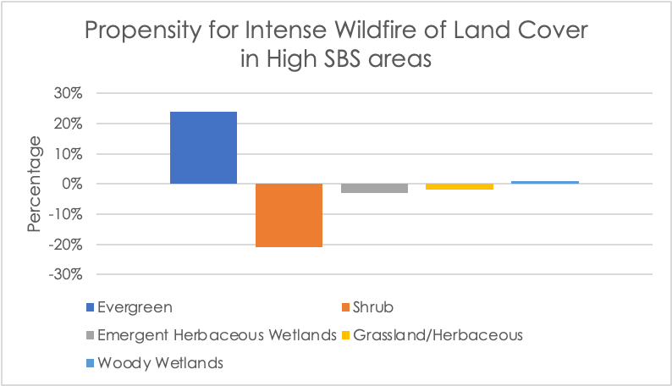
(c)

Figure B5. Comparison of wildfire intensity of five land cover classes in High SBS areas of the Bootleg Fire on August 5, 2021. The percent areas for evergreen, shrub, grassland/herbaceous, and two wetland (emergent herbaceous wetlands, woody wetlands) classes are shown in (a), and percent areas of these classes in high SBS areas are shown in (b). Determination of wildfire intensity is shown in (c), and is calculated as the difference between (b) and (a). Positive values indicate a higher propensity for igniting intense wildfires, negative values indicate a lower propensity. All values are summarized in Table B4.

