**NASA DEVELOP National Program**

****NASA Ames Research Center

**Summer 2015**

**Short Title: Sierra Nevada Water Resources**

**Subtitle:** Quantifying the Effects of Wildfire Severity on Snow Water Equivalent in the Sierra Nevada

**VPS Title:** A Song Of Fire and Snow: Wildfire and Snowpack in the Sierra Nevada

**Project Team & Partners**

**Project Team:**

Sean Cunningham (Project Lead), [sean.m.cummingham@nasa.gov](mailto:sean.m.cummingham@nasa.gov)

Justin Anzelc

Vishal Arya

Nolan Cate

Clayton Sodergren

**Advisors & Mentors:**

Andrew Nguyen (DEVELOP National Program, Ames Research Center)

Dr. Juan Torres Perez (Bay Area Environmental Research Institute, DEVELOP National Program)

**Partner Organizations**

USDA Forest Service (USFS), End-User, POC: Dr. Marc Meyer

National Park Service (NPS), End-User, POC: Jim Roche

**Project Details**

**Applied Sciences National Applications Addressed:** Water Resources

**Study Area:** The study area lies within the Sierra Nevada and incorporates nine wildfires over five California counties: Tuolumne, Tulare, Mariposa, Plumas, and Shasta counties.

**Study Period:** April 24, 1984 - April 29, 2015

**Earth Observations & Parameters**

Landsat 4, TM - Snow cover measurements, NDSI, NDVI

Landsat 5, TM - Snow cover measurements, NDSI, NDVI

Landsat 7, ETM+ - Snow cover measurements, NDSI, NDVI

Landsat 8, OLI - Snow cover measurements, NDSI, NDVI

NASA SRTM - Elevation data

**Ancillary Datasets Utilized**

* USDA Forest Service CALVEG - Vegetation data
* USDA Forest Service - Region 5 Vegetation Burn Severity data
* Bureau of Land Management (BLM) National Landscape Conservation System - California Wilderness Area boundaries
* USDA Natural Resources Conservation Service HUC-10 California watersheds – Watershed Boundaries

**Models Utilized**

* USGS, California Basin Characterization Model (BCM)

**Software Utilized**

ESRI ArcGIS Desktop - Clipping & reprojecting ancillary data

Fmask - Generating cloud mask and snow cover for Landsat images

R Statistical Package - Creating various scripts to convert file formats

Clark Labs TerrSet - Projecting elevation data and creating a mosaic, preprocessing Landsat data

**Project Overview**

**80-100 Word Objectives Overview**

Trends of diminishing snowpack throughout the Sierra Nevada, coupled with an increase in wildfire frequency and severity, have the capacity to threaten California’s water resources. To examine this interaction, Landsat data were analyzed to determine snow cover extent within the Sierra Nevada and to support the California BCM snow water equivalent (SWE) estimates in order to quantify potential SWE changes in areas experiencing low, moderate, and high severity wildfires. These results will aid our end users in decision-making by describing impacts different levels of wildfire severity have on SWE throughout the region.

**Abstract**

Snowpack in the Sierra Nevada is a crucial component of the California water supply. Climate change effects on forest ecosystems in this region have reduced snowpack resulting in earlier snowmelt. Wildfire frequency and severity in the Sierra Nevada have also increased, due to climate change-induced warmer temperatures, drought, and a legacy of fire suppression policies leading to increased fuel loads beyond their range of historic variability. These combined factors have the potential to severely impact California’s water supply. However, the effects of wildfire severity on snowpack have not been geospatially quantified. This study used NASA Earth observations, modeled climate data, and automated classification of Landsat imagery, to quantify the effect of low, moderate, and high severity wildfire on snowpack and snow water equivalent (SWE) in the Sierra Nevada. Results indicate a moderate to strong correlation of rapid deceases in snowpack and SWE in areas of moderate to high severity burns. This information will assist in decision and policy making related to management of forest ecosystems and water resources within the Sierra Nevada.

**Community Concerns**

* Snowpack in the Sierra Nevada is a major source of drinking water for California.
* Wildfire size, severity, and frequency are increasing in the Sierra Nevada.
* Current forest management practices and policies cause deviations from natural fire regimes.

**Current Management Practices & Policies**

Since the 1930s, federal fire suppression policies have been mandated nationwide for all wildfires, natural or human-caused; this policy has been extremely effective in achieving its goal. However, many forest ecosystems in California are adapted to frequent, low-to-moderate intensity wildfires, which maintained forest structure, health, and resilience. Deviation from the natural fire regime has led to an increase in fuel load and the density of understory brush. Multiplied by rising temperatures, lower precipitation levels, and the expanding human presence in forested lands, an increased frequency of high severity wildfires has created a substantial financial burden on the state--upwards of $1 billion in 2008 alone. As a result, the USDA Forest Service and National Park Service implemented mechanical thinning operations, and more recently, prescribed burning as treatments to reduce fuels.

**Decision Support Tools & Benefits**

|  |  |  |
| --- | --- | --- |
| **End-Product** | **Earth Observations Used** | **Benefit & Impact** |
| Snow cover change detection from 1984-2015 | Landsat 4-5 (TM)  Landsat 7 (ETM+)  Landsat 8 (OLI) | Will provide qualitative and quantitative data on variation in snowpack from 1984-2015 |
| Correlation coefficient between wildfire severity and snowpack | Landsat 4-5 (TM)  Landsat 7 (ETM+)  Landsat 8 (OLI) | Will provide quantitative data on how wildfire severity effects snowpack and SWE |

**Project Imagery**

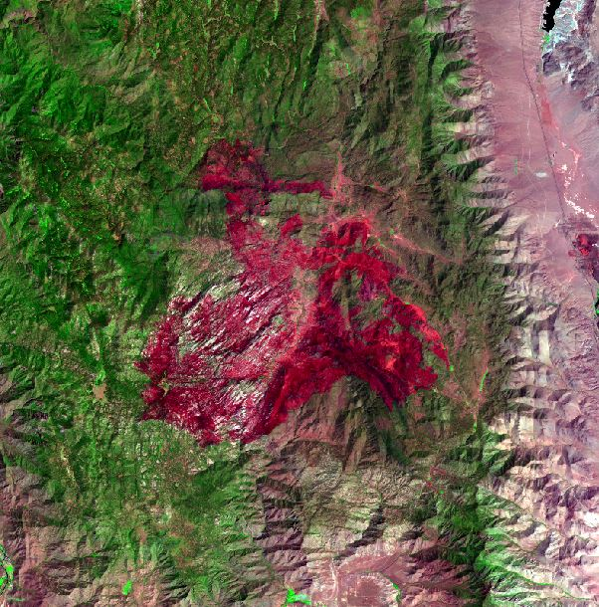

**Caption:** The 2000 Manter fire in Tulare County, CA. Landsat bands 7, 4, and 3 are used to highlight the burn scar in red.

**Image:** Landsat_2000Manter