**NASA DEVELOP National Program**



NASA Langley Research Center

**Fall 2015**

**Short Title: North Carolina Ecological Forecasting**

**Subtitle:** Update of NOAA C-CAP Wetland Delineation and Further Disaggregation of Land Use Classes using Remote Sensing

**VPS Title:** Sensing the Sounds

**Project Team & Partners**

**Project Team:**

Ben Roberts-Pierel (Project Lead), benjamin.m.roberts-pierel@nasa.gov

Brett Buzzanga

Michelle Pasco

Jake Patrick

Benjamin Charlem

Taylor Sage

**Advisors & Mentors:**

Dr. Kenton Ross (NASA DEVELOP National Program)

**Past or Other Contributors:**

Zand Bakhtiari

Stephen Zimmerman

Kayla Patel

Brad Gregory

**Partner Organizations:**

Albamerle-Pamlico National Estuary Partnership (APNEP) (End-User), POC: Bill Crowell and Dean Carpenter

**Project Details**

**Applied Sciences National Applications Addressed:** Ecological Forecasting, Water Resources

**Study Area:** Albemarle-Pamlico Watershed (NC, VA)

**Study Period:** May 2000 - Nov 2015

**Earth Observations & Parameters:**

Landsat 8, OLI – land cover

**Ancillary Datasets Utilized:**

* USGS National Land Cover Dataset (NLCD) - land cover
* NOAA Coastal Change Analysis Program (C-CAP) - regional land cover
* USGS National Hydrological Dataset (NHD)
* USGS Digital Elevation Model (DEM)- 1 arc second, 1/3 arc second and 1/9 arc second
* Soil Survey Geographic Database (SSURGO) – parameter

**Models Utilized:**

* Remote Sensing for Biodiversity and Conservation, R Random Forest Model

**Software Utilized:**

ERDAS IMAGINE- supervised land classification of Landsat imagery

ESRI ArcGIS- raster manipulation/analysis, image enhancement & map creation of Landsat 8. Selection of training sites for supervised land-use classification in R random forest model and Google Earth Engine.

Google Earth Engine – exploring other tools for land use and land cover classifications (LULC).

**Project Overview**

Landsat 8 imagery, in combination with LiDAR, DEMs, soil, and ground truth data provided powerful tools for this land classification project. Data were used to classify land use types, specifically wetlands, update NOAA’s C-CAP program, and identify additional land cover categories, such as areas impacted by the invasive species, *Phragmites australis*. The project provided updated Land Use Land Classification (LULC) maps to the partner organization as well as a usable methodology that would allow APNEP to update the imagery on an annual or biannual basis. The project also aimed to investigate whether there was any correlation between wetland type and wetland health.

**Abstract:**

This project focused on ecological forecasting for wetlands in the Albemarle-Pamlico watershed in Northeastern North Carolina and Southeastern Virginia. The Albemarle-Pamlico watershed encompasses the second largest estuary system in the United States. Understanding land cover types and uses is incredibly important in managing the myriad of uses for, and stressors on, this valuable resource. In partnership with the Albemarle-Pamlico National Estuary Partnership (APNEP), this project aimed to provide an updated version of NOAA’s Coastal Change Analysis Program (C-CAP) land-use classification, with a specific focus on delineation of wetland types within this watershed. The project also further disaggregated land cover types such as crop varieties and the invasive species, *Phragmites australis*. The team utilized a supervised land classification methodology and cross-referenced Landsat 8 imagery with ground truth, LiDAR or Digital Elevation Models (DEM), the National Hydrological Dataset (NHD) and soil datasets to create inputs for the R classifying model. The end goal of the project was to produce maps and a methodology by which APNEP can continually update wetland types and to establish if there is a correlation between wetland type and wetland health within the watershed. This was all with the aim of helping APNEP to make informed policy and management decisions.

**Community Concerns:**

* Like many land/water management organizations, APNEP suffers from some of the same issues in budget shortfalls and lack of personnel. Another limiting factor in their operations is the availability of data on land cover. As noted, C-CAP is only updated approximately every five years and has an accuracy of about 82%. APNEP is also limited in their ability to utilize the data that does exist, such as the data from the NASA Earth Observation System, because of limited knowledge or access to the appropriate software and understanding of the subject.
* Existing active wetland monitoring programs are limited in their utility for ecosystem-based management because of some of the resource limitations listed above and their scalability.
* C-CAP is helpful but does not cover the entire Albemarle-Pamlico basin and it is only updated on approximately a five year cycle.
* Wetlands within the Albemarle-Pamlico basin provide a breadth of positive benefits for people and ecosystems. Beyond the obvious economic benefits of tourism and fishing, wetlands provide extensive flood control, water filtration (removal of excess nutrients and other pollutants) and extensive habitat for a range of flora and fauna. All of these aspects are integral to people living within the basin and APNEP strives to incorporate this consideration into their work wherever possible.

**Current Management Practices & Policies**:

APNEP relies on an ecosystem-based approach to watershed management and five main guiding principles: to identify, protect, restore, engage and monitor trends in the basin. This outlines a logical approach to management where they identify stressors or trends in the basin and establish whether a restoration or protection strategy is required on a case by case basis. APNEP’s model in particular lends itself to strong engagement with the communities which they serve. They aim to incorporate a broad range of actors from government scientists to commercial fishermen to farmers to the general public. APNEP also utilizes citizen monitoring programs and outreach/education programs, amongst other strategies, to include input from many different user groups within the basin. Finally, monitoring and assessment is necessary for any organization managing natural resources and provides a means by which to establish the success of APNEP’s programs.

As APNEP advocates this holistic approach to ecosystem/basin management, the policies they advance are varied. Because they have the dual management directive of human use and ecosystems, they must pursue policy options which aim to protect and restore ecosystem resources while also preserving human use in the area. This is apparent in their management strategy where they extol the virtues of a rich culture anchored in a long connection with the area, the fisheries and natural environment, as well as the importance of protecting habitats and restoring ecosystems to a more pristine state.

**Decision Support Tools & Benefits:**

|  |  |  |
| --- | --- | --- |
| **End-Product** | **Earth Observations Used** | **Benefit & Impact** |
| Land use classification and wetland type map | Landsat 8 OLI  Terra MODIS | Aid in describing focus areas and wetland types for protection/conservation or remediation efforts |
| Methodology for continuously updating C-CAP | Landsat 8 OLI  Terra MODIS | C-CAP is only updated by NOAA once every 5 years so this would enable APNEP to update wetland types and other classifications such as *Phragmites* more regularly |

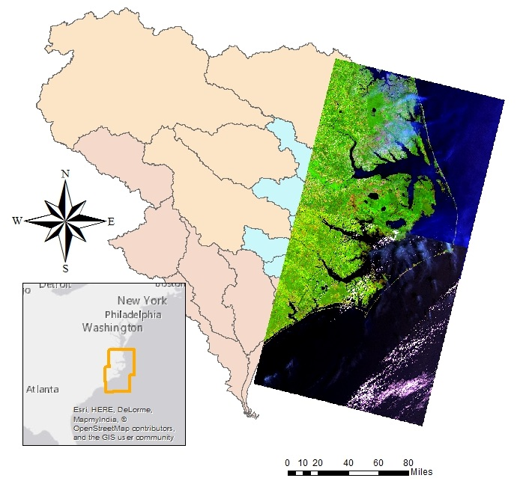 **Project Imagery**

**Caption:** Landsat 8 scene from path 14, row 35. Image is a composite of bands 6, 5 and 2. Image Credit: North Carolina Ecological Forecasting Team.

**Image:** File Name (Please submit your image as a separate .jpeg as well as inserting it in this document)

**Software Release Requirements**

What category do the tools your project is creating fall within?

Category II